Supplementary material
Supplementary Figures
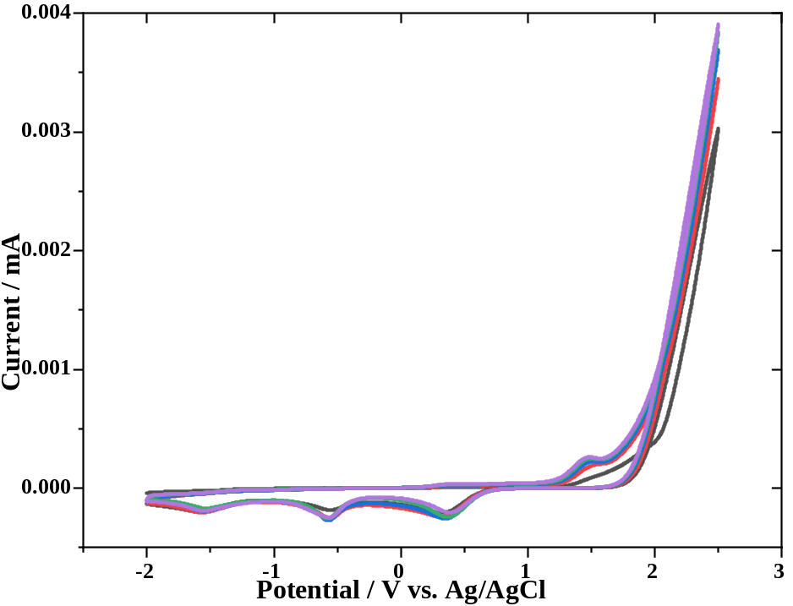
Figure S1. CV voltammogram of electropolymerized poly (p-TSA) grown at 5 cycles in 0.1 M NaCl solution

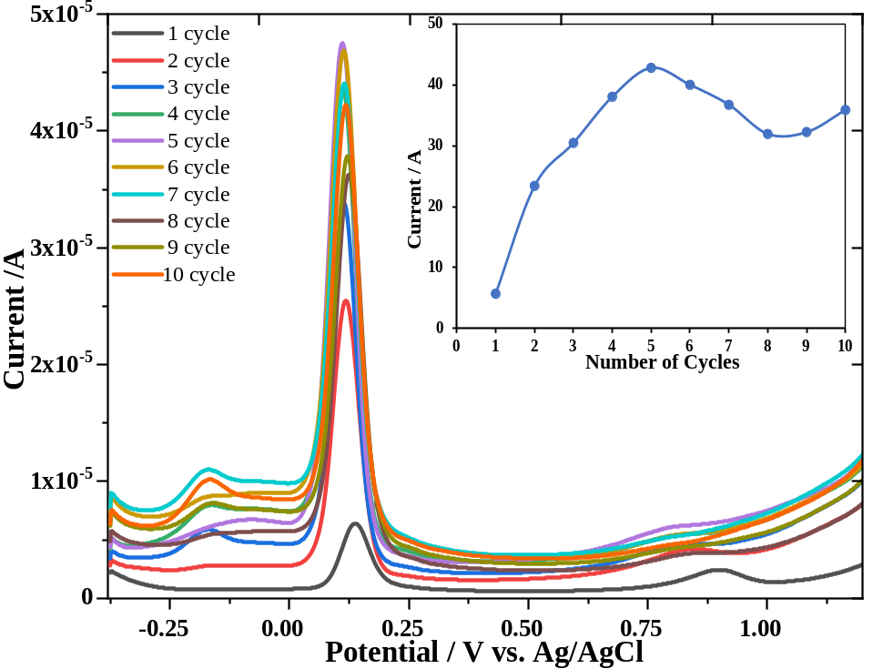
Figure S2. DPV responses of 100 ppm Trolox at poly (p-TSA) electrode of different film thicknesses in PBS pH 7.4
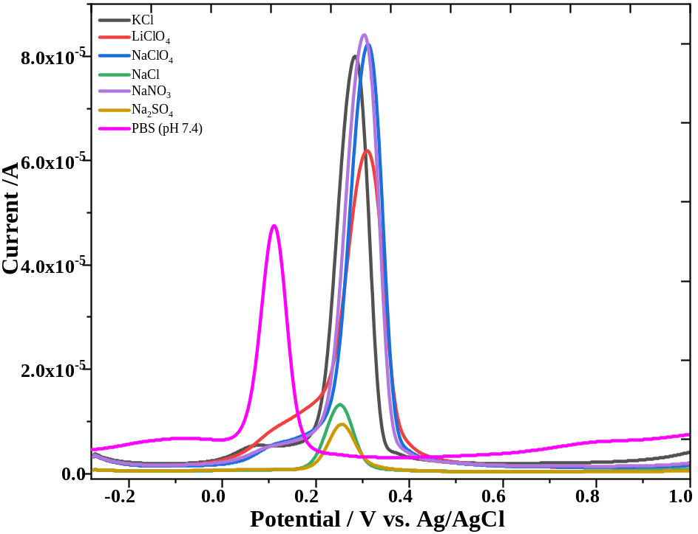
Figure S3. DPV responses of 100 ppm Trolox in different electrolyte solutions
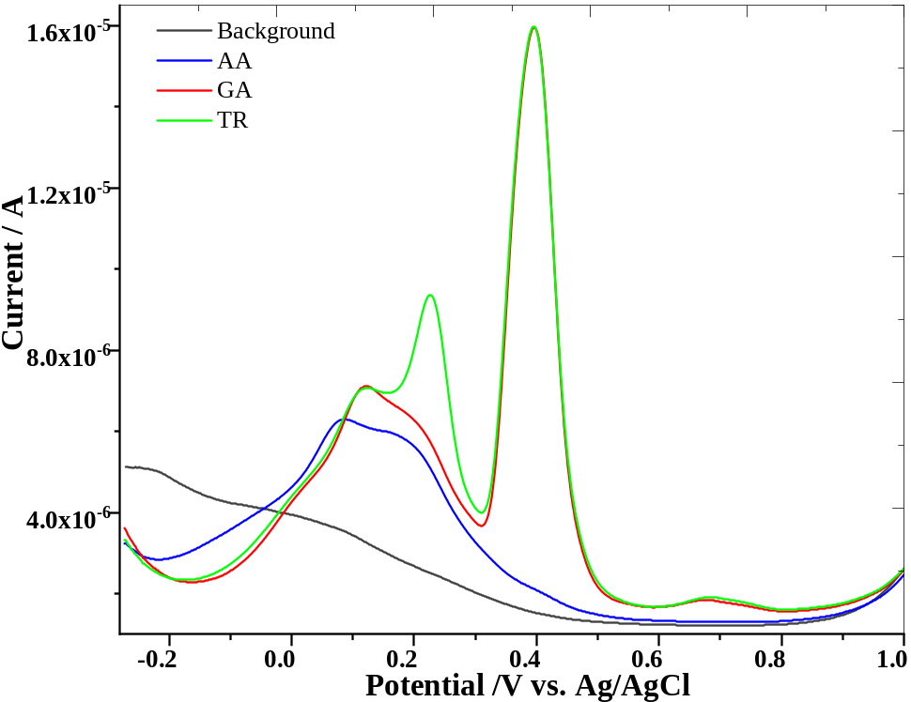
Figure S4. DPV responses of 19.6 ppm ascorbic acid, 19.2 ppm gallic acid and 1.9 ppm trolox in a 0.1 M NaNO₃ solution at the poly (p-TSA) modified sensor

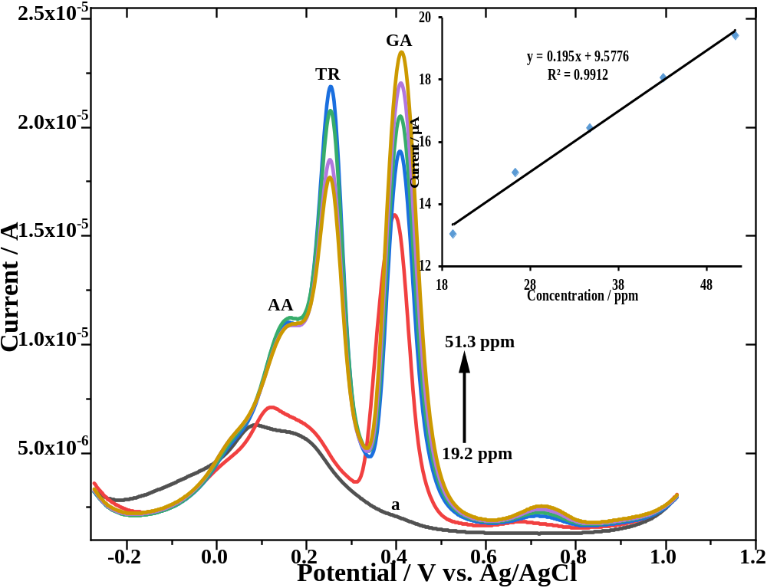Figure S5. DPV responses of gallic acid (19.2, 26.3, 34.8, 43.1, 51.3 ppm), 8.9 ppm Trolox and 19.2 ppm ascorbic acid in 0.1 M NaNO₃ solution at the poly (p-TSA) modified sensor (a: background). The inner graph represents the curve showing the relationship between the measured current values versus increasing gallic acid concentrations
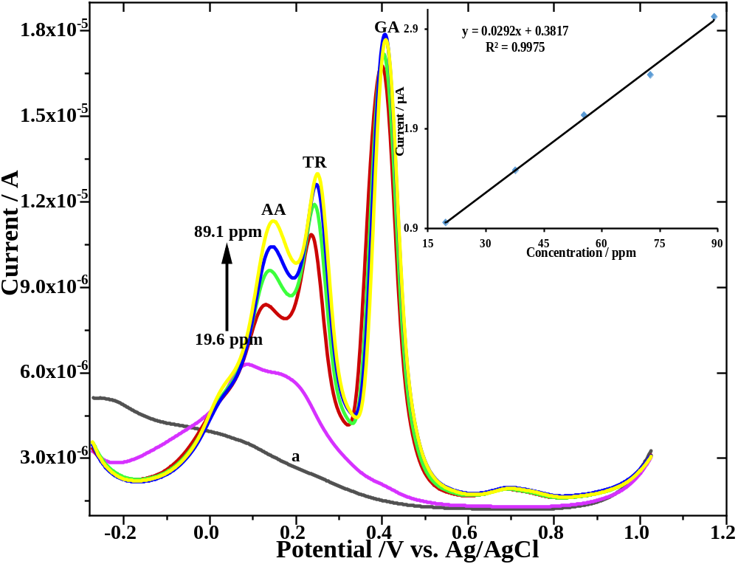
Figure S6. DPV responses of ascorbic acid (19.6, 37.7, 55.5, 72.6, 89.1 ppm), 1.9 ppm Trolox and 19.2 ppm gallic acid in 0.1 M NaNO₃ solution at the poly (p-TSA) modified sensor (a: background). The inner graph represents the curve showing the relationship between the measured current values versus increasing ascorbic acid concentrations

