Supplementary information

Supplementary Table 1.
Information about the samples included in the study. ID = individual identification number. NA = information missing.

ID | Population | Sample site | Tissue | Sample year | Sex
U1 | Roslagen | Lötaholmen | Dried, whole specimen | NA | NA
U2 | Roslagen | Lötaholmen | Dried, whole specimen | NA | NA
U3 | Roslagen | Lötaholmen | Dried, whole specimen | NA | NA
U4 | Roslagen | Lötaholmen | Dried, whole specimen | NA | NA
U5 | Roslagen | Lötaholmen | Dried, whole specimen | NA | NA
U6 | Roslagen | Brudskäret | Dried, whole specimen | NA | NA
U7 | Roslagen | Brudskäret | Dried, whole specimen | NA | NA
U8 | Roslagen | Brudskäret | Dried, whole specimen | NA | NA
U9 | Roslagen | Brudskäret | Dried, whole specimen | NA | NA
NAU37 | NordensArk | NA | Dried, whole specimen | 2020 | NA
B11 | Blekinge | NA | Leg in EtOH | 2015 | NA
B14 | Blekinge | NA | Leg in EtOH | 2016 | NA
B15 | Blekinge | NA | Leg in EtOH | 2016 | NA
B16 | Blekinge | NA | Leg in EtOH | 2016 | NA
B18 | Blekinge | NA | Leg in EtOH | 2016 | NA
B20 | Blekinge | NA | Leg in EtOH | 2016 | NA
B25 | Blekinge | NA | Wing piece in EtOH | 2017 | NA
B26 | Blekinge | NA | Wing piece in EtOH | 2017 | NA
B27 | Blekinge | NA | Wing piece in EtOH | 2017 | NA
B28 | Blekinge | NA | Wing piece in EtOH | 2017 | NA
NAB2 | NordensArk | NA | Full specimen, frozen | 2017 | NA
NAB4 | NordensArk | NA | Full specimen, frozen | 2017 | NA
NAB5 | NordensArk | NA | Full specimen, frozen | 2018 | NA
NAB6 | NordensArk | NA | Full specimen, frozen | 2018 | NA
NAB7 | NordensArk | NA | Full specimen, frozen | 2018 | NA
NAB10 | NordensArk | NA | Full specimen, frozen | 2018 | NA
NAB12 | NordensArk | NA | Full specimen, frozen | 2018 | NA
NAB17 | NordensArk | NA | Full specimen, frozen | 2018 | NA
NAB21 | NordensArk | NA | Full specimen, frozen | 2018 | NA
NAB23 | NordensArk | NA | Full specimen, frozen | 2018 | NA
VN2 | Västernorrland | Tynderö | Wing in EtOH | 2016 | Male
VN4 | Västernorrland | Tynderö | Wing in EtOH | 2016 | Male
VN10 | Västernorrland | Alnö | Wing in EtOH | 2016 | Male
VN11 | Västernorrland | Alnö | Wing in EtOH | 2016 | Male
VN12 | Västernorrland | Alnö | Wing in EtOH | 2016 | Male
VN13 | Västernorrland | Alnö | Wing in EtOH | 2016 | Male
VN14 | Västernorrland | Alnö | Wing in EtOH | 2016 | Male
VN15 | Västernorrland | Hässjö | Wing in EtOH | 2016 | Male
VN16 | Västernorrland | Hässjö | Wing in EtOH | 2016 | Male
VN18 | Västernorrland | Hässjö | Wing in EtOH | 2016 | Male

Supplementary Table 2.
Information about the yield (Mreads = millions of read-pairs) and percentage of bases with Phred score > 30 (Q30%) for the 40 specimens included in the sequencing effort. NGI ID = identification number from the sequencing facility, User ID = identification number from collectors, Mreads = antal sekvensläsningar (*10⁶), Q30(%) = proportion baser med Phred-score >30 (%).

Population | NGI ID | User ID | Mreads | Q30(%)
Roslagen | P21213_101 | U1 | 106.60 | 92.63
Roslagen | P21213_102 | U2 | 68.44 | 92.76
Roslagen | P21213_103 | U3 | 74.11 | 92.42
Roslagen | P21213_104 | U4 | 74.84 | 92.57
Roslagen | P21213_105 | U5 | 96.29 | 92.56
Roslagen | P21213_106 | U6 | 92.34 | 92.64
Roslagen | P21213_107 | U7 | 85.61 | 92.52
Roslagen | P21213_108 | U8 | 86.65 | 92.60
Roslagen | P21213_109 | U9 | 104.05 | 93.07
Roslagen | P21213_110 | NAU37 | 84.53 | 93.04
Blekinge | P21213_111 | B11 | 60.43 | 93.02
Blekinge | P21213_112 | B14 | 47.68 | 92.95
Blekinge | P21213_113 | B15 | 60.71 | 92.86
Blekinge | P21213_114 | B16 | 65.52 | 92.86
Blekinge | P21213_115 | B18 | 58.07 | 92.85
Blekinge | P21213_116 | B20 | 61.44 | 92.68
Blekinge | P21213_117 | B25 | 64.41 | 93.56
Blekinge | P21213_118 | B26 | 63.63 | 93.24
Blekinge | P21213_119 | B27 | 66.07 | 93.15
Blekinge | P21213_120 | B28 | 54.62 | 93.32
Nordens Ark | P21213_121 | NAB2 | 73.88 | 93.31
Nordens Ark | P21213_122 | NAB4 | 85.28 | 93.31
Nordens Ark | P21213_123 | NAB5 | 73.87 | 93.12
Nordens Ark | P21213_124 | NAB6 | 97.58 | 93.27
Nordens Ark | P21213_125 | NAB7 | 79.13 | 92.95
Nordens Ark | P21213_126 | NAB10 | 69.33 | 93.24
Nordens Ark | P21213_127 | NAB12 | 63.39 | 93.39
Nordens Ark | P21213_128 | NAB17 | 82.24 | 93.01
Nordens Ark | P21213_129 | NAB21 | 92.62 | 92.71
Nordens Ark | P21213_130 | NAB23 | 95.23 | 93.28
Västernorrland | P21213_131 | VN2 | 82.01 | 93.14
Västernorrland | P21213_132 | VN4 | 86.08 | 93.27
Västernorrland | P21213_133 | VN10 | 106.32 | 93.25
Västernorrland | P21213_134 | VN11 | 86.59 | 93.21
Västernorrland | P21213_135 | VN12 | 75.22 | 93.40
Västernorrland | P21213_136 | VN13 | 79.85 | 93.05
Västernorrland | P21213_137 | VN14 | 95.80 | 93.28
Västernorrland | P21213_138 | VN15 | 96.82 | 93.12
Västernorrland | P21213_139 | VN16 | 88.76 | 93.34
Västernorrland | P21213_140 | VN18 | 87.90 | 93.34

Supplementary Table 3.
Information about sample origin for the previously sequenced and publicly available individuals included in the mtDNA-analysis (Gratton et al. 2008).

Origin | NCBI Accesionsnummer
Italy | EU836664
Greece | EU836670
Czech Rep. | EU836680
Austria | EU836664, EU836673
Åland, Fin. | EU092977
Finland | EU836676, EU093006
Lithuania | EU836676, EU836677, EU836678, EU836679
Macedonia | EU836666, EU836667, EU836668
Russia | EU836681, EU836682

Supplementary Table 4.
Summary of estimated levels (median +/- standard deviation) of genetic diversity (θ_{π}, θ_{W}, *10⁻³) and Tajima’s D (Taj. D) in the two subpopulations in Roslagen (Lötaholmen och Brudskäret). All estimates are based on autosomal 4D-sites estimated in 100 kb windows. CP = codon position. 4D = 4D-sites.

Population | Position | θ_{π} | θ_{W} | T_{D}
Brudskäret | 4D | 5.3 ± 13.7 | 5.5 ± 10.6 | 0.12 ± 1.05
Lötaholmen | 4D | 4.6 ± 13.5 | 4.8 ± 10.4 | 0.06 ± 1.10
Brudskäret | CP3 | 4.7 ± 12.2 | 4.9 ± 9.4 | 0.10 ± 1.06
Lötaholmen | CP3 | 4.2 ± 12.1 | 4.4 ± 9.3 | 0.02 ± 1.11
Brudskäret | CP2 | 3.4 ± 9.9 | 3.6 ± 7.7 | 0.06 ± 1.04
Lötaholmen | CP2 | 3.0 ± 9.9 | 3.2 ± 7.6 | 0.03 ± 1.08
Brudskäret | CP1 | 3.5 ± 10.2 | 3.6 ± 7.9 | 0.07 ± 1.04
Lötaholmen | CP1 | 3.0 ± 10.2 | 3.2 ± 7.8 | 0.02 ± 1.08

Supplementary Table 5.
Summary of the counts of fixed, shared and private alleles for autosmal 4D-sites in the comparison of the two subpopulations in Roslagen (Lötaholmen och Brudskäret).

Population A | Population B | Fixed | Shared | Private A | Private B | Total
Brudskäret | Lötaholmen | 76 | 43,841 | 19,871 | 15,295 | 79,083

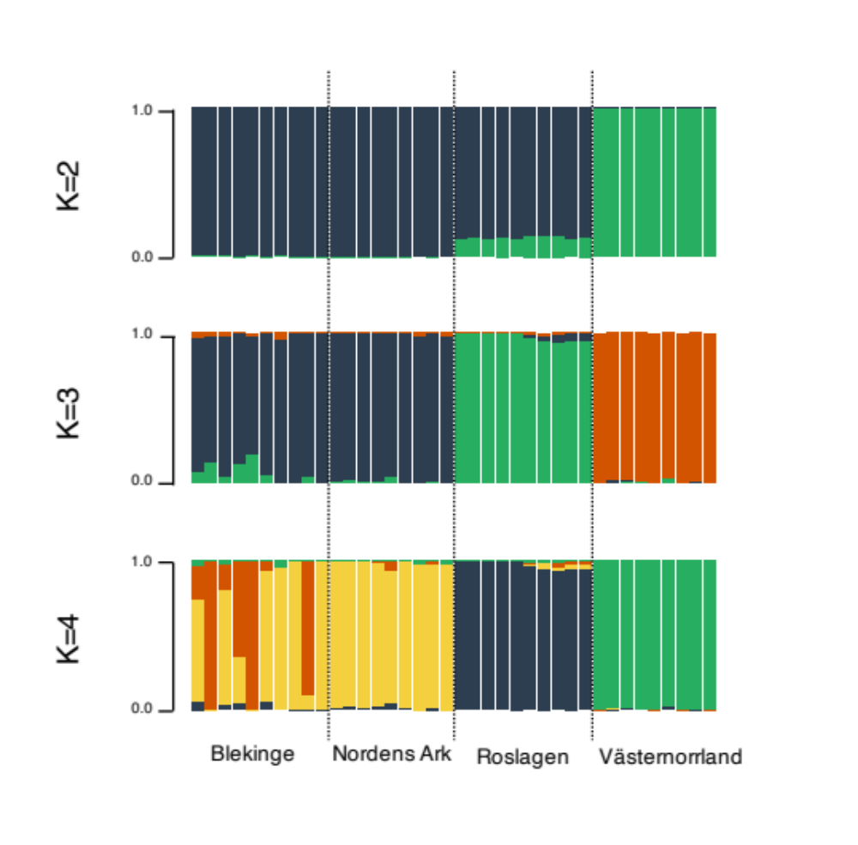

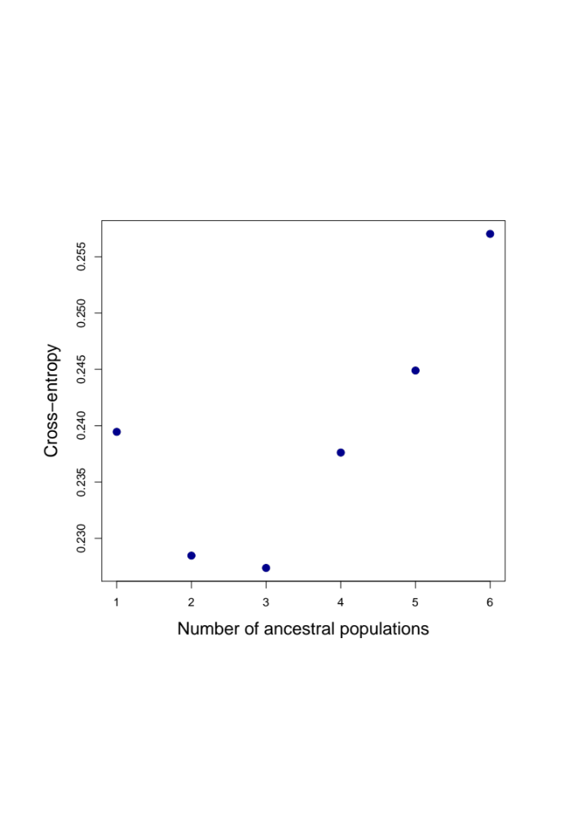

Supplementary Figure 1.
Top three panels illustrate the results from the Admixture analysis of SNPs at 4D-sites for the clouded apollo in Sweden for K = 2 – 4, respectively. At the bottom the cross-entropy scores for different K values are given.

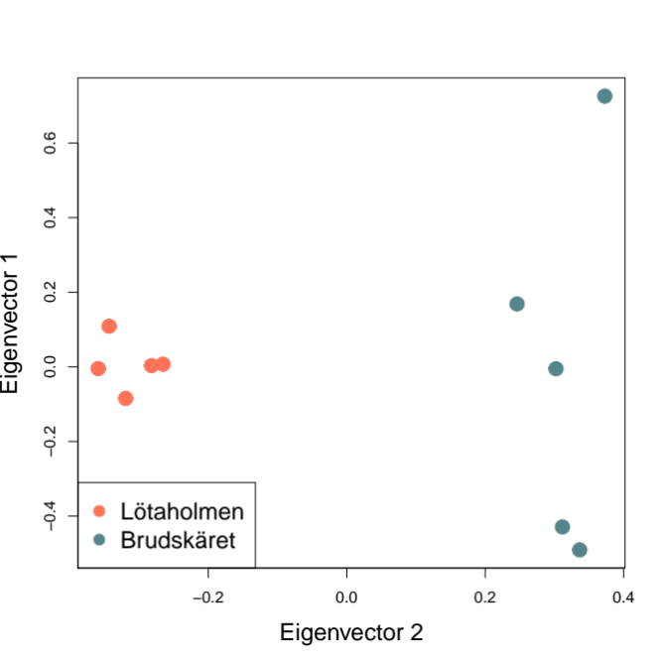
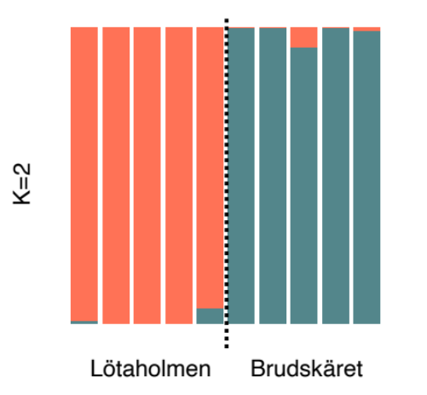

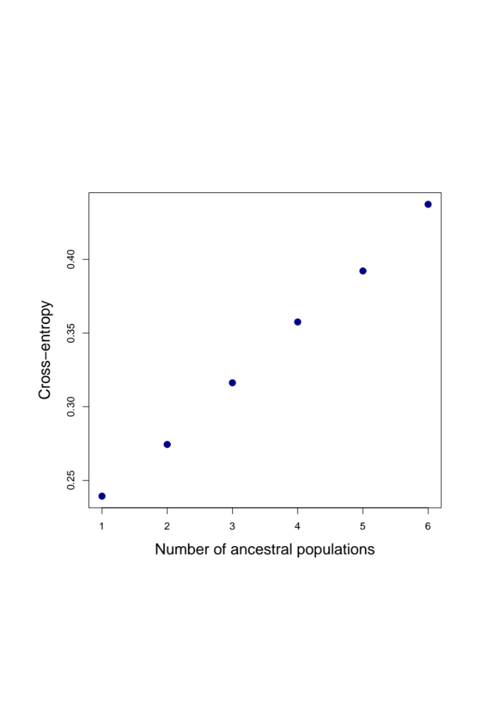

Supplementary Figure 2.
Results from a principal component analysis (PCA, top) and Admixture-analysis (middle) of the genetic variation at autosomal 4D-sites in clouded apollo individuals from two sampling sites in Roslagen. The X-axis (PCA1) explained 14% and the Y-axis (PCA2) 12% of the total variation. The two sub-populations came out as distinct clusters in the Admixture analysis but the cross-entropy scores showed that the data were best explained by a single population.
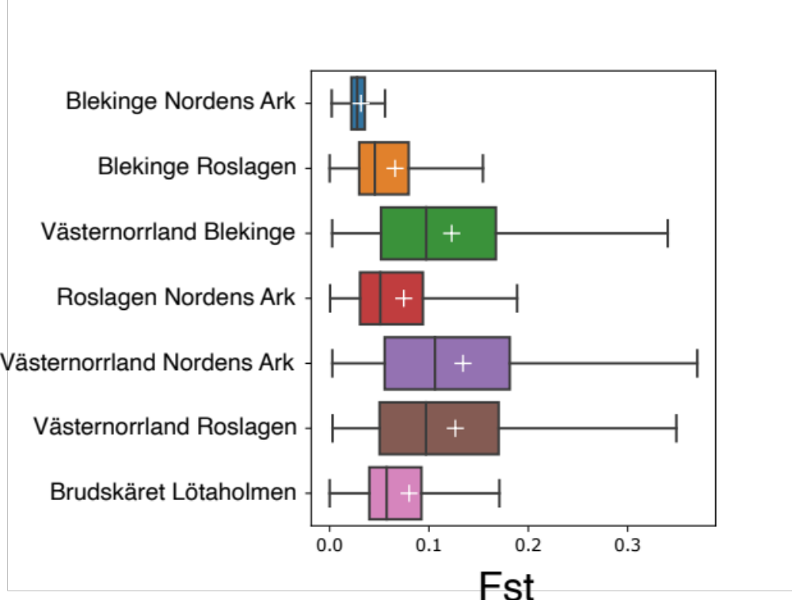

Supplementary Figure 3.
Box-plots illustrating the distribution o festimates of genetic differentiation (F_{ST}) in the comparison between the two sampling sites in Roslagen (bottom) in comparison to the estimates from all population comparisons (same data as in Table 3). F_{ST} was estimated based on genetic variation at autosomal 4D-sites as summarized in 100 kb non-overlapping windows. Boxes indicate the 25 - 75 percentiles, vertical bars within boxes show the median estimate and white + show the mean estimates. Whiskers delimit the total span o festimates over all 100 kb windows.

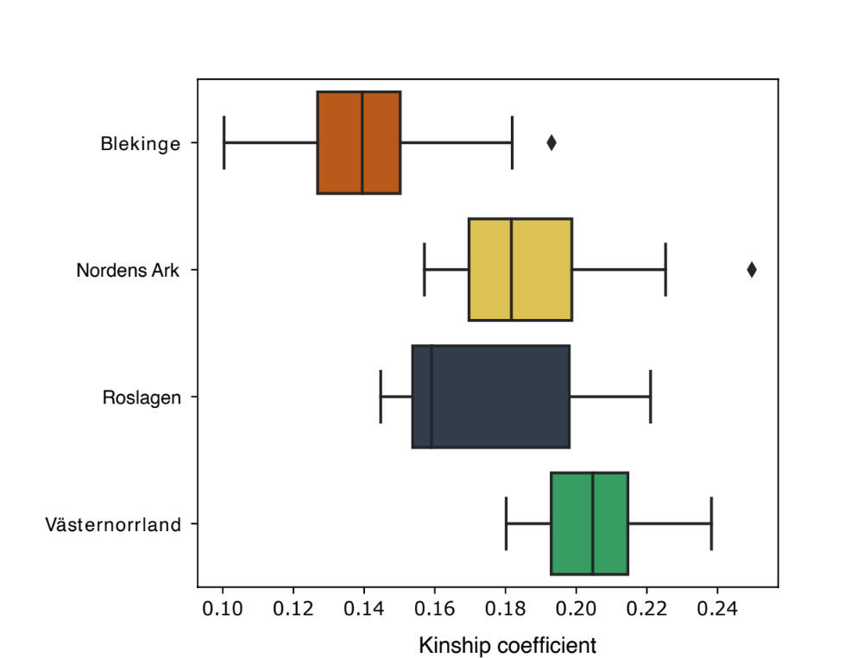
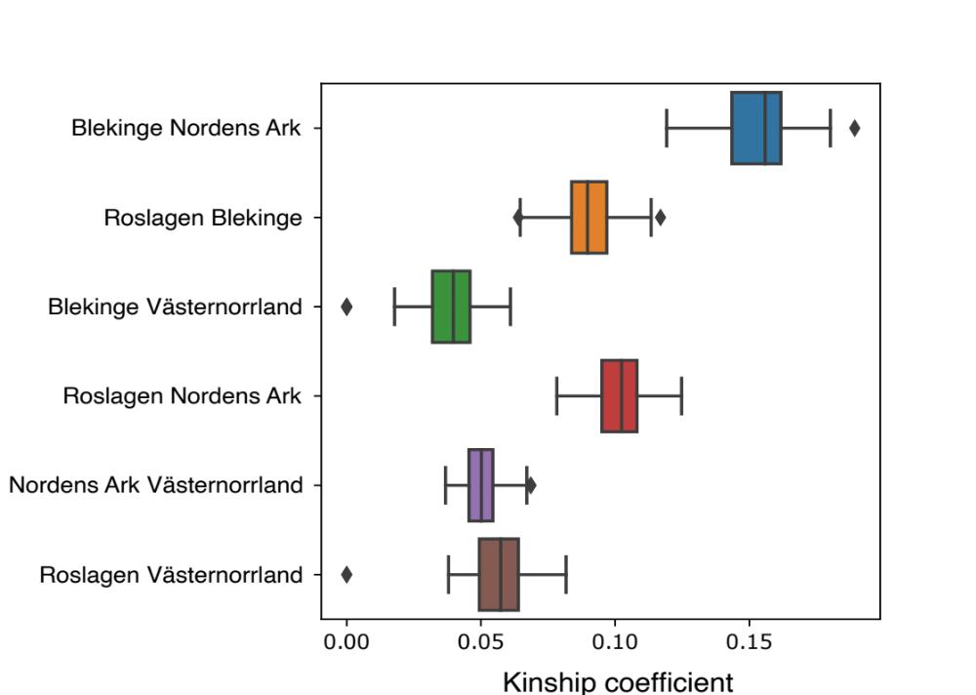

Supplementary Figure 4. Estimates of within (top) and between population (bottom) kinship coefficients (x-axis). The analysis was based on autosomal 4D-sites. Note that the scale of the X-axis differs between the panels.

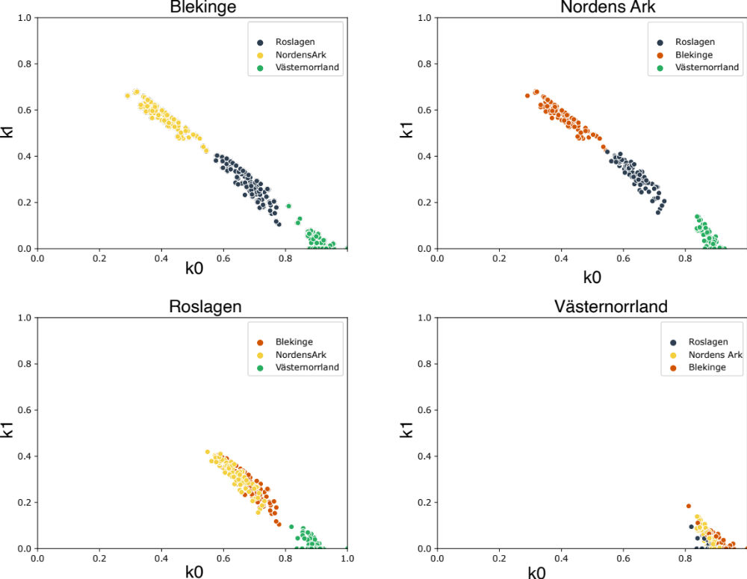

Supplementary Figure 5. Estimates of probability of identity-by-descent (IBD) of two alleles in an individual, as compared to the probability of an allele in an individual having IBD with an allele from another individual. The analysis was based on autosmal 4D-sites and repeated for individuals in each subpopulation separately to give a clearer picture of the relationship between individuals in different populations. The analysis. The X-axis shows the probability that no allele in a pair is in IBD (k0) and the Y-axis the probability that at least on allele in a pair is in IBD (k1).

