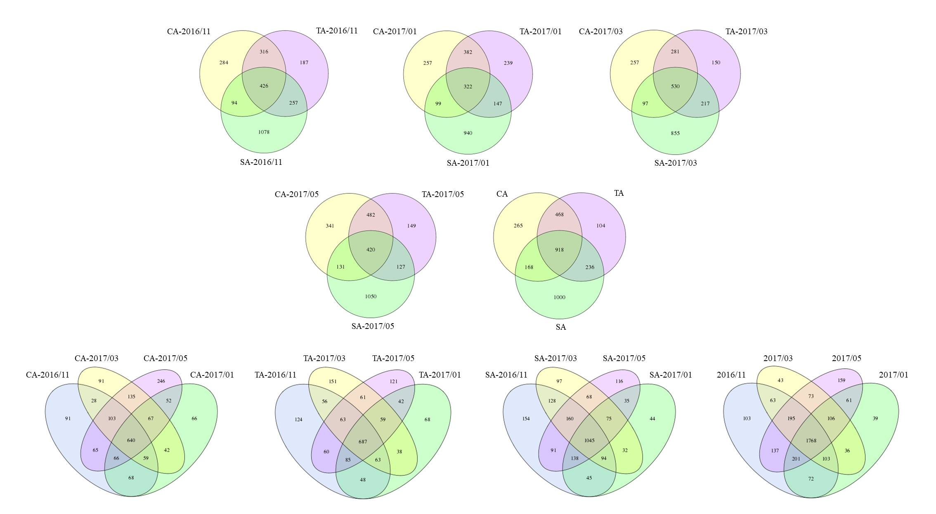
Fig. S2. Venn diagram representing the OTUs obtained from CA, TA, and SA soils between November 2016 and May 2017. The diagrams were implemented by the R software.

