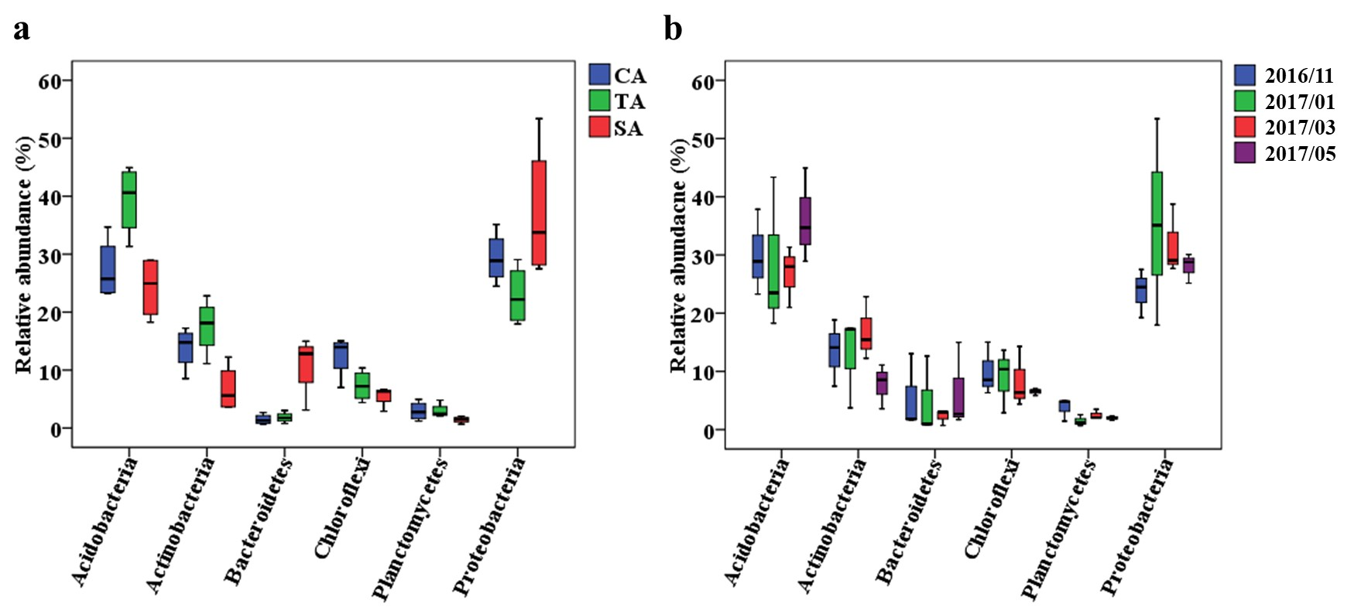
Fig. S3. Box plot showing (a) the distribution top six phyla at three soils and (b) at different sampling times.

