Supplemental figures and tables for the article

A) B)
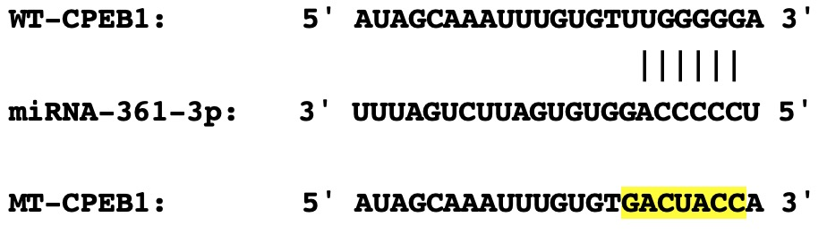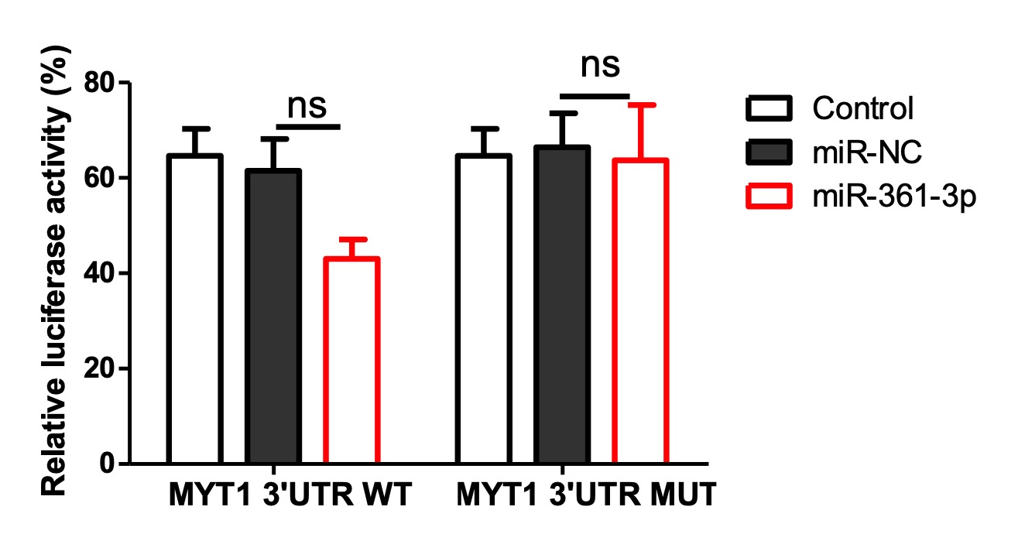

C) D)
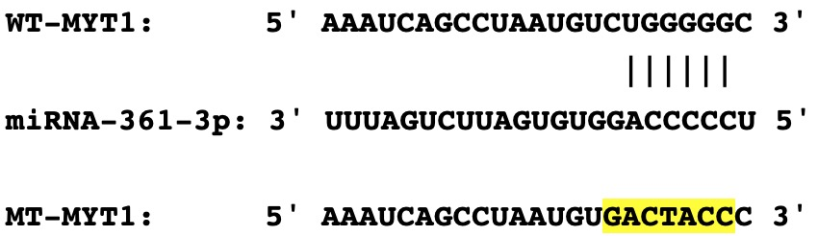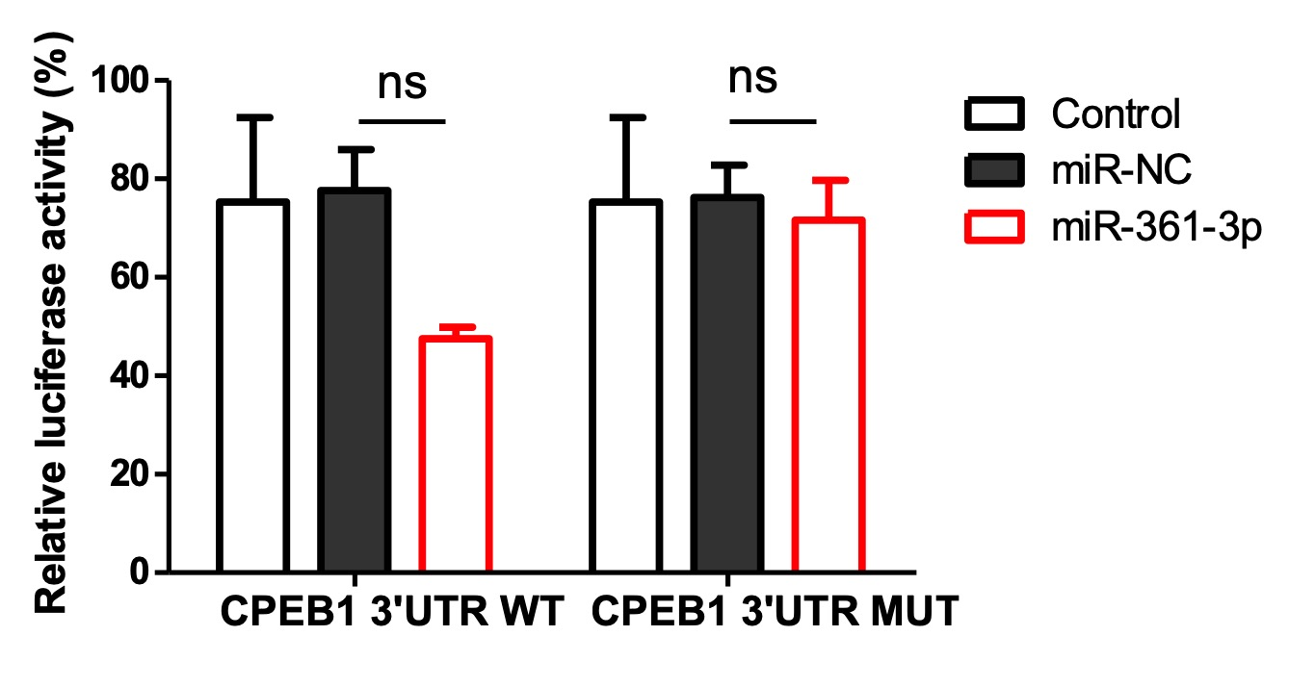

Figure S1. Luciferase activity assays was performed to confirm the direct binding efficiency of miR-361-3p and CPEB1 or MYT1.
A and C) Alignment of miR-361-3p and its corresponding complementary binding sequence in the CPEB1 or MYT1 3′ UTR, as determined by the TargetScan bioinformatics algorithm.
B and D) HEK293 cells were transfected with 200 ng mL⁻¹luciferase reporter plasmid containing wild-type (WT) or mutant CPEB1 or MYT1 3′ UTR or empty vector (Vector) together with 20 nM pre-miR-361-3p or pre-miR-control, and luciferase activity was measured 48 h later. Data of one representative experiment out of three independent experiments are shown with mean ± SD. ns >0.05.

A)
control 9s-HODE (12.5μM)
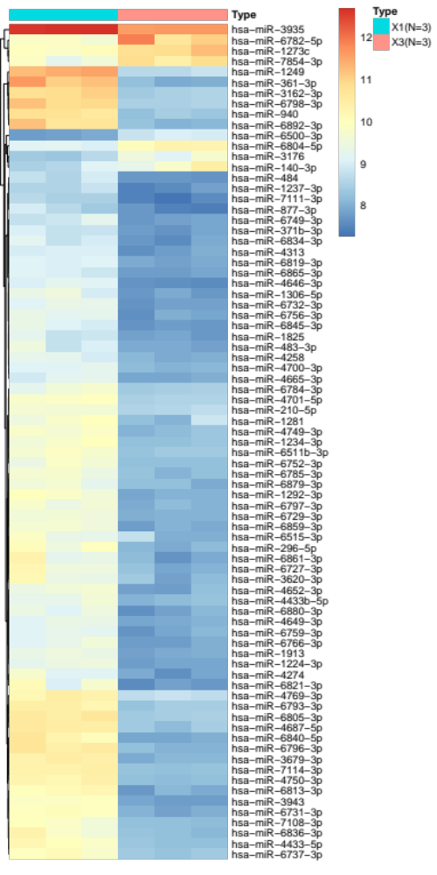

B)
control 9s-HODE (25μM)
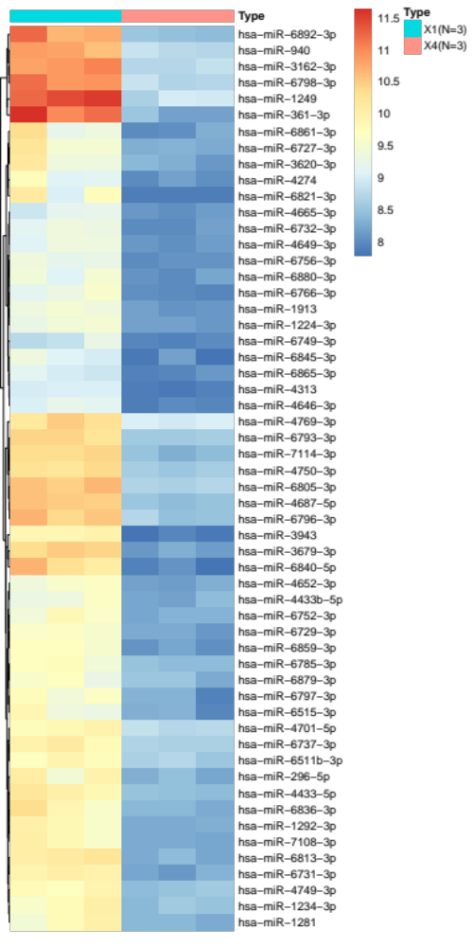
Figure S2. microRNA regulated during 9s-HODE treated HL-60 cells
Unsupervised clustering analysis of microRNA expression profiles of HL-60 cells. The heatmap generated by miRNA expression patterns demonstrated two clusters.
Red: higher expression; green: lower expression;
A) control group vs 9s-HODE treated group (12.5μM)
B) control group vs 9s-HODE treated group (25μM)

