Metabolite Standard TIC Diagram and standard curve results
The 40 fatty-acid methyl ester standards were analyzed using the established fatty acid analysis method, and a total of 37 fatty acids were obtained, of which 1 fatty acid was not separated due to its isomers, and 2 were not detected. It can be seen from the figure that the internal standard was separated from each standard, and the chromatographic separation of each metabolite is good (Figure 1). The peak shape is sharp and symmetrical, which can quantify each metabolite by mass spectrometry. Take the ratio of the concentration of each component of the standard variety to the internal standard as the abscissa, and the ratio of the peak area as the ordinate, and calculate the linearity and correlation coefficient for each component according to the proportion of each component in the total concentration. This is used to examine the linearity of the standard solution. The results (table 2) show that the linearity of each analyte in the linear range is good, and the correlation coefficients are greater than 0.99.
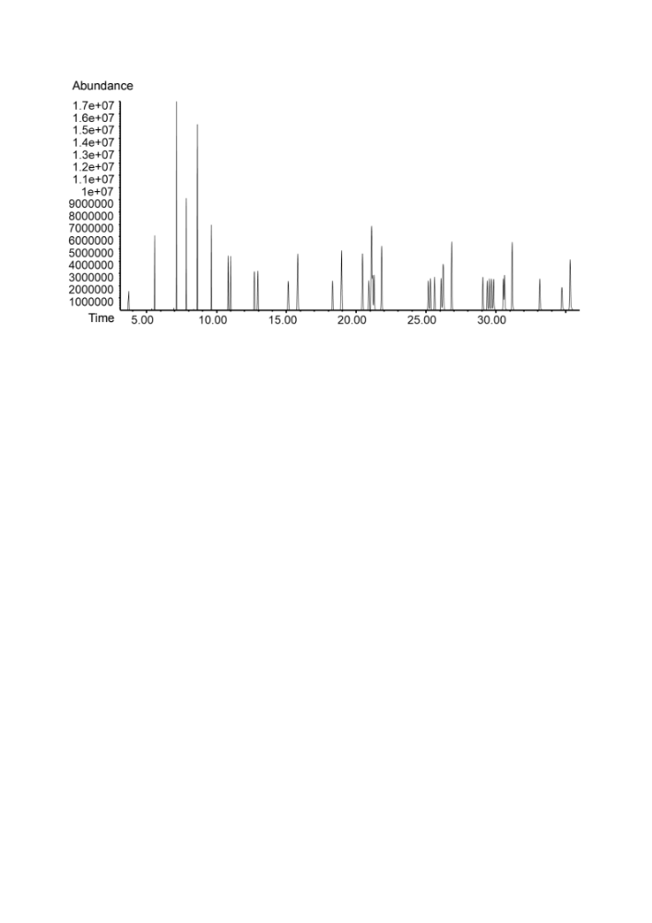
Figure 1: Metabolite Standard TIC Diagram

Table 2: Standard curve results of free fatty acids
No | Chemical name | Retention time  （min） | Quantitative ion  （m/z） | Linear Regression | R² | Linear range  (μg/mL)
1 | C6:0 | 3.7 | 74.1 | y=1.129735x+0.005851 | 0.9994 | 0.01-50
2 | C8:0 | 5.567 | 74.1 | y=3.458898x-0.004110 | 0.9987 | 0.01-50
3 | C10:0 | 7.115 | 74.1 | y=3.876513x+0.011607 | 0.9998 | 0.02-100
4 | C11:0 | 7.804 | 74.1 | y=4.190526x-8.819728E-005 | 0.9999 | 0.01-50
5 | C12:0 | 8.626 | 74.1 | y=4.589719x+0.001475 | 0.9999 | 0.02-100
6 | C13:0 | 9.618 | 74.1 | y=4.760675x+0.001341 | 0.9999 | 0.01-50
7 | C14:0 | 10.978 | 74 | y=0.872259x+0.014967 | 0.9994 | 0.01-50
8 | C14:1 | 10.815 | 55.1 | y=1.492988x+0.027478 | 0.9992 | 0.01-50
9 | C15:0 | 12.96 | 74 | y=1.593854x+0.010799 | 0.9991 | 0.01-50
10 | C15:1 | 12.687 | 55.1 | y=1.192027x-5.803434E-005 | 0.9998 | 0.01-50
11 | C16:0 | 15.787 | 74 | y=1.536525x+0.033646 | 0.9992 | 0.02-100
12 | C16:1 | 15.114 | 55.1 | y=0.340850x+0.003235 | 0.9997 | 0.01-50
13 | C17:0 | 18.932 | 74 | y=1.588367x+0.015938 | 0.9995 | 0.02-100
14 | C17:1 | 18.305 | 55.1 | y=0.350114x+0.001156 | 0.9987 | 0.01-50
15 | C18:0 | 21.788 | 74 | y=1.328304x+0.068665 | 0.9982 | 0.02-100
16 | C18:1 | 21.062 | 79 | y=1.125590x+0.039877 | 0.9994 | 0.02-100
17 | C18:1T | 21.252 | 74 | y=0.722215x+0.013222 | 0.999 | 0.01-50
18 | C18:2 | 21.128 | 79 | y=0.924506x+0.010896 | 0.9996 | 0.01-50
19 | C18:2TT | 20.426 | 79 | y=1.072456x-0.007404 | 0.9999 | 0.02-100
20 | C18:3N6 | 20.889 | 79 | y=0.891041x-0.001309 | 0.999 | 0.01-50
21 | C20:0 | 26.802 | 55.1 | y=1.492947x+0.009350 | 0.9994 | 0.02-100
22 | C20:2 | 26.211 | 55.1 | y=0.907653x+0.007250 | 0.9997 | 0.01-50
23 | C20:3N8 | 26.048 | 67 | y=0.759175x+0.006041 | 0.9996 | 0.01-50
24 | C20:1 | 25.602 | 67 | y=1.255394x+0.019695 | 0.9994 | 0.01-50
25 | C20:4 | 25.14 | 79 | y=0.588506x+9.758030E-004 | 0.9998 | 0.01-50
26 | C20:5 | 25.305 | 79 | y=0.568992x+0.002899 | 0.9996 | 0.01-50
27 | C21:0 | 29.056 | 55.1 | y=1.550417x+0.002178 | 0.9997 | 0.01-50
28 | C22:0 | 31.156 | 74 | y=1.574826x+0.003045 | 0.9995 | 0.02-100
29 | C22:1 | 30.596 | 55.1 | y=0.843236x+0.005379 | 0.9991 | 0.01-50
30 | C22:2 | 30.51 | 67.1 | y=0.875030x+0.001814 | 0.9997 | 0.01-50
31 | C22:4 | 29.665 | 79 | y=0.552147x+0.002740 | 0.9997 | 0.01-50
32 | C22:5N3 | 29.346 | 79 | y=0.515088x+7.095505E-004 | 0.9998 | 0.01-50
33 | C22:5N6 | 29.81 | 79 | y=0.610603x+0.002740 | 0.9999 | 0.01-50
34 | C22:6 | 29.501 | 79 | y=0.587313x+0.002210 | 0.9998 | 0.01-50
35 | C23：0 | 33.127 | 74 | y=1.501108x+3.735004E-004 | 0.9997 | 0.01-50
36 | C24:0 | 35.302 | 74 | y=0.793872 x+0.006620 | 0.9999 | 0.02-100
37 | C24:1 | 34.71 | 55.1 | y=1.235373x+0.004521 | 0.9994 | 0.01-50

