Growth performance of broilers and prevalence of different diseases vary with environmental variation

Table S1 Vaccine schedule of broiler

Days (Age) | Diseases | Vaccine Nature | Route
03-06 | IB+ND | Live | Eye drop
10-12 | IBD | Live | Water
17-18 | IB+ND | Live | Water
20-22 | IBD | Live | Water

Bacterial, protozoal and fungal diseases
 | January | February | March | April | May | June | July | August | September | October | November | December | Prevalence  (%)
Aspergillosis | 1 | 2 | 3 | 0 | 0 | 0 | 1 | 1 | 1 | 4 | 2 | 2 | 23.94
Bacterial Enteritis | 2 | 0 | 0 | 0 | 0 | 0 | 3 | 1 | 4 | 2 | 2 | 1 | 16.90
Coccidiosis | 0 | 0 | 0 | 0 | 0 | 4 | 5 | 1 | 0 | 0 | 0 | 2 | 16.90
Colibacillosis | 0 | 0 | 0 | 0 | 0 | 0 | 0 | 0 | 0 | 0 | 0 | 0 | 0.00
Mycotoxicosis | 0 | 0 | 0 | 0 | 0 | 0 | 0 | 0 | 2 | 0 | 0 | 0 | 2.81
Necrotic Enteritis | 0 | 0 | 0 | 0 | 0 | 0 | 0 | 0 | 0 | 0 | 0 | 0 | 0.00
Omphalitis | 0 | 1 | 1 | 0 | 0 | 0 | 1 | 0 | 1 | 0 | 0 | 1 | 7.04
Salmonellosis | 0 | 4 | 3 | 0 | 0 | 1 | 3 | 5 | 0 | 3 | 0 | 1 | 28.16
Table S2 Prevalence of bacterial, protozoal, and fungal diseases throughout the year (2019).

Table S3 Prevalence of metabolic and mineral deficiency diseases throughout the year (2019).
Metabolic and mineral deficiency related diseases
 | January | February | March | April | May | June | July | August | September | October | November | December | Prevalence  (%)
Ascites | 4 | 3 | 3 | 0 | 0 | 0 | 2 | 2 | 2 | 2 | 4 | 5 | 47.36
Gout | 0 | 0 | 0 | 0 | 0 | 0 | 0 | 0 | 10 | 0 | 7 | 2 | 33.33
Heat Stroke | 0 | 0 | 0 | 0 | 0 | 0 | 2 | 0 | 0 | 4 | 0 | 0 | 10.52
Mineral Deficiency | 0 | 1 | 1 | 0 | 0 | 0 | 1 | 2 | 0 | 0 | 0 | 0 | 8.77

Table S4 Prevalence of viral diseases and prevalence throughout the year (2019).

Viral diseases
 | January | February | March | April | May | June | July | August | September | October | November | December | Prevalence  (%)
Chicken Infectious Anemia | 0 | 0 | 0 | 0 | 0 | 0 | 0 | 0 | 0 | 0 | 0 | 0 | 0.00
Chronic Respiratory Disease | 5 | 5 | 5 | 0 | 0 | 0 | 4 | 7 | 8 | 3 | 4 | 20 | 35.88
Fatty Liver Syndrome | 0 | 0 | 0 | 0 | 0 | 0 | 0 | 0 | 0 | 0 | 0 | 0 | 0.00
Fowl Cholera | 0 | 0 | 0 | 0 | 0 | 0 | 0 | 0 | 0 | 0 | 0 | 0 | 0.00
Inclusion Body Hepatitis (IBH) | 10 | 2 | 2 |  |  | 1 | 1 | 4 |  | 3 | 4 | 8 | 20.58
Infectious Coryza | 0 | 0 | 0 | 0 | 0 | 0 | 0 | 0 | 0 | 0 | 0 | 0 | 0.00
Infectious Bronchitis | 0 | 0 | 0 | 0 | 0 | 0 | 0 | 0 | 0 | 0 | 0 | 0 | 0.00
Infectious Bursal Diseases | 6 | 3 | 3 | 0 | 0 | 2 | 5 | 4 | 3 | 3 | 5 | 4 | 22.35
Newcastle Disease | 8 | 9 | 9 | 0 | 0 | 2 | 2 | 2 | 1 | 1 | 0 | 2 | 21.17

15+

Table S5 Prevalence of bacterial, protozoal, and fungal diseases throughout the year (2020).
Bacterial, protozoal and fungal diseases
 | January | February | March | April | May | June | July | August | September | October | November | December | Prevalence  (%)
Aspergillosis | 1 | 3 | 2 | 1 | 0 | 2 | 4 | 2 | 0 | 2 | 3 | 1 | 17.64
Bacterial Enteritis | 4 | 2 | 3 | 0 | 0 | 0 | 4 | 5 | 3 | 1 | 0 | 1 | 19.32
Coccidiosis | 0 | 0 | 0 | 0 | 0 | 6 | 8 | 5 | 2 | 0 | 0 | 2 | 19.32
Colibacillosis | 0 | 0 | 0 | 0 | 0 | 3 | 2 | 4 | 5 | 0 | 0 | 0 | 11.76
Mycotoxicosis | 0 | 0 | 0 | 0 | 0 | 0 | 3 | 2 | 1 | 0 | 0 | 0 | 5.04
Necrotic Enteritis | 0 | 0 | 0 | 0 | 0 | 0 | 0 | 0 | 0 | 0 | 0 | 0 | 0.00
Omphalitis | 3 | 2 | 1 | 0 | 0 | 2 | 2 | 1 |  | 1 | 2 | 1 | 12.60
Salmonellosis | 2 | 2 | 3 | 0 | 0 | 4 | 1 | 2 | 1 |  | 2 |  | 14.28

Table S6 Prevalence of metabolic and mineral deficiency diseases throughout the year (2020).
Metabolic and mineral deficiency related diseases
 | January | February | March | April | May | June | July | August | September | October | November | December | Prevalence  (%)
Ascites | 8 | 4 | 3 | 0 | 0 | 0 | 0 | 2 | 2 | 3 | 3 | 6 | 42.64
Gout | 0 | 0 | 0 | 0 | 0 | 0 | 0 | 2 | 8 | 3 | 2 | 0 | 22.05
Heat Stroke | 0 | 0 | 0 | 0 | 0 | 3 | 2 | 4 | 2 | 4 | 0 | 0 | 22.05
Mineral Deficiency | 0 | 1 | 2 | 0 | 0 | 0 | 3 | 2 | 0 | 0 | 1 | 0 | 13.23

Table S7 Prevalence of viral diseases and prevalence throughout the year (2020).
Viral diseases
 | January | February | March | April | May | June | July | August | September | October | November | December | Prevalence  (%)
Chicken Infectious Anemia | 0 | 0 | 0 | 0 | 0 | 0 | 0 | 0 | 0 | 0 | 0 | 0 | 0.00
Chronic Respiratory Disease | 6 | 4 | 6 |  |  | 2 | 1 | 2 | 4 | 1 | 4 | 10 | 29.68
Fatty Liver Syndrome | 0 | 0 | 0 | 0 | 0 | 0 | 0 | 0 | 0 | 0 | 0 | 0 | 0.00
Fowl Cholera | 0 | 0 | 0 | 0 | 0 | 0 | 0 | 0 | 0 | 0 | 0 | 0 | 0.00
Inclusion Body Hepatitis (IBH) | 8 | 1 | 5 |  | 3 | 2 |  | 3 |  | 2 | 2 | 5 | 24.21
Infectious Coryza | 0 | 0 | 0 | 0 | 0 | 0 | 0 | 0 | 0 | 0 | 0 | 0 | 0.00
Infectious Bronchitis | 0 | 0 | 0 | 0 | 0 | 0 | 0 | 0 | 0 | 0 | 0 | 0 | 0.00
Infectious Bursal Diseases | 5 | 2 | 2 | 0 | 0 | 3 | 1 | 3 | 3 | 1 | 2 | 5 | 21.09
Newcastle Disease | 7 | 8 | 9 | 0 | 0 | 1 | 1 | 0 | 1 | 2 | 1 | 2 | 25.00

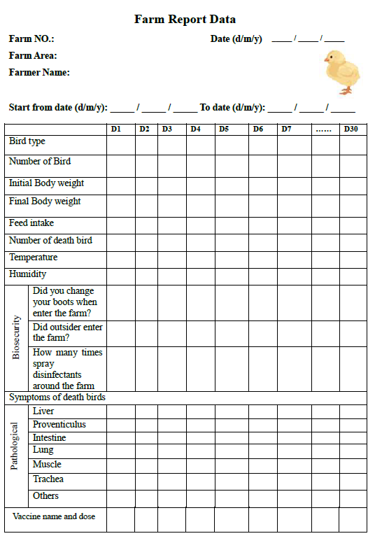
Fig.S1 Questinare form for collecting farm data.

