[Supplementary materials]

Dynamics of functional genes and bacterial community during bioremediation of diesel-contaminated soil amended with compost

Hyoju Yang, Jiho Lee, Kyung-suk Cho

Department of Environmental Science and Engineering,
Ewha Womans University, Seoul 03760, Republic of Korea

Table S1
The primer sets and qPCR conditions for the analysis of functional genes
Functional gene |  | Coding enzyme | Primer | Sequence (5'-3') | qPCR conditions | Reference
16S rRNA |  | 16S rRNA sequence of E. coli | 340F  805R | TCC TAC GGG AGG CAG CAG  GAC TAC HVG GGT ATC TAA TCC | 95℃ 3 min;  95℃ 15 s, 50 ℃ 30 s, 72 ℃ 30 s; 40 cyc  82 ℃ 30 s | Kim et al., 2012
alkB |  | Rubredoxin dependent alkane monooxygenase | alkB-1F  alkB-1R | AAYACNGCNCAYGARCTNGGNCAYAA  GCRTGRTGRTCNGARTGNCGYTG | 95 ℃ 2 min;  95 ℃ 20 s, 55 ℃ 20 s, 72 ℃ 40 s; 40 cyc  82 ℃ 30 s | Wasmund et al., 2009
CYP153 |  | Cytochrome P450 alkane hydroxylase | CYP153_C4_F  CYP153_C4_R | CGA GAA GCT CAA GTC CAA CC  CAC ATC ACG ACC TTG TCA CC | 95 ℃ 5 min;  95 ℃ 30 s, 58 ℃ 30 s, 72 ℃ 30 s; 40 cyc  82 ℃ 30 s | Alonso-Gutierrez et al., 2011
pmoA |  | Alpha subunit of particulate methane monooxygenase | A189f  mb661r | GGN GAC TGG GAC TTC TGG  CCG GMG CAA CGT CYT TAC C | 95 ℃ 3 min;  95 ℃ 15 s, 63 ℃ 30 s, 72 ℃ 30 s; 40 cyc  82 ℃ 30 s | Kolb et al., 2003
mcrA |  | Alpha subunit of methyl coenzyme-M reductase | mlas  mcrA-rev | GGT GGT GTM GGD TTC ACM CAR TA  CGT TCA TBG CGT AGT TVG GRT AGT | 95 ℃ 3 min;  95 ℃ 30 s, 50 ℃ 40 s, 72 ℃ 40 s; 35 cyc  82 ℃ 30s | Luton et al., 2002
qnorB |  | Subunit B of nitric oxide reductase | qnorB-2F  qnorB-7R | GGN CAY CAR GGN TAY GA  GGN GGR TTD ATC ADG AAN CC | 95 ℃ 5 min;  95 ℃ 30 s, 51 ℃ 30 s, 72 ℃ 60 s; 40 cyc  82 ℃ 30 s | Braker et al., 2003
cnorB | Subunit B of nitric oxide reductase |  | norB1-F  norB6-R | CGN GAR TTY CTS GAR CAR CC  TGC AKS ARR CCC CAB ACB CC | 95 ℃ 5 min;  95 ℃ 30 s, 50 ℃ 30 s, 72 ℃ 60 s; 40 cyc  82 ℃ 30 s | Casciotti et al., 2005
nosZⅠ | Subunit Z of nitrous oxide reductase |  | nosZ 1F  nosZ 1R | WCS YTG TTC MTC GAC AGC CAG  ATG TCG ATC ARC TGV KCR TTY TC | 95 ℃ 5 min;  95 ℃ 30 s, 56 ℃ 30 s, 72 ℃ 60 s; 40 cyc  82 ℃ 30 s | Henry et al., 2006

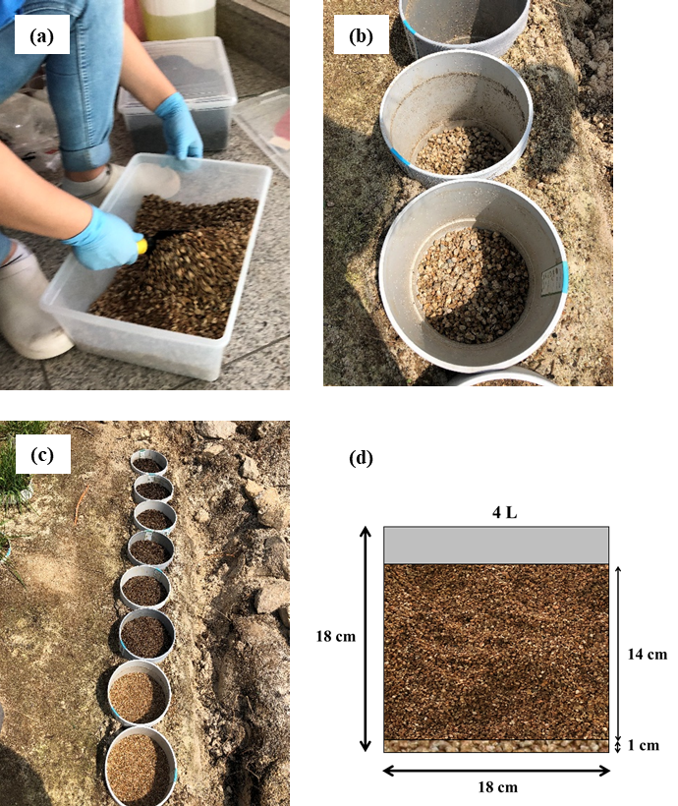

Fig. S1. Soil preparation and pot setting: (a) mixing the soil, compost, and diesel; (b) the layers of coarse sand in the pots; (c) the pots partially buried in the garden soil; (d) a schematic cross section of a pot containing the sand and soil.

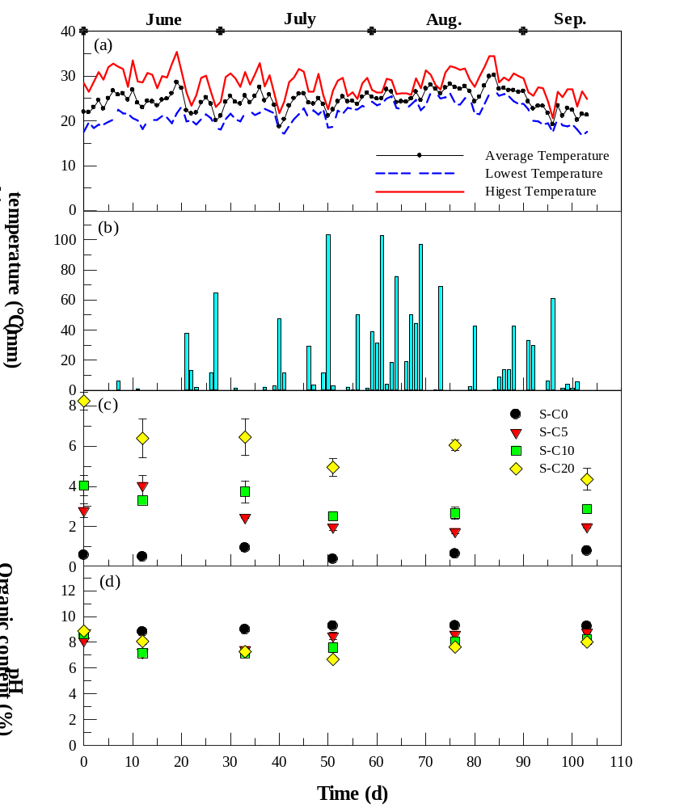

Fig. S2. The changes in (a) ambient temperature, (b) precipitation, (c) soil organic content, and (d) soil pH with time during the bioremediation of the diesel-contaminated soils. S-C0 = soil without compost; S-C5 = soil with 5% compost; S-C10 = soil with 10% compost; S-C20 = soil with 20% compost.

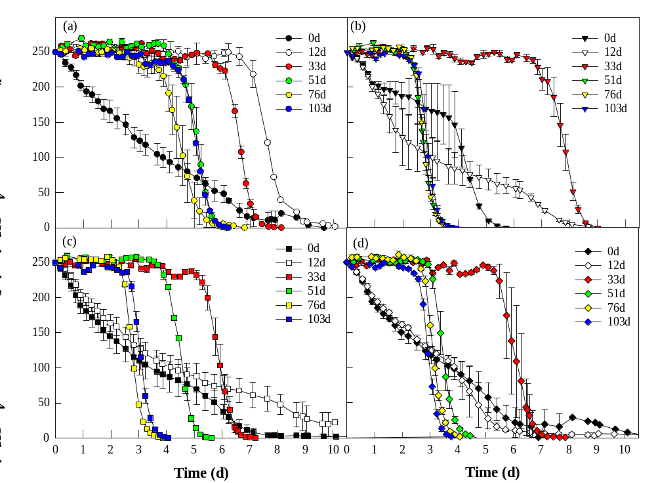

Fig. S3. The changes in CH₄ concentration in the headspace of the serum bottle inoculated with the various soil samples: (a) S-C0 (soil without compost); (b) S-C5 (soil with 5% compost); (c) S-C10 (soil with 10% compost); (d) S-C20 (soil with 20% compost).

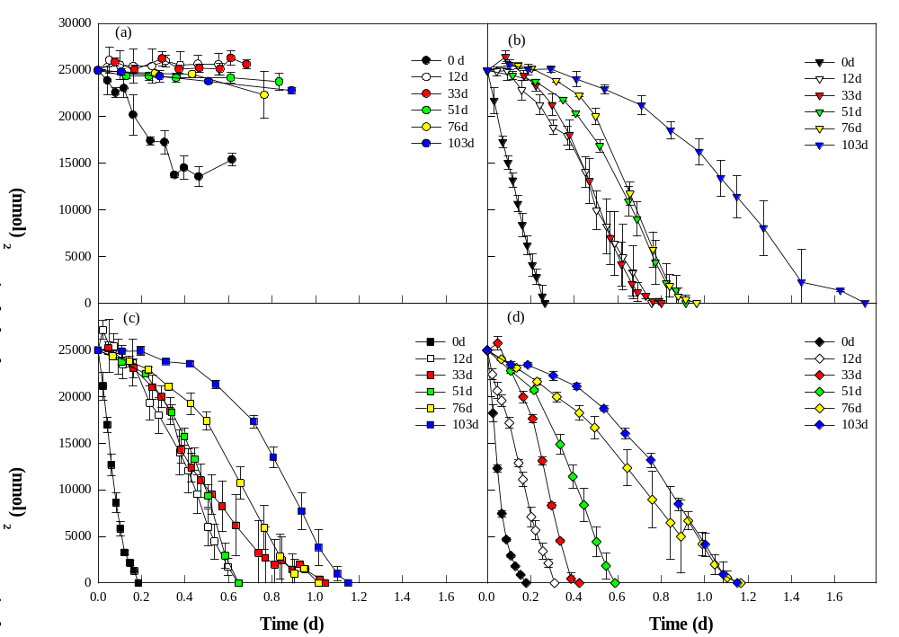

Fig. S4. The changes in the N₂O concentration in the headspace of the serum bottle inoculated with soil samples: (a) S-C0 (soil without compost); (b) S-C5 (soil with 5% compost); (c) S-C10 (soil with 10% compost); (d) S-C20 (soil with 20% compost).

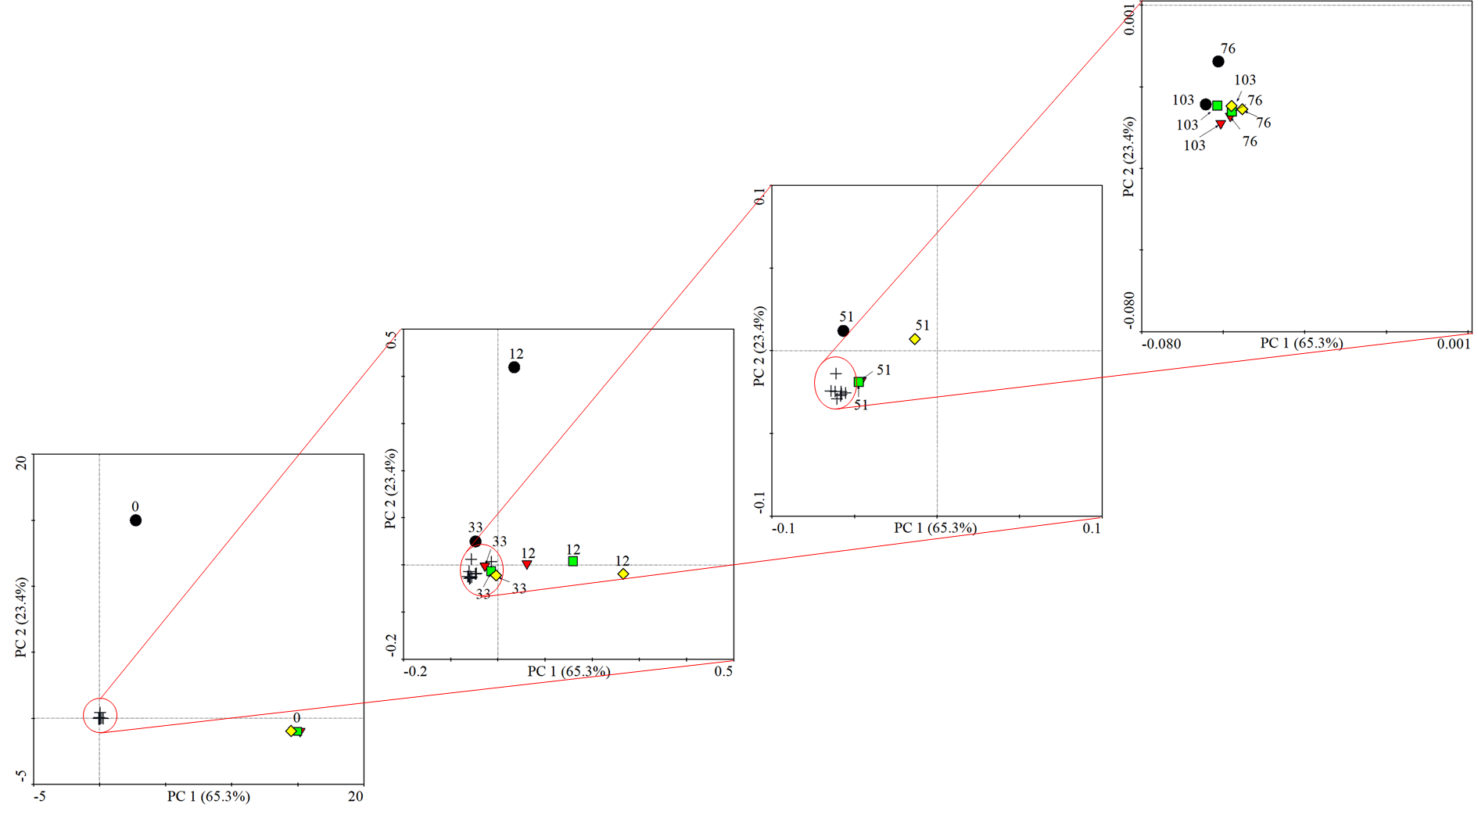
Fig. S5. Principal component analysis (PCA) of the bacterial community structure at the genus level in the diesel-contaminated soil. The community structure was analyzed in duplicate. The circles represent the soil without compost (S-C0), the inverted triangles represent the soil with 5% compost (S-C5), the squares represent the soil with 10% compost (S-C10), and the diamonds represent the soil with 20% compost (S-C20).

Corresponding author: Department of Environmental Science and Engineering, Ewha Womans University, 12, Ewhayeodae-gil, Seodaemun-gu, Seoul 03760, Republic of Korea. E-mail address: kscho@ewha.ac.kr (K.S. Cho)

