Table 1: The physicochemical, elemental and spectral characteristics of synthesized thiazolidine-2,4-dione derivatives.
Compound | Physicochemical and spectral characteristics
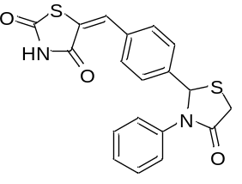  (H1) | (E)-5-(4-(4-oxo-3-phenylthiazolidin-2-yl)benzylidene)thiazolidine-2,4-dione: m.p. ºC: 280-282; Rf value: 0.56*; % yield: 74; IR (KBr pellets) cm⁻¹: 3448.73 (N-H str.), 1770.59 (C=O str.), 1497.42 (C=C str., aromatic ring), 1661.76 (C=C str., methylene group), 2943.38 (C-H str., aliphatic), 1255.61 (C-N str.), 847.82 (C-H oop bend., aromatic), 663.15 (C-S bend.) 1101.06 (C-C str., aromatic ring); ¹H-NMR (δ, DMSO): 7.10-7.88 (m, 9H, Ar-H), 7.94 (s, 1H, -CH=), 3.44, 3.46 (d, 2H, -CH₂ of thiazolidine-4-one), 6.77 (s, 1H, -CH of thiazolidine-4-one) 12.59 (s, 1H, NH); M. Formula: C₁₉H₁₄N₂O₃S₂; MS: m/z 383.04 (M⁺); Elemental analysis (CHN) Theoretical calc: C, 59.67; H, 3.69; N, 7.32 Found: C, 59.7; H, 3.67; N, 7.30
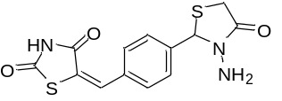  (H2) | (E)-5-(4-(3-amino-4-oxothiazolidin-2-yl)benzylidene)thiazolidine-2,4-dione: m.p. ºC: 208-210; Rf value: 0.61**; % yield: 60; IR (KBr pellets) cm⁻¹: 3472.36 (N-H str.), 1690.31 (C=O str.), 1524.13 (C=C str., aromatic ring), 1637.59 (C=C str., methylene group), 3119.42 (C-H str., aromatic ring), 3003.75 (C-H str., aliphatic), 1336.47 (C-N str.), 801.42 (C-H oop bend., aromatic), 628.31 (C-S bend.) 1149.31 (C-C str., aromatic ring) 3313.97, 3382.58 (N-H str., aliphatic amine); ¹H-NMR (δ, DMSO): 6.98-7.78 (m, 4H, Ar-H), 7.95 (s, 1H, -CH=), 3.45, 3.58 (d, 2H, -CH₂ of thiazolidine-4-one), 5.22 (s, 1H, -CH of thiazolidine-4-one), 3.79 (s, 2H, -NH₂ group), 12.61 (s, 1H, NH); M. Formula: C₁₃H₁₁N₃O₃S₂; MS: m/z 323.21 (M⁺+2); Elemental analysis (CHN) Theoretical calc: C, 48.59; H, 3.45; N, 13.08 Found: C, 48.62; H, 3.44; N, 13.10
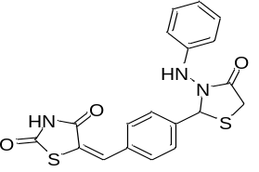  (H3) | (E)-5-(4-(4-oxo-3-(phenylamino)thiazolidin-2-yl)benzylidene)thiazolidine -2,4-dione: m.p. ºC: 282-284; Rf value: 0.51**; % yield: 65; IR (KBr pellets) cm⁻¹: 3477.42 (N-H str.), 3357.17 (N-H str., secondary amine), 1694.69 (C=O str.), 1518.27 (C=C str., aromatic ring), 1649.21 (C=C str., methylene group), 3191.78 (C-H str., aromatic ring), 2950.88 (C-H str., aliphatic), 1274.86 (C-N str.), 801.86 (C-H oop bend., aromatic), 631.19 (C-S bend.), 1166.66 (C-C str., aromatic ring); ¹H-NMR (δ, DMSO): 6.68-7.506 (m, 9H, Ar-H), 7.61 (s, 1H, -CH=), 3.32, 3.34 (d, 2H, -CH₂ of thiazolidine-4-one), 5.71 (s, 1H, -CH of thiazolidine-4-one), 9.61 (s, 1H, NH adjacent to phenyl ring), 12.51 (s, 1H, NH of thiazolidine ring); M. Formula: C₁₉H₁₅N₃O₃S₂; MS: m/z 398.27 (M⁺+1); Elemental analysis (CHN) Theoretical calc: C, 57.42; H, 3.80; N, 10.57 Found: C, 57.40; H, 3.79; N, 10.55

Table 1 Contd..
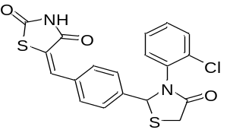  (H4) | (E)-5-(4-(3-(2-chlorophenyl)-4-oxothiazolidin-2-yl)benzylidene) thiazolidine-2,4-dione: m.p. ºC: 222-224; Rf value: 0.63*; % yield: 62; IR (KBr pellets) cm⁻¹: 3335.73 (N-H str.), 1743.82 (C=O str.), 1520.84 (C=C str., aromatic ring), 1693.17 (C=C str., methylene group), 3186.47 (C-H str., aromatic ring), 2981.68 (C-H str., aliphatic), 1293.41 (C-N str.), 836.53 (C-H oop bend., aromatic), 623.85 (C-S bend.), 761.83 (C-Cl bend., o-substitution on phenyl ring) 1069.19 (C-C str., aromatic ring); M. Formula: C₁₉H₁₃ClN₂O₃S₂; MS: m/z 415.47 (M⁺-1); Elemental analysis (CHN) Theoretical calc: C, 54.74; H, 3.14; N, 6.72 Found: C, 54.76; H, 3.15; N, 6.70
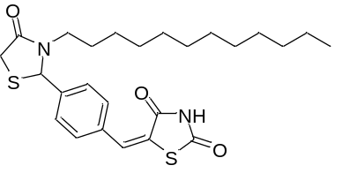  (H5) | (E)-5-(4-(3-dodecyl-4-oxothiazolidin-2-yl)benzylidene)thiazolidine-2,4-dione: m.p. ºC: 160-162; Rf value: 0.57**; % yield: 70; IR (KBr pellets) cm⁻¹: 3393.96 (N-H str.), 1692.08 (C=O str.), 1515.19 (C=C str., aromatic ring), 1612.17 (C=C str., methylene group), 3160.90 (C-H str., aromatic ring), 3020.88 (C-H str., aliphatic), 1296.92 (C-N str.), 841.16 (C-H oop bend., aromatic), 661.02 (C-S bend.), 1067.74 (C-C str., aromatic ring) 2915.30 (C-H str., side chain); ¹H NMR (δ, DMSO): 7.04-7.65 (m, 4H, Ar-H), 7.95 (s, 1H, -CH=), 3.87, 3.99 (d, 2H, -CH₂ of thiazolidine-4-one), 4.90 (s, 1H, -CH of thiazolidine-4-one), 12.53 (s, 1H, NH), 1.23-2.88 (m, 20H, CH₂), 0.90 (t, J = 85 Hz, 3H, CH₃), 3.71 (m, 2H, CH₂ adjacent to CH=N); M. Formula: C₂₅H₃₄N₂O₃S₂; MS: m/z 476.1 (M⁺-1); Elemental analysis (CHN) Theoretical calc: C, 63.26; H, 7.22; N, 5.90 Found: C, 63.25; H, 7.24; N, 5.91
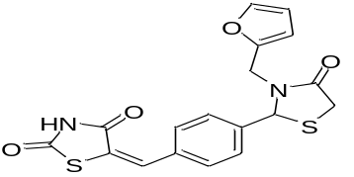  (H6) | (E)-5-(4-(3-(furan-2-ylmethyl)-4-oxothiazolidin-2-yl)benzylidene) thiazolidine-2,4-dione: m.p. ºC: 127-129; Rf value: 0.56*; % yield: 60; IR (KBr pellets) cm⁻¹: 3437.28 (N-H str.), 1760.34 (C=O str.), 1549.27 (C=C str., aromatic ring), 1660.96 (C=C str., methylene group), 3199.60 (C-H str., aromatic ring), 2901.27 (C-H str., aliphatic), 1339.28 (C-N str.), 844.33 (C-H oop bend., aromatic), 660.47 (C-S bend.), 1096.59 (C-C str.), 1018.24 (C-O-C str., furan ring); ¹H NMR (δ, DMSO): 7.12-7.95 (m, 4H, Ar-H), 7.97 (s, 1H, -CH=), 3.76, 3.97 (d, 2H, -CH₂ of thiazolidine-4-one), 6.59 (s, 1H, -CH of thiazolidine-4-one), 12.58 (s, 1H, NH), 4.79 (s, 2H, -CH₂ adjacent to furan ring), 7.21 (d, 1H, CH of furan ring at 3rd position), 7.12 (t, 1H, CH of furan ring at 4th position), 8.17 (d, 1H, CH of furan ring adjacent to O); M. Formula: C₁₇H₁₂N₂O₄S₂; Elemental analysis (CHN) Theoretical calc: C, 54.83; H, 3.25; N, 7.52 Found: C, 54.85; H, 3.22; N, 7.53

Table 1 Contd..
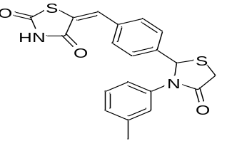  (H7) | (E)-5-(4-(4-oxo-3-(m-tolyl)thiazolidin-2-yl)benzylidene)thiazolidine-2,4-dione: m.p. ºC: 141-143; Rf value: 0.61**; % yield: 61; IR (KBr pellets) cm⁻¹: 3423.62 (N-H str.), 1694.32 (C=O str.), 1514.80 (C=C str., aromatic ring), 1645.13 (C=C str., methylene group), 3117.59 (C-H str., aromatic ring), 2966.25 (C-H str., aliphatic), 1335.01 (C-N str.), 824.35 (C-H oop bend., aromatic), 680.72 (C-S bend.), 1108.60 (C-C str.) 2873.73 (C-H str., side chain); M. Formula: C₂₀H₁₆N₂O₃S₂; Elemental analysis (CHN) Theoretical calc: C, 60.59; H, 4.07; N, 7.07 Found: C, 60.60; H, 4.06; N, 7.07
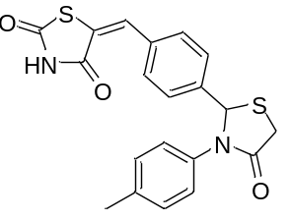  (H8) | (E)-5-(4-(4-oxo-3-(p-tolyl)thiazolidin-2-yl)benzylidene)thiazolidine-2,4-dione: m.p. ºC: 191-193; Rf value: 0.54*; % yield: 61; IR (KBr pellets) cm⁻¹: 3471.71 (N-H str.), 1689.58 (C=O str.), 1538.27 (C=C str., aromatic ring), 1646.90 (C=C str., methylene group), 3163.62 (C-H str., aromatic ring), 3022.64 (C-H str., aliphatic), 1328.53 (C-N str.), 809.91 (C-H oop bend., aromatic), 679.58 (C-S bend.), 1140.25 (C-C str. aromatic ring) 2946.07 (C-H str., side chain); ¹H NMR (δ, DMSO): 7.03-7.75 (m, 8H, Ar-H), 7.94 (s, 1H, -CH=), 3.76, 3.97 (d, 2H, -CH₂ of thiazolidine-4-one), 6.46 (s, 1H, -CH of thiazolidine-4-one), 12.55 (s, 1H, NH), 2.73(s, 3H, CH_{3,} p-position); M. Formula: C₂₀H₁₆N₂O₃S₂; Elemental analysis (CHN) Theoretical calc: C, 60.59; H, 4.07; N, 7.07 Found: C, 60.62; H, 4.09; N, 7.05
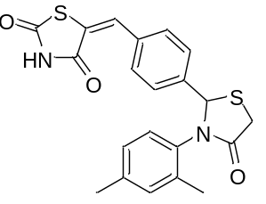  (H9) | (E)-5-(4-(3-(2,4-dimethylphenyl)-4-oxothiazolidin-2-yl)benzylidene) thiazolidine-2,4-dione: m.p. ºC: 231-233; Rf value: 0.59**; % yield: 60; IR (KBr cm⁻¹): 3498.49 (N-H str.), 1743.71 (C=O str.), 1542.27 (C=C str., aromatic ring), 1696.07 (C=C str., methylene group), 3178.82 (C-H str., aromatic ring), 3029.83 (C-H str., aliphatic), 1268.36 (C-N str.), 838.86 (C-H oop bend., aromatic), 661.91 (C-S bend., thiazolidine ring), 1038.69 (C-C str.) 2978.93 (C-H str., side chain); ¹H NMR (δ, DMSO): 7.20-7.42 (m, 7H, Ar-H), 7.49 (s, 1H, -CH=), 3.68, 3.75 (d, 2H, -CH₂ of thiazolidine-4-one), 6.48 (s, 1H, -CH of thiazolidine-4-one), 12.61 (s, 1H, NH), 2.23(s, 3H, CH_{3,} p-position), 2.16 (s, 3H, CH₃ o-position); M. Formula: C₂₁H₁₉N₂O₃S₂; Elemental analysis (CHN) Theoretical calc: C, 61.44; H, 4.22; N, 6.82 Found: C, 61.45; H, 4.23; N, 6.81

Table 1 Contd..
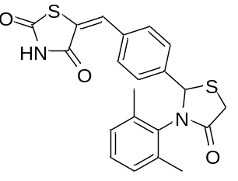  (H10) | (E)-5-(4-(3-(2,6-dimethylphenyl)-4-oxothiazolidin-2-yl)benzylidene) thiazolidine-2,4-dione: m.p. ºC: 145-147; Rf value: 0.63**; % yield: 56; IR (KBr cm⁻¹): 3475.21 (N-H str.), 1687.76 (C=O str.), 1508.71 (C=C str., aromatic ring), 1546.87 (C=C str., methylene group), 2997.90 (C-H str., aromatic ring), 2948.20 (C-H str., aliphatic), 1232.86 (C-N str., thiazolidine ring), 629.87 (C-S bend.), 1094.67 (C-C str.) 2821.33 (C-H str., side chain); ¹H NMR (δ, DMSO): 7.15-7.30 (m, 7H, Ar-H), 7.95 (s, 1H, -CH=), 3.93, 4.05 (d, 2H, -CH₂ of thiazolidine-4-one), 6.52 (s, 1H, -CH of thiazolidine-4-one), 12.49 (s, 1H, NH), 2.12 (s, 6H, CH₃ o-position); M. Formula: C₂₁H₁₉N₂O₃S₂; Elemental analysis (CHN) Theoretical calc: C, 61.44; H, 4.22; N, 6.82 Found: C, 61.42; H, 4.21; N, 6.83
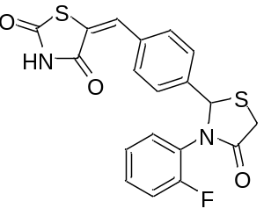  (H11) | (E)-5-(4-(3-(2-fluorophenyl)-4-oxothiazolidin-2-yl)benzylidene) thiazolidine-2,4-dione: m.p. ºC: 121-123; Rf value: 0.53*; % yield: 69; IR (KBr cm⁻¹): 3397.62 (N-H str.), 1690.56 (C=O str.), 1556.85 (C=C str., aromatic ring), 1621.56 (C=C str., methylene group), 3022.29 (C-H str., aromatic ring), 2942.43 (C-H str., aliphatic), 1308.11 (C-N str.), 831.66 (C-H oop bend., aromatic), 666.00 (C-S bend.), 1196.21 (C-C str.), 1016.77 (C-F bend., o-substitution on phenyl ring); ¹H NMR (δ, DMSO): 7.19-7.21 (m, 8H, Ar-H), 7.951 (s, 1H, -CH=), 3.694, 3.961 (d, 2H, -CH₂ of thiazolidine-4-one), 6.39 (s, 1H, -CH of thiazolidine-4-one), 12.57 (s, 1H, NH); M. Formula: C₁₉H₁₃FN₂O₃S₂; MS: m/z 401.03 (M⁺+1); Elemental analysis (CHN) Theoretical calc: C, 56.99; H, 3.27; N, 7.00 Found: C, 57.00; H, 3.25; N, 7.01
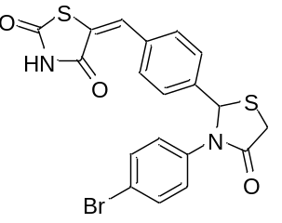  (H12) | (E)-5-(4-(3-(4-bromophenyl)-4-oxothiazolidin-2-yl)benzylidene) thiazolidine-2,4-dione: m.p. ºC: 119-121; Rf value: 0.59**; % yield: 73; IR (KBr cm⁻¹): 3381.80 (N-H str.), 1746.01 (C=O str.), 1512.02 (C=C str., aromatic ring), 1672.91 (C=C str., methylene group), 3110.07 (C-H str., aromatic ring), 2966.14 (C-H str., aliphatic), 1243.62 (C-N str.), 1156.04 (C-C str.), 826.49 (C-H oop bend., aromatic), 680.92 (C-Br bend., p-substitution on phenyl ring); ¹H NMR (δ, DMSO): 7.21-7.49 (m, 8H, Ar-H), 7.952 (s, 1H, -CH=), 3.691, 3.981 (d, 2H, -CH₂ of thiazolidine-4-one), 6.51 (s, 1H, -CH of thiazolidine-4-one), 12.63 (s, 1H, NH); M. Formula: C₁₉H₁₃BrN₂O₃S₂; MS: m/z 459.91 (M⁺-1); Elemental analysis (CHN) Theoretical calc: C, 49.41; H, 3.27; N, 7.00 Found: C, 49.48; H, 3.25; N, 7.01

Table 1 Contd..
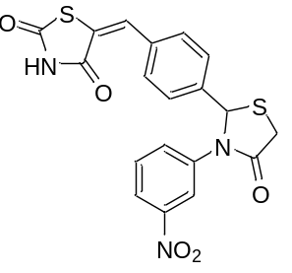  (H13) | (E)-5-(4-(3-(3-nitrophenyl)-4-oxothiazolidin-2-yl)benzylidene) thiazolidine-2,4-dione: m.p. ºC: 159-161; Rf value: 0.58*; % yield: 74; IR (KBr cm⁻¹): 3380.87 (N-H str.), 1717.77 (C=O str.), 1541.24 (C=C str., aromatic ring), 1663.52 (C=C str., methylene group), 3007.25 (C-H str., aromatic ring), 2885.82 (C-H str., aliphatic), 1250.32 (C-N str.), 618.67 (C-S bend.), 1079.45 (C-C str.), 1220.79 (N-O str., m-substitution on phenyl ring), 1436.75 ( N=O str., m-substitution on phenyl ring); ¹H NMR (δ, DMSO): 7.211-7.523 (m, 8H, Ar-H), 7.950 (s, 1H, -CH=), 4.098, 4.132 (d, 2H, -CH₂ of thiazolidine-4-one), 6.49 (s, 1H, -CH of thiazolidine-4-one), 12.61 (s, 1H, NH); M. Formula: C₁₉H₁₃N₃O₅S₂; Elemental analysis (CHN) Theoretical calc: C, 53.39; H, 3.07; N, 9.83 Found: C, 53.41; H, 3.05; N, 9.85
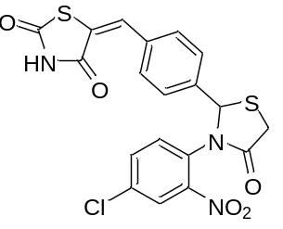  (H14) | (E)-5-(4-(3-(4-chloro-2-nitrophenyl)-4-oxothiazolidin-2-yl)benzyli- dene)thiazolidine-2,4-dione: m.p. ºC: 117-119; Rf value: 0.51*; % yield: 67; IR (KBr cm⁻¹): 1509.11 (C=C str., aromatic ring), 2972.95 (C-H str., aromatic ring), 2885.16 (C-H str., aliphatic), 1249.06 (C-N str.), 622.84 (C-S bend., thiazolidine ring), 1074.34 (C-C str.), 1176.56 ( N-O str., o-substitution on phenyl ring), 1437.32 ( N=O str., o-substitution on phenyl ring), 640.18 (C-Cl bend., p-substitution on phenyl ring); ¹H NMR (δ, DMSO): 7.092-7.269 (m, 7H, Ar-H), 7.953 (s, 1H, -CH=), 3.76, 3.88 (d, 2H, -CH₂ of thiazolidine-4-one), 6.53 (s, 1H, -CH of thiazolidine-4-one), 12.46 (s, 1H, NH), M. Formula: C₁₉H₁₂ClN₃O₅S₂; MS: m/z 462.1 (M⁺); Elemental analysis (CHN) Theoretical calc: C, 49.41; H, 2.62; N, 9.10 Found: C, 49.43; H, 2.61; N, 9.11
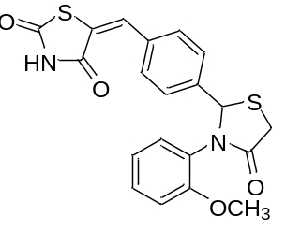  (H15) | (E)-5-(4-(3-(2-methoxyphenyl)-4-oxothiazolidin-2-yl)benzylidene)thia- zolidine-2,4-dione: m.p. ºC: 131-133; Rf value: 0.67**; % yield: 65; IR (KBr cm⁻¹): 3449.87 (N-H str.), 1748.92 (C=O str.), 1536.40 (C=C str., aromatic ring), 1659.37 (C=C str., methylene group), 3138.14 (C-H str., aromatic ring), 3011.17 (C-H str., aliphatic), 1323.04 (C-N str.), 835.87 (C-H oop bend., aromatic), 659.25 (C-S bend.), 1101.58 (C-C str.), 1033.96 (O-CH₃ str., o-substitution on phenyl ring); ¹H NMR (δ, DMSO): 7.063-7.595 (m, 8H, Ar-H), 7.949 (s, 1H, -CH=), 3.99, 4.02 (d, 2H, -CH₂ of thiazolidine-4-one), 5.88 (s, 1H, -CH of thiazolidine-4-one), 12.53 (s, 1H, NH), 3.795 (s, 3H, OCH₃, o-position); M. Formula: C₂₀H₁₆N₂O₄S₂; MS: m/z 413.24 (M⁺+1); Elemental analysis (CHN) Theoretical calc: C, 58.24; H, 3.91; N, 6.79 Found: C, 58.25; H, 3.90; N, 6.80
Table 1 Contd..
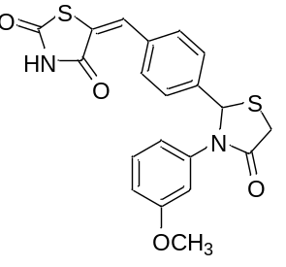  (H16) | (E)-5-(4-(3-(3-methoxyphenyl)-4-oxothiazolidin-2-yl)benzylidene) thiazolidine-2,4-dione: m.p. ºC: 196-198; Rf value: 0.61**; % yield: 65; IR (KBr cm⁻¹): 3438.44 (N-H str.), 1741.31 (C=O str.), 1543.46 (C=C str., aromatic ring), 1664.46 (C=C str., methylene group), 2899.96 (C-H str., aliphatic), 3089.91 (C-H str., aromatic ring), 1381.07 (C-N str.), 822.62 (C-H oop bend., aromatic), 649.37 (C-S bend.), 1115.13 (C-C str.), 1025.29 (O-CH₃ str., m-substitution on phenyl ring); ¹H NMR (δ, DMSO): 7.208-7.393 (m, 8H, Ar-H), 7.95 (s, 1H, -CH=), 3.61, 3.92 (d, 2H, -CH₂ of thiazolidine-4-one), 6.16 (s, 1H, -CH of thiazolidine-4-one), 12.50 (s, 1H, NH), 2.89 (s, 3H, OCH₃, m-position); M. Formula: C₂₀H₁₆N₂O₄S₂; MS: m/z 413.63 (M⁺+1); Elemental analysis (CHN) Theoretical calc: C, 58.24; H, 3.91; N, 6.79 Found: C, 58.23; H, 3.88; N, 6.78
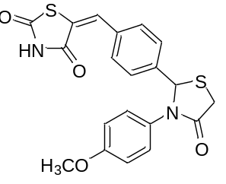  (H17) | (E)-5-(4-(3-(4-methoxyphenyl)-4-oxothiazolidin-2-yl)benzylidene) thiazolidine-2,4-dione: m.p. ºC: 130-132; Rf value: 0.64**; % yield: 70; IR (KBr cm⁻¹): 3361.69 (N-H str.), 1693.75 (C=O str.), 1509.86 (C=C str., aromatic ring), 1606.81 (C=C str., methylene group), 2922.73 (C-H str., aliphatic), 1395.80 (C-N str.), 651.12 (C-S bend., thiazolidine ring), 1027.91 (O-CH₃ str., o-substitution on phenyl ring); ¹H NMR (δ, DMSO): 7.206-7.445 (m, 8H, Ar-H), 7.827 (s, 1H, -CH=), 3.86, 3.91 (d, 2H, -CH₂ of thiazolidine-4-one), 6.951 (s, 1H, -CH of thiazolidine-4-one), 12.45 (s, 1H, NH), 3.33 (s, 3H, OCH_{3,} p-position); M. Formula: C₂₀H₁₆N₂O₄S₂; MS: m/z 414.93 (M⁺+2); Elemental analysis (CHN) Theoretical calc: C, 58.24; H, 3.91; N, 6.79 Found: C, 58.21; H, 3.89; N, 6.77
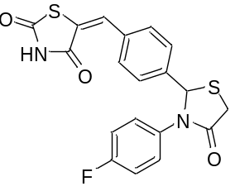  (H18) | (E)-5-(4-(3-(4-fluorophenyl)-4-oxothiazolidin-2-yl)benzylidene) thiazolidine-2,4-dione: m.p. ºC: 150-152; Rf value: 0.57*; % yield: 60; IR (KBr cm⁻¹): 3414.71 (N-H str.), 1800.02 (C=O str.), 1501.61 (C=C str., aromatic ring), 1660.40 (C=C str., methylene group), 3064.39 (C-H str., aromatic ring), 2924.57 (C-H str., aliphatic), 1288.86 (C-N str., thiazolidine ring), 824.35 (C-H oop bend., aromatic), 660.68 (C-S bend., thiazolidine ring), 1095.34 (C-C str.), 1019.92 (C-F str., p-substitution on phenyl ring); ¹H NMR (δ, DMSO): 7.12-7.69 (m, 8H, Ar-H), 7.951 (s, 1H, -CH=), 3.90, 3.98 (d, 2H, -CH₂ of thiazolidine-4-one), 6.82 (s, 1H, -CH of thiazolidine-4-one), 12.51 (s, 1H, NH);M. Formula: C₁₉H₁₃FN₂O₃S₂; MS: m/z 401.5 (M⁺+1); Elemental analysis (CHN) Theoretical calc: C, 56.99; H, 3.27; N, 7.00 Found: C, 56.97; H, 3.26; N, 7.03

Table 1 Contd..
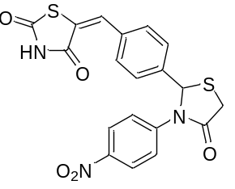  (H19) | (E)-5-(4-(3-(4-nitrophenyl)-4-oxothiazolidin-2-yl)benzylidene) thiazolidine-2,4-dione: m.p. ºC: 144-146; Rf value: 0.60*; % yield: 70; IR (KBr cm⁻¹): 3391.53 (N-H str.), 1788.47 (C=O str.), 1502.43 (C=C str., aromatic ring), 1660.13 (C=C str., methylene group), 3115.33 (C-H str., aromatic ring), 2977.35 (C-H str., aliphatic), 1300.51 (C-N str.), 823.74 (C-H oop bend., aromatic), 663.28 (C-S bend.), 1097.38 (C-C str.), 1200.58 (N-O str., p-substitution on phenyl ring), 1388.68 (N=O str., p-substitution on phenyl ring); ¹H NMR (δ, DMSO): 7.29-7.70 (m, 8H, Ar-H), 7.951 (s, 1H, -CH=), 3.90, 4.01 (d, 2H, -CH₂ of thiazolidine-4-one), 6.52 (s, 1H, -CH of thiazolidine-4-one), 12.59 (s, 1H, NH); M. Formula: C₁₉H₁₃N₃O₅S₂; Elemental analysis (CHN) Theoretical calc: C, 53.39; H, 3.03; N, 9.83 Found: C, 53.35; H, 3.05; N, 9.87
TLC mobile phase= *n-Hexane : Ethyl Acetate :: 1 : 1, ** n-Hexane : Ethyl Acetate :: 3 : 7

