Supplemental Tables and Figures

List of 21 plant families that contain poricidal plant species that have joined anther architectures:
Anthericaceae, Boraginaceae, Commelinaceaea, Dilleniaceaea, Elaeocarpaceae, Ehretiaceae, Ericaceae, Gentianaceae, Gesneriaceae, Iridaceae, Liliaceae, Luzuriageaceae, Malvaceae, Mayacaceae, Myrsinaceae, Pittosporaceae, Pontederiaceae, Primulaceae, Rapateaceae, Solanaceae, Tecophilaceae. See Vogel 1978; Faegri 1986; Glover et al. 2004; De Luca & Vallejo-Marín 2013 and references within; Russell et al. 2016 and references and photos within; Huang et al. 2022.

Figures exported via sjPlot

Anther architecture alone affected pollen remaining within the anthers after bee visitation

Results associated with Figure 3a,b
Table S1
Fixed effects:
 | Estimate | Std. Error | z value | Chisq | Pr(>Chisq)
(Intercept) | 1.448469 | 4.705222 | 0.308
TreatmentSham | -6.44577 | 6.475703 | -0.995 | 12.1345 | 0.000495
HeadWidth | -0.91174 | 1.339374 | -0.681 | 0.5479 | 0.459176
VisitTime | 0.032002 | 0.027591 | 1.16 | 0.0208 | 0.88536
TreatmentSham:HeadWidth | 1.910039 | 1.850989 | 1.032 | 0.3261 | 0.567952
TreatmentSham:VisitTime | -0.03011 | 0.036871 | -0.817 | 1.9809 | 0.1593
HeadWidth:VisitTime | -0.00925 | 0.00776 | -1.192 | 1.7787 | 0.182311
TreatmentSham:HeadWidth:  VisitTime | 0.008294 | 0.010293 | 0.806 | 0.0001 | 0.991617

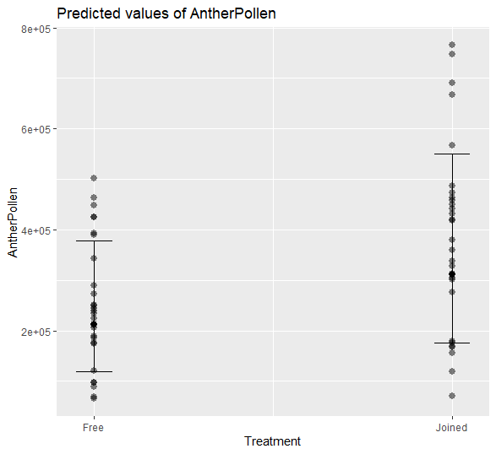
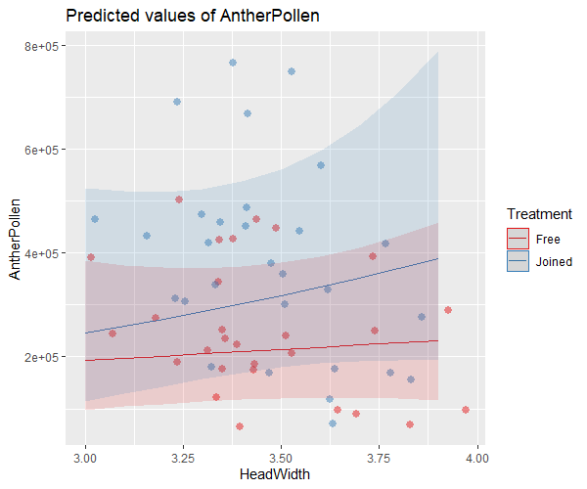
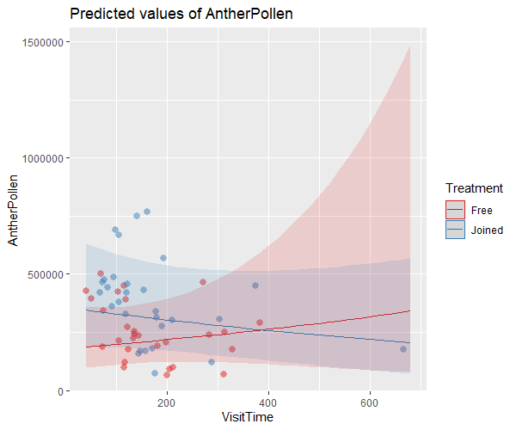

Anther architecture and body size affected pollen collection and pollen available for pollination

Results associated with Figure 4a,b
Table S2
Fixed effects:
 | Estimate | Std. Error | z value | Chisq | Pr(>Chisq)
(Intercept) | 9.296883 | 4.346485 | 2.139
TreatmentSham | -1.70051 | 5.982041 | -0.284 | 4.1112 | 0.0426
VisitTime | -0.0276 | 0.025487 | -1.083 | 0.1021 | 0.749347
HeadWidth | 0.766509 | 1.237256 | 0.62 | 7.4348 | 0.006397
TreatmentSham:VisitTime | 0.052661 | 0.03406 | 1.546 | 0.4784 | 0.48913
TreatmentSham:HeadWidth | 0.480107 | 1.709885 | 0.281 | 4.7249 | 0.029729
VisitTime:HeadWidth | 0.007578 | 0.007169 | 1.057 | 0.0153 | 0.901529
TreatmentSham:VisitTime:  HeadWidth | -0.01436 | 0.009508 | -1.51 | 2.2801 | 0.13104

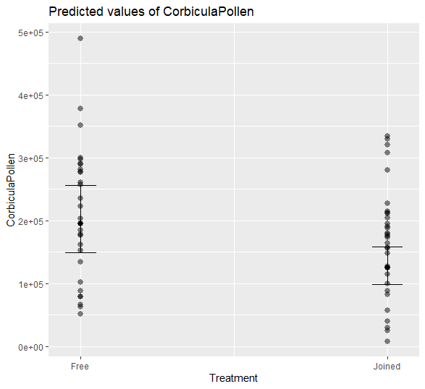
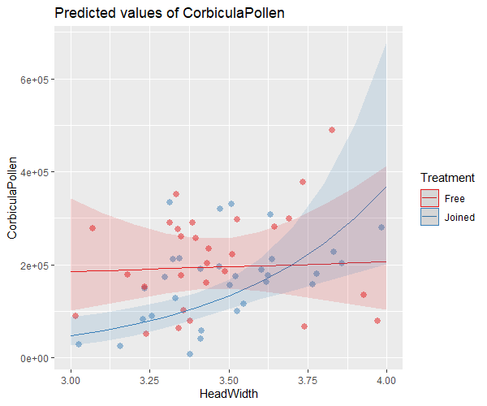
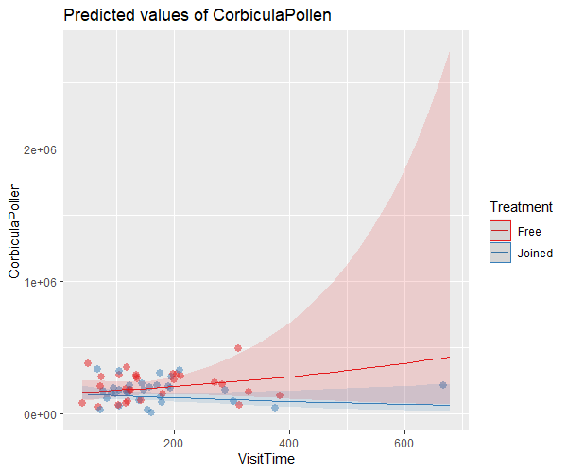

Results associated with Figure 4c,d
Table S3
Fixed effects:
 | Estimate | Std. Error | z value | Chisq | Pr(>Chisq)
(Intercept) | 10.74331 | 3.725925 | 2.883
TreatmentSham | -8.14212 | 5.127971 | -1.588 | 5.6139 | 0.01782
HeadWidth | -0.14464 | 1.06061 | -0.136 | 0.4505 | 0.50208
VisitTime | 0.004414 | 0.021849 | 0.202 | 3.3428 | 0.0675
TreatmentSham:HeadWidth | 2.388944 | 1.46576 | 1.63 | 4.1479 | 0.04169
TreatmentSham:VisitTime | 0.022524 | 0.029197 | 0.771 | 0.2806 | 0.59632
HeadWidth:VisitTime | -0.00168 | 0.006145 | -0.273 | 1.6085 | 0.20471
TreatmentSham:HeadWidth:  VisitTime | -0.00606 | 0.008151 | -0.743 | 0.5523 | 0.45738

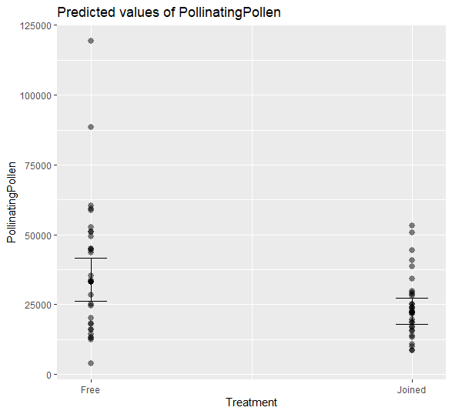
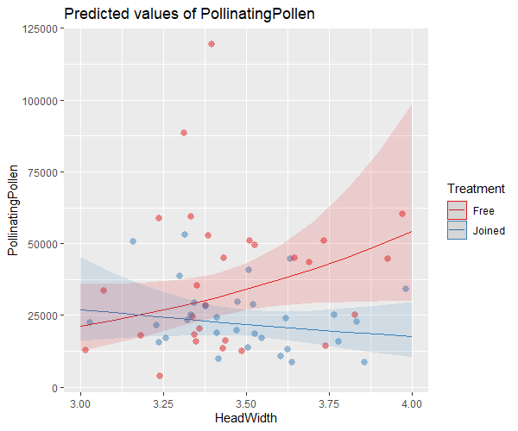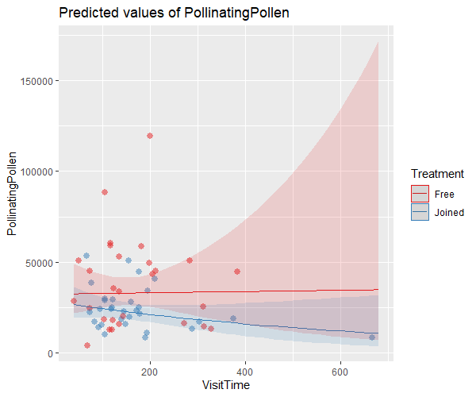

Results associated with Figure 5a,b
Table S4
Fixed effects:
 | Estimate | Std. Error | z value | Chisq | Pr(>Chisq)
(Intercept) | 1.448469 | 4.705222 | 0.308
TreatmentSham | -6.44577 | 6.475703 | -0.995 | 0 | 0.9972697
HeadWidth | -0.91174 | 1.339374 | -0.681 | 3.9486 | 0.0469102
VisitTime | 0.032002 | 0.027591 | 1.16 | 1.3287 | 0.2490336
TreatmentSham:HeadWidth | 1.910039 | 1.850989 | 1.032 | 13.112 | 0.0002934
TreatmentSham:VisitTime | -0.03011 | 0.036871 | -0.817 | 0.0482 | 0.8261683
HeadWidth:VisitTime | -0.00925 | 0.00776 | -1.192 | 0.7921 | 0.3734596
TreatmentSham:HeadWidth:  VisitTime | 0.008294 | 0.010293 | 0.806 | 0.6493 | 0.4203609

SjPlot would not output figures for this data.

Anther architecture and body size affected pollen receipt by the stigma

Results associated with Figure 6a,b,c
Table S5
Fixed effects:
 | Estimate | Std. Error | z value | Chisq | Pr(>Chisq)
(Intercept) | 14.61797 | 10.25488 | 1.426
TreatmentSham | -9.69781 | 13.25226 | -0.732 | 0.4142 | 0.51986
log(BodyPollen) | -0.84379 | 0.509777 | -1.655 | 0.1458 | 0.70253
VisitTime | 0.034944 | 0.051782 | 0.675 | 1.9305 | 0.1647
HeadWidth | 0.342877 | 2.513017 | 0.136 | 4.8341 | 0.0279
TreatmentSham:log(BodyPollen) | 1.439494 | 0.62536 | 2.302 | 5.2986 | 0.02134
TreatmentSham:VisitTime | -0.00224 | 0.069863 | -0.032 | 0.0072 | 0.93224
TreatmentSham:HeadWidth | -1.29285 | 3.566004 | -0.362 | 0.4723 | 0.49192
VisitTime:HeadWidth | -0.01055 | 0.014572 | -0.724 | 1.0955 | 0.29525
TreatmentSham:VisitTime:  HeadWidth | 0.000721 | 0.019513 | 0.037 | 0.0014 | 0.97052

