Supplementary Files
Multilevel linear growth curve model
Multilevel growth curve modeling is robust in handling missing data by treating them as missing at random, minimizing bias in estimates attributable to attrition in longitudinally structured data[1, 2]. Also, the incorporated multilevel approach in the growth curve model accounted for the complex survey design of the AusDiab. A three-level linear growth curve model was fitted with the repeated measures at level-1 nested in individuals at level-2 who are also nested in CCD clusters at level-3.
First, unconditional growth trajectory was modeled (random intercept and random slope models) with bodily pain score regressed as a function of age (centered at age 50 years, about the mean age at baseline). A likelihood ratio test comparing the two models indicated that the more flexible random slope model with unstructured covariance was preferred over the random intercept model (chi-square test (χ²) = 22.53; p < 0.001).
The equation for the unconditional multilevel linear growth curve model for individual i in cluster j at measurement occasion (age) t is presented as:
Level 1: Repeated Measurement within an individual
$Y_{\left(Bodily pain\right)ijt}= π_{0ij}+ π_{1ij}{Age}_{it}+ ε_{ijt}$ [ $ε_{ijt }\sim N(0,σ_{ε}^{2})$ ]
Level 2: Individual nested within cluster (CCD)
$π_{0ij}= β_{0j}+ μ_{0ij}$ [ $μ_{0ij}\sim N(0,σ_{μ_{0}}^{2})$ ]
$π_{1ij}= β_{1j}+ μ_{1ij}$ [ $μ_{1ij}\sim N(0,σ_{μ_{1}}^{2})$ ]
Level 3: Cluster
$β_{0j}= γ_{0}+ ν_{0j}$ [ $ν_{0j}\sim N(0,σ_{ν_{0}}^{2})$ ]
$β_{1j}= γ_{1}+ ν_{1j}$ [ $ν_{1j}\sim N(0,σ_{ν_{1}}^{2})$ ]
Or in composite
$$Y_{\left(Bodily pain\right)ijt}=\left[γ_{0}+ γ_{1}{Age}_{it}\right]+[ ν_{0j} +μ_{0ij} + ε_{ijt}+\left(ν_{1j}+μ_{1ij}\right){Age}_{it}]$$
Where,
$ε_{ijt }\sim N(0,σ_{ε}^{2})$
$\left(\begin{matrix}μ_{0ij} \\ μ_{1ij}\end{matrix}\right) \sim N\left(0, Ω_{μ}\right), where Ω_{μ}= \left(\begin{matrix}σ_{μ_{0}}^{2} & σ_{μ_{0}μ_{1}} \\ σ_{μ_{0}μ_{1}} & σ_{μ_{1}}^{2}\end{matrix}\right)$ and
$\left(\begin{matrix}ν_{0j} \\ ν_{1j}\end{matrix}\right) \sim N\left(0, Ω_{μ}\right), where Ω_{μ}= \left(\begin{matrix}σ_{ν_{0}}^{2} & σ_{ν_{0}ν_{1}} \\ σ_{ν_{0}ν_{1}} & σ_{ν_{1}}^{2}\end{matrix}\right)$
Where $π_{0ij}$ + $π_{1ij}{Age}_{it}$ is mean bodily pain for individual i in cluster j at age t and $ε_{ijt}$ is the difference between the observed bodily pain for this individual i and the mean. $β_{0j}$is the mean bodily pain at age=0 across all individuals in cluster j, while $μ_{0ij}$ measures how much the mean bodily pain at age=0 for individual i differs from their cluster-level average. Similarly, $β_{1j}$is the mean change in bodily pain per unit age for all individuals in cluster j, while $μ_{1ij}$ measures how much individual i differs from their cluster-level average in terms of this parameter. Finally, $γ_{0}$ is the mean bodily pain at age=0 averaged across all clusters and $ν_{0j}$ measures how cluster j differs from this average and, $γ_{1}$ is the mean change in bodily pain per unit age averaged across all clusters and $ν_{1j}$ measures how cluster j differs from this average in terms of these parameters.

To understand whether the effect of TV time on bodily pain trajectory changed with age, the interaction between TV time and age was added to the fitted model, but the interaction term was non-significant, and a likelihood ratio test comparing this with the previous non-interaction model was non-significant (χ² = 0.14; p = 0.707). Thus, the non-interaction model was preferred over the interaction model. A linear-additive model was therefore fitted, excluding the interaction term.

References
1. Gibbons RD, Hedeker D, DuToit S: Advances in analysis of longitudinal data. Annu Rev Clin Psychol 2010, 6:79-107.
2. Dingemanse NJ, Dochtermann NA: Quantifying individual variation in behaviour: Mixed-effect modelling approaches. J Anim Ecol 2013, 82(1):39-54.

Sensitivity Table 1: Sensitivity analysis for unconditional and conditional linear growth curve models
 | Unconditional model | Conditional models
 | Model 1  (Function of age) | Model 2  Model 1 + TV time | Model 3  Fully adjusted linear-additive model | Model 4  Model 2 + TV time # T2D status | Model 5  Fully adjusted with TV time#T2D status
 | Coefficient (S.E) | Coefficient (S.E) | Coefficient (S.E) | Coefficient (S.E) | Coefficient (S.E)
Fixed effect
Intercept | 75.58 (0.45)*** | 77.49 (0.53)*** | 75.96 (2.26)*** | 77.78 (0.55)*** | 75.74 (2.26)***
Slopes
Age (Centred at 50 years) | - 0.27 (0.03)*** | - 0.24 (0.03)*** | - 0.30 (0.03)*** | - 0.21 (0.03)*** | - 0.30 (0.03)***
TV time |  | - 1.11 (0.18)*** | -0. 66 (0.17)*** | - 0.98 (0.20)*** | - 0.50 (0.20)**
T2D status
Normal GM (Reference) |  |  |  | 0 | 0
Prediabetes |  |  |  | - 0.67 (0.99) | 1.26 (0.99)
T2D |  |  |  | - 4.54 (1.54)** | 0.19 (1.52)
TV time#T2D status
Normal GM (Reference) |  |  |  | 0 | 0
Pre-diabetes |  |  |  | - 0.25 (0.42) | - 0.40 (0.41)
T2D |  |  |  | - 0.52 (0.57) | -0.91 (0.56)
Random effect
Intercept variance
Cluster | 4.71 (1.93)** | 4.01 (1.77)** | 1.07 (0.92) | 3.37 (1.61)** | 1.06 (0.92)
Participants | 191.92 (7.65)*** | 190.17 (7.63)*** | 143.87 (6.73)*** | 187.78 (7.64)*** | 145.05 (6.05)***
Slope variance | 0.012 (0.006)** | 0.013 (0.006)** | 0.006 (0.004) | 0.013 (0.006)** | 0.006 (0.004)
Intercept-Slope covariance | 1.51 (0.35)** | 1.55 (0.35)** | 0.93 (0.31) | 1.54 (0.35)* | 0.93 (0.31)
Within-individual variance | 264.90 (4.72)*** | 264.50 (4.75)*** | 261.63 (4.87)*** | 264.34 (4.74)*** | 261.44 (4.87)***
Goodness-of-fit
AIC | 89576.09 | 88768.87 | 84666.83 | 88685.66 | 84667.67
BIC | 89590.54 | 88790. 51 | 84824.70 | 88736.16 | 84839.90
Log-likelihood | - 44786.05 | - 443841.44 | - 42311.41 | - 44335.83 | - 42309.84
No of parameters | 7 | 8 | 22 | 11 | 24
Statistically significant: *** p < 0.001; ** p < 0.01 | TV = Television-viewing | S.E = Standard error | T2D = type 2 diabetes (included newly diagnosed and known T2D).
The analysis excluded 6.6% of participants that reported a history of cancer at baseline (this data was only available at baseline)
The fully adjusted linear additive model included model 2 + sex, education level, household income, smoking status, leisure-time physical activity, waist circumference, energy intake, T2D status, SF36 mental component score, presence of chronic kidney disease, and history of cardiovascular disease.
The fully adjusted model with TV time#T2D status included model 4 + sex, education level, household income, smoking status, leisure-time physical activity, waist circumference, energy intake, SF36 mental component score, presence of chronic kidney disease, and history of cardiovascular disease.

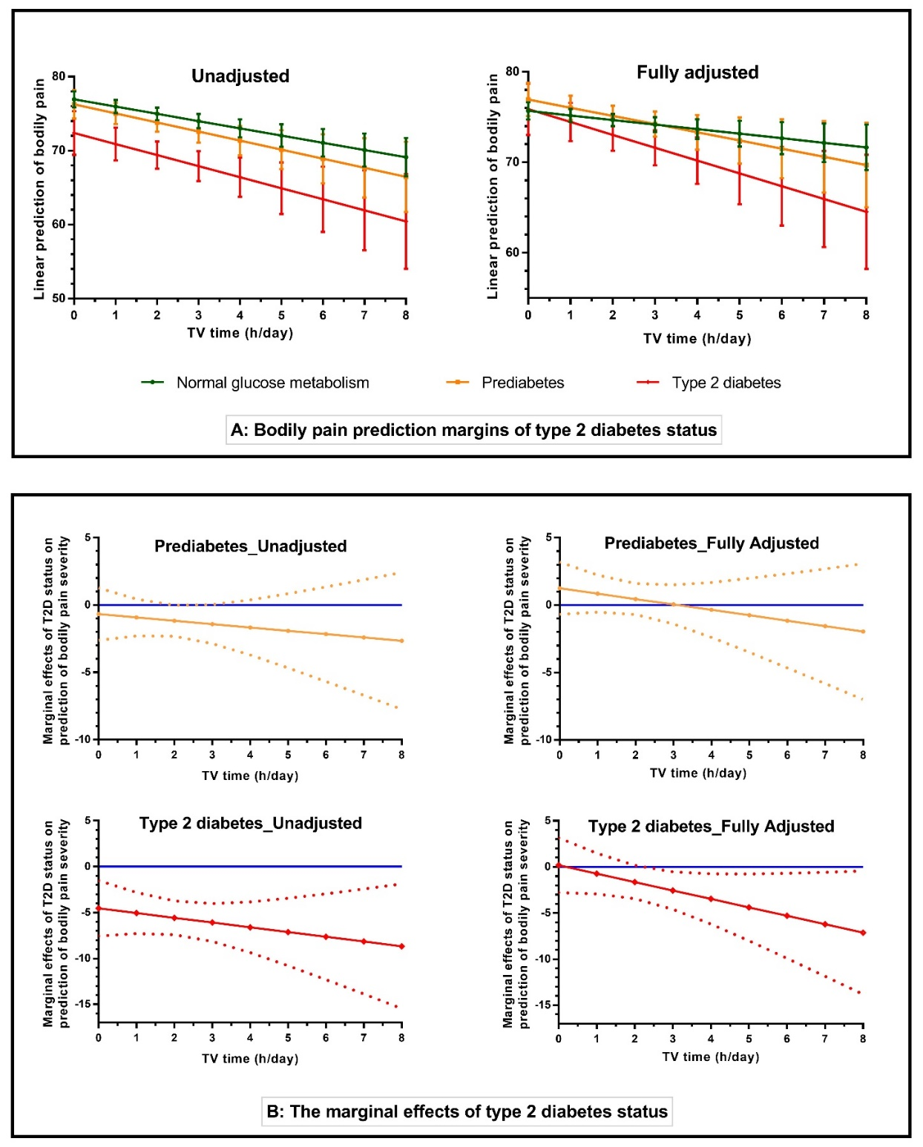

Sensitivity Figure 1: Shows the sensitivity analysis after excluding those with a history of cancer to check the robustness of the effects of multiplicative interaction of TV time with type 2 diabetes status on bodily pain trajectory. (A) The bodily pain prediction margins of type 2 diabetes status with 95% confidence intervals for the unadjusted and fully adjusted models. (B) The marginal effects of prediabetes and type 2 diabetes (in reference to normal glucose metabolism) on bodily pain trajectory with increasing TV time in the unadjusted and fully adjusted models. The solid lines indicate the marginal effects of changes in bodily pain severity with changing TV time. The dotted lines are the confidence intervals around the lines, which determine the threshold of TV time that has a statistically significant effect on bodily pain severity in those with prediabetes (ORANGE) and type 2 diabetes (RED). They are statistically significant whenever the lower and upper limits of the confidence intervals are both below or above the zero (0 - BLUE) lines. Note: Normal glucose metabolism was set as the reference point in the regression model.

