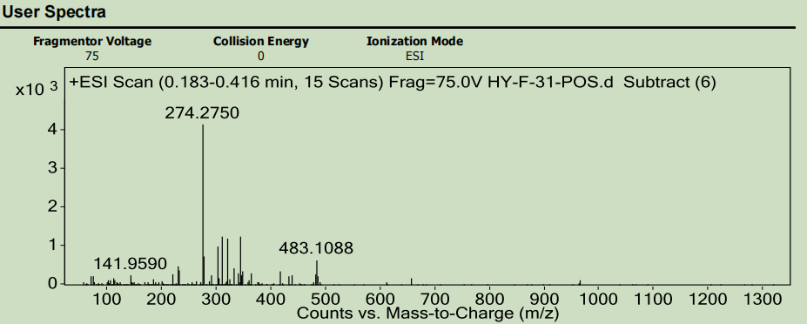
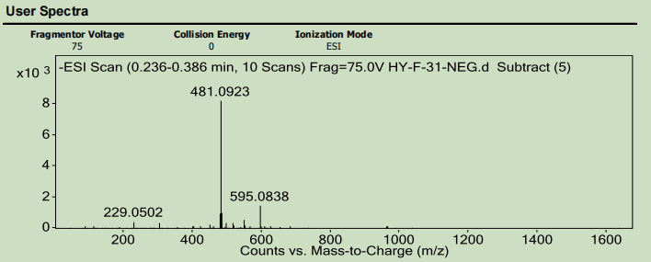

Figure S1 HR-ESI-MS spectrum of compound 1

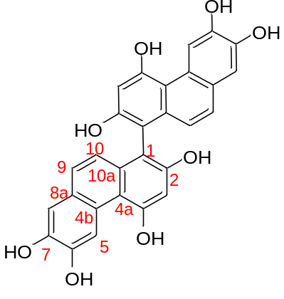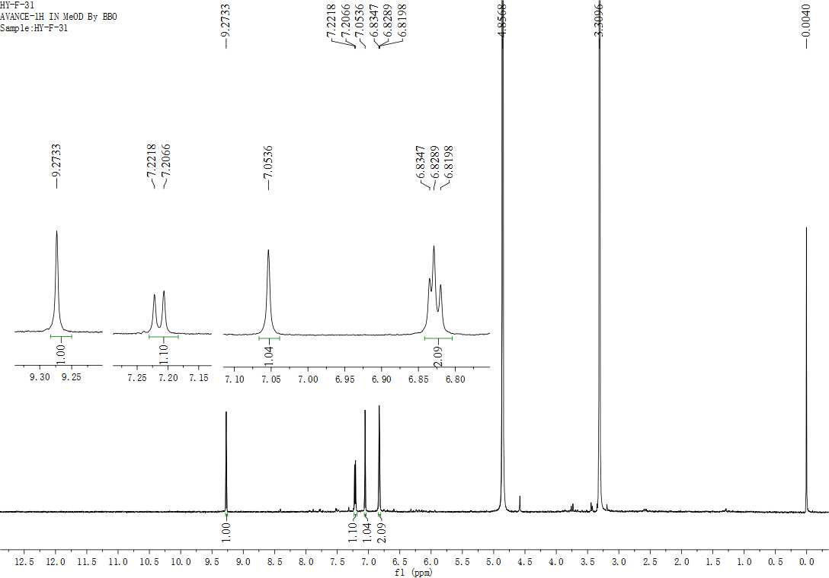 Figure S2 ¹H-NMR spectrum of 1
2,2',4,4',6,6',7,7'-octahydroxy-1,1'-biphenanthrene
8
9
10
5
3

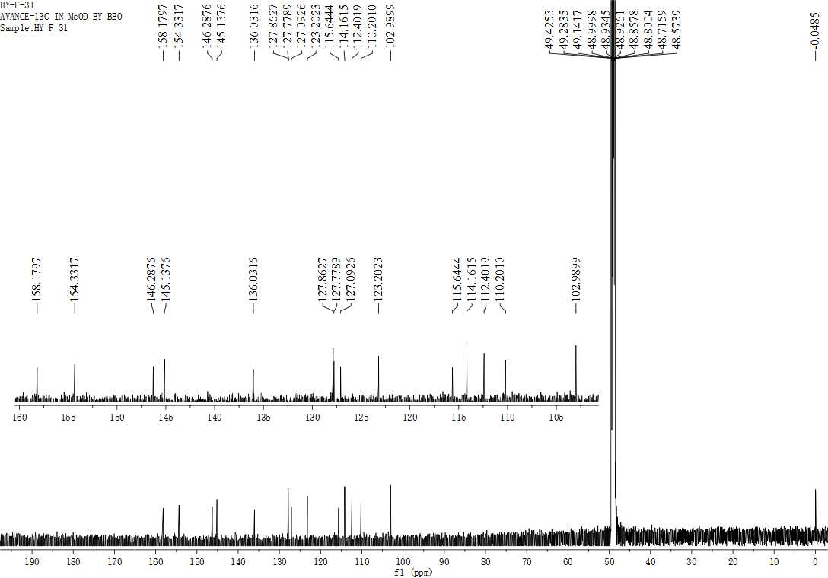Figure S3 ¹³C-NMR spectrum of 1
5
7
6
4
2
10a
8a
9
1
8
4a
10
3
4b
6
2,2',4,4',6,6',7,7'-octahydroxy-1,1'-biphenanthrene
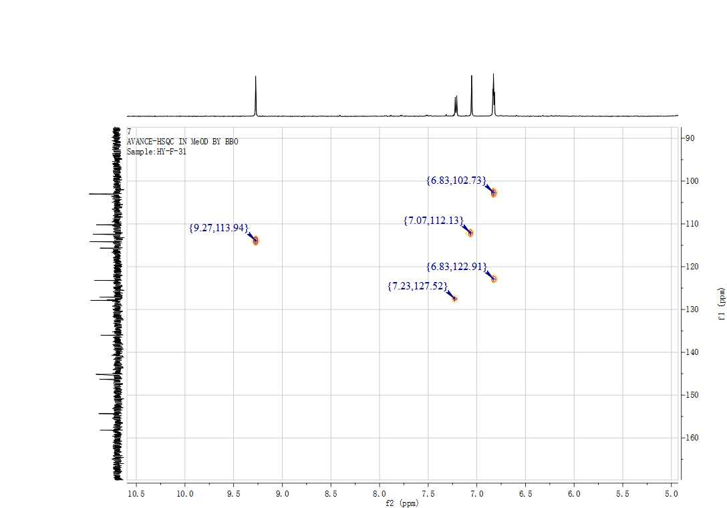
Figure S4 HSQC spectrum of 1
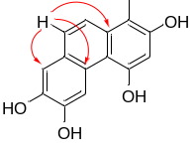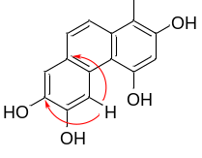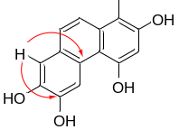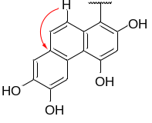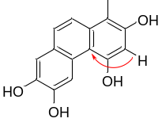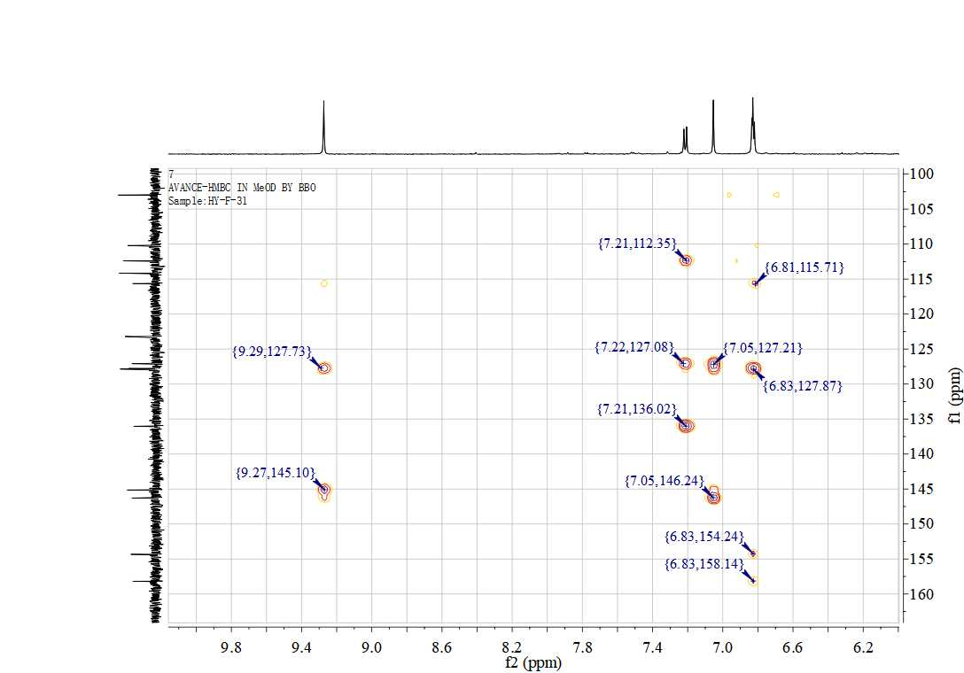
2,2',4,4',6,6',7,7'-octahydroxy-1,1'-biphenanthrene
2,2',4,4',6,6',7,7'-octahydroxy-1,1'-biphenanthrene
Figure S5 HMBC spectrum of compound 1
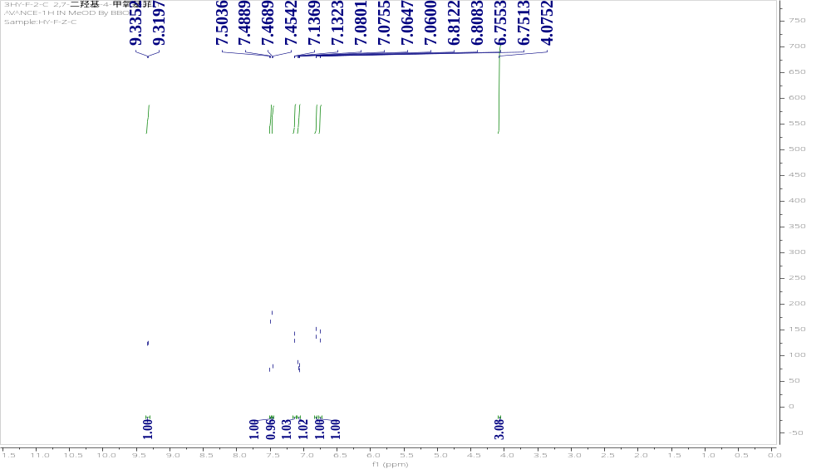
Figure S6 ¹H-NMR spectrum of compound 2

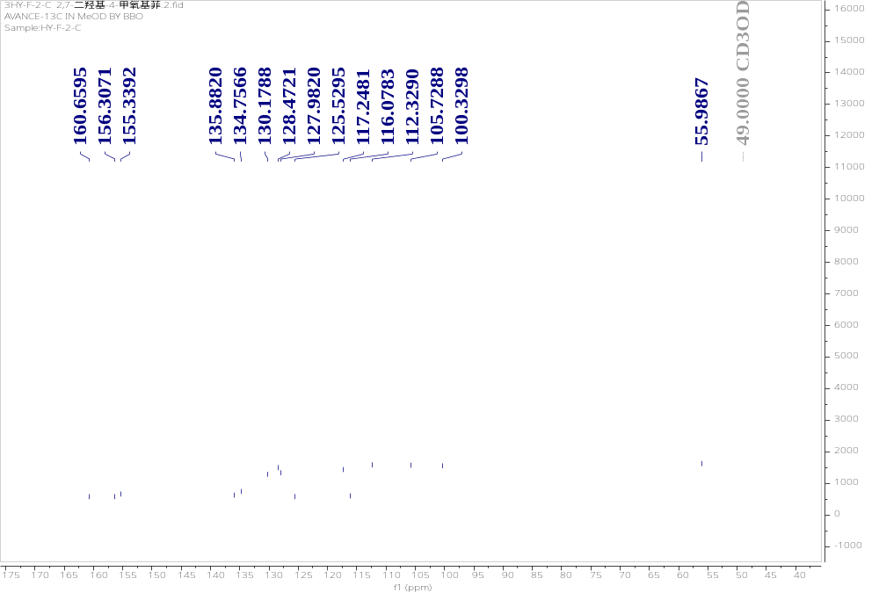
Figure S7 ¹³C-NMR spectrum of compound 2

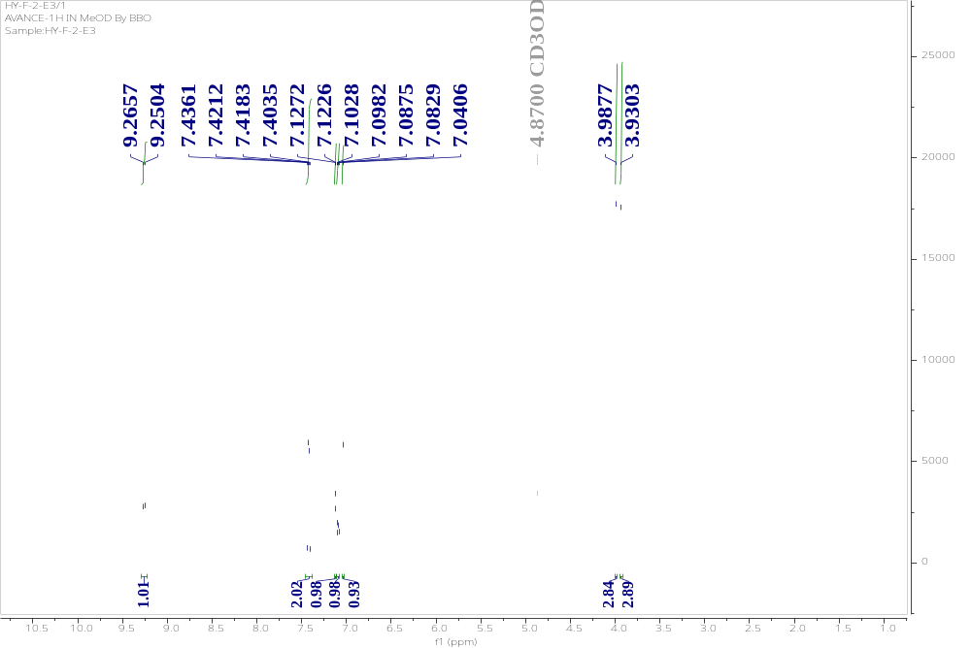
Figure S8 ¹H-NMR spectrum of compound 3

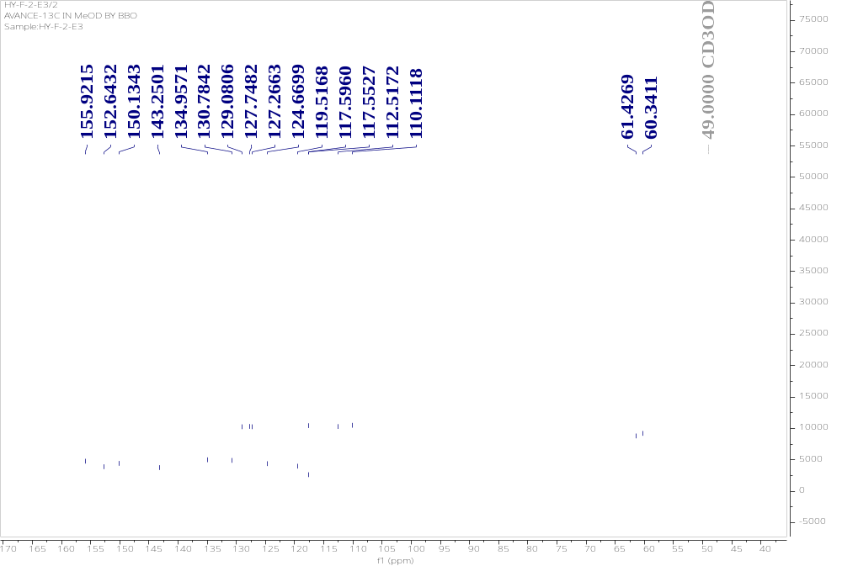
Figure S9 ¹³C-NMR spectrum of compound 3

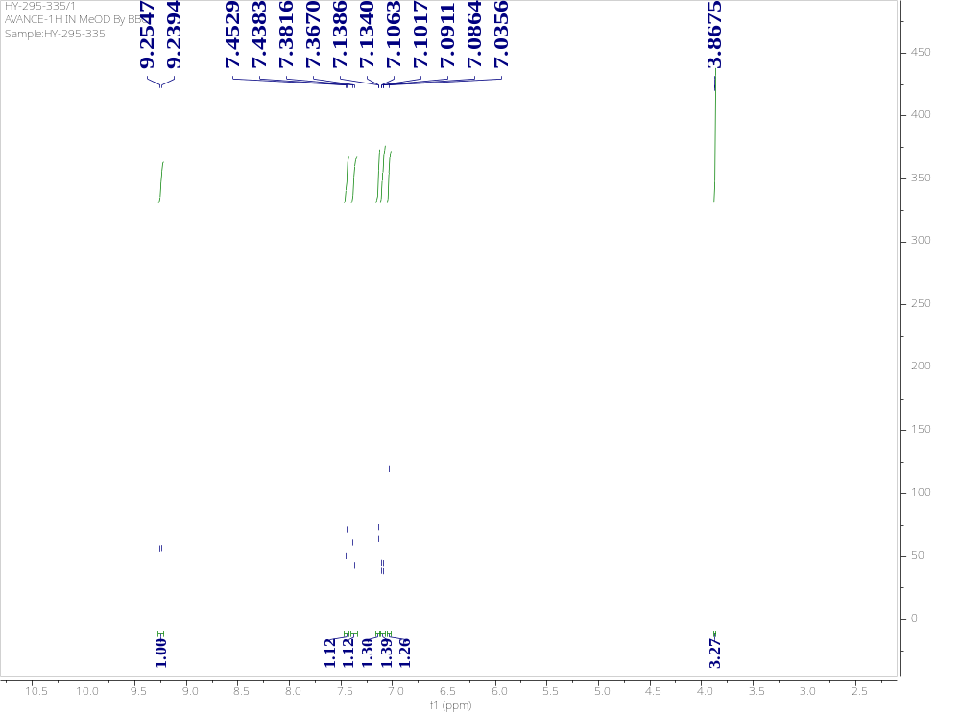
Figure S10 ¹H-NMR spectrum of compound 4
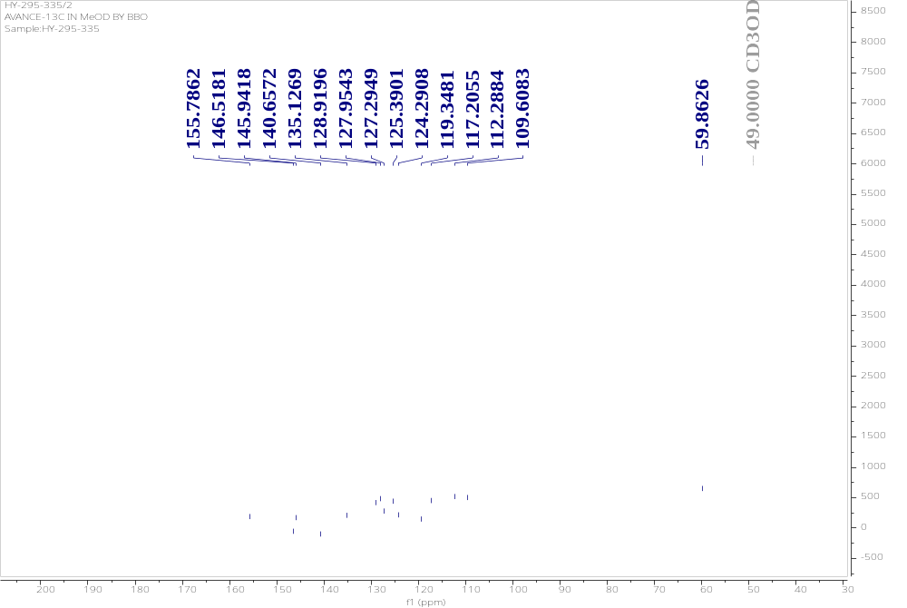
Figure S11 ¹³C-NMR spectrum of compound 4

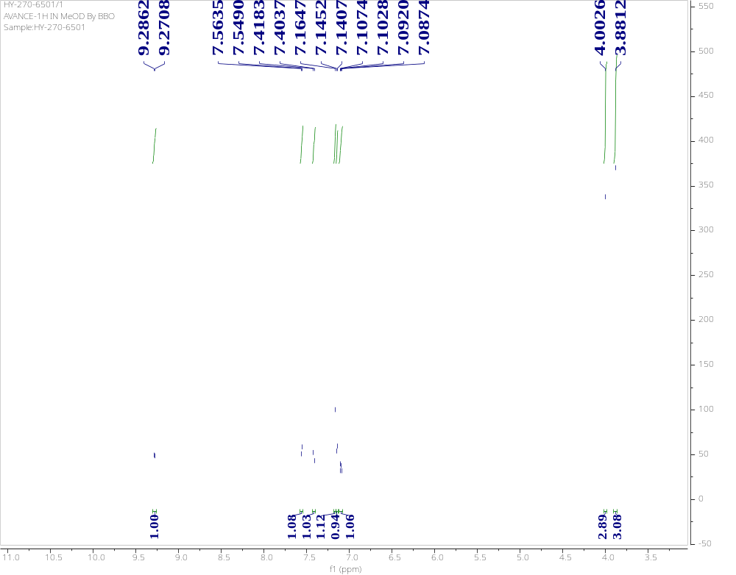
Figure S12 ¹H-NMR spectrum of compound 5

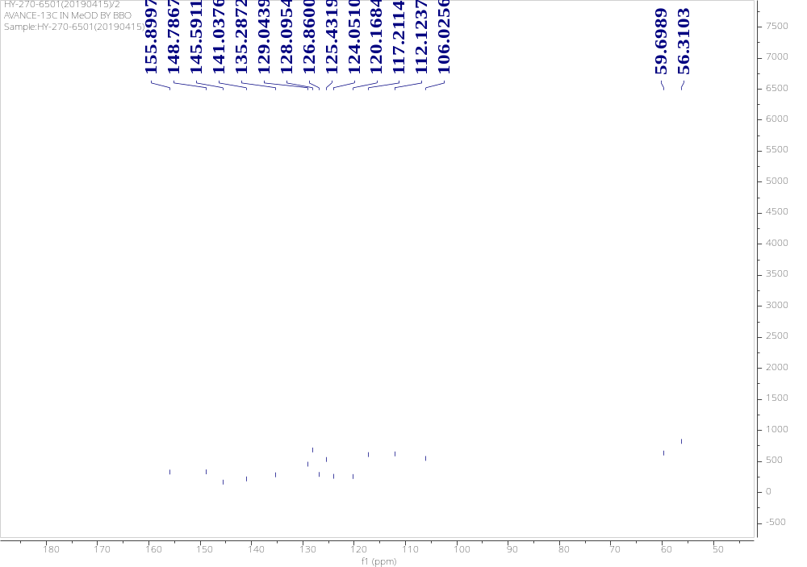
Figure S13 ¹³C-NMR spectrum of compound 5
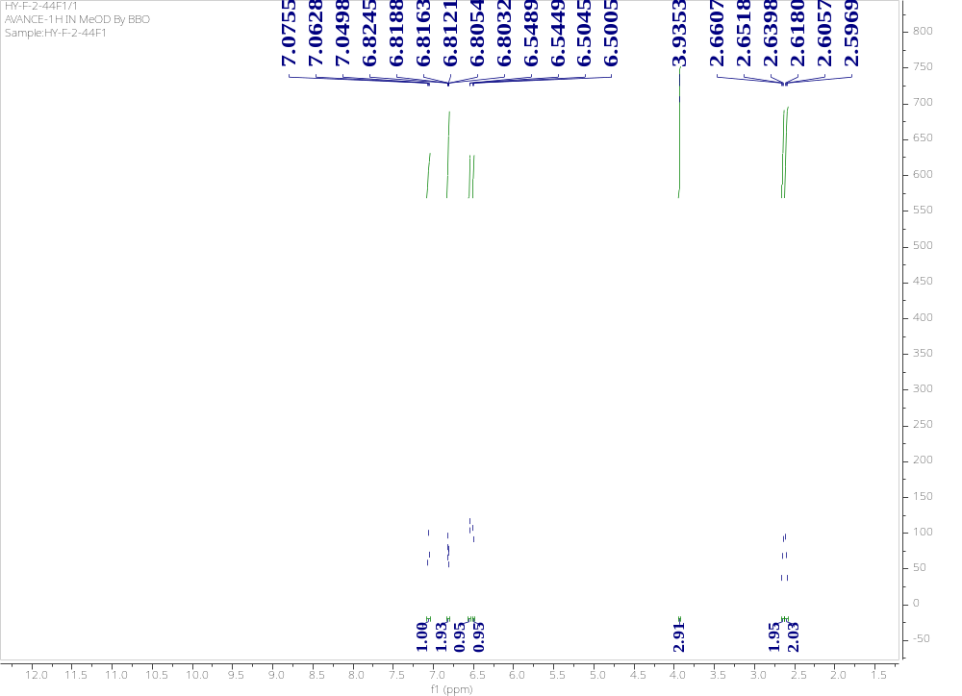
Figure S14 ¹H-NMR spectrum of compound 6

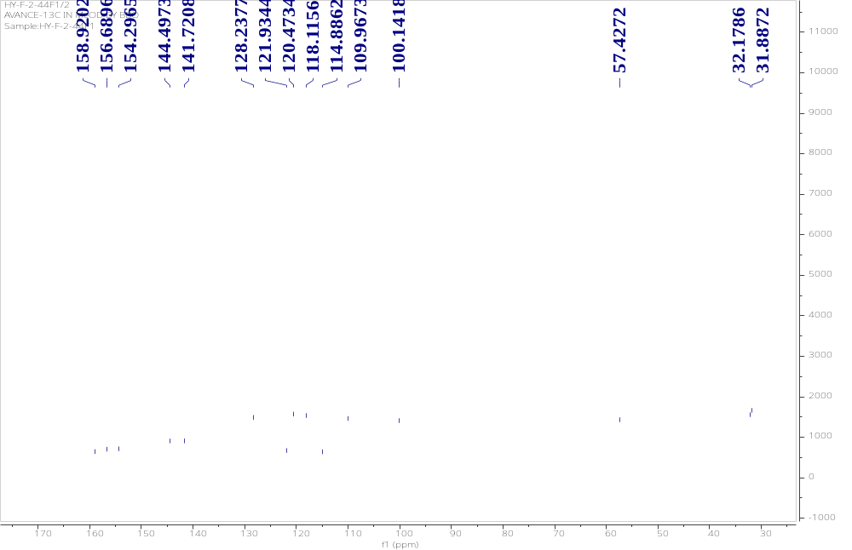
Figure S15 ¹³C-NMR spectrum of compound 6

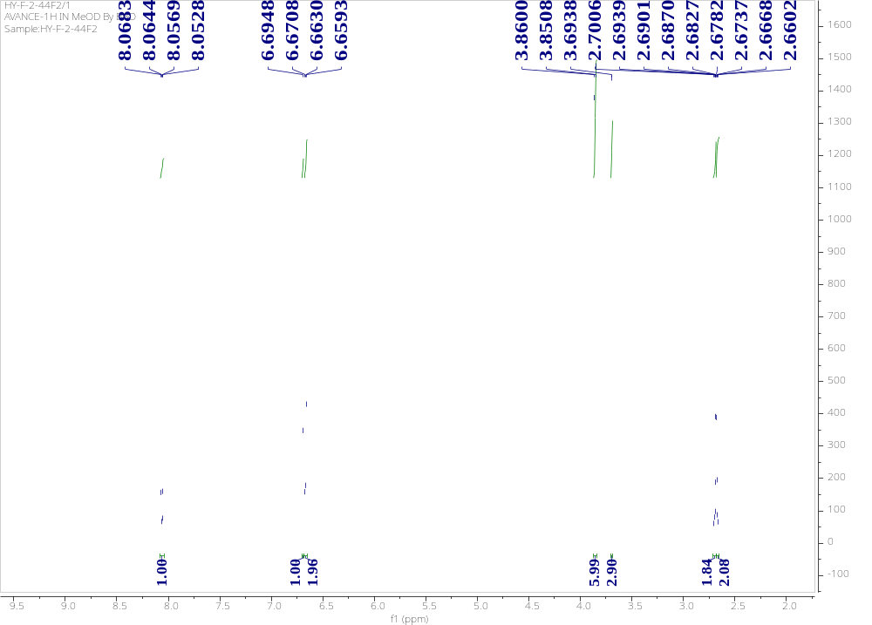
Figure S16 ¹H-NMR spectrum of compound 7
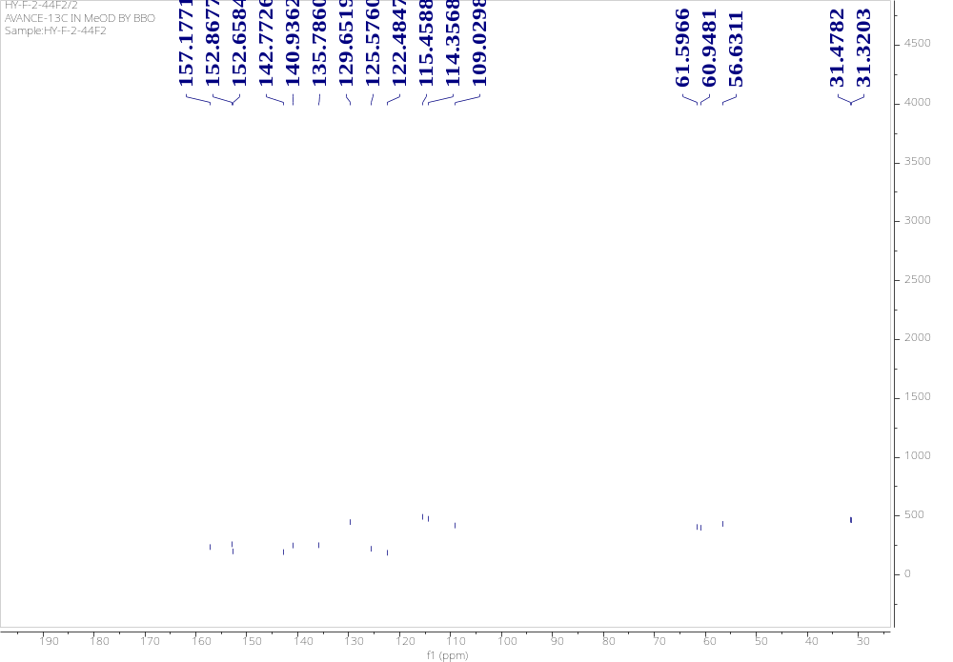
Figure S17 ¹³C-NMR spectrum of compound 7
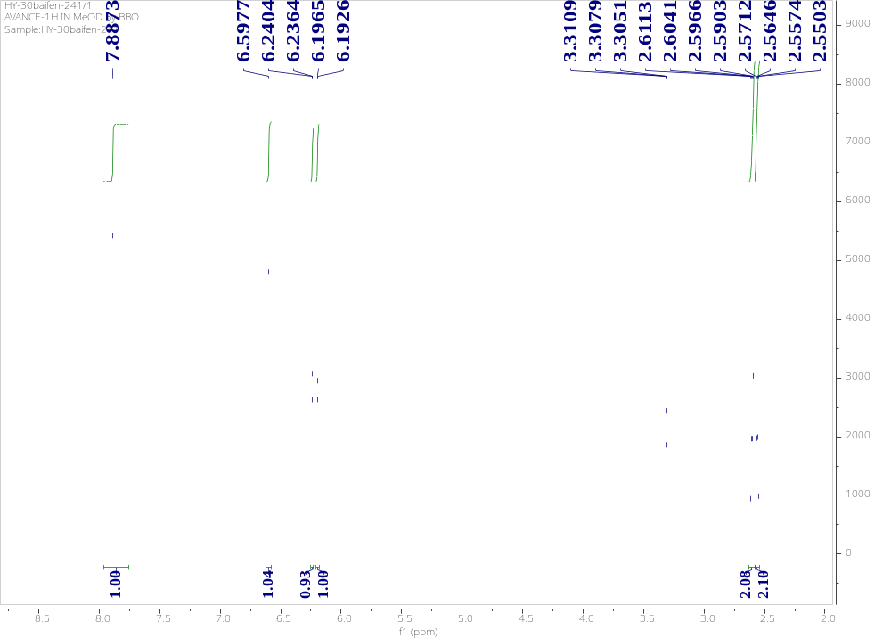
Figure S18 ¹H-NMR spectrum of compound 8
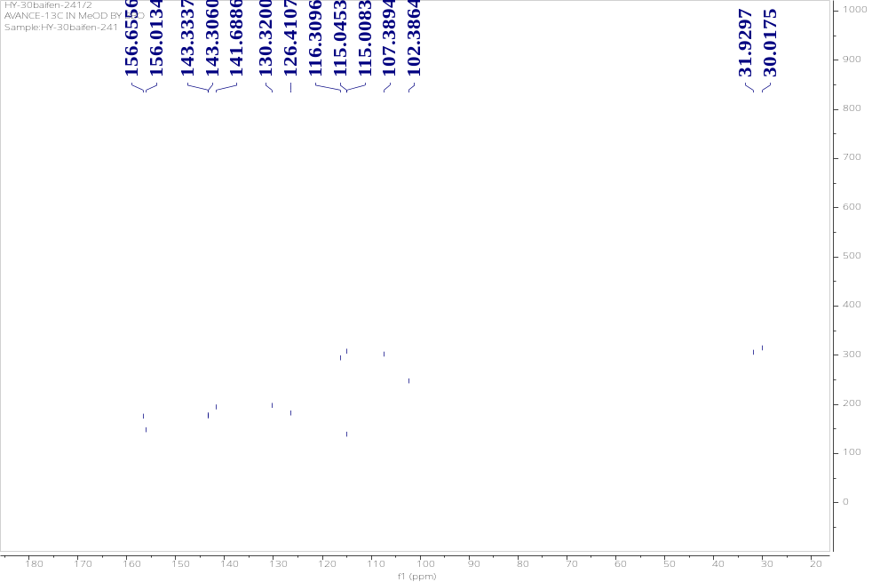
Figure S19 ¹³C-NMR spectrum of compound 8

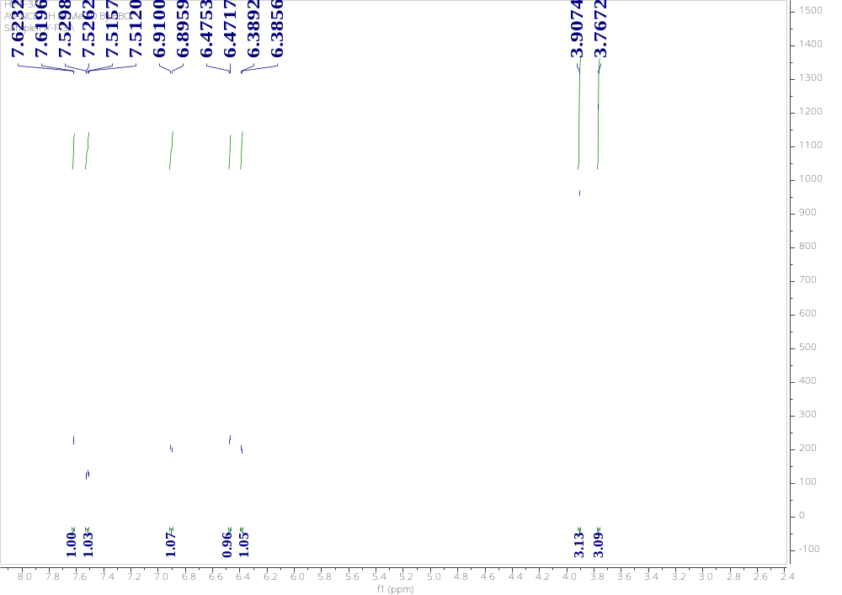
Figure S20 ¹H-NMR spectrum of compound 9
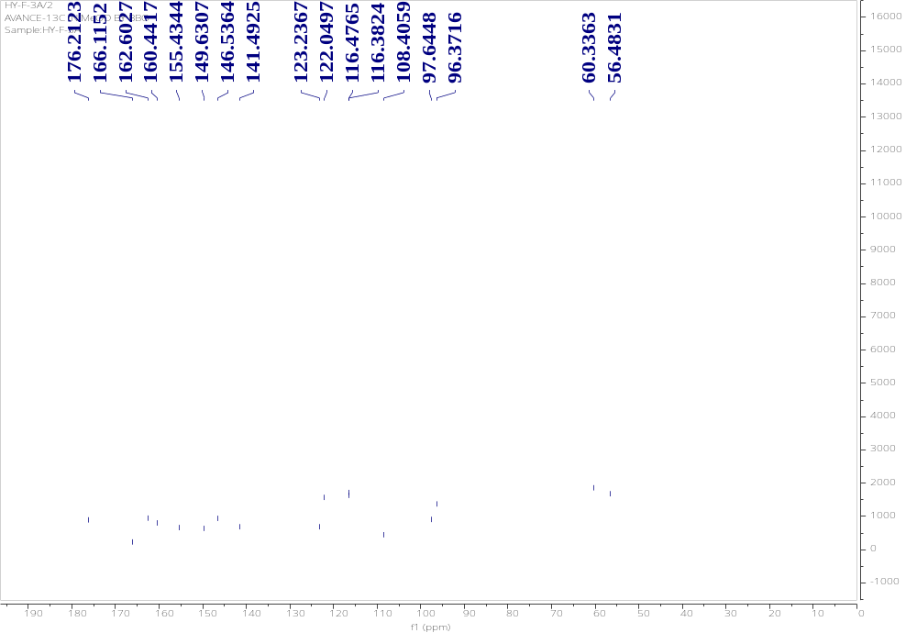
Figure S21 ¹³C-NMR spectrum of compound 9
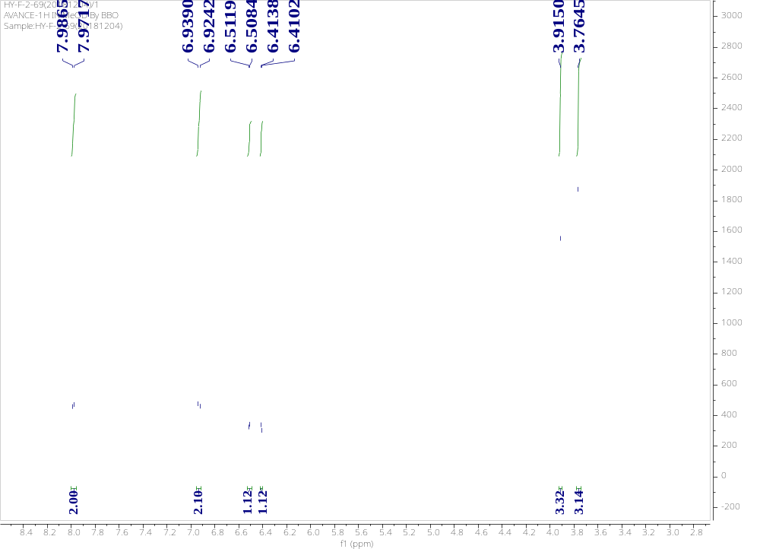
Figure S22 ¹H-NMR spectrum of compound 10
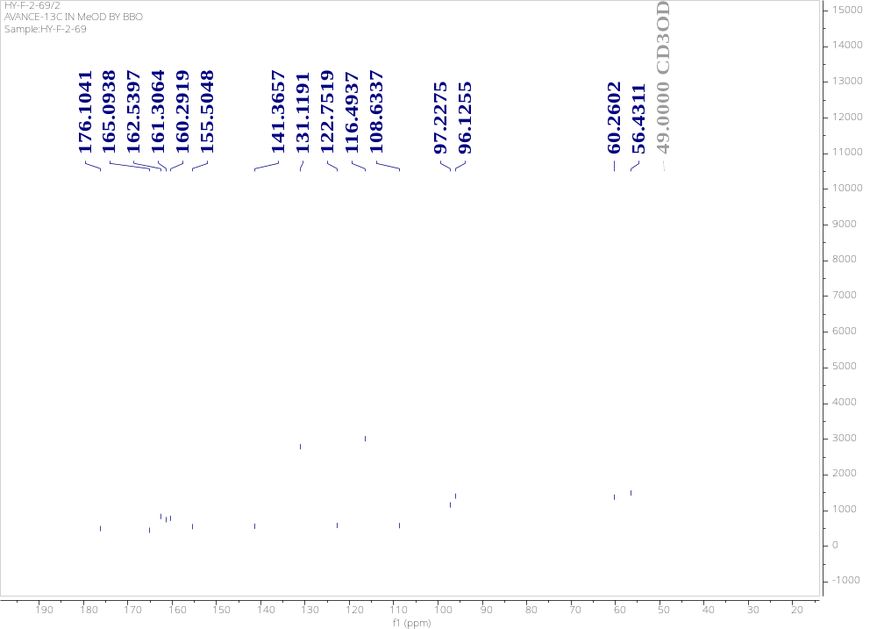
Figure S23 ¹³C-NMR spectrum of compound 10
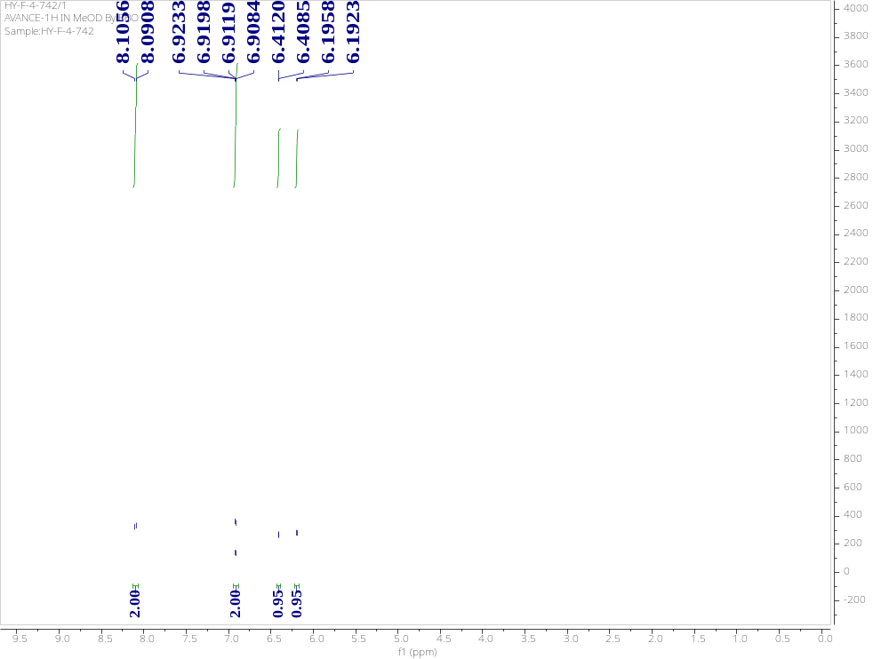
Figure S24 ¹H-NMR spectrum of compound 11
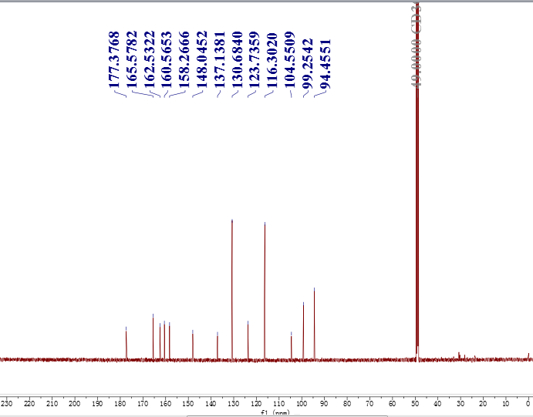
Figure S25 ¹³C-NMR spectrum of compound 11

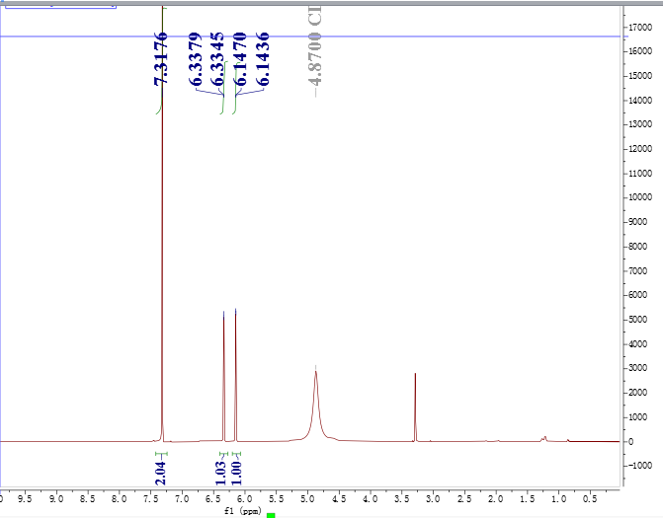
Figure S26 ¹H-NMR spectrum of compound 12

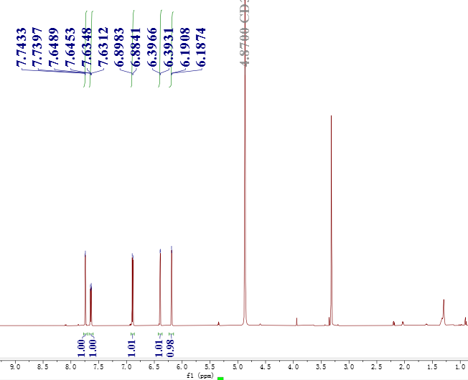
Figure S27 ¹H-NMR spectrum of compound 13

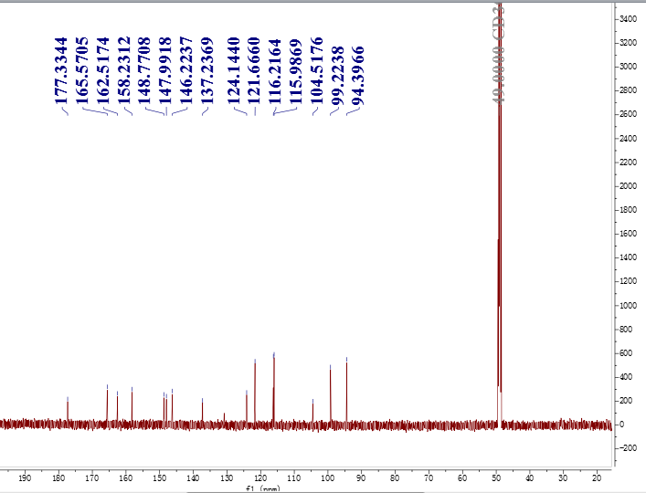
Figure S28 ¹³C-NMR spectrum of compound 13

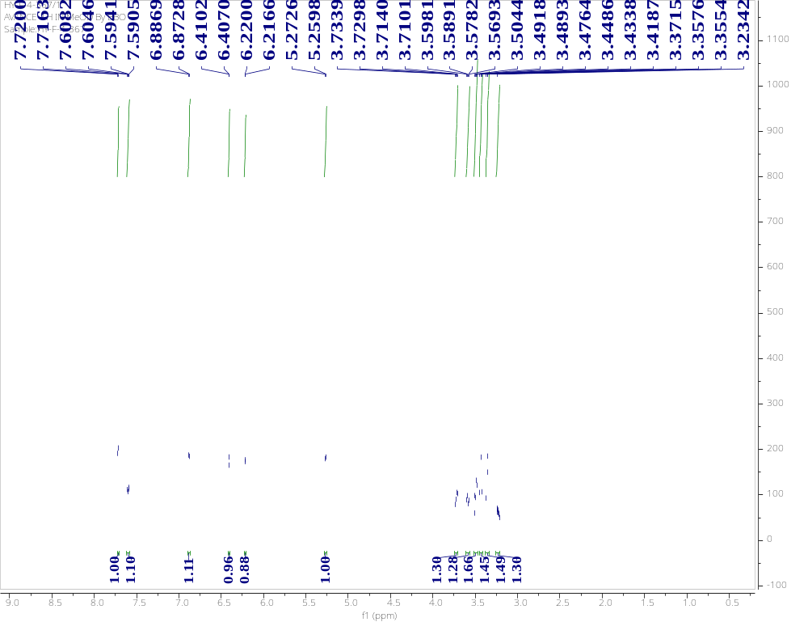
Figure S29 ¹H-NMR spectrum of compound 14
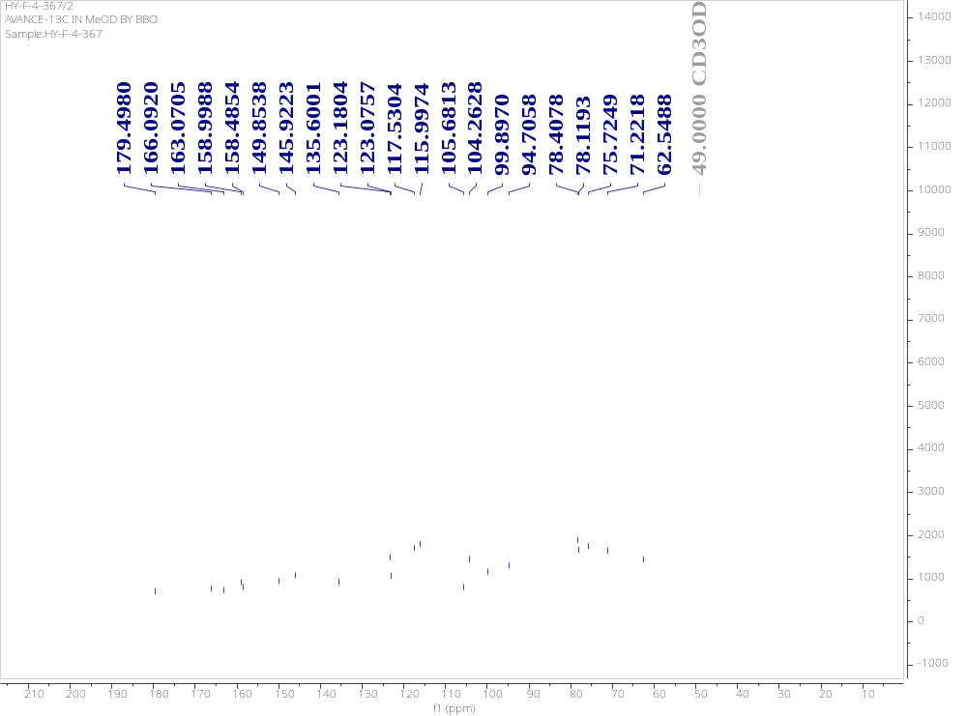
Figure S30 ¹³C-NMR spectrum of compound 14

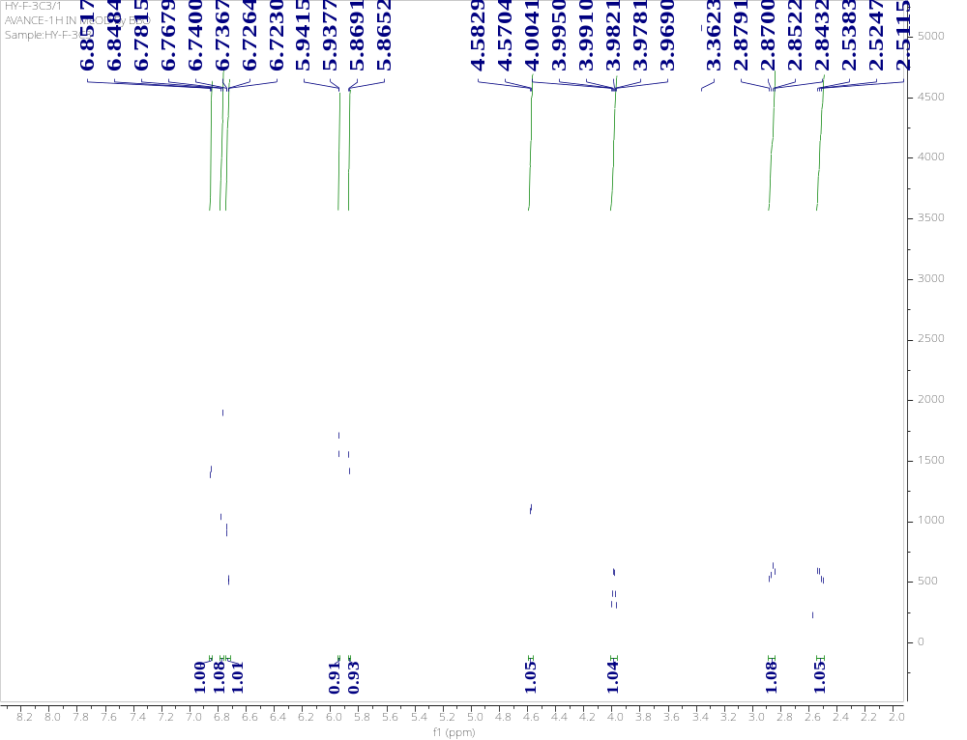
Figure S31 ¹H-NMR spectrum of compound 15

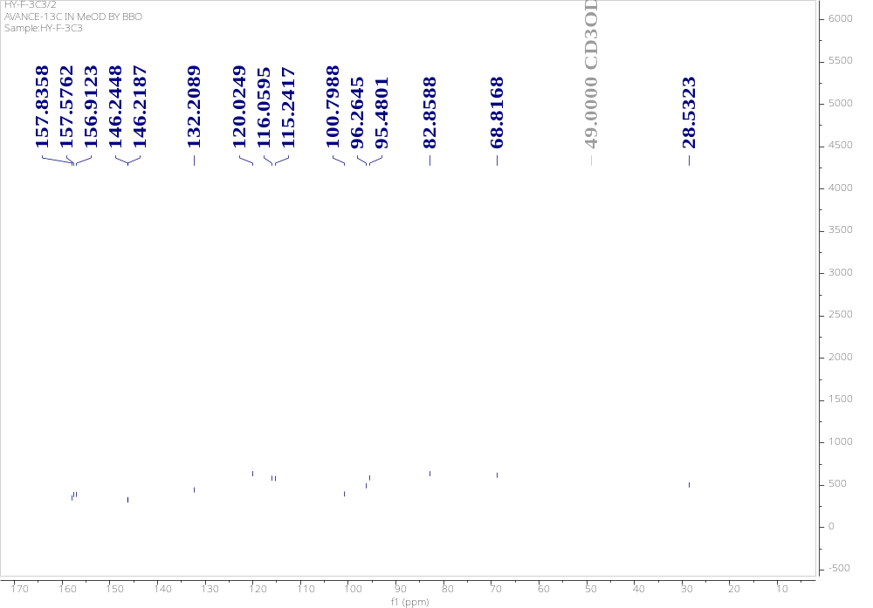
Figure S32 ¹³C-NMR spectrum of compound 15

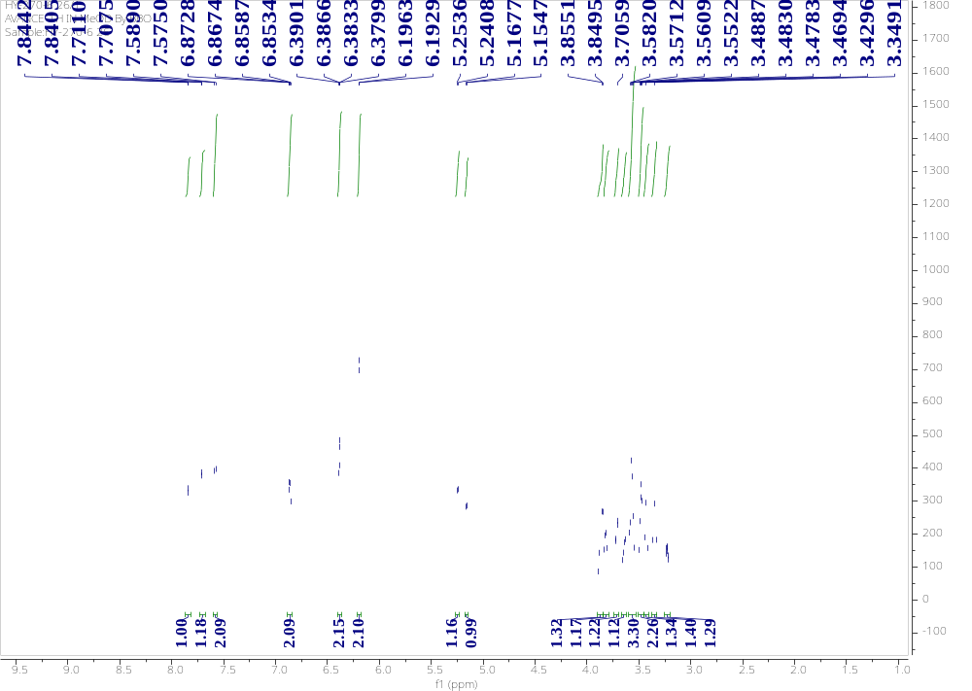
Figure S33 ¹H-NMR spectrum of compound 16
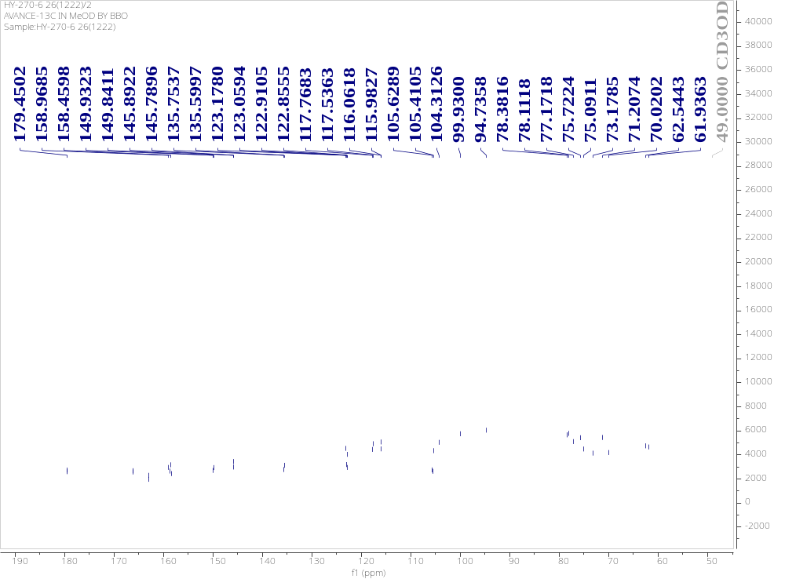
Figure S34 ¹³C-NMR spectrum of compound 16

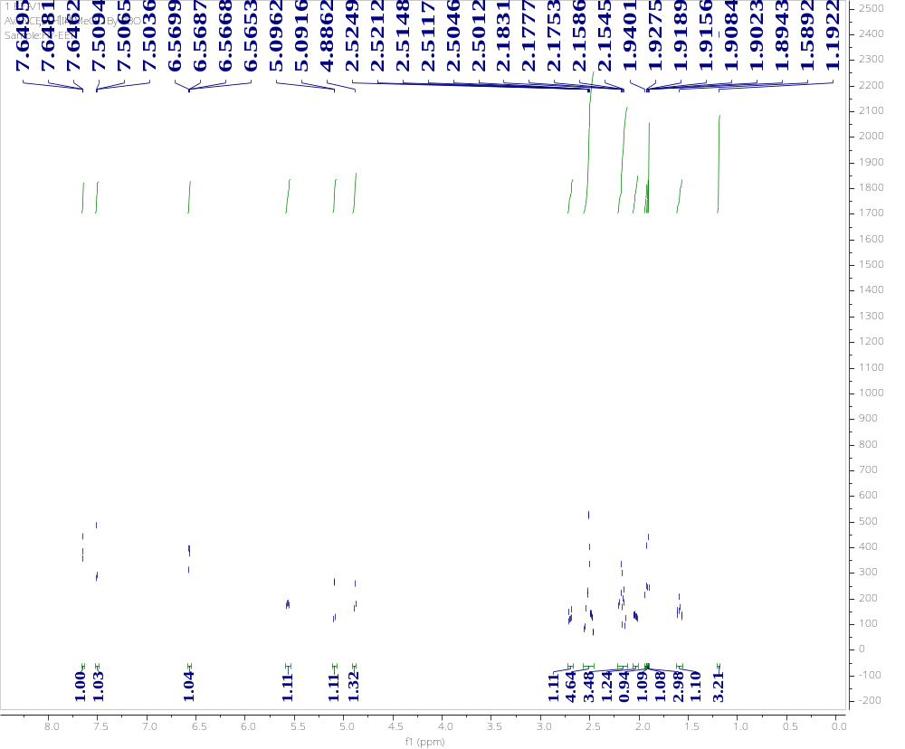
Figure S35 ¹H-NMR spectrum of compound 17
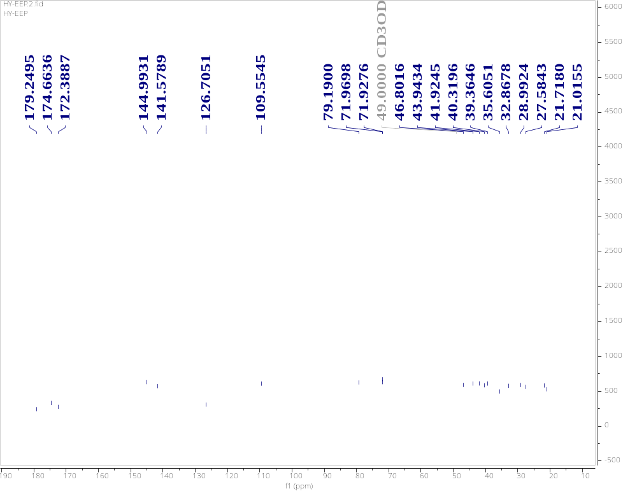
Figure S36 ¹³C-NMR spectrum of compound 17

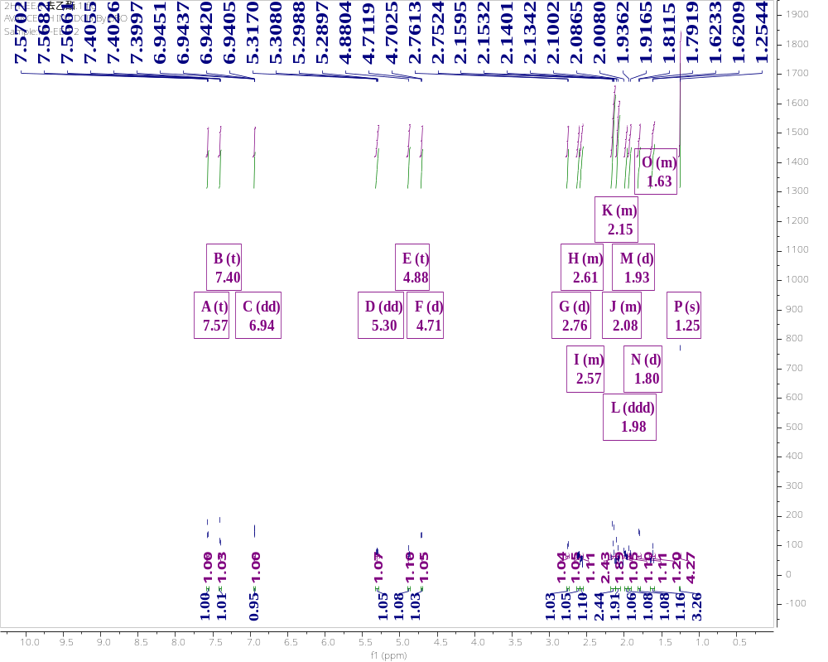
Figure S37 ¹H-NMR spectrum of compound 18

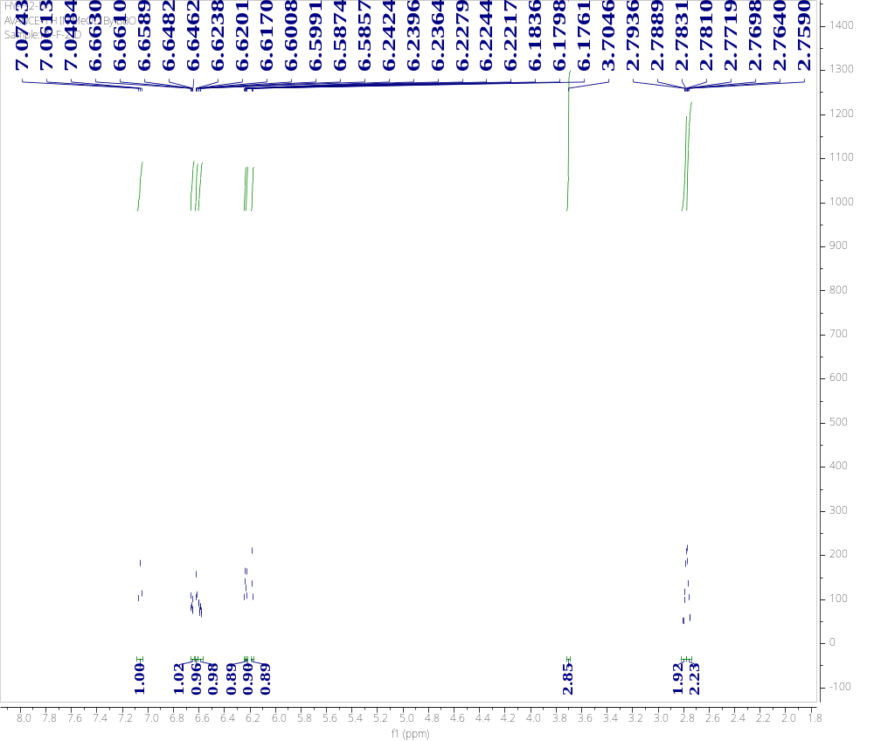
Figure S38 ¹H-NMR spectrum of compound 19
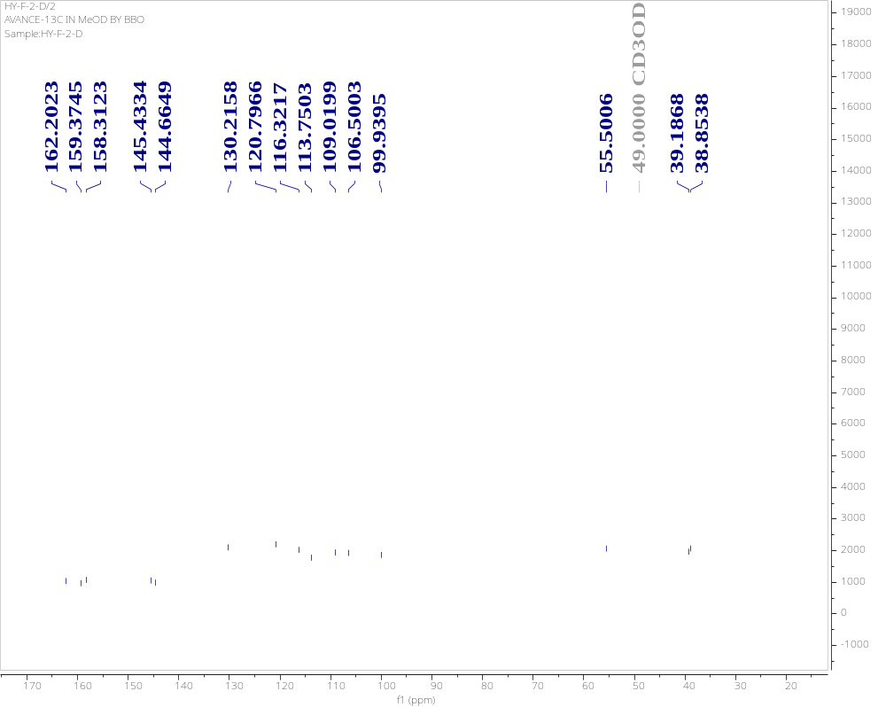

Figure S39 ¹³C-NMR spectrum of compound 19

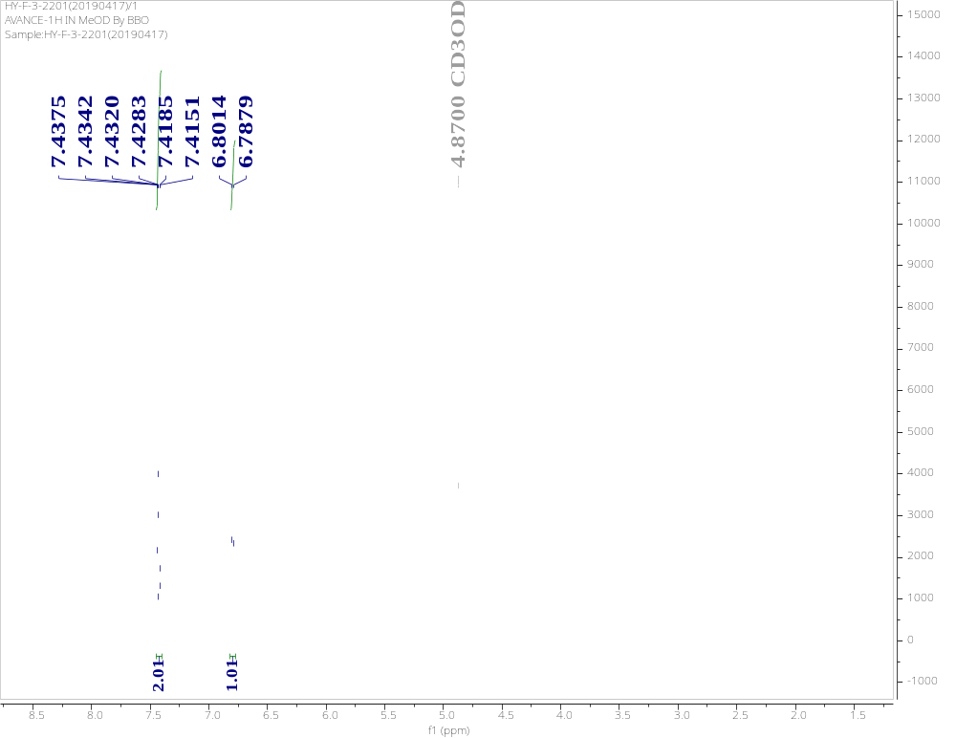
Figure S40 ¹H-NMR spectrum of compound 20

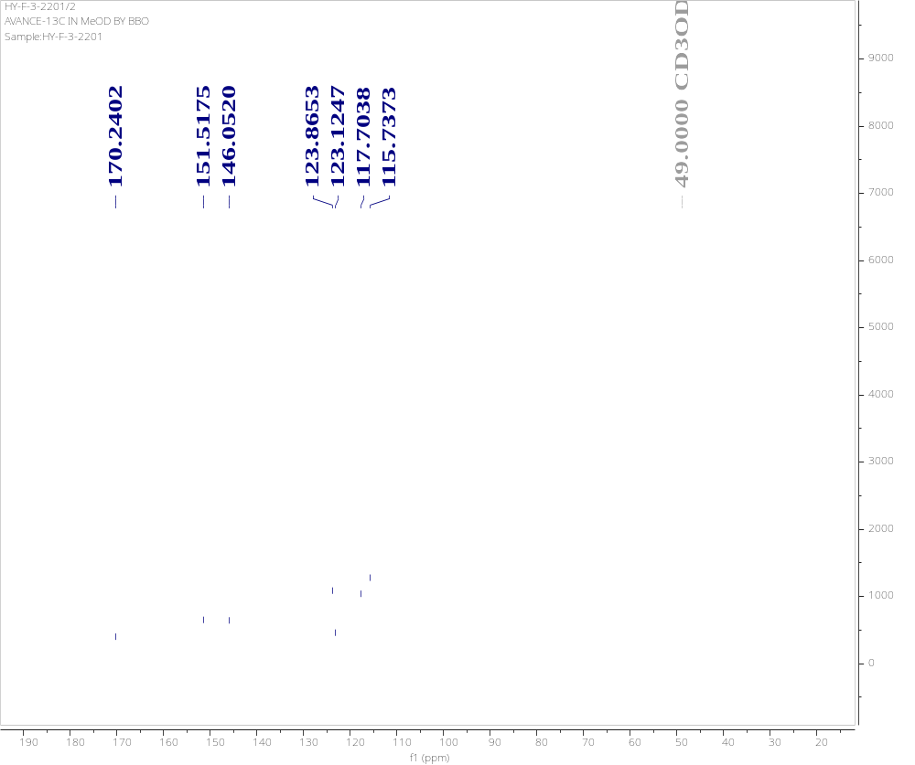
Figure S41 ¹³C-NMR spectrum of compound 20

3b

