Supplementary information:
Zeolites as equilibrium-shifting agents in shuttle catalysis: Expanding the conceptual utility of shape-selectivity in microporous catalysts.
Jesse Dallenes¹, Jonas Wuyts¹, Niels Van Velthoven¹, Andraž Krajnc², Gregor Mali², Oleg A. Usoltsev³, Aram L. Bugaev³ and Dirk De Vos¹*.
¹Centre for Membrane Separations, Adsorption, Catalysis, and Spectroscopy for Sustainable Solutions (cMACS), KU Leuven, Leuven, Belgium. ²Department of Inorganic Chemistry and Technology, National Institute of Chemistry, Ljubljana, Slovenia. ³The Smart Materials Research Institute, Southern Federal University, Rostov-on-Don, Russia. *e-mail: dirk.devos@kuleuven.be

Supplementary information

Table of contents

- General information 3

- Synthesis and treatment of zeolites 4

- Evaluation of reference HCN-transfer reactions without zeolite 6

- Evaluation of reference HCHO-transfer reactions without zeolite 13

- Zeolite-assisted transfer hydrocyanations 16

- Zeolite-assisted transfer hydroformylations 34

- Control experiments with isobutene, propylene and ethylene 42

- In-depth study of zeolite-assisted transfer hydrocyanation with propionitrile 49

- HCN-transfer scope and gram-scale synthesis 59

- HCHO-transfer scope and zeolite recycling 70

- Powder X-Ray Diffraction (PXRD) 82

- Thermogravimetric analysis (TGA) 86

- Inductively coupled plasma (ICP) 88

- X-ray Absorption Spectroscopy (XAS) 90

- Solid-state NMR characterization 98

- Scanning electron microscopy (SEM) 100

- NMR spectra of products 101

- Computational geometry optimizations 156

- Supplementary references 163

- General information
Chemicals were purchased from commercial suppliers (Acros Organics, Merck, TCI Europe, Fluorochem or VWR International) and used without further purification. Propionitrile (99%, from Merck) and 3-methylbutanal (98%, Alfa Aesar) were flushed with argon prior to use, and subsequently stored in a desiccator under inert atmosphere. Toluene was dried over molecular sieves before use. All reactions were carried under an argon atmosphere in heat-gun-dried glassware. ZSM-5, Beta, ferrierite and Y zeolites were purchased from Zeolyst (e.g. CBV-28014) or Tosoh Europe (e.g. TSZ-720 KOA). MCM-22 and chabazite zeolites were kindly provided by BASF. Other zeolites used in this study were synthesized via reported procedures.
Product quantification was performed on a Shimadzu CP-Sil 5 CB column (Shimadzu GC-2010) equipped with a flame ionization detector using 1,3,5-tri-tert-butylbenzene as an internal standard. The effective carbon number (ECN) method¹ was used to calculate the reaction yield, selectivities and conversions:
From mmol_{product} = $\frac{A_{product}*{mmol}_{IS}*{ECN}_{IS}}{{A_{IS}*ECN}_{product}}$: conversion = $\left(1-\frac{{mmol}_{substrate,t} }{{mmol}_{subtrate,t=0}}\right)*100$,
yield = $\frac{{mmol}_{product}}{{mmol}_{total}}*100$, selectivity = $\frac{{mmol}_{product,1}}{{mmol}_{product, 1+2}}*100$.
The theoretical ECN values of the nitrile and aldehyde groups were experimentally verified (nitrile = 0.3, aldehyde = 0) via a calibration curve with 3-phenylpropionitrile and 3-phenylpropionaldehyde. Preliminary adsorption studies were performed to exclude the possibility of internal standard adsorption into the zeolite framework. Linear alkanes (e.g. n-dodecane) were not suitable, as they did show significant adsorption (>20%), while 1,3,5-tri-tert-butylbenzene did not show any adsorption (viz. section 2.4, supplementary table S1).
Samples were automatically injected with a volume of 1 µL in split mode. An Agilent 6890 gas chromatograph with a HP-1 MS column and a 6973 MSD mass spectrometer was used for the identification of the different products. ¹H and ¹³C NMR spectra of nitrile products were recorded using a Bruker Avance III HD 400 spectrometer with CDCl₃ or DMSO-d₆ as the solvent. The data were analyzed using the MestReNova 12.0.2 software package. Powder X-ray diffraction patterns (PXRD) were recorded on a Malvern PANalytical Empyrean diffractometer equipped with a PIXcel 3D 1x1 detector. The powder samples were put onto a 96-well plate and patterns were recorded at room temperature in transmission geometry within a 1.3 °- 50 ° 2θ-range with a step size of 0.013° and analyzed via PANalytical Data Viewer software. The Pd- and Al-contents of zeolites were determined via ICP-OES using a Varian 720-ES. Prior to this, low-boiling organics were evaporated and the zeolites were digested in an HF solution. Thermogravimetric analysis was performed on a TA Instruments TGA Q500 using an O₂/N₂ gas flow (2/3) at a heating rate of 3.5 °C/min. X-ray absorption measurements have been performed at BM23 beamline of ESRF (Grenoble, France). The measurements were performed in transmission geometry with the beam intensity registered by ionization chambers. The reference Pd foil was measured simultaneously with the samples for energy calibration. The energy was selected by Si(111) double-crystal monochromator operated in the continuous scanning mode. The rejection of higher harmonics was achieved by Rh-coated mirrors. Solid-state NMR experiments were performed on a 600 MHz Varian spectrometer, using a 1.6 mm FastMAS probe. Larmor frequencies for ²⁷Al and ²⁹Si were 156.18 MHz and 119.06 MHz, respectively. The samples were spun at 20 kHz. ²⁷Al magic-angle spinning (MAS) NMR spectra were recorded with a short 1.0 µs excitation pulse and a recycle delay of 0.1 s. 60 000 scans were recorded per spectrum.
- Synthesis and treatment of zeolites

2.1 General treatment of zeolites
All zeolites used in the reaction were activated in vacuo prior to use. The zeolites were placed in Schlenk tube and put under vacuum (10⁻²-10⁻³ mbar) while being heated in a sand bath at T=250°C for 16h (for some zeolites, e.g. hydrophobic and high-silica zeolites, thermal activation can be less stringent). Afterwards, the zeolites were sealed in a tube with parafilm and stored in a desiccator. In between uses, the zeolites were put under inert atmosphere to avoid readsorption of water.

2.2 Synthesis of zeolites
Commercial zeolites in NH₄-from were calcined at T=550°C for 6h using a temperature ramp of 2°C/min. Ferrierite (in K⁺ form; TSZ-720 KOA) was exchanged with NH₄NO₃ (0.5 M, 50 ml/g zeolite) three times at 80°C, and then calcined at 550°C for 6h at a heating rate of 2°C/min.
High-silica ferrierite with Si/Al = 104 was synthesized following a procedure from Kamimaru et al². Sodium hydroxide (29.3 mg) and sodium aluminate (21.8 mg) were dissolved in water (6.5 ml). Subsequently, sodium fluoride (1.34 g) was added together with pyridine (4.83 ml), followed by addition of Cab-O-Sil M5 (2.399 g) under vigorous mixing. The gel was transferred into a Teflon liner, which was sealed inside a stainless autoclave. The autoclave was placed in an oven at 165°C for 5 days. Next, the solid was separated by filtration and washed with hot water. The solid was then dried at 60°C overnight, and subsequently calcined at 650°C for 10h. To convert the zeolite into its H-form, it was ion exchanged three times with an aqueous solution of NH₄NO₃ (0.5 M, 50 ml/g zeolite), and then calcined at 550°C for 6h at a heating rate of 2°C/min.
Silicalite-1 (NH₄F) and silicalite-1 (OH) were synthesized according to reported procedures^{3,4}. Sn-Beta was synthesized in fluoride media according to the procedure from Corma et al⁵. H-ZSM-48 (Si/Al = 100) was synthesized following a reported procedure⁶.
The synthesis of H-ZSM-11 (Si/Al = 120) was adapted from the reported procedure of Wang et al⁷. Briefly, sodium aluminate (32 mg) and sodium hydroxide (214 mg) were mixed in water (8.52 ml), followed by addition of tetrabutylammonium hydroxide (2.6 ml). Next, Ludox HS-40 silica sol was added (4.62 ml) under continuous stirring. The mixture was allowed to stir for 2h, before being transferred into a Teflon liner, which was sealed inside a stainless autoclave. The autoclave was placed in an oven at 170°C for 24h. The solid was recovered via filtration, washed with water and dried at 100°C overnight. The zeolite was calcined at 550°C for 10h, using a heating rate of 2°C/min. To convert the zeolite into its H-form, it was ion exchanged three times with an aqueous solution of NH₄NO₃ (0.5 M, 50 ml/g zeolite), and then calcined at 550°C for 6h at a heating rate of 2°C/min.

2.3 Modification of zeolites
Silylated H-ZSM-5 was prepared according to the reported procedure from Zheng et al⁸. 360 mg of H-ZSM-5 zeolite was mixed with 9 ml of n-hexane and heated to 70°C. Then, tetraethoxysilane (54 µl) was added, and the mixture was stirred at 70°C for 1h. The hexane was removed via evaporation, and recovered solid was dried at 120°C overnight. Finally, the solid was calcined at 500°C for 4h. This process was repeated one time, resulting in the material denoted Sil-H-ZSM-5.
Metal-doped zeolites were prepared in two ways; 1) via ion exchange 2) via impregnation. Generally, 100 ml of a 0.1 M metal salt solution (Ni(NO₃)₂, Zn(NO₃)₂, Pd(NO₃)₂) was mixed with 1g of zeolite (Na-form, NH₄-from or H-form). Pd-ZSM-5 was synthesized from NH₄-ZSM-5 using a 0.005 M Pd(NO₃)₂ solution⁹. For impregnation, the amount of metal salt added was determined based on the desired wt.% of the metal in the zeolite. In the case of ion-exchange, the mixture was stirred at 80°C for 24h. Subsequently, the solution was removed from the zeolite via centrifugation and fresh metal salt solution was added. The ion exchange was repeated two more times. After the final exchange, the zeolites were washed with water, dried at 100°C overnight and calcined at 550°C for 4h. In the case of impregnation, the solution was heated to 90°C for 2 days while vigorously stirring, letting the water evaporate. Pd-H-ZSM-5 was also prepared in a different way: briefly, the desired amount of Pd(OAc)₂ (e.g. 0.3 wt.%: 3.2 mg) was added to 500 mg of H-ZSM-5 zeolite. Next, 10 ml of toluene was added, and the mixture was stirred overnight at room temperature. Toluene was removed via centrifugation, and the suspension was dried under vacuo overnight, resulting in Pd-H-ZSM-5.
  - Zeolite internal standard adsorption tests.
Entry | Internal standard (0.1 mmol) | Conditions | Zeolite (Si/Al, mg) | Adsorption (mol%)^{[A]}
1 | n-dodecane | A | H-ZSM-5 (140, 50) | 17.5
2 | n-dodecane | A | H-ZSM-5 (140, 90) | 25.2
3 | tert-butylbenzene | A | H-ZSM-5 (140, 50) | 3.2
4 | tert-butylbenzene | A | H-ZSM-5 (140, 90) | 4
5 | 1,3,5-tri-tert-butylbenzene | A | H-ZSM-5 (140, 90) | 0.3^{[B]}
6 | 1,3,5-tri-tert-butylbenzene | B | H-ZSM-5 (140, 90) | -0.1
7 | 1,3,5-tri-tert-butylbenzene | B | H-ZSM-5 (140, 200) | 0.5
8 | 1,3,5-tri-tert-butylbenzene | C | H-ZSM-5 (140, 100) | 0.1
9 | 1,3,5-tri-tert-butylbenzene | C | H-FER (9, 100) | -0.2
Supplementary table S1: Internal standard adsorption experiments. The experiments were performed under the standard HCN- and HCHO-transfer reaction conditions (i.e. A-C).
[A] Determined via GC based on calibration curve of internal standard. Mol% adsorption was calculated as (mmol start – mmol end)/mmol start. [B] Mean value of three identical runs.
Conditions A (transfer hydrocyanation conditions in toluene): 0.5 ml toluene, 130 µl isovaleronitrile, 0.1 mmol internal standard, T = 120°C, t = 18h
Conditions B (transfer hydrocyanation conditions in propionitrile): 0.8 ml propionitrile, 0.1 mmol internal standard, T = 100°C, t = 18h
Conditions C (transfer hydroformylation conditions in 3-methylbutanal): 0.8 ml 3-methylbutanal, 0.1 mmol internal standard, T = 80°C, t = 22h

- Evaluation of reference HCN-transfer reactions without zeolite
General reaction procedures:
Procedure A: transfer hydrocyanation reaction in an open system.
To a 1.5 ml glass vial was added the indicated amount of metal catalyst (e.g. 0.0125 mmol Pd(OAc)₂) and phosphine ligand (e.g. 0.0125 mmol Xphos), together with 0.1 mmol of 1,3,5-tri-tert-butylbenzene as internal standard. The glass vial was capped and put under an inert argon atmosphere using a Schlenk line, after which dry toluene (0.5 ml), nitrile donor (1.25 mmol - 2.5 mmol) and olefin acceptor (0.25 mmol) were added. Finally, the indicated amount of a Lewis acid solution was injected (e.g. 50 µl 1M AlMe₂Cl in hexanes, 20 mol%). The vial was then placed in a preheated aluminum heating block at 100°C, and connected to a continuous flow of argon via a needle in order to create an open system. After 18h, the vial was cooled on ice, and two drops of methanol were added to quench residual Lewis acid. The solution was filtered, and the products were analysed via GC-FID/GC-MS.
Procedure B: transfer hydrocyanation reaction in a closed system.
To a 1.5 ml glass vial was added the indicated amount of metal catalyst (e.g. 0.0125 mmol Pd(OAc)₂) and phosphine ligand (e.g. 0.0125 mmol Xphos), together with 0.1 mmol of 1,3,5-tri-tert-butylbenzene as internal standard. The glass vial was capped and put under an inert argon atmosphere using a Schlenk line, after which dry toluene (0.5 ml), nitrile donor (1.25 mmol - 2.5 mmol) and olefin acceptor (0.25 mmol) were added. Finally, the indicated amount of a Lewis acid solution was injected (e.g. 100 µl 1M AlMe₂Cl in hexanes, 40 mol%). The vial was then capped and placed in a preheated aluminum heating block at the desired reaction temperature (100-120°C). After 18h, the vial was cooled on ice, and two drops of methanol were added to quench residual Lewis acid. The solution was filtered, and the products were analysed via GC-FID/GC-MS.
Procedure C: transfer hydrocyanation reaction in an open system with a reflux setup.
To a 25 ml three-neck glass flask was added the indicated amount of metal catalyst (e.g. 0.125 mmol Pd(OAc)₂) and phosphine ligand (e.g. 0.125 mmol Xphos), together with 1 mmol of 1,3,5-tri-tert-butylbenzene as internal standard. The flask was connected to a continuous argon flow, after which solvent (e.g. argon-flushed propionitrile, 6 ml) and olefin acceptor (2.5 mmol) were added. Finally, the indicated amount of a Lewis acid solution was injected (e.g. 1.1 ml 0.9M AlMe₂Cl in heptane, 40 mol%). The flask was then placed in a heating mantle at 100°C, and connected to a reflux setup . After 18h, the flask was cooled on ice, and methanol (0.5 ml) was added to quench residual Lewis acid. The solution was filtered, and the products were analysed via GC-FID/GC-MS. The reaction setup is depicted in figure S1.

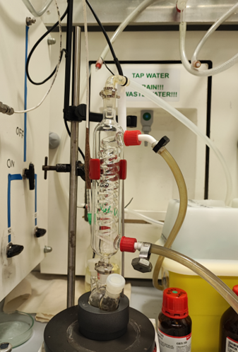
Gas outlet connected to a scrubber

argon inlet

Fig. S1: Transfer hydrocyanation reaction setup procedure C.

Catalyst screening (table S2).
Initially, the exact conditions of Morandi and co-workers were used (Science 351.6275 (2016): 832-836) (table S2, entry 1)¹⁰. Due to practical considerations, we screened several bench-stable nickel(0)-precursors^{11,12}. Both Ni(COD)(DQ) and NiCl₂ provided comparable yields to Ni(COD)₂, hence Ni(COD)(DQ) and NiCl₂ were used as benchmark Ni-catalysts in further experiments. It was shown by Morandi and co-workers that similar activities can be achieved with Pd-catalysts¹³. Inspired by this, we found that Pd(OAc)₂ and the well-known biaryl dialkyl phosphine ligand L4 (Xphos) was an effective combination for this reaction. Similar to the Ni-based system of Morandi, AlMe₂Cl functions as the superior Lewis acid. Related dialkyl aluminum chloride Lewis acids show respectable yields, while the use of other Lewis acids results in only small amounts of products.

Table S2: Screening of catalysts (reaction procedure A).
Entry | Catalyst (mol%) | Ligand (mol%) | Lewis acid (mol%) | Yield (%)
1^{[A)} | Ni(COD)₂ (5) | L1 (5) | AlMe₂Cl (20) | 85
2^{[A],[B]} | Ni(COD)₂ (5) | L1 (5) | AlMe₂Cl (20) | 86
3 | Ni(COD)(DQ) (5) | L1 (5) | AlMe₂Cl (20) | 84
4 | Ni(COD)(DQ) (10) | L1 (10) | AlMe₂Cl (40) | 81
5 | NiCl₂ (5) | L1 (5) | AlMe₂Cl (20) | 83
6 | Ni(^{tbu}stb)₃ (10) | L1 (10) | AlMe₂Cl (40) | 68
7 | Ni(TMEDA)(o-tolyl)Cl (10) | L1 (10) | AlMe₂Cl (40) | 64
8 | Pd(dba)₂ (5) | L1 (5) | AlMe₂Cl (20) | n.d.
9 | Pd(dba)₂ (5) | L2 (5) | AlMe₂Cl (20) | 69
10 | Pd(dba)₂ (10) | L2 (10) | AlMe₂Cl (40) | 79
11 | Pd(Cl)₂ (10) | L2 (10) | AlMe₂Cl (40) | 61
12 | Pd(OAc)₂ (10) | L2 (10) | AlMe₂Cl (40) | 84
13 | Pd(OAc)₂ (10) | L3 (10) | AlMe₂Cl (40) | 90
14 | Pd(OAc)₂ (10) | L4 (10) | AlMe₂Cl (40) | 92
15 | Pd(OAc)₂ (5) | L4 (5) | AlMe₂Cl (20) | 81
16 | Pd(OAc)₂ (10) | L4 (10) | AlEt₂Cl (40) | 74
17 | Pd(OAc)₂ (10) | L4 (10) | Al(Ibu)₂Cl (40) | 79
18 | Pd(OAc)₂ (10) | L4 (10) | AlMe₃ (40) | 21
19^{[C]} | Pd(OAc)₂ (10) | L4 (10) | AlCl₃ (40) | n.d.
20^{[C]} | Pd(OAc)₂ (10) | L4 (10) | B(C₆F₅)₃ (40) | 7
21^{[C]} | Pd(OAc)₂ (10) | L4 (10) | BPh₃ (40) | n.d.
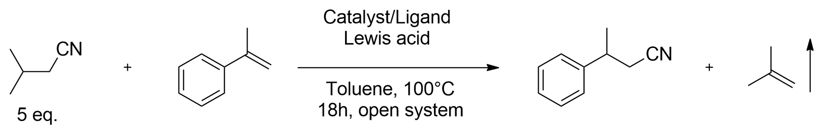

[A] Ni(COD)₂ was added to the reaction vial in a N₂-filled glovebag; [B] The reaction was conducted in a Schlenk tube connected with a positive argon flow; [C] Solid Lewis acids were added to the reaction vial in a N₂-filled glovebag.
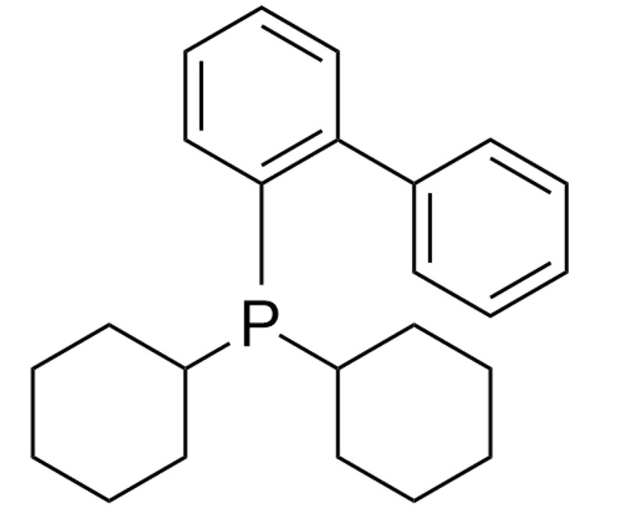
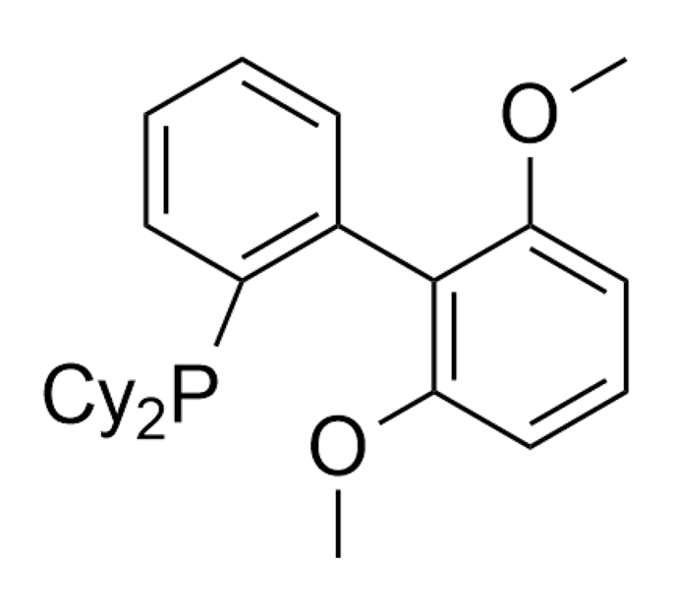
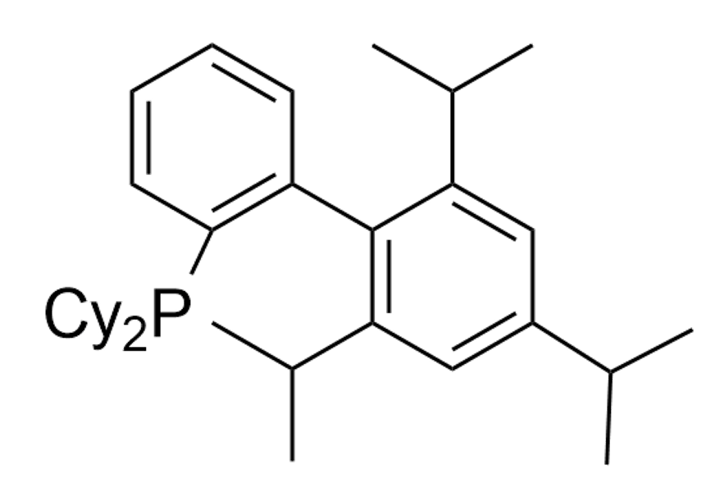
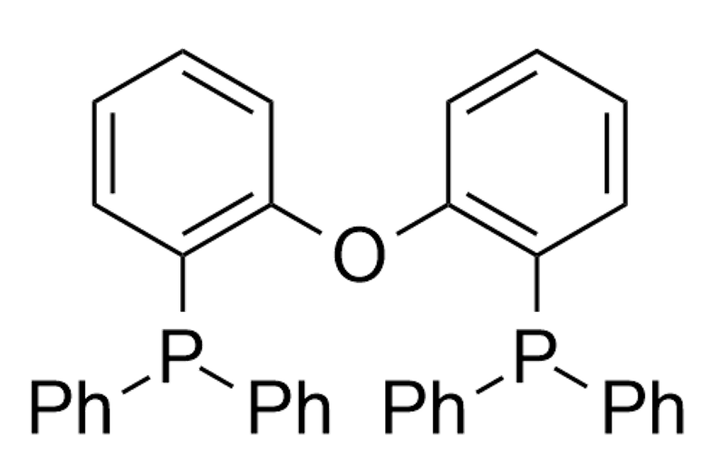

L2, CyJohnPhos
L3, SPhos
L4, Xphos
L1, DPEphos

Evaluation of open vs closed system (table S3)
During our initial studies with the Pd-Xphos catalyst system, we noticed big differences in the reactivity of α-substituted styrenes and unsubstituted styrenes (table S3). For the former, the effect of evaporation and high catalyst loadings were essential to achieve the highest yields. In contrast, classic styrenes provided the best yields with 5 mol% catalyst and 20 mol% Lewis acid in a closed system.

Table S3: Evaluation of open (reaction procedure A) vs closed system (reaction procedure B).
Entry | R | Open/closed system | Temperature (°C) | Mol% (Pd/L/AlMe₂Cl) | Yield (%)
1 | Me | Open | 100 | 10/10/40 | 92
2 | Me | Closed | 100 | 10/10/40 | 46
3 | Me | Closed | 120 | 10/10/40 | 57
4 | Me | Closed | 120 | 5/5/20 | 50
5 | H | Open | 100 | 10/10/40 | 72^{[A]}
6 | H | Open | 100 | 5/5/20 | 83
7 | H | Closed | 100 | 5/5/20 | 80
8 | H | Closed | 120 | 5/5/20 | 84
9 | H | Closed | 120 | 5/5/40 | 78
10 | H | Closed | 120 | 2.5/2.5/10 | 79
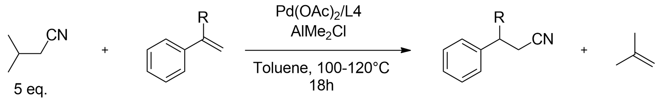

[A] The yields were determined as the sum of the linear and branched nitrile products.

Screening of nitrile donors (tables S4-S6).
In order to gain insight into the thermodynamic properties of the system, a series of nitrile donors was screened (table S4). While isovaleronitrile was established as the optimal donor in the original study of Morandi and co-workers¹⁰, we found that other nitrile donors are more effective in our setup. For example, donors D3-D4-D8, of which the alkene by-products can isomerize rapidly in the presence of Pd-H species, show high yields. The alkene isomers in the reaction mixtures were in thermodynamic equilibrium, as was evident from the large amounts of stable internal alkenes. Because of this, linear alkyl nitrile donors D2-D4-D5-D8 did isomerize to their more stable internal alkyl nitriles via consecutive C-CN bond activation, β-hydride elimination, isomerization and reductive elimination sequences. Nitrile donors D11-D12-D13 were selected based on a recent study of Morandi and co-workers¹⁴. Donor D11 was synthesized via a reported procedure¹⁵. Donors D5-D6-D7-D9 were selected because of their low price and industrial abundance. Generally, higher yields could be obtained when using more equivalents of nitrile sources D5-D6-D7. Because of its common use as a solvent¹⁶, we performed reactions with propionitrile D7 both as solvent and nitrile donor. Beware that propionitrile is still classified as toxic, albeit obviously significantly less compared to HCN and in-situ HCN-releasing surrogates such as acetone cyanohydrin. Nevertheless, caution is advised especially when performing the reactions while refluxing propionitrile (reactions must be performed in a well-ventilated fume hood, which should be closed during the reaction). Interestingly, Pd clearly outperforms Ni when performing reactions with propionitrile (Pd: 25% vs Ni: 6% yield) and to a lesser extent butyronitrile (Pd: 47% vs Ni: 40% yield) as HCN-donors.
The effect of evaporation was compared for nitrile donors D1-D5-D7 (table S5). For isovaleronitrile D1, the effect was an increase in yield of 32%. For butyronitrile D5, the effect was diminished to 23%, while for propionitrile D7, only 6% more products were formed.
Both the yield and the effect of evaporation were correlated with the free enthalpy of formation of the alkene by-product, and as a result, with the free reaction enthalpy (table S6). Alkenes that are more thermodynamically stable, i.e. substituted alkenes such as isobutene, generate the highest thermodynamic driving force (lowest free reaction enthalpy), and thus lead to the highest yields.
Computational procedure for DFT calculations (cfr. table S6).
DFT calculations were set up in Gaussian 09 using the B3LYP functional^{17,18}. Molecule geometries were optimized using the basis set 6-311G(d,p) at DFT level, and subsequent energy calculations were performed using the same basis set. Standard reaction energies were computed based on the difference in calculated electronic free energies between reactants and products in the gas phase at 298K. Geometric coordinates of optimized molecules are shown in in section 18.

Table S4: Screening of nitrile donors with the Pd(OAc)₂/Xphos catalyst system, in the absence of zeolite (reaction procedure B).
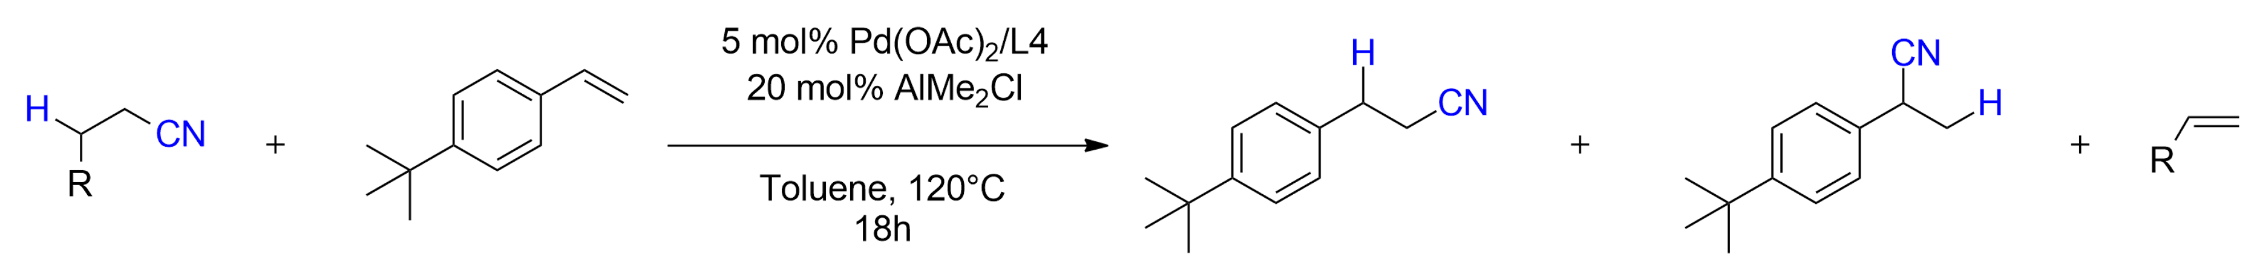

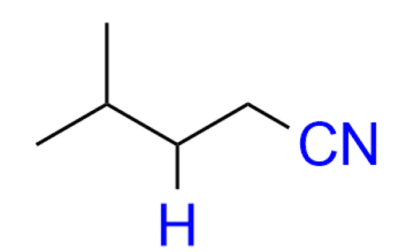
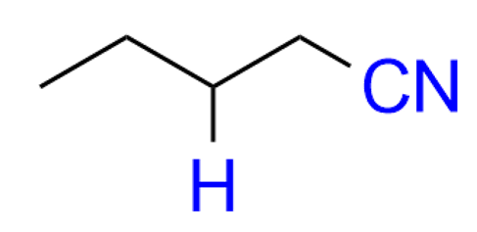
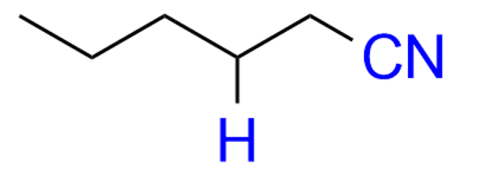
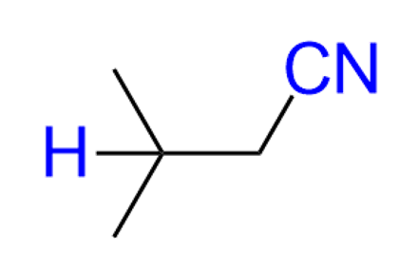
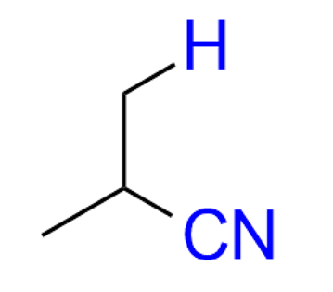
D4
D3
D2
D1
51% yield l:b = 77:23
(10 eq.)
(5 eq.)
72% yield l:b = 77:23
(5 eq.)
(5 eq.)
(5 eq.)
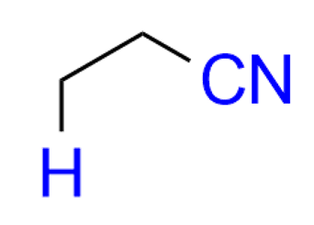
85% yield (Ni:77%)^{[A]} l:b = 76:24
77% yield (Ni:79%)^{[A]} l:b = 76:24
79% yield l:b = 77:23

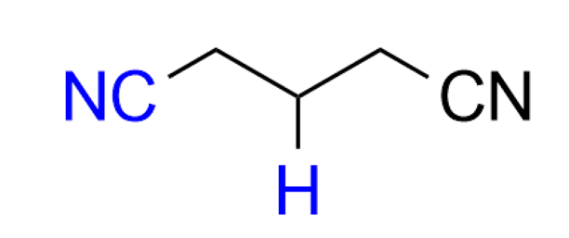
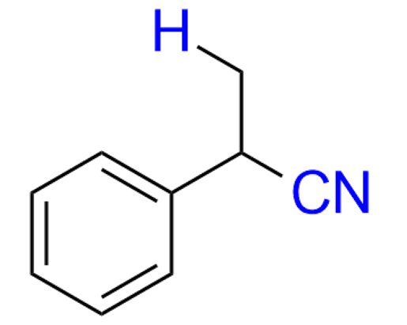
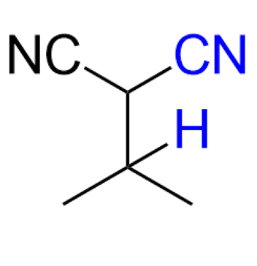
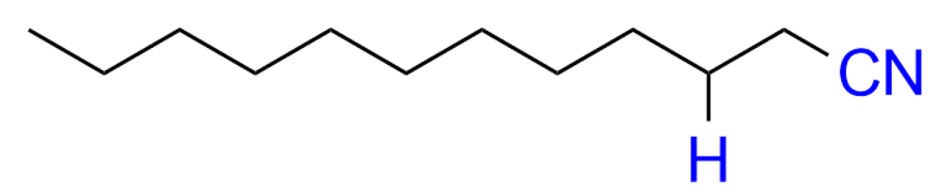
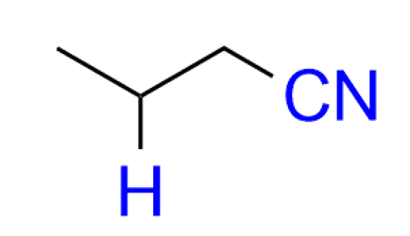
(10 eq.)
10% yield (Ni: <1%)^{[A]} l:b = 79:21
81% yield l:b = 77:23
(5 eq.)
(5 eq.)
76% yield l:b = 80:20
(1.5 eq.)
40% yield l:b = 80:20
(5 eq.)
80% yield l:b = 81:79
(10 eq.)
D7
D6
D5
(solvent)^{[B]}
47% yield (Ni:40%)^{[A]} l:b = 77:23
25% yield (Ni: 4%)^{[A]} Open: 30%^{[C,D]}, 29%^{[E]} l:b = 80:20

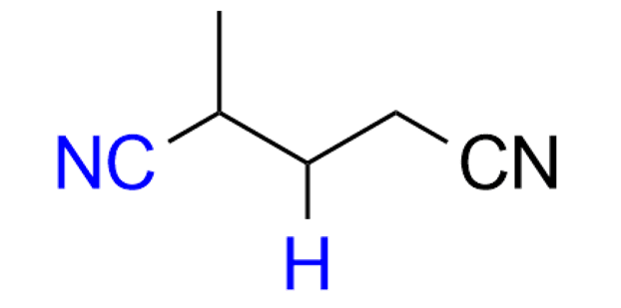
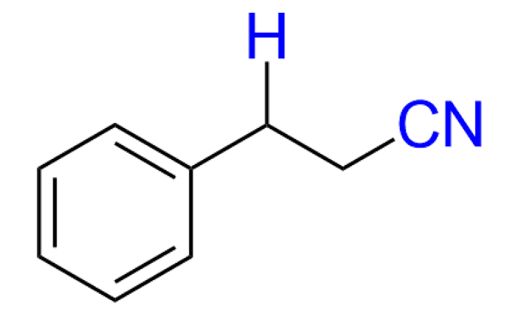
80% yield l:b = 77:23
(5 eq.)
(5 eq.)
57% yield l:b = 80:20
D10
D8
D9

D13
D12
D11

[A] Yields in parentheses correspond to yields obtained with 5 mol% Ni(COD)(DQ) and 5 mol% DPEphos as catalyst system. [B] Reaction with propionitrile as solvent was conducted at 100°C, with 0.5 ml argon-flushed propionitrile and 40 mol% AlMe₂Cl [C] Open system method 1 (reaction procedure A); the vial was connected to a continuous argon flow via a needle during the reaction. The propionitrile liquid level was checked several times, and if needed refilled to account for evaporation of the solvent. [D] Mean value of 4 identical reaction runs (σ = 2.53% yield). [E] Open system method 2 (reaction procedure C); reflux setup under continuous argon flow (see fig. S1).

Table S5: Comparison of evaporation as a driving force for different nitrile donors (open = reaction procedure A, closed = reaction procedure B).
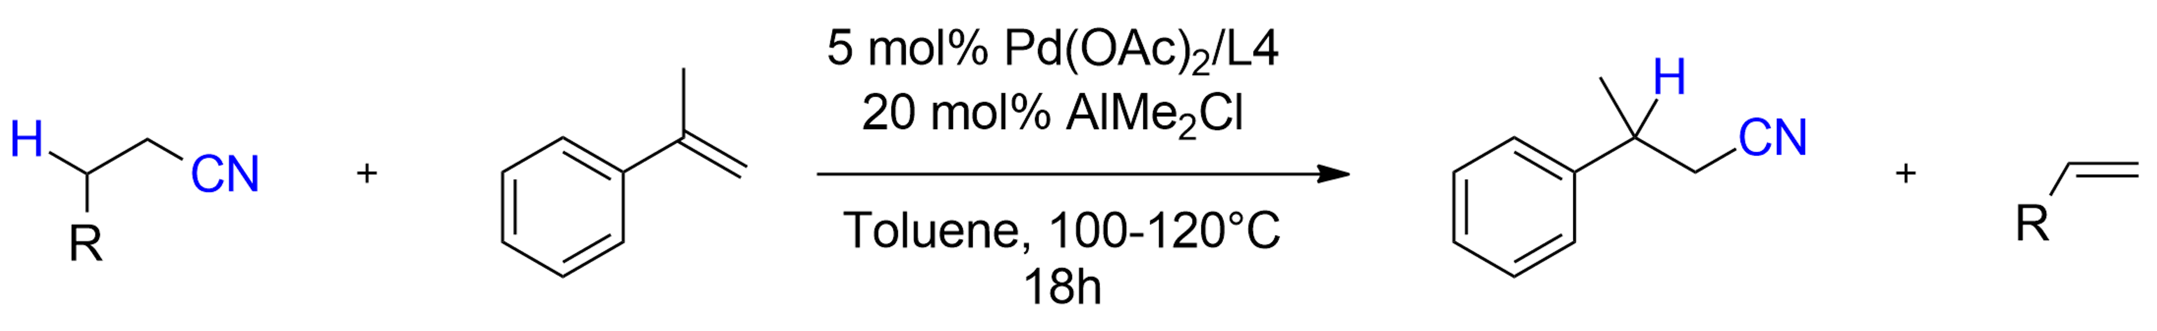

Yield closed: 30% Yield open: 53%
D5
(10 eq.)
(5 eq.)
D7
(solvent)
D1
Yield closed: 13%^{[A]} Yield open: 19%
Yield closed: 49% Yield open: 81%

[A] Reaction with propionitrile as solvent was performed at 100°C, with 0.5 ml argon-flushed propionitrile and 40 mol% AlMe₂Cl.

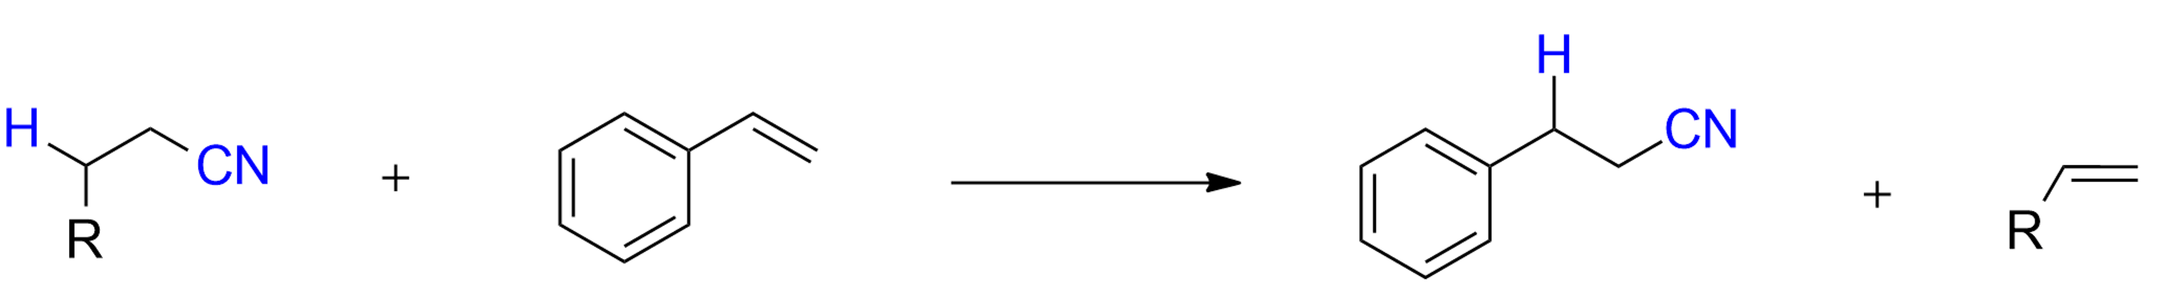
Table S6: Comparison of alkene by-product standard enthalpy of formation, computed enthalpy of reaction at T = 298K and experimental yield with different HCN-donors (reaction procedure B).

Nitrile donor | Alkene by-product | Δ_{f}H⁰ alkene (kJ/mol)^{[B]} | Δ_{r}G⁰ reaction (kJ/mol) ^{[C]} | Yield (%)
Isovaleronitrile (D1) | Isobutene | -17 | +13,2 | 84
Valeronitrile (D2) | 1-butene and 2-butene^{[D]} | -8,8 | +15,0 | 76
Butyronitrile (D5) | Propene | +20 | +23,9 | 48
Propionitrile (D7) | Ethylene | +52,3 | +38,9 | 8
[A] Yields using styrene as acceptor are reported (sum of linear and branched nitrile products) and 5 eq. of nitrile source (first two donors) or 10 eq. of nitrile source (last two donors). [B] Experimental data were obtained from NIST standard reference database nr. 69. [C] Standard reaction energies were calculated based on the difference in calculated free energies (sum of electronic and thermal, using Gaussian 09) between reactants and products in the gas phase at 298K. [D] Calculated based on a thermodynamic equilibrium mixture of 1-butene (20%) and trans-2-butene (80%), since rapid isomerization of 1-butene to 2-butene was observed under the reaction conditions (resulting in approximately the same thermodynamic ratio). Note that without this isomerization process, the reaction energy would be significantly higher (+34,4 kJ/mol).

- Evaluation of reference HCHO-transfer reactions without zeolite
General reaction procedure for transfer hydroformylation reactions without zeolite.
To a 1.5 ml glass vial were added 1.21 mg [Rh(OMe)(1,5-cod)]₂ (0.0025 mmol), 2.78 mg Xantphos (0.005 mmol) and 0.76 mg 3-methoxybenzoic acid (0.005 mmol), together with 0.1 mmol of 1,3,5-tri-tert-butylbenzene (TTBB) as internal standard. The glass vial was capped and placed under an inert argon atmosphere using a Schlenk line, after which argon-flushed aldehyde (0.8 ml) and olefin substrate (0.25 mmol) were added. The vial was then placed in a preheated aluminum heating block at 80°C. After 22h, the vial was cooled on ice. The solution was filtered, and the products were analysed via GC-FID/GC-MS.
Reaction conditions were initially adapted from Murphy et al¹⁹. Further modifications such as tweaking the counter-ion and inclusion of AcOH as additive were made with the rationale of better controlling the Rh coordination sphere in the aldehyde solvent.

Table S7: Initial screening with simple aldehydes as solvents.
1 mol% [Rh(COD)(OMe)]₂
2 mol% Xantphos
2 mol% 3-OMe-Benzoic acid
Entry | Aldehyde | Condition | Yield (%) | l:b
1 | Propanal | standard^{[A]} | 13 | 92:8
2 | Propanal | 4 mol% cat. | 35 | 91:9
3 | Butanal | standard | 44 | 92:8
4 | Butanal | 20 mol% counter-ion | 47 | 94:6
5 | Butanal | open system^{[B]} | 43 | 92:8
6 | Isobutanal | standard | 20 | 92:8
7 | 3-methylbutanal | standard | 36 | 93:7
8 | 3-methylbutanal | 4 mol% cat. | 44 | 95:5
9 | 3-methylbutanal | open system | 40 | 93:7
10 | Pentanal | standard | 45 | 90:10
11 | Heptanal | standard | 44 | 95:5
12 | Heptanal | 70°C | 20 | 95:5
13 | Heptanal | 100°C | 46 | 90:10
14 | Heptanal | 5 eq. in THF | 9 | 91:9
Neat (0.3 M), 80°C, 22h
Closed system

[A]: Standard conditions: 1 mol% [Rh(OMe)(1,5-cod)]₂; 2 mol% Xantphos; 2 mol% 3-OMeBzOH; 0.8 ml aldehyde; 0.25 mmol 4-phenyl-1-butene; 0.1 mmol TTBB; 80 °C; 20 h; argon atmosphere. [B]: Reaction was conducted under a positive argon flow. The yields were determined as the sum of the linear and branched aldehyde products via GC using 1,3,5-tri-tert-butylbenzene as internal standard.

Table S8: Counter-ion screening with 3-methylbutanal as aldehyde and 4-phenyl-1-butene as substrate.
2 mol% [Rh(COD)(OMe)]₂
4 mol% Xantphos
4-20 mol% counter-ion
Additive
Neat (0.3 M), 80°C, 22h
Closed system

Entry | Counter-ion (mol%) | Additive | Yield (%) | l:b
1 | C1 (4 mol%) | / | 44 | 93:7
2 | C1 (20 mol%) | / | 45 | 96:4
3 | C1 (20 mol%) | 3 eq. AcOH | 50 | 95:5
4 | C1 (20 mol%) | 6 eq. AcOH | 42 | 95:5
5 | / | 3 eq. AcOH | 39 | 95:5
6 | C2 (20 mol%) | 3 eq. AcOH | 43 | 95:5
7 | C3 (20 mol%) | 3 eq. AcOH | 44 | 95:5
8 | C4 (20 mol%) | 3 eq. AcOH | 47 | 95:5
9 | C5 (20 mol%) | 3 eq. AcOH | 48 | 92:8
10 | C6 (20 mol%) | 3 eq. AcOH | 55 | 96:4
11 | C7 (20 mol%) | 3 eq. AcOH | 51 | 92:8
12 | C8 (20 mol%) | 3 eq. AcOH | 53 | 95:5

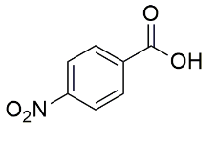
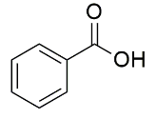
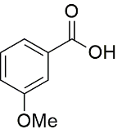
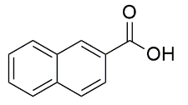
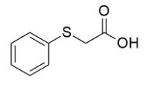
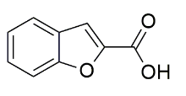
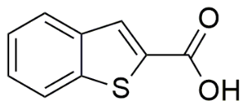
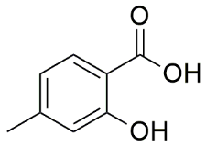
C1
C2
C3
C4
C5
C6
C7
C8

Table S9: Optimization of the HCHO-transfer reaction for styrene substrates.
2.5 mol% [Rh(COD)(OMe)]₂
5 mol% Ligand
4-40 mol% counter-ion
Additive

Neat (0.3 M), T (°C), 18h
Closed system
Entry | Counter-ion (mol%) | Additive | Temperature (°C) | Ligand | Yield (%) | l:b
1 | C1 (4 mol%) | / | 80 | Xantphos | 14 | 68:32
2 | C1 (20 mol%) | / | 105 | Xantphos | 46 | 79:21
3 | C1 (20 mol%) | 3 eq. AcOH | 105 | Xantphos | 21 | 69:31
4 | C2 (20 mol%) | / | 105 | Xantphos | 47 | 77:23
5 | C3 (20 mol%) | / | 105 | Xantphos | 40 | 80:20
6 | C4 (20 mol%) | / | 105 | Xantphos | 52 | 75:25
7 | C5 (20 mol%) | / | 105 | Xantphos | 63 | 83:17
8 | C6 (20 mol%) | / | 105 | Xantphos | 62 | 79:21
9 | C7 (20 mol%) | / | 105 | Xantphos | 68 | 80:20
10 | C7 (10 mol%) | / | 105 | Xantphos | 64 | 81:19
11 | C7 (40 mol%) | / | 105 | Xantphos | 61 | 77:23
12 | C7 (20 mol%) | / | 105 | N-Xantphos | 70 | 83:17
13 | C8 (20 mol%) | / | 105 | Xantphos | 65 | 79:21

C1
C2
C3
C4
C5
C6
C7
C8

- Zeolite-assisted transfer hydrocyanations
General reaction procedure for transfer hydrocyanation with zeolite.
To a 1.5 ml glass vial was added 2.81 mg Pd(OAc)₂ (0.0125 mmol) and 5.95 mg Xphos (0.0125 mmol) together with 0.1 mmol of 1,3,5-tri-tert-butylbenzene as internal standard and the indicated amount of vacuum-activated zeolite. The glass vial was capped and put under an inert argon atmosphere using a Schlenk line, after which dry toluene (0.5 ml), nitrile donor (1.25 – 2.5 mmol) and 4-tert-butylstyrene (46 µl, 0.25 mmol) were added. Finally, 50-100 µl 1M AlMe₂Cl in hexanes (20-40 mol%) was injected. The vial was then placed in a preheated aluminum heating block at 120°C. After 18h, the vial was cooled on ice, and two drops of methanol were added to quench residual Lewis acid. The solution was centrifuged, and the organic products were analysed via GC-FID/GC-MS.

5.1 Zeolite screening with isovaleronitrile (table S10)
Zeolites with varying pore sizes and Si/Al ratios were prepared in different synthesis media (e.g. fluoride or hydroxide media) (see part 2 of SI). We selected a relatively bulky styrene substrate, i.e. 4-tert-butylstyrene, to limit the diffusion inside the zeolite pore system. Initially poor results seemed due to an incompatibility between the Lewis acid and the zeolite, presumably because of the presence of reactive surface hydroxyl groups, e.g. silanols. Such sites are known to be ideal anchors for grafting organo-aluminium complexes^{20–23}; hence zeolites with a high density of hydroxyl groups may lead to loss of the AlMe₂Cl Lewis acid. Consequently, we performed reactions with both 20 and 40 mol% Lewis acid (with constant amount of Pd catalyst). Additionally, the presence of water adsorbed on the zeolite, and diffusion of the Lewis acid inside the pores of the zeolite might contribute to the consumption of the Lewis acid (vide infra). Thus, all zeolites were thermally activated under vacuum (T=250°C, P < 10⁻³ mbar).
Zeolites that are synthesized in F⁻ media contain very few silanol defects²⁴. Reactions with such defect-free 10 MR zeolites (group A, entries 3-6) show a slightly negative effect on the yield when 20 mol% Lewis acid is added. Increasing the Lewis acid loading to 40 mol% provides a similar yield as in the reference reaction with 20 mol% Lewis acid. A more pronounced version of this trend is observed with 12 MR zeolites (group A, entries 7-10). Some of the Lewis acid molecules will likely diffuse into the solid; the extent of this is determined by the pore size of the solid. Hence, quick diffusion of a significant portion of the Lewis acid into 12 MR zeolites explains the poor yields obtained at low Lewis acid loadings. At higher Lewis acid loadings, poor selectivity is observed for 12 MR zeolites, which might be explained by diffusion of the styrene substrate into the pore system. Reactions with non-acidic zeolites synthesized in alkaline media (group B, entries 11-14) provided no products at 20 mol% Lewis acid loading, in line with the expected reaction of the silanol groups with the Lewis acid. With 40 mol% Lewis acid, addition of silicalite-1 to the reaction mixture results in a higher yield (+10%) compared to the reaction without solid catalyst. Note that doubling the Lewis acid concentration did not positively affect the homogeneous benchmark reactions (entry 2). Na-Beta on the other hand leads to poor yield and selectivity (entry 14). Next, acidic zeolites with pore windows ranging from 3.8 Å to 7.4 Å were screened (group C, entries 15-27). Zeolites with Si/Al < 75 show no products at low or high Lewis acid loadings, regardless of pore size (table S10, entries 15-21 and 25-27). Acidic zeolites with Si/Al ≥ 75 and large pore size (12 MR) furnish trace amounts of products (table S7, entry 26), while zeolites with Si/Al ≥ 75 and small or medium pore size (= 10 MR) showed a yield increase between 17-21% compared to the reference reaction at 40 mol% Lewis acid loading (entries 22-24). Based on this, we conclude that: 1) zeolites with low Si/Al impede the reaction by consuming the Lewis acid, 2) zeolites with large pore size (e.g. Beta) can have a negative effect on the reaction due to diffusion of the Lewis acid and/or the styrene substrate into the solid.
Table S10: Zeolite screening with isovaleronitrile (general reaction procedure with 50 mg zeolite).
Reference reaction without zeolite
Entry |  |  |  | AlMe₂Cl (mol%) | Yield (%) | Conversion styrene (%) | Selectivity (%)
1 |  |  |  | 20 | 77 | 84 | 92
2 |  |  |  | 40 | 71 | 85 | 84
Group A: defect-free zeolites (syn. in F-media)
Entry | Zeolite |  | Max ring | AlMe₂Cl (mol%) | Yield (%) | Conversion styrene (%) | Selectivity (%)
3 | FER (104) |  | 10 MR | 20 | 71 | 80 | 89
4 | FER (104) |  | 10 MR | 40 | 73 | 88 | 83
5 | Silicalite-1 (NH₄F) |  | 10 MR | 20 | 67 | 74 | 91
6 | Silicalite-1 (NH₄F) |  | 10 MR | 40 | 76 | 90 | 84
7 | Beta (All-Si) |  | 12 MR | 20 | 28 | 43 | 65
8 | Beta (All-Si) |  | 12 MR | 40 | 68 | 93 | 73
9 | Sn-Beta |  | 12 MR | 20 | 7 | 19 | 37
10 | Sn-Beta |  | 12 MR | 40 | 71 | 97 | 73
Group B: Zeolites containing silanols but no/few acid sites
Entry | Zeolite |  | Max ring | AlMe₂Cl mol% | Yield (%) | Conversion styrene (%) | Selectivity (%)
11 | Silicalite-1 (OH) |  | 10 MR | 20 | n.d. | 5 | n.d.
12 | Silicalite-1 (OH) |  | 10 MR | 40 | 87 | 96 | 91
13 | Na-Beta (CP814C) |  | 12 MR | 20 | n.d. | 93 | 73
14 | Na-Beta (CP814C) |  | 12 MR | 40 | 12 | 27 | 44
Group C: Zeolites containing acid sites and silanol defect sites
Entry | Zeolite (Si/Al) |  | Max ring | AlMe₂Cl mol% | Yield (%) | Conversion styrene (%) | Selectivity (%)
15 | H-CHA (10) |  | 8 MR | 20 | n.d. | 2 | n.d.
16 | H-CHA (10) |  | 8 MR | 40 | n.d. | 5 | n.d.
17 | H-ZSM-5 (15) |  | 10 MR | 20 | n.d. | 8 | n.d.
18 | H-ZSM-5 (15) |  | 10 MR | 40 | n.d. | 4 | n.d.
19 | H-ZSM-5 (25) |  | 10 MR | 40 | n.d. | 10 | n.d.
20 | H-ZSM-5 (40) |  | 10 MR | 40 | n.d. | 9 | n.d.
21 | H-ZSM-5 (140) |  | 10 MR | 20 | n.d. | 3 | n.d.
22 | H-ZSM-5 (140) |  | 10 MR | 40 | 88 | 94 | 94
23 | H-ZSM-48 (100) |  | 10 MR | 40 | 95 | 97 | 98
24 | H-ZSM-11 (120) |  | 10 MR | 40 | 89 | 93 | 96
25 | H-MCM-22 (15) |  | 10 MR | 40 | n.d. | 4 | n.d.
26 | H-Beta (75) |  | 12 MR | 40 | 11 | 28 | 39
27 | H-USY (30) |  | 12 MR | 40 | n.d. | 29 | n.d.

  - Interaction between Lewis acid and zeolite: experimental observations (table S11).
Based on the results in table S10, we decided to study the interaction between the Lewis acid and the zeolite in more detail. An experiment was designed to separately study the contributions of diffusion into the solid material and complexation with external acidic silanol sites (table S11). In order to limit the effect of diffusion, Al(i-Bu)₂Cl was chosen as a bulky Lewis acid. The external and pore-mouth acidic silanol sites were deactivated using CLD (chemical liquid deposition) with TEOS (see SI section 2 for more details)⁸. With AlMe₂Cl as a Lewis acid, full reaction inhibition occurs when the loading is 20 mol% or less, both with non-modified H-ZSM-5 and silylated Si-H-ZSM-5. With the bulky Al(i-Bu)₂Cl as Lewis acid, only the silylated Si-H-ZSM-5 shows no reaction inhibition at 20 mol% Lewis acid loading. This indicates that 1) the smaller AlMe₂Cl Lewis acid is able to diffuse inside the pores of the ZSM-5 zeolite, and 2) External and pore mouth acid sites are responsible for the consumption of a significant amount of Lewis acid, which can be suppressed by passivation of these sites. Considering the yields are superior with higher loadings of AlMe₂Cl (40 mol%) and the parent acidic zeolites, we pursued our studies without passivation of the zeolites.
Table S11: Interaction between Lewis acid (LA) and zeolite (general reaction procedure with zeolite).
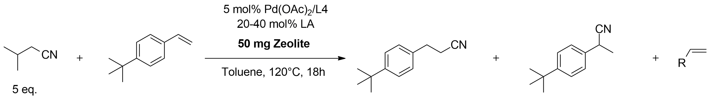

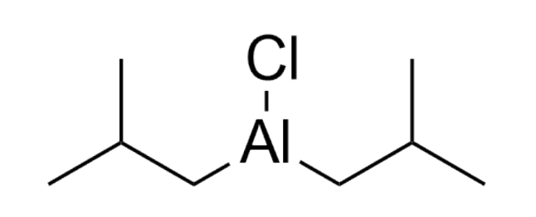
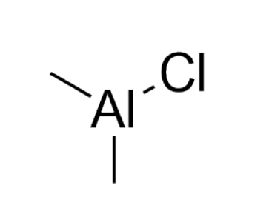
LA2:
LA1:

Entry | LA (mol%) | Zeolite (Si/Al) | Yield (%) | Selectivity (%)
1 | LA1 (20 mol%) | / | 77 | 92
2 | LA1 (40 mol%) | / | 71 | 84
3 | LA1 (20 mol%) | H-ZSM-5 (140) | 0 | 0
4 | LA1 (40 mol%) | H-ZSM-5 (140) | 88 | 93
5 | LA1 (20 mol%) | Si-H-ZSM-5 (140) | 0 | 0
6 | LA1 (40 mol%) | Si-H-ZSM-5 (140) | 89 | 96
7 | LA2 (20 mol%) | / | 75 | 90
8 | LA2 (40 mol%) | / | 72 | 85
9 | LA2 (20 mol%) | H-ZSM-5 (140) | 0 | 0
10 | LA2 (40 mol%) | H-ZSM-5 (140) | 86 | 90
11 | LA2 (20 mol%) | Si-H-ZSM-5 (140) | 79 | 91
12 | LA2 (40 mol%) | Si-H-ZSM-5 (140) | 84 | 86

5.3 Optimizing the amount of zeolite (fig. S2).
The added amount of H-ZSM-5 (140) was optimized, considering a constant Lewis acid loading of 40 mol% (fig. S2). A yield of 97% was achieved with 90 mg zeolite, which amounts to a yield increase of 26% compared to the identical reaction without zeolite. Higher amounts of zeolite result in slightly lower yields, presumably due to consumption of the Lewis acid by diffusion inside the zeolite or by reaction with silanol groups of the zeolite.
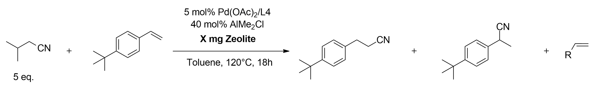

Fig. S2: Influence of the amount of zeolite on the yield using isovaleronitrile as HCN-donor (general reaction procedure with zeolite).

5.4 H-ZSM-5-assisted reaction with different nitrile donors (fig. S3).
The effect of H-ZSM-5 (140) was studied for the nitrile donors previously screened in table S4. In order to guarantee an unambiguous comparison, all reactions in fig. S3 were performed under identical conditions (i.e. 40 mol% Lewis acid). Hence, some reference reactions without zeolite show slightly lower yields than in table S4. Zeolite-assisted experiments with propionitrile, isovaleronitrile and glutaronitrile were repeated multiple times (3 or 4), providing standard deviations as indicated by the error bars that show the 95% confidence interval.

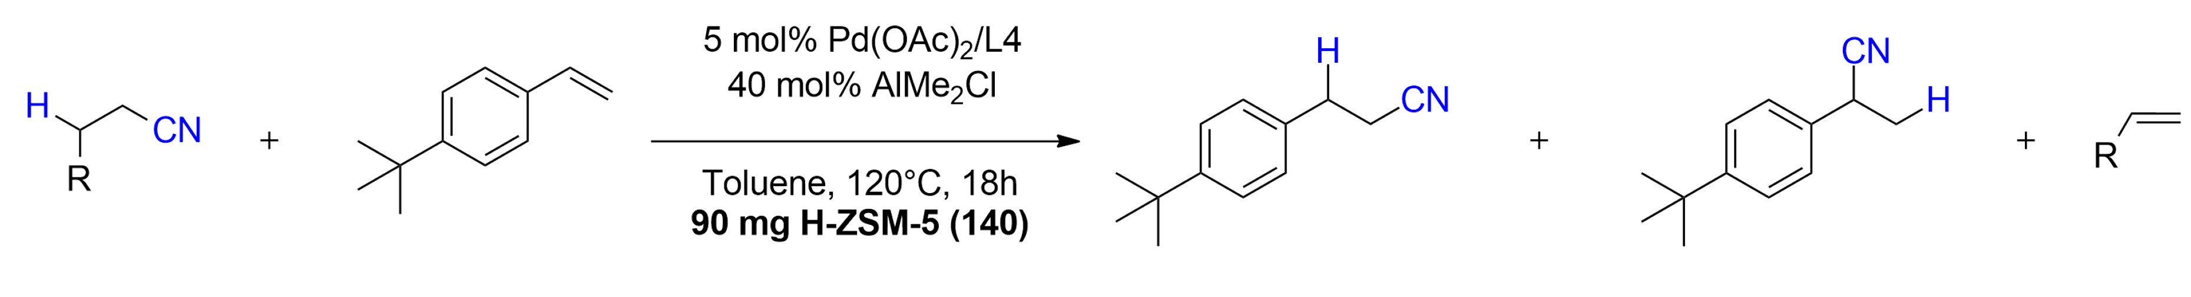

(5 eq.)
(5 eq.)
(5 eq.)
(5 eq.)
D1
D2
D3
D4

(10 eq.)
(10 eq.)
(10 eq.)
(solvent)
D5
D6
D7
D7s^{[A]}

(5 eq.)
(5 eq.)
(5 eq.)
D8
D9
D10

(2 eq.)
(5 eq.)
(5 eq.)
D11
D12
D13

Fig. S3: Screening of nitrile donors with zeolite H-ZSM-5 (Si/Al = 140) (general reaction procedure). [A] Reaction with propionitrile as solvent was done at 100°C. L/b was between 76:24 and 79:21 for all donors except for D7s (propionitrile as solvent) and D8, where l/b were 81:19 and 82:18 respectively.

5.5 Tracing the olefin-based reaction products (table S12)
Following the general procedure above, GC-MS spectra were recorded of all reactions. The difference chromatograms between reactions without zeolite and reactions with zeolite were computed, and the resulting peaks were identified. Note that some products are likely not recorded due to overlap with the solvent peak (toluene). GC-MS ESI data of some reaction products which gave multiple matches (e.g. unsaturated hydrocarbons) are given below the table.
Table S12: Identification of reaction products derived from HCN-donors. All products were identified with GC-MS EI (70 eV). Dominant products (i.e. fraction of total > 40%) in zeolite-assisted reactions are bolded. Nitrile products are in cursive.
Nitrile donor | Without H-ZSM-5 (140) | With H-ZSM-5 (140)
D1  Isovaleronitrile | Isobutene | Isobutene  2,4,4-trimethyl-2-pentene  2,4,4-trimethyl-1-pentene  2,3,4-trimethyl-2-pentene  3,4,4-trimethyl-2-pentene  2,2,4,6,6-pentamethyl-3-heptene and isomers  3,5,5-trimethyl-hexanenitrile and isomers
D2  Valeronitrile | 1-butene  cis-2-butene  trans-2-butene  2-methylbutanenitrile | 1-butene  cis-2-butene  trans-2-butene  2-methylbutanenitrile  3,​4-​dimethyl-3-hexene  1-methyl-4-(1-methylpropyl)benzene  1-methyl-3-(1-methylpropyl)benzene
D3  Isocapronitrile | 3-methyl-1-butene  2-methyl-2-butene  2,3-dimethyl-butanenitrile | 3-methyl-1-butene  2-methyl-2-butene  2,3-dimethyl-butanenitrile  2,​3,​4,​4-​tetramethyl-2-hexene  2,4,4-trimethyl-3-methylenehexane  2,​3,​4,​4-​tetramethyl-1-hexene
D4  Hexanenitrile | 1-pentene  2-pentene  2-methylpentanenitrile  2-ethylbutanenitrile | 1-pentene  2-pentene  2-methylpentanenitrile  2-ethylbutanenitrile
D5  Butyronitrile | Propene  Isobutyronitrile | Propene  Isobutyronitrile  2-hexene  3-hexene  2-methyl-2-pentene  p-cymene  m-cymene  3-methylhexanenitrile
D6  Isobutyronitrile | Propene  Butyronitrile | Propene  Butyronitrile  2-hexene  3-hexene  2-methyl-2-pentene  p-cymene  m-cymene  3-methylhexanenitrile
Propionitrile  D7 | Ethylene | Ethylene  1-butene  cis-2-butene  trans-2-butene  2-methylbutanenitrile  Valeronitrile
D8  Dodecanenitrile | Undecene  Mixture of internal olefins  Mixture of internal nitriles (poorly distinguishable) | Undecene  Mixture of internal olefins  Mixture of internal nitriles (poorly distinguishable)
D9  2-methylglutaronitrile | 3-pentenenitrile  2-pentenenitrile | 3-pentenenitrile  2-pentenenitrile
D10  Glutaronitrile | Allyl cyanide  Crotonitrile | Allyl cyanide  Crotonitrile  Solid deposit starts appearing from ~ 25 min reaction time
D11  Isopropylmalononitrile | 3-methyl-2-butenenitrile | 3-methyl-2-butenenitrile  Solid paste starts appearing from ~ 15 min reaction time
D12  3-phenylpropionitrile | Styrene  α-methyl phenyl acetonitrile | Styrene  α-methyl phenyl acetonitrile
D13  α-methyl phenyl acetonitrile | Styrene  3-phenylpropionitrile | Styrene  3-phenylpropionitrile
GC-MS EI (70 eV, m/z rel. int%):
3,4,4-trimethyl-2-pentene : 112 (26), 97 (100), 69 (31), 57 (23), 55 (99), 53 (11), 41 (34), 39 (21)
2,2,4,6,6-pentamethyl-3-heptene: 168 (15), 112 (22), 97 (95), 83 (19), 69 (29), 57 (100), 55 (28), 41 (48), 39 (14), 29 (16)
2,2,4,6,6-pentamethyl-3-heptene isomer: 168 (5), 112 (5), 97 (10), 83 (5), 69 (5), 57 (100), 41 (27), 29 (10)
3,5,5-trimethyl-hexanenitrile: 138 (5), 124 (10), 110 (49), 97 (50), 96 (85), 83 (72), 82 (87), 57 (46), 56 (20), 55 (59), 54 (77), 43 (76), 42 (22), 41 (100), 39 (25), 29 (47), 27 (34)
3,5,5-trimethyl-hexanenitrile isomer: 97 (54), 83 (12), 69 (27), 68 (29), 57 (100), 56 (73), 55 (52), 43 (24), 41 (69), 39 (18), 29 (23), 27 (16)

5.6 Additional zeolite screenings
Different zeolites were tested in the transfer hydrocyanation reaction using butyronitrile as a donor (fig. S4). Ni-zeolites were prepared as explained in the experimental procedures in chapter 2 of the SI. The relative magnitude of the increase in yield with unmodified zeolites H-ZSM-5, H-ZSM-48, silicalite-1 and Sn-Beta is similar to what was observed with isovaleronitrile as donor (table S10). Incorporating Ni via ion exchange of the H-form of ZSM-5 (100) leads to another 15% increase in yield, resulting in a to a total yield increase of 35% compared to the reaction without zeolite.

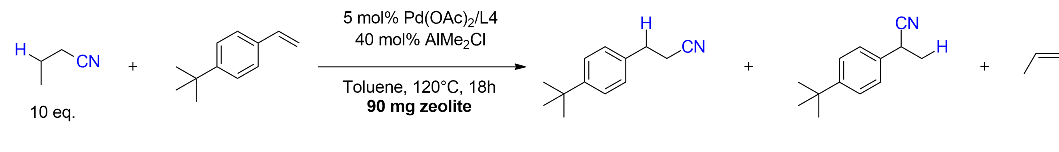
Zeolite screening with butyronitrile (fig. S4)

Fig. S5: Zeolite screening with butyronitrile as a donor (general reaction procedure). 90 mg of zeolite was used, except for Sn-Beta (50 mg). Abbreviations; i.e. = ion exchange, imp. = impregnation.

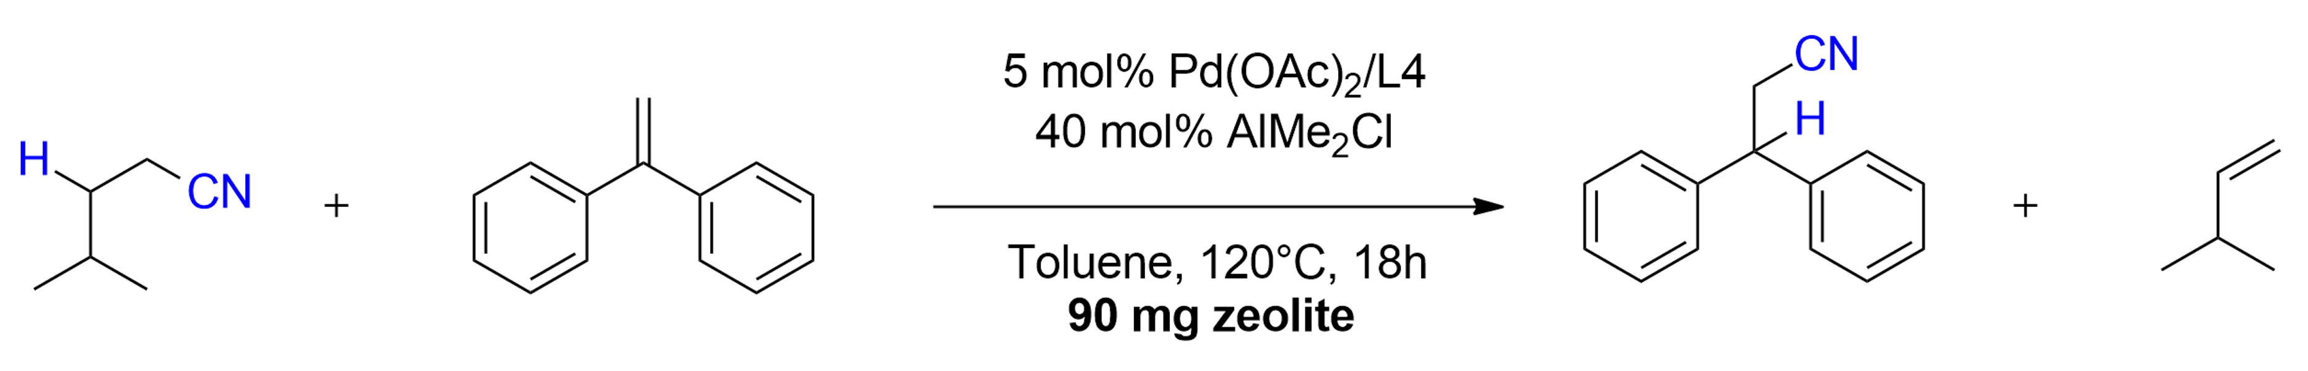
Zeolite screening with isocapronitrile (fig. S5)

Fig. S5: zeolite screening with isocapronitrile as a donor (general reaction procedure with zeolite). 90 mg of zeolite was used, except for Sn-Beta (50 mg).

Zeolite screening with propionitrile (fig. S6)
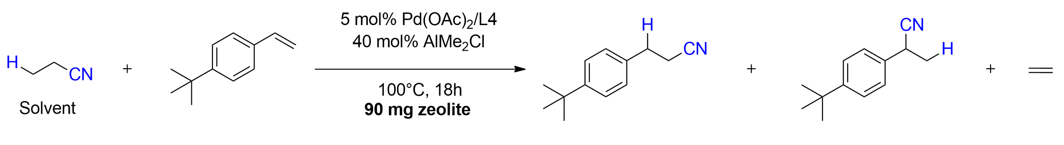

Fig. S6: zeolite screening with propionitrile as a donor. 90 mg of zeolite was used (general reaction procedure with zeolite, but with 0.5 ml argon-flushed propionitrile instead of toluene, and at T=100°C). Abbreviations; i.e. = ion exchange, imp. = impregnation, sil = silylated.

Zeolite screening with glutaronitrile (fig. S7)
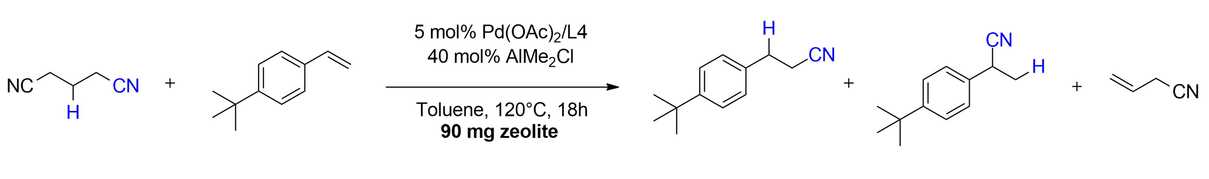

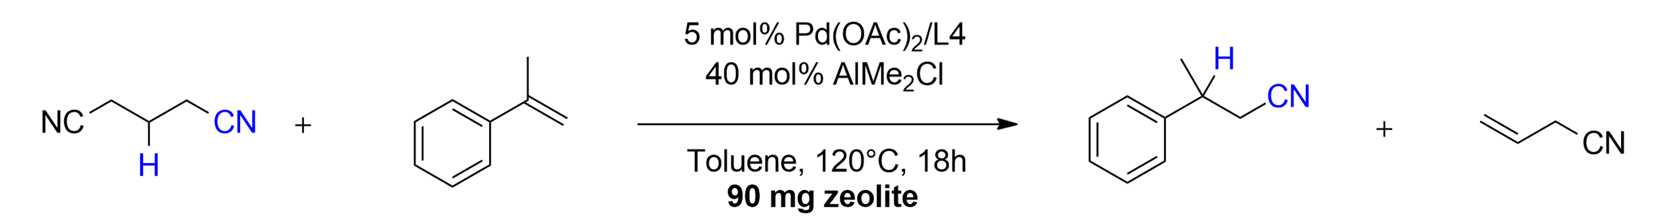

Fig. S7: zeolite screening with glutaronitrile as a donor (general reaction procedure with zeolite). 90 mg of zeolite was used, except for Sn-Beta (60 mg of zeolite). Abbreviations; i.e. = ion exchange, imp. = impregnation.

5.7 Influence of Pd-source and Pd/Ligand amount (fig. S8-S10)
The effect of the zeolite is rather insensitive to the Pd-source when isovaleronitrile is used as HCN-donor (fig. S8). With propionitrile on the other hand, significant differences between Pd-sources can be observed. Most notably, with a Pd(0)-source such as Pd₂dba₃, the zeolite has no effect on the yield. With Pd(TFA)₂, the yield is still rather low with the zeolite, but has increased (doubled) relative to reaction without zeolite. Varying the Pd-Xphos catalyst loading provides a somewhat more consistent result when comparing both HCN-donors (fig. S9). However, changing the ratio of Pd/Xphos again leads to contrasting results (fig. S10). For isovaleronitrile, higher amounts of Xphos relative to Pd provides slightly improved results, while with propionitrile an optimum is reached at a 1:1 ratio.
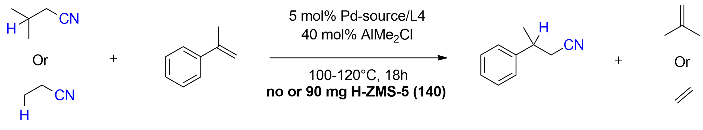

Fig. S8: Pd-source screening with isovaleronitrile (5 eq. in toluene at T=120°C) or propionitrile (solvent at T=100°C) as HCN-donors and α-methylstyrene as acceptor (general closed system reaction procedure).

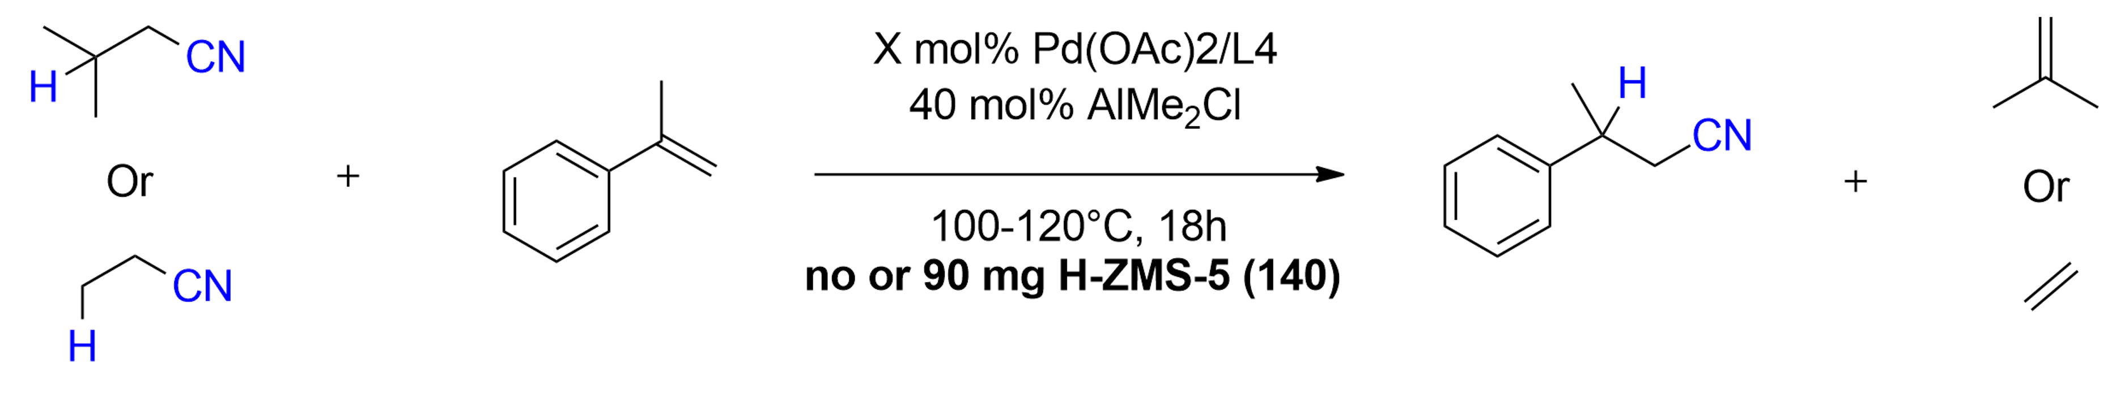

Fig. S9: Catalyst mol% screening with isovaleronitrile (5 eq. in toluene at T=120°C) or propionitrile (solvent at T=100°C) as HCN-donors and α-methylstyrene as acceptor (general closed system reaction procedure).

Fig. S10: Pd:L4 (mol%:mol%) ratio screening with isovaleronitrile (5 eq. in toluene at T=120°C) or propionitrile (solvent at T=100°C) as HCN-donors and α-methyl styrene as acceptor (general closed system reaction procedure).

5.8 Kinetic experiments (figs. S11-S17).
Figures S11-S13 and S16 show time profiles of reactions with isovaleronitrile, butyronitrile, propionitrile and glutaronitrile as HCN-donors, both with and without addition of H-ZSM-5 (140). With propionitrile as donor, a hot filtration test was performed (fig. S14). To this end, a standard reaction was set up with the zeolite, and after the indicated amount of time (e.g. 1 or 4h), the zeolite was removed via filtration and the clear, hot solution was left reacting for up to 18h. Furthermore, the time experiment with propionitrile showed a highly linear first-order relationship between ln(substrate) (mmol) and time (hours), indicating first-order kinetics in the substrate (fig. S15). It is also worth mentioning that, in some experiments with propionitrile, an induction period was observed (of 1-2h). We hypothesize that this could be related to the formation of the active species responsible for the dimerization, similarly to previous studies on Pd-catalyzed dimerization of ethylene^{25,26}.

5.8.1 Isovaleronitrile

Fig. S11: Time profile for isovaleronitrile reaction with and without zeolite (general closed system reaction procedure with 4-tert-butylstyrene as acceptor).

5.8.2 Butyronitrile
Fig. S12: Time profile for butyronitrile reaction with H-ZSM-5, Ni/H-ZSM-5 and without zeolite (general closed system reaction procedure with 4-tert-butylstyrene as acceptor).

5.8.3 Propionitrile

Fig. S13: Time profile for propionitrile reaction with H-ZSM-5 and without zeolite (general closed system reaction procedure with 4-tert-butylstyrene as acceptor).
Hot filtration experiments with propionitrile

Fig. S14: Hot filtration test of propionitrile reaction with H-ZSM-5 (140) (general closed system reaction procedure with 4-tert-butylstyrene as acceptor).

First-order kinetic fit between Ln[substrate] and reaction time (first 4h)

Fig. S15: Fit between Ln(substrate) and reaction time for the first 4h of the reaction with propionitrile and H-ZSM-5 (140) (general closed system procedure with 4-tert-butylstyrene as acceptor).

5.8.4 Glutaronitrile

Fig. S16: Time profile for glutaronitrile reaction with H-ZSM-5 (140) and without zeolite (general closed system procedure with 4-tert-butylstyrene as acceptor).

5.8.5 Comparison of kinetic profiles with different HCN-donors (fig. S17)
The time profiles show differences in kinetic behaviour between the HCN-donors (fig. S17). Without zeolite, reactions rapidly equilibrate, and the position of the equilibrium depends on the HCN-donor. With H-ZSM-5, the initial kinetics are similar, but in a next phase, the equilibrium substantially shifts to higher product concentrations, as seen for example with isovaleronitrile. In reactions with propionitrile, no real distinction between these phases can be made. Such differences in kinetic behaviour strongly indicate different mechanisms of the zeolite-catalyzed olefin conversion associated with the corresponding HCN-donors.
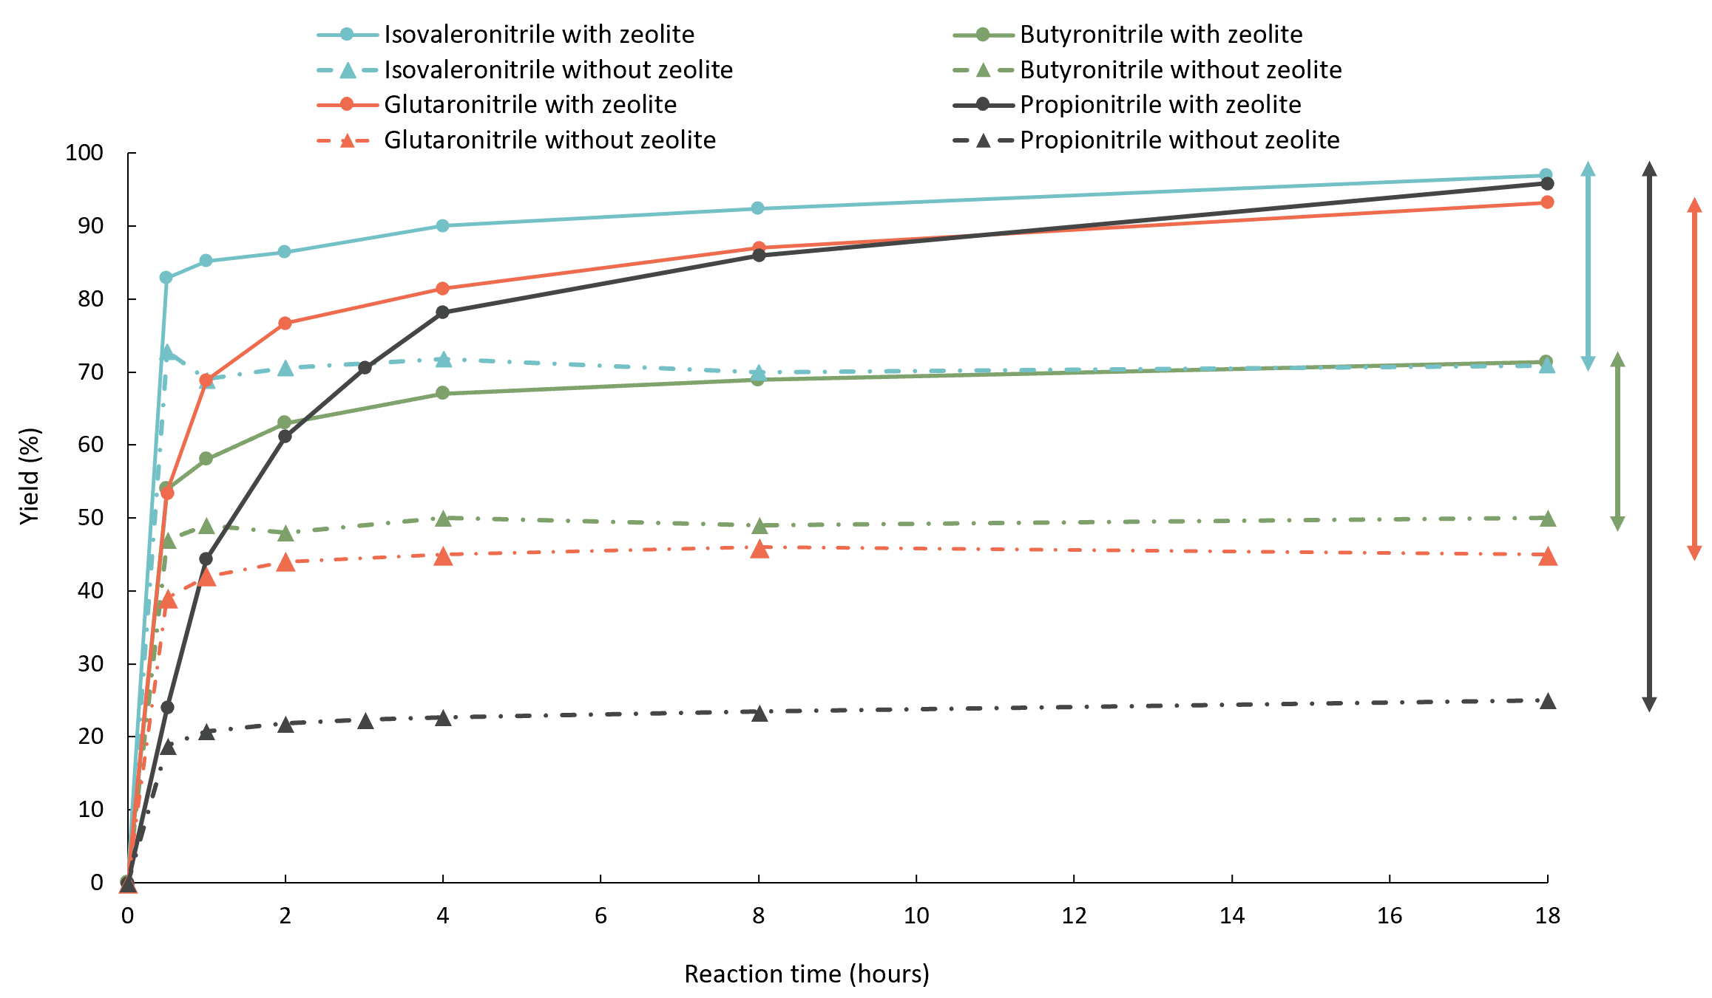

Fig. S17: Time profiles of reactions with isovaleronitrile (light blue), butyronitrile (green), glutaronitrile (orange) and propionitrile (dark grey) without (dotted lines) and with zeolite (full lines). Reaction conditions: 5 mol% Pd(OAc)₂, 5 mol% Xphos, 40 mol% AlMe₂Cl, 5 eq. isovaleronitrile, 5 eq. glutaronitrile, 10 eq. butyronitrile or propionitrile as solvent, 1 eq. 4-tert-butylstyrene, 120°C (isovaleronitrile and butyronitrile) or 100°C (propionitrile), 0.6 ml solvent (toluene or propionitrile, 0.4M), no or 90 mg H-ZSM-5, 18h

- Zeolite-assisted transfer hydroformylations

6.1 Aldehyde screening with zeolites (table S13)
General reaction procedure for transfer hydroformylations with zeolite.
To a 1.5 ml glass vial were added 1.21 mg [Rh(OMe)(1,5-cod)]₂ (0.0025 mmol), 2.78 mg Xantphos (0.005 mmol) and 0.76 mg 3-methoxybenzoic acid (0.005 mmol), together with 0.1 mmol of 1,3,5-tri-tert-butylbenzene as internal standard and the indicated amount of zeolite catalyst. The glass vial was capped and placed under an inert argon atmosphere using a Schlenk line, after which argon-flushed aldehyde (0.8 ml) and olefin substrate (0.25 mmol) were added. The vial was then placed in a preheated aluminum heating block at 80°C. After 22h, the vial was cooled on ice. The zeolite was removed via centrifugation, and the products were analysed via GC-FID/GC-MS.
Table S13: Aldehyde screening with H-ZSM-5 zeolites and 4-phenyl-1-butene.
1 mol% [Rh(COD)(OMe)]₂
2 mol% Xantphos
2 mol% 3-OMe-Benzoic acid
Neat (0.3 M), 80°C, 22h
Closed system
50 mg zeolite

Entry | Aldehyde | Zeolite | Yield (%) | l:b
1 | Propanal^{[A]} | No | 35 | 91:9
2 | Propanal^{[A]} | H-ZSM-5 (140) | 19 | 90:10
3 | Propanal^{[A]} | Pd@ZSM-5 (140) | 24 | 91:9
4 | Butanal | No | 44 | 92:8
5 | Butanal | H-ZSM-5 (140) | 34 | 91:9
6 | Butanal | Ni@ZSM-5 (140) | 39 | 91:9
7 | Isobutanal | No | 20 | 92:8
8 | Isobutanal | H-ZSM-5 (140) | 28 | 94:6
9 | 3-methylbutanal | No | 36 | 93:7
10 | 3-methylbutanal | H-ZSM-5 (140) | 49 | 94:6
11 | 3-methylbutanal | H-ZSM-5 (140) (100 mg) | 56 | 94:6
12 | Heptanal | No | 44 | 90:10
13 | Heptanal | H-ZSM-5 (140) | 36 | 90:10

[A]: 2 mol% [Rh(OMe)(1,5-cod)]₂, 4 mol% Xantphos, 4 mol% 3-OMeBzOH. The yields were determined as the sum of the linear and branched aldehyde products via GC using 1,3,5-tri-tert-butylbenzene as internal standard.

6.2 Condensation products analysis (fig. S18-S19)
The detrimental effect of acidic zeolites on the reaction with small linear aldehydes was studied in more detail by analysing the resulting product mixtures, showing a clear surge in aldol-type condensation products (fig. S18). In contrast, for 3-methylbutanal, essentially no increase in condensation products was observed after adding H-ZSM-5 (fig. S19). Adding 2 eq. of 2-methyl-2-pentenal (propanal condensation product) resulted in a decrease in yield of 58%, indicating a poisoning effect of the aldol products on the transfer hydroformylation catalyst.
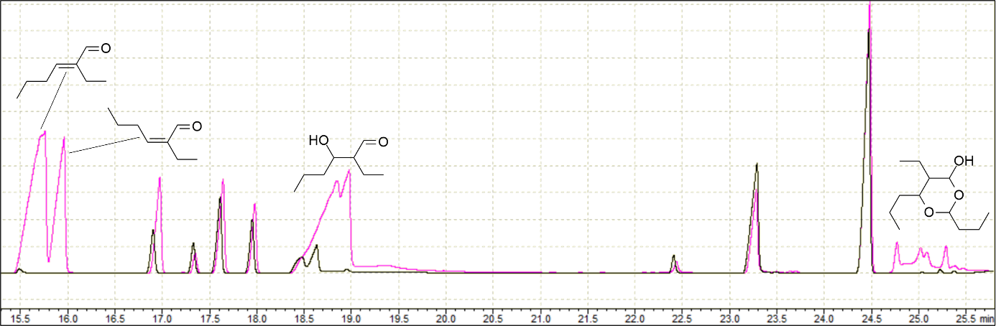
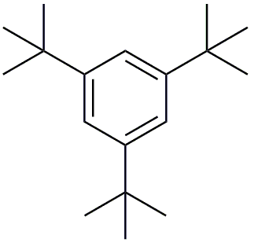
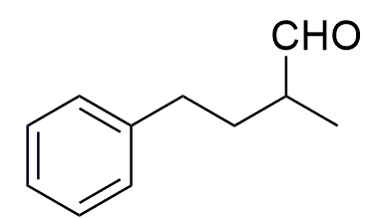
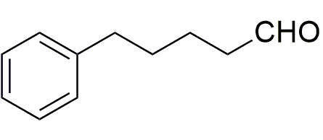
Substrate + isomers

Fig. S18: Appearance of condensation products in reaction with butanal and H-ZSM-5. Relevant GC cut of the reference reaction with butanal; without zeolite (black) and with H-ZSM-5 (140) (pink).

Fig. S19: Quantification of condensation products after reaction without and with H-ZSM-5 zeolite using different aldehyde solvents.

6.3 Zeolite screening and optimization for HCHO-transfer (table S14)
The influence of the zeolite’s topology and pore size on the equilibrium-shifting effect is similar as in the transfer hydrocyanation with isovaleronitrile (table S10). Zeolites with large 12-membered rings (or with a layered structure, i.e. MCM-22) are not suitable, as undesired consumption of the 4-phenyl-1-butene substrate was observed (entries 10-12; low mass balance). Zeolites with smaller 10-membered rings and no or few acid sites (silicalite-1 and Na-ZSM-5) have little effect on the yield and selectivities (entries 2,3), indicating the necessity of acid sites. In contrast to the HCN-transfer, no reaction inhibition took place with low Si/Al zeolites (entries 5, 8 and 9), enabling the use of these zeolites which are out of consideration for the HCN-transfer (e.g. H-ferrierite with Si/Al = 9). The FER topology is particularly interesting, as the pore entrances are not perfectly circular and the channels contain intersecting 10 and 8 rings. This makes them more constrained than e.g. MFI zeolites, in which the intersections of 10-MR channels are significantly more spacious. Consequently, ferrierite zeolites are highly selective in converting isobutene (rather than e.g. aromatics and larger olefins). This rationale can explain the improved performance of H-FER (9) over e.g. H-ZSM-5 (140).
Table S14: Zeolite screening with 3-methylbutanal and 4-phenyl-1-butene.
1 mol% [Rh(COD)(OMe)]₂
2 mol% Xantphos
2 mol% 3-OMe-Benzoic acid

Neat (0.3 M), 80°C, 22h
Closed system
50 mg zeolite

Entry | Zeolite (Si/Al) | Max ring | Yield (%) | l:b | Substrate mass balance (%)^{[B]}
1 | No | / | 36 | 93:7 | 99
2 | Silicalite-1 | 10 MR | 40 | 93:7 | 98
3 | Na-ZSM-5 (140) | 10 MR | 37 | 93:7 | 100
4 | H-ZSM-5 (140) | 10 MR | 49 | 93:7 | 101
5 | H-ZSM-5 (40) | 10 MR | 41 | 93:7 | 97
6 | H-ZSM-11 (120) | 10 MR | 44 | 92:8 | 96
7 | H-ZSM-48 (100) | 10 MR | 50 | 93:7 | 99
8 | H-FER (9) | 10 MR | 52^{[C]} | 93:7 | 98
9 | H-FER (15) | 10 MR | 49 | 93:7 | 100
9 | Zn-ZSM-5 (140) | 10 MR | 41 | 93:7 | 96
10 | H-MCM-22 (15)^{[A]} | 10 MR | 25 | 91:9 | 58
11 | H-Beta (75) | 12 MR | 35 | 93:7 | 91
12 | H-USY (30)^{[A]} | 12 MR | 17 | 90:10 | 60
[A]: Low mass balance of 4-phenyl-1-butene (> 40% missing) indicates undesired consumption by zeolite. [B]: Calculated based on residual 4-phenyl-1-butene, its isomers (4-phenyl-2-butene and 4-phenyl-3-butene) and the hydrogenated substrate (4-phenylbutane). [C] Mean value of 4 identical reaction runs (σ = 2.08% yield).

Table S15: Reaction optimization with 3-methylbutanal/H-FER for 4-phenyl-1-butene.
2 mol% [Rh(COD)(OMe)]₂
4 mol% Xantphos
20 mol% 4-Me-Salicyclic acid
3 eq. AcOH

Neat (0.3 M), 80°C, 22h
Closed system
X mg H-FER

Entry | Zeolite amount | Yield (%) | l:b
1 | No | 55 | 96:4
2 | No (open system)^{[A]} | 59^{[C]} | 96:4
3 | 50 mg | 72 | 96:4
4 | 100 mg | 80^{[C]} | 96:4
5 | 200 mg | 81 | 96:4
6 | 200 mg^{[B]} | 84 | 97:3

[A]: Reaction conducted under a positive flow of argon; [B]: Zeolite was added in two parts, 100 mg at start, and after 4h reaction, the solution was filtered and added to another 100 mg of zeolite. [C] Mean value of 4 identical reaction runs (σ_{entry,2} = 2.93% yield, σ_{entry,4} = 1.67% yield).
Table S16: Reaction optimization with 3-methylbutanal for styrenes.
2.5 mol% [Rh(COD)(OMe)]₂
5 mol% N-Xantphos
20 mol% Benzo[b]furan-2-COOH

Neat (0.3 M), 105°C, 22h
Closed system
X mg zeolite

Entry | Zeolite (Si/Al) | Zeolite amount | Yield (%) | l:b
1 | No | No | 70 | 83:17
2 | H-FER (9) | 50 mg | 75 | 84:16
3 | H-FER (9) | 100 mg | 81 | 84:16
4 | H-ZSM-5 (140) | 50 mg | 83 | 84:16
5 | H-ZSM-48 (100) | 50 mg | 81 | 84:16
6 | H-ZSM-5 (140) | 100 mg | 89^{[B]} | 84:16
7 | H-ZSM-5 (140) | 200 mg^{[A]} | 87 | 84:16

[A] Zeolite was added in two parts, 100 mg at start, and after 6h reaction, the solution was filtered and added to another 100 mg of zeolite. [B] Mean value of 4 identical reaction runs (σ = 2.37% yield).

6.4 Tracing the isobutene-based reaction products (table S17 and fig. S20)
Following the general procedure explained above, GC-MS spectra were recorded for HCHO-transfer reactions at T=80°C (with 4-phenyl-1-butene) and at T=105°C (with 4-tert-butylstyrene). The difference chromatograms between reactions without zeolite and reactions with zeolite were computed, and the resulting peaks were identified with GC-MS (table S17). Note that some products might not be recorded due to overlap with the solvent peak (3-methylbutanal).
Table S17: Identification of reaction products derived from isobutene. All products were identified with GC-MS EI (70 eV). Dominant products (i.e. fraction of total > 40%) in zeolite-assisted reactions are underlined.
Without zeolite | With H-Fer (at 80°C) | With H-ZSM-5 (at 105°C)
Isobutene | Isobutene  2,4,4-trimethyl-2-pentene  and isomers (small amount)  2,6-dimethyl-2,4-heptadiene*  2,5-dimethyl-2,4-heptadiene  Other skeletal isomers  1,​4,​4-​trimethyl-cyclohexene  1,2,4,4-tetramethylcyclopentene  2,6-dimethyl-4-heptanone | Isobutene  2,4,4-trimethyl-2-pentene  and isomers (small amount)  2,6-dimethyl-2,4-heptadiene*  2,5-dimethyl-2,4-heptadiene  Other skeletal isomers  1,​4,​4-​trimethyl-cyclohexene  1,2,4,4-tetramethylcyclopentene  2,6-dimethyl-4-heptanone

*Note that C₉H₁₆ hydrocarbon regioisomers (e.g. 2,6-dimethyl-2,4-heptadiene etc.) are poorly distinguishable by GC-MS. The mass spectra for the most abundant tandem products are attached below, along with the library reference (fig. S20);
a)
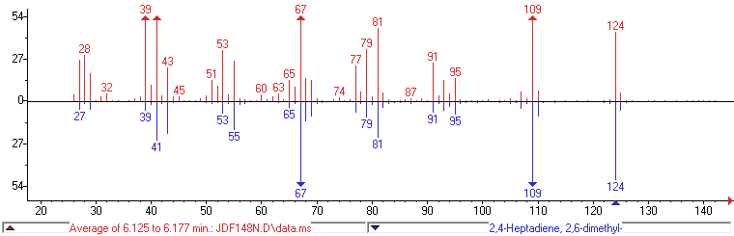

b)
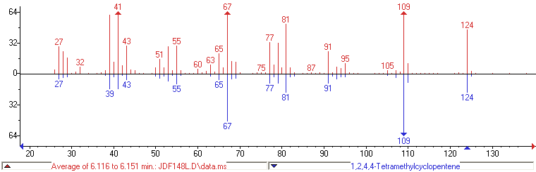

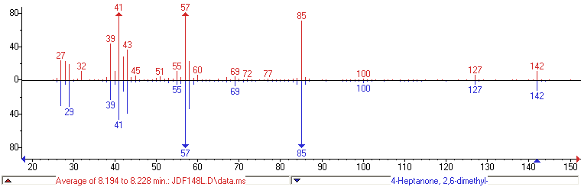
c)

Fig. S20: Experimental (blue) mass spectra of most abundant tandem products, matched with the library references (red) for (a) 2,6-dimethyl-2,4-heptadiene, (b) 1,2,4,4-tetramethylcyclopentene and (c) 2,6-dimethyl-4-heptanone.
Additionally, a recovered H-FER zeolite was digested in HF after the reaction (T=80°C)²⁷. (Precaution: HF is highly toxic and must be handled in a dedicated fumehood using the appropriate safety measures). For comparison, another H-FER zeolite that was stirred at T=80°C in neat 3-methylbutanal was digested. The trapped organics were measured with ¹H-NMR, and compared for both experiments (figure S21). The ¹H NMR spectrum of digested H-FER after HCHO-transfer reaction shows additional peaks possibly originating from isobutene-derived products (note that olefinic peaks in the 4.5-6.5 ppm region are not visible due to overlap with the water peak).
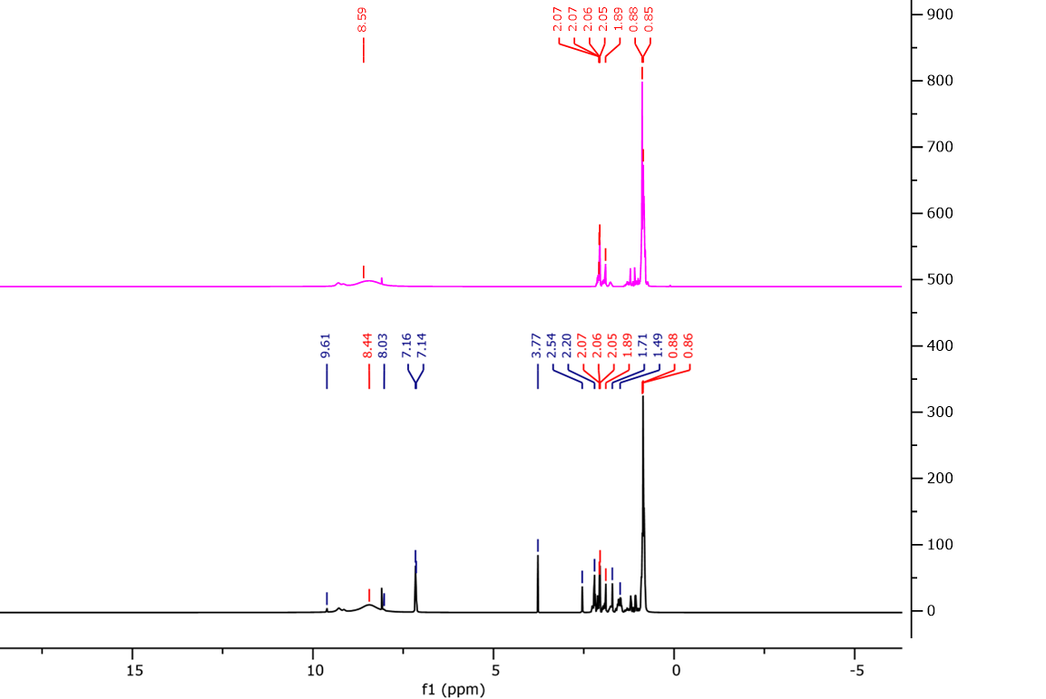

Fig. S21: ¹H NMR spectra of H-FER zeolite after stirring in neat 3-methylbutanal at T=80°C (pink) and H-FER zeolite after standard HCHO-transfer (black). The spectra were corrected for the broad signal originating from H₂O present in HF.

6.5 Hot filtration test with zeolite-assisted HCHO-transfer reaction (fig. S22)
The procedure was followed as described previously (i.e. fig. S14). An HCHO-transfer reaction was performed with 4-phenyl-1-butene and H-FER (9) zeolite (table S15, conditions 4). After the indicated amount of time (4h), the zeolite was removed via filtration and the clear, hot solution was left reacting for up to 24h. Alternatively, a fresh batch of 100 mg H-FER was added to the filtered reaction solution, which was then left reacting until 24h (blue data point). When the reaction is filtered after 4h, essentially no further increase in yield is observed, underpinning the zeolite’s equilibrium-shifting role. Addition of fresh zeolite to the filtrate leads to an improved yield compared to the standard, unfiltered reaction (dark blue curve).
2 mol% [Rh(COD)(OMe)]₂
4 mol% Xantphos
20 mol% 4-Me-Salicyclic acid
3 eq. AcOH
Neat (0.3 M), 80°C, 22h
Closed system
100 mg H-FER until filtration

~Homogeneous reference yield (55%)

Fig. S22: Hot filtration experiments of 3-methylbutanal reaction with H-FER (9); red = hot filtration after 1h, green = hot filtration after 4h, blue = addition of fresh H-FER to filtrate after 4h.

6.6 Shape-selectivity effects with zeolite-assisted HCHO-transfer reaction (fig. S23)
The shape-selective nature of our concept holds for both HCN and HCHO-transfer reactions (the former is illustrated in the main text, fig. 5a). Transfer hydroformylation with linear olefin acceptors with a small kinetic diameter (1-hexene, 1-octene) in the presence of a zeolite leads to poor mass balances, indicating olefin diffusion into the zeolite framework (fig. S23). The effect is dependent on the zeolite’s pore sizes; the series *BEA (12 MR) < MFI (10 MR) < FER (twisted 10 MR) gives an increasingly better mass balance. When branched C7 olefins are used as acceptor, the mass balances of the zeolite reactions clearly improve. Moreover, the yields start overtaking those of the zeolite-free reaction, indicating that the zeolite’s equilibrium-shifting role comes into effect. With 5,5-dimethyl-1-pentene as olefin acceptor, we could observe a difference in efficiency between H-FER and H-ZSM-5, the latter giving a worse yield and mass balance. This observation further supports the choice of a zeolite such as H-FER, which, due to its smaller pore windows, best exploits the shape-selectivity concept.
2 mol% [Rh(COD)(OMe)]₂
4 mol% Xantphos
20 mol% 4-Me-Salicyclic acid
3 eq. AcOH

Neat (0.3 M), 80°C, 22h
Closed system
No or 50 mg zeolite

Fig. S23: Shape-selectivity effects in the transfer hydroformylation with 3-methylbutanal. Yields were calculated as the sum of linear and branched isomers, and mass balances refer to the amount of recovered substrate, aldehyde products and hydrogenated side-products compared to the amount of substrate added. Mass balances of volatile olefin substrates (i.e. hexene) are lower in both reactions without and with zeolite due to evaporation.
- Control experiments with isobutene (HCN and HCHO-transfer), propene and ethylene (HCN-transfer)
Control experiments with isobutene, propene and ethylene were conducted to clarify the interactions between the olefin by-product and the zeolite. Experiments were set up in two ways; 1) in a glass-vial with the olefin dissolved in a toluene/nitrile solution or 2) in a reactor with a specified pressure of the olefin. Method 1 simulates the actual reaction set-up and provides a qualitative result, while method 2 allows to accurately calculate catalyst performances for olefin conversion as e.g. TON and TOF values. The latter method was only used in experiments with ethylene.

7.1 Control experiments with isobutene (fig. S24).
A series of control experiments with a 6 wt.% isobutene in toluene solution was performed under various conditions (fig. S24). Using the benchmark reaction conditions without zeolite (viz chapter 3), no isobutene-derived products are observed. Upon addition of H-ZSM-5 (140), isobutene is nearly fully converted into a mixture of products. Isobutene dimers, predominantly 2,4,4-trimethyl-2-pentene and 2,4,4-trimethyl-1-pentene, constitute the bulk of the as formed reaction products. Alkylated toluene products (mostly in the para-position) and small amounts of isobutene trimers are observed as well. When isovaleronitrile is added, the isobutene conversion is much lower and only dimers are observed. Upon addition of the Lewis acid, the conversion increases, but again exclusive formation of dimers and trace amounts of trimers is observed. When the Pd-Xphos transfer catalyst is included, a small fraction of the dimers further reacts into their corresponding nitriles via transfer hydrocyanation. From these control experiments, we can conclude the following:
- The presence of large amounts of nitriles does decrease the reactivity of the system, presumably by interacting with the acid sites in the zeolite.
- Isobutene dimerization still happens relatively smoothly in the presence of nitrile.
- Addition of the Lewis acid increases isobutene reactivity in the presence of nitrile. This is likely caused by the interaction of the Lewis acid with the zeolite framework (or associated water molecules), creating new acidic sites capable of converting isobutene.
The control experiments thus confirm the observed olefin/nitrile products in the transfer hydrocyanation reaction with isovaleronitrile (table S12).
Procedure for isobutene experiments
To a 1.5 ml glass vial was added 0.5 ml of a 6 wt.% isobutene in toluene solution under an inert argon atmosphere, together with:
- No additional reagents,
- 0.130 ml isovaleronitrile, 100 µl 1M AlMe₂Cl in hexanes, 2.81 mg Pd(OAc)₂ and 5.95 mg Xphos,
- 90 mg H-ZSM-5 (140) zeolite,
- 90 mg H-ZSM-5 (140) zeolite and 0.13 ml isovaleronitrile,
- 90 mg H-ZSM-5 (140) zeolite, 0.13 ml isovaleronitrile and 100 µl 1M AlMe₂Cl in hexanes,
- 90 mg H-ZSM-5 (140) zeolite, 0.13 ml isovaleronitrile, 100 µl 1M AlMe₂Cl in hexanes, 2.81 mg Pd(OAc)₂ and 5.95 mg Xphos.
The vials were then placed in a preheated aluminum heating block at 120°C. After 18h, the vials were cooled on ice, the solution was centrifuged, and the products were analysed via GC-FID/GC-MS.

Fig. S24: Distribution of isobutene-derived reaction products without (1-2) and with (3-6) H-ZSM-5 (140) zeolite. Conditions (120°C, 18h): 1) Only isobutene in toluene 2) 0.13 ml isovaleronitrile, 100 µl 1M AlMe₂Cl in hexanes, 2.81 mg Pd(OAc)₂ and 5.95 mg Xphos 3) 90 mg H-ZSM-5 (140) zeolite 4) 90 mg H-ZSM-5 (140) zeolite and 0.13 ml isovaleronitrile 5) 90 mg H-ZSM-5 (140) zeolite, 0.13 ml isovaleronitrile and 100 µl 1M AlMe₂Cl in hexanes 6) 90 mg H-ZSM-5 (140) zeolite, 0.13 ml isovaleronitrile, 100 µl 1M AlMe₂Cl in hexanes, 2.81 mg Pd(OAc)₂ and 5.95 mg Xphos.

To trace the HCHO-transfer tandem products, two qualitative control experiments were performed:
- A 1:1 solution of 6 wt.% isobutene in toluene and 3-methylbutanal was added to 100 mg H-FER at 80°C. The formation of C₉H₁₆ hydrocarbons (e.g. 2,6-dimethyl-2,4-heptadiene) and 2,6-dimethyl-4-heptanone could be verified via GC-MS. The presence of toluene also seemingly resulted in the formation of some alkylation products, which were logically not observed in the HCHO-transfer reaction (which is conducted in the absence of toluene).
- A 10:1 solution of 6 wt.% isobutene in toluene and 3-methylbutanal was added to 100 mg H-FER at 80°C. Here, no C₉H₁₆ hydrocarbons and 2,6-dimethyl-4-heptanone could be observed. Instead, alkylation and dimerization products were found.

7.2 Control experiments with propene (fig. S25)
Similarly to the experiments with isobutene, rapid conversion of propene into dimers and alkylated toluene products is observed in the presence of H-ZSM-5 (140), and addition of butyronitrile lowers the activity of the system (fig. S25). Exchanging H-ZSM-5 (140) for Ni/H-ZSM-5 (140) provides a higher fraction of propene dimers, thus confirming the oligomerization activity of the Ni-species.
Procedure for propene experiments
To a 1.5 ml glass vial was added 0.5 ml of toluene under an inert argon atmosphere. The vial was then flushed with propene. Following reactants were subsequently added:
- No additional reagants,
- 0.218 ml butyronitrile, 100 µl 1M AlMe₂Cl in hexanes, 2.81 mg Pd(OAc)₂ and 5.95 mg Xphos,
- 90 mg H-ZSM-5 (140) zeolite,
- 90 mg H-ZSM-5 (140) zeolite and 0.218 ml butyronitrile,
- 90 mg H-ZSM-5 (140) zeolite, 0.218 ml butyronitrile and 100 µl 1M AlMe₂Cl in hexanes,
- 90 mg H-ZSM-5 (140) zeolite, 0.218 ml butyronitrile, 100 µl 1M AlMe₂Cl in hexanes, 2.81 mg Pd(OAc)₂ and 5.95 mg Xphos,
- Idem as 6, but with Ni/H-ZSM-5 (140) instead of H-ZSM-5 (140).

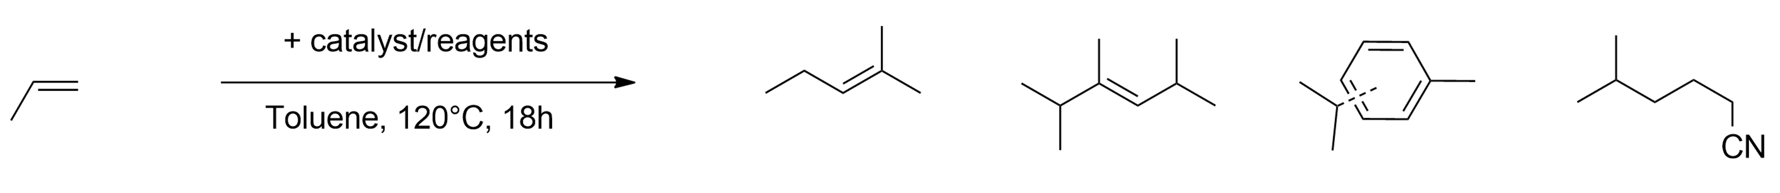

Fig. S25: Distribution of propene-derived reaction products without (1-2) and with (3-6) H-ZSM-5 (140) zeolite or (7) Ni/H-ZSM-5 (140). Conditions (120°C, 18h): 1) Only propene in toluene 2) 0.218 ml butyronitrile, 100 µl 1M AlMe₂Cl in hexanes, 2.81 mg Pd(OAc)₂ and 5.95 mg Xphos 3) 90 mg H-ZSM-5 (140) zeolite 4) 90 mg H-ZSM-5 (140) zeolite and 0.218 ml butyronitrile 5) 90 mg H-ZSM-5 (140) zeolite, 0.218 ml butyronitrile and 100 µl 1M AlMe₂Cl in hexanes 6) 90 mg H-ZSM-5 (140) zeolite, 0.218 ml butyronitrile, 100 µl 1M AlMe₂Cl in hexanes, 2.81 mg Pd(OAc)₂ and 5.95 mg Xphos 7) 90 mg Ni/H-ZSM-5 (140) zeolite, 0.218 ml butyronitrile, 100 µl 1M AlMe₂Cl in hexanes, 2.81 mg Pd(OAc)₂ and 5.95 mg Xphos

7.3 Control experiments with ethylene (figs S26-S29).
Reactions with ethylene were performed in a similar fashion as in the experiments with isobutene and propene (e.g. in a glass vial with ethylene dissolved in toluene or propionitrile) (fig. S26). Without zeolite, again no significant formation of ethylene-derived products could be observed. With H-ZSM-5 (140), only alkylated toluene products were observed, in contrast to reactions with isobutene and propene in which large fractions of dimers were formed. After addition of Pd(OAc)₂, butenes start appearing in large amounts, indicating Pd-catalyzed dimerization activity. Moreover, when propionitrile is added, the fraction of butenes increases at the expense of the alkylated toluene products. With propionitrile as solvent, highly selective formation of butenes (96%) is observed, together with a small fraction of hexenes (3%). When the Pd-Xphos-AlMe₂Cl transfer catalyst is present, trace amounts of C₅ nitriles (2-methylbutanenitrile and valeronitrile) are detected, providing more evidence for the reaction sequence ethylene -> butenes -> hydrocyanated butenes. Varying the added Pd-source results in marked differences in dimerization activity (fig. S27). Only Pd(OAc)₂ and Pd(TFA)₂ furnish butenes in large amounts. PdCl₂ leads to an equal mixture of ethylene and butenes, while Pd₂dba₃ provides no butenes at all. This establishes the necessary cationic nature of the Pd-source, and neatly aligns with the results obtained in the Pd-source screening (SI 4.7, fig. S8). The ratio of 2-butenes/1-butene was around 80/20 in most experiments.
Procedure I for ethylene experiments
To a 1.5 ml glass vial was added 0.5 ml of toluene or propionitrile under an inert argon atmosphere. The vial was then flushed with ethylene. Following reactants were subsequently added:
- Reactions in toluene (T = 120°C)

- No additional reagents,
- 0.175 ml propionitrile, 100 µl 1M AlMe₂Cl in hexanes, 2.81 mg Pd(OAc)₂ and 5.95 mg Xphos,
- 90 mg H-ZSM-5 (140) zeolite ,
- 90 mg H-ZSM-5 (140) zeolite and 2.81 mg Pd(OAc)_{2,}
- 90 mg H-ZSM-5 (140) zeolite, 0.175 ml propionitrile and 2.81 mg Pd(OAc)_{2,}
- 90 mg H-ZSM-5 (140) zeolite, 0.175 ml propionitrile, 100 µl 1M AlMe₂Cl in hexanes, 2.81 mg Pd(OAc)₂ and 5.95 mg Xphos.

- Reactions in propionitrile (T = 100°C)

- 90 mg H-ZSM-5 (140) zeolite and 2.81 mg Pd(OAc)_{2,}
- 90 mg H-ZSM-5 (140) zeolite, 100 µl 1M AlMe₂Cl in hexanes, 2.81 mg Pd(OAc)₂ and 5.95 mg Xphos.

- Pd-source screening (in propionitrile, T = 100°C)

- 90 mg H-ZSM-5 (140) zeolite and 2.81 mg Pd(OAc)₂ (cfr. reaction 7),
- 90 mg H-ZSM-5 (140) zeolite and 2.22 mg PdCl_{2,}
- 90 mg H-ZSM-5 (140) zeolite and 4.12 mg Pd(TFA)_{2,}
- 90 mg H-ZSM-5 (140) zeolite and 5.72 mg Pd₂dba_{3.}

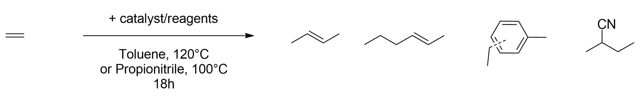

Fig. S26: Distribution of ethylene-derived reaction products without (1-2) and with (3-8) H-ZSM-5 (140) zeolite in toluene (1-6, T = 120°C) or propionitrile (7-8, T = 100°C). Conditions: 1) only ethylene in toluene 2) 0.175 ml propionitrile, 100 µl 1M AlMe₂Cl in hexanes, 2.81 mg Pd(OAc)₂ and 5.95 mg Xphos 3) 90 mg H-ZSM-5 (140) zeolite 4) 90 mg H-ZSM-5 (140) zeolite and 2.81 mg Pd(OAc)₂ 5) 90 mg H-ZSM-5 (140) zeolite, 0.175 ml propionitrile and 2.81 mg Pd(OAc)₂ 6) 90 mg H-ZSM-5 (140) zeolite, 0.175 ml propionitrile, 100 µl 1M AlMe₂Cl in hexanes, 2.81 mg Pd(OAc)₂ and 5.95 mg Xphos 7) 90 mg H-ZSM-5 (140) zeolite and 2.81 mg Pd(OAc)₂ 8) 90 mg H-ZSM-5 (140) zeolite, 100 µl 1M AlMe₂Cl in hexanes, 2.81 mg Pd(OAc)₂ and 5.95 mg Xphos.

Fig. S27: Distribution of ethylene-derived reaction products with different Pd-sources (conditions: 0.0125 mmol Pd, 90 mg H-ZSM-5 (140), propionitrile, T = 100°C, 18h)
Having established qualitative proof of the Pd-zeolite catalyzed ethylene dimerization in conditions identical to those of the transfer hydrocyanation reaction, we set out to quantify the performance of the catalysts in the dimerization of ethylene using a pressurized batch reactor.
Procedure II for ethylene experiments
To a glass liner, 1 mg of Pd(OAc)₂ and 150 mg zeolite (A: in-situ loading), or alternatively 150 mg of Pd-zeolite or Ni-zeolite (B: preloaded zeolites), were added together with 1 ml of toluene. A Teflon-coated magnetic stir bar was added to the reaction medium. The liner was inserted in a steel autoclave equipped with a manometer. The autoclaves were flushed three times with N₂ and two times with ethylene, and then pressurized with ethylene gas to 8 bar. The autoclaves were placed in a preheated aluminium heating block at 60°C for 5 min - 2h, after which the autoclaves were depressurized and allowed to cool down to room temperature. The zeolite was then centrifuged, and the organics were analyzed with GC-FID/GC-MS (composition of mixture) and ¹H NMR (ratio of 2-cis/trans-butenes and 1-butene).
- In-situ loaded zeolites
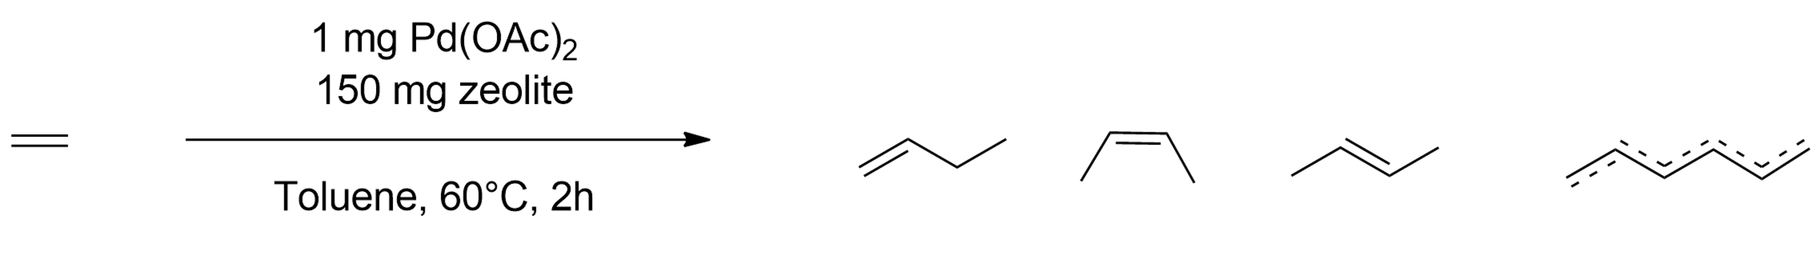
8 bar

Fig. S28: Distribution of ethylene-derived reaction products and turnover frequency (mmol C₄/mmol Pd*h) using in-situ loaded zeolites with Pd(OAc)₂ under 8 bar ethylene and T= 60°C. H-ZSM-5 with Si/Al = 140 and H-ZSM-11 with Si/Al = 120 were used.

- Preloaded zeolites

Fig. S29: Distribution of ethylene-derived reaction products and turnover frequency (mmol C₄/mmol Pd*h) using preloaded zeolites under 8 bar ethylene and T= 60°C.

As was observed in the zeolite screening with propionitrile (fig. S6), silicalite-1 does not produce an active ethylene dimerization catalyst when contacted with Pd(OAc)₂ (fig. S28). On the contrary, H-ZSM-5 and H-ZSM-11, which are the best zeolites for the transfer hydrocyanation with propionitrile, clearly show very high ethylene dimerization activities in the presence of Pd(OAc)₂. Preloaded Pd-zeolites, prepared via Pd(OAc)₂ impregnation or Pd(NO₃)₂ ion exchange and subsequent calcination, are nearly equally active. Fascinatingly, a Pd-zeolite with only 0.075 wt% Pd still shows very high activity (turnover number = 436 mmol C₄/mmol Pd). Running the reaction for 5 min using the 0.3 wt% Pd zeolite provided 72% conversion of ethylene and a TOF of 1157 mmol C₄/mmol Pd*h. It is apparent from these results that small fractions of highly dispersed Pd-zeolite species result in exceedingly potent and active ethylene dimerization catalysts.

- In-depth study of zeolite-assisted transfer hydrocyanation with propionitrile
General procedures follow those with propionitrile as solvent as explained in chapter 4 of the SI.

8.1 Ligand screening (table S18)
The superiority of Xphos over similar ligands in this reaction system was confirmed with a ligand screening (table S18). Notably, the differences in yield between ligands appear to be much more pronounced compared to those of the benchmark transfer hydrocyanation system with isovaleronitrile (table S2). To study the influence of the ligand on substrate isomerization, a reactant with an allyl substituent was chosen. A trend can be observed between the ligands’ electron donating tendency and the selectivity towards the linear isomer.
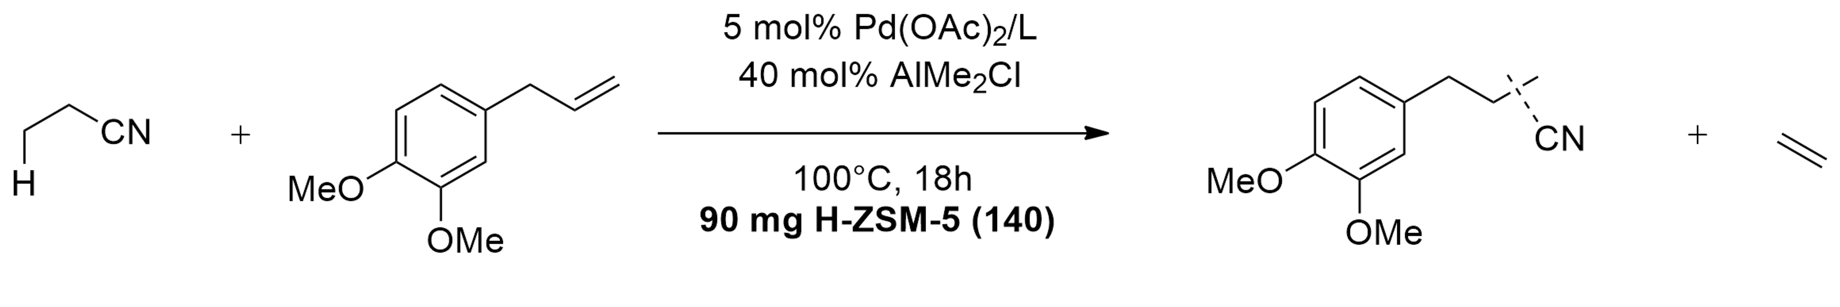
c
b
a

Table S18: Ligand screening under standard conditions
Entry | Ligand | Yield (%) | Selectivity (a:b:c)
1 | L2 | 15 | 44:36:20
2 | L3 | 36 | 51:40:9
3 | L4 | 64 | 51:40:9
4 | L5 | 52 | 41:42:16
5 | L6 | 49 | 51:40:9
6 | L7 | 21 | 41:47:13
7 | L8 | 14 | 63:18:19

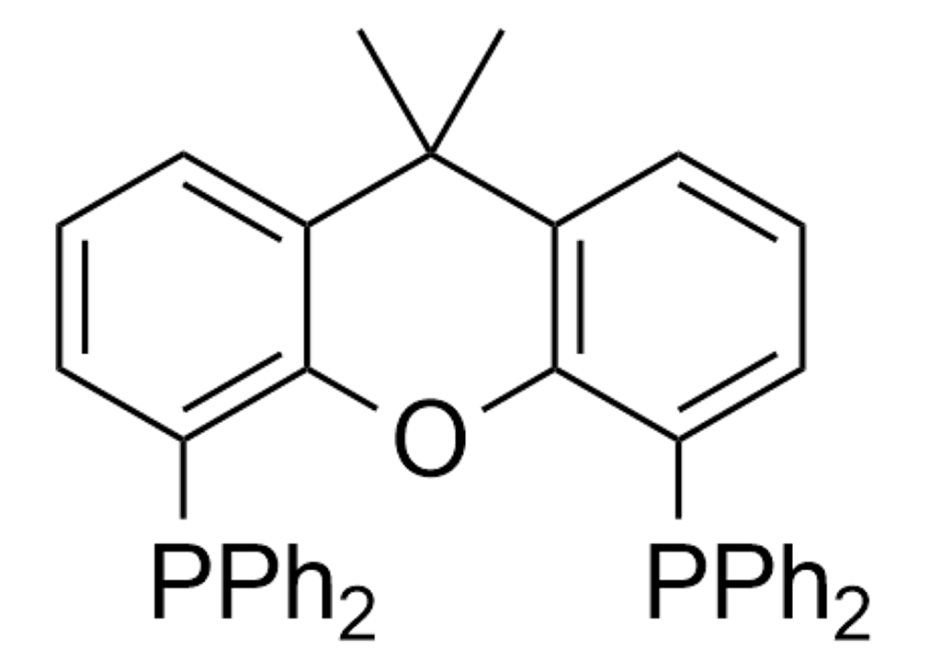
L2, CyJohnPhos
L3, SPhos
L4, Xphos

L5, Xantphos
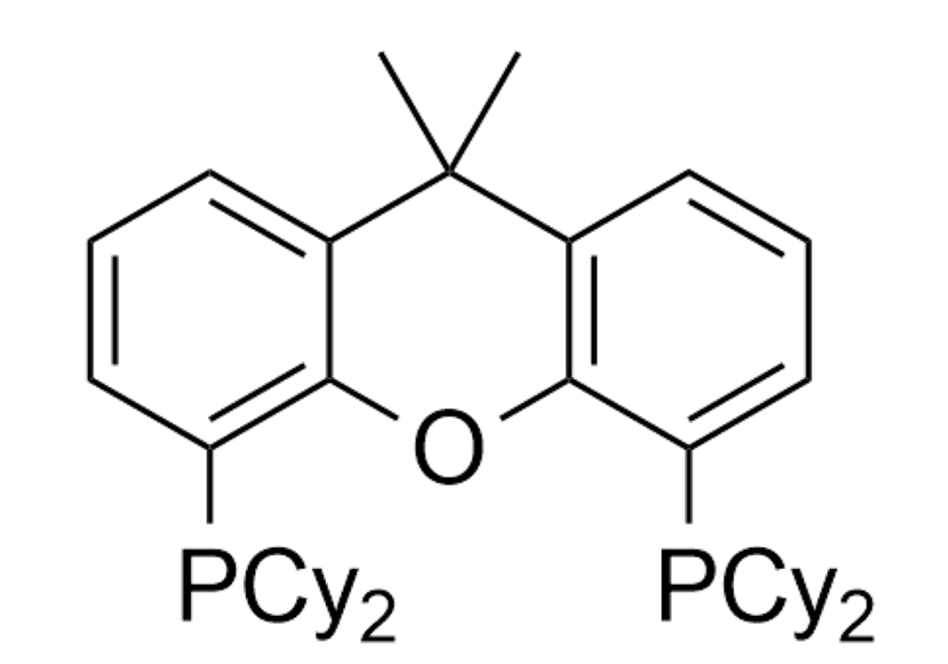
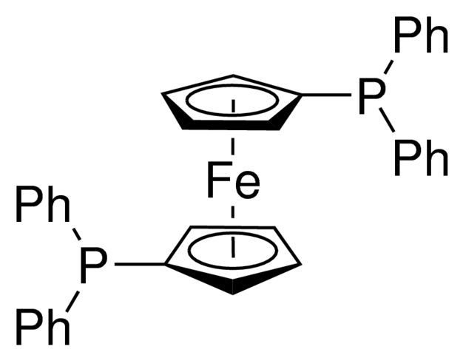
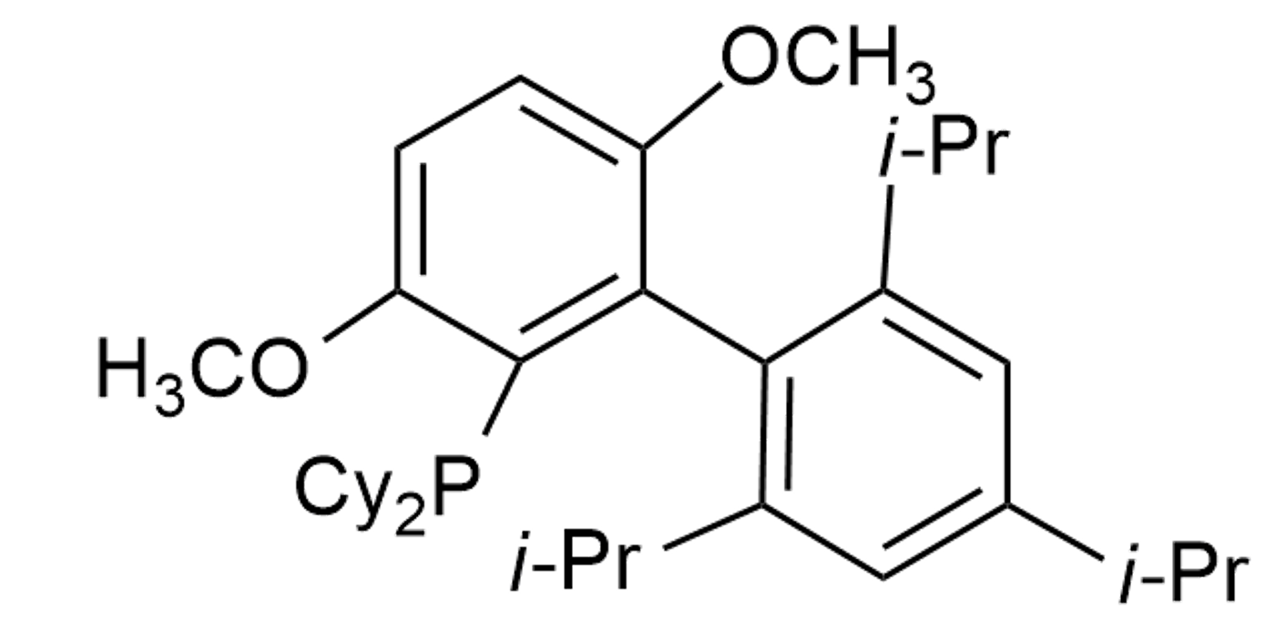

L6, Brettphos
L8, CyXantphos
L7, dppf

  - Lewis acid screening (table S19)
Dialkylaluminum chlorides are the most effective Lewis acids (table S19). Increasing lengths of the alkyl fragments results in a significant decrease in yield, which was less clear in the reaction with isovaleronitrile (table S2). As an additional reference, we performed the reaction with Al(i-Bu)₂Cl as Lewis acid without zeolite. The yield is inherently lower with Al(i-Bu)₂Cl compared to AlMe₂Cl.
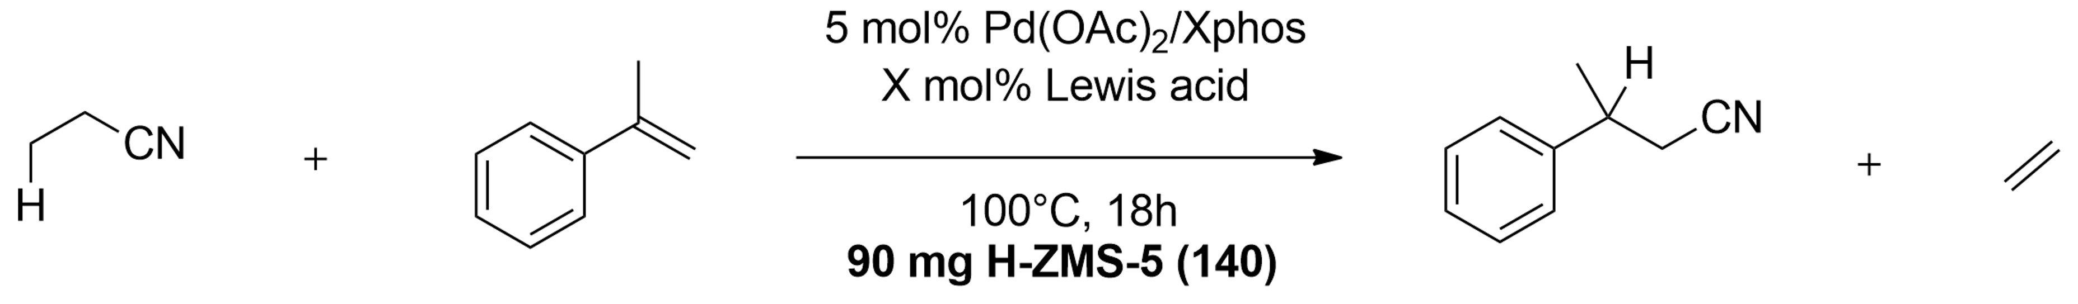

Table S19: Lewis acid screening in propionitrile/H-ZSM-5 reaction.
Entry | Lewis acid (mol%) | Yield (%) | Product selectivity (%)
1 | AlMe₂Cl (30) | 32 | 65
2 | AlMe₂Cl (40) | 93 | 97
3 | AlMe₂Cl (50) | 80 | 91
4 | AlEt₂Cl (40) | 51 | 93
5 | Al(i-bu)₂Cl (40) | 47 | 93
6 | AlMe₃ (40) | 24 | 72
7 | Al(C₆F₅)₃ (40) | 11 | 59
8 | AlCl₃ (40) | 0 | 0
9 | BPh₃ (40) | 0 | 0
Reference (no zeolite) | Lewis acid (mol%) | Yield (%) | Product selectivity (%)
1 | AlMe₂Cl (40) | 13 | 66
2 | Al(i-bu)₂Cl (40) | 10 | 68

  - Temperature screening (tables S20-S21)
Data obtained from temperature screening are presented in tables S19-S20. The model reaction with styrenes works relatively well at a mild temperature of 80°C. For comparative purposes, we included a small screening with a non-activated olefin acceptor, i.e. cyclododecene. In this case, higher reaction temperatures (>100°C) are imperative.
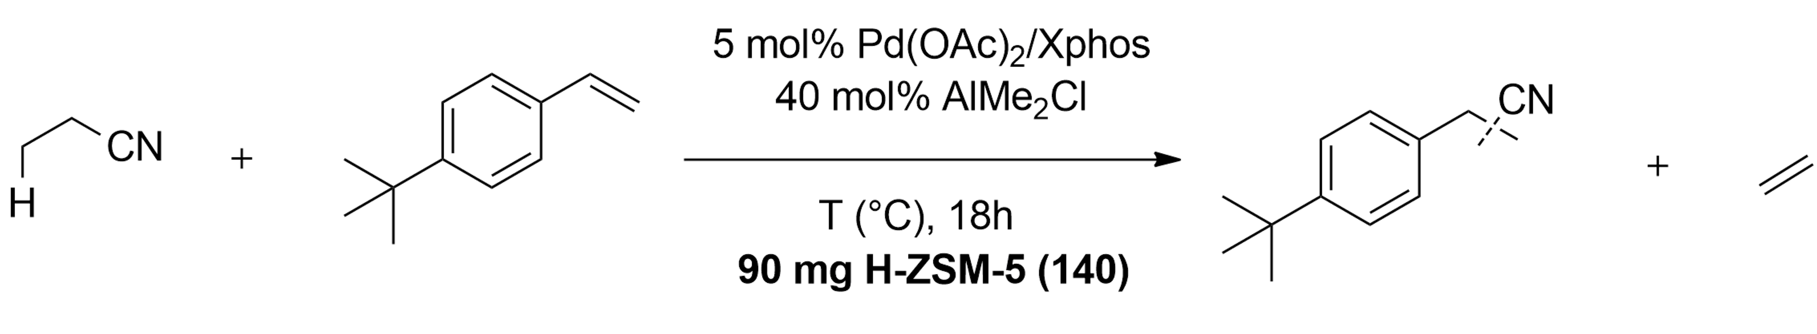

Table S20 Temperature screening in propionitrile/H-ZSM-5 reaction.
Entry | Temperature (°C) | Yield (%) | Selectivity (l:b)
1 | 60 | 20 | 83:17
2 | 80 | 79 | 85:15
3 | 100 | 96 | 81:19
4 | 120 | 93 | 80:20

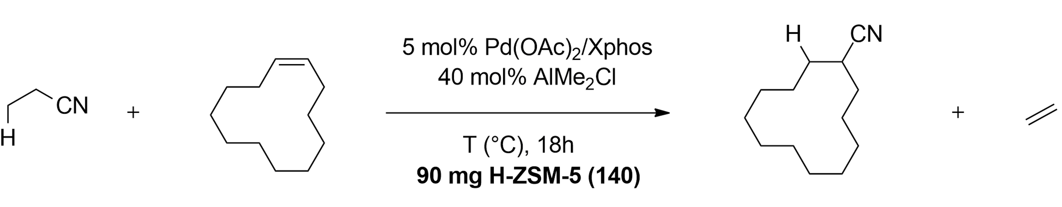

Table S21: Temperature screening in propionitrile/H-ZSM-5 reaction with cyclic alkene.
Entry | Temperature (°C) | Yield (%) | Product selectivity (%)
1 | 80 | 34 | 97
2 | 100 | 66 | 95
3 | 120 | 71 | 92
4 | 130 | 70 | 89

  - Zeolite preloading (table S22)
As previously shown in fig. S8, the zeolite has no effect on the reaction with Pd₂dba₃ as Pd-source. Control experiments showed that the combination of Pd₂dba₃/H-ZSM-5 did not afford an active ethylene dimerization catalyst (fig. S27). Hence, the reaction must be performed with a preloaded Pd-zeolite which is active for ethylene dimerization. Pd-zeolites were synthesized via two pathways; 1) preloading H-ZSM-5 with Pd(OAc)₂ in toluene or 2) Ion-exchanging NH₄-ZSM-5 with Pd(NO₃)₂ with or without subsequent calcination (cfr. chapter 2 of SI). The Pd-content of the resulting zeolites can be manipulated via the amount of added Pd(OAc)₂. Both zeolites are highly active in the dimerization of ethylene (fig. S29). Consequently, reactions using Pd₂dba₃ as homogeneous transfer catalyst and Pd-zeolites as equilibrium-shifting agents provide greatly enhanced yields compared to the reaction without zeolite or with H-ZSM-5 (table S22). The 0.3 wt% Pd(OAc)-zeolite, which appeared to be the most active catalyst for ethylene dimerization (fig. S29), provides the highest yield. Reaction with Ni-exchanged ZSM-5 has little effect on the yield, in accordance to the very low ethylene dimerization activity of this zeolite (fig. S29). Interestingly, Ni-based transfer catalysts provide no product at all when combined with Pd-zeolites, highlighting the indispensability of Pd-based transfer catalysts in this reaction. Lastly, in situ preloading of H-ZSM-5 with Pd(OAc)₂ in propionitrile for 30 min, followed by addition of Xphos and the other reagents, results in a very slight decrease in yield compared to standard conditions.
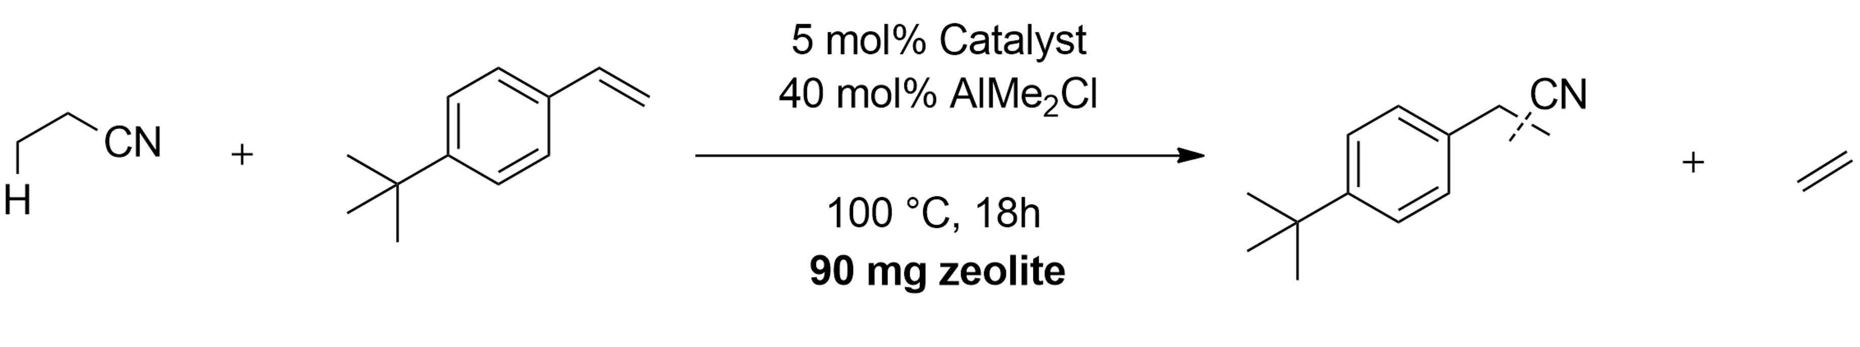

Table S22: Effect of zeolite preloading on yield with various catalysts.
Entry | Catalyst | Zeolite | Yield (%)
1 | Pd(OAc)₂/Xphos | H-ZSM-5 (140) | 96
2 | Pd(OAc)₂/Xphos | Pd(OAc)-ZSM-5 (0.3 wt%) | 90
3 | Pd(OAc)₂/Xphos | Pd-ZSM-5 (calcined) (1.2 wt%) | 83
4 | Pd₂dba₃/Xphos | H-ZSM-5 (140) | 21
5 | Pd₂dba₃/Xphos | Pd(OAc)-ZSM-5 (0.3 wt%) | 80
6 | Pd₂dba₃/Xphos | Pd(OAc)-ZSM-5 (0.075 wt%) | 69
7 | Pd₂dba₃/Xphos | Pd-ZSM-5 (not calcined) (1.2 wt%) | 76
8 | Pd₂dba₃/Xphos | Pd-ZSM-5 (calcined) (1.2 wt%) | 73
9 | Pd₂dba₃/Xphos | Ni-ZSM-5 (0.6 wt%) | 24
10 | NiCl₂/DPEphos | Pd(OAc)-ZSM-5 (0.3 wt%) | n.d.
11 | Pd(OAc)₂ premixed in propionitrile before Xphos addition | H-ZSM-5 (140) | 91

  - Optimization for challenging substrates (table S23)
More challenging, stable substrates require a higher driving force to be transfer hydrocyanated. Addition of larger amounts of zeolite, and accordingly higher Lewis acid loadings, can be used to generate extra driving force. Employing 1,1-diphenylethylene as a substrate, we were able to achieve 57% yield with 200 mg H-ZSM-5 (140) and 80 mol% Lewis acid, while keeping the amount of transfer catalyst constant (5 mol%). This is attractive from an economic standpoint, as both the zeolite and the Lewis acid are cheap and easily available on kg-scale. Even higher amounts of zeolite cause the yield to decrease again, presumably due to the transfer reaction becoming limiting by the lower availability of Pd(OAc)₂ as HCN-transfer catalyst.
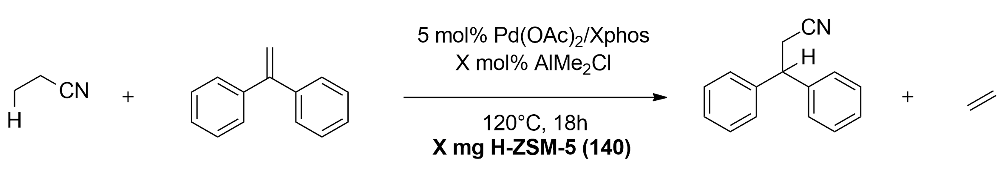

Table S23: Effect of zeolite/Lewis acid amount on the reaction with 1,1-diphenylethylene.
Entry | Amount zeolite (mg) | Amount LA (mol%) | Yield (%)
1 | 90 | 40 | 38
2 | 150 | 60 | 50
3 | 200 | 80 | 56
4 | 300 | 120 | 39
5 | 400 | 150 | 23

  - Relation between the amount of zeolite, the Pd:Xphos ratio and the yield (fig. S30).
The relation between the amount of zeolite and its equilibrium-shifting effect was studied with various amounts of Pd(OAc)₂ and Xphos (figure S30). The magnitude of the zeolite’s induced increase in yield visibly differs between a Pd:Xphos molar ratio of 5:5 and 5:10, the latter showing a diminished zeolite-induced effect. Pd:Xphos ratios of 5:2.5 and 2.5:2.5 initially show similar zeolite-induced yield increases to the 5:5 ratio. However, at higher zeolite loading, the increases fall off compared to the 5:5 ratio. These results reinforce the importance of mobile Pd-species which can be adequately partitioned in catalytic Pd-Xphos and Pd-zeolite complexes, ensuring efficient tandem transfer hydrocyanation – ethylene dimerization.
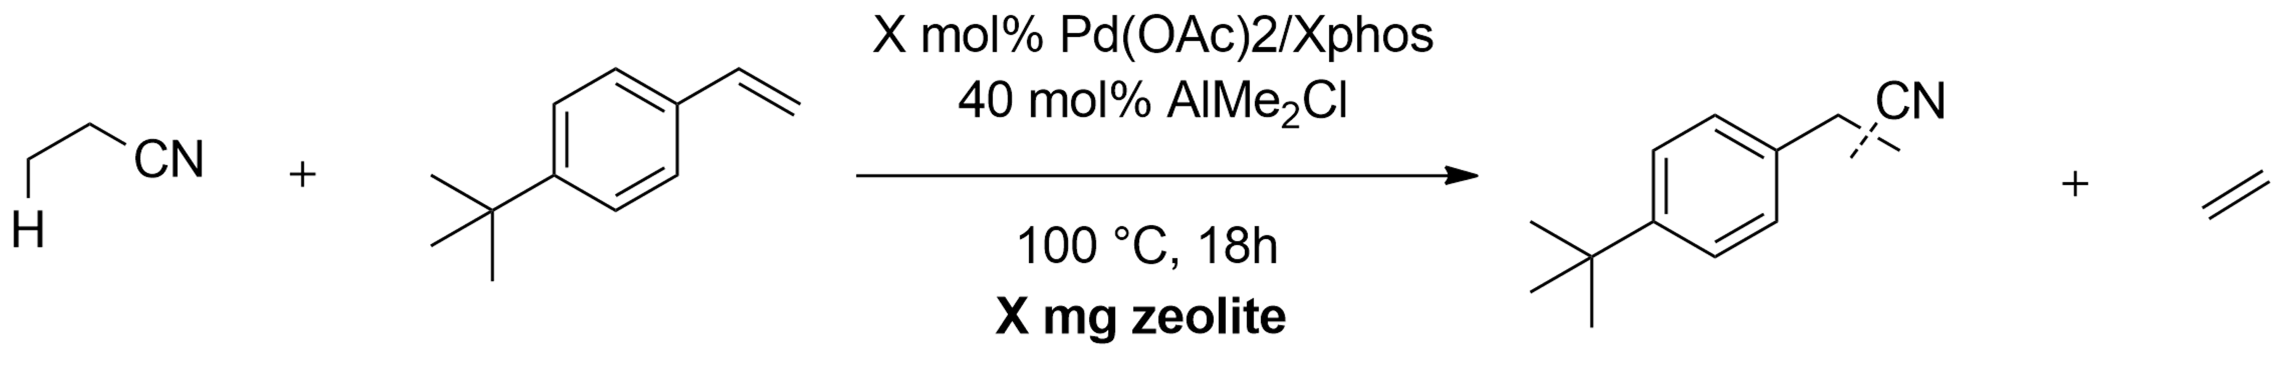

Solvent (0.4 M)

Fig. S30: Relation between the amount of added zeolite (H-ZSM-5, Si/Al = 140) and the yield in the HCN-transfer with propionitrile for different molar Pd:Xphos ratios and amounts; red = 5 mol% Pd:5 mol% Xphos, blue = 5 mol% Pd:2.5 mol% Xphos, yellow = 2.5 mol% Pd:2.5 mol% Xphos, purple = 5 mol% Pd, 10 mol% Xphos.

  - Thermodynamic calculations

8.7.1 Calculations based on reaction data and tabulated values
The beneficial effect of the zeolite on the transfer reaction is grounded in a change of the reaction free energy, induced by consecutive exergonic reactions. The apparent change of the reaction free energy, i.e. Δ(Δ_{r}G°), can be calculated empirically from the experimental data and from tabulated thermodynamic values. Starting from the actual transfer hydrocyanation (‘reaction 1’), with 4-tert-butylstyrene and propionitrile as the reactants, the reaction equation is:
4-tert-butylstyrene + propionitrile Product nitriles (l + b) + ethylene (1)
The main product nitrile is 3-(4-tert-butylphenyl)propionitrile (linear isomer). This reaction, with propionitrile as a nitrile donor/solvent, was conducted with initially 7 mmol of propionitrile (11.7 M) and 0.25 mmol of 4-tert-butylstyrene (0.417 M) in 600 µl total volume. In the absence of a zeolite and in a closed system, a 25% conversion of 4-tert-butylstyrene to the product nitriles is obtained. This is the closest one can empirically come to the equilibrium of this (difficult) transfer hydrocyanation. Thus:

[Product nitrile]_{eq} = 0.104 M
[Ethylene]_{eq} = 0.104 M . (fraction in liquid phase) = 0.104 . 0.6 = 0.0624 M
[Propionitrile] = 11.61 M
[tBu-styrene] = 0.313 M

It has been assumed that 60 % of the ethylene formed stays in the liquid phase, while 40 % evaporates.^{Note 1}
Then K_{eq,1} = $\frac{{[Product Nitrile]}_{eq }.{ [ethylene]}_{eq}}{{[Propionitrile]}_{eq }. { [tBu-styrene]}_{eq}}$ = $\frac{0.104 . 0.0624}{11.61 . 0.313}$ = 0.0018

and Δ_{r,1}G° = - RT lnK_{eq,1} = + 19.6 kJ/mol (for a reaction at 373 K)

The second reaction is the dimerization of ethylene to butene:
Ethylene 0.5 butene (2)

The reaction produces a mixture of 66 % trans-2-butene, 17 % cis-2-butene and 17 % 1-butene.^{Note 2, Note 3} Based on this distribution, we calculated an average
Δ_{f}G_{butene,298} = 65 kJ/mol and Δ_{f}H_{butene,298} = -8.6 kJ/mol vs.
Δ_{f}G_{ethylene,298} = 68.2 kJ/mol and Δ_{f}H_{ethylene,298} = 52.4 kJ/mol
Assuming the Van ‘t Hoff equation is valid (i.e. the reaction enthalpy is constant over the relatively limited temperature range 298-373 K), one calculates for a reaction at 373 K that
Δ_{r,2}G° = - 30.4 kJ/mol and K_{2,373} = $\frac{{[butene]}^{0.5}}{[ethylene]}$ = 18000
The latter shows that if reaction (2) is sufficiently kinetically enabled by the presence of a catalyst, the concentration of ethylene will (at equilibrium) eventually be negligible, in the liquid and in the gas phase.

Combining (1) and (2) into a sequence:
4-tert-butylstyrene + propionitrile Product nitrile + ethylene (1)
ethylene 0.5 butene (2)
the total reaction is:
4-tert-butylstyrene + propionitrile Product nitrile + 0.5 butene (total)
with Δ_{r,total}G° = -10.8 kJ/mol.
The equilibrium constant then becomes
K_{eq,total} = 32.5 = $\frac{{[Product Nitrile]}_{eq }. {[butene]}_{eq}^{0.5}}{ {[Propionitrile]}_{eq }. { [tBu-styrene]}_{eq}}$
Or starting from the same initial concentrations as before, and neglecting the [ethylene]:
K_{eq,total} = 32.5 = $\frac{x . {\left(0.5 x\right)}^{0.5}}{ \left(0.417-x\right) . (11.7-x) }$
With x the molarity of the product nitrile formed. One finds (by iteration) that x = 0.41648... In principle, the consecutive reaction allows to increase the conversion in the transfer hydrocyanation to more than 99%.

Summarizing, the change of the reaction free energy is Δ(Δ_{r}G°) = -30.4 kJ/mol.

Note 1
We did not find direct data on the solubility of ethylene in propionitrile at elevated temperatures, but Sahgal et al. (The Canadian Journal of Chemical Engineering 56(3), 354-357 (1978)) report on ethylene solubility in acetone (and other polar solvents) for a range of temperatures. From their data, we estimate that at 100°C, a vapor-liquid equilibrium is established with:
1 bar of ethylene in the headspace, and
a mole fraction x_{ethylene} = 0.005 in the solvent acetone, which as similar polarity characteristics as propionitrile.
It is reasonable to assume that Henry’s law is valid: this means that a limited pressures (e.g. ≤ 1 bar), there is a linear proportionality between the liquid phase concentration of a solute (expressed as mole fraction x, or as molarity) and its partial pressure. Following Henry’s law:
x_{ethylene} = K_{ethylene,373K} . p_{ethylene} with K_{ethylene,373K} = 0.005 bar⁻¹
Considering the (fixed) relative volumes of headspace (900 µl) and liquid (600 µl), one calculates that 60 % of the ethylene would be dissolved in the liquid phase, and 40 % would be in the vapour phase. Therefore we calculated the ethylene concentration in the liquid phase as
[ethylene]_{eq} = $\frac{moles of ethylene formed}{liquid volume}$ . 0.6
The impact of this factor (0.6) is relatively small, viz. a change of -0.5 for the value of lnK_{1,373K}, and a change of -1.6 kJ/mol for Δ_{r}G₁.

Note 2
The observed butene isomer distribution somewhat deviates from the thermodynamically expected distribution at 100 °C (which would be 65.6 % trans-, 28.8 % cis- and 5.6 % 1-butene).

Note 3
For the ethylene – butene equilibrium, tabulated gas phase data were used (from Stull, Westrum, Sinke, The Chemical Thermodynamics of Organic Compounds, Wiley, 1969).

8.7.2 DFT calculations
DFT calculations were set up in Gaussian 09 using the B3LYP functional^{17,18}. Molecule geometries were optimized using the basis set 6-311G(d,p) at DFT level, and subsequent energy calculations were performed using the same basis set. Standard reaction energies were computed based on the difference in calculated electronic free energies between reactants and products in the gas phase at 298K.
The transfer hydrocyanation reaction with styrene is (‘reaction 1’):
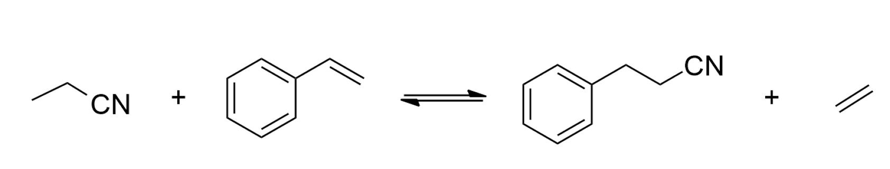
Δ_{r}G⁰ = +38.9 kJ/mol
(1)

and, factoring in consecutive ethylene dimerization (‘reaction 2’, cfr. ‘total reaction’ in section 8.7.1 above):
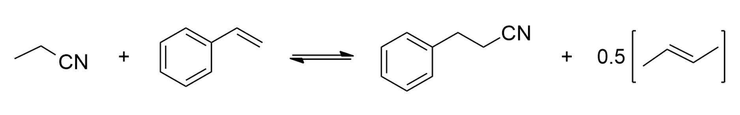
Δ_{r}G⁰ = +9.4 kJ/mol
(2)

This results in a reaction free energy shift Δ(Δ_{r}G°) = -29.5 kJ/mol. Note that, although this value is computed at 298K in the gas phase and for styrene instead of 4-tert-butylstyrene, it is very similar to the empirical value calculated in section 8.7.1 (Δ(Δ_{r}G°) = -30.4 kJ/mol).
Reactions approaching the actual reaction stoichiometry in the presence of the zeolite (e.g. butenes react to C₅ nitriles, etc.) were also computed with DFT;
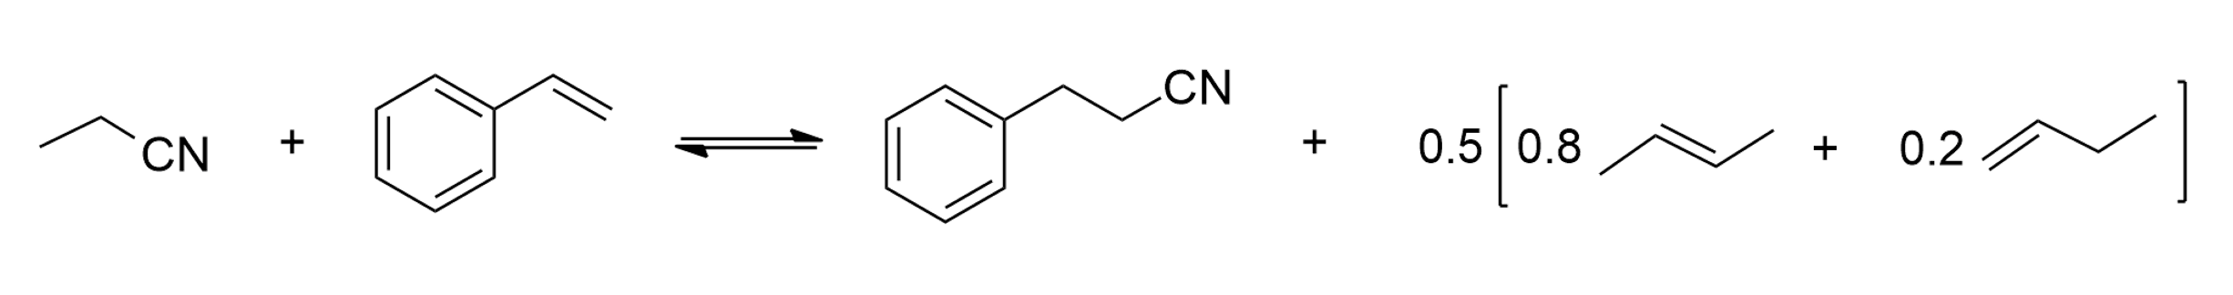
(3)
Δ_{r}G⁰ = +11.9 kJ/mol
Δ (Δ_{r}G⁰) = -27 kJ/mol

(4)

Δ_{r}G⁰ = +12.79 kJ/mol
Δ(Δ_{r}G⁰) = -26.1 kJ/mol

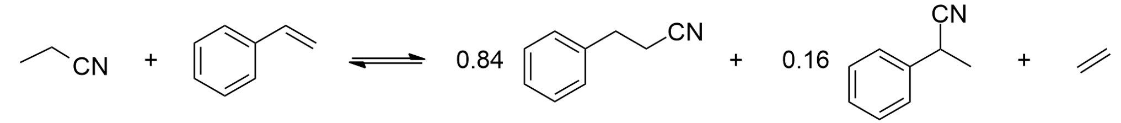
(5)
Δ_{r}G⁰ = +39.7 kJ/mol

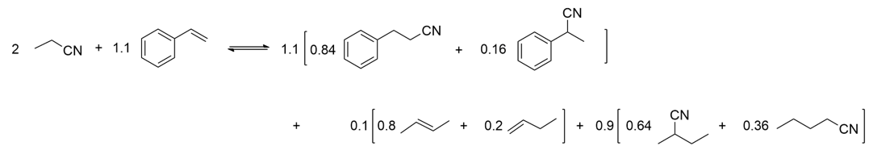
(6)

Δ_{r}G⁰ = +12.75 kJ/mol
Δ (Δ_{r}G⁰) = -27 kJ/mol

Factoring in consecutive transfer hydrocyanation of butenes to C₅-nitriles, the reaction free energy shift is thus Δ(Δ_{r}G°) = -27 kJ/mol.

- HCN-transfer scope and gram-scale synthesis
All substrates were subjected to reaction without zeolite in a closed system as reference (under identical conditions). Reactions with zeolite were performed with the following general procedures:
Procedure A
To a 1.5 ml glass vial was added 2.81 mg Pd(OAc)₂ (0.0125 mmol) and 5.95 mg Xphos (0.0125 mmol) together with 0.1 mmol of 1,3,5-tri-tert-butylbenzene as internal standard and 90 mg of H-ZSM-5. The glass vial was capped and put under an inert argon atmosphere using a Schlenk line, after which argon-flushed propionitrile (0.5 ml) and olefin substrate (0.25 mmol) were added. Finally, 100 µl AlMe₂Cl in hexanes (40 mol%) was injected. The vial was then placed in a preheated aluminum heating block at 100°C. After 18h, the vial was cooled on ice, and methanol was added to quench residual Lewis acid.
Procedure B
To a 1.5 ml glass vial was added 2.81 mg Pd(OAc)₂ (0.0125 mmol) and 5.95 mg Xphos (0.0125 mmol) together with 0.1 mmol of 1,3,5-tri-tert-butylbenzene as internal standard and 150 mg of H-ZSM-5. The glass vial was capped and put under an inert argon atmosphere using a Schlenk line, after which argon-flushed propionitrile (1 ml) and olefin substrate (0.25 mmol) were added. Finally, 150 µl AlMe₂Cl in hexanes (60 mol%) was injected. The vial was then placed in a preheated aluminum heating block at 100°C. After 18h, the vial was cooled on ice, and two drops of methanol were added to quench residual Lewis acid.
Procedure C
To a 10 ml glass crimp-cap vial was added 2.81 mg Pd(OAc)₂ (0.0125 mmol) and 5.95 mg Xphos (0.0125 mmol) together with 0.1 mmol of 1,3,5-tri-tert-butylbenzene as internal standard and 200 mg of H-ZSM-5. The glass vial was capped and put under an inert argon atmosphere using a Schlenk line, after which argon-flushed propionitrile (1 ml) and olefin substrate (0.25 mmol) were added. Finally, 200 µl AlMe₂Cl in hexanes (80 mol%) was injected. The vial was then placed in a preheated aluminum heating block at 120°C. After 18h, the vial was cooled on ice, and four drops of methanol were added to quench residual Lewis acid.
Procedure D
To a 10 ml glass crimp-cap vial was added 5.72 mg Pd₂dba₃ (0.00625 mmol) and 8.76 mg CyJohnPhos (0.025 mmol) together with 0.1 mmol of 1,3,5-tri-tert-butylbenzene as internal standard and 90 mg of preloaded Pd-ZSM-5 (0.3 wt%). The glass vial was capped and put under an inert argon atmosphere using a Schlenk line, after which argon-flushed propionitrile (0.75 ml), dry toluene (0.25 ml) and olefin substrate (0.25 mmol) were added. Finally, 100 µl AlMe₂Cl in hexanes (40 mol%) was injected. The vial was then placed in a preheated aluminum heating block at 120°C. After 18h, the vial was cooled on ice, and two drops of methanol were added to quench residual Lewis acid.
General procedure for the product work-up and analysis
The solution was diluted with 200 µl ethanol, after which the zeolite was removed via centrifugation. The homogeneous solution was concentrated under vacuum at 35°C. The residue was re-immersed in 1 ml of a 1:1 acetonitrile:hexane solution. The acetonitrile fraction was extracted three times with hexane, after which it was concentrated under vacuum at room temperature. The residue was dispersed in CDCl₃, purified via column chromatography (indicated compounds), and analysed via ¹H NMR and ¹³C NMR. Reactions for isolated compounds were performed on a 0.5 mmol scale.
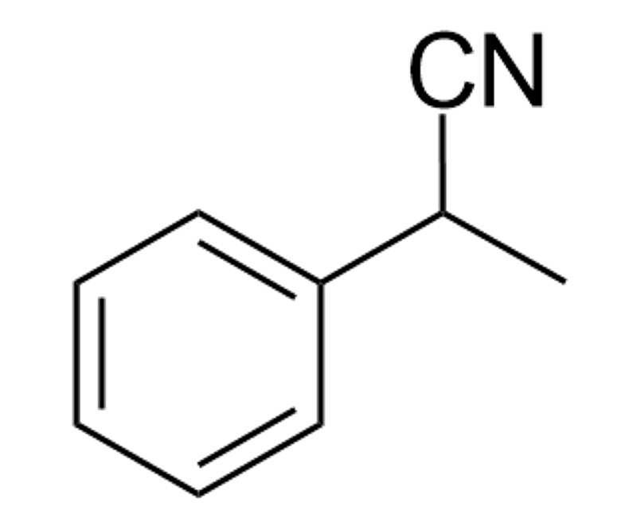
3-phenylpropanenitrile and 2-phenylpropenanitrile (1)
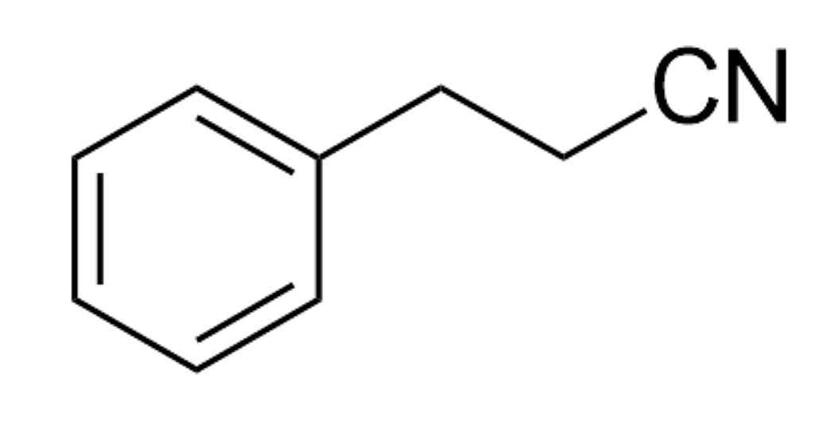
Reaction procedure A: Yield: 90%, l:b = 84:16
Without zeolite: Yield: 21%, l:b = 82:18

1

Linear product: ¹H NMR (400 MHz, CDCl₃): δ 7.40 – 7.34 (m, 2H), 7.33 – 7.29 (m, 1H), 7.28-7.24 (m, 2H), 2.99 (t, J = 7.4 Hz, 2H), 2.65 (t, J = 7.4 Hz, 2H). ¹³C NMR (101 MHz, CDCl₃): δ 138.05, 128.90, 128.27, 127.27, 119.14, 31.60, 19.39. The NMR data are consistent with those reported in the literature²⁸.
Branched product: ¹H NMR (400 MHz, CDCl₃), aliphatic region: δ 3.93 (q, J = 7.3 Hz, 1H), 1.68 (d, J = 7.3 Hz, 3H). ¹³C NMR (101 MHz, CDCl₃), aliphatic region: δ 31.28, 21.49. The NMR data are consistent with those reported in the literature¹⁴.

3-(4-tert-butylphenyl)propanenitrile and 2-(4-tert-butylphenyl)propanenitrile (2)
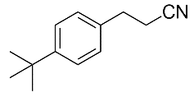
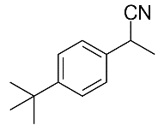
Reaction procedure A: Yield: 96%, l:b = 81:19
Without zeolite: Yield: 25%, l:b = 80:20

2

Linear product: ¹H NMR (400 MHz, CDCl₃): δ 7.39 (d, J = 8.2 Hz, 2H), 7.19 (d, J = 8.2 Hz, 2H), 2.96 (t, J = 7.4 Hz, 2H), 2.64 (t, J = 7.4 Hz, 2H), 1.31 (s, 9H). ¹³C NMR (101 MHz, CDCl₃): δ 150.18, 135.03, 127.94, 125.79, 119.48, 34.50, 31.34, 31.09, 19.36. GC-MS (EI, 70 eV): m/z (rel. int%):187 (59), 172 (100), 158 (16), 117 (17), 104 (34), 91 (17), 90 (15), 41 (29). The NMR data are consistent with those reported in the literature²⁸.
Branched product: ¹H NMR (400 MHz, CDCl₃), aliphatic region: δ 3.88 (q, J = 7.3 Hz, 1H), 1.64 (d, J = 7.2 Hz, 3H), 1.34 (s, 9H). ¹³C NMR (101 MHz, CDCl₃), aliphatic region: δ 31.61, 30.80, 21.38. GC-MS (EI, 70 eV): m/z (rel. int%): 187 (47), 172 (100), 154 (13), 144 (38), 130 (9), 117 (24), 116 (8), 91 (13). The NMR data are consistent with those reported in the literature¹⁴.

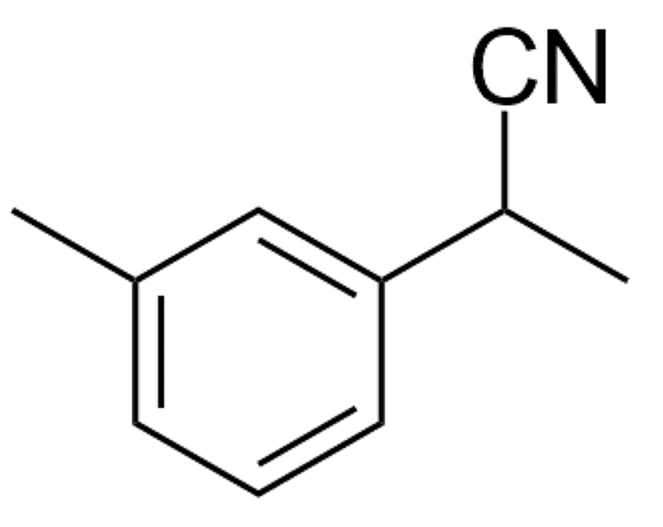
3-(3-methylphenyl)propanenitrile and 2-(3-methylphenyl)propanenitrile (3)
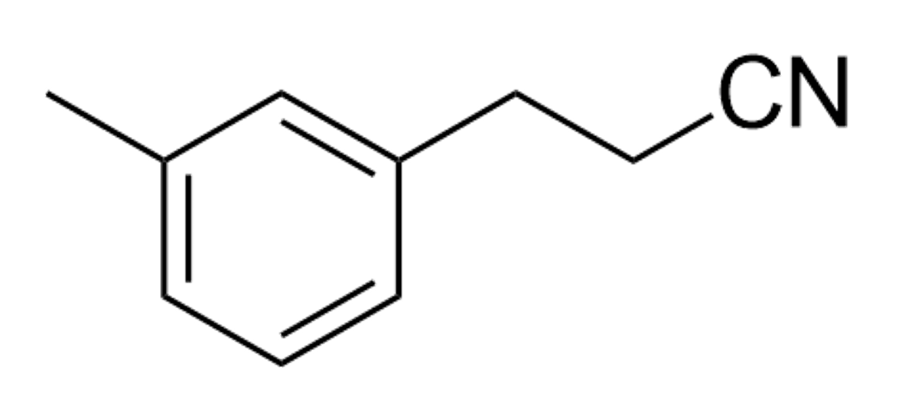
Reaction procedure A: Yield: 92%, l:b = 86:14
Without zeolite: Yield: 23%, l:b = 85:15

3

Linear product: ¹H NMR (400 MHz, CDCl₃): δ 7.25 (t, J = 7.5 Hz, 1H), 7.11 (d, J = 7.8 Hz, 1H), 7.05 (d, J = 8.5 Hz), 2.94 (t, J = 7.4 Hz, 2H), 2.63 (t, J = 7.4 Hz, 2H), 2.37 (s, 3H). ¹³C NMR (101 MHz, CDCl₃): δ 138.55, 138.03, 129.04, 128.78, 127.98, 125.25, 119.23, 31.52, 21.38, 19.35. The NMR data are consistent with those reported in the literature²⁹.
Branched product: ¹H NMR (400 MHz, CDCl₃), aliphatic region: δ 3.88 (q, J = 7.3 Hz, 1H), 2.37 (s, 3H), 1.66 (d, J = 7.3 Hz, 3H). ¹³C NMR (101 MHz, CDCl₃), aliphatic region: δ 31.19, 21.51, 19.35. The NMR data are consistent with those reported in the literature³⁰.

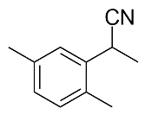
3-(2,5-dimethylphenyl)propanenitrile and 2-(2,5-dimethylphenyl)propanenitrile (4)
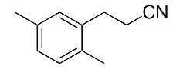
Reaction procedure A: Yield: 89%, l:b = 89:11
Without zeolite: Yield: 18%, l:b = 87:13

4

Linear product: ¹H NMR (400 MHz, CDCl₃): δ 7.11-7.07 (m, 1H), 7.03-7.0 (m, 2H), 2.97 (t, J = 7.7 Hz, 2H), 2.6 (t, J = 7.7 Hz, 2H), 2.33 (s, 3H), 2.31 (s, 3H). ¹³C NMR (101 MHz, CDCl₃): δ 136.07, 135.99, 132.57, 130.58, 129.49, 128.06, 119.29, 28.94, 20.94, 18.71, 18.09.
Branched product: ¹H NMR (400 MHz, CDCl₃), aliphatic region: δ 4.04 (q, J = 7.2 Hz, 1H), 2.33 (s, 3H), 2.31 (s, 3H), 1.62 (d, J = 7.2 Hz, 3H). ¹³C NMR (101 MHz, CDCl₃), aliphatic region: δ 28.15, 20.99, 20.17, 18.52.

3-mesitylpropanenitrile (5)
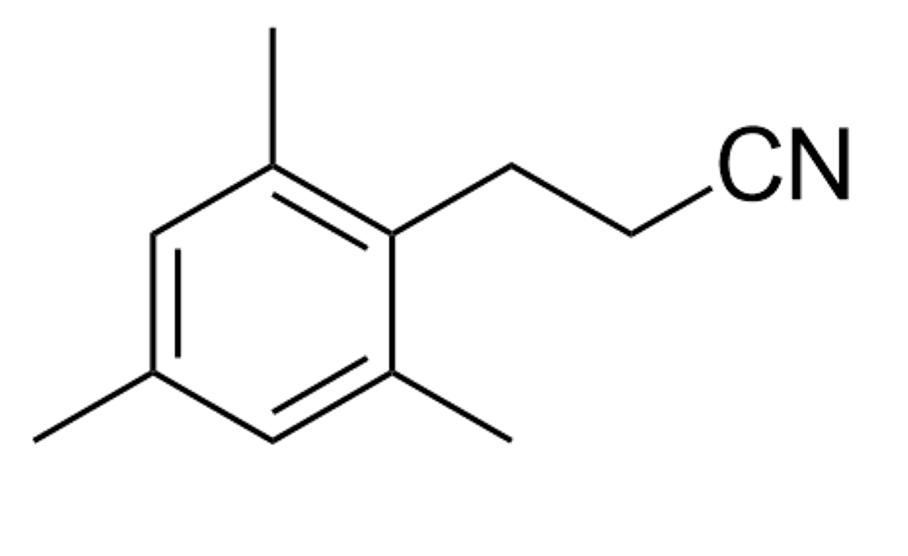
Reaction procedure A: Yield: 98% (Isolated: 92%)
Without zeolite: Yield: 22%

5

The compound was isolated by column chromatography (silica gel, 10% Et₂O in petroleum ether) to give product 5 as pale yellow oil (79.6 mg, 0.46 mmol, 92% yield).
¹H NMR (400 MHz, CDCl₃): δ 6.89 (s, 1H), 3.04 (t, J = 8.3 Hz, 2H), 2.49 (t, J = 8.3 Hz, 2H), 2.34 (s, 6H), 2.28 (s, 3H). ¹³C NMR (101 MHz, CDCl₃): δ 136.63, 136.07, 131.88, 129.38, 119.43, 25.21, 20.84 , 19.70, 16.73. The NMR data are consistent with those reported in the literature²⁸.

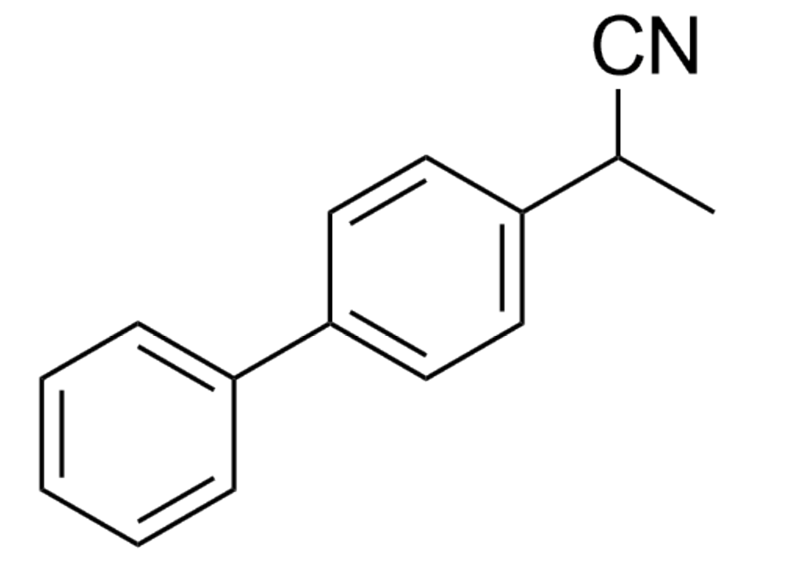
3-(1,1-biphenyl)propanenitrile and 2-(1,1-biphenyl)propanenitrile (6)
Reaction procedure A: Yield: 93% ; l:b = 84:16
Without zeolite: Yield: 20%, l:b = 81:19

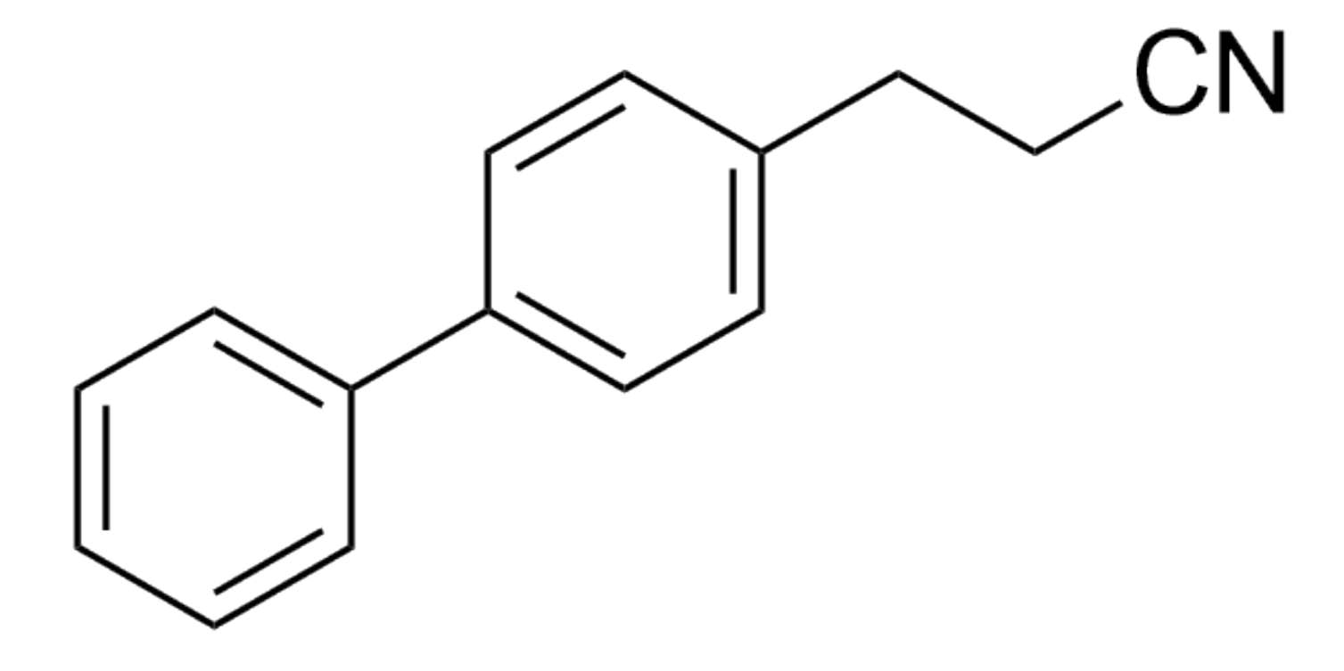

6

Linear product: ¹H NMR (400 MHz, CDCl₃): δ 7.62-7.59 (m, 4H), 7.49-7.45 (m, 3H), 7.40-7.32 (m, 3H), 3.03 (t, J = 7.4 Hz, 2H), 2.69 (t, J = 7.4 Hz, 2H). ¹³C NMR (101 MHz, CDCl₃): δ 140.65, 140.27, 137.07, 128.83, 128.74, 127.62, 127.40, 127.07, 119.17, 31.24, 19.38. The NMR data are consistent with those reported in the literature³¹.
Branched product: ¹H NMR (400 MHz, CDCl₃), aliphatic region: δ 3.98 (q, J = 7.3 Hz, 1H), 1.72 (d, J = 7.3 Hz, 3H). ¹³C NMR (101 MHz, CDCl₃), aliphatic region: δ 121.59 (CN), 30.98, 24.16. The NMR data are consistent with those reported in the literature³².

3-(Naphtalen-2-yl)propanenitrile and 2-(Naphtalen-2-yl)propanenitrile (7)
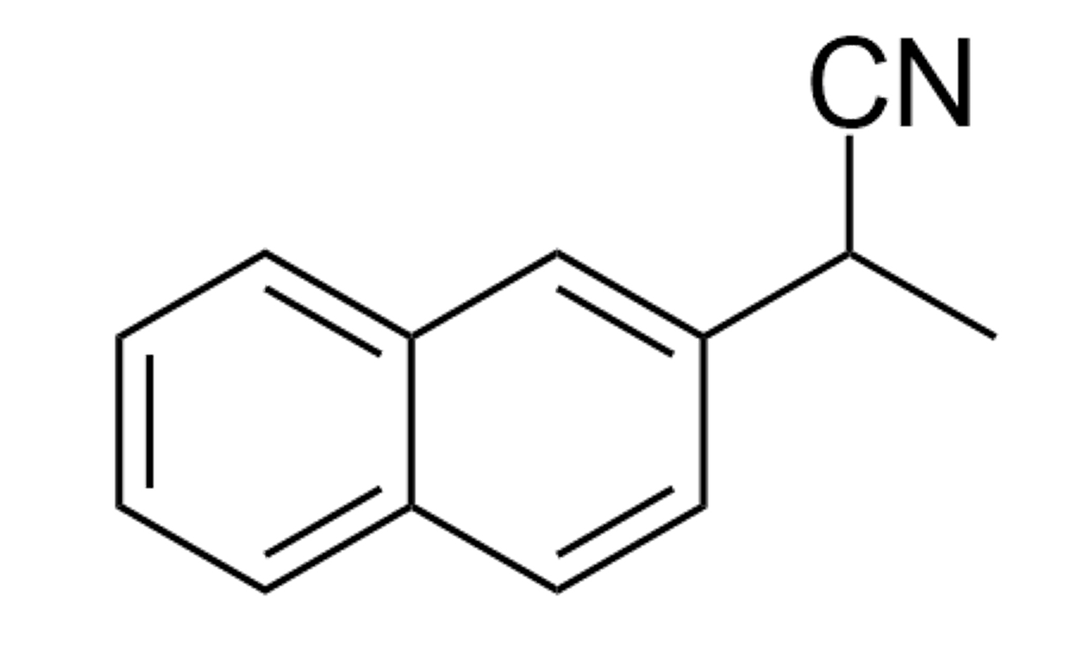
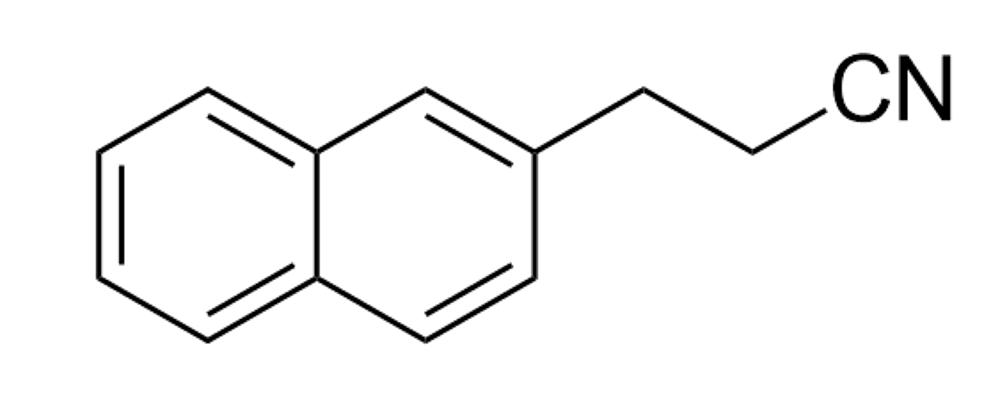
Reaction procedure A: Yield: 88%, l:b = 85:15
Without zeolite: Yield: 20%, l:b = 84:16

7

Linear product: ¹H NMR (400 MHz, CDCl₃): δ 7.84-7.80 (m, 3H), 7.68 (s, 3H), 7.50-7.46 (m, 2H), 7.34 (dd, J₁ = 8.4 Hz, J₂ = 1.8 Hz, 1H), 3.12 (t, J = 7.4 Hz, 2H), 2.71 (t, J = 7.4 Hz, 2H). ¹³C NMR (101 MHz, CDCl₃): δ 135.47, 133.52, 132.54, 128.71, 127.72, 127.66, 126.9, 126.4, 126.33, 125.96, 119.14, 140.27, 137.07, 128.83, 128.74, 127.62, 127.40, 127.07, 119.17, 31.77, 19.32. The NMR data are consistent with those reported in the literature²⁸.
Branched product: ¹H NMR (400 MHz, CDCl₃), aliphatic region: δ 4.06 (q, J = 7.3 Hz, 1H), 1.73 (d, J = 7.3 Hz, 3H). ¹³C NMR (101 MHz, CDCl₃), aliphatic region: δ 119.49 (CN), 31.45, 21.46. The NMR data are consistent with those reported in the literature¹⁴.

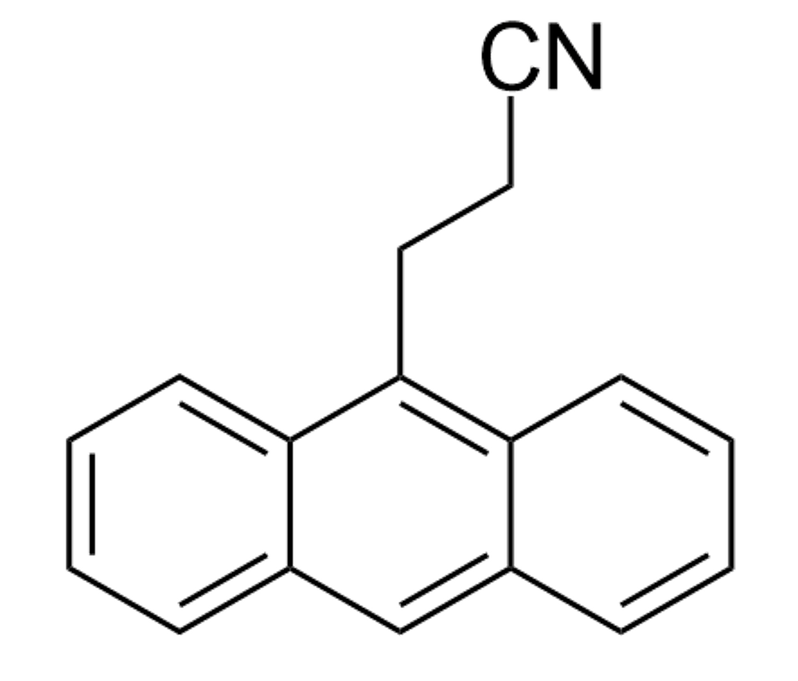
9-anthracenepropanenitrile (8)
Reaction procedure A: Yield: 87% (isolated: 82%)
Without zeolite: Yield: 16%

8

The compound was isolated by column chromatography (silica gel, 0-5% Et₂O in petroleum ether) to give product 8 as an orange solid (94.7 mg, 0.41 mmol, 82% yield).
¹H NMR (400 MHz, CDCl₃): δ 8.46 (s, 1H), 8.22 (d, J = 9 Hz, 2H), 8.07 (d, J = 8.5 Hz, 2H), 7.61 (ddd, J₁ = 8.9, J₂ = 6.6, J₃ = 1.4 Hz, 2H), 7.53 (ddd, J₁ = 7.6, J₂ = 6.5, J₃ = 1.1 Hz, 2H), 4.07-4.03 (m, 2H), 2.84–2.80 (m, 2H). ¹³C NMR (101 MHz, CDCl₃): δ 131.55, 129.60, 129.52, 129.46, 127.53, 126.64, 125.15, 123.15, 119.23, 77.36, 77.04, 76.73, 23.79, 18.10. The NMR data are consistent with those reported in the literature³³.

3-phenylbutanenitrile (9)
Reaction procedure A: Yield: 93% (isolated: 86%)
Without zeolite: Yield: 13%

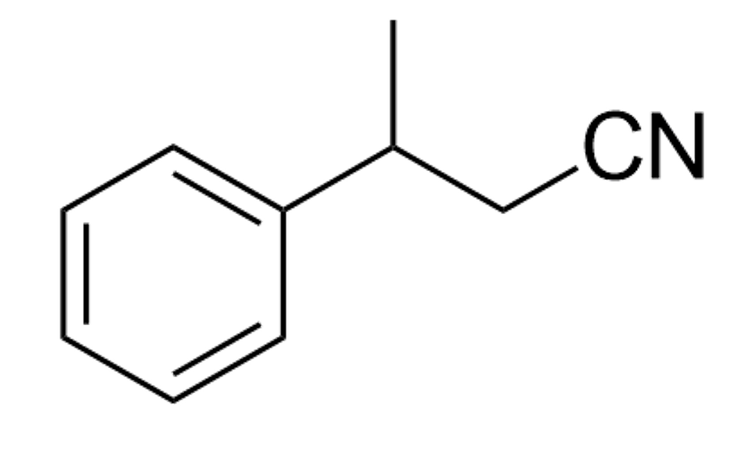
9

The compound was isolated by column chromatography (silica gel, 0-10% Et₂O in petroleum ether) to give product 9 as a pale yellow oil (62.35 mg, 0.43 mmol, 86% yield).
¹H NMR (400 MHz, CDCl₃): δ 7.40 – 7.34 (m, 2H), 7.32 – 7.24 (m, 3H), 3.19 (h, J = 7.0 Hz, 1H), 2.68 – 2.54 (m, 2H), 1.48 (d, J = 7.0 Hz, 3H). ¹³C NMR (101 MHz, CDCl₃): δ 143.16, 128.89, 127.35, 126.56, 118.59, 36.55, 26.39, 20.69. The NMR data are consistent with those reported in the literature²⁸.

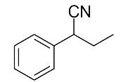
4-phenylbutanenitrile, 2-methyl-3-phenylpropanenitrile and 2-phenylbutanenitrile (10)
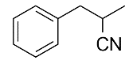
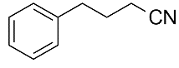
Reaction procedure A: Yield: 80% (l:β:α = 55:38:7)
Without zeolite: Yield: 8%

10

Linear product: ¹H NMR (400 MHz, CDCl₃), aliphatic region: δ 2.81 (t, J = 7.4 Hz, 2H), 2.35 (t, J = 7.4 Hz, 2H), 2.02 (p, J = 7.3 Hz, 2H). ¹³C NMR (101 MHz, CDCl₃): δ 139.72, 128.70, 128.48, 126.54, 119.52, 34.40, 26.93, 16.41. The NMR data are consistent with those reported in the literature²⁸.
Branched product (β-substituted to phenyl): ¹H NMR (400 MHz, CDCl₃), aliphatic region: δ 2.96 (dd, J₁ = 10.8, J₂ = 5.0 Hz, 1H), 2.91 – 2.83 (m, 2H), 1.38 – 1.35 (m, 3H). ¹³C NMR (101 MHz, CDCl₃): δ 136.86, 129.06, 128.74, 127.28, 122.55, 40.02, 27.56, 17.62. The NMR data are consistent with those reported in the literature³⁴.
Branched product (α-substituted to phenyl): ¹H NMR (400 MHz, CDCl₃), benzylic proton: δ 3.83 – 3.63 (m, 1H). ¹³C NMR (101 MHz, CDCl₃), aliphatic region: δ 38.95, 29.24, 11.50. The NMR data are consistent with those reported in the literature³².

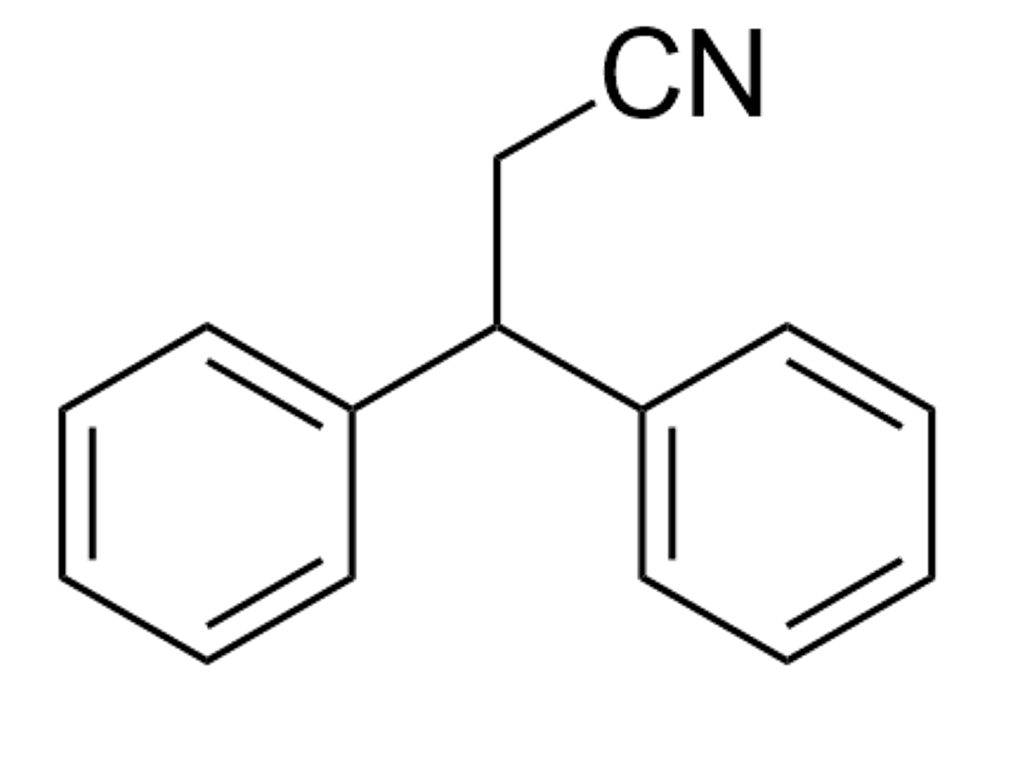
3,3-diphenylpropanenenitrile (11)
Reaction procedure C: Yield: 56%
Without zeolite: Yield: <2%

11

¹H NMR (400 MHz, CDCl₃): δ 7.39 – 7.35 (m, 4H), 7.32 – 7.25 (m, 6H), 4.42 (t, J = 7.6 Hz, 1H), 3.07 (d, J = 7.6 Hz, 2H). ¹³C NMR (101 MHz, CDCl₃): δ 141.25, 128.93, 127.56, 127.43, 118.42, 47.18, 24.27. The NMR data are consistent with those reported in the literature²⁸.

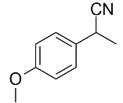
3-(4-methoxyphenyl)propanenitrile and 2-(4-methoxyphenyl)propanenitrile (12)
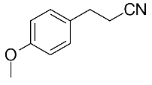
Reaction procedure A: Yield: 71%, l:b = 81:19
Without zeolite: Yield: 22%, l:b = 80:20

12

Linear product: ¹H NMR (400 MHz, CDCl₃): δ 7.21 – 7.15 (m, 2H), 6.92 – 6.87 (m, 2H), 3.83 (s, 3H), 2.93 (t, J = 7.3 Hz, 2H), 2.61 (t, J = 7.4 Hz, 2H). ¹³C NMR (101 MHz, CDCl₃): δ 158.78, 130.14, 129.33, 119.24, 114.28, 55.30, 30.79, 19.72. The NMR data are consistent with those reported in the literature²⁸.
Branched product: ¹H NMR (400 MHz, CDCl₃), aliphatic region: δ 3.88 (q, J = 7.4 Hz, 1H), 3.84 (s, 3H), 1.64 (d, J = 7.3 Hz, 3H). ¹³C NMR (101 MHz, CDCl₃), aliphatic region: δ 55.37, 30.48, 21.53. The NMR data are consistent with those reported in the literature¹⁴.

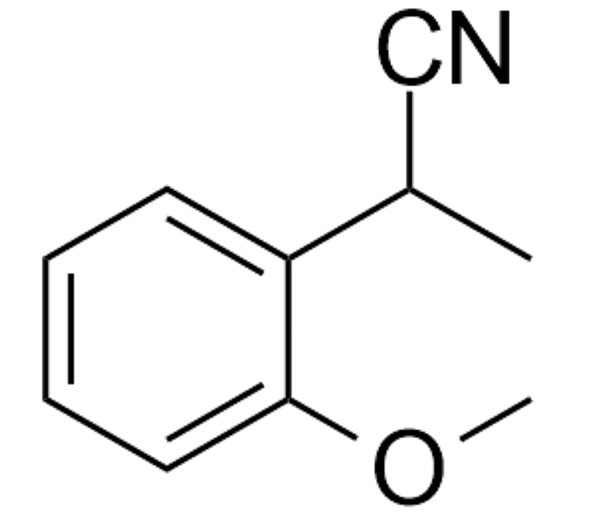
3-(2-methoxyphenyl)propanenitrile and 2-(2-methoxyphenyl)propanenitrile (13)
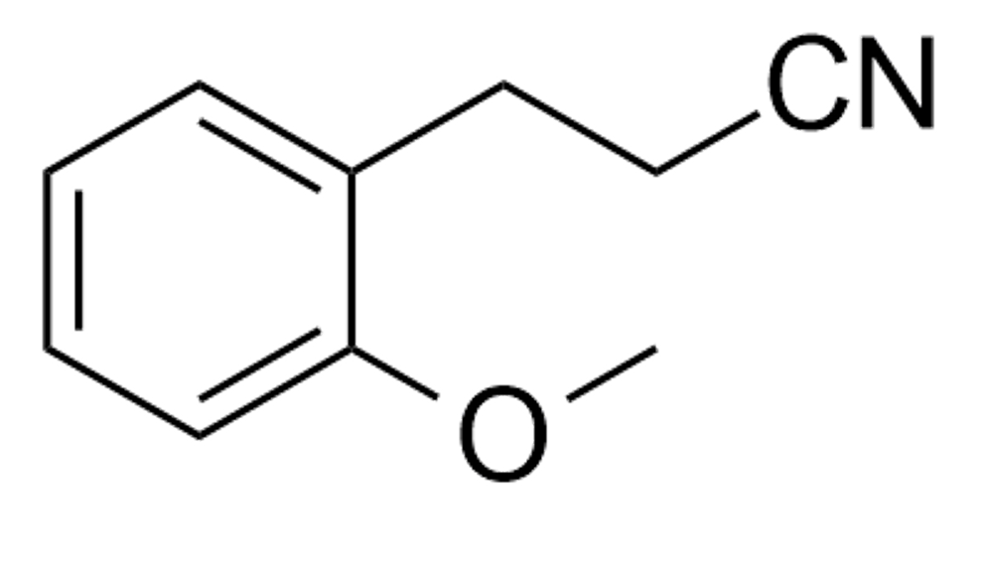
Reaction procedure A: Yield: 95%, l:b = 90:10
Without zeolite: Yield: 24%, l:b = 89:11

13

Linear product: ¹H NMR (400 MHz, CDCl₃): δ 7.31 – 7.26 (m, 1H), 7.20 (dd, J₁ = 7.4, J₂ = 1.7 Hz, 1H), 6.98 – 6.87 (m, 2H), 3.87 (s, 3H), 2.99 (t, J = 7.4 Hz, 2H), 2.65 (t, J = 7.4 Hz, 2H). ¹³C NMR (101 MHz, CDCl₃): δ 157.32, 130.24, 128.67, 126.37, 120.71, 119.70, 110.39, 55.22, 27.10, 17.50. The NMR data are consistent with those reported in the literature¹⁴.
Branched product: ¹H NMR (400 MHz, CDCl₃), aliphatic region: δ 4.28 (q, J = 7.2 Hz, 1H), 3.89 (s, 3H), 1.61 (d, J = 7.3 Hz, 3H). ¹³C NMR (101 MHz, CDCl₃), aliphatic region: δ 55.48, 25.63, 19.53. The NMR data are consistent with those reported in the literature³⁴.

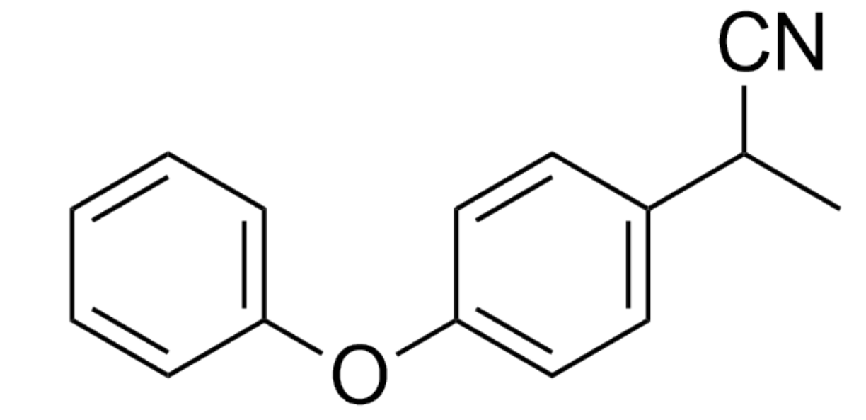
3-(4-phenoxyphenyl)propanenitrile and 2-(4-phenoxyphenyl)propanenitrile (14)
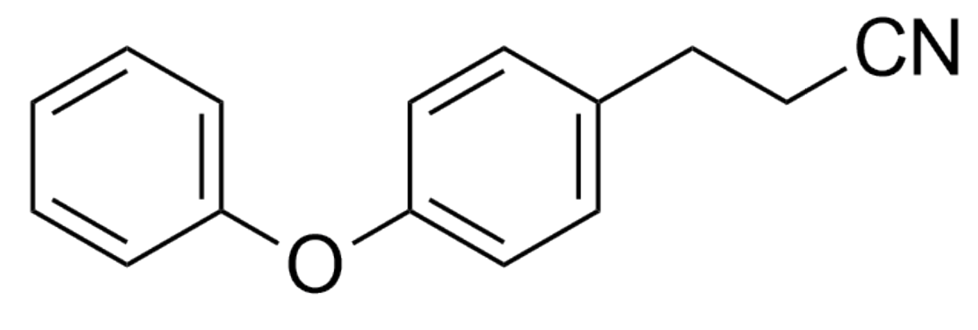
Reaction procedure A: Yield: 79%, l:b = 85:15
Without zeolite: Yield: 18%, l:b = 83:17

14

Linear product: ¹H NMR (400 MHz, CDCl₃): 7.41 – 7.32 (m, 3H), 7.24 – 7.20 (m, 2H), 7.14 (t, J = 7.4 Hz, 1H), 7.02 (tdd, J₁ = 8.6, J₂ = 4.2, J₃ = 2.5 Hz, J₄ = 5H), 2.97 (t, J = 7.3 Hz, 2H), 2.65 (t, J = 7.3 Hz, 2H). ¹³C NMR (101 MHz, CDCl₃): δ 157.08, 156.54, 132.79, 129.80, 129.65, 123.41, 119.17, 118.97, 30.90, 19.59. The NMR data are consistent with those reported in the literature³⁵.
Branched product: ¹H NMR (400 MHz, CDCl₃), aliphatic region: δ 3.91 (q, J = 7.3 Hz, 1H), 1.67 (d, J = 7.3 Hz, 3H). ¹³C NMR (101 MHz, CDCl₃), aliphatic region: δ 30.63, 21.49. The NMR data are consistent with those reported in the literature³⁶.

3-(4-fluorophenyl)propanenitrile and 2-(4-fluorophenyl)propanenitrile (15)
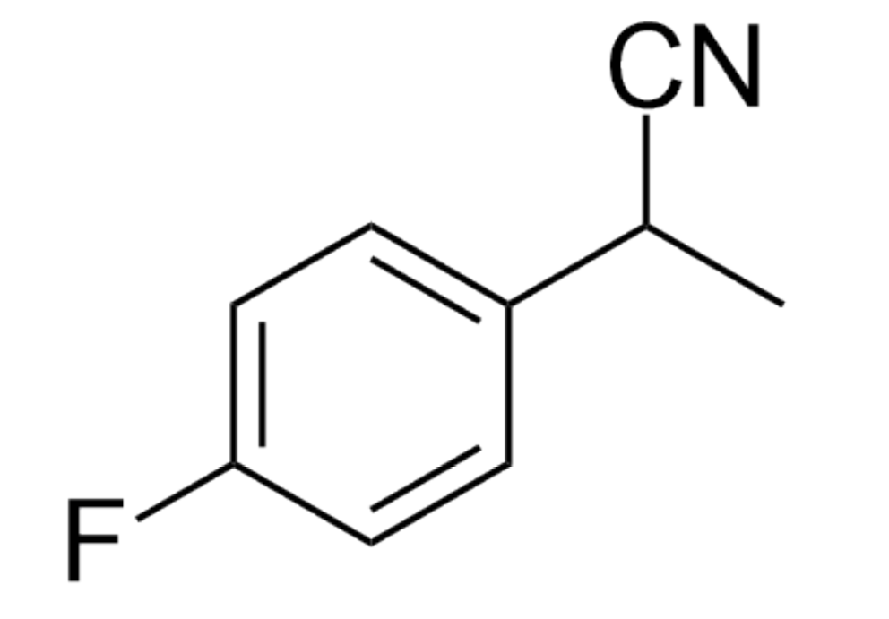
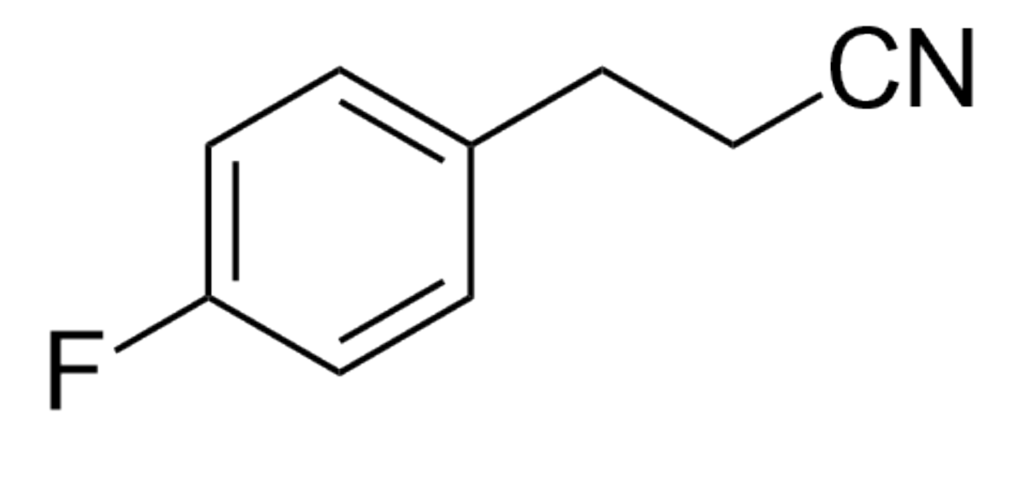
Reaction procedure A: Yield: 81%, l:b = 85:15
Without zeolite: Yield: 17%, l:b = 82:18

15

Linear product: ¹H NMR (400 MHz, CDCl₃): 7.28 – 7.19 (m, 2H), 7.12 – 6.99 (m, 2H), 2.96 (t, J = 7.4 Hz, 2H), 2.63 (t, J = 7.3 Hz, 2H). ¹⁹F NMR (376 MHz, CDCl₃): δ -115.33. The NMR data are consistent with those reported in the literature¹⁰.
Branched product: ¹H NMR (400 MHz, CDCl₃), aliphatic region: δ 3.92 (q, J = 7.4 Hz, 1H), 1.66 (d, J = 7.3 Hz, 3H). ¹⁹F NMR (376 MHz, CDCl₃): δ -113.91. The NMR data are consistent with those reported in the literature¹⁰.

3-(4-trimethylsilylphenyl)propanenitrile and 2-(4-trimethylsilylphenyl)propanenitrile (16)
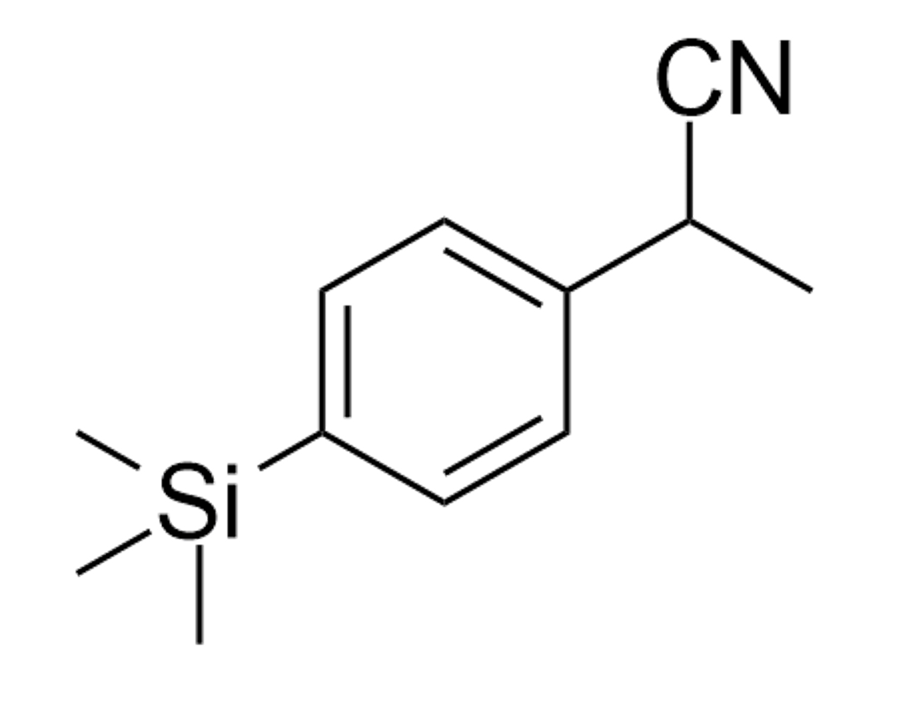
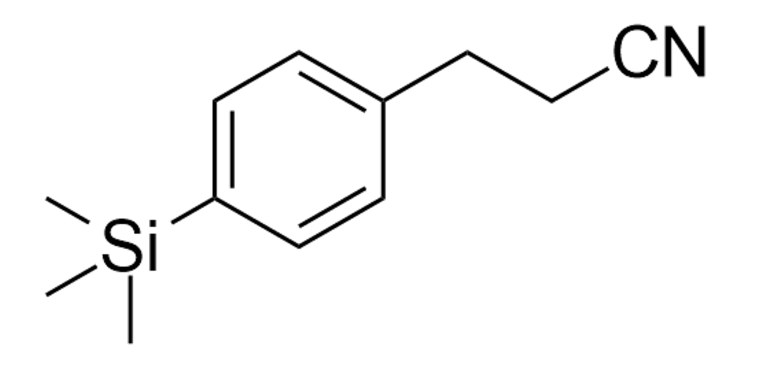
Reaction procedure A: Yield: 68%, l:b = 83:17
Without zeolite: Yield: 25%, l:b = 81:19

16

Linear product: ¹H NMR (400 MHz, CDCl3): δ 7.55 – 7.50 (m, 2H), 7.27 – 7.23 (m, 2H), 2.98 (t, J = 7.5 Hz, 2H), 2.65 (t, J = 7.4 Hz, 2H), 1.67 (d, J = 7.3 Hz, 1H), 0.29 (s, 9H). ¹³C NMR (101 MHz, CDCl₃): δ 139.40, 138.54, 133.92, 127.66, 119.18, 31.55, 19.25, -1.14.
Branched product: ¹H NMR (400 MHz, CDCl₃): δ 7.59 – 7.55 (m, 2H), 7.39 – 7.35 (m, 2H), 3.92 (q, J = 7.3 Hz, 1H), 1.67 (d, J = 7.3 Hz, 3H), 0.30 (s, 9H). ¹³C NMR (101 MHz, CDCl₃): δ 140.60, 137.49, 134.15, 126.06, 121.55, 31.25, 21.41, -1.19. The NMR data are consistent with those reported in the literature³⁷.

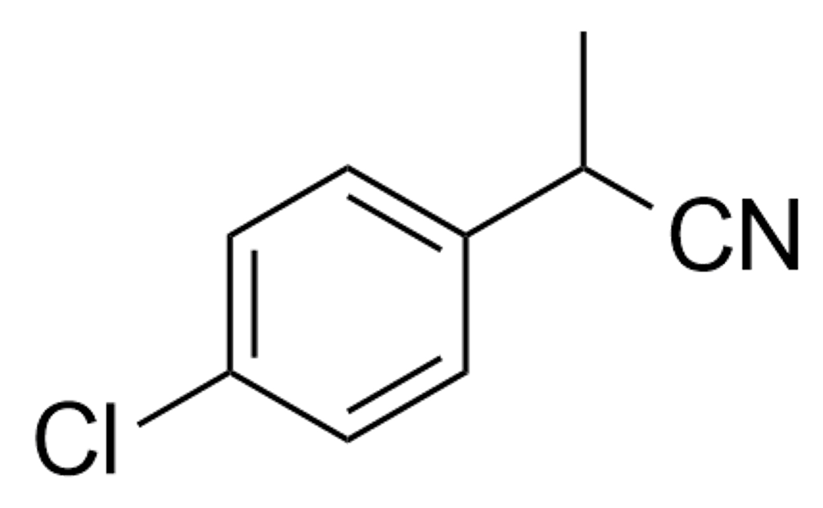
3-(4-chlorophenyl)propanenitrile and 2-(4-chlorophenyl)propanenitrile (17)
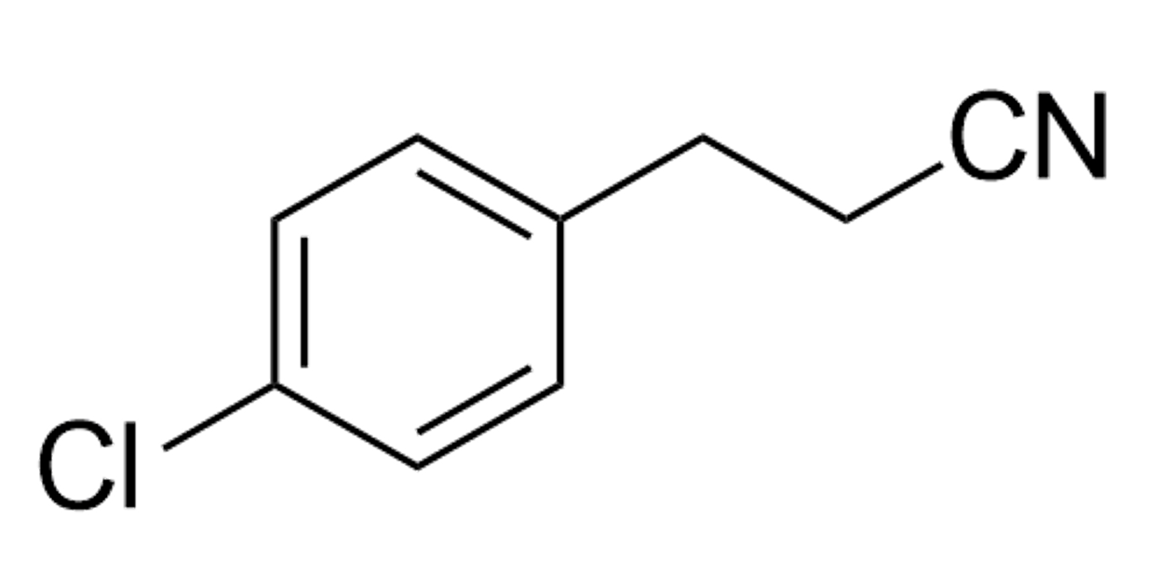
Reaction procedure D: Yield: 66%, l:b = 85:15
Without zeolite: Yield: 6%, l:b = 83:17

17

Linear product: ¹H NMR (400 MHz, CDCl3): δ 7.33 – 7.29 (m, 2H), 7.17 (d, J = 8.2 Hz, 2H), 2.93 (t, J = 7.2 Hz, 2H), 2.61 (t, J = 7.3 Hz, 2H). ¹³C NMR (101 MHz, CDCl₃): δ 136.45, 129.71, 129.05, 118.84, 30.91, 19.33. The NMR data are consistent with those reported in the literature³⁴.
Branched product: ¹H NMR (400 MHz, CDCl₃): aliphatic region: δ 3.89 (q, J = 7.3 Hz, 1H), 1.63 (d, J = 7.3 Hz, 3H). ¹³C NMR (101 MHz, CDCl₃): δ 135.57, 134.07, 129.35, 128.14, 121.15, 30.74, 21.39. The NMR data are consistent with those reported in the literature³⁴.

3-(2-chlorophenyl)propanenitrile and 2-(2-chlorophenyl)propanenitrile (18)
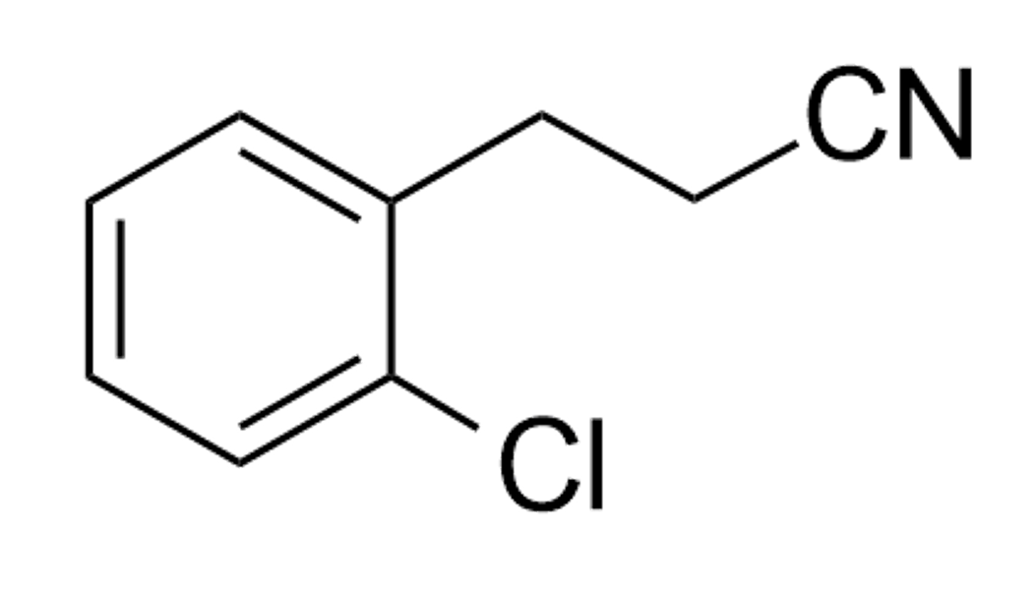
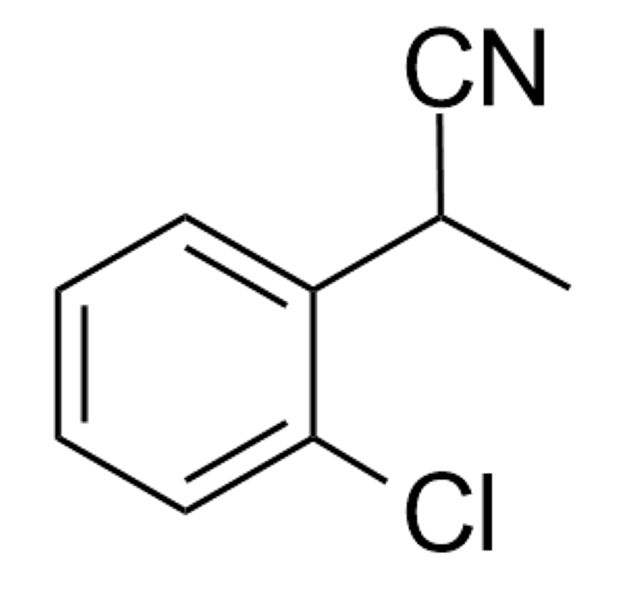
Reaction procedure D: Yield: 59%, l:b = 87:13
Without zeolite: Yield: 5%, l:b = 88:12

18

Linear product: ¹H NMR (400 MHz, CDCl3): δ 7.41 – 7.35 (m, 1H), 7.32 – 7.28 (m, 1H), 7.27 – 7.22 (m, 2H), 3.09 (t, J = 7.3 Hz, 2H), 2.68 (t, J = 7.4 Hz, 2H). ¹³C NMR (101 MHz, CDCl₃): δ 135.53, 133.77, 130.78, 129.85, 128.95, 127.35, 118.87, 29.68, 17.48. The NMR data are consistent with those reported in the literature³⁸.
Branched product: ¹H NMR (400 MHz, CDCl₃): aliphatic region: 4.35 (q, J = 7.2 Hz, 1H), 1.63 (d, J = 7.3 Hz, 3H). ¹³C NMR (101 MHz, CDCl₃): aliphatic region: δ 28.87, 19.96. The NMR data are consistent with those reported in the literature³⁹.

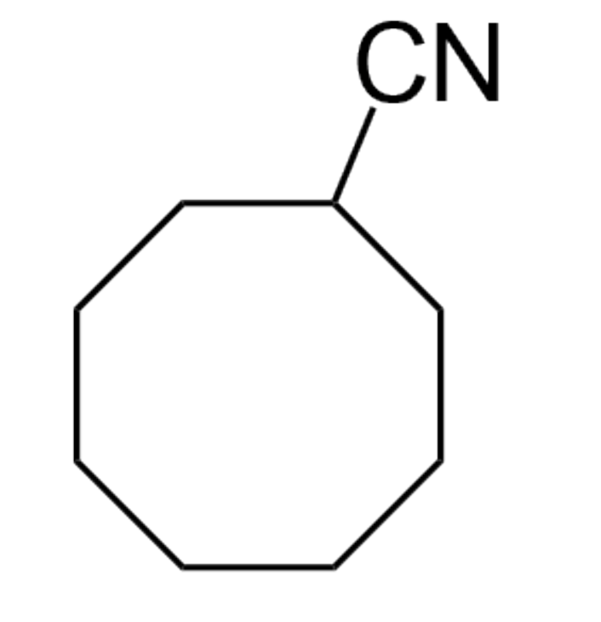
Cyclooctanecarbonitrile (19)
Reaction procedure A: Yield: 67%
Without zeolite: Yield: 11%

19

¹H NMR (400 MHz, CDCl3): δ 2.78 (tt, J₁ = 8.5, J₂ = 4.3 Hz, 1H), 1.99 -1.95 (m, 2H), 1.93 – 1.68 (m, 4H), 1.58 (m, 8H). ¹³C NMR (101 MHz, CDCl₃): δ 123.60, 29.48, 28.79, 26.85, 25.17, 24.29. The NMR data are consistent with those reported in the literature¹⁰.

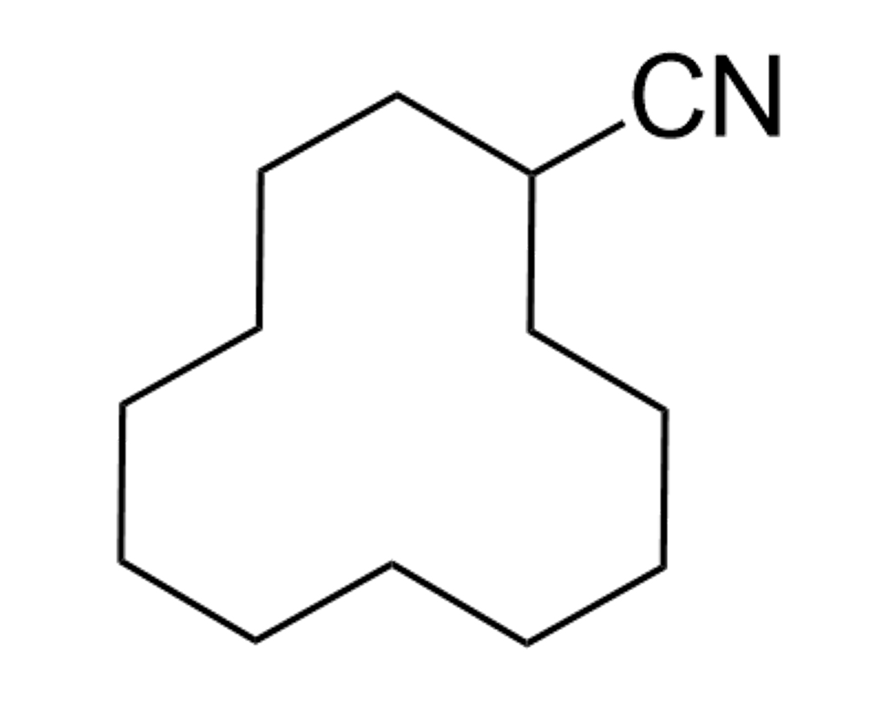
Cyclododecanecarbonitrile (20)
Reaction procedure B: Yield: 78%
Without zeolite: Yield: 9%

20

¹H NMR (400 MHz, CDCl3): δ 2.70 – 2.64 (m, 1H), 1.81 – 1.65 (m, 4H), 1.56 – 1.23 (m, 18H). ¹³C NMR (101 MHz, CDCl₃): δ 123.30, 27.19, 26.51, 23.67, 23.48, 23.27, 23.15, 21.89. The NMR data are consistent with those reported in the literature⁴⁰.

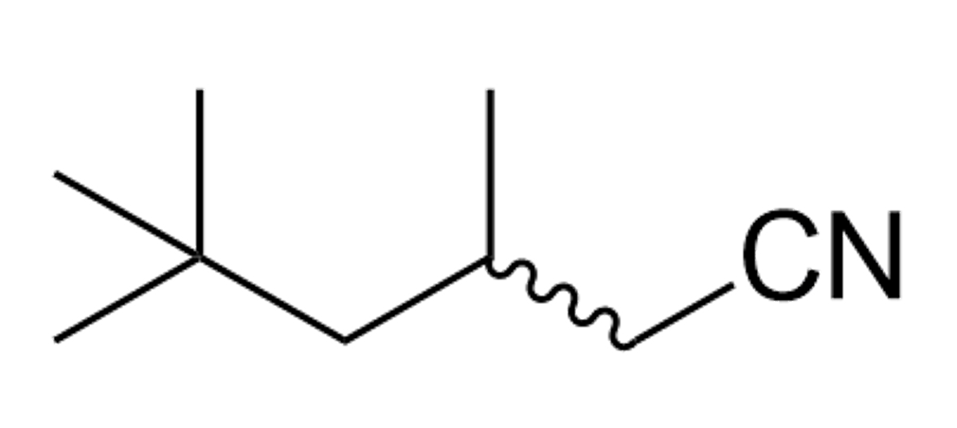
3,5,5-trimethylhexanenitrile (21)
Reaction procedure A: Yield: 58% (isolated: 54%)
Without zeolite: Yield: <5%

21

The compound was isolated by column chromatography (silica gel, 5% Et₂O in petroleum ether) to give product 21 as a colorless liquid (37.8 mg, 0.27 mmol, 54% yield).
¹H NMR (400 MHz, CDCl3): δ 2.37 – 2.25 (m, 2H), 2.01 – 1.94 (m, 1H), 1.15 (d, J = 4.2 Hz, 2H), 1.00 (dd, J₁ = 6.9, J₂ = 3.8 Hz, 3H), 0.95 (s, 9H). ¹³C NMR (101 MHz, CDCl₃): δ 119.35, 62.49, 49.81, 29.82, 28.75, 27.16, 26.74, 22.33.

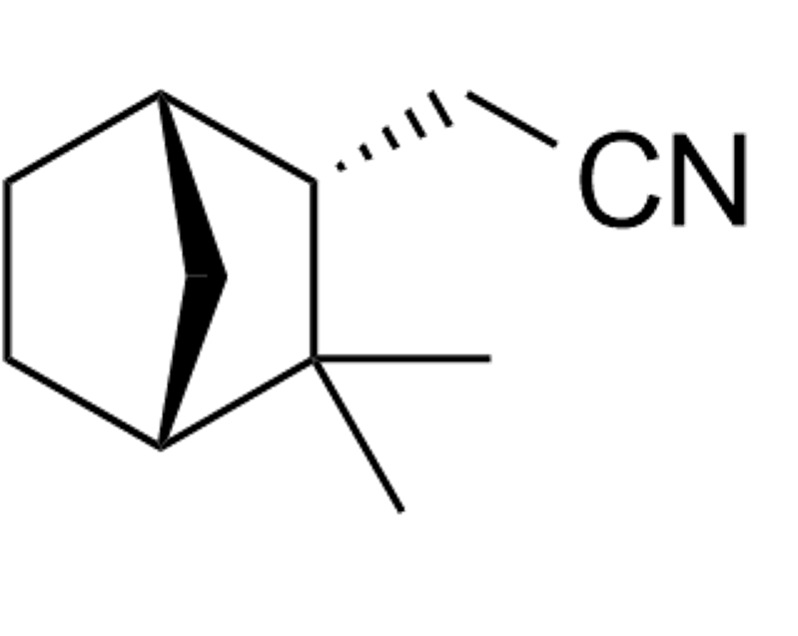
2-(3,3-dimethylbicyclo[2.2.1]heptan-2-yl)acetonitrile (22)
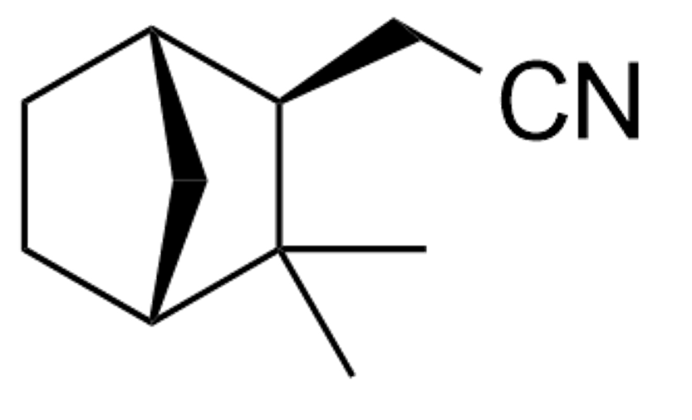
Reaction procedure B: Yield: 80%
Without zeolite: Yield: 10%

22

¹H NMR (400 MHz, CDCl3): δ 2.42 – 2.22 (m, 3H), 2.20 – 2.10 (m, 1.87H), 1.84 (q, J = 4.2, 3.8 Hz, 1.51H), 1.78 (d, J = 4.0 Hz, 1.01H), 1.75 – 1.66 (m, 2.92H), 1.62 (dt, J = 14.2, 3.4 Hz, 1.28H), 1.47 (ddd, J = 9.0, 6.7, 1.8 Hz, 1.4H), 1.39 (d, J = 12.4 Hz, 2.32H), 1.32 (d, J = 4.5 Hz, 2.08H), 1.28 – 1.22 (m, 3.25H), 1.22 – 1.16 (m, 2.06H), 1.07 (s, 2.23H), 1.05 (s, 1.96H), 0.97 (s, 2.4H), 0.88 (d, J = 9.2 Hz, 2.82H). ¹³C NMR (101 MHz, CDCl₃): δ 119.48, 50.63, 49.43, 48.91, 47.25, 43.72, 42.02, 40.44, 36.99, 36.79, 35.48, 35.00, 32.79, 31.91, 31.60, 30.08, 29.37, 27.57, 24.42, 24.33, 23.81, 20.93, 19.98, 18.91, 15.22. The NMR data are consistent with those reported in the literature¹⁰.

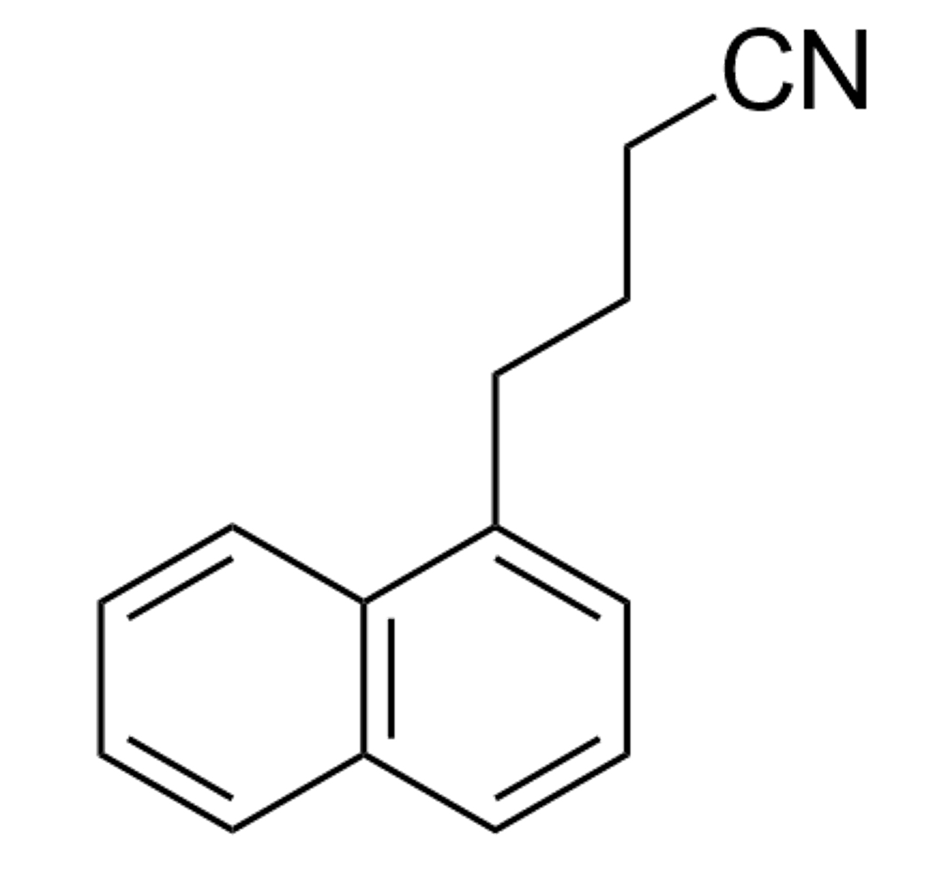
4-naphtalenebutanenitrile and 2-methyl-3-napthalenepropanenitrile (23)
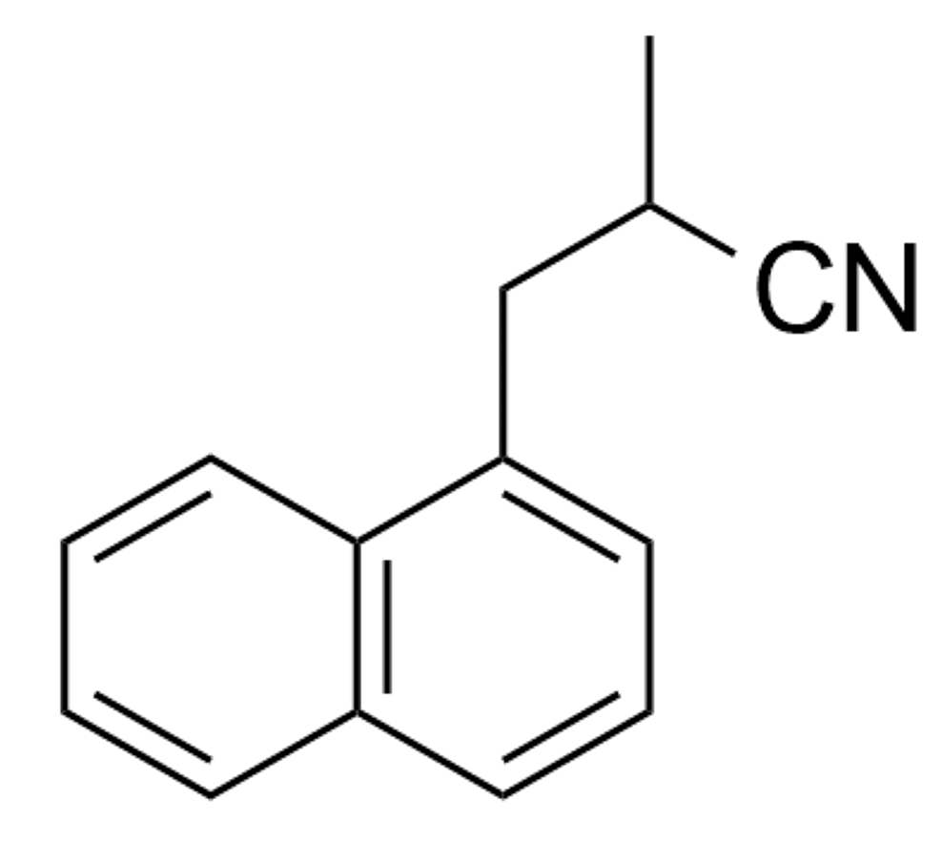
Reaction procedure B: Yield: 79%, l:b = 68:32
Without zeolite: Yield: 13%, l:b = 61:39

23

Linear product: ¹H NMR (400 MHz, CDCl3): δ 8.03 (d, J = 8.5 Hz, 1H), 7.97 – 7.73 (m, 3H), 7.62 – 7.41 (m, 3H), 3.28 (t, J = 7.5 Hz, 2H), 2.40 (t, J = 7.0 Hz, 2H), 2.15 (p, J = 7.2 Hz, 2H). ¹³C NMR (101 MHz, CDCl₃): δ 135.72, 134.02, 129.19, 128.99, 127.43, 126.53, 126.22, 125.75, 125.53, 132.33, 119.60, 31.62, 26.18, 16.81. The NMR data are consistent with those reported in the literature⁴¹.
Branched product: ¹H NMR (400 MHz, CDCl₃): aliphatic region: δ 3.48 (dd, J₁ = 14.1, J₂ = 7.8 Hz, 1H), 3.33-3.32 (m, 1H), 3.14-3.02 (m,1H), 1.43 (d, J = 7.0 Hz, 3H). ¹³C NMR (101 MHz, CDCl₃): aliphatic region: δ 37.29, 26.72, 18.06.
3,4-dimethoxybenzenebutanenitrile, 2-methyl-3-(3,4-dimethoxybenzene)propanenitrile and 2-(3,4-dimethoxybenzene)butanenitrile (24)
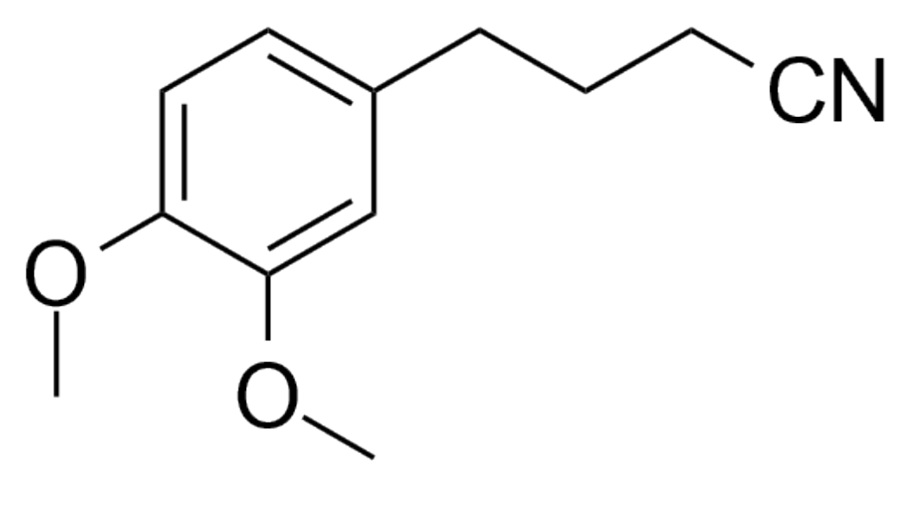
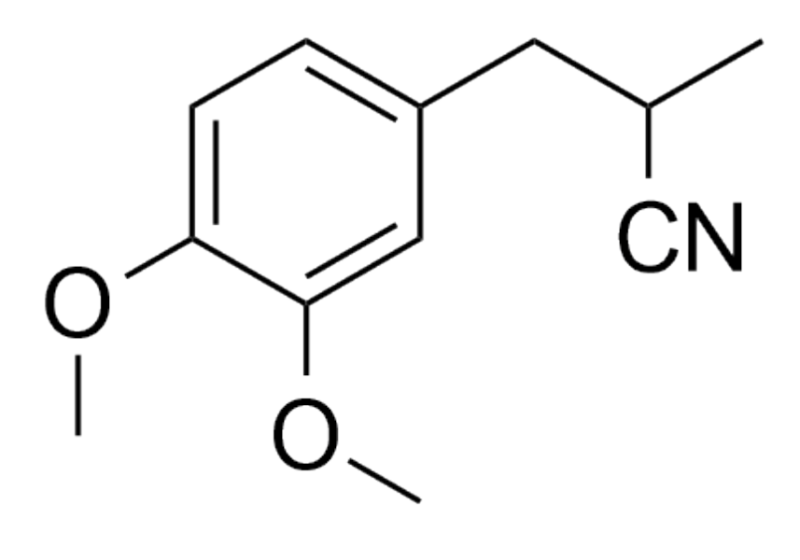
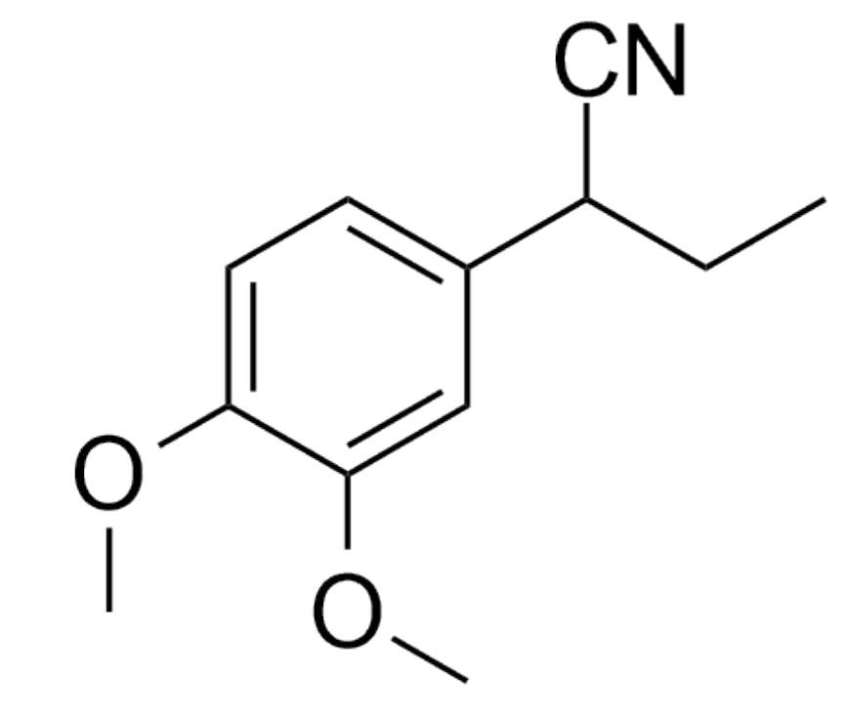
Reaction procedure B: Yield: 70%, l:b₁:b₂ = 51:43:6
Without zeolite: Yield: 9%, l:b₁:b₂ = 40:56:3

24

Linear product: ¹H NMR (400 MHz, CDCl3): δ 6.92-6.08 (m, 3H), 3.92-3.88 (m, 6H), 2.76 (t, J = 7.3 Hz, 2H), 2.34 (t, J = 7.0 Hz, 2H), 1.99 (p, J = 7.1 Hz, 2H). ¹³C NMR (101 MHz, CDCl₃): δ 149.08, 147.70, 131.16, 120.47, 118.66, 111.67, 111.40, 55.92, 33.96, 27.08, 16.34. The NMR data are consistent with those reported in the literature⁴².
Branched product (major): ¹H NMR (400 MHz, CDCl₃): aliphatic region: δ 2.94 – 2.79 (m, 3H), 1.35 (d, J = 6.4 Hz, 3H). ¹³C NMR (101 MHz, CDCl₃): δ 149.03, 148.27, 132.25, 121.23, 112.16, 111.31, 55.89, 39.68, 27.80, 18.39.
Branched product (minor): ¹H NMR (400 MHz, CDCl₃): benzylic proton δ 3.70-3.68 (m, 1H). ¹³C NMR (101 MHz, CDCl₃): aliphatic region: δ 38.56, 29.27, 11.52. The NMR data are consistent with those reported in the literature⁴³.
5-ethylidene(E/Z)-2-norbornanecarbonitrile (25a), 6-ethylidene(E/Z)-2-norbornanecarbonitrile (25b), 6-cyano-2-norbornanepropanenitrile (25c) and 5-cyano-2-norbornanepropanenitrile (25d) (endo/exo mixtures)
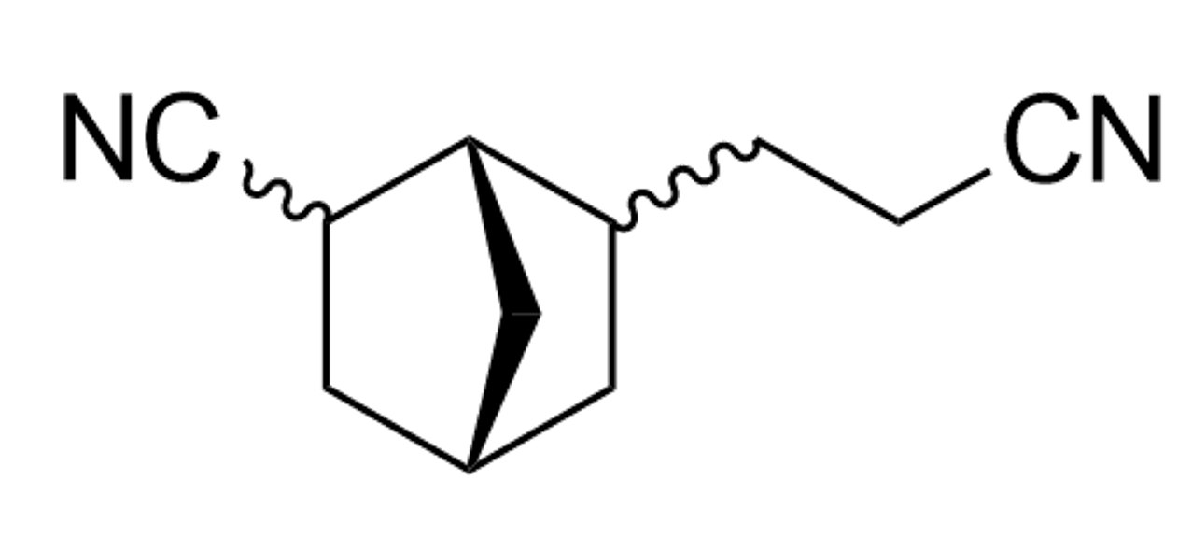
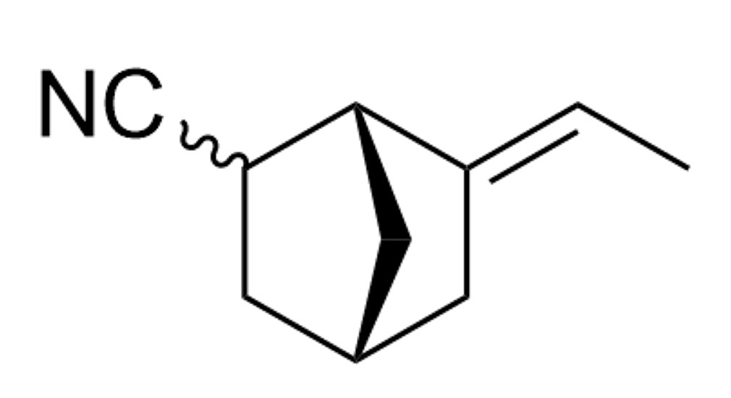
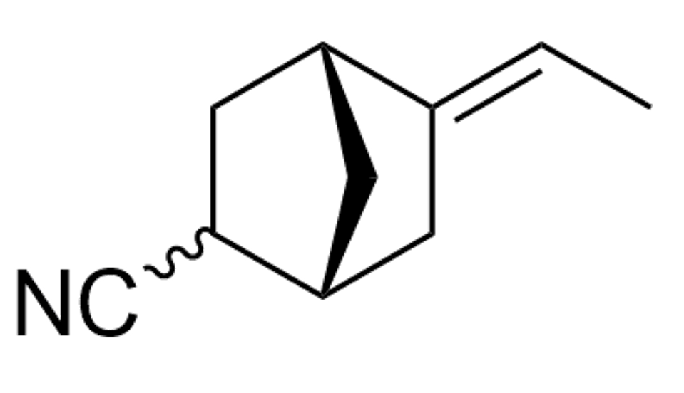
Reaction procedure A: Yield: 93% (69% mono-nitrile, a:b = 48:52 and 31% dinitrile)
Without zeolite: Yield: 84% (only mono-nitrile, a:b = 46:54)

b
a

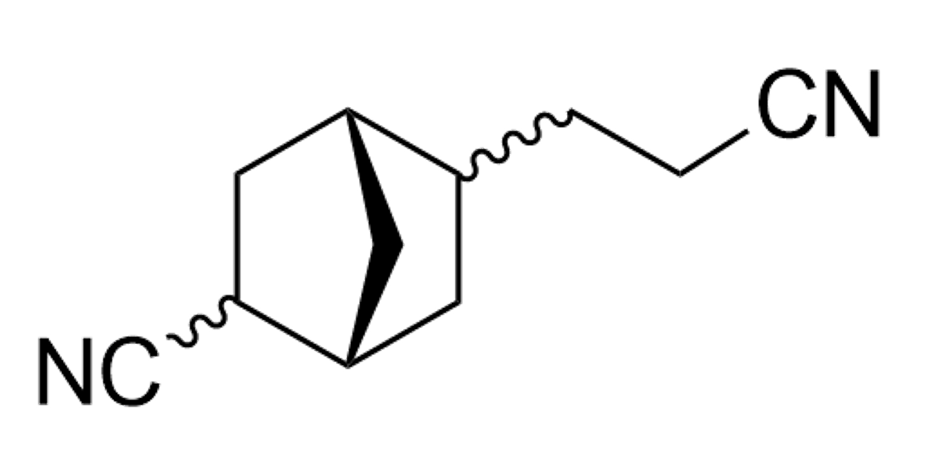
d
c

25

The compounds were isolated as the indicated isomer mixtures using column chromatography (silica gel, 5-20% Et₂O in petroleum ether, followed by 10-20% EtOAc in petroleum ether) affording 25a, 25b and a mixture of 25c+25d as colorless oils. The regioselectivity and relative product ratios were determined via GC analysis (25a:25b:25c-d = 36:33:31).
5-ethylidene(E/Z)-2-norbornanecarbonitrile (25a): ¹H NMR (400 MHz, DMSO-d₆): δ 5.52 – 5.05 (m, 1H), 2.68 – 2.55 (m, 1H), 2.17 – 2.03 (m, 1H), 1.95 – 1.68 (m, 4H), 1.66 – 1.50 (m, 3H), 1.48 (dt, J = 7.2, 1.6 Hz, 3H). ¹³C NMR (101 MHz, CDCl₃): δ 142.41, 123.51, 116.03, 115.26, 44.20, 38.09, 37.82, 37.60, 36.36, 36.22, 35.05, 34.89, 34.57, 31.14, 30.30, 14.91, 14.20.
6-ethylidene(E/Z)-2-norbornanecarbonitrile (25b): ¹H NMR (400 MHz, DMSO-d₆): δ 5.39 – 4.94 (m, 1H), 2.70 (ddd, J = 19.8, 10.8, 4.4 Hz, 2H), 2.17 – 1.93 (m, 2H), 1.85 – 1.69 (m, 2.49H), 1.66 – 1.48 (m, 2.67H), 1.48 – 1.39 (m, 3H). ¹³C NMR (101 MHz, CDCl₃): δ 143.37, 124.16, 113.85, 41.99, 41.26, 38.10, 37.88, 37.23, 36.37, 35.89, 35.62, 34.31, 31.16, 29.61, 29.50, 28.95, 27.56, 14.77, 14.15.
5 and 6-cyano-2-norbornanepropanenitrile (25c + 25d): ¹H NMR (400 MHz, DMSO-d₆): 2.61 (dd, J = 13.8, 6.4 Hz, 1H), 2.49 – 2.41 (m, 2H), 1.65 (dddd, J = 12.3, 10.3, 7.8, 3.4 Hz, 2H), 1.56 – 1.49 (m, 2H), 1.41 (ddt, J = 14.3, 7.4, 2.8 Hz, 2H), 1.36 – 1.18 (m, 5H). ¹³C NMR (101 MHz, CDCl₃): δ 124.21, 121.09, 41.87, 41.26, 40.10, 38.66, 38.13, 36.21, 35.70, 35.06, 34.53, 34.41, 33.59, 31.33, 31.19, 29.56, 28.95, 27.55, 15.07.

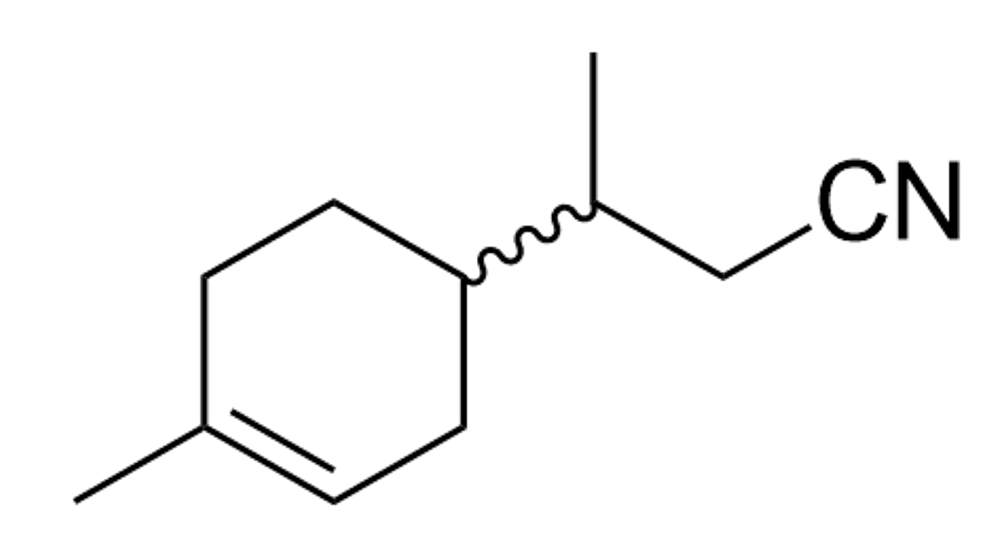
3-(4-methylcyclohex-3-en-1-yl)butanenitrile (26)
Reaction procedure A: Yield: 44%
Without zeolite: Yield: n.d.

26

GC-MS (EI, 70 eV): m/z (rel. int%): 163 (7), 148 (10), 123 (34), 107 (22), 95 (20), 81 (40), 79 (19), 69 (100), 68 (27), 67 (37), 55 (16), 53 (16), 41 (27), 39 (15).

Nonanenitrile, 2-methyloctanenitrile, 2-ethylheptanenitrile and 2-propylhexanenitrile (27)
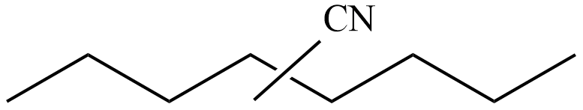
Reaction procedure A: Yield: 30%, ratio of isomers (from linear to middle): 15:26:36:27
Without zeolite: Yield: 18%, ratio = 22:25:30:23

27

Linear nitrile: GC-MS (EI, 70 eV): m/z (rel. int%): 110 (51), 97 (49), 96 (88), 83 (68), 82 (85), 69 (78), 55 (61), 54 (76), 43 (67), 41 (100).
Branched nitriles: GC-MS (EI, 70 eV): m/z (rel. int%): 97 (46), 96 (65), 83 (63), 82 (69), 69 (66), 55 (52), 54 (62), 43 (65), 41 (100), 29 (49).

Gram-scale synthesis
Procedure A
To a 50 ml Schlenk reaction flask were added 84 mg Pd(OAc)₂ (0.375 mmol) and 178 mg Xphos (0.375 mmol) together with 3 mmol of 1,3,5-tri-tert-butylbenzene as internal standard and 3 g of H-ZSM-5. The flask vial was put under an inert argon atmosphere using a Schlenk line, after which argon-flushed propionitrile (20 ml) and olefin substrate (7.5 mmol) were added. Finally, 3 ml AlMe₂Cl in hexanes (40 mol%) was injected. The flask was then placed in a heating bath at T=100°C or 120°C. After 18h, the flask was cooled on ice, and methanol was added to quench residual Lewis acid. The work-up was as described previously.
3,3-diphenylpropanenenitrile (11): Yield = 54% (reaction at T=120°C)
9-anthracenepropanenitrile (8): Yield = 83%
Procedure B (low temperature and low catalyst loading)
To a 50 ml Schlenk reaction flask were added 34 mg Pd(OAc)₂ (0.15 mmol) and 71 mg Xphos (0.15 mmol) together with 3 mmol of 1,3,5-tri-tert-butylbenzene as internal standard and 3 g of H-ZSM-5. The flask vial was put under an inert argon atmosphere using a Schlenk line, after which argon-flushed propionitrile (20 ml) and olefin substrate (7.5 mmol) were added. Finally, 1.2 ml AlMe₂Cl in hexanes (40 mol%) was injected. The flask was then placed in a heating bath at 80°C. After 18h, the flask was cooled on ice, and methanol was added to quench residual Lewis acid. The work-up was as described previously.
3-(2-methoxyphenyl)propanenitrile and 2-(2-methoxyphenyl)propanenitrile (13): Yield = 69% (l:b = 94:6)

- HCHO-transfer scope and recycling
Several substrates were subjected to reaction without zeolite in a closed system as reference (under identical conditions). Due the high price of the Rh-catalyst, reference reactions were not performed for all substrates. Reactions with zeolite were performed with the following general procedures:
Conditions A:
To a 1.5 ml glass vial were added 2.42 mg [Rh(OMe)(1,5-cod)]₂ (0.005 mmol), 5.78 mg Xantphos (0.01 mmol) and 6.1 mg 4-methyl-salicyclic acid (0.05 mmol), together with 0.1 mmol of 1,3,5-tri-tert-butylbenzene as internal standard and 100 mg of H-FER (9). The glass vial was capped and put under an inert argon atmosphere using a Schlenk line, after which argon-flushed aldehyde (0.8 ml), acetic acid (40 µl) and olefin substrate (0.25 mmol) were added. The vial was then placed in a preheated aluminum heating block at 80°C. After 22h, the vial was cooled on ice. The zeolite was removed via centrifugation, and the products were analysed via GC-FID/GC-MS.
Conditions B:
To a 1.5 ml glass vial were added 2.42 mg [Rh(OMe)(1,5-cod)]₂ (0.005 mmol), 5.52 mg N-Xantphos (0.01 mmol) and 6.5 mg benzo[b]furan-2-carboxylic acid (0.05 mmol), together with 0.1 mmol of 1,3,5-tri-tert-butylbenzene as internal standard and 100 mg of H-ZSM-5 (140). The glass vial was capped and put under an inert argon atmosphere using a Schlenk line, after which argon-flushed aldehyde (0.8 ml) and olefin substrate (0.2 mmol) were added. The vial was then placed in a preheated aluminum heating block at 105°C. After 18h, the vial was cooled on ice. The zeolite was removed via centrifugation, and the products were analysed via GC-FID/GC-MS.
Conditions A or B-HZ:
Following general procedure A or B, after 6h, the reaction mixture was filtered (while still hot!), adding the resulting clear liquid to fresh 100 mg H-FER. After 22h, the vial was cooled on ice. The zeolite was removed via centrifugation, and the products were analysed via GC-FID/GC-MS.
General procedure for the product work-up and analysis
The homogeneous solution was concentrated under vacuum at 35°C. The residue was dispersed in DMSO-d₆, purified via column chromatography (for indicated compounds), and analysed via ¹H NMR , ¹³C NMR and GC-MS. Reactions for isolated compounds were performed on a 0.5 mmol scale.

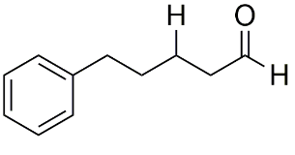
5-phenylpentanal (28)
Reaction procedure A: Yield: 80%, l:b = 96:4
Reaction procedure A-HZ: Yield: 84%, l:b = 97:3
No zeolite: Yield: 55%, l:b = 96:4

28

¹H NMR (400 MHz, DMSO-d₆): 9.66 (t, J = 1.6 Hz, 1H), 7.29 – 7.25 (m, 2H), 7.20 – 7.16 (m, 3H), 2.58 (t, J = 7.2 Hz, 2H), 2.46 (td, J = 6.9, 1.5 Hz, 2H), 1.62 – 1.49 (m, 4H). ¹³C NMR (101 MHz, DMSO-d₆): δ 203.84, 142.40, 128.73, 128.70, 126.14, 43.36, 40.62, 40.41, 40.20, 39.99, 39.78, 39.58, 39.37, 35.36, 30.87, 21.61. The NMR data are consistent with those reported in the literature⁴⁴.
GC-MS (EI, 70 eV): m/z (rel. int%): 162 (36), 144 (13), 129 (15), 118 (25), 105 (15), 104 (12), 92 (38), 91 (100), 65 (14).

4-(1-naphtyl)butanal (29)
Reaction procedure A: Yield: 69%, l:b = 97:3 (isolated: 67% linear product)
Reaction procedure A-HZ: Yield: 75%, l:b = 97:3

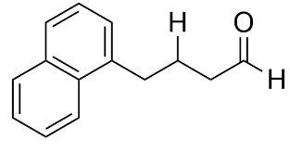
29

The compound was isolated by column chromatography (silica gel, 0-10% Et₂O in petroleum ether) to give product 29 as an off-white solid (66.3 mg, 0.34 mmol, 67% yield).
¹H NMR (400 MHz, DMSO-d₆): δ 9.70 (t, J = 1.4 Hz, 1H), 8.12 (d, J = 8.4 Hz, 1H), 7.92 (m, 1H), 7.76 (t, J = 7.8 Hz, 1H), 7.52 (ddd, J = 7.8, 3.3, 1.5 Hz, 3H), 7.35 (d, J = 6.0 Hz, 1H), 3.05 (t, J = 7.3 Hz, 2H), 2.55 (td, J = 7.1, 1.2 Hz, 2H), 1.96 (t, J = 7.5 Hz, 2H). ¹³C NMR (101 MHz, DMSO-d₆): δ 203.70, 138.22, 133.97, 131.83, 129.05, 127.00, 126.52, 126.41, 126.03, 126.03, 124.19, 43.26, 32.03, 23.48. The NMR data are consistent with those reported in the literature⁴¹.
GC-MS (EI, 70 eV): m/z (rel. Int%): 198 (26), 155 (15), 154 (100), 153 (46), 142 (21), 139 (17), 115 (50), 28 (25).

3-cyclohexene-1-propanal (30)
Reaction procedure A: Yield: 77%, l:b > 99:1 (isolated yield: 70%)
No zeolite: 49%, l:b > 99:1

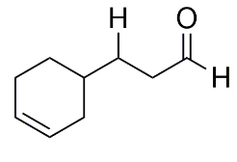
30

The compound was isolated by column chromatography (silica gel, 0-10% Et₂O in petroleum ether) to give product 30 as a colorless oil (46.1 mg, 0.35 mmol, 70% yield).
¹H NMR (400 MHz, DMSO-d₆): δ 9.72 (t, J = 1.3 Hz, 1H), 7.28 (t, J = 8.0 Hz, 3H), 6.94 – 6.89 (m, 4H), 3.97 (t, J = 6.4 Hz, 2H), 2.60 (td, J = 7.2, 1.4 Hz, 2H), 1.98 (p, J = 6.8 Hz, 3H). ¹³C NMR (101 MHz, DMSO-d₆): δ 203.90, 127.19, 126.62, 41.13, 32.98, 31.52, 28.60, 28.49, 25.05. The NMR data are consistent with those reported in the literature⁴⁵.

GC-MS (EI, 70 eV): m/z (rel. Int%): 92 (26), 91 (36), 79 (100), 77 (39), 54 (30), 53 (35), 41 (43), 39 (67), 29 (70).
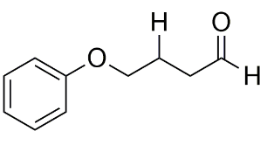
4-phenoxybutanal (31)
Reaction procedure A: Yield: 65%, l:b > 99:1 (isolated yield: 54%)

31

The compound was isolated by column chromatography (silica gel, 0-30% Et₂O in petroleum ether) to give product 31 as a pale yellow oil (44.3 mg, 0.27 mmol, 54% yield).
¹H NMR (400 MHz, DMSO-d₆): δ 9.69 (t, J = 1.5 Hz, 1H), 5.62 (m, 3H), 2.50 – 2.43 (m, 2H), 2.00 – 1.93 (m, 3H), 1.61 – 1.43 (m, 5H), 1.21 – 1.15 (m, 1H). ¹³C NMR (101 MHz, DMSO-d₆): δ 203.34, 158.88, 129.92, 120.98, 114.86, 66.98, 40.28, 22.08. The NMR data are consistent with those reported in the literature⁴⁶.
GC-MS (EI, 70 eV): m/z (rel. Int%): 94 (100), 77 (54), 71 (61), 66 (60), 65 (60), 51 (37), 43 (51), 39 (85), 29 (52).

4-(3,4-dimethoxyphenyl)butanal (32)
Reaction procedure A: Yield: 72%, l:b = 94:6 (isolated yield: 69% linear product)

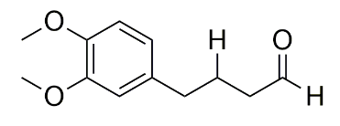
32

The compound was isolated by column chromatography (silica gel, 0-30% Et₂O in petroleum ether) to give product 32 as a yellow oil (71.8 mg, 0.35 mmol, 69% yield).
¹H NMR (400 MHz, DMSO-d₆): δ 9.66 (t, J = 1.5 Hz, 1H), 6.84 (d, J = 8.1 Hz, 2H), 6.79 (d, J = 1.8 Hz, 1H), 3.74 (s, 3H), 3.71 (s, 3H), 2.54 – 2.48 (m, 2H), 2.42 (t, J = 6.5 Hz, 2H), 1.81 (t, J = 7.4 Hz, 2H).¹³C NMR (101 MHz, DMSO-d₆): δ 203.71, 149.15, 147.52, 134.41, 120.53, 119.35, 112.70, 112.32, 55.82, 42.94, 35.01, 24.08. The NMR data are consistent with those reported in the literature⁴⁶.
GC-MS (EI, 70 eV): m/z (rel. Int%): 208 (23), 164 (59), 151 (100), 105 (14), 91 (25), 78 (20), 77 (26), 65 (20), 29 (32).

4-(2-hydroxy-3-methylphenyl)butanal (33)
Reaction procedure A: Yield: 57%, l:b > 99:1 (isolated yield: 51%)
No zeolite: Yield: 30%, l:b > 99:1

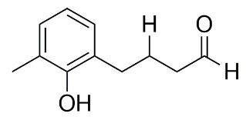
33

The compound was isolated by column chromatography (silica gel, 0-20% EtOAc in petroleum ether) to give product 33 as an off-white solid (45.4 mg, 0.26 mmol, 51% yield).
¹H NMR (400 MHz, DMSO-d₆): δ 9.66 (t, J = 1.6 Hz, 1H), 6.93 (d, J = 7.0 Hz, 1H), 6.69 – 6.63 (m, 2H), 2.60 – 2.54 (m, 3H), 2.42 (td, J = 7.3, 1.6 Hz, 2H), 2.17 (s, 3H), 1.78 (p, J = 7.5 Hz, 2H). ¹³C NMR (101 MHz, DMSO-d₆): δ 203.88, 153.28, 128.92, 128.60, 127.94, 124.86, 119.71, 43.17, 35.03, 25.49, 17.15.
GC-MS (EI, 70 eV): m/z (rel. Int%): 134 (65), 122 (25), 121 (79), 91 (100), 78 (23), 77 (77), 51 (24), 39 (27), 29 (58), 27 (21).

Methyl 3,3-dimethyl-6-oxohexanoate (34)
Reaction procedure B: Yield: 82%, l:b > 99:1 (isolated yield: 70%)
Reaction procedure B-HZ: Yield: 87%, l:b > 99:1
No zeolite: Yield: 48%, l:b > 99:1

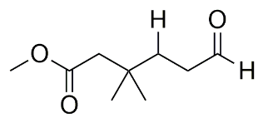

34

The compound was isolated by column chromatography (silica gel, 0-10% EtOAc in petroleum ether) to give product 34 as a colorless oil (60.2 mg, 0.35 mmol, 70% yield).
¹H NMR (400 MHz, DMSO-d₆): δ 9.68 (t, J = 1.4 Hz, 1H), 3.57 (s, 3H), 2.43 (td, J = 8, 1.5 Hz, 2H), 2.20 (s, 2H), 1.56 (dd, J = 5.9, 3.0 Hz, 2H), 0.93 (s, 6H).¹³C NMR (101 MHz, DMSO-d₆): δ 203.56, 172.15, 51.37, 45.28, 38.99, 33.42, 32.77, 27.13.
GC-MS (EI, 70 eV): m/z (rel. Int%): 81 (46), 73 (80), 69 (42), 59 (40), 55 (72), 43 (68), 41 (100), 39 (65), 29 (99), 27 (36).

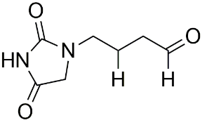
1-(butan-4-al)-2,4-imidazolidinedione (35)
Reaction procedure A: Yield: 71%, l:b > 99:1 (isolated yield: 62%)

35

The compound was isolated by column chromatography (silica gel, 20-30% EtOAc in petroleum ether) to give product 35 as a beige solid (52.7 mg, 0.31 mmol, 62% yield).
¹H NMR (400 MHz, DMSO-d₆): δ 9.65 (t, J = 2.1 Hz, 1H), 3.94 – 3.89 (m, 2H), 3.28 (t, J = 7.2 Hz, 2H), 2.47 (t, J = 7.2 Hz, 2H), 1.85 – 1.65 (m, 2H).¹³C NMR (101 MHz, DMSO-d₆): δ 203.74, 170.49, 157.41, 52.20, 50.82, 23.21, 22.73.

4,4,5,5-Tetramethyl-1,3,2-dioxaborolane-2-propanal (36)
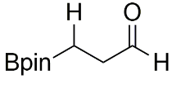
Reaction procedure B: Yield: 49%, l:b > 99:1 (isolated yield: 47%)

36

The compound was isolated by column chromatography (silica gel, 0-10% Et₂O in petroleum ether) to give product 36 as a pale yellow oil (44.2 mg, 0.24 mmol, 47% yield).
¹H NMR (400 MHz, DMSO-d₆): δ 9.68 (t, J = 1.1 Hz, 1H), 2.14 (dt, J = 6.7, 0.7 Hz, 2H), 1.17 (s, 12H), 0.79 (t, J=6.7 Hz, 2H).¹³C NMR (101 MHz, DMSO-d₆): δ 203.75, 83.25, 38.62, 25.00 (The carbon atom next to the boron atom was not observed due to quadrupole broadening caused by the ¹¹B nucleus⁴⁷). The NMR data are consistent with those reported in the literature⁴⁸.
GC-MS (EI, 70 eV): m/z (rel. Int%): 126 (47), 99 (27), 98 (89), 97 (28), 85 (46), 55 (37), 43 (79), 41 (100), 39 (62), 29 (60).

3-(Dimethylphenylsilyl)propanal (37)
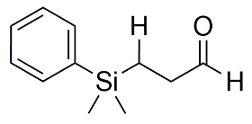
Reaction procedure B: Yield: 75%, l:b > 99:1

37

¹H NMR (400 MHz, DMSO-d₆): δ 9.63 (t, J = 1.6 Hz, 1H), 7.52 – 7.50 (m, 2H), 7.38 (t, J = 2.4 Hz, 3H), 2.39 – 2.34 (m, 2H), 0.94 – 0.91 (m, 2H), 0.25 (s, 6H). ¹³C NMR (101 MHz, DMSO-d₆): δ 203.84, 138.52, 133.86, 133.81, 129.54, 128.30, 40.56, 40.35, 40.14, 39.94, 39.73, 39.52, 39.31, 38.00, 7.16, -2.80. The NMR data are consistent with those reported in the literature⁴⁹.
GC-MS (EI, 70 eV): m/z (rel. Int%): 177 (58), 159 (15), 136 (15), 135 (100), 121 (25), 115 (35), 107 (13), 105 (26), 99 (36), 43 (14)

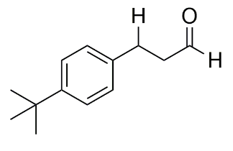
3-(4-tert-butylphenyl)propanal (38)
Reaction procedure B: Yield: 89%, l:b = 84:16
No zeolite: Yield: 70%, l:b = 83:17

38

¹H NMR (400 MHz, DMSO-d₆): δ 9.71 (t, J = 1.4 Hz, 1H), 7.28 (s, 2H), 7.13 (d, J = 8.4 Hz, 2H), 2.81 (d, J = 7.0 Hz, 2H), 2.77 – 2.74 (m, 2H), 1.25 (s, 9H). ¹³C NMR (101 MHz, DMSO-d₆): δ 203.36, 148.68, 138.09, 128.36, 125.53, 44.86, 40.56, 40.36, 40.15, 39.94, 39.73, 39.52, 39.31, 34.51, 31.63, 27.42. The NMR data are consistent with those reported in the literature⁴⁶.
GC-MS (EI, 70 eV): m/z (rel. Int%): 190 (140), 176 (13), 175 (100), 132 (7), 131 (40), 117 (11), 116 (8), 115 (10), 91 (16), 41 (7)

3-(2-naphtyl)propanal (39)
Reaction procedure B: Yield: 80%, l:b = 80:20 (isolated yield: 65% linear product)
No zeolite: Yield: 59%, l:b = 78:22

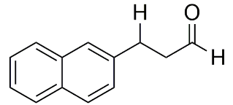
39

The compound was isolated by column chromatography (silica gel, 0-10% Et₂O in petroleum ether) to give product 39 as a colorless oil (59.8 mg, 0.33 mmol, 65% yield).
¹H NMR (400 MHz, DMSO-d₆): δ 9.77 (t, J = 1.4 Hz, 1H), 7.89 – 7.80 (m, 3H), 7.72 (s, 1H), 7.51 – 7.39 (m, 3H), 3.04 (t, J = 7.4 Hz, 2H), 2.88 (t, J = 7.4 Hz, 2H).¹³C NMR (101 MHz, DMSO-d₆): δ 203.13, 138.88, 133.61, 132.10, 128.29, 127.92, 127.75, 127.67, 126.54, 126.49, 125.77, 44.68, 28.14. The NMR data are consistent with those reported in the literature⁵⁰.
GC-MS (EI, 70 eV): m/z (rel. Int%): 184 (34), 155 (27), 153 (30), 152 (29), 142 (55), 141 (83), 128 (100), 127 (26), 115 (63), 29 (42).

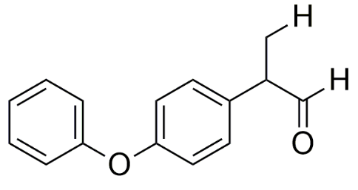
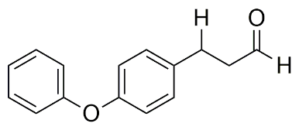
3-(4-phenoxyphenyl)propanal and 2-(4-phenoxyphenyl)propanal (40)
Reaction procedure B: Yield: 82%, l:b = 80:20

40

Linear aldehyde: ¹H NMR (400 MHz, DMSO-d₆): δ 9.72 (t, J = 1.3 Hz, 1H), 7.38 – 7.36 (m, 2H), 7.23 (d, J = 8.5 Hz, 2H), 7.11 (s, 1H), 6.98 – 6.95 (m, 2H), 6.93 – 6.91 (m, 2H), 2.84 (d, J = 6.9 Hz, 2H), 2.78 (d, J = 6.8 Hz, 2H). ¹³C NMR (101 MHz, DMSO-d6): δ 203.25, 157.45, 155.15, 136.40, 130.43, 130.25, 123.63, 119.23, 118.72, 44.90, 40.55, 40.34, 40.13, 39.92, 39.71, 39.51, 39.30, 27.21. The NMR data are consistent with those reported in the literature⁵¹.
Branched aldehyde (aliphatic part): ¹H NMR (400 MHz, DMSO-d₆): δ 9.63 (s, 1H), 3.78 (q, J = 7.3 Hz, 1H), 1.33 (d, J = 7.1 Hz, 1H). ¹³C NMR (101 MHz, DMSO-d₆): δ 202.26, 157.01, 156.36, 51.43, 15. The NMR data are consistent with those reported in the literature⁵².
GC-MS Linear aldehyde (EI, 70 eV): m/z (rel. Int%): 227 (12), 226 (69), 184 (15), 183 (100), 170 (41), 155 (13), 153 (10), 91 (11), 77 (35), 51 (18).

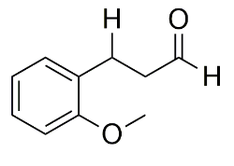
3-(2-methoxyphenyl)propanal (41)
Reaction procedure B: Yield: 94%, l:b = 91:9
No zeolite: Yield: 78%, l:b = 91:9

41

¹H NMR (400 MHz, DMSO-d₆): δ 9.70 (t, J = 1.6 Hz, 1H), 7.19 – 7.13 (m, 2H), 6.95 (d, J = 8.0 Hz, 1H), 6.88 – 6.84 (m, 1H), 3.78 (s, 3H), 2.82 (t, J = 7.4 Hz, 2H), 2.68 (t, J = 7.2 Hz, 2H). ¹³C NMR (101 MHz, DMSO-d₆): δ 203.39, 157.46, 129.94, 128.83, 127.97, 120.73, 111.05, 55.65, 43.48, 22.66. The NMR data are consistent with those reported in the literature⁵³.
GC-MS (EI, 70 eV): m/z (rel. Int%): 164 (65), 121 (63), 108 (67), 103 (14), 91 (100), 78 (22), 77 (34), 65 (24), 51 (17), 29 (16).

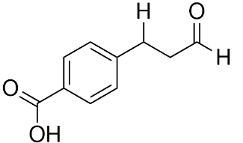
4-(3-oxopropyl)-benzoic acid (42)
Reaction procedure B: Yield: 66%, l:b = 85:15 (isolated yield: 45% linear product)
No zeolite: Yield = 41%, l:b = 84:16

42

The compound was isolated by column chromatography (silica gel, 30-50% EtOAc in petroleum ether) to give product 42 as a white solid (41 mg, 0.23 mmol, 45% yield).
¹H NMR (400 MHz, DMSO-d₆): δ 9.71 (t, J = 0.8 Hz, 1H), 7.87 (d, J = 8.0 Hz, 2H), 7.31 (d, J = 8.0 Hz, 2H), 2.92 (t, J = 7.2 Hz, 2H), 2.81 (t, J = 7.2 Hz, 2H). ¹³C NMR (101 MHz, DMSO-d₆): δ 202.79, 167.77, 146.61, 129.89, 128.36, 127.36, 44.33, 27.90. The NMR data are consistent with those reported in the literature⁵⁴.

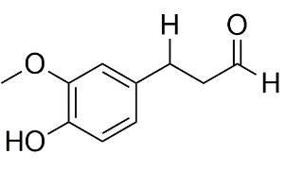
3-(4-hydroxy-3-methoxyphenyl)propanal (43)
Reaction procedure B: Yield: 76%, l:b = 81:19 (isolated yield: 57% linear product)

43

The compound was isolated by column chromatography (silica gel, 0-20% EtOAc in petroleum ether) to give product 43 as a yellow oil (51.3 mg, 0.29 mmol, 57% yield).
¹H NMR (400 MHz, DMSO-d₆): δ 9.71 (t, J = 1.5 Hz, 1H), 6.78 (d, J = 1.7 Hz, 1H), 6.66 – 6.59 (m, 2H), 5.41 (s, OH), 3.74 (s, 3H), 2.75 – 2.70 (m, 4H). ¹³C NMR (101 MHz, DMSO-d₆): δ 203.56, 147.91, 145.14, 131.90, 120.72, 115.78, 112.95, 56.00, 45.25, 27.64. The NMR data are consistent with those reported in the literature⁵⁵.
GC-MS (EI, 70 eV): m/z (rel. Int%): 180 (28), 137 (100), 124 (41), 109 (17), 91 (36), 77 (29), 51 (20), 32 (19), 29 (24), 28 (33).

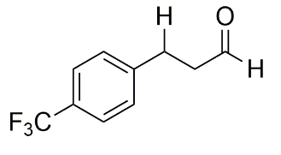
3-(4-trifluoromethylphenyl)propanal (44)
Reaction procedure B: Yield: 79%, l:b = 83:17 (isolated yield: 61% linear product)

44

The compound was isolated by column chromatography (silica gel, 0-10% Et₂O in petroleum ether) to give product 44 as a colorless oil (62.6 mg, 0.31 mmol, 61% yield).
¹H NMR (400 MHz, DMSO-d₆): δ 9.72 (t, J = 1.2 Hz, 1H), 7.63 (d, J = 8.0 Hz, 2H), 7.46 (d, J = 8.0 Hz, 2H), 2.95 (t, J = 7.3 Hz, 2H), 2.83 (t, J = 7.3 Hz, 2H). ¹³C NMR (101 MHz, DMSO-d₆): δ 202.75, 146.32, 129.72 (q, J = 29.6 Hz), 129.58, 125.53 (q, J = 3.8 Hz), 124.50 (q, J = 270.9 Hz), 44.29, 27.71.¹⁹F NMR (376 MHz, DMSO-d₆) δ -60.86. The NMR data are consistent with those reported in the literature⁵⁰.
GC-MS (EI, 70 eV): m/z (rel. Int%): 202 (65), 183 (43), 160 (98), 159 (67), 153 (31), 146 (29), 133 (100), 127 (41), 109 (38), 91 (56).

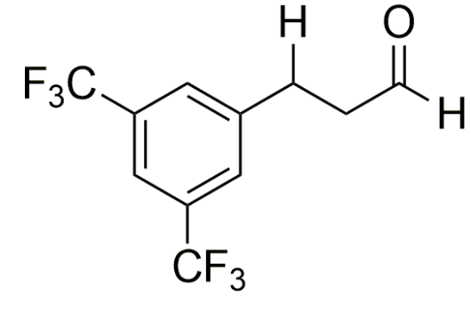
3-(3,5-bis-trifluoromethylphenyl)propanal (45)
Reaction procedure B: Yield: 58%, l:b = 85:15 (isolated yield: 46% linear product)

45

The compound was isolated by column chromatography (silica gel, 0-10% Et₂O in petroleum ether) to give product 45 as a colorless oil (51.8 mg, 0.23 mmol, 46% yield).
¹H NMR (400 MHz, DMSO-d₆): δ 9.71 (t, J = 0.9 Hz, 1H), 7.64 (s, 1H), 7.49 (s, 2H), 3.05 (t, J = 7.3 Hz, 2H), 2.92 (t, J = 7.3 Hz, 2H).¹³C NMR (101 MHz, DMSO-d₆): δ 202.50, 143.76, 132.18 (q, J = 31.9 Hz), 129.86, 129.83, 127.96, 123.94 (q, J = 271 Hz), 120.08 (q, J = 4.5 Hz), 44.20, 28.10. ¹⁹F NMR (376 MHz, DMSO-d₆) δ -61.44. The NMR data are consistent with those reported in the literature⁴⁶.
GC-MS (EI, 70 eV): m/z (rel. Int%): 270 (72), 251 (30), 228 (100), 227 (77), 221 (30), 209 (44), 201 (74), 195 (28), 159 (75), 151 (39).

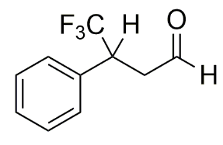
4,4,4-Trifluoro-3-phenylbutanal (46)
Reaction procedure B: Yield: 64%, l:b > 99:1 (isolated yield: 52%)
No zeolite: Yield: 37%, l:b > 99:1

46

The compound was isolated by column chromatography (silica gel, 0-10% Et₂O in petroleum ether) to give product 46 as a pale yellow oil (49.4 mg, 0.26 mmol, 52% yield).
¹H NMR (400 MHz, DMSO-d₆): δ 9.58 (br s, 1H), 7.48 – 7.27 (m, 5H), 4.26 (dq, J = 13.6, 4.9, 4.2 Hz, 1H), 3.31 – 3.12 (m, 2H). ¹³C NMR (101 MHz, DMSO-d₆): δ = 199.84, 134.39 (br s), 130.09, 129.59, 129.06, 128.77, 125.88 (q, J = 279 Hz), 42.80 (q, J = 29.8 Hz), 31.09. ¹⁹F NMR (376 MHz, DMSO-d₆) δ -68.98. The NMR data are consistent with those reported in the literature⁵⁶.
GC-MS (EI, 70 eV): m/z (rel. Int%): 182 (100), 154 (23), 153 (21), 133 (29), 109 (52), 103 (32), 91 (45), 78 (78), 77 (39), 51 (25)

3-(4-chlorophenyl)propanal (47)
Reaction procedure B: Yield: 85%, l:b = 81:19 (isolated yield: 66% linear product)

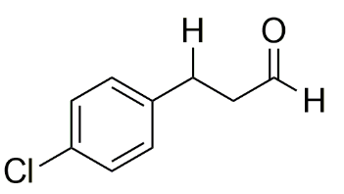
47

The compound was isolated by column chromatography (silica gel, 0-20% Et₂O in petroleum ether) to give product 47 as a colorless oil (55.4 mg, 0.33 mmol, 66% yield).
¹H NMR (400 MHz, DMSO-d₆): δ 9.71 (t, J = 1.2 Hz, 1H), 7.41 (d, J = 8.2 Hz, 2H), 7.23 (d, J = 8.2 Hz, 2H), 2.84 (t, J = 7.5 Hz, 2H), 2.77 (t, J = 7.5 Hz, 2H). ¹³C NMR (101 MHz, DMSO-d₆): δ = 202.91, 140.29, 131.04, 130.62, 128.68, 44.61, 27.26. The NMR data are consistent with those reported in the literature⁵⁷.
GC-MS (EI, 70 eV): m/z (rel. Int%): 126 (100), 112 (46), 103 (82), 89 (53), 77 (92), 75 (57), 63 (56), 51 (52), 50 (46), 29 (86).

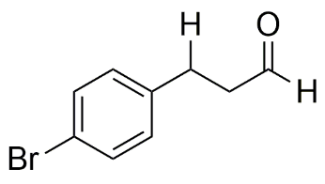
3-(4-bromophenyl)propanal (48)
Reaction procedure B: Yield: 79%, l:b = 85:15 (isolated yield: 63% linear product)

48

The compound was isolated by column chromatography (silica gel, 0-20% Et₂O in petroleum ether) to give product 48 as a colorless oil (68.2 mg, 0.32 mmol, 63% yield).
¹H NMR (400 MHz, DMSO-d₆): δ 9.70 (t, J = 1.1 Hz, 1H), 7.46 (d, J = 8.4 Hz, 2H), 7.20 (d, J = 8.4 Hz, 2H), 2.83 – 2.78 (m, 4H).¹³C NMR (101 MHz, DMSO-d₆): δ 202.99, 140.76, 131.62, 131.06, 119.44, 44.54, 27.31. The NMR data are consistent with those reported in the literature⁴⁶.

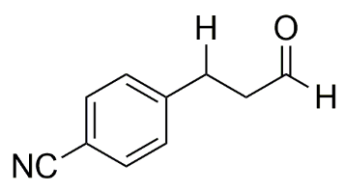
3-(4-cyanophenyl)propanal (49)
Reaction procedure B: Yield: 68%, l:b = 83:17 (isolated yield: 49% linear product)
No zeolite: Yield: 44%

49 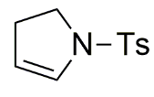

The compound was isolated by column chromatography (silica gel, 0-20% Et₂O in petroleum ether) to give product 49 as a pale yellow oil (39.2 mg, 0.25 mmol, 49% yield).
¹H NMR (400 MHz, DMSO-d₆): δ 9.71 (t, J = 1.2 Hz, 1H), 7.72 (d, J = 8.3 Hz, 2H), 7.41 (d, J = 8.3 Hz, 2H), 2.93 (t, J = 7.2 Hz, 2H), 2.83 (t, J = 7.2 Hz, 2H). ¹³C NMR (101 MHz, DMSO-d₆): δ 202.59, 147.45, 132.61, 129.94, 119.42, 109.03, 44.07, 28.00. The NMR data are consistent with those reported in the literature⁴⁶.
GC-MS (EI, 70 eV): m/z (rel. Int%): 130 (76), 117 (100), 116 (77), 103 (48), 102 (45), 89 (65), 77 (54), 63 (62), 39 (58), 29 (83).

Multi-step reactions:
N-(p-toluenesulfonyl)-2-pyrroline (50)
Reaction procedure A: Yield: 68% (isolated yield: 56%)
No zeolite: Yield: 41%

50

The compound was isolated by column chromatography (silica gel, 0-20% EtOAc in petroleum ether) to give product 50 as an off-white solid (62.4 mg, 0.28 mmol, 56% yield).
¹H NMR (400 MHz, DMSO-d₆): δ 7.68 (d, J = 8.1 Hz, 2H), 7.44 (d, J = 8.2 Hz, 2H), 6.28 (t, J = 4.2 Hz, 1H), 5.15 (td, J = 4.2 Hz, J = 2.6 Hz, 1H), 3.34 (m, 2H), 2.72 – 2.65 (m, 2H), 2.40 (s, 3H). ¹³C NMR (101 MHz, DMSO-d₆): δ 143.82, 132.04, 130.51, 130.02, 127.64, 112.66, 47.82, 29.50, 21.47. The NMR data are consistent with those reported in the literature⁵⁸.
GC-MS (EI, 70 eV): m/z (rel. Int%): 223 (36), 155 (21), 92 (28), 91 (100), 89 (19), 68 (61), 65 (50), 63 (18), 41 (72), 39 (47).

Manoyl oxide propionaldehyde (51)
The envisioned cyclization of sclareol to manoyl oxide was inspired by literature reports^{59,60}. To account for a possible cyclization under standard conditions, an HCHO-transfer reaction with sclareol was performed according to procedure A (but at T = 105°C). No substantial amounts of cyclization products were found (with GC-MS, vide infra). Aldehyde products from sclareol (51a, 25% GC-yield) and manool (51c, dehydrated sclareol, 11% GC-yield) were observed with GC-MS. In a first attempt at one-pot cyclization, an HCHO-transfer reaction (procedure B) with sclareol was conducted in the presence of 3 eq. trifluoroacetic acid, leading to a complex mixture of sclareol, manoyl oxide and manool isomers. The aldehyde product from manoyl oxide (51 b) was found in 15% yield, along with small amounts of sclareol and manool-derived aldehydes. In order to improve the yield, trifluoroacetic acid was slowly added during the reaction (starting after 1h; then 0.25 eq./30 min), or after the reaction, giving aldehyde 51b in respectively 34% and 25% yield (GC chromatogram is shown in fig. S31). As a control, sclareol was cyclized prior to the HCHO transfer; 3 eq. trifluoroacetic acid was added to a solution of 0.5 mmol sclareol in 1 ml THF. The solution was stirred for 3h at 50°C, after which equal volumes of a Et₂O and H₂O (10 ml) were added. The organic layer was recovered, and the solvents were removed in vacuo. The crude was redispersed in 3-methylbutanal, and directly used as such in a HCHO-transfer reaction, providing aldehyde 51b in 40% yield.
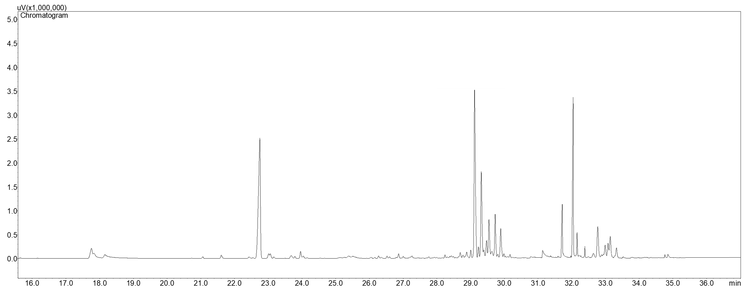
Manoyl oxide propionaldehyde (51b)

Manool + isomers
Manoyl oxide
51a,c

Sclareol
Internal standard

Fig. S31: GC-chromatogram of one-pot sclareol cyclization - transfer hydroformylation reaction.

Sclareol propionaldehyde: ​(R,2R,8aS)-1-[(3R)-3-hydroxy-3-methylhexanal]-2,5,5,8a-tetramethyl-3,4,4a,6,7,8-hexahydro-1H-naftalen-2-ol (51a).

Manoyl oxide propionaldehyde: 1H-​Naphtho[2,​1-​b]​pyran-​3-​propionaldehyde, dodecahydro-​3,​4a,​7,​7,​10a-​pentamethyl-​, (3S,​4aR,​6aS,​10aS,​10bR)​ (51b) (mixture of stereoisomes; 13R-(+)-, 13S-ent- and 13R-ent-)⁶¹.
Manool propionaldehyde: 5-(5,5,8a-trimethyl-2-methylidene-3,4,4a,6,7,8-hexahydro-1H-naphthalen-1-yl)-3-methyl-3-hydroxy-hexanal (51c) (mixture of stereoisomes; (+)-, ent- and syn-)⁶¹.
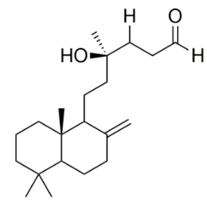
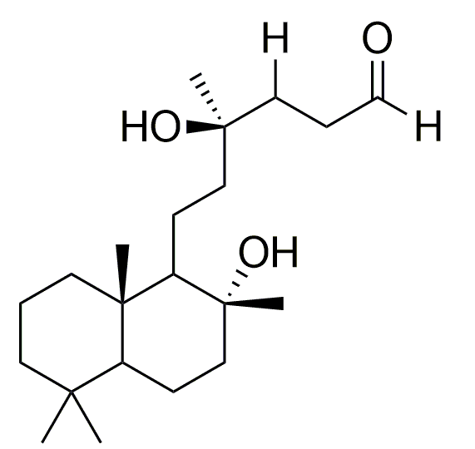
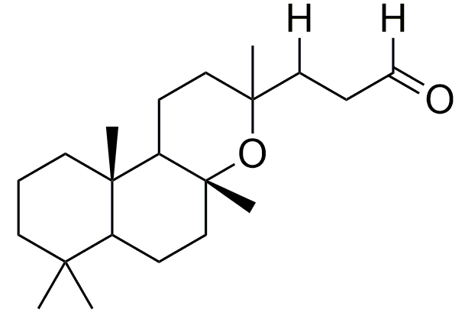

51b
51c
51a

The GC-MS patterns of the different structural backbones are in line with those reported in literature (without the aldehyde)⁶¹:
51a: GC-MS (EI, 70 eV): m/z (rel. Int%): 320 (18), 177 (20), 95 (36), 93 (26), 83 (32), 81 (47), 79 (36), 69 (47), 67 (64), 55 (75), 43 (100), 71 (70).
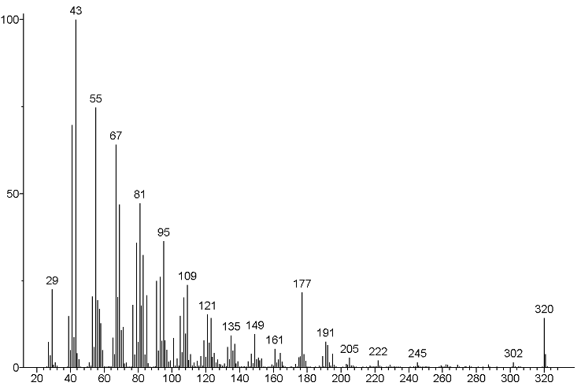
Sclareol-type fragmentation

Molecular ion -18 (H₂O)
2nd dehydration

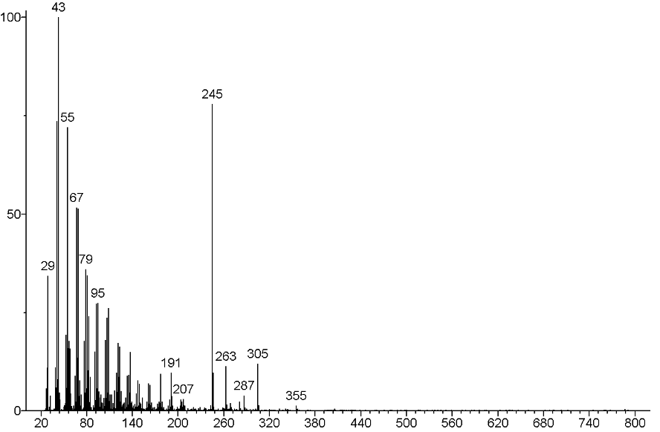
51b: GC-MS (EI, 70 eV): m/z (rel. int%): 245 (97), 95 (41), 93 (31), 81 (53), 79 (38), 69 (58), 67 (56), 55 (73), 43 (100), 41 (73).
Stabilized manoyl oxide-derivative ion

Molecular ion -15 (CH₃)

51c: GC-MS (EI, 70 eV): 95 (57), 93 (48), 91 (51), 83 (57), 81 (68), 79 (54), 69 (60), 67 (53), 55 (85), 41 (100).
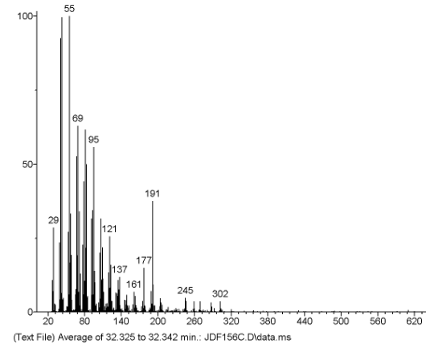
manool-type fragmentation

Molecular ion -18 (H₂O)

Following the procedure with prior sclareol cyclization (vide supra), and subsequent transfer hydroformylation (conditions B), compound 51b was isolated by column chromatography (silica gel, 0-10% Et₂O in petroleum ether) as a white solid (0.11 mmol, 36.8 mg, 23% yield*). *Yield of the purest fractions (i.e. purity > 85%); Due to difficult separation, fractions with multiple products were obtained.
51b

¹H NMR (400 MHz, CDCl₃): δ 9.69 (t, J = 1.2 Hz, 1H), 2.44 (td, J = 7.8, 1.2 Hz, 2H), 1.83-1.25 (m, 22H), 0.88-0.81 (m, 11H). ¹³C NMR (101 MHz, CDCl₃): δ 202.05, 74.80, 66.54, 56.48, 55.81, 43.64, 42.35, 39.08, 37.18, 36.23, 34.48, 32.85, 32.71, 31.91, 30.42, 25.45, 21.41, 19.97, 18.70, 15.48, 15.42. The NMR data of the manoyl oxide backbone are consistent with those reported in the literature⁶².

Zeolite recycling experiment
A reaction was setup follwing general HCHO-transfer procedure A with 4-phenyl-1-butene as acceptor (i.e. with 100 mg H-FER). After the reaction, the zeolite was removed via centrifugation, and throughly washed with THF (5x) and hexanes (2x). The hexanes were removed in vacuo, after which the washed zeolite was dried at 100°C for 24h. The dried zeolite was calcined at 550°C for 6h at a heating rate of 2°C/min, and reused for a 2nd reaction run, and afterwards a 3th run, following the same procedure.
1st run: Yield = 80%, l:b = 96:4
2nd run: Yield = 78%, l:b = 96:4
3th run: Yield = 78%, l:b = 95:5
No zeolite: Yield: 45%

- Powder X-Ray Diffraction (PXRD)

11.1 Experimental XRD patterns of synthesized zeolites (fig.s S32A-F):
Ferrierite (Si/Al = 104)

Fig. S32A: PXRD pattern of FER (Si/Al = 104) synthesized via a reported procedure².

Silicalite-1 (NH₄F)

Fig. S32B: PXRD pattern of silicalite-1 (NH₄F) synthesized via a reported procedure³.

Sn-Beta

Fig. S32C: PXRD pattern of Sn-Beta synthesized via a reported procedure⁵.

Silicalite-1 (OH)

Fig. S32D: PXRD pattern of silicalite-1 (OH) synthesized via a reported procedure⁴.

H-ZSM-48 (Si/Al = 100)

Fig. S32E: PXRD pattern of H-ZSM-48 (Si/Al = 100) synthesized via a reported procedure⁶.

H-ZSM-11 (Si/Al = 120)

Fig. S32F: PXRD pattern of H-ZSM-11 (Si/Al = 120) synthesized via a reported procedure⁷.

11.2 Experimental XRD patterns of H-ZSM-5 before and after HCN-transfer reaction and AlMe₂Cl exposure (fig. S33)

Fig. S33: Experimental PXRD patterns of parent H-ZSM-5 (140) zeolite (red), H-ZSM-5 after AlMe₂Cl exposure (100 µl/90 mg zeolite) in propionitrile (purple), and after HCN-transfer reaction (blue).

- Thermogravimetric analysis (TGA)
Fig. S34 shows the TGA profiles of the H-ZSM-5 reference zeolite and zeolites recovered after HCN-transfer reactions in toluene using isovaleronitrile (5 eq.), butyronitrile (10 eq.) and propionitrile (10 eq.). The organics were evaporated before measurements. TGA analysis of the spent zeolites from reactions with isovaleronitrile and isobutyronitrile shows high weight loss rates at 300-400°C, suggesting coke formation associated with the acid-catalyzed olefin transformations⁶³. This weight loss is absent in the case of propionitrile, suggesting that coke formation is limited, and acid-catalyzed oligomerization of ethylene likely doesn’t occur.

Toluene/nitrile

Coked oligomers

Fig. S34: TGA curves (solid lines) and their first derivatives (dashed lines) of parent H-ZSM-5 (140) (black), H-ZSM-5 (140) recovered after HCN-transfer reaction with isovaleronitrile (yellow), butyronitrile (blue) and propionitrile (green).

TGA profiles of H-FER zeolites are shown in figure S35. An H-FER zeolite recovered after stirring in 3-methylbutanal at 80°C shows a mass loss at about 150°C, presumably due to adsorbed aldehyde. Comparing to a zeolite recovered after an HCHO-transfer reaction with 3-methylbutanal, additional mass losses are visible between 270-370°C, which may originate from adsorbed Prins products, as well as coke originating from acid-catalyzed isobutene conversions.
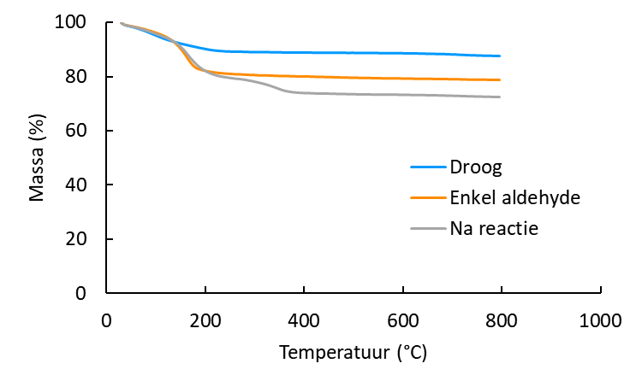
Temperature (°C)
Mass (%)
Dry reference
Aldehyde reference
After reaction

Fig. S35: TGA curves of parent H-FER (blue), H-FER recovered after stirring in 3-methylbutanal at 80°C (orange), and H-FER recovered after HCHO-transfer reaction with 3-methylbutanal (grey).

- Inductively coupled plasma (ICP)
The Pd and Al-content of zeolites after reaction was determined by ICP-OES (see general information) after evaporating the organics and digesting the zeolites in an HF-solution (table S24).
Table S24: ICP results of zeolites recovered after HCN-transfer reactions (see below).
Reaction | Al wt.% | Al-zeolite/Al-total (%) | Pd wt.% | Pd-zeolite/Pd total (%)
H-ZSM-5 (140) reference | 0.28 | 0 | / | /
R1 (1h) | 0.51 | 8 | 0.09 | 6.2
R1 (4h) | 0.47 | 7.4 | 0.12 | 8.2
R1 (18h) | 0.52 | 8 | 0.13 | 8.9
R2 | 0.74 | 5 | 0.11 | 3.3
R3 | 0.79 | 3.5 | 0.12 | 2.5
R4 | 0.93 | 14.3 | 0.07 | 9.3
R5 | 1.57 | 10.6 | 0.03 | 3.7
R6 | 0.96 | 14.7 | 0.46 | 31.1
R7 | 1.01 | 6.9 | 0.33 | 10
R8 | 0.70 | 10.7 | 0.05 | 3.12
R9 | 0.73 | 4.9 | 0.04 | 1.2
R10 | 0.69 | 10.6 | 0.5 | 34
R11 | 1.24 | 19 | 0.62 | 42.1
R12 | 0.49 | 7.5 | 0.07 | 4.8
R13 | 0.58 | 8.9 | 0.33 | 22

Reactions:
R1 = 5 mol% Pd(OAc)₂, 5 mol% Xphos, 40 mol% AlMe₂Cl, 1 eq. 4-tert-butylstyrene, 0.6 ml propionitrile, T=100°C, 90 mg H-ZSM-5, 18h
R2 = 5 mol% Pd(OAc)₂, 5 mol% Xphos, 40 mol% AlMe₂Cl, 1 eq. 4-tert-butylstyrene, 0.6 ml propionitrile, T=100°C, 40 mg H-ZSM-5, 18h
R3 = 5 mol% Pd(OAc)₂, 5 mol% Xphos, 40 mol% AlMe₂Cl, 1 eq. 4-tert-butylstyrene, 0.6 ml propionitrile, T=100°C, 20 mg H-ZSM-5, 18h
R4 = 2.5 mol% Pd(OAc)₂, 2.5 mol% Xphos, 40 mol% AlMe₂Cl, 1 eq. 4-tert-butylstyrene, 0.6 ml propionitrile, T=100°C, 90 mg H-ZSM-5, 18h
R5 = 2.5 mol% Pd(OAc)₂, 2.5 mol% Xphos, 40 mol% AlMe₂Cl, 1 eq. 4-tert-butylstyrene, 0.6 ml propionitrile, T=100°C, 40 mg H-ZSM-5, 18h
R6 = 5 mol% Pd(OAc)₂, 2.5 mol% Xphos, 40 mol% AlMe₂Cl, 1 eq. 4-tert-butylstyrene, 0.6 ml propionitrile, T=100°C, 90 mg H-ZSM-5, 18h
R7 = 5 mol% Pd(OAc)₂, 2.5 mol% Xphos, 40 mol% AlMe₂Cl, 1 eq. 4-tert-butylstyrene, 0.6 ml propionitrile, T=100°C, 40 mg H-ZSM-5, 18h
R8 = 5 mol% Pd(OAc)₂, 10 mol% Xphos, 40 mol% AlMe₂Cl, 1 eq. 4-tert-butylstyrene, 0.6 ml propionitrile, T=100°C, 90 mg H-ZSM-5, 18h
R9 = 5 mol% Pd(OAc)₂, 10 mol% Xphos, 40 mol% AlMe₂Cl, 1 eq. 4-tert-butylstyrene, 0.6 ml propionitrile, T=100°C, 40 mg H-ZSM-5, 18h
R10 = 5 mol% Pd(OAc)₂, 5 mol% Xphos, 40 mol% AlMe₂Cl, 1 eq. 4-tert-butylstyrene, 5 eq. isovaleronitrile, 0.6 ml toluene, T=120°C, 90 mg H-ZSM-5, 18h
R11 = 5 mol% Pd(OAc)₂, 5 mol% Xphos, 40 mol% AlMe₂Cl, 1 eq. 4-tert-butylstyrene, 10 eq. isobutyornitrile, 0.6 ml toluene, T=120°C, 90 mg H-ZSM-5, 18h
R12 = 5 mol% Pd(OAc)₂, 5 mol% Xphos, 40 mol% Al(i-bu)₂Cl, 1 eq. 4-tert-butylstyrene, 0.6 ml propionitrile, T=100°C, 90 mg H-ZSM-5, 18h
R13 = 5 mol% Pd(OAc)₂, 5 mol% Xphos, 40 mol% AlMe₂Cl, 1 eq. 4-tert-butylstyrene, 0.6 ml propionitrile, T=100°C, 90 mg H-ZSM-5, 18h – Pd(OAc)₂ premixed in propionitrile with H-ZSM-5 (140) for 30 min.

- X-ray Absorption Spectroscopy (XAS)
X-ray absorption measurements were performed at BM23 beamline of ESRF (Grenoble, France). Ex situ measurements were conducted on pelletized samples of optimal thickness. In situ samples were measured in liquid phase inside a glass cell under controlled temperature and gas atmosphere with a time resolution of ca. 90s per spectrum. The measurements were performed in transmission geometry with the beam intensity registered by ionization chambers. The reference Pd foil was measured simultaneously with the samples for energy calibration. The energy was selected by Si(111) double-crystal monochromator operated in the continuous scanning mode. The rejection of higher harmonics was achieved by Rh-coated mirrors. Processing of the in situ data, multivariate curve resolution (MCR) analysis and construction of the concentration profiles was performed in PyFitIt program^{64,65}. Processing of ex situ data and EXAFS fitting was performed in the Demeter package⁶⁶.

14.1 Ex situ measurements
Pd-loaded zeolites were prepared by preloading 150 mg H-ZSM-5 (140) with 2.81 mg Pd(OAc)₂ in 1 ml toluene or propionitrile for 24h at room temperature. The zeolite samples were washed 5x with CHCl₃, evacuated under vacuum at RT and stored under argon. Spectra were recorded and plotted against reference Pd-compounds: Pd-foil and Pd(OAc)₂ (i.e. Pd₃(OAc)₆) (fig. S36a). The oxidation state of the Pd-species can be inferred from the XANES either according to the edge position or via linear combination fitting (LCF) using reference spectra of Pd(0) and Pd(II). The Pd-zeolite preloaded in toluene exclusively shows Pd(II)-species, and its spectrum is very similar to the Pd(OAc)₂ reference (fig. S35a). The sample preloaded in propionitrile shows a pre-edge which is slightly shifted towards Pd(0). LCF analysis gives a Pd(II)/Pd(0) ratio of 72/28. This reduction might be facilitated by clustering of Pd(II)-species inside the zeolite. The EXAFS spectra of Pd-ZSM-5 preloaded in toluene and propionitrile are shown in fig. S36b. The structural parameters for Pd-O and Pd-Pd contributions are given in table S25. For the Pd-ZSM-5 zeolite preloaded in toluene, a Pd-O coordination number of 3.8 was found, similarly to as reported in our previous study with Pd-Beta (3.3)⁶⁷. As the space available in the unit cell of ZSM-5 is more confined compared to Beta (due to the higher framework density), it is reasonable to assume that less toluene is present in the near vicinity of the Pd-centres, and the speciation leans to 4-coordinated Pd-O species of the type shown in fig. S37b.
Fig. S36: XANES (a) and EXAFS (b) data of Pd-ZSM-5 zeolite preloaded in toluene (solid green) and propionitrile (solid blue) compared with Pd(II)(OAc)₂ (dashed red) and Pd(0) NPs (dashed grey).

The sample prepared via preloading in propionitrile gives a Pd-O coordination number of 3.3, with an additional Pd-Pd coordination number of 3.8. The interatomic Pd-Pd distance of 2.74 is similar to that in metallic Pd foil. The presence of a coordinating -CN moiety likely perturbs the Pd coordination sphere, manifested by a lowering of the Pd-O coordination number. Hence, the relative fraction of the Pd-ZSM-5 species is lowered at the expense of a fraction of small Pd(0)-clusters. At the same time, the presence of propionitrile inside the pores of the zeolite might results in a Pd-ZSM-5 species as shown in fig. S37c.
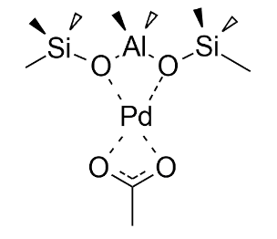
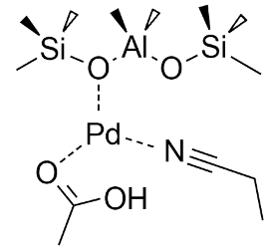
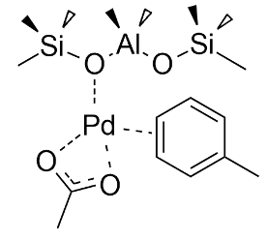
C)
B)
A)

Fig. S37: A) Theoretical Pd-Beta structure determined via DFT in a previous study with toluene-loaded Pd-Beta⁶⁷ B) Possible toluene-loaded Pd-ZSM-5 structure C) Possible propionitrile-loaded Pd-ZSM-5 structure.
The presence of Xphos (1:1 molar ratio to Pd) or AlMe₂Cl (8:1 molar ratio) in the preloading process with propionitrile influences the Pd-speciation, as shown in figures S38 and S39, and table S25. The presence of Xphos has a pronounced effect on the oxidation state of the Pd-species. LCF analysis shows a Pd(II)/Pd(0) ratio of 31/69 (fig. S39c). Xphos is known to facilitate the reduction of Pd(II)(OAc)₂ to Pd(0)-species, even at room temperature⁶⁸. Also AlMe₂Cl leads to a shift in the Pd(II)/Pd(0) ratio, from 72/28 in pure propionitrile to 53/47 in the presence of the Lewis acid (fig. S39b). The reducing effect is thus less pronounced, but still provides valuable insight into possible pathways for the Pd(OAc)₂ activation to the active Pd(0)-species.

Fig. S38: XANES (a) and EXAFS (b) data of Pd-ZSM-5 zeolite preloaded in propionitrile (solid blue), with addition of AlMe₂Cl (solid purple) and Xphos (solid orange) compared with Pd(II)(OAc)₂ (dashed red), Pd(II)(PPh₃)₂Cl₂ (dashed green), and Pd(0) NPs (dashed grey).

Fig. S39: XANES spectra (coloured solid lines) and the results of LCF (dashed grey) for Pd-ZSM-5 zeolite preloaded in propionitrile (a), with addition of AlMe₂Cl (b) and Xphos (c). The relative amount of Pd(0) phase is 28, 47 and 69%, respectively.
Table S25: Local structure of Pd species from the EXAFS analysis of Pd-ZSM-5 preloaded in toluene and propionitrile.
 |  | R (Å) | N | σ² (Å²)
Pd(II)(OAc)₂ | Pd‒O | 2.00 ± 0.02 | 4 (fixed) | 0.002 ± 0.001
Preloaded in toluene | Pd‒O | 2.00 ± 0.01 | 3.8 ± 0.4 | 0.002 ± 0.001
Preloaded in toluene | Pd‒Pd* | - | - | -
Preloaded in propionitrile | Pd‒O | 1.98 ± 0.02 | 3.3 ± 0.5 | 0.004 ± 0.002
Preloaded in propionitrile | Pd‒Pd | 2.74 ± 0.03 | 3.8 ± 0.4 | 0.013 ± 0.004
Preloaded in propionitrile with AlMe₂Cl | Pd‒O | 1.98 ± 0.01 | 2.4 ± 0.5 | 0.003 ± 0.002
Preloaded in propionitrile with AlMe₂Cl | Pd‒Cl | 2.49 ± 0.03 | 2.8 ± 1.8 | 0.026 ± 0.022
Preloaded in propionitrile with AlMe₂Cl | Pd‒Pd | 2.75 ± 0.02 | 3.4 ± 1.2 | 0.016 ± 0.004
Preloaded in propionitrile with Xphos | Pd‒O | 1.95 ± 0.02 | 2.3 ± 1.1 | 0.013 ± 0.008
Preloaded in propionitrile with Xphos | Pd‒P* | - | - | -
Preloaded in propionitrile with Xphos | Pd‒Pd | 2.76 ± 0.01 | 5.3 ± 0.7 | 0.008 ± 0.001
*addition of these phases led to the instability of the fitting procedure due to bigger number of variable parameters
The EXAFS spectra of Pd-ZSM-5 preloaded in propionitrile in the presence of Xphos shows that the Pd-speciation is split among Pd-O, Pd-P and Pd-Pd distributions (fig. S38b). It should be noted that the presence of Pd-P contributions likely originates from surface-bound Pd(Xphos)(Zeolite)-type species (which are either chemisorbed or covalently attached to surface OH-groups). There was no washing step implemented when preparing the Pd-Xphos preloaded samples, thus keeping the surface-bound species intact. Pd-clusters or Pd-nanoparticles may form as a results of the reduction of Pd(OAc)₂ by Xphos, in which Xphos get oxidized, leading to an underligated Pd(0)-fraction⁶⁸. Importantly, there is still a fair amount of Pd-O contributions, confirming that in the presence of equimolar amounts of Xphos, some Pd(II)-species are still covalently attached to the zeolite framework.

The fate of the Pd-zeolite species after the reaction was probed by recovering the zeolite after 1) a standard transfer hydrocyanation reaction and 2) an ethylene dimerization reaction. Reaction procedures are given in SI section 9 procedure A for the former and SI section 7.3, procedure II for the latter. The zeolites were dried under vacuum and stored under argon as noted above. The XANES and EXAFS spectra are given in fig. S40. All Pd-species in both zeolites are fully reduced, and the spectra are strikingly similar in both XANES and EXAFS regions. The analysis indicate the formation of a distinct Pd(0)-carbide phase, according to the increased Pd-Pd interatomic distance (table S26) and characteristic shape of first XANES maximum⁶⁹.
Moreover, the low coordination number (N < 10) indicates that the Pd-phase is composed of small Pd(0)-clusters, instead of metallic bulk Pd(0)-particles (N > 12). Hence, the majority of the Pd(0)- particles likely started nucleating inside the pores of the zeolite, as the diameter would be greater without local confinement. The fact that the ethylene dimerization reaction with Pd(OAc)₂ and H-ZSM-5 as the sole catalytic compounds brings forth the exact same Pd(0)-carbide species as the transfer hydrocyanation reaction in propionitrile firmly confirms the ethylene dimerization activity of Pd-ZSM-5 species present in the transfer hydrocyanation reaction.
Fig. S40: XANES (a) and EXAFS (b) data of Pd-ZSM-5 recovered after transfer hydrocyanation reaction (green) and Pd-ZSM-5 recovered after ethylene dimerization reaction (blue) compared with Pd(0) NPs (dashed grey).

Table S26: Local structure of Pd species from the EXAFS analysis for Pd-ZSM-5 after transfer hydrocyanation reaction and after ethylene dimerization reaction.
 |  | R (Å) | N | σ² (Å²)
Transfer hydrocyanation reaction | Pd-Pd | 2.78 ± 0.01 | 9.7 ± 1.1 | 0.009 ± 0.001
Ethylene dimerization reaction | Pd-Pd | 2.78 ± 0.01 | 9.9 ± 0.7 | 0.009 ± 0.001

  - In situ measurements
In situ experiments were setup following the general procedure for the transfer hydrocyanation reaction in propionitrile (SI chapter 9, procedure A). Some modifications were made to ensure proper irradiation of the sample during reaction. After addition of all reagents, the sample was sealed with a septum containing a gas inlet tube. This tube was connected with a valve which could be switched between argon and ethylene gas via a remote controller. The sample was partly suspended in an oil bath placed on a heating/stirring plate. The temperature of the reaction mixture was monitored and calibrated via a thermocouple placed against the outside wall of the reaction vial. The heating plate was placed on a sample stage whose horizontal and vertical positions that were adjusted in order to irradiate the central part of the sample above the oil bath. Due to negligible absorption of the solvent at Pd K-edge energy and sufficient concentration of palladium, the measurements were also performed in transmission geometry.
The first in situ measurement was conducted of the HCN-transfer reaction without zeolite under following reaction conditions: 5 mol% Pd(OAc)₂/Xphos, 40 mol% AlMe2Cl, 1 eq. 4-tert-butylstyrene, 0.9 ml propionitrile, T ~ 77 °C. The evolution of XANES and EXAFS spectra gets to the saturation fast after the mixture reaches 77 °C and remains stable over the following 1 h of measurements (Fig. S41). To extract the spectra of the pure species and their time evolution, pyMCR procedure implemented in pyFitIt code was applied. The starting state (green lines) is represented by Pd(0) species mainly coordinated with P-atoms of the ligand along with a smaller Pd-Pd contribution.
The change in relative contribution of the species observed at the start and at the end of the reaction is shown in fig. S41c. Based on the XAS edge, the Pd oxidation state is zero during the full reaction course. Analysis of the EXAFS spectra points to a dominant Pd-P contribution, along with smaller Pd-Pd and Pd-O contribution (table S27). It should be noted that the latter cannot be distinguished from Pd-C or Pd-N in EXAFS. However, the final state is characterized by Pd-P and Pd-Pd contributions only, which indicates that the Pd-O ones in the initial spectrum are most likely arising from Pd-acetate species not reacted with Xphos. Quantitative analysis of EXAFS summarized in Fig. S41d and table S27 is coherent with a Pd(0)(Xphos)₂ species, which may be regarded as the resting state of the catalyst. The theoretical EXAFS spectrum of Pd(0)(Xphos)₂ shows a good fit with the experimental spectrum (fig. S41d). The presence of Pd-Pd dimers (i.e. with the Pd-Pd coordination number of 1) has also been observed before in systems with Pd(OAc)₂ and Xphos, and was shown to originate from Pd(I)-species⁶⁸. For comparison with the references 3-14 Å⁻¹ k-range was used, but a shorter range of 3-14 Å⁻¹ was used for the analysis. To reduce the number of variable parameters, the Pd-P coordination number was varied (except for system A, after reaction) from the set {0.5, 1.0, 1.5, 2.0}, and the value yielding the best fit was chosen.

Fig. S41: In situ XANES (a) and EXAFS (b) data for the initial (solid green) and final (solid blue) states during the transfer hydrocyanation reaction without zeolite compared with Pd(II)(OAc)₂ (dashed red) and Pd(0) NPs (dashed grey). (c) Evolution of the species from panel (a) (blue and green lines, left ordinate axis) and registered reaction temperature (red line, right ordinate axis) as function of time. (d) Results of the fit (dashed black lines) for the initial (solid green) and final (solid blue) states.

Table S27: Local structure of Pd species from the analysis of in situ EXAFS data of the transfer hydrocyanation reaction without zeolite.
 |  | R (Å) | N | σ² (Å²)
Initial state | Pd-O | 2.05 ± 0.04 | 1.1 ± 0.9 | 0.005 ± 0.003
Initial state | Pd-P | 2.23 ± 0.01 | 2 (fixed) | 0.006 ± 0.001
Initial state | Pd-Pd | 2.79 ± 0.04 | 1.7 ± 0.7 | 0.013 ± 0.004
After reaction | Pd-O | - | - | -
After reaction | Pd-P | 2.26 ± 0.01 | 1.9 ± 0.2 | 0.006 ± 0.001
After reaction | Pd-Pd | 2.75 ± 0.02 | 1.1 ± 0.5 | 0.011 ± 0.004

The same in situ protocol was repeated for the HCN-transfer reaction with H-ZSM-5 (140) (same conditions, 90 mg zeolite, 77°C). The extracted XANES and EXAFS spectra of the starting and final states, their time evolution and EXAFS fits are shown in fig. S42. The overall spectral features and their changes during reaction are consistent with those observed in absence of zeolite. However, the edge position in both the initial XANES spectrum and the one after reaction is slightly shifted to higher
energies, indicating a more oxidized state of Pd (which is still close to Pd(0), as Pd-Xphos species are dominating). Much slower evolution of Pd species is observed during reaction (compare parts (c) in Fig. S41 and S42). In the EXAFS data, the Pd-O signal remains even after reaction, supporting the fact that a fraction of Pd is bonded to the zeolite framework (table S28). To quantify the relative amount of different Pd species, the XANES spectrum after reaction was fitted by a linear combination of the three spectra: 1) catalytic system after reaction without zeolite (i.e. Pd-Xphos), 2) preloaded zeolite and 3) metallic Pd foil (fig. S43).

Fig. S42: In situ XANES (a) and EXAFS (b) data for the initial (solid green) and final (solid blue) states during the transfer hydrocyanation reaction with zeolite compared with Pd(II)(OAc)₂ (dashed red) and Pd(0) NPs (dashed grey). (c) Evolution of the species from panel (a) (blue and green lines, left ordinate axis) and registered reaction temperature (red line, right ordinate axis) as function of time. (d) Results of the fit (dashed black lines) for the initial (solid green) and final (solid blue) states.

Table S28: Local structure of Pd species from the analysis of in situ EXAFS data of the transfer hydrocyanation reaction with zeolite.
 |  | R (Å) | N | σ² (Å²)
Initial state | Pd-O | 2.00 ± 0.04 | 0.8 ± 0.6 | 0.002 ± 0.002
Initial state | Pd-P | 2.22 ± 0.02 | 1.5 (fixed) | 0.005 ± 0.002
Initial state | Pd-Pd | 2.75 ± 0.03 | 2.6 ± 0.8 | 0.014 ± 0.004
After reaction | Pd-O | 1.99 ± 0.03 | 0.6 ± 0.5 | 0.001 ± 0.002
After reaction | Pd-P | 2.27 ± 0.03 | 1.0 (fixed) | 0.003 ± 0.002
After reaction | Pd-Pd | 2.79 ± 0.03 | 1.7 ± 0.6 | 0.013 ± 0.004
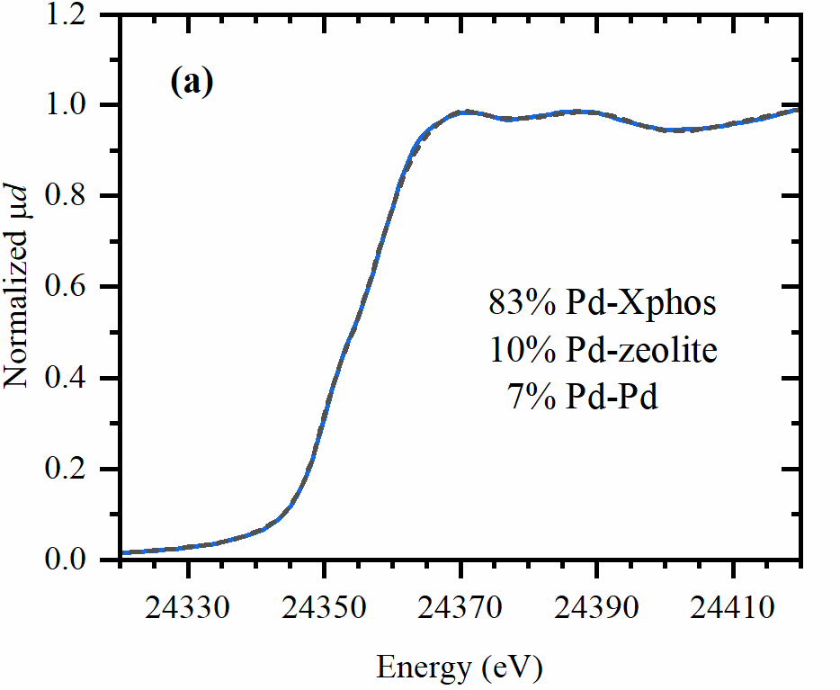

Fig. S43: Linear combination fit (dashed grey lines) of the XANES spectra (solid coloured lines) collected after the transfer hydrocyanation reaction with zeolite.
The figure below shows the XAS spectra of four distinct palladium partitioning cases: 1) full ligation to Xphos (no zeolite) 2) dominant Xphos ligation, small zeolite contribution (Pd:Xphos = 1:1, 90 mg zeolite) 3) roughly even split between Xphos and zeolite (Pd:Xphos = 2:1, 90 mg zeolite) 4) full ligation to zeolite (no Xphos). The second case corresponds with the optimal HCN-transfer reaction conditions. The shift from Pd-P to Pd-O contributions with increasing zeolite:Xphos ratios is in accordance with results obtained from ICP-data of the zeolites (table S24).
Fig. S44: In situ XANES (a) and EXAFS (b) data for the systems with various zeolite:Xphos ratios after HCN-transfer reaction: with 1 mol eq. Xphos (blue), 1 mol eq. Xphos and 90 mg H-ZSM-5 (~0.85 mol eq. acid sites) (red), 0.5 mol eq. Xphos and 90 mg H-ZSM-5 (~0.85 mol eq.) (green) and after ethylene dimerization reaction with 90 mg H-ZSM-5 (purple)
- Solid-state NMR characterization
Solid-state NMR experiments were performed on a 600 MHz Varian spectrometer, using a 1.6 mm FastMAS probe. Larmor frequencies for ²⁷Al and ²⁹Si were 156.18 MHz and 119.06 MHz, respectively. The samples were spun at 20 kHz. ²⁷Al magic-angle spinning (MAS) NMR spectra were recorded with a short 1.0 µs excitation pulse and a recycle delay of 0.1 s. 60 000 scans were recorded per spectrum. In the ²⁹Si MAS NMR experiment, the π/2 pulse of 1.8 µs was used and 1000 scans were recorded with a recycle delay of 60 s. ¹H-²⁹Si cross-polarization (CP) MAS NMR measurements employed a ¹H excitation pulse of 1.5 µs and ramped amplitude CP block of 4 ms. The delay was 1 s and the number of scans was 40 000. The ²⁹Si spin-lattice relaxation times (T₁) were measured with saturation recovery pulse sequence. A block of sixty π/2 pulses separated by a rotor period was employed before the magnetization-recovery delay (τ). The recycle delay was 0.1 s and the number of scans was 160.
The aluminum content of the three samples was estimated by integrating the ²⁷Al MAS NMR spectra (Main text, fig. 4d) and normalizing the values by dividing them with the integrals of ²⁹Si MAS spectra. The relative amounts for the parent H-ZSM-5, H-ZSM-5 preloaded in propionitrile with AlMe₂Cl, and Pd-ZSM-5 after 20 h of transfer hydrocyanation reaction are approximately 1, 1.5, and 1.33, respectively. Note that these values are probably underestimated because a portion of the aluminum, especially that of AlMe₂Cl species, could be “NMR-invisible” due to their large quadrupolar coupling constants. Similarly as XAS, NMR spectroscopy can also often provide valuable information about local structure within solids. Different local environments are reflected in different chemical shifts of atomic nuclei. Heteronuclear and homonuclear dipolar couplings, which bear information about the distances among the coupled nuclei, are particularly informative⁶⁷. Additional information on the local structure can be inferred from the NMR relaxation time constants. NMR spin–lattice relaxation rates describe the rates with which nuclear spin systems return to their equilibrium state, i.e. the rates at which the spin system recovers the Boltzmann population over the Zeeman energy levels. Relaxation proceeds through an exchange of energy between a spin system and an energy reservoir, typically called the lattice. In our study, we compared ²⁹Si spin-lattice relaxation times within the parent H-ZSM-5 and ZSM-5 samples modified by Pd (Fig. S45).
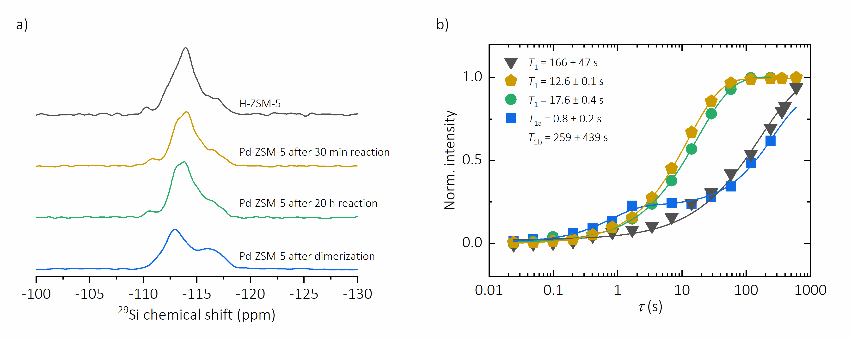
Fig. S45: ²⁹Si MAS NMR spectra (a) of parent H-ZSM-5 (black), Pd-ZSM-5 after 30 min (orange) and after 20 hours (green) of transfer hydrocyanation reaction, and Pd-ZSM-5 after ethylene dimerization (blue). ²⁹Si NMR spin–lattice relaxation curves (b) and the calculated T₁ values for the four samples, respectively.
As expected, and typically observed, spin-lattice relaxation times in high-silica zeolites are very long. This is because the system of ²⁹Si nuclei can exchange energy with the lattice only through the fluctuations of relatively weak chemical shift anisotropy and dipolar coupling interactions (which are in high Si/Al zeolites mostly limited to very weak ²⁹Si-²⁹Si couplings and to very rare ²⁹Si-²⁷Al or ²⁹Si-¹H couplings). However, the relaxation times drastically shorten in the ZSM-5 samples that contain Pd centres. Since both Pd(0) (configuration 4d¹⁰), as well as Pd(II) (configuration 4d⁸) in a square planar coordination have no unpaired electrons, the accelerated relaxation cannot be due to paramagnetic contributions. Instead, the cross-relaxation between ²⁹Si nuclei and quadrupolar ¹⁰⁵Pd nuclei induce the accelerated relaxation. This type of relaxation enhancement mechanism was quite thoroughly studied in some metal hydride compounds, where it was shown that ¹H spin-lattice relaxation rates could increase by several orders of magnitude if protons were coupled to metal nuclei that experienced strong electric quadrupolar couplings^{70,71}. ¹⁰⁵Pd nuclei are a typical example of quadrupolar nuclei with large electric quadrupole moment. However, if cross relaxation is to be efficient between the two spin systems (²⁹Si and ¹⁰⁵Pd in our case), these nuclei have to be strongly coupled. Given that both ²⁹Si and ¹⁰⁵Pd nuclei have rather small magnetic moments, this means that the two nuclei have to be very close in space. In summary, drastic shortening of the ²⁹Si spin-lattice relaxation times in Pd-containing ZSM-5 zeolites is a strong indirect proof of a proximity between the Pd centres and the silicon nuclei of the zeolite framework. Different relaxation times in samples with different oxidation states of Pd most probably stem from the fact that due to different electronic configurations such Pd centres also experience different electric field gradients, leading to differences in electric quadrupolar couplings.
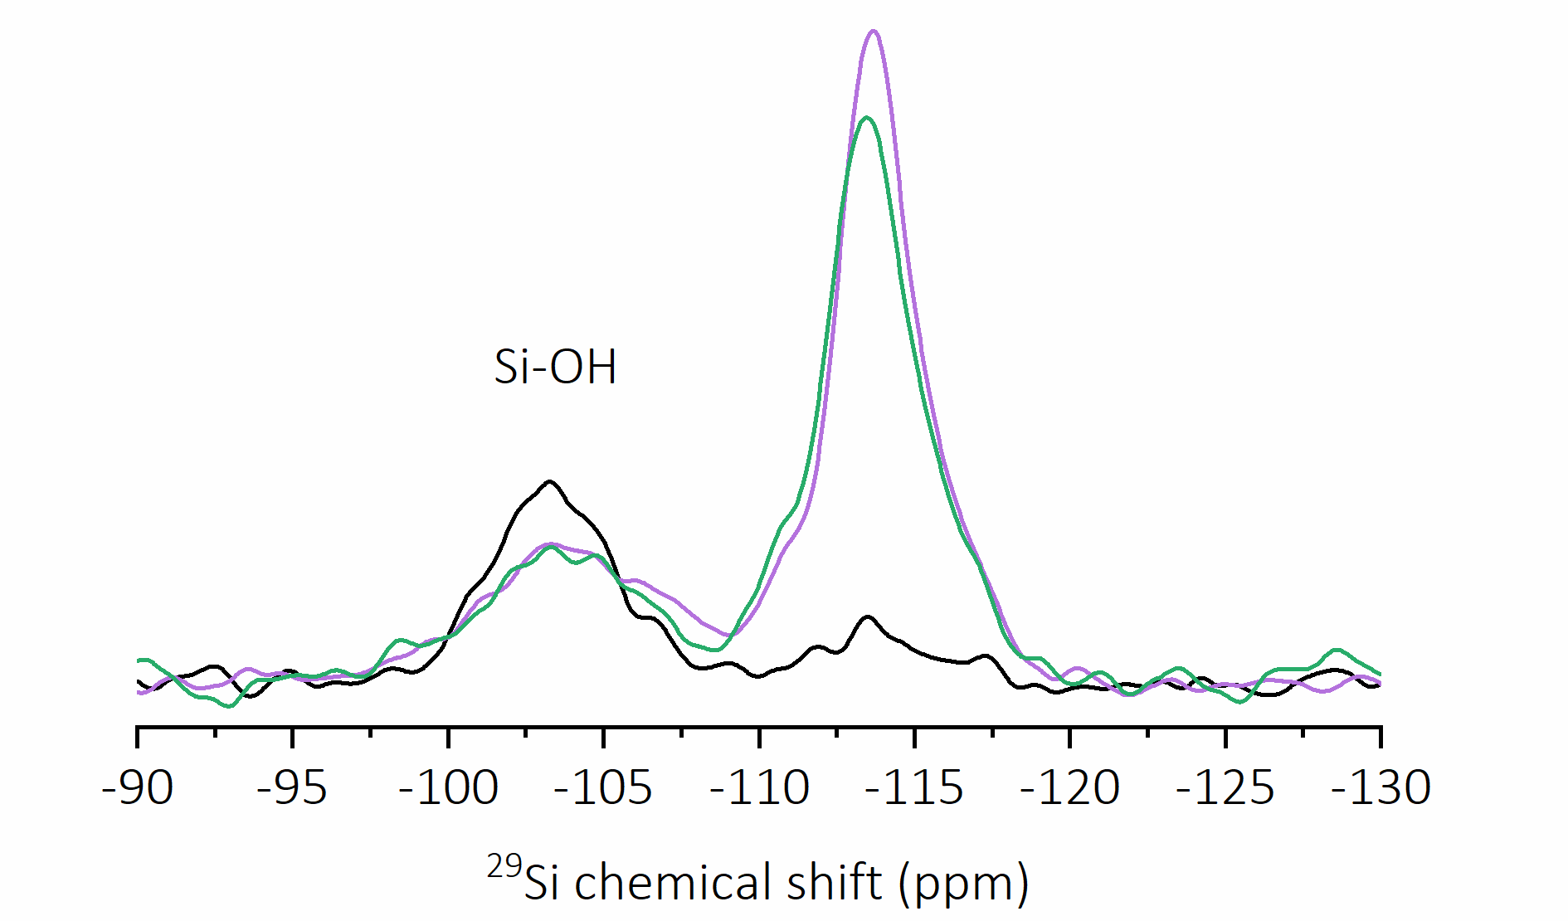
Fig. S46: ¹H-²⁹Si CP MAS NMR spectra of H-ZSM-5 (black), H-ZSM-5 zeolite preloaded in propionitrile with addition of AlMe₂Cl (purple), and Pd-ZSM-5 after 20 h of transfer hydrocyanation reaction (green).
In high-silica zeolites, the number of silanol groups is small and the corresponding ²⁹Si signals are hardly observable in ²⁹Si MAS NMR spectra. With the ¹H-²⁹Si CP MAS NMR experiment (Fig. S46), the signals of ²⁹Si that are close in space to protons are strongly enhanced. The ¹H-²⁹Si CPMAS NMR spectra were normalized according to the total amount of ²⁹Si signal detected by the direct excitation experiment (²⁹Si MAS NMR). The additional peak resonating at about -103 ppm can be assigned to silanol groups. The number of silanol groups is slightly lower for the samples containing AlMe₂Cl compared to the parent H-ZSM-5. The signal enhancement in the range between -110 and -120 ppm is due to the polarization transfer between the protons of adsorbed organic molecules (propionitrile, butenes, valeronitriles, etc.) and the framework silicon.

- Scanning electron microscopy (SEM)
Scanning electron microscopy (SEM) images were taken using a PHILIPS scanning electron microscope XL30 FEG at an acceleration voltage of 30 kV. Zeolite samples were attached to a piece of carbon tape. Subsequently, a thin Pd/Pt layer was deposited on top of samples to achieve sufficient conductivity.
B: H-ZSM-48
A: H-ZSM-5
C: H-FER

Fig. S47: SEM images of H-ZSM-5 (Si/Al = 140) (A), H-ZSM-48 (Si/Al = 100) (B) and H-FER (Si/al = 9) (C).

- NMR spectra of products

17.1 HCN-transfer products
Nitrile products from styrene (1)
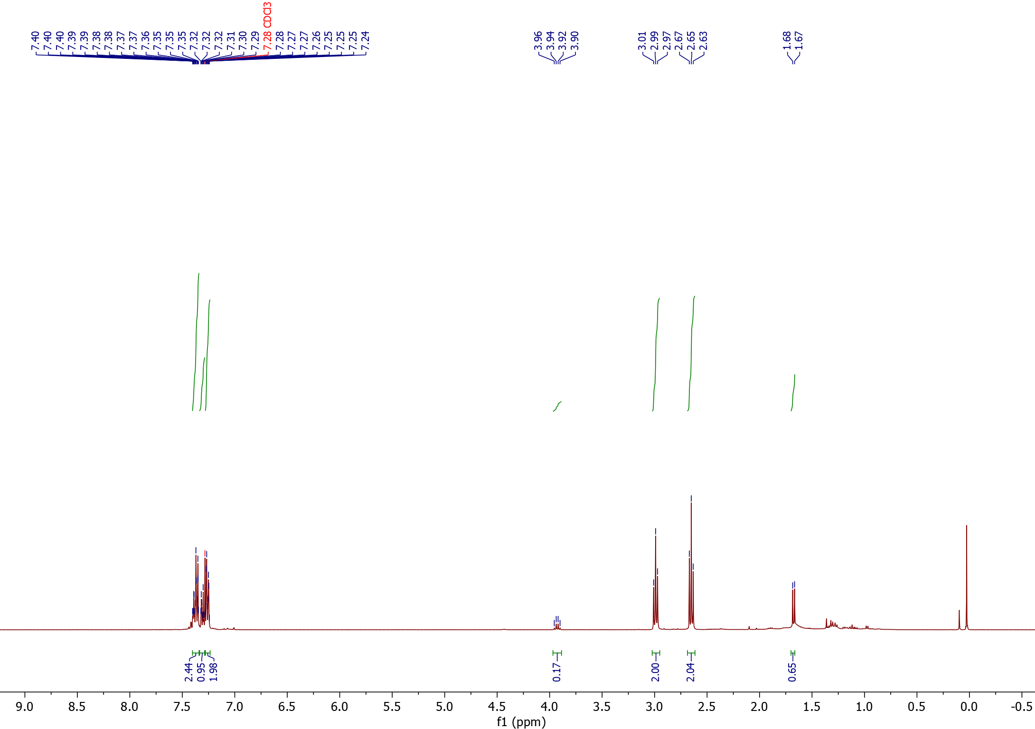
¹H-NMR

1
2

1
2
2

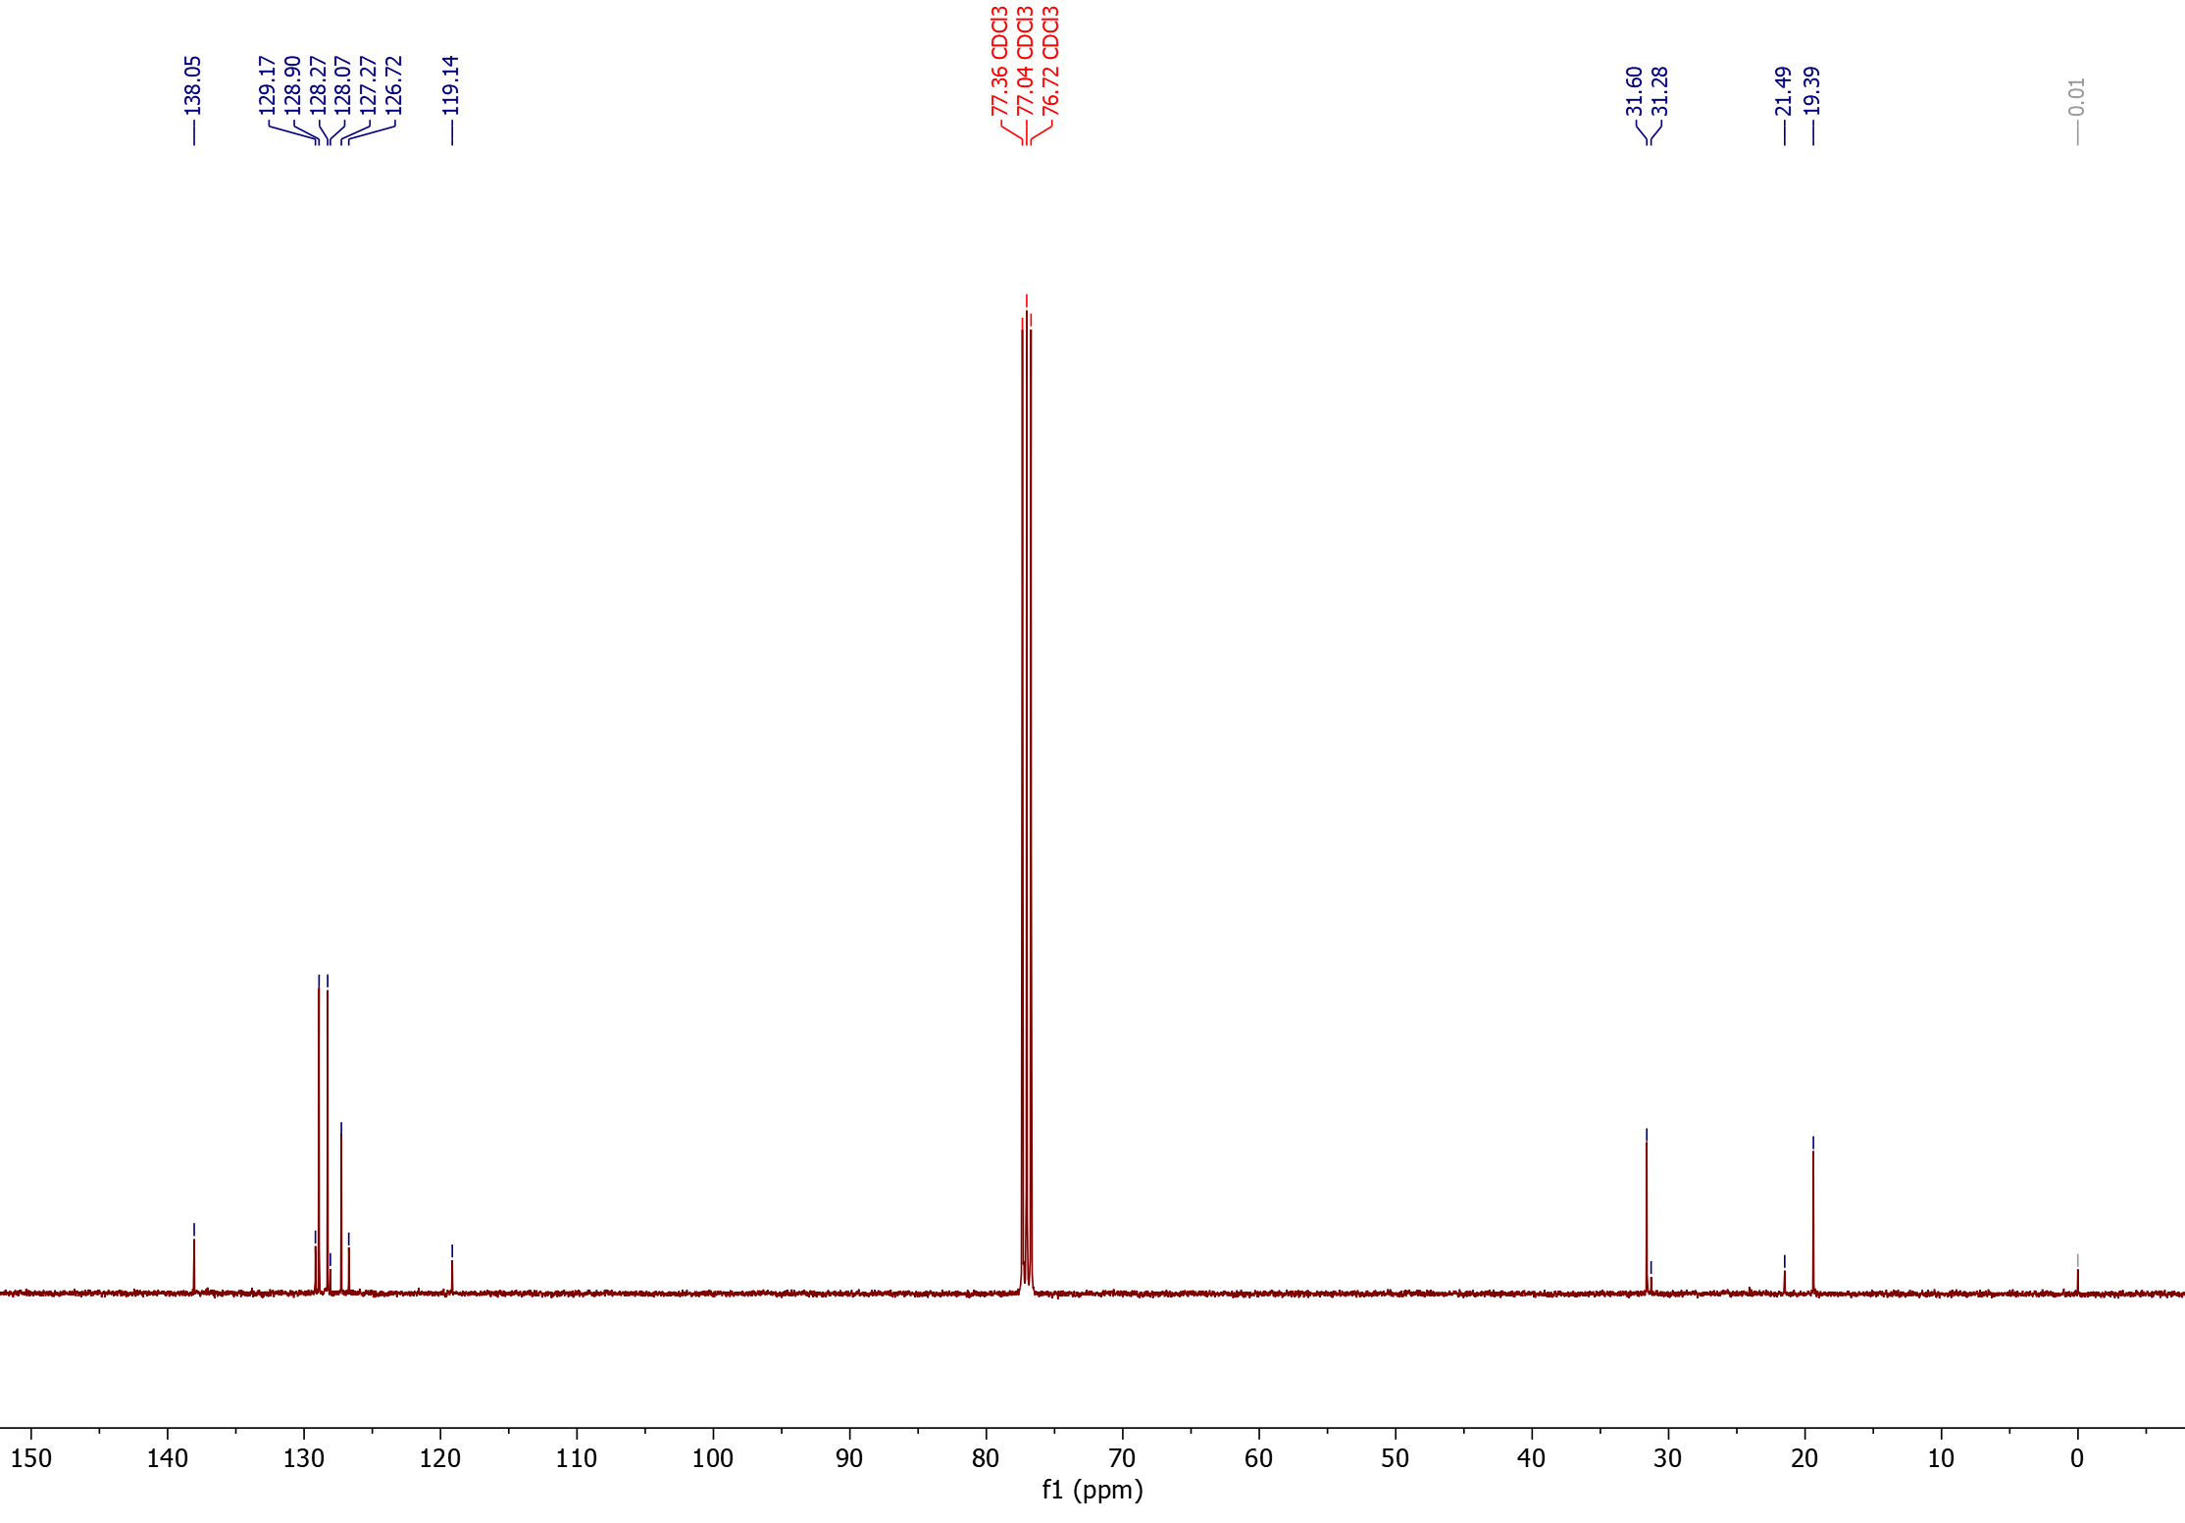
¹³C-NMR

°
1
2
*
°
*

1°,*
2°,*

Nitrile products from 4-tert-butyl styrene (2)
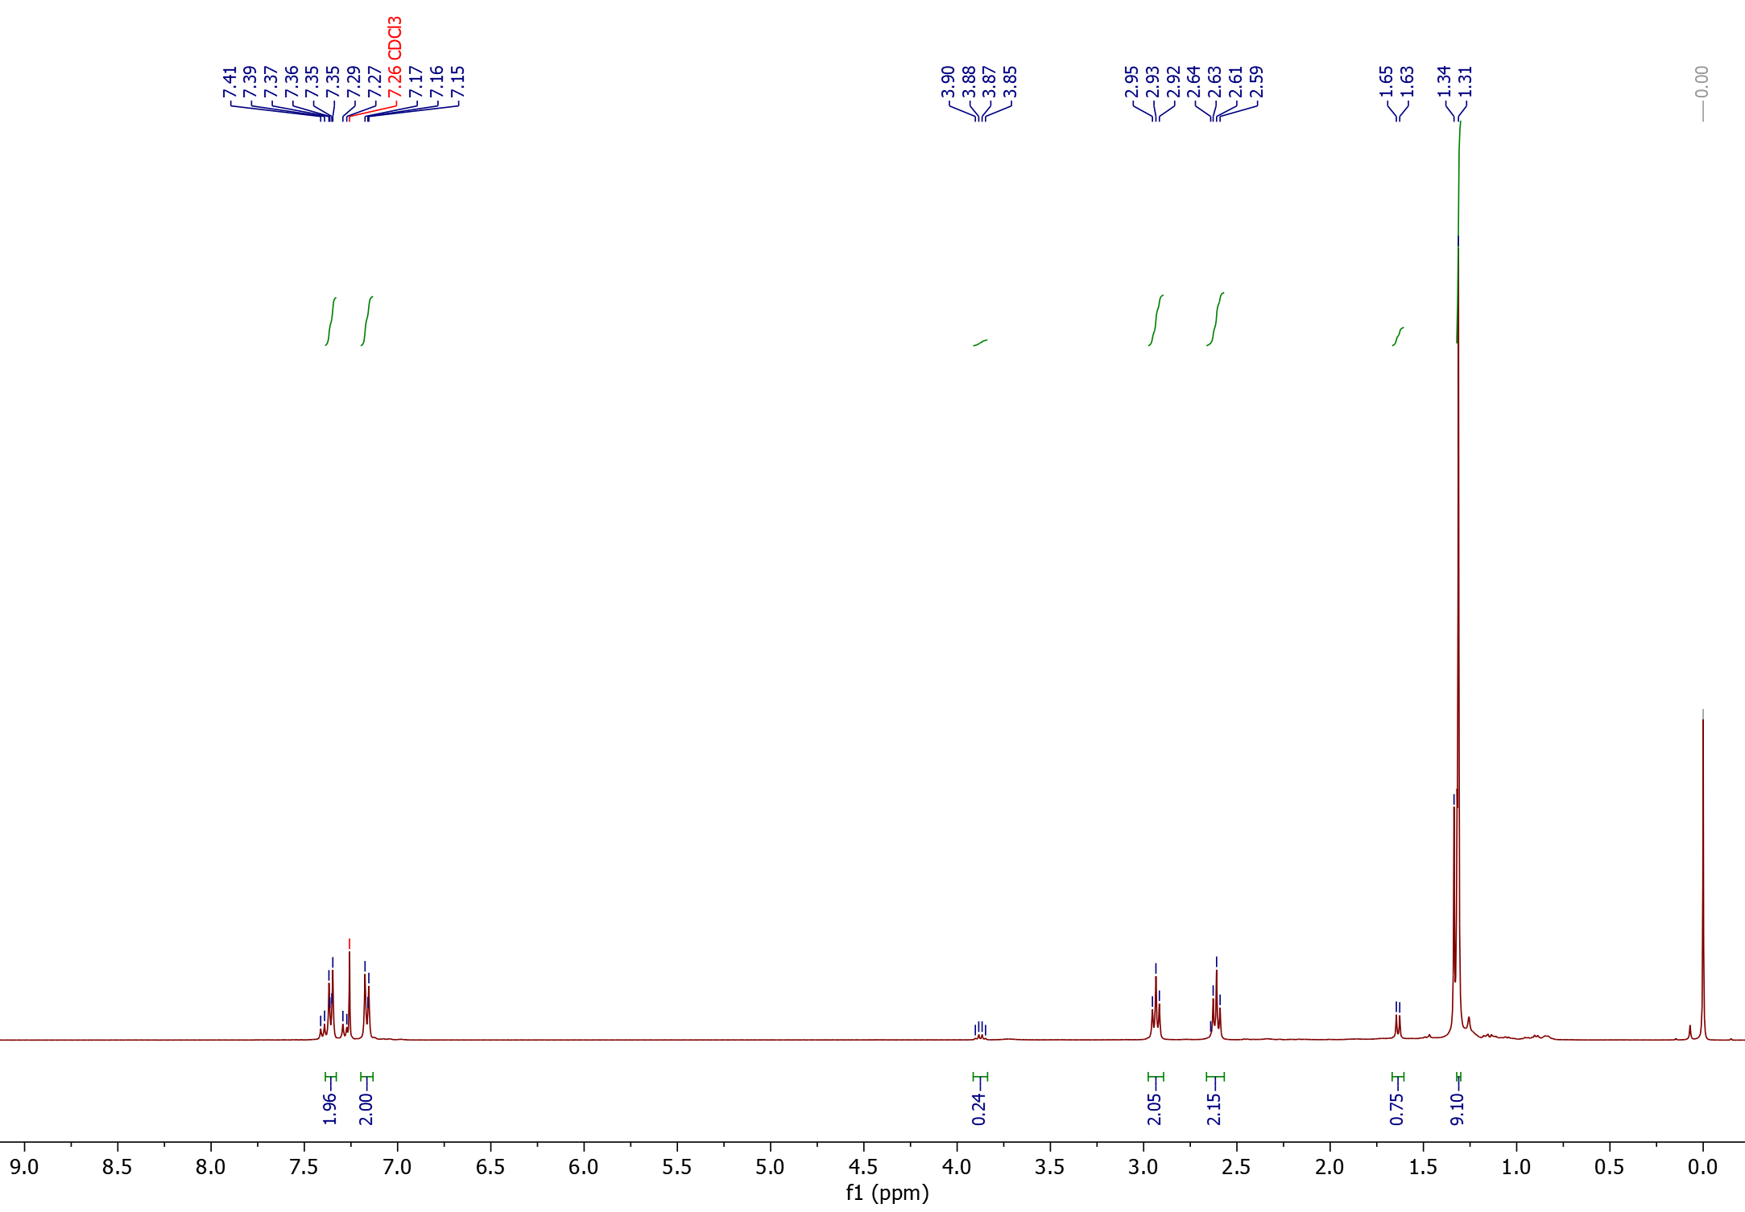
¹H-NMR

2
1<

1

2

2
2
1

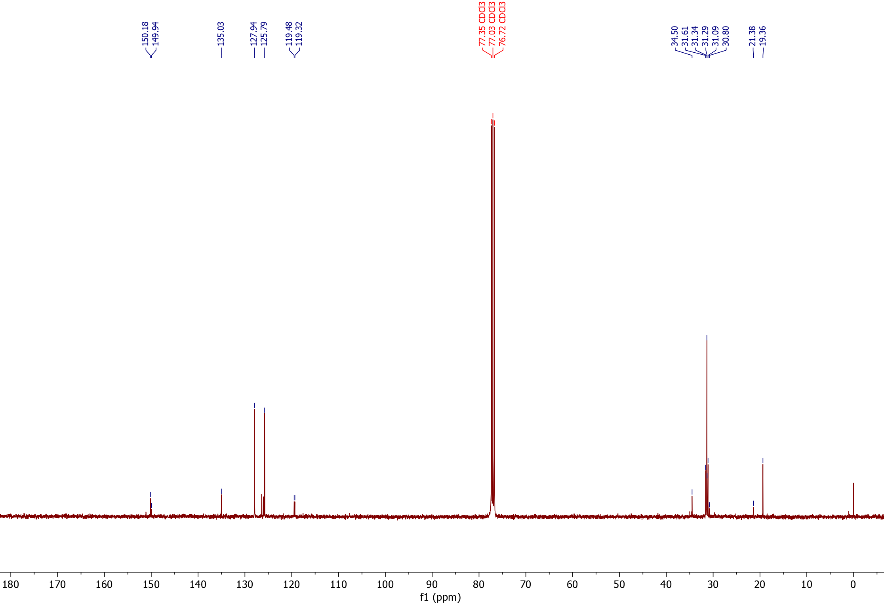
¹³C-NMR
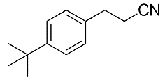
2
1<

°
*
°
*

1°,*
2°,*

Nitrile products from 3-methyl styrene (3)
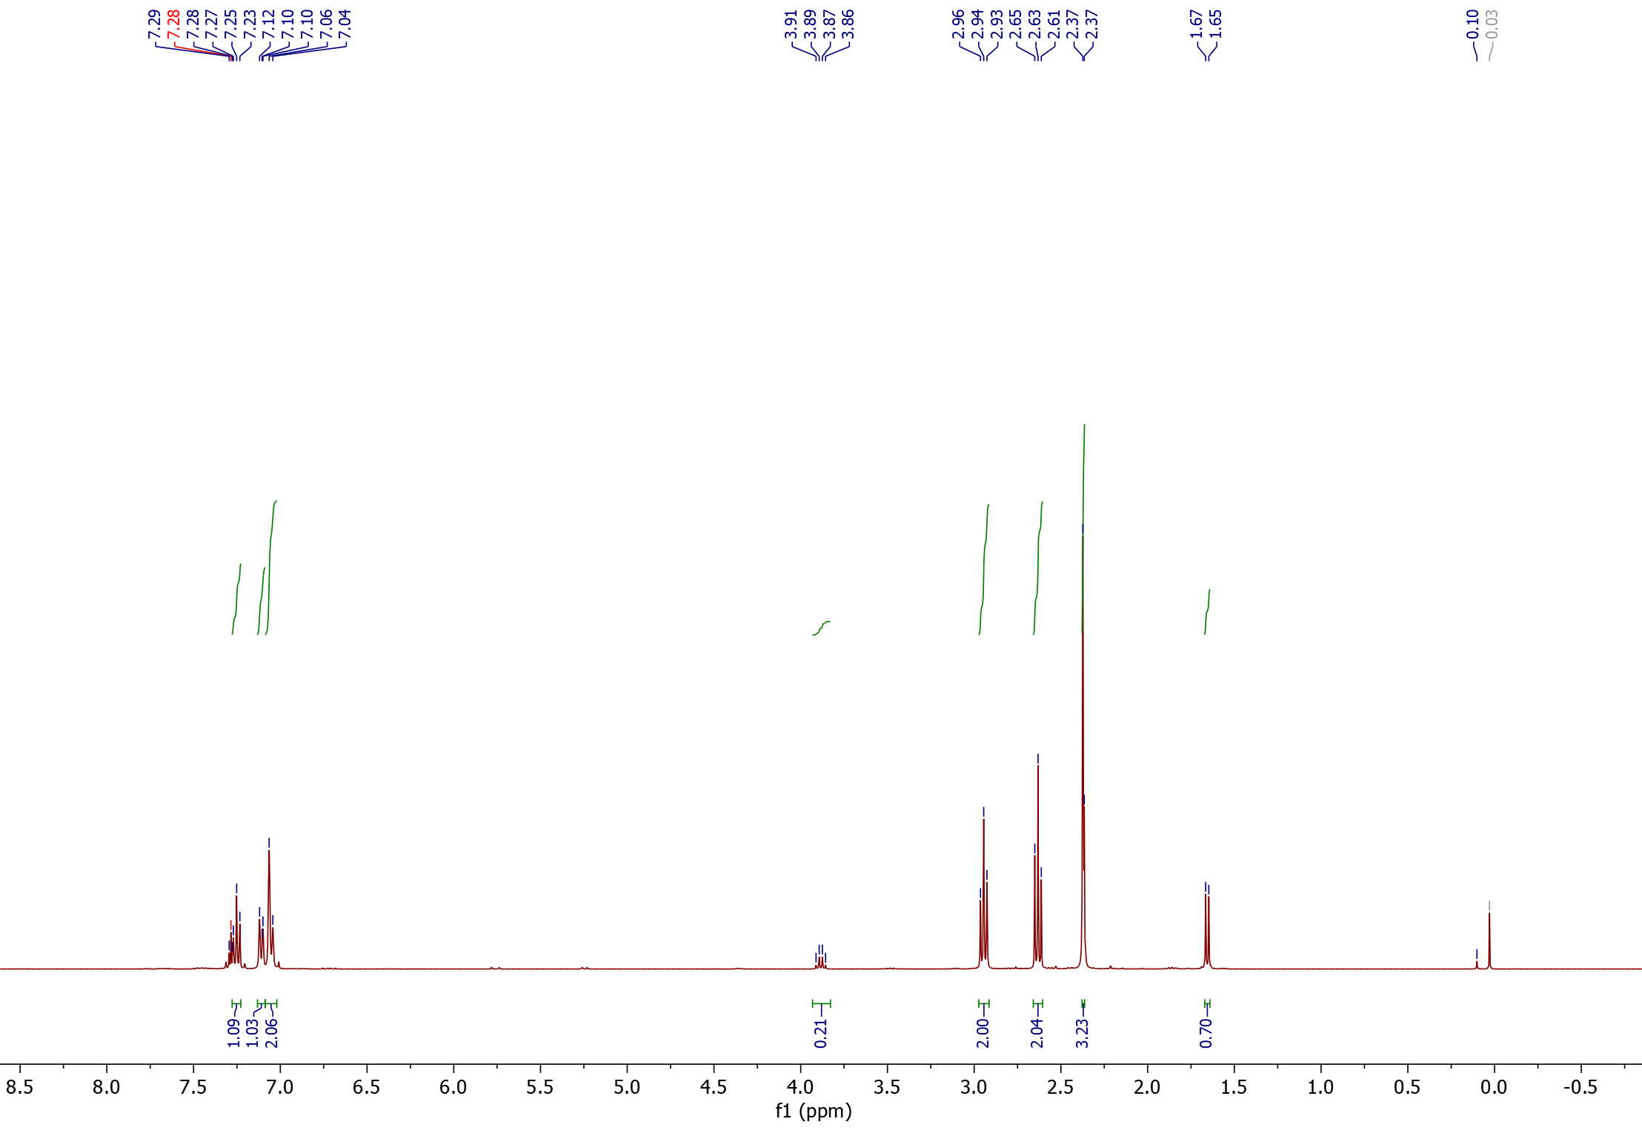
¹H-NMR

2
1<

1
2
2

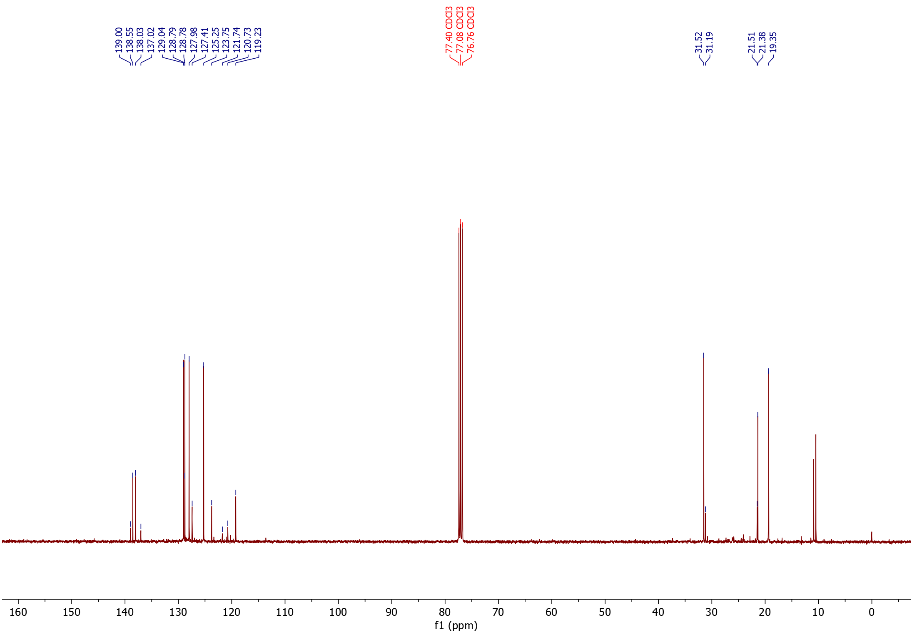
¹³C-NMR

°
2
1<
*
°
*

1°,*

2°,*

Nitrile products from 2,5-dimethyl styrene (4)
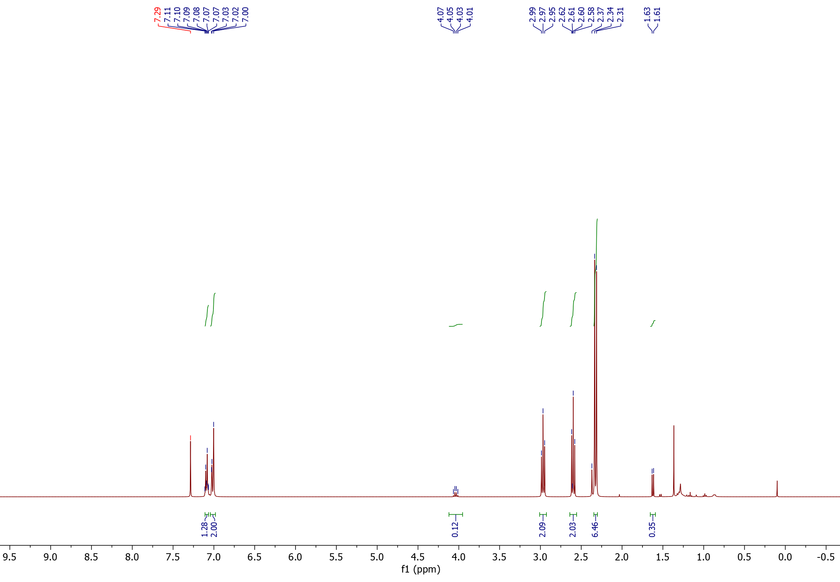
¹H-NMR

2
1<

1
1
2
2

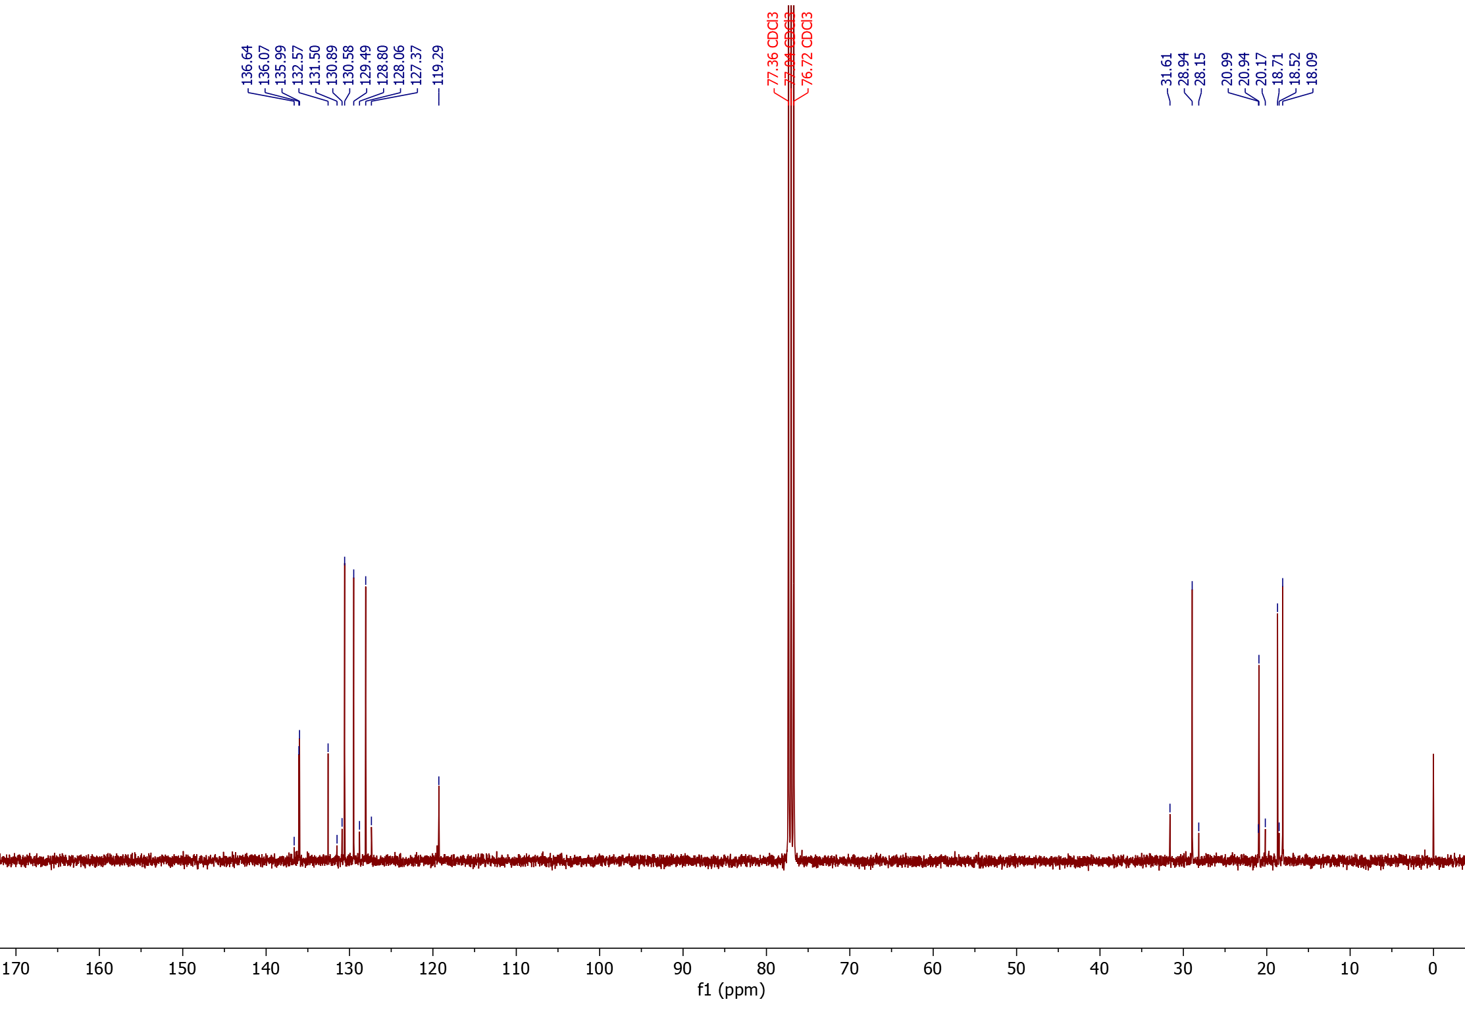
¹³C-NMR

1<
2
*
°
°
*
2°,*
1*
1°
Nitrile product from 2,4,6-trimethyl styrene (5) (isolated product)
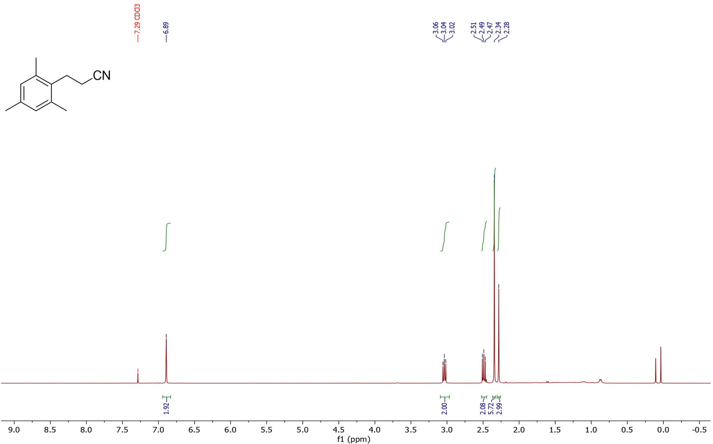
¹H-NMR

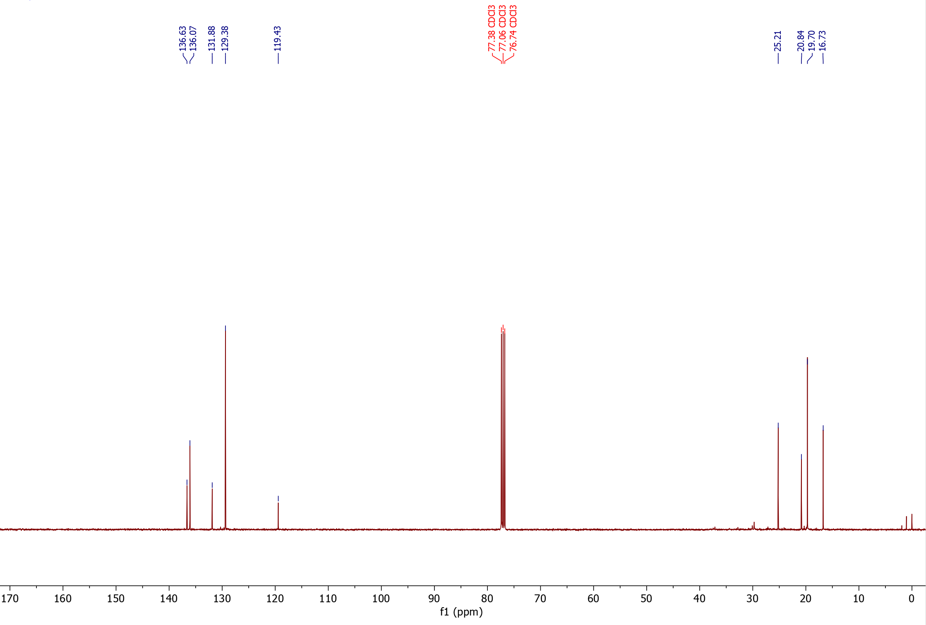
¹³C-NMR

Nitrile products from 4-vinyl biphenyl (6)
¹H-NMR
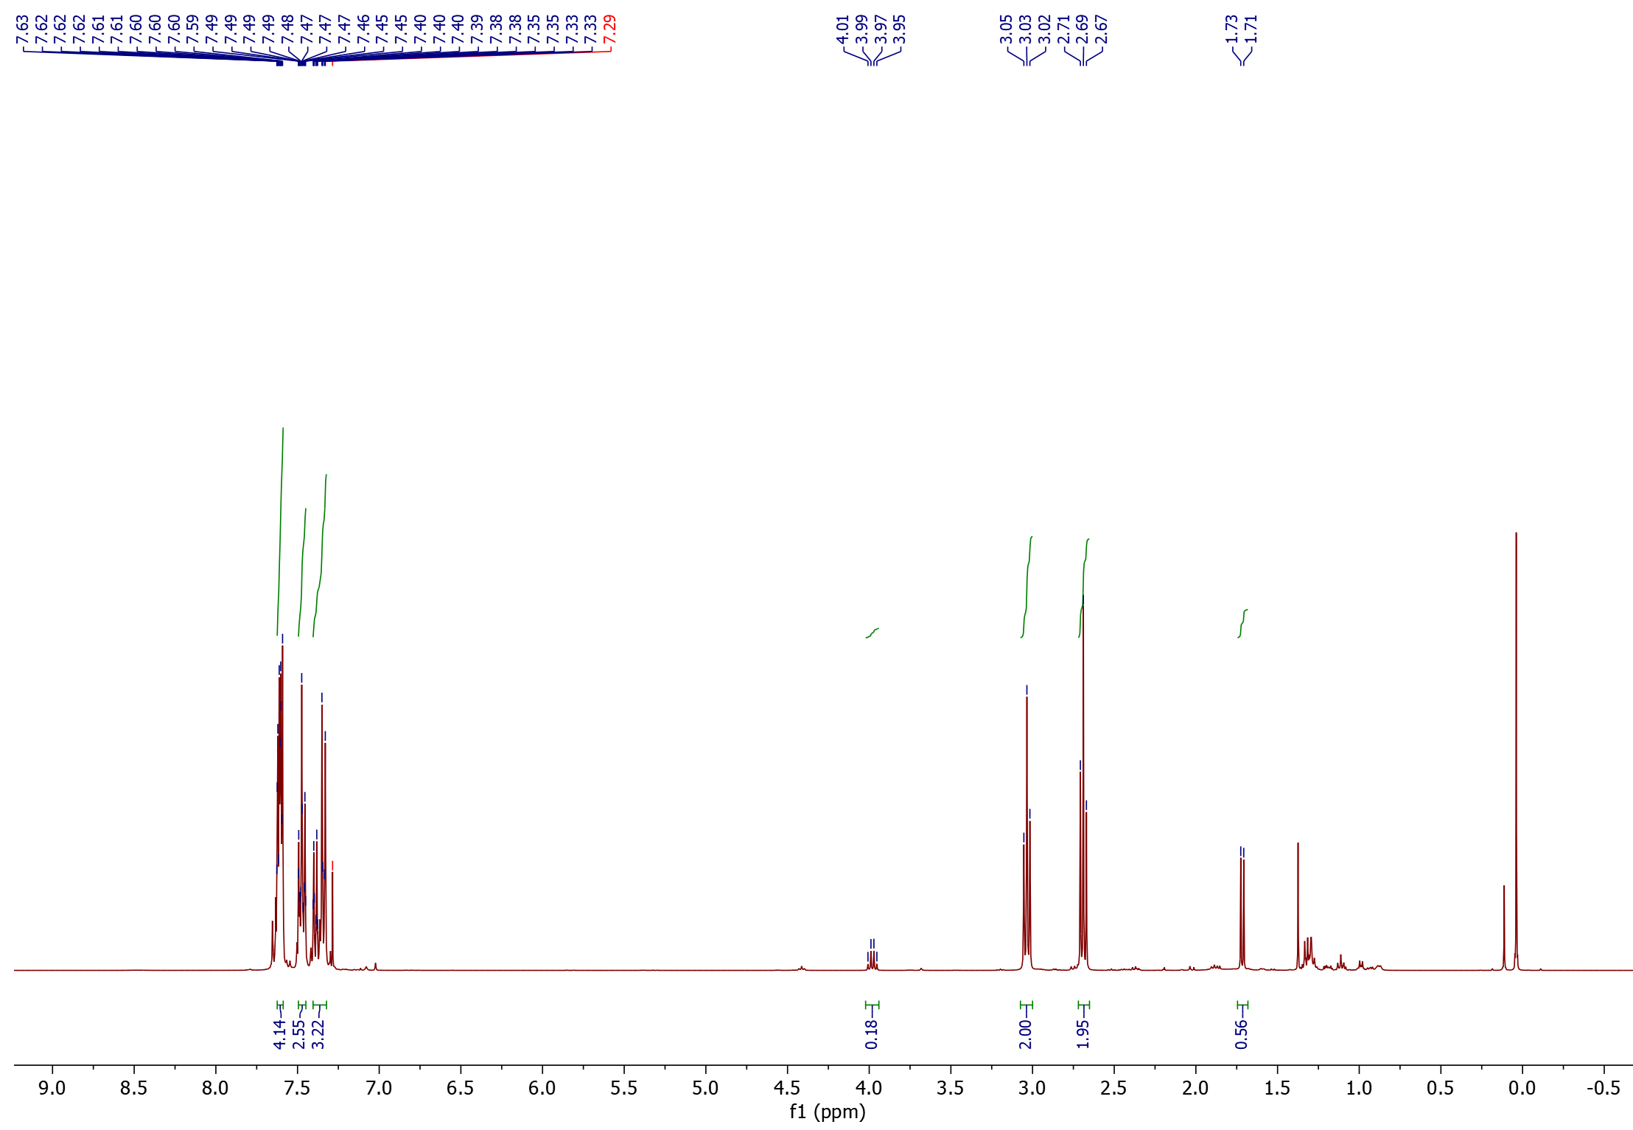
1<
2<

1
2
2

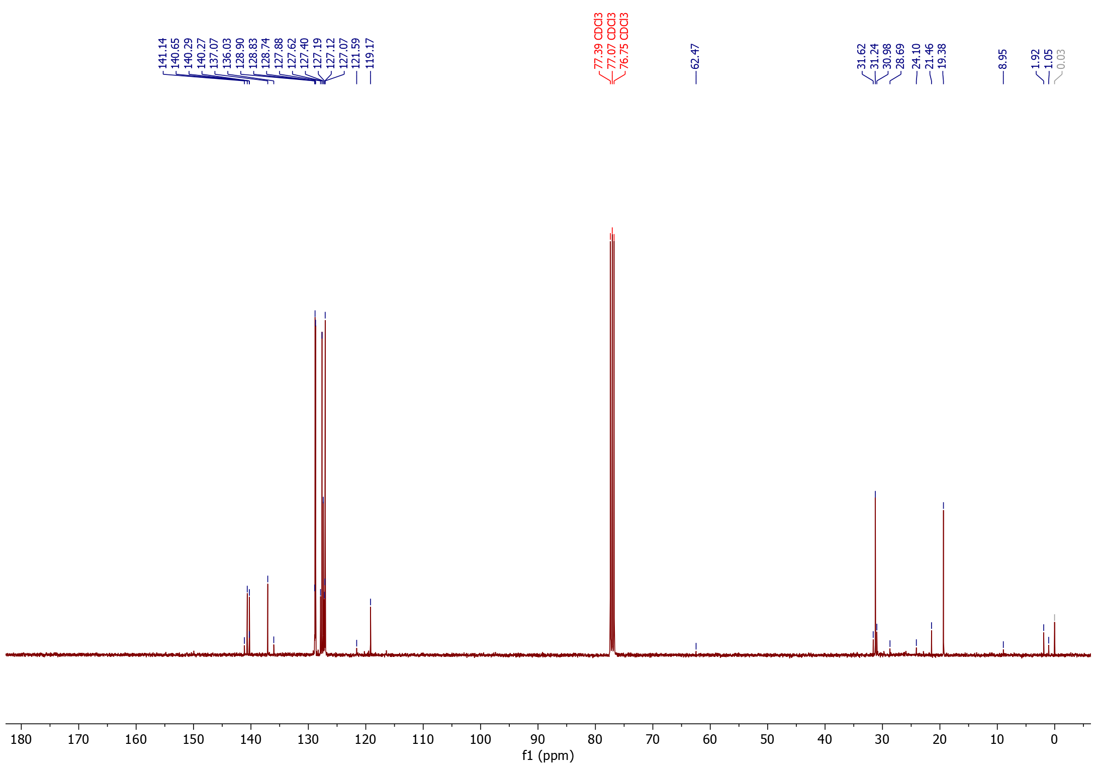
¹³C-NMR
2°,*
1°,*
2§
§
°
*
§
1<
2<
*
°

1§

Nitrile products from 2-vinyl naphthalene (7)
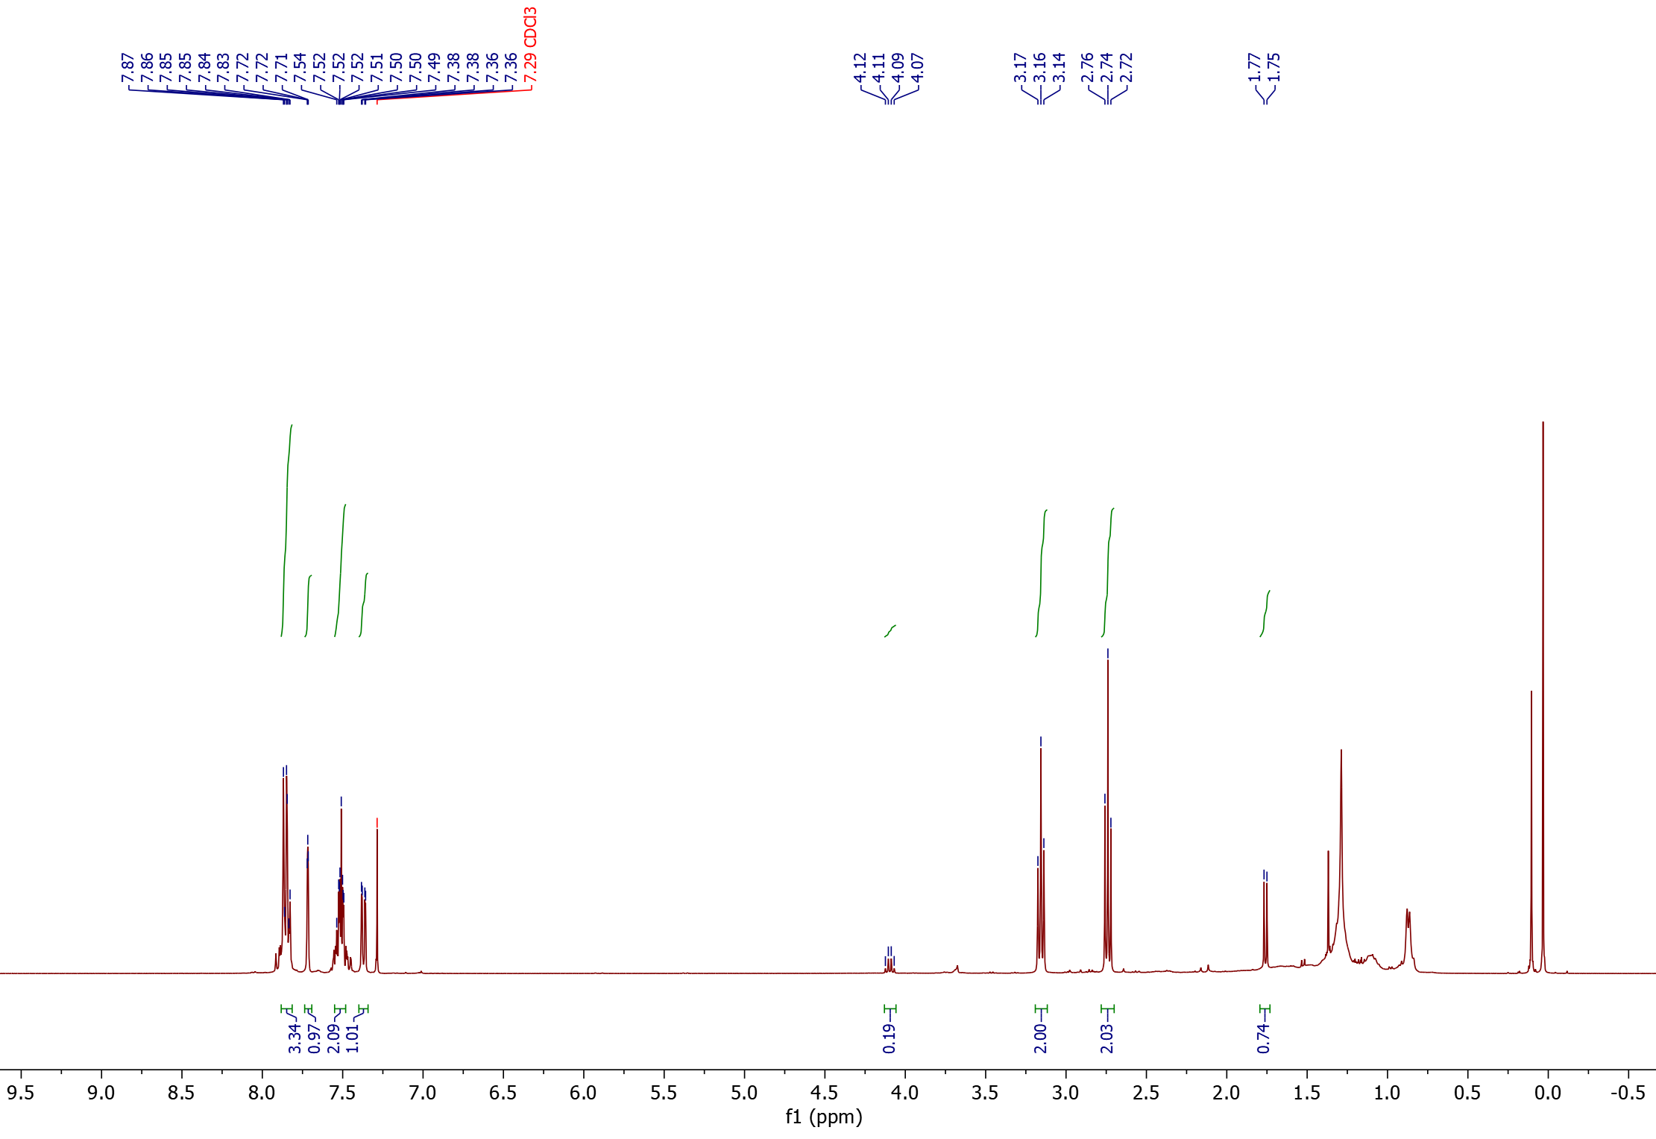
¹H-NMR
2
2
1
2<
1<

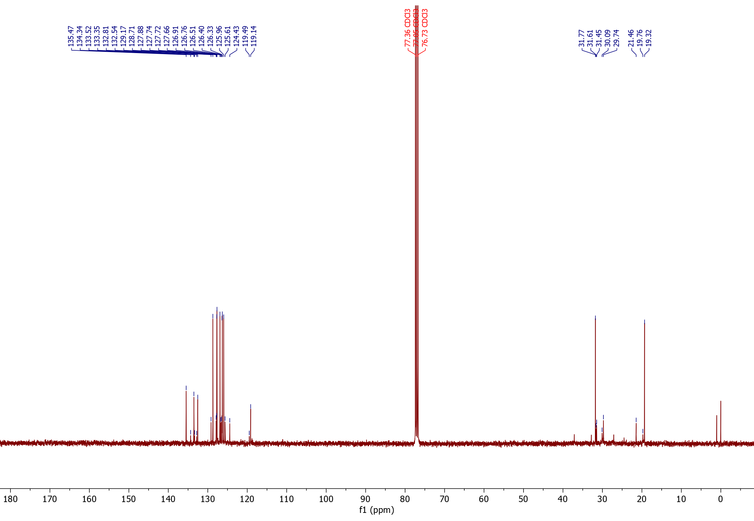
¹³C-NMR

*
°
°
*
2<
1<

1°,*

2°,*

Nitrile product from 9-vinyl anthracene (8) (isolated product)
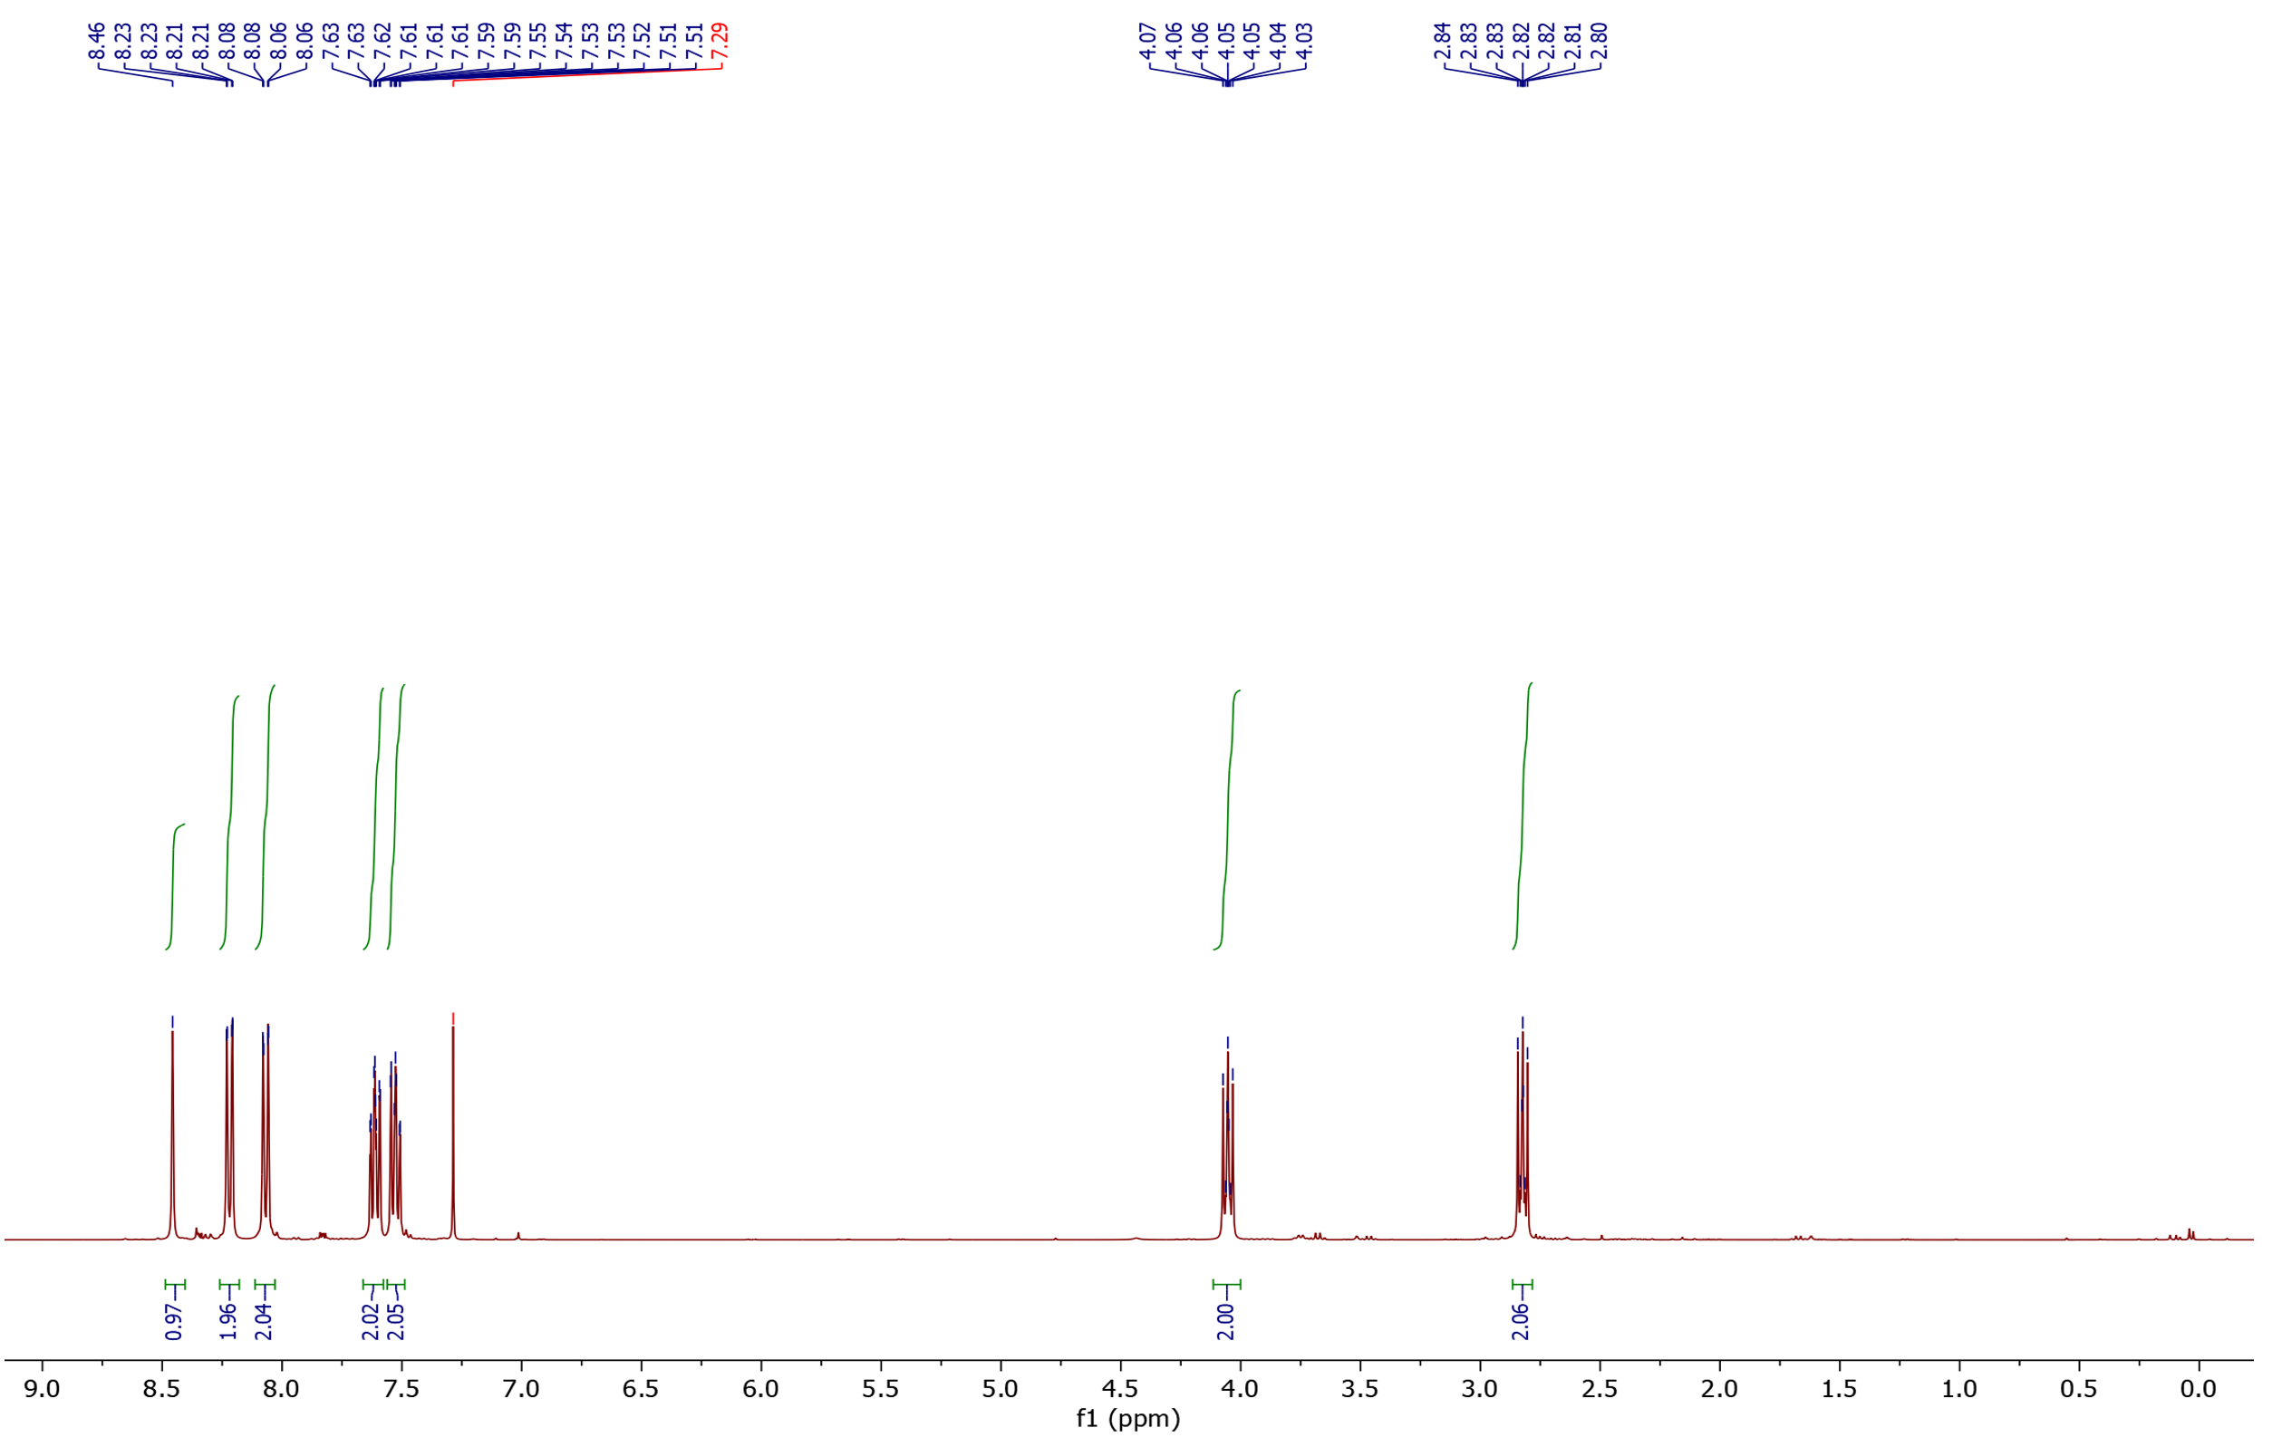
¹H-NMR

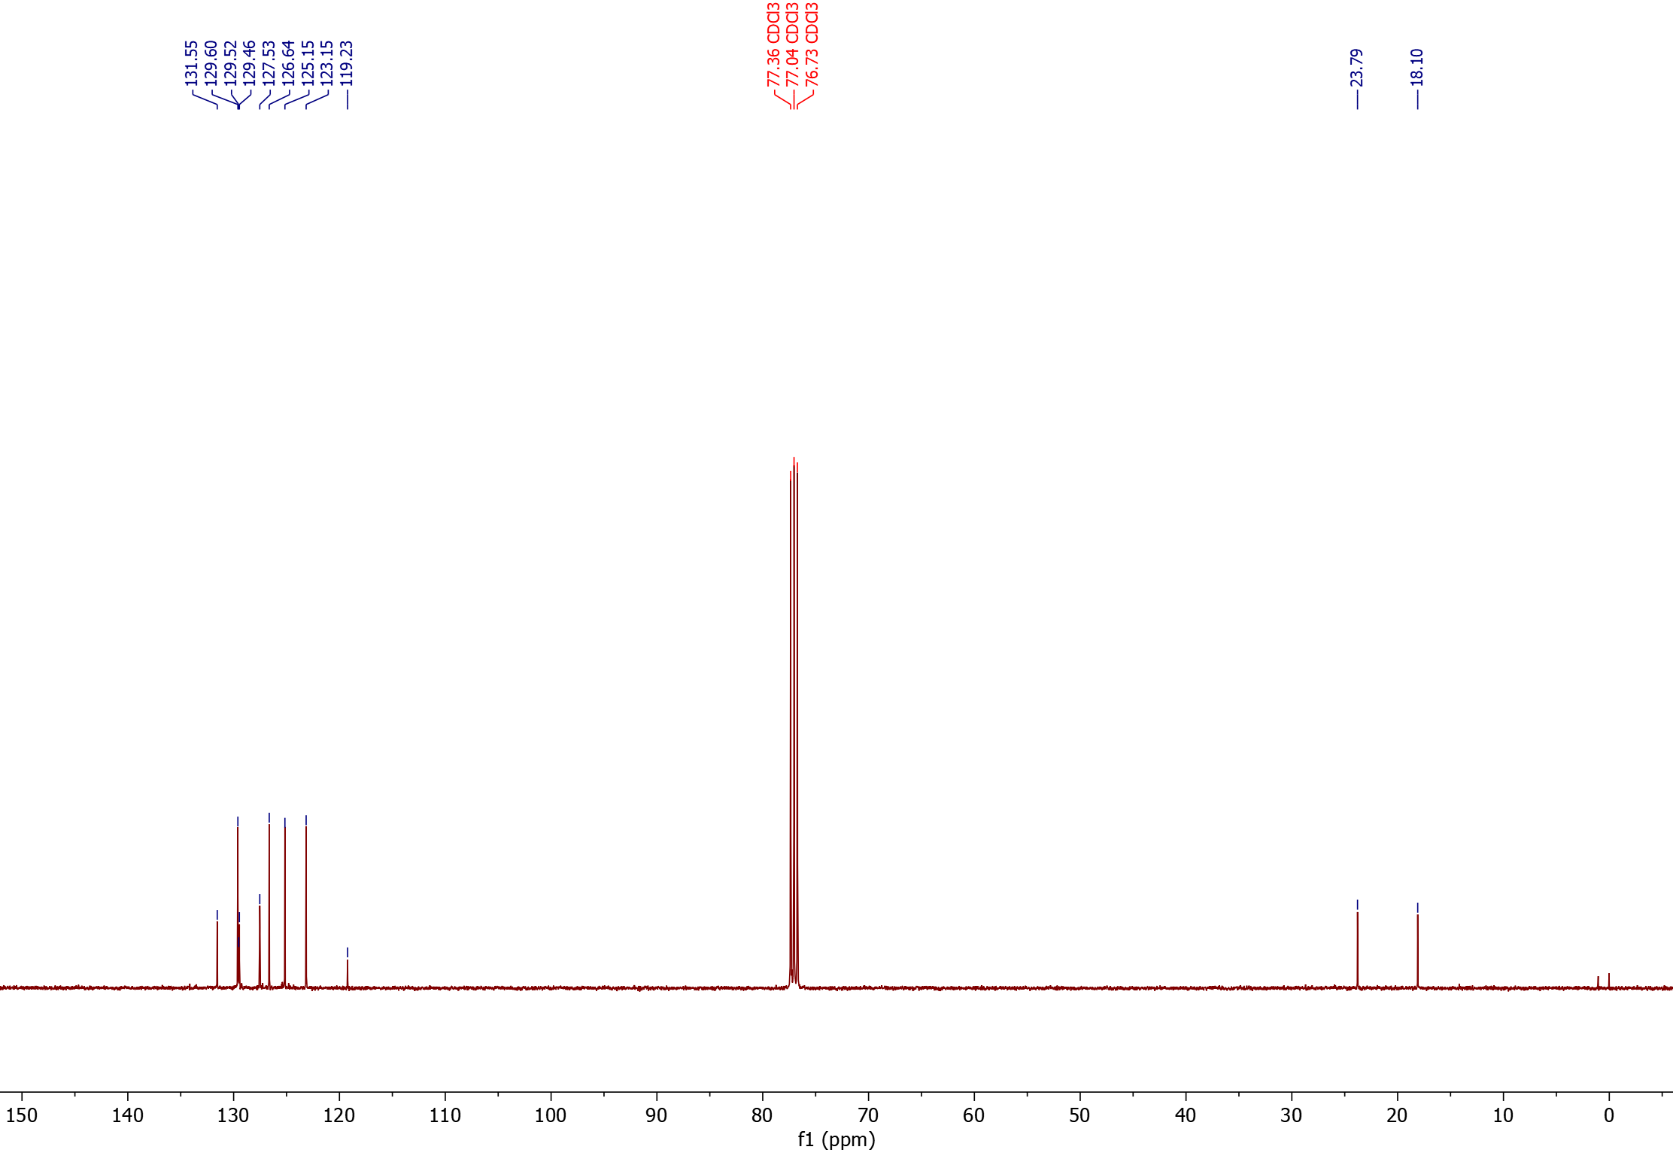
¹³C-NMR

Nitrile products from α-methyl styrene (9) (isolated product)
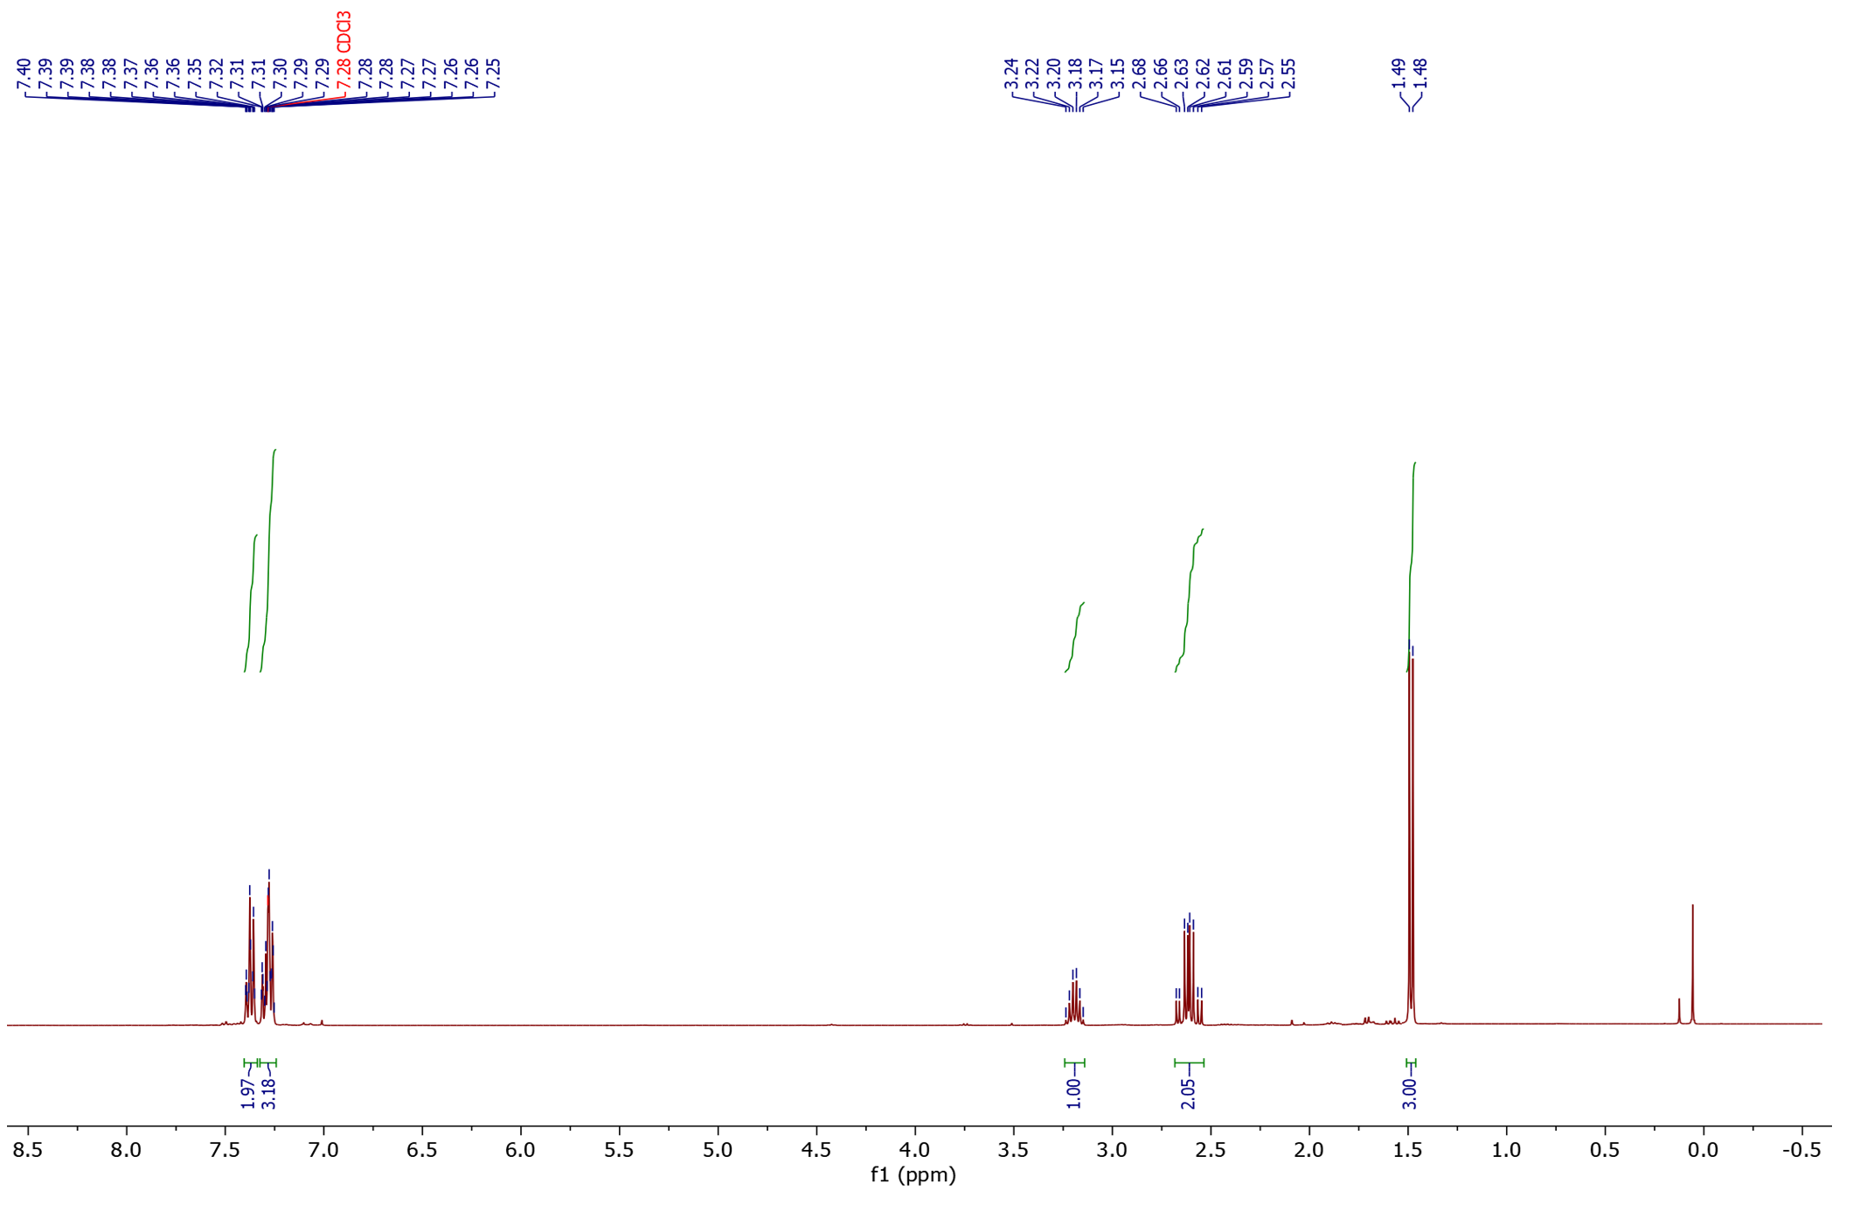
¹H-NMR

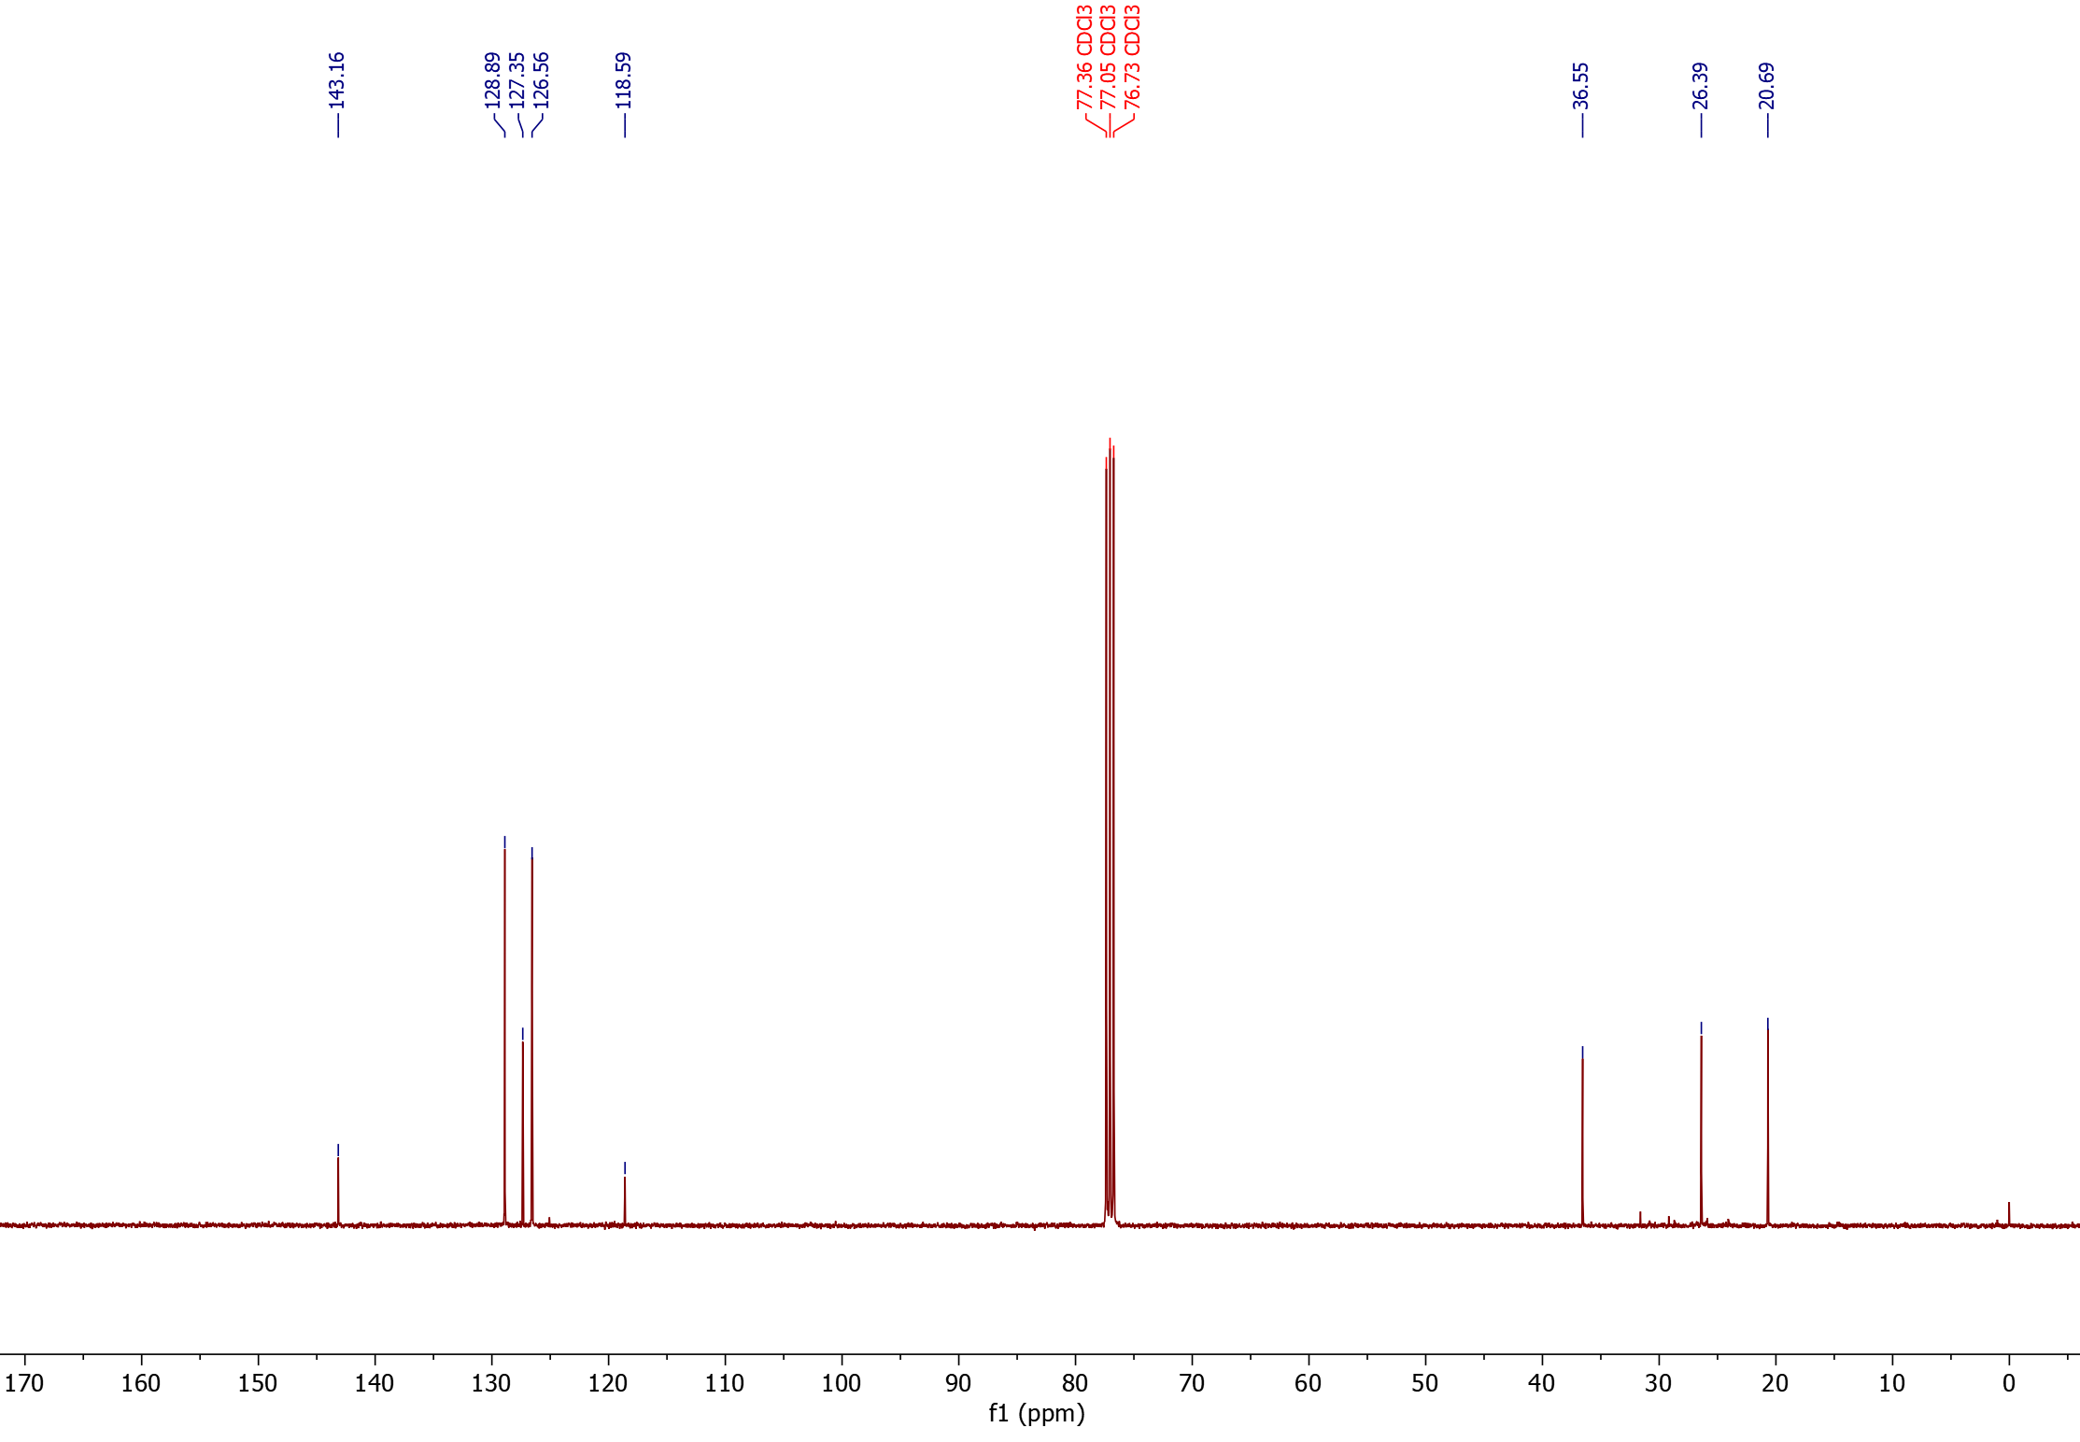
¹³C-NMR

Nitrile products from trans-β-methyl styrene (10)
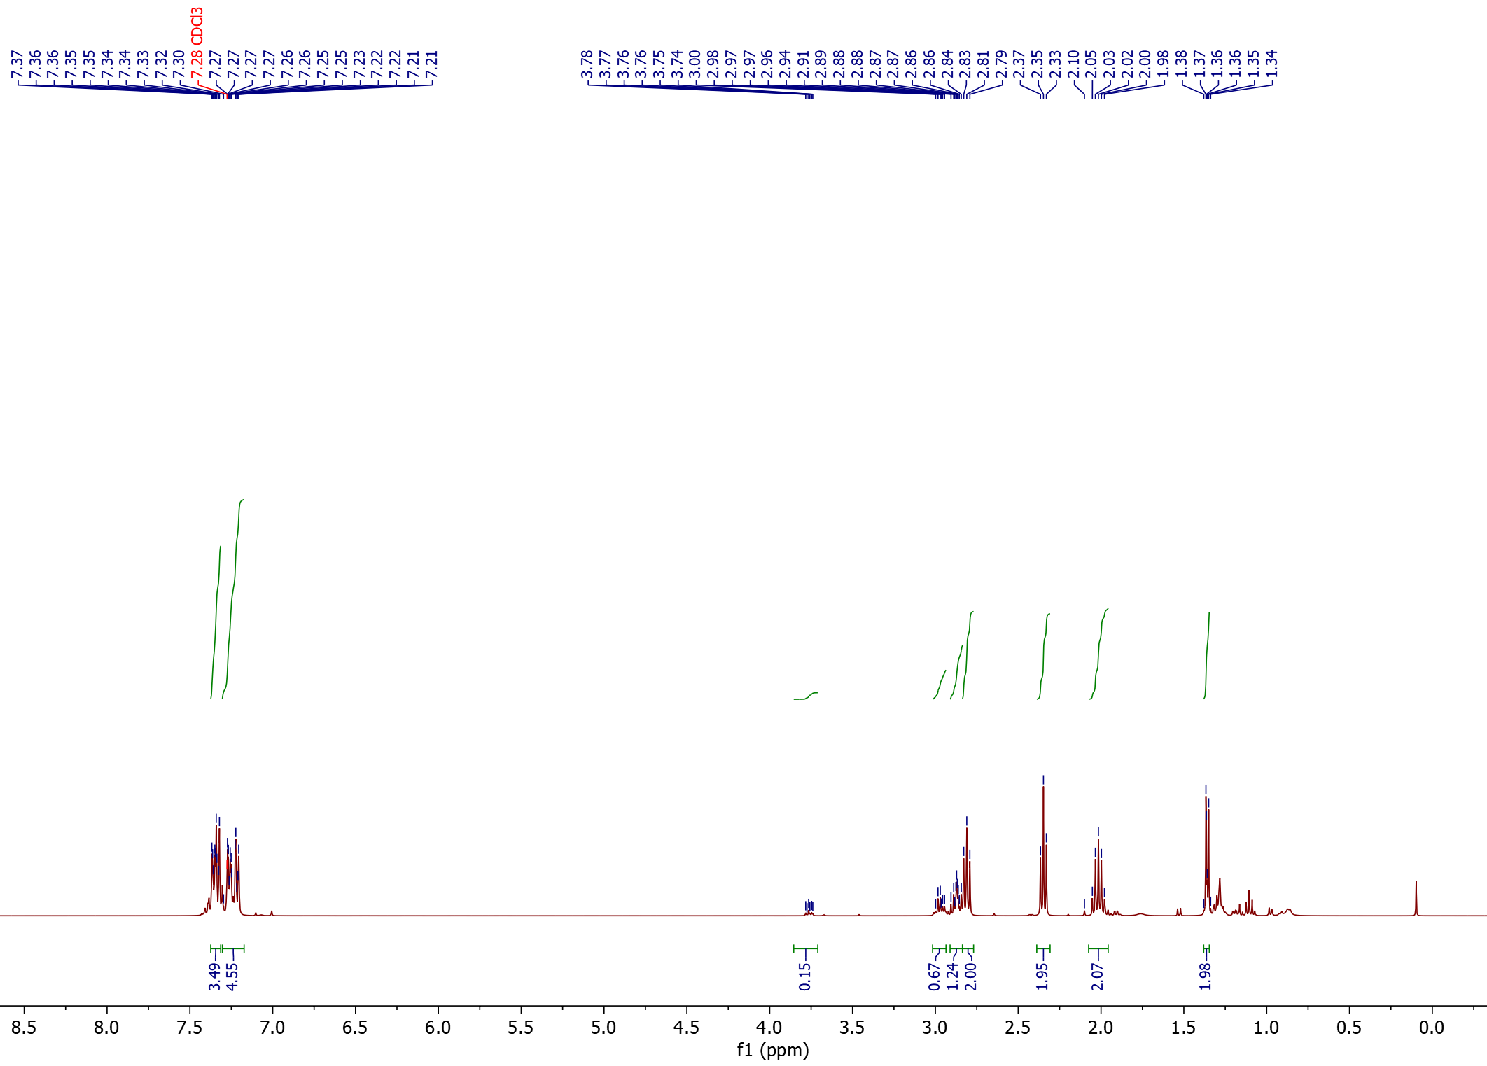
¹H-NMR

1
2
3

1
1
1
2
3
2
2

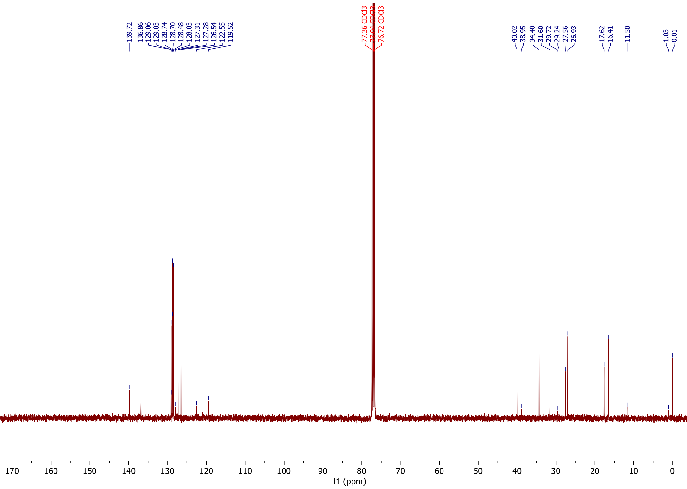
¹³C-NMR

1
2
3
°
§
*
§
°
*
*
°
§

2§
1§
1°
1*
2*
2°

3*
3§
3°

Nitrile product from 1,1-diphenylethylene (11)
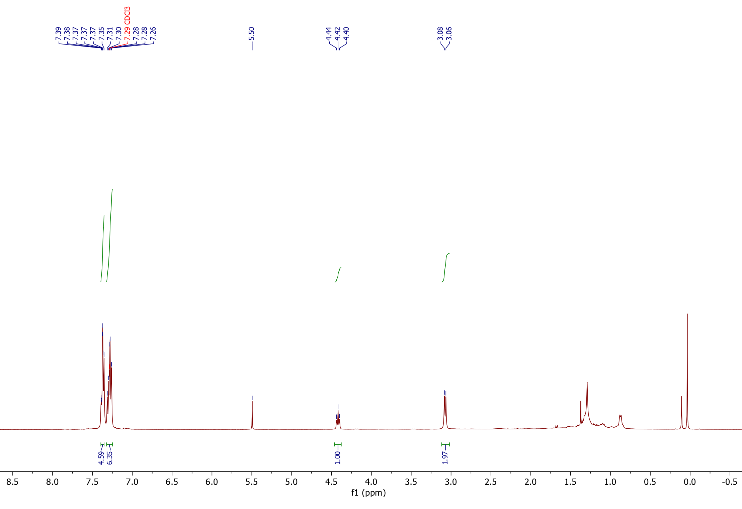
¹H-NMR

Substrate

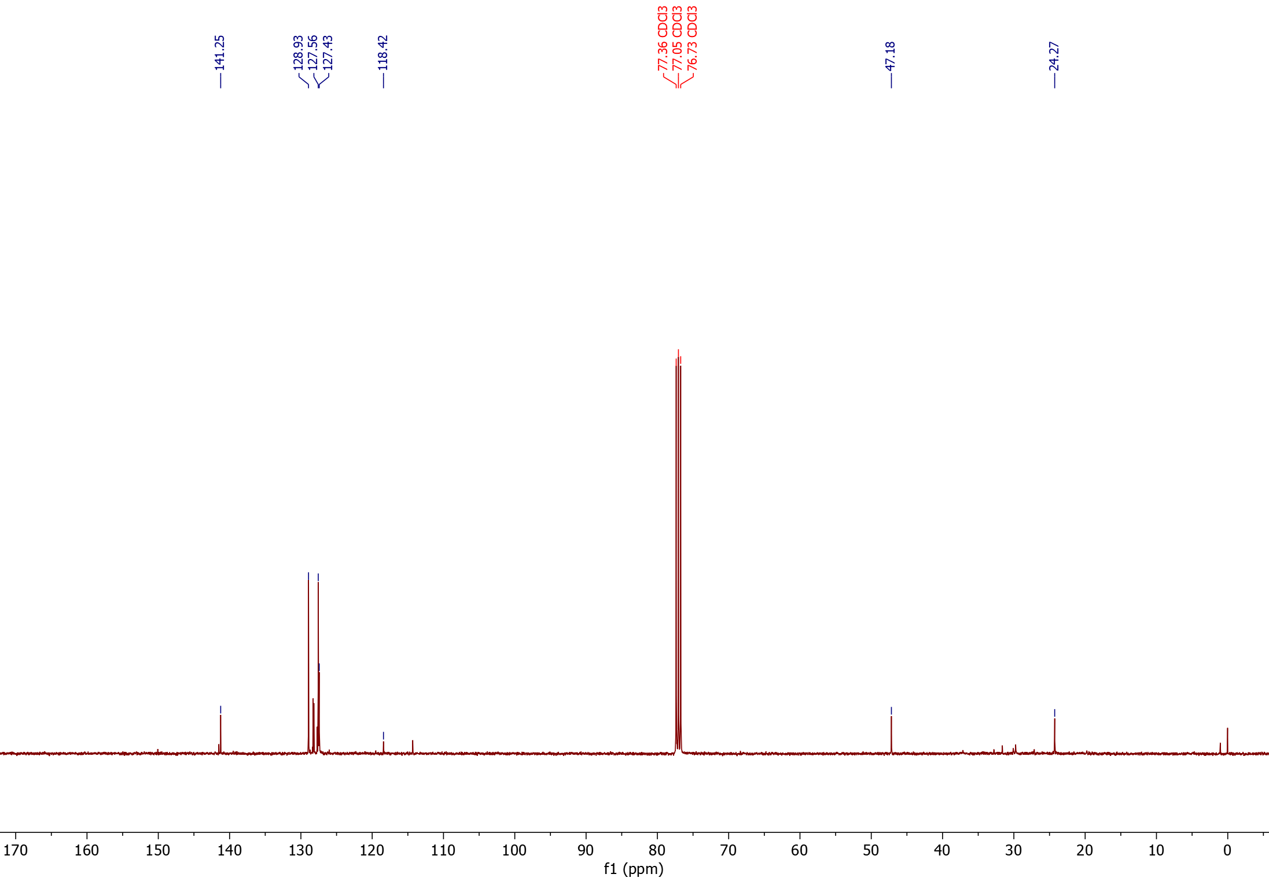
¹³C-NMR

Nitrile products from 4-methoxy styrene (12)
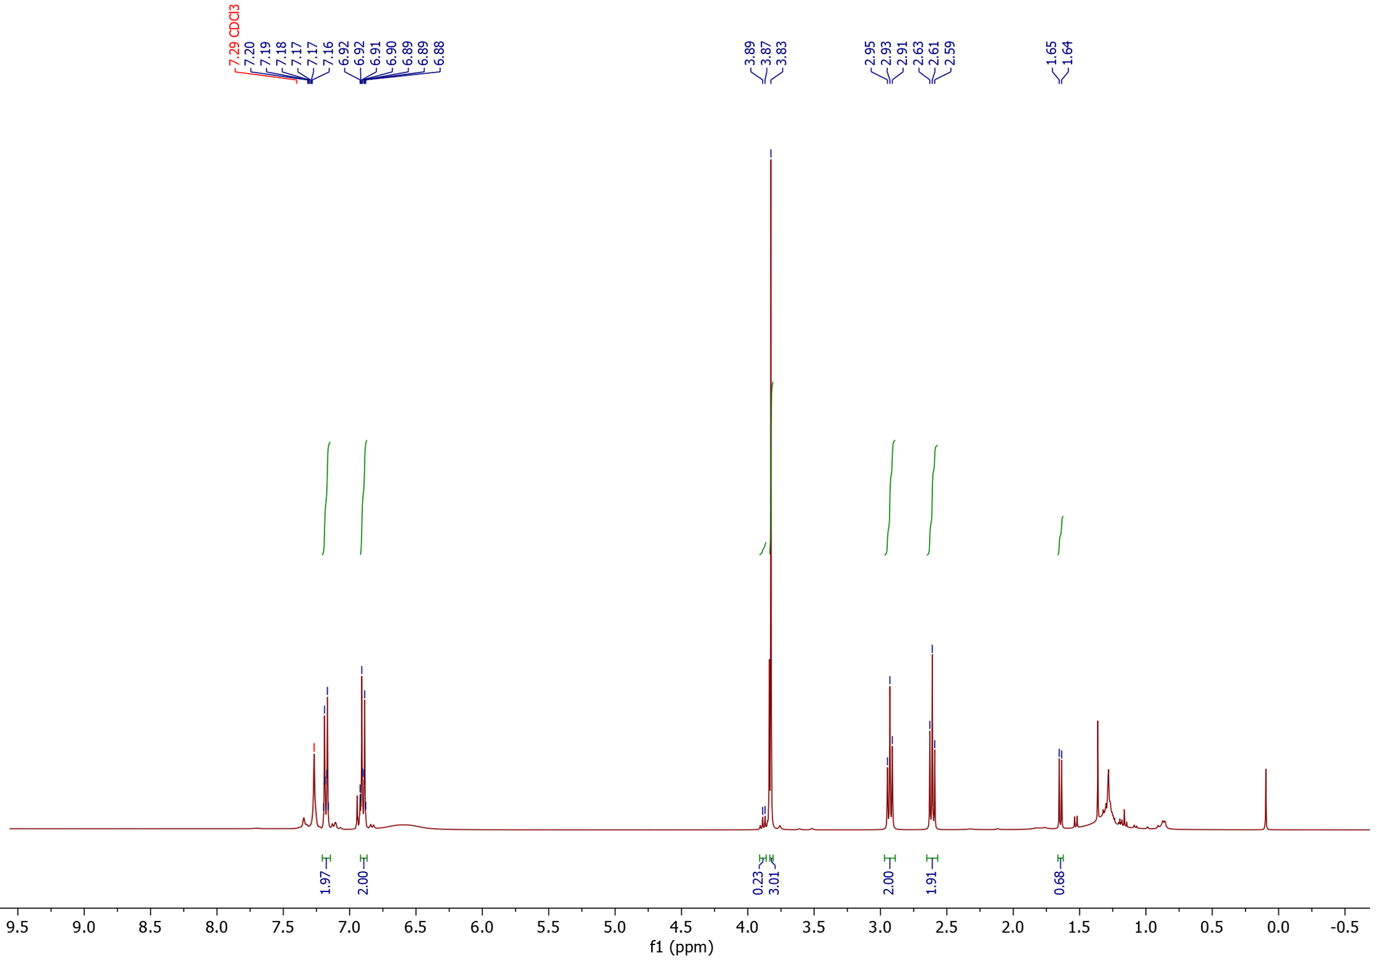
¹H-NMR

2
1<

2
2

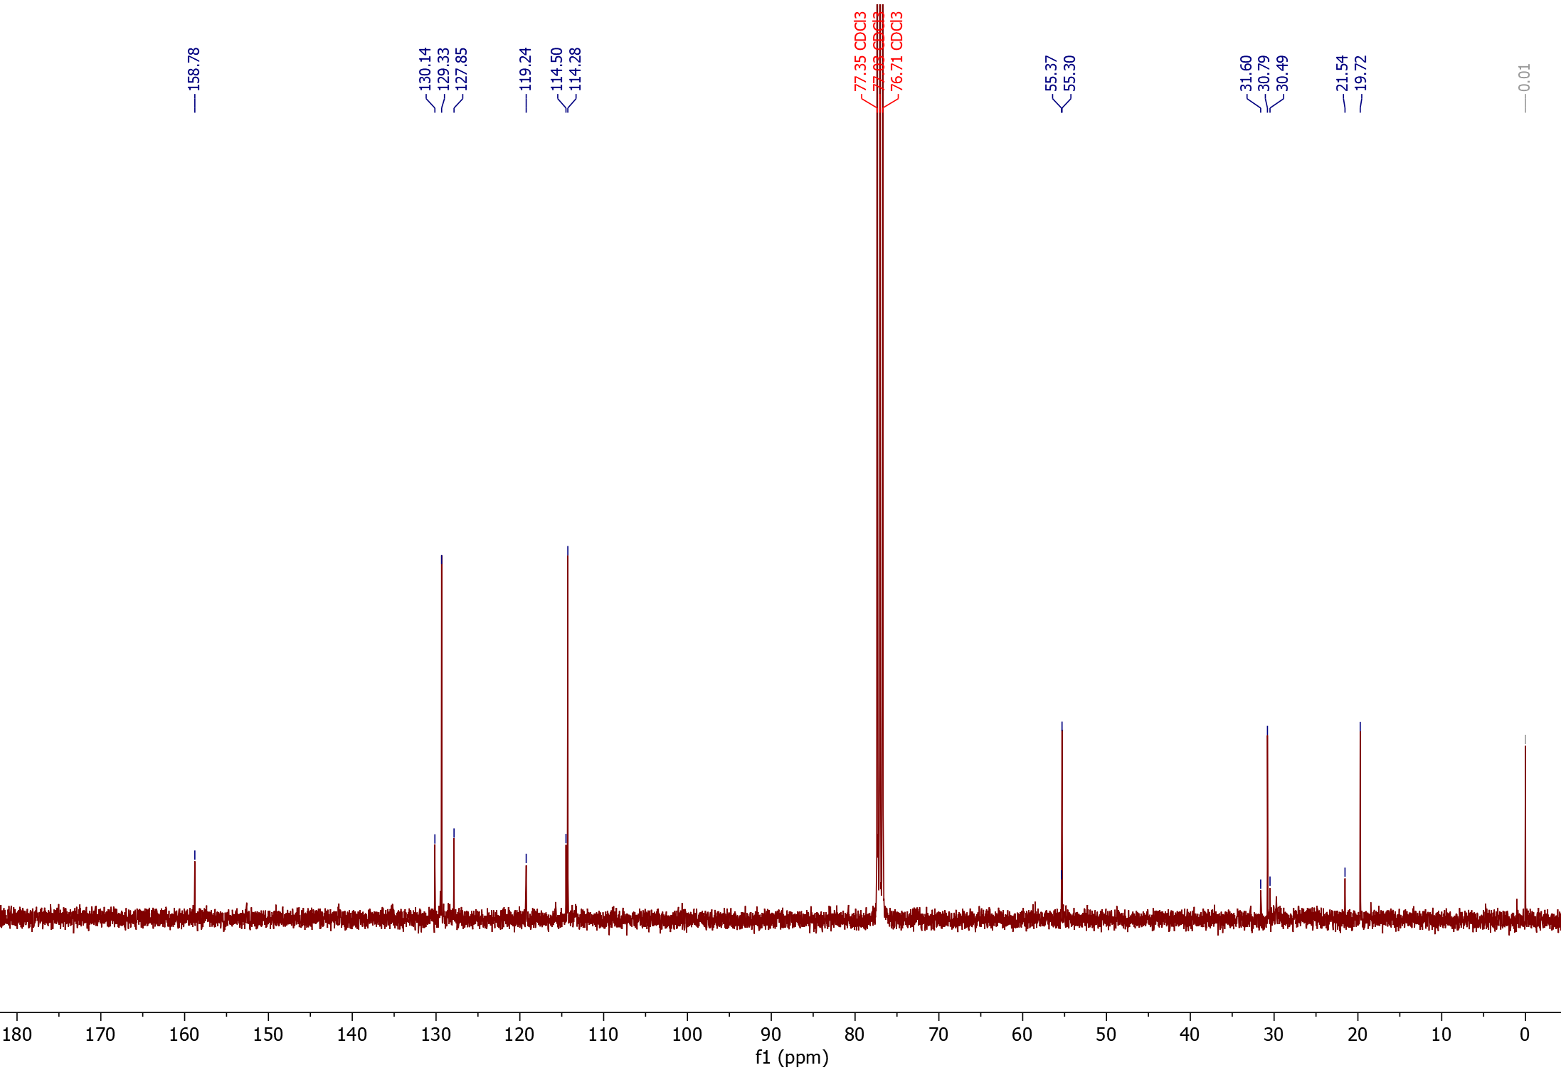
¹³C-NMR

§
°
1<
2
*
*

2*
1*
1§

1°

Nitrile products from 2-methoxy styrene (13)
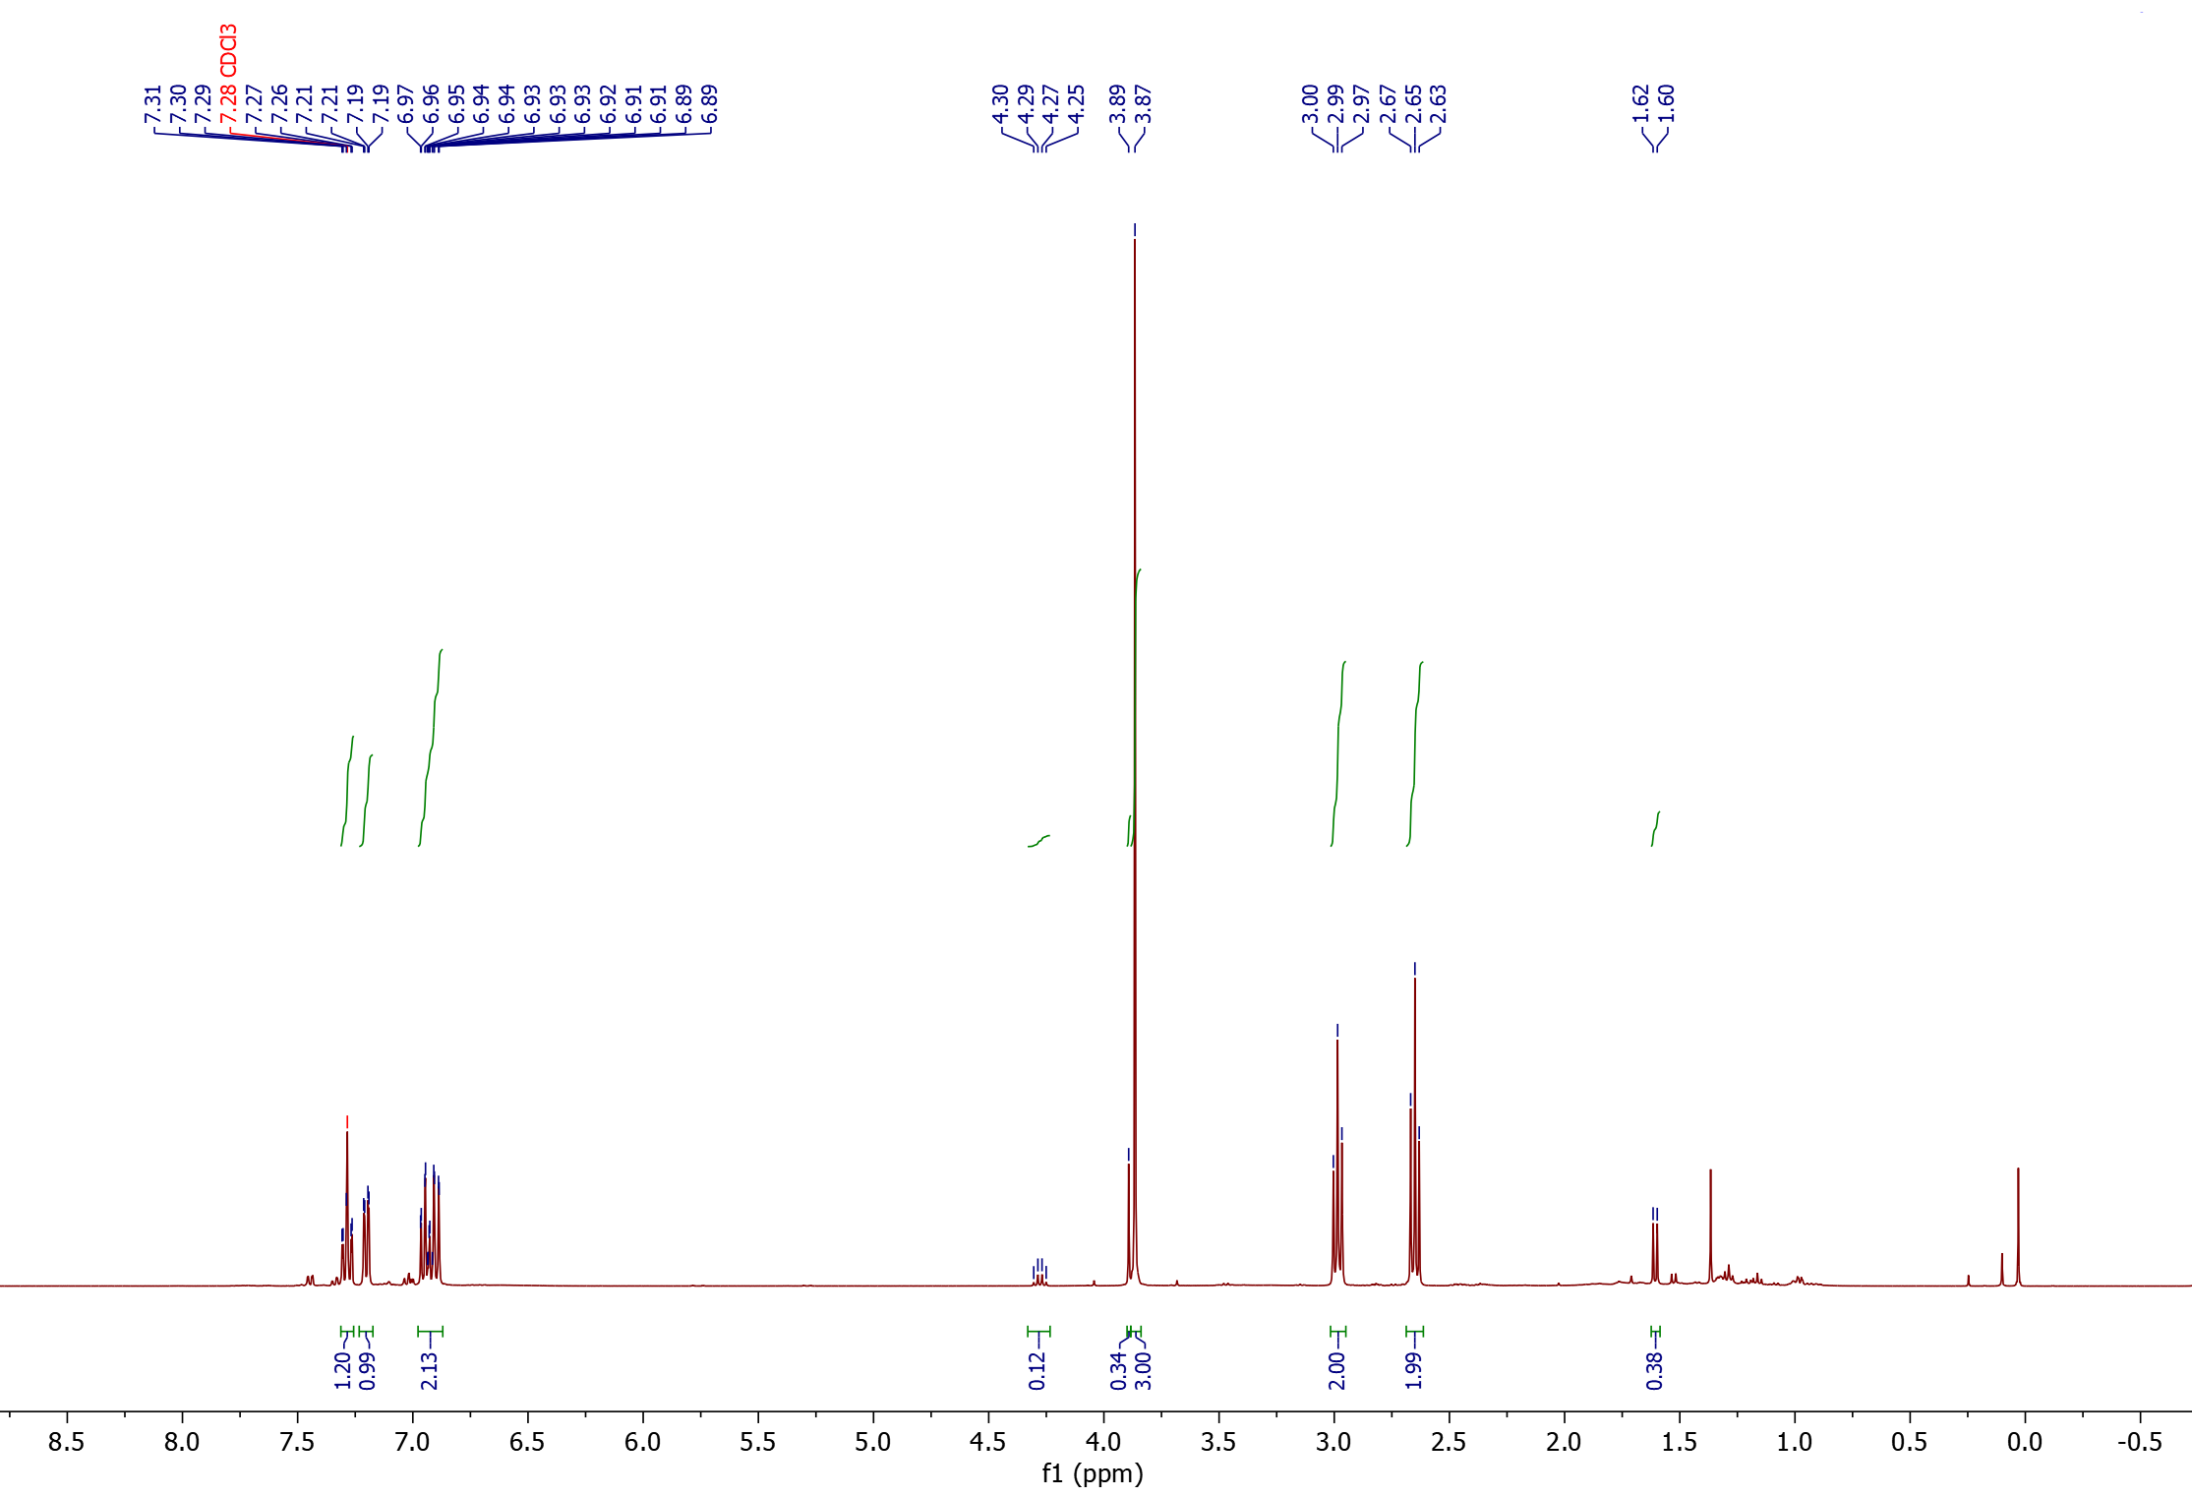
¹H-NMR

1<
2

1

2
2

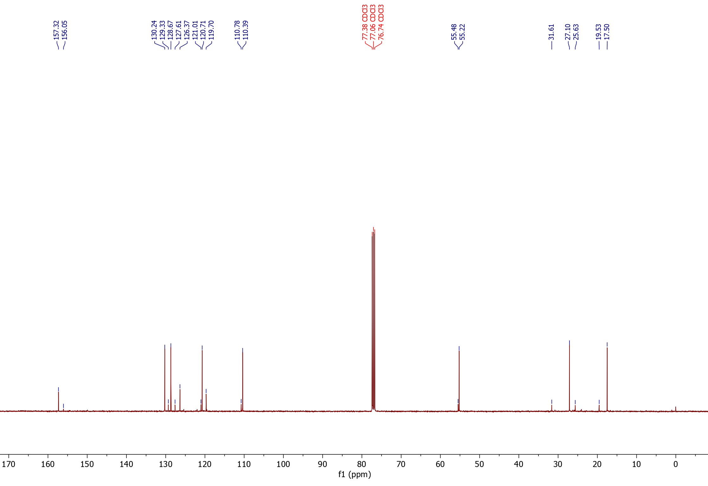
¹³C-NMR

*
°
*
°
1<
2

1*
1°
2°,*

Nitrile products from 4-phenoxy-1-vinylbenzene (14)
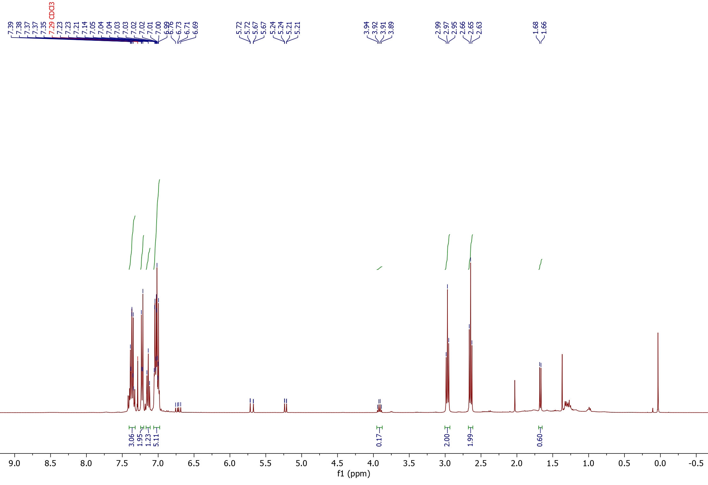
¹H-NMR

2<
1<

1

Substrate
2
2

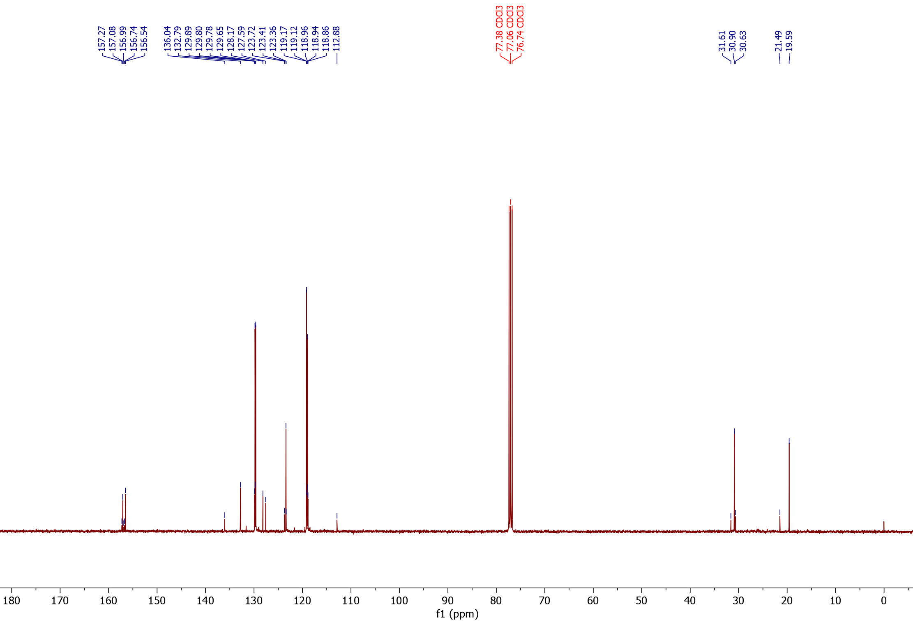
¹³C-NMR

2°,*
1°,*
*
°
*
°
2<
1<

Nitrile products from 4-fluorostyrene (15)
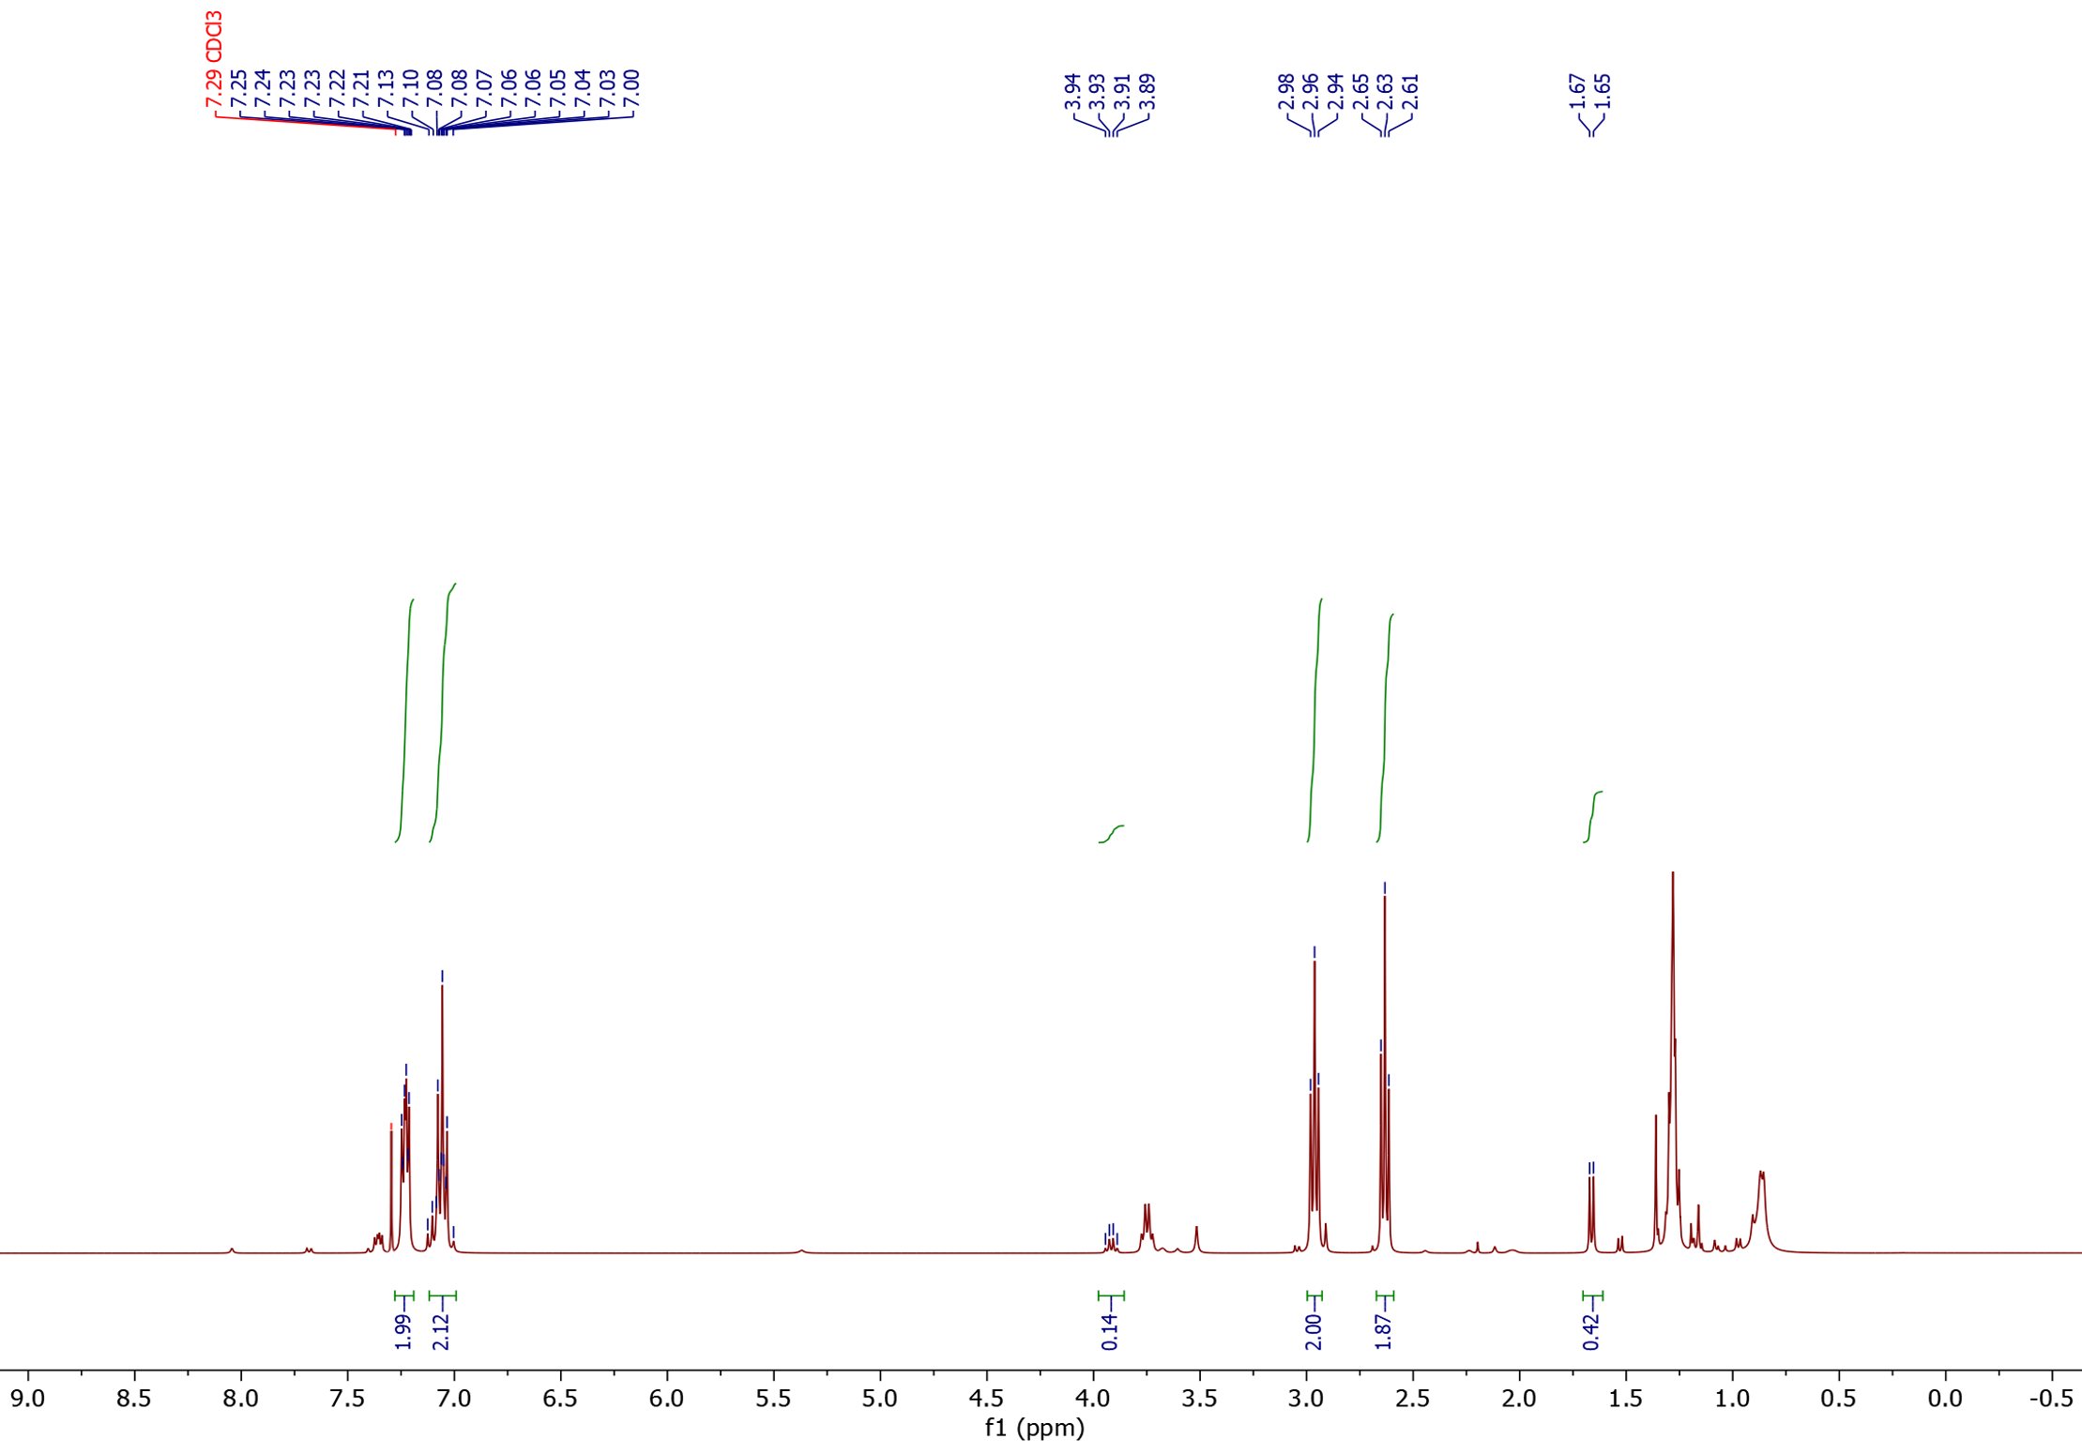
¹H-NMR

2
2
1
2<
1<

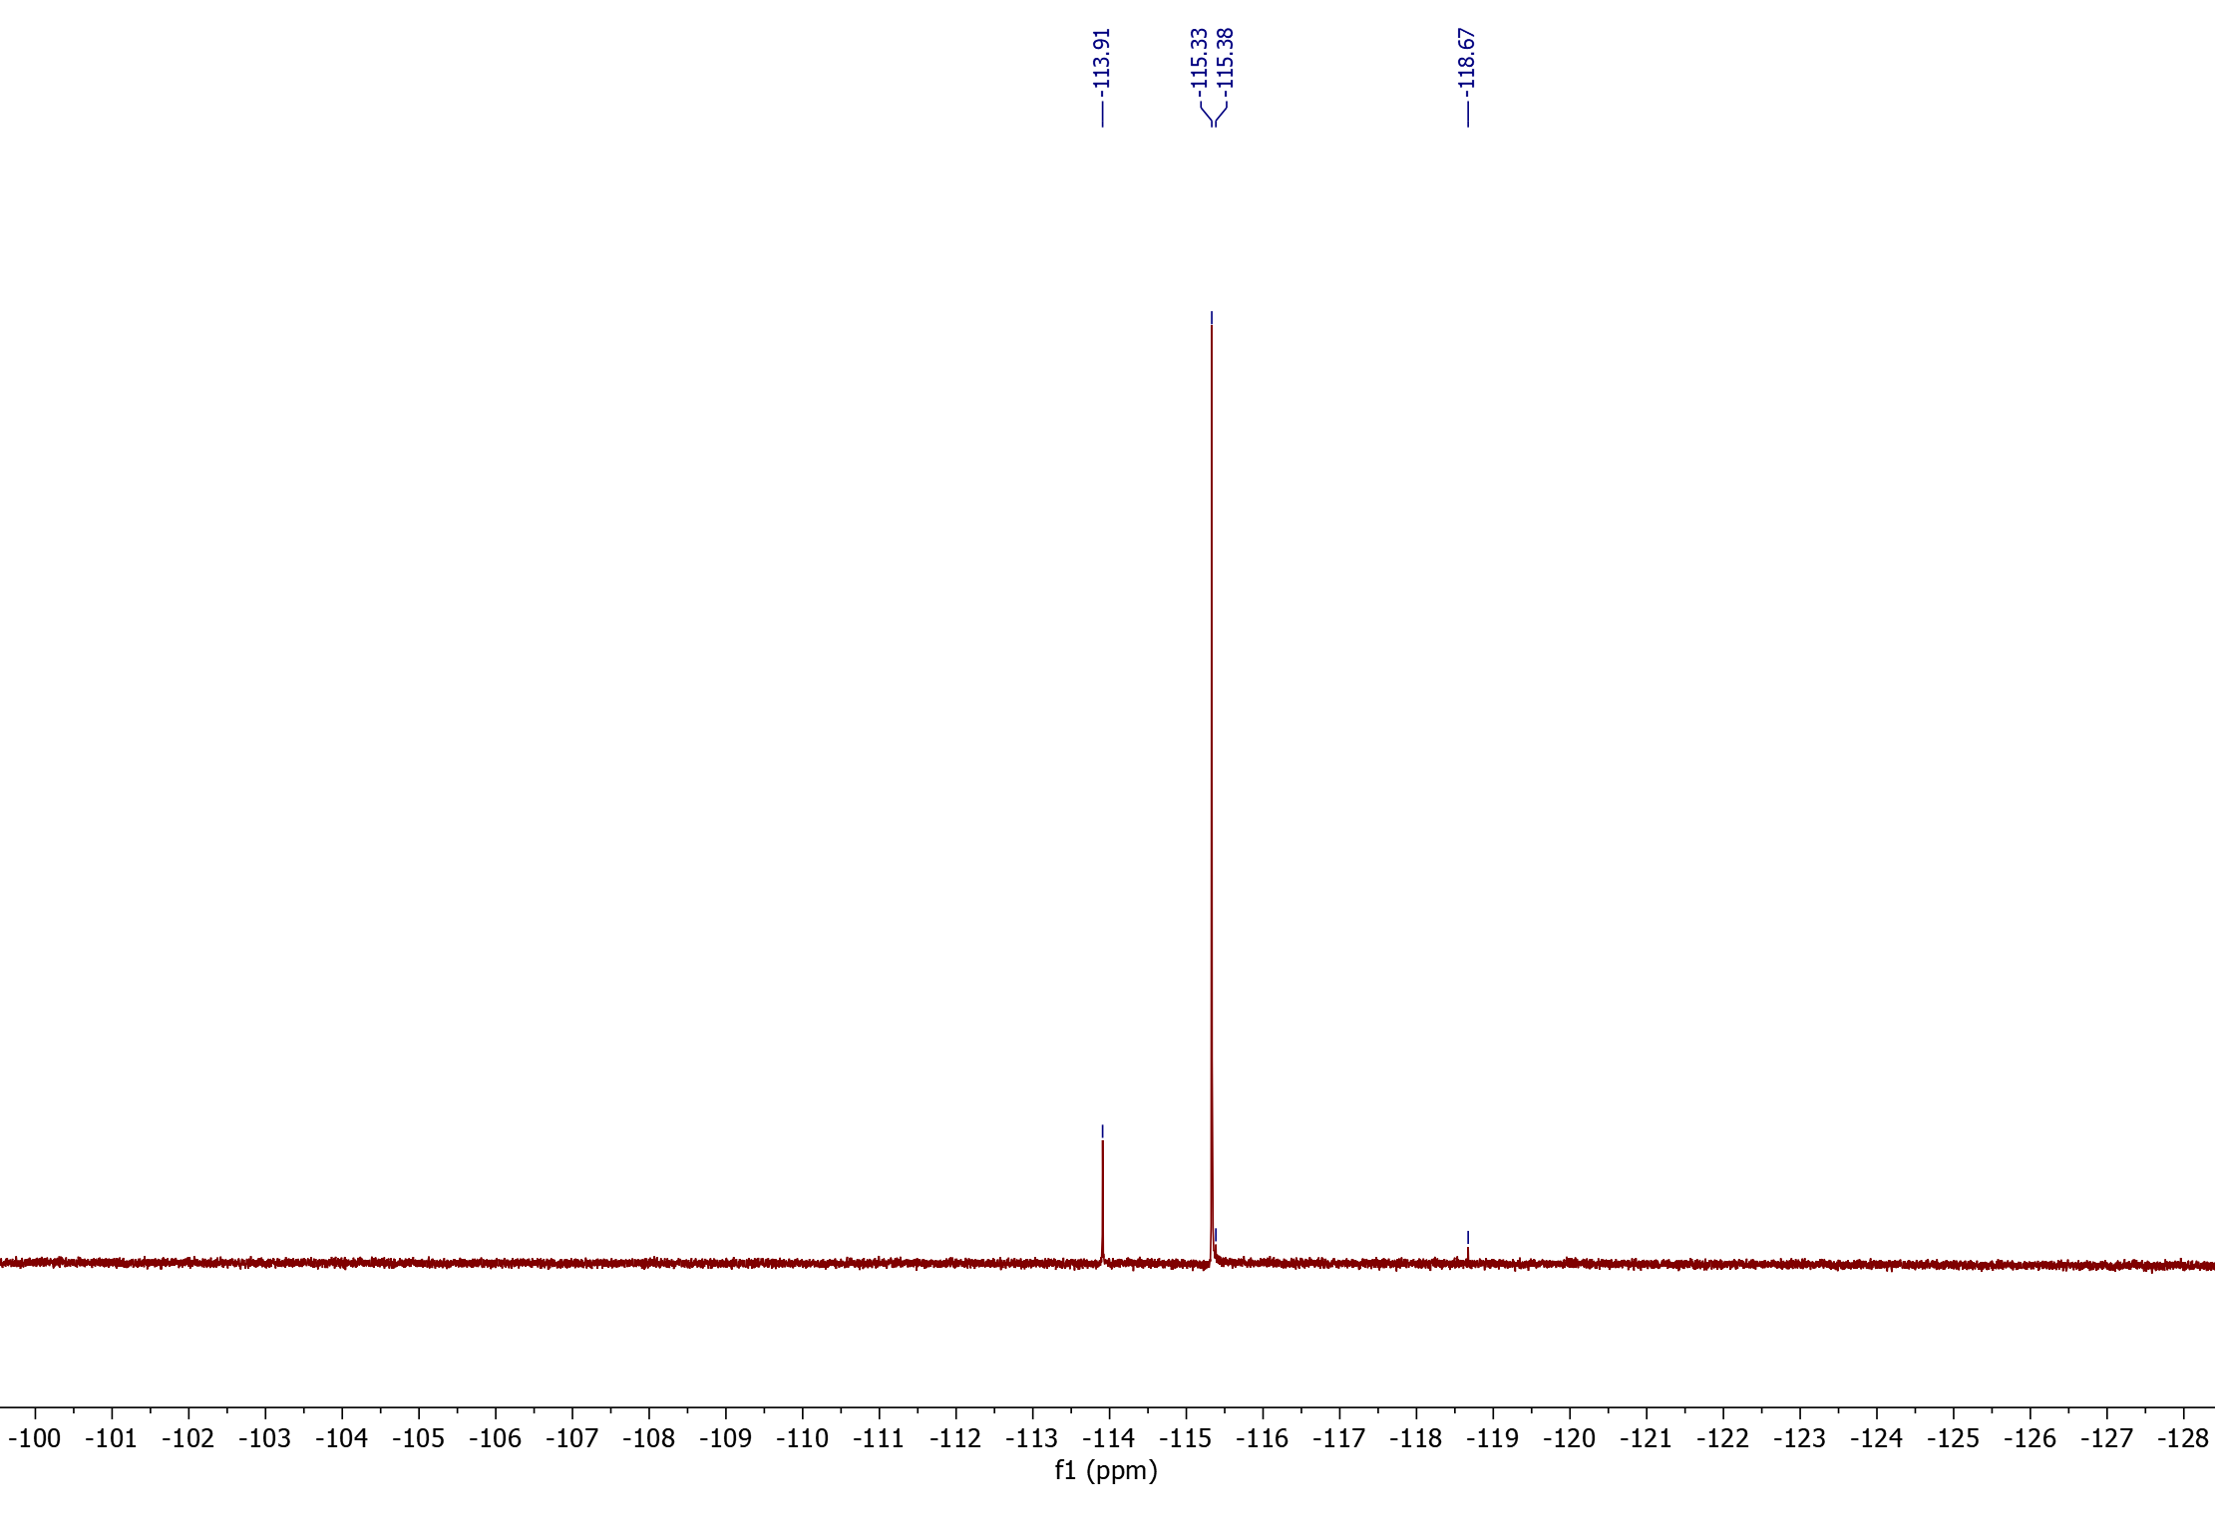
¹⁹F-NMR
1<
2<
1

2

Nitrile products from 4-trimethylsilyl-styrene (16)
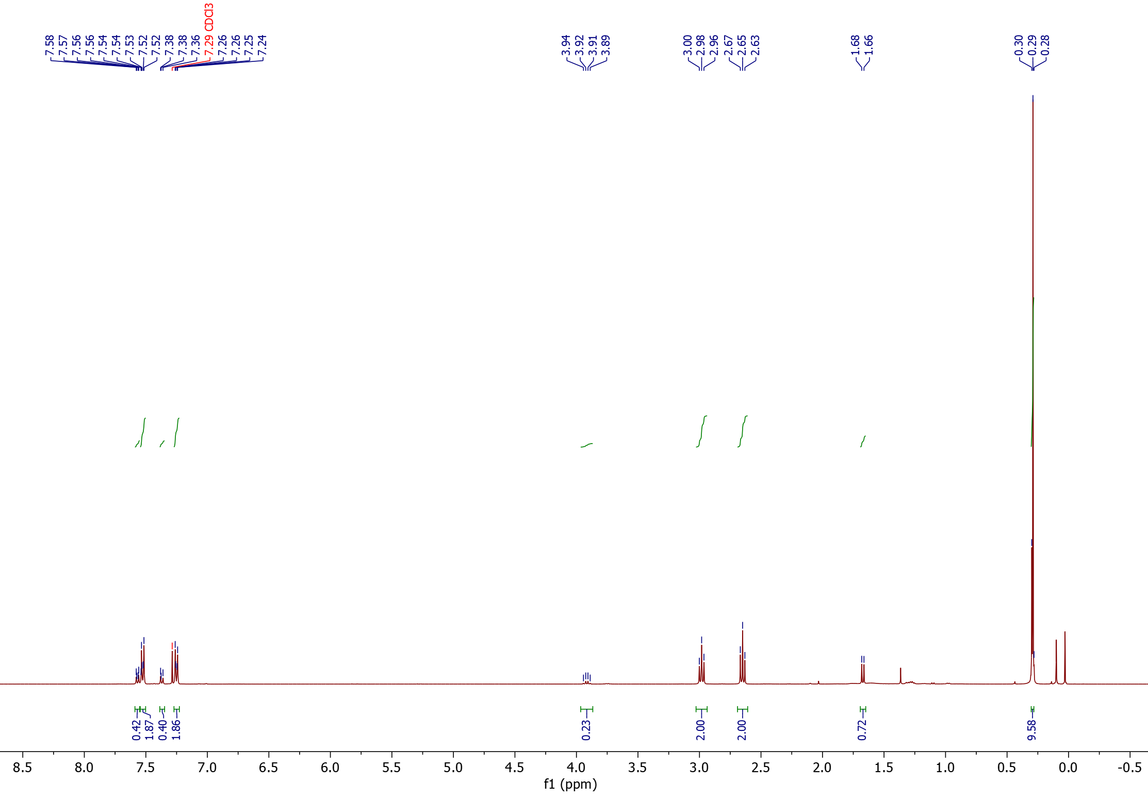
¹H-NMR

2<
1<

1
2
1
2
2

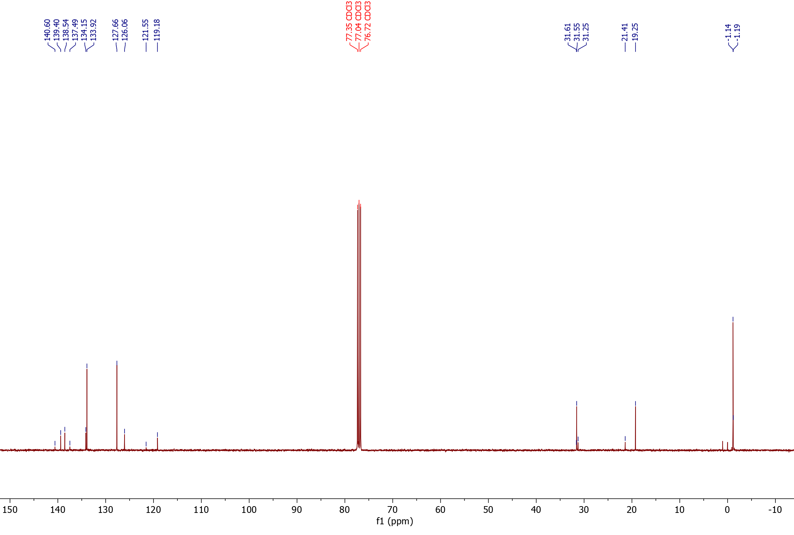
¹³C-NMR

^{$a}
° 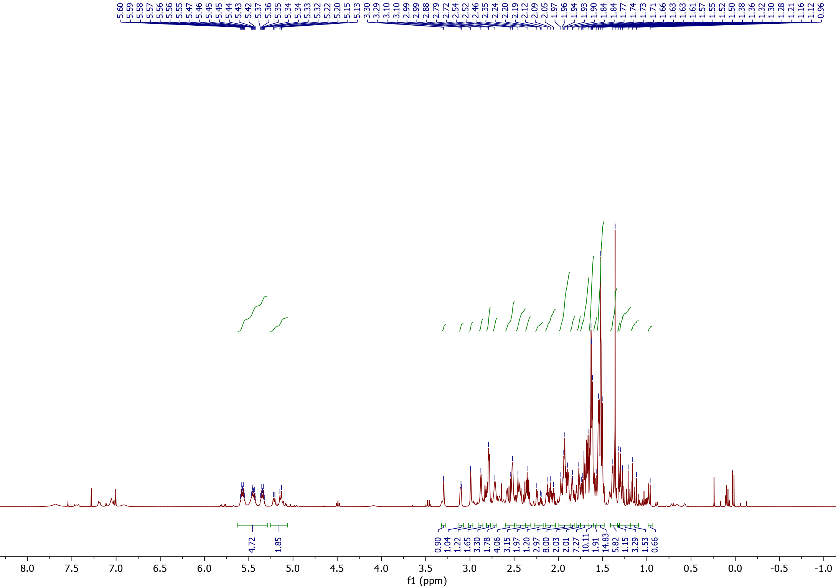°
$
1<
2<
*
° °
*

1°,*
2§

1§

2°,*

Nitrile products from 4-chloro-styrene (17)
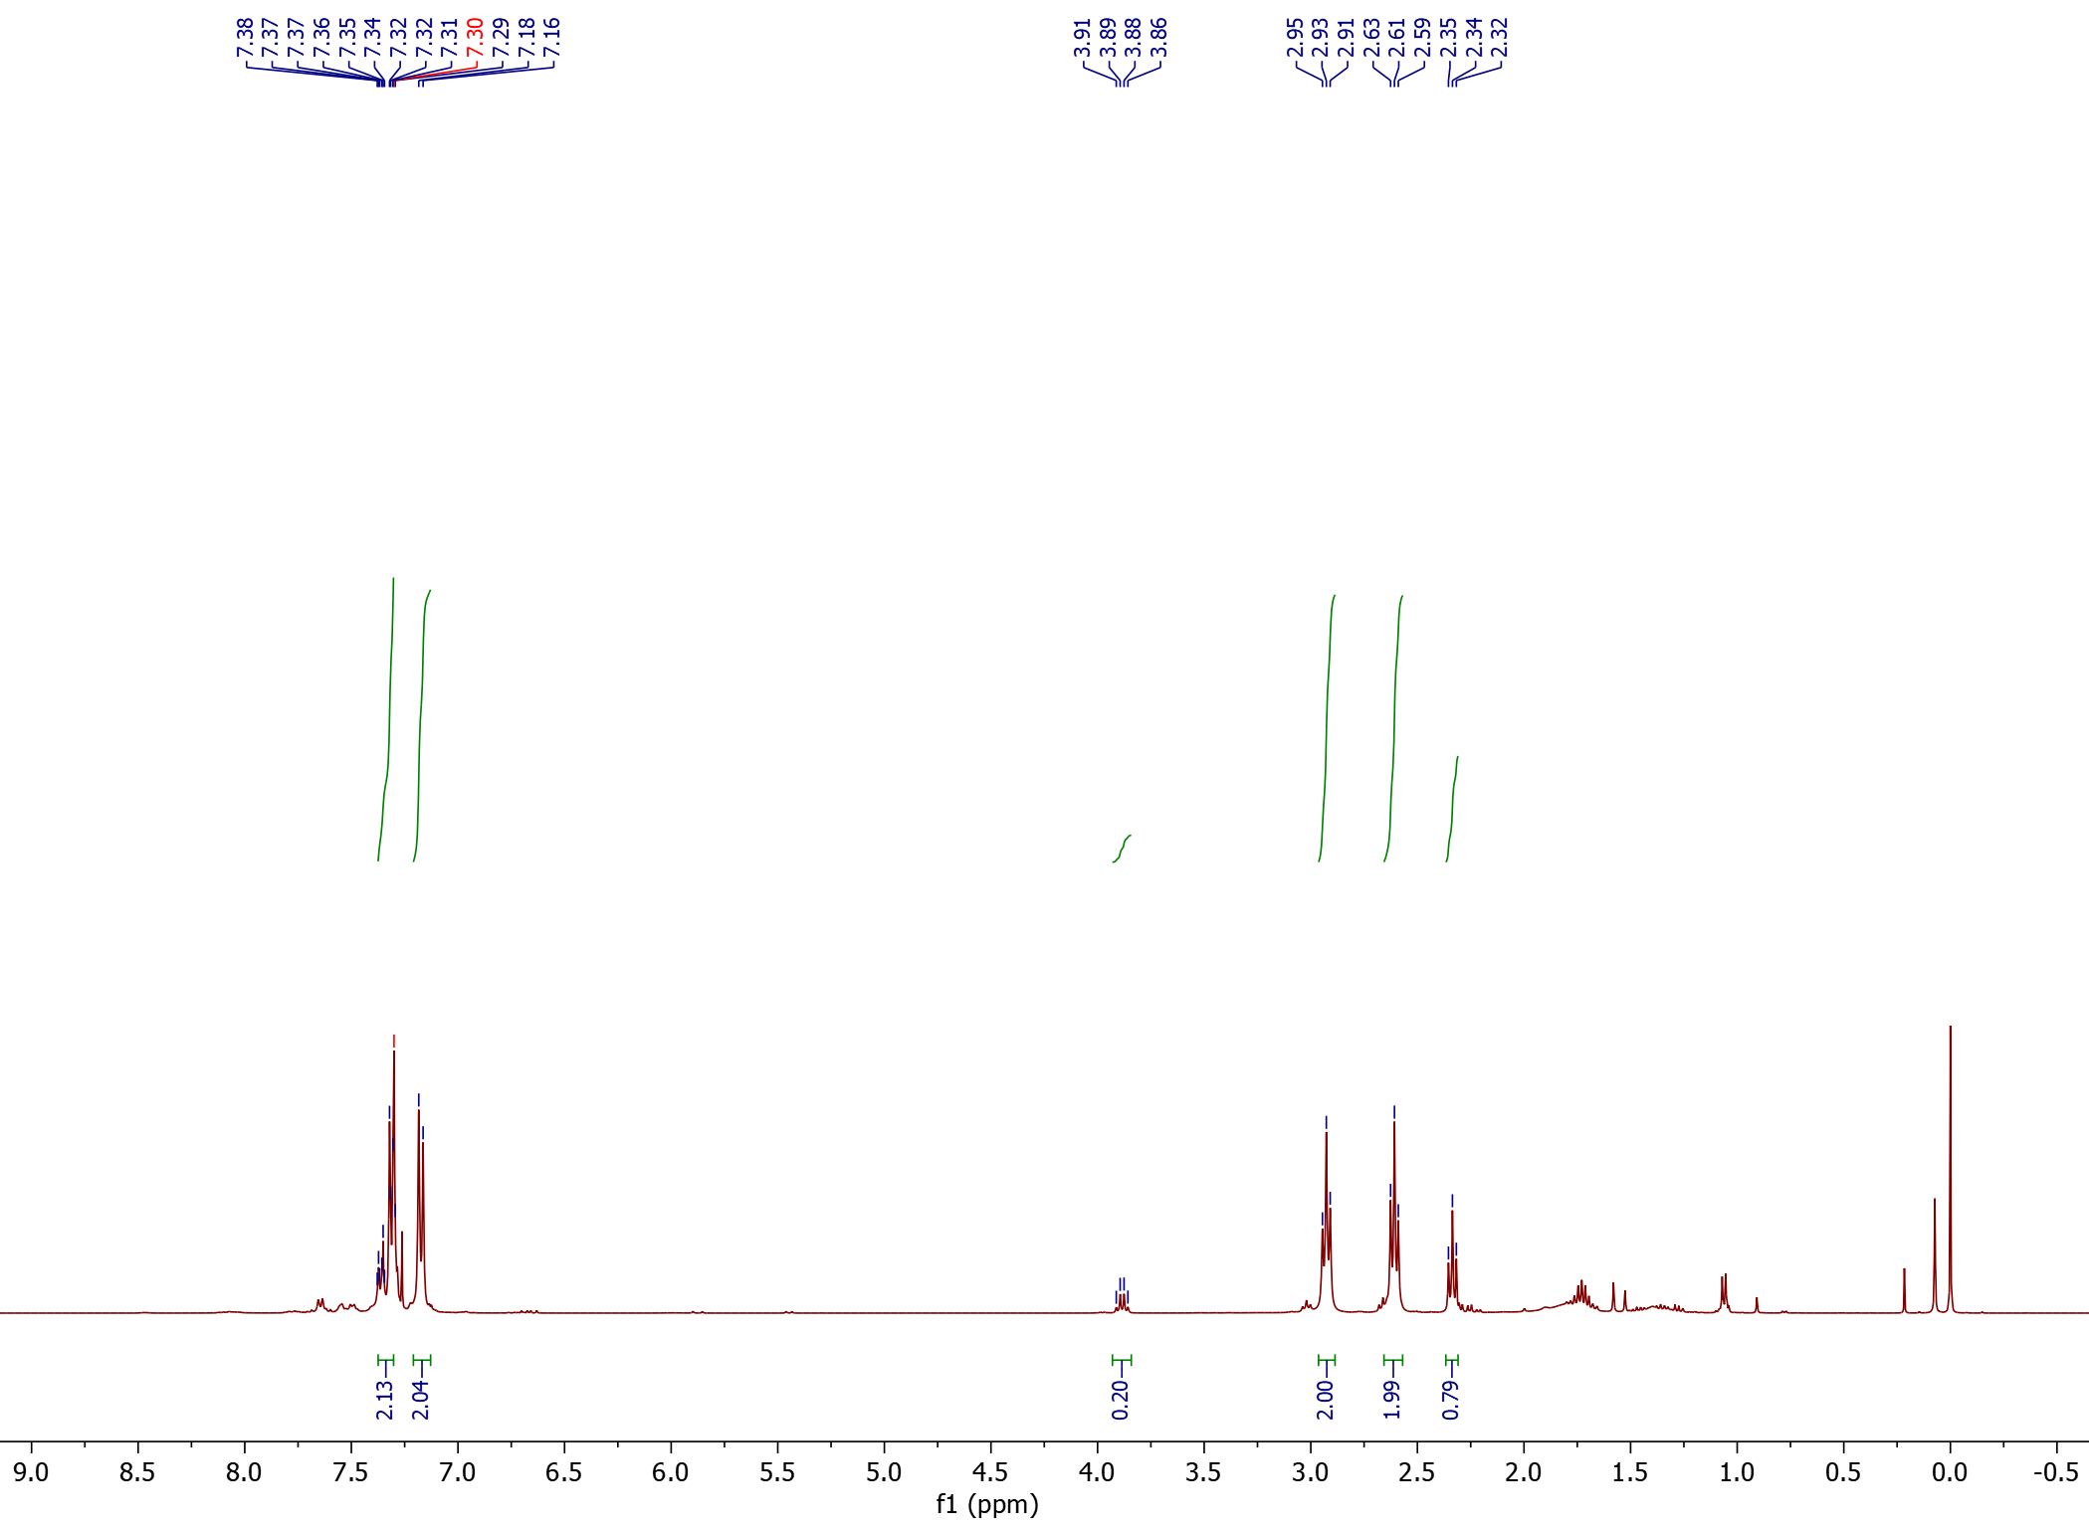
¹H-NMR

2<
1<

1
2
2

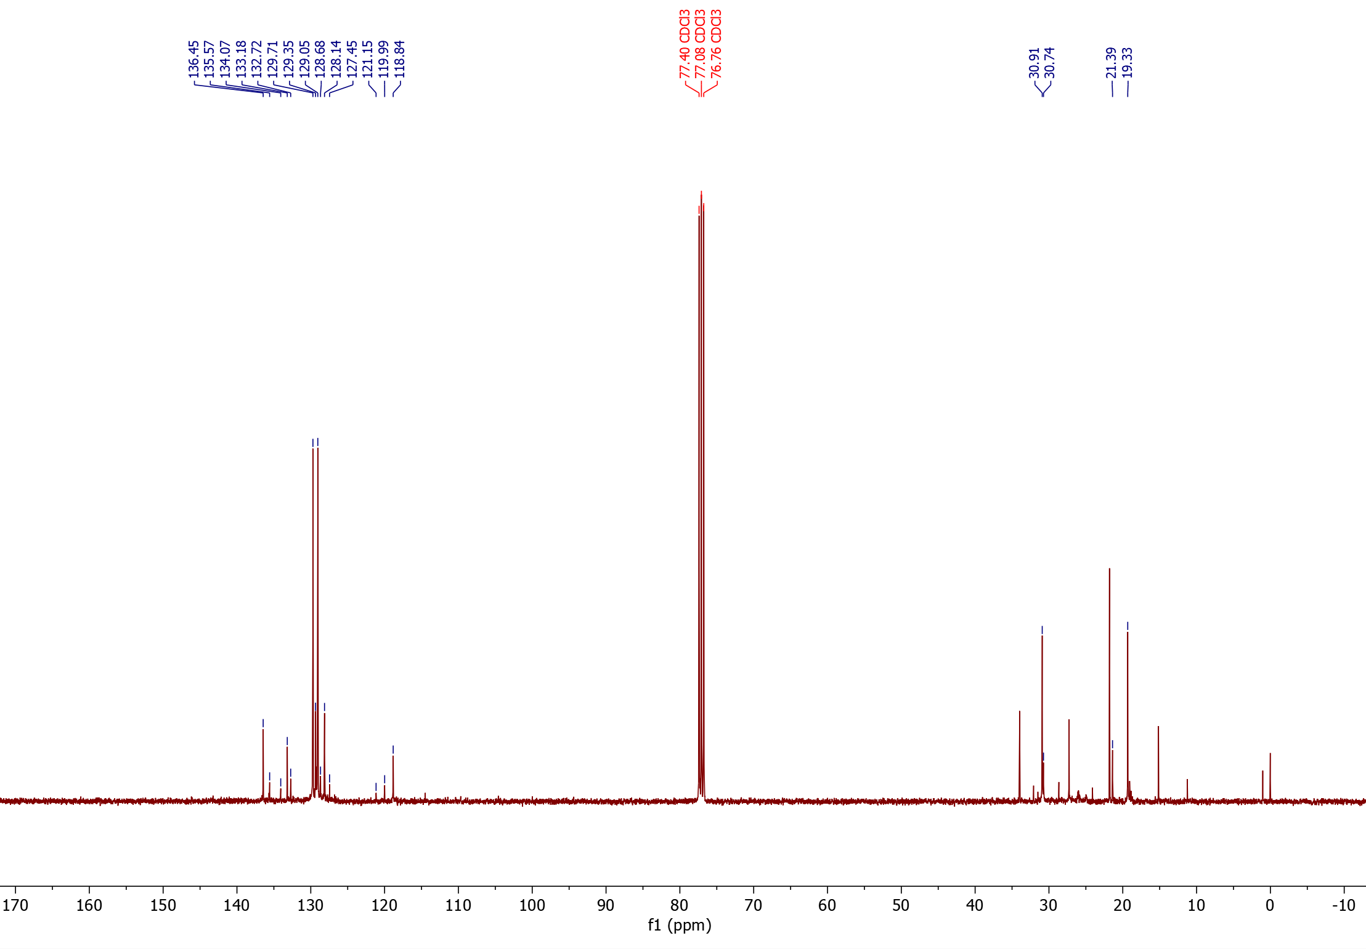
¹³C-NMR

*
°
°
*
1<
2<

1°,*
2°,*

Nitrile products from 2-chloro-styrene (18)
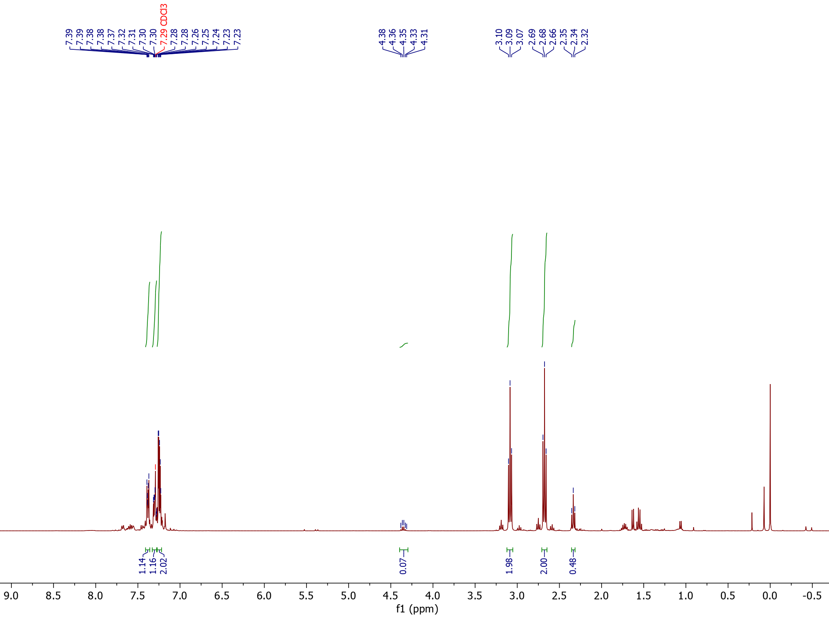
¹H-NMR
2<
1<

1

2
2

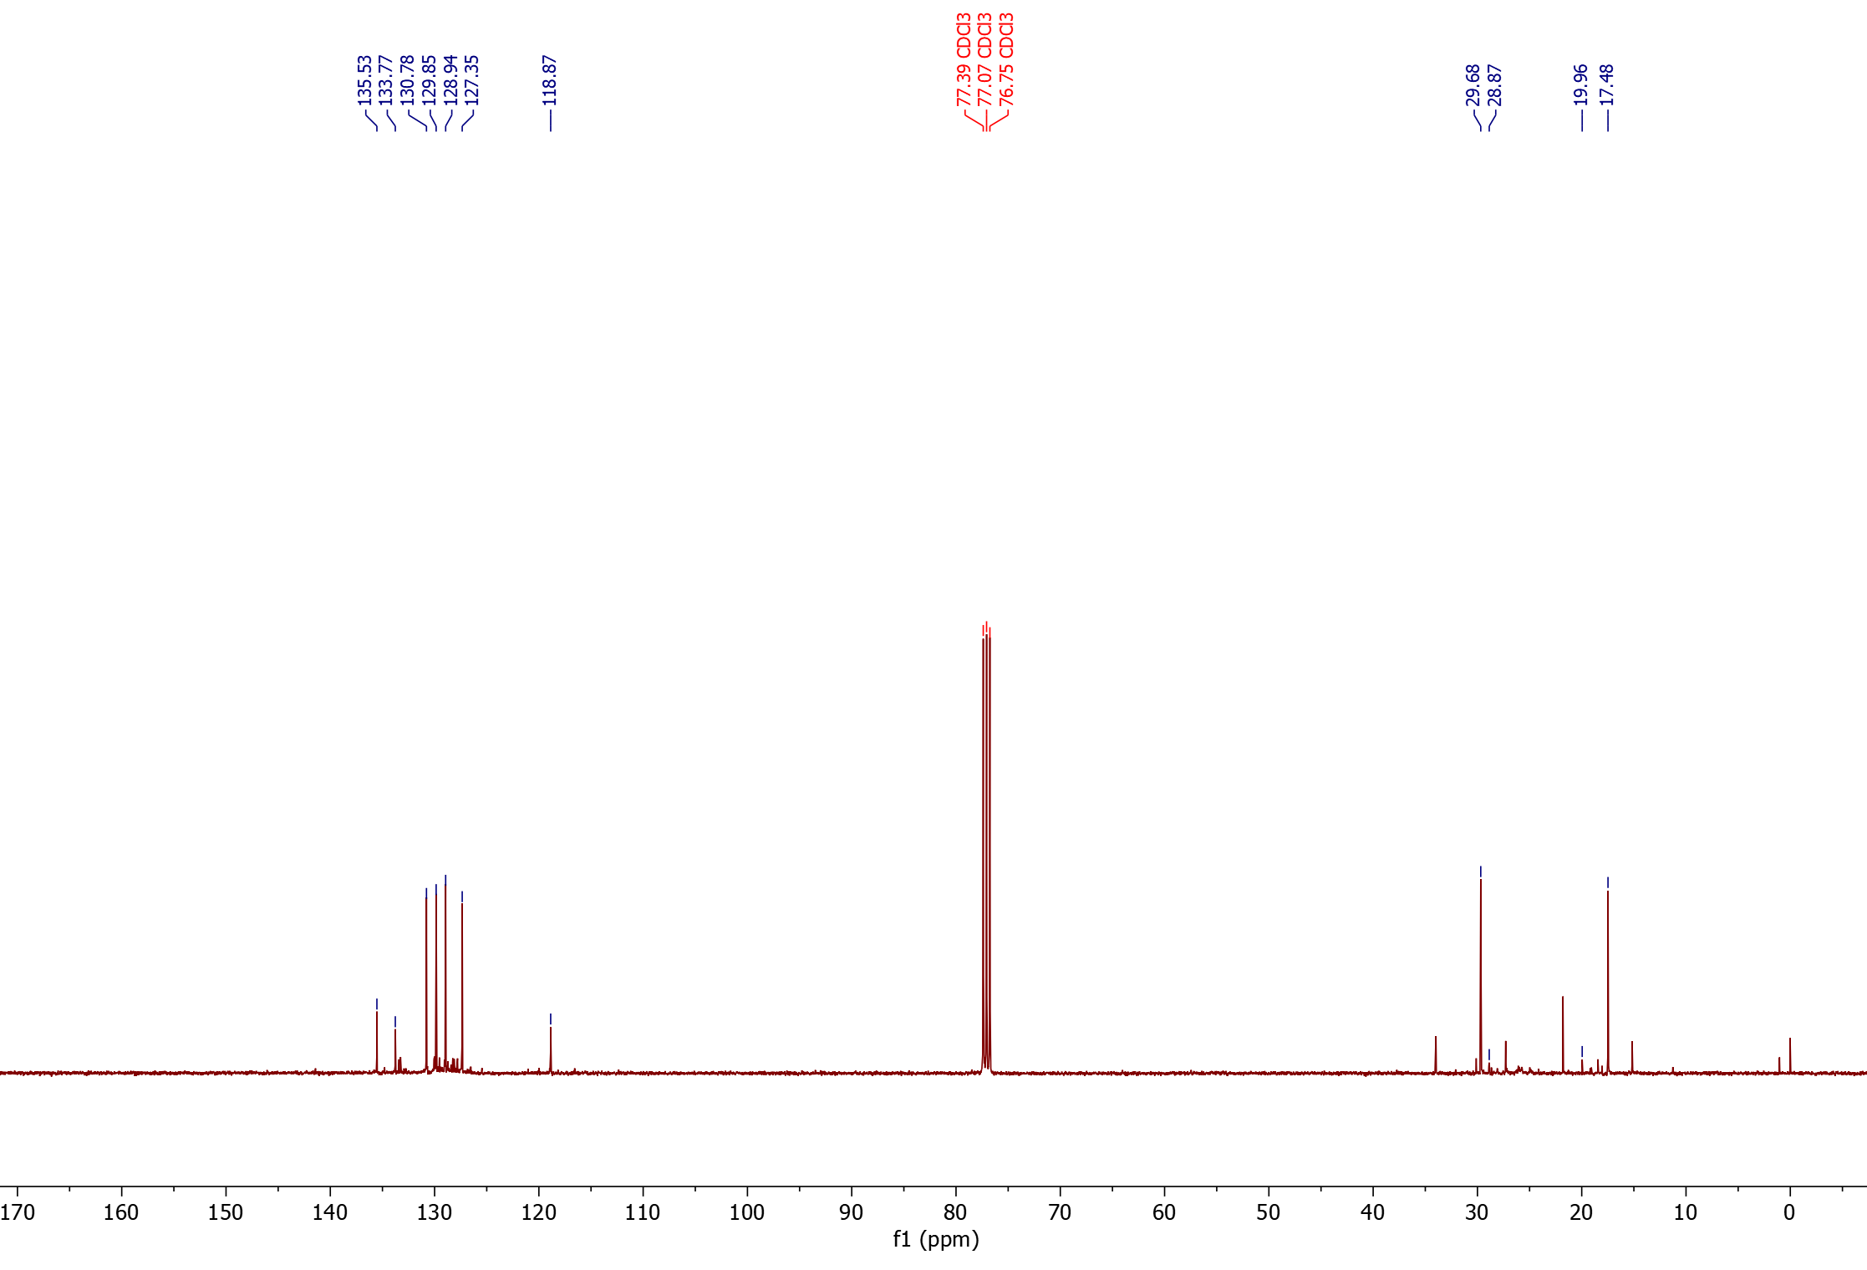
¹³C-NMR

°
1<
2<
*
°
*

1°,*

2°,*

Nitrile product from cyclooctene (19)
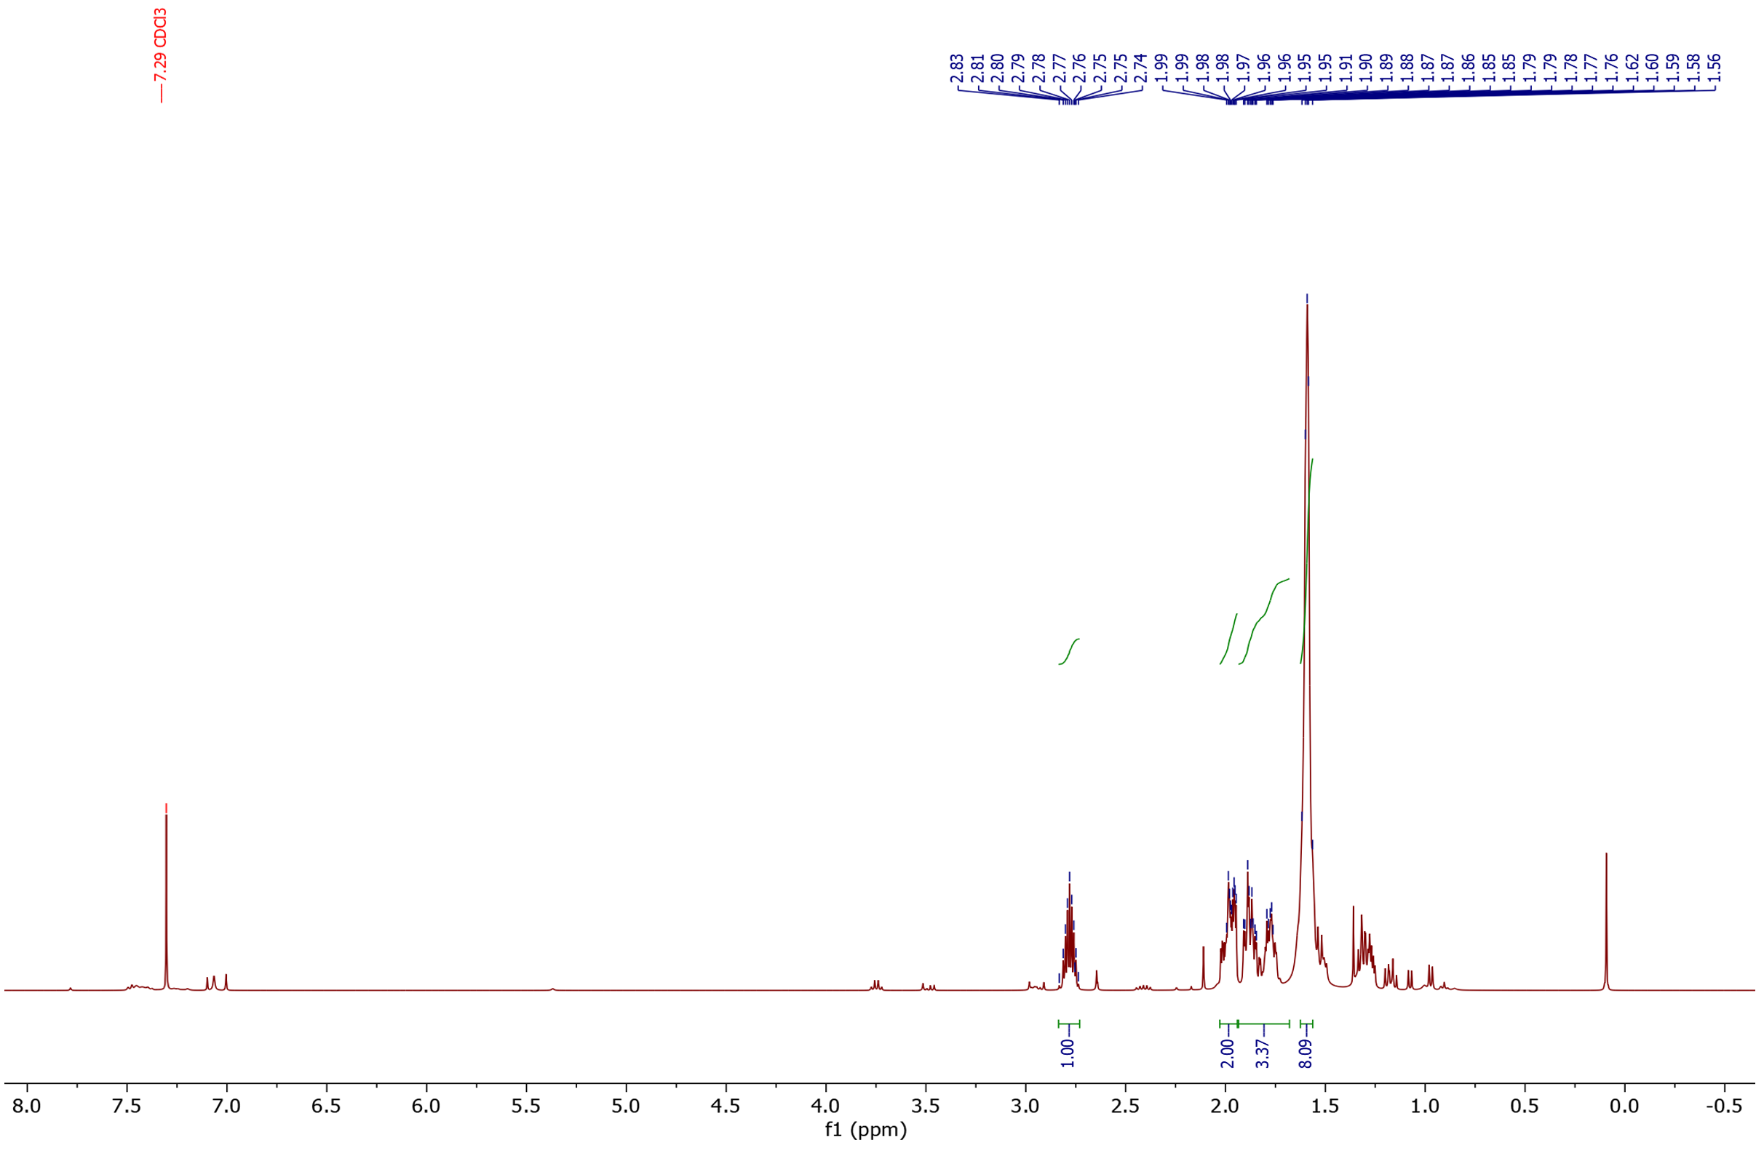
¹H-NMR

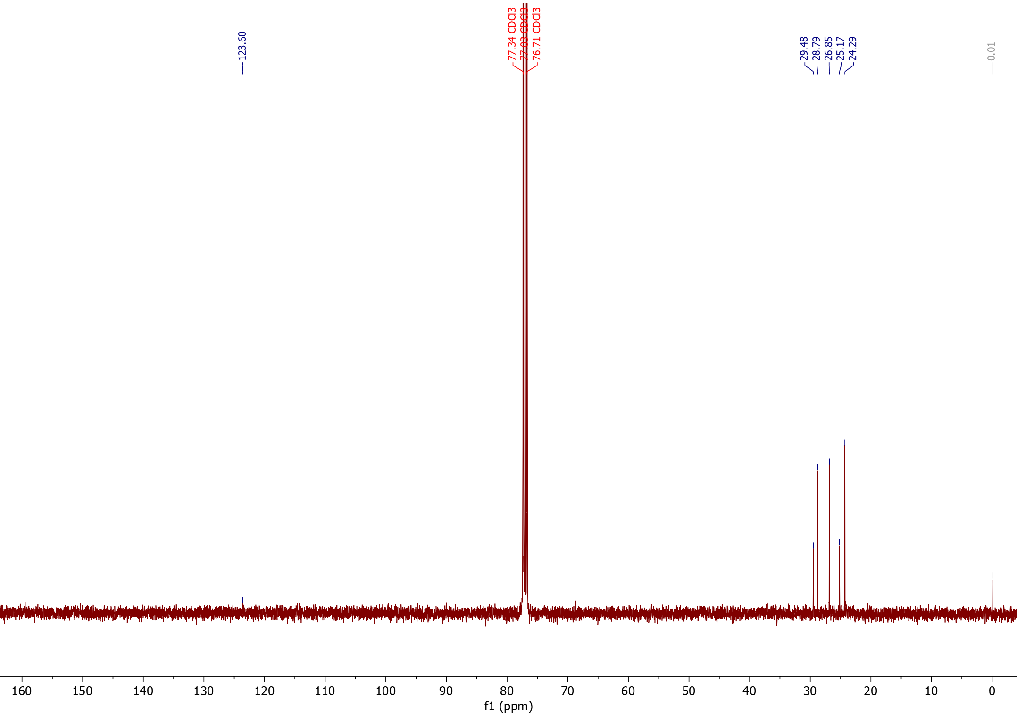
¹³C-NMR

Nitrile product from cyclododecene (20)
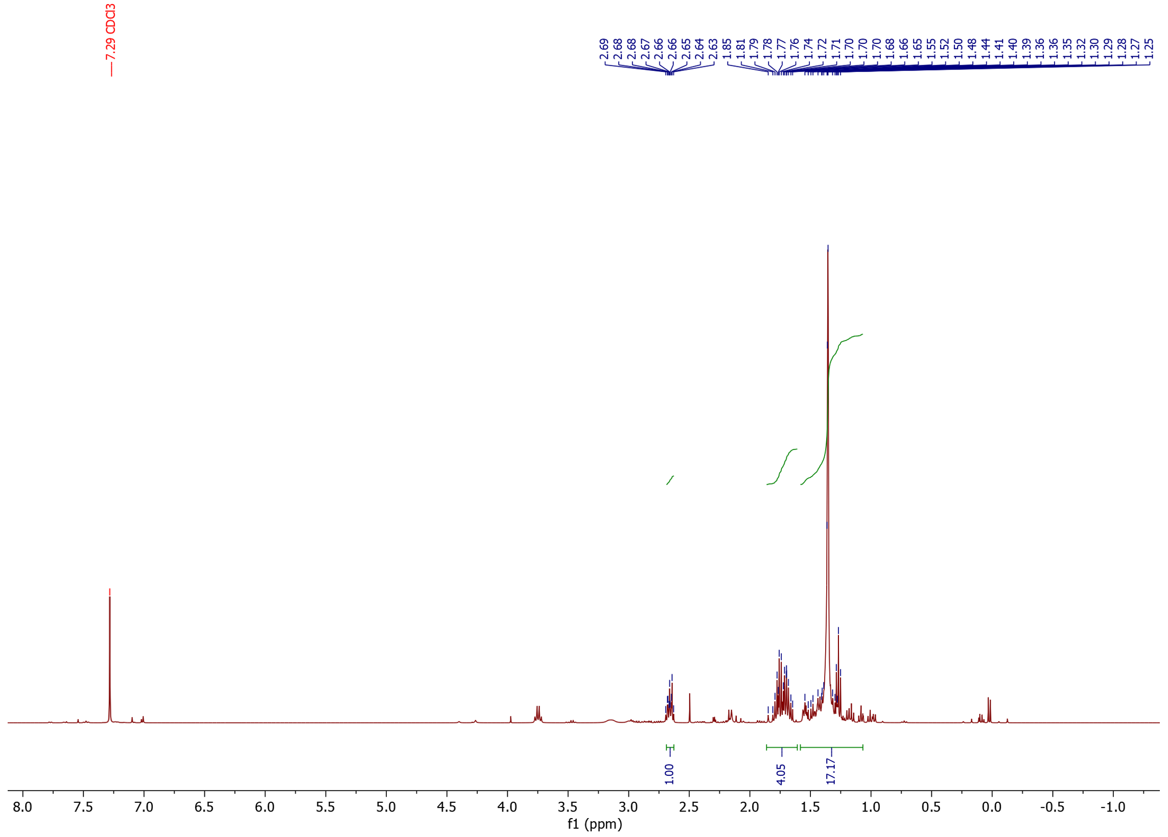
¹H-NMR

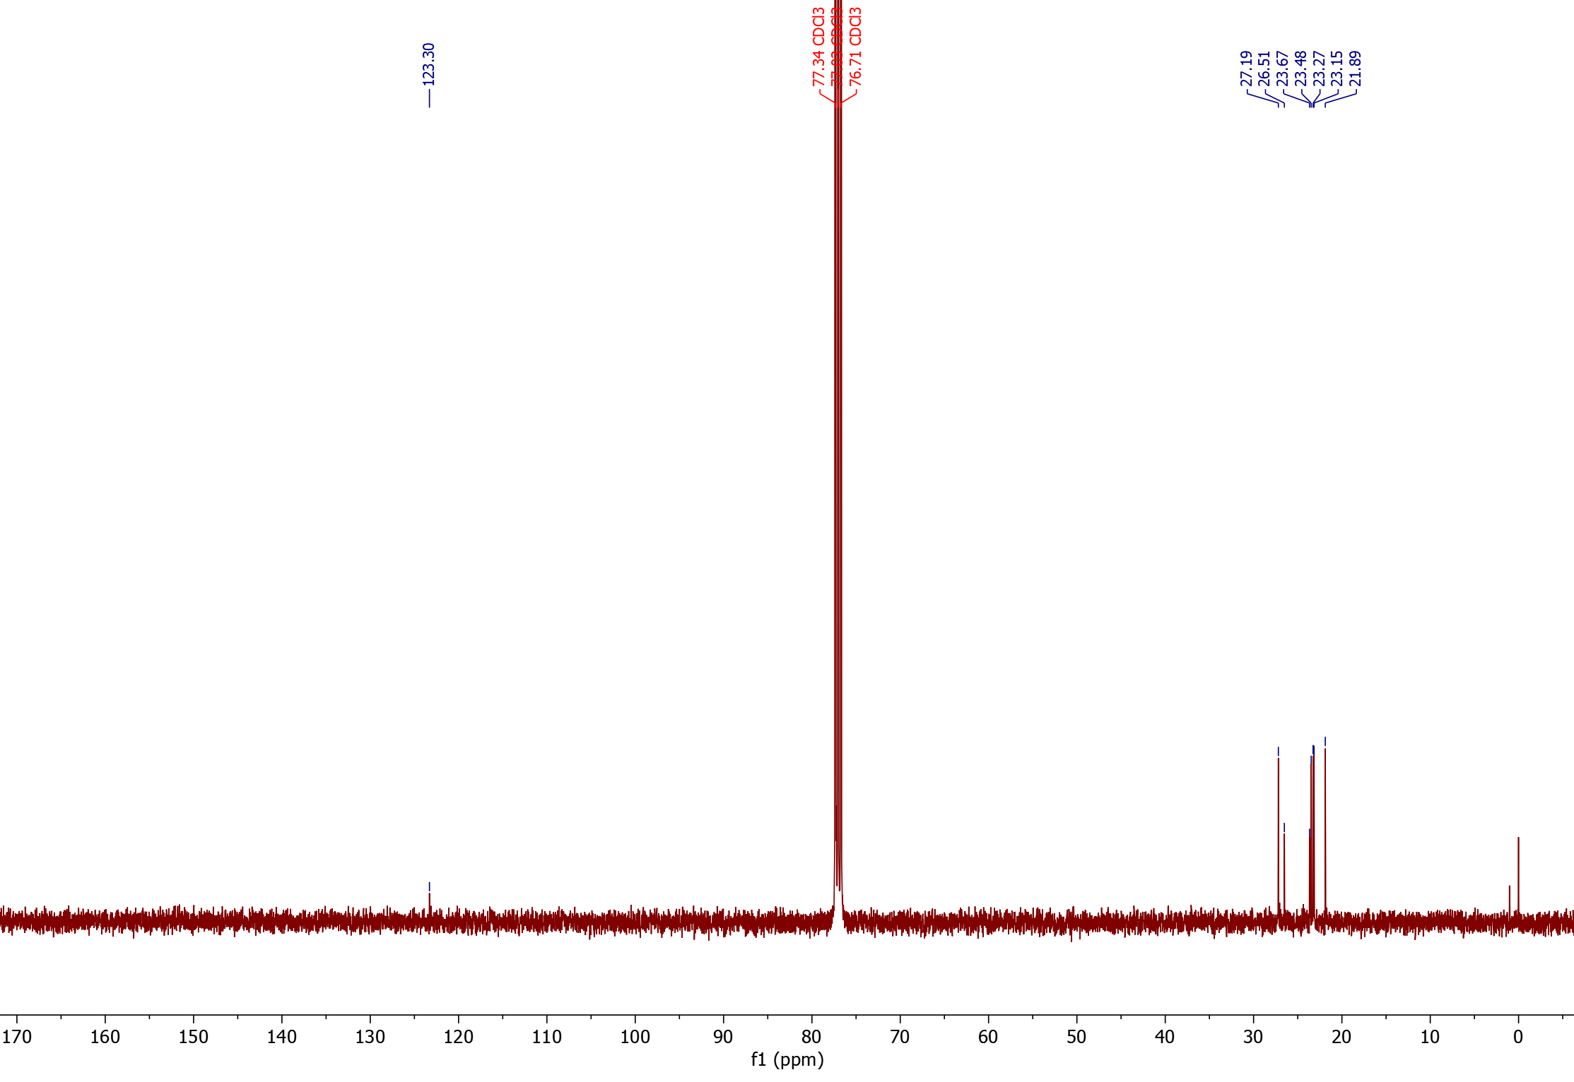
¹³C-NMR

Nitrile products from diisobutylene (21) (isolated product)
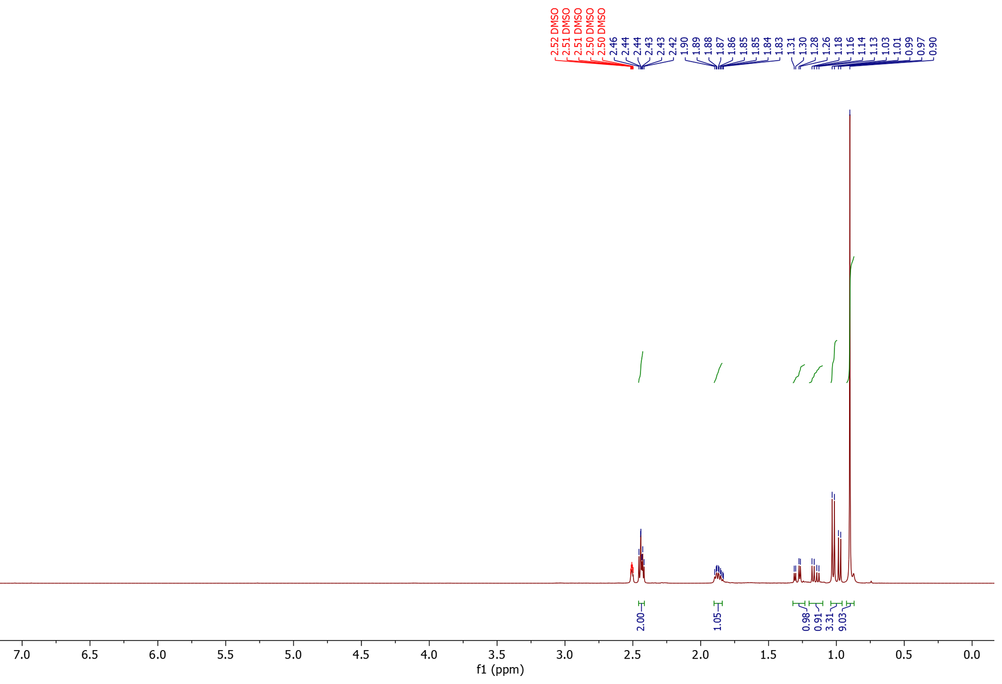
¹H-NMR

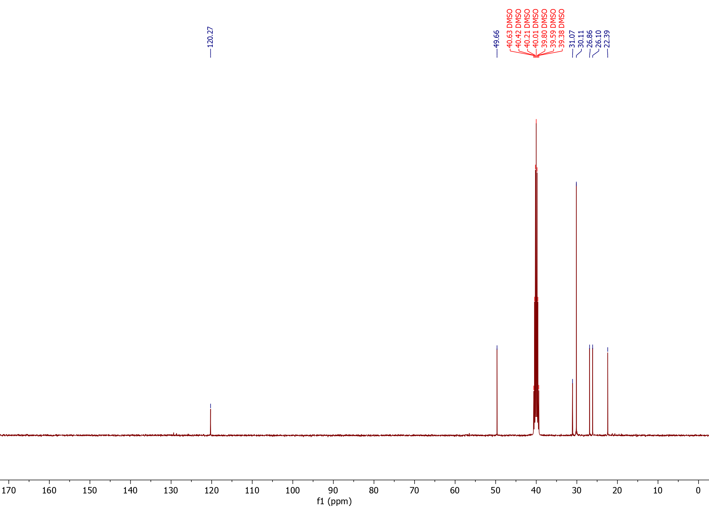
¹³C-NMR

Nitrile products from camphene (22)
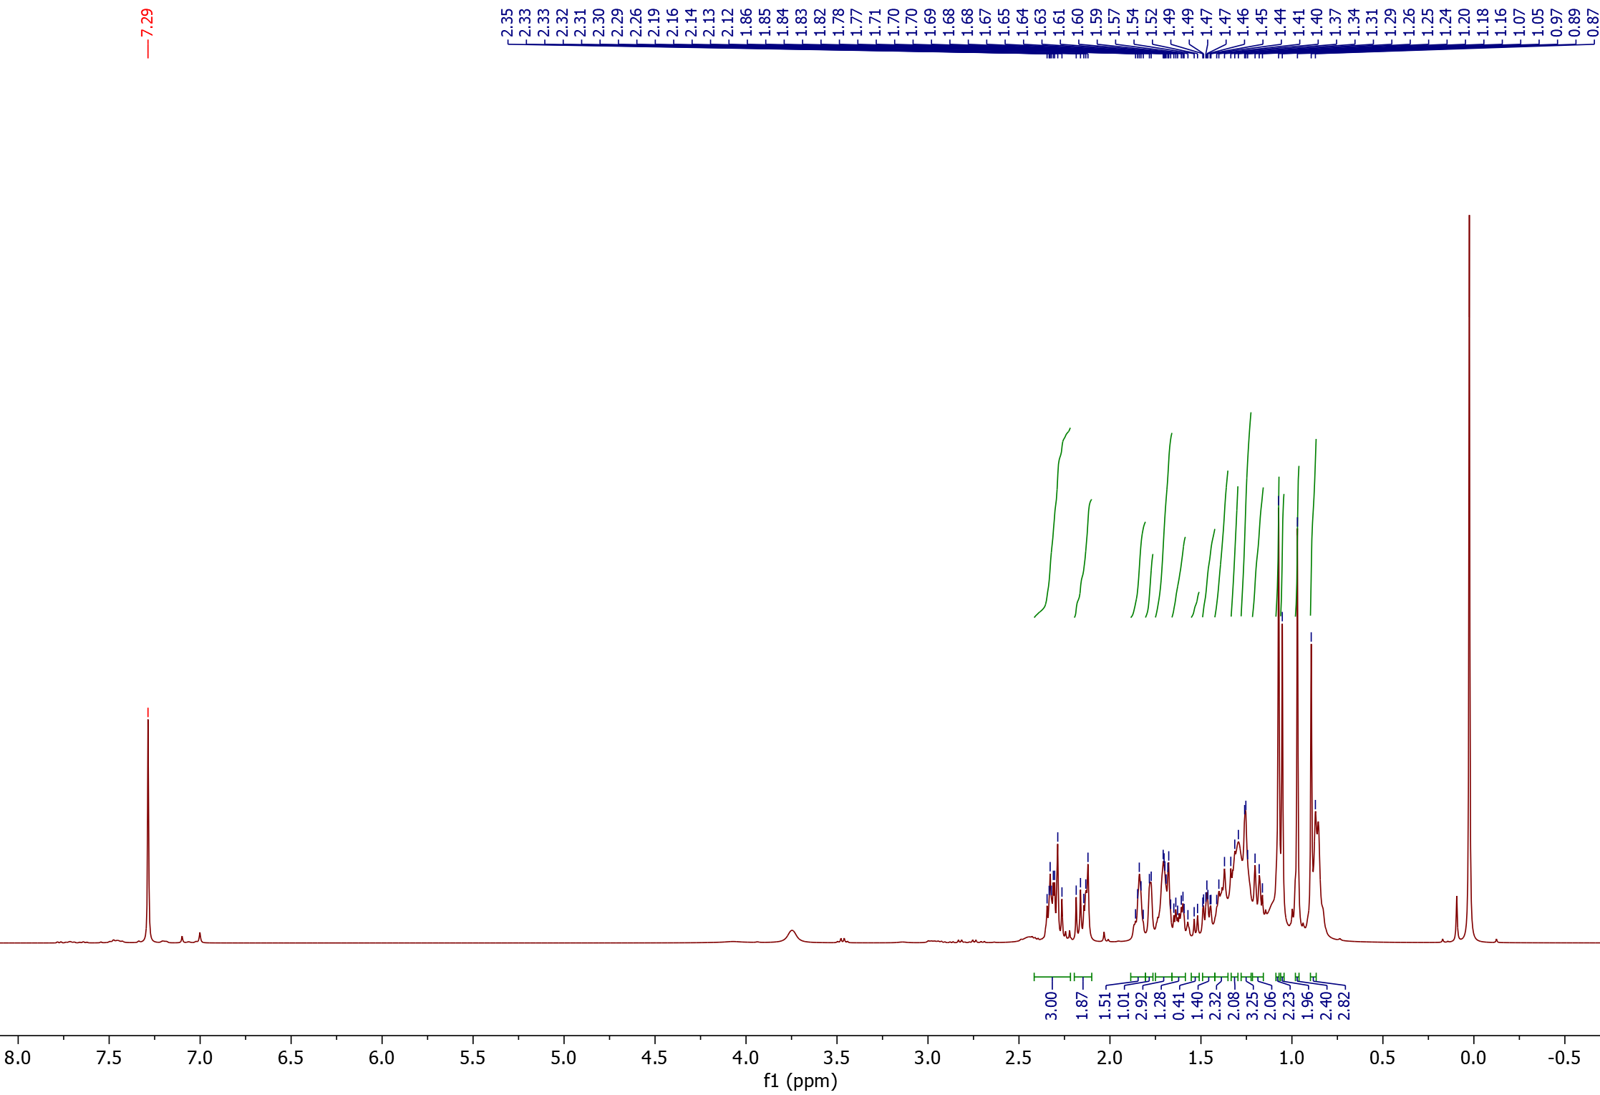
¹H-NMR

2<
1<

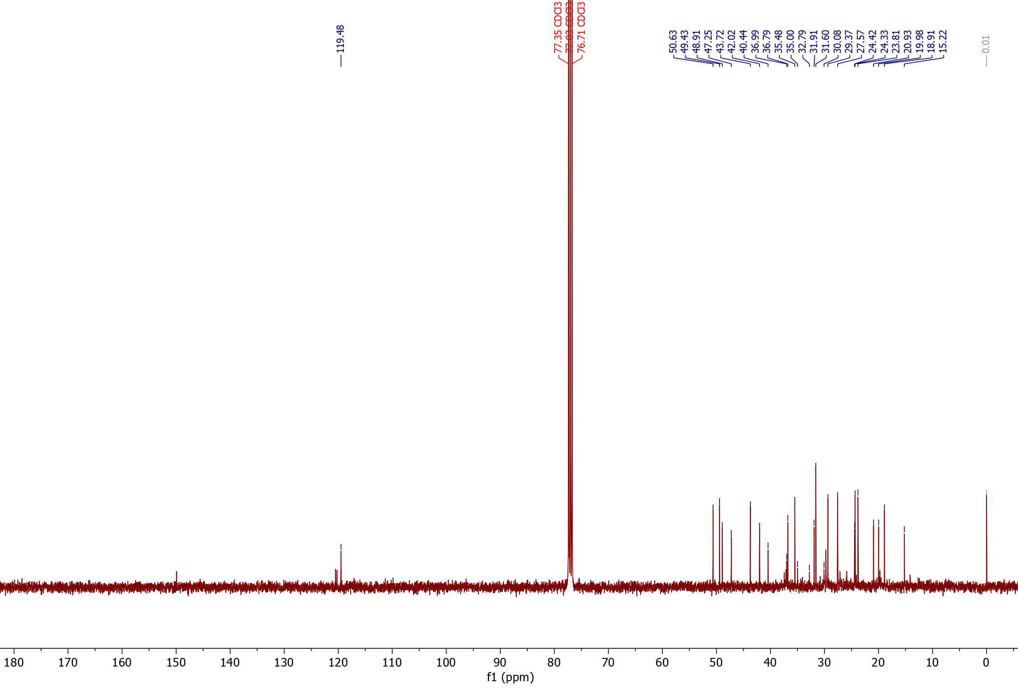
¹³C-NMR

2<
1<

Nitrile products from 1-allyl naphthalene (23)
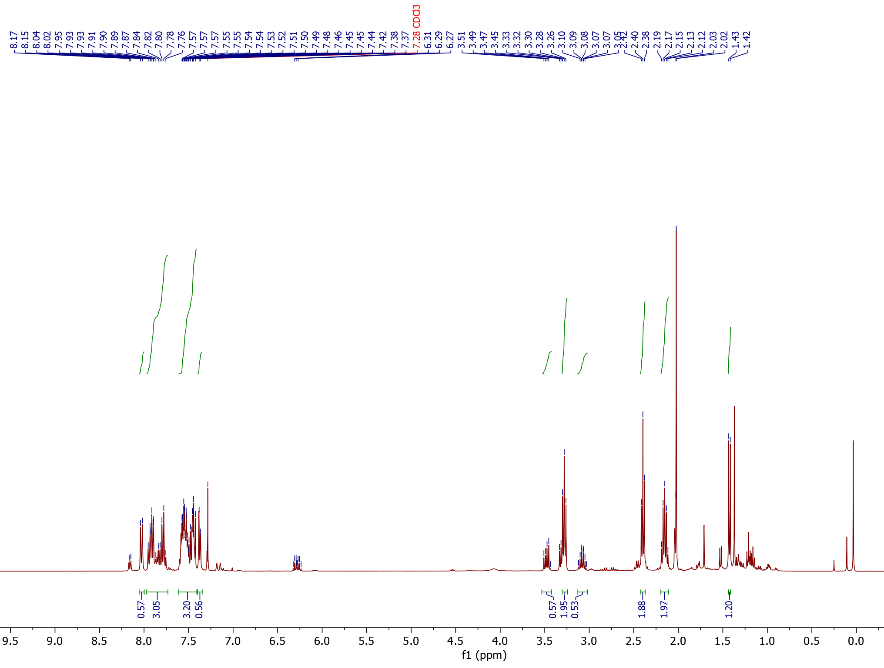
¹H-NMR

1<
2<

2
1
1
1
2
2
Substrate

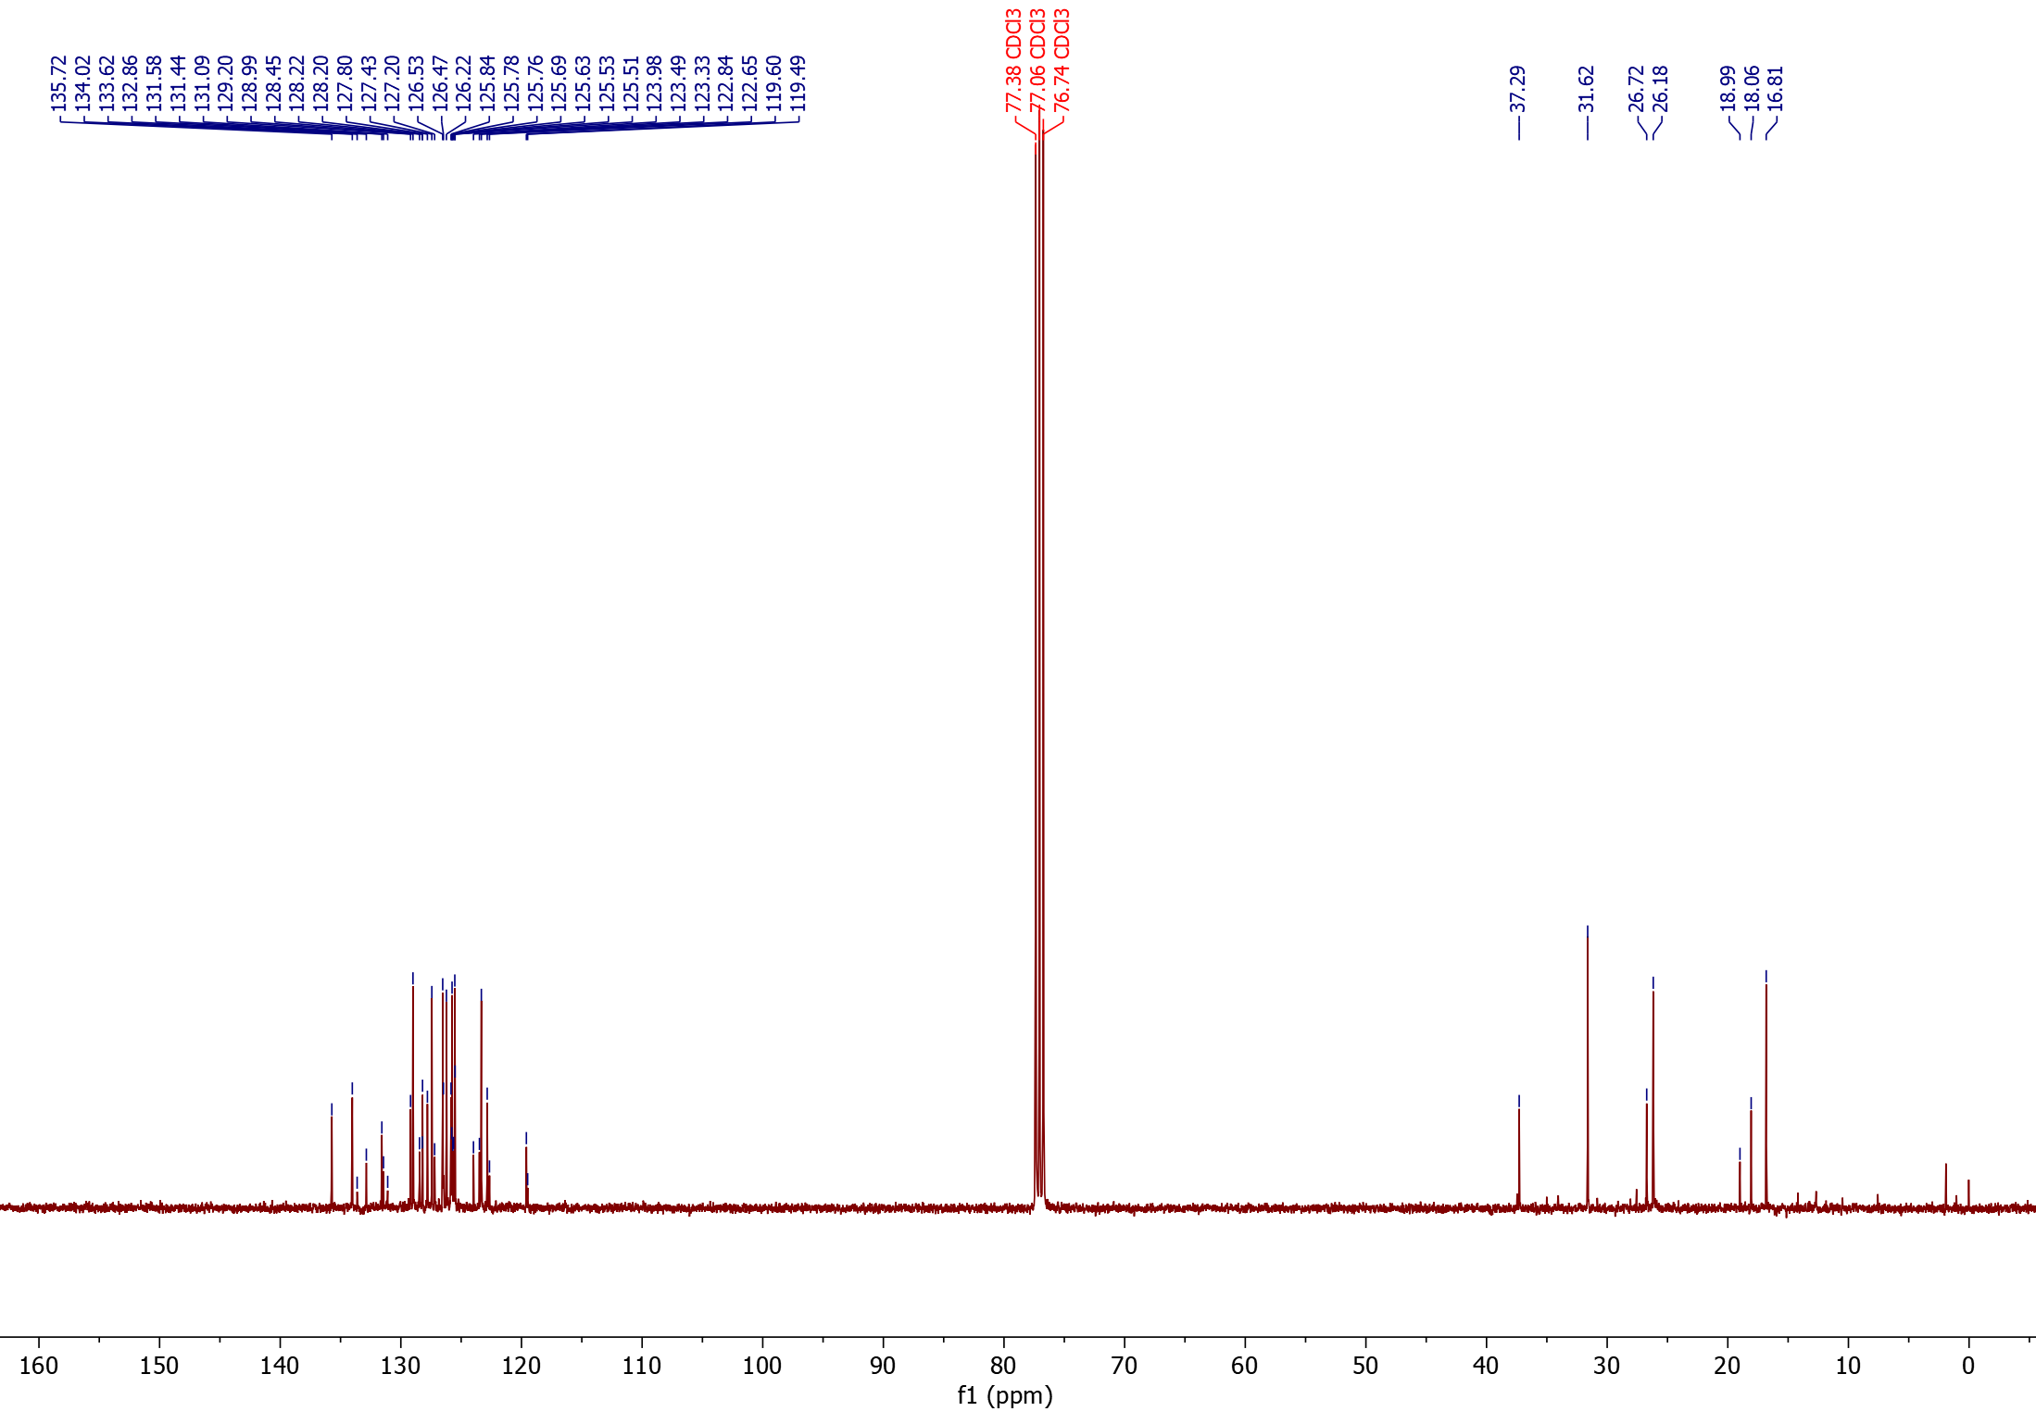
¹³C-NMR

*
*
1<
2<
°
§
°
§

1§
1*
1°
2*
2°
2§

Nitrile products from 4-allyl-1,2-dimethoxybenzene (24)
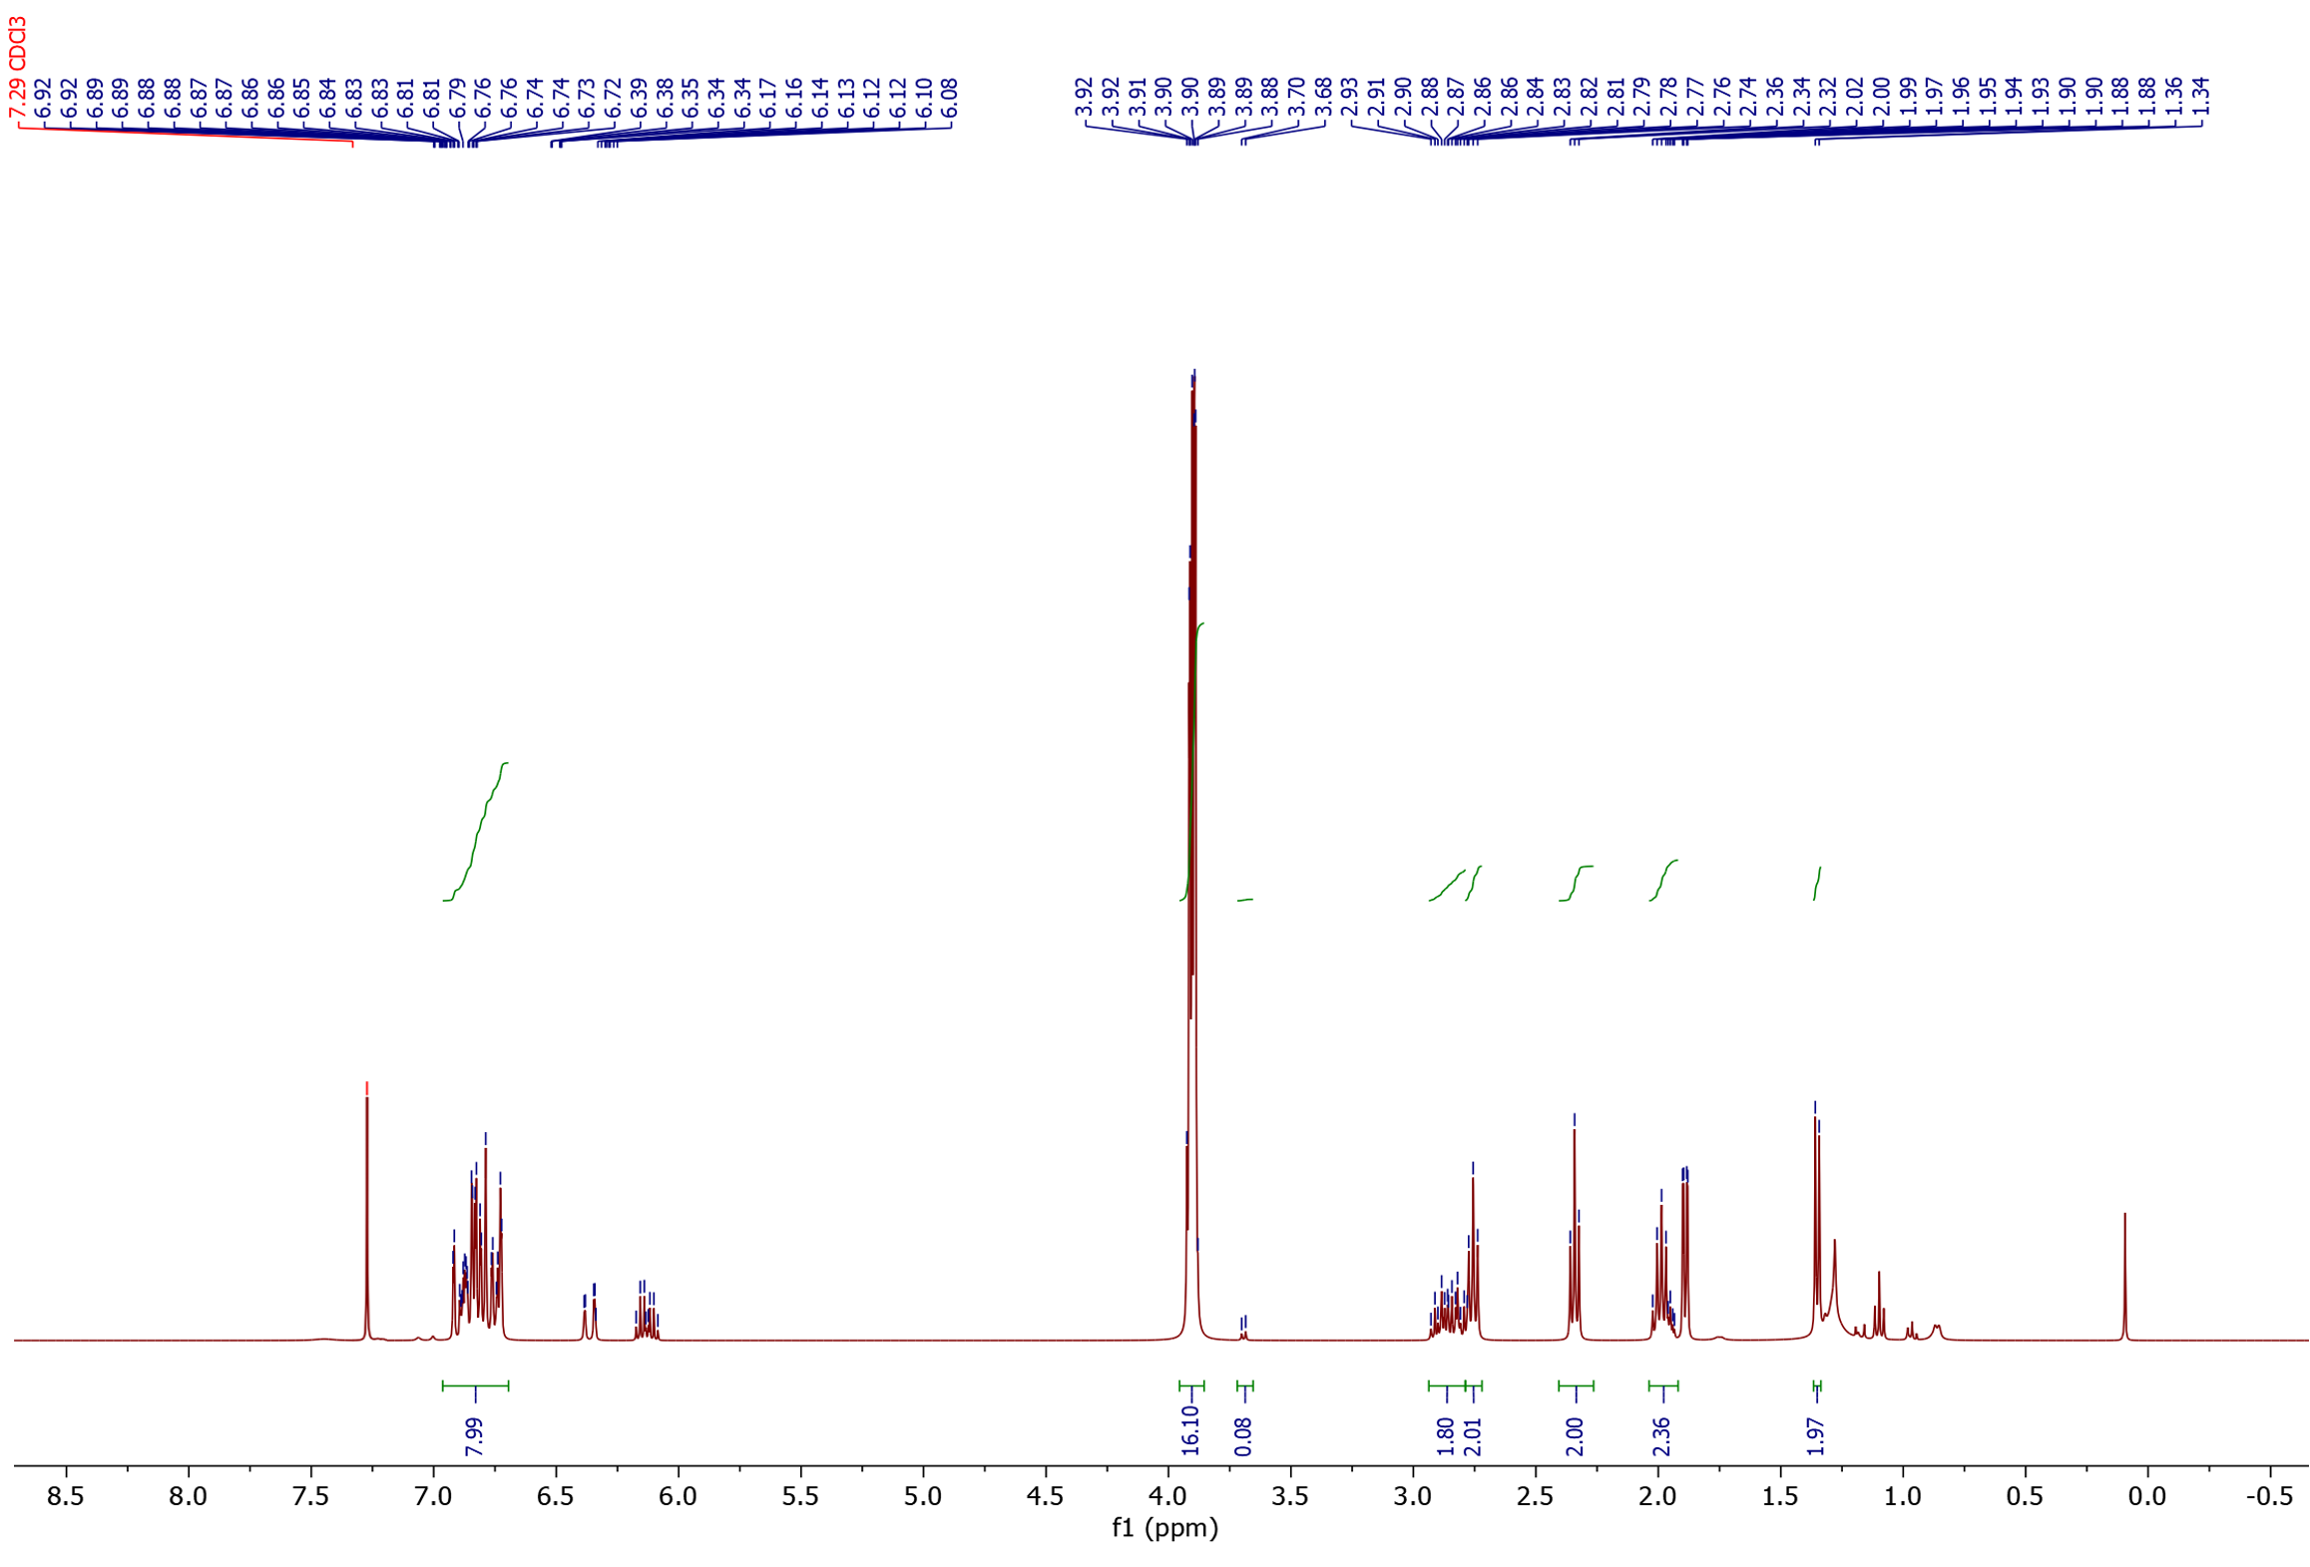
¹H-NMR

3<
2<
1<

Substrate
2
1
1
1
2
Substrate
3

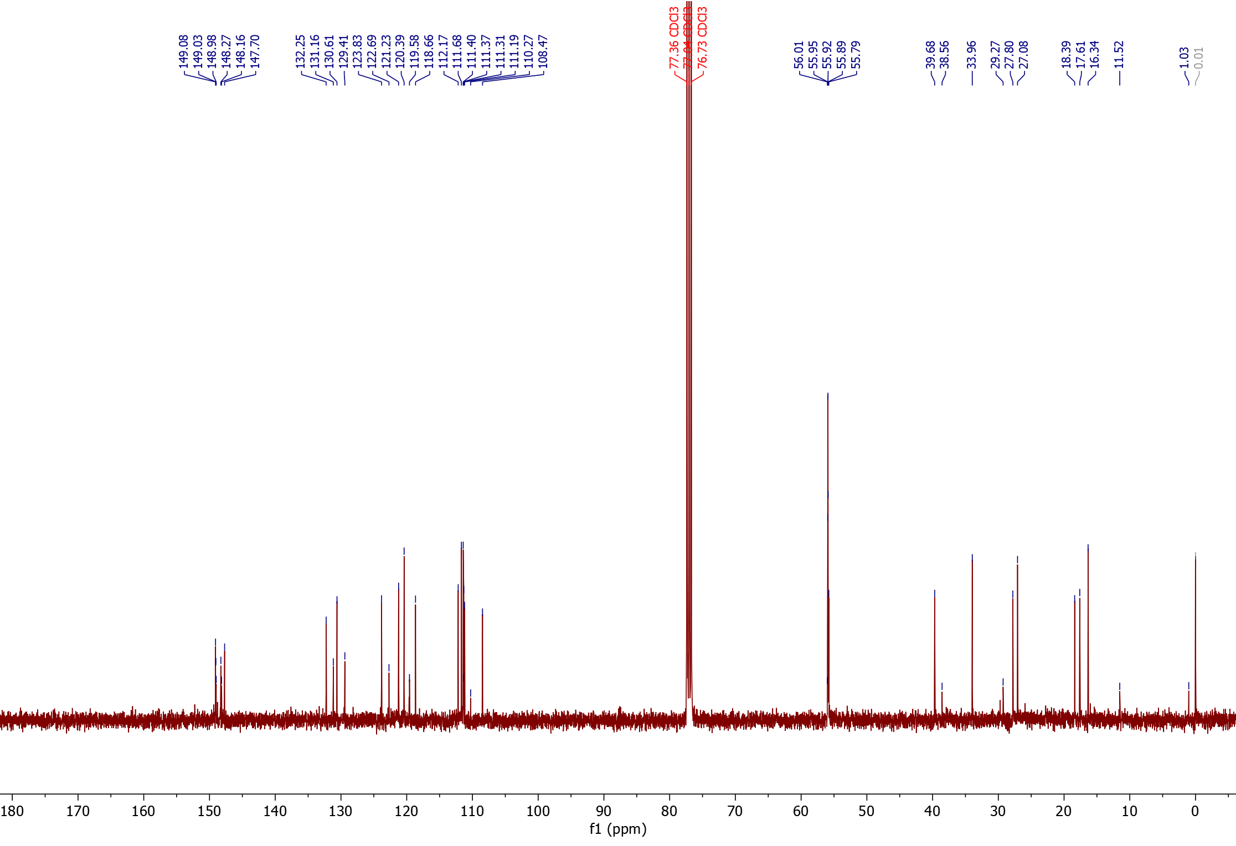
¹³C-NMR

§
°
*
°
*
§
§
°
*
3<
1<
2<

1°
2*
2§
2°
1§
1*

3§
3°
3*

Nitrile products from 5-Vinyl-2-norbornene (25) (isolated as indicated isomer mixtures)
25a: 5-ethylidene(E/Z)-2-norbornanecarbonitrile (mixture of endo/exo products).
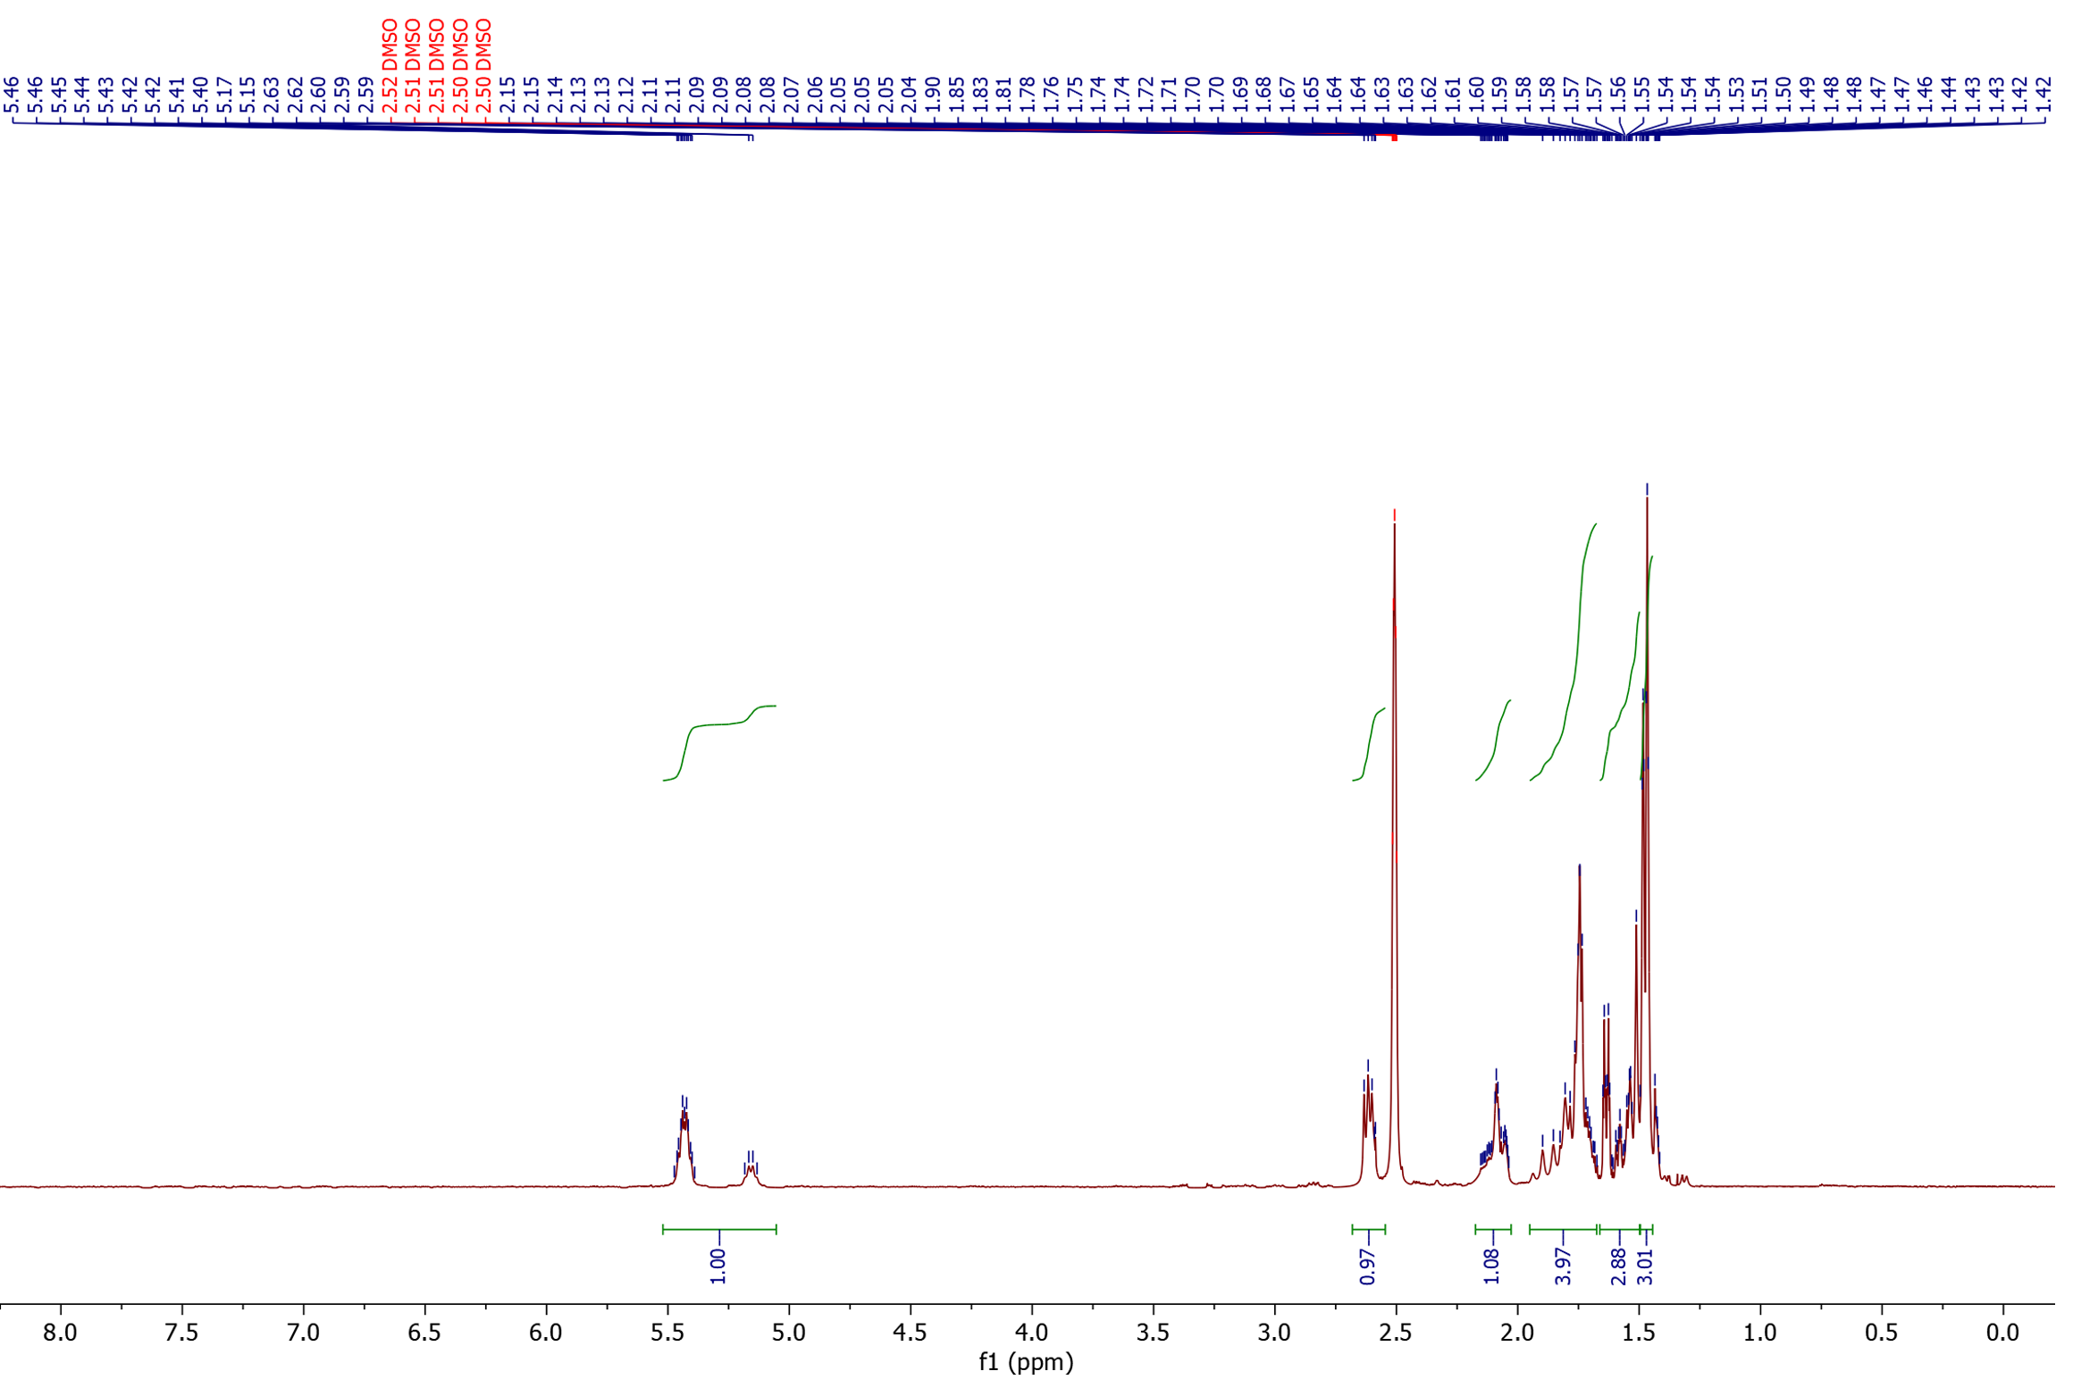
¹H-NMR

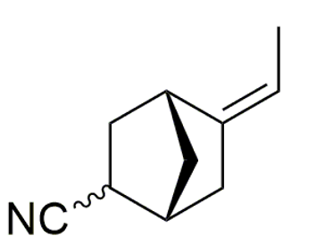
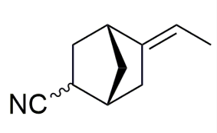

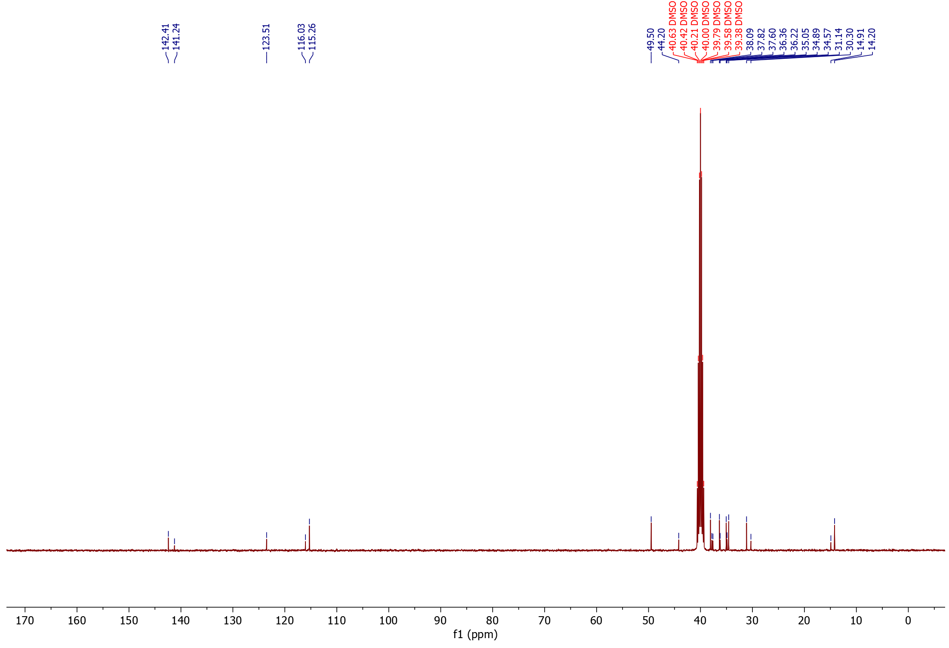
¹³C-NMR

25b: 6-ethylidene(E/Z)-2-norbornanecarbonitrile (mixture of endo/exo products).
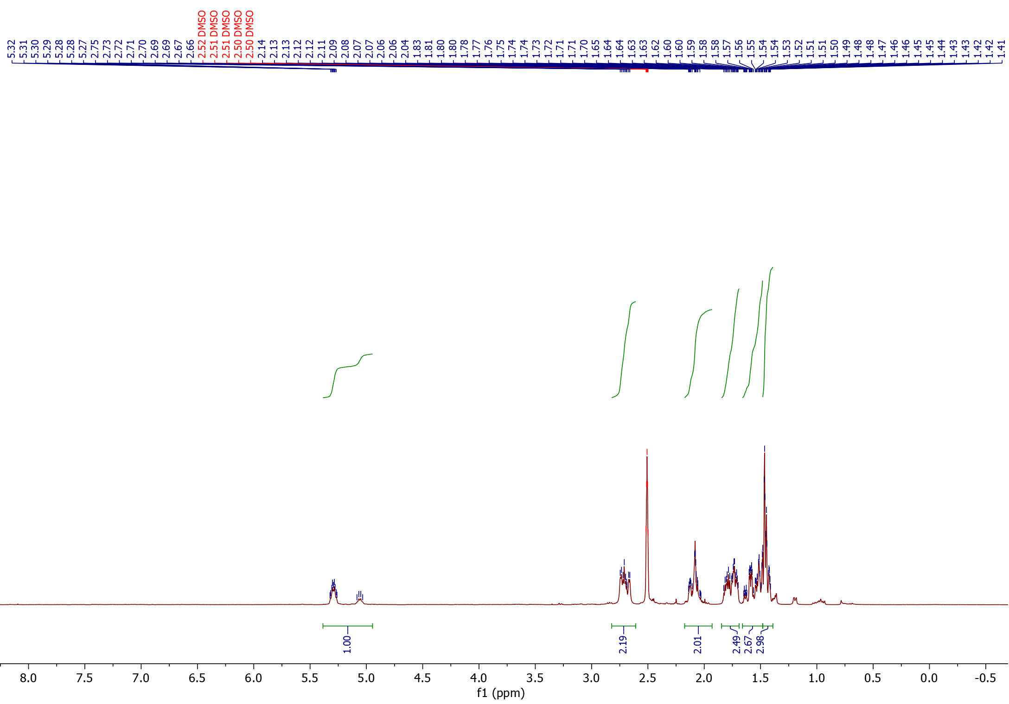
¹H NMR

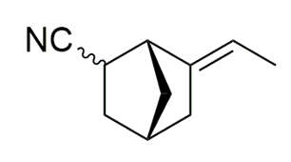
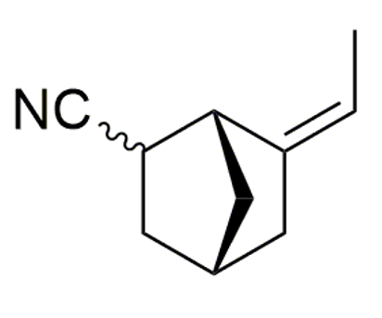

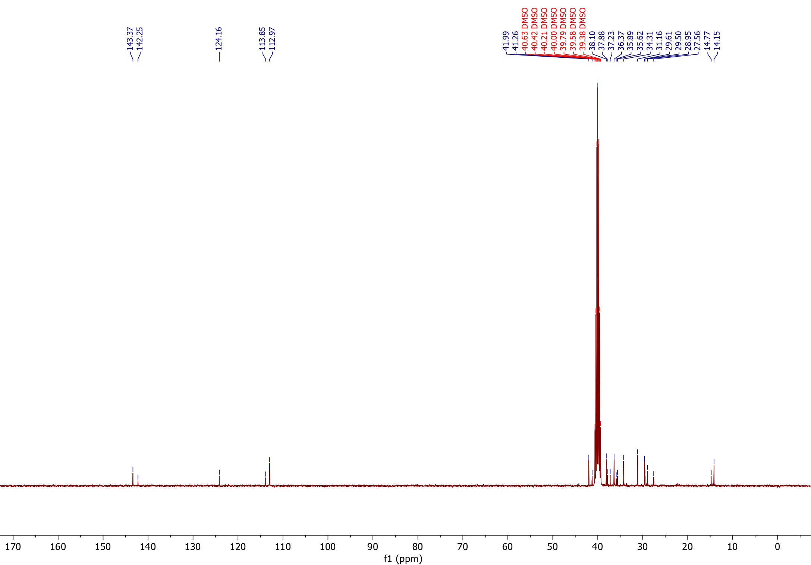
¹³C NMR

25c: 6-cyano-2-norbornanepropanenitrile and 5-cyano-2-norbornanepropanenitrile (mixture of endo/exo products).
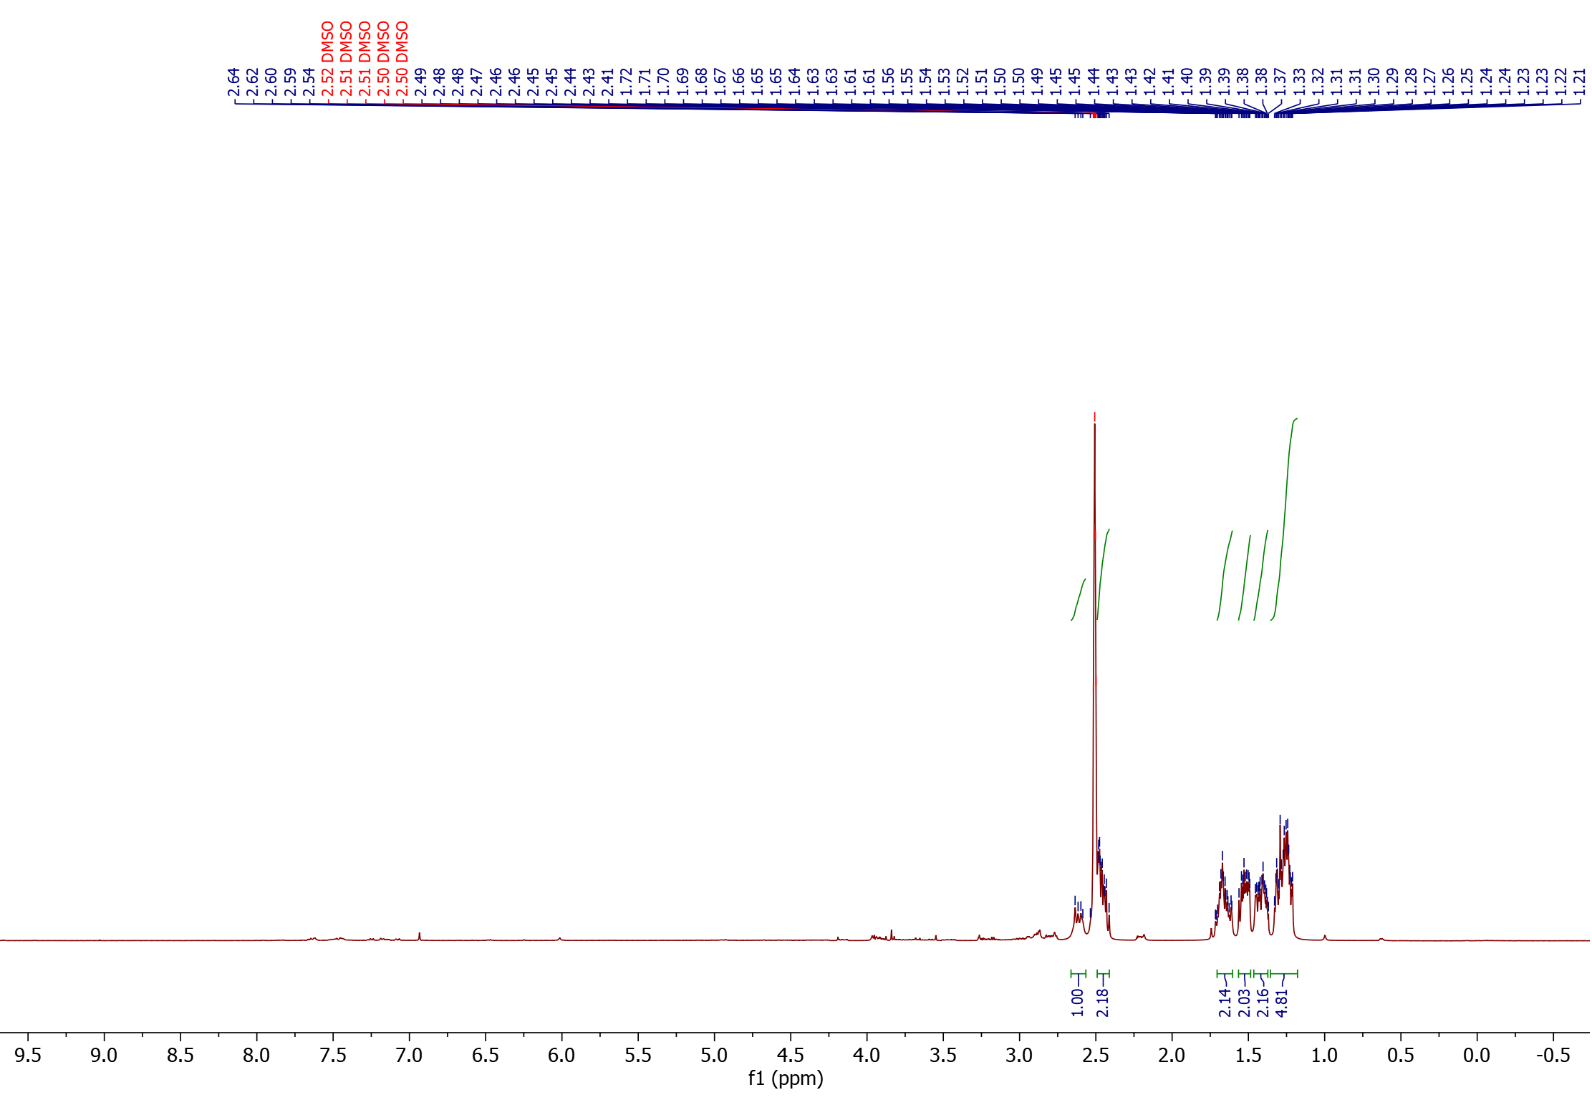
¹H NMR

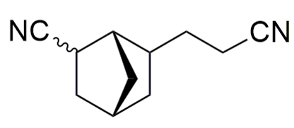
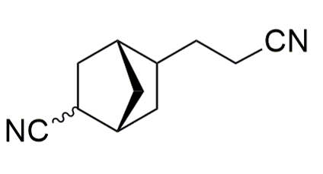

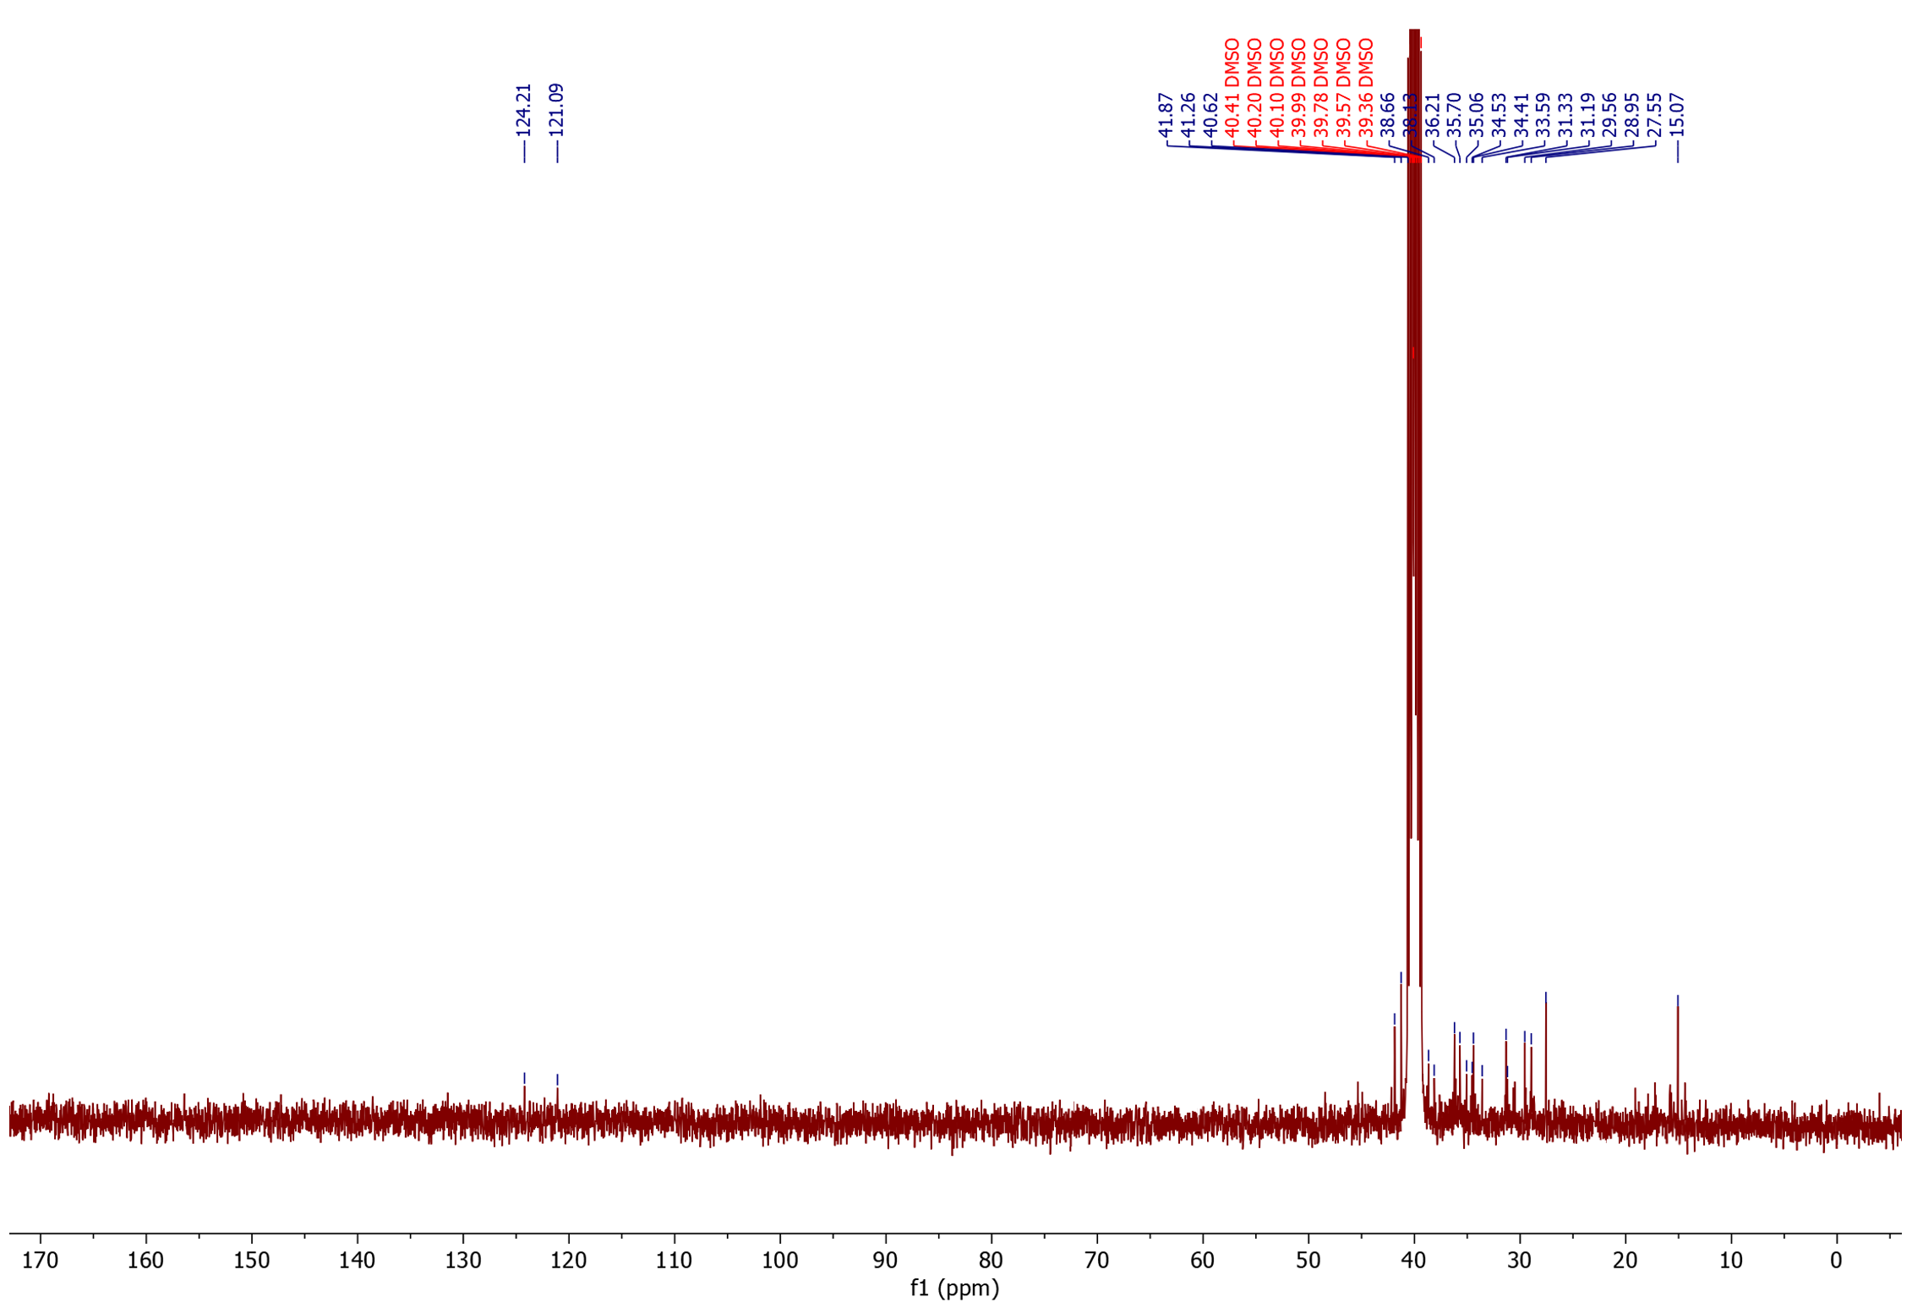
¹³C NMR

Butene products from ethylene dimerization
Conditions: 4 bar ethylene, 80°C in C₆D₆ for 2h using 1 mg Pd(OAc)₂ and 150 mg H-ZSM-5
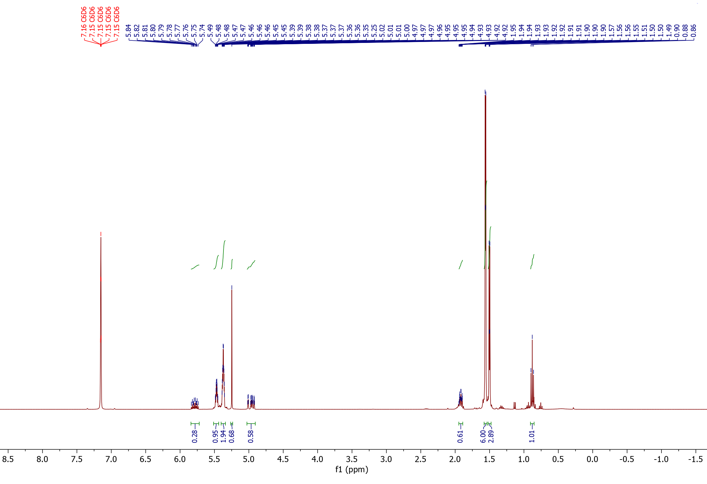
¹H-NMR
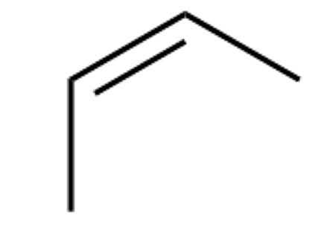
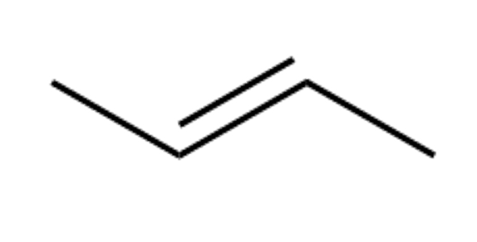
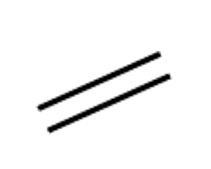
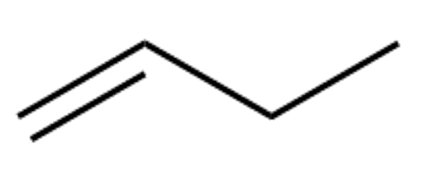
d<
c<
b<
a<
c

d
a<
b<
c
d
b<
b<
b<

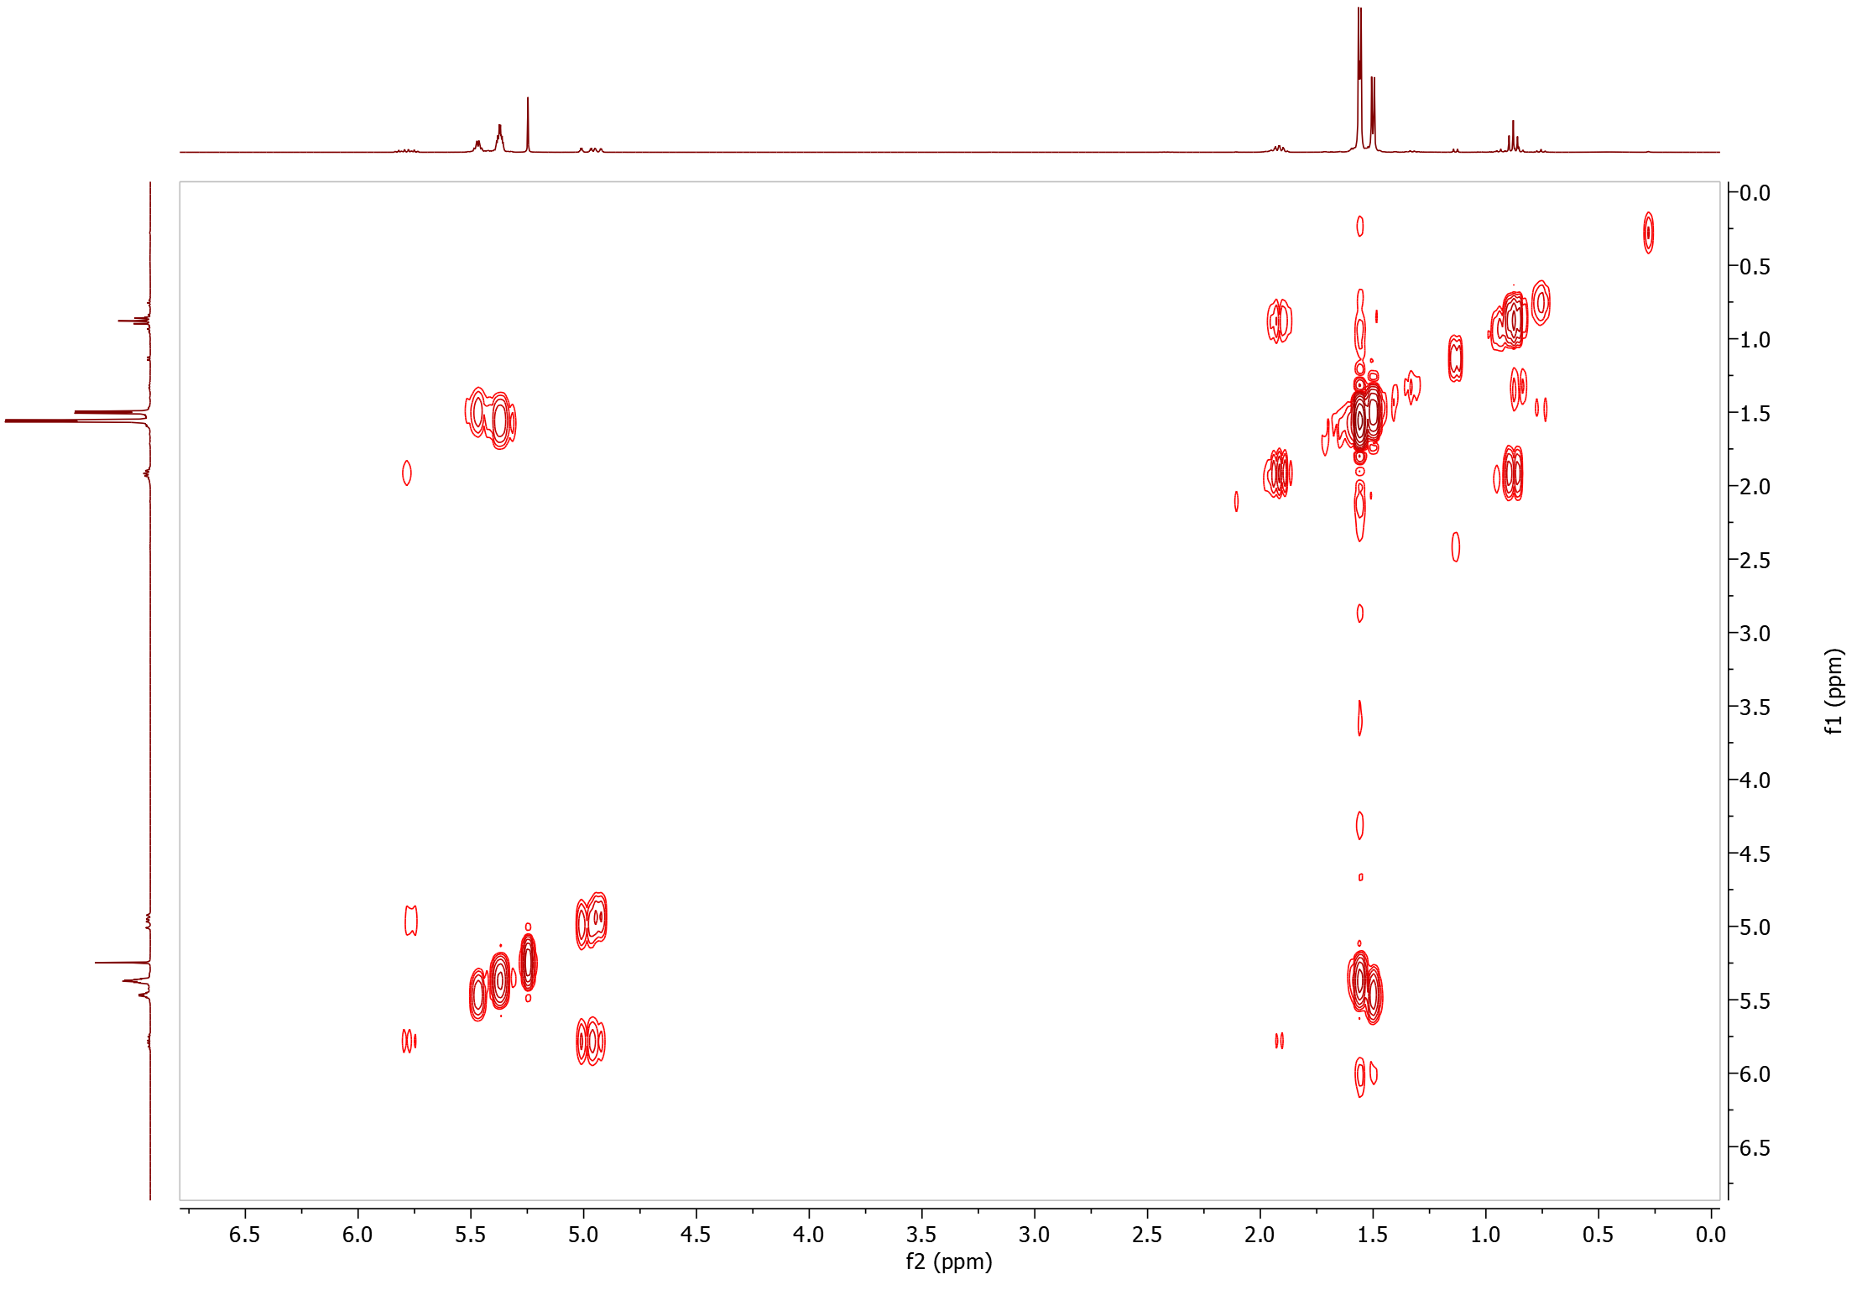
COSY

17.2 HCHO-transfer products
5-phenylpentanal (28)
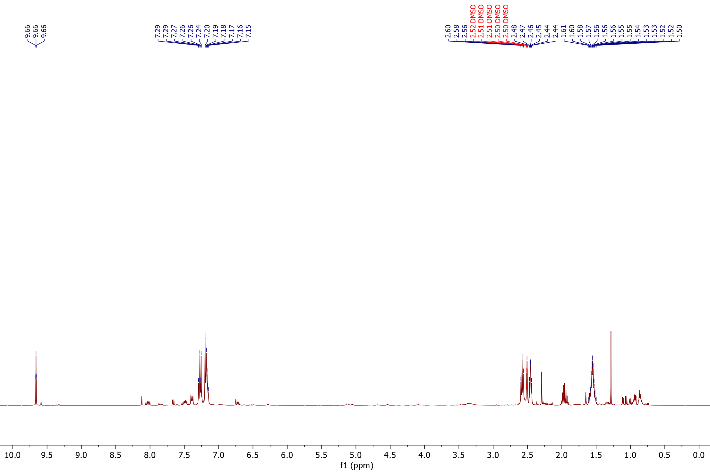
¹H NMR

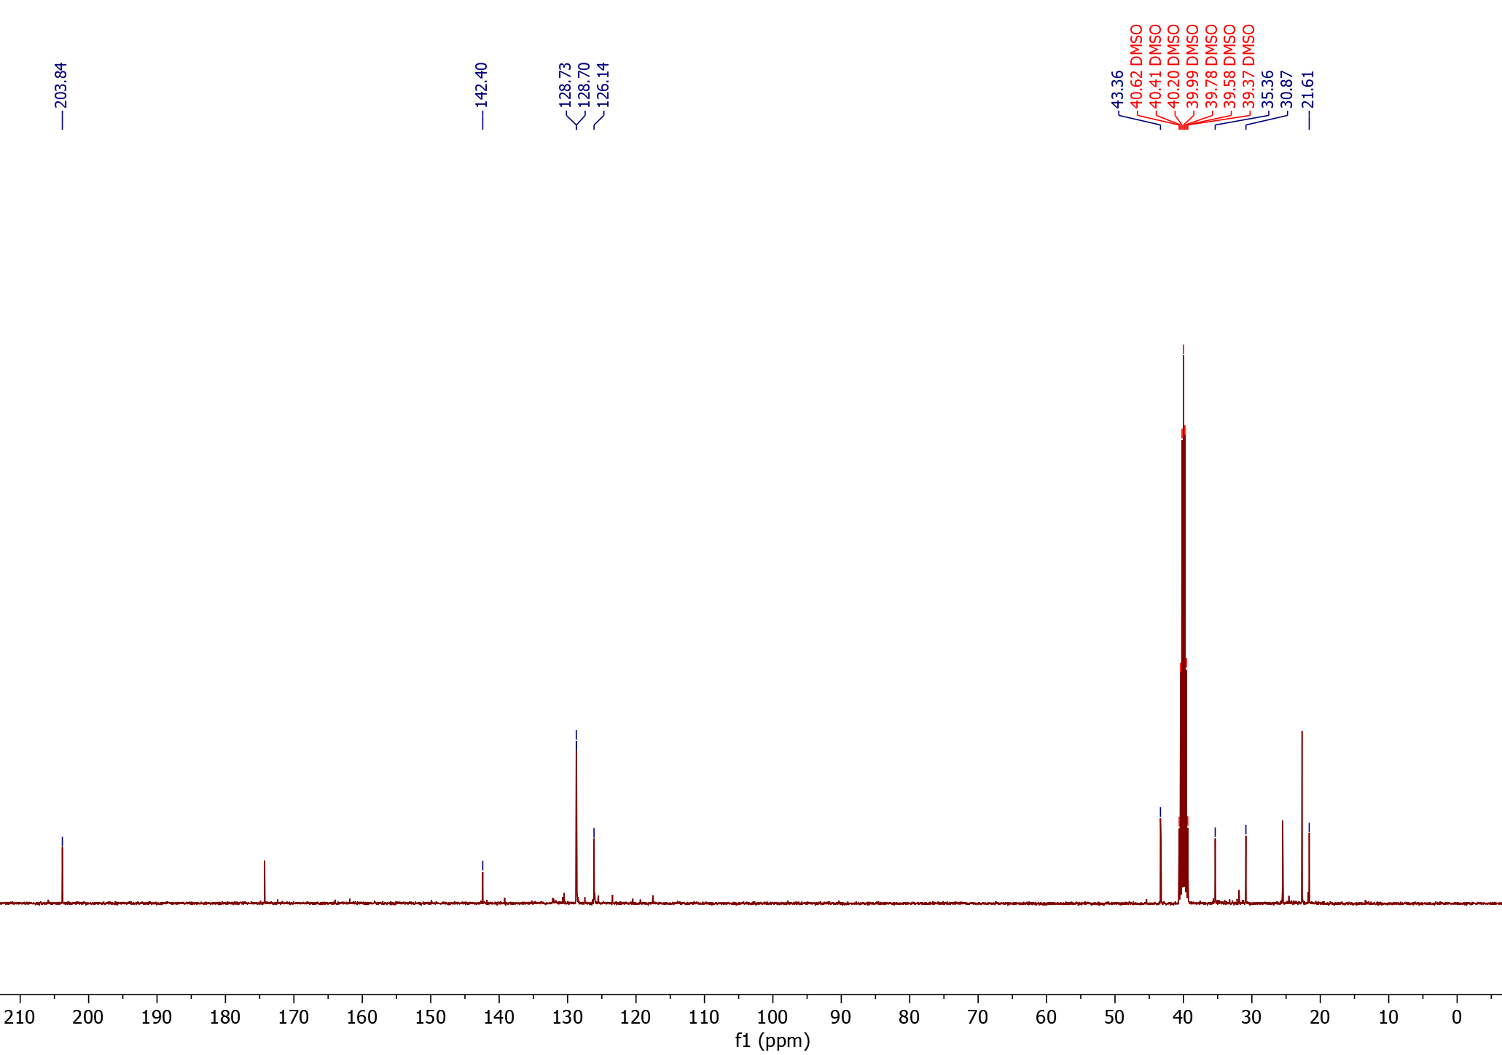
¹³C NMR

4-(1​-naphthyl)butanal (29) (isolated product)

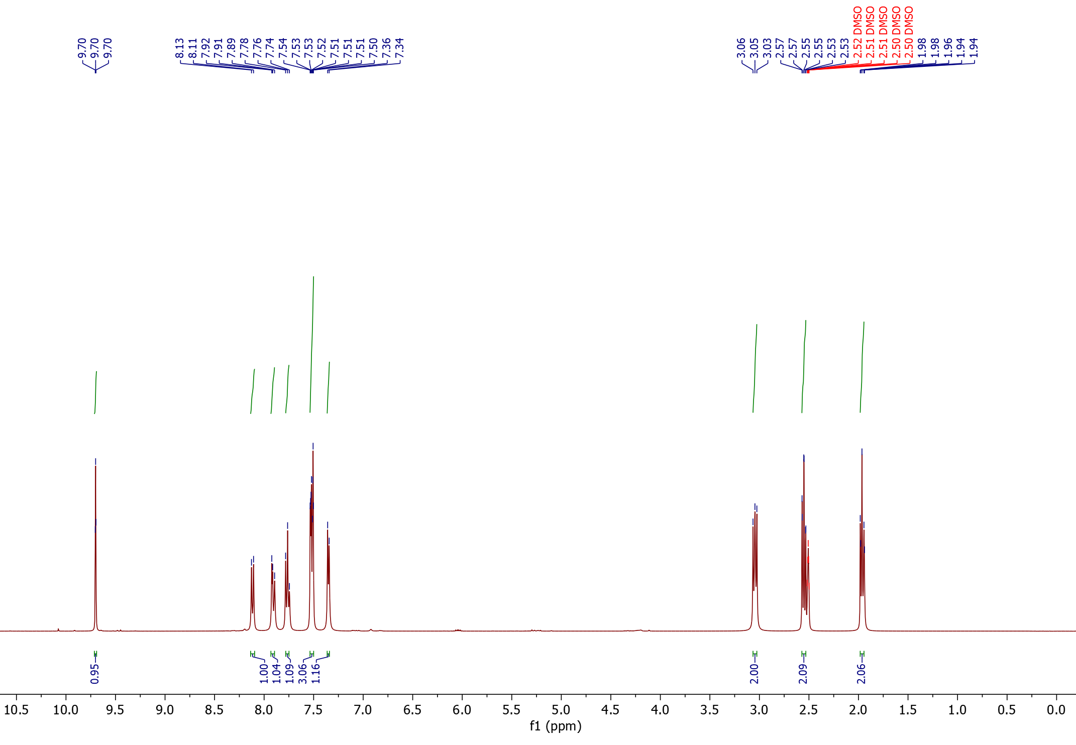
¹H NMR

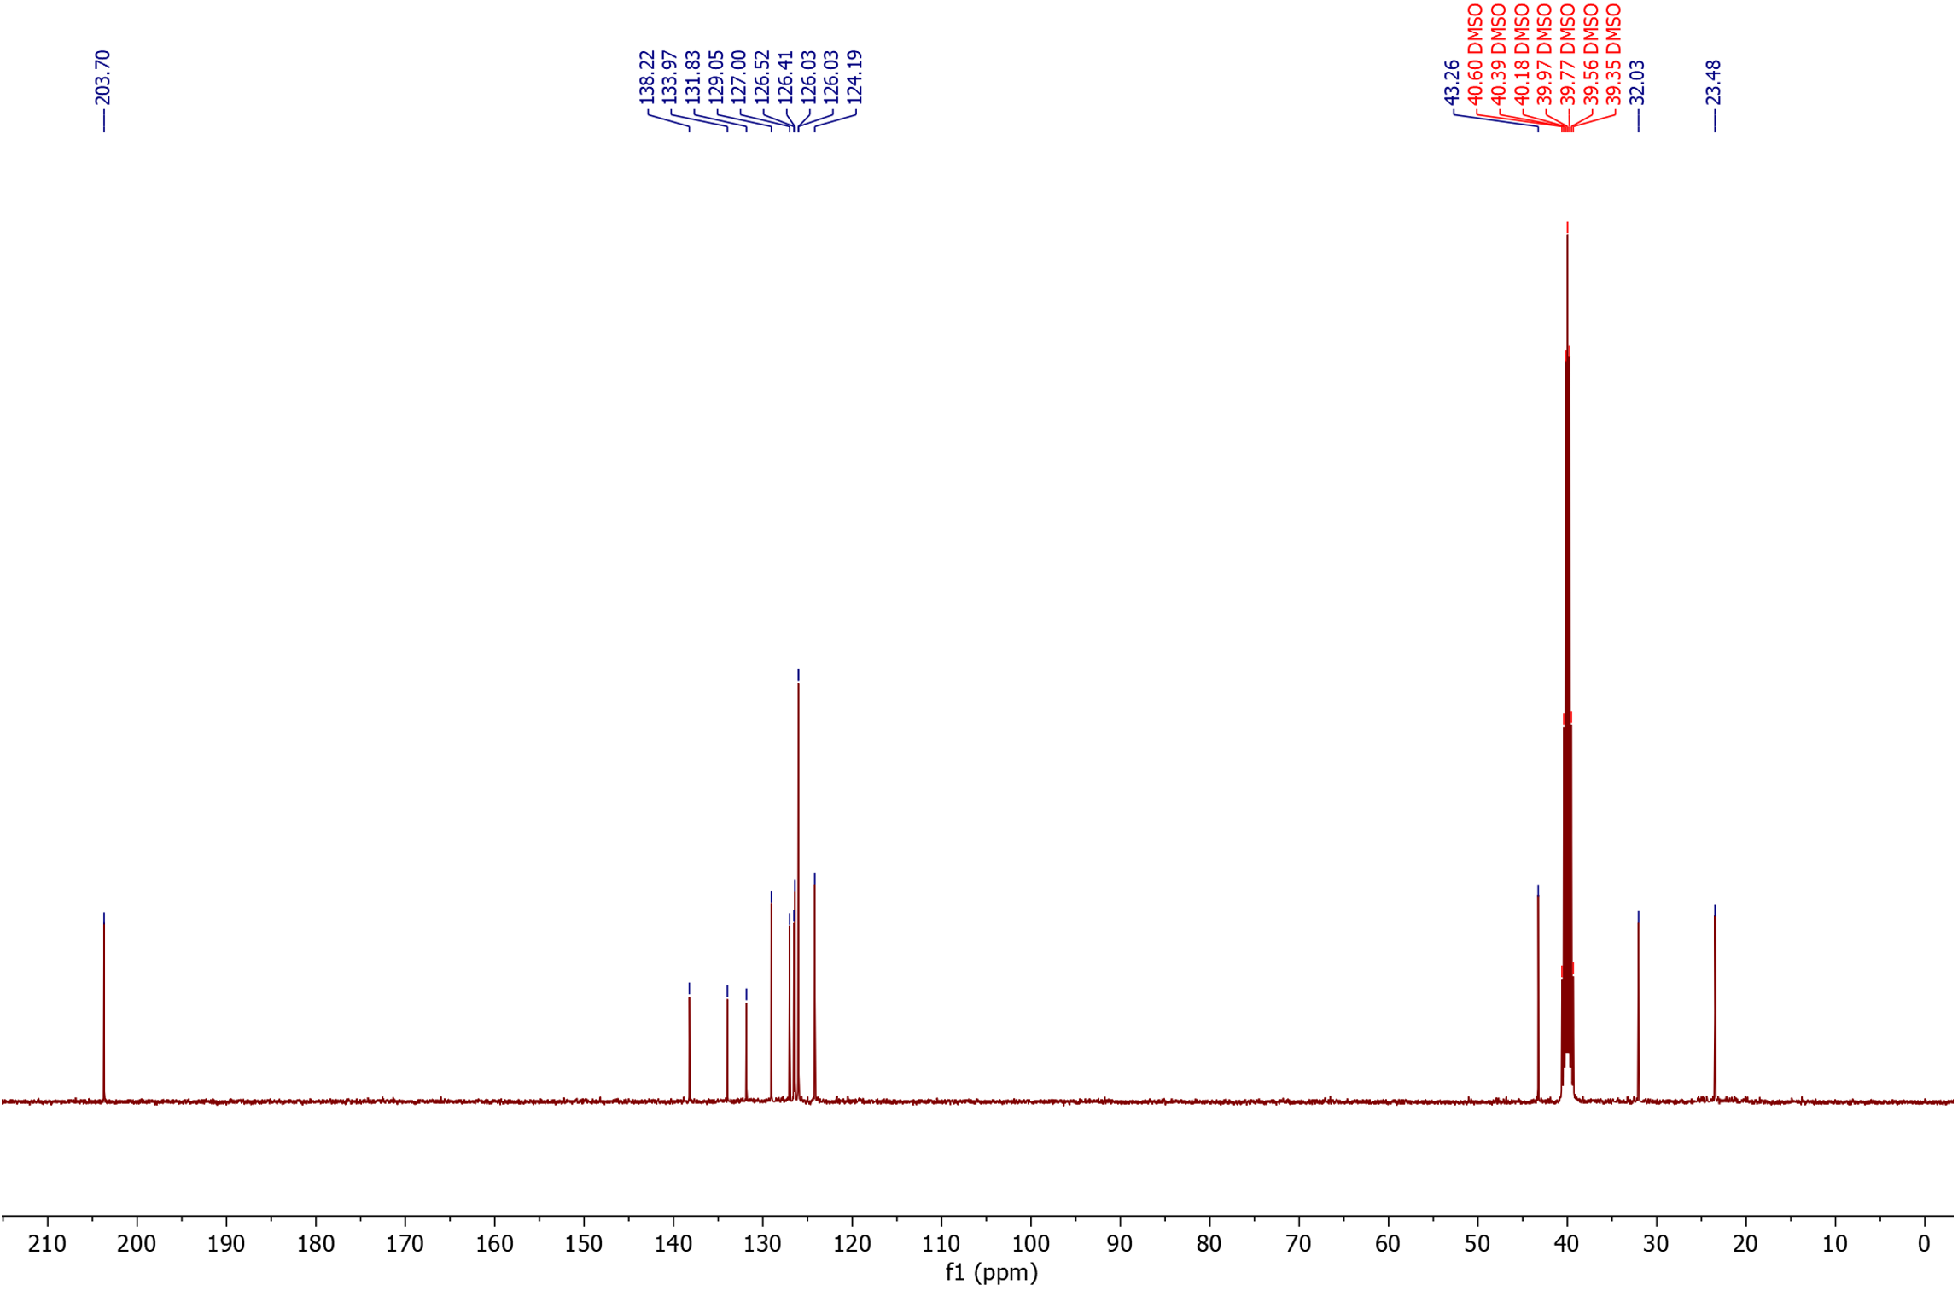
¹³C NMR

3-(cyclohex-3-en-1-yl)propanal (30) (isolated product)
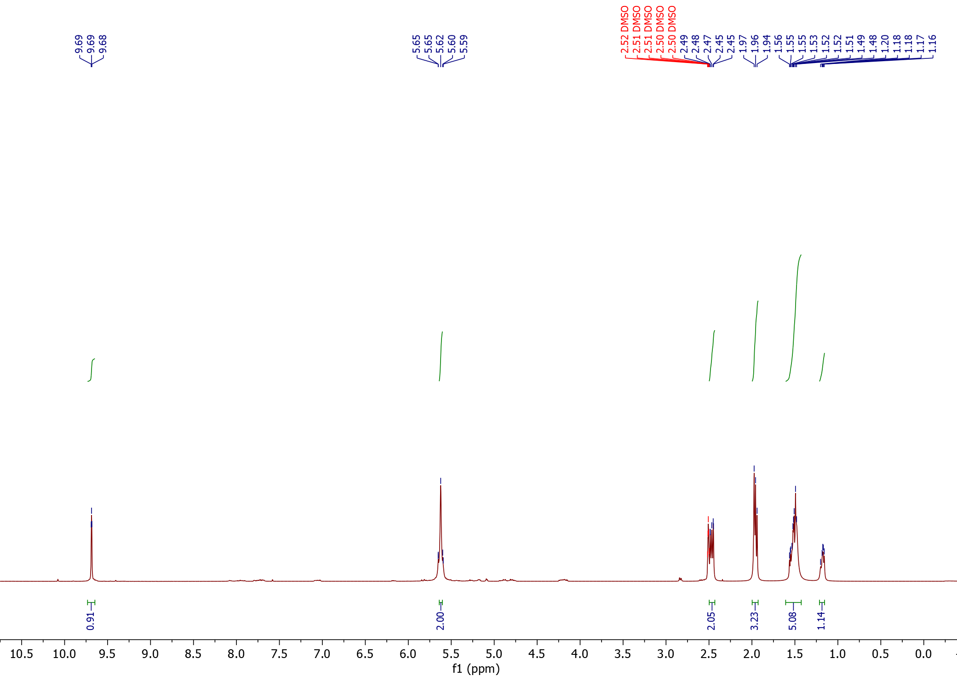
¹H NMR

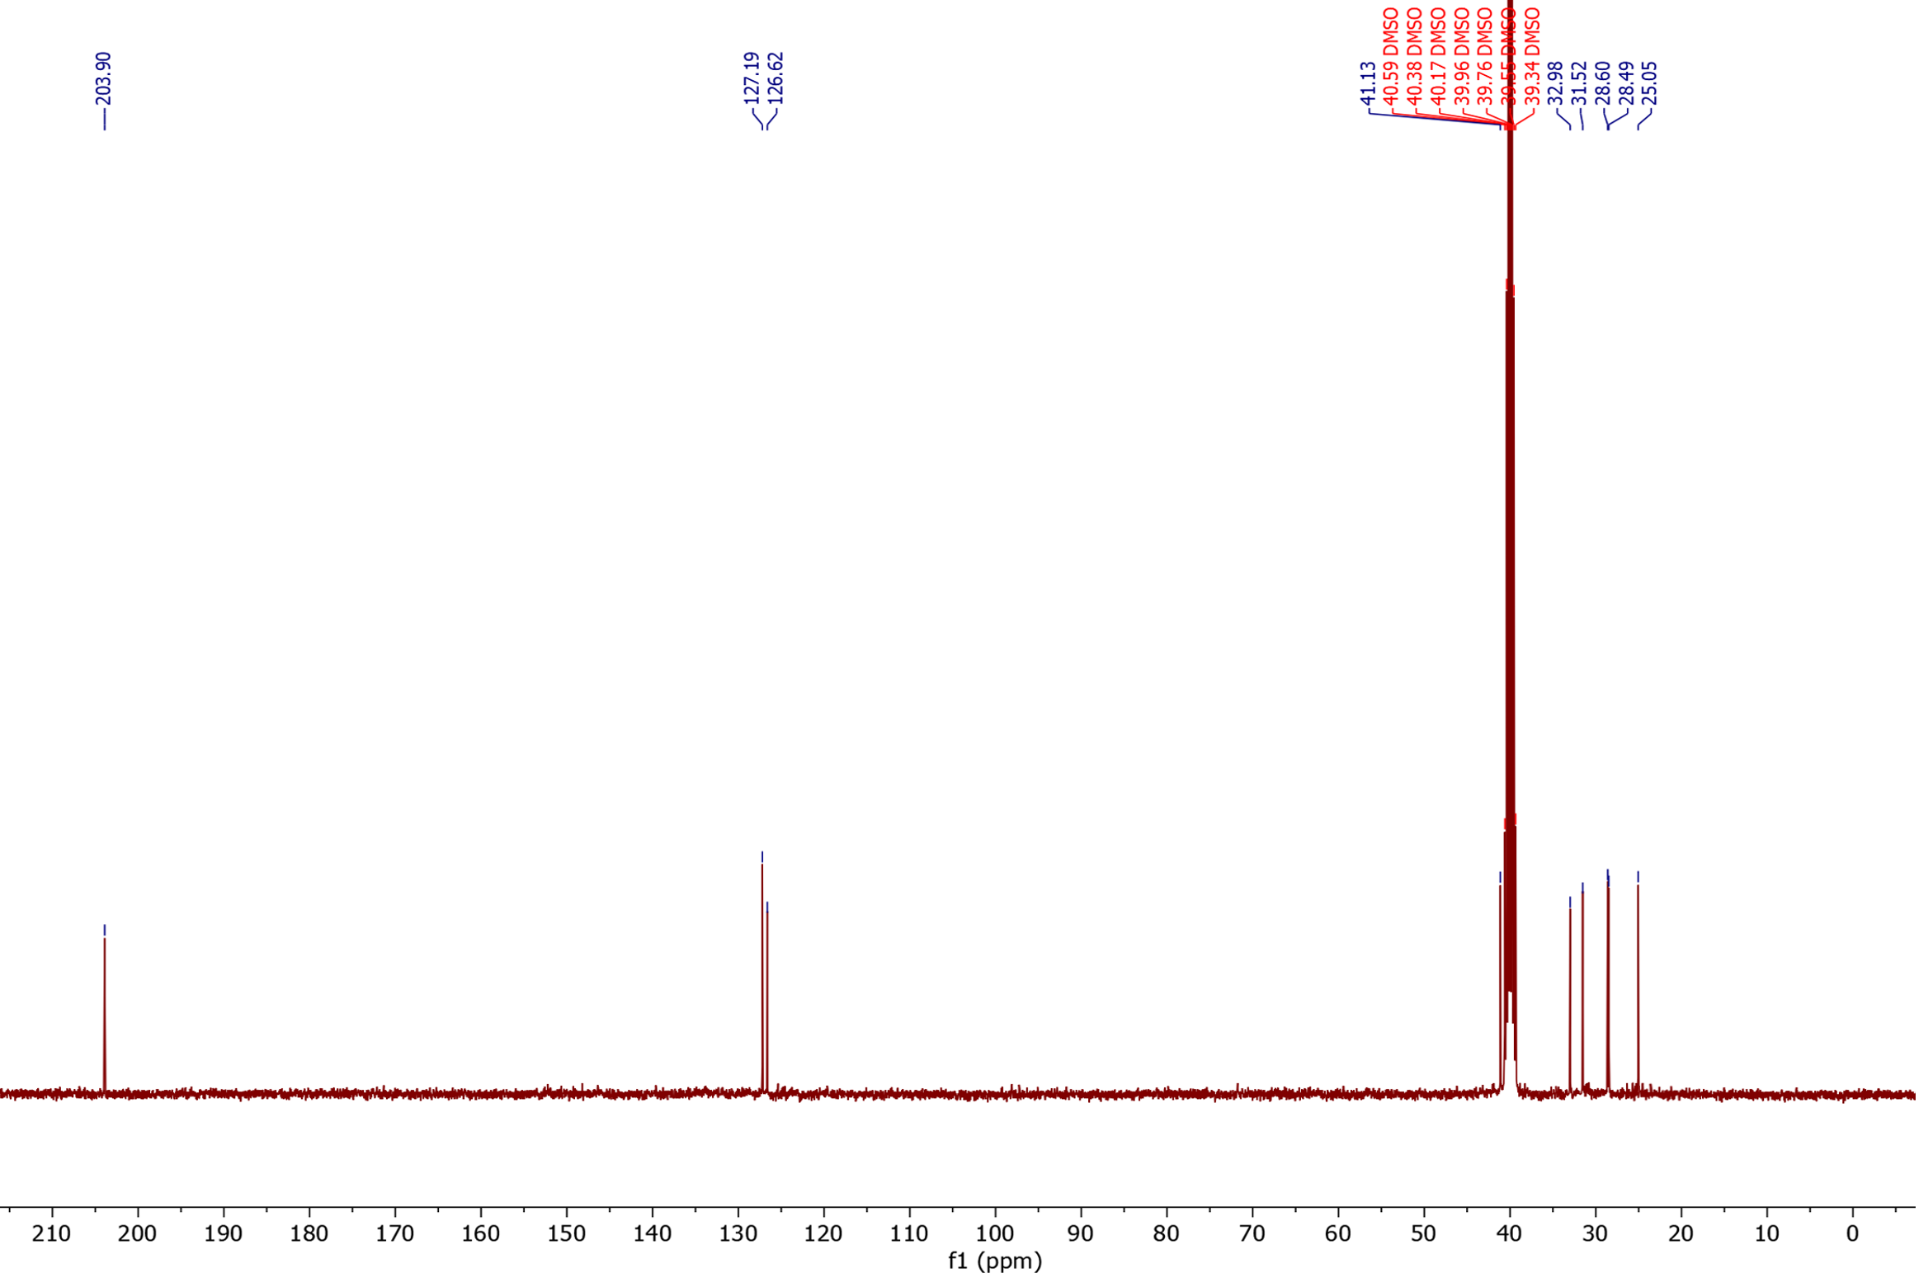
¹³C NMR

4-phenoxybutanal (31) (isolated product)
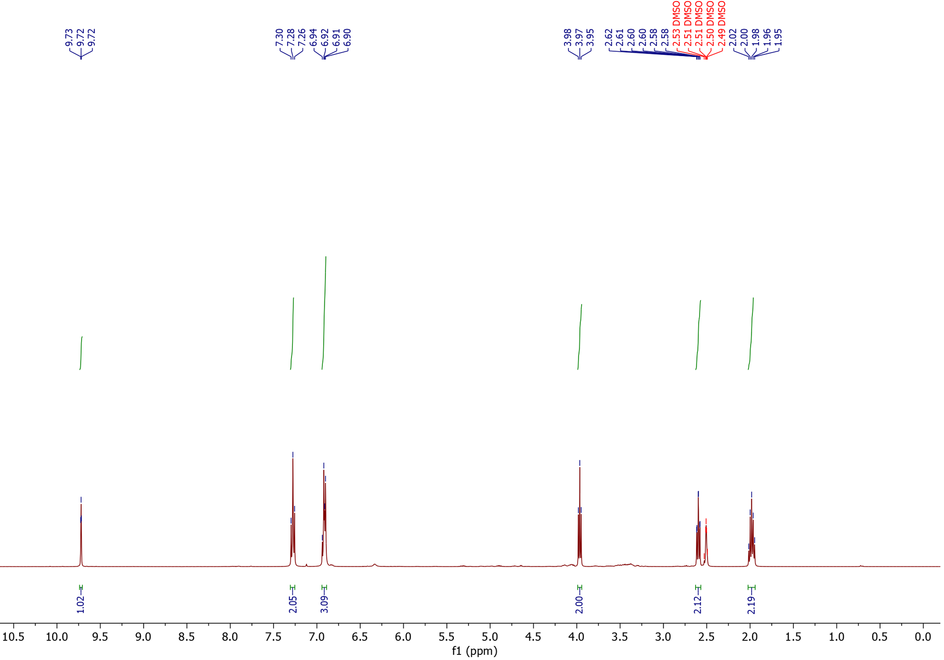
¹H NMR

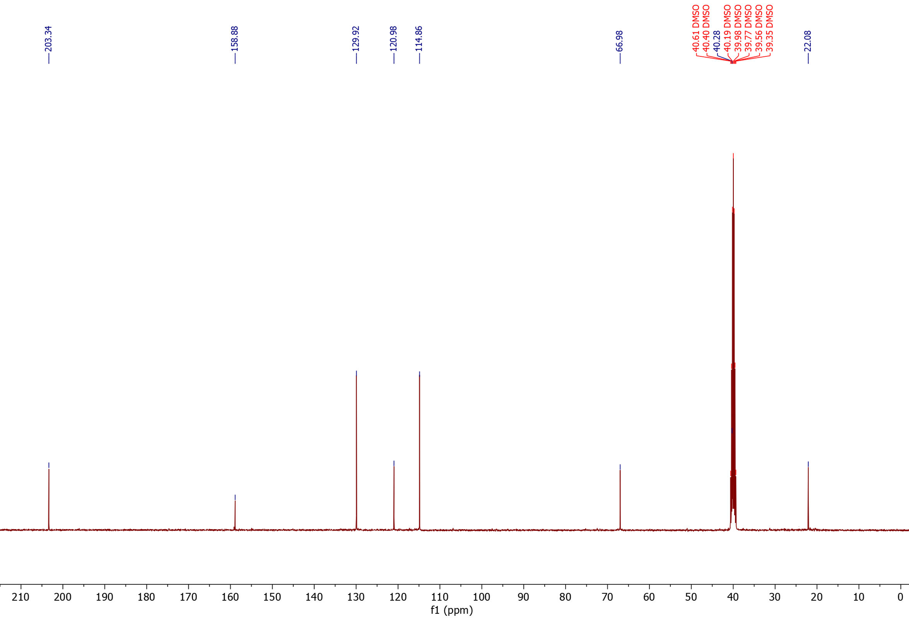
¹³C NMR

4-(3,4-dimethoxyphenyl)butanal (32) (isolated product)
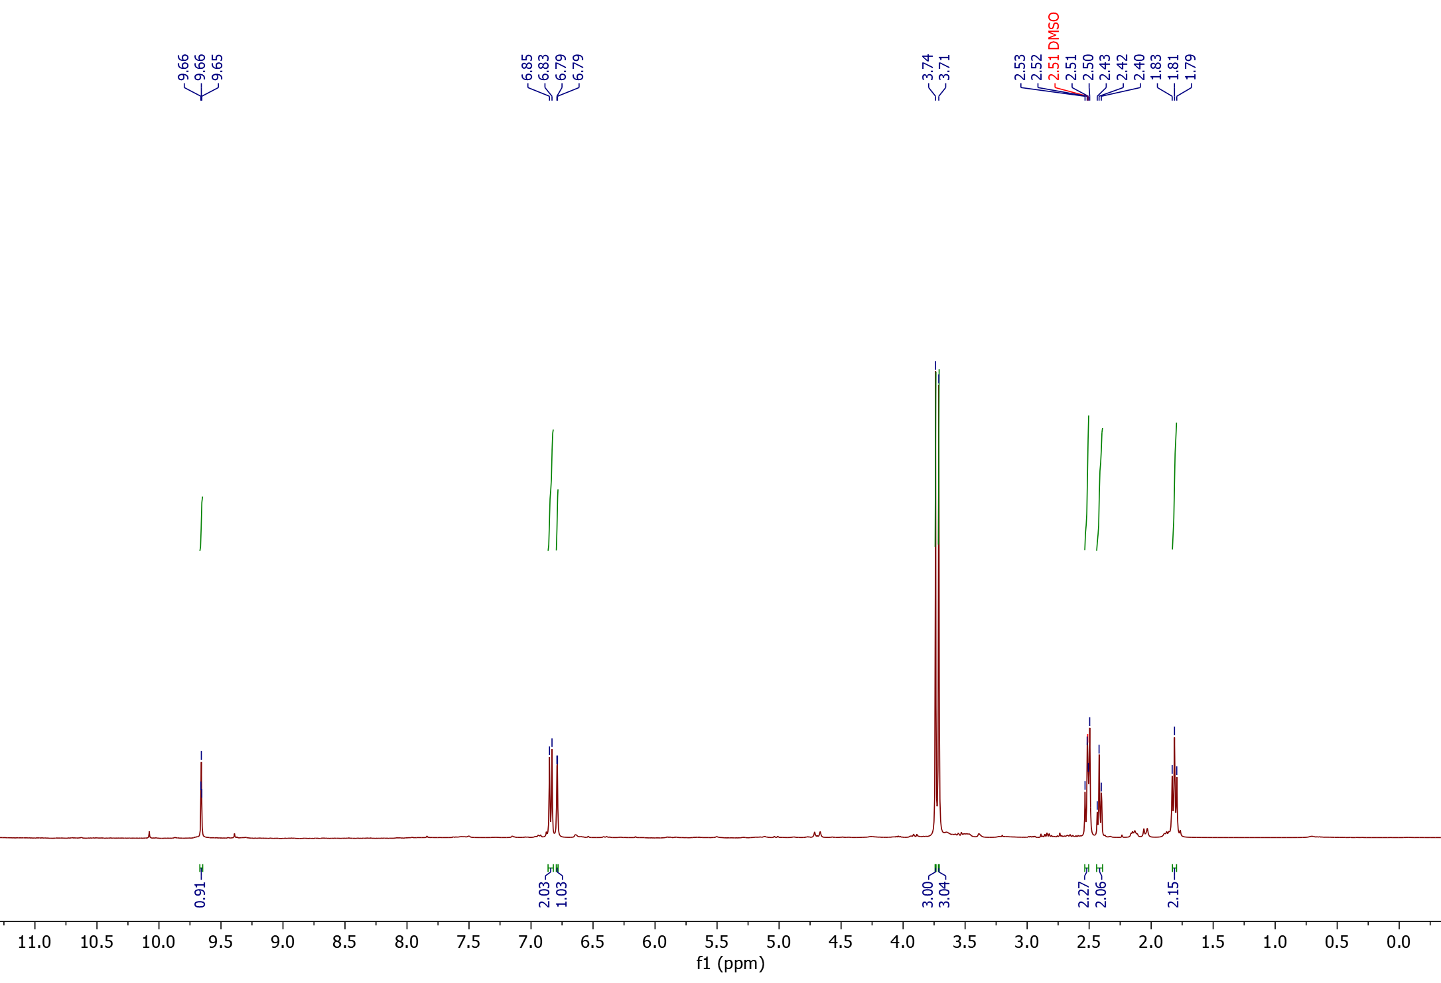
¹H NMR

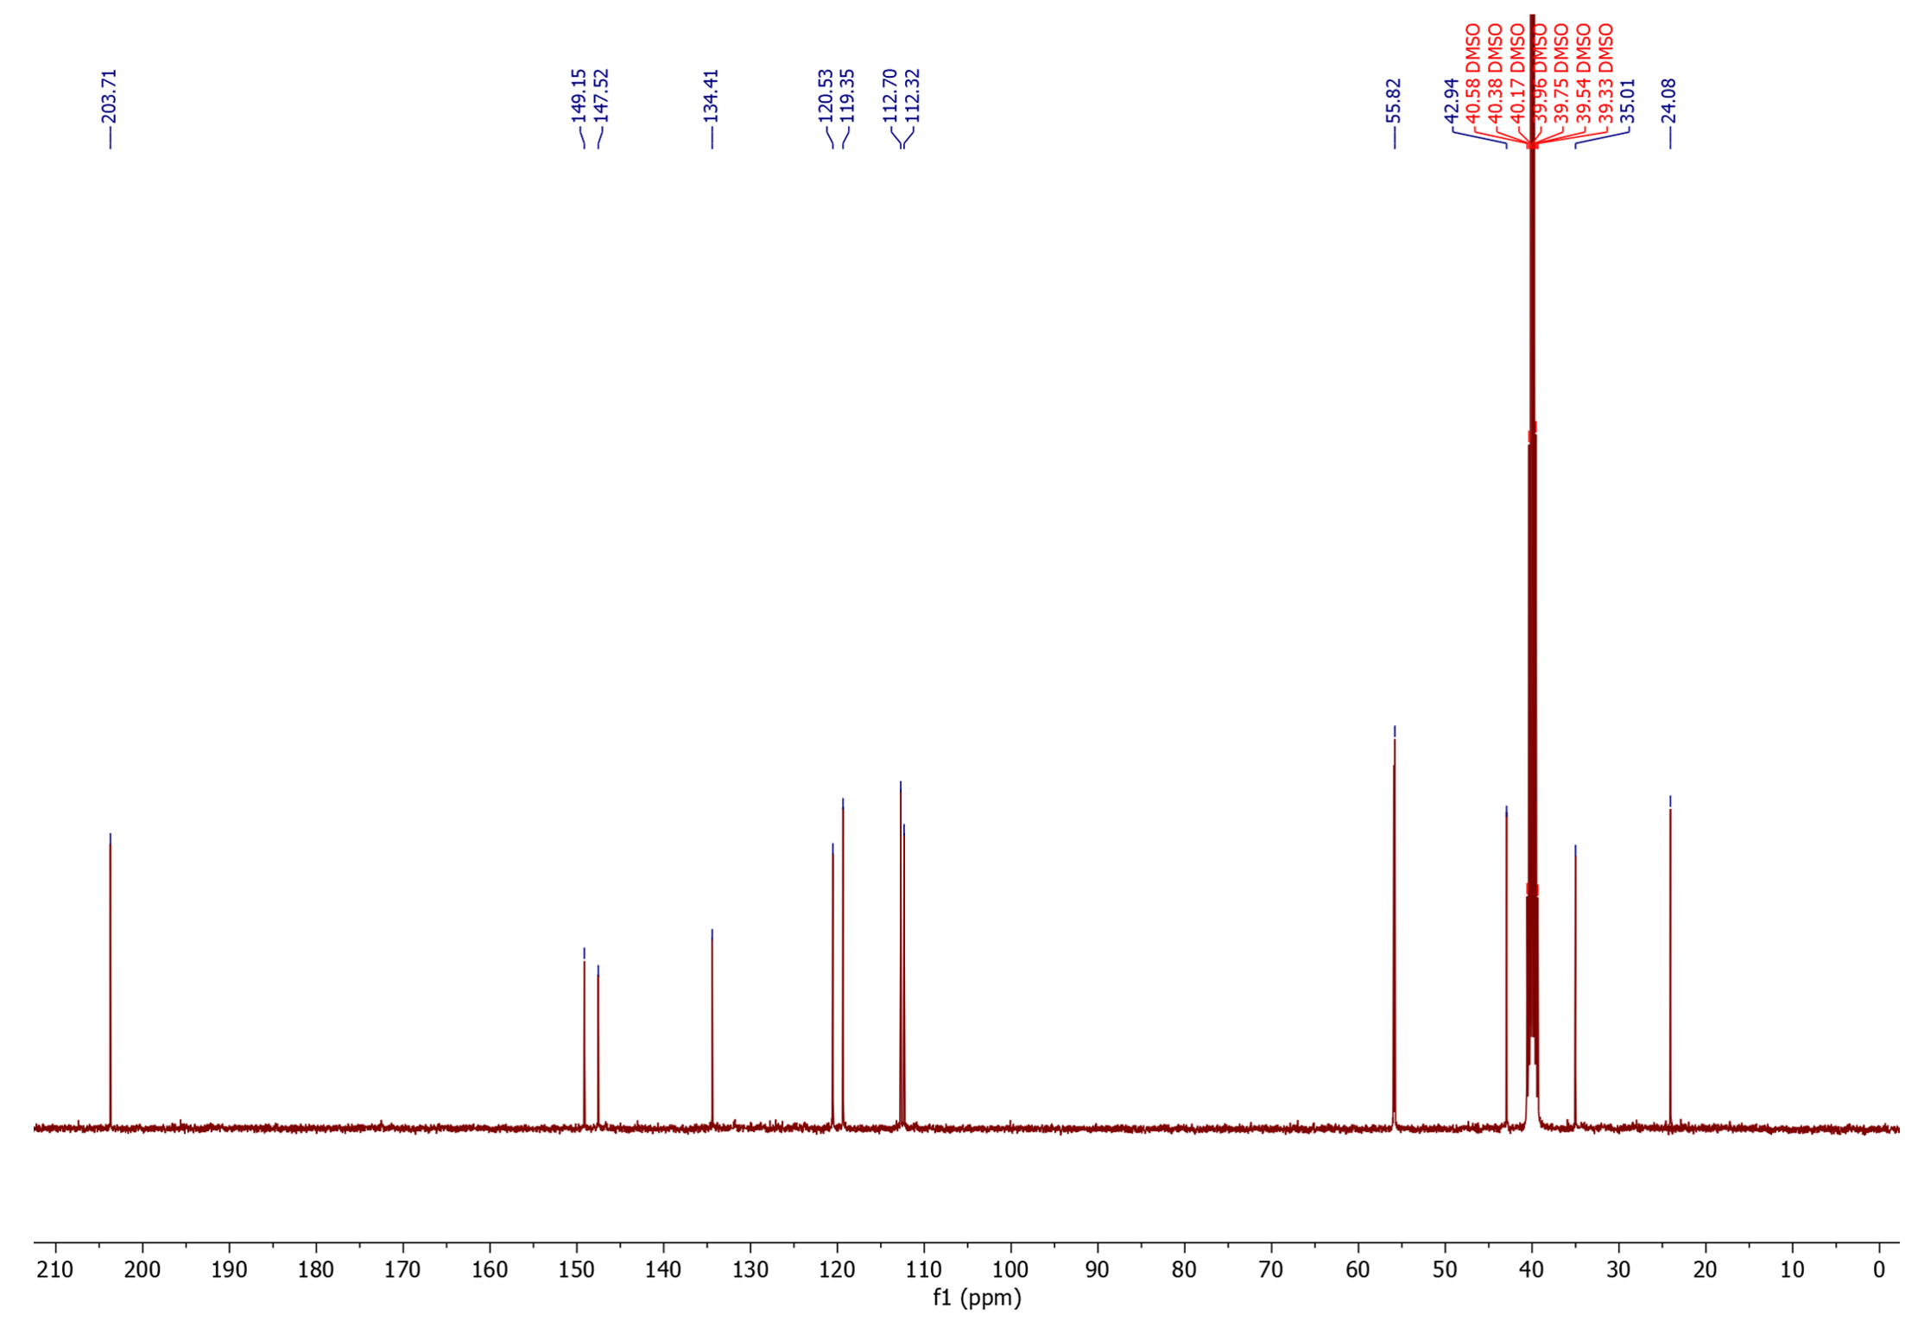
¹³C NMR

4-(2-hydroxy-3-methylphenyl)butanal (33) (isolated product)
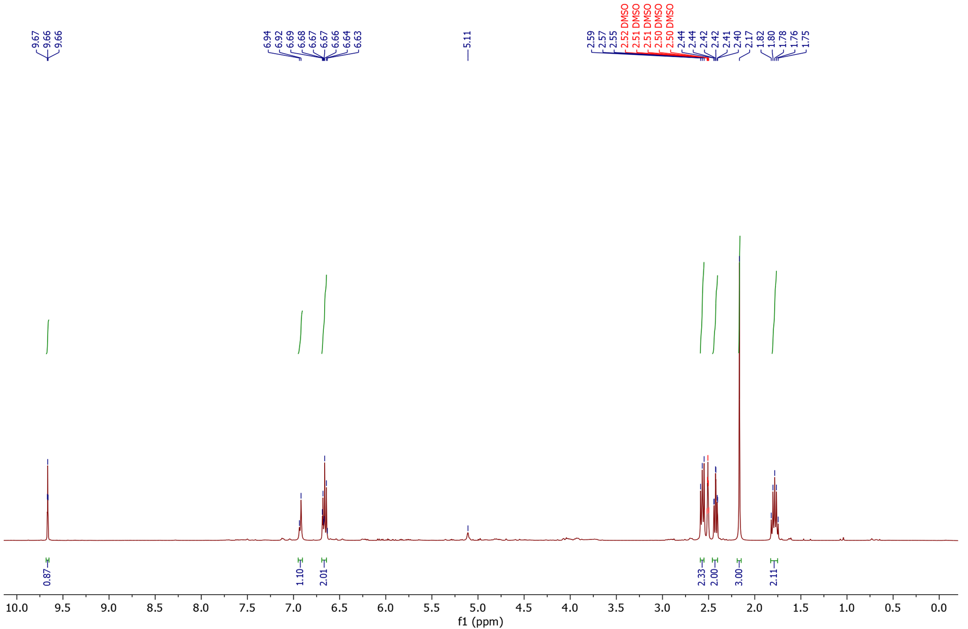
¹H NMR

¹³C NMR
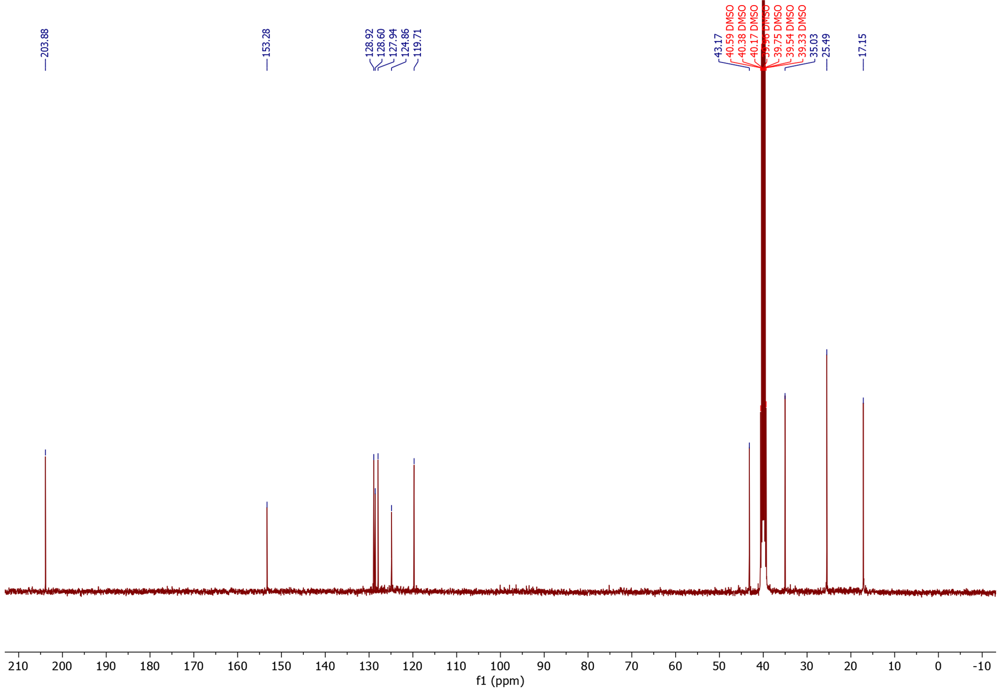

Methyl 3,3-dimethyl-6-oxohexanoate (34) (isolated product)

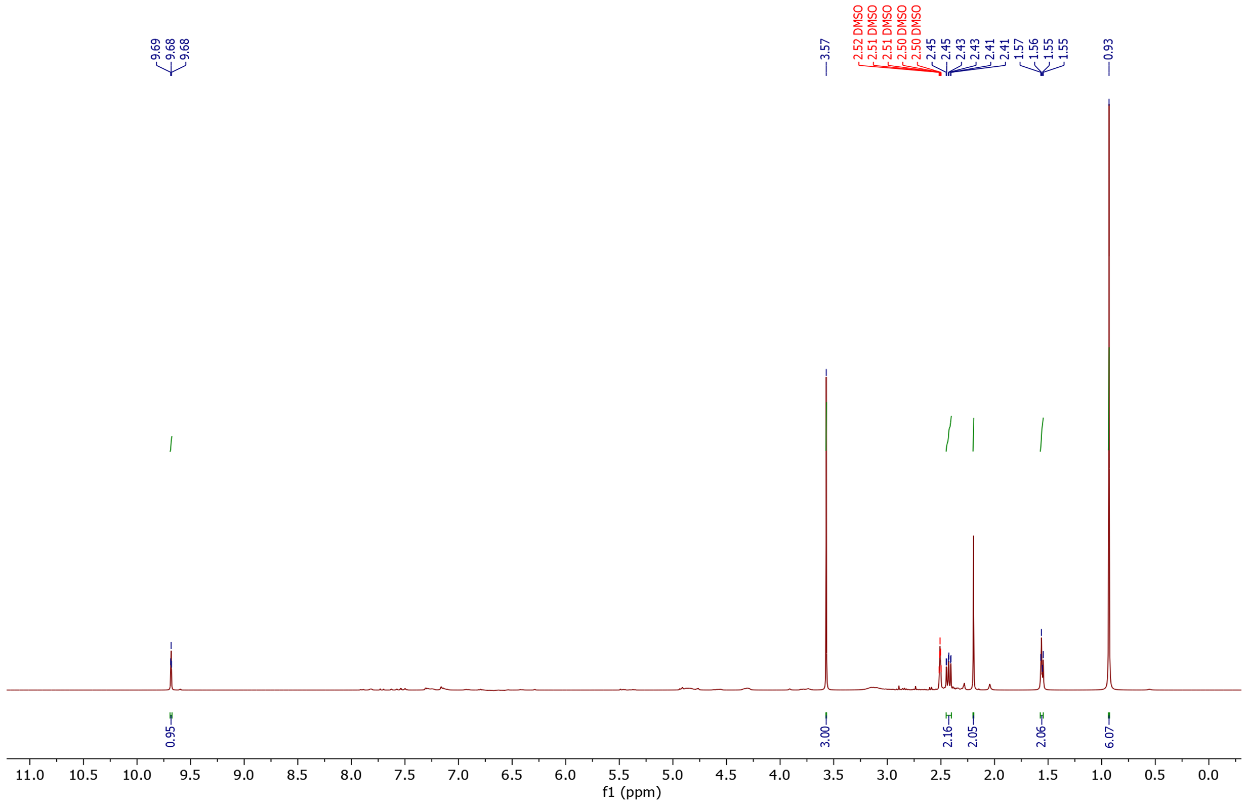
¹H NMR

¹³C NMR
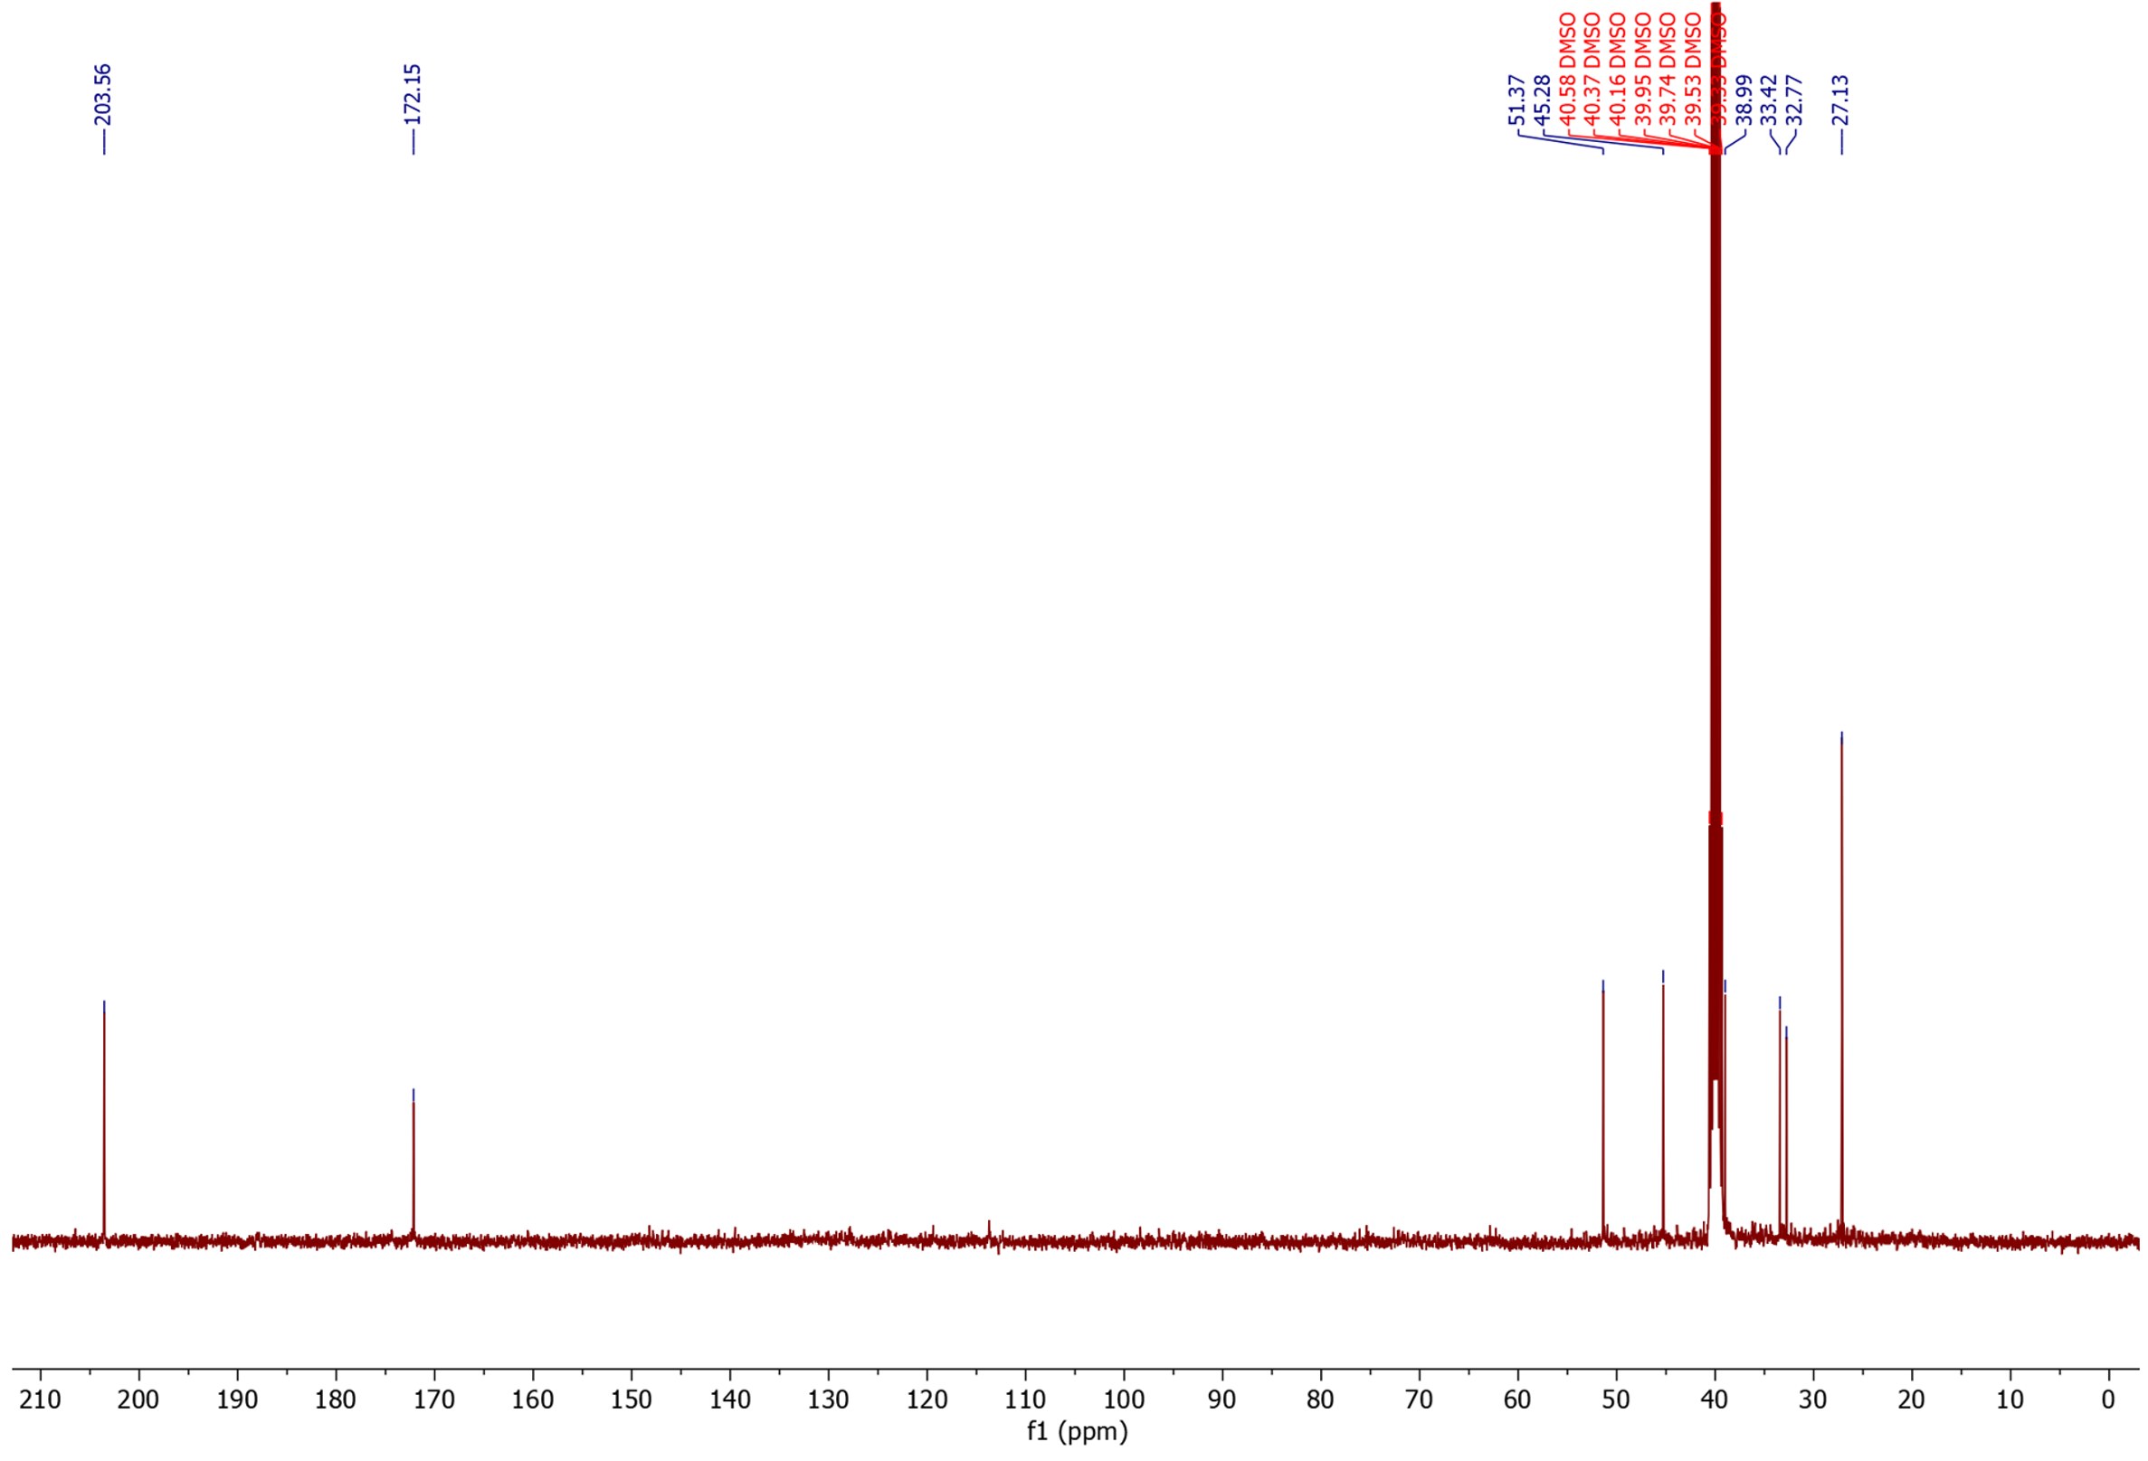

1-(butan-4-al)-2,4-imidazolidinedione (35) (isolated product)
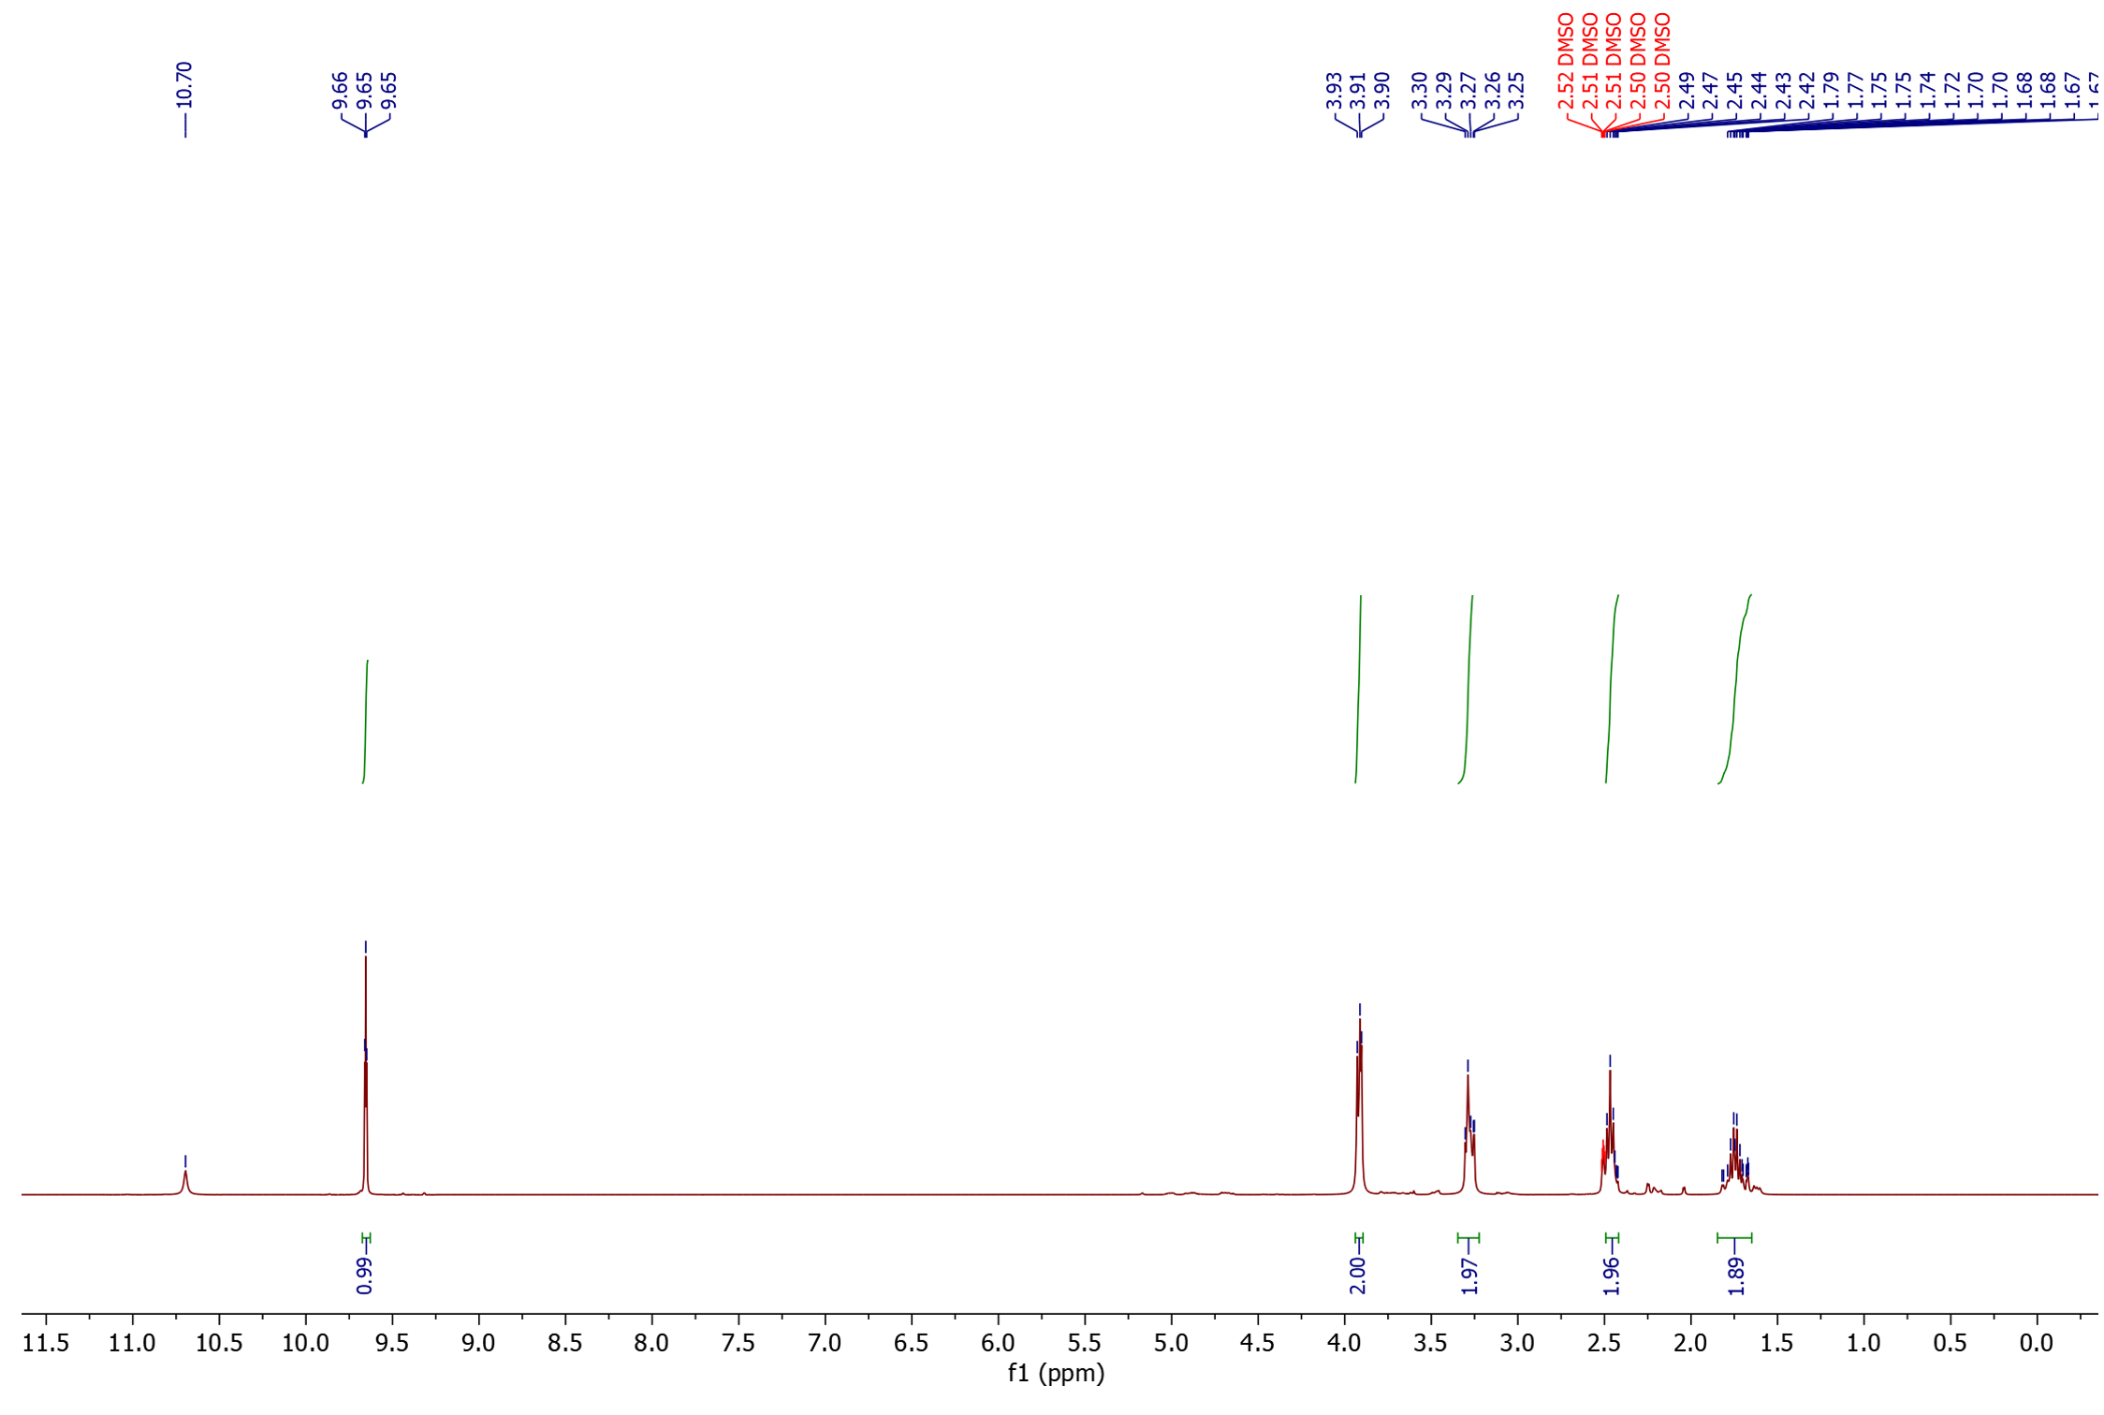
¹H NMR

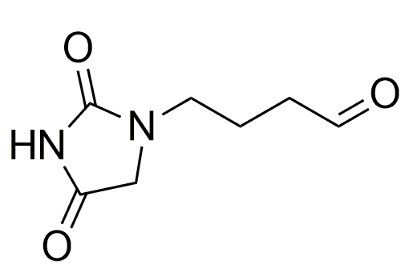

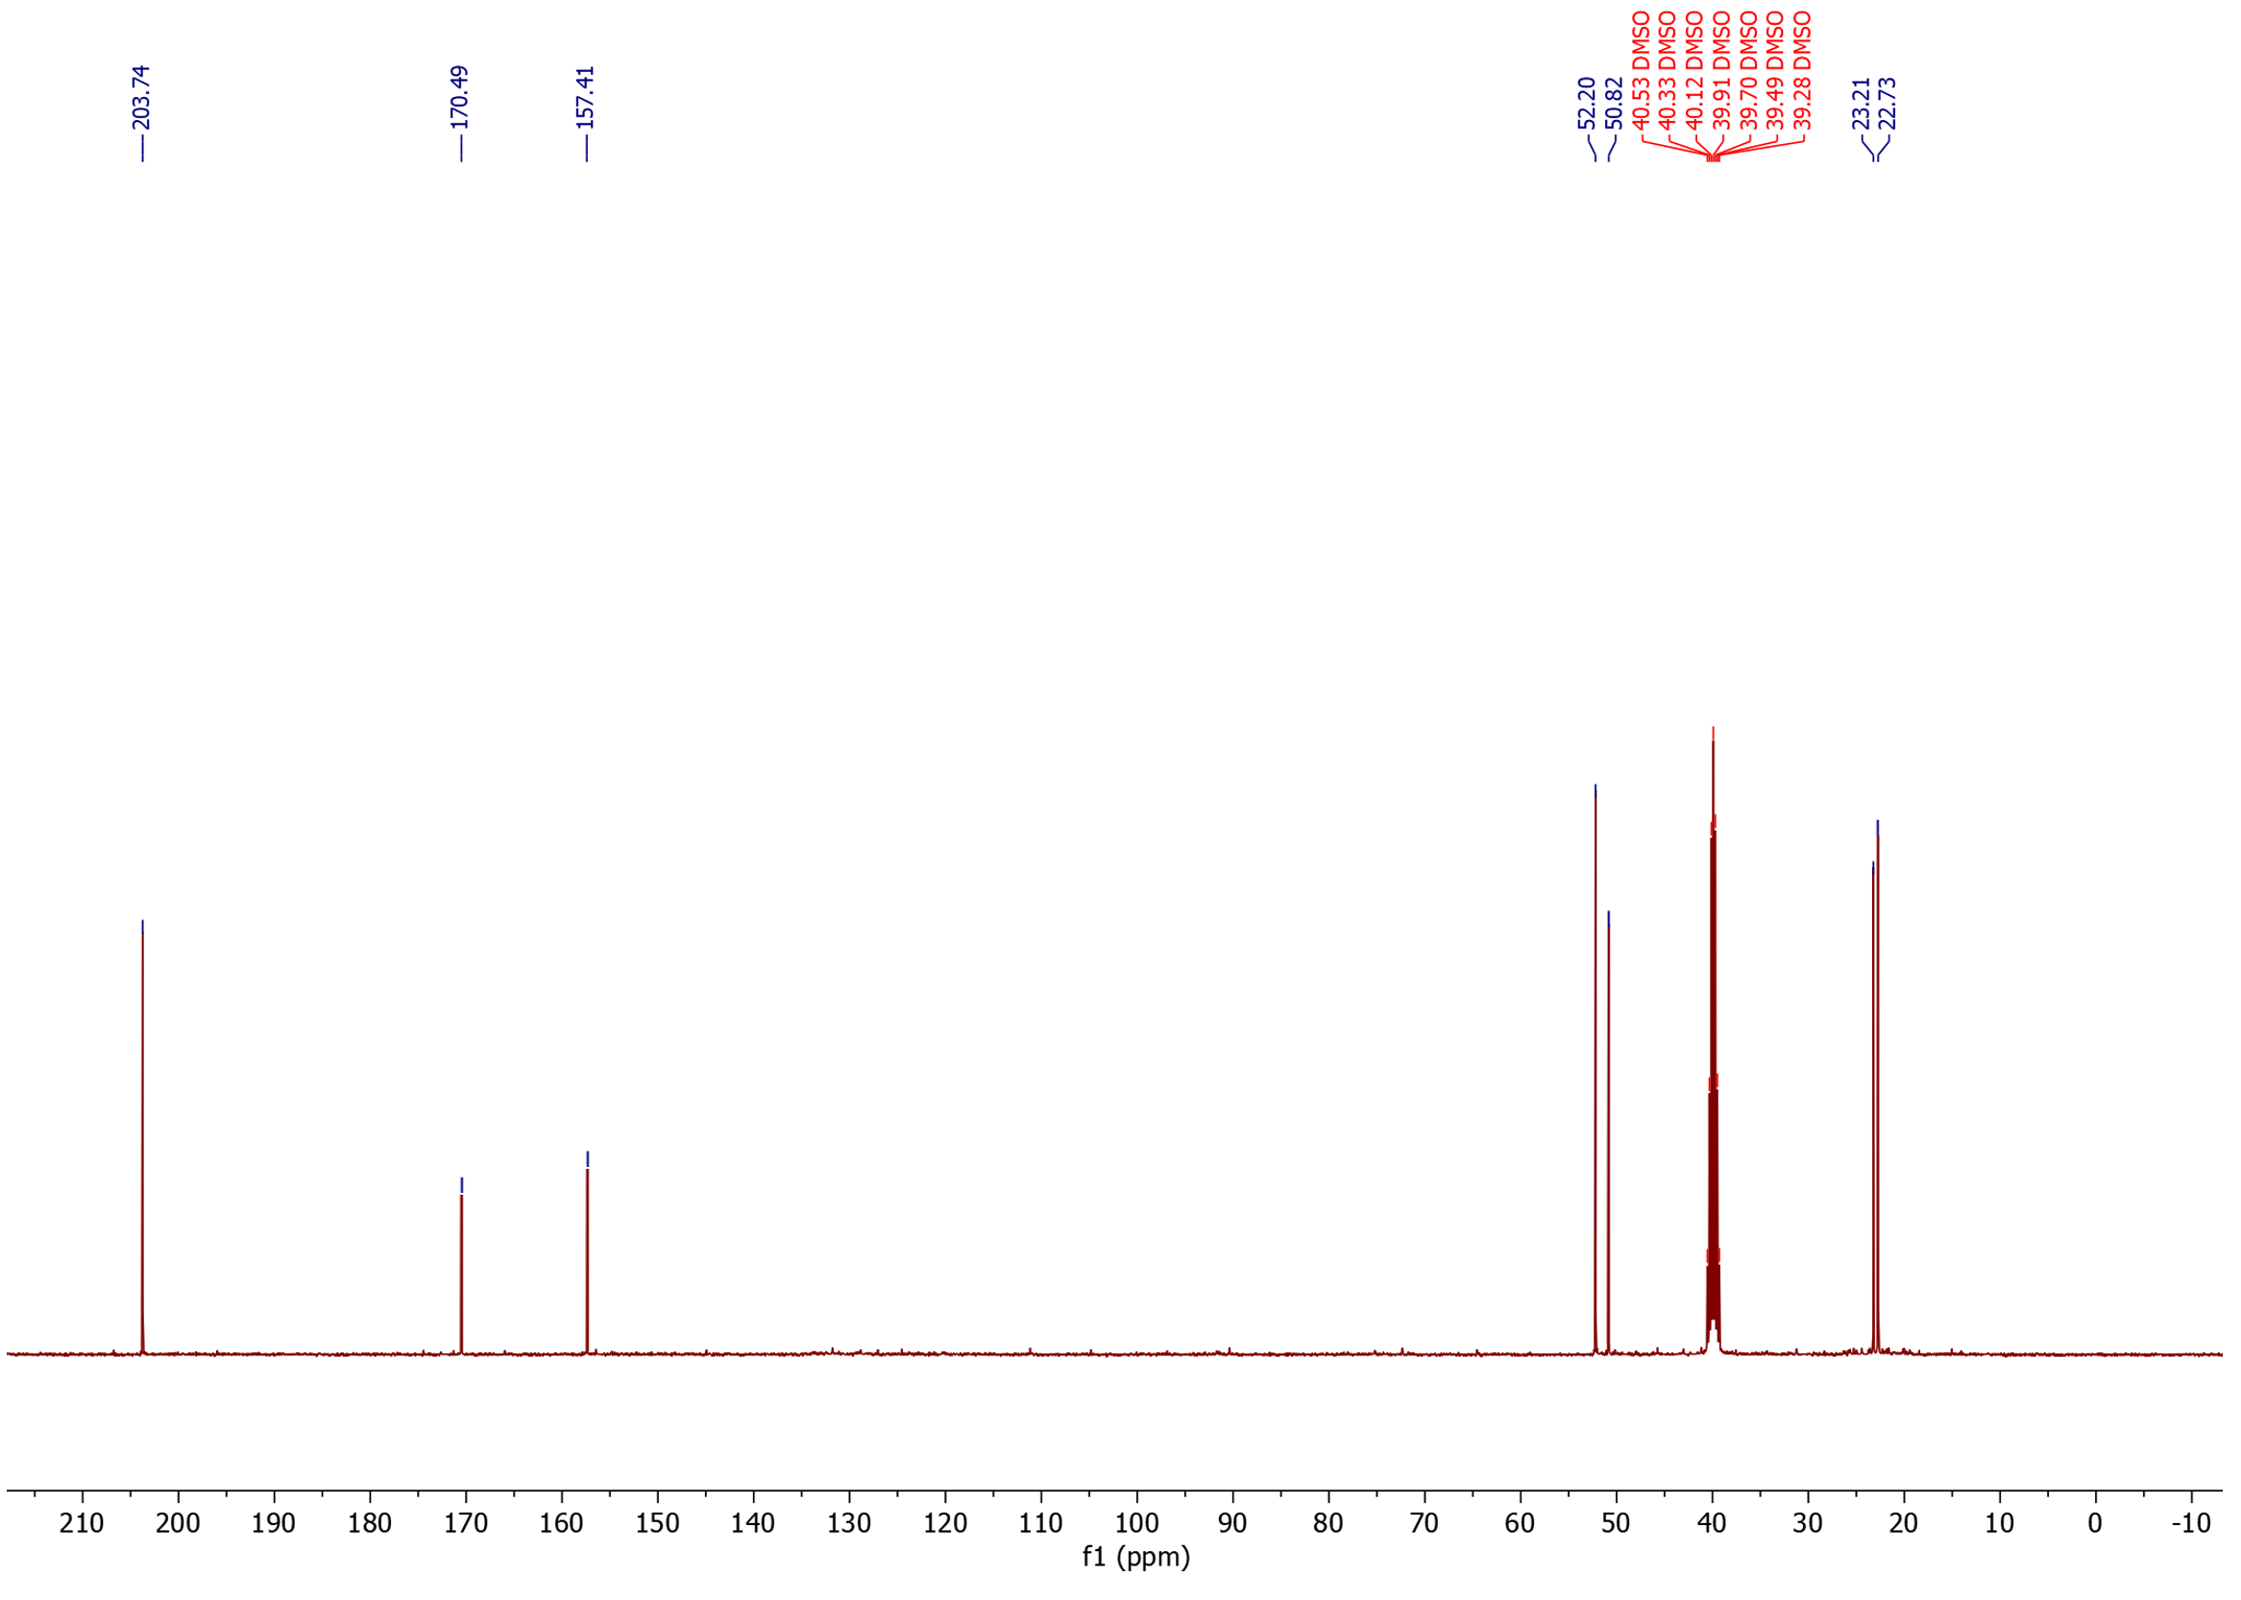
¹³C NMR

4,4,5,5-Tetramethyl-1,3,2-dioxaborolane-2-propanal (36) (isolated product)

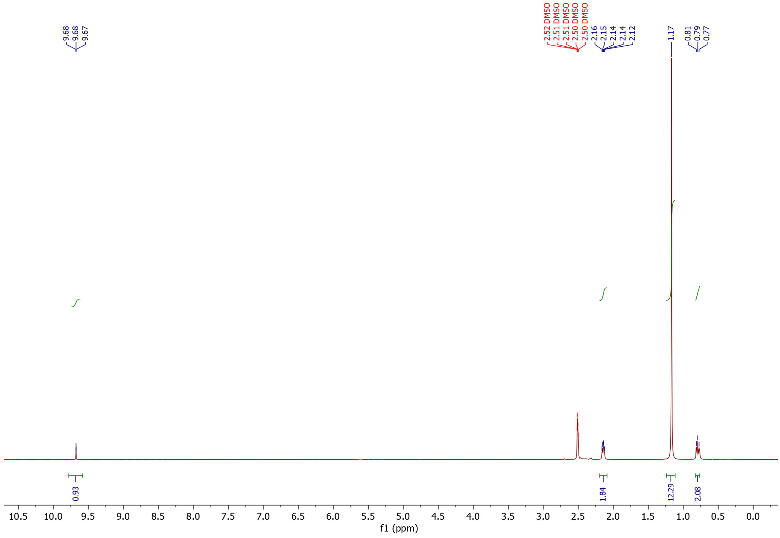
¹H NMR

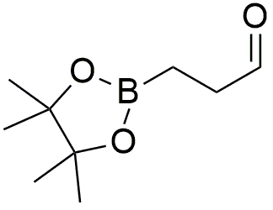

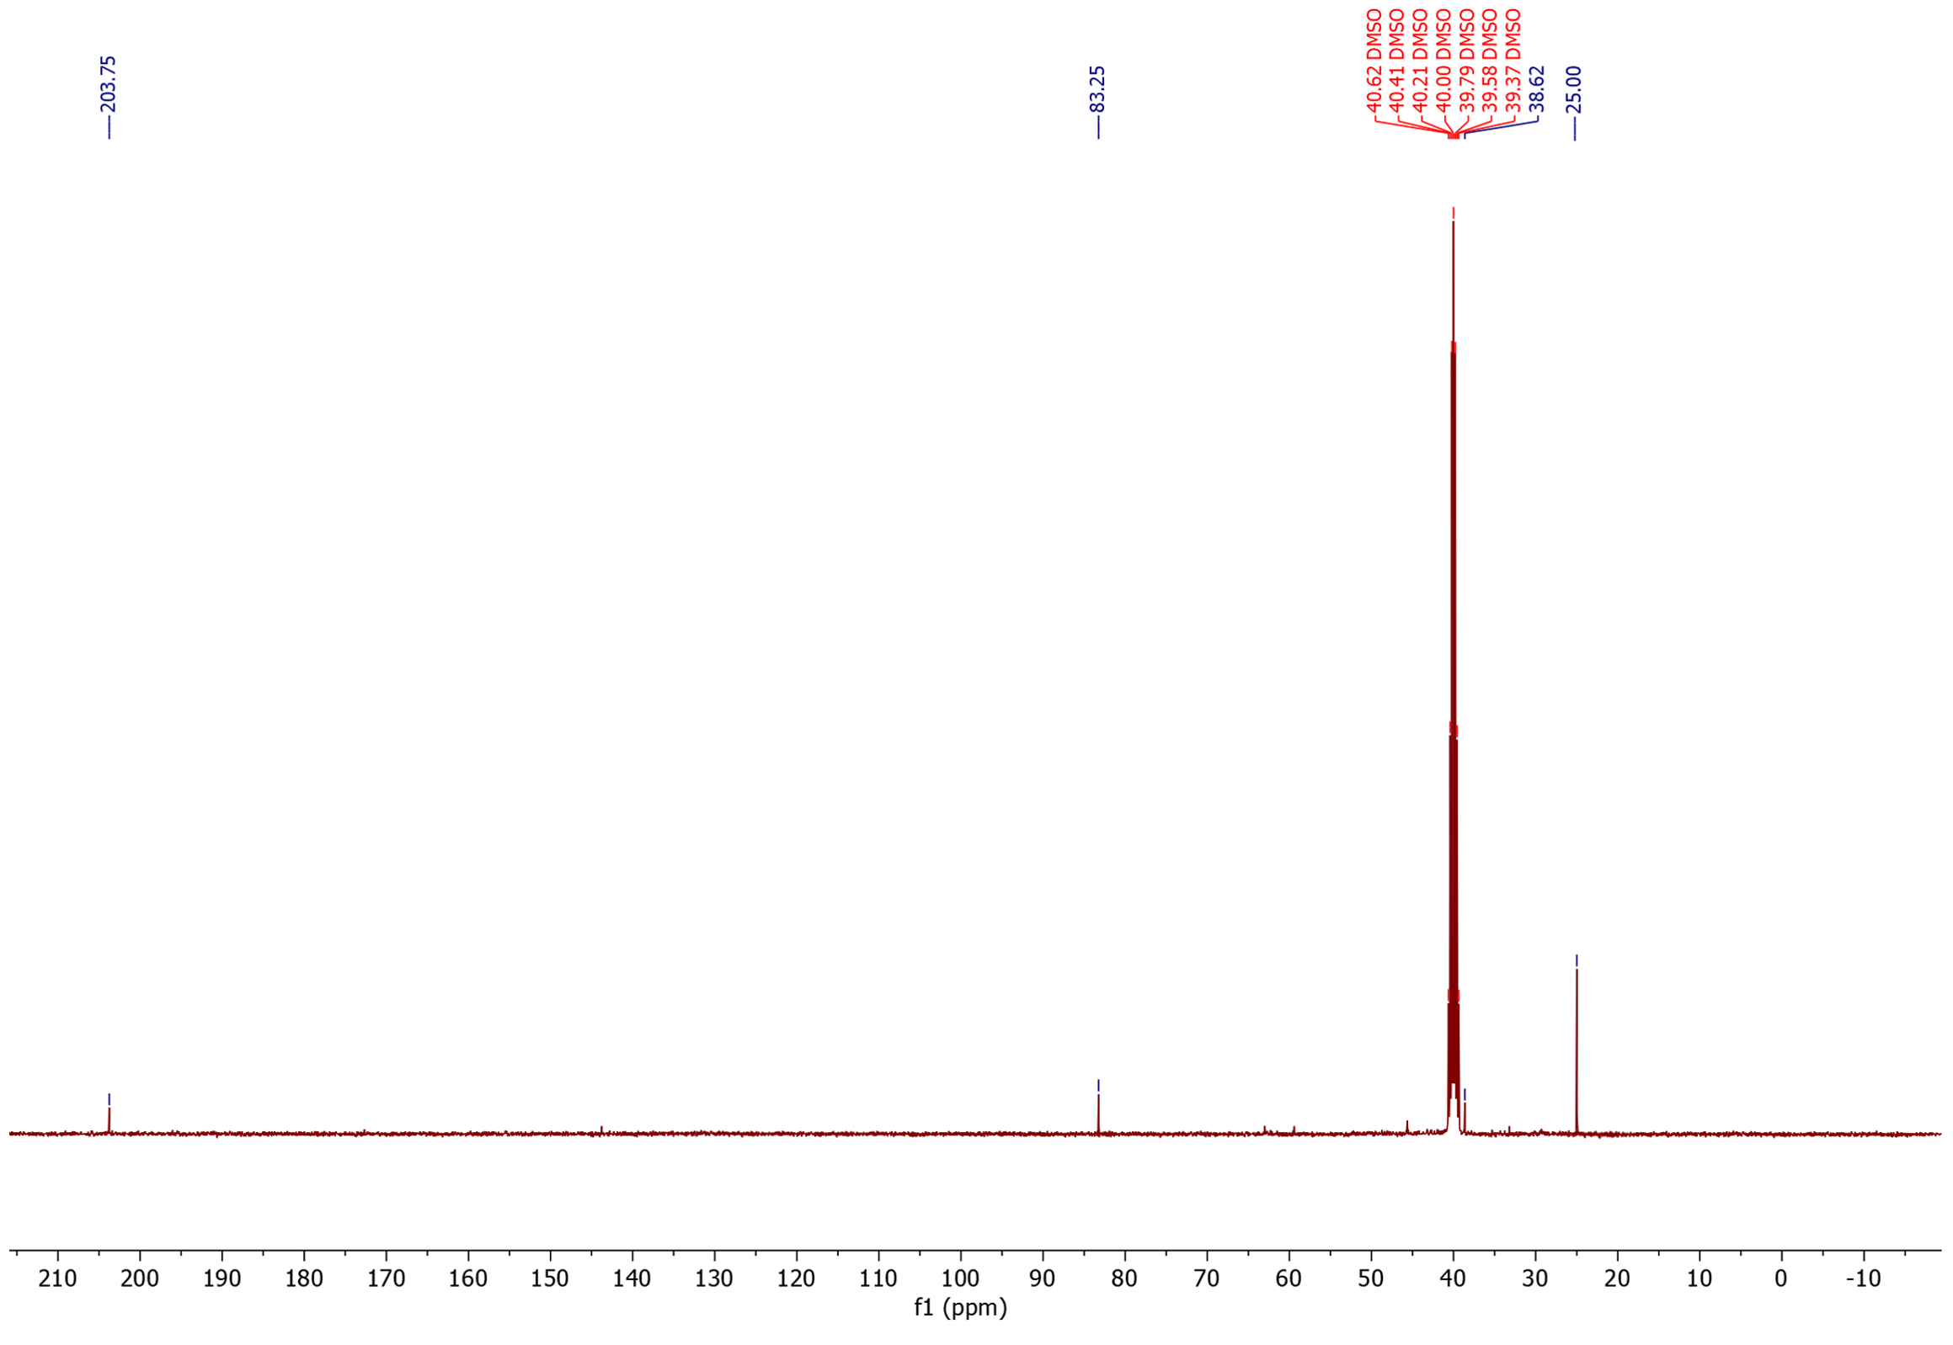
¹³C NMR

3-(dimethylphenylsilyl)propanal (37)
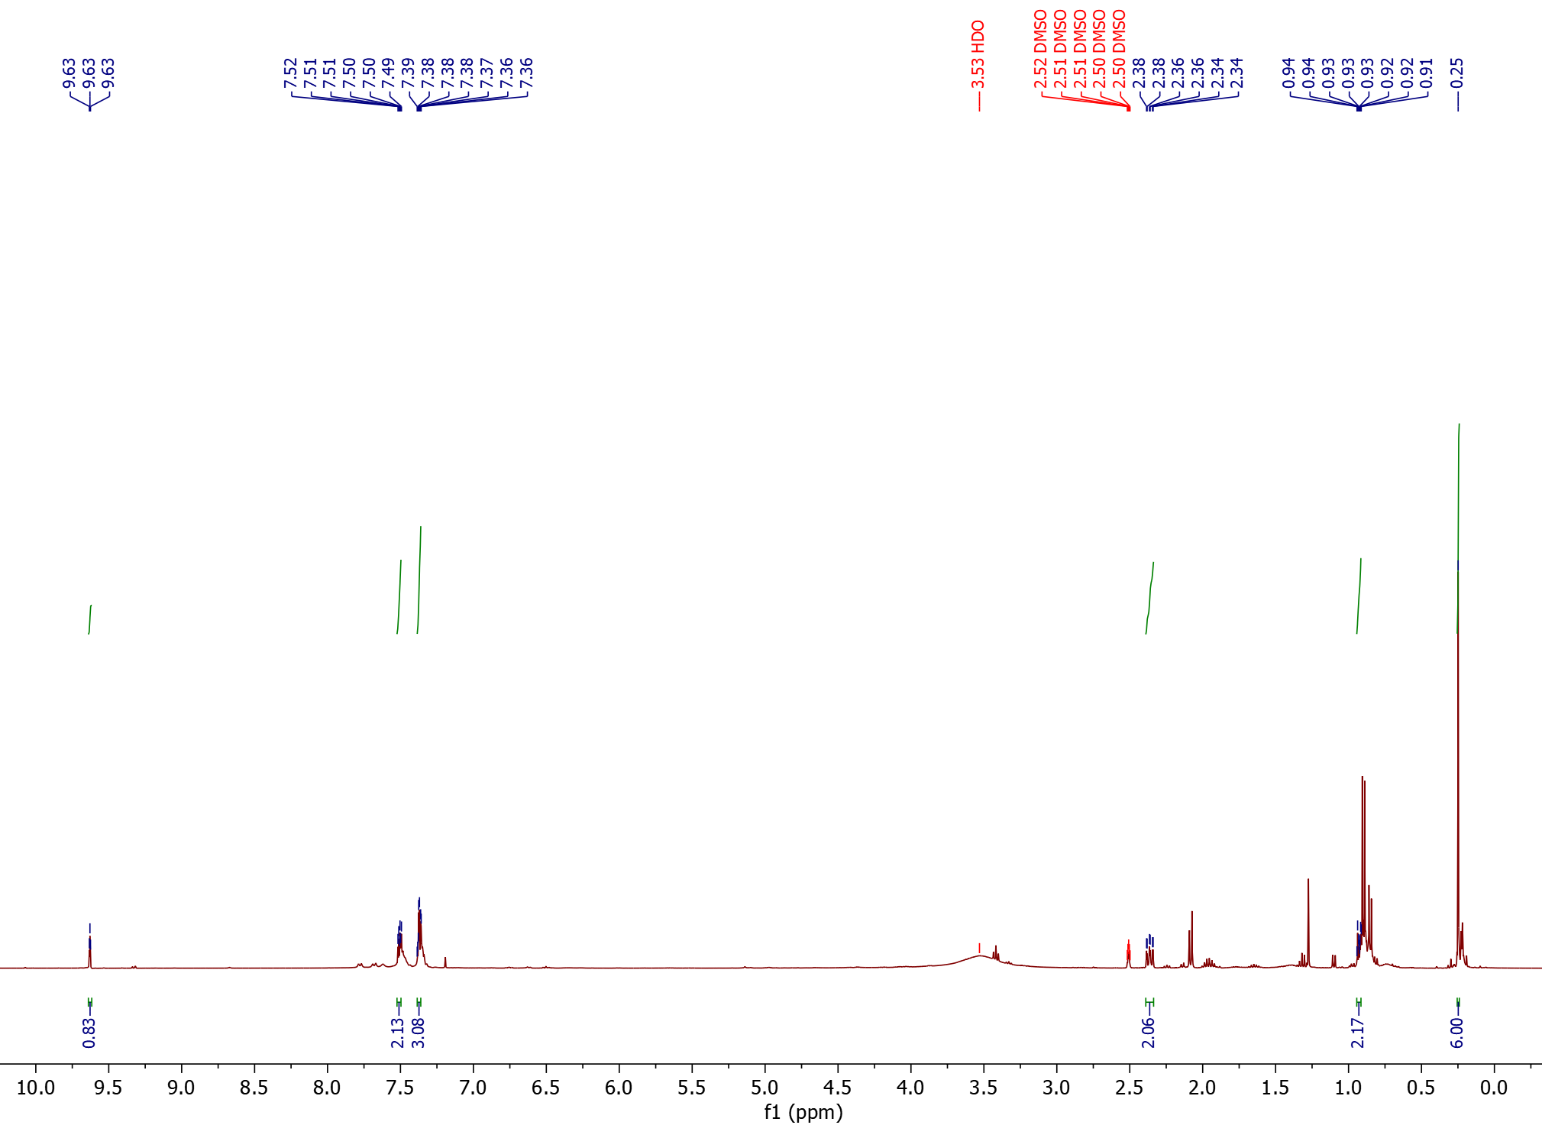
¹H NMR

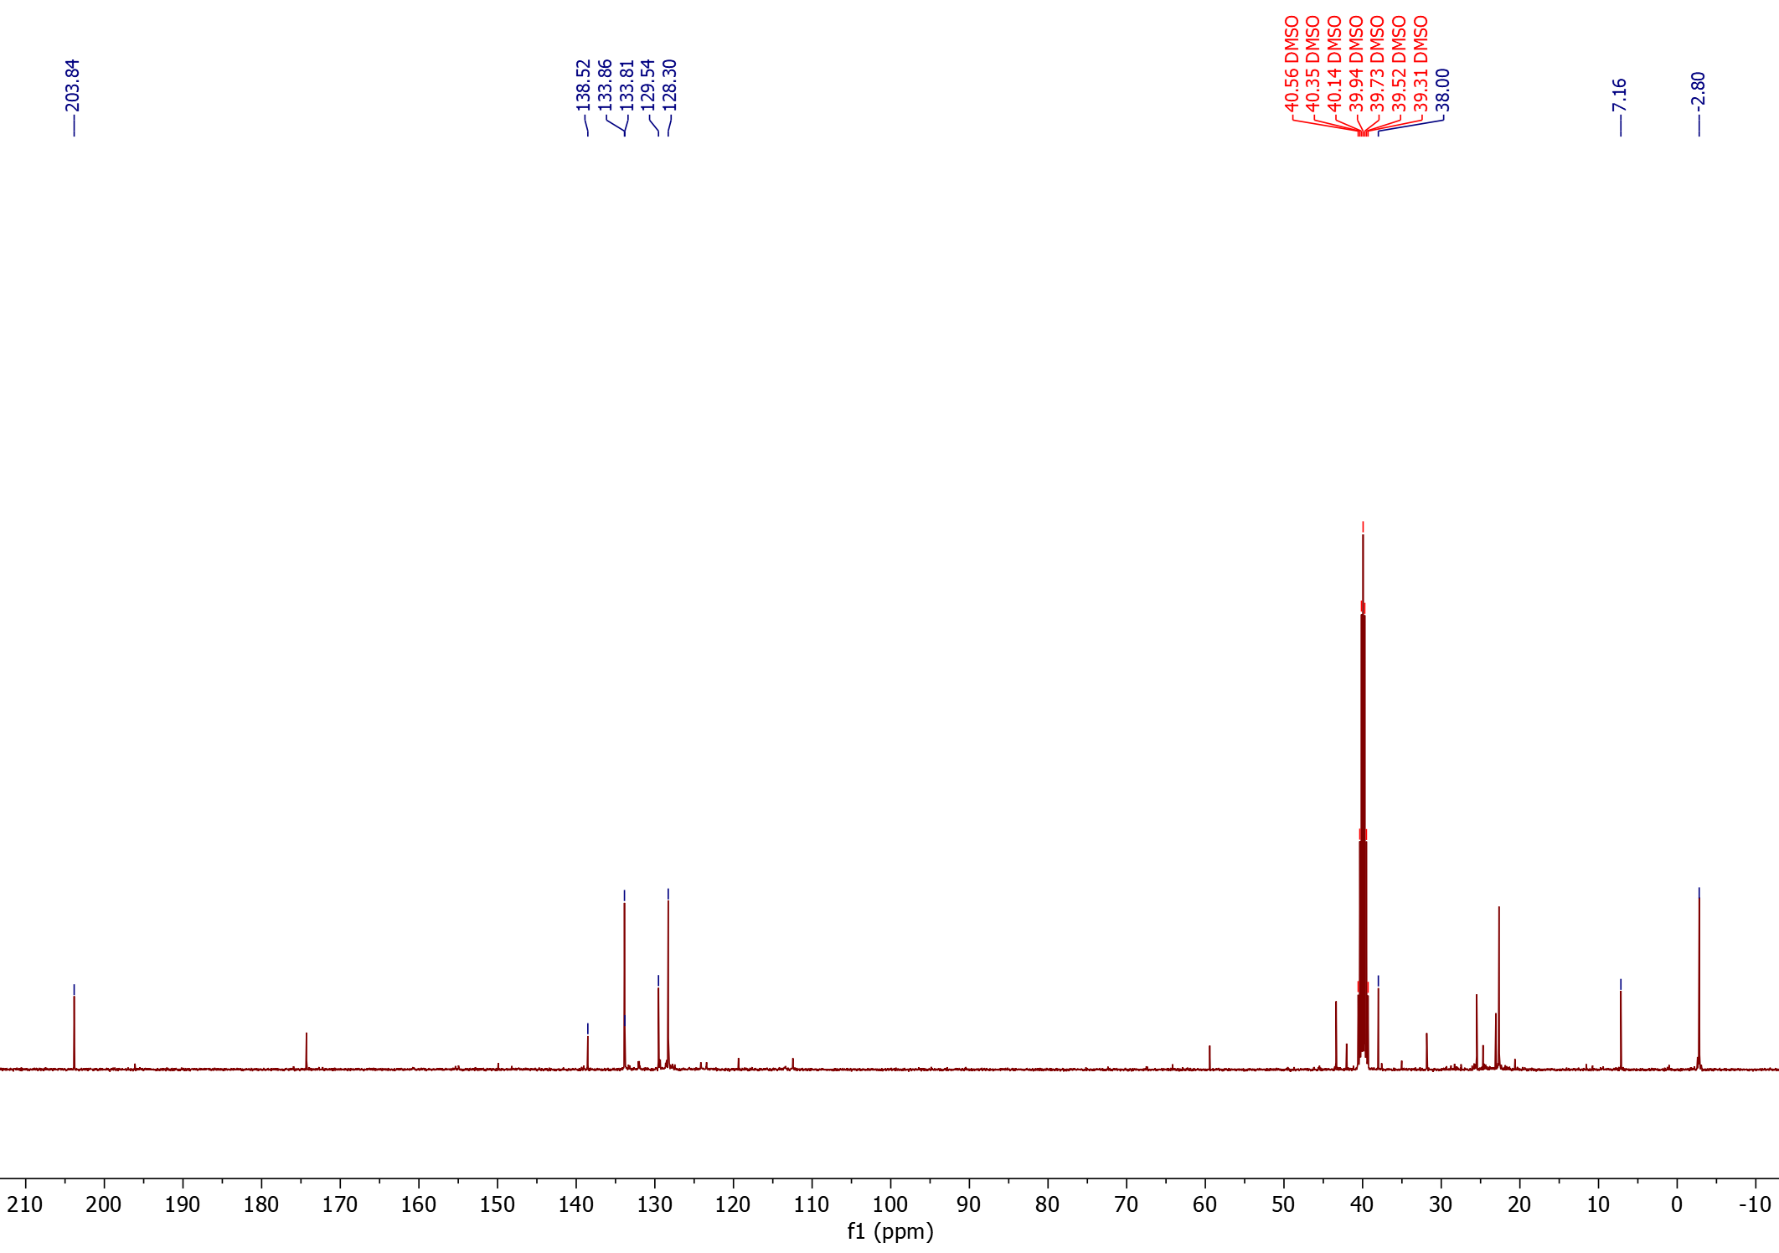
¹³C NMR

3-(4-tert-butylphenyl)propanal (38)
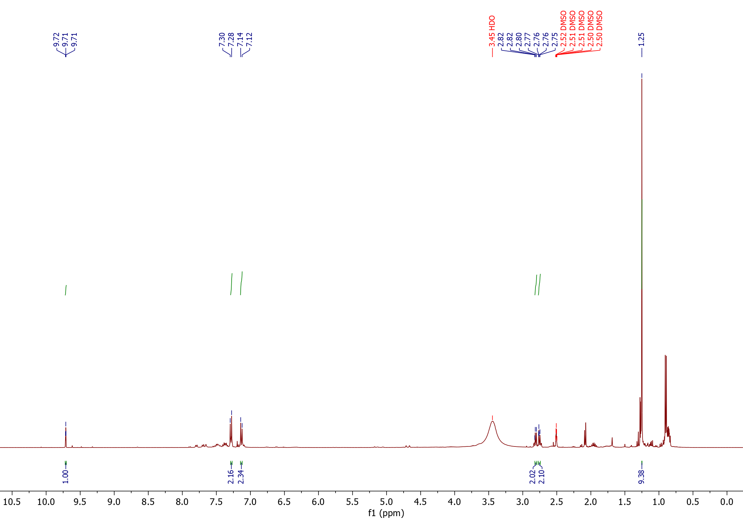
¹H NMR

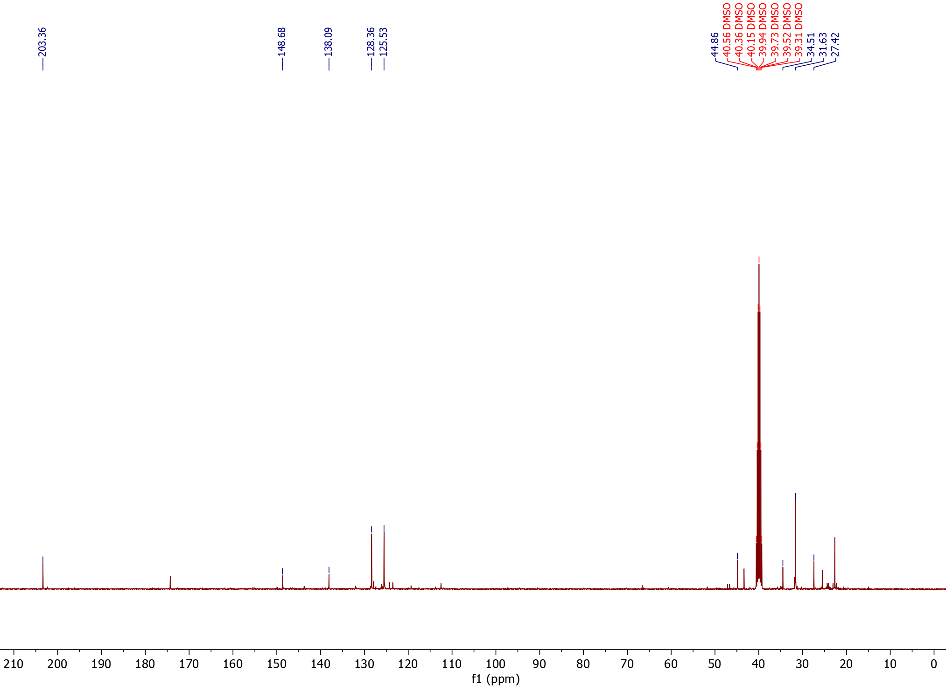
¹³C NMR

3-(2-naphtyl)propanal (39) (isolated product)
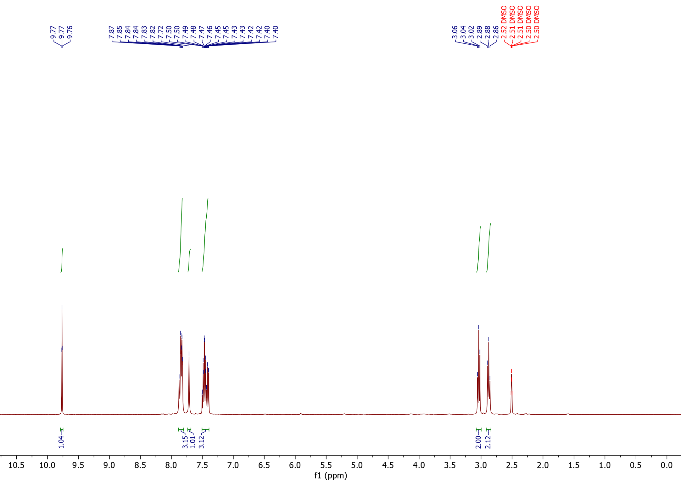
1H NMR

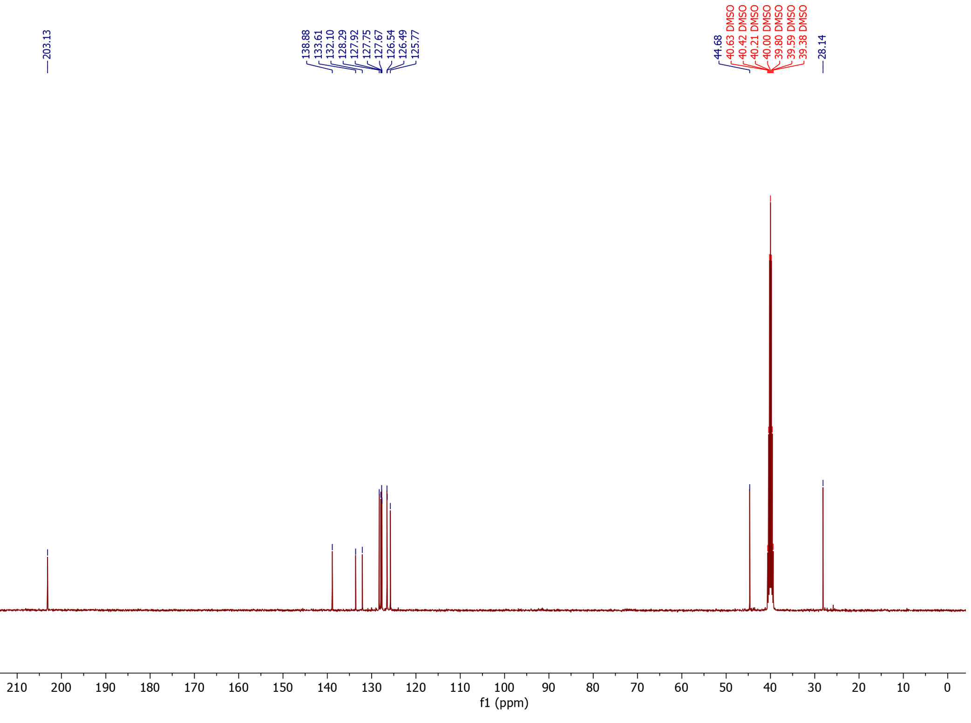
¹³C NMR

3-(4-phenoxyphenyl)propanal and 2-(phenoxyphenyl)propanal (40)
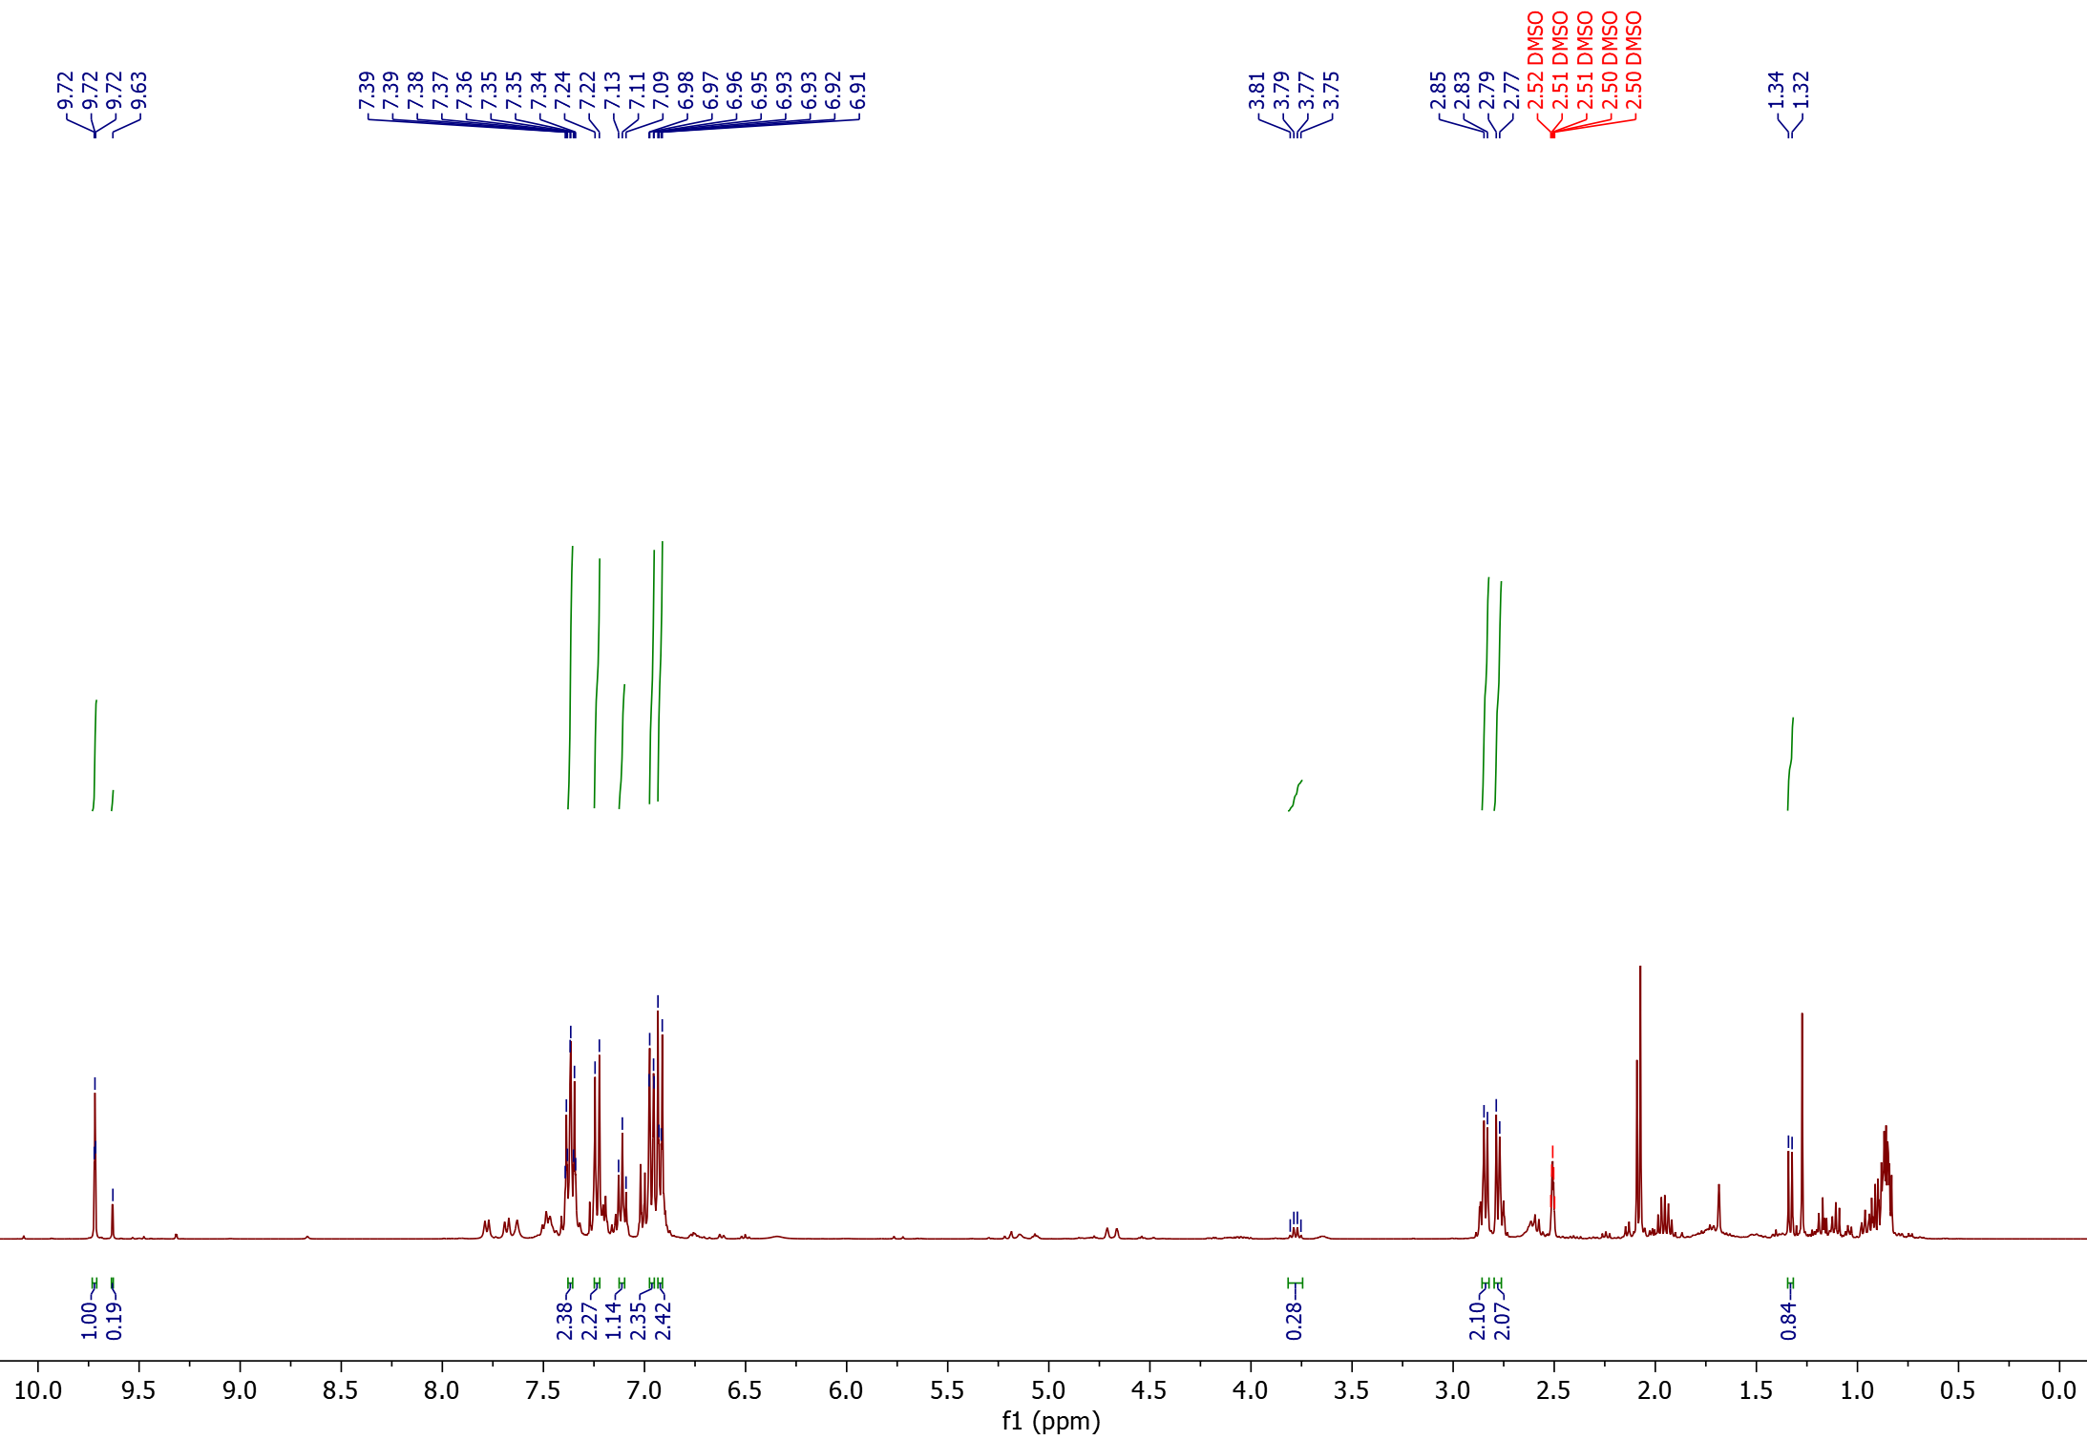
¹H NMR
1
2
1
2
1

2
2

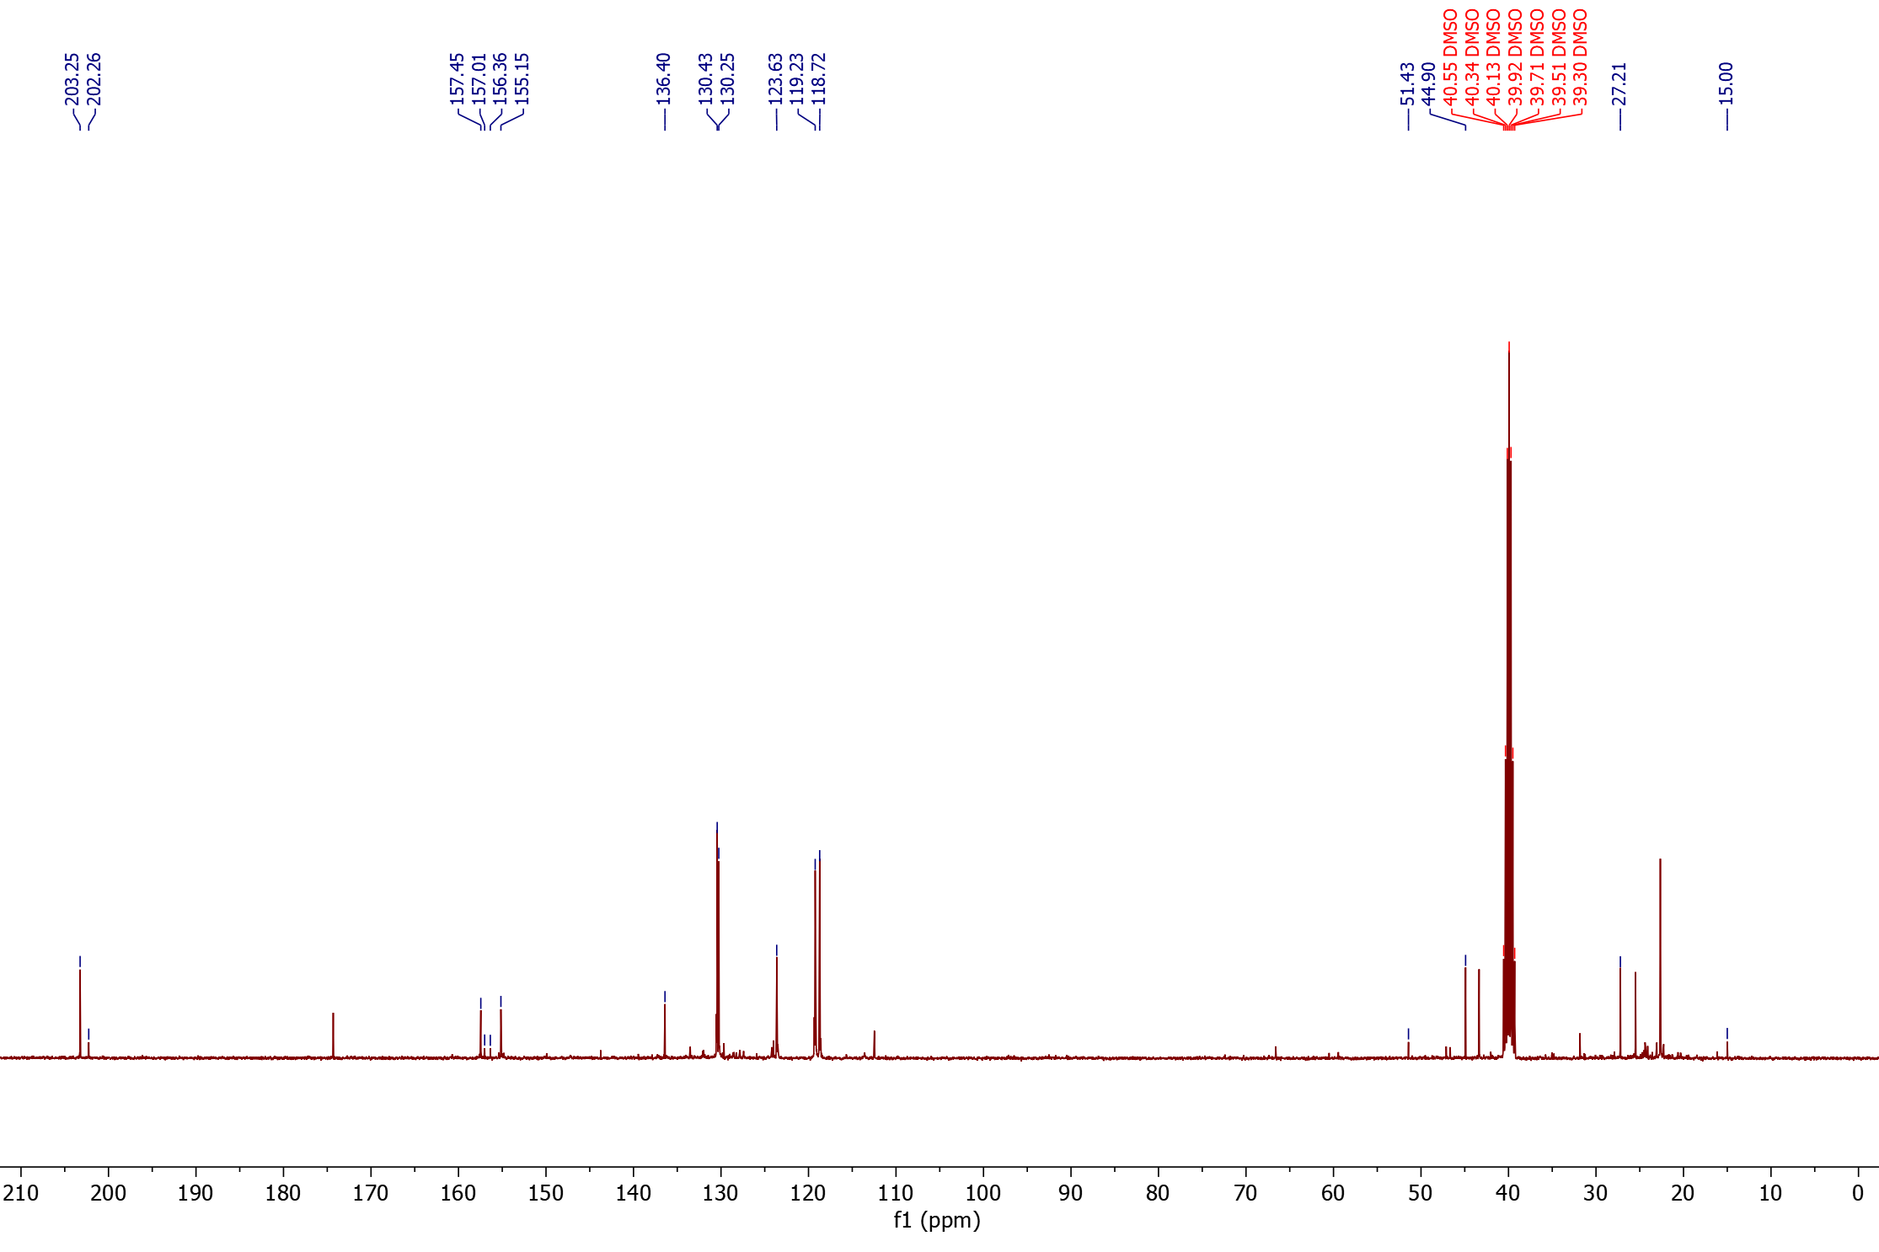
¹³C NMR

2
2
1
1
2
1
2
1
1
2

3-(2-methoxyphenyl)propanal (41)
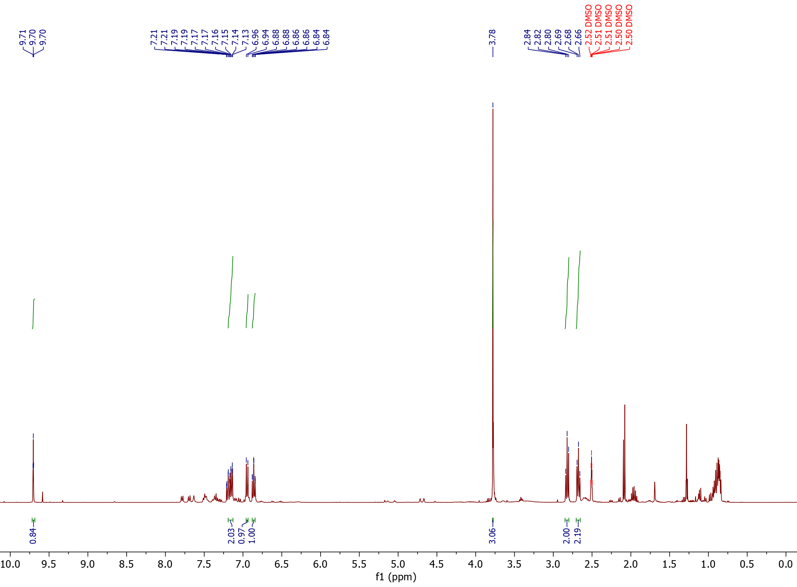
¹H NMR

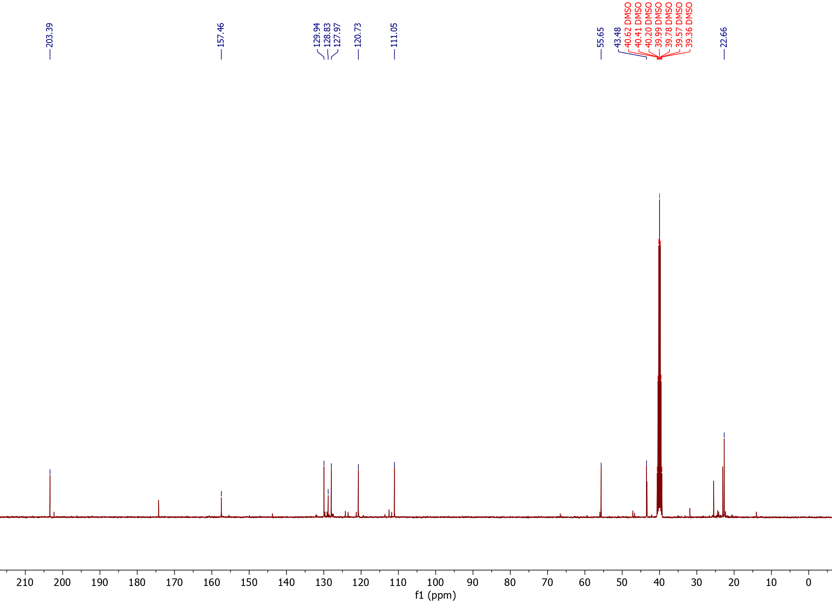
¹³C NMR

4-(3-oxopropyl)-benzoic acid (42) (isolated product)
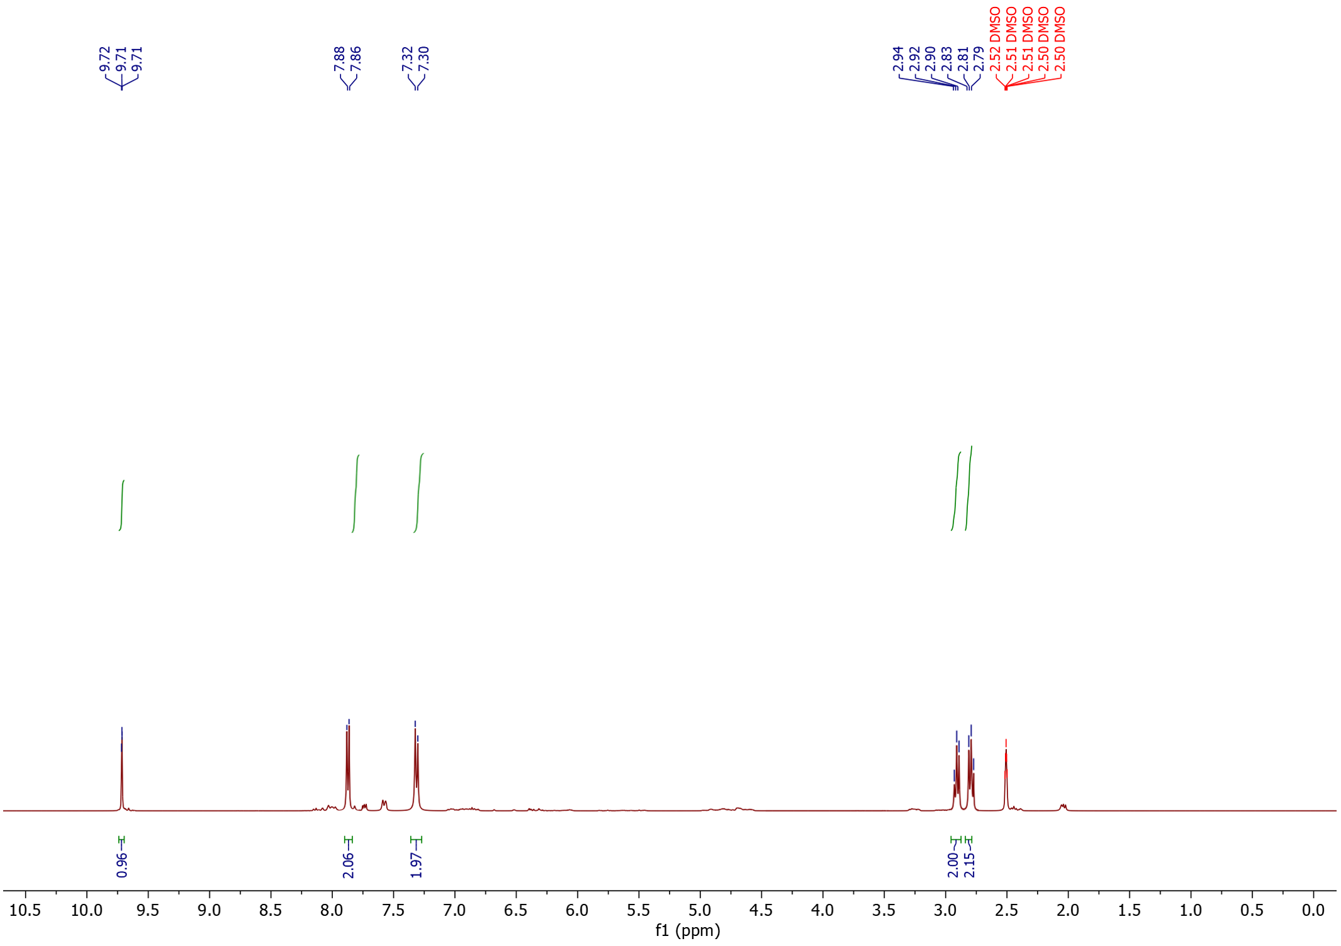
¹H NMR

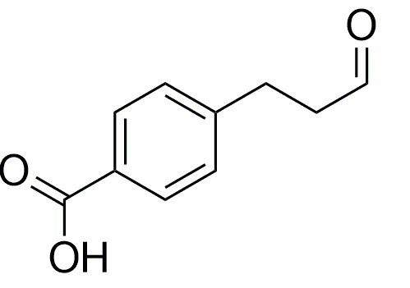

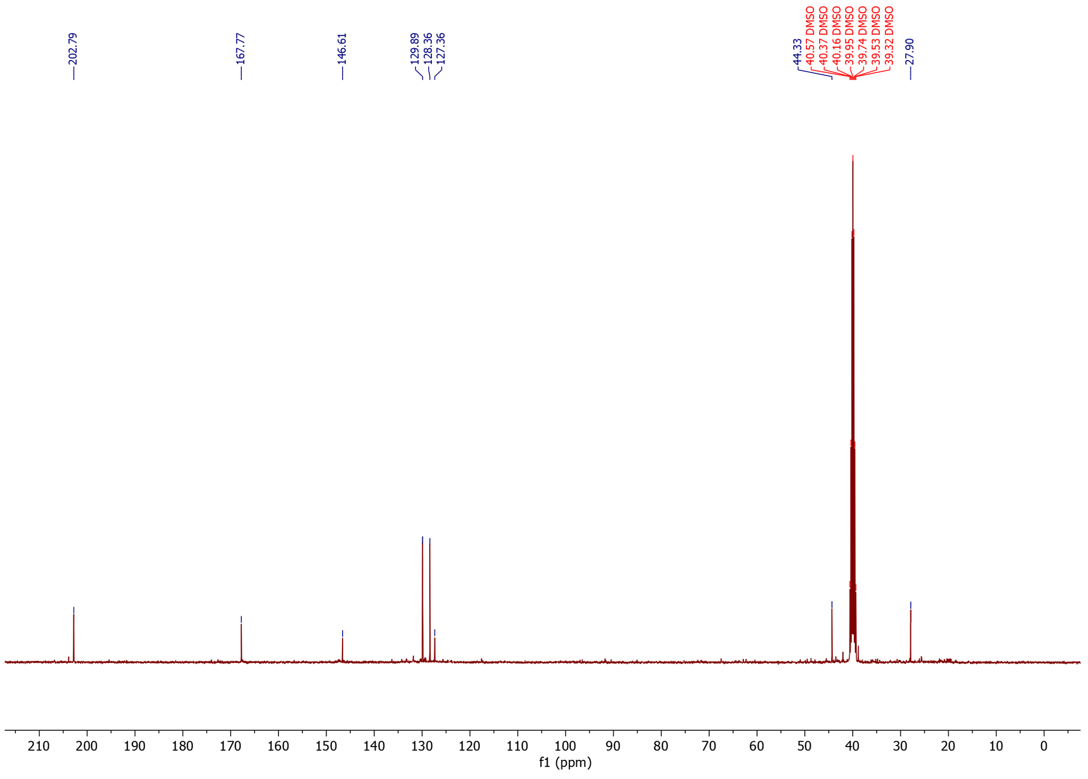
¹³C NMR

3-(4-Hydroxy-3-methoxyphenyl)propionaldehyde (43) (isolated product)
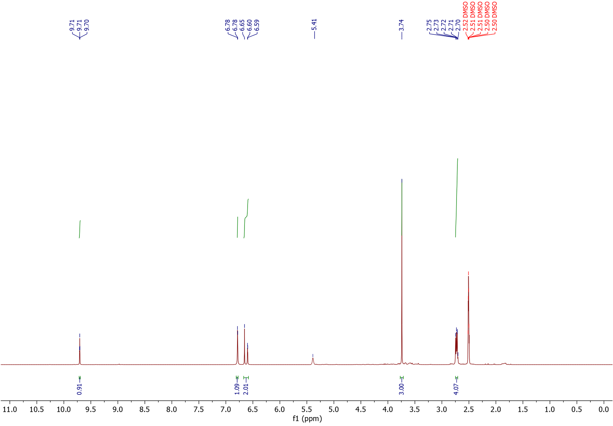
¹H NMR

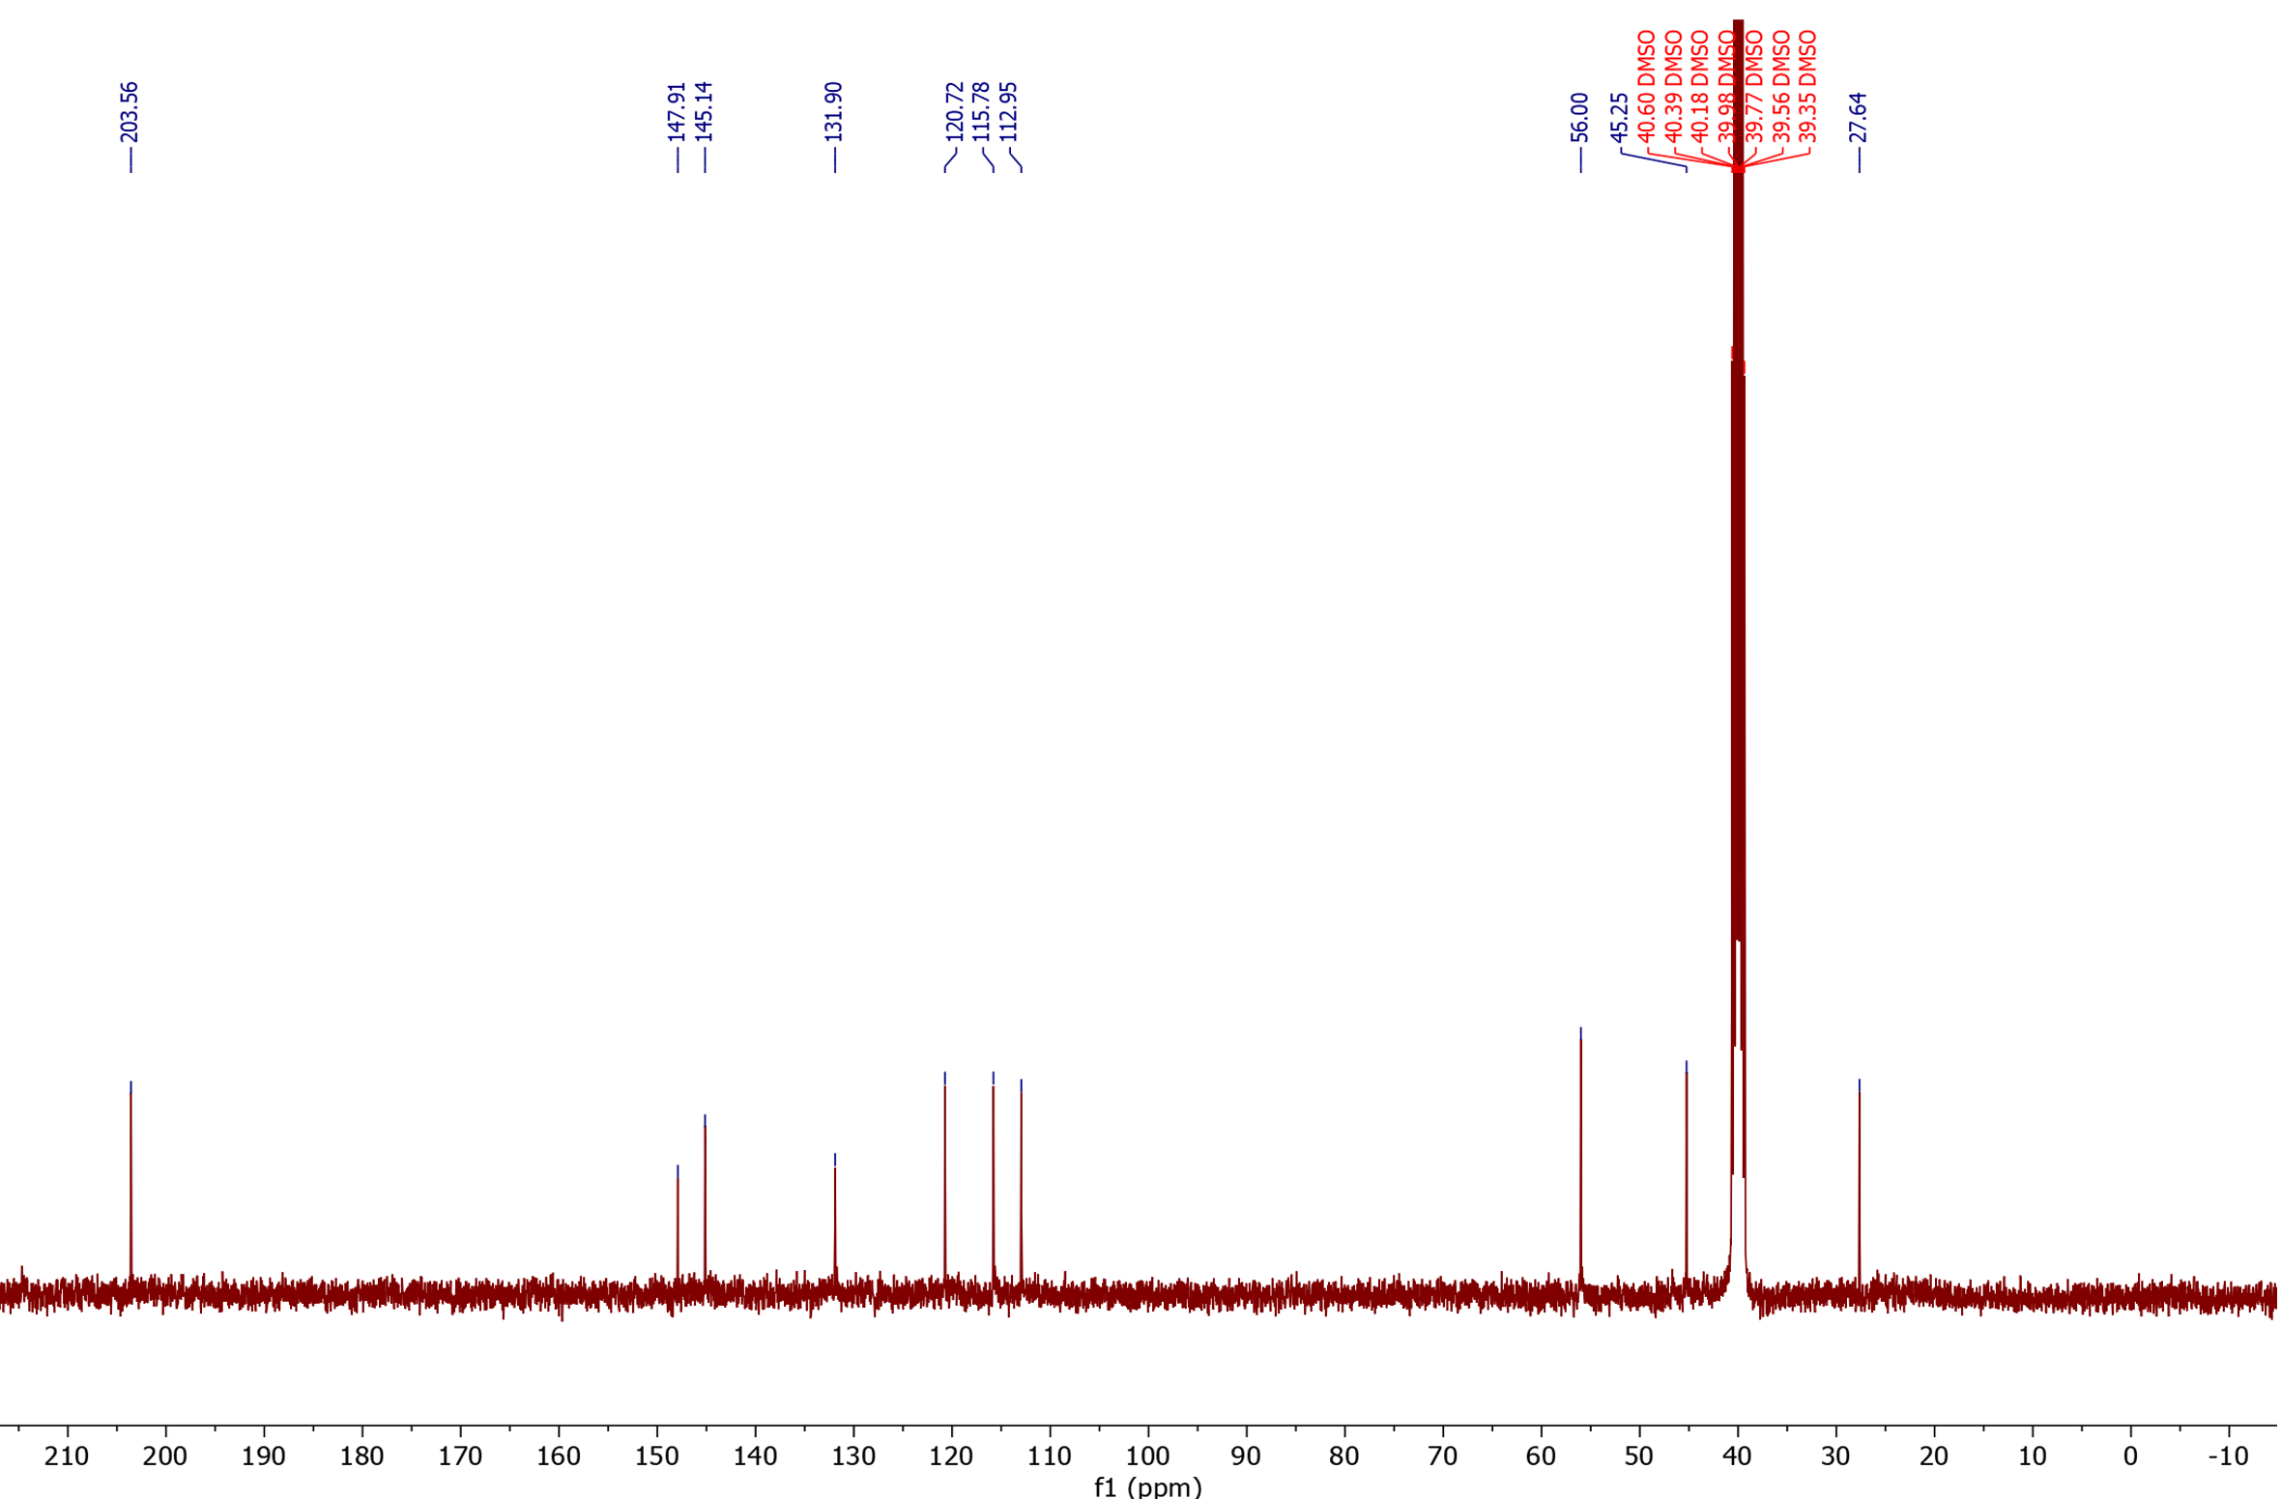
¹³C NMR

3-(4-trifluoromethylphenyl)propanal (44) (isolated product)
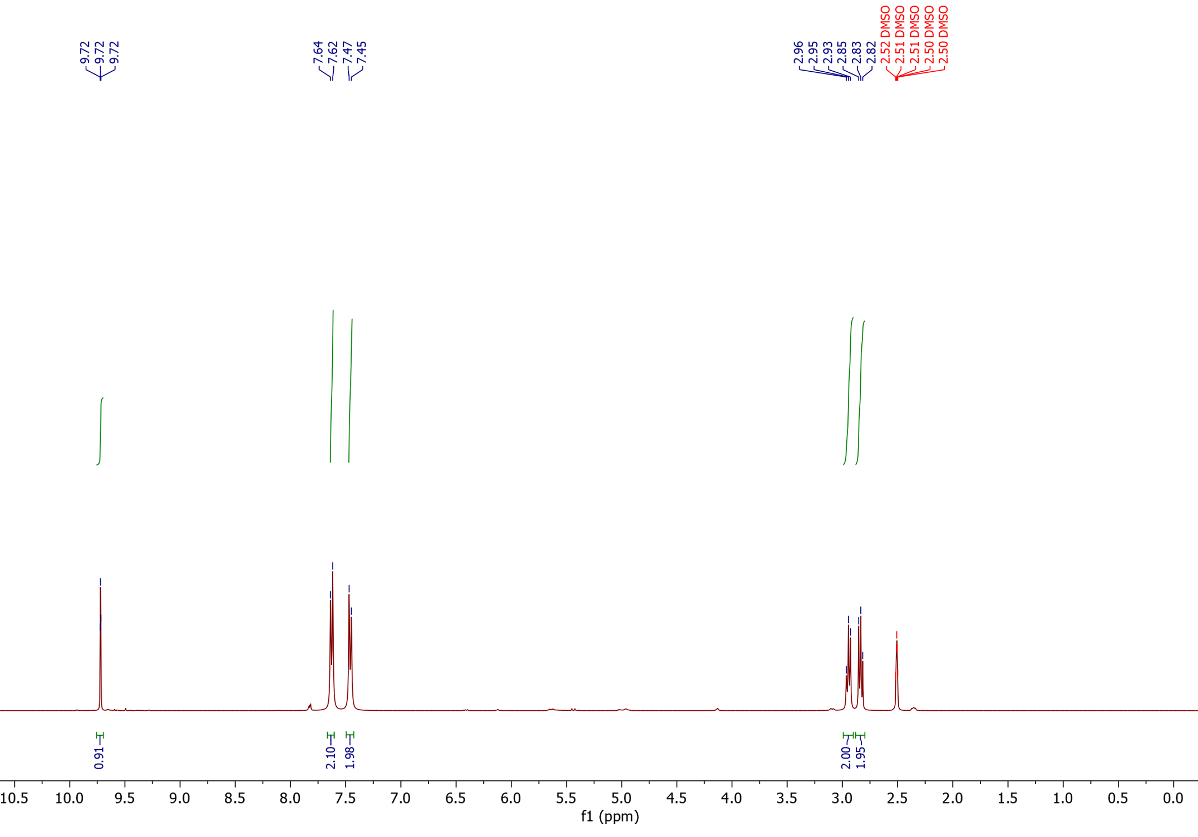
¹H NMR

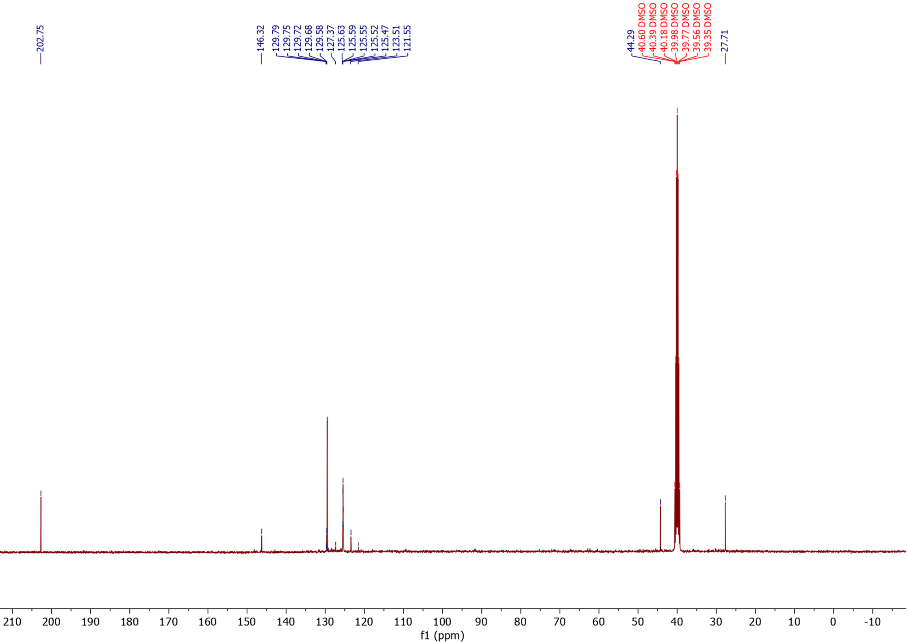
¹³C NMR

¹⁹F NMR
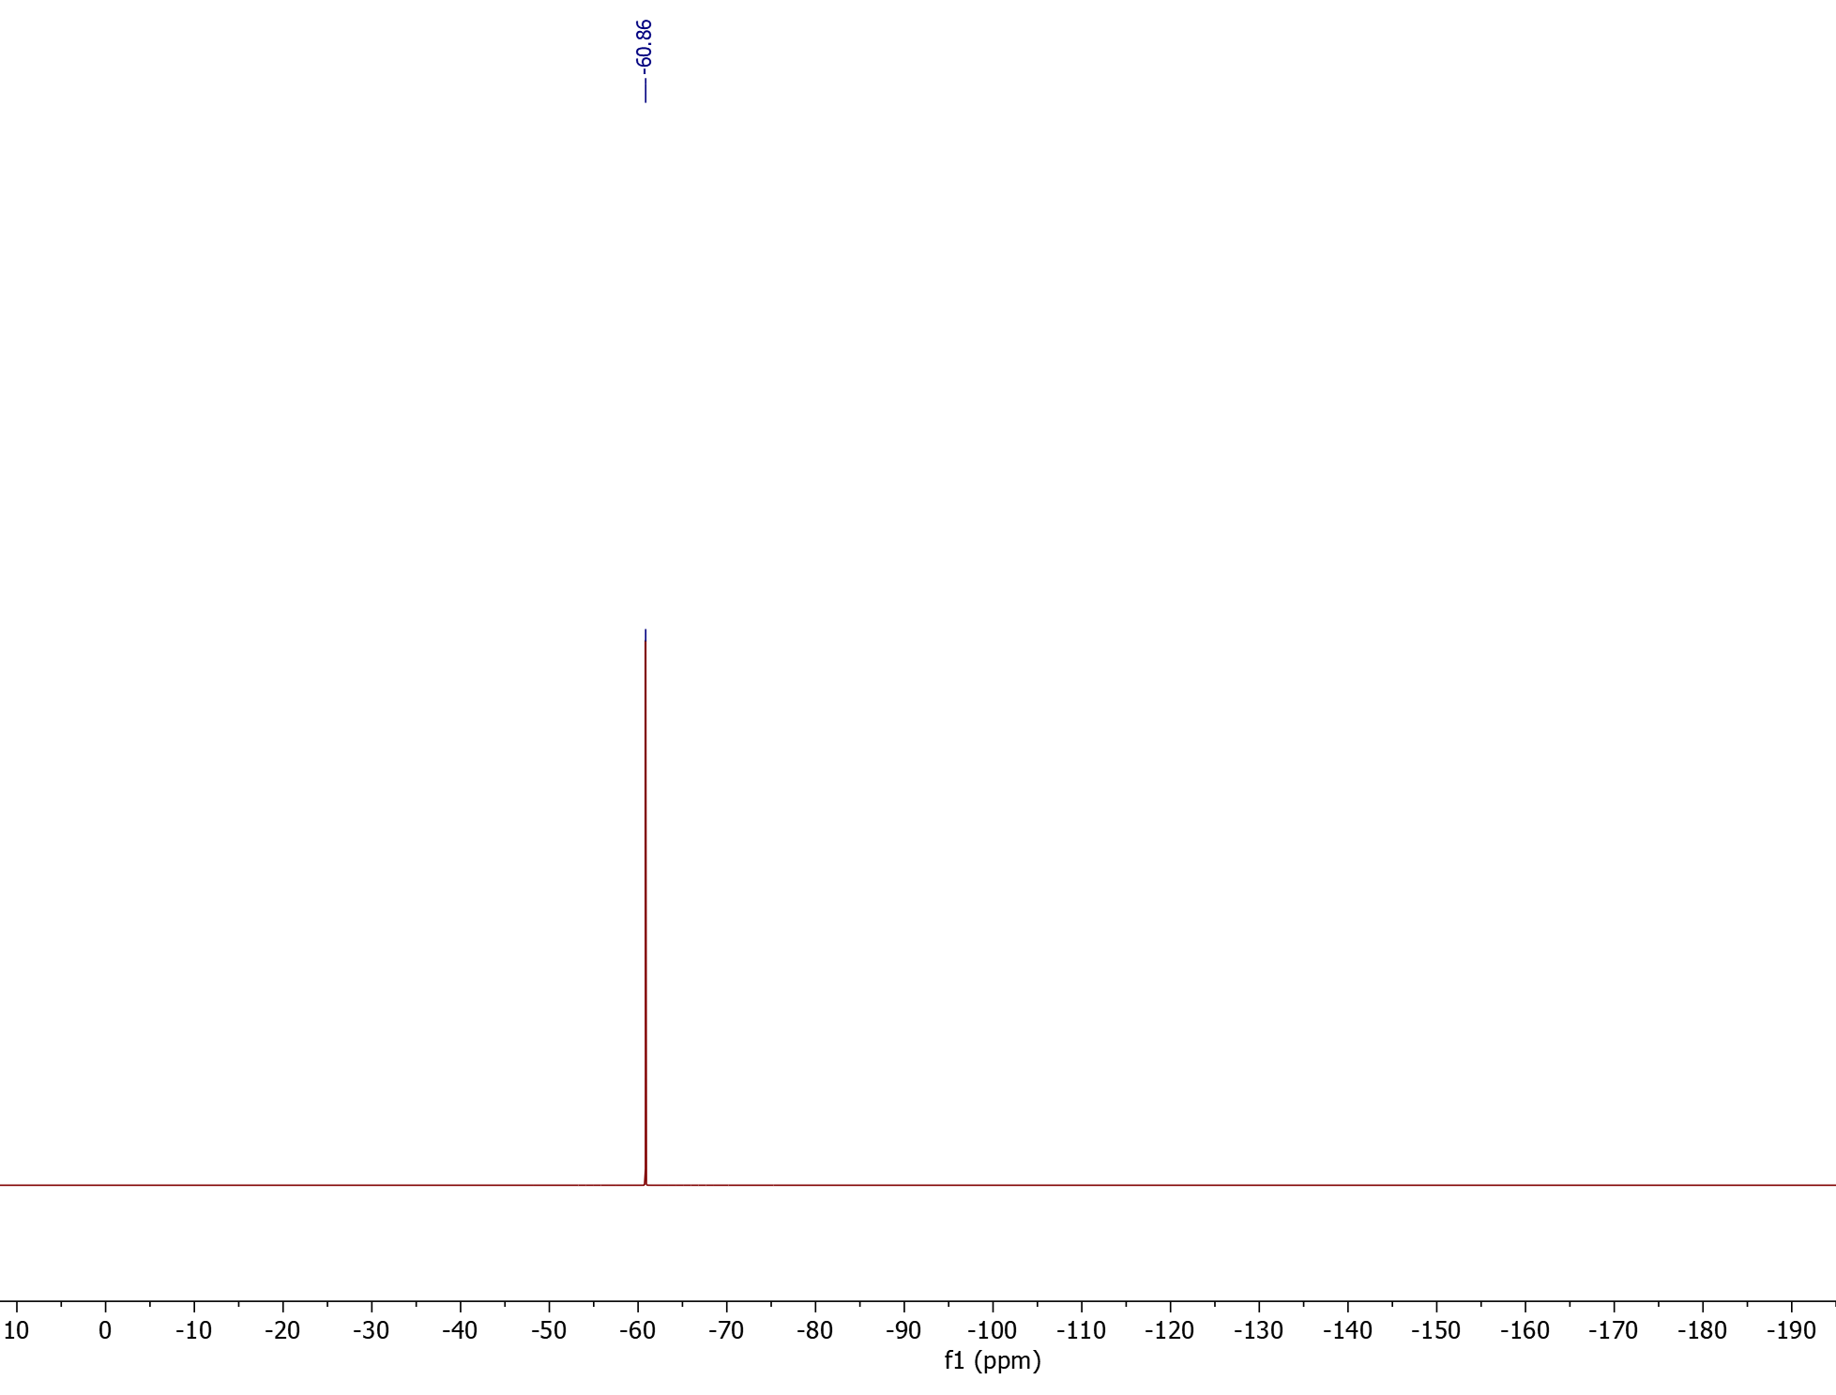

3-(3,5-bis-trifluoromethylphenyl)propanal (45) (isolated product)
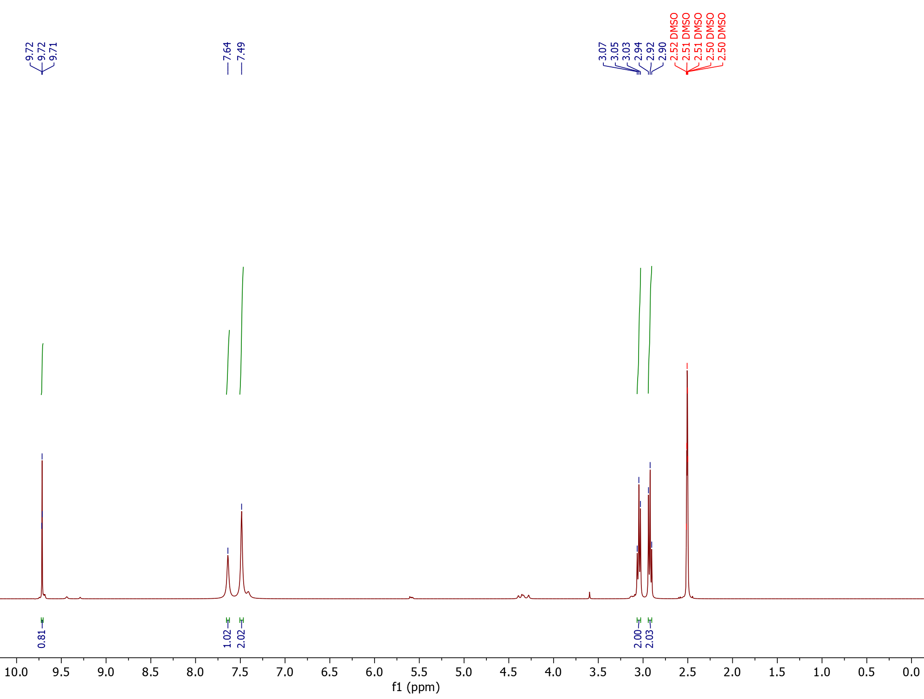
¹H NMR

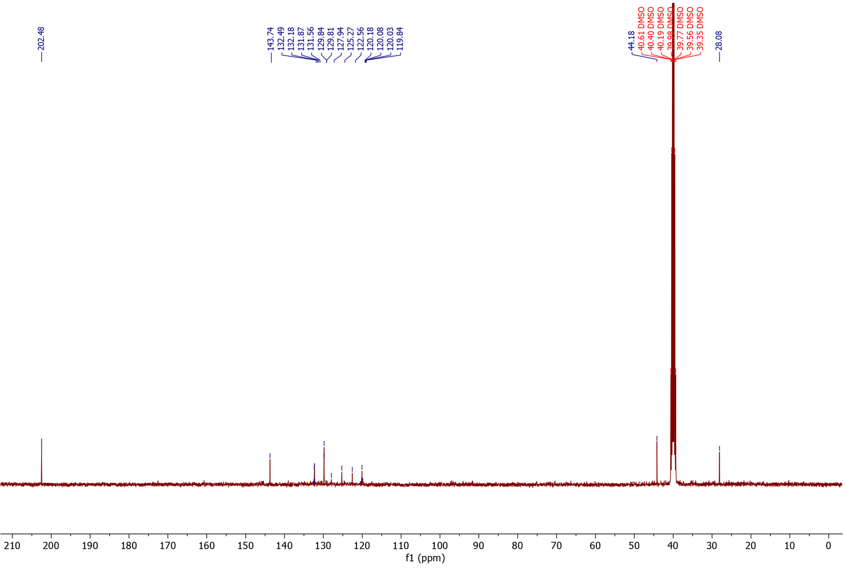
¹³C NMR

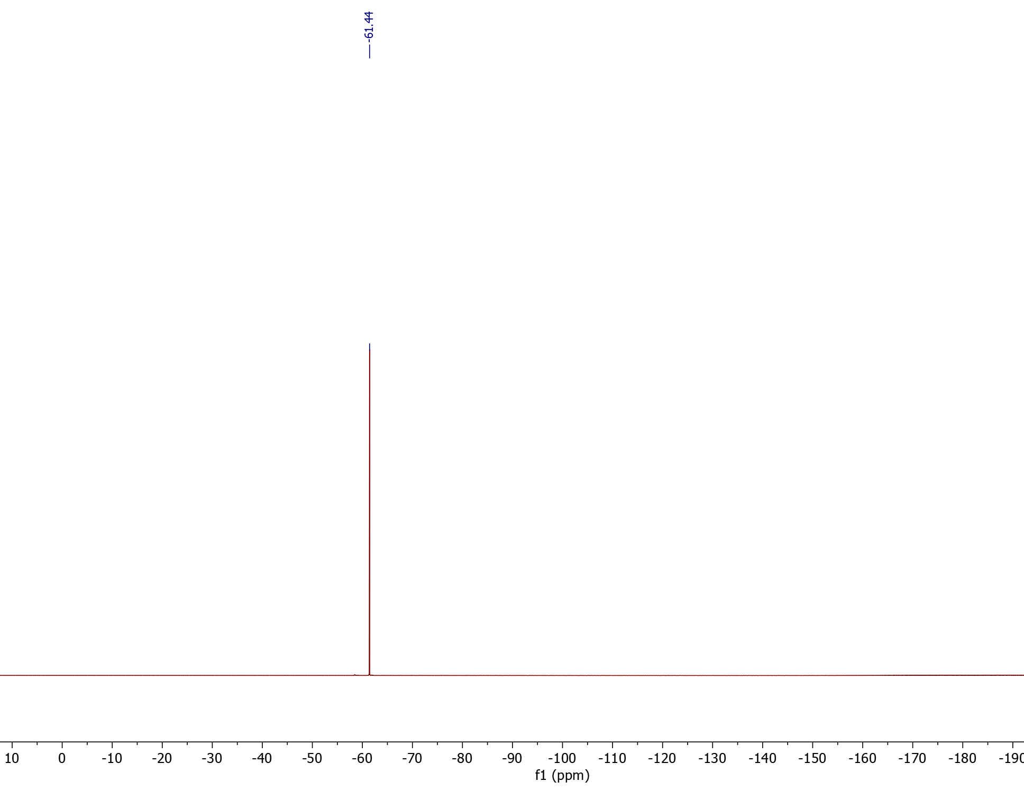
¹⁹F NMR

4,4,4-Trifluoro-3-phenylbutanal (46) (isolated product)
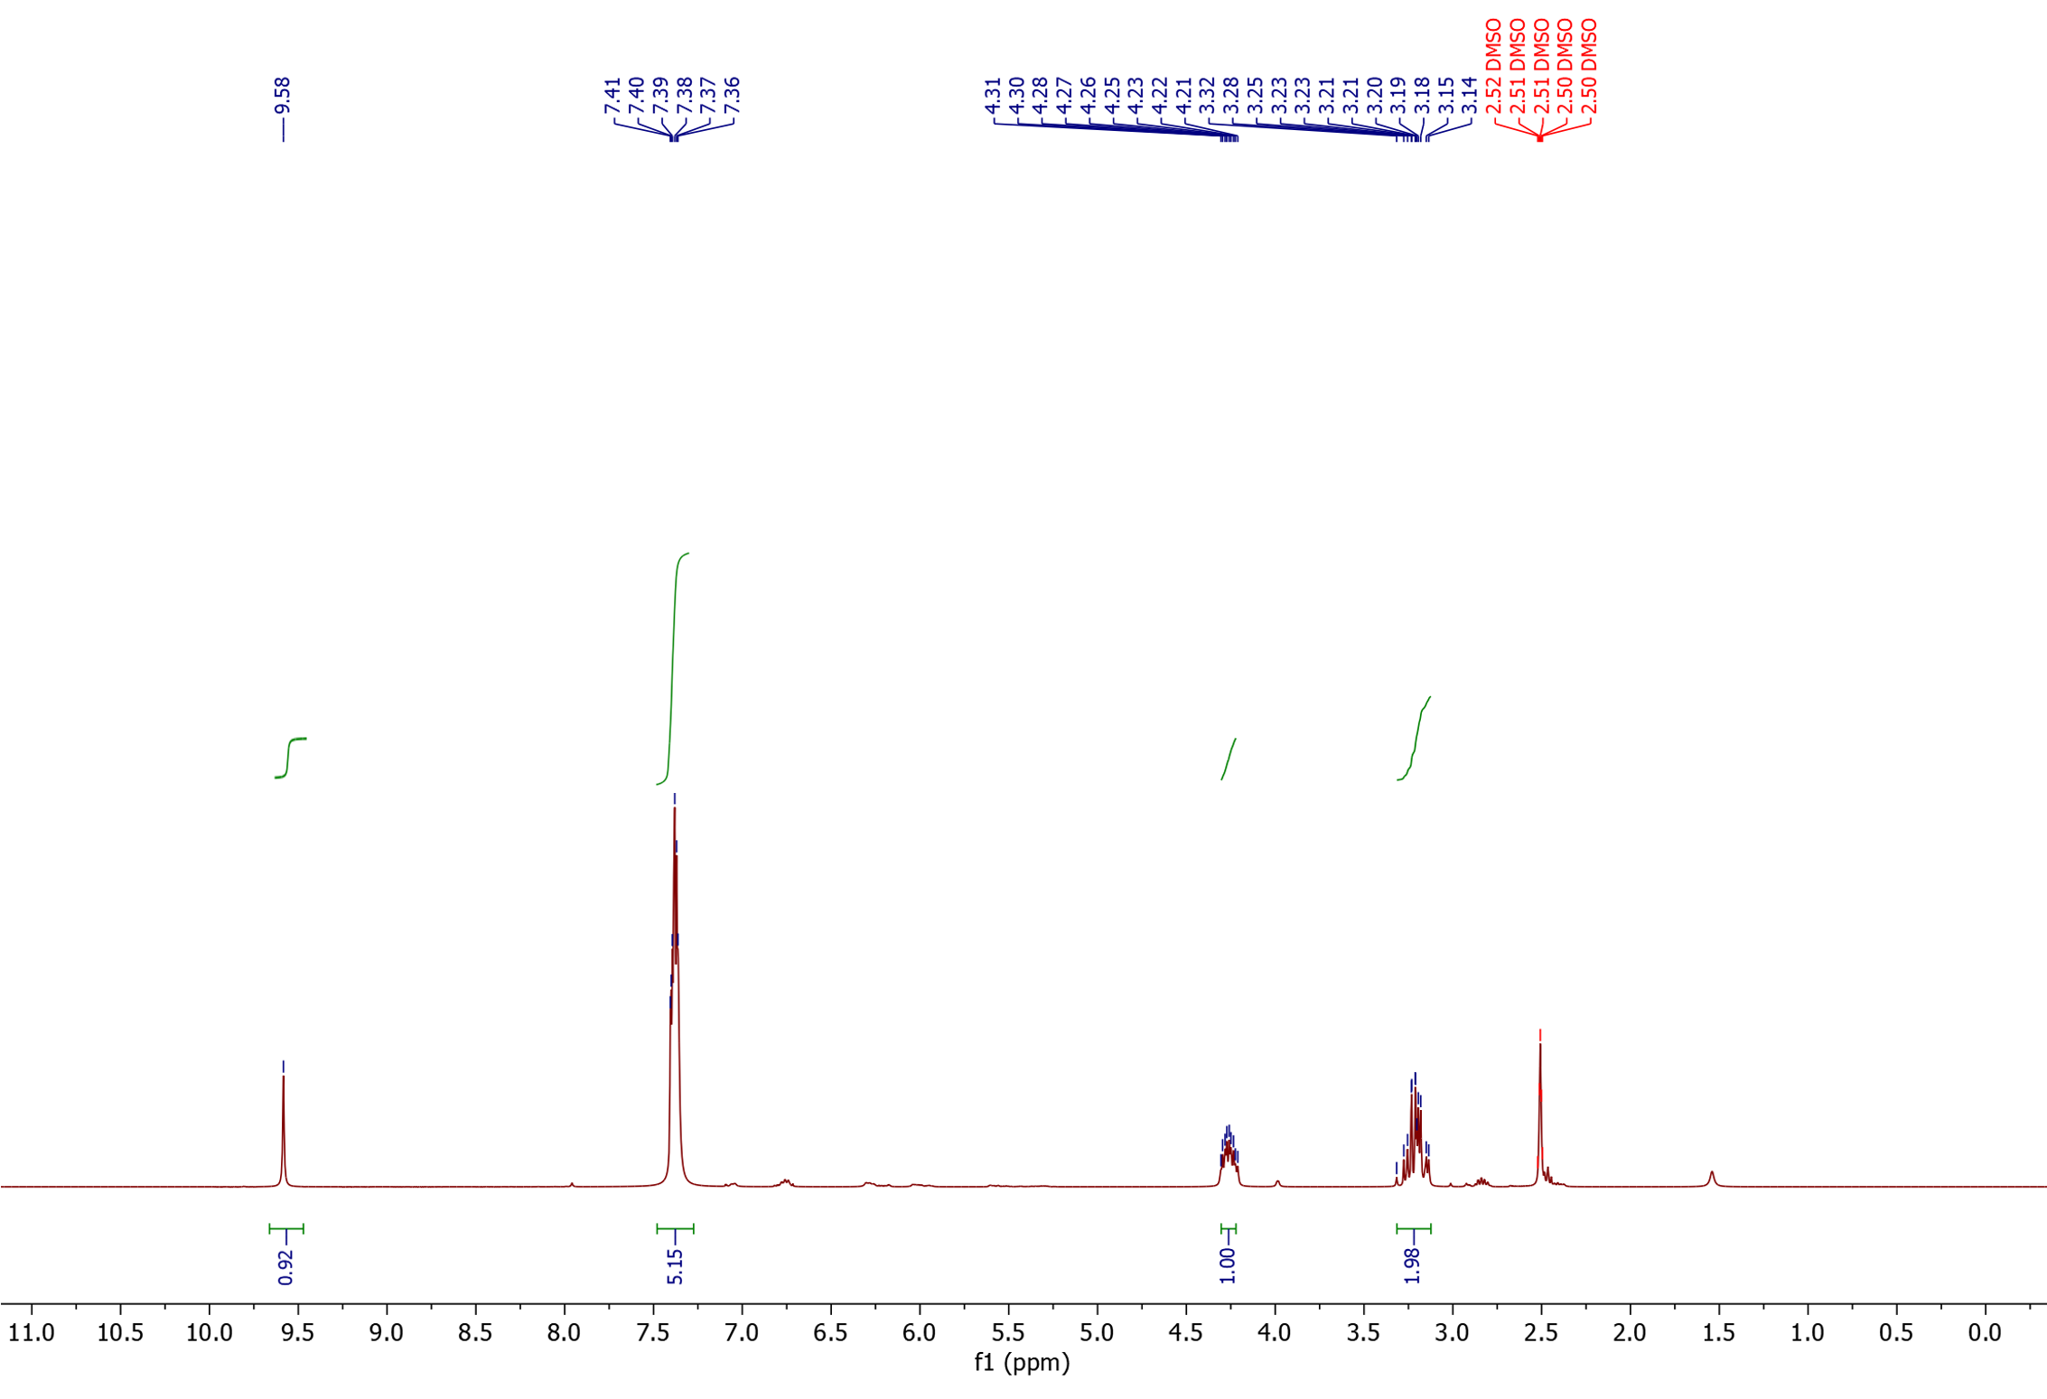
¹H NMR

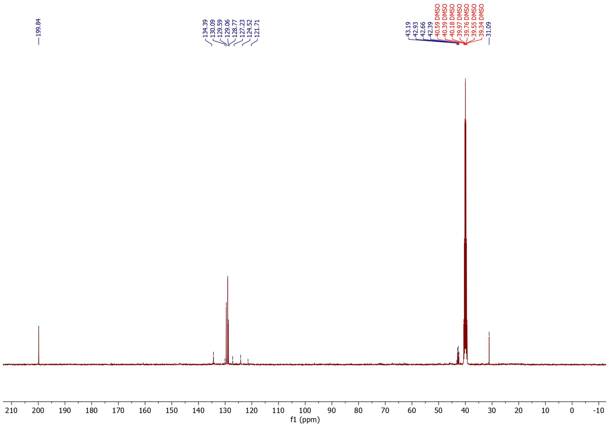
¹³C NMR

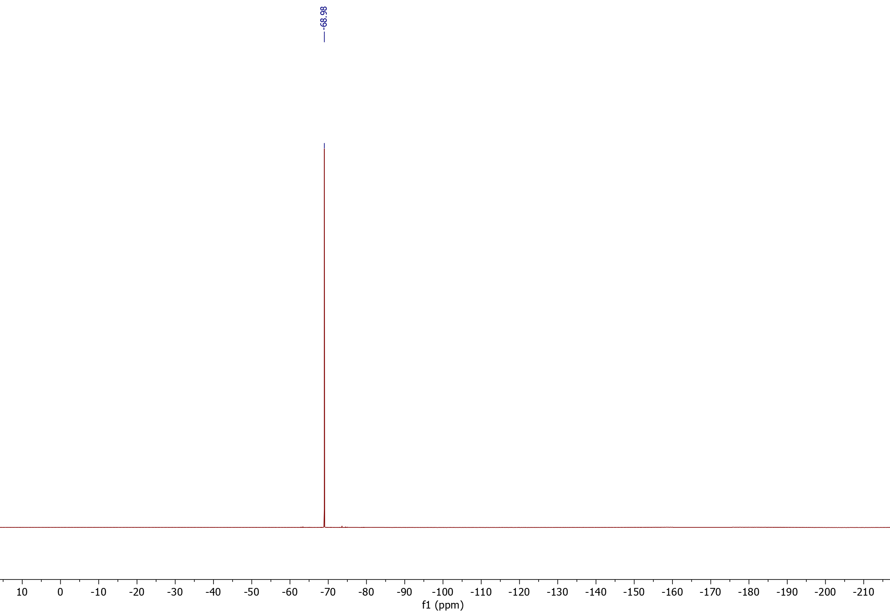
¹⁹F NMR

3-(4-chlorophenyl)propanal (47) (isolated product)
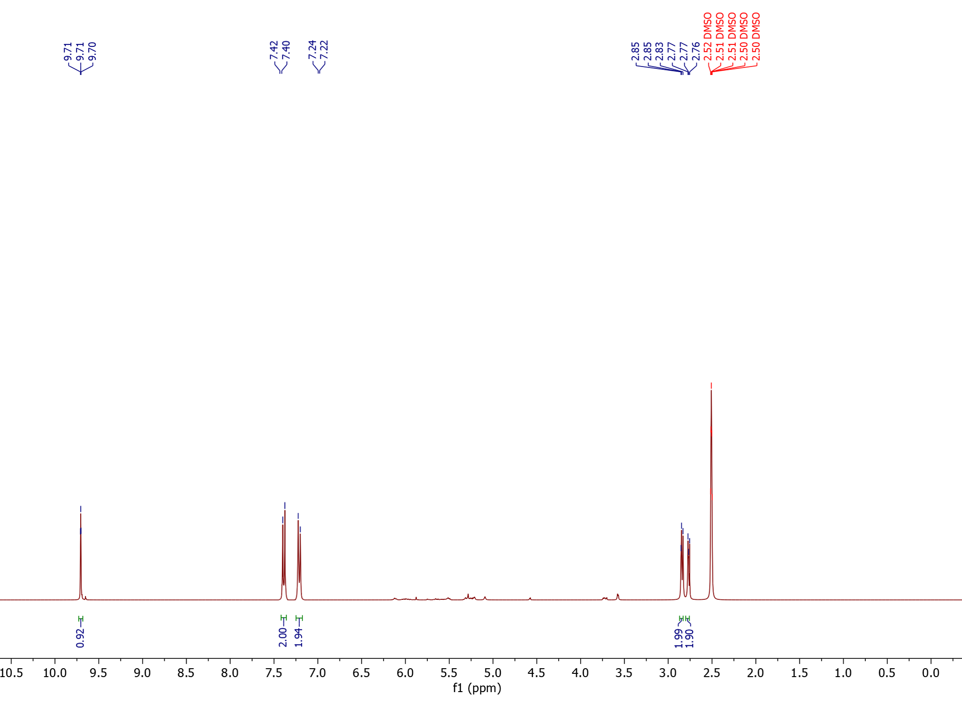
¹H NMR

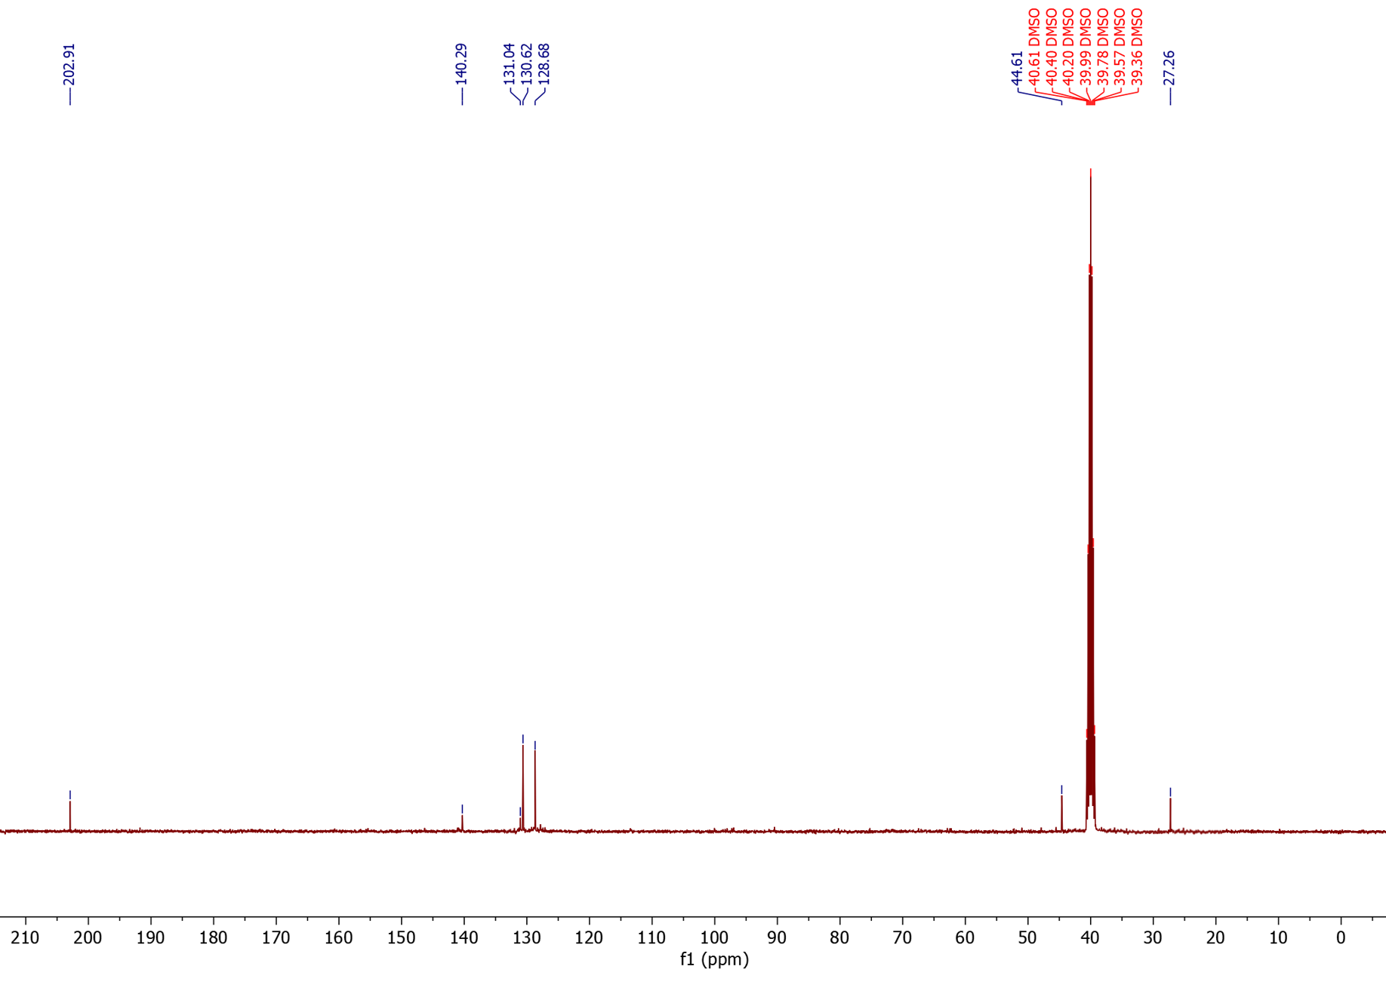
¹³C NMR

3-(4-bromophenyl)propanal (48) (isolated product)
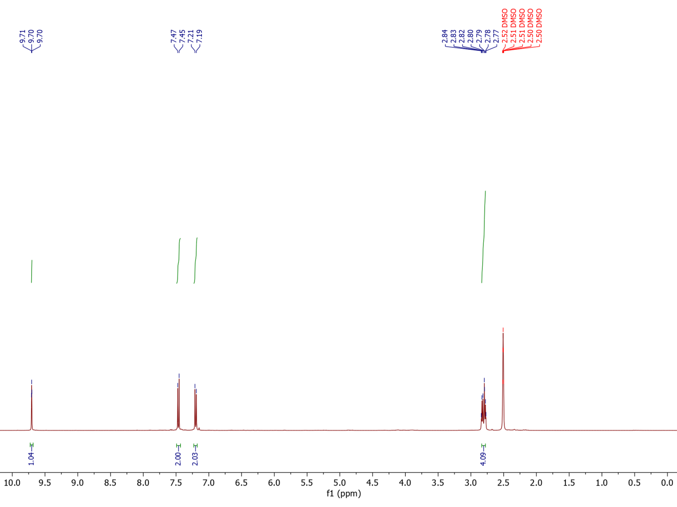
¹H NMR

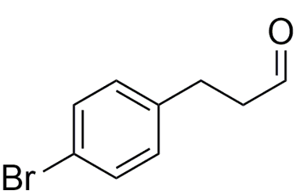

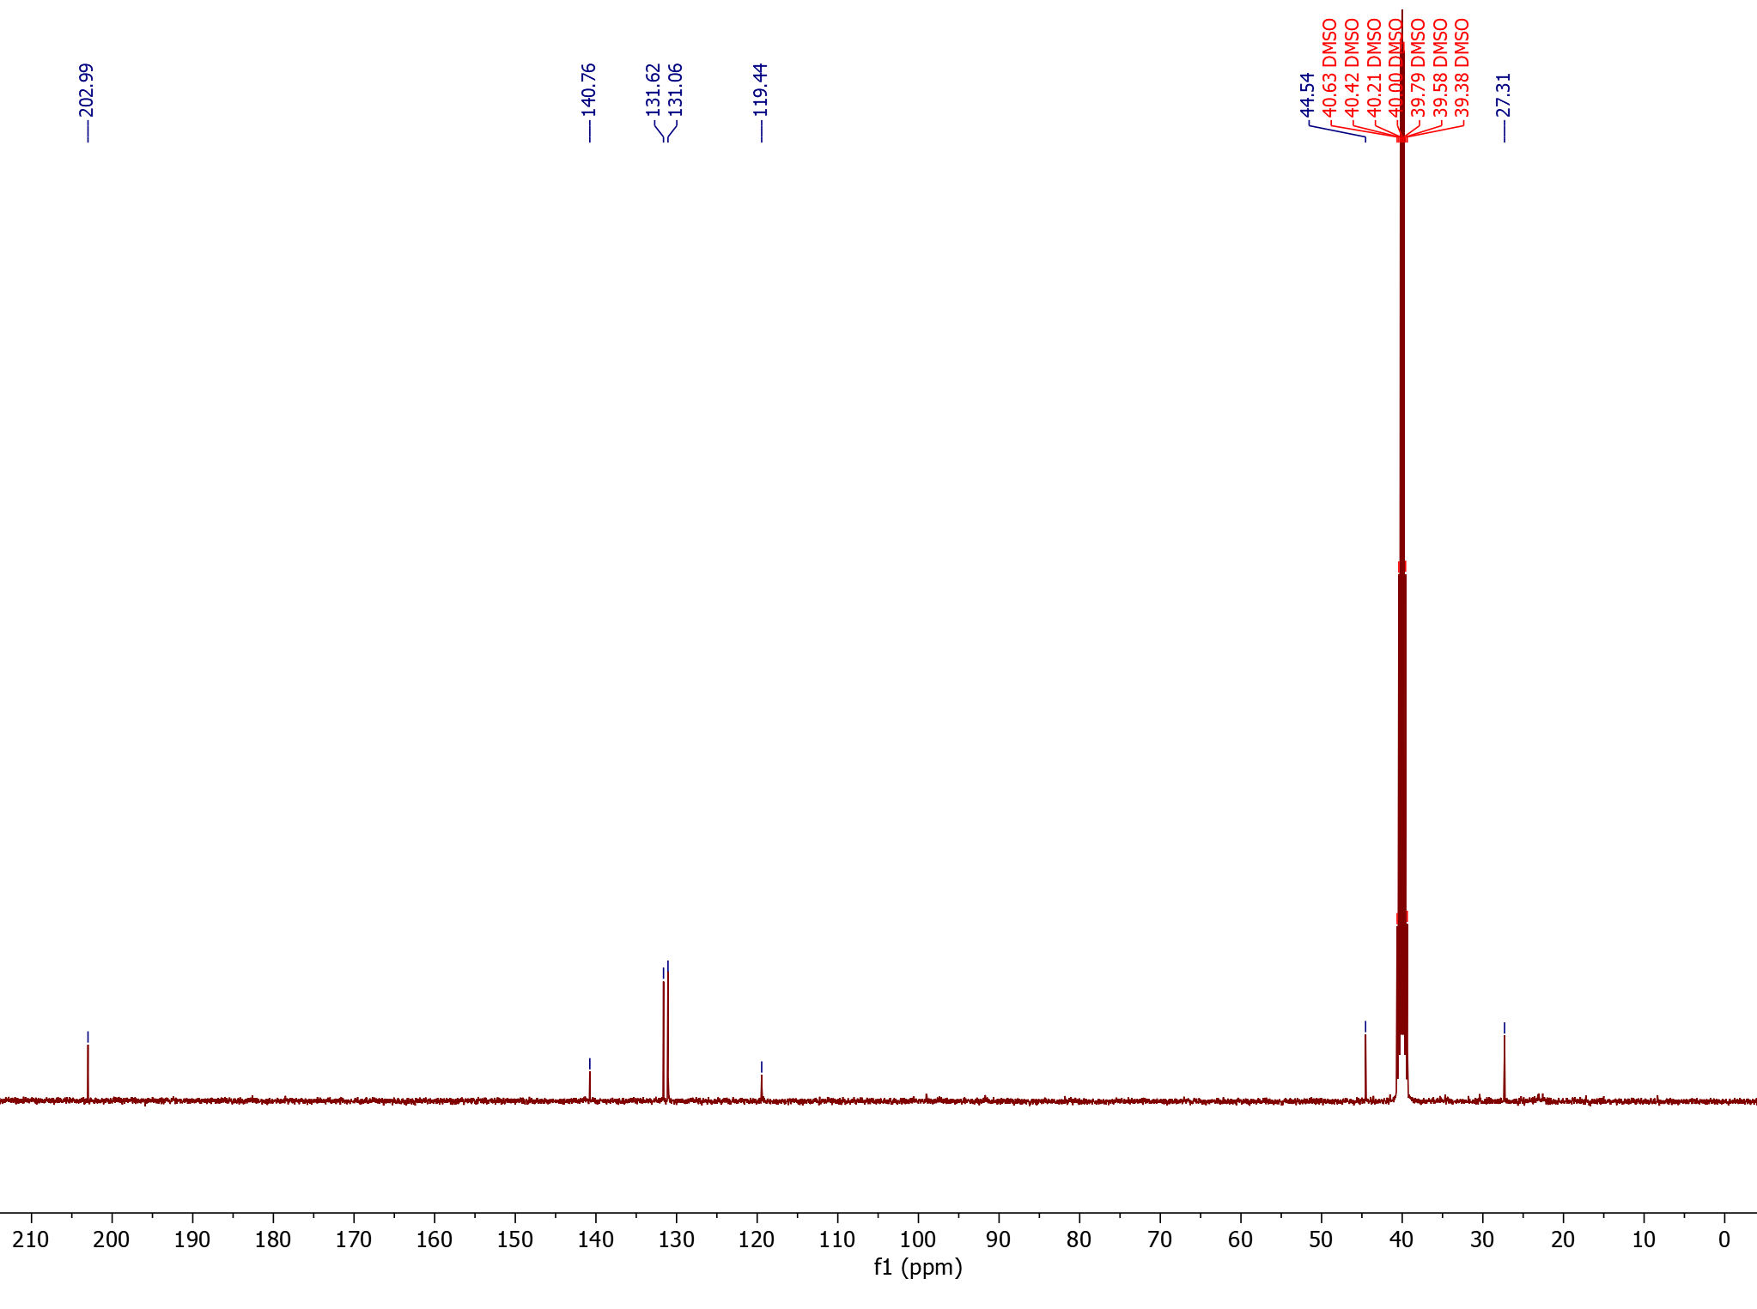
¹³C NMR

3-(4-cyanophenyl)propanal (49) (isolated product)
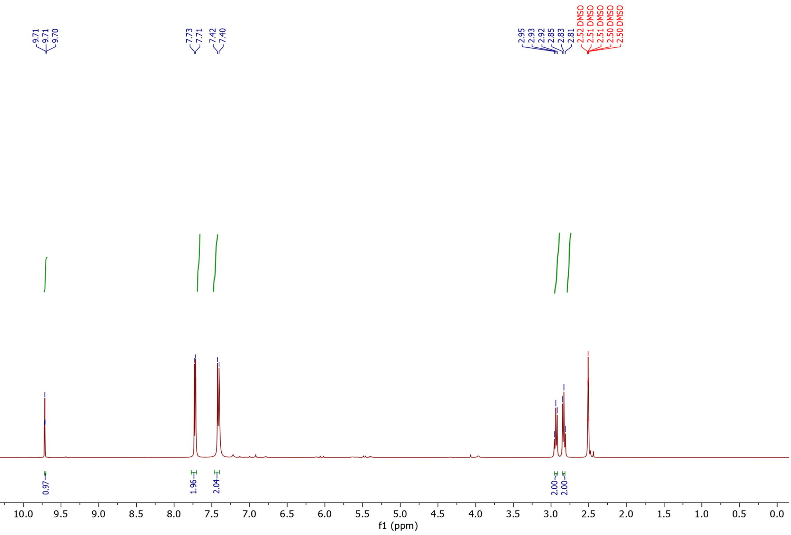
¹H NMR

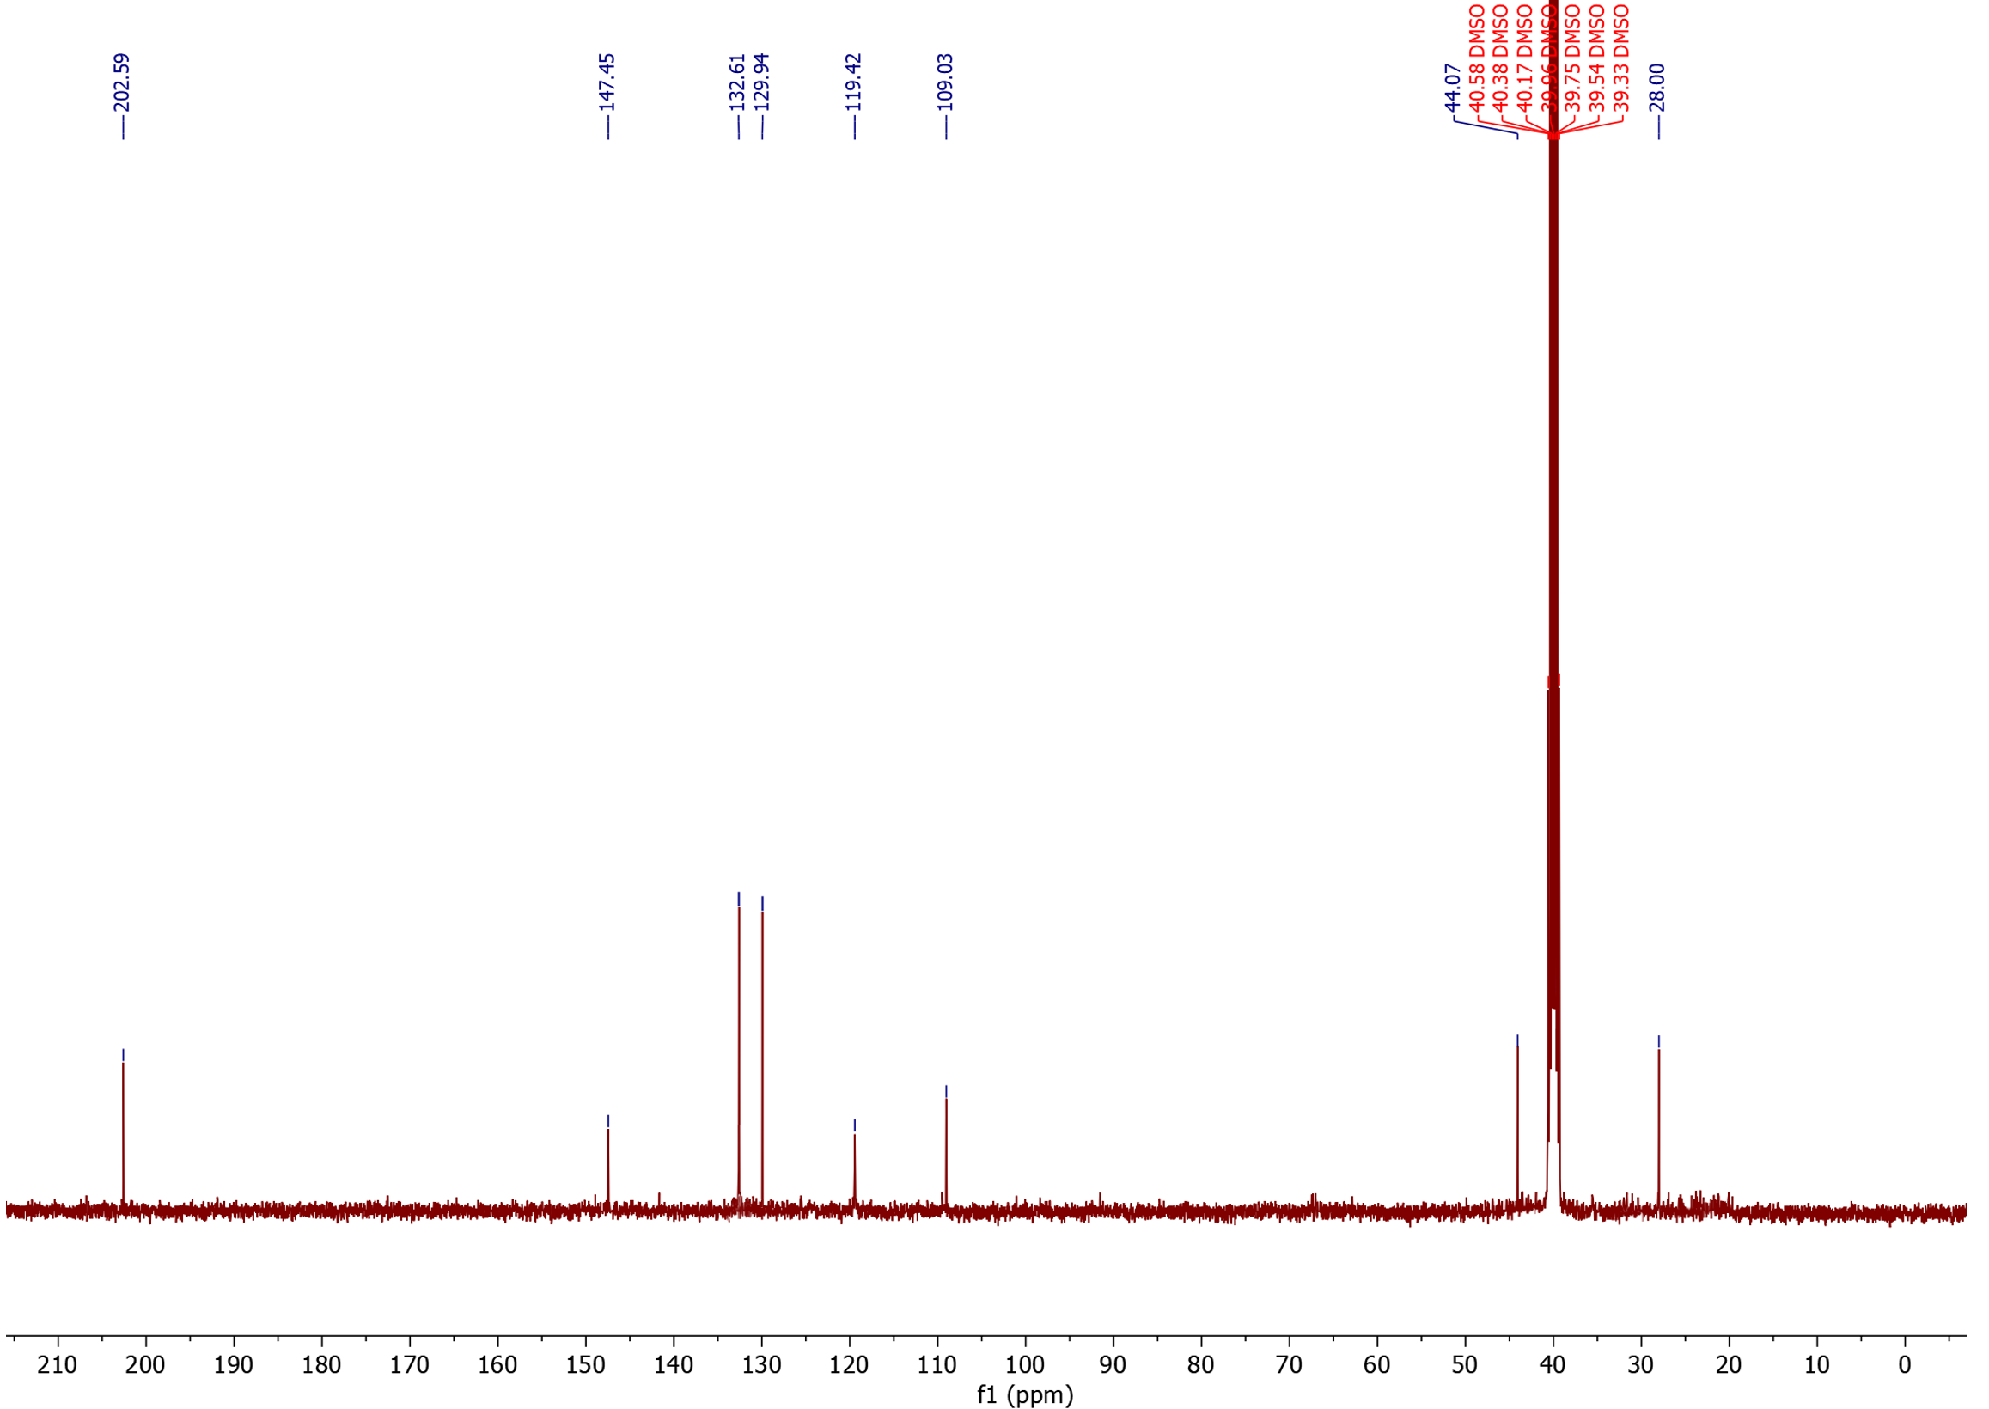
¹³C NMR

1-tosyl-2,3-dihydro-1H-pyrrole (50) (isolated product)
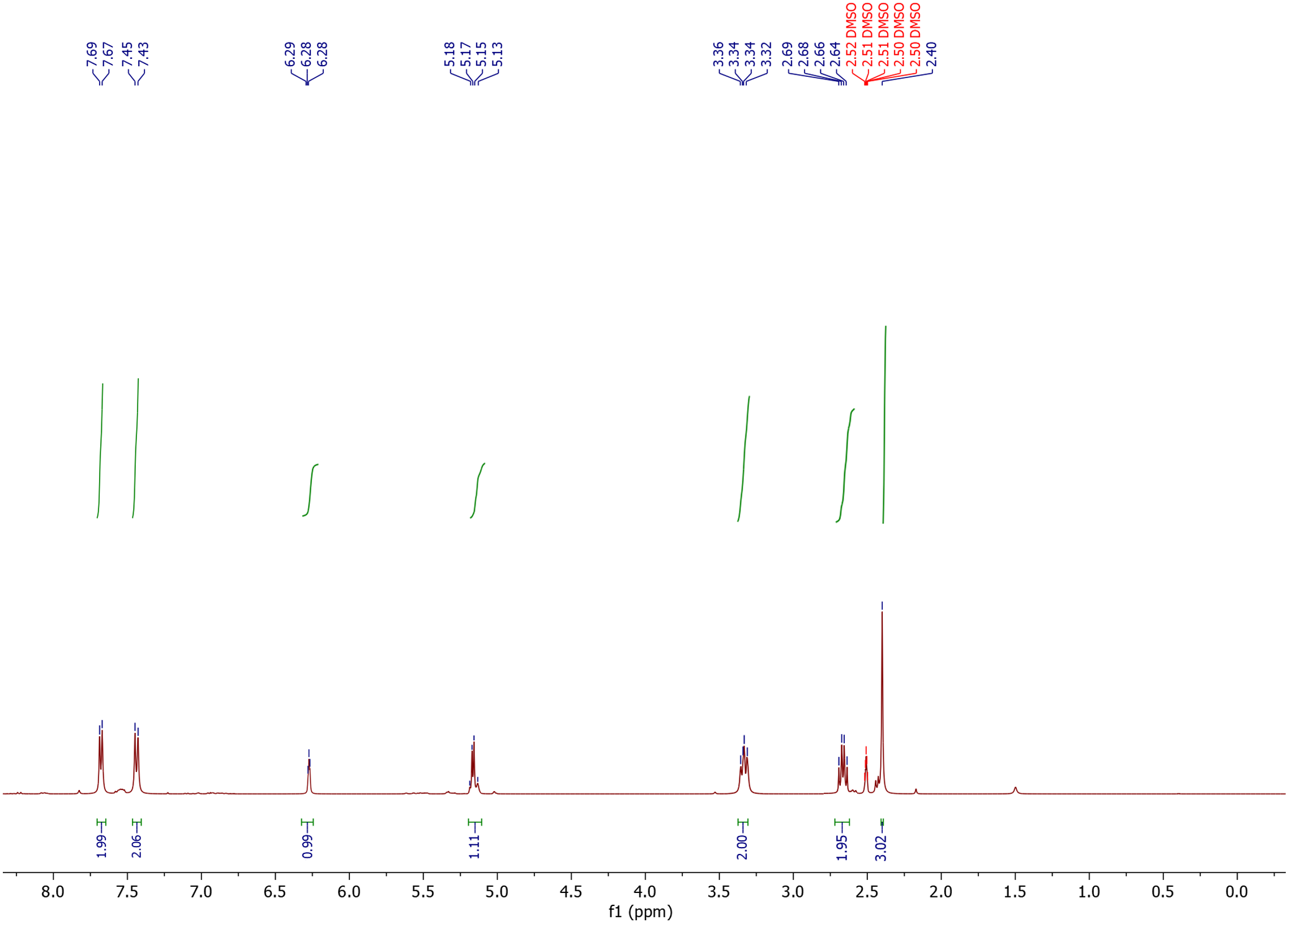
¹H NMR

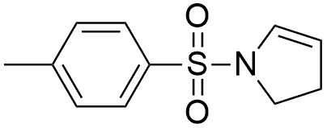

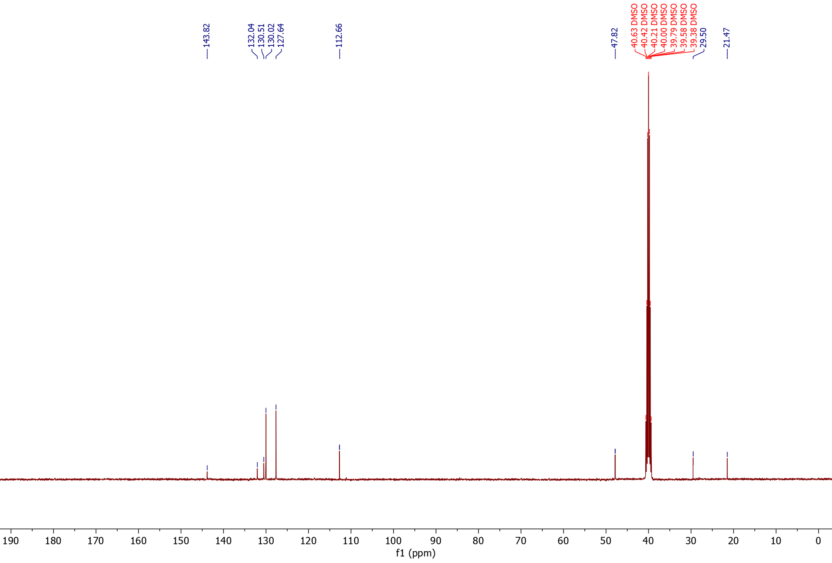
¹³C NMR

Manoyl oxide propionaldehyde: 1H-​Naphtho[2,​1-​b]​pyran-​3-​propionaldehyde, dodecahydro-​3,​4a,​7,​7,​10a-​pentamethyl-​, (3S,​4aR,​6aS,​10aS,​10bR)​ (51b) (isolated product)

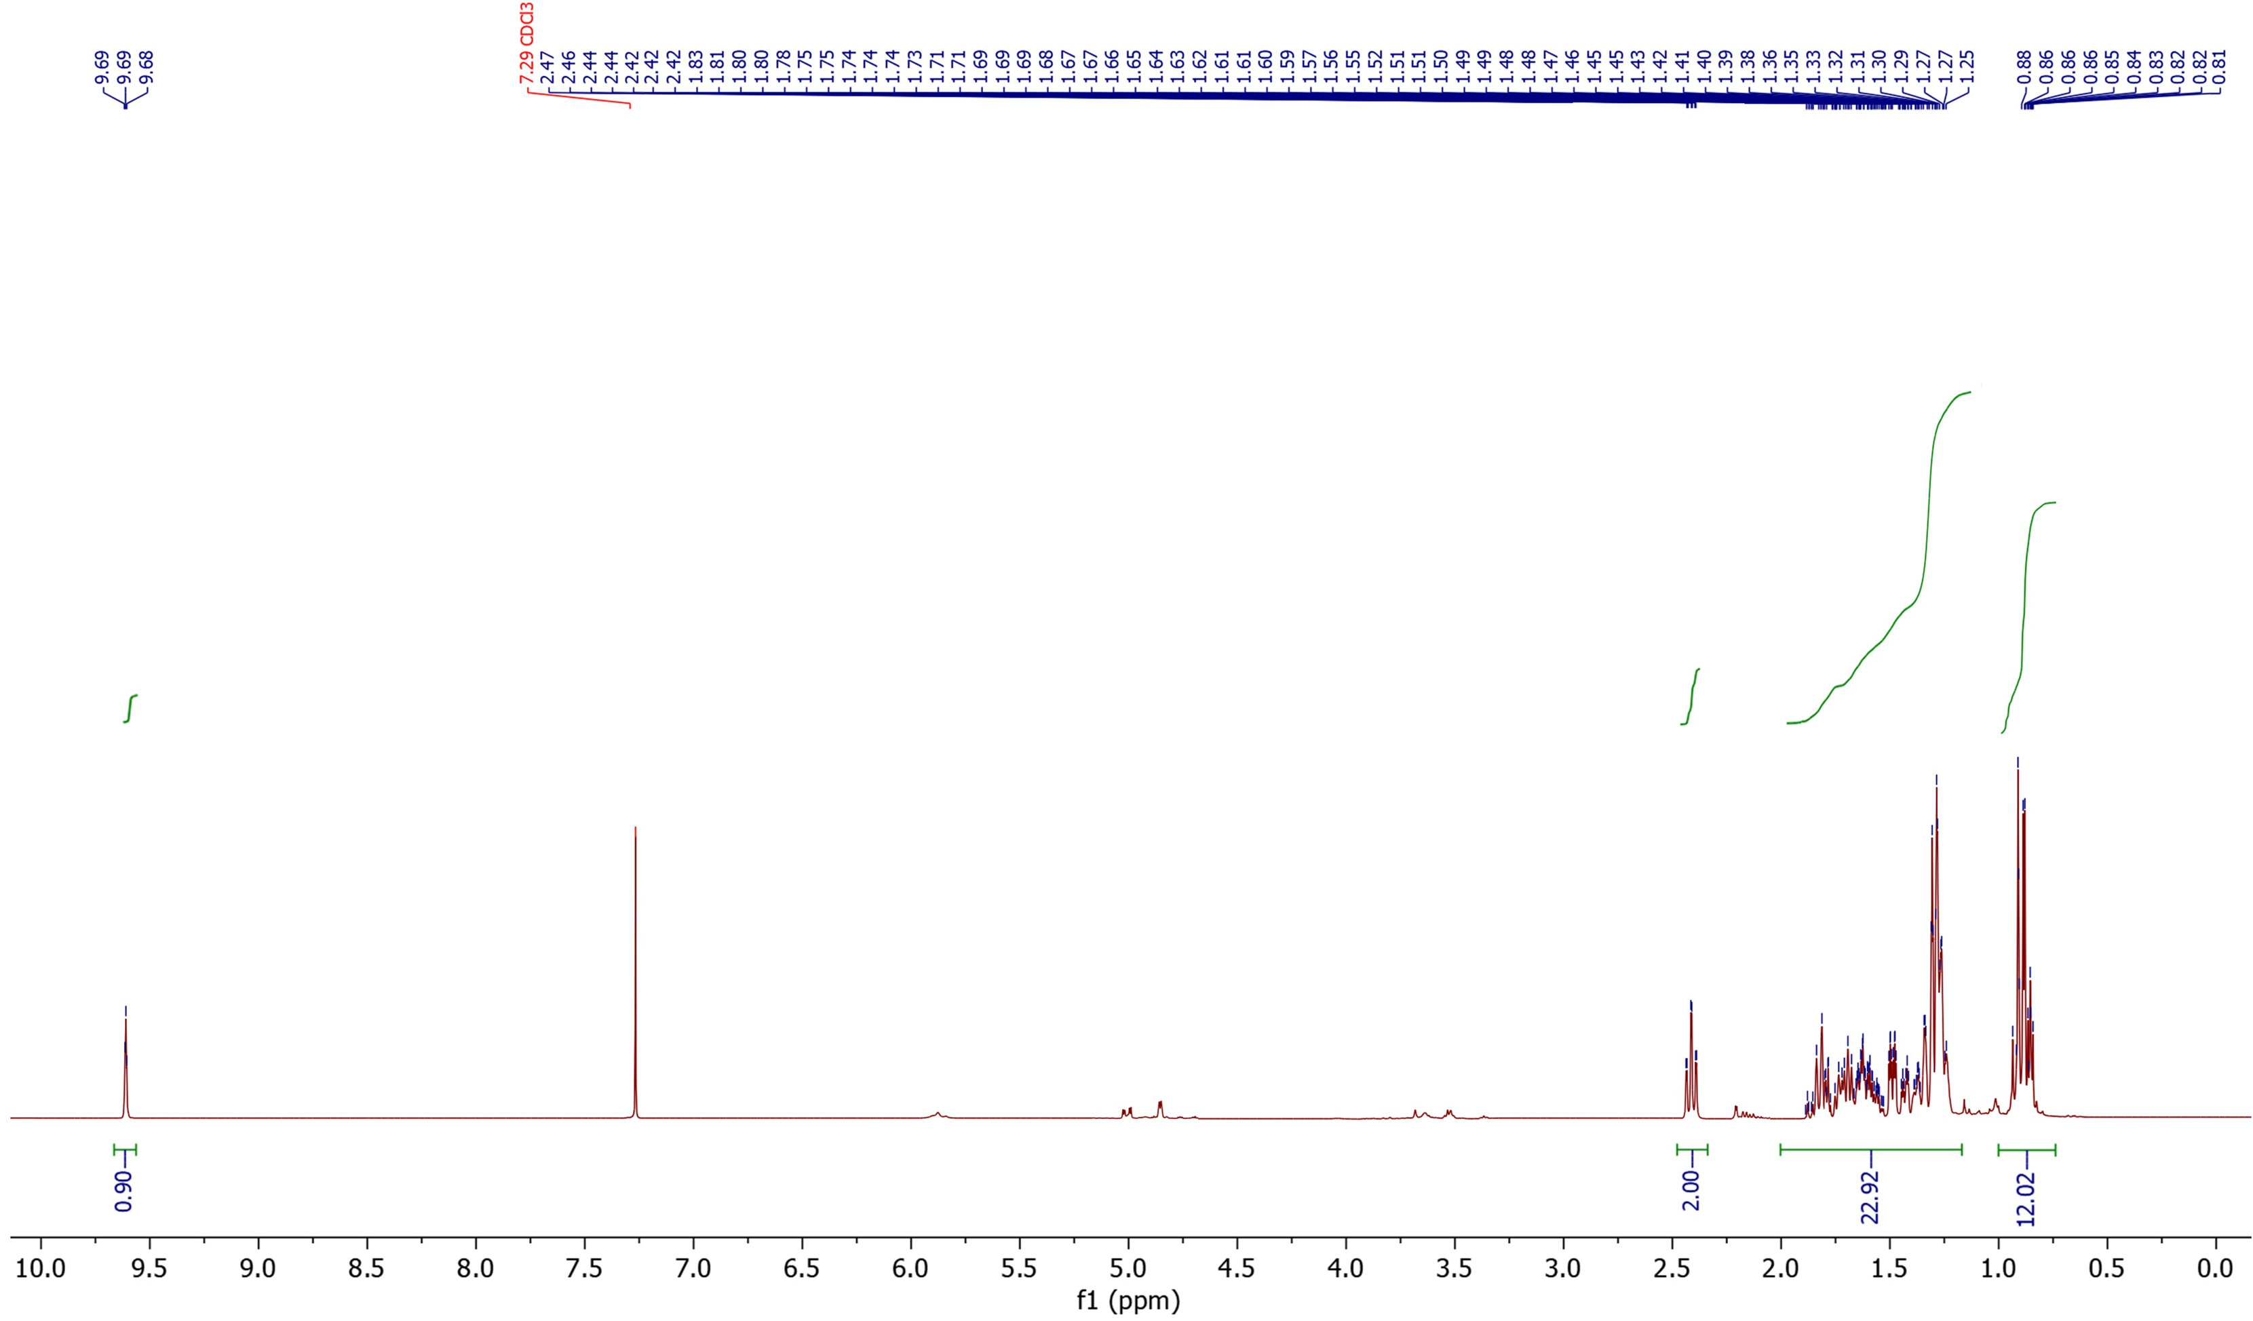
¹H NMR

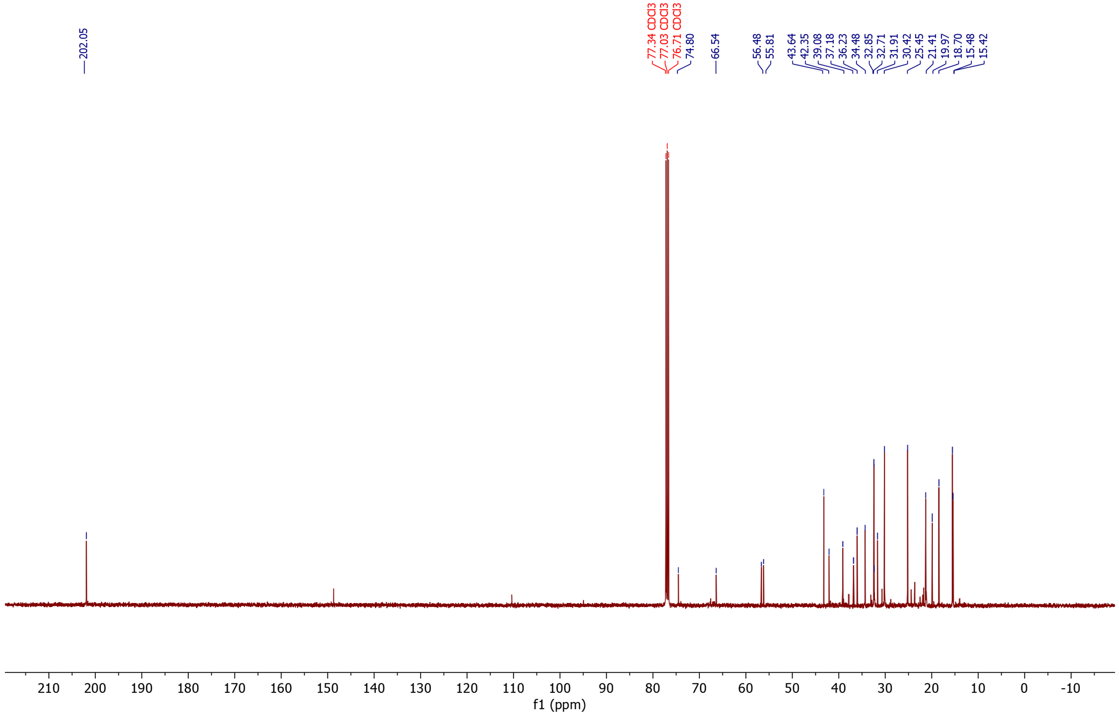
¹³C NMR

- Computational geometry optimizations
Table S29-A: Isovaleronitrile coordinates
C -0.7663091 0.0262740 -0.3354580
H -0.5733790 0.0312330 -1.4141981
C -0.7781841 1.4767221 0.1596850
C 0.3681990 -0.7930241 0.3291120
C -2.1115342 -0.6662250 -0.0879770
C 1.7043551 -0.2778480 0.0398250
N 2.7507392 0.1411490 -0.2026820
H -1.5619521 2.0486162 -0.3435540
H -0.9737851 1.5197881 1.2366261
H 0.1752950 1.9749752 -0.0305110
H -2.1152512 -1.6898011 -0.4734680
H 0.2309580 -0.8048371 1.4164091
H 0.3263900 -1.8339641 -0.0068070
H -2.9217682 -0.1215980 -0.5789580
H -2.3408412 -0.7078491 0.9821141

Table S29-B: Styrene coordinates
C | -1.3596440 | 1.3269910 | -0.0001110
C | 0.0086740 | 1.0902830 | -0.0003210
C | 0.5140370 | -0.2204730 | -0.0002290
C | -0.4061690 | -1.2792840 | -0.0000020
C | -1.7782520 | -1.0440000 | 0.0002550
H | -3.3289270 | 0.4497840 | 0.0003170
H | -1.7277880 | 2.3470500 | -0.0002030
H | 0.6912810 | 1.9320150 | -0.0005980
H | -0.0359890 | -2.2995280 | 0.0000500
H | -2.4685120 | -1.8802620 | 0.0004760
C | 1.9532530 | -0.5282910 | -0.0003550
C | 2.9720290 | 0.3348410 | 0.0005200
H | 2.1858330 | -1.5911040 | -0.0013430
H | 3.9968360 | -0.0161650 | 0.0001680
H | 2.8318880 | 1.4100160 | 0.0015420

Table S29-C: Isobutene coordinates
C | 0.0000000 | 1.2760670 | -0.6782090
C | 0.0000000 | 0.0000000 | 0.1241090
C | 0.0000000 | -1.2760670 | -0.6782090
C | 0.0000000 | 0.0000000 | 1.4570180
H | 0.0000000 | 2.1586740 | -0.0361260
H | 0.8786080 | 1.3267030 | -1.3318390
H | -0.8786080 | 1.3267030 | -1.3318390
H | 0.0000000 | -2.1586740 | -0.0361260
H | -0.8786080 | -1.3267030 | -1.3318390
H | 0.8786080 | -1.3267030 | -1.3318390
H | 0.0000000 | 0.9239040 | 2.0256780
H | 0.0000000 | -0.9239040 | 2.0256780

Table S29-D: 3-phenylpropionitrile coordinates
C | -0.5410190 | 2.8685040 | 0.0000000
C | -1.9041120 | 2.5715710 | 0.0000000
C | -2.3121870 | 1.2430080 | 0.0000000
C | -1.3675290 | 0.2150640 | 0.0000000
C | 0.0000000 | 0.4985450 | 0.0000000
C | 0.3966940 | 1.8428280 | 0.0000000
C | 1.0774600 | -0.5717180 | 0.0000000
C | 0.5632660 | -2.0230860 | 0.0000000
C | 1.6583800 | -2.9895600 | 0.0000000
N | 2.5324760 | -3.7408660 | 0.0000000
H | -0.2093450 | 3.9008440 | 0.0000000
H | -2.6375440 | 3.3696790 | 0.0000000
H | -3.3684930 | 0.9982200 | 0.0000000
H | -1.7183070 | -0.8101380 | 0.0000000
H | 1.4551580 | 2.0847160 | 0.0000000
H | 1.7219330 | -0.4314070 | 0.8736900
H | 1.7219330 | -0.4314070 | -0.8736900
H | -0.0591910 | -2.2126920 | -0.8798000
H | -0.0591910 | -2.2126920 | 0.8798000

Table S29-E: 2-phenylpropionitrile coordinates
C | -2.3980860 | 0.8018350 | -0.4931260
C | -2.7972830 | -0.4046630 | 0.0771740
C | -1.8353800 | -1.3002270 | 0.5389310
C | -0.4813640 | -0.9910200 | 0.4356020
C | -0.0739960 | 0.2185500 | -0.1318850
C | -1.0439390 | 1.1096240 | -0.5977910
C | 1.3985650 | 0.6167940 | -0.1999280
C | 1.8604060 | 1.3429500 | 1.0875050
H | -3.1393070 | 1.5012330 | -0.8630320
H | -3.8506670 | -0.6482250 | 0.1550050
H | -2.1377010 | -2.2450300 | 0.9761840
H | 0.2613980 | -1.7004330 | 0.7837380
H | -0.7394510 | 2.0487610 | -1.0492760
H | 1.5241890 | 1.3044490 | -1.0431840
H | 1.7585120 | 0.6870510 | 1.9538640
H | 1.2393310 | 2.2257850 | 1.2486000
H | 2.9037990 | 1.6543080 | 1.0058410
C | 2.2706820 | -0.5314910 | -0.4715780
N | 2.9688950 | -1.4288570 | -0.6624510

Table S29-F: Valeronitrile coordinates
H | -0.2493330 | -0.9117750 | 0.8785430
C | 0.8889060 | 0.7035230 | 0.0005430
C | 2.1746240 | 0.0098770 | 0.0000310
N | 3.1795220 | -0.5549700 | -0.0005790
H | 0.8516080 | 1.3565030 | -0.8777220
H | 0.8519810 | 1.3559940 | 0.8792130
C | -1.6526250 | 0.4832350 | -0.0007850
C | -2.8566360 | -0.4623090 | 0.0000300
H | -1.7018690 | 1.1386020 | -0.8786320
H | -1.7024700 | 1.1408530 | 0.8753440
H | -3.7968800 | 0.0946520 | -0.0013570
H | -2.8519470 | -1.1095300 | -0.8820450
H | -2.8529260 | -1.1067990 | 0.8841100
C | -0.3136980 | -0.2610800 | 0.0006300
H | -0.2482390 | -0.9131860 | -0.8760980

Table S29-G: 1-butene coordinates
C | -1.4553760 | -1.3274140 | 0.0000000
C | -0.2568740 | -0.7519810 | 0.0000000
C | 0.0000000 | 0.7409220 | 0.0000000
C | 1.4889170 | 1.1011950 | 0.0000000
H | -2.3717110 | -0.7433640 | 0.0000000
H | -1.5671780 | -2.4057120 | 0.0000000
H | 0.6265520 | -1.3892260 | 0.0000000
H | -0.4835720 | 1.1915080 | 0.8744150
H | -0.4835720 | 1.1915080 | -0.8744150
H | 1.6344600 | 2.1843350 | 0.0000000
H | 1.9925090 | 0.6973080 | 0.8834140
H | 1.9925090 | 0.6973080 | -0.8834140

Table S29-H: 2-butene (trans) coordinates
C | -0.5364490 | -0.3940770 | -0.0000340
C | 0.5364630 | 0.3941540 | 0.0000050
C | 1.9609120 | -0.0791320 | 0.0000060
H | -2.0207560 | 1.1702790 | -0.0002320
H | -2.5021950 | -0.2903290 | -0.8784260
H | -0.3902180 | -1.4742240 | -0.0000030
H | 0.3902240 | 1.4743010 | 0.0000040
H | 2.5021810 | 0.2901440 | 0.8785160
H | 2.0205980 | -1.1703170 | 0.0001550
H | 2.5020910 | 0.2899260 | -0.8786520
H | -2.5020640 | -0.2900140 | 0.8787110

Table S29-I: Butyronitrile coordinates
H | -0.7147740 | -1.1567710 | 0.8768710
C | 0.1639380 | 0.6115370 | 0.0000100
C | 1.5399920 | 0.1208240 | 0.0000010
N | 2.6186330 | -0.2857940 | -0.0000120
H | 0.0273260 | 1.2507510 | -0.8785990
H | 0.0273320 | 1.2507530 | 0.8786180
C | -2.3101590 | 0.0168370 | -0.0000140
H | -2.5033670 | 0.6319970 | -0.8839830
H | -2.5033950 | 0.6320150 | 0.8839380
C | -0.8794640 | -0.5243180 | 0.0000150
H | -0.7147510 | -1.1567980 | -0.8768190
H | -3.0346440 | -0.8006680 | -0.0000170

Table S29-J: Propene coordinates
C | -1.2804280 | 0.2204120 | -0.0000190
H | -2.2390540 | -0.2860400 | 0.0001170
H | -1.3013870 | 1.3064460 | -0.0002260
C | 1.2334670 | 0.1623480 | -0.0000500
H | 1.8074830 | -0.1534290 | -0.8783930
H | 1.8073970 | -0.1529000 | 0.8785410
H | 1.1818440 | 1.2536670 | -0.0003780
C | -0.1346340 | -0.4536990 | 0.0000770
H | -0.1667130 | -1.5421100 | 0.0002930

Table S29-K: Propionitrile coordinates
H | -1.4690980 | -1.0806220 | 0.8841360
C | -0.4791590 | 0.6508210 | -0.0000020
C | 0.8792180 | 0.1103860 | -0.0000030
N | 1.9436670 | -0.3318540 | -0.0000040
H | -0.5882890 | 1.2948110 | -0.8778510
H | -0.5882840 | 1.2948210 | 0.8778400
C | -1.5570550 | -0.4469940 | 0.0000070
H | -1.4691020 | -1.0806320 | -0.8841160
H | -2.5489180 | 0.0093190 | 0.0000070

Table S29-L: Ethylene coordinates
C | -0.6634720 | 0.0000000 | -0.0000040
C | 0.6634720 | 0.0000000 | 0.0000030
H | -1.2346040 | 0.9225150 | 0.0000110
H | -1.2346040 | -0.9225160 | -0.0000220
H | 1.2346040 | -0.9225150 | -0.0000090
H | 1.2346040 | 0.9225160 | 0.0000230

Table S29-M: 2-methylbutyronitrile coordinates
H | -0.6422500 | -1.7763070 | 0.0518260
C | 0.1666430 | 0.2023800 | 0.3530870
C | 1.5228890 | -0.3051260 | 0.1168750
N | 2.5856140 | -0.7047570 | -0.0850120
H | 0.0186870 | 0.1966050 | 1.4402450
C | -2.3197180 | -0.4209950 | 0.0833740
H | -2.6283090 | 0.5503790 | -0.3099200
H | -2.4653940 | -0.4070590 | 1.1680340
C | -0.8713670 | -0.7591300 | -0.2782700
H | -0.7407000 | -0.7494940 | -1.3653510
H | -2.9982440 | -1.1705480 | -0.3306940
C | 0.0506080 | 1.6553980 | -0.1483850
H | 0.1709410 | 1.6994290 | -1.2335670
H | -0.9254720 | 2.0688620 | 0.1094740
H | 0.8171130 | 2.2862720 | 0.3049420

19. Supplementary references
1. Scanlon, J. T. & Willis, D. E. Calculation of flame ionization detector relative response factors using the effective carbon number concept. J. Chromatogr. Sci. 23, 333–340 (1985).
2. Kamimura, Y., Kowenje, C., Yamanaka, K., Itabashi, K., Endo, A., & Okubo, T. Synthesis of hydrophobic siliceous ferrierite by using pyridine and sodium fluoride. Microporous Mesoporous Mater. 181, 154–159 (2013).
3. Jiao, K., Xu, X., Lv, Z., Song, J., He, M., & Gies, H. Synthesis of nanosized Silicalite-1 in F−media. Microporous Mesoporous Mater. 225, 98–104 (2016).
4. Wang, C., Liu, J., Yang, J. & Li, J. A crystal seeds-assisted synthesis of microporous and mesoporous silicalite-1 and their CO2/N2/CH4/C2H6 adsorption properties. Microporous Mesoporous Mater. 242, 231–237 (2017).
5. Corma, A., Domine, M. E. & Valencia, S. Water-resistant solid Lewis acid catalysts: Meerwein-Ponndorf-Verley and Oppenauer reactions catalyzed by tin-beta zeolite. J. Catal. 215, 294–304 (2003).
6. Zhang, M., Chen, Y., Wang, L., Zhang, Q., Tsang, C. W., & Liang, C. Shape Selectivity in Hydroisomerization of Hexadecane over Pt Supported on 10-Ring Zeolites: ZSM-22, ZSM-23, ZSM-35, and ZSM-48. Ind. Eng. Chem. Res. 55, 6069–6078 (2016).
7. Wang, S., Wang, P., Qin, Z., Chen, Y., Dong, M., Li, J., Zhang, K., Liu, P., Wang, J., and Fan, W. Relation of catalytic performance to the aluminum siting of acidic zeolites in the conversion of methanol to olefins, viewed via a comparison between ZSM-5 and ZSM-11. ACS Catal. 8, 5485–5505 (2018).
8. Zheng, S., Heydenrych, H. R., Jentys, A. & Lercher, J. A. Influence of surface modification on the acid site distribution of HZSM-5. J. Phys. Chem. B 106, 9552–9558 (2002).
9. Aylor, A. W., Lobree, L. J., Reimer, J. A. & Bell, A. T. Investigations of the dispersion of Pd in H-ZSM-5. J. Catal. 172, 453–462 (1997).
10. Fang, X., Yu, P. & Morandi, B. Catalytic reversible alkene-nitrile interconversion through controllable transfer hydrocyanation. Science 351, 832–836 (2016).
11. Tran, V.T., Li, Z.Q., Apolinar, O., Derosa, J., Joannou, M.V., Wisniewski, S.R., Eastgate, M.D. and Engle, K.M. Ni(COD)(DQ): An Air-Stable 18-Electron Nickel(0)–Olefin Precatalyst. Angew. Chemie - Int. Ed. 59, 7409–7413 (2020).
12. Nattmann, L. & Cornella, J. Ni(4‑Tbustb)3: A robust 16-electron Ni(0) olefin complex for catalysis. Organometallics 39, 3295–3300 (2020).
13. Morandi, B., Fang, Y. & Yu, P. Process for the catalytic reversible alkene-nitrile interconversion U.S. patent 10597356 B2 (2020).
14. Bhawal, B. N., Reisenbauer, J. C., Ehinger, C. & Morandi, B. Overcoming Selectivity Issues in Reversible Catalysis: A Transfer Hydrocyanation Exhibiting High Kinetic Control. J. Am. Chem. Soc. 142, 10914–10920 (2020).
15. Sammelson, R. E. & Allen, M. J. A convenient and selective one-pot method for the synthesis of monosubstituted secondary alkyl malononitriles. Synthesis (Stuttg). 2005, 543–546 (2005).
16. Jin, J. & MacMillan, D. W. C. Direct α‐Arylation of Ethers through the Combination of Photoredox‐Mediated C-H Functionalization and the Minisci Reaction. Angew. Chemie 127, 1585–1589 (2015).
17. Frisch, M. J.; Trucks, G. W.; Schlegel, H. B.; Scuseria, G. E.; Robb, M. A.; Cheeseman, J. R.; Scalmani, G. . et al. Gaussian 09 (Gaussian, Inc., Wallingford CT, 2009) VERSION D.01.
18. Stephens, P. J., Devlin, F. J., Chabalowski, C. F. & Frisch, M. J. Ab Initio Calculation of Vibrational Absorption and Circular Dichroism Spectra Using Density Functional Force Fields. J. Phys. Chem. 98, 11623–11627 (1994).
19. Murphy, S. K., Park, J.-W., Cruz, F. A. & Dong, V. M. Rh-catalyzed C-C bond cleavage by transfer hydroformylation. Science 347, 56–60 (2015).
20. Coperet, C., Comas-Vives, A., Conley, M.P., Estes, D.P., Fedorov, A., Mougel, V., Nagae, H., Nunez-Zarur, F. and Zhizhko, P.A. Surface Organometallic and Coordination Chemistry toward Single-Site Heterogeneous Catalysts: Strategies, Methods, Structures, and Activities. Chem. Rev. 116, 323–421 (2016).
21. Himes, G. R., Sanders, A. & Kety. Catalyst for polymerizing alpha-olefins and process for polymerization. U.S. Patent N. 6.063.726. (1989).
22. Kermagoret, A., Kerber, R.N., Conley, M.P., Callens, E., Florian, P., Massiot, D., Delbecq, F., Rozanska, X., Copéret, C. and Sautet, P. Chlorodiethylaluminum supported on silica: A dinuclear aluminum surface species with bridging μ2-Cl-ligand as a highly efficient co-catalyst for the Ni-catalyzed dimerization of ethene. J. Catal. 313, 46–54 (2014).
23. Li, J., DiVerdi, J. A. & Maciel, G. E. Chemistry of the silica surface: Liquid-solid reactions of silica gel with trimethylaluminum. J. Am. Chem. Soc. 128, 17093–17101 (2006).
24. Camblor, M. A., Villaescusa, L. A. & Diaz-Cabanas, M. J. Synthesis of all-silica and high-silica molecular sieves in fluoride media. Top. Catal. 9, 59–76 (1999).
25. Al-Jarallah, A. M., Anabtawi, J. A., Siddiqui, M. A. B., Aitani, A. M. & Al-Sa’doun, A. W. Ethylene dimerization and oligomerization to butene-1 and linear α-olefins. A review of catalytic systems and processes. Catal. Today 14, 1–121 (1992).
26. Ghosh, A. K. & Kevan, L. Catalytic and ESR studies of ethylene dimerization on palladium-exchanged Na-X and Ca-X zeolites. J. Phys. Chem. 92, 4439–4446 (1988).
27. Shetti, V. N., Kim, J., Srivastava, R., Choi, M. & Ryoo, R. Assessment of the mesopore wall catalytic activities of MFI zeolite with mesoporous/microporous hierarchical structures. J. Catal. 254, 296–303 (2008).
28. Bhunia, A., Bergander, K. & Studer, A. Cooperative Palladium/Lewis Acid-Catalyzed Transfer Hydrocyanation of Alkenes and Alkynes Using 1-Methylcyclohexa-2,5-diene-1-carbonitrile. J. Am. Chem. Soc. 140, 16353–16359 (2018).
29. Zhang, X., Jiang, R. & Cheng, X. Electrochemical Tandem Olefination and Hydrogenation Reaction with Ammonia. J. Org. Chem. 86, 16016–16025 (2021).
30. Frye, N. L., Bhunia, A. & Studer, A. Nickel-catalyzed Markovnikov transfer hydrocyanation in the absence of Lewis acid. Org. Lett. 22, 4456–4460 (2020).
31. Fang, W-Y. & Qin, H-L. Cascade Process for Direct Transformation of Aldehydes (RCHO) to Nitriles (RCN) Using Inorganic Reagents NH2OH/Na2CO3/SO2F2 in DMSO. J. Org. Chem. 84, 5803–5812 (2019).
32. Yan, F., Bai, J. F., Dong, Y., Liu, S., Li, C., Du, C. X., & Li, Y. Catalytic Cyanation of C–N Bonds with CO2/NH3. JACS Au 2, 2522–2528 (2022).
33. Zaragoza, F. One-Step Conversion of Alcohols into Nitriles with Simultaneous Two-Carbon Chain Elongation. (Cyanomethyl)trimethylphosphonium Iodide as a Reagent with a Dual Mode of Action. J. Org. Chem. 67, 4963–4964 (2002).
34. Zhang, J., Luo, C.-P. & Yang, L. Nickel/Cobalt-Catalyzed Reductive Hydrocyanation of Alkynes with Formamide as the Cyano Source, Dehydrant, Reductant, and Solvent. Adv. Synth. Catal. 363, 283–288 (2021).
35. Málek, J. Reductions by Metal Alkoxyaluminum Hydrides. Part II. Carboxylic Acids and Derivatives, Nitrogen Compounds, and Sulfur Compounds. Org. React. (1988).
36. Arnano, T., Yoshikawa, K., Sano, T., Ohuchi, Y., Shiono, M., Ishiguro, M. & Fujita, Y. A new convenient synthesis of α-arylpropionic acid esters and α-arylpropionitriles. Synth. Commun. 16, 499–507 (1986).
37. Shang, R., Ji, D.-S., Chu, L., Fu, Y. & Liu, L. Synthesis of α-Aryl Nitriles through Palladium-Catalyzed Decarboxylative Coupling of Cyanoacetate Salts with Aryl Halides and Triflates. Angew. Chemie Int. Ed. 50, 4470–4474 (2011).
38. Anxionnat, B., Gomez Pardo, D., Ricci, G. & Cossy, J. Monoalkylation of Acetonitrile by Primary Alcohols Catalyzed by Iridium Complexes. Org. Lett. 13, 4084–4087 (2011).
39. Borghs, J. C., Tran, M. A., Sklyaruk, J., Rueping, M. & El-Sepelgy, O. Sustainable Alkylation of Nitriles with Alcohols by Manganese Catalysis. J. Org. Chem. 84, 7927–7935 (2019).
40. Xia, A., Xie, X., Chen, H., Zhao, J., Zhang, C. & Liu, Y. Nickel-Catalyzed Cyanation of Unactivated Alkyl Chlorides or Bromides with Zn(CN)2. Org. Lett. 20, 7735–7739 (2018).
41. Stokker, G. E., Hoffman, W. F., Alberts, A. W., Cragoe Jr, E. J., Deana, A. A., Gilfillan, J. L., … & Prugh, J. D. 3-Hydroxy-3-methylglutaryl-coenzyme A reductase inhibitors. I. Structural modification of 5-substituted 3,5-dihydroxypentanoic acids and their lactone derivatives. J. Med. Chem. 28, 347–358 (1985).
42. Hu, H., Dyke, J. C., Bowman, B. A., Ko, C-C. & You, W. Investigation of Dopamine Analogues: Synthesis, Mechanistic Understanding, and Structure–Property Relationship. Langmuir 32, 9873–9882 (2016).
43. Singh, K., Kumar, M., Pavadai, E., Naran, K., Warner, D. F., Ruminski, P. G. & Chibale, K. Synthesis of new verapamil analogues and their evaluation in combination with rifampicin against Mycobacterium tuberculosis and molecular docking studies in the binding site of efflux protein Rv1258c. Bioorg. Med. Chem. Lett. 24, 2985–2990 (2014).
44. Delolo, F. G., Yang, J., Neumann, H., dos Santos, E. N., Gusevskaya, E. V. & Beller, M. Cobalt-Catalyzed Hydroformylation under Mild Conditions in the Presence of Phosphine Oxides. ACS Sustain. Chem. Eng. 9, 5148–5154 (2021).
45. Wu, L., Liu, Q., Spannenberg, A., Jackstell, R. & Beller, M. Highly regioselective osmium-catalyzed hydroformylation. Chem. Commun. 51, 3080–3082 (2015).
46. Zhang, Y., Torker, S., Sigrist, M., Bregovic, N. & Dydio, P. Binuclear Pd (I)-Pd (I) Catalysis Assisted by Iodide Ligands for Selective Hydroformylation of Alkenes and Alkynes. J. Am. Chem. Soc. 142, 18251–18265 (2020).
47. Wrackmeyer, B. Organoboron Chemistry in Modern Magnetic Resonance (ed. Webb, G. A.) 455–457 Springer Netherlands (2006).
48. Hoffmann, R. W. & Brückner, D. Stereoselective synthesis of alcohols. Part LV. Domino hydroformylation-allylboration-hydroformylation reactions to give trans-perhydropyrano [3, 2-b] pyridine derivatives. New J. Chem. 25, 369–373 (2001).
49. Mercadante, M. A., Kelly, C. B., Hamlin, T. A., Delle Chiaie, K. R., Drago, M. D., Duffy, K. K., ... & Tilley, L. J. 1,3-γ-Silyl-elimination in electron-deficient cationic systems. Chemical Science 10, 3983-3994 (2014).
50. Huang, H., Yu, C., Zhang, Y., Zhang, Y., Mariano, P. S., & Wang, W. Chemo-and regioselective organo-photoredox catalyzed hydroformylation of styrenes via a radical pathway. J. Am. Chem. Soc. 139, 9799–9802 (2017).
51. Kimball, F. S., Romero, F. A., Ezzili, C., Garfunkle, J., Rayl, T. J., Hochstatter, D. G., ... & Boger, D. L. Optimization of α-ketooxazole inhibitors of fatty acid amide hydrolase. J. Med. Chem. 51, 937–947 (2008).
52. Geng, H-Q., Meyer, T., Franke, R. & Wu, X-F. Copper-catalyzed hydroformylation and hydroxymethylation of styrenes. Chem. Sci. 12, 14937–14943 (2021).
53. Ren, W., Chang, W., Dai, J., Shi, Y., Li, J., & Shi, Y. An effective Pd-catalyzed regioselective hydroformylation of olefins with formic acid. J. Am. Chem. Soc. 138, 14864–14867 (2016).
54. Delorme, D., Woo, S. H., Vaisburg, A., Moradei, O., Leit, S., Raeppel, S., ... & Bouchain, G. Inhibitors of histone deactylase. U.S. Patent No. 7,868,204 (2011).
55. Luo, D., Sharma, H., Yedlapudi, D., Antonio, T., Reith, M. E., & Dutta, A. K. Novel multifunctional dopamine D2/D3 receptors agonists with potential neuroprotection and anti-alpha synuclein protein aggregation properties. Bioorganic & Med. Chem. 24, 5088–5102 (2016).
56. Arai, N., Sato, K., Azuma, K. & Ohkuma, T. Enantioselective Isomerization of Primary Allylic Alcohols into Chiral Aldehydes with the tol-binap/dbapen/Ruthenium (II) Catalyst. Angew. Chemie 125, 7648–7652 (2013).
57. Nestl, B. M., Glueck, S. M., Hall, M., Kroutil, W., Stuermer, R., Hauer, B., & Faber, K. Biocatalytic Racemization of (Hetero) Aryl-aliphatic α-Hydroxycarboxylic Acids by Lactobacillus spp. Proceeds via an Oxidation-Reduction Sequence. Eur. J. Org. Chem. 20, 4573-4577 (2006).
58. García-Reynaga, P., Carrillo, A. K. & VanNieuwenhze, M. S. Decarbonylative Approach to the Synthesis of Enamides from Amino Acids: Stereoselective Synthesis of the (Z)-Aminovinyl-d-Cysteine Unit of Mersacidin. Org. Lett. 14, 1030–1033 (2012).
59. Koval'skaya, S. S., Kozlov, N. G., Kulcitki, V., Aricu, A. & Ungur, N. Transformation of sclareol under ritter reaction conditions. Russ. J. Org. Chem. 49, 303–311 (2013).
60. Makarouni, D., Kordulis, C. & Dourtoglou, V. Solvent-Driven Selectivity on the One-Step Catalytic Synthesis of Manoyl Oxide Based on a Novel and Sustainable "Zeolite Catalyst--Solvent" System. Catal. Letters 152, 1298–1307 (2022).
61. Andersen‐Ranberg, J., Kongstad, K.T., Nielsen, M.T., Jensen, N.B., Pateraki, I., Bach, S.S., Hamberger, B., Zerbe, P., Staerk, D., Bohlmann, J. and Møller, B.L. Expanding the landscape of diterpene structural diversity through stereochemically controlled combinatorial biosynthesis. Angew. Chemie Int. Ed. 55, 2142–2146 (2016).
62. Nielsen, M. T., Ranberg, J. A., Christensen, U., Christensen, H. B., Harrison, S. J., Olsen, C. E., ... & Nørholm, M. H. Microbial Synthesis of the Forskolin Precursor Manoyl Oxide in an Enantiomerically Pure Form. Appl. Environ. Microbiol. 80, 7258–7265 (2014).
63. Kofke, T. J. G. & Gorte, R. J. A temperature-programmed desorption study of olefin oligomerization in H ZSM-5. J. Catal. 115, 233–243 (1989).
64. Martini, A., Guda, S.A., Guda, A.A., Smolentsev, G., Algasov, A., Usoltsev, O., Soldatov, M.A., Bugaev, A., Rusalev, Y., Lamberti, C. and Soldatov, A.V. PyFitit: The software for quantitative analysis of XANES spectra using machine-learning algorithms. Comput. Phys. Commun. 250, 107064 (2020).
65. Kozyr, E.G., Bugaev, A.L., Guda, S.A., Guda, A.A., Lomachenko, K.A., Janssens, K., Smolders, S., De Vos, D. and Soldatov, A.V. Speciation of Ru Molecular Complexes in a Homogeneous Catalytic System: Fingerprint XANES Analysis Guided by Machine Learning. J. Phys. Chem. C 125, 27844–27852 (2021).
66. Ravel, B. & Newville, M. ATHENA, ARTEMIS, HEPHAESTUS: data analysis for X-ray absorption spectroscopy using IFEFFIT. J. Synchrotron Radiat. 12, 537–541 (2005).
67. Vercammen, J., Bocus, M., Neale, S., Bugaev, A., Tomkins, P., Hajek, J., Van Minnebruggen, S., Soldatov, A., Krajnc, A., Mali, G. and Van Speybroeck, V. Shape-selective C–H activation of aromatics to biarylic compounds using molecular palladium in zeolites. Nat. Catal., 3(12), 1002-1009 (2020).
68. Wagschal, S., Perego, L.A., Simon, A., Franco‐Espejo, A., Tocqueville, C., Albaneze‐Walker, J., Jutand, A. and Grimaud, L. Formation of XPhos-Ligated Palladium (0) Complexes and Reactivity in Oxidative Additions. Chem. Eur. J. 25, 6980–6987 (2019).
69. Bugaev, A.L., Guda, A.A., Pankin, I.A., Groppo, E., Pellegrini, R., Longo, A., Soldatov, A.V. and Lamberti, C. The role of palladium carbides in the catalytic hydrogenation of ethylene over supported palladium nanoparticles. Catal. Today 336, 40–44 (2019).
70. Lichty, L. R., Han, J. W., Torgeson, D. R., Barnes, R. G. & Seymour, E. F. W. Cross relaxation between proton and quadrupolar nuclear spins in metal-hydrogen systems. Phys. Rev. B 42, 7734 (1990).
71. Shmyreva, A. A., Safdari, M., Furó, I. & Dvinskikh, S. V. NMR longitudinal relaxation enhancement in metal halides by heteronuclear polarization exchange during magic-angle spinning. J. Chem. Phys. 144, 224201 (2016).

