Supplementary Section

S1 Comparison metrics
As recommended by the GPM team, the metrices which are less sensitive to missing data values like mean, median and root mean squared error difference (GPM, 2020b) were used to evaluate rainfall products in this study. The individual mean monthly values are compared at geographical scale along with their spread for IMERG (CFSR) and GSOM precipitation. At station levels, a range of performance indicators like Nash Sutcliffe Efficiency (NSE), Volumetric Efficiency (VE), Percentage Bias (PBIAS), Root Mean Square Error (RMSE) and Pearson’s correlation coefficient (R) are computed by comparing IMERG (CFSR) and GSOM precipitation during 2001-2020 using R package “hydroGOF” (Zambrano-Bigiarini, 2014) (Table 2). At country levels, these statistics at station levels are aggregated by their median and presented as spatial-plots. To have an objective evaluation of each scale using the geographical region, the following performance criteria is also proposed based on widely accepted performance evaluation criteria.
Table S1 Performance metrices and their meanings proposed for this study
Metrices | Value | Optimal value | Value | Value | Value | Value
NSE | -∞ to 1 | 1 | NSE<0.5 | 0.5<NSE<0.7 | NSE>0.7 | NSE>0.9
Remark | Possible range |  | Unsatisfactory | Satisfactory | Good | Excellent
R | 1 to 1 | 1 | R< -0.75 | -0.75< R<0 | 0< R<0.75 | R>0.75
Remark | Possible range |  | Strongly negatively correlated | Negatively correlated | Positively correlated | Strongly positively correlated
VE | 0 to 1 | 1 | VE<0.5 | 0.5<VE<0.7 | VE>0.7 | VE>0.9
Remark | Possible range |  | Unsatisfactory | Satisfactory | Good | Excellent
KGE | -∞ to 1 | 1 | KGE<0.5 | 0.5<KGE<0.7 | KGE>0.7 | KGE>0.9
Remark | Possible range |  | Unsatisfactory | Satisfactory | Good | Excellent
PBIAS | -∞ to +∞ | 0 | PBIAS<-30 | -30<PBIAS<5 | 5<PBIAS<30 | PBIAS>30
Remark | Possible range |  | Unsatisfactory underestimation | Satisfactory underestimation | Satisfactory overestimation | Unsatisfactory overestimation
It is also understood that while RMSE has an optimal value of zero, achieving its optimal value is almost next to impossible in these comparison studies. However, a common understanding of RMSE is that the lesser values generally indicate lesser errors or disagreement among two datasets. However, in this study, RMSE of one station or country is not advised to compare with other because of their own climatology. Generally, stations with high precipitation in tropics are likely to have higher RMSE values than the stations in arid climate.
Similarly, to test the significance of the outperformance of one dataset above another, Welch T test has been employed with a null hypothesis that mean of the metrices calculated for IMERG and CFSR are not significantly different at a significance level of alpha=0.05, at geographical region, continent and country scales.

Section S2
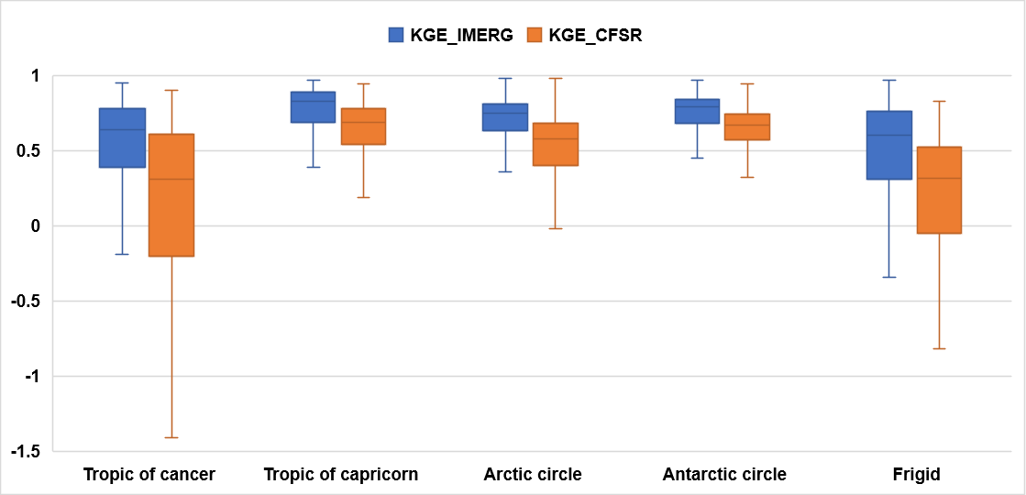
Figure S1. KGE values computed for each geographical region by comparing IMERG (CFSR) with GSOM rainfall during 2001-2020

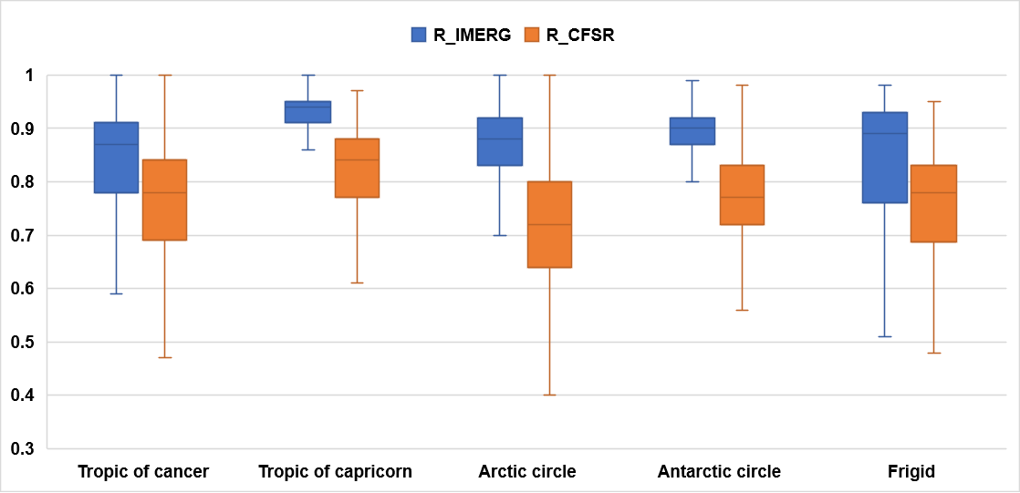
Figure S2. R values computed for each geographical region by comparing IMERG (CFSR) with GSOM rainfall during 2001-2020

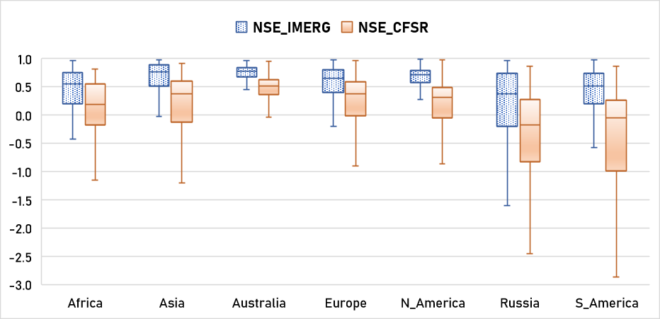
Figure S3. NSE values computed for each continent by comparing IMERG (CFSR) with GSOM rainfall during 2001-2020

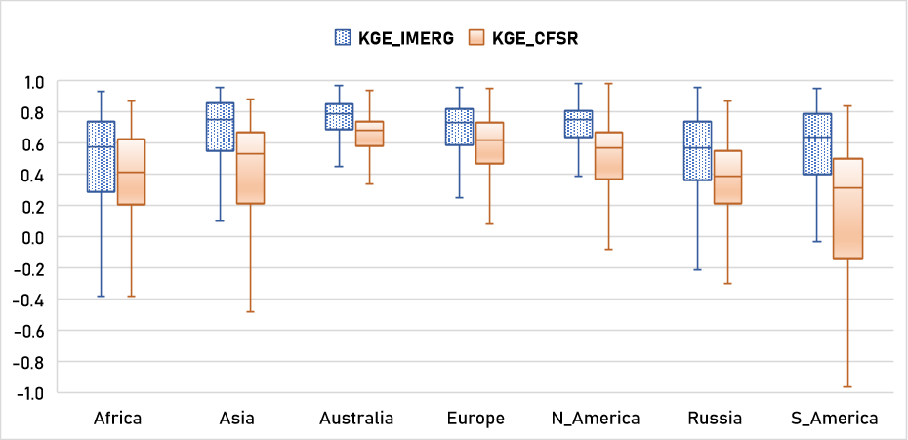
Figure S4. KGE values computed for each continent by comparing IMERG (CFSR) with GSOM rainfall during 2001-2020

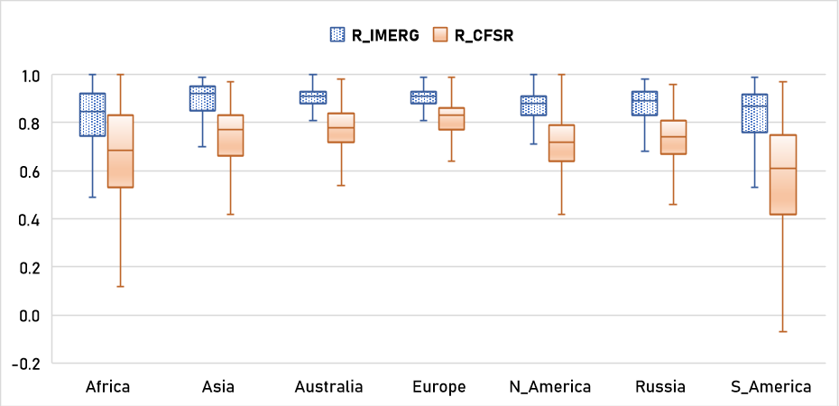
Figure S5. R values computed for each continent by comparing IMERG (CFSR) with GSOM rainfall during 2001-2020

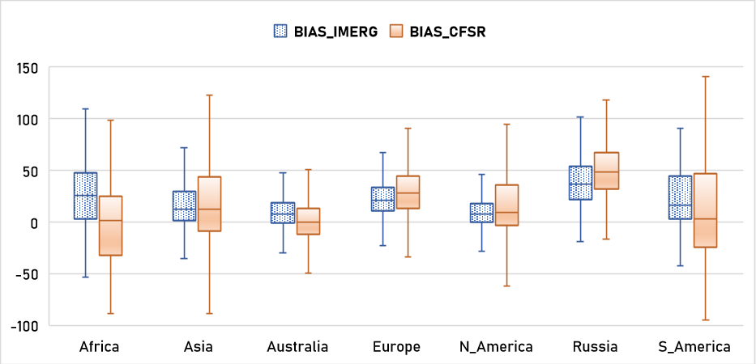
Figure S6. PBIAS (%) computed for each continent by comparing IMERG (CFSR) with GSOM rainfall during 2001-2020
Figure S7. Density of stations considered for analysis in this study

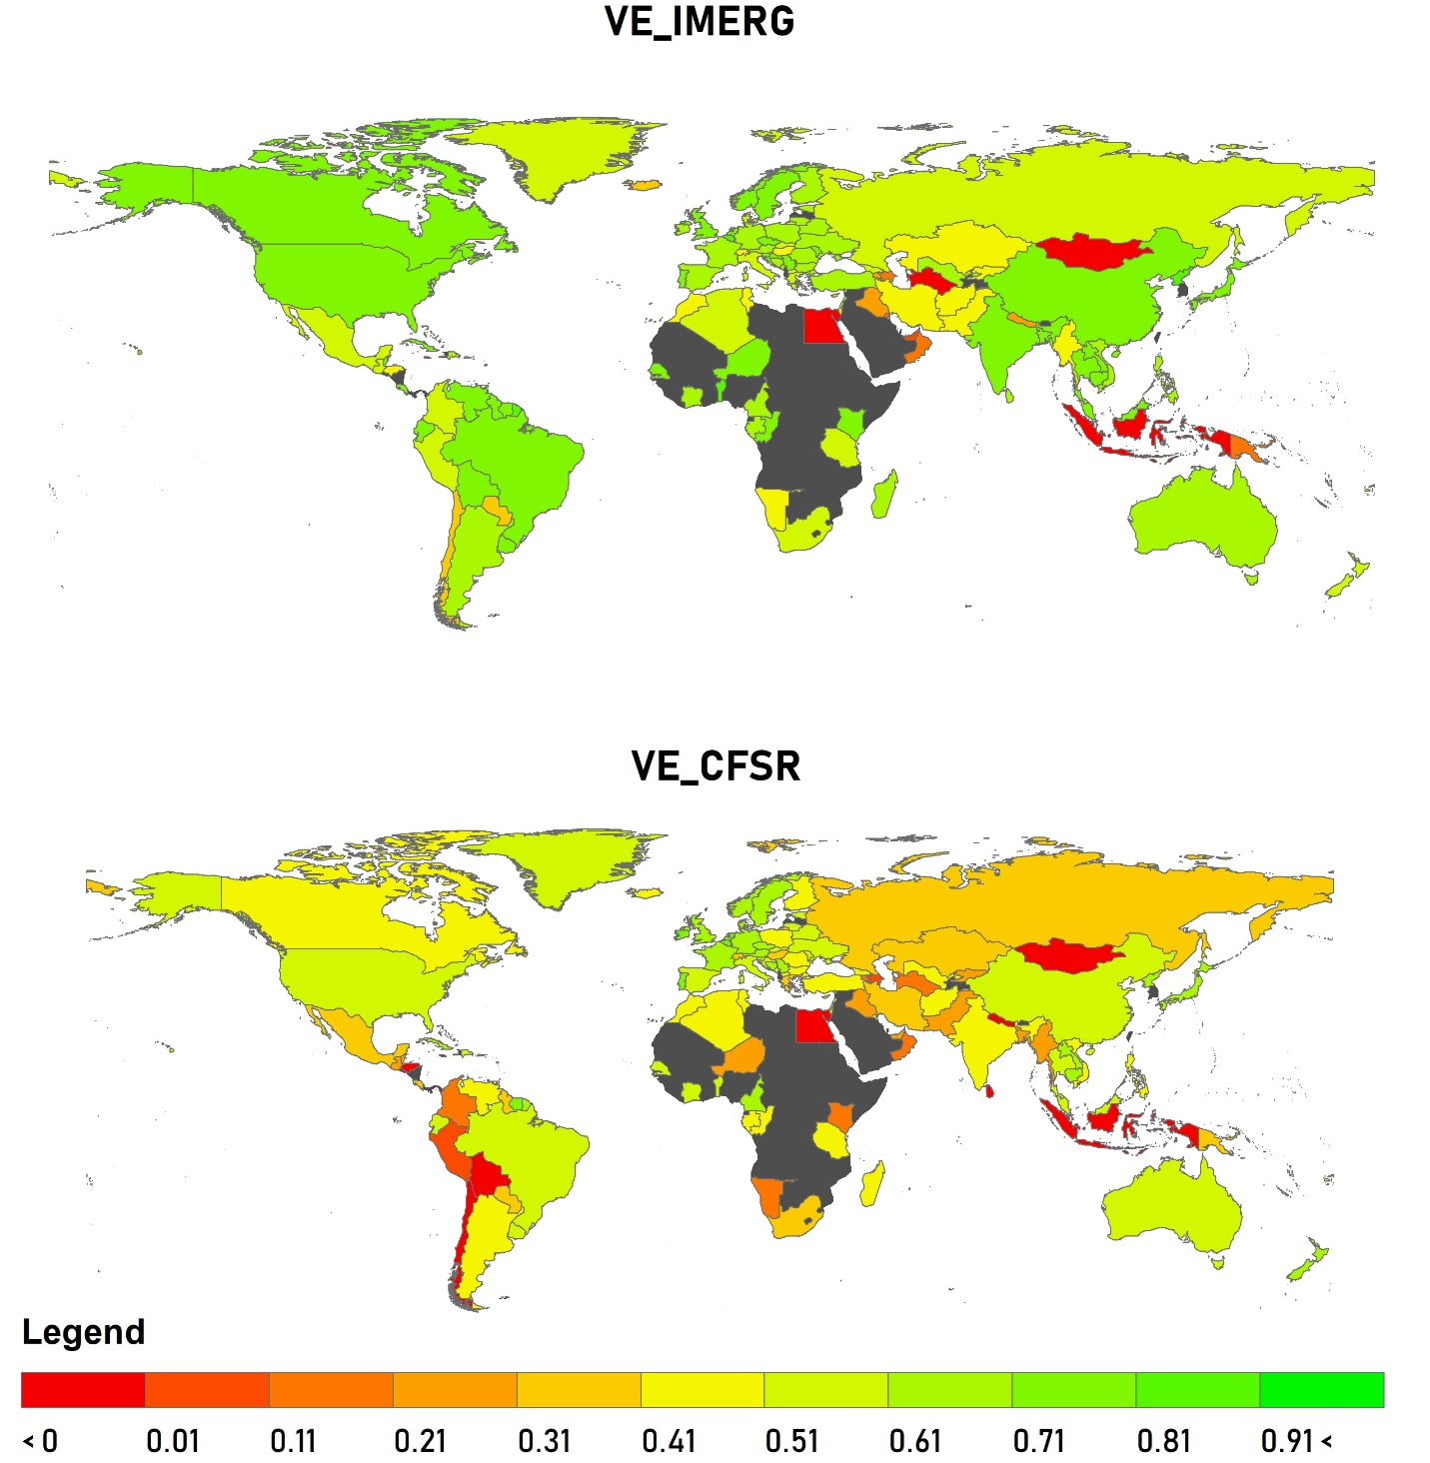
Figure S8. Median VE computed at country level using IMERG (CFSR) and GSOM rainfall during 2001-2020
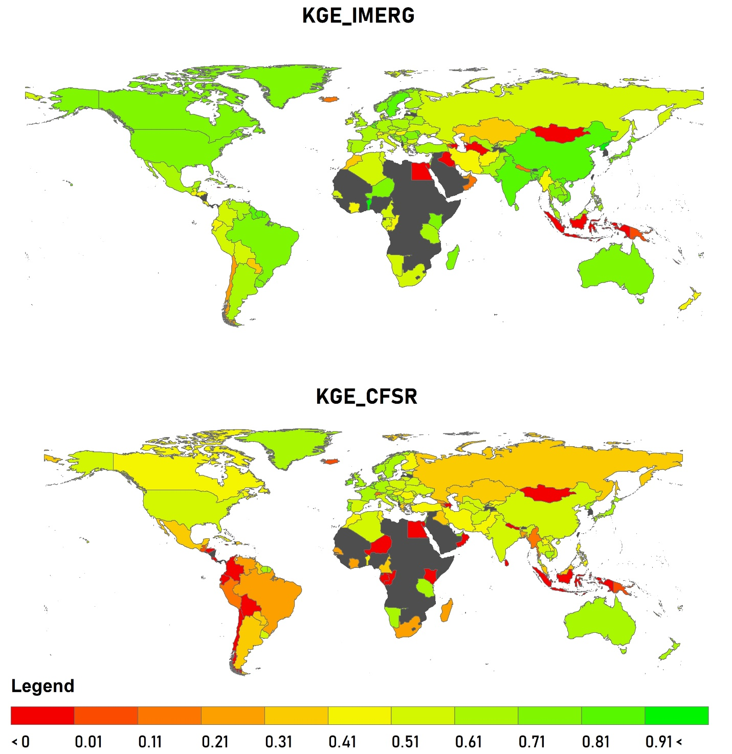
Figure S9. Median KGE computed at country level using IMERG (CFSR) and GSOM rainfall during 2001-2020

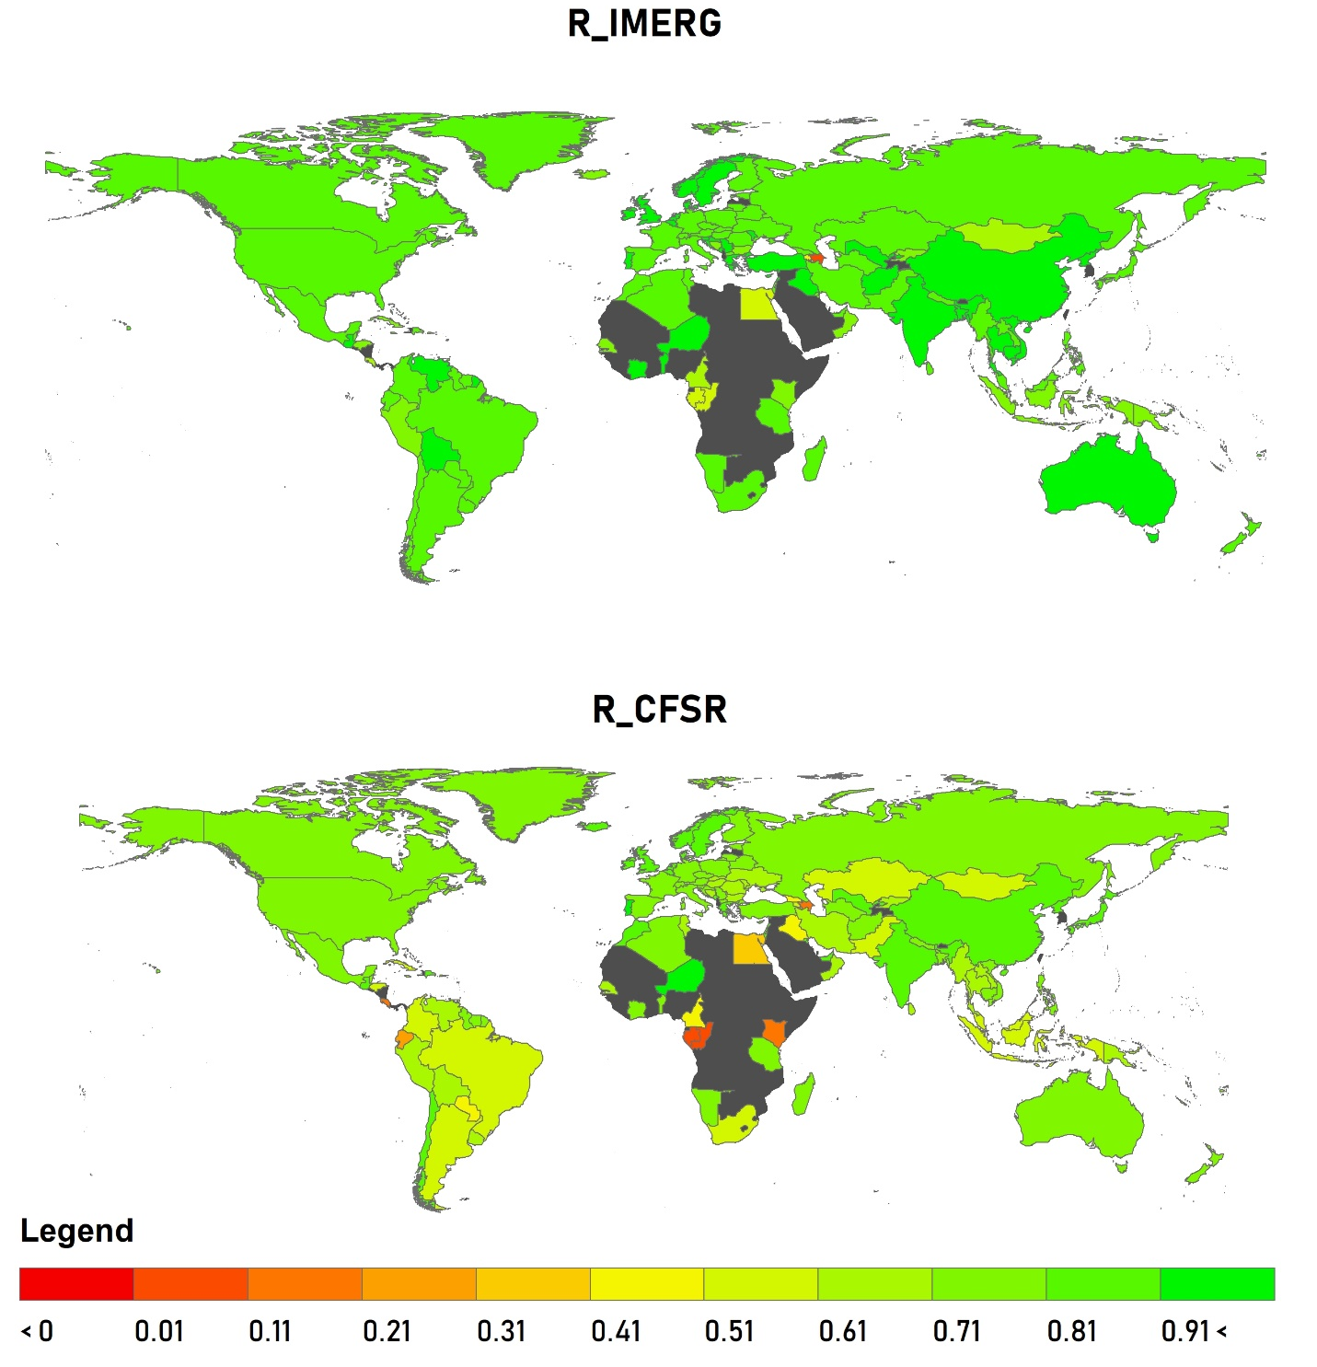
Figure S10. Median R computed at country level using IMERG (CFSR) and GSOM rainfall during 2001-2020
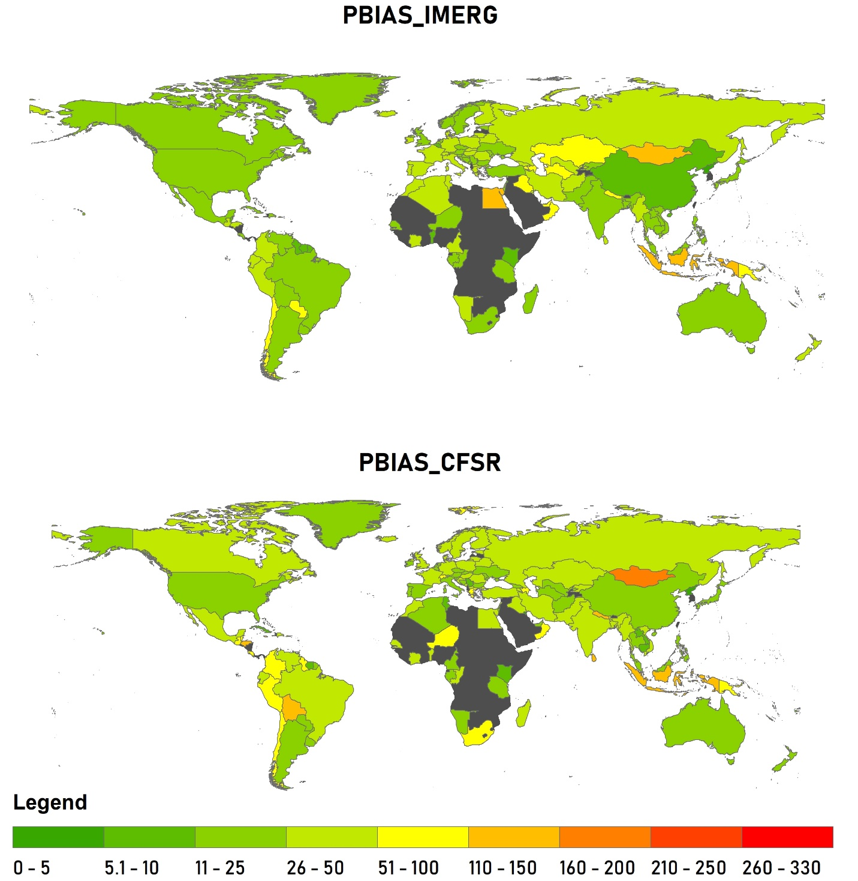
Figure S11. Median PBIAS computed at country level using IMERG (CFSR) and GSOM rainfall during 2001-2020
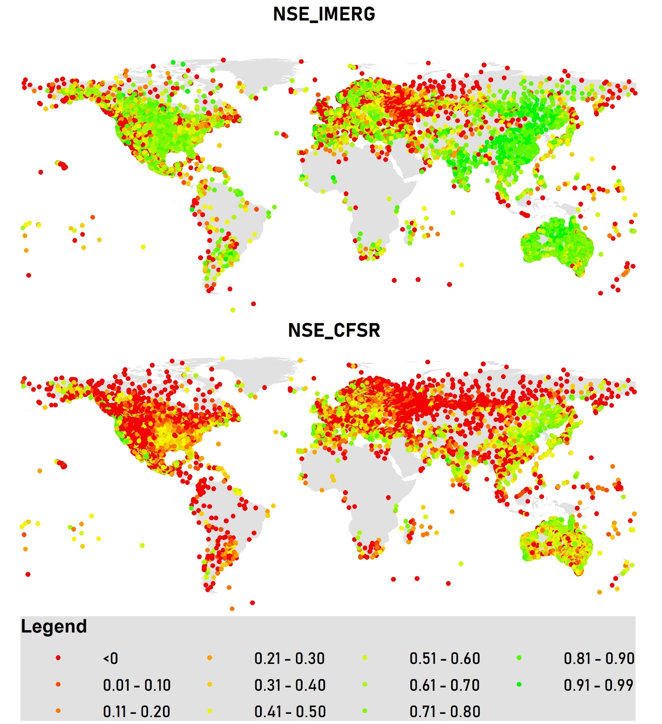
Figure S12. NSE computed at station levels using IMERG (CFSR) and GSOM rainfall during 2001-2020
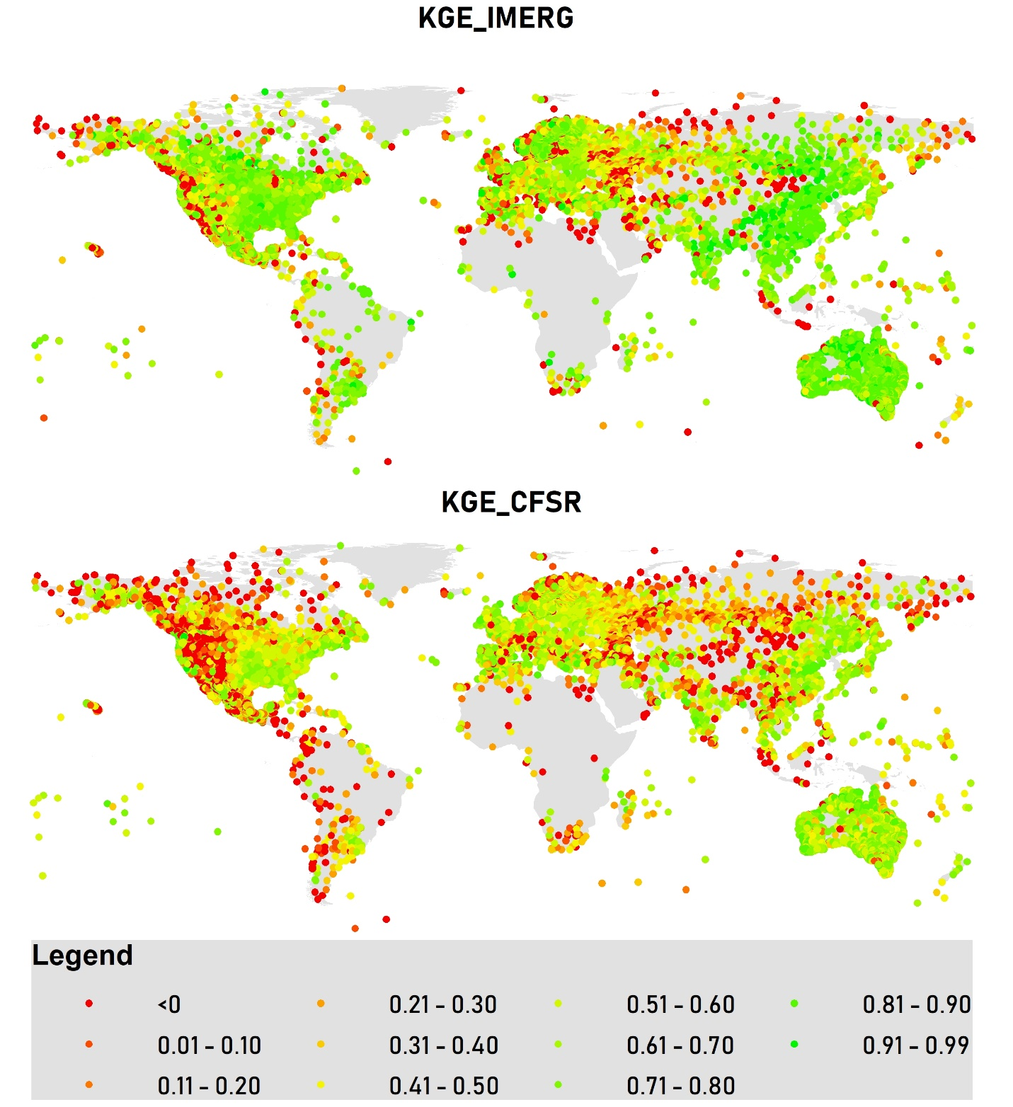
Figure S13. KGE computed at station levels using IMERG (CFSR) and GSOM rainfall during 2001-2020
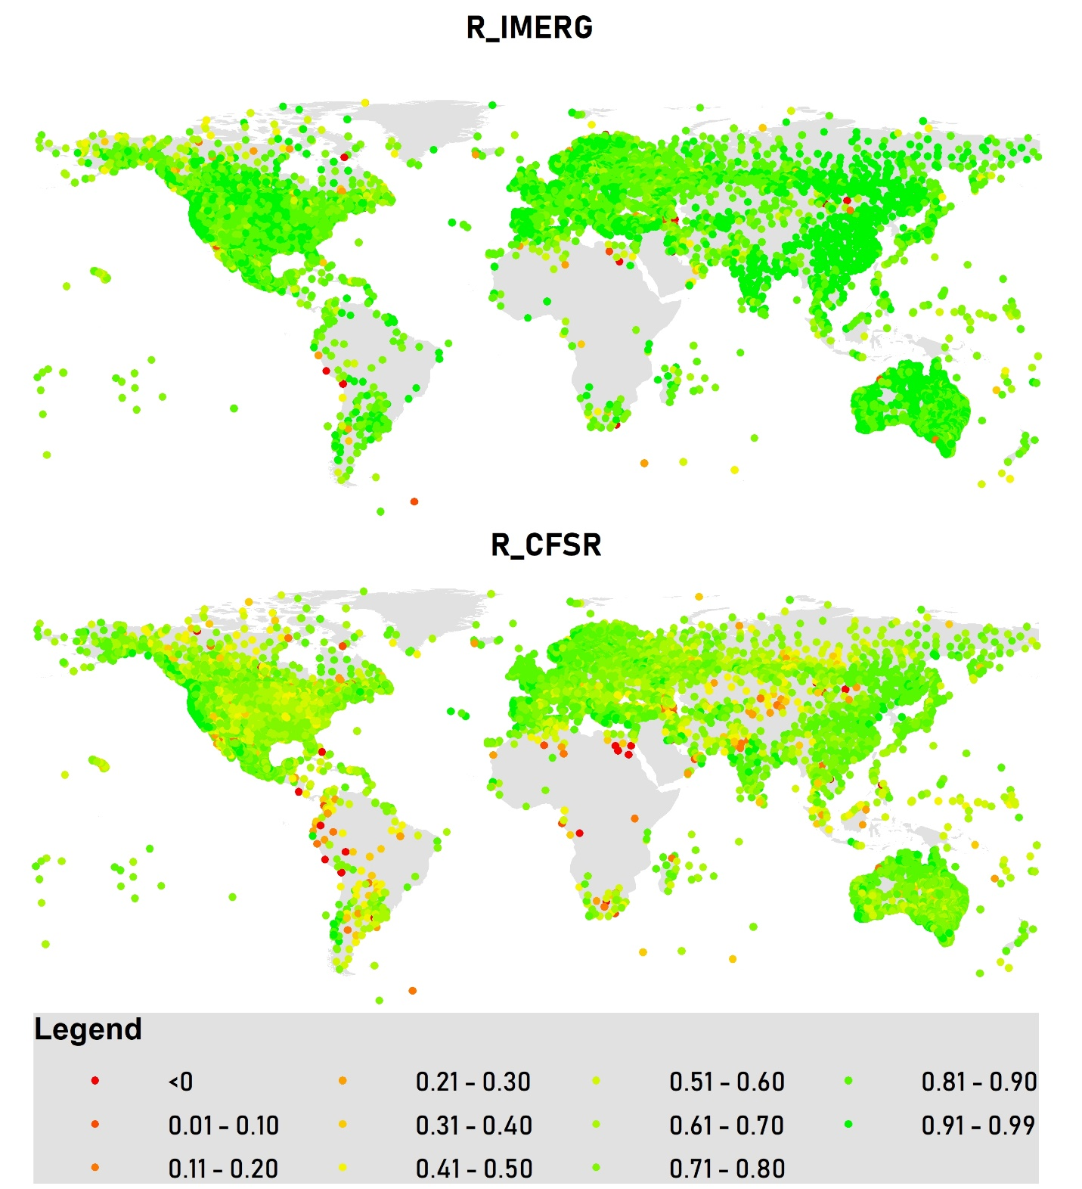
Figure S14. R computed at station levels using IMERG (CFSR) and GSOM rainfall during 2001-2020

Figure S15. PBIAS computed at station levels using IMERG (CFSR) and GSOM rainfall during 2001-2020
References
GPM, 2020b. What are the differences between IMERG Early, Late, and Final Runs, and which should be used for research?
Zambrano-Bigiarini, M., 2014. hydroGOF: Goodness-of-fit functions for comparison of simulated and observed hydrological time series. R package version 0.3-8.

