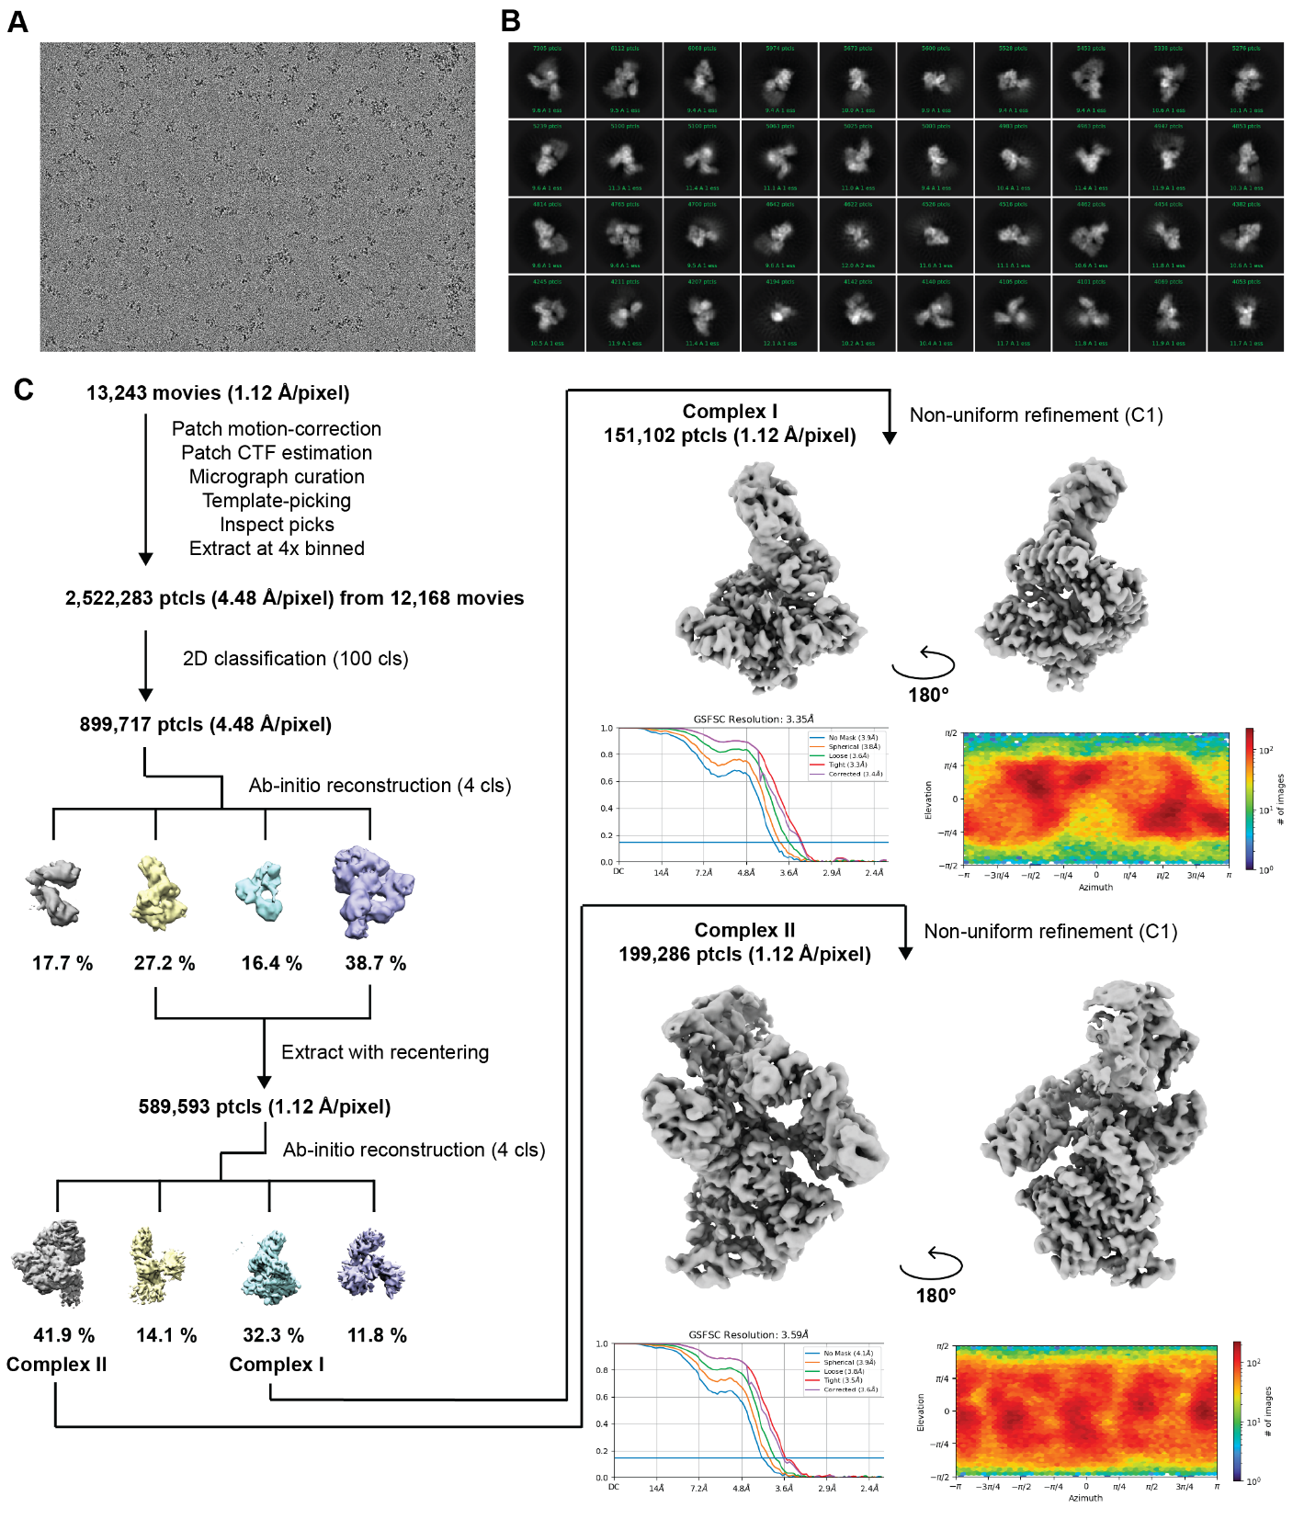
Extended Data Figure 1. Cryo-EM processing pipeline for the elongation complexes. (a) Representative micrograph of the cryo-EM dataset. (b) 2D classification averages of the elongation complexes. (c) Cryo-EM processing pipeline that was used to obtain the two cryo-EM maps of elongation complex I and II.
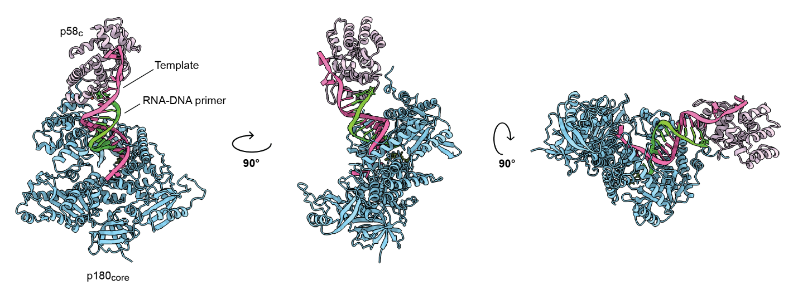
Extended Data Figure 2. Architecture of primosome elongation complex I. Elongation complex I (EC-I) consists of p180_{core} and p58_{C} co-binding a template:primer substrate. The 5'-triphosphate group of an RNA-DNA primer (9 nt of RNA, 2 nt of DNA, and a terminating ddCMP) and the template 3' overhang are bound by the p58_{C} domain, while p180_{core} engages the primer 3'-end with the incorporation of dATP, in accordance with a template sequence. ddCMP: dideoxycytidine monophosphate.

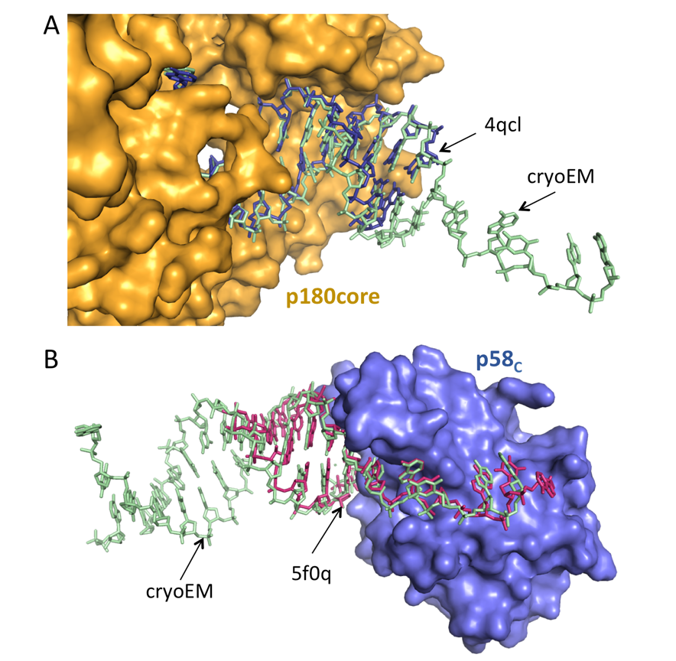
Extended Data Figure 3. Comparison of template:primer in primosome with template:primers bound to Polα catalytic core and to p58_{C} of primase. (a) The crystal structure of p180core/template:primer (PDB code 4qcl) was superimposed with p180core/template:primer part of primosome elongation complex (rmsd = 1.1 Å²). (b) The crystal structure of template:primer/p58_{C} (5f0q) was superimposed with template:primer/p58_{C} part of primosome elongation complex (rmsd = 0.59 Å²).

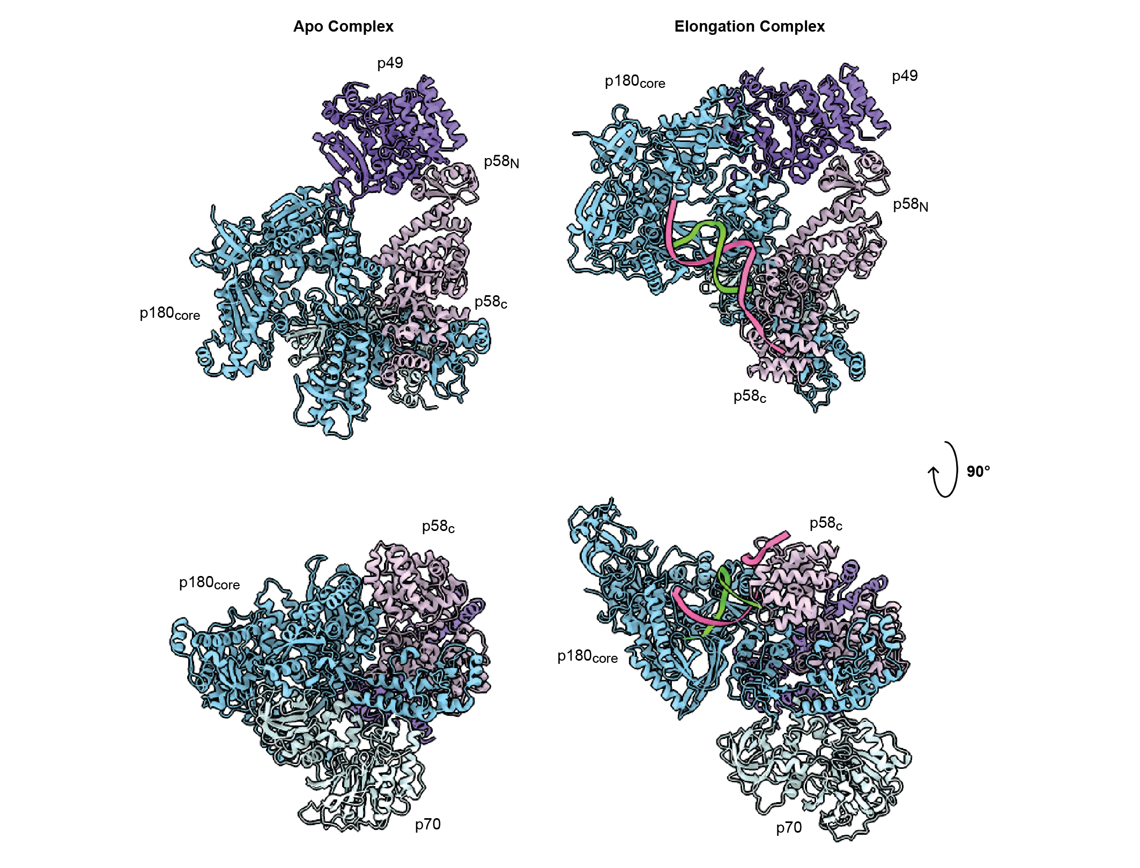
Extended Data Figure 4. Primosome undergoes a large conformation change as it progresses from the apo to elongation state. The apo state of human primosome (PDB: 5EXR) is compared with this work elongation state primosome. The four subunits of primosome are colored the same between these two states for comparative visualization. The structures are aligned using the p49 subunit (colored purple). Visual inspection shows p180_{core} domain makes a large swing upon enzyme progression into DNA elongation.

T1 | ACCAACACTAACAAACAACATACAACATCAAGAGGTCGTGCCGCCAAAAA ^{b} | Primer extension | 50
P1 | GGCGGCACGACC | Primer extension | 12
P2 | pppGGCGGCACGACC | Primer extension | 12
T2 | ATAATGGTCGTGCCGCCAATAA | Cryo-EM | 22
P3 | pppGGCGGCACGAC/ddC/ | Cryo-EM | 12
T3 | CCGCCTATAGTGAGTCGTATTA | P5 synthesis | 22
P4 | AATACGACTCACTATAGG | P5 synthesis | 18
P5 | pppGGCGG | P1 and P2 synthesis | 5
P6 | pCACGACC | P1 and P2 synthesis | 7
P7 | pCACGAC/ddC/ | P1 and P2 synthesis | 7
T4 | AAATGCCACCGCCAATA | Trap | 17
P8 | GGCGGCACGAC/ddC/ | Trap | 12
Extended Data Table 1. Oligonucleotides used in this study. Sequences are listed in the order from 5' to 3'. The regions complementary to a primer are underlined. The ribonucleotides are italic; ppp indicates the 5'-triphosphate group. ddC indicates dideoxy cytosine.

 | Primosome  Elongation Complex-I  (EMDB-X)  (PDB Y) | Primosome  Elongation Complex-II  (EMDB-XX)  (PDB YY)
Data collection and processing
Magnification | 81,000x | 81,000x
Microscope | KRIOS | KRIOS
Voltage (kV) | 300 | 300
Electron exposure (e–/Å²) | 50.0 | 50.0
Defocus range (μm) | −1.0 to −2.5 | −1.0 to −2.5
Pixel size (Å) | 1.12 | 1.12
Symmetry imposed | C1 | C1
Detector | Gatan K3/Counting | Gatan K3/Counting
Energy Filter slit (eV) | 20 | 20
Movies collected (no.) | 13,243 | 13,243
Initial particle images (no.) | 2,522,283 | 2,522,283
Final particle images (no.) | 151,102 | 199,286
Map resolution (Å)  FSC threshold | 3.35 | 3.59
Map resolution (Å)  FSC threshold | 0.143 | 0.143
Map resolution range (Å) | 2.444 to 26.935 | 2.950 to 36.853
Refinement
Initial model used (PDB code) | 5EXR, 4QCL | 5EXR, 4QCL
Model resolution (Å)  FSC threshold | 3.4 (unmasked) | 3.6 (unmasked)
Model resolution (Å)  FSC threshold | 0.5 | 0.5
Map sharpening B factor (Å²)  Model-to-map CC (masked) | -127.0  0.85 | -133.6  0.79
Model composition
Non-hydrogen atoms
Protein residues
Ligands (DNA)
 | 9204 | 19442
 | 1056 | 2312
 | 30 | 30
B factors (Å²)
Protein
Ligand (DNA)
B factors (Å²)  Protein  Ligand (DNA) | 154.19 | 94.70
B factors (Å²)  Protein  Ligand (DNA) | 80.46 | 80.46
R.M.S. deviations
Bond lengths (Å)
Bond angles (°)
R.M.S. deviations  Bond lengths (Å)  Bond angles (°) | 0.002 | 0.003
R.M.S. deviations  Bond lengths (Å)  Bond angles (°) | 0.581 | 0.656
Validation
MolProbity score
Clashscore
Poor rotamers (%)
Validation  MolProbity score  Clashscore  Poor rotamers (%) | 1.53 | 1.68
Validation  MolProbity score  Clashscore  Poor rotamers (%) | 7.36 | 7.57
Validation  MolProbity score  Clashscore  Poor rotamers (%) | 0 | 0
Ramachandran plot
Favored (%)
Allowed (%)
Disallowed (%)
EMRinger
 | 97.32 | 96.16
 | 2.49 | 3.58
 | 0.19  1.96 | 0.26  1.53
Extended Data Table 2. Cryo-EM map and model validation and statistics.

