Supplementary file C – Sensitivity analysis

Method
A screening-exercise can be useful for indicating which variables have the greatest impact on results. This enables selection of the parameters that should be considered in a more detailed sensitivity analysis. The screening approach chosen here is the Method of Morris^{1,2}. Method of Morris gives insight to what variables are the most important for the selected output, as well as how much the variables interact with one-another. It is a highly efficient method in terms of computational power, compared to other global sensitivity analysis methods². We ran 580 scenarios to assess the effects of 28 different parameters. The full suite of input parameters used in the sensitivity analysis are listed in table 1. Note that the sensitivity analysis is conducted for the social benefits scenario. In order to conduct the screening exercise, the Morris implementation in SALib³ is used.
Table 1. The input parameters in used in the screening exercise and their ranges.
Parameter | Minimum value | Maximum value
Value of statistical life* | 1 | 2
Cost of illness – Stroke | 3,970 USD⁴ | 40,800 USD⁴
Cost of illness – ALRI | 6 USD⁵ | 60 USD⁵
Cost of illness – COPD | 30 USD⁵ | 1,057 USD⁵
Cost of illness – IHD | 18.5 USD⁵ | 72.5 USD⁵
Cost of illness – LC | 110 USD⁵ | 4,750 USD⁵
Social discount rate | 2%⁶ | 5%⁶
Minimum wage** | 2 USD/month | 269 USD/month
Social cost of carbon | 0 USD/MT⁶ | 220 USD/MT⁶
Fraction of non-renewable biomass** | 0 | 1
Diesel cost** | 0.09 USD/l | 1.6 USD/l
LPG cost | 0.3 USD/kg⁵ | 1.2 USD/kg⁵
Grid generation cost** | 0.013 USD/kWh | 0.157 USD/kWh
Charcoal cost | 0.06 USD/kg⁵ | 0.45 USD/kg⁵
Traditional biomass investment cost | 0 USD⁷ | 0.5 USD⁸
Biomass ICS investment cost | 25 USD⁸ | 43 USD⁷
Traditional charcoal investment cost | 0.5 USD⁸ | 4 USD⁷
Charcoal ICS investment cost*** | 25 USD⁷ | 67 USD⁷
Electrical stove investment cost | 36.3 USD⁷ | 70 USD⁸
LPG stove investment cost | 27.5 USD⁷ | 55 USD⁸
Biogas stove investment cost**** | 406 USD⁸ | 550 USD⁷
Traditional biomass PM_{2.5} | 500 24-hr ug/m3⁸ | 844 24-hr ug/m3⁷
Biomass ICS PM_{2.5} | 100 24-hr ug/m3⁷ | 500 24-hr ug/m3⁸
Traditional charcoal PM_{2.5} | 256 24-hr ug/m3⁷ | 500 24-hr ug/m3⁸
Charcoal ICS PM_{2.5} | 35 24-hr ug/m3⁸ | 185 24-hr ug/m3⁷
Electrical stove PM_{2.5} | 5 24-hr ug/m3⁸ | 80 24-hr ug/m3⁹
LPG stove PM_{2.5} | 10 24-hr ug/m3⁸ | 101 24-hr ug/m3⁹
Biogas stove PM_{2.5} | 5 24-hr ug/m3⁸ | 173 24-hr ug/m3⁹
* Elasticity between GNI per capita and VSL. The base GNI value is powered by a value within the range given in this table.
** The range found amongst the countries of the analysis.
*** Range given in BAR-HAP
**** Biogas stove price is given as 550 in both sources, but there is a projection of expected price in 2030. This is used as the lower value of the range.
The output parameters for which we assess the sensitivity are listed in table 2 below. The sensitivity analysis is carried out on a regional level and may not be representative on different national levels.
Table 2. Outputs included in the screening activity
Share of total population using LPG stoves
Share of total population using electrical stoves
Share of total population using biogas stoves
Share of total population using charcoal ICS
Share of total population using biomass ICS
Share of total population using traditional biomass stoves
Share of total population using traditional charcoal stoves
Total net-benefit in the region
Total number of deaths avoided
Total health costs avoided
Total time saved
Total avoided emissions
Total investment costs
Total fuel costs

Results
The Morris implementation of SALib outputs two important factors that we use for our sensitivity analysis, µ* and σ. µ* is the mean of variation of output given the variation in each input and describes how important each input variable is in relation to the assessed output (higher values for µ* indicates higher impact). σ is the standard deviation of the variation and gives insight into how much each parameter interacts with other parameters. Across the 580 scenarios there is no change in population shares using either traditional biomass, traditional charcoal or biogas for cooking (they all remain 0). Therefore no deeper analysis is conducted on these specific parameters.

Population cooking with LPG
When share of population cooking with LPG is the dependent variable, the most important parameter is the LPG stove’s assumed PM_{2.5} emissions (Figure 1a). The PM_{2.5} emissions of electric stoves also plays a significant role, as does the VSL. This highlights the importance of the health effects stemming from the use of traditional fuels in determining the optimal adoption of LPG stoves. Furthermore, the social cost of carbon plays a significant role as does the fuel cost of LPG and the PM_{2.5} emissions of charcoal ICS. Figure 1b shows the µ* and σ values for each variable. The PM_{2.5} emissions parameter for the LPG stove has a comparatively high σ-value, which can be interpreted as this factor having significant effects on outputs that involve either interactions with other parameters or non-linearity. A low σ-value would have indicated that the parameter is important due to its first-order effect¹⁰.
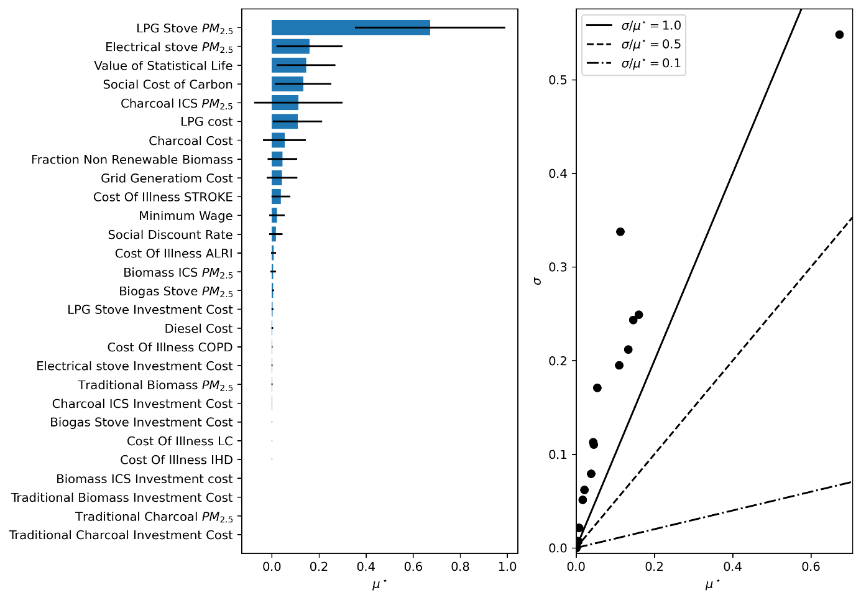
Fig. 1. (left) the importance of different parameters with regards to the population share using LPG for cooking and (right) the relation between µ* and σ with regards to population using LPG for cooking.

Population cooking with electricity
For the share of population cooking with electricity the most important parameter is once again the LPG stove’s PM_{2.5} emissions, followed by the electrical stove’s PM_{2.5} emissions, the LPG fuel cost, value of statistical life and electricity fuel cost (Figure 2). The electrical and LPG stoves have fairly similar PM_{2.5} values during use and similar costs, hence competition between these two stoves is to be expected. Investment costs do not have a significant impact. The fact that PM_{2.5} values and VSL play such an important role, again highlights the importance of understanding the health effects of traditional cooking. Figure 2 further shows that both of the two aforementioned PM_{2.5} values have comparatively large interactions with other parameters or produce a non-linear response when altered.
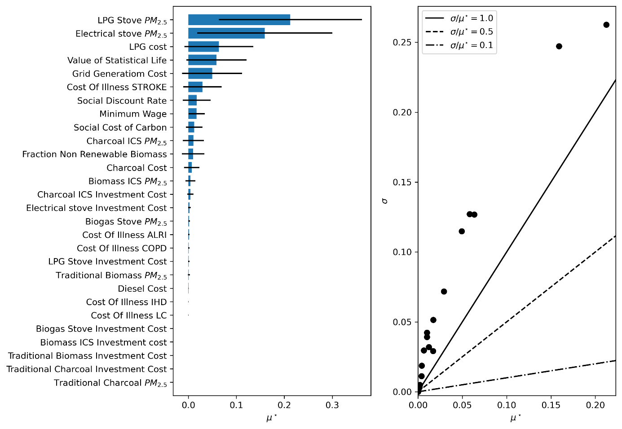
Fig. 2. (left) the importance of different parameters with regards to the population share using electricity for cooking and (right) the relation between µ* and σ with regards to population using electricity for cooking.

Population cooking with charcoal ICS
For the share of population cooking with charcoal ICS the most important parameter is the LPG stove’s PM_{2.5} emissions, followed by the charcoal ICS’s PM_{2.5} emissions, value of statistical life, social cost of carbon and charcoal fuel cost (Figure 3). The charcoal ICS is the stove with the lowest PM_{2.5}- emissions amongst non-clean options. From a health-perspective this makes it a viable alternative to LPG in areas that are currently un-electrified. This would explain why the three most significant parameters are all coupled with health. The social cost of carbon is also comparatively important. Charcoal production is a very emission intensive process and higher values of social cost of carbon consequently reduce the competitiveness of charcoal ICS from a net-benefit perspective. Similarly to the case of LPG and electricity, the LPG PM_{2.5} emissions parameter also has the highest σ-values.
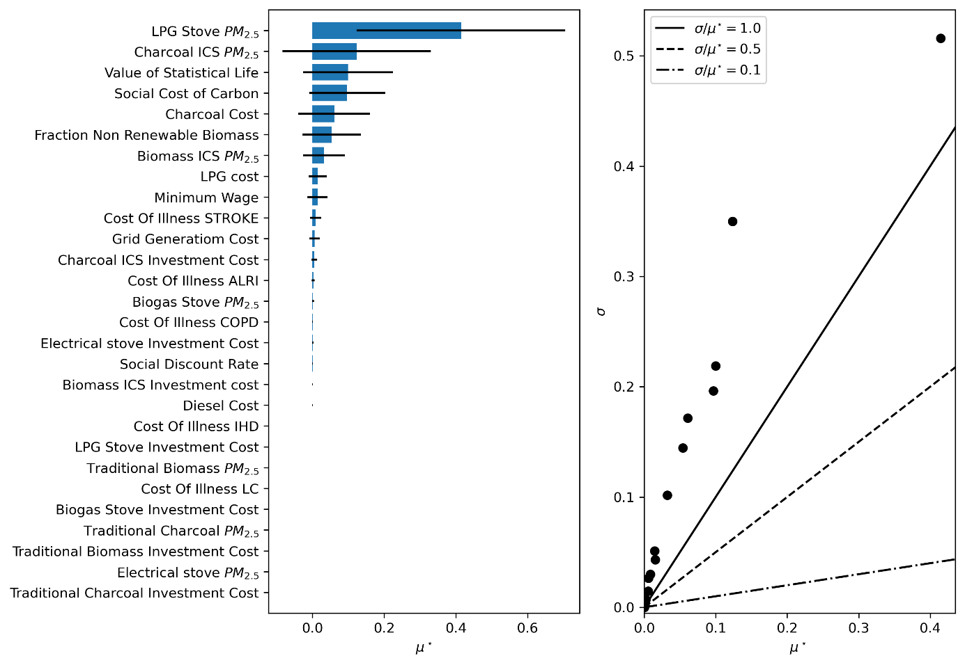
Fig. 3. (left) the importance of different parameters with regards to the population share using charcoal ICS for cooking and (right) the relation between µ* and σ with regards to population using charcoal ICS for cooking.

Population cooking with biomass ICS
For the share of population cooking with biomass ICS the most important parameter is the biomass ICS’s PM_{2.5} emissions, followed by the LPG stove’s PM_{2.5} emissions, SCC, LPG fuel cost and minimum wage (Figure 4). Minimum wage plays an important role mainly as this is related to the valuation of time (biomass ICS is the only one of the four stoves included in the screening that requires collection time). Biomass ICS also has a cooking time that is considerably higher than that for the other three stoves included in the screening, which increases the importance of minimum wage and the shadow value of time. All parameters with significant µ*-value also have a significant σ-value.
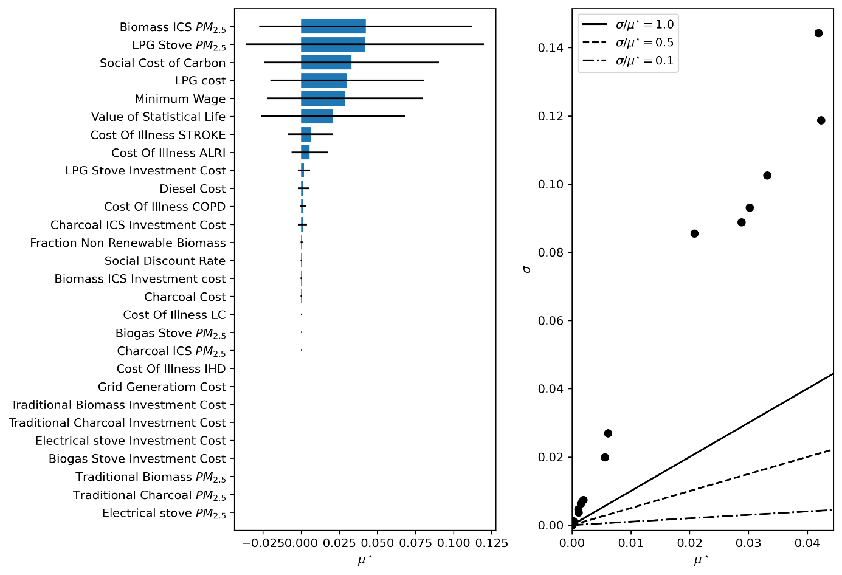
Fig. 4. (left) the importance of different parameters with regards to the population share using biomass ICS for cooking and (right) the relation between µ* and σ with regards to population using biomass ICS for cooking.

Total fuel cost
This refers to the total fuel costs seen across SSA if the stove with the highest net-benefit in each settlement is to be adopted. The stoves with fuel costs associated with them are the LPG stove, the electrical stove and the two charcoal stoves. Figure 5 shows that fuel costs associated with these three stoves are all identified as some of the more important parameters with regards to the total fuel cost in SSA. Diesel cost, included to account for transportation cost of LPG to remote areas, has a comparatively small µ* value, which would indicate that the cost needed for transport is not necessarily very impactful for the fuel cost and consequently choice of stove.
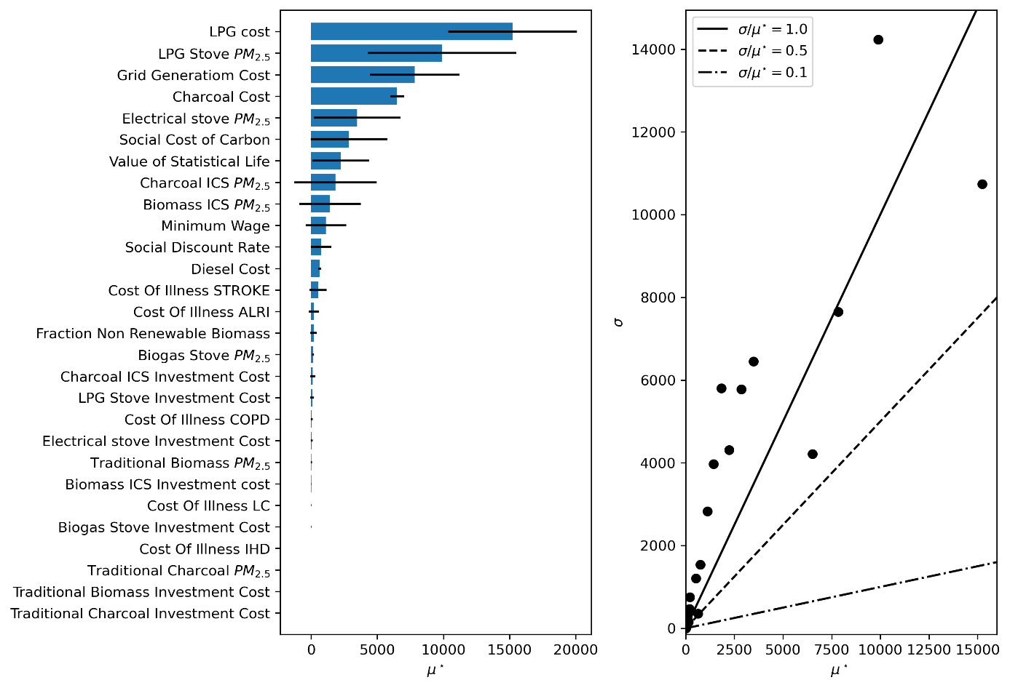
Fig. 5. (left) the importance of different parameters with regards to the total fuel costs and (right) the relation between µ* and σ with regards to total fuel costs.

Total investment cost
Figure 6 shows the importance of each input assessed, with regards to the total stove investment cost across SSA. The investment costs of LPG and electrical stoves, as well as charcoal ICS, impact the investment cost considerably. Furthermore, variables associated with stove-selection (PM_{2.5} emissions, fuel costs etc.) also play an important role in determining total investment cost.
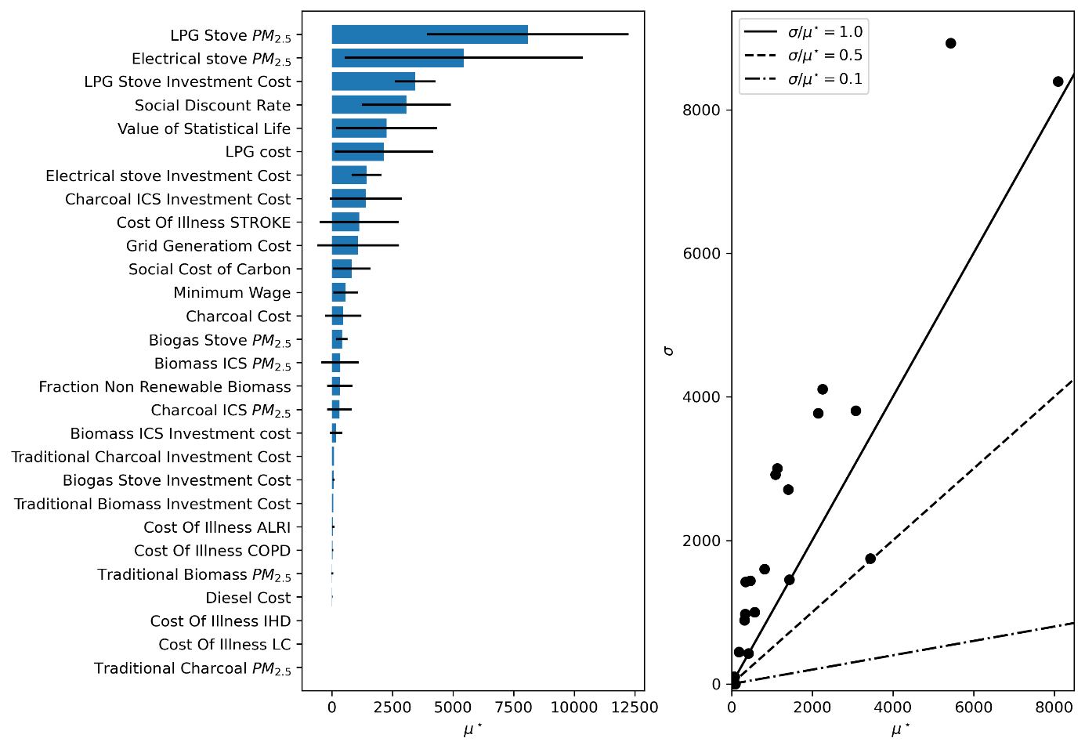
Fig. 6. (left) the importance of different parameters with regards to the total investment and (right) the relation between µ* and σ with regards to total investments.

Health costs avoided
Figure 7 shows the importance of each input assessed with regards to the total health costs avoided across SSA. As expected, parameters directly linked to health play an important role (value of statistical life and PM_{2.5} values). The cost of illness of stroke is also amongst the most important parameters, while the costs of illness for other diseases are ranked lower. This is most likely due to the large range of possible values that cost of illness of stroke can take in comparison to the other cost of illnesses (the national incidence rates of stroke do not stand out in comparison to other diseases). The 6th most important parameter here is traditional biomass PM_{2.5} emissions even though traditional biomass stoves are never used in any of the scenarios produced. This is due to all benefits and costs being directly compared to the base-line and the fact that the traditional biomass stove use is so prevalent in this base-line.
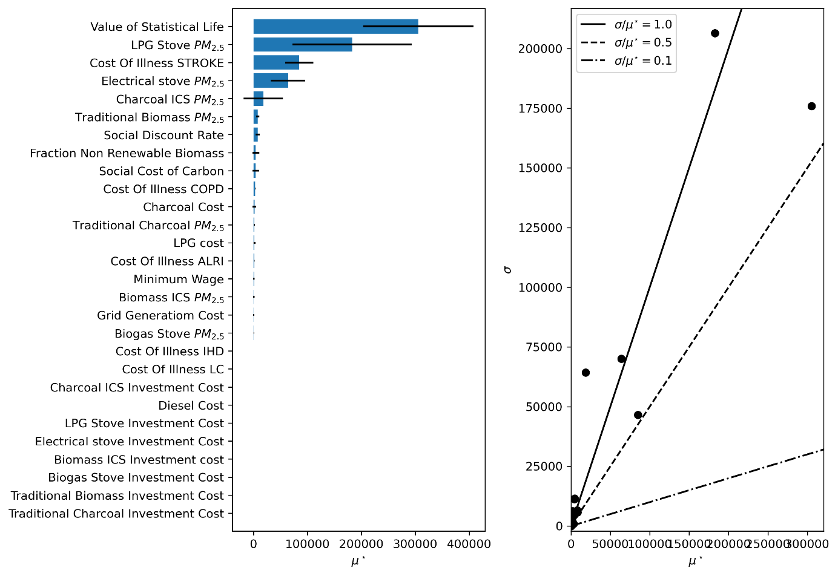
Fig. 7. (left) the importance of different parameters with regards to the total health costs avoided and (right) the relation between µ* and σ with regards to total health costs avoided.

Time saved
Figure 8 shows the importance of each input assessed with regards to the total time saved by stove-switching across SSA. The ranking of parameters by importance is very similar to that for population share using biomass ICS. The reason for this is due to none of the other stove options having any collection time associated with them (other fuels are purchased). Furthermore, the other stoves have similar cooking times, while the cooking time associated with biomass ICS is approximately four thirds of that of the other stoves.
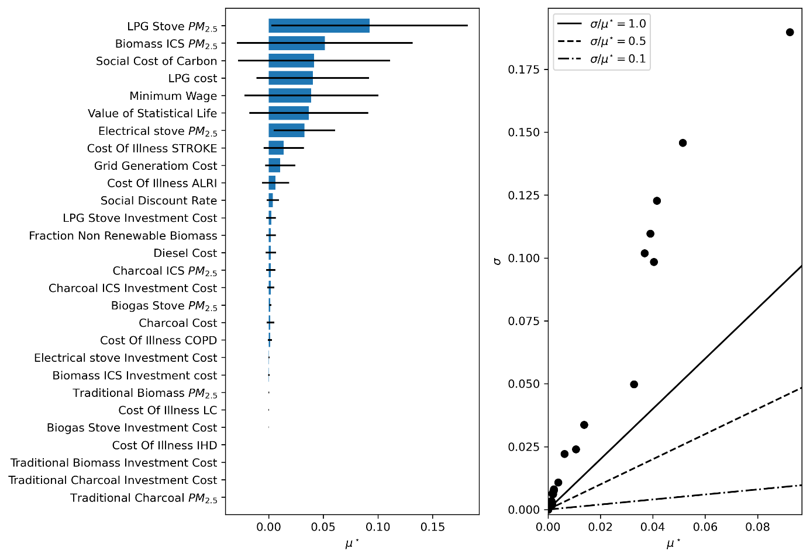
Fig. 8. (left) the importance of different parameters with regards to the total time saved and (right) the relation between µ* and σ with regards to total time saved.

Emissions avoided
Figure 9 shows the importance of each input parameter assessed with regards to the total emissions (GHG) avoided by stove-switching across SSA. The two parameters that stand out significantly in comparison to the others are the fraction of non-renewable biomass and LPG stove emissions. The fraction of non-renewable biomass will have a significant impact on the emissions associated with both biomass and charcoal. LPG PM_{2.5} emissions may have an impact for two reasons. Firstly, if the PM_{2.5} emissions are too high for the stove to be considered competitive in non-electrified areas, people may resort to using charcoal ICS instead, with high resulting GHG-emissions, especially where the fraction of non-renewable biomass is also high. Secondly, if PM_{2.5} emissions are low, LPG stoves become more favorable. Then, it becomes optimal for more population currently living far away from LPG supply to use LPG, which in turn increases transport distance and associated diesel emissions.
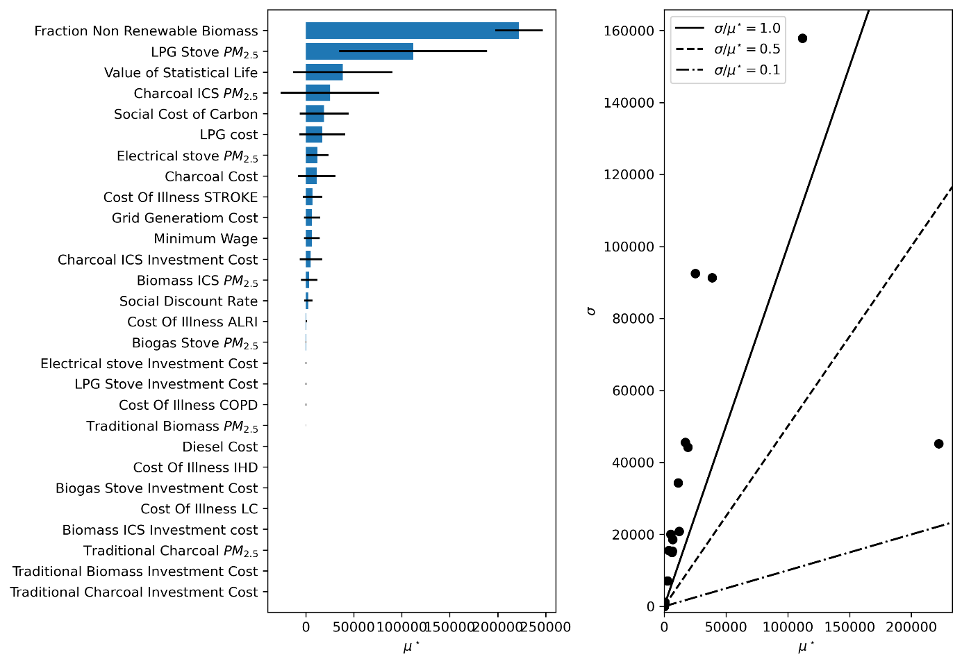
Fig. 9. (left) the importance of different parameters with regards to the total GHG avoided and (right) the relation between µ* and σ with regards to total GHG avoided.

Total net-benefit
Figure 10 shows the importance of each input parameter assessed with regards to the sum of total net-benefit across SSA. Since this screening is conducted in the social benefits scenario, all benefits and costs associated with stove-switching are included. The figure shows that the seven most important parameters cover the full suite of different benefits included in the analysis. Specifically, the value of statistical life and PM_{2.5} emissions are connected to reduced mortality, minimum wage is connected to time saved, social cost of carbon and fraction of non-renewable biomass are connected to GHG-emissions, and cost of illness (as well as LPG PM_{2.5} emissions) is connected to reduced morbidity. This highlights the need to understand all of the benefits associated with clean cooking to correctly identify their sum. The results indicate that net benefits are significant and that a singular focus on one benefit at a time is insufficient to fully make the case for cleaner cooking.
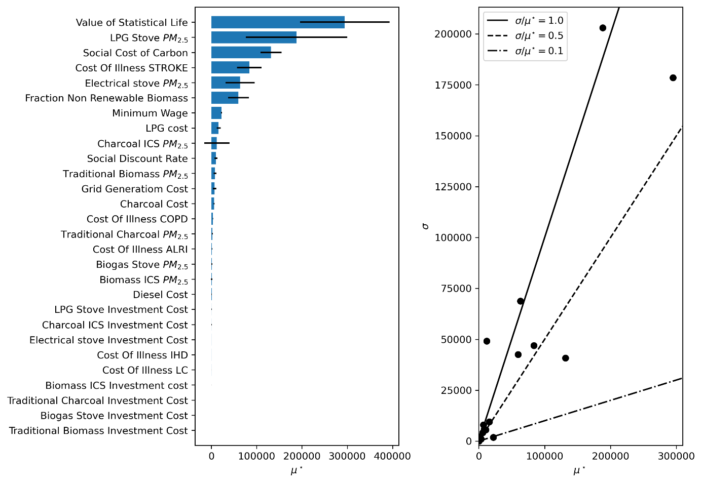
Fig. 10. (left) the importance of different parameters with regards to the total net-benefit and (right) the relation between µ* and σ with regards to total net-benefit.

References
1. Morris, M. D. Factorial Sampling Plans for Preliminary Computational Experiments. Technometrics 33, 161–174 (1991).
2. Campolongo, F., Cariboni, J. & Saltelli, A. An effective screening design for sensitivity analysis of large models. Environmental Modelling & Software 22, 1509–1518 (2007).
3. Herman, J. & Usher, W. SALib: An open-source Python library for Sensitivity Analysis. Journal of Open Source Software 2, 97 (2017).
4. Rochmah, T. N., Rahmawati, I. T., Dahlui, M., Budiarto, W. & Bilqis, N. Economic Burden of Stroke Disease: A Systematic Review. Int J Environ Res Public Health 18, 7552 (2021).
5. Jeuland, M., Tan Soo, J.-S. & Shindell, D. The need for policies to reduce the costs of cleaner cooking in low income settings: Implications from systematic analysis of costs and benefits. Energy Policy 121, 275–285 (2018).
6. Interagency Working Group on Social Cost of Greenhouse Gases. Technical Support Document: Social Cost of Carbon, Methane, and Nitrous Oxide Interim Estimates under Executive Order 13990. (2021).
7. Das, I. et al. The benefits of action to reduce household air pollution (BAR-HAP) model: A new decision support tool. PLOS ONE 16, e0245729 (2021).
8. Dagnachew, A. G., Lucas, P. L., van Vuuren, D. P. & Hof, A. F. Towards universal access to clean cooking solutions in sub-Saharan Africa.
9. Pope, D. et al. Are cleaner cooking solutions clean enough? A systematic review and meta-analysis of particulate and carbon monoxide concentrations and exposures. ENVIRONMENTAL RESEARCH LETTERS 16, (2021).
10. Saltelli, A., Tarantola, S., Campolongo, F. & Ratto, M. Sensitivity analysis in practice - a guide to assessing scientific models. (John Wiley & Sons Ltd, 2004).

