New Constraints on Cenozoic Subduction between India and Tibet
Liang Liu^{1,2,3}*, Lijun Liu^{2**}, Jason. P. Morgan⁴, Yi-Gang Xu^{1,3}, and Diandian Peng²

^{1.} State Key Laboratory of Isotope Geochemistry and CAS center of Excellence in Deep Earth Science, Guangzhou Institute of Geochemistry, Chinese Academy of Science, Guangzhou, 510640, China.
^{2.} Department of Geology, University of Illinois at Urbana-Champaign, Urbana, 61801, USA.
^{3.} Southern Marine Science and Engineering Guangdong Laboratory (Guangzhou), Guangzhou, 511458, China.
4. Department of Marine Science and Engineering, Southern University of Science and Technology, Shenzhen, Guangdong 518055, China.

* Liang Liu: llsinogm@yeah.net
** Lijun Liu: ljliu@illinois.edu

Supplementary Materials
This file provides additional supporting information to the main text. It contains the result summary for sensitivity tests, two tables, twenty-six figures, and the captions for the eight movies.

1. Summary of the sensitivity tests.
As mentioned in the main text, we tested different compositional densities for the incoming plates in the numerical models (Figures S5, S7, S9, S11, S24). The density of the incoming continental lithospheric mantle (ICLM, including the cratonic Indian plate) does not obviously affect the final plateau width but can determine the final plateau elevation. To increase the ICLM composition density by 20 kg/m³, the average elevation of the plateau will be ~30-60 m higher (Figures S6, S8, S10, S12, S24). In these sensitivity tests, the melting patterns change slightly when the ICLM compositional density is ≤3360 kg/³ (Figures S6, S8, S10, S12). In the scenarios where the cratonic Indian plate develops steep subduction, the melting close to the suture keeps active at the end of the model (Figures S6d, S16d, S24), in contrast with the observations (Figures 2a-2b).
In the Type 6 models, except for the effects of the ICLM, we also tested the effects of the overriding-plate viscosity (Figure S22), the terrane slab rheology (Figure S23), and the lower mantle viscosity (Figure S25):
1) The maximum yielding stress of the overriding-plate crust does not noticeably affect the terrane slab evolution (Figures S22a-S22c); however, if the lithospheric mantle of the overriding plate strongly resists shortening, the initiation of the flat terrane subduction delays by ~9 Myr, leading to a distinctive evolution of the lithospheric deformation and melting (Figure S22d).
2) We found that the rapid roll-back of the oceanic slab could drag the terrane towards the trench (Figures 4e-4f)^{19,26}. This process tears the terrane slab into two parts, while the scale of the relic terrane beneath the overriding plate highly depends on the rheology of the terrane slab (Figures 4, S23). An extensive relic terrane can protect the post-delamination Tibetan lithosphere from the hot underlying mantle (Figure 3d, 4), and thus, may help explain the magmatic hiatus in the central plateau after ~25 Ma (Figure 2b). The low yielding stress (20 MPa) that we presumed for the terrane slab during the roll-back of the oceanic slab (Figure 4) could be due to the fluids released from the underlying slab (Figure 4e) (cf., Hirth and Kohlstedf, 2003)⁷⁷. As we did not explicitly calculate the effect of fluids on yielding behaviors, this parameter choice could be largely suppositional but within the estimated ranges for lithospheric deformation (cf., Ghosh and Holt, 2012)⁷⁸.
3) The lower mantle viscosity determines the sinking rate of slabs (Figure S25). The slab sinking rate keeps unchanged when the lower mantle viscosity is larger than 5× 10²² Pa·s (Figures S25d-S25f), and in these scenarios, the former slabs could partially stay within the upper mantle (Figures S4, S25).
More sensitivity tests regarding the length, rheology, and density of incoming plates, the rheology of the overriding plates, and the convergence rate are in Liu et al., 2021a.
2. Supplementary movies
Seven movies are presented to summarize the model evolution (Figure 1b) (plotting habits are the same as those in Figure 4) (Table S2).
Movie-1: Type 1 Model (Run 4).
Movie-2: Type 2 Model (Run 6).
Movie-3: Type 3 model (Run 9).
Movie-4: Type 4 model (Run 13).
Movie-5: Type 5 Model (Run 15).
Movie-6: Type 5 Model (Run 18).
Movie-7: Type 6 Model (Run 23).
Movie-8: Evolution of viscosity and density fields in the Type 6 model (Run 23). The plotting habits are the same as those in Figures S19 and S20.

3. Supplementary tables and figures
Materials | 1 | 2 | 3 | 4 | 5 | 6 | 7 | 8 | 9 | 10 | 11 | 12
Flow Law Parameters (Ref. 1-8)
A_{dis} (Pa^{-n}∙s⁻¹) | 10^{-15.05} | 4.85∙10⁻¹⁷ | 4.85∙10⁻¹⁷ | 4.85∙10⁻¹⁷ | 4.85∙10⁻¹⁷ | 3.3∙10^{-21.2} | 1.8∙10⁻³² | 6.7∙10^{-20.4} | 10^{-5.3} | 10^{-5.3} | 10^{-7.3} | 1.8∙10⁻³²
n_{dis} | 3.5 | 3.5 | 3.5 | 3.5 | 3.5 | 3.2 | 4.0 | 2.4 | 3 | 3 | 3 | 4.0
E_{dis} (kJ/mol) | 480 | 535 | 535 | 535 | 535 | 238 | 137 | 156 | 648 | 648 | 648 | 137
V_{dis} (cm³/mol) | 8 | 8 | 8 | 8 | 8 | 1 | 8 | 8 | 1 | 8 | 1 | 8
A_{dif} (Pa^{-n}∙s⁻¹) | 10^{-8.65} | 10^{-8.65} | 10^{-8.65} | 10^{-8.65} | 10^{-8.65} | 4.0∙10⁻⁸ | 4.0∙10⁻⁷ | 4.0∙10⁻¹³ | 10^{6.1} | 10^{6.1} | 10^{4.1} | 4.0∙10⁻⁷
n_{dif} | 1 | 1 | 1 | 1 | 1 | 1 | 1 | 1 | 1 | 1 | 1 | 1
E_{dif} (kJ/mol) | 335 | 375 | 375 | 375 | 375 | 153 | 220 | 220 | 476 | 476 | 476 | 220
V_{dif} (cm³/mol) | 4 | 4 | 4 | 4 | 4 | 1 | 4 | 4 | 1 | 4 | 1 | 4
c₀ (Mpa) | 20 | 20 | 20 | 20 | 2 | 20 | 2 | 20 | 2 | 20 | 2 | 2
φ (º) | ICP middle crust, and WOP materials: 30 (γ = 0) → 2 (γ > 1); other materials: 30 (γ = 0) → 15 (γ > 1)
Thermal Parameters (Ref. 2)
k (Wm⁻¹K⁻¹) | 3.3 | 3.3 | 3.3 | 3.3 | 3.3 | 2.5 | 2.5 | 2.5 | 2.5 | 2.5 | 2.5 | 2.5
H_{r} (μW/m³) | 0.03 | 0.03 | 0.03 | 0.03 | 0.03 | 0.25 | 1.5 | 1.5 | 1 | 0.25 | 0.25 | 1.5
c_{p} (J/(kg·K) | 1200 | 1200 | 1200 | 1200 | 1200 | 1200 | 1200 | 1200 | 1200 | 1200 | 1200 | 1200
Density Parameters (Ref. 9-10)
ρ₀ (g·cm⁻³) | 3.39 | Table S2 | Table S2 | 3.34 | 3.34 | 3.00 | 2.70 | 2.70 | 2.80 | 2.85 | 2.90 | 2.90
a₁(10⁻⁴) | 0.27768 | 0.27014 | 0.27768 | 0.27014 | 0.27768 | 0.27768 | 0.27014 | 0.27014 | 0.27014 | 0.27014 | 0.27014 | 0.27014
a₂(10⁻⁸ K⁻¹) | 0.95451 | 1.05945 | 0.95451 | 1.05945 | 0.95451 | 0.95451 | 1.05945 | 1.05945 | 1.05945 | 1.05945 | 1.05945 | 1.05945
a₃ (K²) | -0.12404 | -0.1243 | -0.12404 | -0.1243 | -0.12404 | -0.12404 | -0.1243 | -0.1243 | -0.1243 | -0.1243 | -0.1243 | -0.1243
K (Gpa⁻¹) | 128 | 130 | 128 | 130 | 128 | 63 | 63 | 63 | 63 | 63 | 63 | 63
Table S1. Parameters in numerical experiments. Materials: 1- Asthenosphere (Ref. 1-2), 2- ICP lithospheric mantle (Ref. 1-2), 3- IOP lithospheric mantle (Ref. 1-2), 4- SOP lithospheric mantle, 5-WOP lithospheric mantle (Ref. 1-2), 6- IOP crust (Ref. 4-7), 7- ICP upper crust (Ref. 3-4), 8- Upper crust of overriding plates (Ref. 4-7), 9- ICP middle crust (Ref. 4-7), 10- Continental lower crust (including the lower crust of the ICP, overriding plates, and Indian lower crust) (Ref. 8), 11- Indian middle crust (Ref. 3-4), 12- Indian upper crust (Ref. 4-7). ICP-Incoming Continental Plate (e.g., Greater India, continental terranes, or the continental margin in the Type 6 models). IOP-Incoming Oceanic Plate (e.g., Greater Indian Basin or back-arc basin). SOP-Strong Overriding Plate (e.g., Asian interiors). WOP-Weak Overriding Plate (e.g., Tibetan terranes).
The parameters for oceanic sediments are the same as those of Material 8, except for ρ₀ = 2.60 g/cm³. The parameters for the continental margin crust are the same as those of Material 6. The parameters for the continental margin lithospheric mantle are the same as those of Material 2, except for ρ₀ = 3.37 g/cm³. The parameters for the “Indian” lower crust and lithospheric mantle are the same as those of the ICP, except for that ρ₀ (Indian lower crust) = 3.0 g/cm³, and A mafic feature of the Indian crust is implied in the results of seismic tomography⁷⁵. In Runs 32-35, ρ₀ (Indian lithospheric mantle) is 3.35 g/cm³, 3.36 g/cm³, 3.37 g/cm³, and 3.38 g/cm³, respectively; in other models, ρ₀ (Indian lithospheric mantle) is 3.34 g/cm³. Except for those be highlighted in Table 2: the maximum yielding stress for the ICP crust and mantle is 100 MPa, that for WOP materials is 50 MPa, and that for other materials is 200 MPa.
Subscript “dis” refers to parameters for dislocation creep, while “dif” refers to diffusion creep (Equation S5). For the depth <660 km, the material viscosity is between 10¹⁹ Pa·s and 10²⁴ Pa·s; For greater depths, we assume that the diffusion creep is the only deformation regime in the mantle, whose viscosity is confined to be ≤10²³ Pa·s (Ref. 11-12). c₀- yielding cohesion, φ- friction angle, γ is the accumulated plastic strain. k- thermal conductivity, H_{r}- radioactive heat production, c_{p}-heat capacity, ρ₀- the reference density at room temperature (20 ̊C) and pressure (0.1 MPa), K- bulk modulus.
References. 1- Hirth and Kohlstedt, 2003⁷⁷; 2- Brune et al., 2014⁷⁹; 3- Gleason and Tullis, 1995⁸⁰; 4- Rutter and Brodie, 2004⁸¹; 5- Kirby and Kronenberg, 1987⁸²; 6- Ranalli and Murphy, 1987⁸³; 7- Huangfu et al., 2018²³; 8- Rybacki and Dresen, 2004⁸⁴; 9- Djomani et al., 2001⁸⁵; 10- Schutt and Lesher, 2006⁸⁶; 11- Karato and Wu, 1993⁸⁷; 12- Yamazaki and Karato, 2001⁸⁸.

Table S2. The presented numerical models and their key variables. M.Y.S.- Maximum Yielding Stress. W.O.C.- Weak Overriding-plate Crust (Figure S1). W.O.L.M.- Weak Overriding-plate Lithospheric Mantle (Figure S1). C. Density- Compositional Density (Equation S8). The terrane hinge refers to the portion of the terrane slab above the oceanic slab (Figures 4e, S23), which is assumed to be weakened by dehydration of the oceanic slab (Supplementary Section 1). In the Type 5 models, the compositional density of the terrane lithospheric mantle is 3.37 g/cm³. In the Type 6 models: the compositional density of the terrane lithospheric mantle is 3.34 g/cm³. Other parameters for the numerical models are in Table S1.

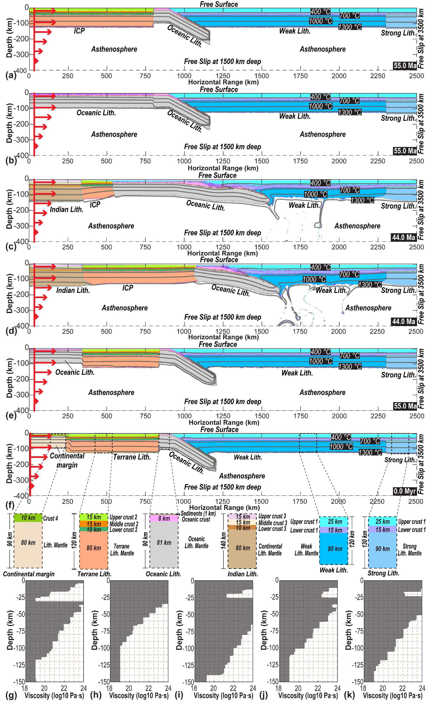
Figure S1. Initial conditions and key evolution snapshots for the numerical models. (a) Material initialization and boundary conditions for the Type 1 models (Runs 1-4), where the incoming plate is purely continental (e.g., Greater India). ICP-Incoming Continental Plate. Litho.- Lithosphere. Strong Litho.- e.g., Asian interiors. Weak Litho.- e.g., Tibetan terranes. (b) Material initialization and boundary conditions for the Type 2 models (Runs 5-6), where the incoming plate before cratonic India is purely oceanic (e.g., Greater Indian Basin). (c) Snapshot of the material distribution in a Type 3 model (Run 9) at 44 Ma, where a 200 km long ICP subducts following the consumption of a young 40 Myr-old oceanic plate (e.g., back-arc basin). (d) Snapshot of the material distribution in a Type 4 model (Run 13) at 44 Ma. Type 4 model is different from the Type 3 model regarding the length of the ICP before cratonic India: ~900 km long vs. 200 km long^{4,13}. (e) Material initialization and boundary conditions for the Type 5 models (Runs 15-22), where a preceding terrane separates with cratonic India by an oceanic block (e.g., Greater Indian Basin). The terrane Lithosphere is 500 km long in Runs 15-18 and 600 km long in Runs 19-22 (Table S2). The oceanic lithosphere is 80 Myr old, with a compositional density of 3.39 g/cm³ for the lithosphere mantle (Table S2). (f) Material initialization for the preferred Type 6 models (Runs 23-40) (Table S2). Here, the plate segment following the terrane contains a thin crust (10 km thick), and its lithospheric mantle has a continent-like compositional density of 3.37 g/cm³ (e.g., a thinned continental margin) (Table S2). The terrane lithosphere is 600 km long ¹⁹. The enlarged views demonstrate the material distribution of different domains. (g-k) The viscosity structure for different material domains.
In the numerical models, the numerical resolution is ~5 km, where the mesh node is within 50 km from the nearest material interface and gradually increases to ~50 km where the node is >190 km away from the closest material interface. We added the horizontal velocity for the incoming plate between 10 and 100 km and above the 400 km depth (cf. Gerya and Meilick, 2011)⁸⁹. Other boundaries are free to slip. The surface and bottom temperatures remain at 0 and 1350 ˚C, respectively. All continental plates initially follow a 1-D steady-state conductive thermal profile. The oceanic slab tip is 80 Myr old, similar to that of the Tethyan Ocean during the early Cenozoic ^{14,15}.

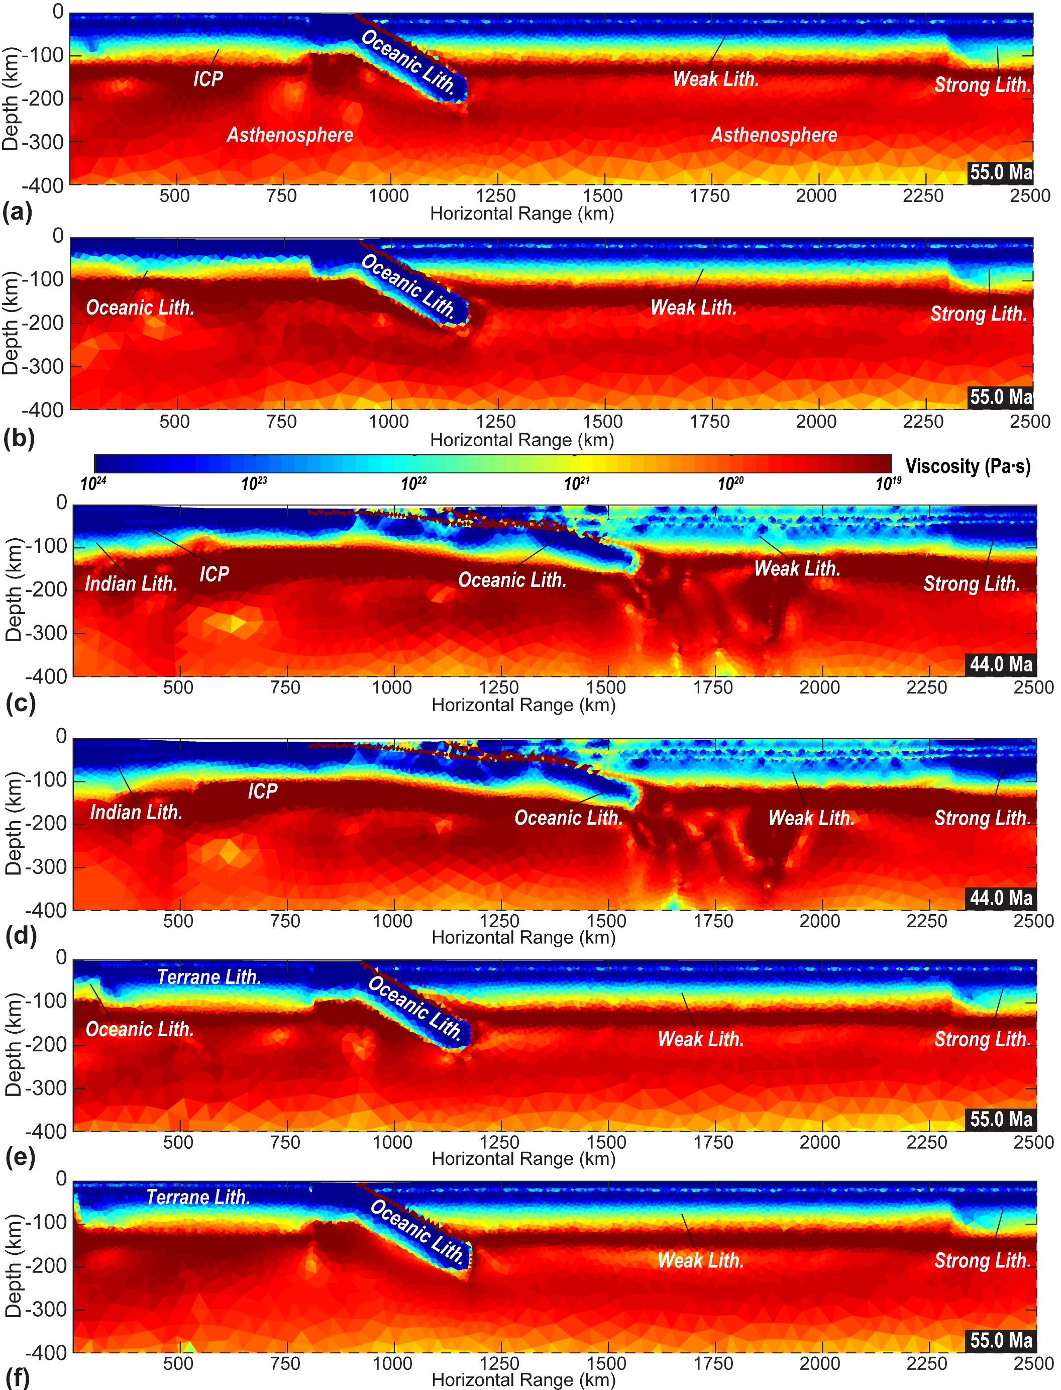
Figure S2. Viscosity structures. (a) Viscosity structure at 55 Ma for the Type 1 models (Figure S1a). (b) Viscosity structure at 55 Ma for the Type 2 models (Figure S1b). (c) Snapshot of the viscosity in a Type 3 model at 44 Ma (Run 9, Figure S1c). (d) Snapshot of the viscosity in a Type 4 model at 44 Ma (Run 13, Figure S1d). (e) Viscosity structure at 55 Ma for the Type 5 models (Figure S1e). (f) Viscosity structure at 55 Ma for the Type 6 models (Figure S1f). ICP-Incoming Continental Plate (e.g., Greater India). Litho.- Lithosphere.

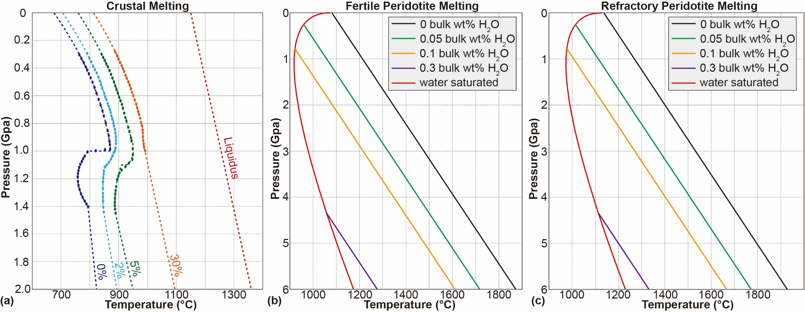
Figure S3. Solidi for the crustal and mantle materials ^{54,60}. (a) The solidus for the crustal materials is based on lab experiments ⁷¹. 2% means that amphibolite has experienced 2% melting. Liquidus equals 100% melting degree. (b)-(c) The solidus for the mantle materials is based on Morgan (2001) and Katz et al. (2003). “0.1 bulk wt. %” refers to the water content we use for calculating the solidus. The fertile peridotite solidus is used for simulating the melting of the asthenospheric mantle and the weak overriding-plate lithospheric mantle (e.g., the metasomatized Tibetan lithospheric mantle) ^{27,30,34}. The refractory mantle solidus is used for calculating the melting of other mantle materials.

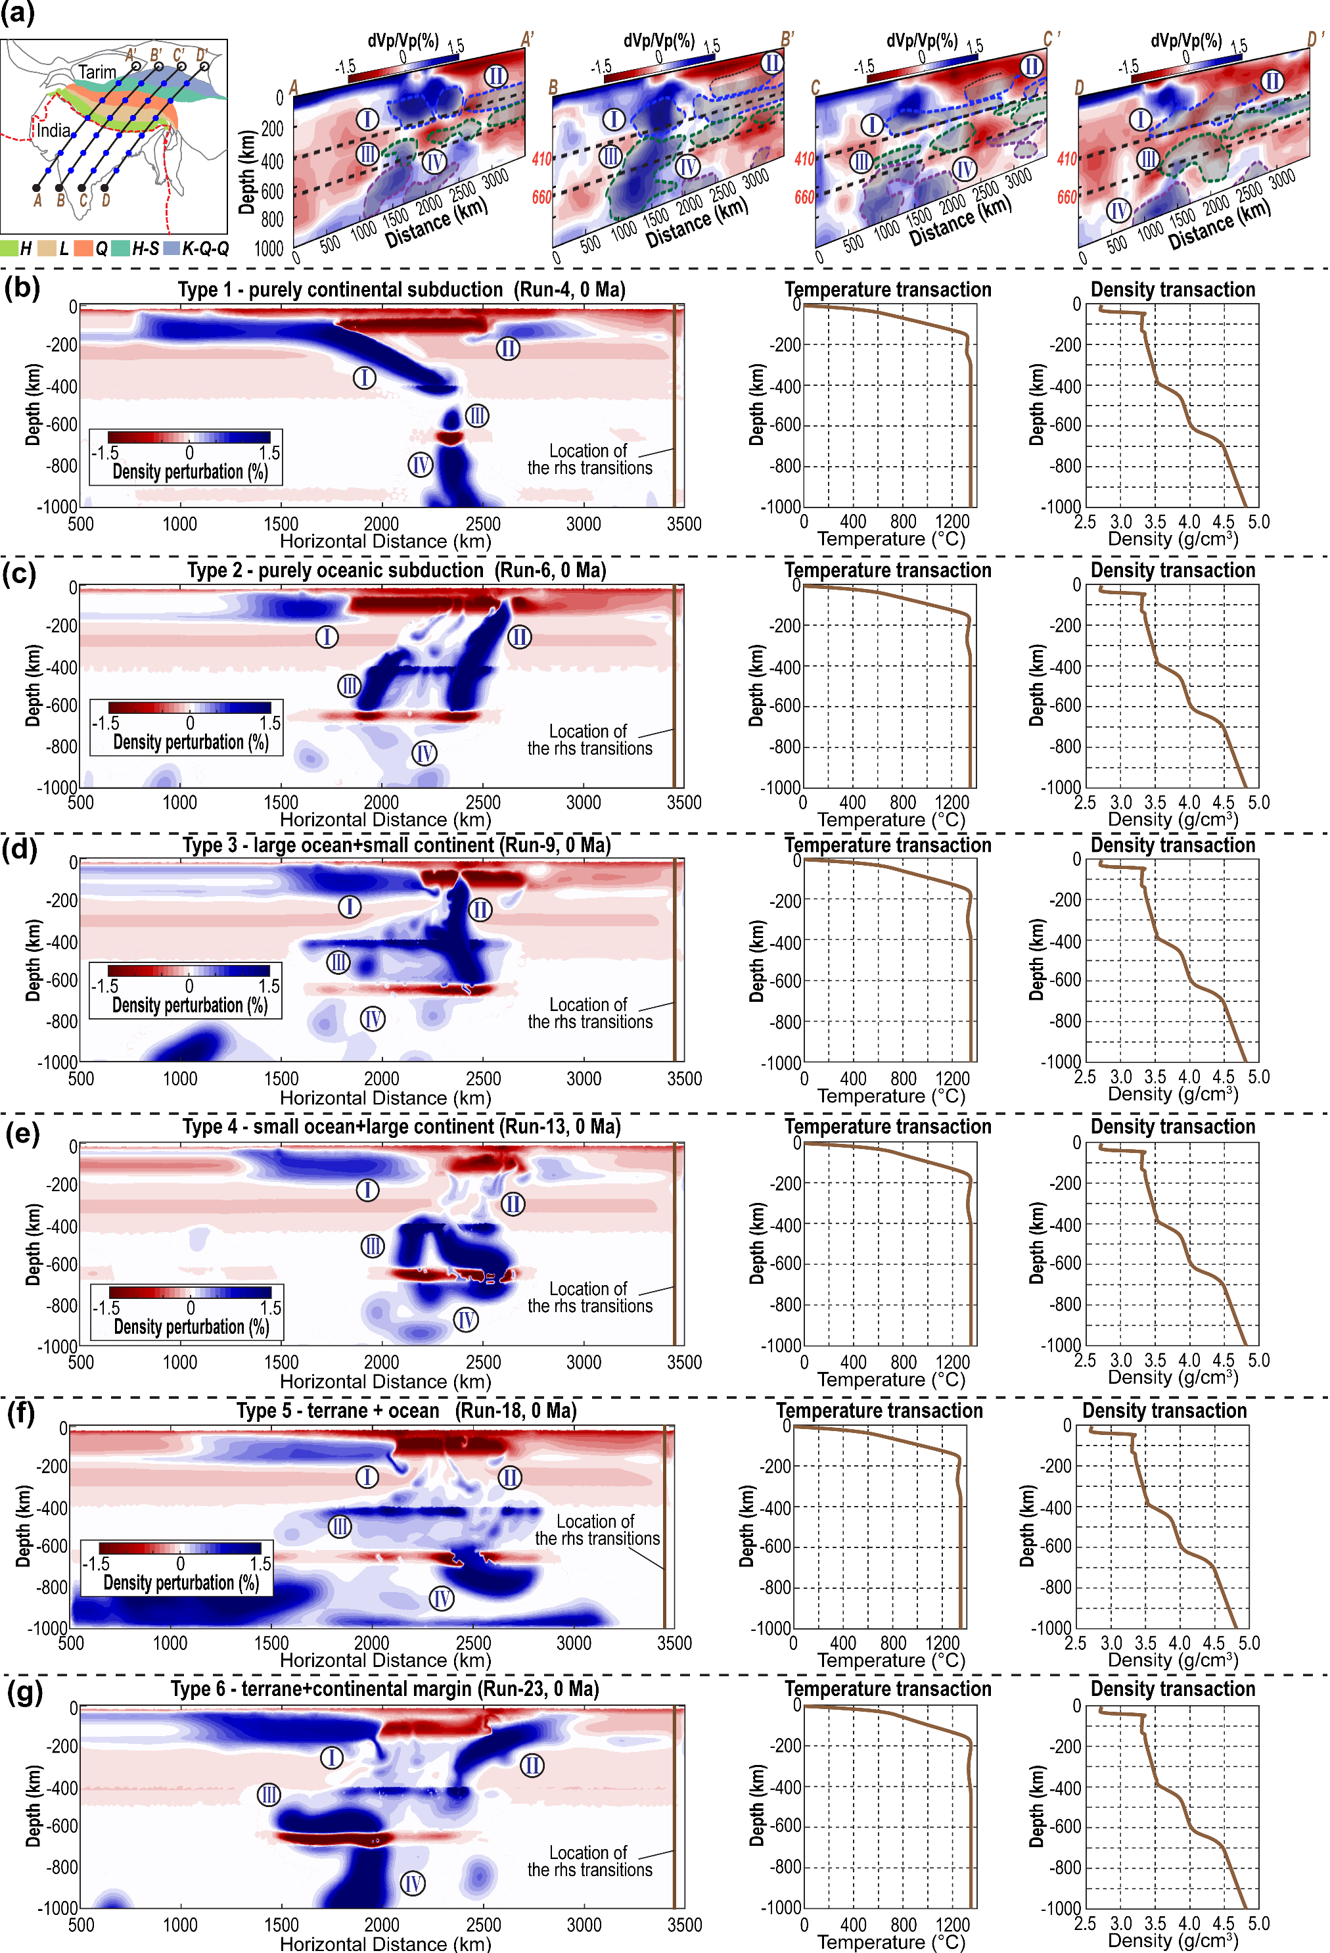
Figure S4. Seismic velocity structure beneath the Indo-Eurasian Orogeny and density variation in the numerical models. (a) Results of P-wave seismic tomography along the four transactions ^{45,90}. In the seismic tomography figures, the background is based on Li et al., 2008, and the dashed lines mark ranges of high-velocity anomalies (dVp/Vp = ~0.5%) in Simmons et al., 2012. The transaction distribution is based on Parsons et al., 2020. The data for drawing seismic tomography profiles is from SubMachine ⁹¹. H- Himalayas, L- Lhasa terrane, Q- Qiangtang terrane, H-S- Hoh Xil- Songpan Ganzi terranes, K-Q-Q- Kunlun-Qaidam-Qilan blocks. (b) Density perturbation at the end of a Type 1 model (Run 4). The density variation is calculated regarding the 1D density transection. rhs- right-hand side. (c) Density perturbation at the end of a Type 2 model (Run 6). (d) Density perturbation at the end of a Type 3 model (Run 9). (e) Density perturbation at the end of a Type 4 model (Run 13). (f) Density perturbation at the end of a Type 5 model (Run 18). (g) Density perturbation at the end of a Type 6 model (Run 23). The variation of the upper mantle density is found to have a crudely linear correlation with that of P-wave seismic velocity ⁹².

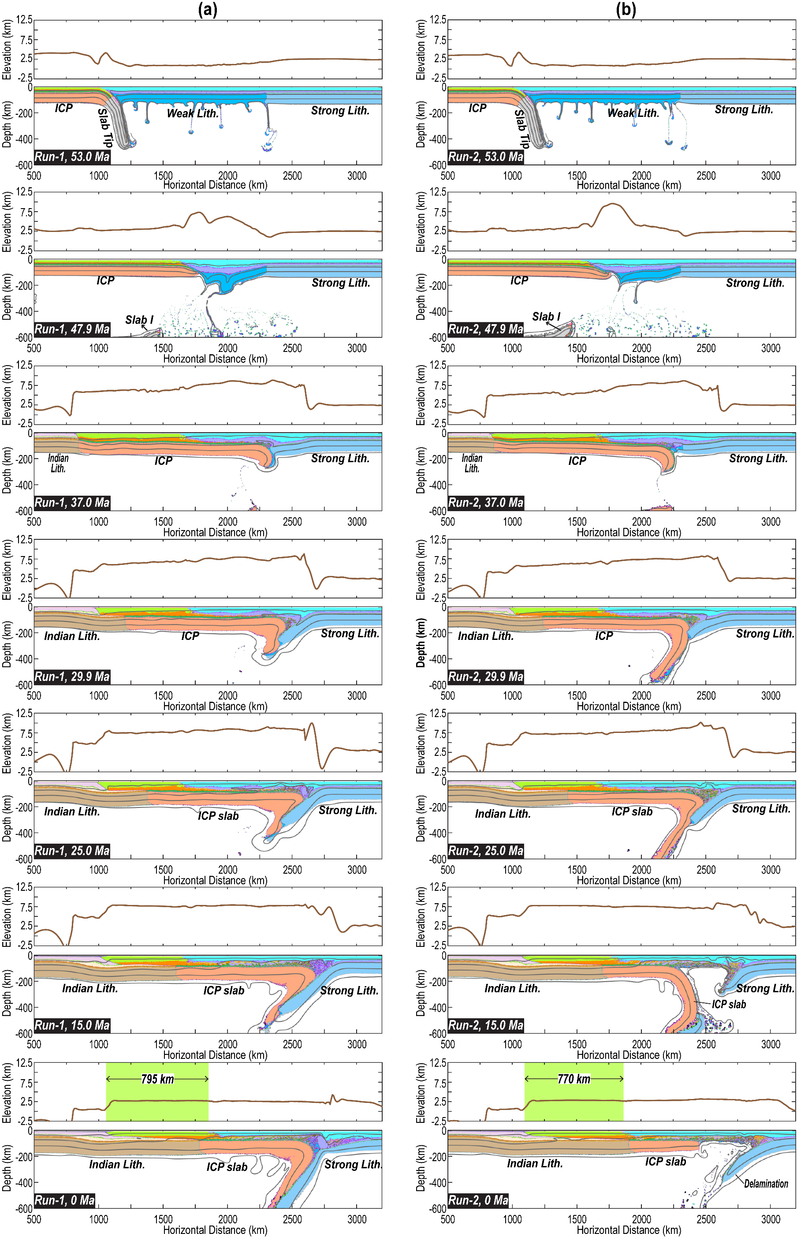
Figure S5. Evolution of material field and surface topography in the Type 1 models (purely continental subduction). (a) Results of Run 1. (b) Results of Run 2. (c) Results of Run 3. (d) Results of Run 4. The green shading with a number in each bottom panel illustrates the width of the accreted crust (e.g., the Tethyan-Greater Himalayas). The key parameters of these models are in Table S1-S2. Other plotting habits are the same as those in Figure 4. ICP-Incoming Continental Plate (e.g., Greater India). Lith.- Lithosphere.
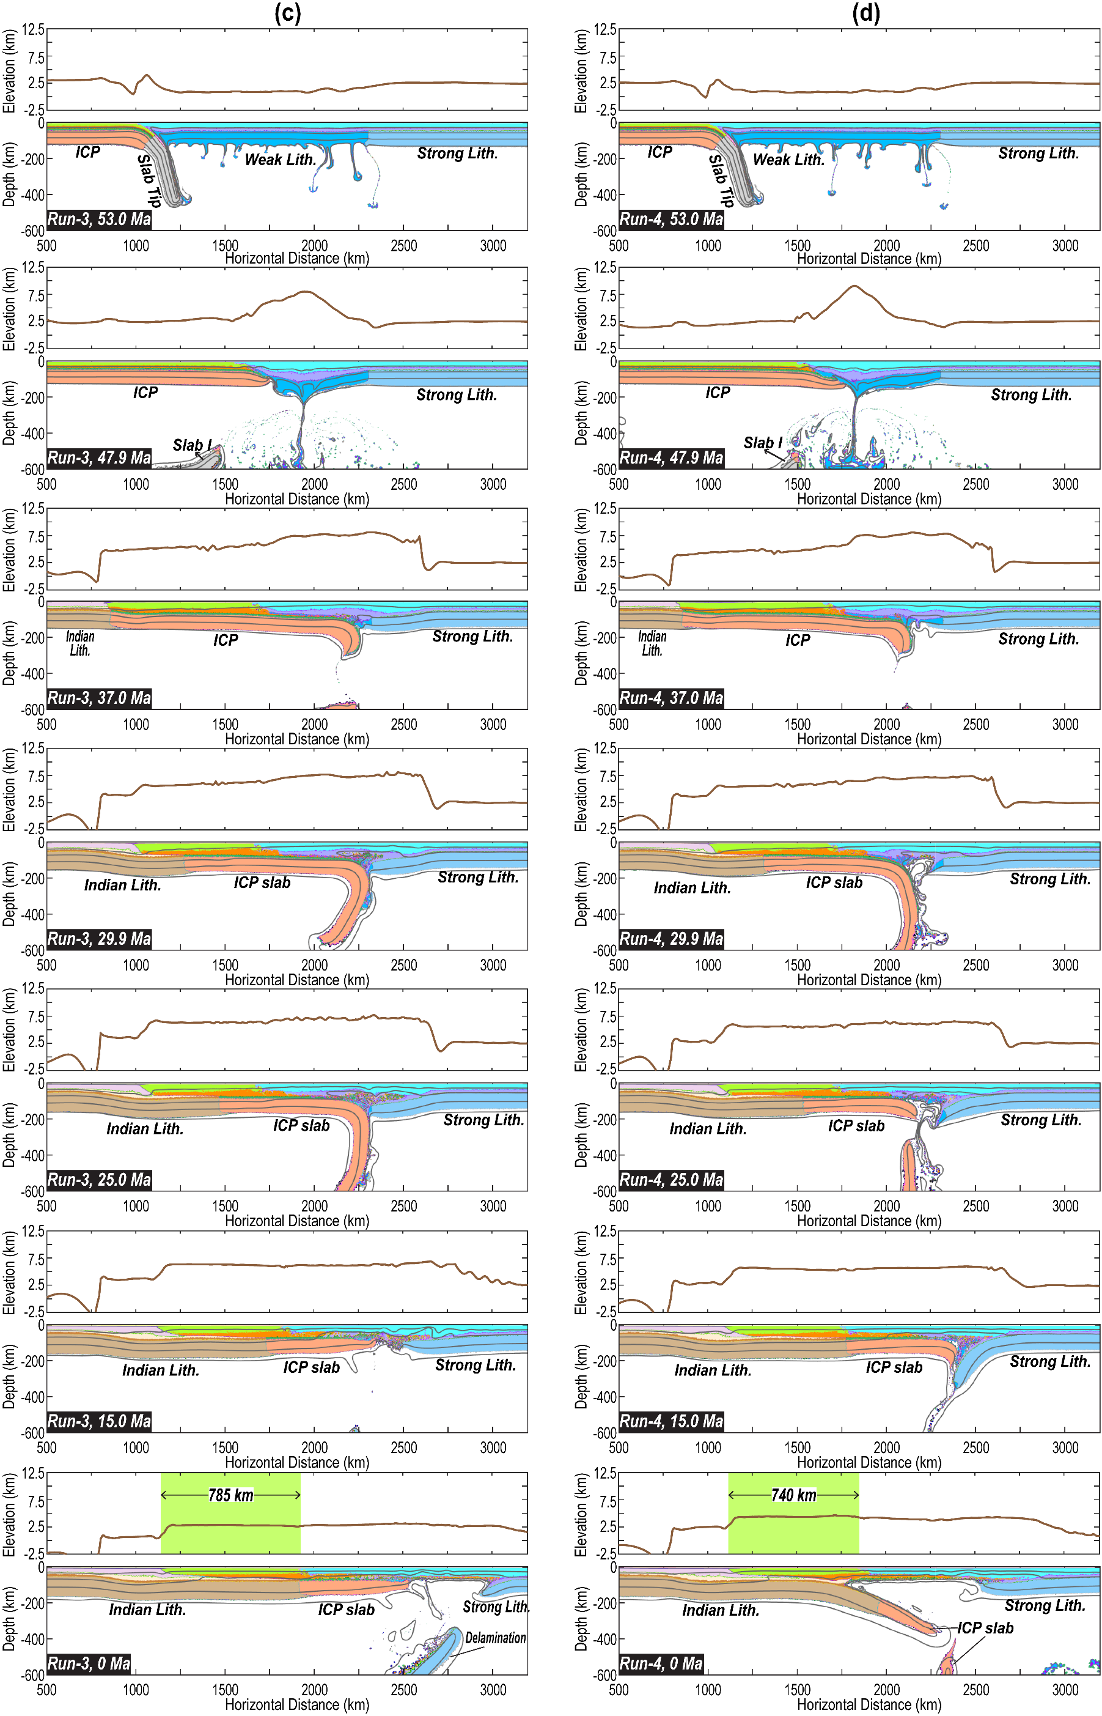
Figure S5 (continued).
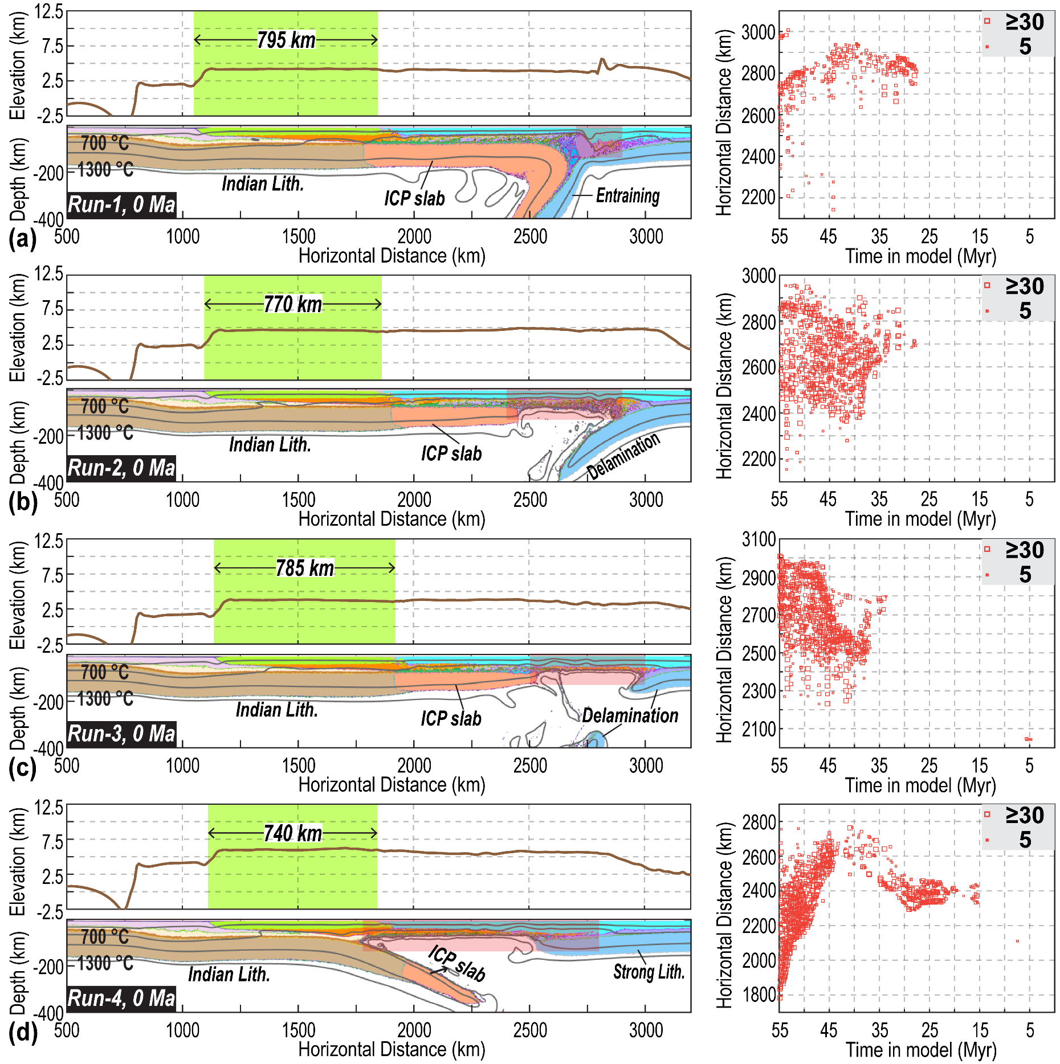
Figure S6. “Present-day” material field, surface topography, and the melting distribution in the Type 1 models. (a) Results of Run 1. (b) Results of Run 2. (c) Results of Run 3. (d) Results of Run 4. The green shading with a number in each elevation panel illustrates the width of the accreted crust (e.g., Tethyan-Greater Himalayas). The red shading in each material panel highlights the spatial range of melting records. The key parameters of these models are in Table S1-S2. The plotting habits for melting distribution are the same as those in Figure 3. ICP-Incoming Continental Plate (e.g., Greater India). Lith.- Lithosphere.

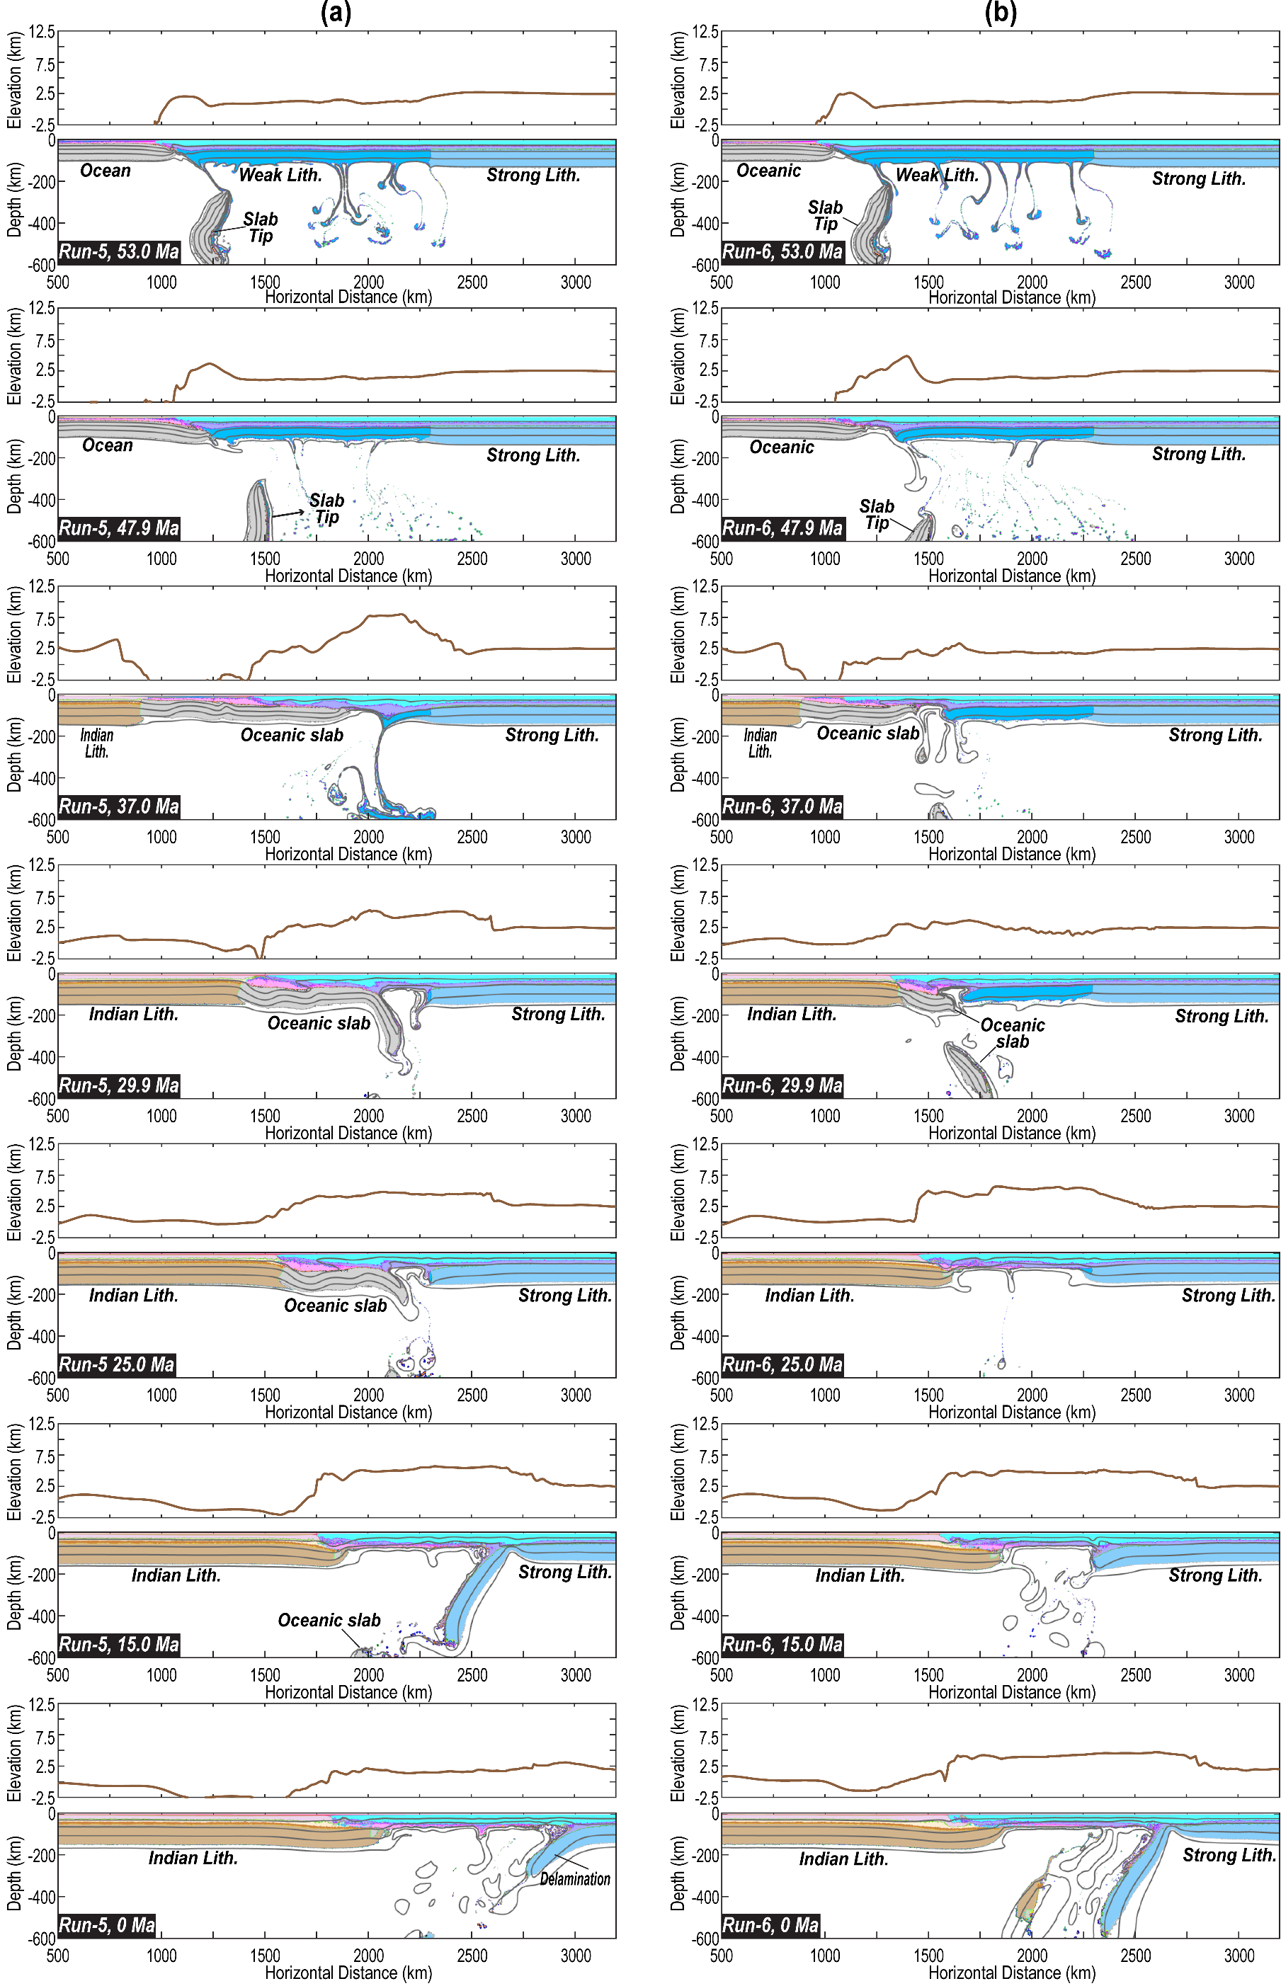
Figure S7. Evolution of material field and surface topography in the Type 2 models (purely oceanic subduction). (a) Results of Run 5. (b) Results of Run 6. The key parameters of these models are in Table S1-S2. Other plotting habits are the same as those in Figure 4. IOP-Incoming Oceanic Plate (e.g., Greater Indian Basin). Lith.- Lithosphere.
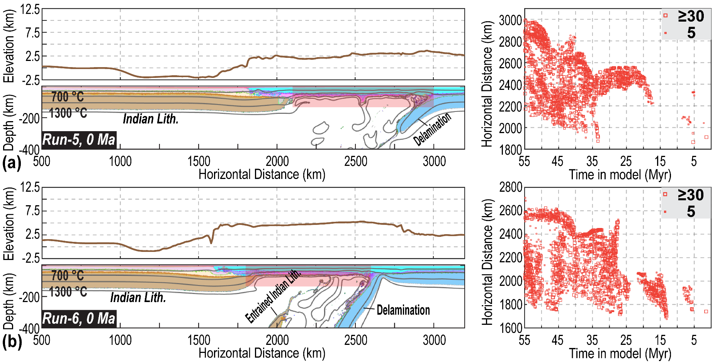
Figure S8. “Present-day” material field, surface topography, and the melting distribution in the Type 2 models. (a) Results of Run 5. (b) Results of Run 6. The red shading in each material panel highlights the spatial range of melting records. The key parameters of these models are in Table S1-S2. The plotting habits for melting distribution are the same as those in Figure 3. Lith.- Lithosphere.

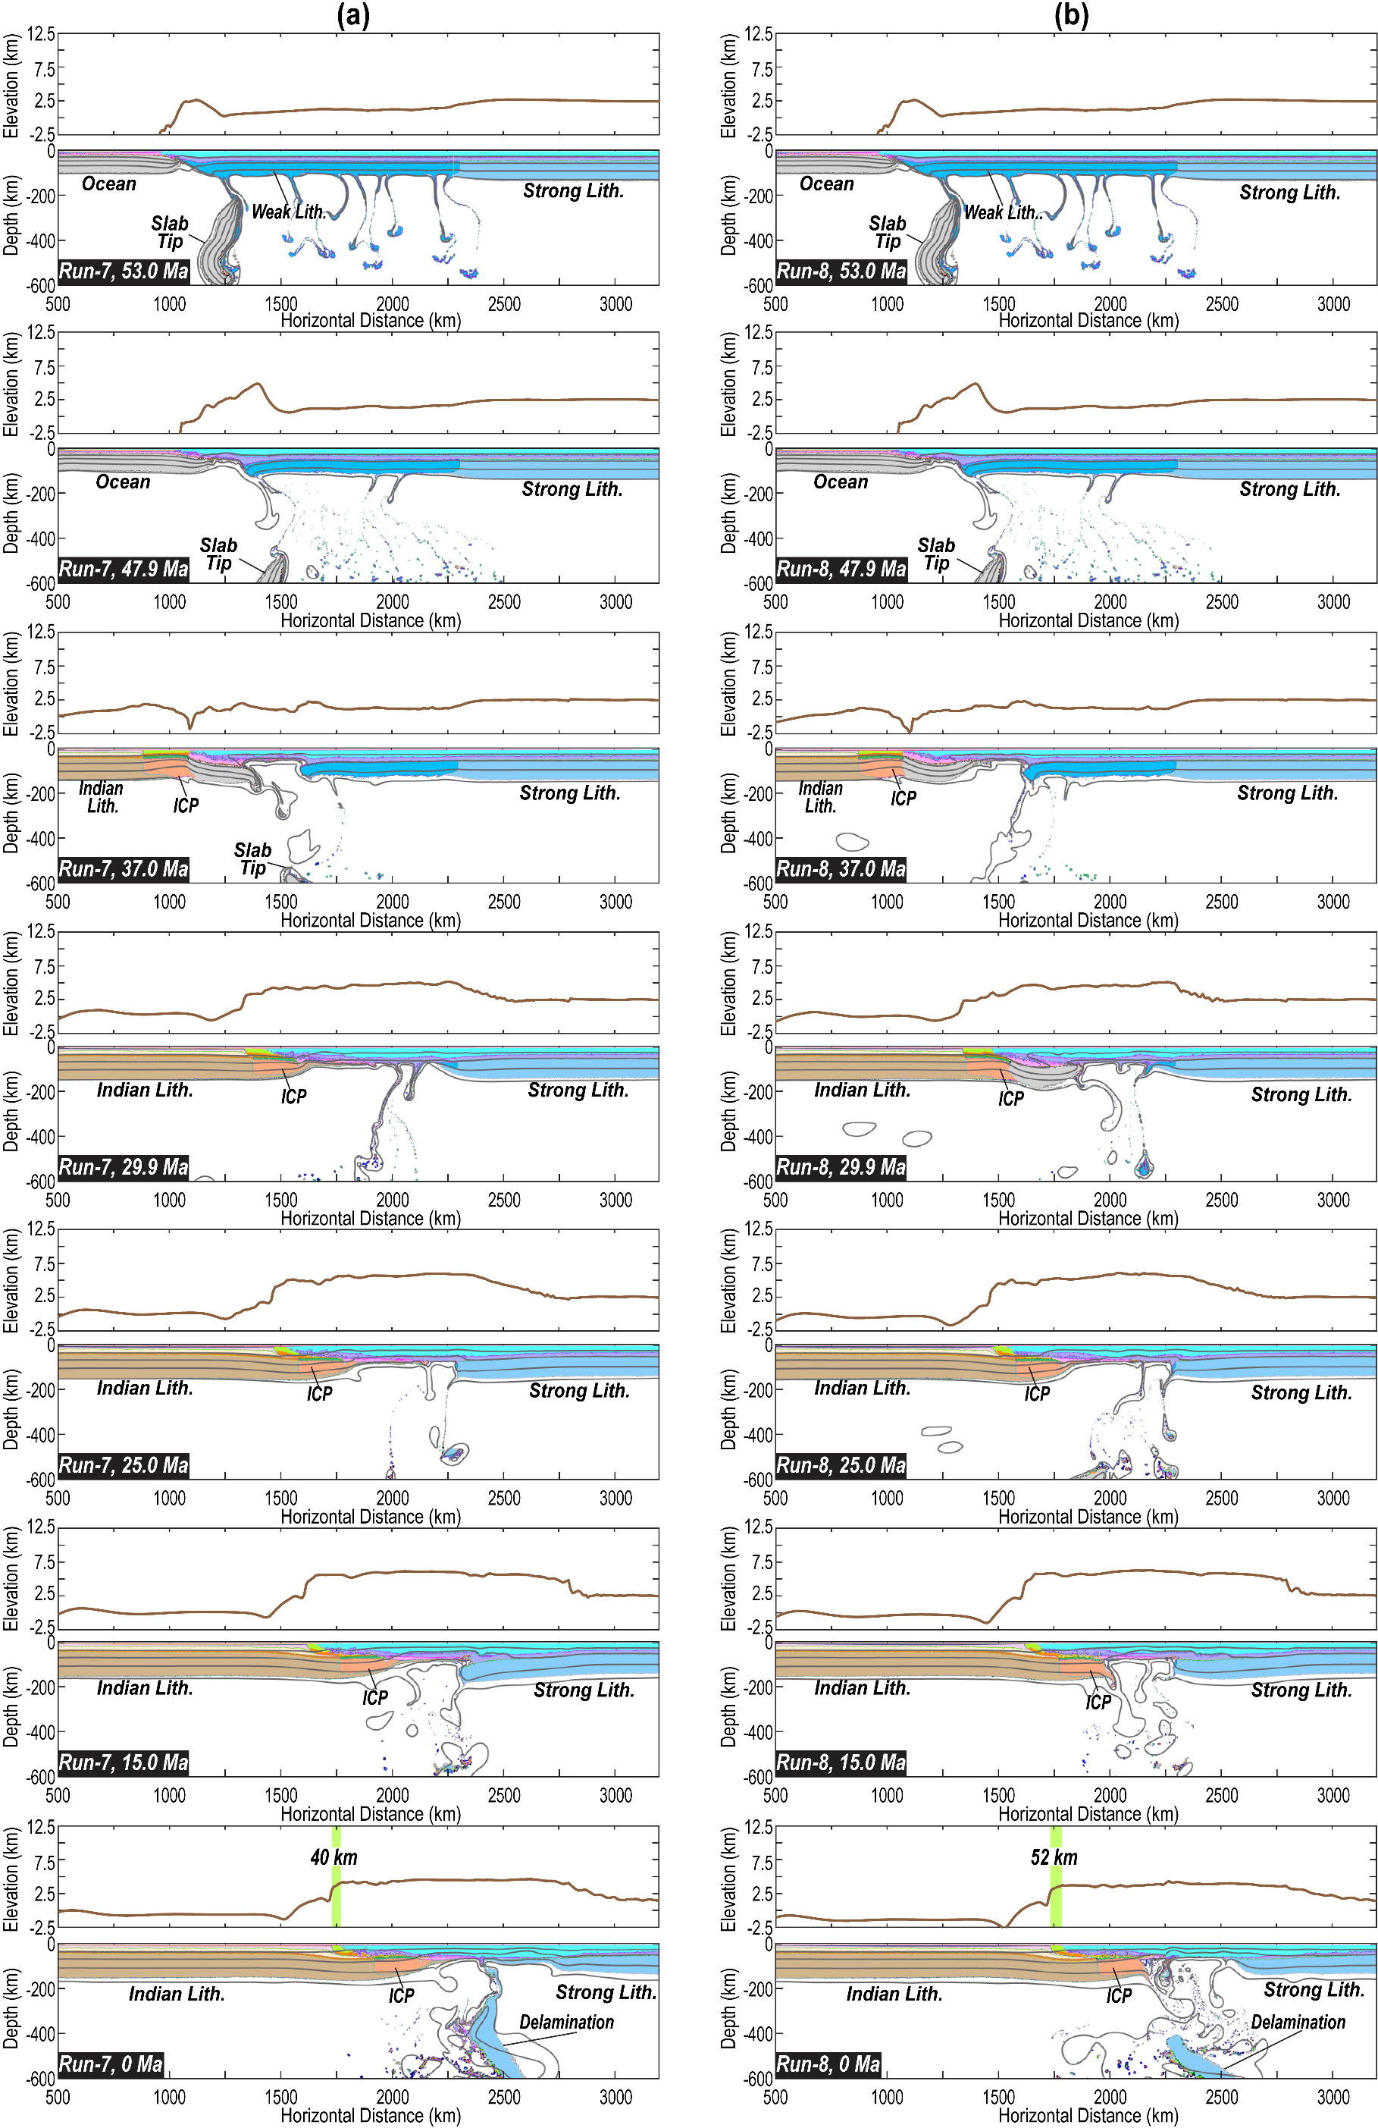
Figure S9. Evolution of material field and surface topography in the Type 3 models. (a) Results of Run 7. (b) Results of Run 8. (c) Results of Run 9. (d) Results of Run 10. The green shading with a number in each bottom panel illustrates the width of the accreted crust (e.g., Tethyan-Greater Himalayas). The key parameters of these models are in Table S1-S2. Other plotting habits are the same as those in Figure 4. ICP-Incoming Continental Plate (e.g., Greater India). Lith.- Lithosphere.
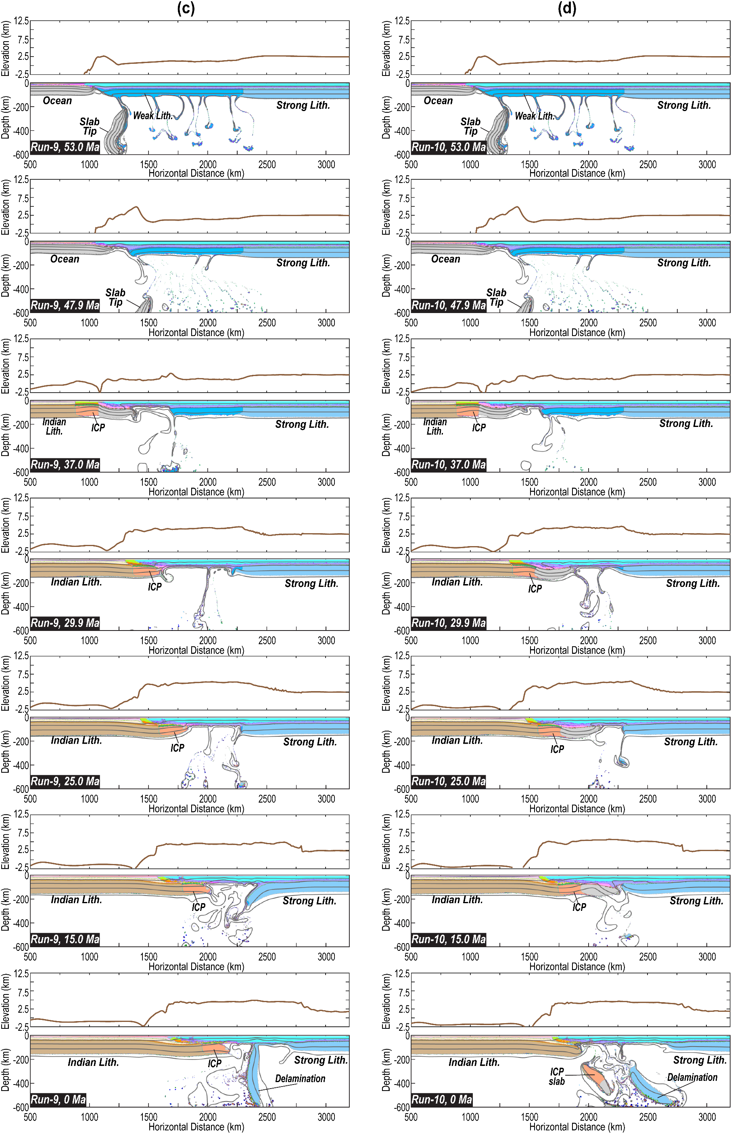
Figure S9 (continued).
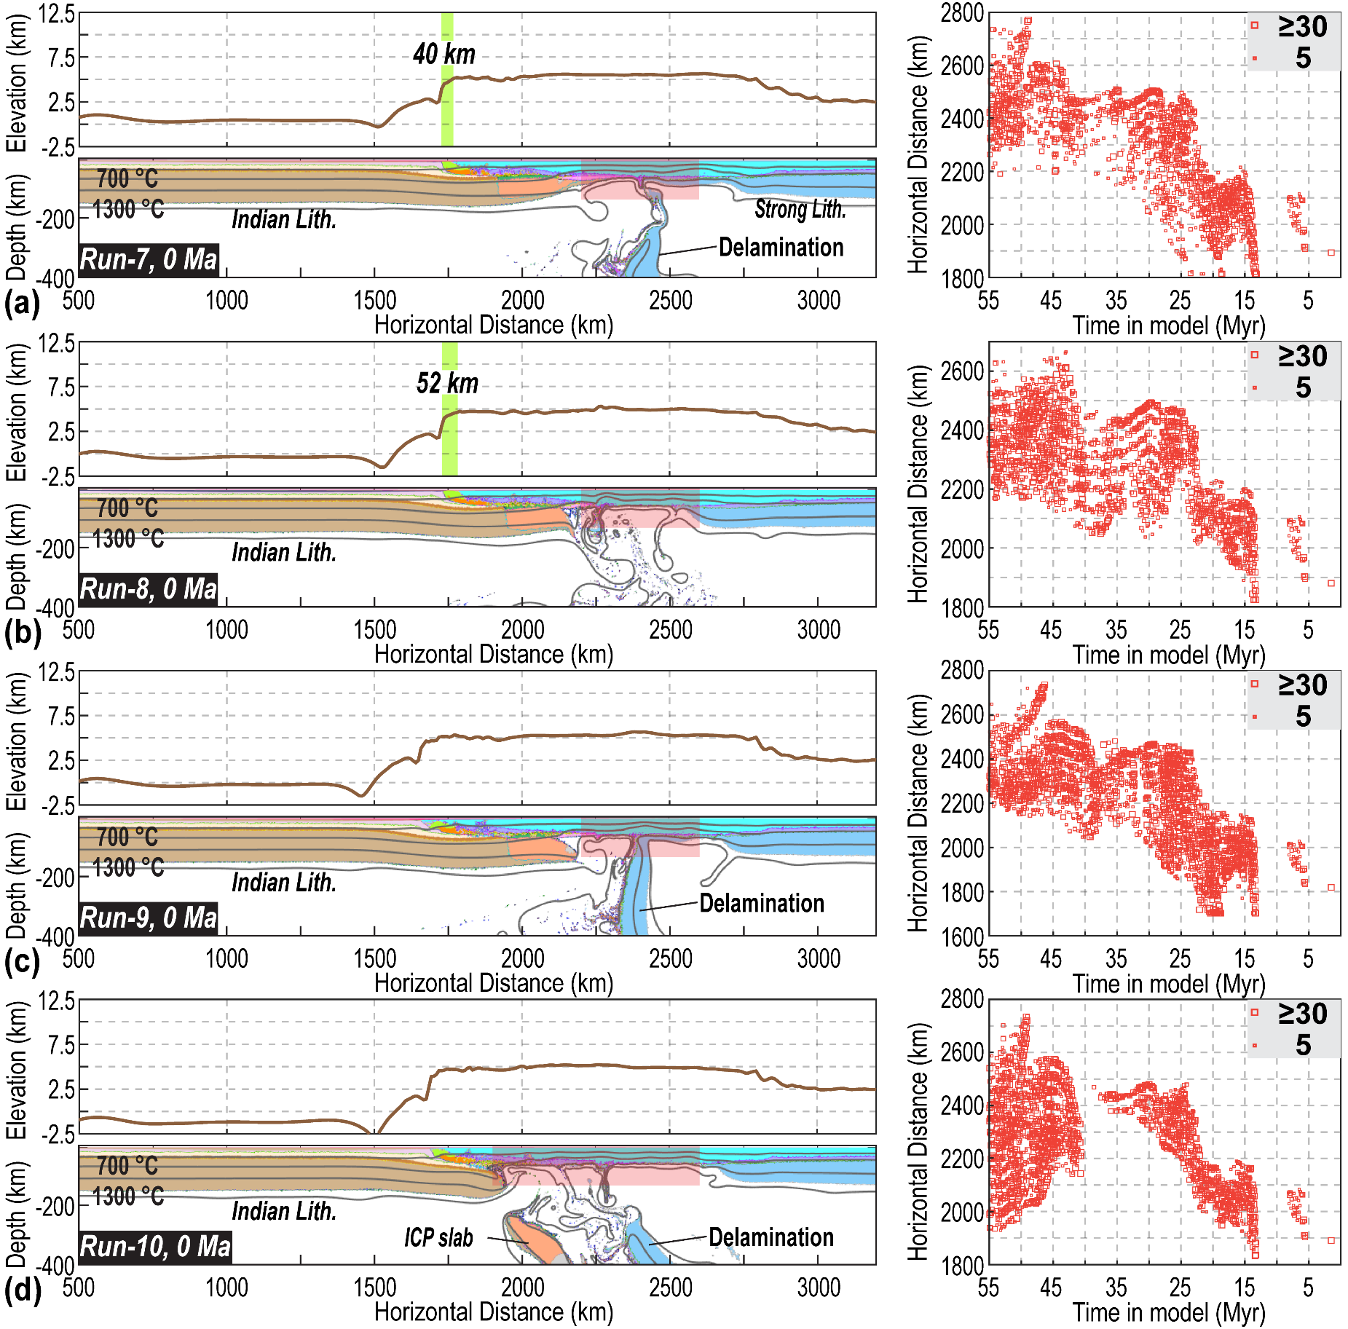
Figure S10. “Present-day” material field, surface topography, and the melting distribution in the Type 3 models. (a) Results of Run 7. (b) Results of Run 8. (c) Results of Run 9. (d) Results of Run 10. The green shading with a number in each elevation panel illustrates the width of the accreted crust (e.g., Tethyan-Greater Himalayas). The red shading in each material panel highlights the spatial range of melting records. The key parameters of these models are in Table S1-S2. The plotting habits for melting distribution are the same as those in Figure 3. ICP-Incoming Continental Plate (e.g., Greater India). Lith.- Lithosphere.

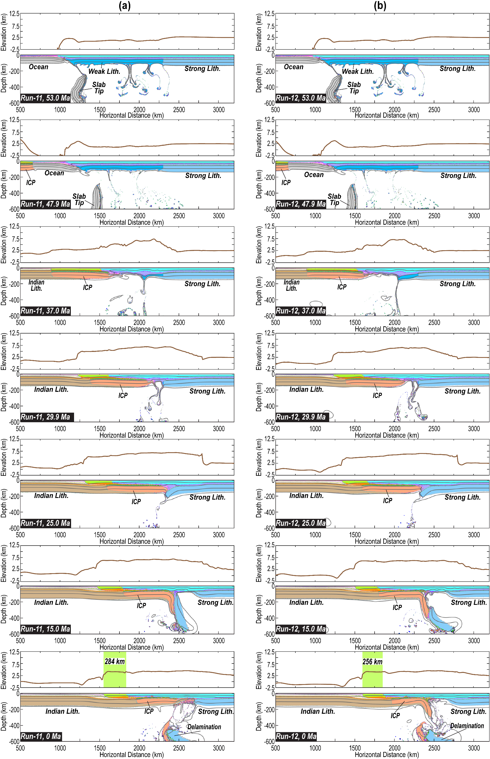
Figure S11. Evolution of material field and surface topography in the Type 4 models. (a) Results of Run 11. (b) Results of Run 12. (c) Results of Run 13. (d) Results of Run 14. The green shading with a number in each bottom panel illustrates the accreted crust's width (e.g., Tethyan-Greater Himalayas). The key parameters of these models are in Table S1-S2. Other plotting habits are the same as those in Figure 4. ICP-Incoming Continental Plate (e.g., Greater India). Lith.- Lithosphere.
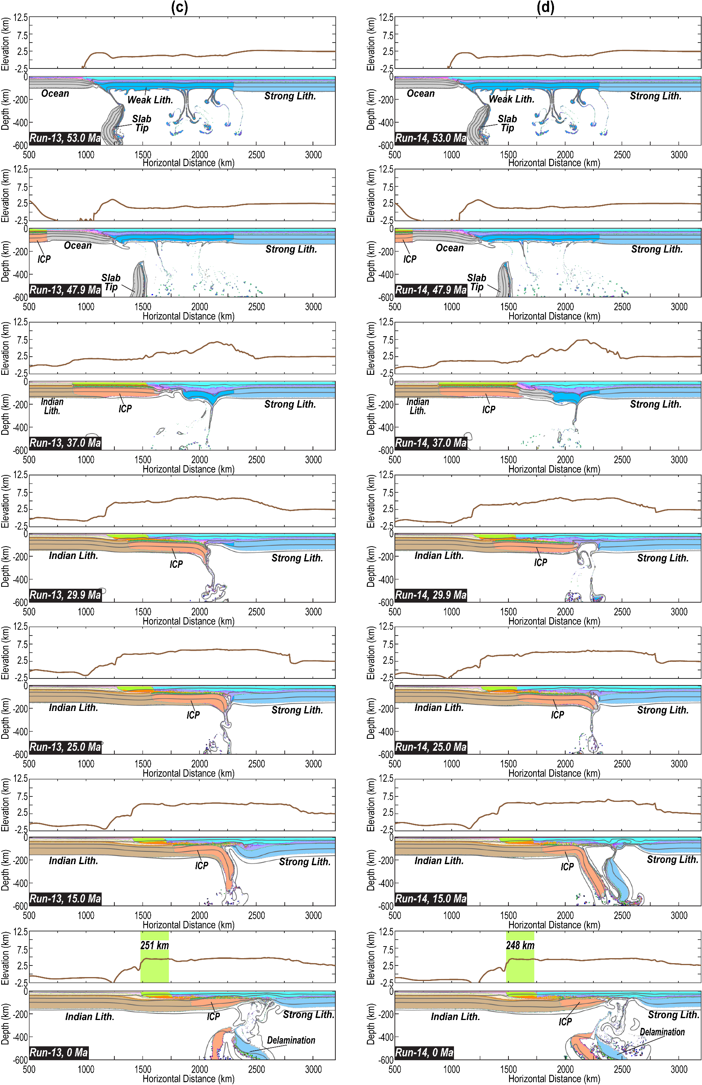
Figure S11 (continued).
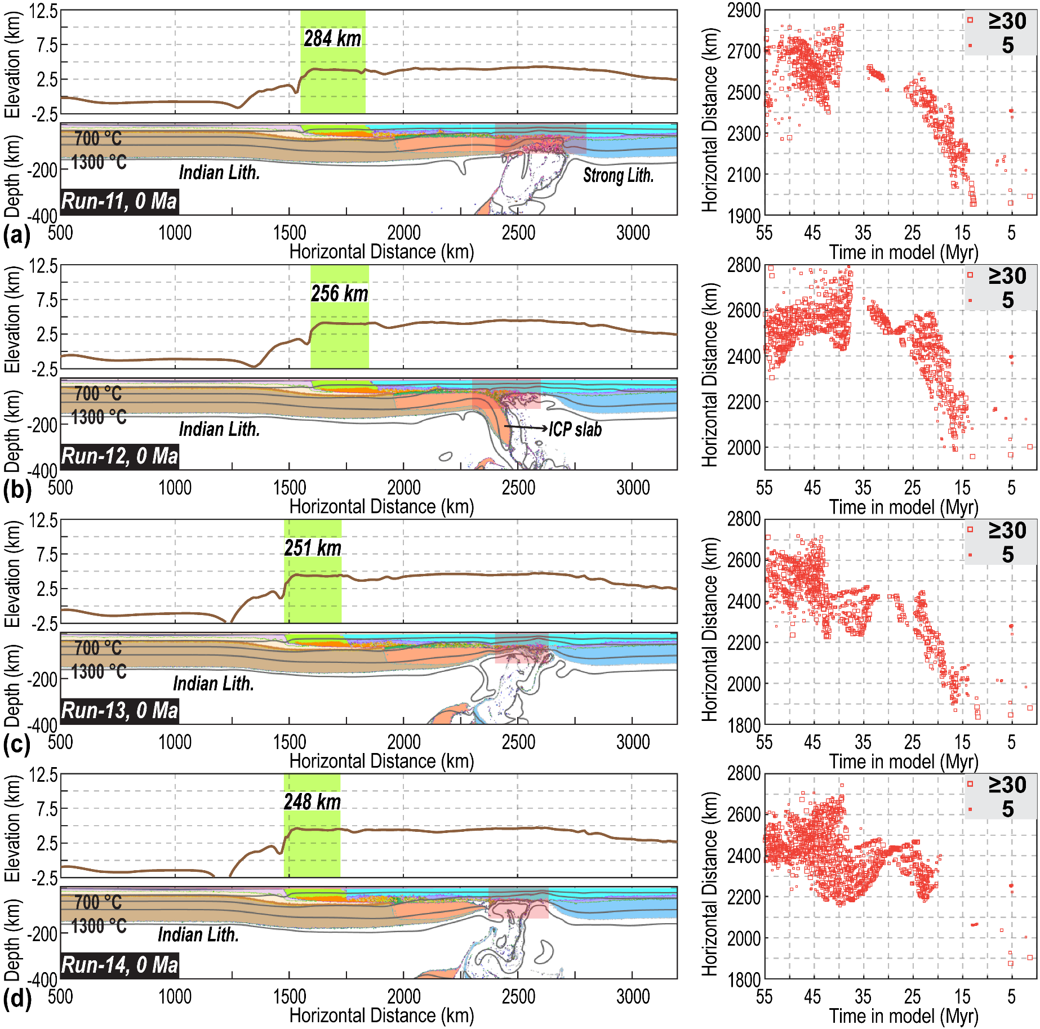
Figure S12. “Present-day” material field, surface topography, and the melting distribution in the Type 4 models. (a) Results of Run 11. (b) Results of Run 12. (c) Results of Run 13. (d) Results of Run 14. The green shading with a number in each elevation panel illustrates the width of the accreted crust (e.g., Tethyan-Greater Himalayas). The red shading in each material panel highlights the spatial range of melting records. The key parameters of these models are in Table S1-S2. The plotting habits for melting distribution are the same as those in Figure 3. Lith.- Lithosphere.

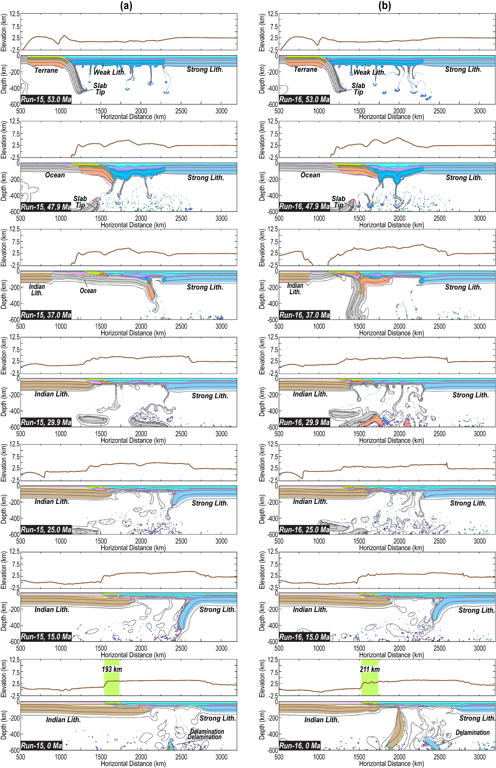
Figure S13. Evolution of material field and surface topography in the Type 5 models (500 km long terrane). (a) Results of Run 15. (b) Results of Run 16. (c) Results of Run 17. (d) Results of Run 18. In these four runs, the terrane is 500 km long. The green shading with a number in each bottom panel illustrates the accreted crust's width (e.g., Tethyan-Greater Himalayas). The key parameters of these models are in Table S1-S2. Other plotting habits are the same as those in Figure 4. Lith.- Lithosphere.

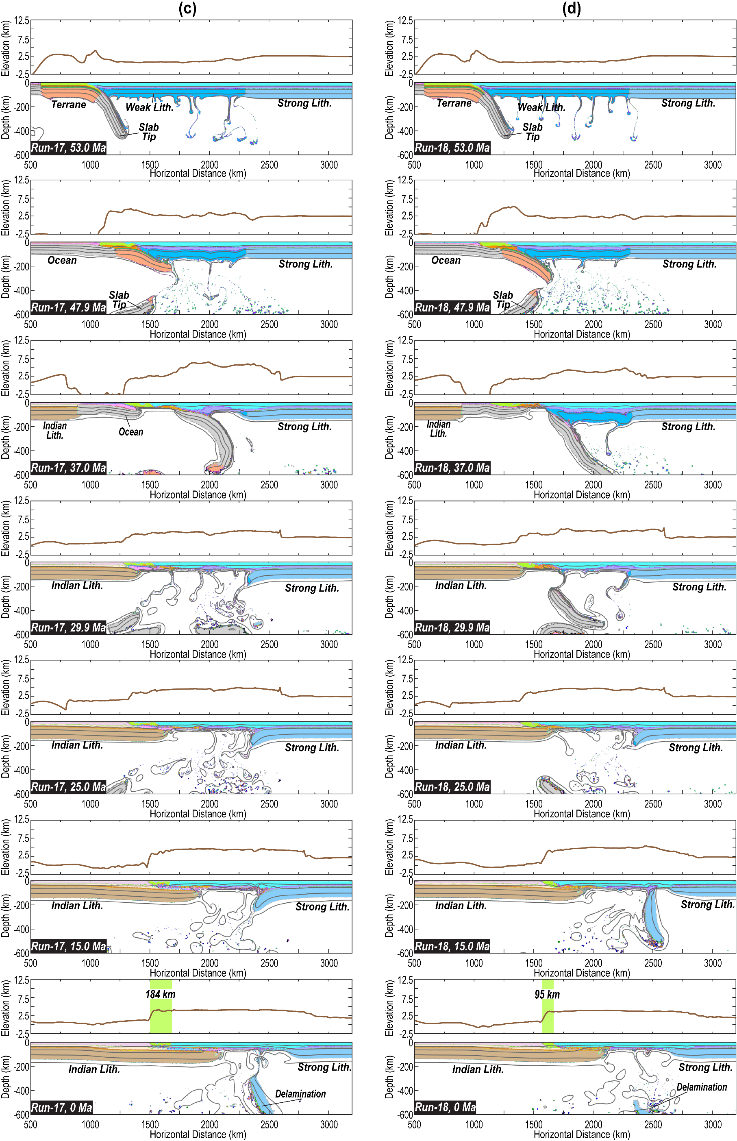
Figure S13 (continued).
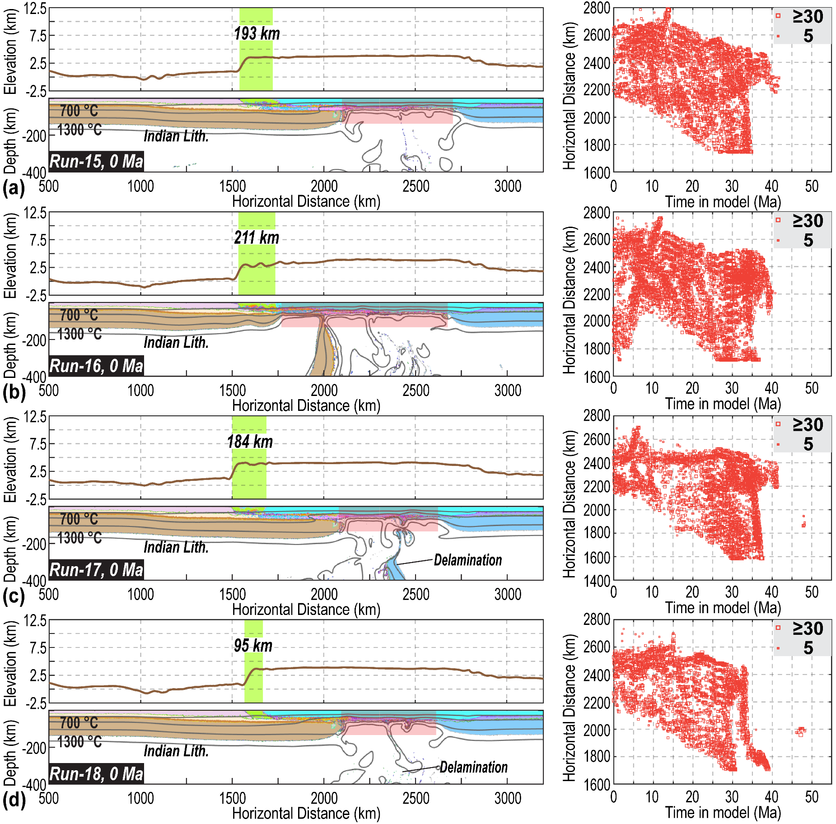
Figure S14. “Present-day” material field, surface topography, and the melting distribution in the Type 5 models. (a) Results of Run 15. (b) Results of Run 16. (c) Results of Run 17. (d) Results of Run 18. The green shading with a number in each bottom panel illustrates the accreted crust's width (e.g., Tethyan-Greater Himalayas). The red shading in each material panel highlights the spatial range of melting records. The key parameters of these models are in Table S1-S2. The plotting habits for melting distribution are the same as those in Figure 3. Lith.- Lithosphere.

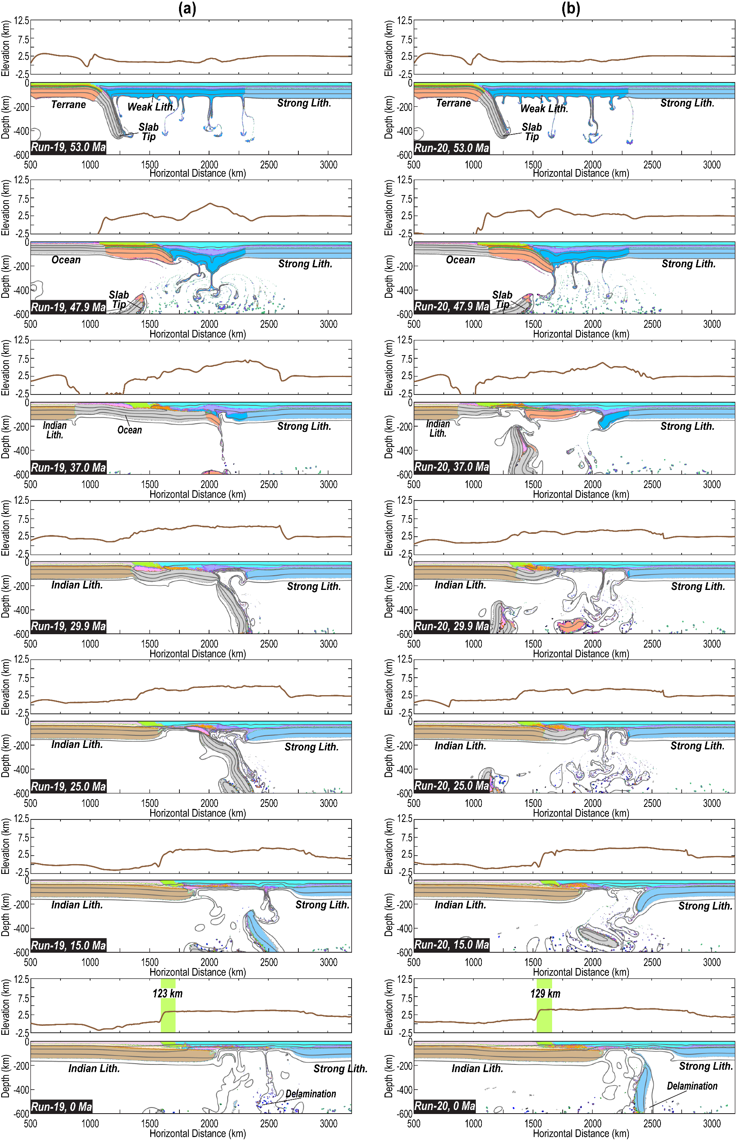
Figure S15. Evolution of material field and surface topography in the Type 5 models (600 km long terrane). (a) Results of Run 19. (b) Results of Run 20. (c) Results of Run 21. (d) Results of Run 22. In these four runs, the terrane is 600 km long. The green shading with a number in each bottom panel illustrates the accreted crust's width (e.g., Tethyan-Greater Himalayas). The key parameters of these models are in Table S1-S2. Other plotting habits are the same as those in Figure 4. Lith.- Lithosphere.

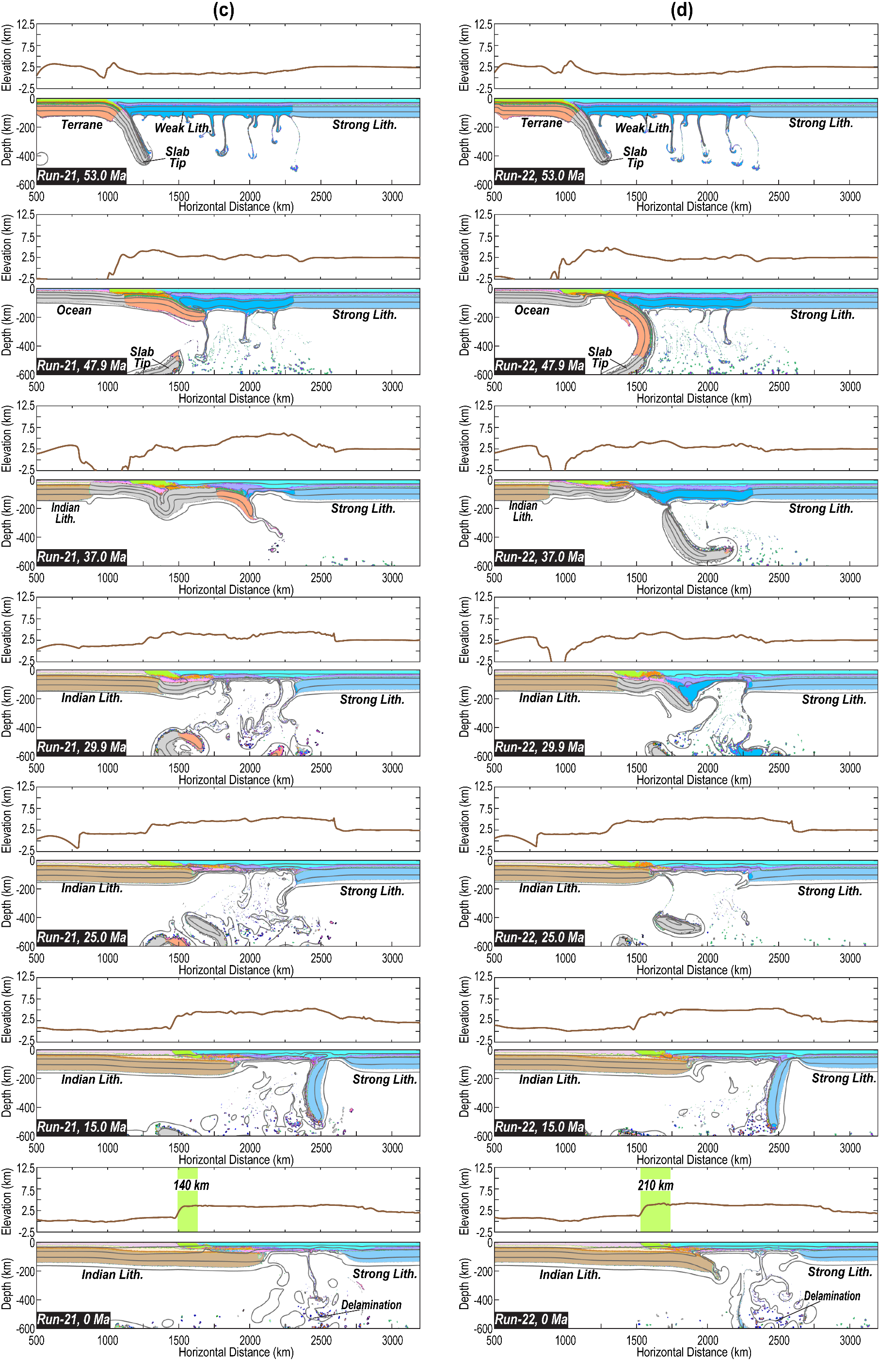
Figure S15 (continued).
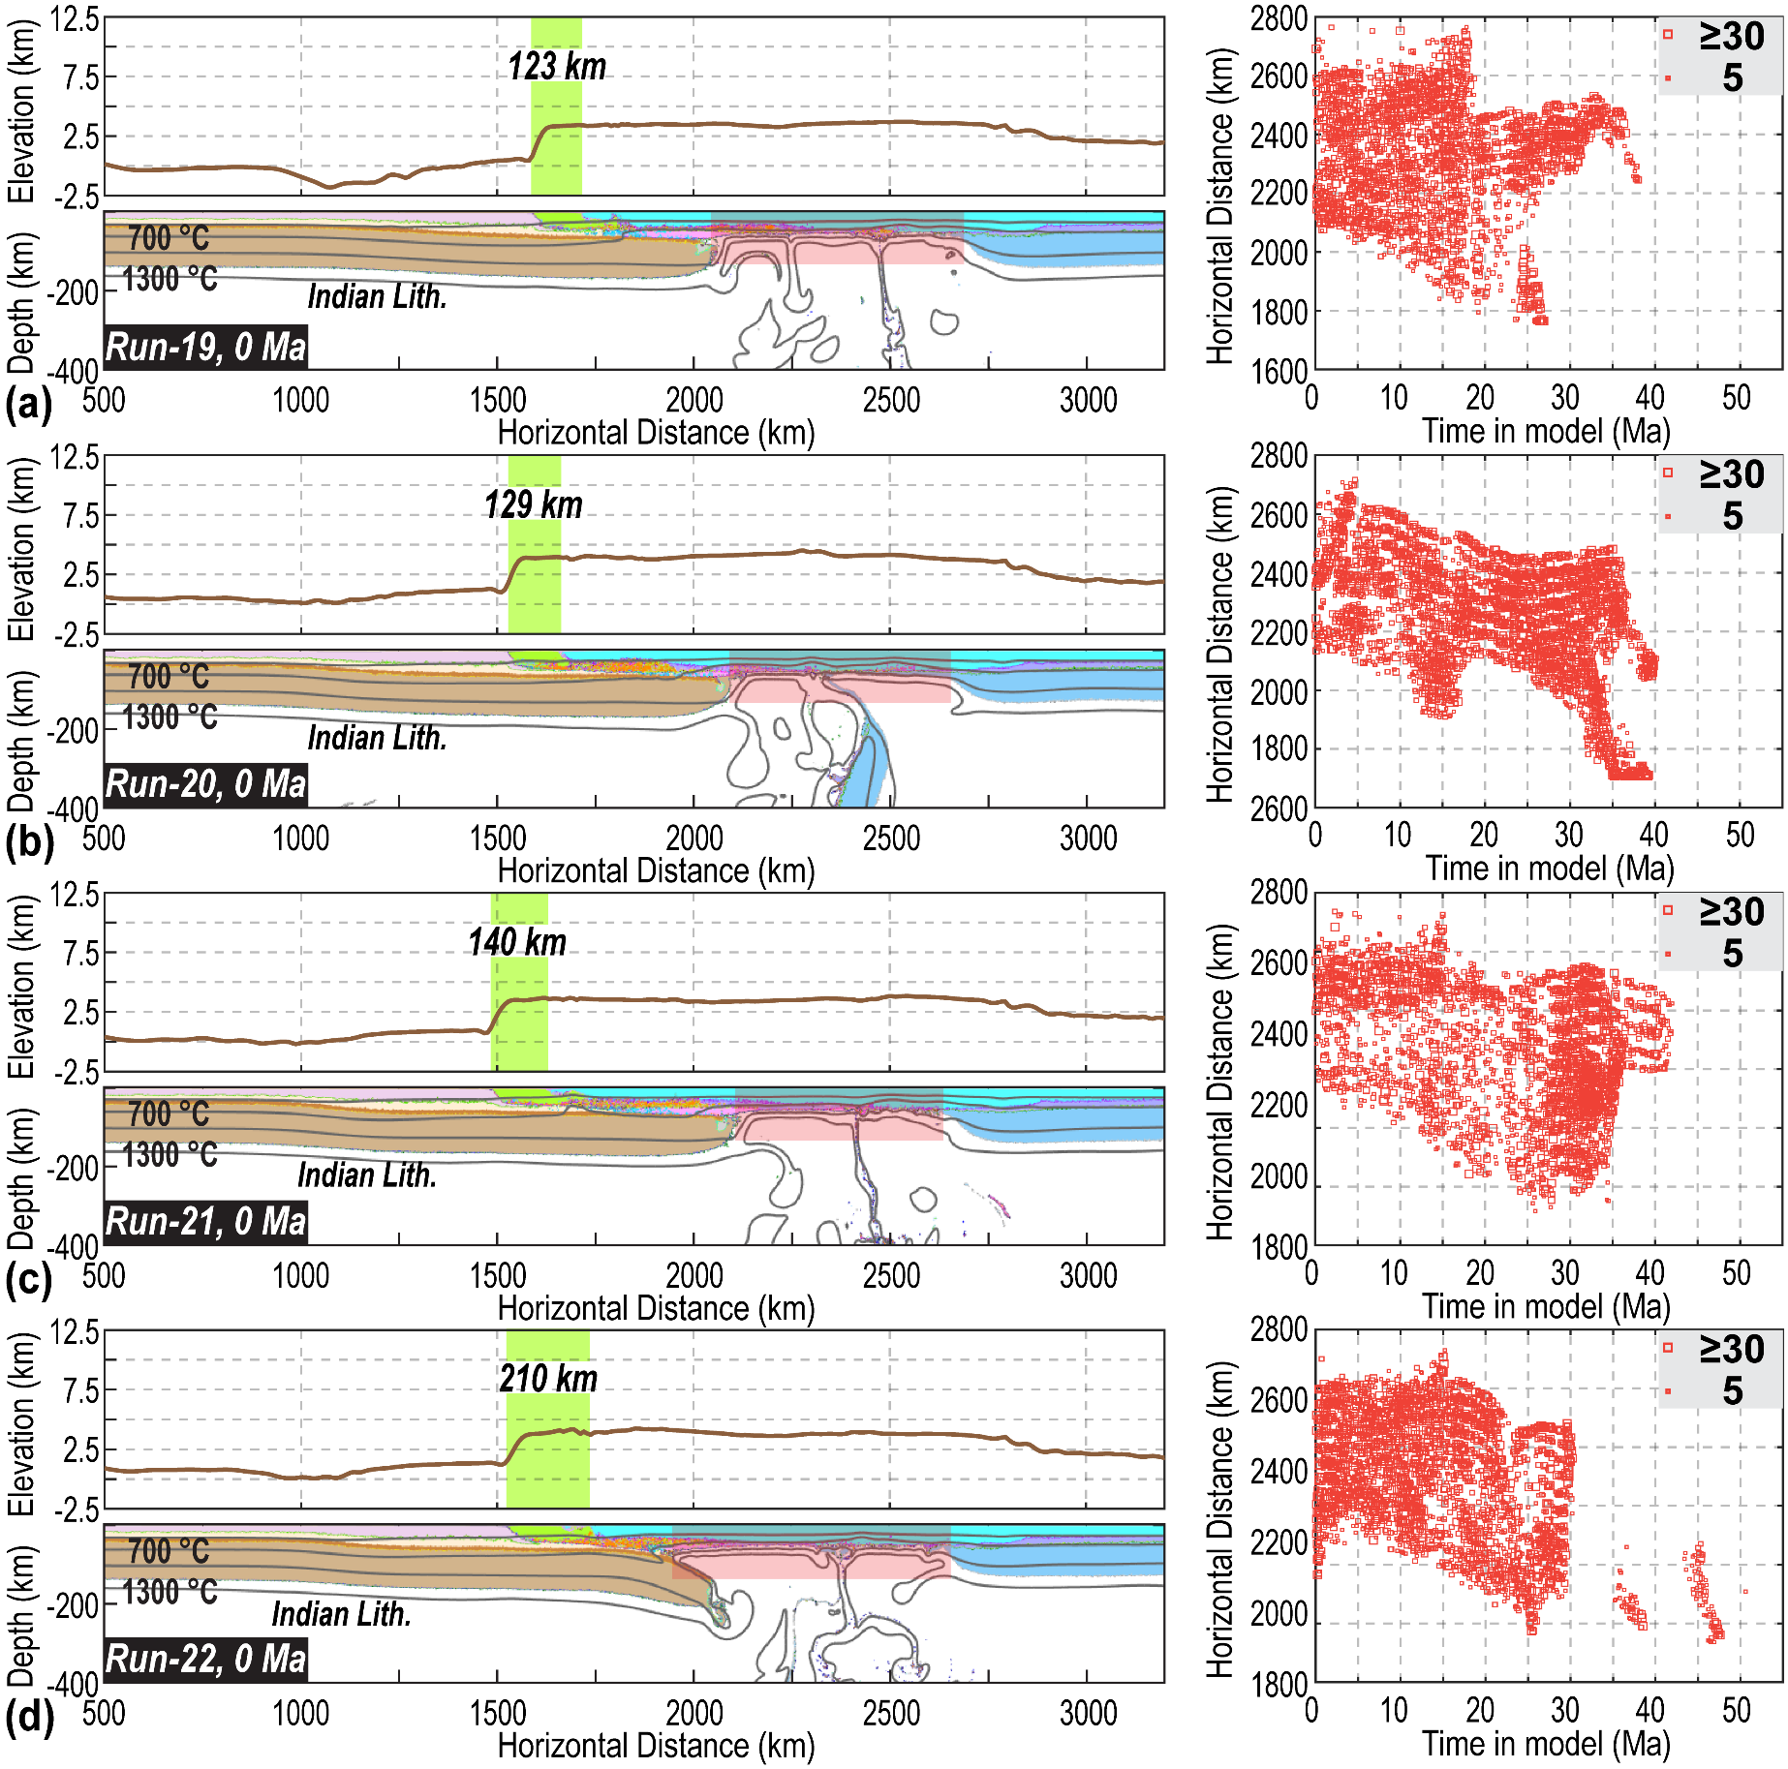
Figure S16. “Present-day” material field, surface topography, and the melting distribution in the Type 5 models. (a) Results of Run 19. (b) Results of Run 20. (c) Results of Run 21. (d) Results of Run 22. The green shading with a number in each bottom panel illustrates the accreted crust's width (e.g., Tethyan-Greater Himalayas). The red shading in each material panel highlights the spatial range of melting records. The key parameters of these models are in Table S1-S2. The plotting habits for melting distribution are the same as those in Figure 3. Lith.- Lithosphere.

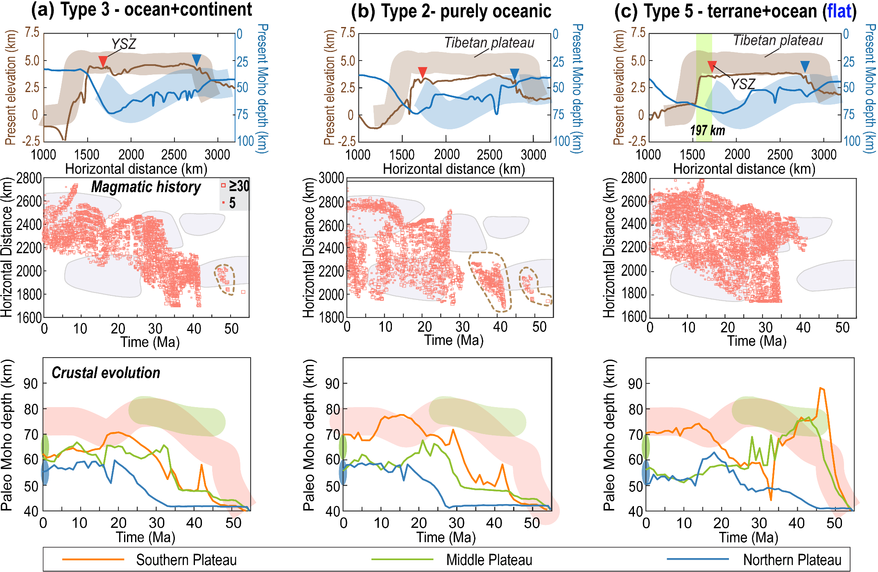
Figure S17. Model evolution and surface responses for different scenarios. The three columns correspond to Type 3 (Run 9, Figures S9c, S10c), Type 2 (Run 6, Figures S7b, S8b), and Type 5 models (Runs 15 in Figures S13a, S14a), respectively (Figure 1b) The plotting habits follows those in Figure 3.

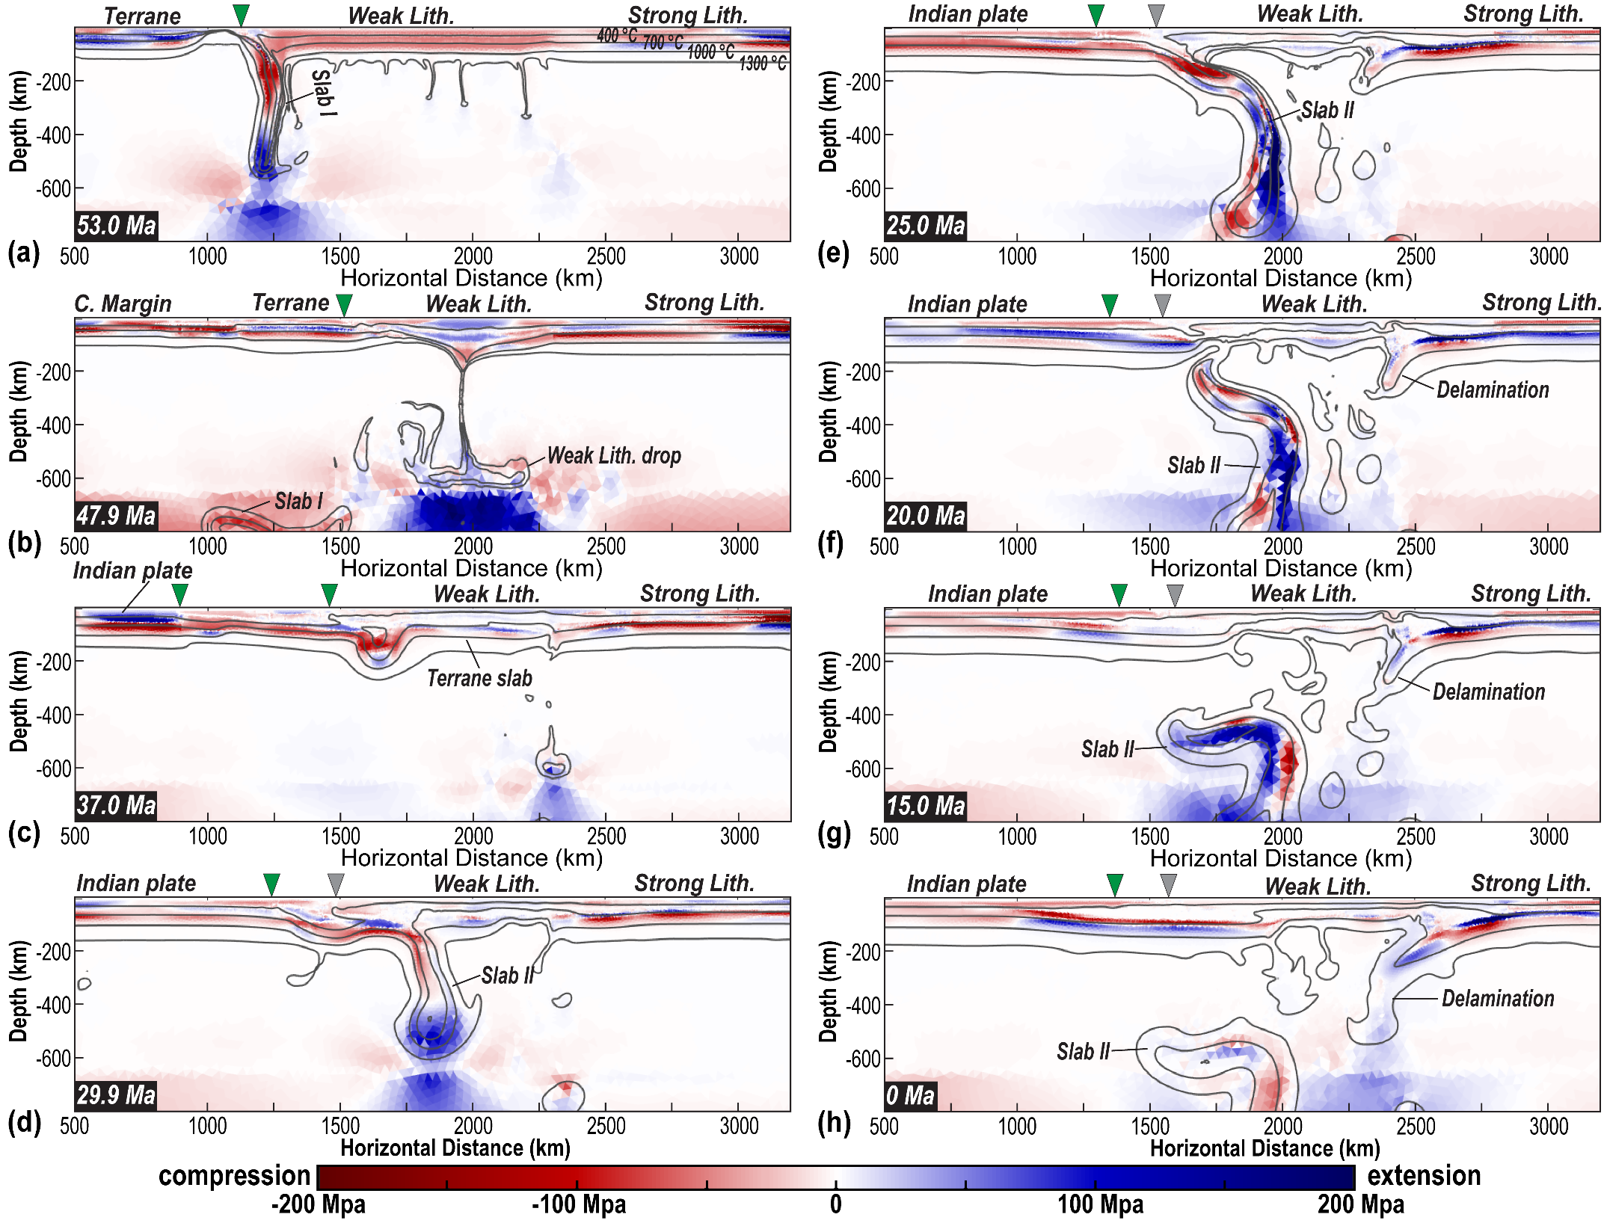
Figure S18. Evolution of the horizontal deviatoric stress in the Type 6 model (Run 23). Lith.- Lithosphere. Slabs I and II demonstrate the same slabs as those in Figure 4. C. Margin- Continental Margin.

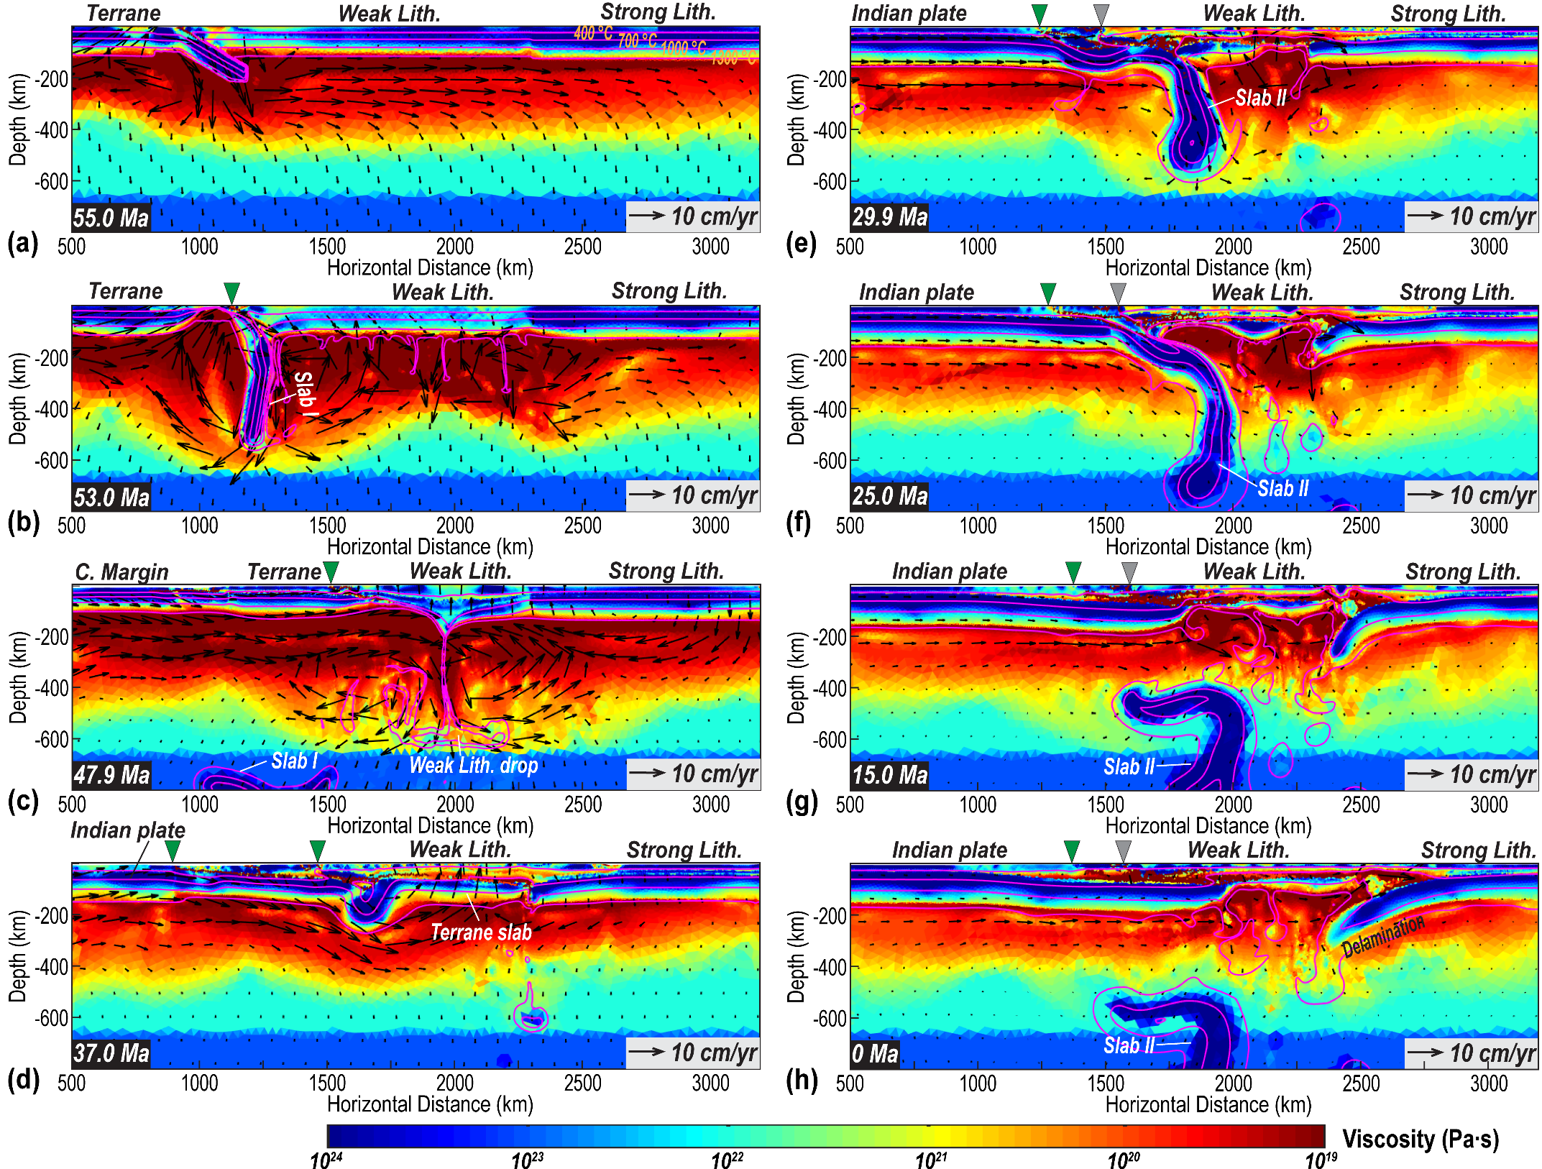
Figure S19. Evolution of the viscosity filed in the Type 6 model (Run 23). Lith.- Lithosphere. Slabs I and II demonstrate the same slabs as those in Figure 4. C. Margin- Continental Margin.

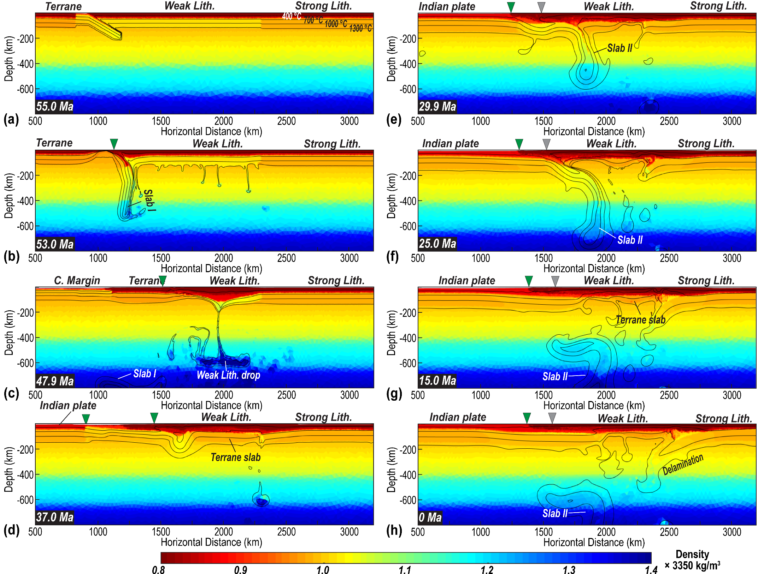
Figure S20. Evolution of the density field in the Type 6 model (Run 23). Lith.- Lithosphere. Slabs I and II demonstrate the same slabs as those in Figure 4. C. Margin- Continental Margin.

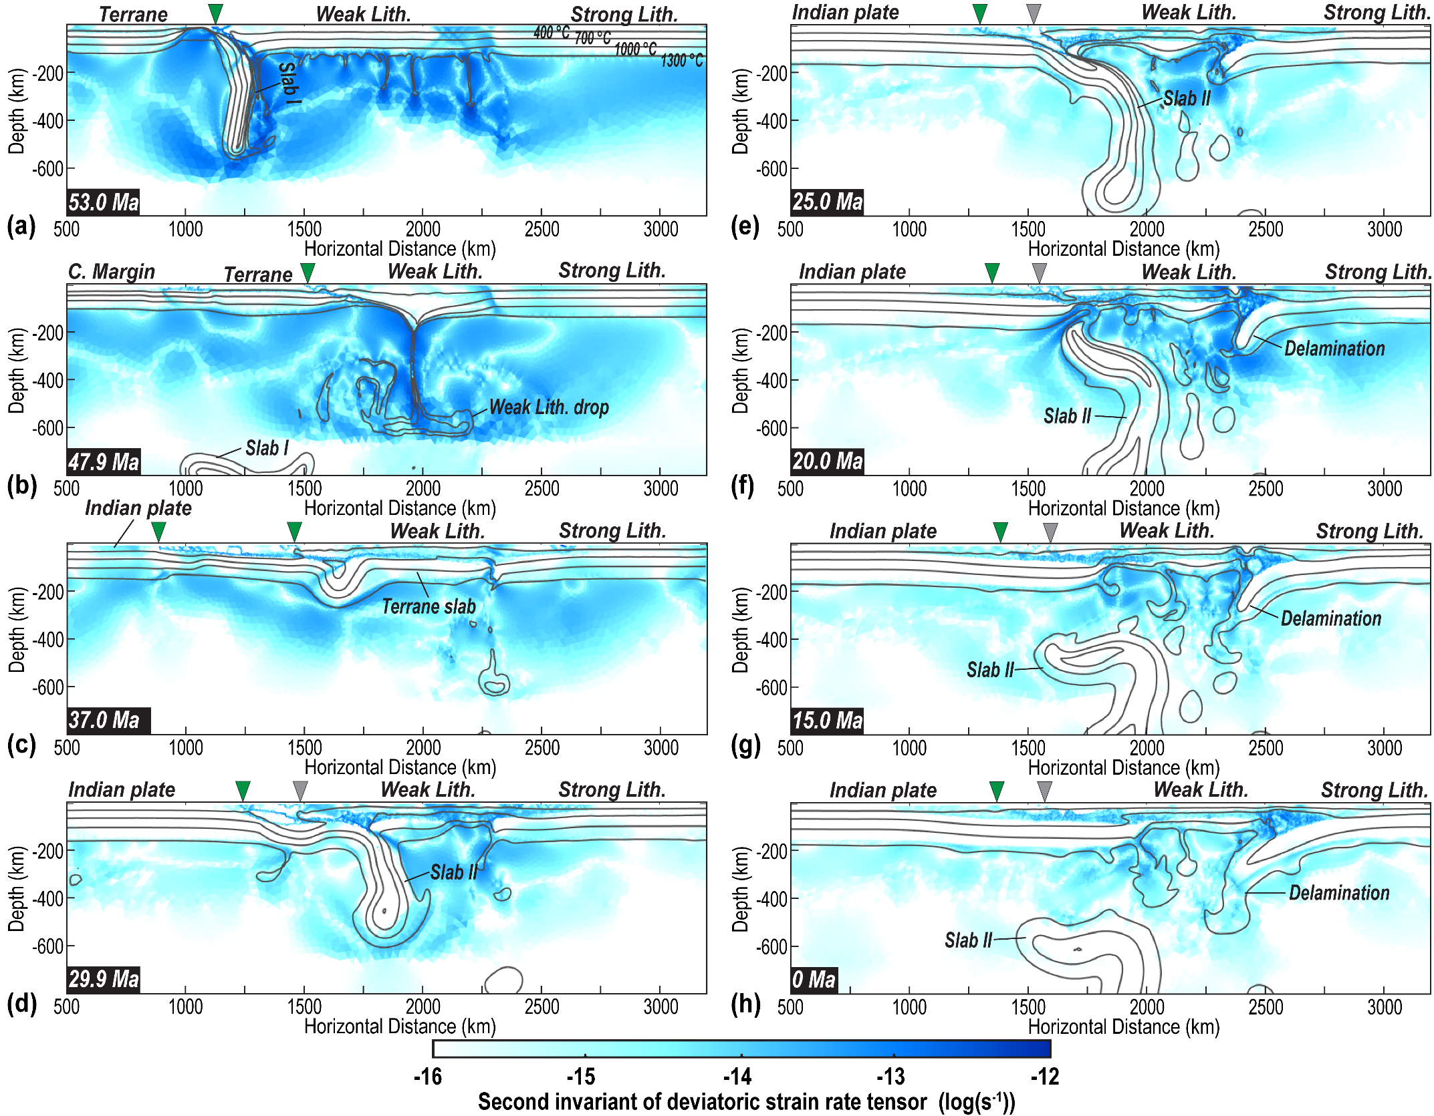
Figure S21. Evolution of the second invariant of deviatoric strain rate tensor (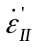) in the Type 6 model (Run 23). Lith.- Lithosphere. Slabs I and II demonstrate the same slabs as those in Figure 4. C. Margin- Continental Margin.

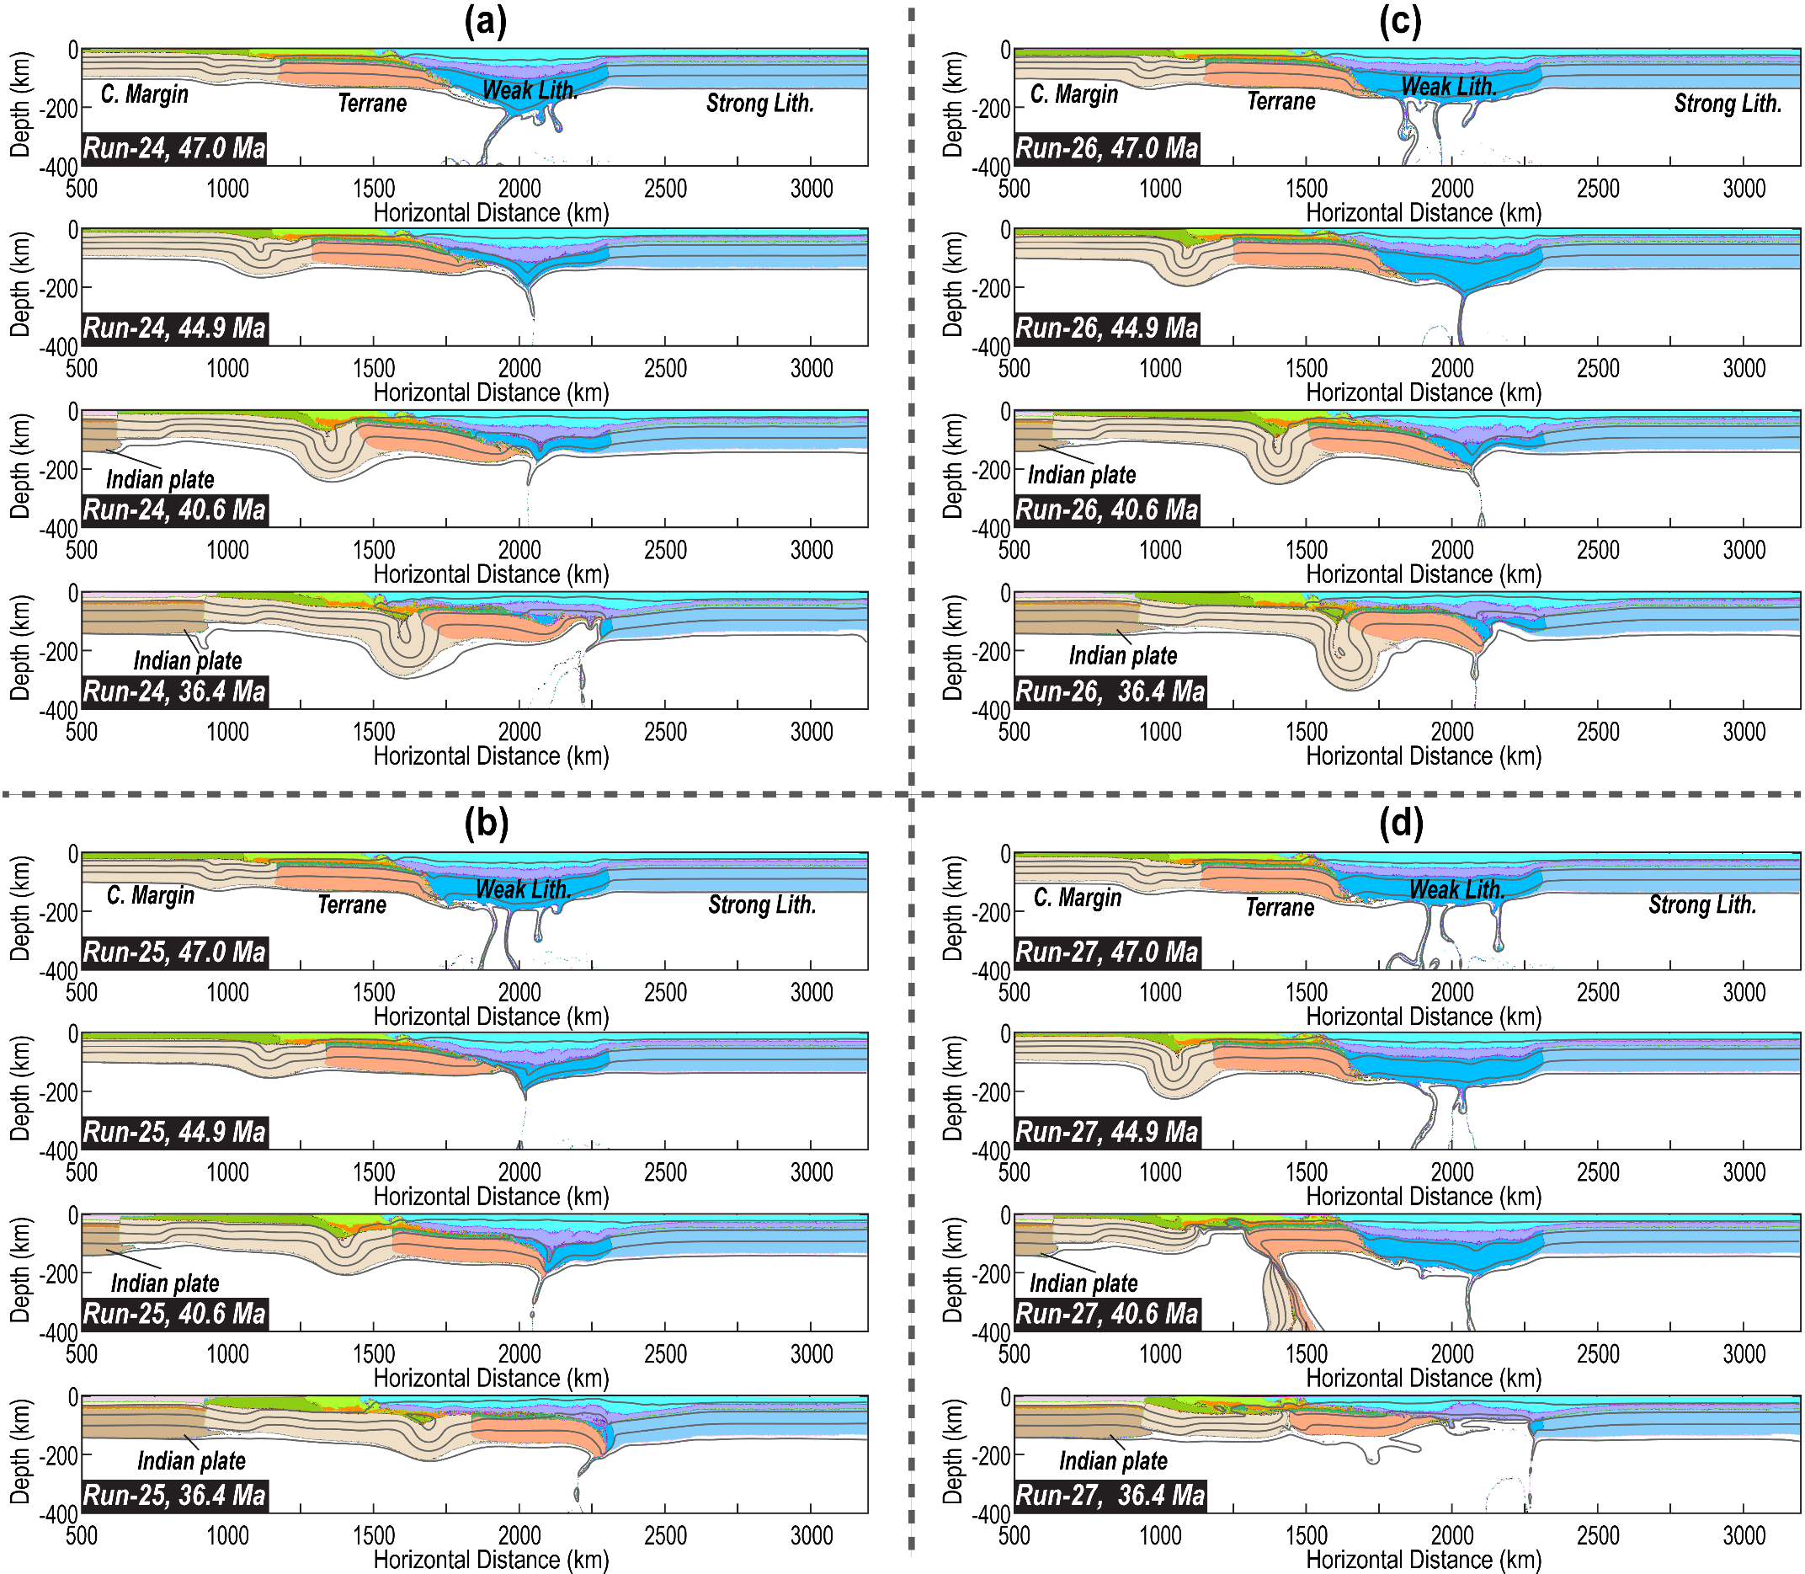
Figure S22. Effects of overriding-plate rheology on the evolution of the Type 6 model. (a) Results of Run 24. This model is the same as Run 23, except that the maximum yielding stress for the crust of the weak overriding plate (Tibetan terranes) is capped at 100 MPa. (b) Results of Run 25. This model is the same as Run 23, except that the maximum yielding stress for the crust of the weak overriding plate (Tibetan terranes) is capped at 150 MPa. (c) Results of Run 26. This model is the same as Run 23, except that the maximum yielding stress for the crust of the weak overriding plate (Tibetan terranes) is capped at 200 MPa. (d) Results of Run 27. This model is the same as Run 23, except that the maximum yielding stress for the lithospheric mantle of the weak overriding plate (Tibetan terranes) is capped at 100 MPa. More parameters are in Tables S1-S2. Lith.- Lithosphere. C. Margin- Continental Margin.

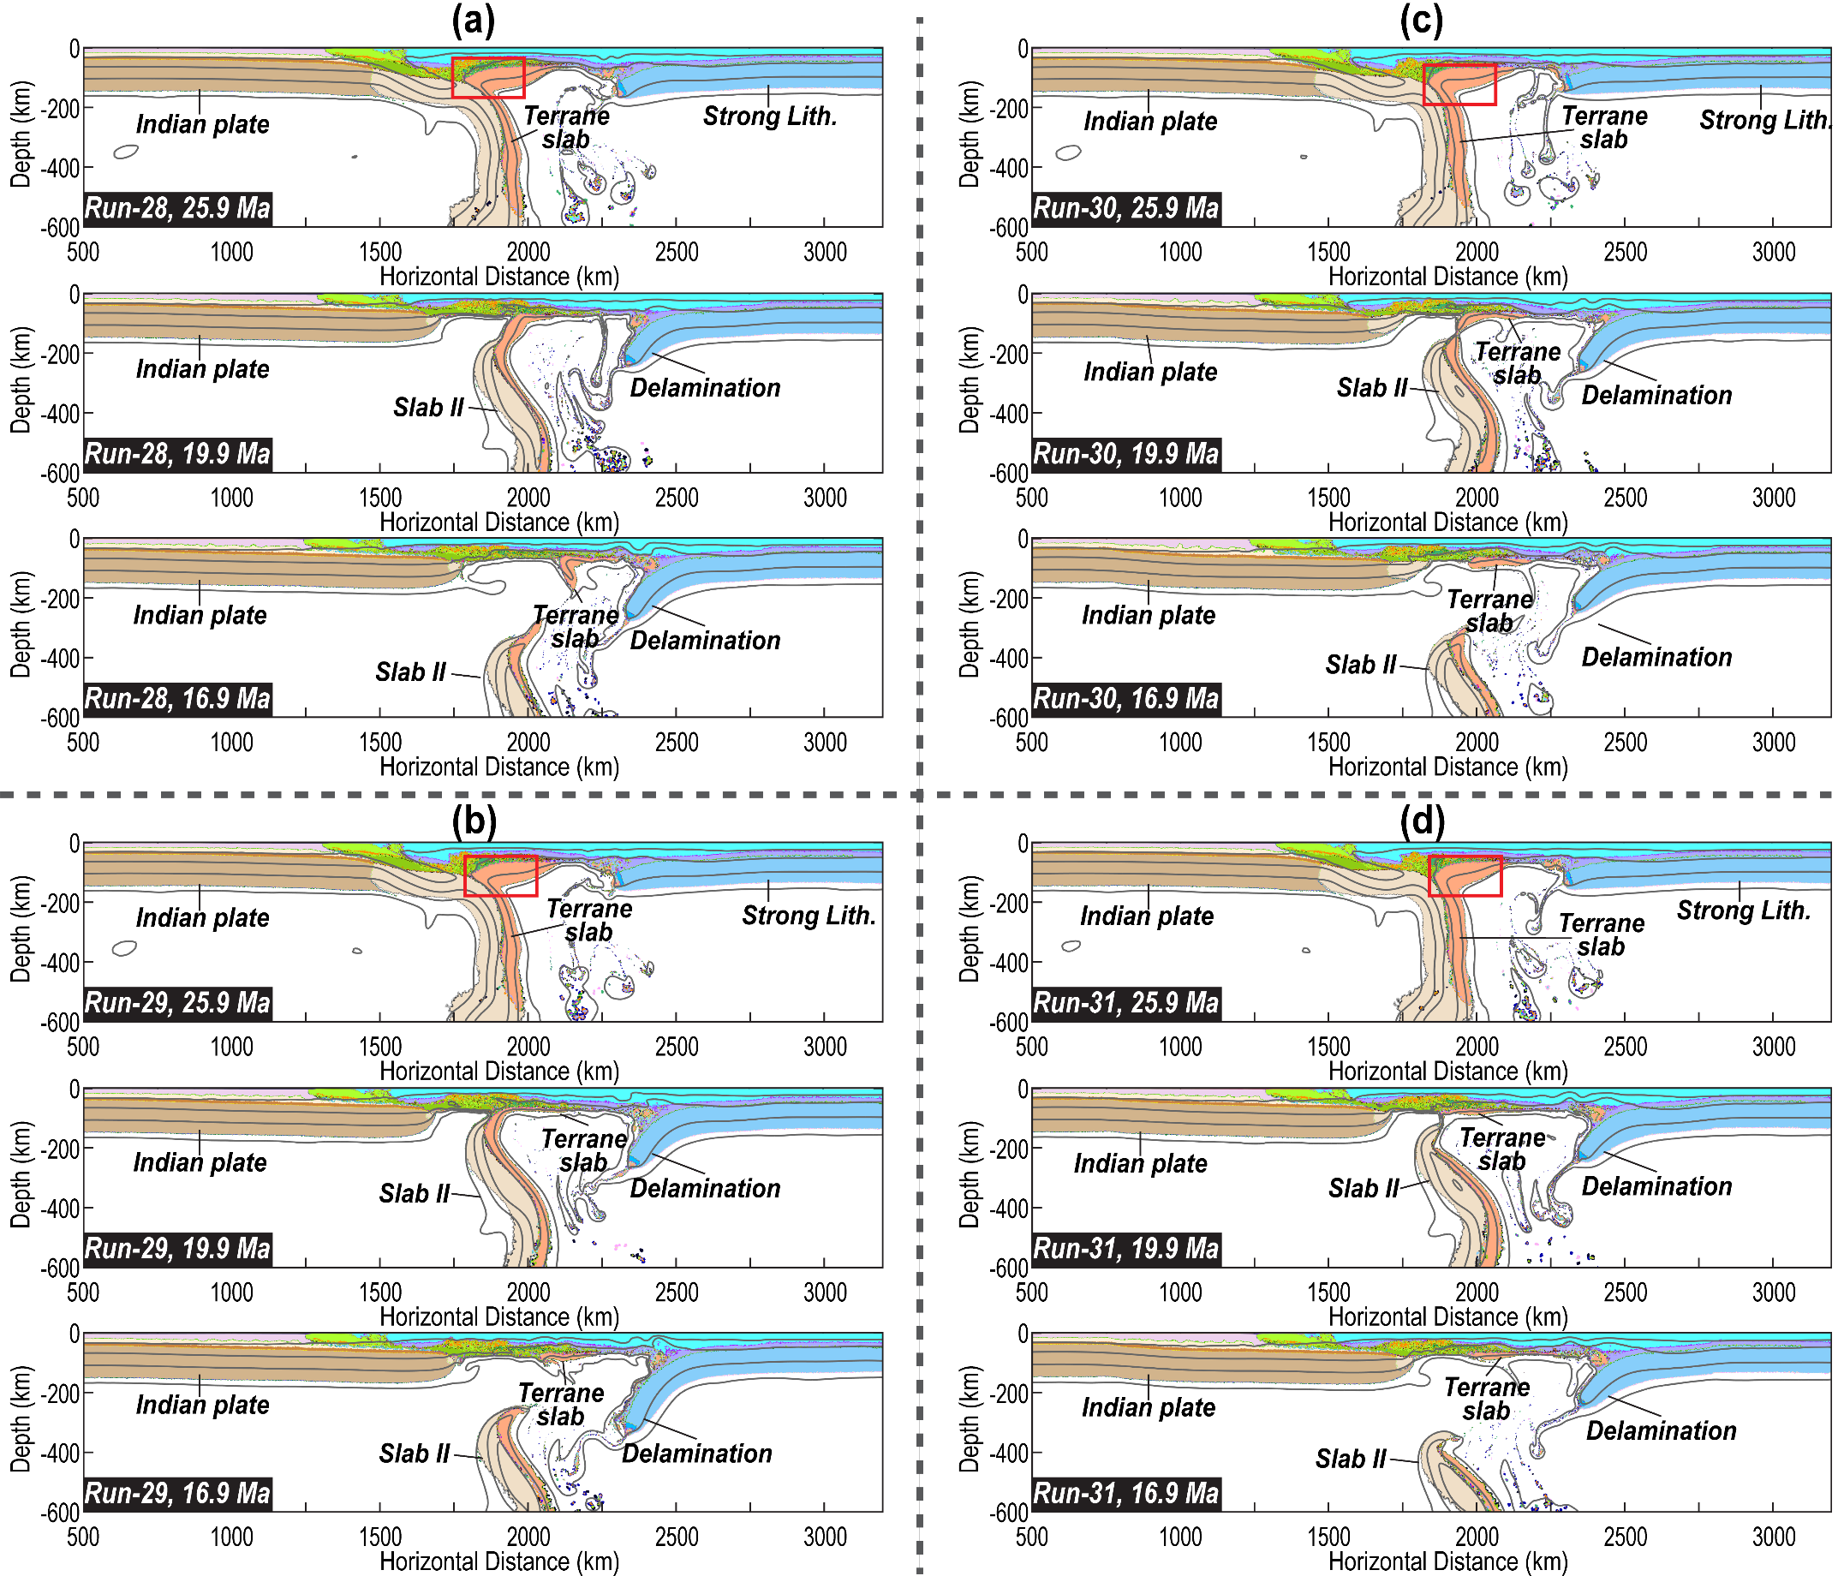
Figure S23. Effects of terrane slab rheology on the evolution of the Type 6 model. (a) Results of Run 28. This model is the same as Run 23, except that the maximum yielding stress for the terrane slab hinge is capped at 40 MPa. Terrane slab hinge (within the red box) refers to the terrane portion above the oceanic slab. (b) Results of Run 29. This model is the same as Run 23, except that the maximum yielding stress for the terrane slab hinge is capped at 60 MPa. (c) Results of Run 30. This model is the same as Run 23, except that the maximum yielding stress for the terrane slab hinge is capped at 80 MPa. (d) Results of Run 31. This model is the same as Run 23, except that the maximum yielding stress for the terrane slab hinge is capped at 100 MPa. More parameters are in Tables S1-S2. Lith.- Lithosphere.

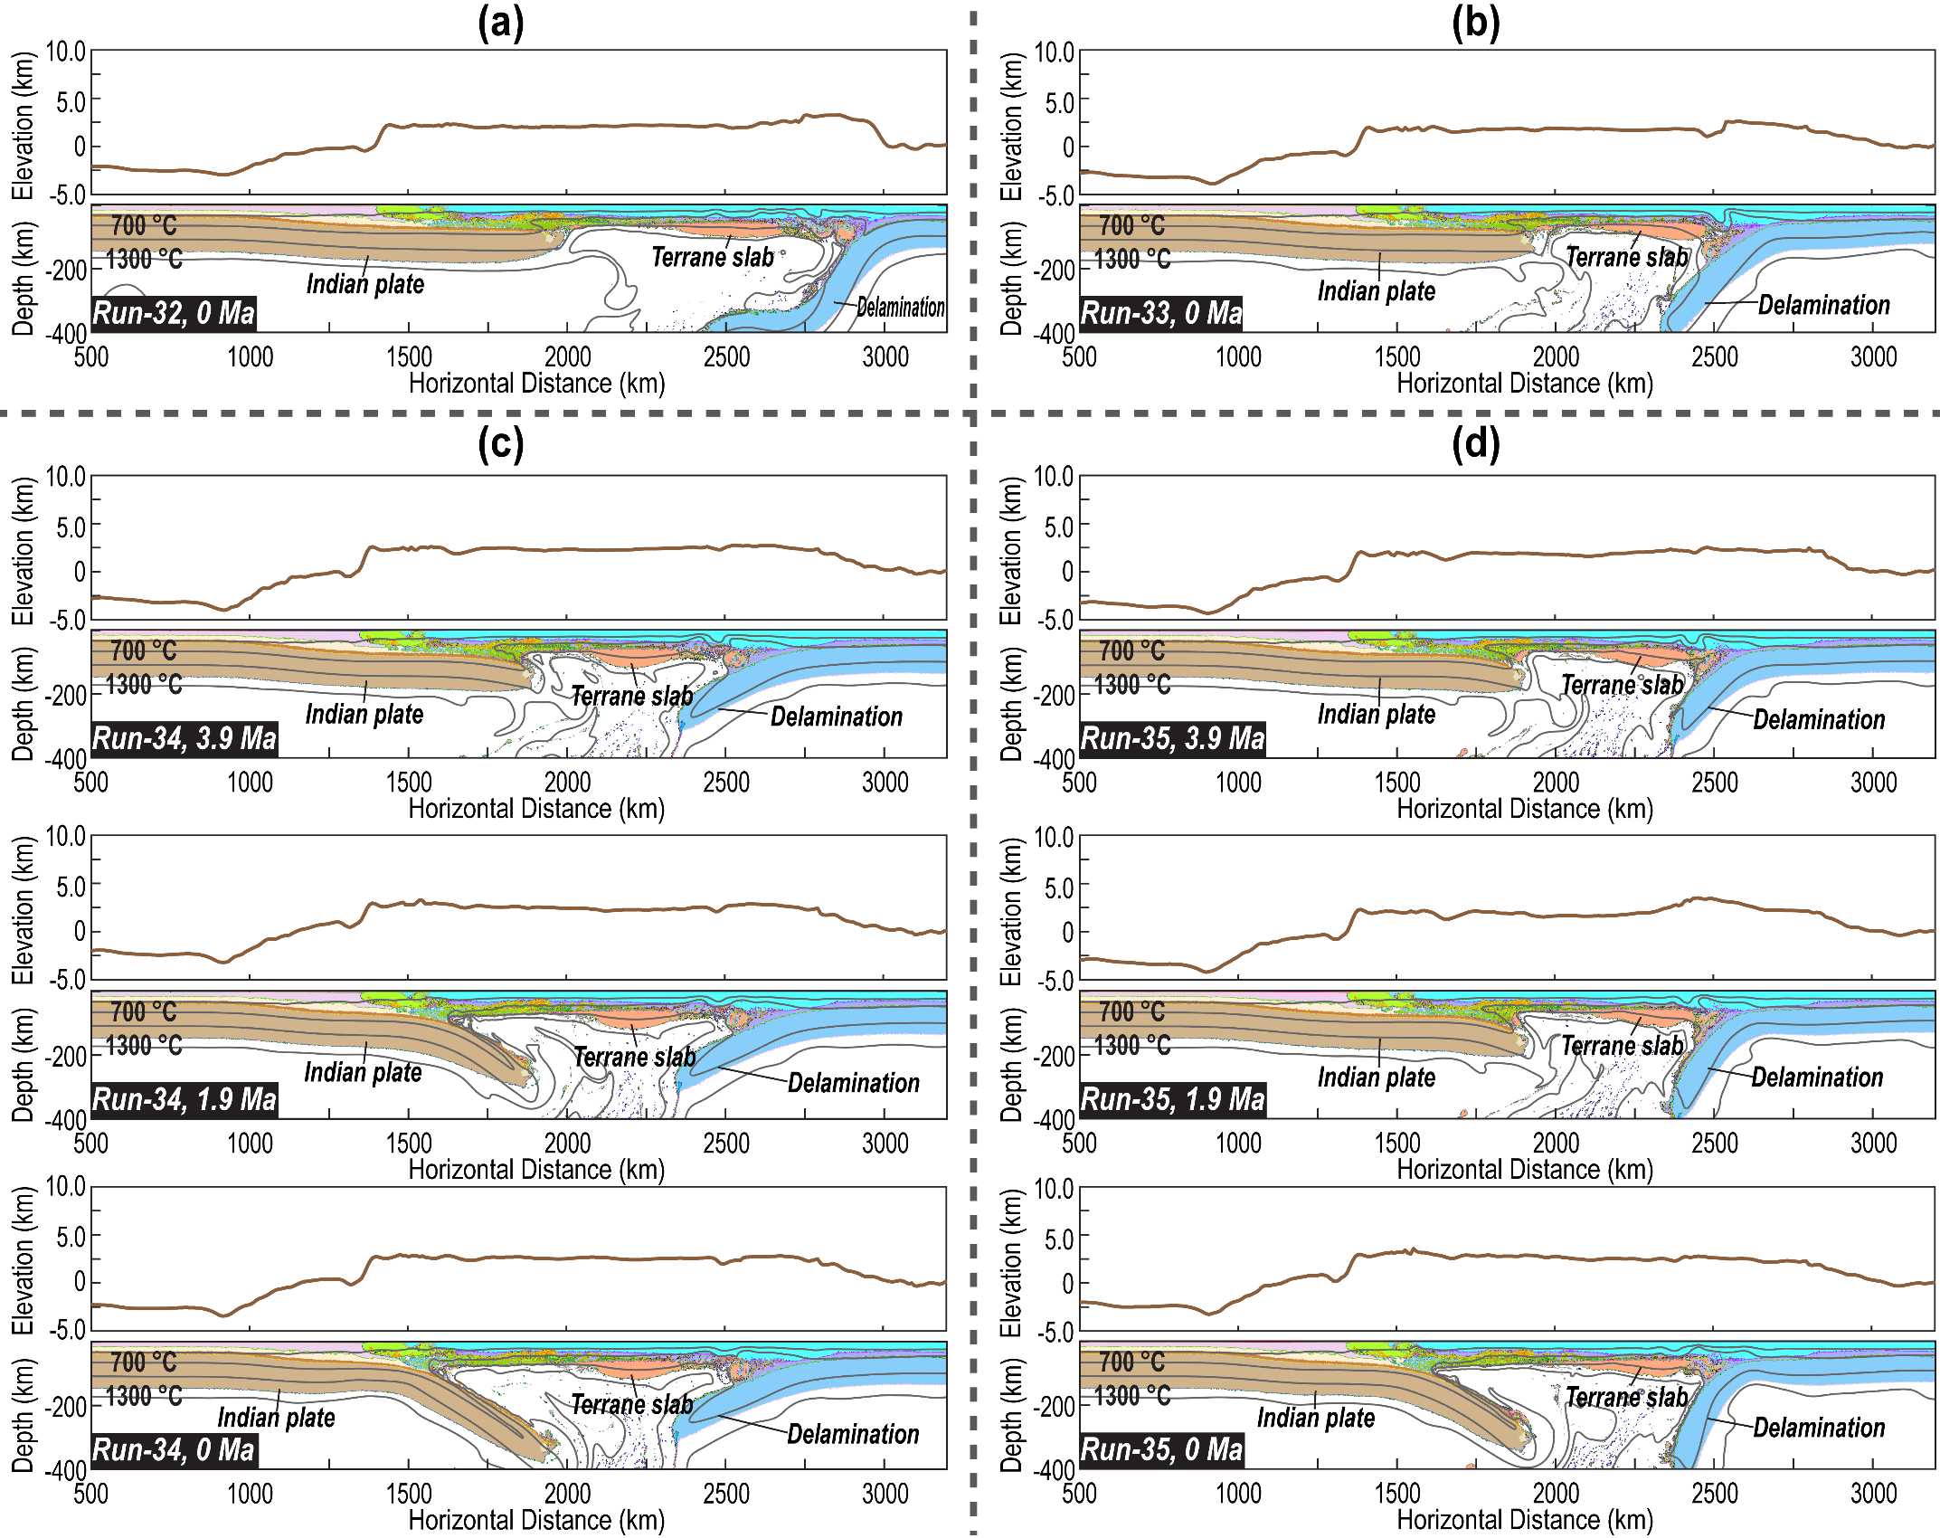
Figure S24. Effects of the Indian plate density on the evolution of the Type 6 model. (a) Results of Run 32. This model is the same as Run 23, except that the compositional density of the Indian lithospheric mantle is 3.35 g/cm³. (b) Results of Run 33. This model is the same as Run 23, except that the compositional density of the Indian lithospheric mantle is 3.36 g/cm³. (c) Results of Run 34. This model is the same as Run 23, except that the compositional density of the Indian lithospheric mantle is 3.37 g/cm³. (d) Results of Run 35. This model is the same as Run 23, except that the compositional density of the Indian lithospheric mantle is 3.38 g/cm³. More parameters are in Tables S1-S2. Lith.- Lithosphere.

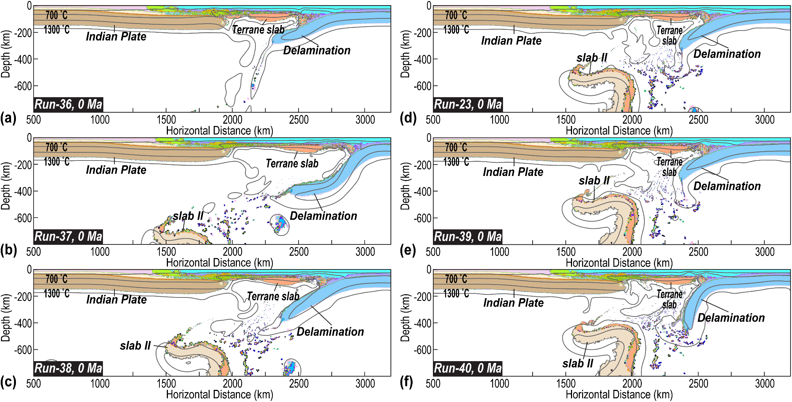
Figure S25. Effects of the lower mantle viscosity on the evolution of the Type 6 model. (a) Results of Run 36. This model is the same as Run 23, except for the lower mantle viscosity of 10²² Pa·s. (b) Results of Run 37. This model is the same as Run 23, except for the lower mantle viscosity is 3$×$10²² Pa·s. (c) Results of Run 38. This model is the same as Run 23, except that the lower mantle viscosity is 5$×$10²² Pa·s. (d) Results of Run 23. In Run 23, the lower mantle viscosity is 10$×$10²² Pa·s. (e) Results of Run 39. This model is the same as Run 23, except that the lower mantle viscosity is 20$×$10²² Pa·s. (f) Results of Run 40. This model is the same as Run 23, except that the lower mantle viscosity is 50$×$10²² Pa·s. More parameters are in Tables S1-S2. Lith.- Lithosphere.

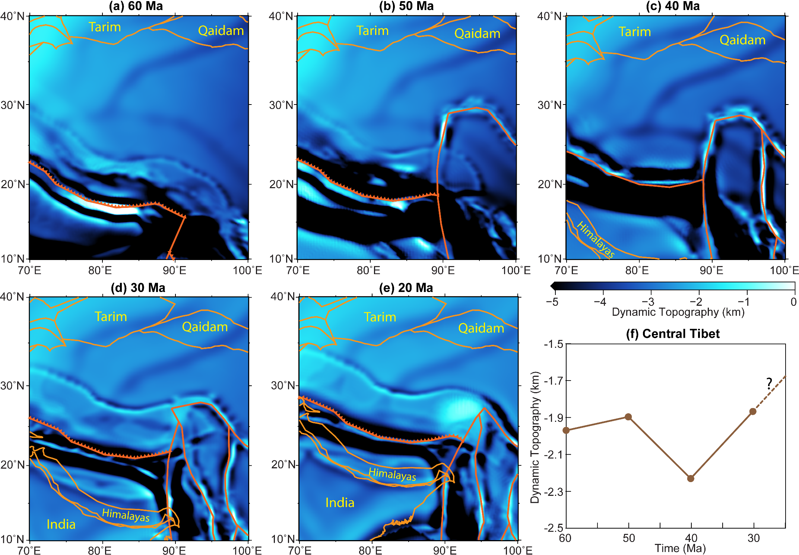
Figure S26. Dynamic topography evolution of the Indo-Eurasian Orogen according to the global numerical modeling ⁹³. The distribution of faults, sutures, and trenches is based on Müller et al., 2016⁹⁴. (a)-(e) Map views of the dynamic topography at 60, 50, 40, 30, and 20 Ma, respectively. (f) Evolution of the dynamic topography in central Tibet. Because the Indian Subcontinental is our 3D model is purely thermal, the dynamic topography of the Tibet Plateau after India approach can be too large ^{46,52,93}.

Supplementary References:
77 Hirth, G. & Kohlstedf, D. Rheology of the upper mantle and the mantle wedge: A view from the experimentalists. Geophysical monograph-american geophysical union 138, 83-106 (2003).
78 Ghosh, A. & Holt, W. E. Plate motions and stresses from global dynamic models. Science 335, 838-843 (2012).
79 Brune, S., Heine, C., Pérez-Gussinyé, M. & Sobolev, S. V. Rift migration explains continental margin asymmetry and crustal hyper-extension. Nature communications 5, 1-9 (2014).
80 Gleason, G. C. & Tullis, J. A flow law for dislocation creep of quartz aggregates determined with the molten salt cell. Tectonophysics 247, 1-23 (1995).
81 Rutter, E. & Brodie, K. Experimental grain size-sensitive flow of hot-pressed Brazilian quartz aggregates. Journal of Structural Geology 26, 2011-2023 (2004).
82 Kirby, S. & Kronenberg, A. Rheology of the lithosphere: Selected topics. Reviews of Geophysics 25, 1219-1244 (1987).
83 Ranalli, G. & Murphy, D. C. Rheological stratification of the lithosphere. Tectonophysics 132, 281-295 (1987).
84 Rybacki, E. & Dresen, G. Deformation mechanism maps for feldspar rocks. Tectonophysics 382, 173-187 (2004).
85 Djomani, Y. H. P., O’Reilly, S. Y., Griffin, W. & Morgan, P. The density structure of subcontinental lithosphere through time. Earth and Planetary Science Letters 184, 605-621 (2001).
86 Schutt, D. & Lesher, C. Effects of melt depletion on the density and seismic velocity of garnet and spinel lherzolite. Journal of Geophysical Research: Solid Earth 111 (2006).
87 Karato, S.-i. & Wu, P. Rheology of the upper mantle: A synthesis. Science 260, 771-778 (1993).
88 Yamazaki, D. & Karato, S.-i. Some mineral physics constraints on the rheology and geothermal structure of Earth’s lower mantle. American Mineralogist 86, 385-391 (2001).
89 Gerya, T. V. & Meilick, F. Geodynamic regimes of subduction under an active margin: effects of rheological weakening by fluids and melts. Journal of Metamorphic Geology 29, 7-31 (2011).
90 Simmons, N. A., Myers, S. C., Johannesson, G. & Matzel, E. LLNL‐G3Dv3: Global P wave tomography model for improved regional and teleseismic travel time prediction. Journal of Geophysical Research: Solid Earth 117 (2012).
91 Hosseini, K. et al. SubMachine: Web‐based tools for exploring seismic tomography and other models of Earth's deep interior. Geochemistry, Geophysics, Geosystems 19, 1464-1483 (2018).
92 Brocher, T. M. Empirical relations between elastic wavespeeds and density in the Earth's crust. Bulletin of the seismological Society of America 95, 2081-2092 (2005).
93 Peng, D., Liu, L., Hu, J., Li, S. & Liu, Y. Formation of East Asian Stagnant Slabs Due To a Pressure‐Driven Cenozoic Mantle Wind Following Mesozoic Subduction. Geophysical Research Letters 48, e2021GL094638 (2021).
94 Müller, R. D. et al. Ocean basin evolution and global-scale plate reorganization events since Pangea breakup. Annual Review of Earth and Planetary Sciences 44, 107-138 (2016).

