Supplementary information for
Subnanometeric optical modulation of
a single-molecule electron source

Examples of emission patterns and their contributing MOs
Examples of emission patterns at E = 4.56eV and E = 4.44eV are shown in Figs. S1(a) and S1(b), respectively. We could reproduce two-leaf and cross patterns at different energies, E. In these examples, the same C₆₀ geometry shown in Fig. 2(e) was employed, where a two-atom face can be seen. The emission patterns in Figs. S1(a) and S1(b) are different because the MO symmetries vary with their energy levels. Next, we investigated which MOs contributed to the emission patterns. For example, as shown in Fig. S1(c), the two-leaf pattern in Fig. S1(a) consisted of electron emissions from three MOs. For convenience, they are named L1, L2, and L3. The weight W determined from the asymmetric energy distribution in Fig. 1(f) is shown together with each MO, which were normalized at the maximum value. The emission pattern from each MO is also displayed in the right panel. The total sum of the intensities of each emission pattern was calculated, and they were normalized to the maximum value among them. This value, C, is denoted below each pattern. The C values differ from the W values. This is because the portion of an electron that reaches the screen depends on the momentum distributions of the MOs, which vary from MO to MO. The actual contribution of the emission pattern from each MO to the total emission pattern is more closely represented by C than by W. Based on the C values, the two-leaf pattern in Fig. S1(a) mainly reflects the two-fold symmetry of the L2 orbital. In contrast, the cross pattern in Fig. S1(b) mainly consists of four MOs, each of which has similar contributions, as shown in Fig. S1(d). Thus, the emission patterns represent an MO or a superposition of several MOs. Because the spatial resolution of FEM for a single molecule is 0.3 nm^{[24]}, the atomic-scale details of the spatial distribution of an MO are smeared out. However, their symmetries can be observed at least.
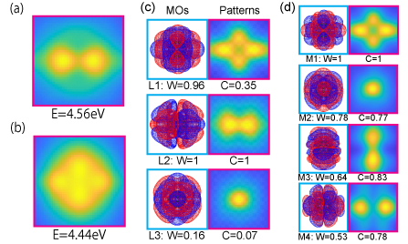
Fig. S1
Simulations of emission patterns from a C₆₀ molecule under DC electric fields of (a) 6.28V/nm and (b) 5.14V/nm. The molecular energy E is defined as the electron energy in a single molecule that is situated at the Fermi level of a substrate. (c) and (d) The front views of MOs and their corresponding emission patterns that are components of the two-leaf and cross patterns in (a) and (b), respectively. Each MO was visualised using MacMolplt^{[32]}. The molecular energy levels of the displayed orbitals are as follows: L1 = 4.577eV, L2 = 4.55eV, L3 = 4.318eV, M1 = 4.506eV, M2 = 4.267eV, M3 = 4.247eV, and M4 = 4.231eV.

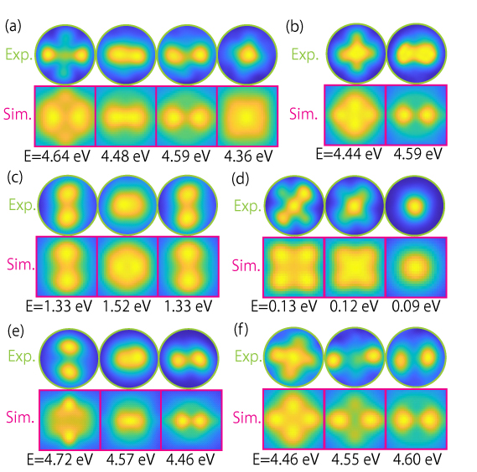
Fig. S2.
(a)-(f) Variations in the observed electron emission patterns (upper panels) and simulated results from a single fullerene molecule (lower panels) under DC electric fields. The geometry of the C₆₀ molecule shown in Fig. 1(f) was used for the simulations. The tip voltages are (a) -4000V; (b) -3600V; (c) -2700V; (d) -2400V; (e) left panel: -3400V, middle panel: -3300V, right panel: -3100V, and (f) left panel: -3600V, middle panel: -3620V, right panel: -4160V. Simulations were performed under constant DC electric fields of 6.17 V/nm for (a) and (e) and 5.14V/nm for (b)-(d), and (f).

