Improvement of water resistance by photoelectrical catalysts Fe₂O₃/TiO₂ for formaldehyde removal: Experimental and theoretical investigation

Supplementary Materials

Dong Jing¹, Li Qing¹, Lv Bihong¹, Xia Wenjie², Jing Guohua¹, Shen Huazhen¹*, Yuan Chung-shin³*

¹ College of Chemical Engineering, Huaqiao University, Xiamen, Fujian, China
²Department of Civil and Environmental Engineering, North Dakota State University, Fargo, ND 58108, USA

³ Institute of Environmental Engineering, National Sun Yat-Sen University,

No. 70, Lian-Hai Road, Kaohsiung 804, Taiwan

* To whom all correspondence should be addressed
Tel: +86-15260231263
Tel: +886-7-5252000 Ext. 4409; Fax: 886-7-52524409;
E-mail: hzhshen@hotmail.com
ycsngi@mail.nsysu.edu.tw
Table Captions

Table S-1 XRD parameters of (101), (200), and (004) peaks for TiO₂ and Fe₂O₃/TiO₂s.

Table S-1 XRD parameters of (101), (200), and (004) peaks for TiO₂ and Fe₂O₃/TiO₂s.

 | (101) |  |  | (200) |  |  | (004) |  |  | X₍₂₀₀₎/X₍₁₀₁₎ |  | X₍₀₀₄₎/X₍₁₀₁₎
 | area | peak height | FWHM | area | peak height | FWHM | area | peak height | FWHM | area ratio | height ratio | area ratio | height ratio
TiO₂ | 50505 | 1298 | 0.661 | 15940 | 422 | 0.642 | 9470 | 219 | 0.735 | 0.315 | 0.325 | 0.187 | 0.168
0.5%Fe₂O₃ | 63655 | 2127 | 0509 | 22013 | 664 | 0.564 | 4365 | 122 | 0.608 | 0.345 | 0.312 | 0.0685 | 0.0573
3%Fe₂O₃ | 61958 | 2038 | 0.517 | 20058 | 584 | 0.584 | 6988 | 141 | 0.843 | 0.323 | 0.286 | 0.112 | 0.0691
5%Fe₂O₃ | 78949 | 2759 | 0.486 | 25600 | 792 | 0.549 | 8127 | 155 | 0.891 | 0.324 | 0.287 | 0.102 | 0.0561

Figure captions
Figure S-1. Structured optimized TiO₂(010) and Fe₂O₃/TiO₂(010).
Figure S-2. Adsorption energy of CHOH on (a) TiO₂ and (b) Fe₂O₃/TiO₂.
Figure S-3. Photo- and Photoelectrical catalytic removal efficiency of TiO₂ and Fe₂O₃/TiO₂ at different R.H. (%).

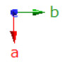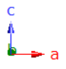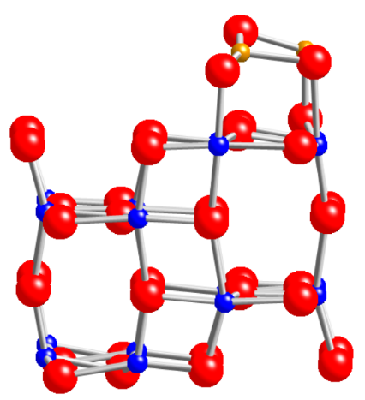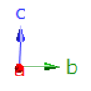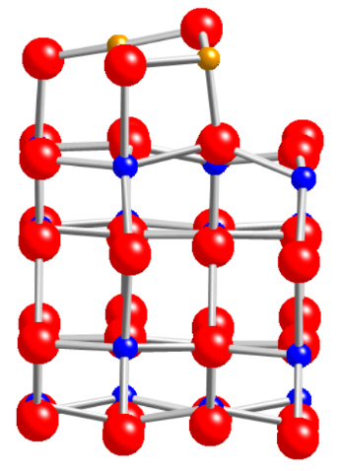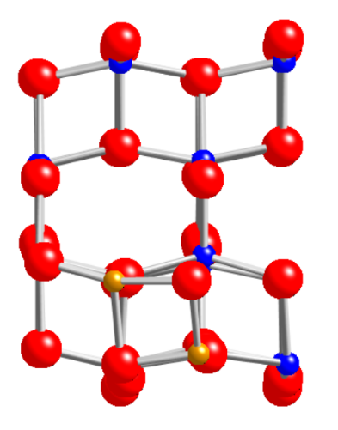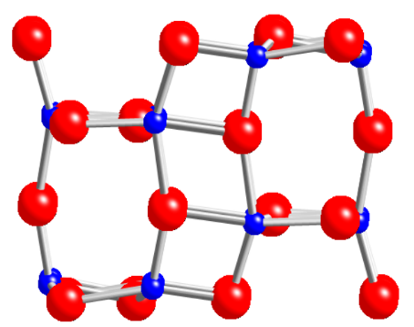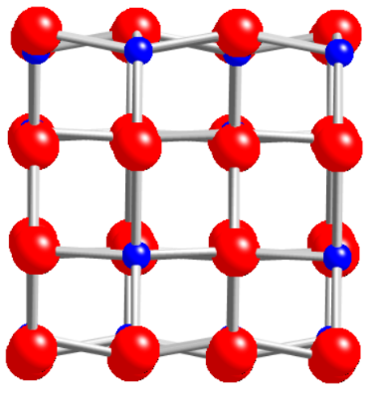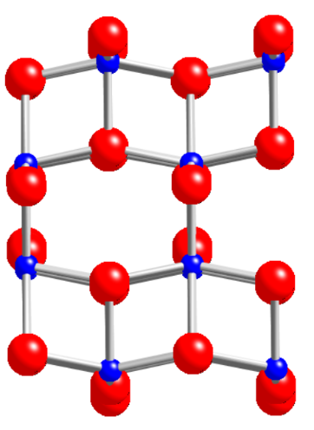
(a)
(b)
(c)
(d)
(e)
(f)
Fe
O
Ti
Figure S-1. The structure optimized TiO₂(010) (a) front view, (b) side view, (c) top view, and Fe₂O₃/TiO₂ (d) front view, (e) side view, (f) top view.

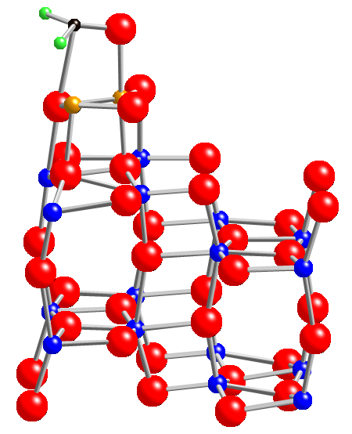
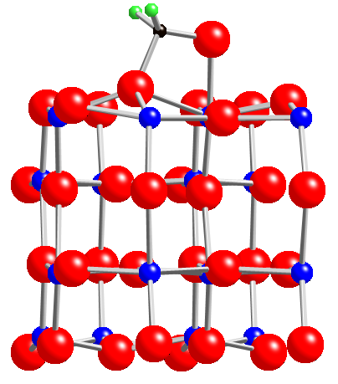
2.007 Å
2.184 Å
△E = -1.491 eV
1.824 Å
1.989 Å
△E = -1.089 eV
Fe
Ti
O
H

Figure S-2. Adsorption energy of CHOH on (a) TiO₂ and (b) Fe₂O₃/TiO₂.

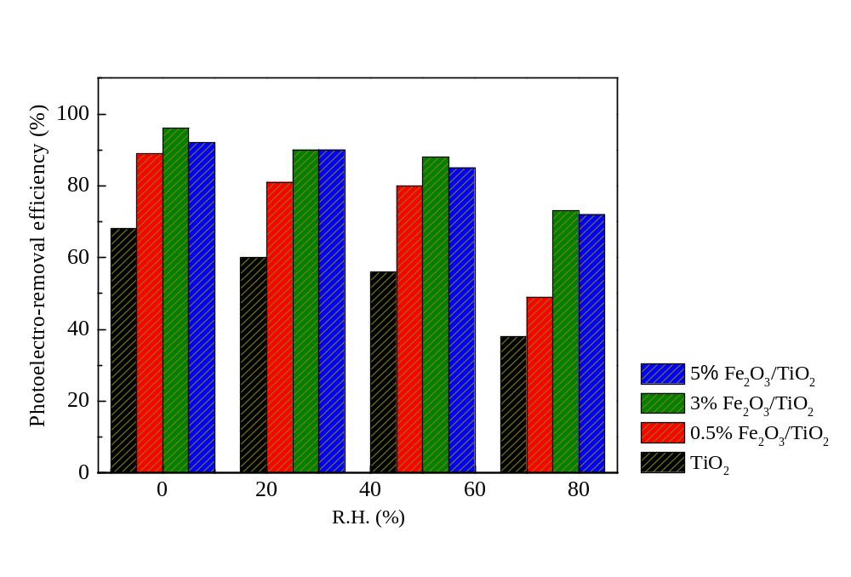
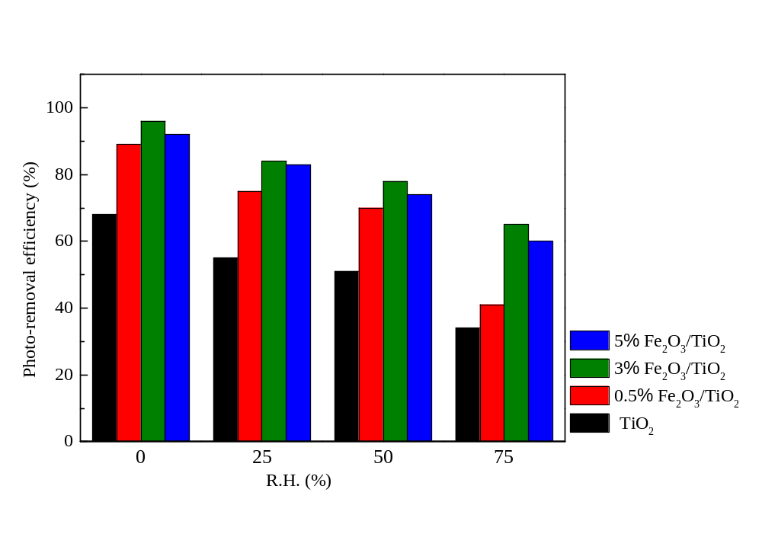
- (b)

Figure S-2. Photo- and Photoelectrical catalytic removal efficiency of TiO₂ and Fe₂O₃/TiO₂ at different R.H. (%).

