The aging behavior of biochar and its immobilizing ability to heavy metals in rhizosphere
Jie Wangª, Lulu Zhaiª, Xiyang Zhangª, Yuting Panª, Long Zhangª, Zhenguo Shen^{ab}, Yahua Chen^{abc*}
a College of Life Sciences, Nanjing Agricultural University, Nanjing 210095, China
b Jiangsu Collaborative Innovation Center for Solid Organic Waste Resource, Nanjing Agricultural University, Nanjing 210095, China
c National Joint Local Engineering Research Center for Rural Land Resources Use and Consolidation, Nanjing Agricultural University, Nanjing 210095, China
Corresponding author: Yahua Chen; E-mail: yahuachen@njau.edu.cn;
Tel: +86-25-84396391; Fax: +86-25-84396542

- Formula
  - Eq. R_{50, biochar} = T_{50, biochar} /T_{50, graphite}×100%, where T _{50, biochar} and T _{50, graphite} are the temperature values corresponding to 50% weight loss by oxidation of biochar and graphite, respectively (Harvey et al., 2012). T_{50, graphite} is 844℃ (Yang et al., 2016)
1.2 Langmuir model was used to describe the isotherms: Ce / Qe= Ce / Q_{max}+1 / (K_{L} Q_{max}) Eq. where Ce and Qe are the same above, Qmax (mg/g) is the max adsorption per gram of biochar, K_{L} (min⁻¹) are the rate constants of Langmuir sorption isotherm model (Quan et al., 2020).
References：
- Harvey, O. R., Kuo, L. J., Zimmerman, A. R., Louchouarn, P., Amonette, J. E., Herbert, B. E., 2012. An index-based approach to assessing recalcitrance and soil carbon sequestration potential of engineered black carbons (biochars). Environ. Sci. Technol. 46 (3), 1415−1421.
- Yang, F., Zhao, L., Gao, B., Xue, X., Cao, X., 2016. The interfacial behavior between biochar and soil minerals and its effect on biochar stability. Environ. Sci. Techn. 50(5): 2264-2271.
- Quan, G., Fan, Q., Cui, L., Zimmerman, A.R., Wang, H., Zhu, Z., Gao, B., Wu, L., Yan, J., 2020. Simulated photocatalytic aging of biochar in soil ecosystem: Insight into organic carbon release, surface physicochemical properties and cadmium sorption, Environ. Res. 183, 109241.

- Figure

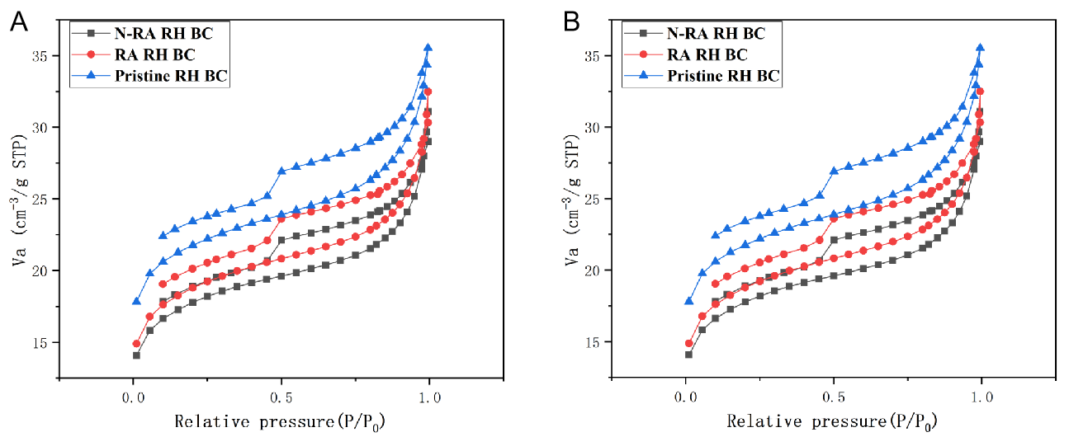
Fig. S1 N2 adsorption-desorption isotherms of RH BC (A) and Sl BC (B) before and after aging. N-RA: aging in the non-rhizosphere; RA: aging in the rhizosphere; RH BC: rice husk biochar; Sl RH: sludge biochar.

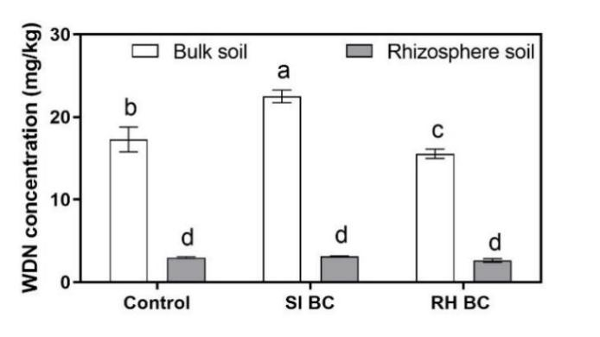
Fig. S2 Effect of wheat roots and biochar on water dissolved nitrogen. The lower-case letters represent significant differences among treatments (p < 0.05). Error bars represent standard error (SE). RH BC: rice husk biochar; Sl BC: sludge biochar; Bulk soil: non-planting of wheat; Rhizosphere soil: planting of wheat (Simulated rhizosphere soil).
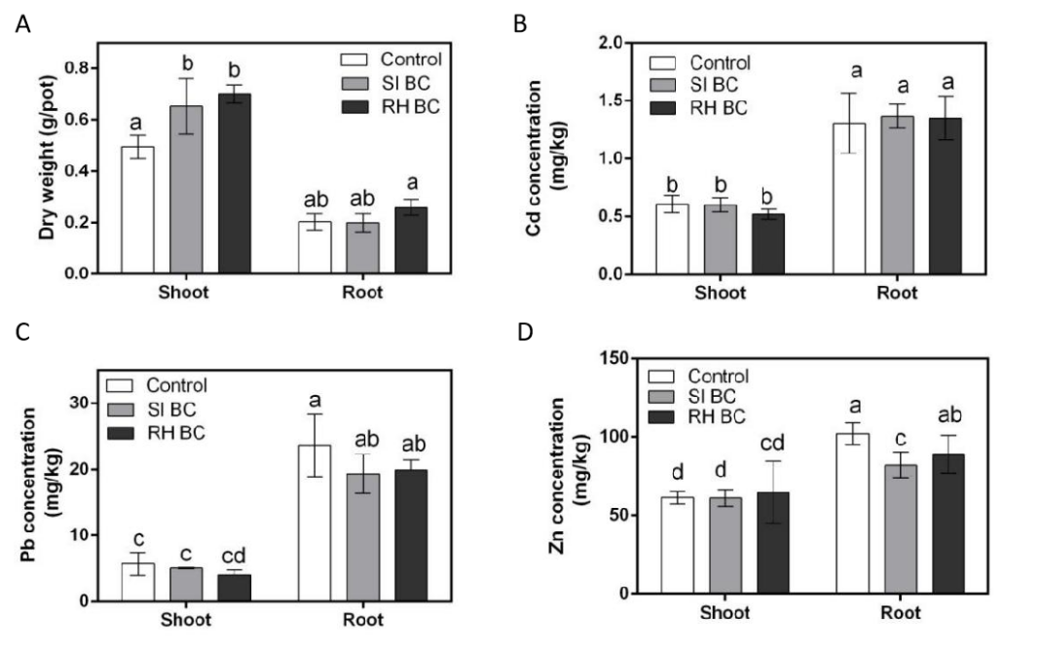
Fig. S3 The dry mass (A), Cd (B), Pb (C) and Zn (D) concentration of wheat in the different treatment treatments. The lower-case letters represent significant differences among treatments (p < 0.05). Error bars represent standard error (SE). RH BC: rice husk biochar; Sl BC: sludge biochar.
- Table
Table S1 The R₅₀% of pristine and aged biochar
Treatments | R₅₀% | Treatments | R₅₀%
Pristine Sl BC | 53.8 | Pristine RH BC | 67.1
N-RA Sl BC | 54.2 | N-RA RH BC | 60.9
RA-Sl BC | 52.8 | RA RH BC | 64.6
Note: N-RA: aging in the non-rhizosphere; RA: aging in the rhizosphere; RH BC: rice husk biochar; Sl BC: sludge biochar.
Biochar sample | Cd²⁺ |  |  | Pb²⁺
Biochar sample | Q_{max} (mg/g) | K₁ (L/mg) | R² | Q_{max} (mg/g) | K₁ (L/mg) | R²
PristineRH BC | 9.87 | 0.032 | 0.986 | 45.7 | 0.006 | 0.989
N-RA RH BC | 9.11 | 0.037 | 0.971 | 75.7 | 0.003 | 0.998
RA-RH BC | 14.43 | 0.020 | 0.986 | 140.0 | 0.002 | 0.997
Pristine Sl BC | 6.5 | 0.043 | 0.990 | 57.8 | 0.004 | 0.995
N-RA Sl BC | 8.5 | 0.031 | 0.992 | 57.3 | 0.004 | 0.999
RA Sl BC | 26.1 | 0.010 | 0.995 | 140.4 | 0.002 | 0.996
Table S2 Parameters for Langmuir modelling
N-RA: aging in the non-rhizosphere; RA: aging in the rhizosphere; RH BC: rice husk biochar; Sl BC: sludge biochar.

