Methane hydrate nuclei in dynamic network of hydrogen bonds of supersaturated solution outside the region of hydrate stability: molecualar dynamics study

Vladimir R. Belosludov^{a,b}, Kirill V. Gets^{a,b,}*, Ravil K. Zhdanov^{a,b}, Yulia Yu. Bozhko^{a,b},
Rodion V. Belosludov^{c} , Li-Jen Chen^{d}, Yoshiyuki Kawazoe^{e,f,g}
ªNikolaev Institute of Inorganic Chemistry, Siberian Branch, Russian Academy of Sciences, Novosibirsk, 630090 Russia
^{b}Novosibirsk State University, Novosibirsk, 630090 Russia
^{c}Institute for Materials Research, Tohoku University, 980-8577 Sendai, Japan
^{d}Department of Chemical Engineering, National Taiwan University, 10617 Taipei, Taiwan
^{e}New Industry Creation Hatchery Center, Tohoku University, 980-8579, Sendai, Japan
^{f}Department of Physics and Nanotechnology, SRM Institute of Science and
Technology, 603203, Chennai, Tamil Nadu, India
^{g}Suranaree University of Technology, 30000, Nakhon Ratchasima, Thailand

*e-mail: gets@niic.nsc.ru

1. Pre-nucleation: spatial distribution of cavities
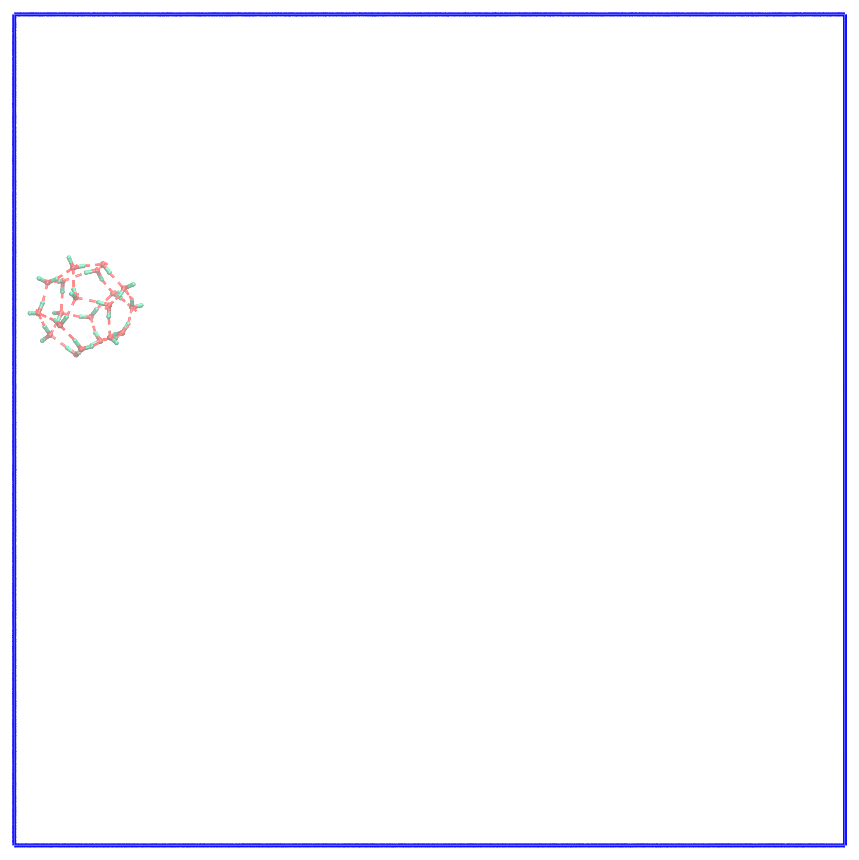 | 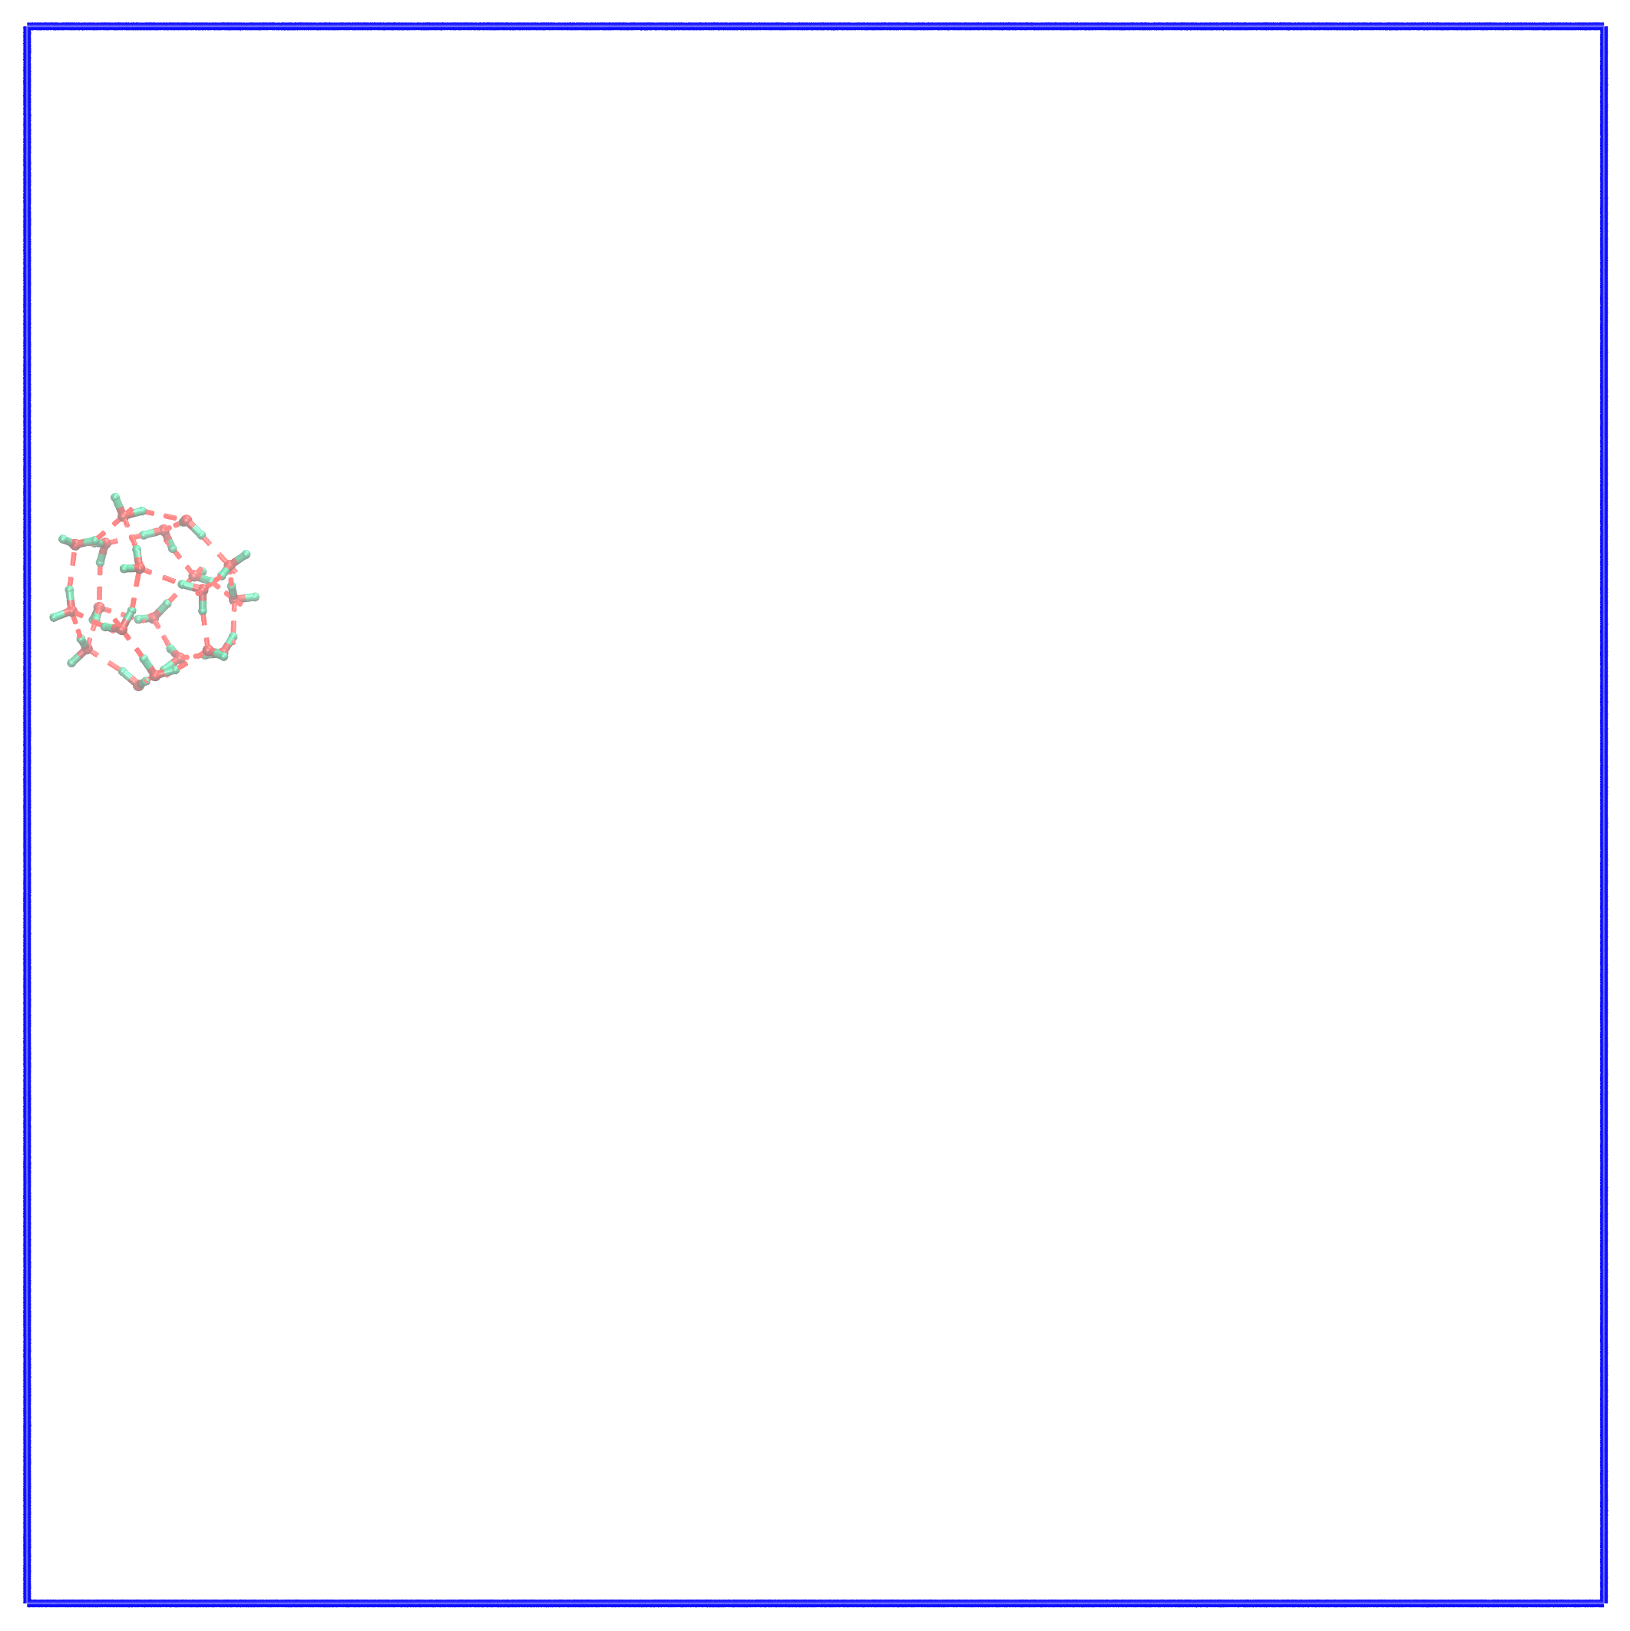 | 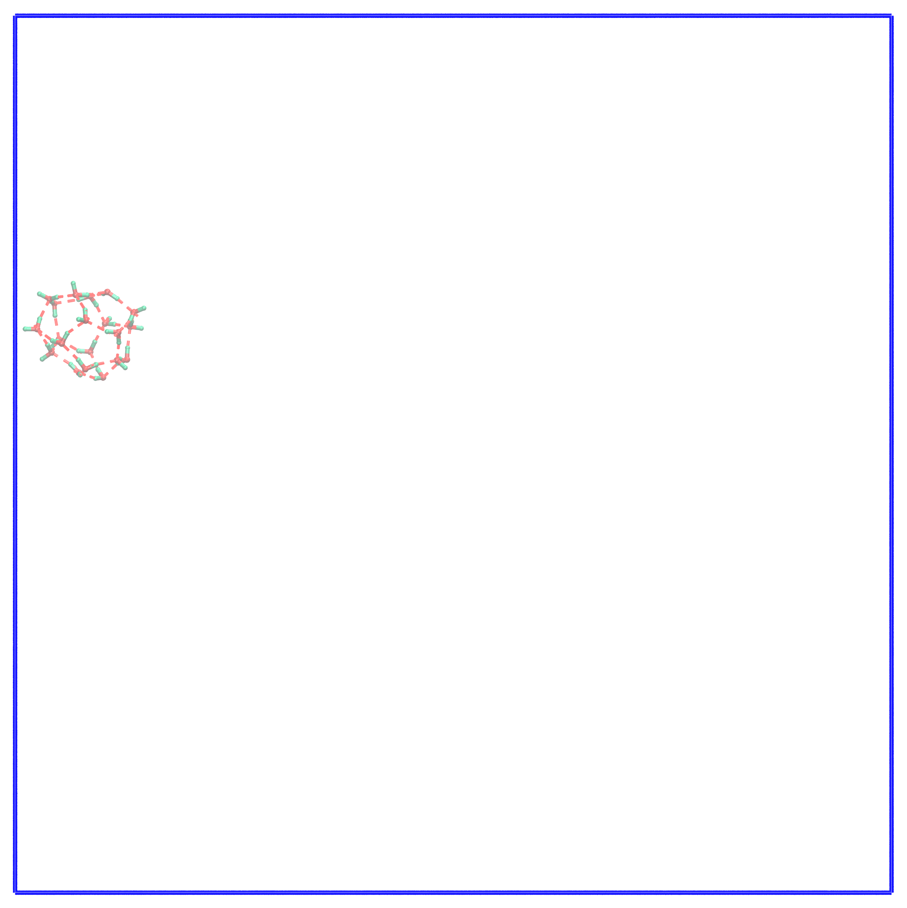
t = 1500 ps | t = 1512 ps | t = 1558 ps
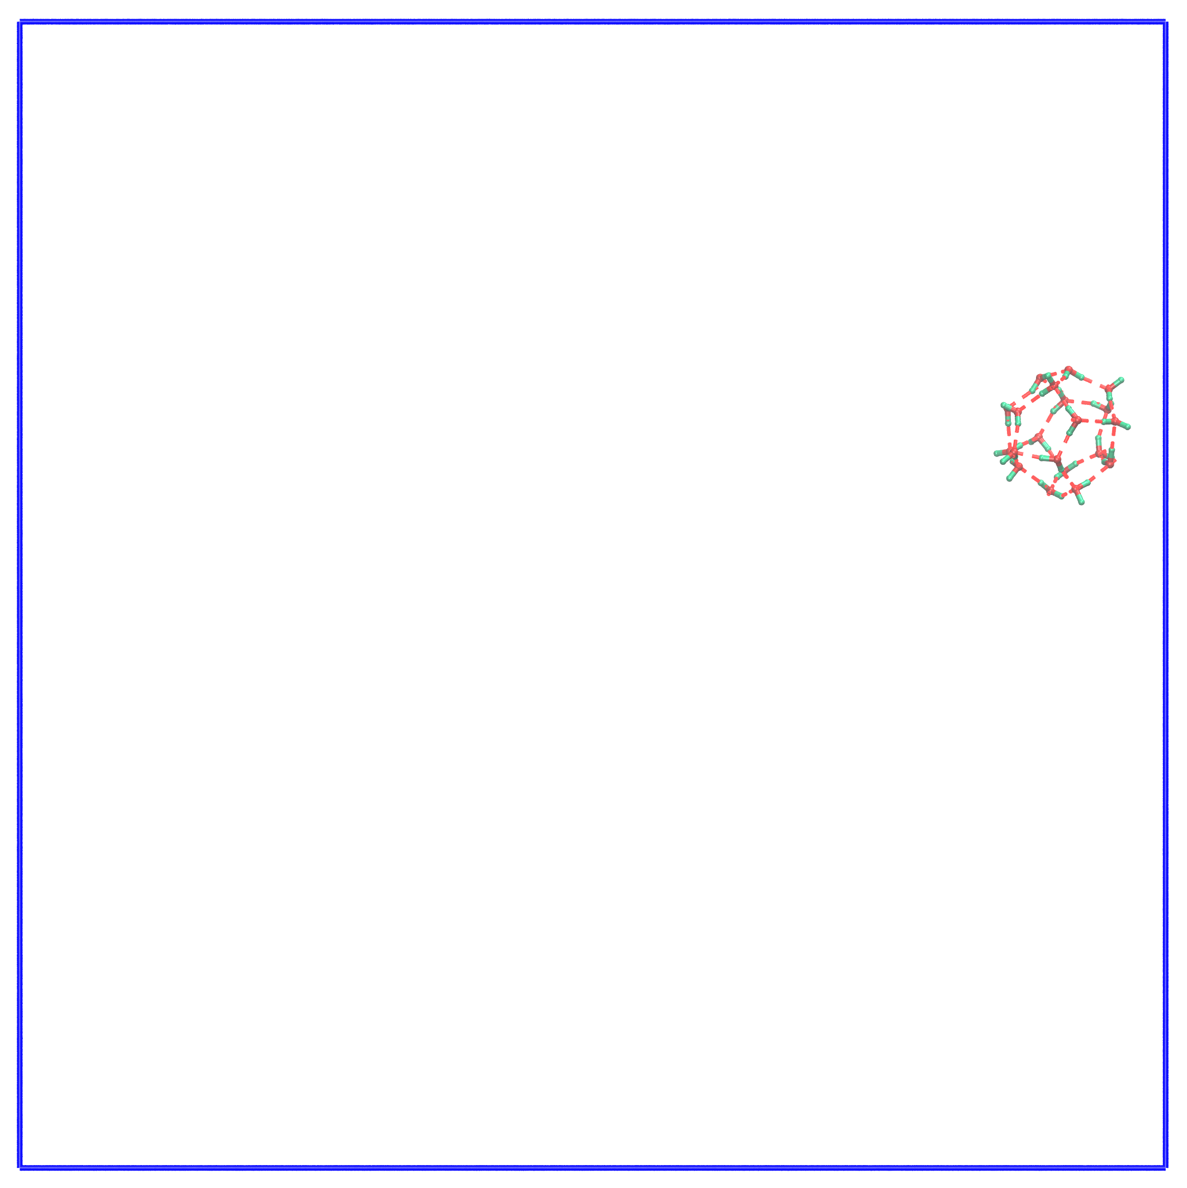 | 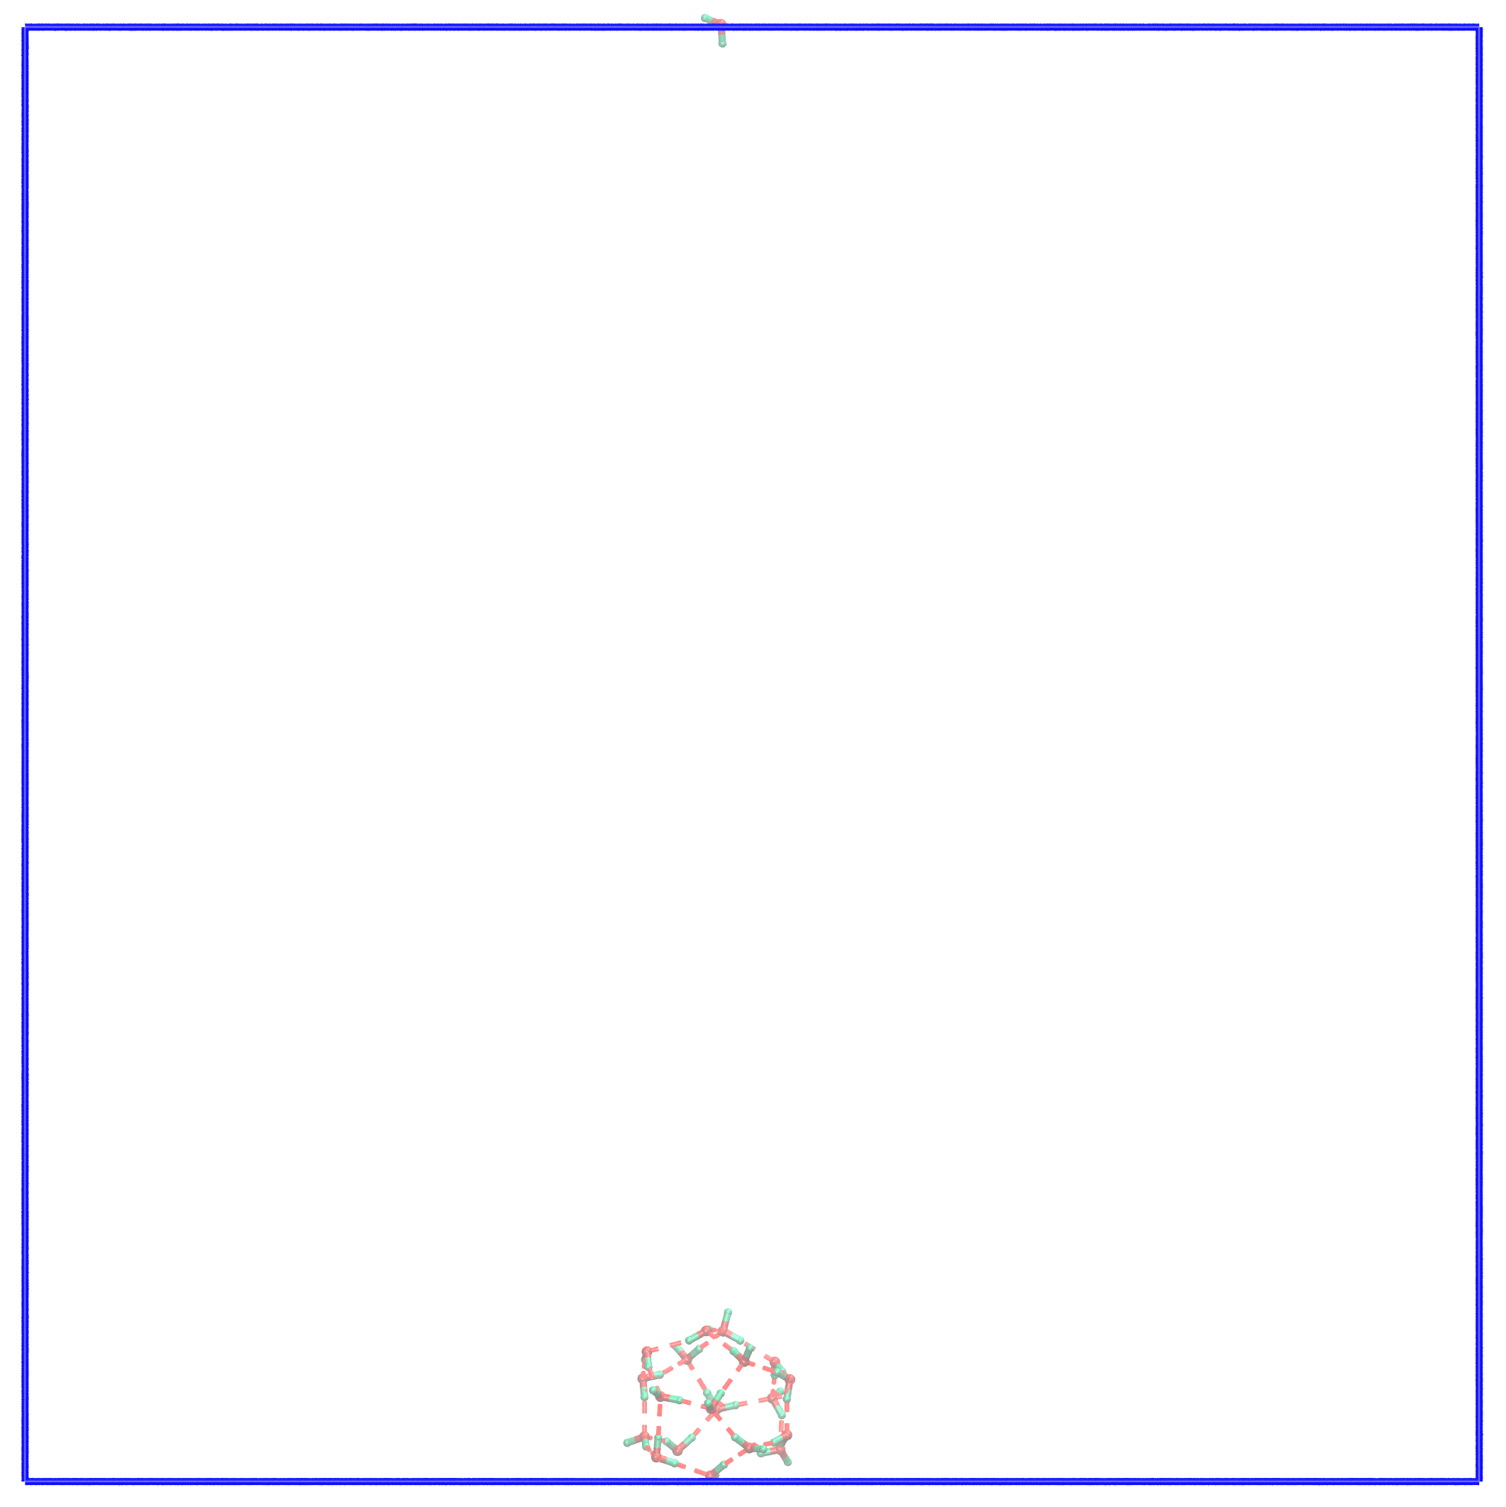 | 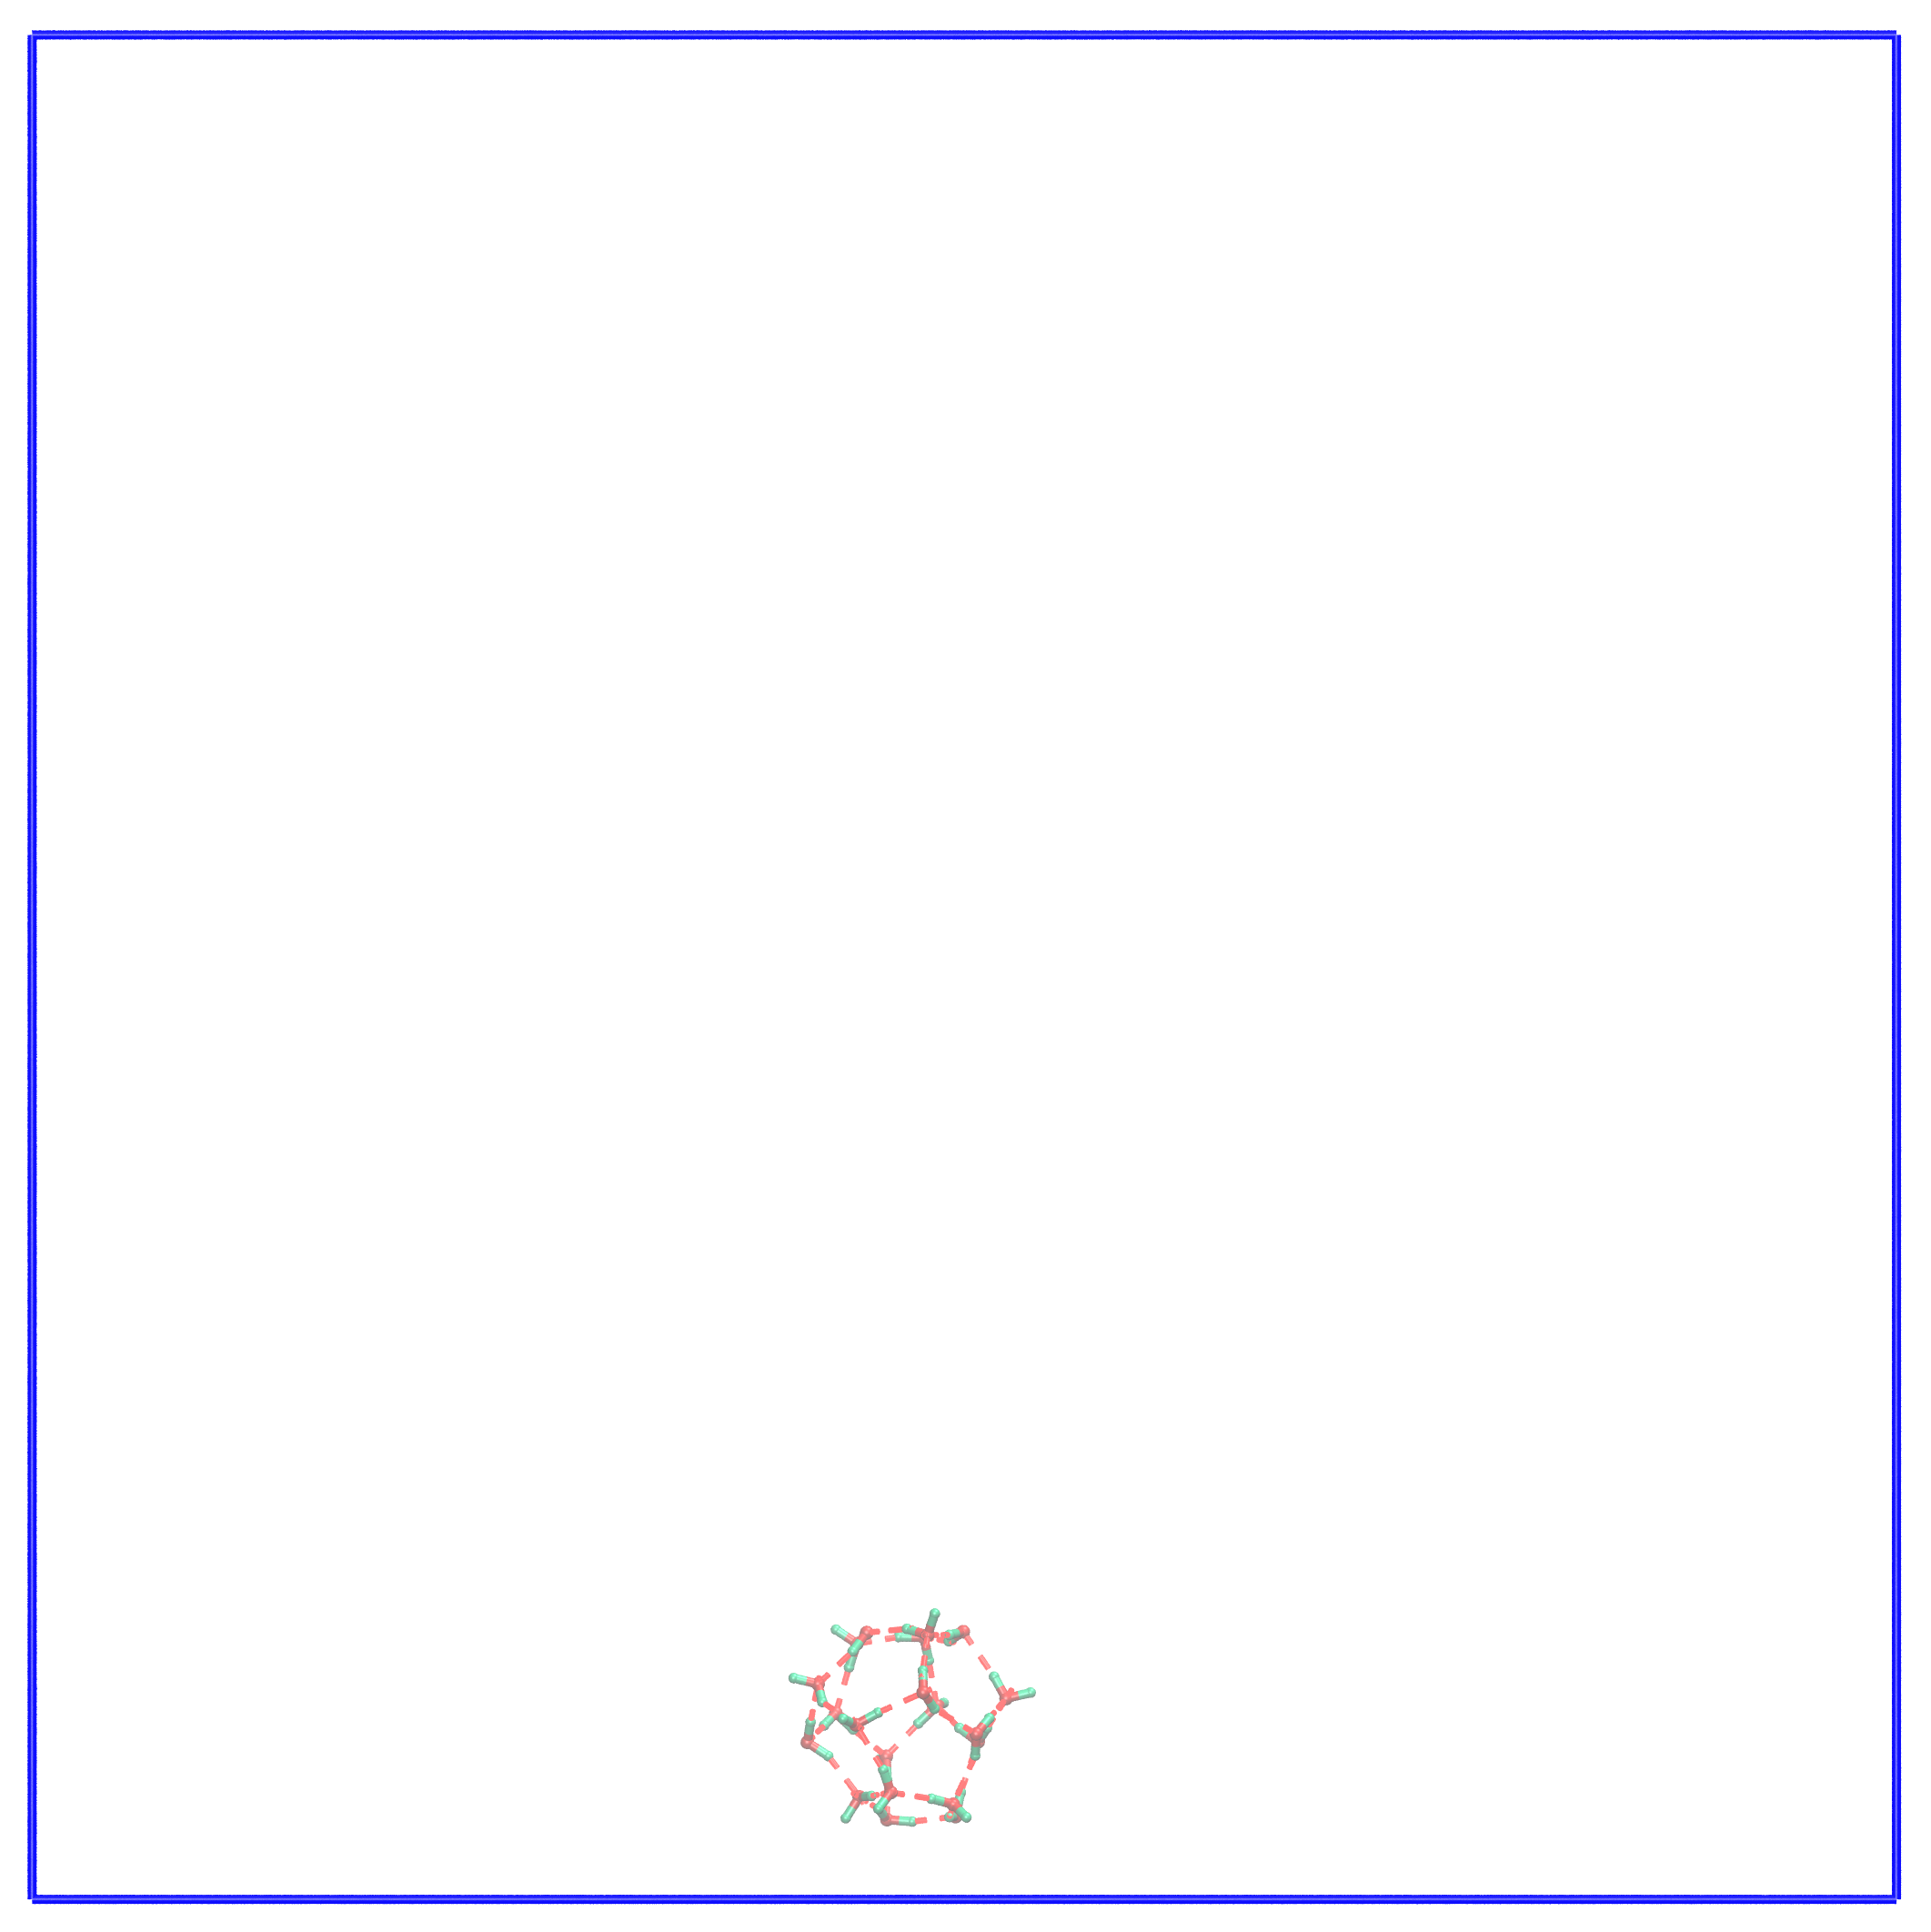
t = 3104 ps | t = 3552 ps | t = 4150 ps
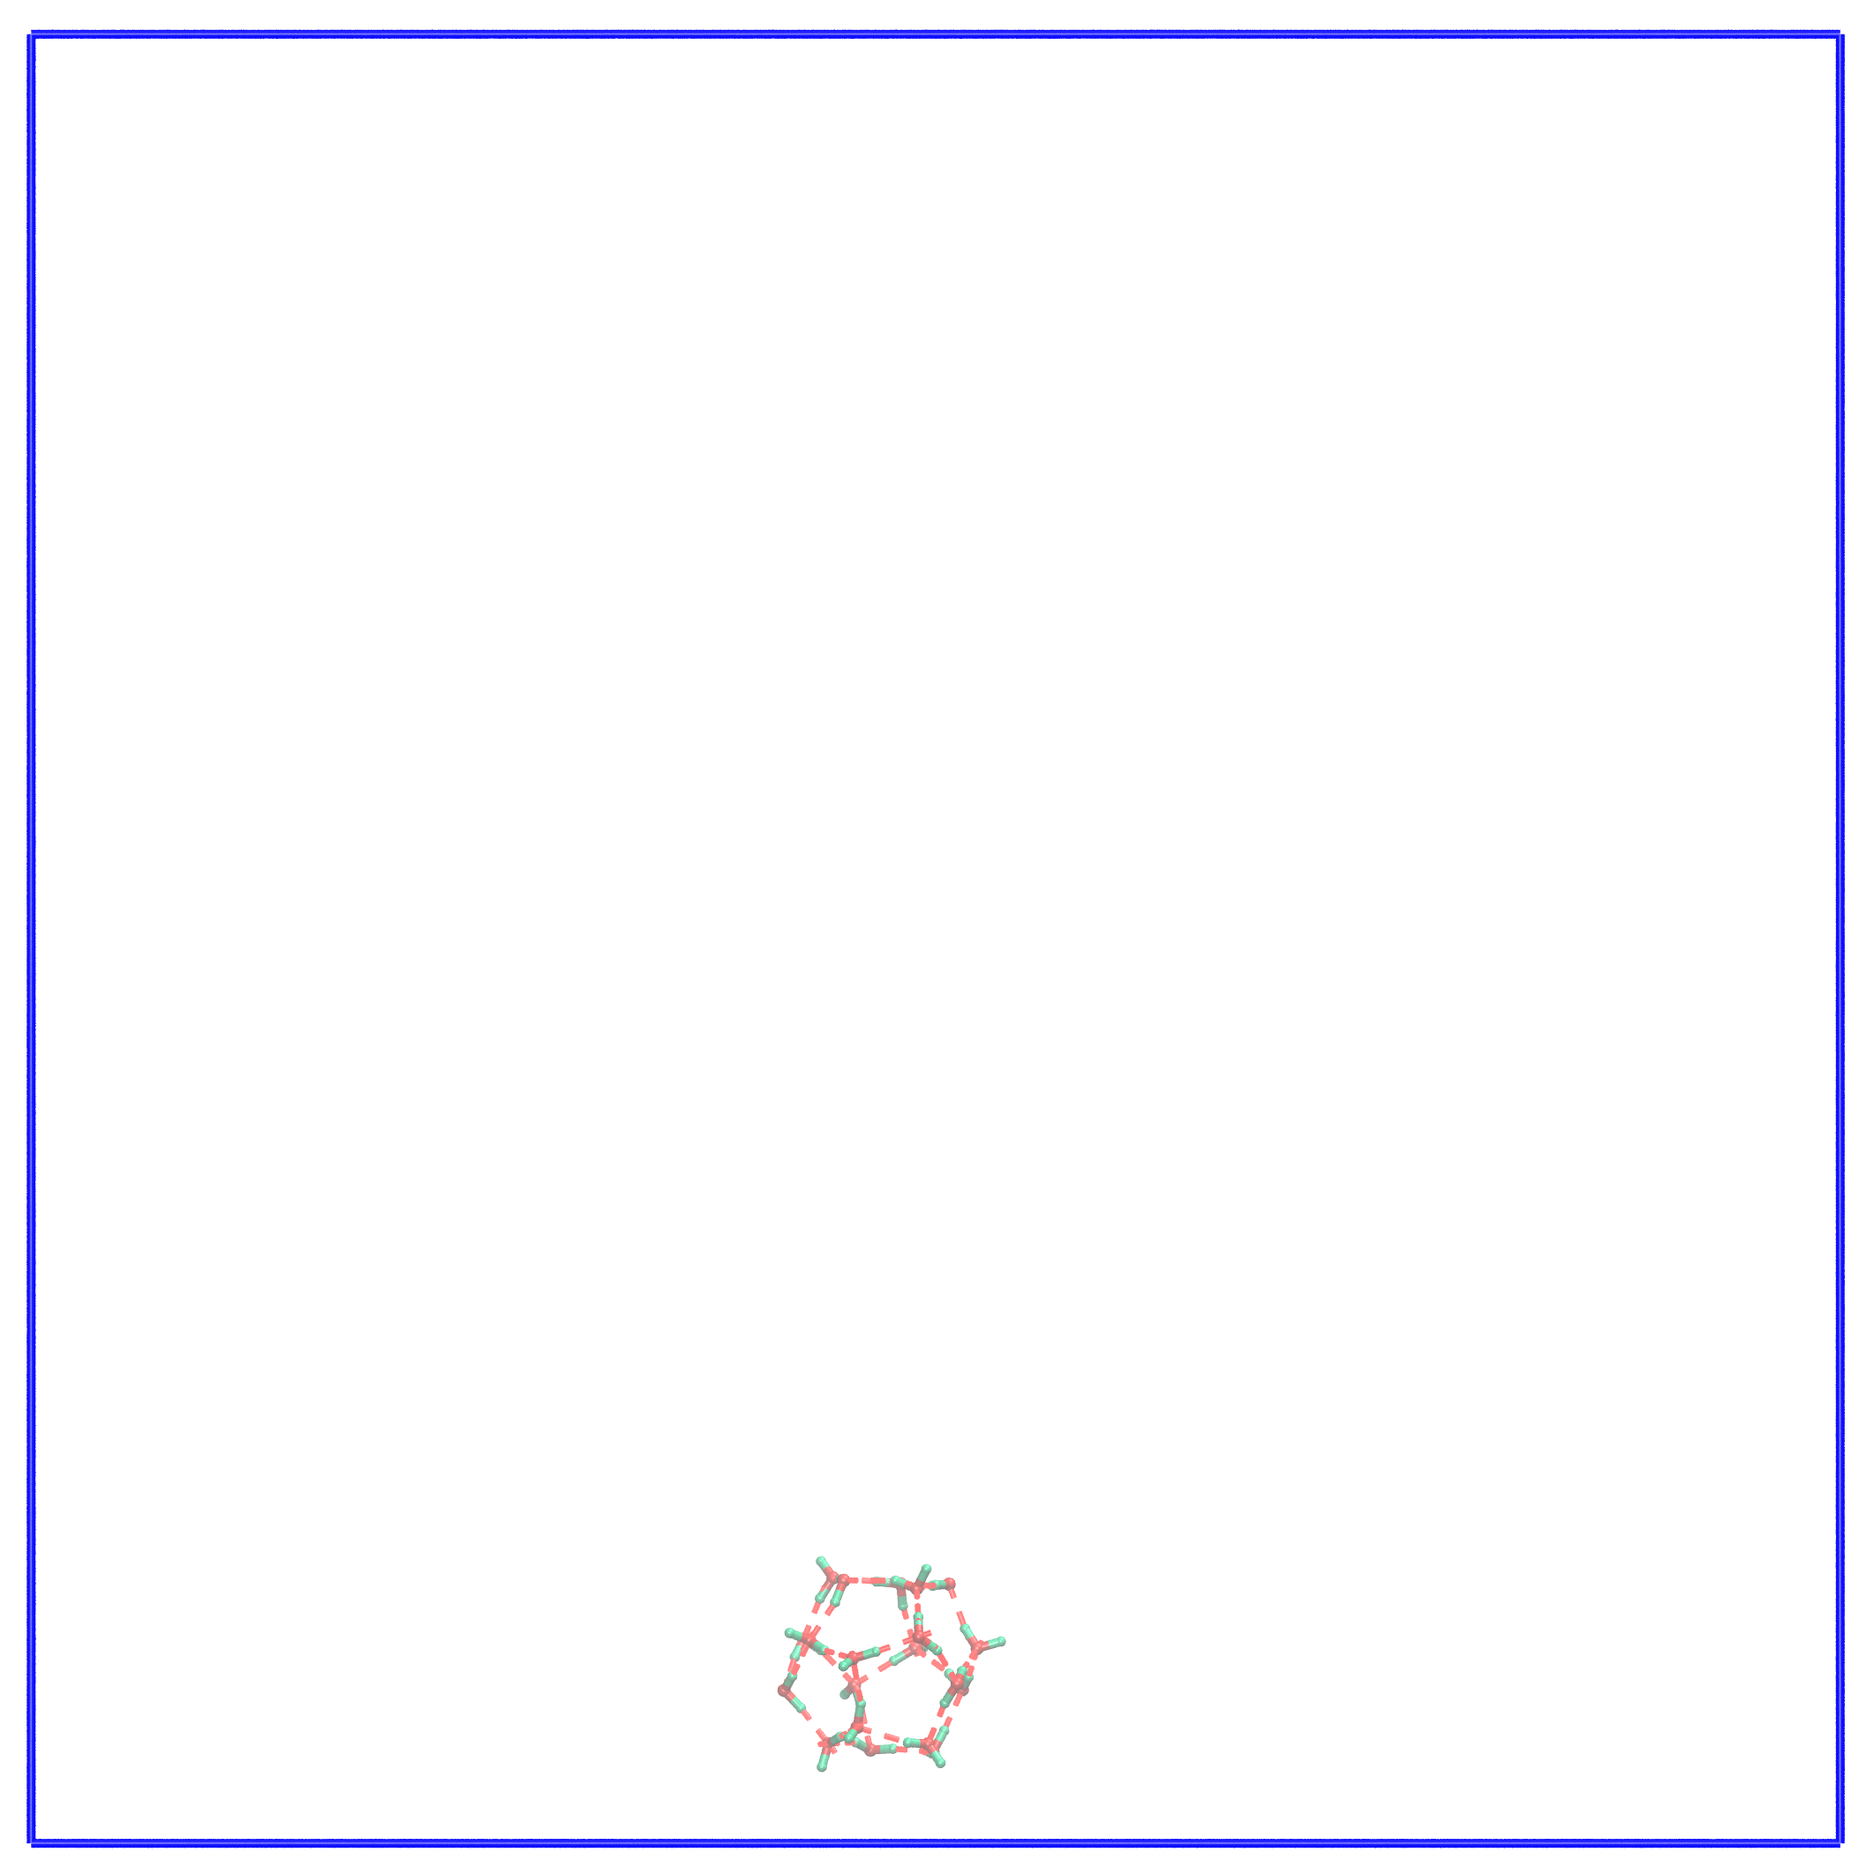 | 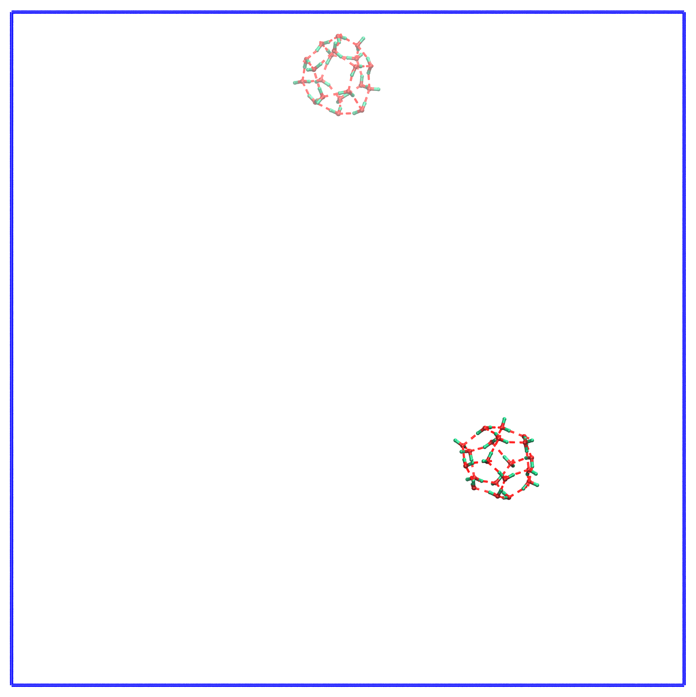 | 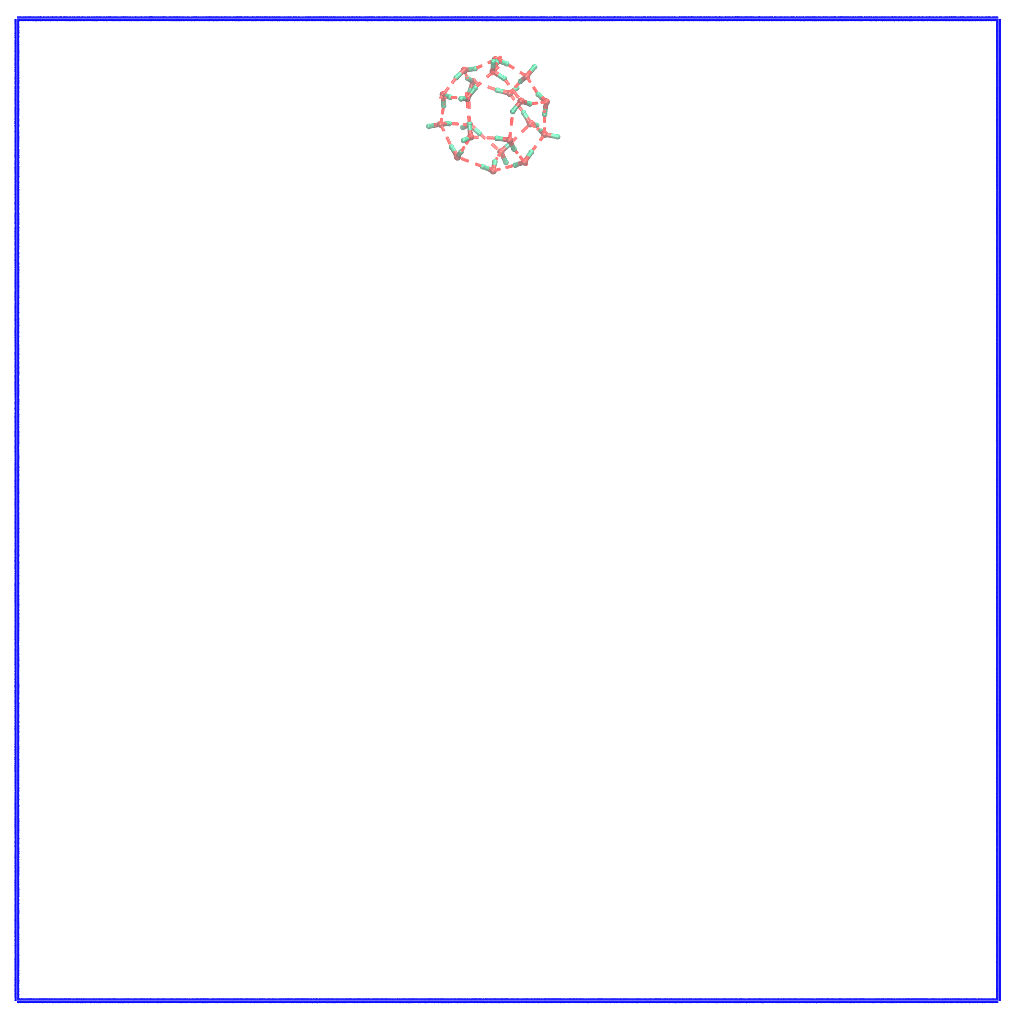
t = 4160 ps | t = 4482 ps | t = 4483 ps
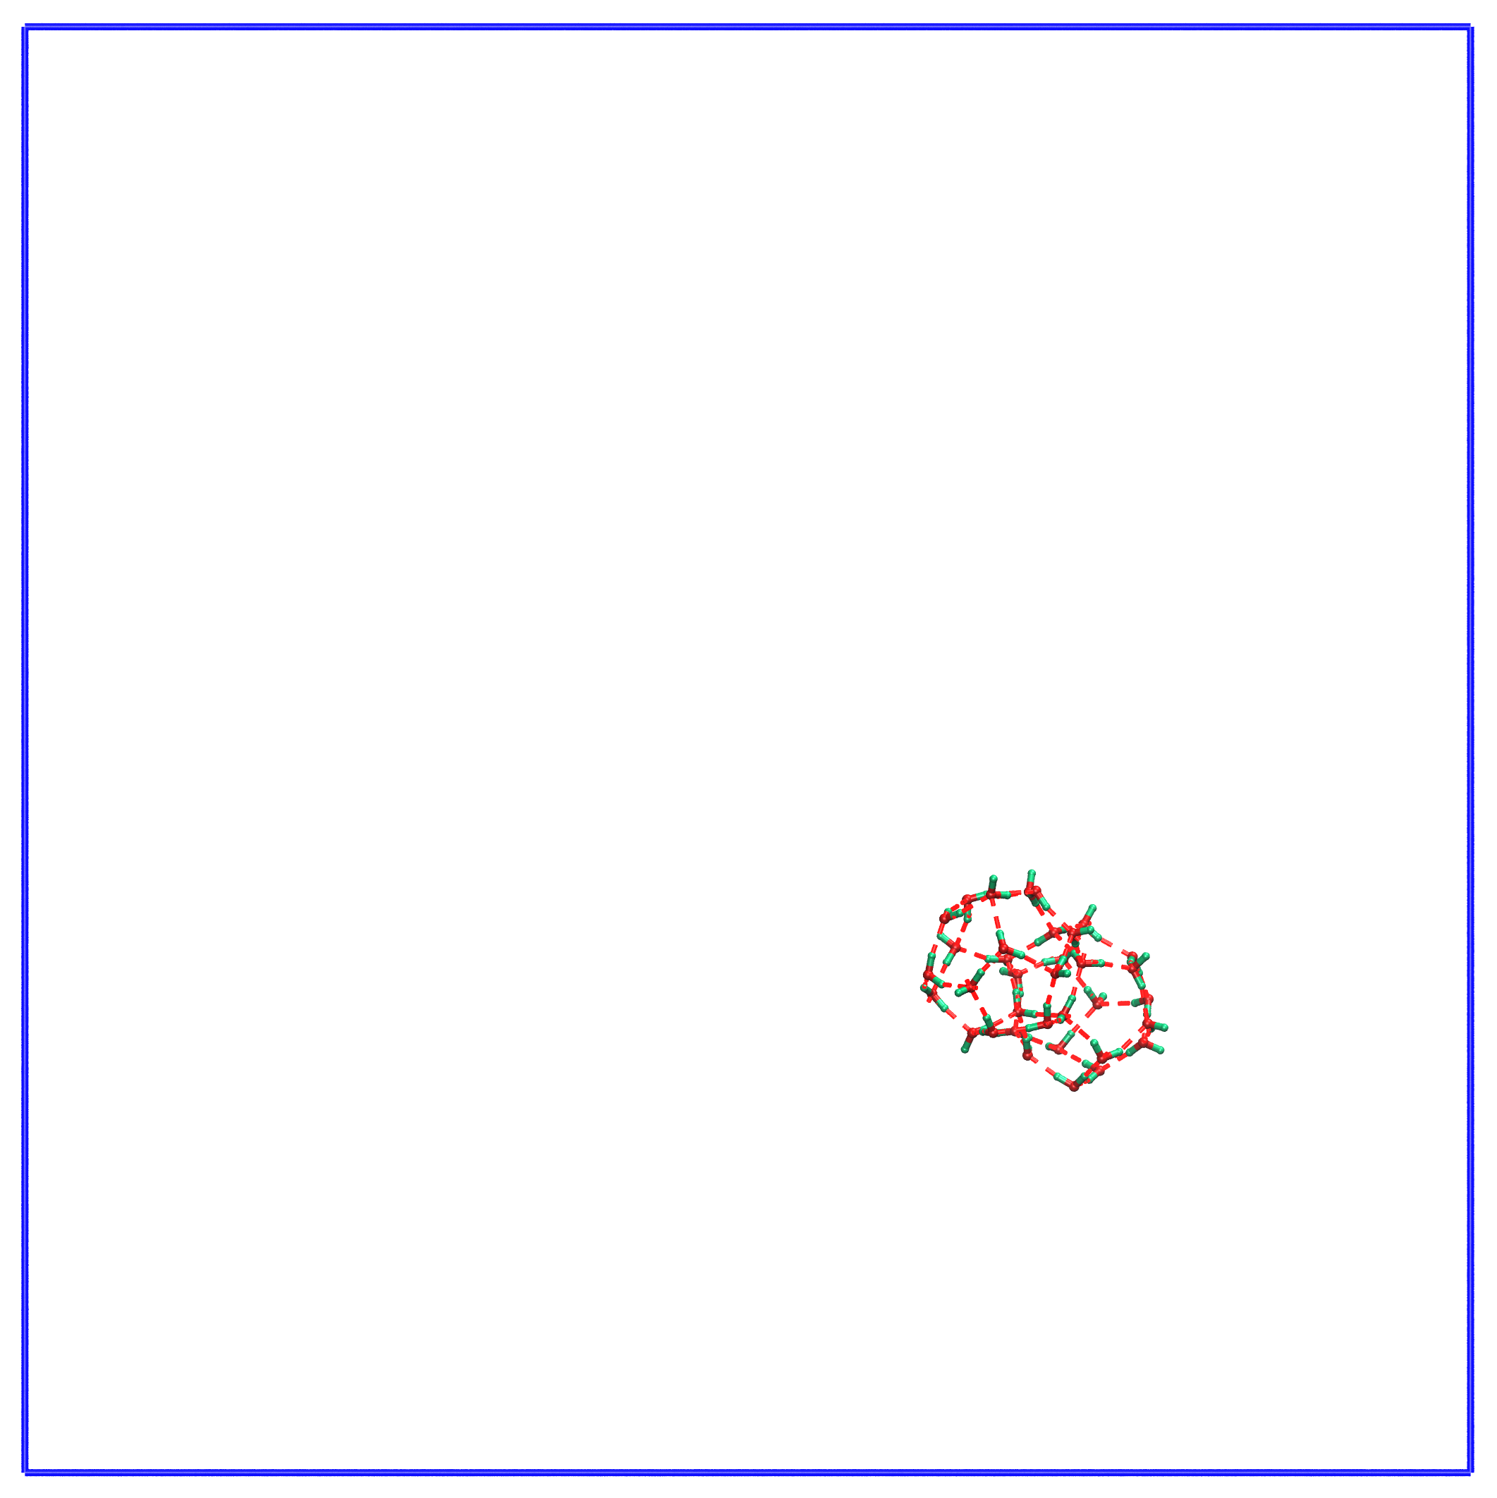 | 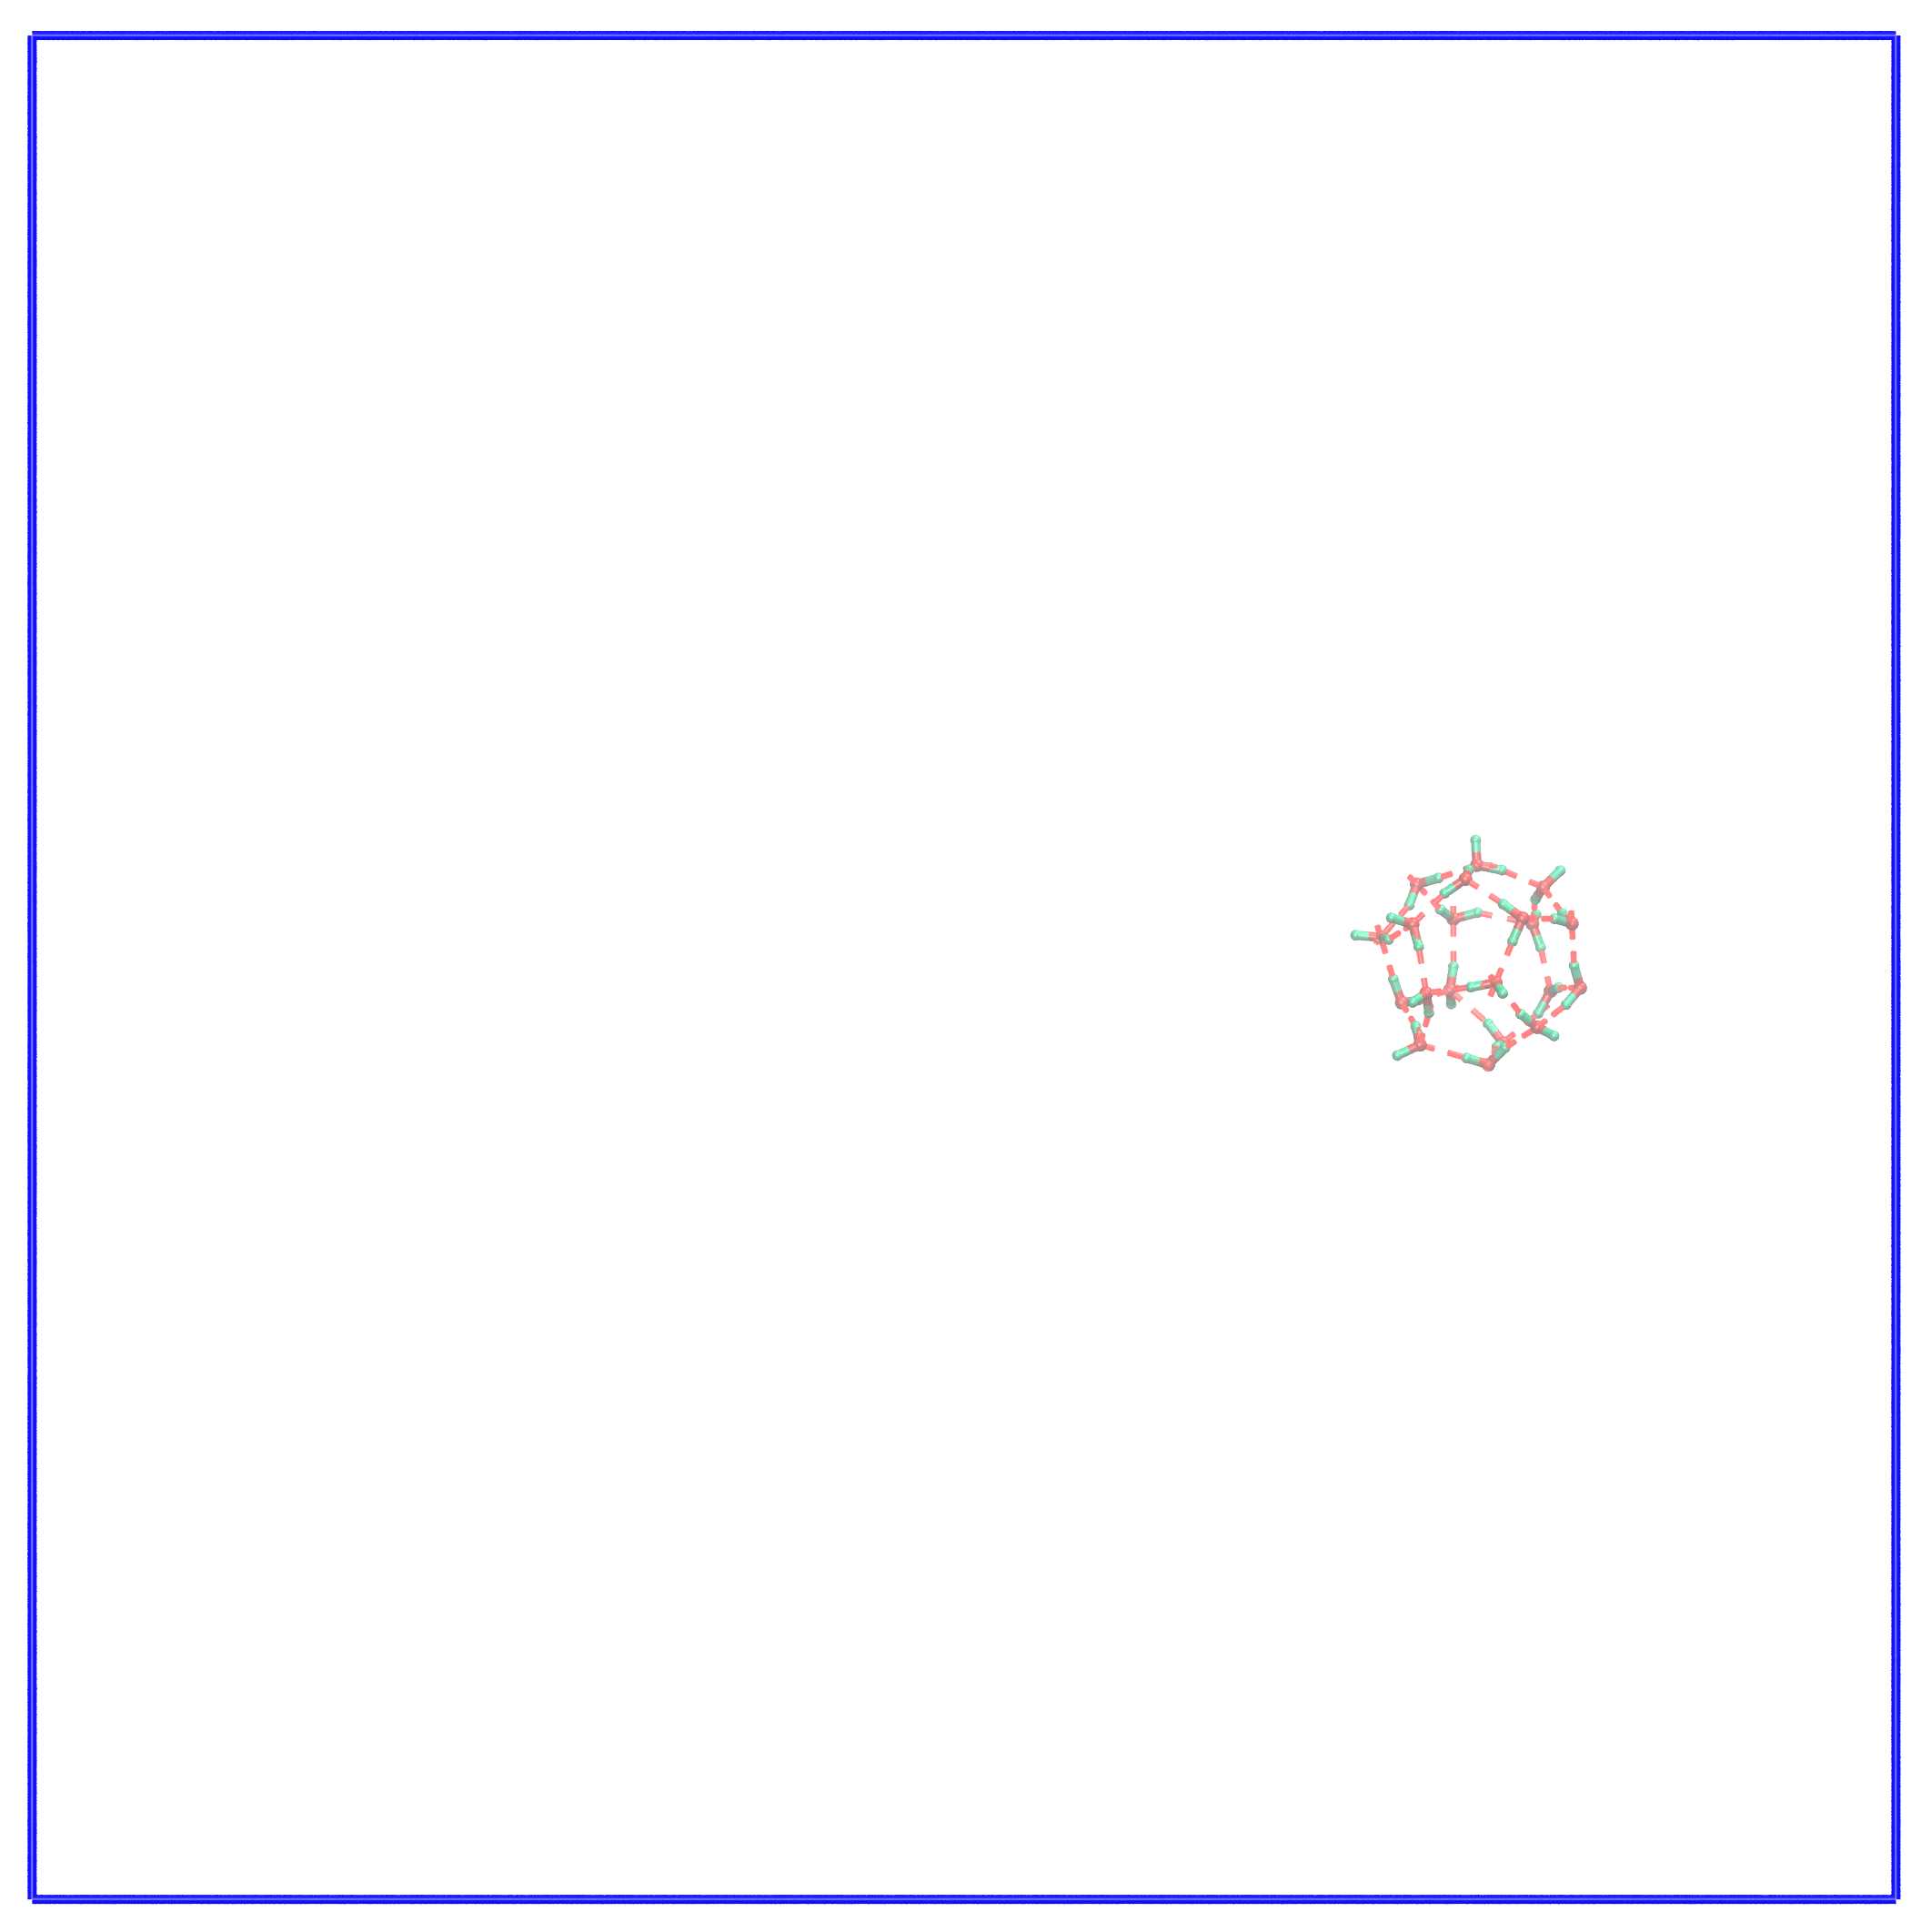 | 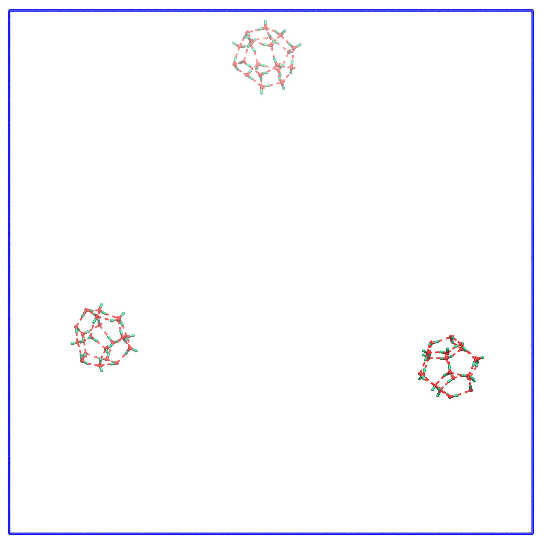
t = 4651 ps | t = 5452 ps | t = 5979 ps
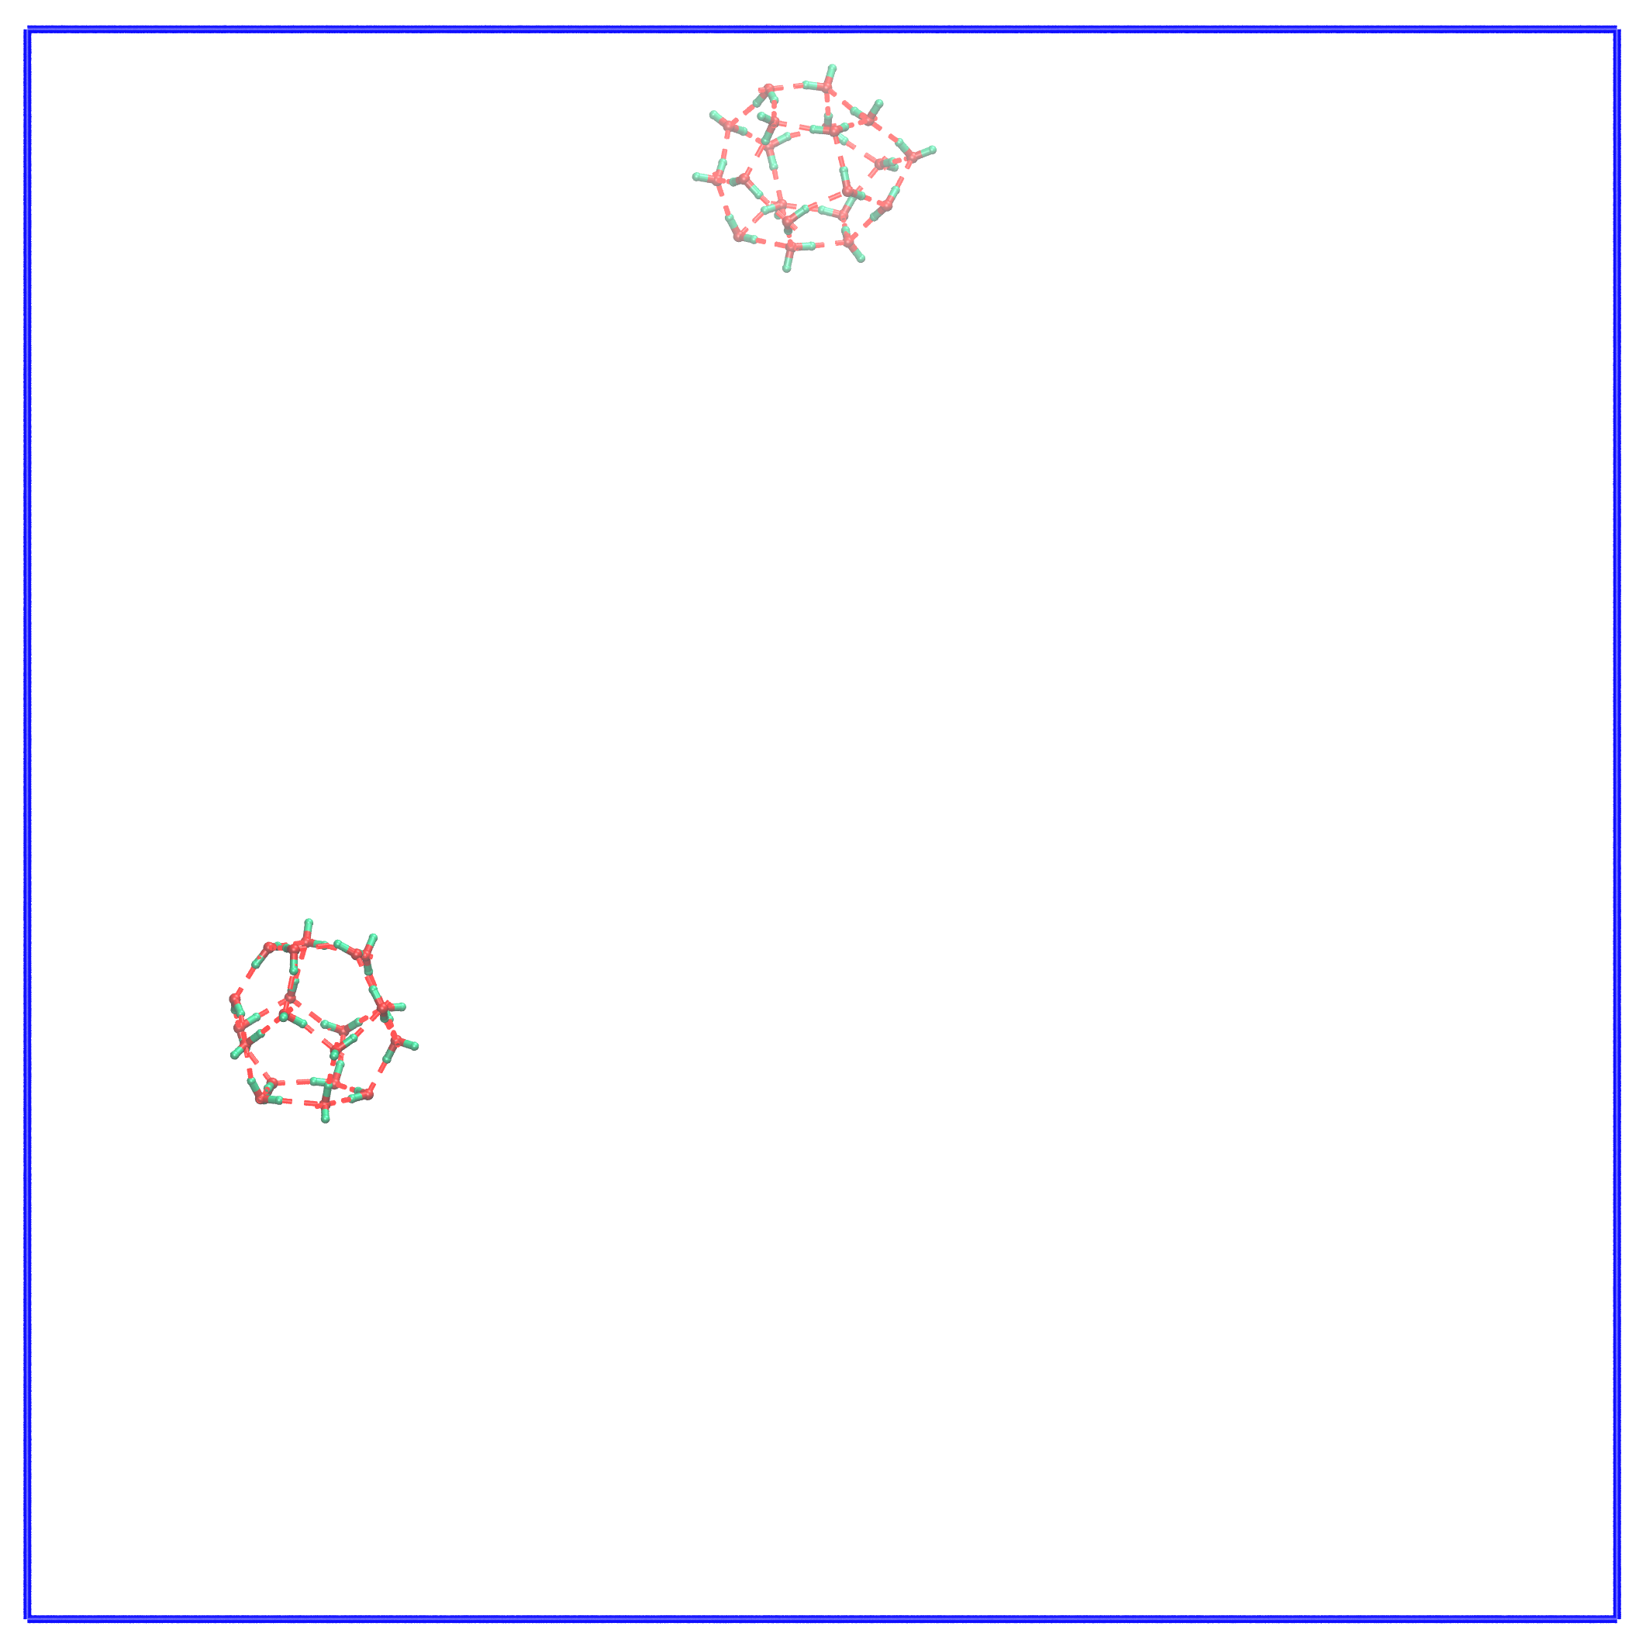 | 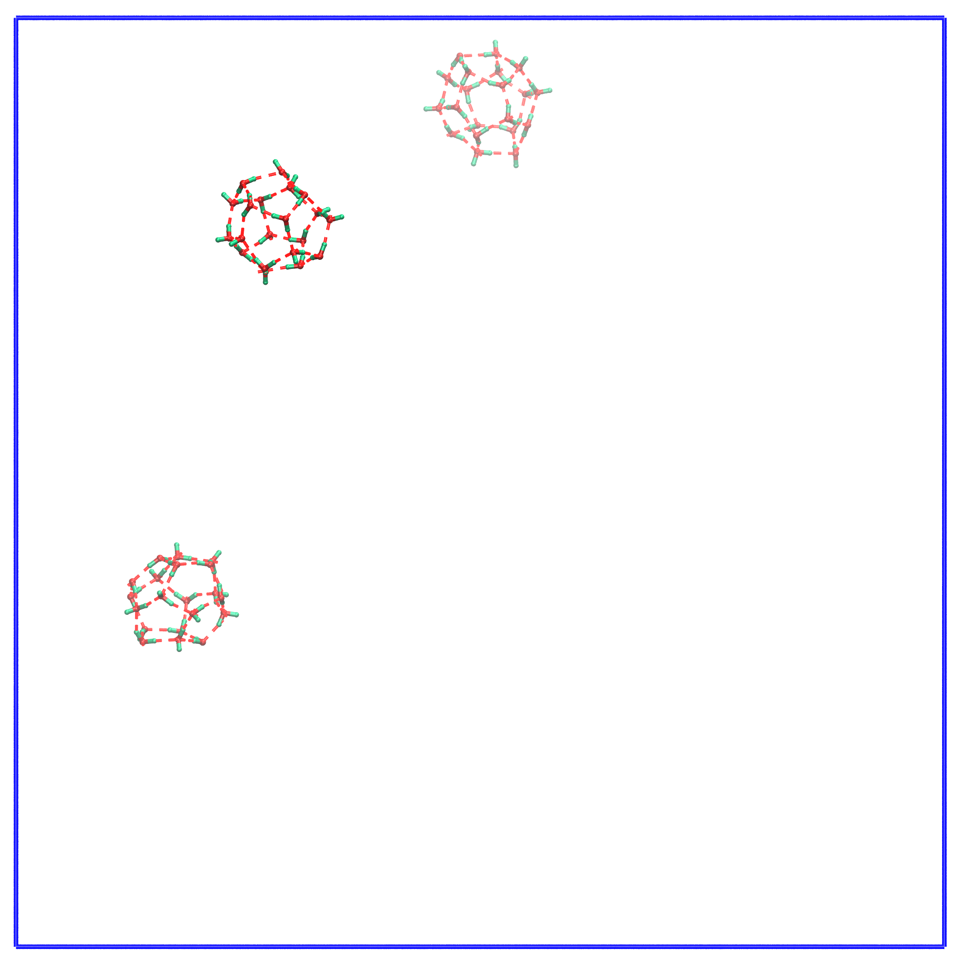 | 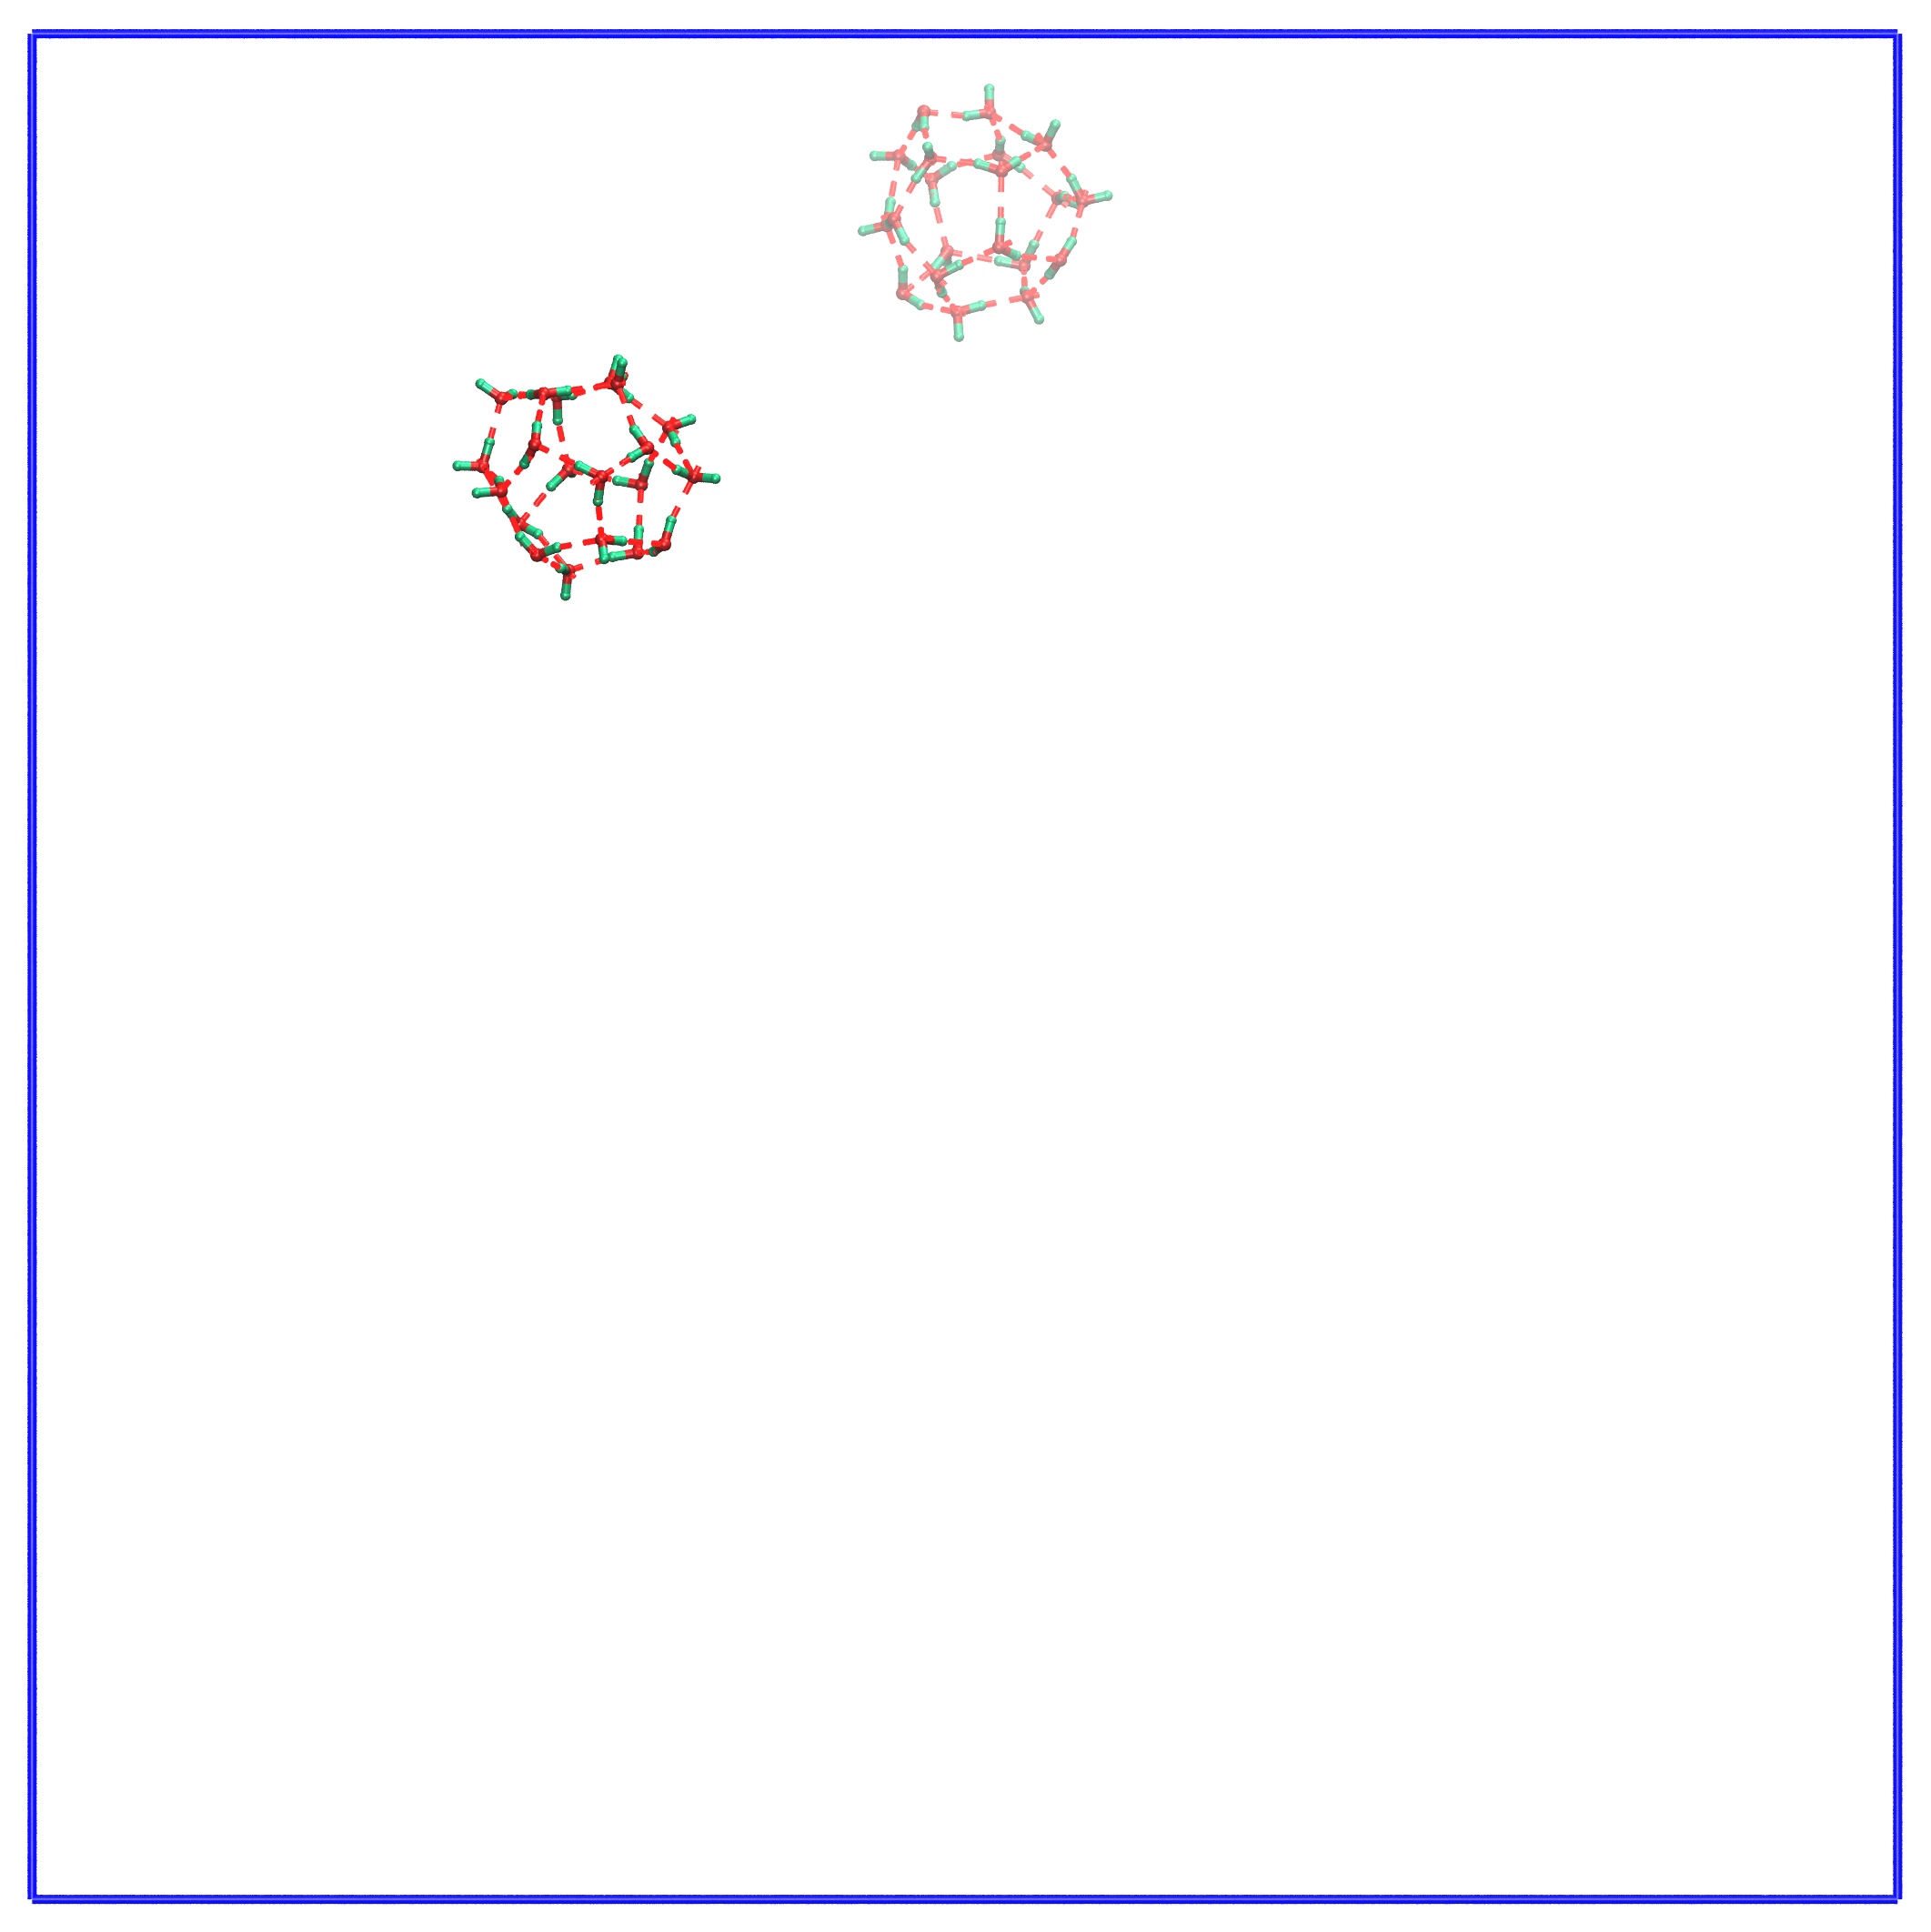
t = 6090 ps | t = 6520 ps | t = 6878 ps
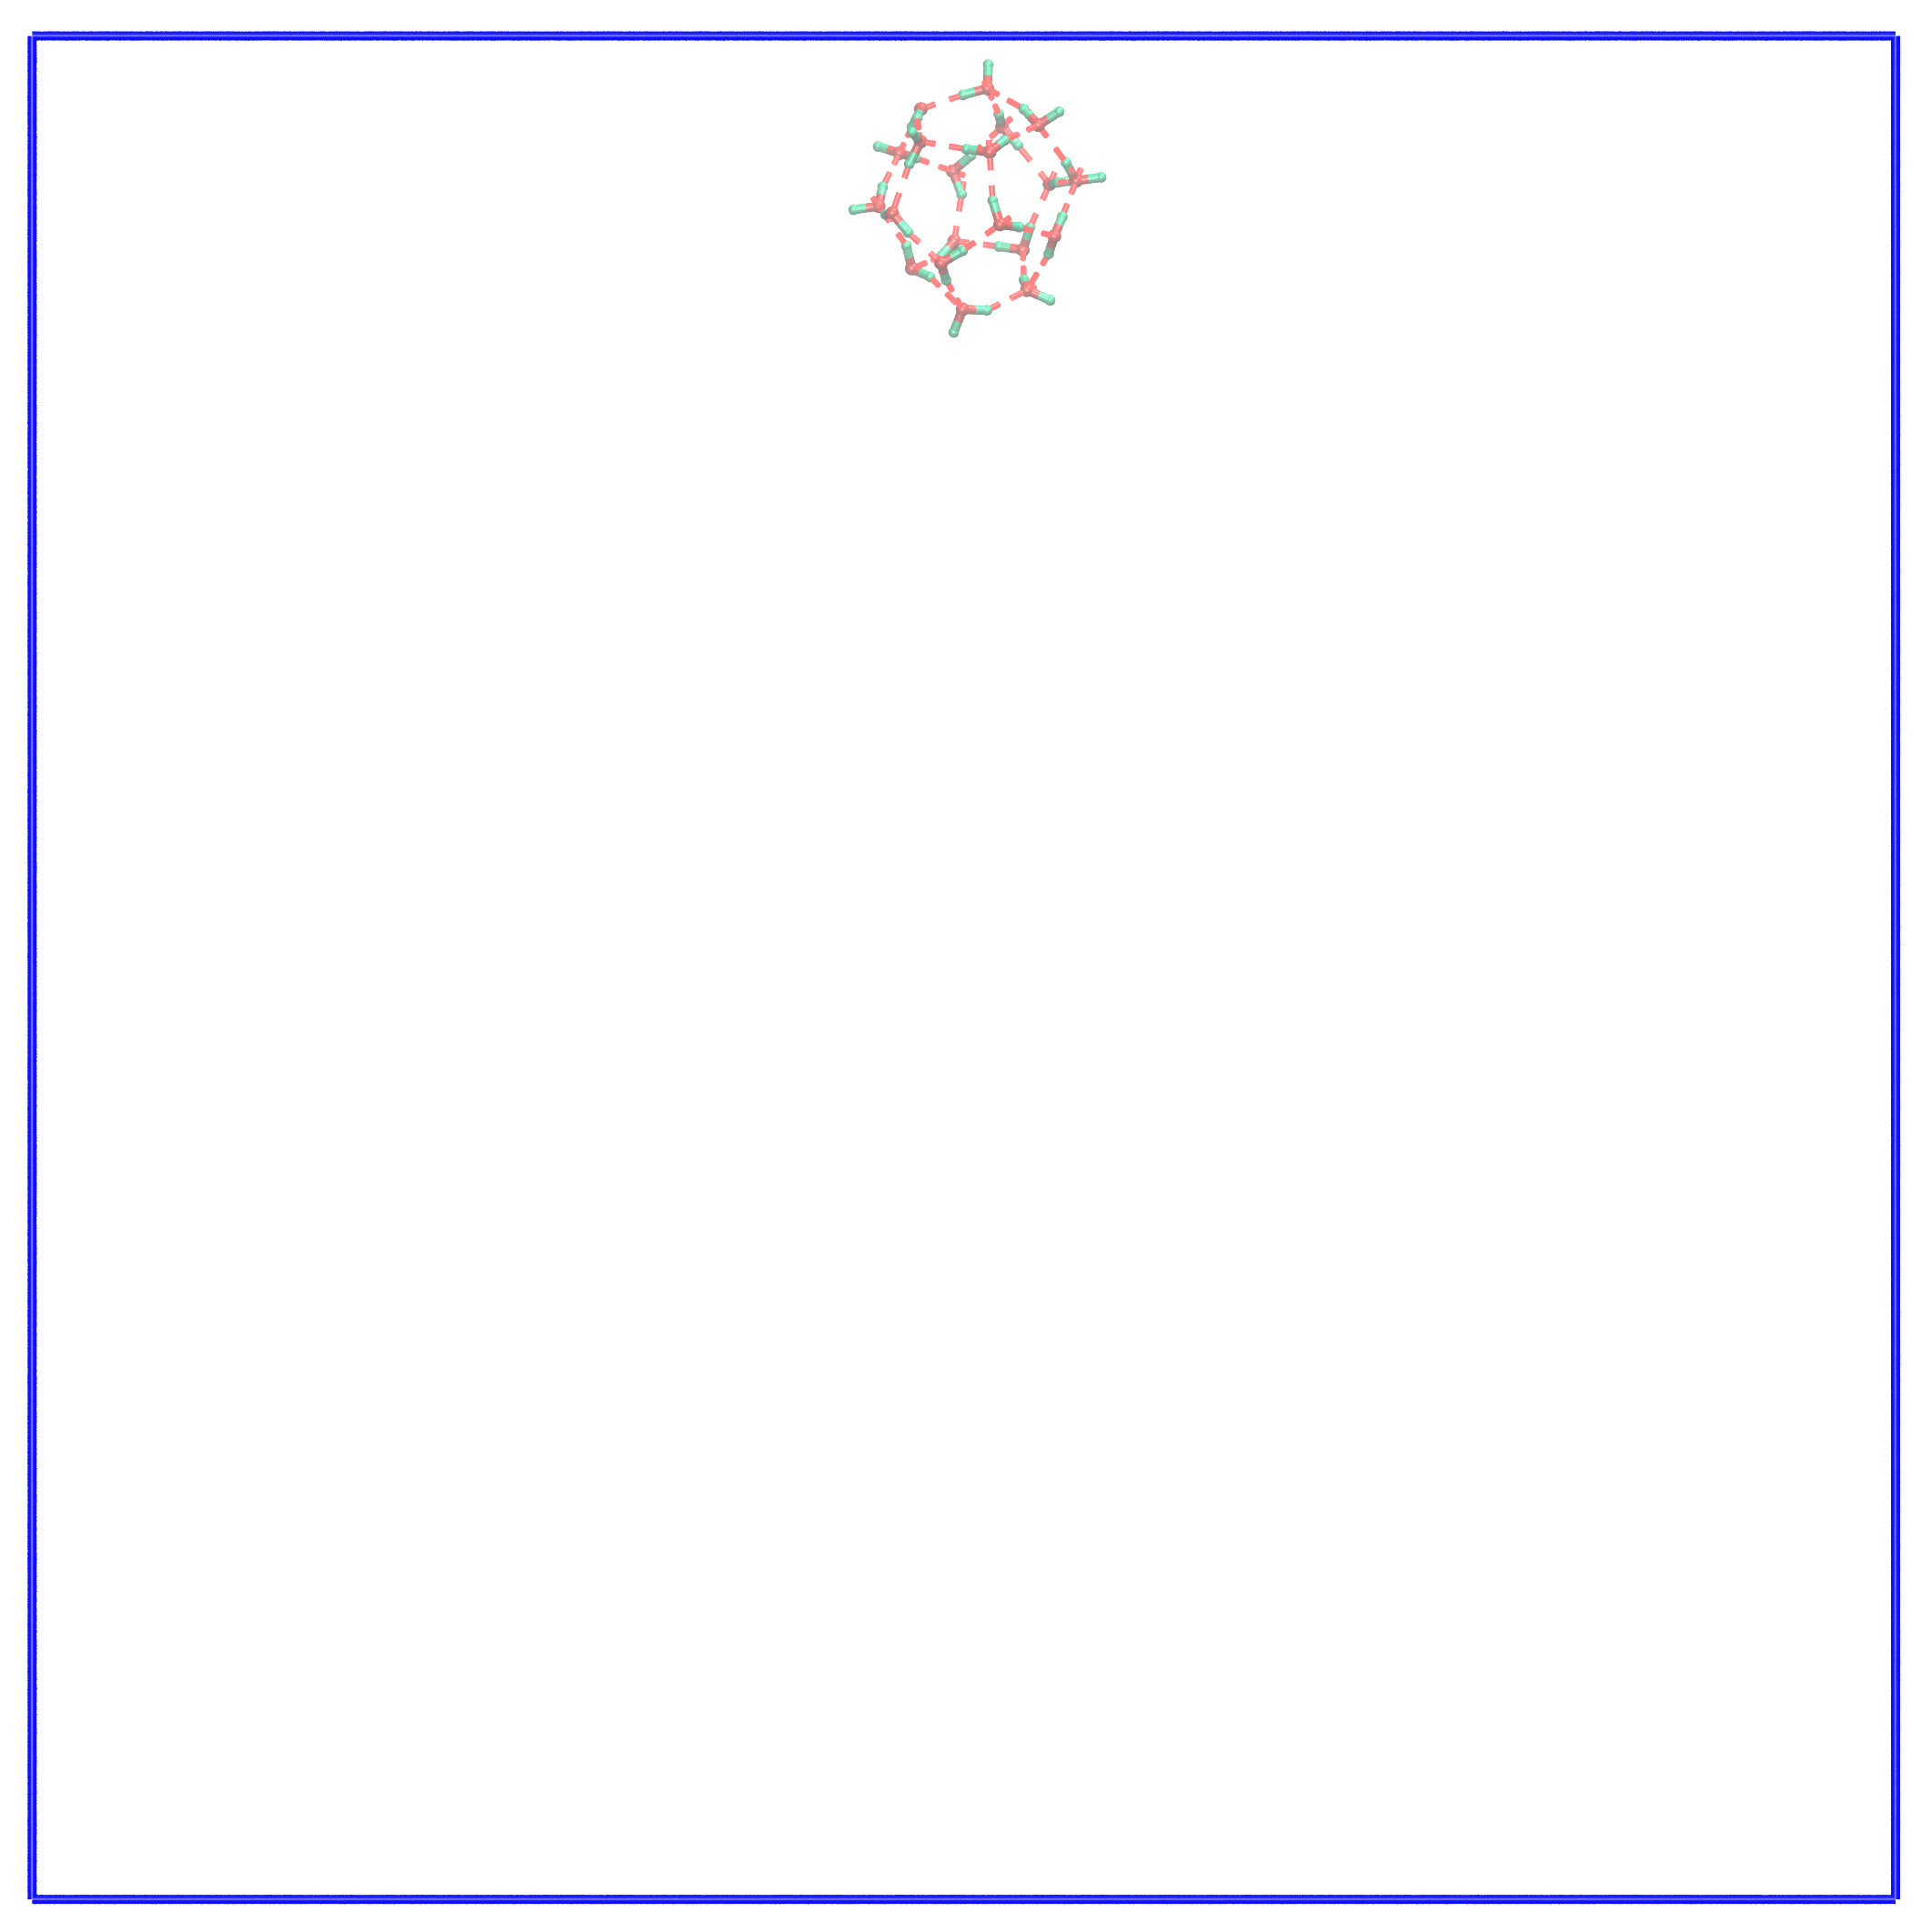 | 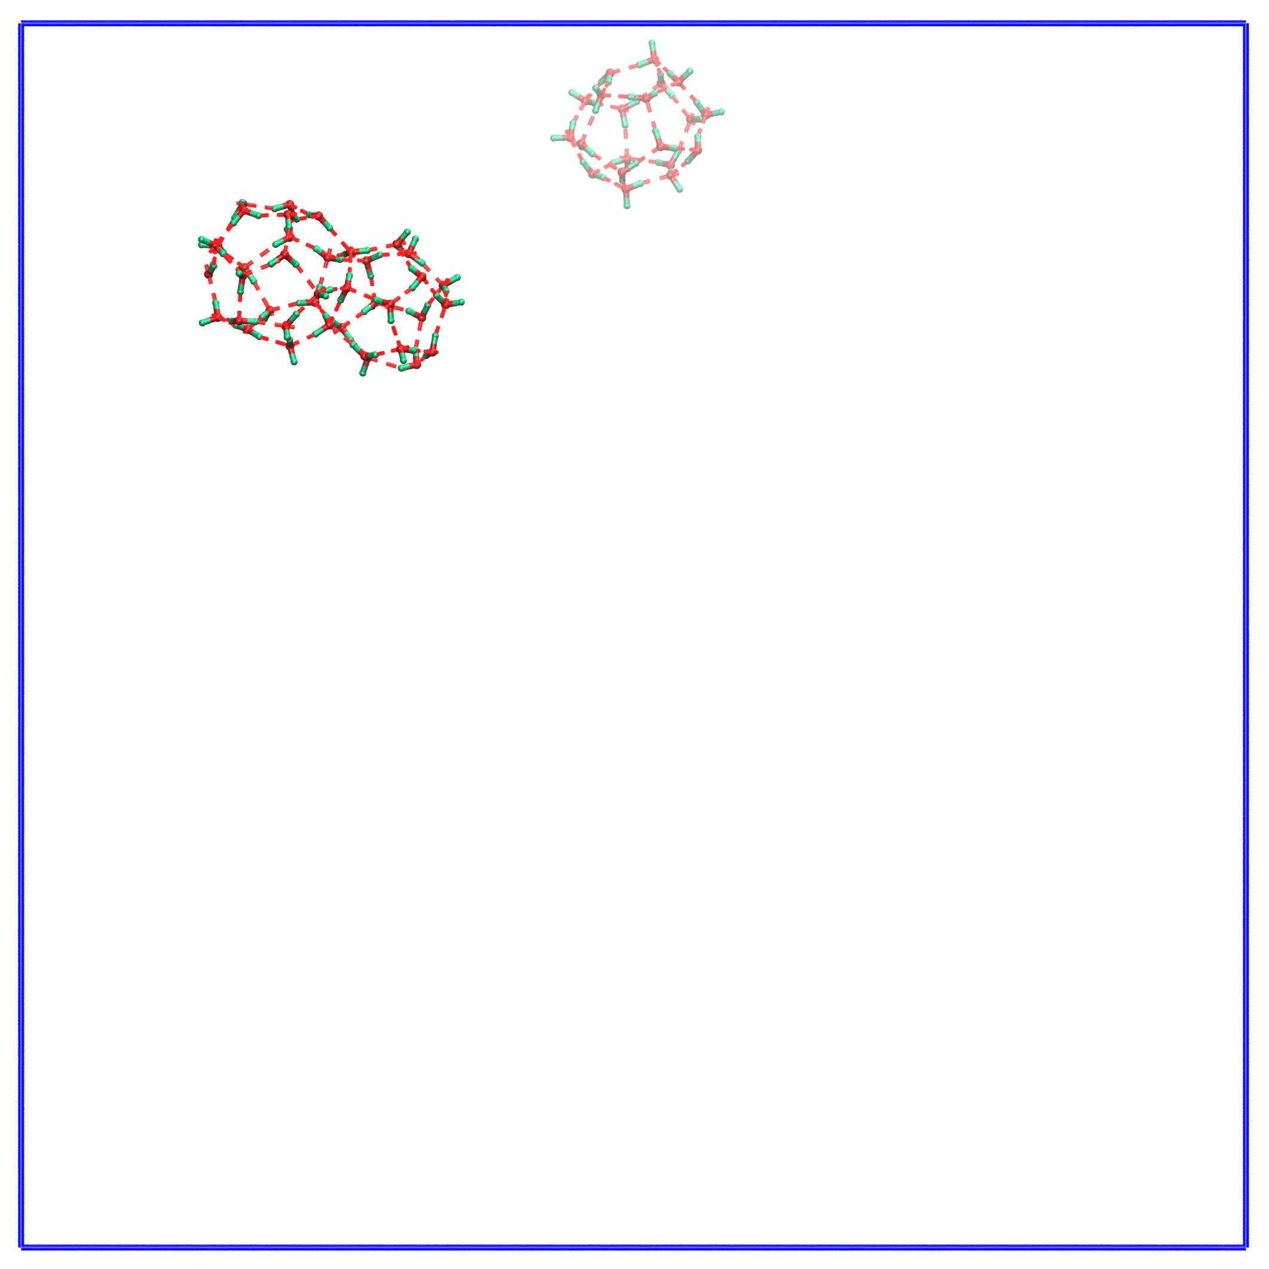 | 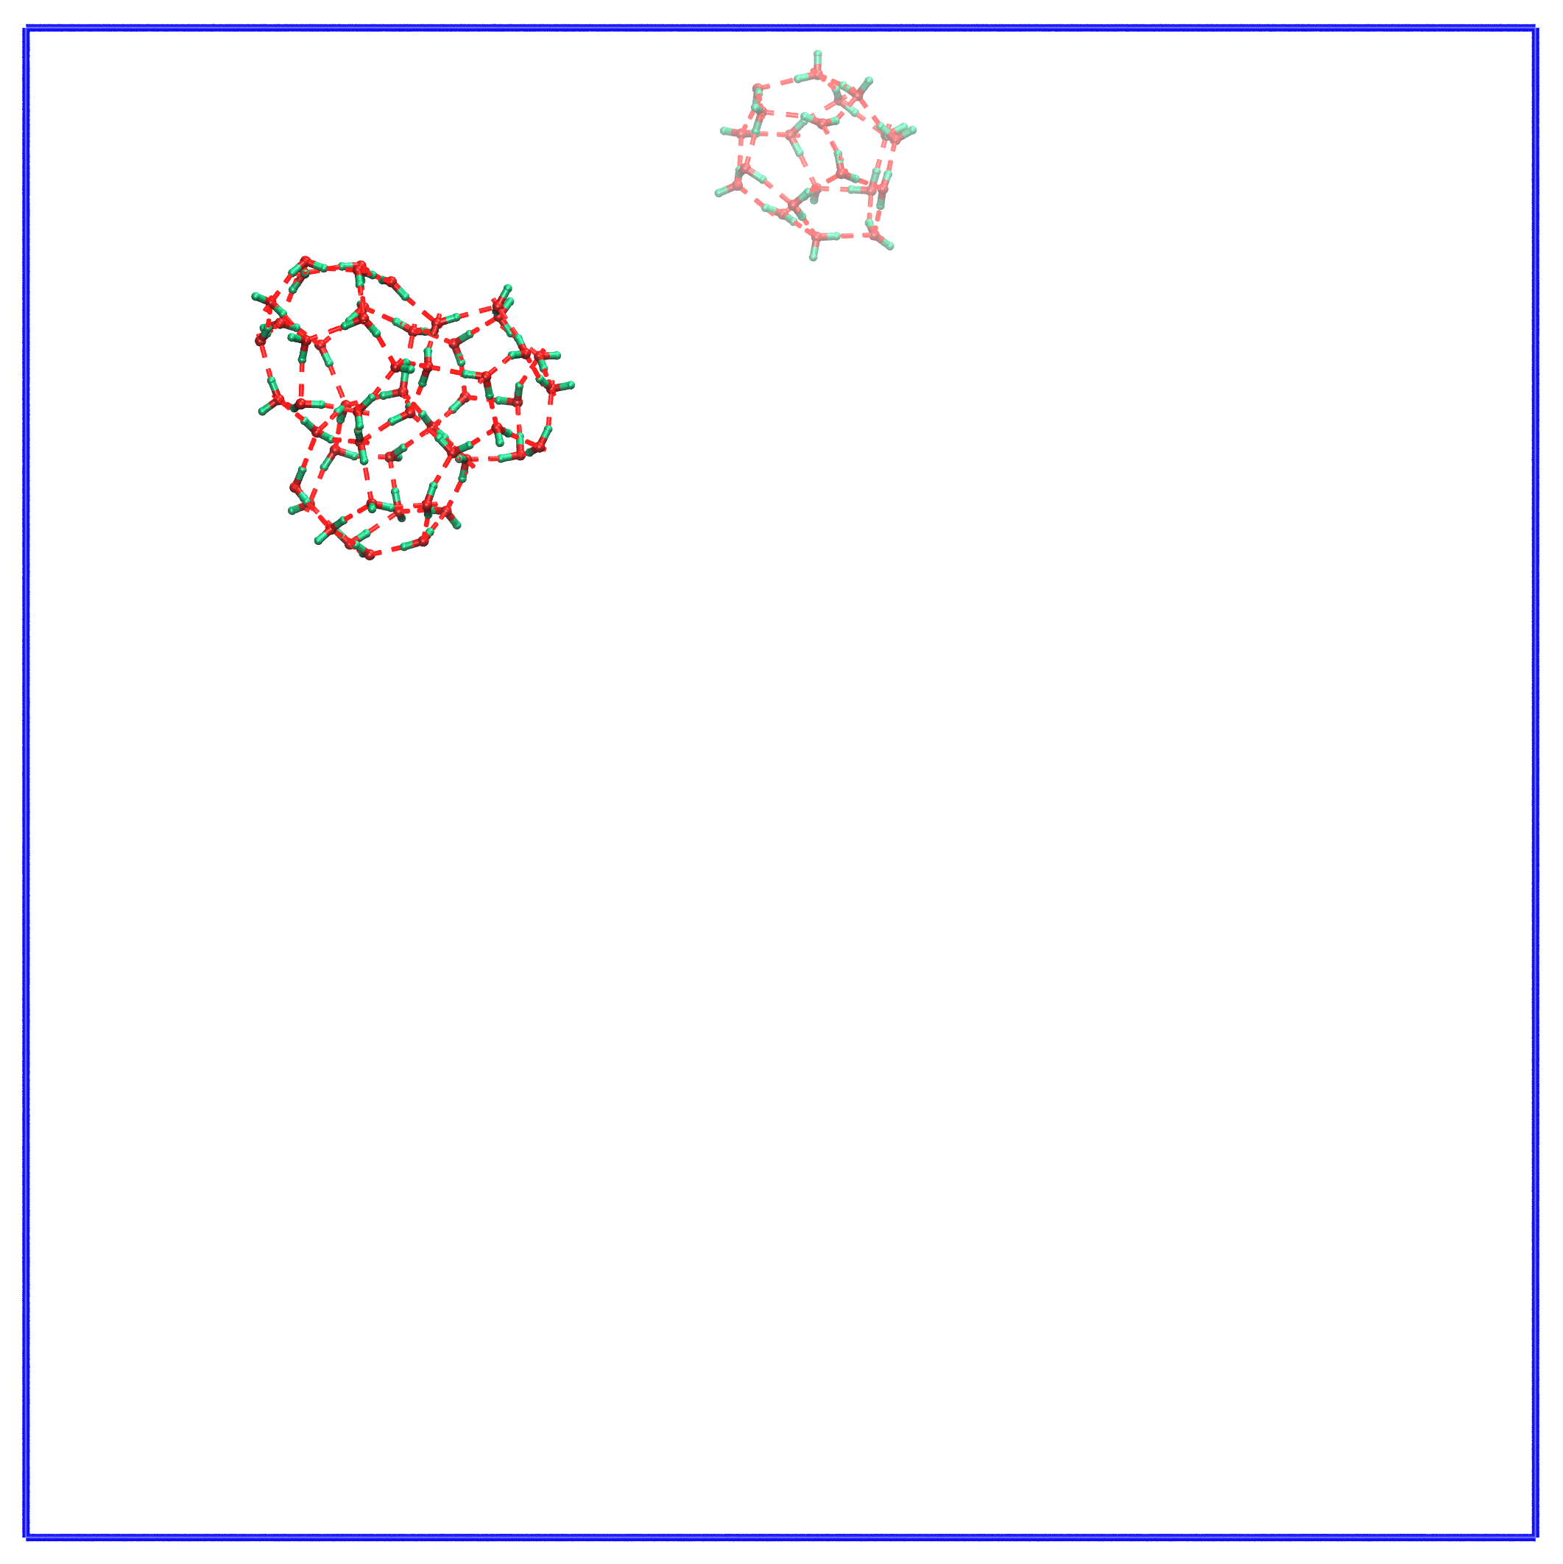
t = 6944 ps | t = 7345 ps | t = 7689 ps
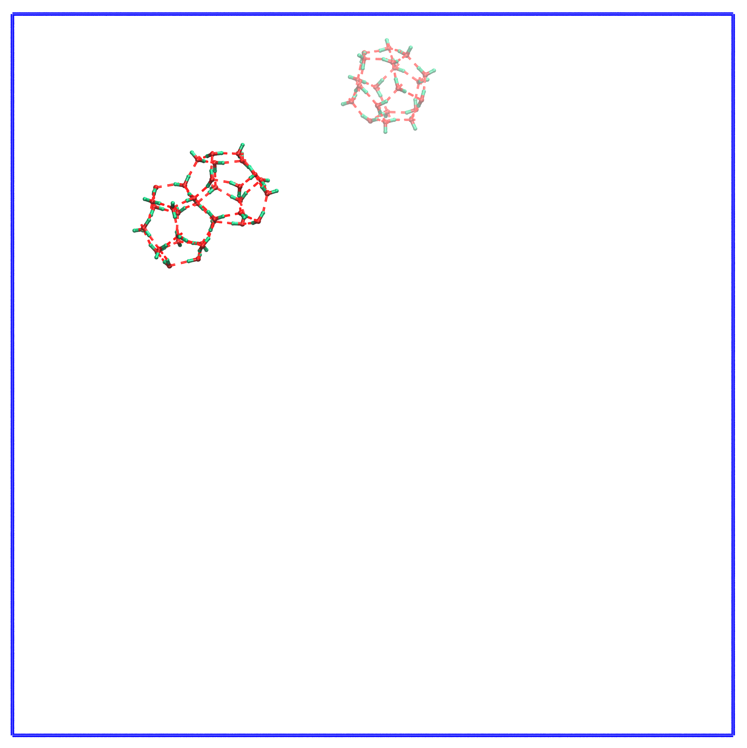 | 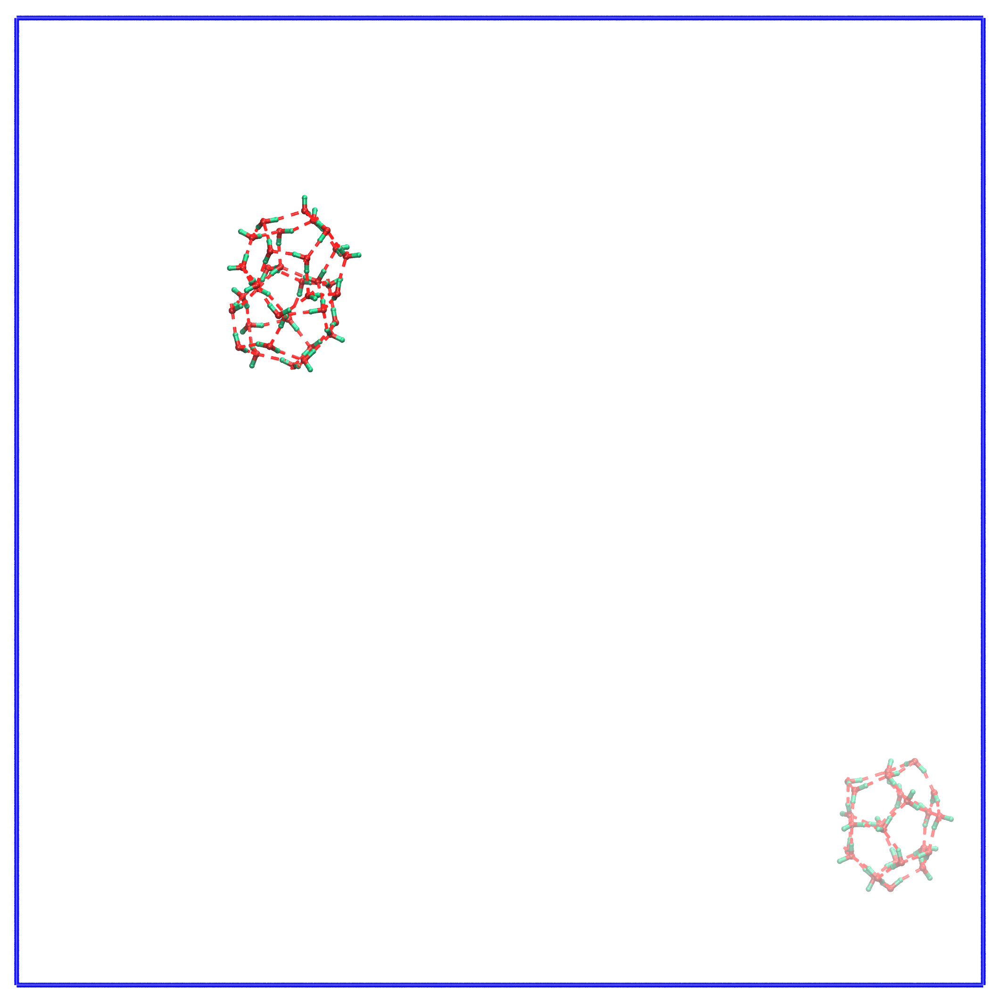 | 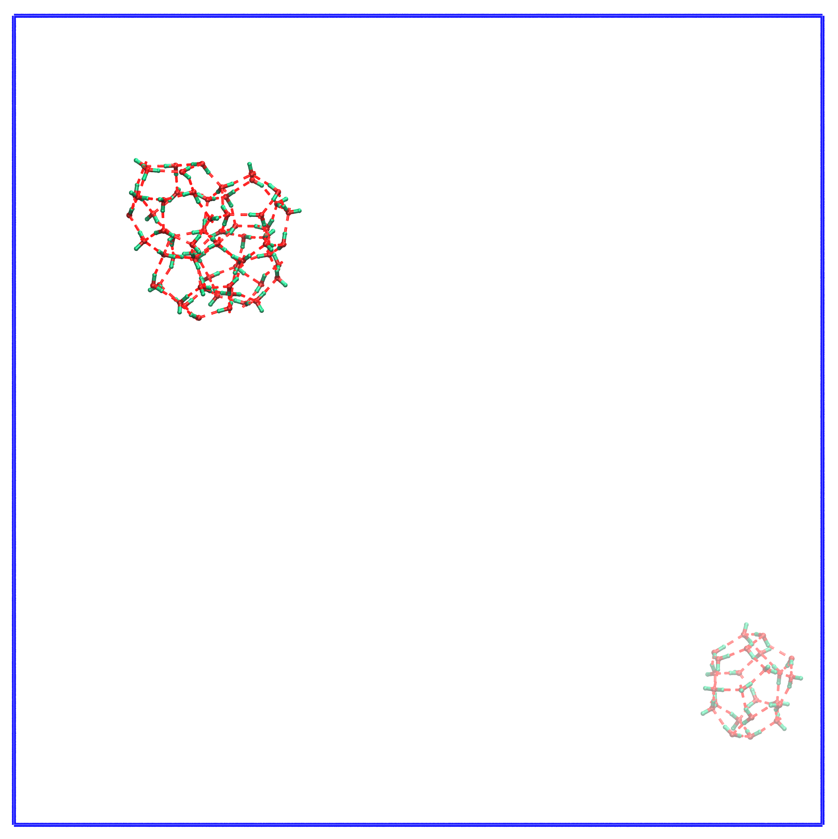
t = 8365 ps | t = 9357 ps | t = 8365 ps
Figure S1. Spatial distribution of small and large cavities.

2. Pre-nucleation: gas-oxygen RDF

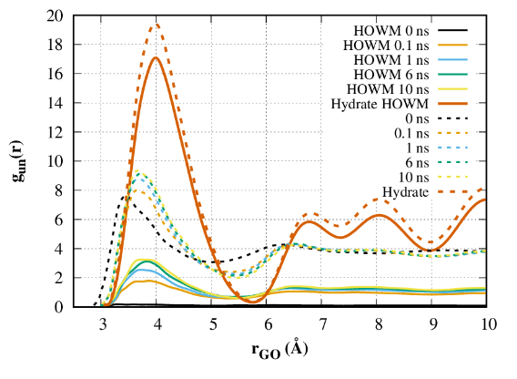
Figure S2. Unnormed by number of G-O pairs Methane-oxygen (eigen F₃ < 0.025) RDF of 0.6 methane solution with 0.01 Å step in comparison to bulk hydrate data at t = 0.5 ns under the same conditions. Dotted lines show the dependence for all water molecules, solid lines – for HOWMs.

Figure S2 shows the density unnormalized methane–oxygen RDF for HOWMs and all water molecules for solution and bulk hydrate. Values of this distribution grow proportionally to the number of HOWMs. Growth of peak with a maximum of 4 Å indicates an increase in the number of water molecules surrounding methane molecules both for HOW sub-system and for whole H-bond network. However the most significant relative growth is observed for HOWMs (2 times). Whole network undergoes a change of the order of 15-20 % that corresponds to the ratio of HOWMs. An increase indicates a gradual transition from an amorphous environment to a crystalline one. The main change in the structure of the solution and HOW sub-system takes place before the start of stable hydrate formation.

3. Methane hydrate growth visualization

Supplementary video S1. Evolution of methane+water solution at concentration of 0.2 (3.36 mol%) during 100 ns of modeling. Positions of water molecules, methane molecules and H-bond are smoothed over 1 ns for clearance.

Supplementary video S2. Evolution of methane+water solution at concentration of 0.4 (6.5 mol%) during 100 ns of modeling. Positions of water molecules, methane molecules and H-bond are smoothed over 1 ns for clearance.

Supplementary video S3. Evolution of methane+water solution at concentration of 0.6 (9.45 mol%) during 100 ns of modeling. Positions of water molecules, methane molecules and H-bond are smoothed over 1 ns for clearance.

Supplementary video S4. Evolution of methane+water solution at concentration of 0.8 (12.2 mol%) during 100 ns of modeling. Positions of water molecules, methane molecules and H-bond are smoothed over 1 ns for clearance.

Supplementary video S5. Evolution of methane+water solution at concentration of 1.0 (14.8 mol%) during 100 ns of modeling. Positions of water molecules, methane molecules and H-bond are smoothed over 1 ns for clearance.

