“Design, synthesis, antimicrobial evaluation, and in-silico studies of some 4-thiazolidinone hybrids bearing coumarin and pyridine moiety”
Nisheeth C. Desaiª*, Harsh K. Mehtaª, Aratiba M. Jethawaª, Jahnvi D. Monaparaª, Vijay M Khedkar^{b}, Bharti P. Dave^{c}
ªDivision of Medicinal Chemistry, Department of Chemistry, Maharaja Krishnakumarsinhji Bhavnagar University, Bhavnagar, 364002, India
^{b}School of Pharmacy, Vishwakarma University, Pune, Maharashtra, 411 048, India
^{C}School of Science, Indrashil University, Rajpur (382740), Gujrat, India
Address For correspondence: dnisheeth@rediffmail.com
1. IR, ¹H NMR, ¹³C NMR and mass spectra of synthesized compounds..………………...2-14
2. Docking images of the synthesized compounds……………………………………….15-21

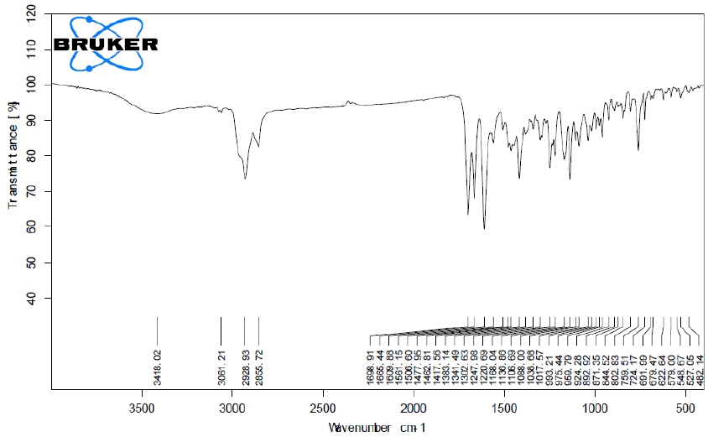
IR spectra of the compound 5a
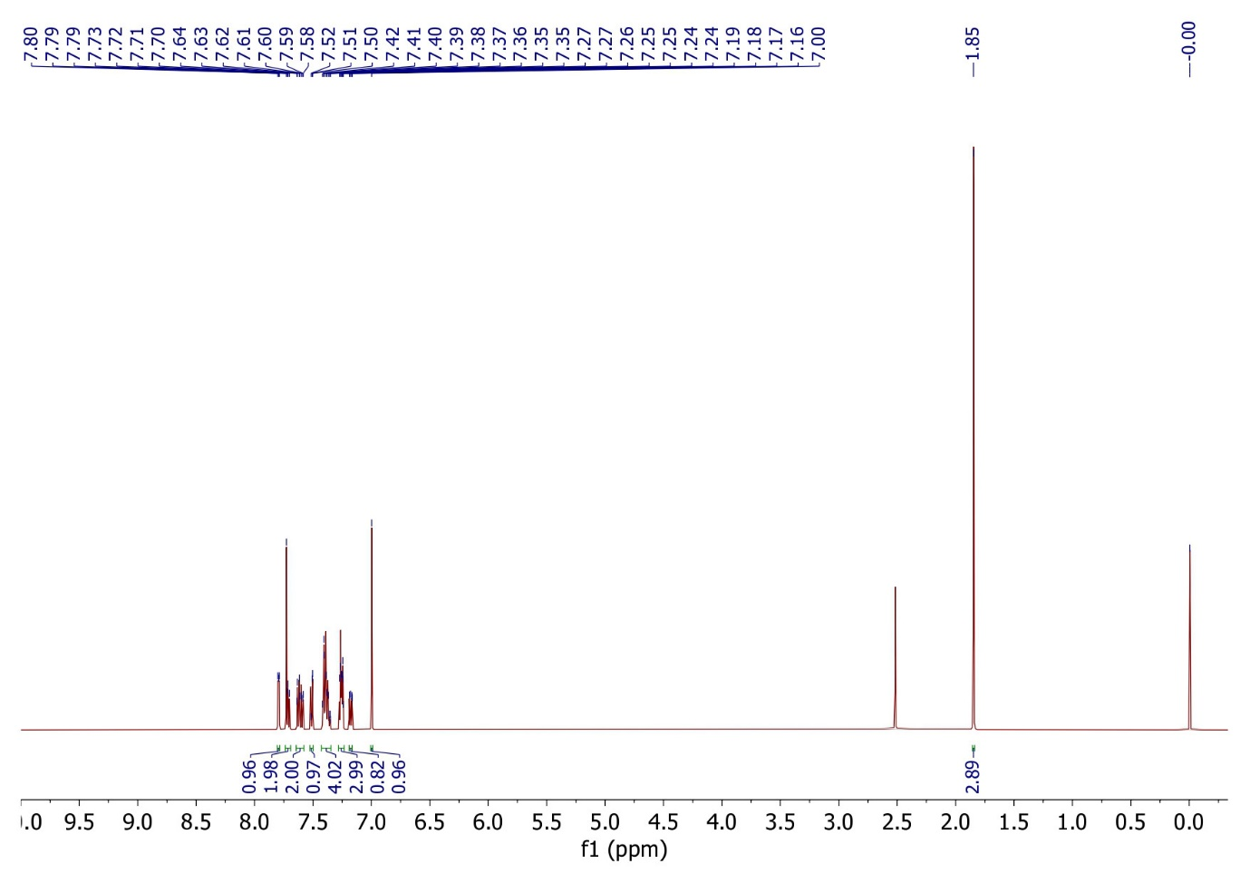
¹H NMR spectra of compound 5a
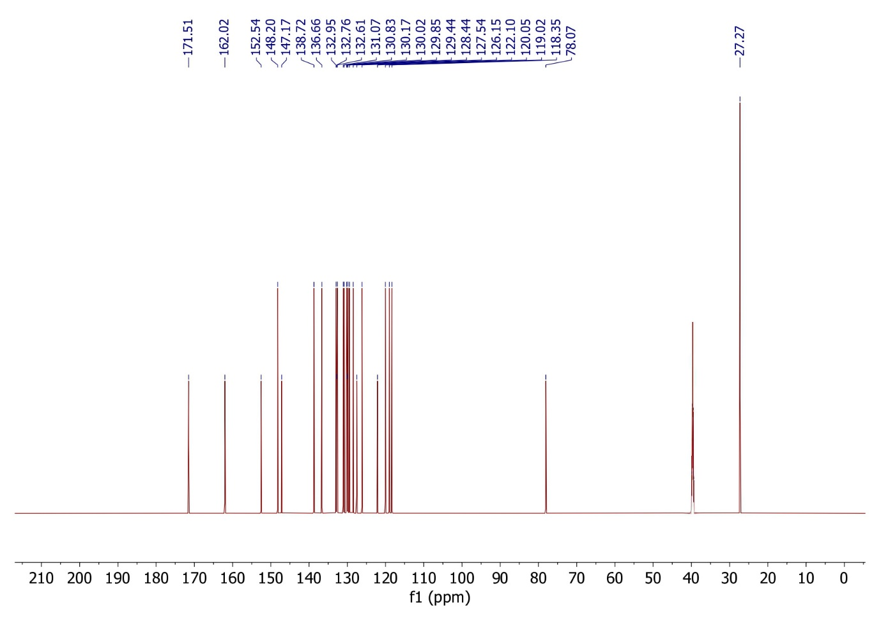¹³C NMR spectra of compound 5a
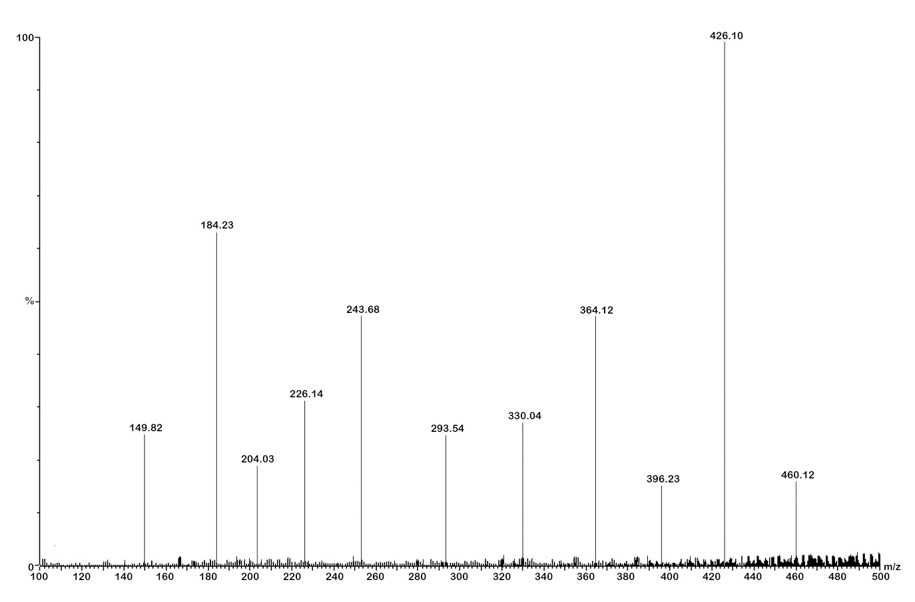
Mass spectra of compound 5a
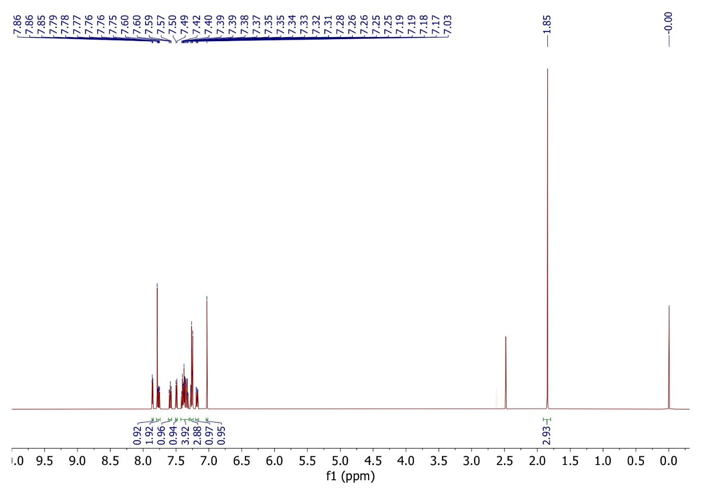
¹H NMR spectra of compound 5b
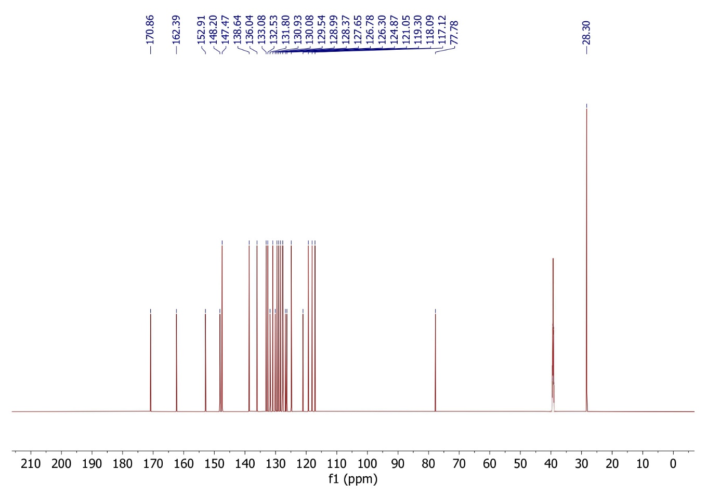
¹³C NMR spectra of compound 5b
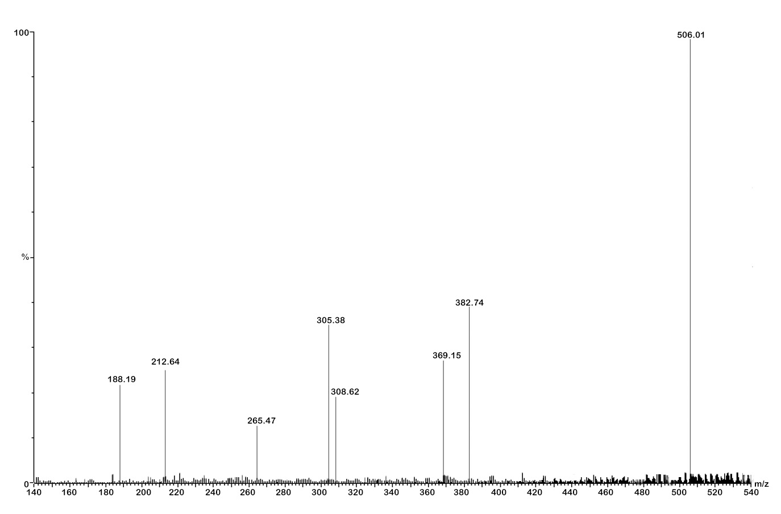
Mass spectra of compound 5b
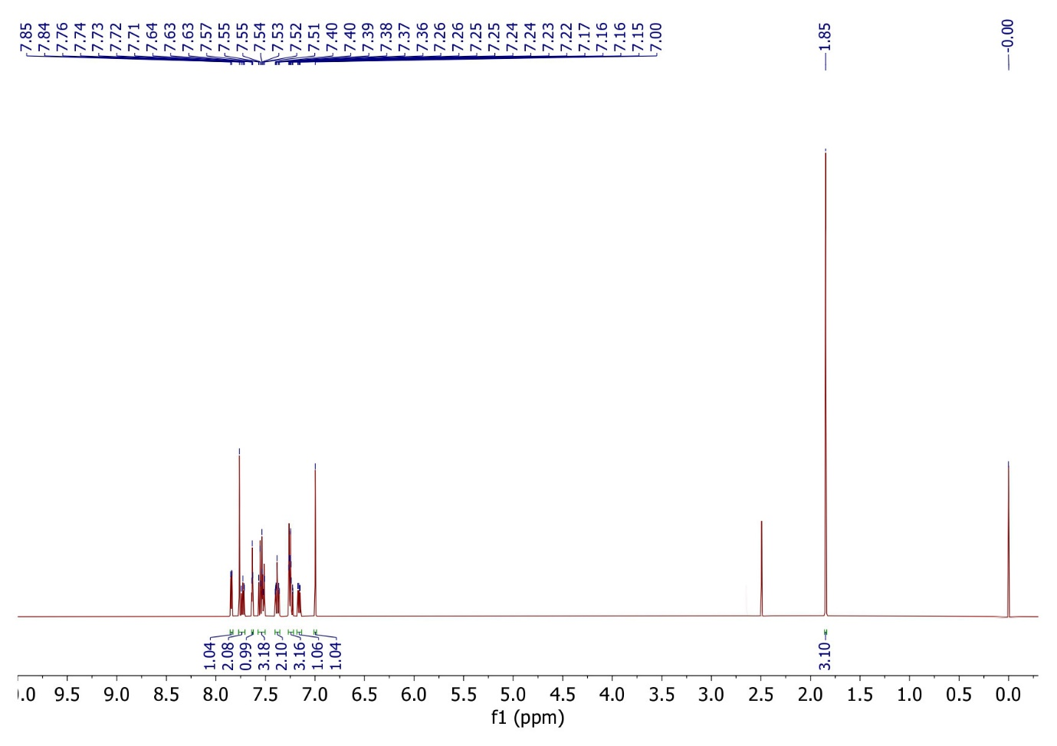
¹H NMR spectra of compound 5c
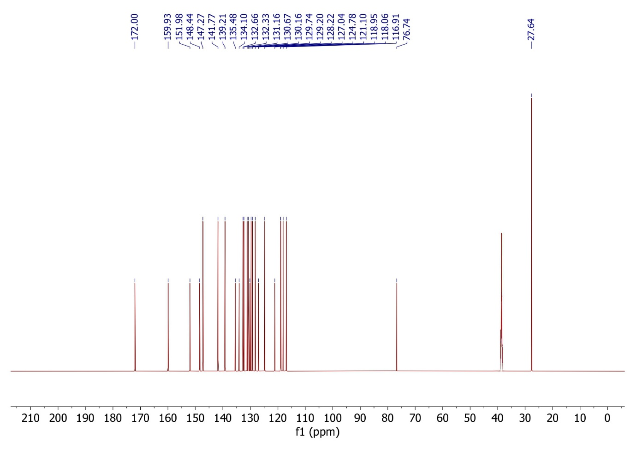
¹³C NMR spectra of compound 5c
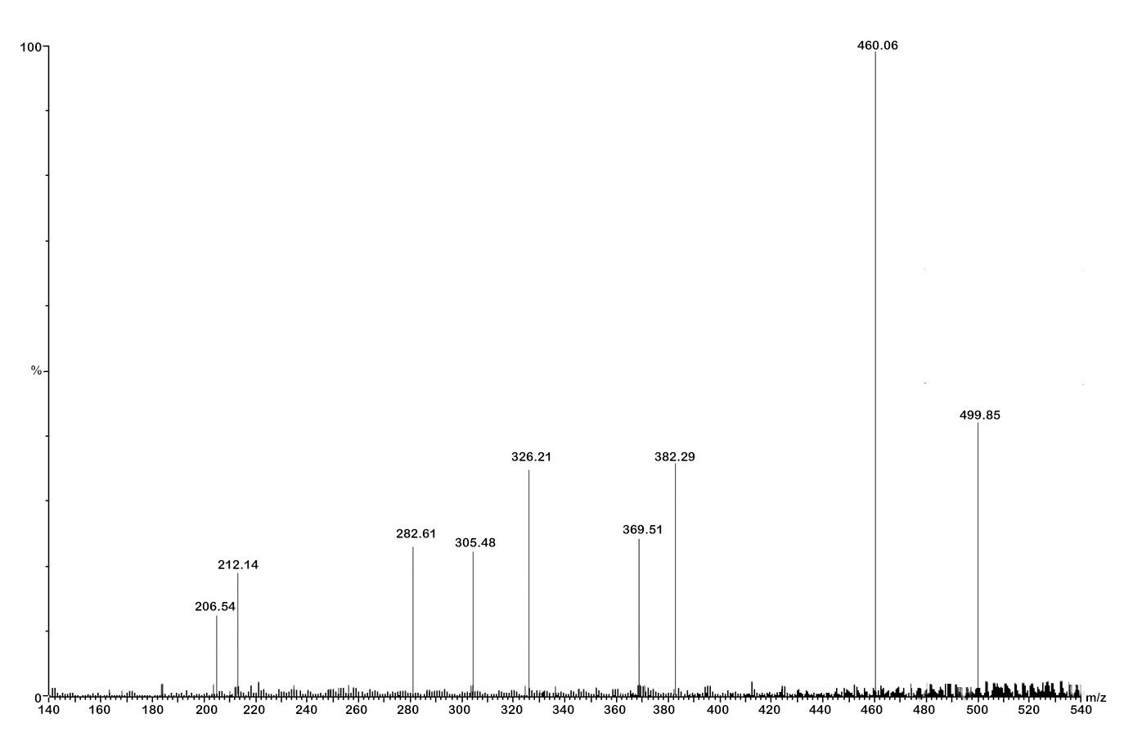
Mass spectra of compound 5c
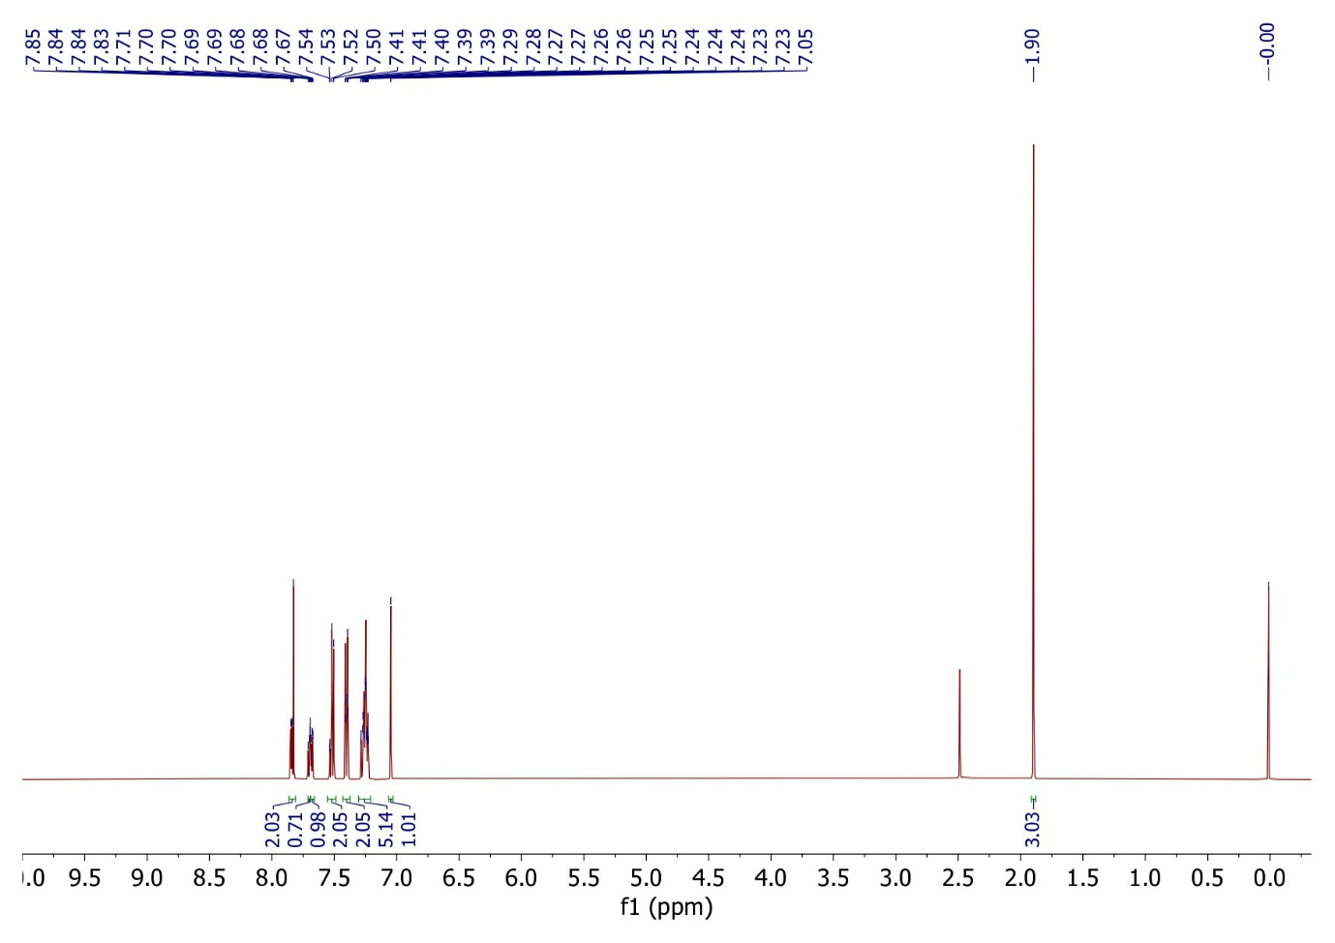
¹H NMR spectra of compound 5d
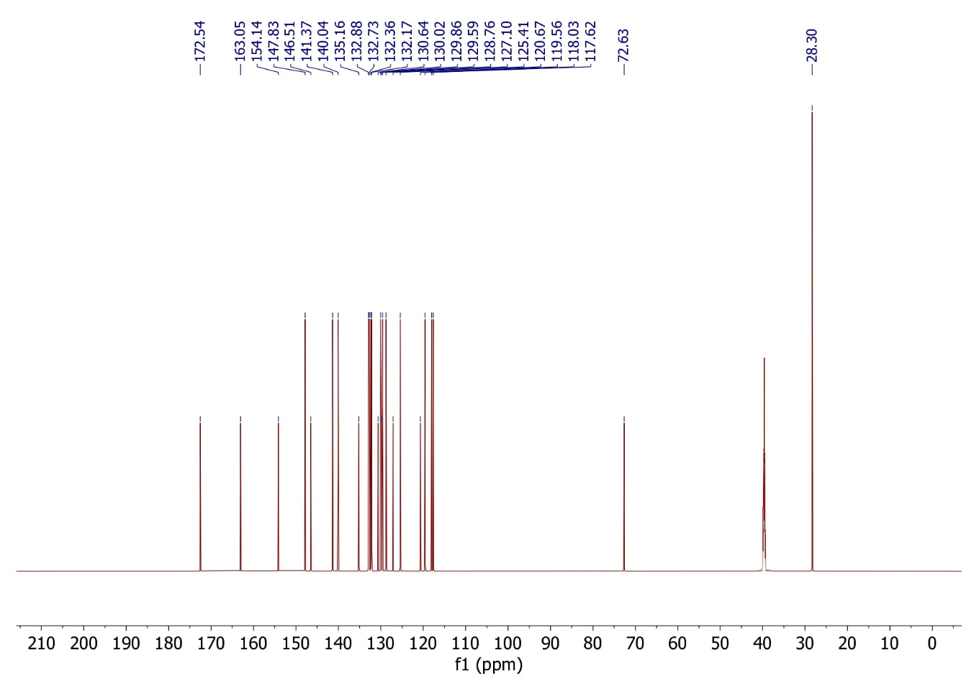
¹³C NMR spectra of compound 5d
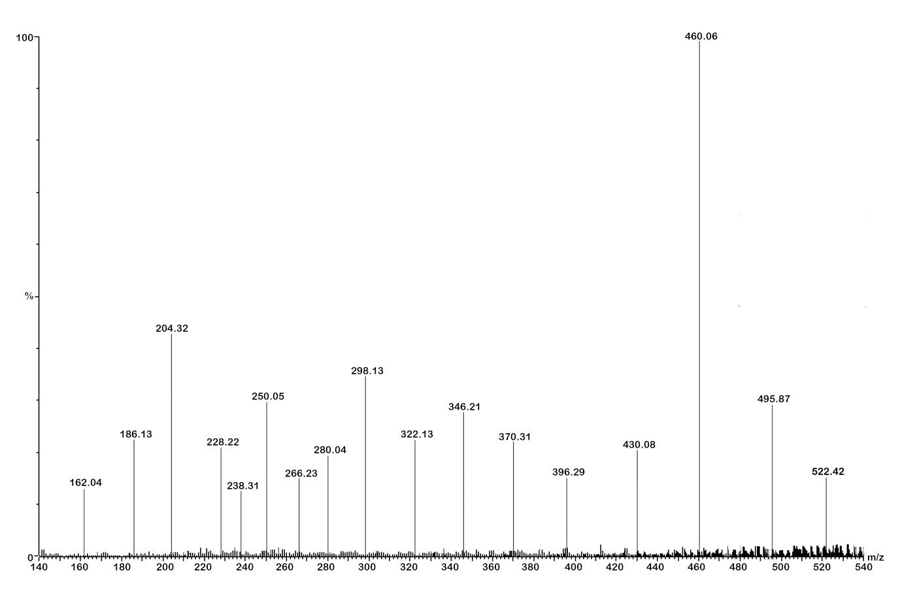
Mass spectra of compound 5d
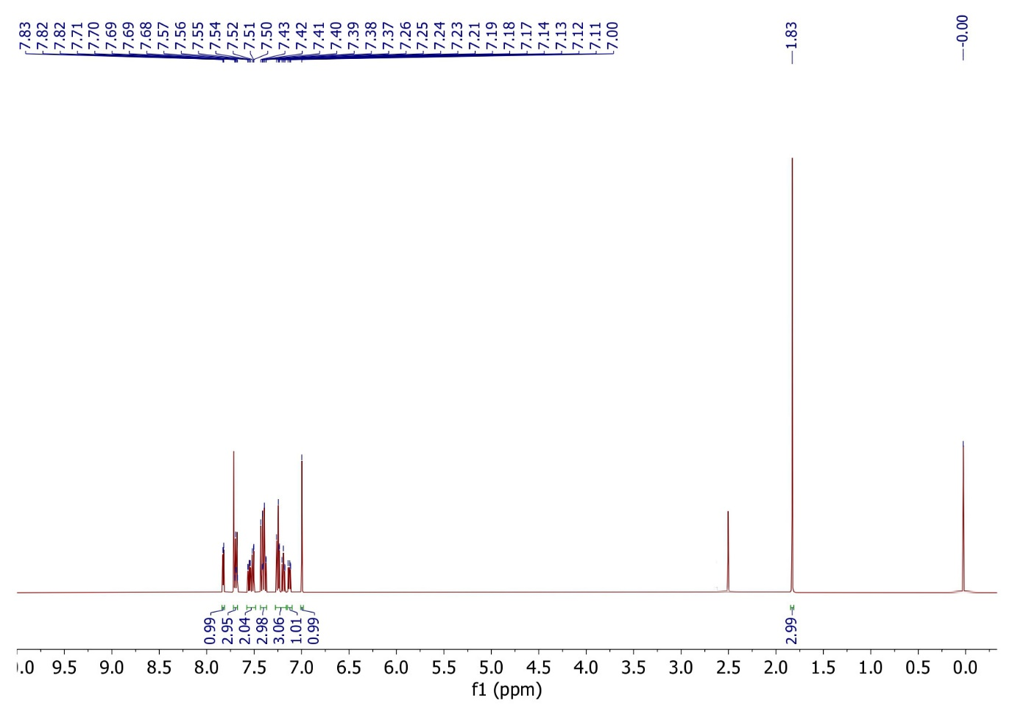
¹H NMR spectra of compound 5e
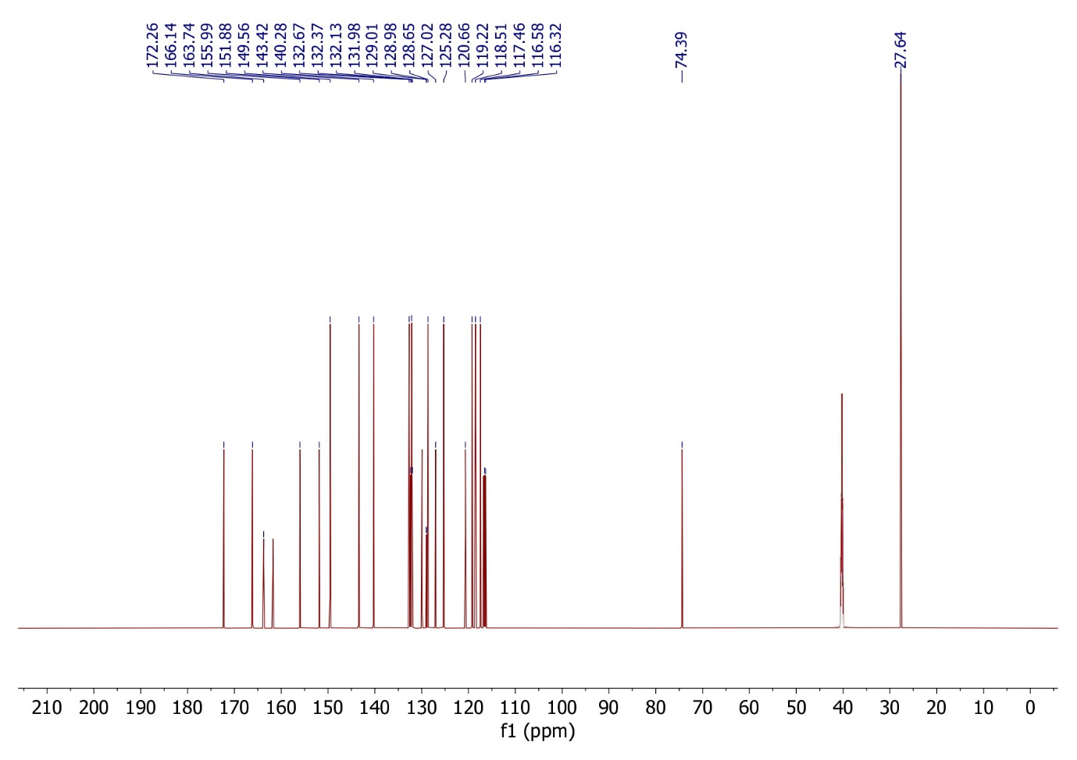
¹³C NMR spectra of compound 5e
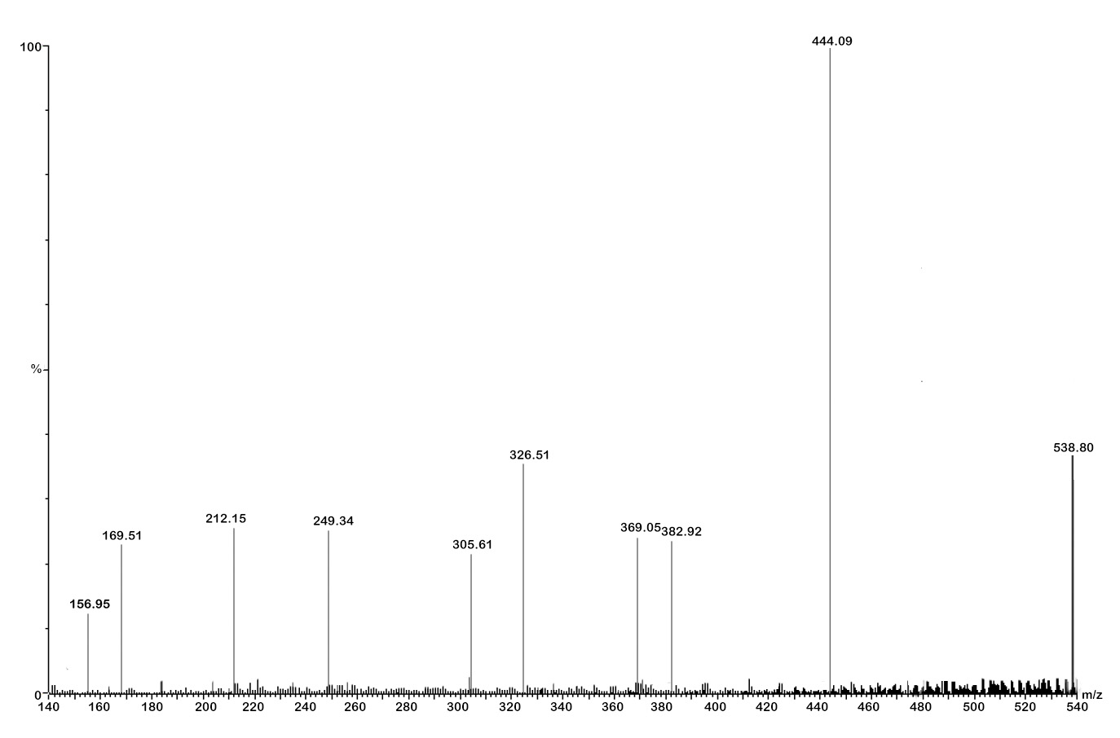
Mass spectra of compound 5e
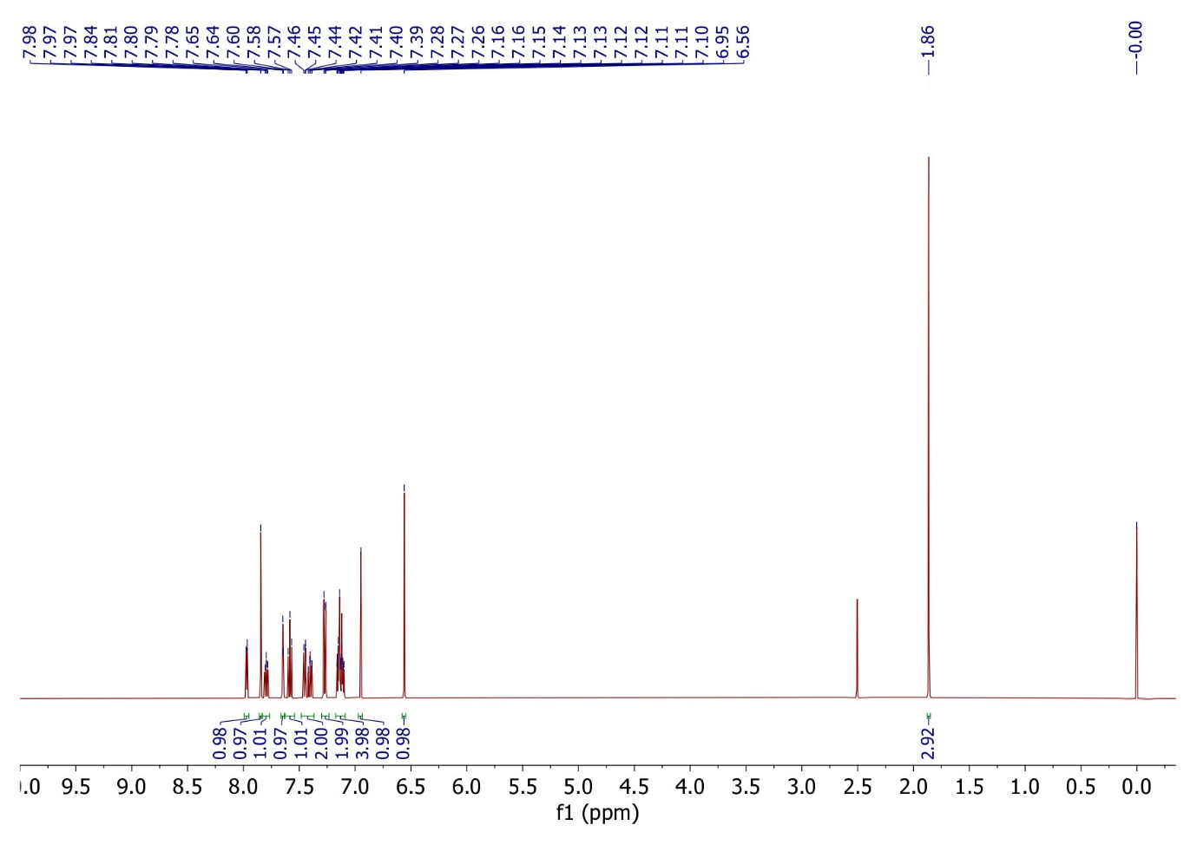
¹H NMR spectra of compound 5f
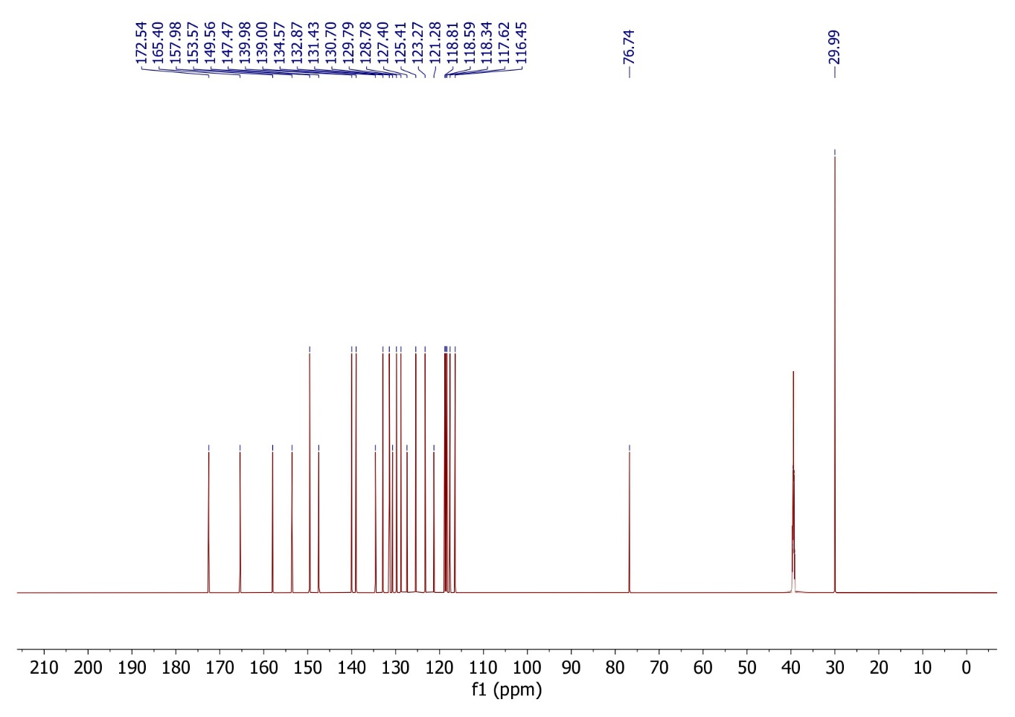
¹³C NMR spectra of compound 5f
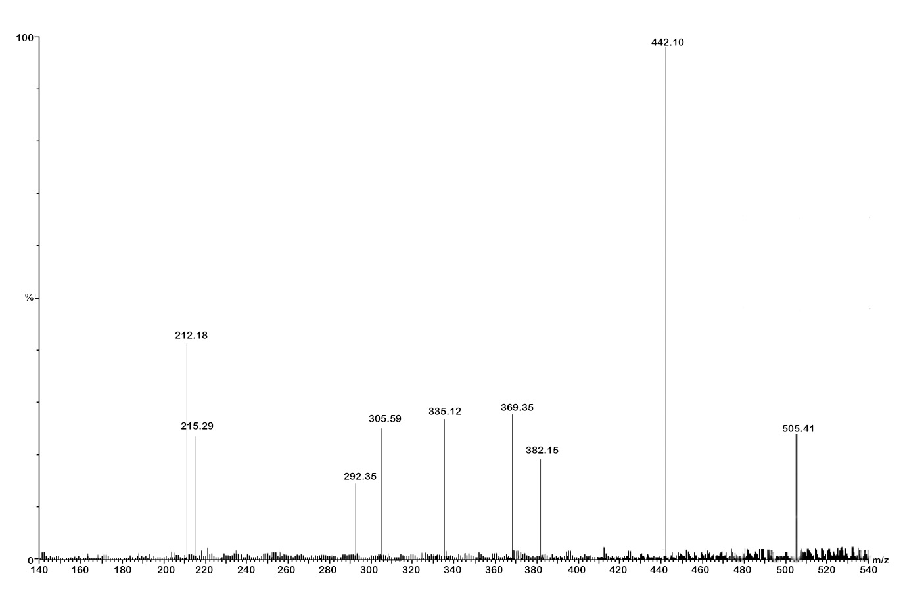
Mass spectra of compound 5f
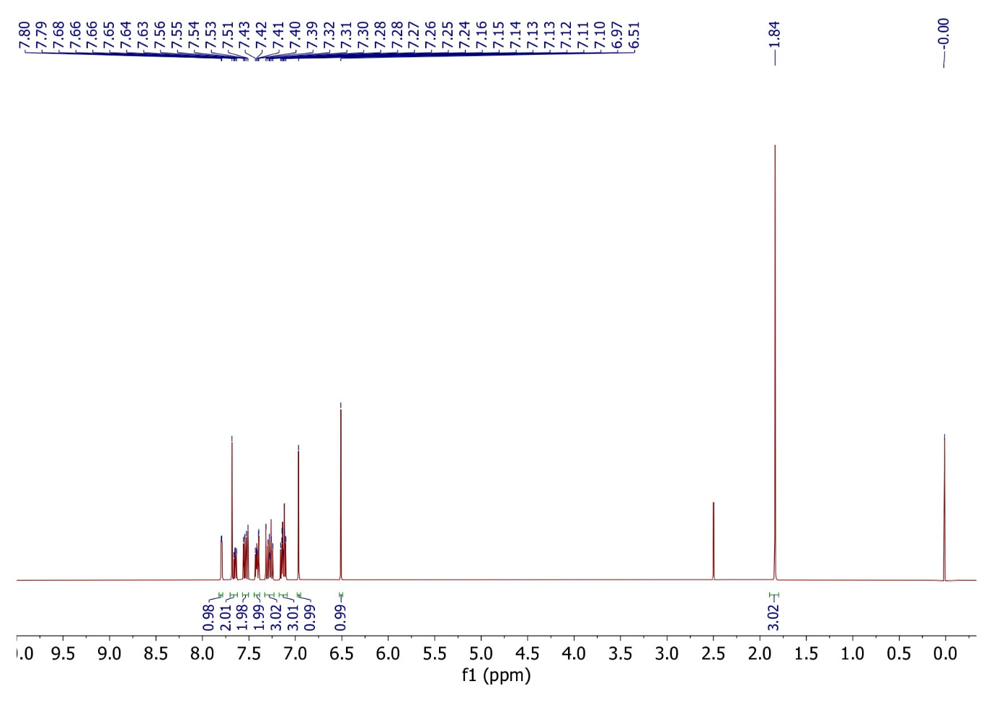
¹H NMR spectra of compound 5g
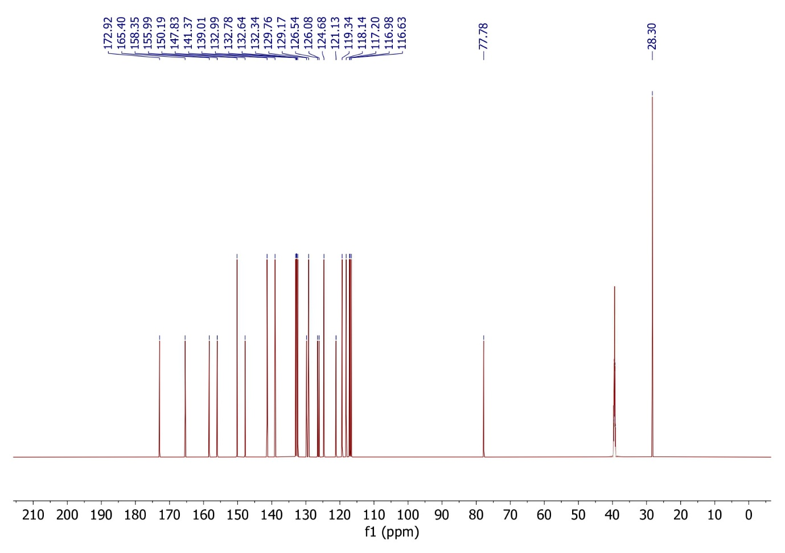
¹³C NMR spectra of compound 5g
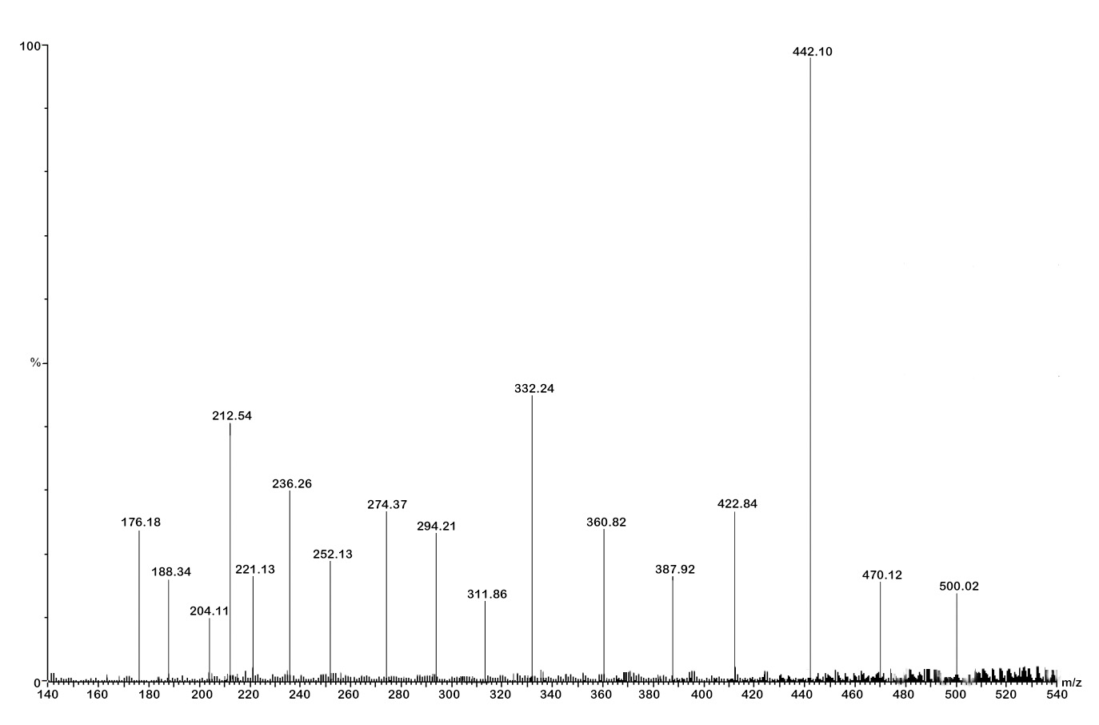
Mass spectra of compound 5g
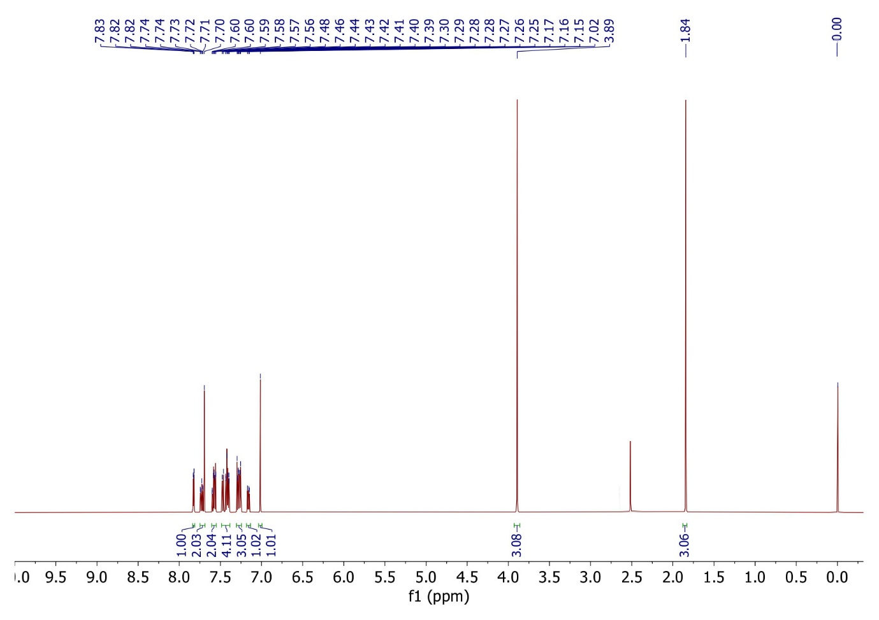
¹H NMR spectra of compound 5h
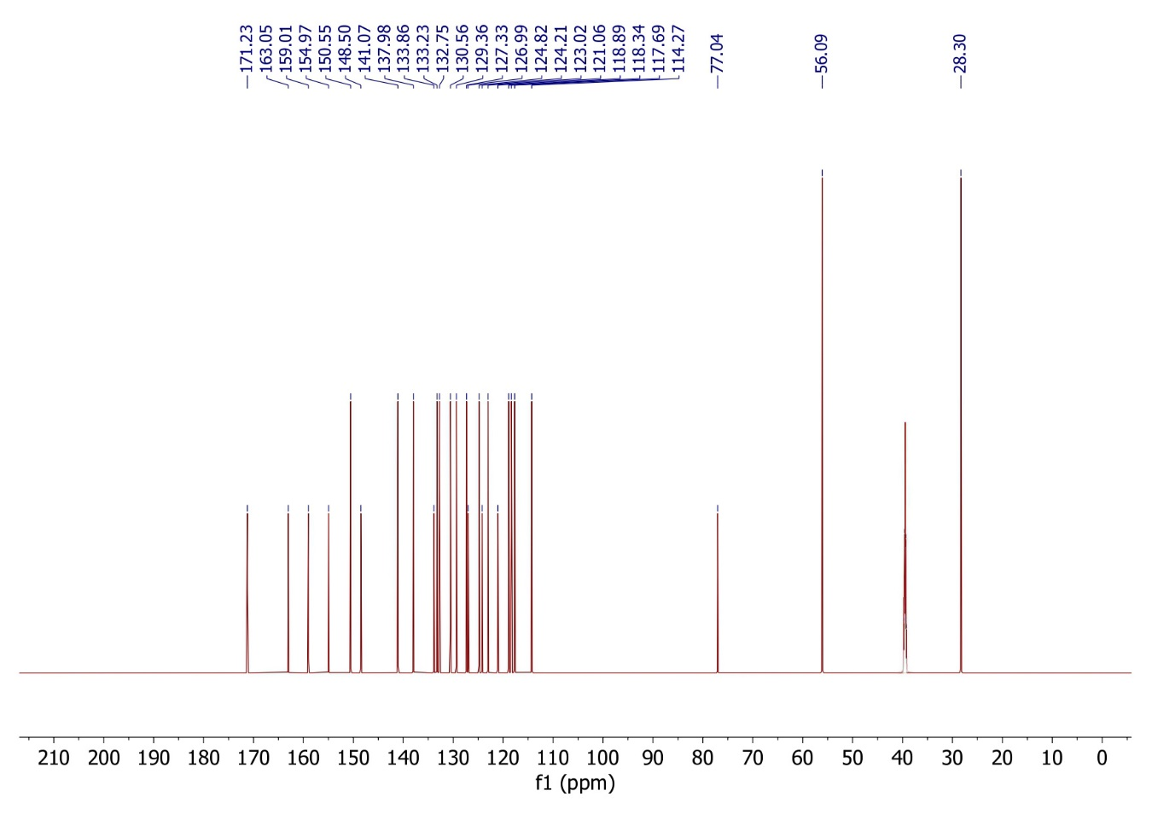
¹³C NMR spectra of compound 5h
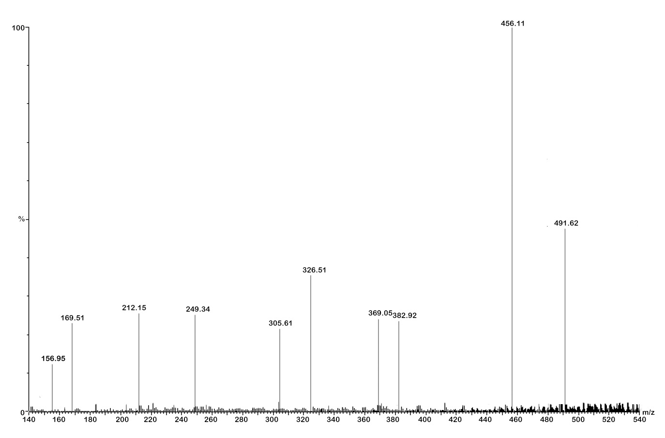
Mass spectra of compound 5h
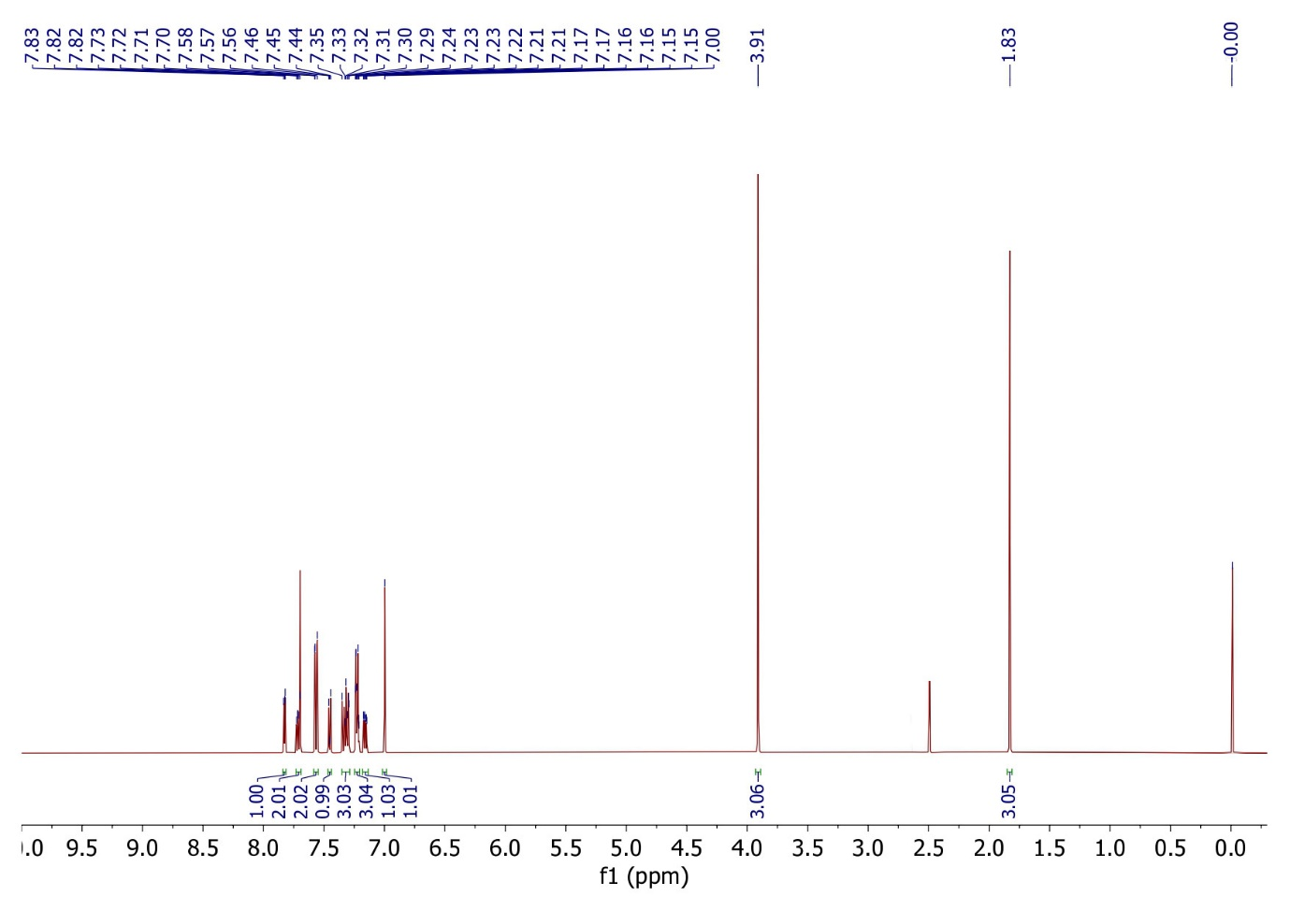
¹H NMR spectra of compound 5i
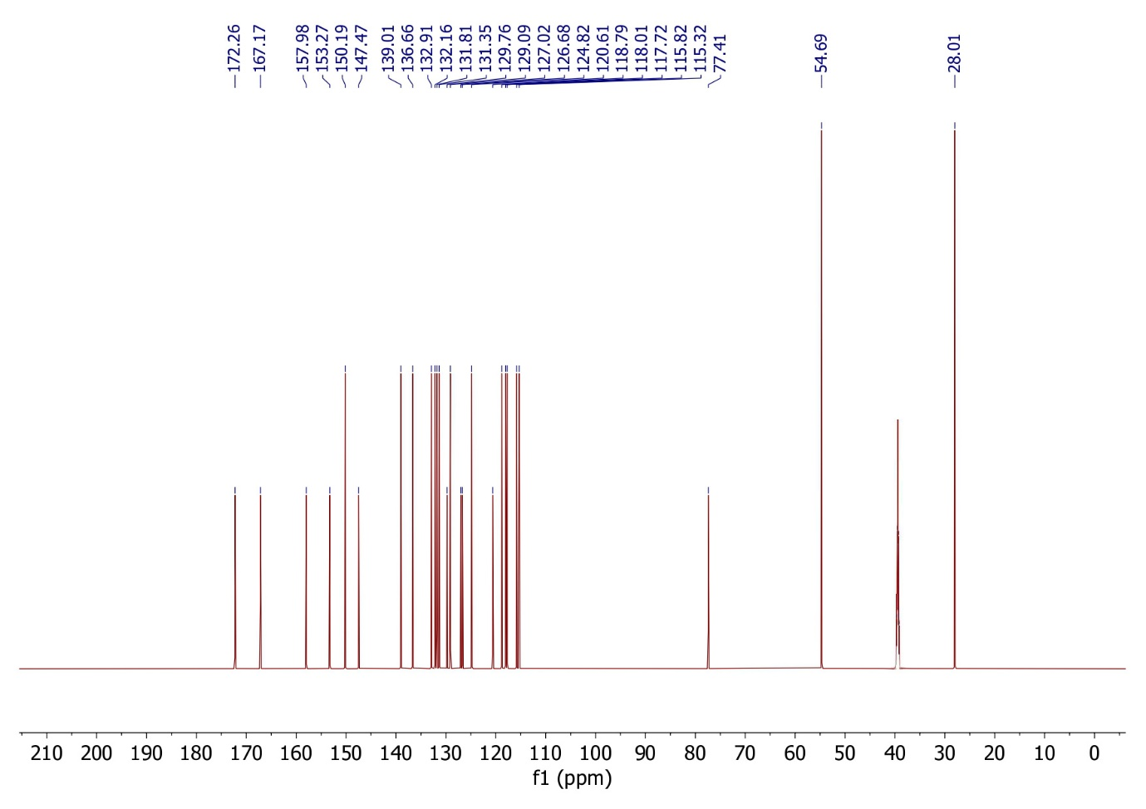
¹³C NMR spectra of compound 5i
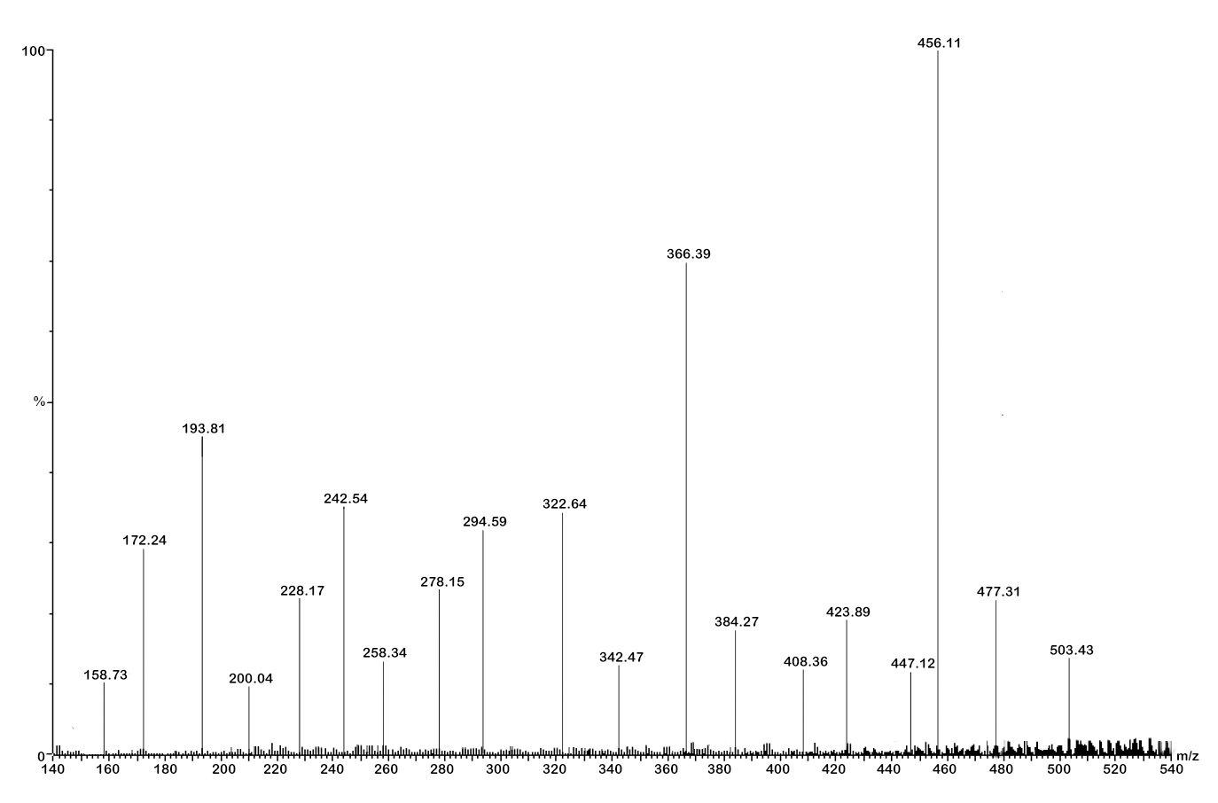
Mass spectra of compound 5i
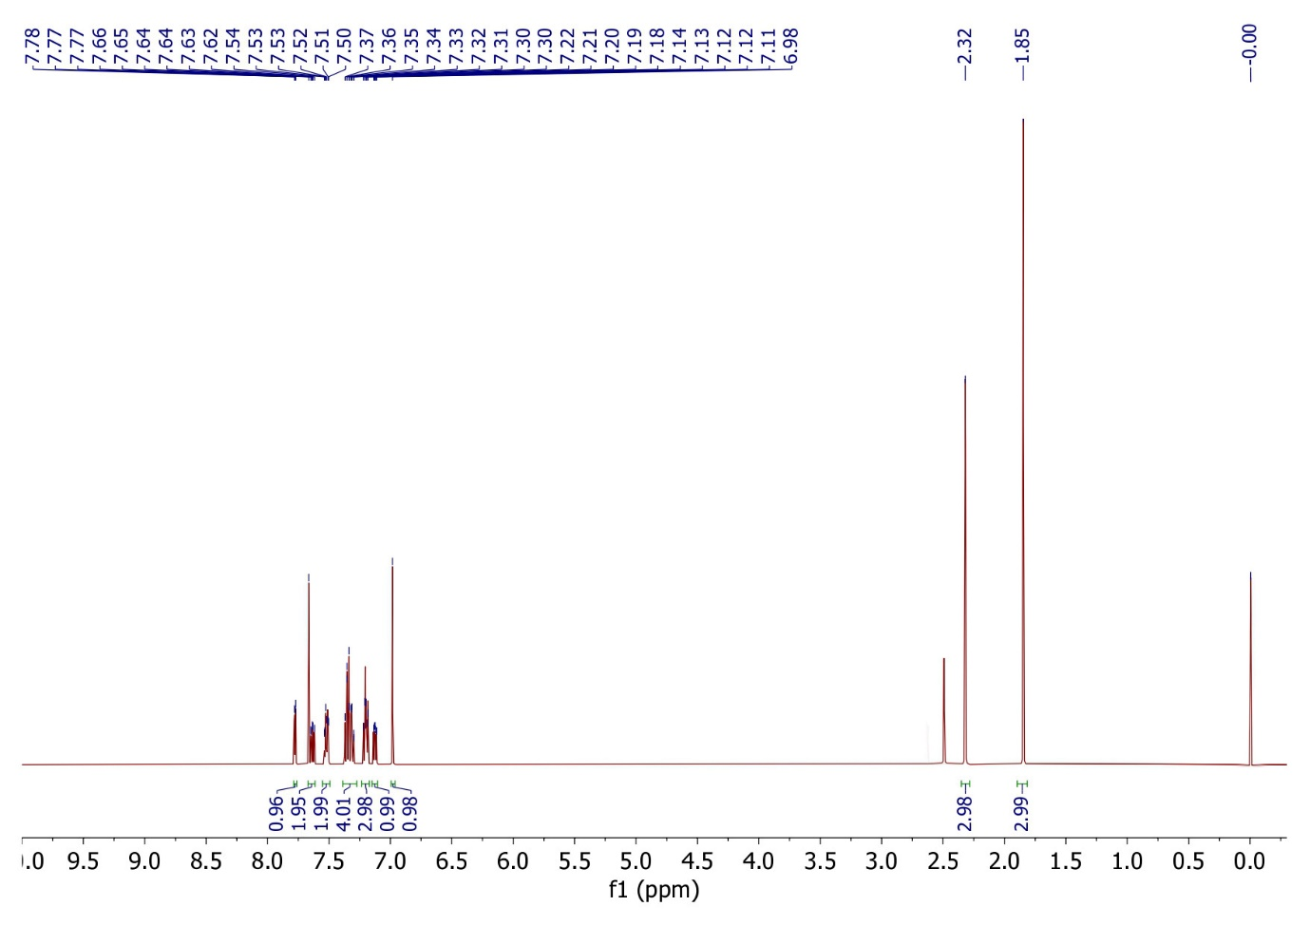
¹H NMR spectra of compound 5j
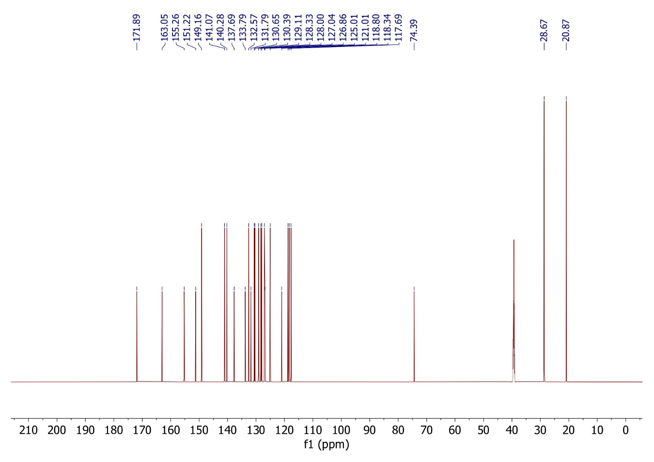
¹³C NMR spectra of compound 5j
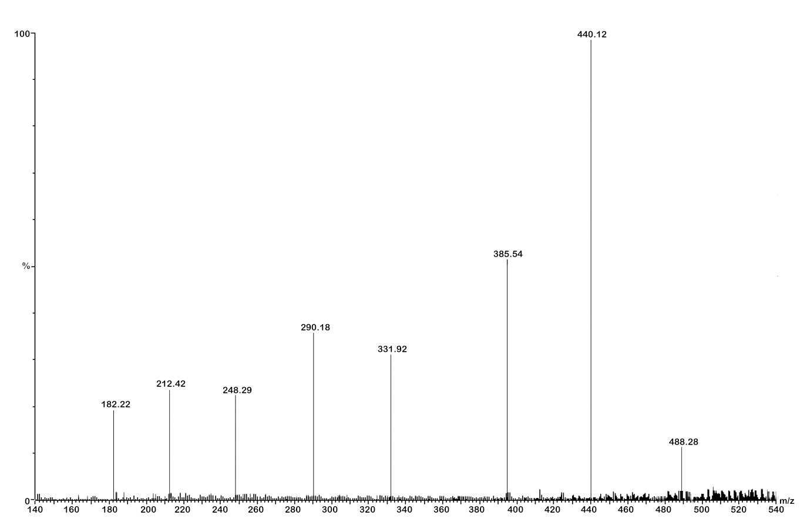
Mass spectra of compound 5j
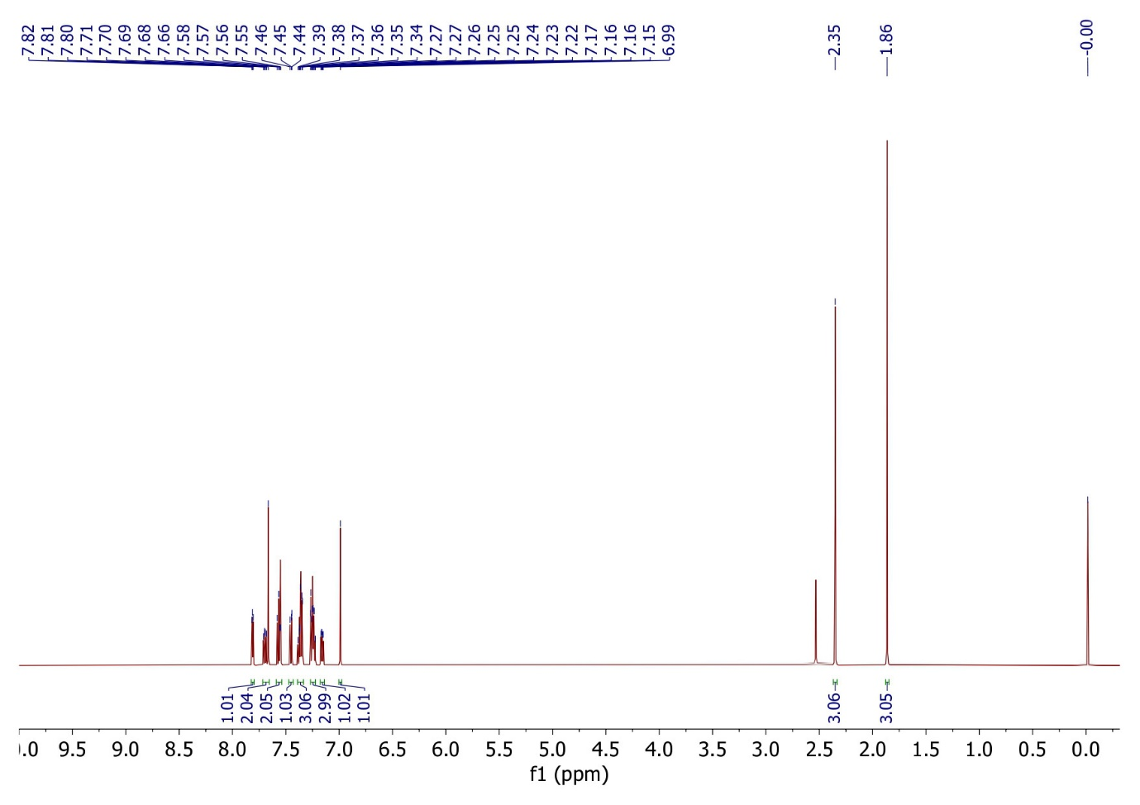
¹H NMR spectra of compound 5k
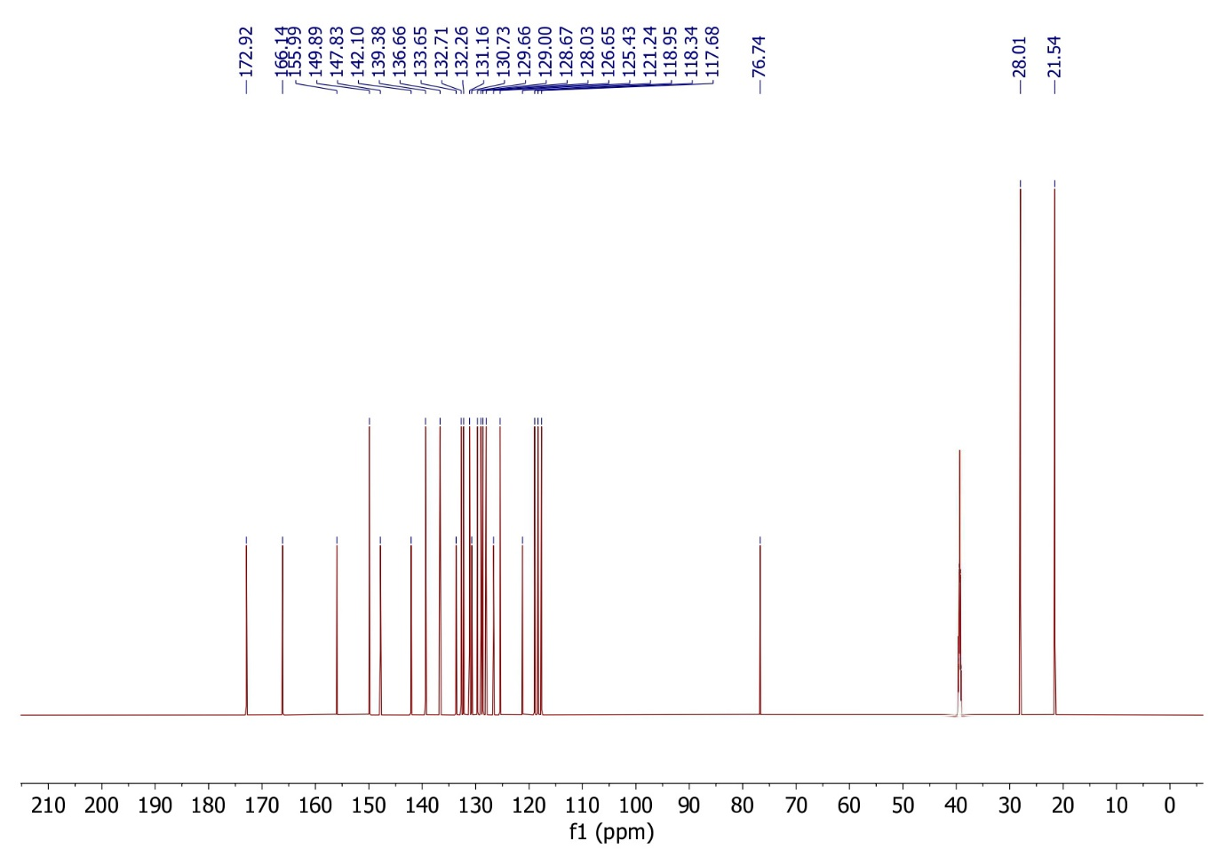
¹³C NMR spectra of compound 5k
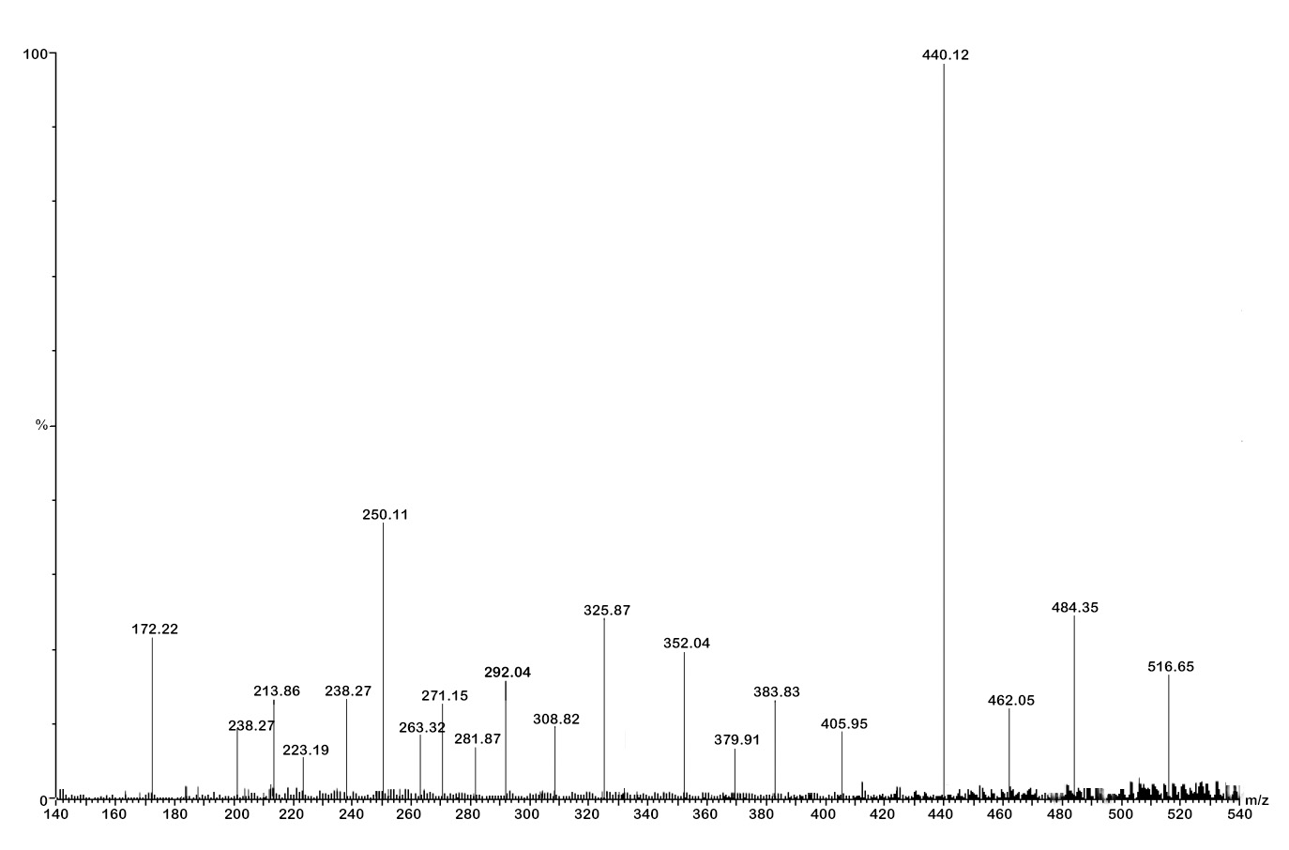
Mass spectra of compound 5k
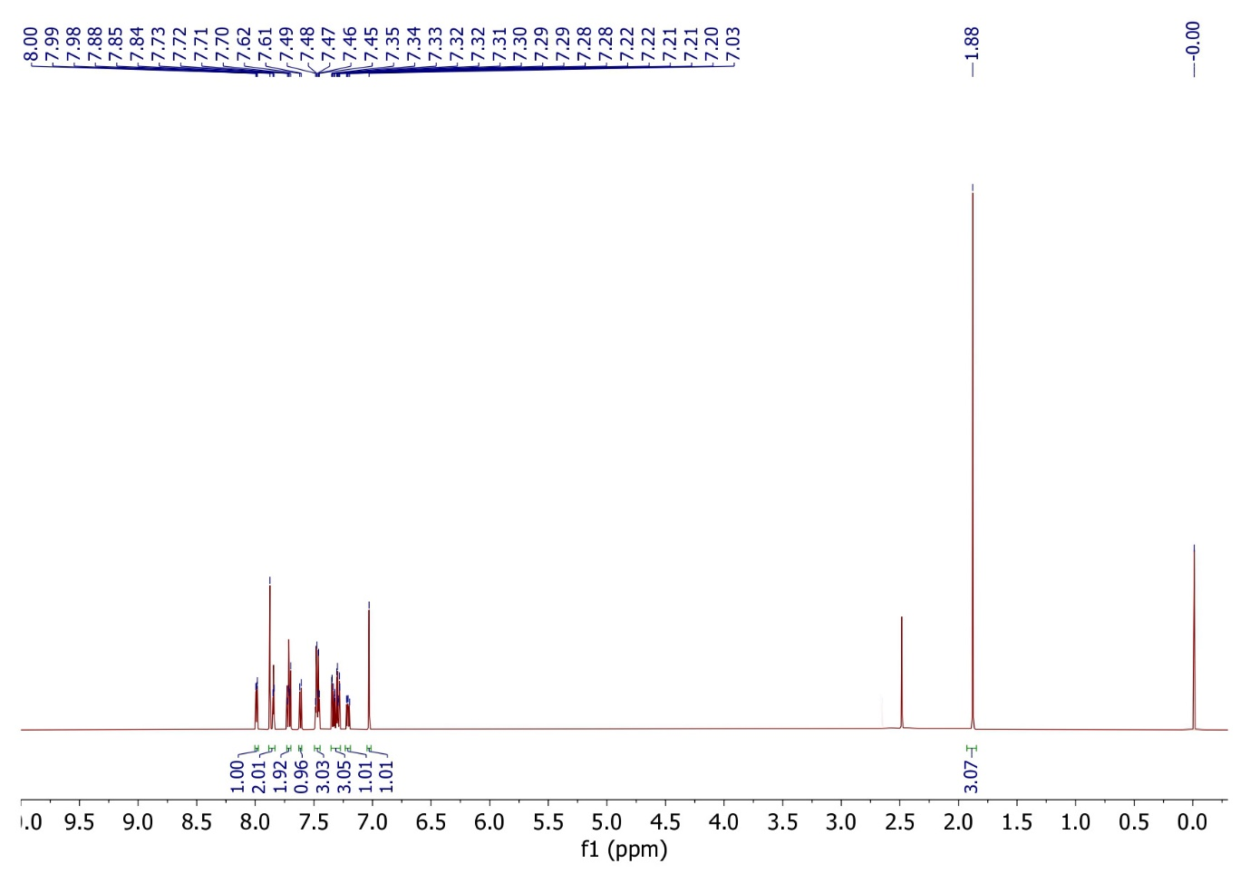
¹H NMR spectra of compound 5l
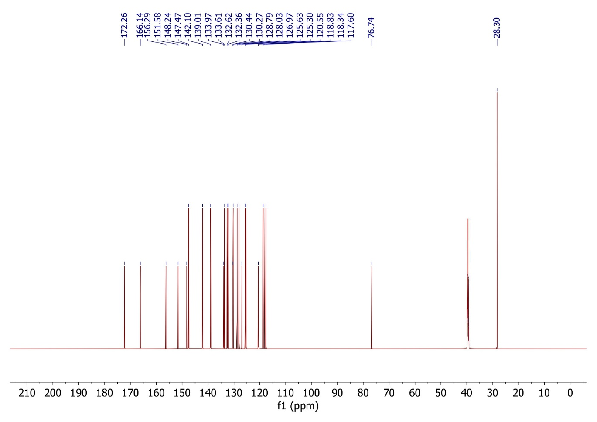
¹³C NMR spectra of compound 5l
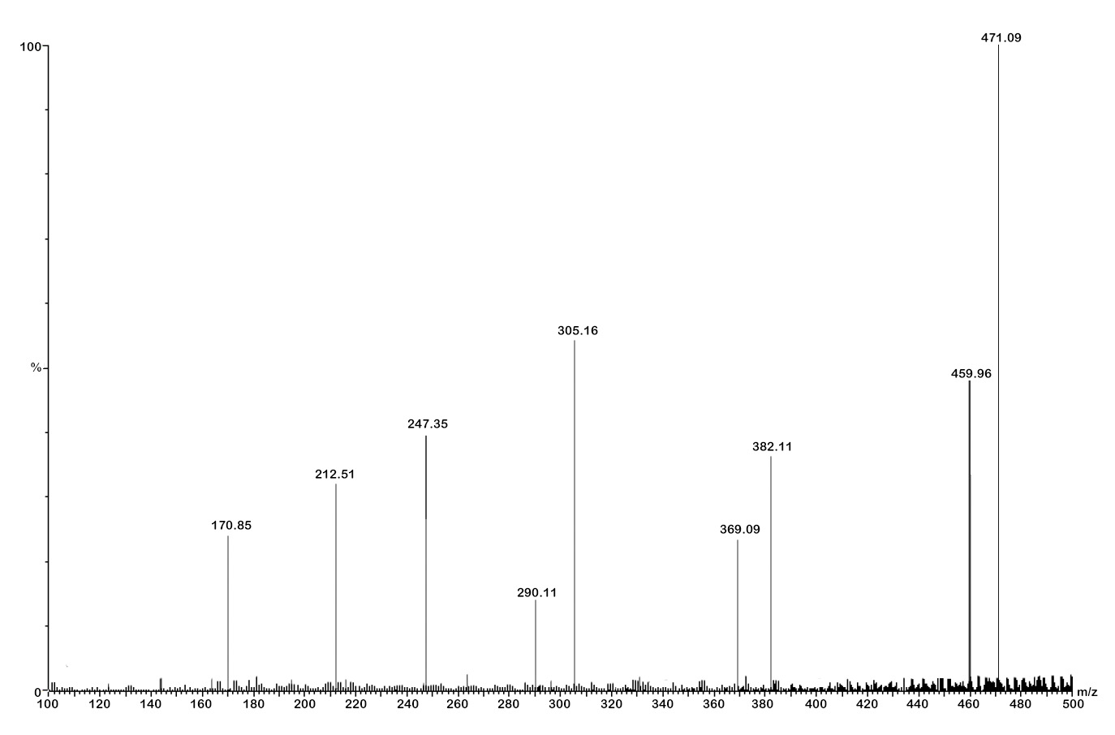
Mass spectra of compound 5l
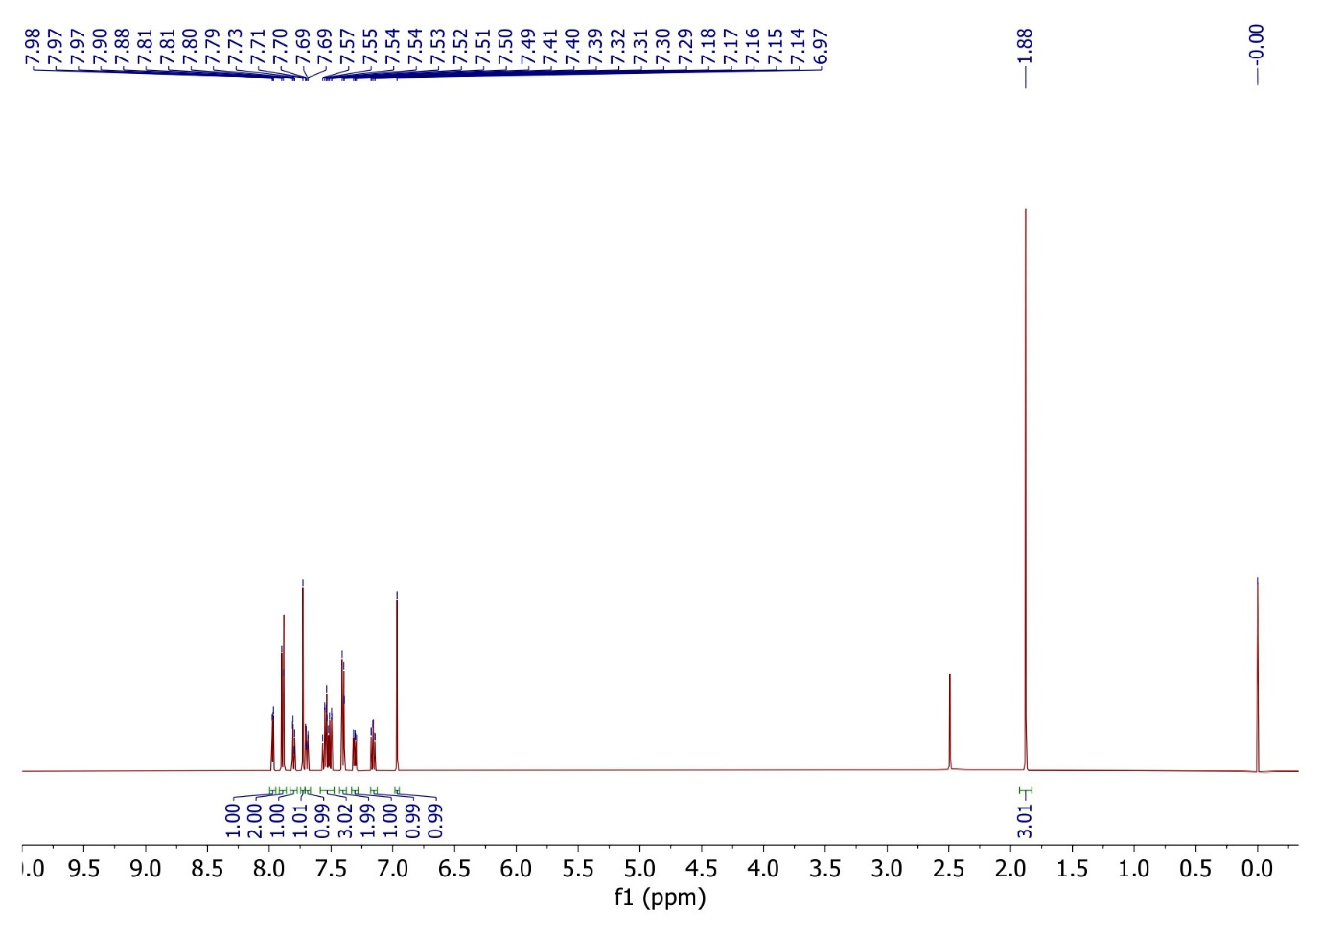
¹H NMR spectra of compound 5m
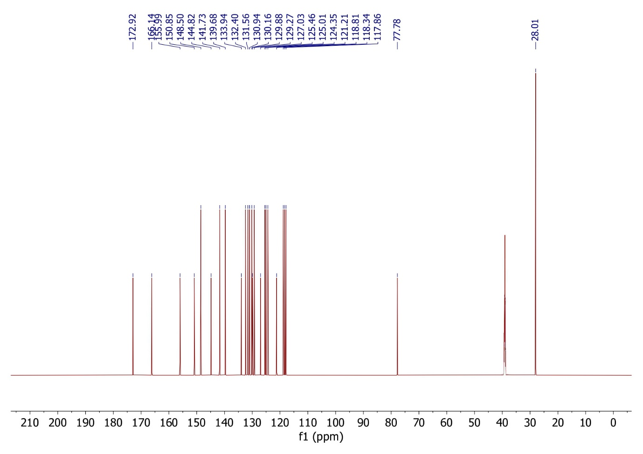
¹³C NMR spectra of compound 5m
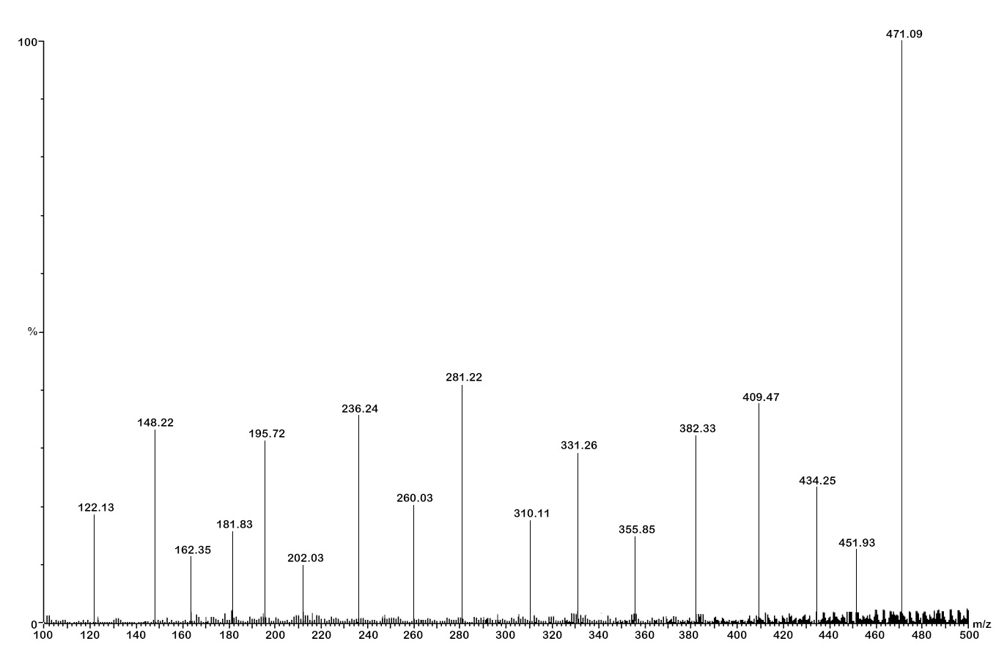
Mass spectra of compound 5m
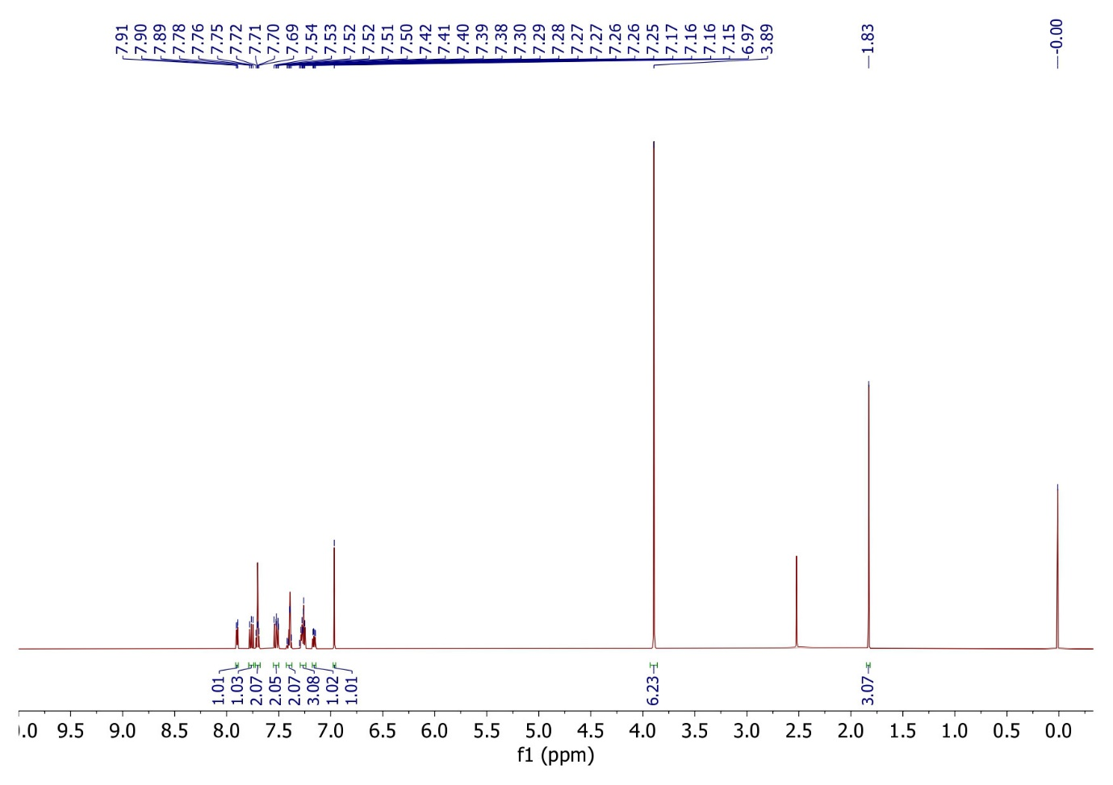
¹H NMR spectra of compound 5n
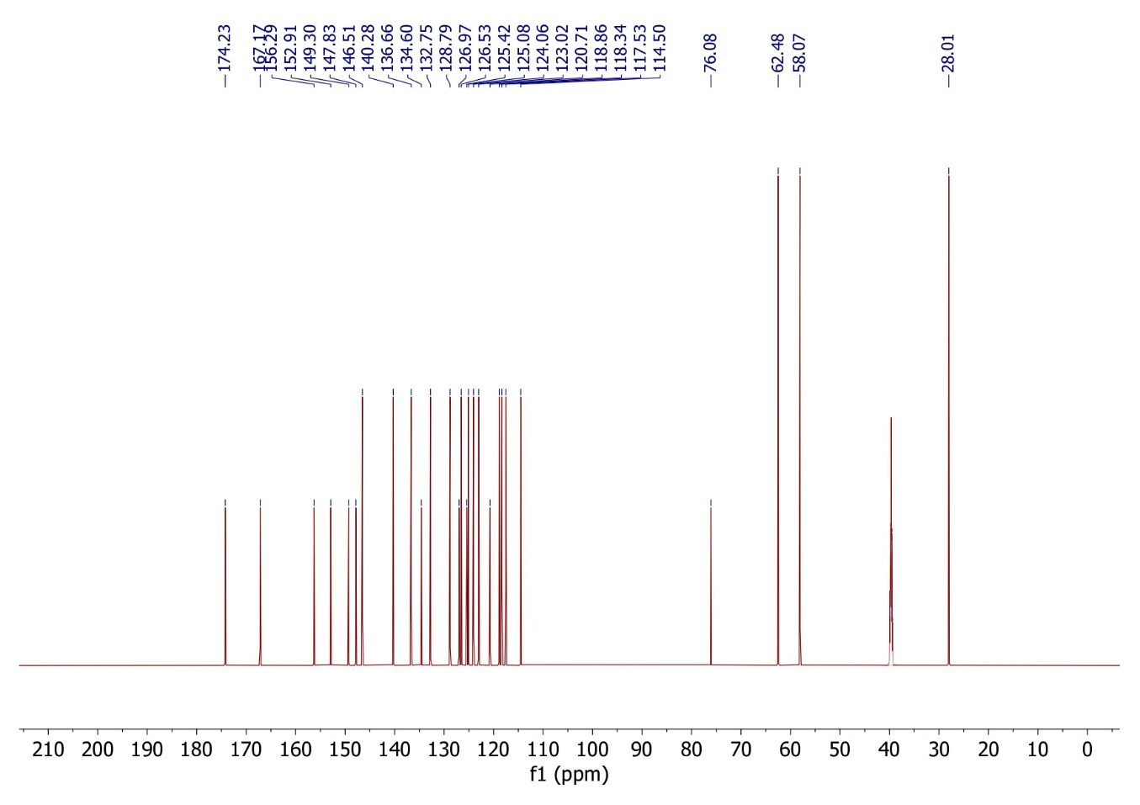
¹³C NMR spectra of compound 5n
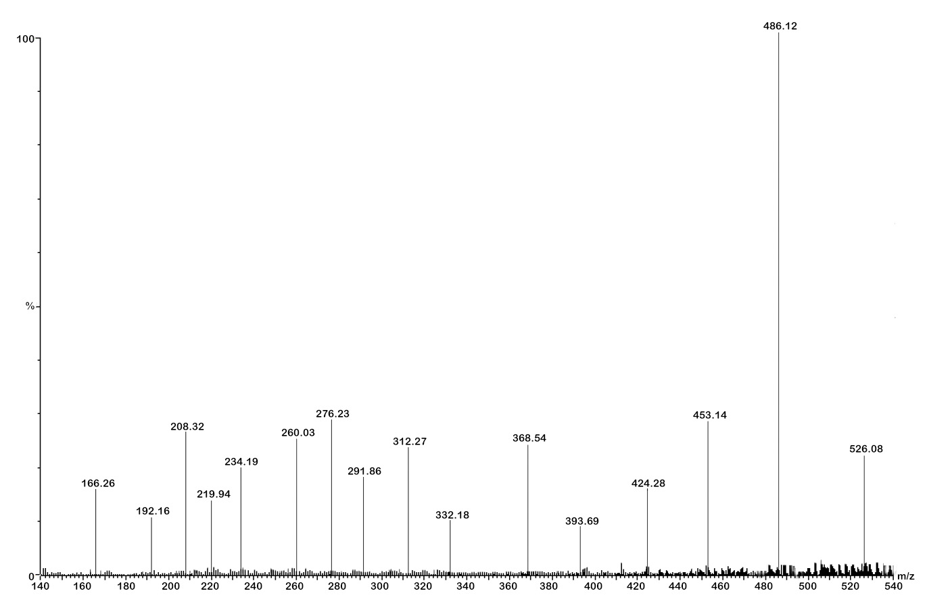
Mass spectra of compound 5n
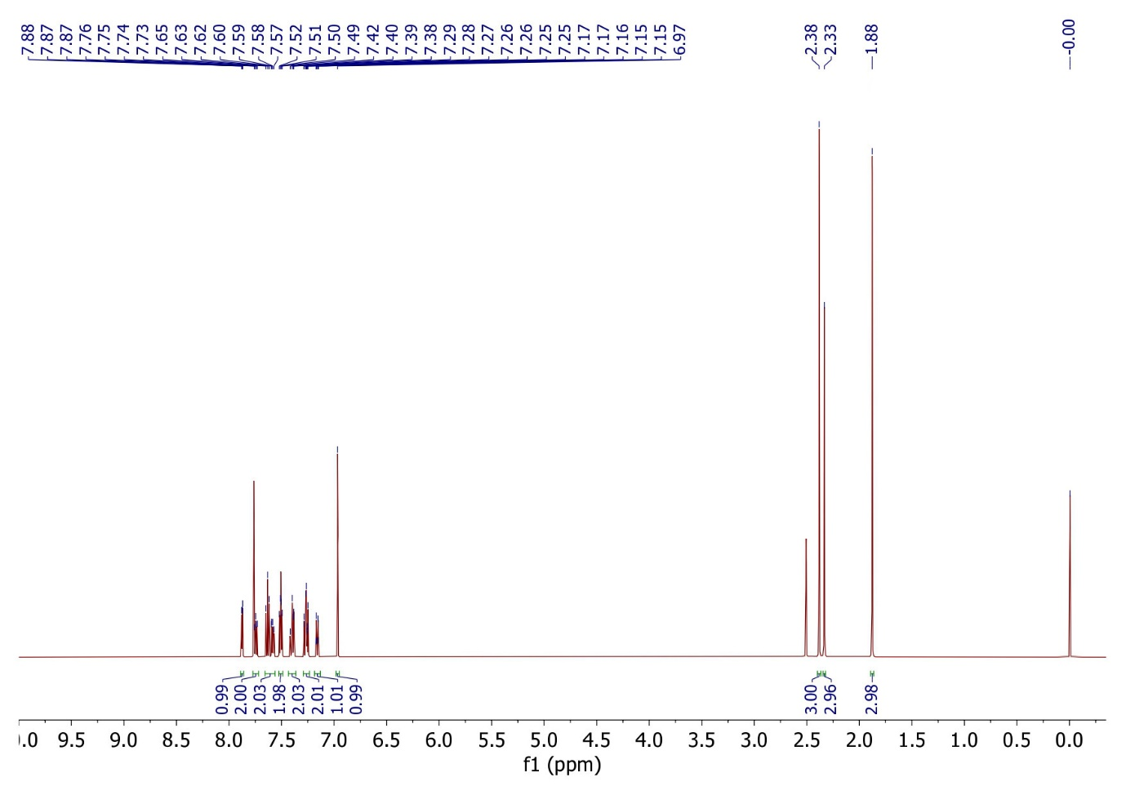
¹H NMR spectra of compound 5o
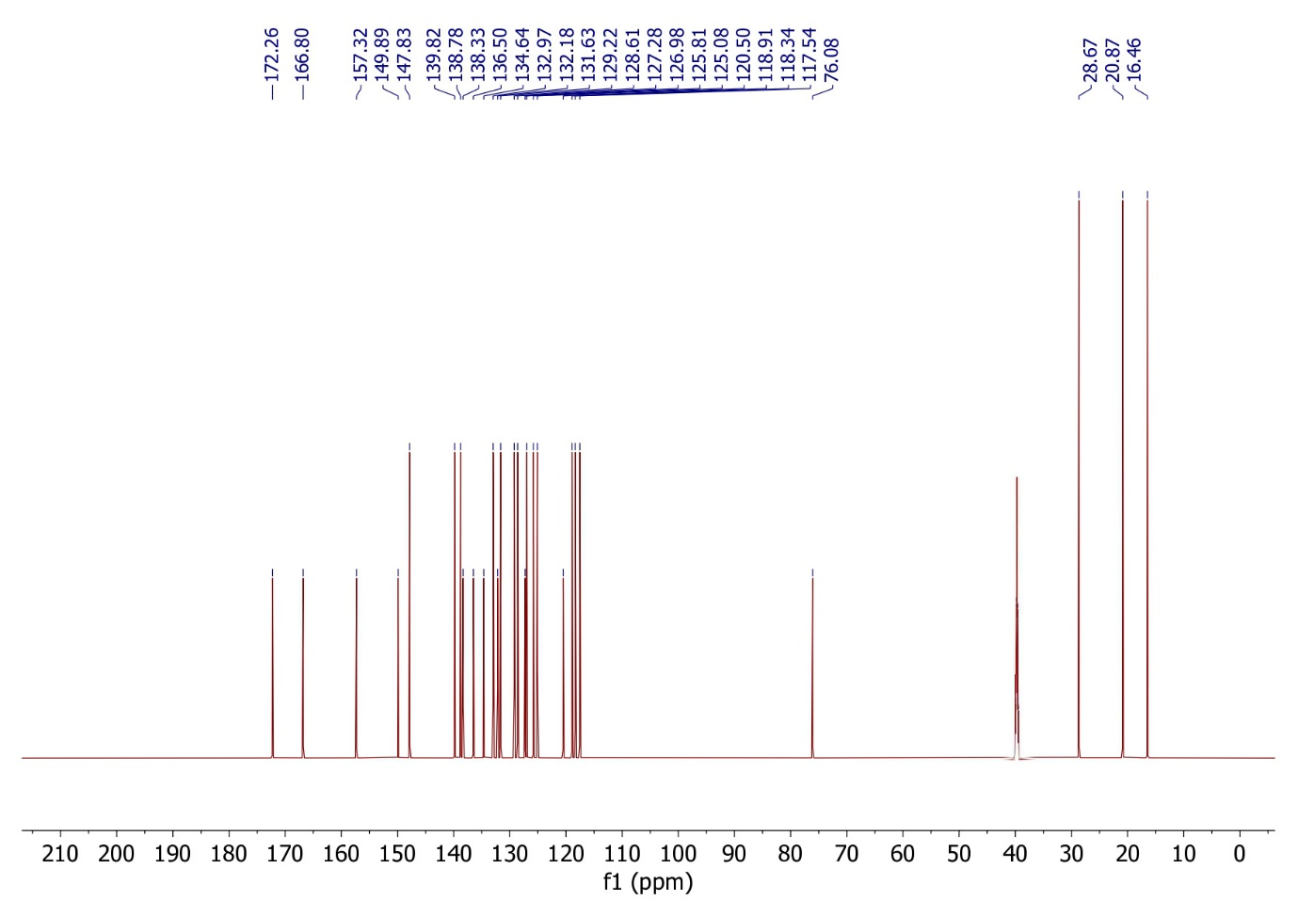
¹³C NMR spectra of compound 5o
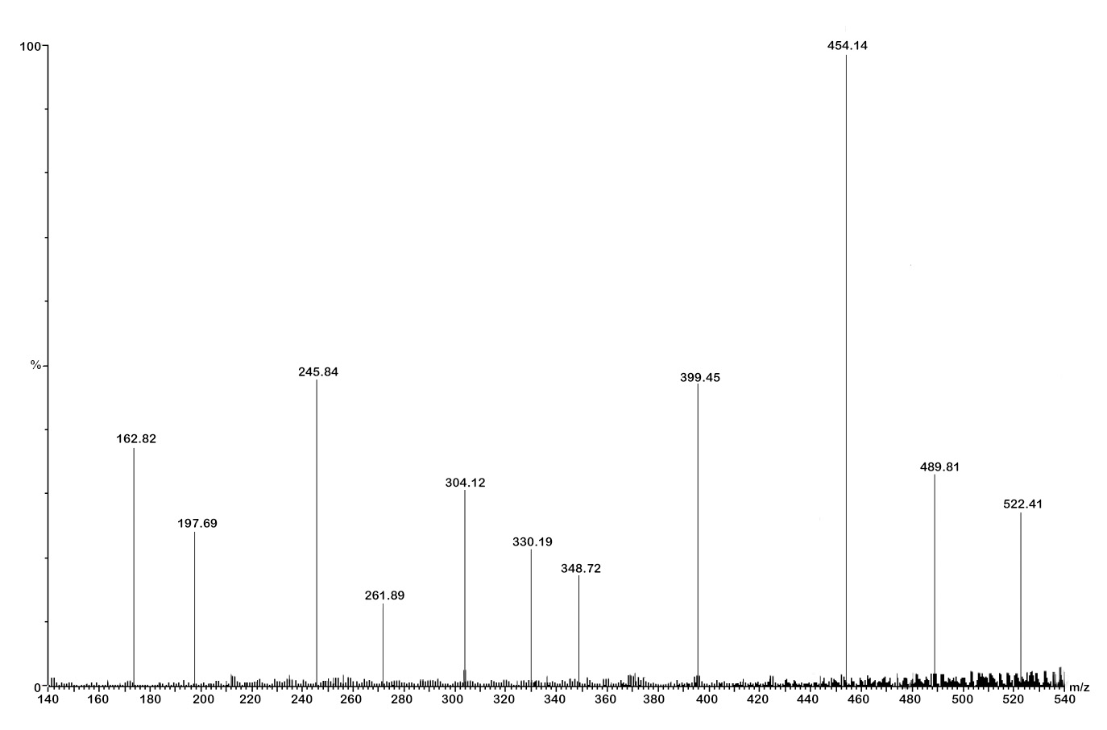
Mass spectra of compound 5o

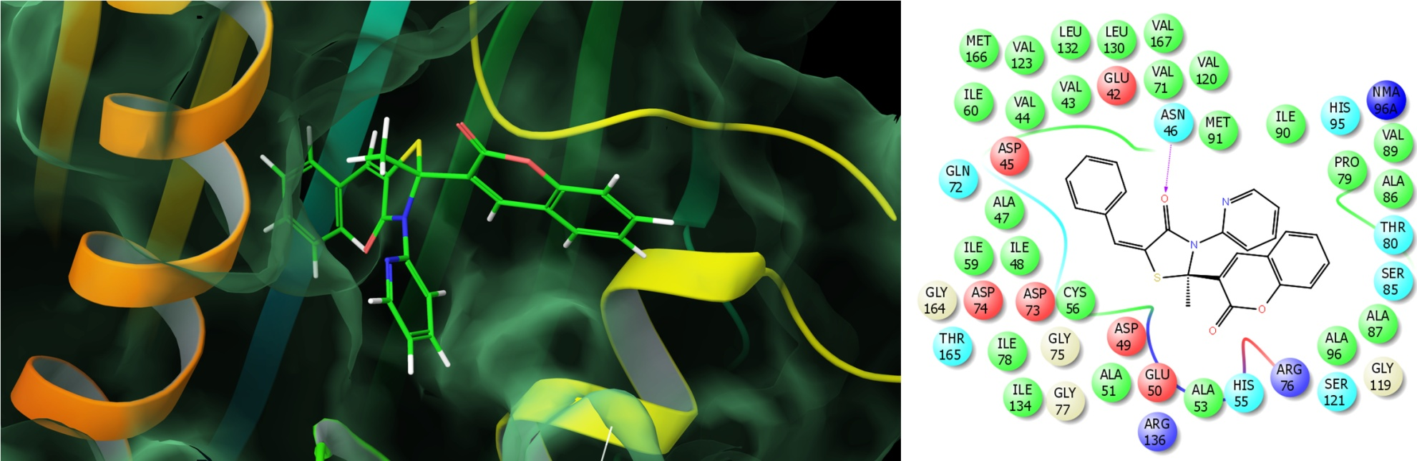
Figure 1S: Molecule 5a docked at the active site of DNA gyrase; 2D interactions on right side showing the hydrogen bonding interactions

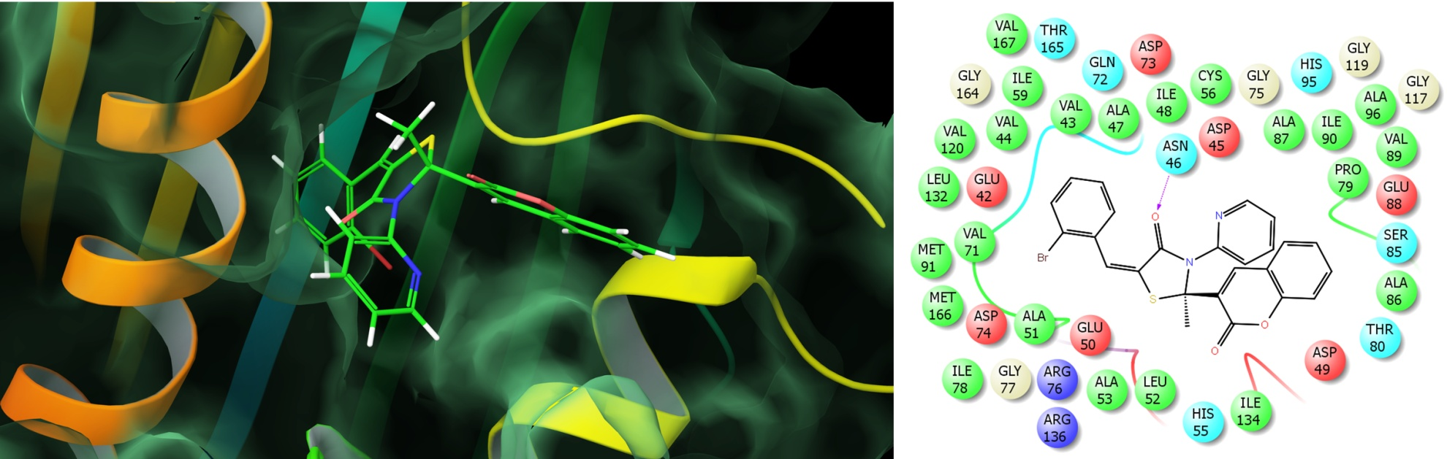
Figure 2S: Molecule 5b docked at the active site of DNA gyrase; 2D interactions on right side showing the hydrogen bonding interactions

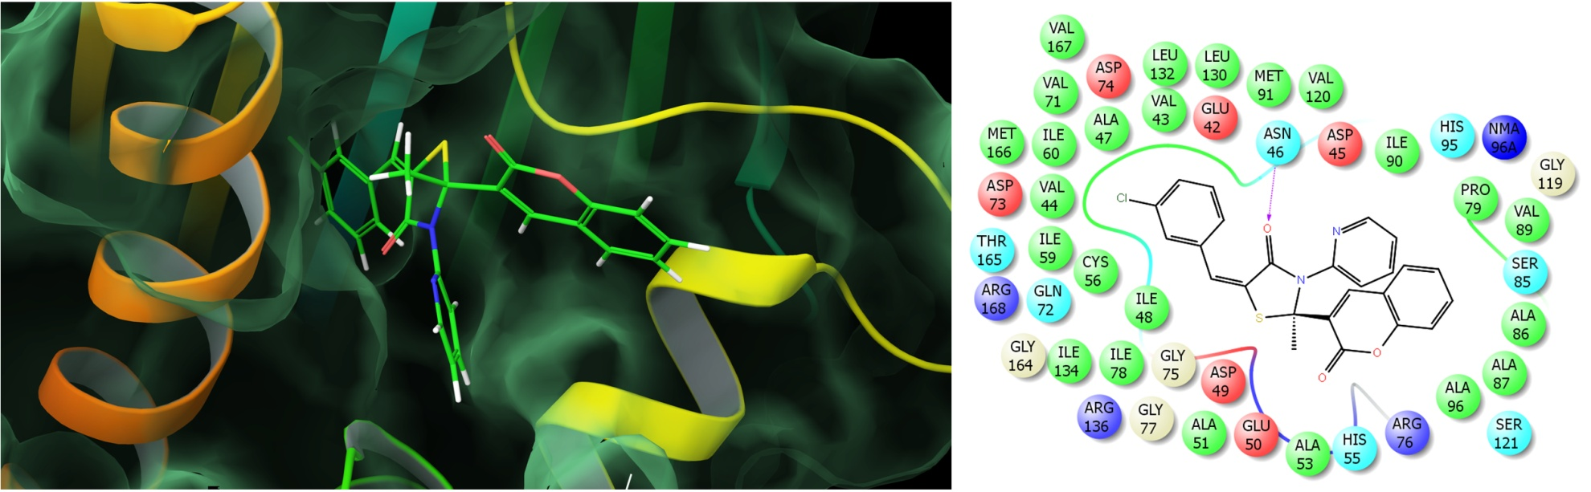
Figure 3S: Molecule 5c docked at the active site of DNA gyrase; 2D interactions on right side showing the hydrogen bonding interactions

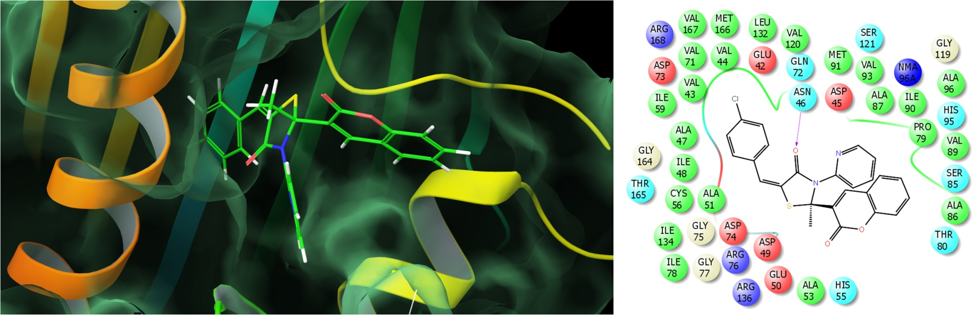
Figure 4S: Molecule 5d docked at the active site of DNA gyrase; 2D interactions on right side showing the hydrogen bonding interactions

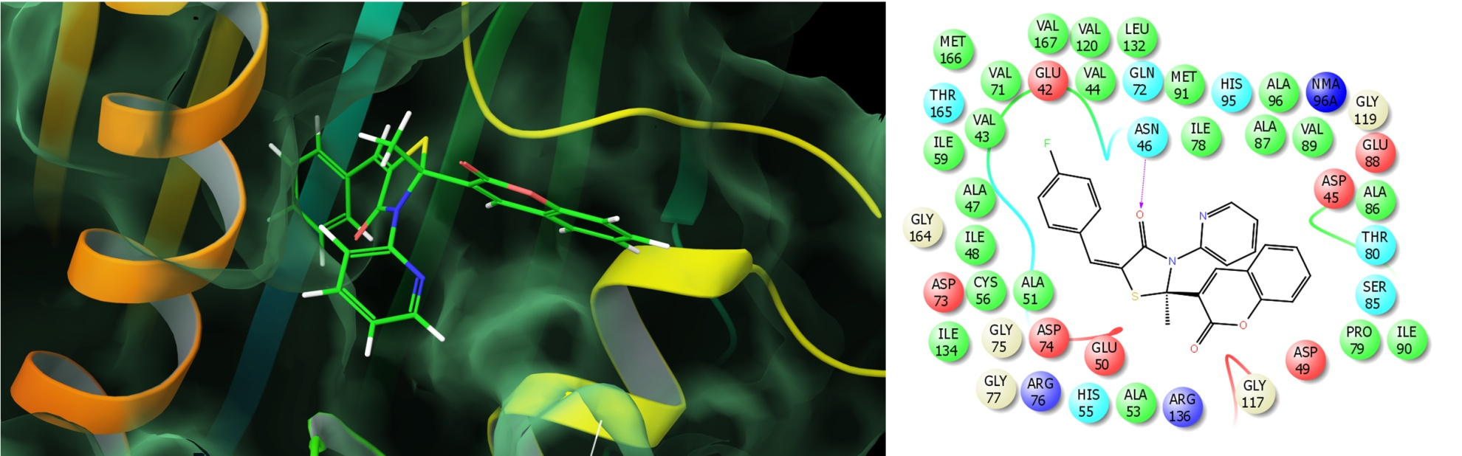
Figure 5S: Molecule 5e docked at the active site of DNA gyrase; 2D interactions on right side showing the hydrogen bonding interactions

Figure 6S: Molecule 5f docked at the active site of DNA gyrase; 2D interactions on right side showing the hydrogen bonding interactions

Figure 7S: Molecule 5g docked at the active site of DNA gyrase; 2D interactions on right side showing the hydrogen bonding interactions

Figure 8S: Molecule 5h docked at the active site of DNA gyrase; 2D interactions on right side showing the hydrogen bonding interactions

Figure 9S: Molecule 5i docked at the active site of DNA gyrase; 2D interactions on right side showing the hydrogen bonding interactions

Figure 10S: Molecule 5j docked at the active site of DNA gyrase; 2D interactions on right side showing the hydrogen bonding interactions

Figure 11S: Molecule 5k docked at the active site of DNA gyrase; 2D interactions on right side showing the hydrogen bonding interactions

Figure 12S: Molecule 5l docked at the active site of DNA gyrase; 2D interactions on right side showing the hydrogen bonding interactions

Figure 13S: Molecule 5n docked at the active site of DNA gyrase; 2D interactions on right side showing the hydrogen bonding interactions

Figure 14S: Molecule 5o docked at the active site of DNA gyrase; 2D interactions on right side showing the hydrogen bonding interactions

