Supplementary Information

Room temperature synthesis of water-soluble spherical particles of a uniform diameter
composed of carbon nanobelts and C₆₀ molecules
Sieun Choi^{1,†}, Shunji Kurosu^{2,†}, Yuta Mashiko^{1,†}, Takanobu Minakawa¹
and Toru Maekawa^{1,2,}*
¹ Graduate School of Interdisciplinary New Science, Toyo University, 2100, Kujirai, Kawagoe, Japan
² Bio-Nano Electronics Research Centre, Toyo University, 2100, Kujirai, Kawagoe, Japan
† Equal contribution as the first author
* Corresponding author: maekawa@toyo.jp

--------------------------------------------------------------------

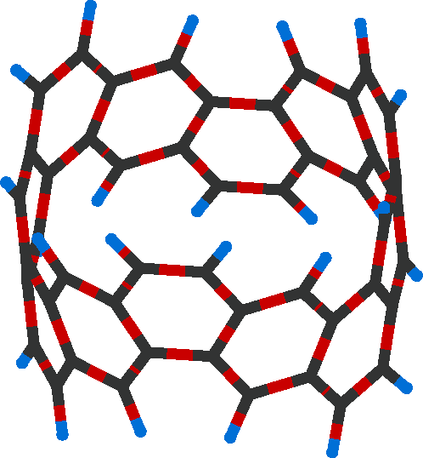
H
C

Fig. 1 (6,6)carbon nanobelt.

Fig. 2 Solutions of (6,6)carbon nanobelts, C₆₀ molecules and a mixture of (6,6)carbon nanobelts and C₆₀ molecules dissolved in 1,2-dichlorobenzene. (a) (6,6)carbon nanobelts dissolved in 1,2-dichlorobenzene. The concentration of (6,6)carbon nanobelts is 0.70 µmol ml⁻¹. (b) C₆₀ molecules dissolved in 1,2-dichlorobenzene. The concentration of C₆₀ is 0.70 µmol ml⁻¹. (c) A mixture of (6,6)carbon nanobelts and C₆₀ molecules dissolved in 1,2-dichlorobenzene. The concentrations of (6,6)carbon nanobelts and C₆₀ are 0.35 µmol ml⁻¹.

Fig. 3 Size distributions of particles formed by (6,6)CNBs and C₆₀ molecules. The concentrations of (6,6)CNBs and C₆₀ molecules are, respectively, 0.35 and 0.70 µmol ml⁻¹. (a) 2 h after the mixture of the two solutions. The diameter of a particle is (4.63 ± 1.78) × 10² nm. (b) 3 h. (5.99 ± 0.38) × 10² nm. (c) 4 h. (6.19 ± 0.52) × 10² nm. (d) 24 h. (6.73 ± 0.47) × 10² nm. (e) 168 h. (7.12 ± 0.63) × 10² nm.

Fig. 4 Size distributions sand SEM images of particles formed by (6,6)CNBs and C₆₀ molecules 168 h after the mixture of the two solutions. (a) The ratio of the molar concentration of CNBs to that of C₆₀ molecules in 1,2-dichlorobenzene is 1 : 1 (the concentrations of (6,6)CNBs and C₆₀ molecules are 0.35 µmol ml⁻¹). The diameter of a particle is (6.10 ± 1.30) × 10² nm. (b) The ratio is 1 : 2 (the concentrations of (6,6)CNBs and C₆₀ molecules are 0.35 and 0.70 µmol ml⁻¹). (7.12 ± 0.63) × 10² nm. (c) The ratio is 1 : 3 (the concentrations of (6,6)CNBs and C₆₀ molecules are 0.35 and 1.05 µmol ml⁻¹). (7.71 ± 2.36) × 10² nm. The scale bars represent 5 µm.

Fig. 5 Absorption spectra by the supernatant of the solution. (6,6)CNBs and C₆₀ molecules are dissolved in 1,2-dichlorobenzene. (a) Absorption spectra measured 168 h after the mixture of two solutions. The ratio of the molar concentration of CNBs to that of C₆₀ is changed. (b) Time variation of the absorption spectra by the supernatant of the solution. The ratio of the molar concentration of CNBs to that of C₆₀ is 1 : 2 (the concentrations of (6,6)CNBs and C₆₀ molecules are 0.35 and 0.70 µmol ml⁻¹).

Fig. 6 Absorption spectra by supernatant of the solution of (a) C₆₀ molecules and (b) (6,6)CNBs dissolved in 1,2-dichlorobenzene.

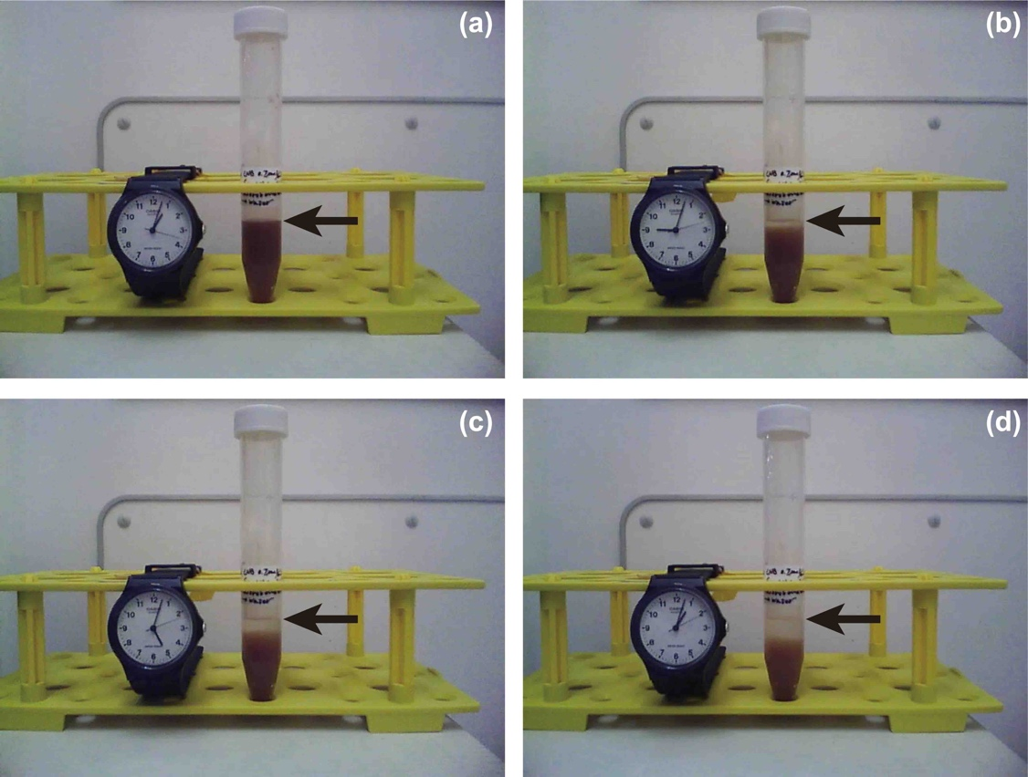

Fig. 7 Snapshots of a suspension of particles formed by (6,6)CNBs and C₆₀ molecules dispersed in distilled water. (a) The initial state; 0 h. (b) 8 h after dispersion. (c) 16 h. (d) 24 h. The arrows indicate the top of the solution.

Fig. 8 Time variation of the turbidity of the solution of particles dispersed in distilled water. The intensity of the transmitted light of 500 and 600 nm wavelength through the whole solution confined in a glass container was measured. The turbidity was defined as $\left(1-{I_{trans}}/{I_{in}}\right)×100 \%$, where $I_{in}$ and $I_{trans}$ are, respectively, the intensities of the incident and transmitted light.

Fig. 9 Mass spectra of the components forming particles. The particles formed 168 h after the mixture of the two solutions are targeted. (6,6)CNBs are positively charged, whereas C₆₀ molecules are negatively charged. (a) (6,6)CNBs. (b) C₆₀.

Fig. 10 Compounds composed of (6,6)CNB and C₆₀ molecules calculated by the PM6 method. (a) Compound formed by one (6,6)CNB and one C₆₀ molecules; (6,6)CNB-C₆₀. (b) Compound formed by one (6,6)CNB and two C₆₀ molecules; (6,6)CNB-(C₆₀)₂. (c) Configuration of [(6,6)CNB-(C₆₀)₂]₂. (d) Configuration of [(6,6)CNB-(C₆₀)₂]₃.

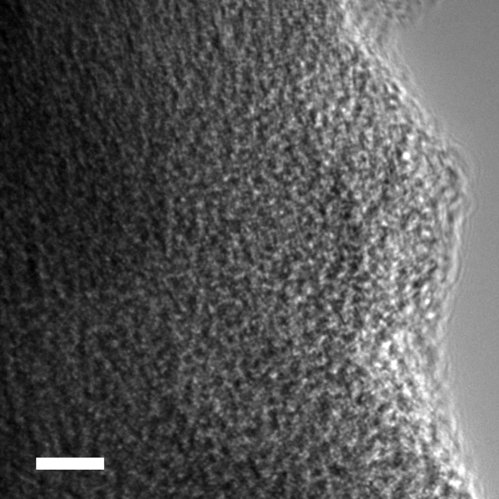

Fig. 11 TEM image of a particle composed of (6,6)CNBs and C₆₀ molecules. The particle was synthesized setting the molar concentration of (6,6)CNBs and C₆₀ molecules, respectively, at 0.35 and 0.7 µmol ml⁻¹. The scale bar represents 5 nm.

Video-1.mp4 Time variation of the precipitation process of the particles dispersed in distilled water from 0 up to 24 h. The arrow indicates the top of the suspension. Although the particles gradually precipitate due to their weight, they can be monodispersed again once the suspension is shaken (see Video-2.mp4).

Video-2.mp4 Monodispersibility of the particles in distilled water. The particles were forced to precipitate on the bottom of the microtube by centrifugation. The particles were monodispersed again in distilled water without any agglomeration by shaking the suspension by hand thanks to the high absolute value of the zeta potential of the particles.

