Metal deposition and shape reproduction at biological temperatures on cell-level samples

Kenshin Takemura^{1,＊}, Taisei Motomura¹, Wataru Iwasaki, Naoki Matsuda

Sensing System Research Centre, The National Institute of Advanced Industrial Science and Technology (AIST), 807-1 Shuku-Machi, Tosu, Saga 841-0052, Japan

¹These authors contributed equally to this work.

Extended Data Figure 1. Difference in amount of sperm adsorbed depending on functionalization of substrate was observed using optical microscopy
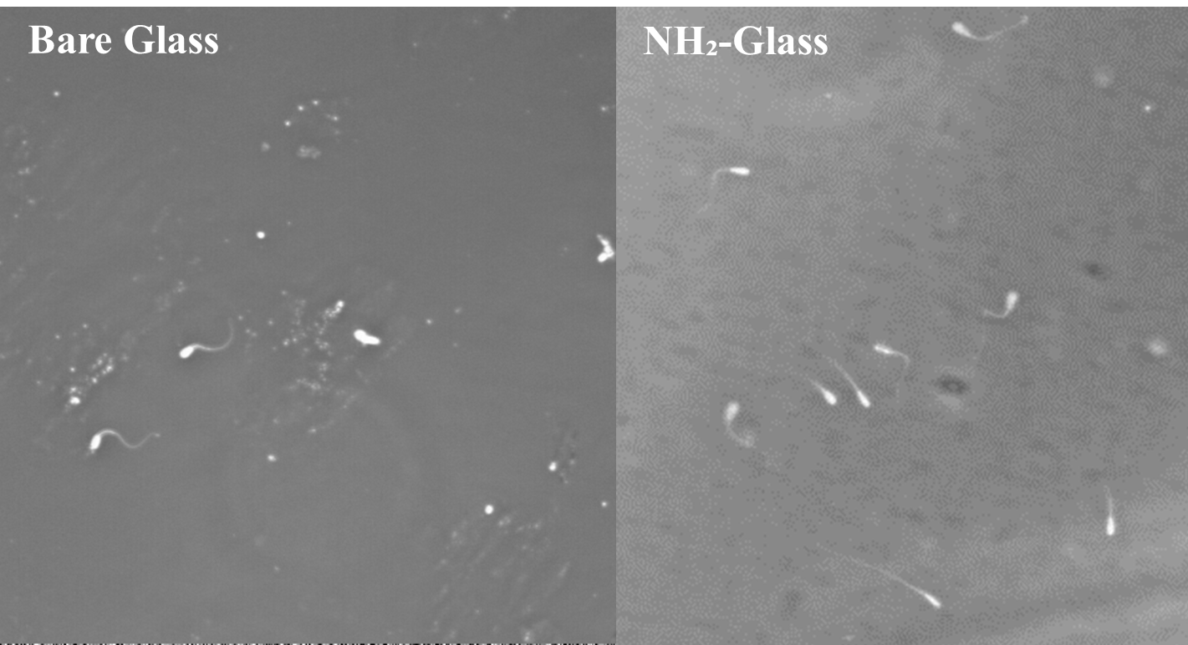

Extended Data Table 1. Difference in amount of sperm adsorbed depending on functionalization of substrate observed using optical microscopy
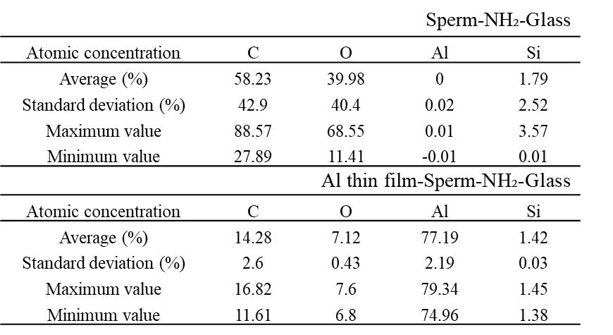

Extended Data Figure 2. Contact angle measurement results for unfunctionalized and amino group-modified glass
