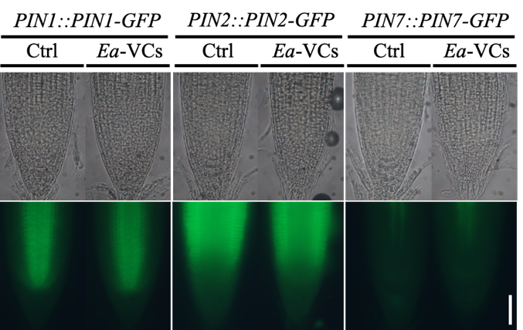

Supplementary Fig. S1 Expression and distribution of PINs in Arabidopsis roots after 24 hr E. aerogenes co-culture. Images of PIN1::PIN1-GFP, PIN2::PIN2-GFP, PIN7::PIN7-GFP expression in Arabidopsis root exposed to E. aerogenes VCs for 24 hr. The results are representative of 3 biological replicates. Scale bar, 50 µm.µm.

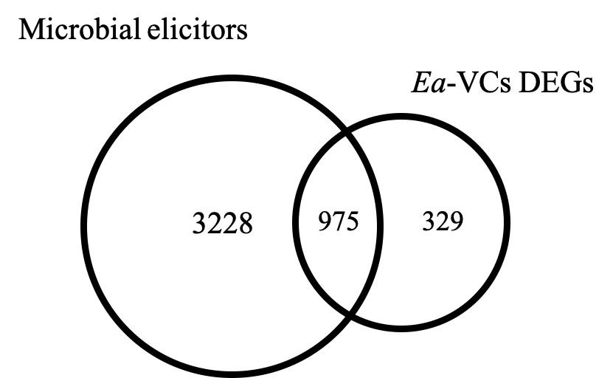

Supplementary Fig. S2 Comparisons of the number of DE genes up-regulated by E. aerogenes VCs after long exposure and microbial elicitors (Stringlis et al. 2018a).

