Supplementary
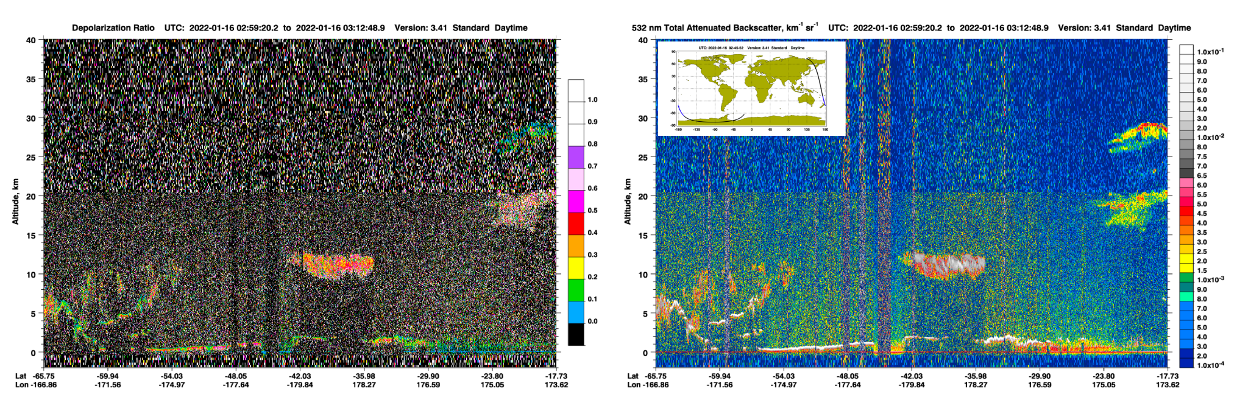
Figure S1. The CALIPSO observation on Jan 16. The left panel is the depolarization ratio showing the plume at 30 km with small depolarization and the plume at 20 km with large depolarization. The right panel shows the backscatter coefficient.

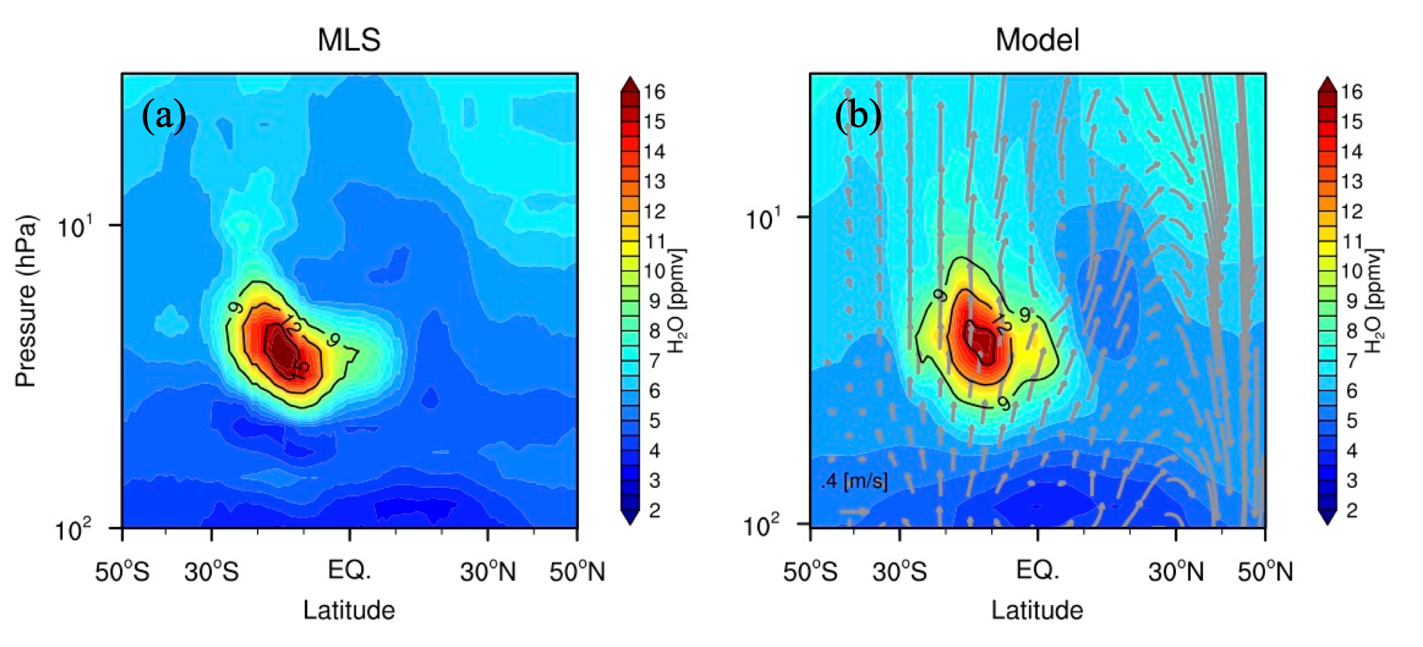
Figure S2. Zonal average H₂O from MLS v4 data on March 1 (a) and the SO₂_H₂O case with Brewer-Dobson circulation (vectors) superimposed on March 1 (b). The simulation shows a positive bias in the background because WACCM6 generally has a wet bias in the stratosphere compared to MLS³³.

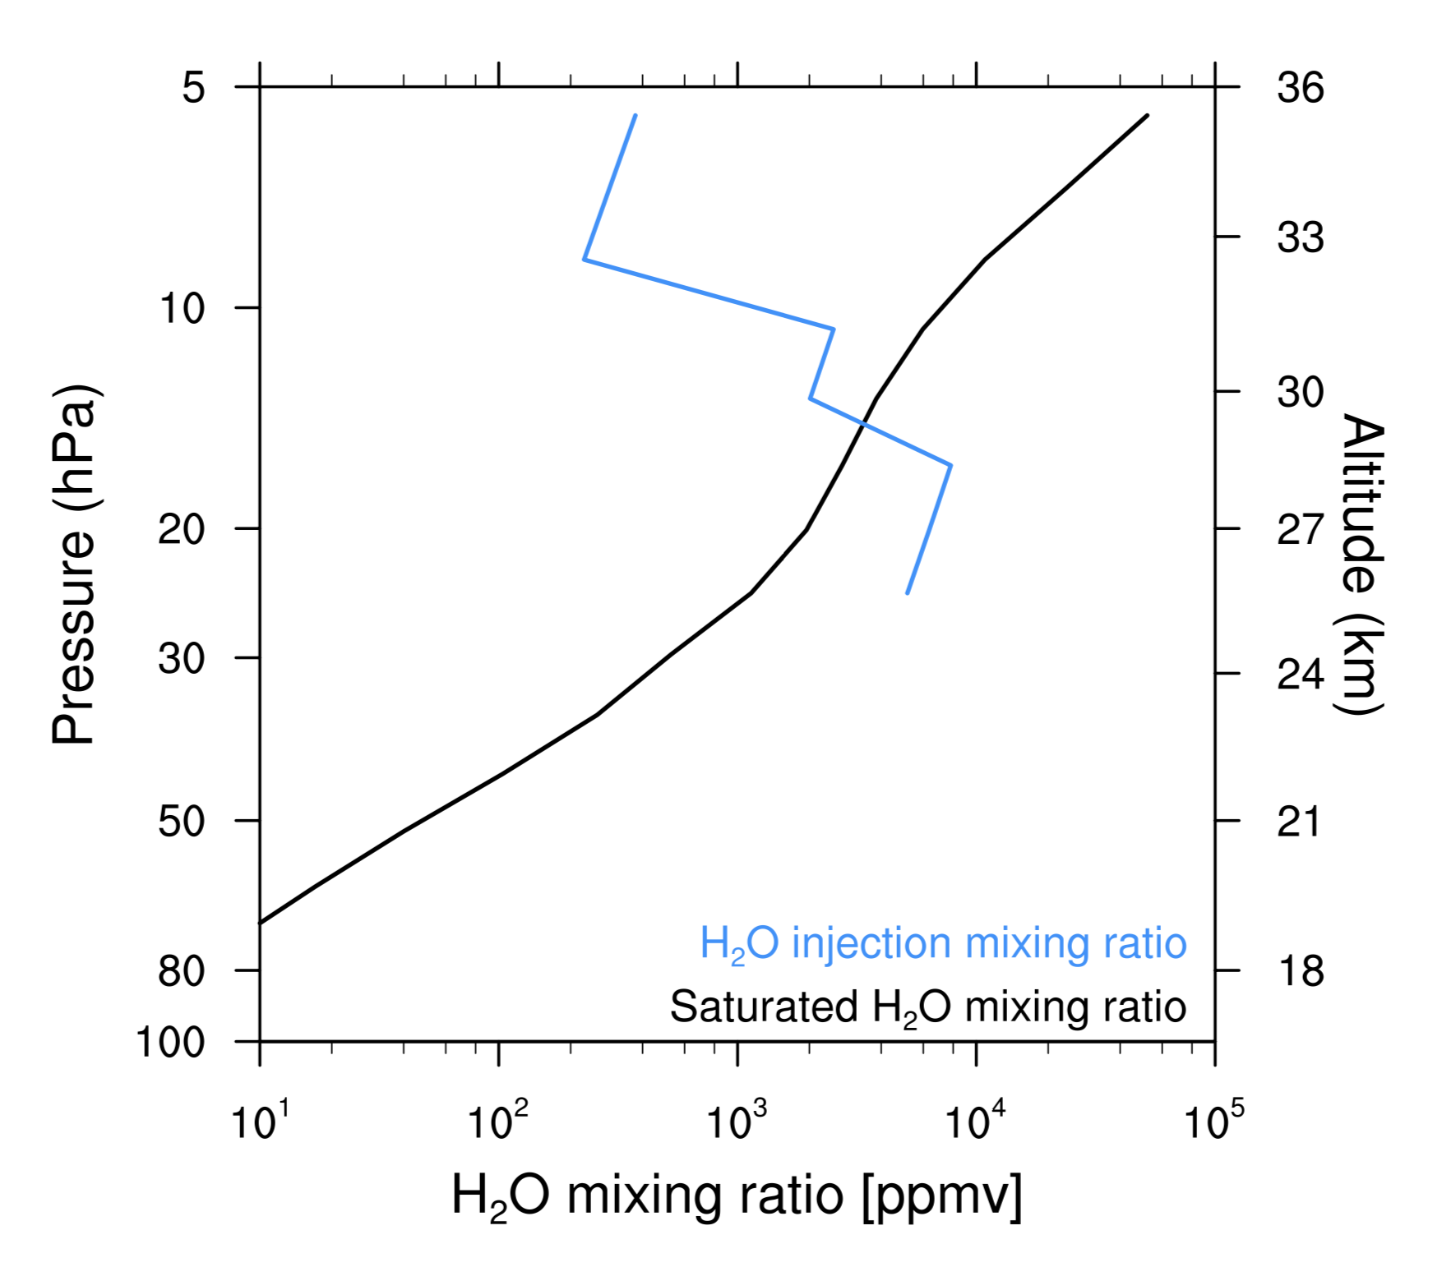
Figure S3. The black line is the saturated H₂O mixing ratio near HTHH on Jan 15 based on the model nudged GEOS5 temperature profile and the temperature profile at the Fiji radiosonde station using the vapor pressure equation of Goff & Gratch⁴¹. The blue line is the mixing ratio of H₂O injection assuming all H₂O is in the vapor phase in the H2O_SO2 case near HTHH on Jan 15. ​​The figure shows water vapor is saturated at pressures above 15 hPa where ice forms.

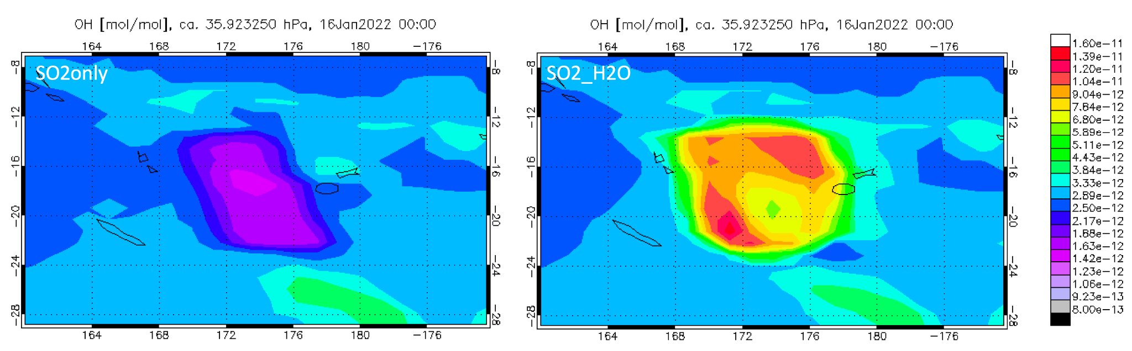
Figure S4. The OH concentration at 35 hPa after the eruption: the left panel without water injection shows the OH gets depleted in the SO₂ plume. The right panel with water injection shows H₂O converting to OH rapidly inside the plume.

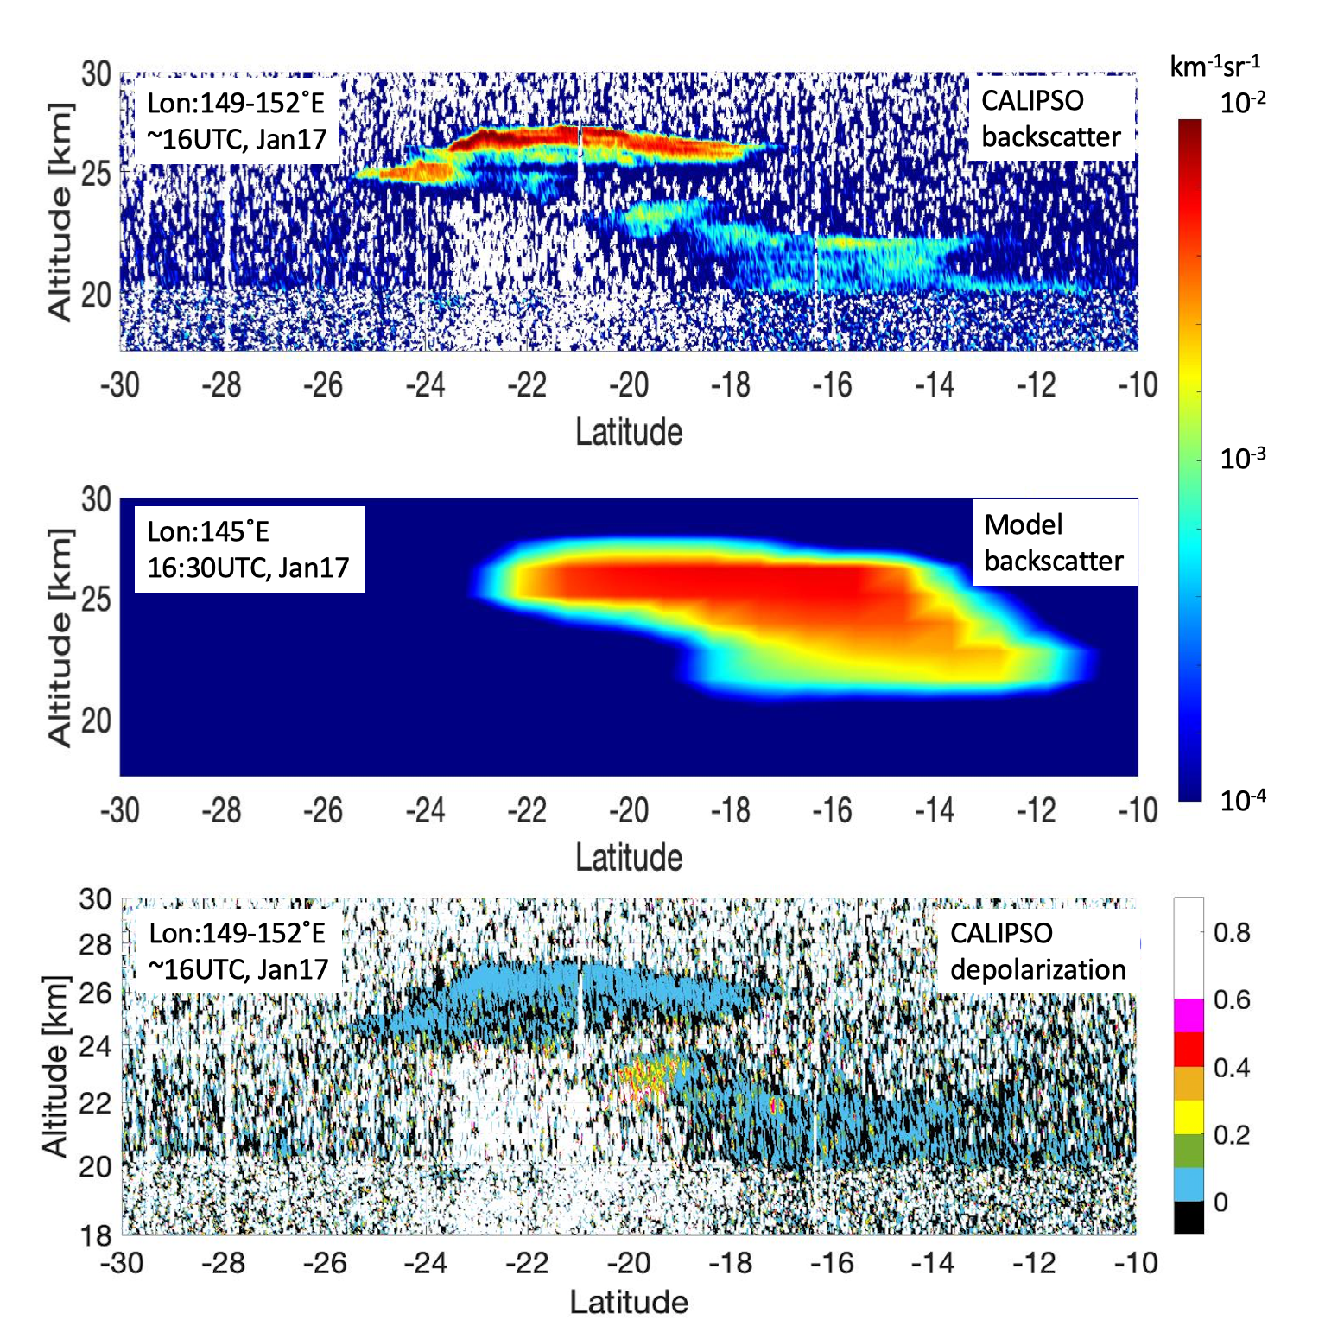
Figure S5. Top and middle: CALIOP backscatter coefficient at 532 nm compared with the simulation on Jan 17 ~ 16 UTC along CALIOP track. Simulated aerosol backscatter is calculated using the simulated visible extinction coefficient divided by the extinction-to-backscatter ratio (value = 55) for volcanic sulfate suggested by the Wyoming balloon particle counter data calculation two years after the Mt. Pinatubo eruption in 1993 (value ~ 50)^{42,43} and CALIOP lidar ratio retrievals for sulfate-rich aerosol layer (value = 60)⁴⁴. Bottom: CALIOP depolarization ratio shows low depolarization for both plumes, but the lower plume shows a small segment of high depolarization near 23 km and 20˚S.

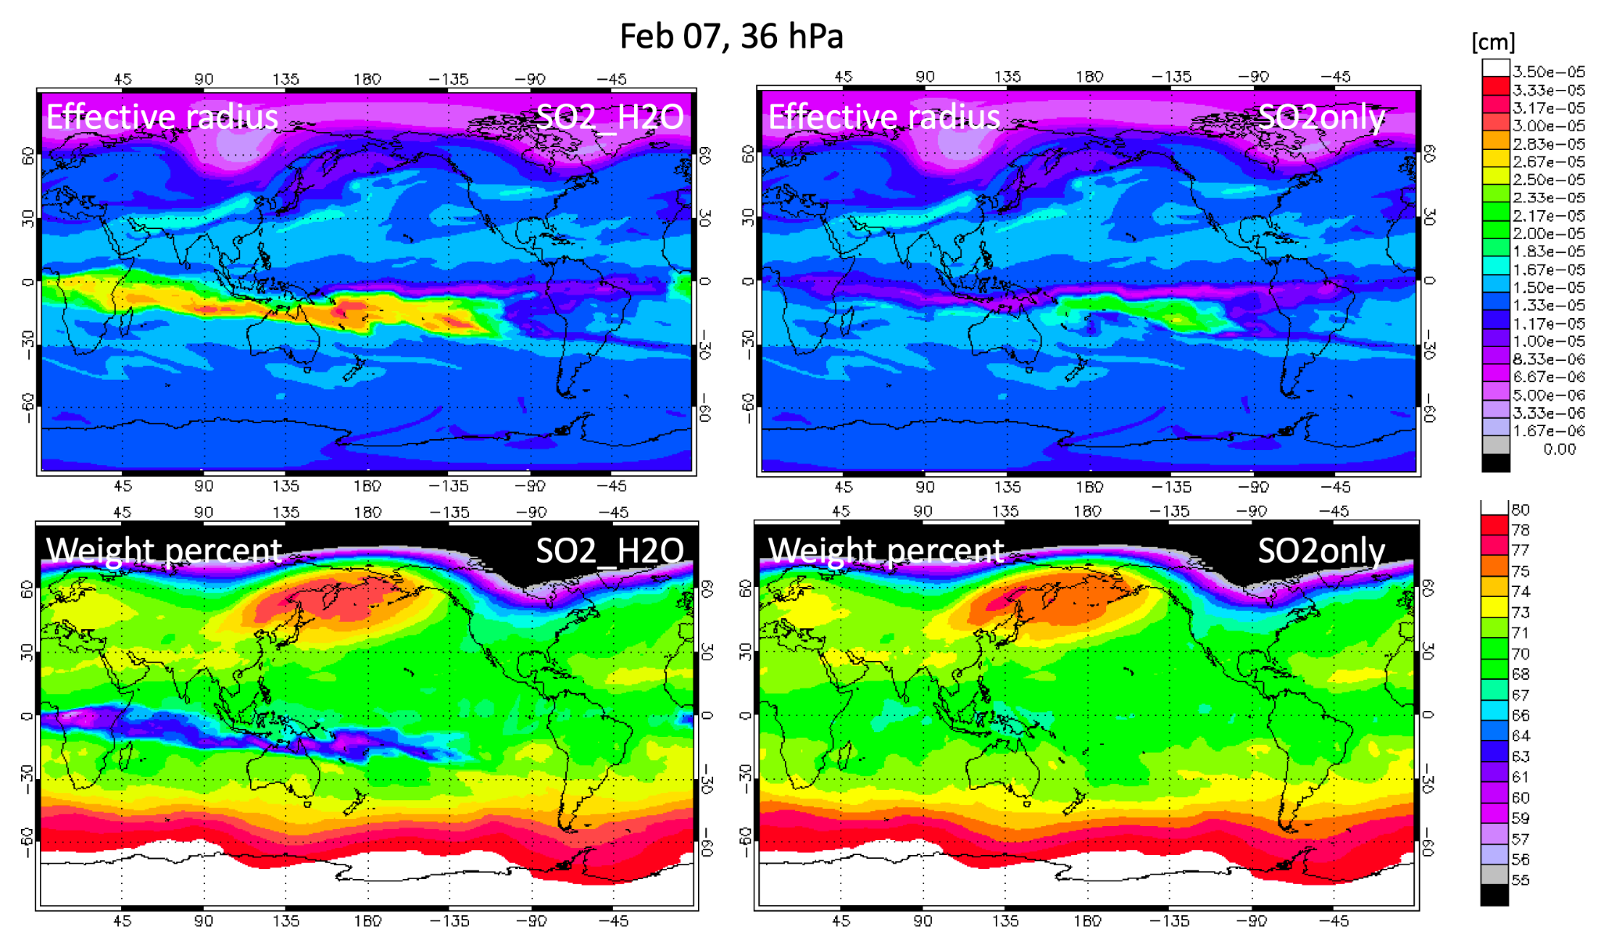
Figure S6. The effective radius and weight percentage of sulfate aerosol (SO4²⁻: (SO4²⁻+H₂O) inside the particle) comparisons between the SO2_H2O case and the SO2only case on February 7 at 36 hPa.

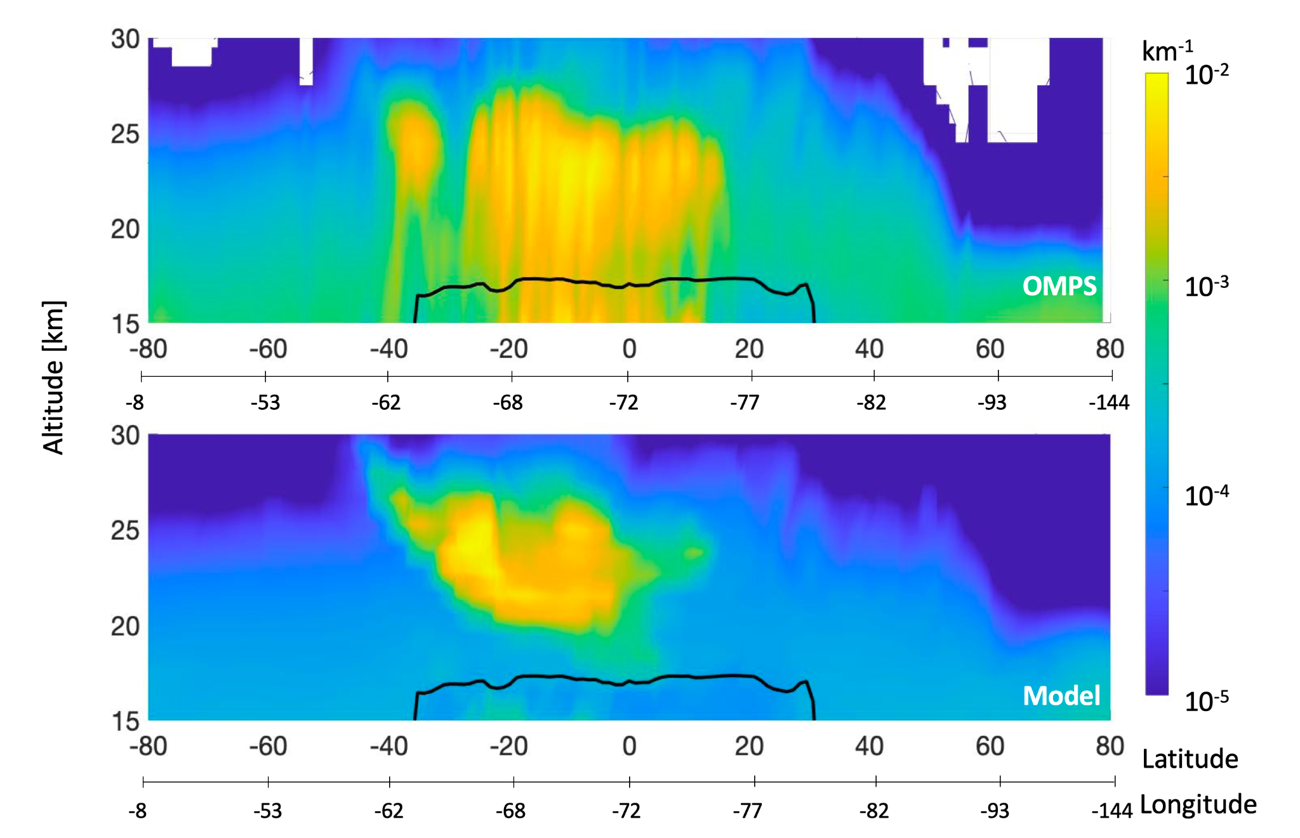
Figure S7. One of the OMPS-LP extinction profiles on March 2 compares with the SO2_H2O simulation for the same sampling. They show a consistent vertical extension above 20 km. OMPS data near the tropical tropopause (black line) may be affected by tropical cirrus clouds. They both show that volcanic sulfate extends from 40˚S to 10˚N, but the simulation has smaller extinction values in the northern hemisphere.

