Early fluid activity on Ryugu: perspectives from oxygen, carbon, and ⁵³Mn-⁵³Cr isotopes

Kaitlyn A. McCain^{1*}, Nozomi Matsuda^{1*}, Ming-Chang Liu¹, Kevin D. McKeegan¹, Akira Yamaguchi², Makoto Kimura², Naotaka Tomioka³, Motoo Ito³, Naoya Imae², Masayuki Uesugi⁴, Naoki Shirai^{5,6}, Takuji Ohigashi^{7,8}, Richard C. Greenwood⁹, Kentaro Uesugi⁴, Aiko Nakato¹⁰, Kasumi Yogata¹⁰, Hayato Yuzawa⁷, Yu Kodama^{11,†}, Kaori Hirahara¹², Ikuya Sakurai¹³, Ikuo Okada¹³, Yuzuru Karouji¹⁰, Satoru Nakazawa¹⁰, Tatsuaki Okada¹⁰, Takanao Saiki¹⁰, Satoshi Tanaka¹⁰, Fuyuto Terui¹⁴, Makoto Yoshikawa¹⁰, Akiko Miyazaki¹⁰, Masahiro Nishimura¹⁰, Toru Yada¹⁰, Masanao Abe¹⁰, Tomohiro Usui¹⁰, Sei-ichiro Watanabe¹⁵, and Yuichi Tsuda^{10,16}.

Submitted to Nature Astronomy

Supplementary Text
Supplementary Figures 1−4
Supplementary Table 1−7
References

Methods

Petrographic characterization
The detailed SEM and EPMA methods are reported by Yamaguchi et al. (2022)¹.

Secondary ion mass spectrometry
In-situ oxygen, carbon, and Mn-Cr isotopes analyses of Ryugu carbonates and magnetite were performed using the UCLA CAMECA ims-1290 ion microprobe. The Ryugu A0037 and C0009 particles were mounted in epoxy and polished under dry conditions and coated with a thin layer of Au for SIMS analyses after petrographic characterization. After SIMS analysis, all pits were observed by scanning electron microscopy (SEM, Tescan Vega) at UCLA. Analyses found to overlap inclusions, cracks, or voids were discarded. In all stable isotope analyses, calcite, magnetite, and a suite of 4 dolomite standards of various Fe compositions were measured to quantify the instrumental mass fractionation (IMF) as a function of Fe content^{2,3}. The chemical and isotopic compositions of these reference materials are listed in Supplementary Table 5.
Oxygen isotope analysis
Oxygen isotope analyses were performed with a focused Cs⁺ primary ion beam with 20 kV total accelerating voltage. Based on the size of the grains analyzed, we used three different primary beam conditions: 3O-I (~3 nA) with ~15 µm spot for dolomite, 3O-II (~700 pA) with ~10 µm spot for dolomite, and 3O-III (~60 pA) with ~ 3µm spot for dolomite, Ca-carbonate, and magnetite. A normal incident electron gun was used for charge compensation. The oxygen isotopic compositions are reported as per mil deviations relative to standard mean ocean water (SMOW), which can be calculated by using $δ{}_{}^{x}O=\left[\frac{{\left({{}_{}^{x}O}/{{}_{}^{16}O}\right)}_{m}}{{\left({{}_{}^{x}O}/{{}_{}^{16}O}\right)}_{t}}-1\right]×1000$, where x = 17 or 18, and “m” and “t” stand for “measured” and “true”. The deviation from the terrestrial fractionation line is expressed as Δ¹⁷O_{SMOW} = δ¹⁷O_{SMOW} – 0.52 × δ¹⁸O_{SMOW}.
In session 3O-I, secondary ¹⁶O⁻, ¹⁷O⁻, and ¹⁸O⁻ ions were collected simultaneously using three Faraday cups (FCs) to achieve the highest possible precision. Typical ¹⁶O⁻ current was equivalent to ~3 × 10⁹ counts/sec for the MS1317J dolomite standard. The mass resolution power (MRP) was set to ~5500 for ¹⁷O⁻. In the second session (3O-II), the secondary ions were measured simultaneously using two FCs (for ¹⁶O⁻ and ¹⁸O⁻) and the axial electron multiplier (EM; for ¹⁷O⁻) under the mass resolution of ~5800 for ¹⁷O⁻ with a typical count rate of for ¹⁶O⁻ ~7.8 × 10⁸ cps (for MS1317J standard). In the third session (3O-III), we used a FC (for ¹⁶O⁻) and two EMs (for ¹⁷O⁻ and¹⁸O⁻) in multicollection mode. The secondary ion count rates of ¹⁶O⁻ were ~6.1 ×10⁷ cps, ~5.8 ×10⁷ cps, and ~6.4 ×10⁷ cps for MS1317J, calcite, and magnetite, respectively. The MRP was ~5600. Ion intensities were corrected for background and yield (FC) or deadtime (EM) as appropriate for each detector.
The contribution of ¹⁶OH⁻ tail to the ¹⁷O⁻ signal was determined by using the ratio of the ion signal measured at the tail of the ¹⁶OH⁻ peak on the high mass end (mass unit = 17.00274 + 0.00361) to that measured at the center of the ¹⁶OH⁻ peak and assuming a symmetric peak. This ratio was then multiplied by the ¹⁶OH⁻ count rate on the unknown samples recorded at the end of each spot analysis. All reported δ¹⁷O values have been corrected for the ¹⁶OH⁻ tail.
The compositional dependence of instrumental bias (i.e., the “matrix effect” on instrumental mass fractionation) was calibrated using the equation similar to that suggested in Śliwiński et al. (2016)². Errors represent 2σ analytical uncertainty including both the internal measurement precision and the external reproducibility for standard measurements.

Carbon isotope analysis
Carbon isotope analysis of carbonate was carried out using a focused Cs⁺ ion primary beam of ~600 to 700 pA. Secondary ¹²C⁻ and ¹³C⁻ ions were simultaneously detected using a FC and EM, respectively. A normal incidence electron gun was used for charge compensation. The typical count rate of ¹²C⁻ was ~5.5–6 ×10⁶ cps for MS1317J. The instrumental bias was corrected using MS1317J with a δ¹³C_{VPDB} value of –1.20‰ (¹³C/¹²C = 0.011167) and optical calcite with a δ¹³C_{VPDB} value of 1.42‰ (¹³C/¹²C = 0.011196) for dolomite and Ca-carbonate, respectively.
We defined the bias as
$$\text{(1) bias =} \frac{{\left({{}_{}^{\text{13}}{\text{C}}}/{{}_{}^{\text{12}}{\text{C}}}\right)}_{\text{m}}}{{\left({{}_{}^{\text{13}}{\text{C}}}/{{}_{}^{\text{12}}{\text{C}}}\right)}_{\text{t}}}$$
where “m” and “t” stand for “measured” and “true” isotope ratios, respectively. Errors represent 2σ analytical uncertainty including both the internal measurement precision and the external reproducibility for standard measurements.

Mn-Cr isotope analysis
Mn-Cr analyses of carbonates were carried out using a 1nA ¹⁶O₃⁻ primary ion beam generated by a Hyperion-II plasma ion source. For dolomite and magnesite with sufficient Mn content, secondary ⁵²Cr⁺, ⁵³Cr⁺, and ⁵⁵Mn⁺ ions were collected simultaneously using two EMs (for ⁵²Cr⁺ and ⁵³Cr⁺) and an FC (for ⁵⁵Mn⁺). An MRP of ~5500 was used to separate ⁵²Cr⁺ from ²⁸Si²⁴Mg⁺ and ⁵³Cr⁺ from ⁵²CrH⁺. For dolomite and calcite with low Mn concentrations, ⁵⁵Mn⁺ was collected using an EM in peak-switching mode. Analysis spots were presputtered using an 8 × 8 or a 4 × 4 μm raster to remove any surface Cr contamination before focusing the beam to a tighter raster (5 × 5 or 2 × 2 μm) for the analysis, resulting in an effective spot size of ~8 × 10 μm². The instrumental mass fractionation for Cr was corrected by comparison to repeated measurements of the 1317J dolomite, which contains trace amounts of terrestrial Cr (⁵³Cr/⁵²Cr = 0.113459)⁴. The relative sensitivity factor between ⁵⁵Mn and ⁵²Cr is defined as
(2) $RSF =\frac{(55Mn/52Cr)_{True}}{(55Mn/52Cr)_{SIMS}}$
and was determined using a combination of San Carlos Olivine and ion-implanted carbonate standards (see next section). Prior to the Mn-Cr analysis, the local distribution of ⁵²Cr was assessed using scanning ion imaging to avoid regions with high ⁵²Cr background, which can indicate contamination from Cr-rich phases.
Calculation of the isochron slope was performed using the ‘fit_bivariate’ python module, an implementation of the York et al. (2004) line fitting algorithm⁵.

Mn-Cr carbonate standard production and characterization
Natural carbonate minerals from the UCLA and Field Museum of Natural History (FMNH) mineral collection which span the range of Fe contents found in Ryugu carbonate (0–8 mol% FeCO₃ for dolomite and 0–40 mol% FeCO₃ for magnesite) were embedded in Field’s Metal and/or indium in the center of aluminum disks. Fragments of San Carlos Olivine and the NIST 612 and 614 glasses were mounted in the same disks for use as concentration standards to calibrate the implant fluence. The mount was coated with 20 nm carbon to ensure conductivity and prevent charging during ion implantation. All mounts were implanted with a 185 KeV ⁵²Cr⁺ ion beam at a nominal fluence of 4 × 10¹³ ions/cm² rastered over the entire surface. A mass filter was used to separate ⁵²Cr⁺ and ⁵³Cr⁺ after Cr ionization, ensuring that only ⁵²Cr⁺ was implanted. No evidence of implanted ⁵³Cr⁺ (e.g. an increase and then decay in intensity similar in shape to the ⁵²Cr⁺ intensity) was observed in any of our implanted materials. Ion implantation was carried out by CuttingEdge Ions.
To determine the implanted ⁵²Cr⁺ fluence and RSF for each terrestrial carbonate, the NIST glasses, San Carlos Olivine, and terrestrial carbonates were sputtered using a 2nA O₃⁻ primary beam focused into a ~3 μm spot rastered over 50 × 50 μm² areas. A field aperture was inserted into an ion image plane to restrict the collected ions to the central 15 × 15 μm² area of each raster square. An 80 μm entrance slit width was used. Secondary ions of ⁴⁴Ca⁺, ⁵²Cr⁺, ⁵³Cr⁺, and ⁵⁵Mn⁺ were counted using an electron multiplier in monocollection mode. Prior to analysis, the C coating was removed without the use of polishing compound and replaced with a 30 nm layer of gold to prevent charging during the ion probe analysis.
The implanted fluence and RSF of each terrestrial carbonate were determined following methods previously described⁶. The calibrated implanted fluence determined using the NIST glasses was (4.57 ± 0.05) × 10¹³ ions/cm² (2SE). For depth profiles of calcite and dolomite, surface ⁵²Cr contamination cannot be completely accounted for by simply measuring the background ⁵³Cr intensity, due to the low background Cr abundance in these minerals and fast sputtering rates observed in depth profiles of these materials (shown in Supplementary Figure 1). Instead, the ⁵²Cr background was corrected for by estimating the expected position and width of the implantation peak, which can be well-modeled by a Gaussian distribution, in each mineral with the SRIM software⁷ (Supplementary Figure 1, red line). As shown in the right panel of Supplementary Figure 1, the modeled implantation peak (red line) fits the measured ⁵³Cr-corrected ⁵²Cr intensities (thin black line) well at depths below 50 nm after which contamination is no longer significant. Therefore, we used the ⁵²Cr intensity predicted by the Gaussian distribution as the corrected intensity for the upper 50 nm of the profile for profiles showing signs of surface contamination and used the measured intensities for the remainder of the profile. For calcite and dolomite, correction for surface contamination resulted in changes to the measured RSF by 20–30%. Analyses of magnesite, NIST glass, and olivine were not affected by surface contamination due to the higher natural Cr abundance of these standard materials.

Variation of RSF with ion probe spot geometry
To ascertain that the RSF of the ⁵⁵Mn/⁵²Cr ratio obtained by depth profiling can be applied to the Ryugu data acquired with a static spot⁸, we compared the RSF results on non-implanted and implanted San Carlos olivine measured in spot and depth profiling modes, respectively. The true ⁵⁵Mn/⁵²Cr ratio of our San Carlos Olivine standard was found to be 9.2 ± 0.7 by EPMA. We found that the RSF values acquired under the two conditions were identical within error (Supplementary Figure 2), and we can therefore use the RSF values for dolomite and magnetite obtained in raster mode to correct the ⁵⁵Mn/⁵²Cr ratio of our spot analyses.
The RSF values obtained from depth profiling of natural materials are given in Supplementary Table 6. The RSF is calculated as
(3) $RSF = \frac{C_{{55}_{Mn}}DA_{{52}_{Cr+}}}{I_{{55}_{Mn}}Ft}$
where C_{55Mn} represents the concentration of ⁵⁵Mn as determined by EPMA (Shown in Supplementary Table 1), D represents the depth of the rastered area, A_{52Cr+} represents the total number of counts of implanted ⁵²Cr⁺ (as defined above), I_{55Mn} represents the measured signal intensity of ⁵⁵Mn⁺ during the depth profile, F represents the fluence of ⁵²Cr implanted as calculated above, and t represents the total duration of the profile. The values used to calculate the RSF for each depth profile are given in Supplementary Table 7.
The relationship of the RSF with the FeCO₃ content of dolomite is shown in supplementary Figure 3, and can be fit to an exponential using the curve_fit function from the SciPy Optimization module⁹:
(4) $RSF =0.235* e^{0.345x} +0.705$
where x refers to the Fe content of the dolomite in Mol %. Due to the large errors associated with MS1305, this point was not included during calculation of the fit. As shown in Supplementary Table 1 of the main text, dolomite in Ryugu has a restricted range of Fe content, with an average of 3.5 mol% FeCO_{3.} This value corresponds to an RSF value of 0.8. The Fe content of Ryugu dolomites show only small departures from the average Fe abundance, which would lead to RSF variations well within our errors. Therefore, we use the value of 0.8 obtained for the average Ryugu dolomite composition for all analyses of Ryugu dolomite.
The relationship of the RSF with the FeCO₃ content of magnesite is shown in Supplementary Figure 4. The data was fit to a linear relationship using the ‘fit_bivariate’ python module, an implementation of the York et al. (2004) line fitting algorithm⁵. For the single magnesite analysis in C0009, the magnesite has an FeCO₃ content of approximately 14 mol% derived from EDS analyses. Using the equation derived from the line fitting algorithm, we obtain an RSF value of 0.86.

Magnetite-calcite equilibrium calculation
The formation temperature is calculated under the assumption that Ca-carbonate ‘Ca 2’ and magnetite were in equilibrium with water of identical oxygen isotopic composition. Ryugu magnetite has an average δ¹⁸O value of 2.1 ± 1.9‰ (2SD) and ‘Ca 2’ has a value of 39 ± 1.7‰ (2SE). With these uncertainties, the 1000 ln α_{Cal-Mgt} inferred by these values ranges from 40.4−33.4‰. Calcite fractionation factors for ‘Ca 2’ were adopted due to the strong resemblance of this target to Type 1b calcite in CM chondrites.
We assume no significant effect of crystallographic orientation on the mass fractionation of oxygen isotopic measurements of magnetite¹⁰. In principle, this could affect the accuracy of our measured δ¹⁸O values of magnetite by up to 3‰, but would not affect measurements of Δ¹⁷O. Any shift in the δ¹⁸O value of magnetite would affect the α_{Cal-Mgt} inferred using the magnetite and calcite pair, thereby affecting the temperature calculation. However, we note that magnetite-water fractionation has a weak temperature dependence relative to calcite-water fractionation. Therefore, a crystallographic orientation effect for δ¹⁸O of would not strongly affect the inferred temperature range.
We estimated the formation temperature of calcite and magnetite to be 0–20 °C based on fractionation factors for the calcite-water and magnetite-water systems derived from theoretical calculations performed by Hayles et al. (2018)¹¹. Some previous studies of magnetite-carbonate equilibrium in carbonaceous chondrites have used other fractionation factors for the magnetite-water equilibrium^{12,13}. If we use the magnetite-water fractionation factors calculated in Zheng et al. 1995, along with experimentally-derived calcite-water fractionation factors¹⁴, we obtain a formation temperature of 23–47 °C. Experimental data for the magnetite-water equilibrium fractionation are available only at temperatures above 300 °C¹⁵. Therefore, we have elected to use the most recent theoretical predictions of the equilibrium fractionation between magnetite and water at low temperature to perform our calculations.

Dolomite-phyllosilicate equilibrium calculation
We estimated the formation temperature of phyllosilicate and dolomite to be 88–240 °C using dolomite-H₂O¹⁶ and brucite-H₂O¹⁷ fractionation factors which have been experimentally determined at the relevant low temperatures. Relatively few hydrated Mg-rich minerals have reliable fractionation factors measured at low temperature. While other minerals (e.g. serpentine) would be better fits to the mineralogy observed in the Ryugu matrix, their mineral-H₂O fractionations are not well constrained at the relevant temperatures. Therefore, we elect to use the brucite-H₂O fractionation factor. The range of temperatures inferred by this calculation is extremely wide due to the uncertainty in the bulk phyllosilicate δ¹⁸O composition, so variation in the phyllosilicate-water fractionation factors is likely within this range of inferred temperatures.

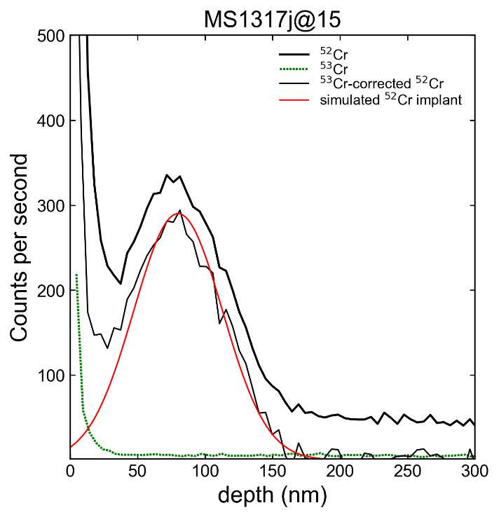
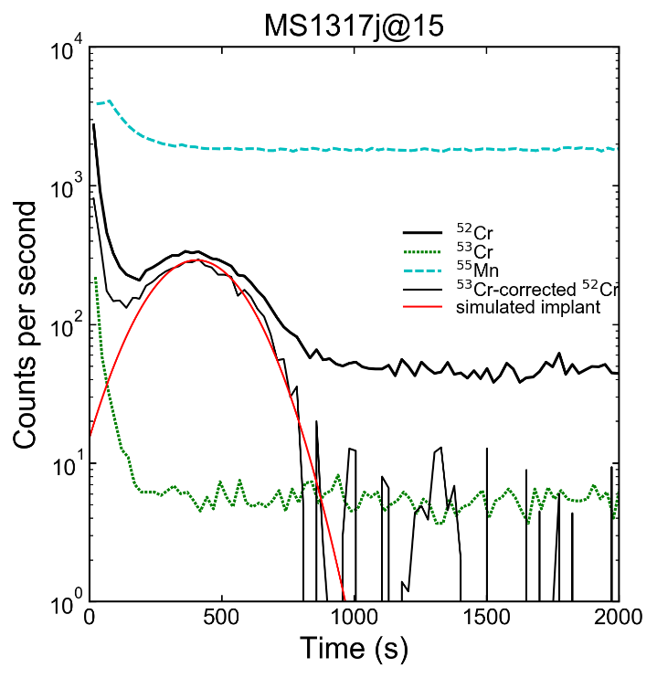

Supplementary Figure 1. Intensities of ⁵²Cr⁺, ⁵³Cr⁺, and ⁵⁵Mn⁺ recorded during depth profiling of terrestrial dolomite 1317J plotted against the time elapsed during the depth profile (left) and the depth below the sample surface (right). The left panel is shown with count rates on a logarithmic scale, and the right with count rates on a linear scale for comparison. The heavy black line represents the intensity of ⁵²Cr⁺ including the implanted Cr and the background Cr in the NIST glass. The dotted green line represents the intensity of the background ⁵³Cr⁺ during the profile. The dashed blue line represents the intensity of ⁵⁵Mn⁺ during the profile. The thin black line represents the intensity of ⁵²Cr⁺ when background-corrected only by the ⁵³Cr⁺ intensity. The red line represents the ⁵²Cr⁺ implantation peak as simulated by the SRIM software.

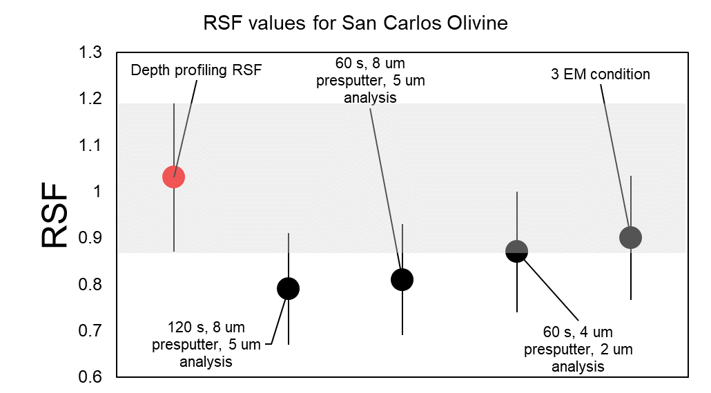

Supplementary Figure 2. RSF values obtained by depth profiling (red point, shaded area) and spot analyses under various presputtering and analysis conditions (black circles). Error bars represent 2 SE.

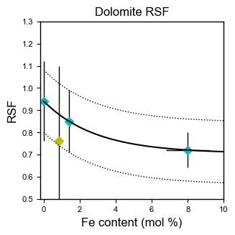

Supplementary Figure 3. RSF values of dolomite versus the FeCO₃ composition of dolomite. The black line is the exponential function given in Eq. 4.

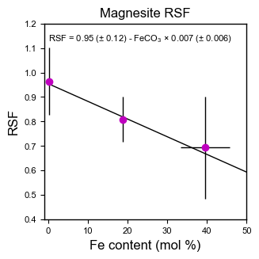

Supplementary Figure 4. RSF values of magnesite versus the FeCO₃ composition of magnesite, errors 2SE. The black line is the best fit line printed on the plot.

Supplementary Table 1. Oxygen-isotope compositions of carbonates in A00037 and C0009.
Particles | Mineral | Spot | δ¹⁷O | 2σ | δ¹⁸O | 2σ | Δ¹⁷O | 2σ | FeCO₃* | MnCO₃*
A0037 | Dolomite | A37_3oxy3FCs@1 | 14.8 | 0.4 | 28.1 | 0.4 | 0.2 | 0.4 | 4.1 | 4.4
 |  | A37_3oxy3FCs@2 | 13.8 | 0.4 | 26.2 | 0.4 | 0.2 | 0.4 | 3.8 | 2.7
 |  | A37_3oxy3FCs@3 | 14.7 | 0.4 | 26.6 | 0.4 | 0.8 | 0.4 | 4.1 | 2.3
 |  | A37_3oxy3FCs@4 | 15.1 | 0.4 | 27.0 | 0.4 | 1.1 | 0.3 | 3.9 | 4.0
 |  | A37_3oxy3FCs@6 | 14.4 | 0.5 | 26.7 | 0.4 | 0.6 | 0.4 | 4.6 | 4.7
 |  | A37_3oxy3FCs@7 | 14.7 | 0.4 | 26.4 | 0.4 | 1.0 | 0.3 | 4.3 | 5.8
 |  | A37_3oxy3FCs@8 | 16.8 | 0.3 | 32.7 | 0.4 | –0.2 | 0.3 | 3.2 | 5.3
 |  | A37_3oxy3FCs@9 | 16.6 | 0.5 | 31.4 | 0.4 | 0.3 | 0.4 | 4.1 | 3.7
 |  | A37_3oxy3FCs@10 | 14.4 | 0.4 | 28.0 | 0.4 | –0.2 | 0.4 | 3.8 | 4.1
 |  | A37_3oxy3FCs@11 | 17.9 | 0.3 | 33.7 | 0.4 | 0.4 | 0.3 | 3.2 | 5.3
 |  | A37_3oxy3FCs@13 | 13.6 | 0.4 | 25.0 | 0.4 | 0.6 | 0.3 | 4.0 | 6.8
 |  | A37_3oxy3FCs@14 | 15.8 | 0.4 | 28.9 | 0.4 | 0.7 | 0.3 | 4.0 | 3.9
 |  | A37_3oxyFCEMFC@1 | 13.9 | 0.4 | 26.7 | 0.6 | 0.0 | 0.3 | 3.0 | 5.7
 |  | A37_3oxyFCEMFC@2 | 15.8 | 0.5 | 27.3 | 0.7 | 1.6 | 0.3 | 4.3 | 5.8
 |  | A37_3oxyFCEMFC@4 | 14.9 | 0.3 | 28.6 | 0.6 | 0.0 | 0.4 | 3.8 | 5.7
 |  | A37_3oxyFCEMFC@5 | 17.9 | 0.6 | 34.0 | 0.6 | 0.2 | 0.5 | 4.0 | 3.9
 |  | A37_3oxyFCEMFC@6 | 14.8 | 0.5 | 28.2 | 0.6 | 0.1 | 0.4 | 4.0 | 3.9
 |  | A37_3oxyFCEMFC@7 | 14.0 | 0.4 | 27.5 | 0.7 | –0.3 | 0.3 | 4.0 | 2.4
 |  | A37_3oxyFCEMFC@8 | 15.3 | 0.5 | 28.6 | 0.8 | 0.5 | 0.4 | 3.4 | 6.9
 |  | A37_3oxyFCEMFC@9 | 14.6 | 0.4 | 27.7 | 0.7 | 0.2 | 0.4 | 3.8 | 6.1
C0009 | Dolomite | C009_dolo@3 | 12.9 | 0.7 | 25.4 | 0.7 | –0.3 | 0.8 | 2.9 | 4.7
 | Ca-carbonate | C009_calcite@1 | 19.1 | 1.0 | 35.1 | 1.7 | 0.8 | 1.0 | 1.3 | n.d.
 |  | C009_calcite@2 | 19.4 | 0.9 | 37.3 | 1.6 | 0.0 | 0.9 | 1.3 | n.d.

Supplementary Table 1 (continued).
Particles | Mineral | Spot | δ¹⁷O | 2σ | δ¹⁸O | 2σ | Δ¹⁷O | 2σ | FeCO₃* | MnCO₃*
C0009 | Ca-carbonate | C009_calcite@3 | 22.5 | 1.0 | 39.0 | 1.7 | 2.2 | 1.0 | 1.1 | n.d.
 |  | C009_calcite@5 | 18.7 | 1.0 | 35.0 | 1.6 | 0.5 | 1.0 | 1.5 | n.d
 |  | C009_calcite@6 | 18.9 | 0.9 | 34.2 | 1.5 | 1.1 | 1.0 | 1.5 | n.d.
 |  | C009_calcite@7 | 19.3 | 0.9 | 36.4 | 1.7 | 0.3 | 0.9 | 1.5 | n.d
* Data from Yamaguchi et al. (2022).
FeCO₃ and MnCO₃ are mol%.
n.d.: not detected.

Supplementary Table 2. Oxygen-isotope compositions of magnetite in A00037.
Particles | Mineral | Spot | δ¹⁷O | 2σ | δ¹⁸O | 2σ | Δ¹⁷O | 2σ | FeO*
A0037 | Magnetite | A37_3oxyFCEMFC@10 | 3.7 | 0.5 | 3.0 | 0.9 | 2.1 | 0.4 | 93.0
 |  | A37_3oxyFCEMEM@1 | 4.8 | 1.0 | 1.7 | 1.0 | 3.9 | 0.9 | 92.8
 |  | A37_3oxyFCEMEM@5 | 3.1 | 0.8 | 1.0 | 0.7 | 2.6 | 0.8 | 93.0
 |  | A37_3oxyFCEMEM@10 | 4.6 | 1.1 | 2.8 | 1.2 | 3.1 | 0.9 | 92.0
Data from Yamaguchi et al. (2022).
FeO is wt%.

Supplementary Table 3. Carbon-isotope compositions of carbonates in A00037 and C0009.
Particles | Mineral | Spot | δ¹³C | 2σ
A0037 | Dolomite | A37_C_dolo@1.asc | 55.4 | 1.6
 |  | A37_C_dolo@2.asc | 62.3 | 1.3
 |  | A37_C_dolo@3.asc | 58.9 | 1.6
 |  | A37_C_dolo@5.asc | 58.2 | 1.2
 |  | A37_C_dolo@6.asc | 72.1 | 1.0
 |  | A37_C_dolo@7.asc | 70.5 | 1.1
 |  | A37_C_dolo@8.asc | 72.0 | 1.0
 |  | A37_C_dolo@9.asc | 69.7 | 1.0
 |  | A37_C_dolo@10.asc | 57.1 | 1.2
 |  | A37_C_dolo@11.asc | 68.1 | 1.0
 |  | A37_C_dolo@12.asc | 74.4 | 1.1
 |  | A37_C_dolo@13.asc | 71.0 | 0.9
 |  | A37_C_dolo@14.asc | 72.6 | 1.1
C0009 | Dolomite | C0009_C_dolo@1.asc | 74.5 | 1.0
 |  | C0009_C_dolo@2.asc | 73.3 | 0.9
 |  | C0009_C_dolo@3.asc | 69.7 | 0.8
 |  | C0009_C_dolo@4.asc | 74.3 | 0.8
 |  | C0009_C_dolo@5.asc | 64.0 | 0.8
 |  | C0009_C_dolo@6.asc | 66.4 | 1.0
 |  | C0009_C_dolo@7.asc | 69.3 | 1.1
C0009 | Ca-carbonate | C0009_ca2@1.asc | 96.9 | 1.1
 |  | C0009_ca1@3.asc | 72.0 | 1.3
 |  | C0009_ca1@4.asc | 70.9 | 1.4

Supplementary Table 4. Mn-Cr isotope data of carbonates in A00037 and C0009.
Particle | Mineral | Spot | ⁵⁵Mn/⁵²Cr | 2σ | ⁵³Cr/⁵²Cr | 2σ | δ⁵³Cr | 2σ | # cycles | RSF used
A0037 | Dolomite | A37@1 | 232 | 47 | 0.11646 | 0.00116 | 26 | 10 | 30 | 0.8
 |  | A37@2 | 23 | 5 | 0.11535 | 0.00108 | 17 | 10 | 30 | 0.8
 |  | A37@3 | 44 | 14 | 0.11473 | 0.00108 | 11 | 10 | 30 | 0.8
 |  | A37@4 | 51 | 13 | 0.11557 | 0.00110 | 19 | 10 | 30 | 0.8
 |  | A37@5 | 122 | 40 | 0.11498 | 0.00114 | 13 | 10 | 14 | 0.8
 |  | A37_Feb15@6 | 601 | 110 | 0.11982 | 0.00134 | 56 | 12 | 26 | 0.8
 |  | A37_Feb15@7 | 7377 | 1333 | 0.16786 | 0.00374 | 480 | 33 | 30 | 0.8
 |  | A37_Feb15@8 | 2787 | 572 | 0.13394 | 0.00224 | 181 | 20 | 30 | 0.8
 |  | A37_Feb15@9 | 283 | 63 | 0.11560 | 0.00118 | 19 | 10 | 30 | 0.8
 |  | A37_Feb15@10 | 1972 | 371 | 0.12495 | 0.00296 | 101 | 26 | 11 | 0.8
 |  | A37_Feb15@12 | 606 | 239 | 0.11786 | 0.00138 | 39 | 12 | 7 | 0.8
 |  | A37_Feb15@13 | 404 | 129 | 0.11702 | 0.00160 | 31 | 14 | 10 | 0.8
 |  | A37_Feb15@14 | 4765 | 865 | 0.14324 | 0.00354 | 262 | 31 | 30 | 0.8
 |  | A37_Feb15@15 | 6209 | 1247 | 0.15734 | 0.00518 | 387 | 46 | 27 | 0.8
 |  | A37_Feb15@17 | 1387 | 466 | 0.12365 | 0.00212 | 90 | 19 | 14 | 0.8
 |  | A37_Feb15@18 | 9404 | 1801 | 0.17455 | 0.00550 | 538 | 48 | 30 | 0.8
 |  | A37_Feb15@19 | 5204 | 1047 | 0.15095 | 0.00302 | 330 | 27 | 15 | 0.8
 |  | A37_Feb15@21 | 5518 | 1204 | 0.15457 | 0.00800 | 362 | 71 | 14 | 0.8
 |  | A37_Feb15@23 | 2368 | 433 | 0.13134 | 0.00178 | 158 | 16 | 30 | 0.8
 |  | A37_Feb15@24 | 6401 | 1151 | 0.16061 | 0.00362 | 416 | 32 | 30 | 0.8
C0009 | Dolomite | C9@2 | 1393 | 332 | 0.12229 | 0.00332 | 78 | 29 | 9 | 0.8
 |  | C9@3 | 4044 | 822 | 0.13980 | 0.00286 | 232 | 25 | 9 | 0.8
 |  | C9@4 | 2252 | 478 | 0.12912 | 0.00258 | 138 | 23 | 12 | 0.8
 |  | C9@5 | 2445 | 942 | 0.12950 | 0.00408 | 141 | 36 | 30 | 0.8
 |  | C9@6 | 2833 | 700 | 0.13138 | 0.00278 | 158 | 25 | 30 | 0.8
 |  | C9@7 | 3070 | 741 | 0.13189 | 0.00318 | 162 | 28 | 20 | 0.8
 |  | C9@8 | 2729 | 479 | 0.12945 | 0.00194 | 141 | 17 | 11 | 0.8
 |  | C9@9 | 1121 | 202 | 0.11905 | 0.00420 | 49 | 37 | 30 | 0.8

Supplementary Table 4 (continued).
Particle | Mineral | Spot | ⁵⁵Mn/⁵²Cr | 2σ | ⁵³Cr/⁵²Cr | 2σ | δ⁵³Cr | 2σ | # Cycles | RSF used
C0009 | Dolomite | C9@11 | 10529 | 1874 | 0.18181 | 0.00412 | 602 | 36 | 12 | 0.8
 |  | C9@12 | 5055 | 951 | 0.14578 | 0.00302 | 285 | 27 | 30 | 0.8
 |  | C9@14 | 1735 | 509 | 0.12537 | 0.00214 | 105 | 19 | 26 | 0.8
 |  | C9@16 | 1650 | 761 | 0.12499 | 0.00362 | 102 | 32 | 10 | 0.8
 |  | C9_3EM@3 | 2243 | 1175 | 0.12873 | 0.00578 | 135 | 51 | 13 | 0.8
C0009 | Breunnerite | C9@10 | 3326 | 680 | 0.13239 | 0.00224 | 167 | 20 | 30 | 0.86
C0009 | Ca-carbonate | C9_3EM@1 | 32 | 14 | 0.11367 | 0.00978 | 2 | 86 | 10 | 1.3
 |  | C9_3EM@2 | 8 | 3 | 0.11772 | 0.00546 | 38 | 48 | 10 | 1.3

Supplementary Table 5. Chemical and isotopic compositions of reference materials used to constrain instrumental mass fractionation during carbon and oxygen stable isotopic analysis of carbonates. Carbon and oxygen isotopic compositions were determined by phosphoric acid digestion and IRMS of CO₂ at UCLA. Elemental compositions were determined using EPMA analysis.

Material name | Mineral | δ¹⁷O SMOW | δ¹⁸O SMOW | δ¹³C VPDB | CaCO₃ | MgCO₃ | FeCO₃ | MnCO₃
OPTI calcite | Calcite | 5.76 | 11.10 | 1.42 | 99.4 | 0.5 | n.d. | n.d.
MS1317 | Dolomite | 11.80 | 22.82 | –21.13 | 51.8 | 48.1 | n.d. | 0.1
MS1305 | Dolomite | 10.99 | 21.24 | –1.10 | 50.8 | 48.0 | 1.1 | 0.1
MS1317J | Dolomite | 11.13 | 21.51 | –1.20 | 51.1 | 45.8 | 2.9 | 0.2
MS1312 | Dolomite | 11.63 | 22.48 | 0.00 | 51.1 | 21.6 | 21.1 | 6.2
CaCO₃, MgCO₃, FeCO₃, and MnCO₃ are mol%.
n.d.: not detected.

Supplementary Table 6. RSF values obtained using depth profiling of ion-implanted materials, where n represents the number of repeat depth profiles. The Mn concentration in each mineral is derived from EPMA data and reported as µg Mn/g.
Mineral | FeCO3 mol% | weighted mean RSF | 2SE | n | Mn concentration (ppm)
Calcite | n.d. | 1.3 | 0.84 | 2 | 100
Dolomite
MS1317 (D) | n.d. | 0.94 | 0.18 | 6 | 411
MS1305 (D) | 0.85 | 0.76 | 0.34 | 2 | 558
MS1317J (D) | 1.4 | 0.85 | 0.14 | 2 | 1011
MS1318 (D) | 8.0 | 0.72 | 0.088 | 6 | 6244
Magnesite
MS1223D | 0.2 | 0.96 | 0.14 | 2 | 761
M1952 | 18.8 | 0.81 | 0.10 | 2 | 6402
M2035 | 39.5 | 0.69 | 0.21 | 1 | 2969
San Carlos Olivine | – | 1.03 | 0.17 | 2 | 1029
n.d.: not detected.

Supplementary Table 7. Values used to calculate the RSF from individual depth profiles of carbonate, glass, and San Carlos olivine. A_{52Cr+}_R refers to the total number of counts of implanted ⁵²Cr⁺ detected before using the SRIM simulation to correct for surface contamination (see supplemental text above). A_{52Cr+}_C refers to the total number of counts of ⁵²Cr⁺ detected after surface contamination correction, and is the value used to calculate the RSF. Δ A_{52Cr} represents the fractional difference between A_{52Cr+}_C and A_{52Cr+}_R, and is defined as

$∆A_{52Cr+}= {(A_{52Cr+}_R - A_{52Cr+}_C)}/{A_{52Cr+}_R}$

The position and shape of the gaussian derived from SRIM modeling and used to correct for surface contamination are reported as Mean of Gaussian and 1SD.
Name | RSF | 2SD | A_{52Cr+}_R (counts) | A_{52Cr+}_C (counts) | ∆ A_{52Cr+} | I_{55Mn} (cps) | 2SD | D (μm) | t (s) | Gaussian mean (nm) | 1SD
Calcite@16 | 1.32 | 1.20 | 152159 | 102185 | 0.33 | 100 | 10 | 0.4649 | 2331 | 72 | 37
Calcite@17 | 1.33 | 1.20 | 154536 | 100183 | 0.35 | 97 | 12 | 0.4176 | 2089 | 72 | 37
Dolomite
MS1305@21 | 0.68 | 0.38 | 172564 | 126476 | 0.27 | 1303 | 44 | 0.6017 | 3257 | 85 | 33
MS1305@22 | 0.95 | 0.52 | 168933 | 127681 | 0.24 | 916 | 32 | 0.4101 | 2284 | 85 | 33
MS1317j@14 | 0.74 | 0.10 | 175584 | 130843 | 0.25 | 2261 | 56 | 0.3448 | 1837 | 76 | 33
MS1317j@15 | 0.95 | 0.26 | 168575 | 127908 | 0.24 | 1825 | 58 | 0.5383 | 2730 | 80 | 33
MS1317@19 | 0.75 | 0.32 | 165357 | 128631 | 0.22 | 895 | 38 | 0.4992 | 2608 | 88 | 32
MS1317@20 | 1.72 | 0.71 | 148793 | 120931 | 0.19 | 372 | 20 | 0.5167 | 2679 | 88 | 32
MS1317_@23 | 0.78 | 0.32 | 153109 | 121795 | 0.20 | 858 | 36 | 0.9917 | 4963 | 92 | 32
MS1317_@24 | 1.56 | 0.66 | 150681 | 120610 | 0.20 | 426 | 30 | 0.9972 | 4961 | 95 | 32
MS1317_@25 | 1.02 | 0.42 | 150376 | 122448 | 0.19 | 673 | 34 | 1.015 | 4962 | 96 | 32
MS1317_@26 | 0.74 | 0.30 | 156392 | 127232 | 0.19 | 940 | 34 | 0.9951 | 4962 | 93 | 32
MS1318_fa2500_max80@43 | 0.70 | 0.16 | 404863 | 288031 | 0.29 | 30411 | 546 | 0.3228 | 1895 | 78 | 33
MS1318@12 | 0.74 | 0.18 | 199599 | 139926 | 0.30 | 14920 | 194 | 0.6268 | 3451 | 75 | 33
MS1318@13 | 0.73 | 0.18 | 191658 | 134540 | 0.30 | 14761 | 200 | 0.5582 | 3003 | 78 | 33
MS1318_@28 | 0.74 | 0.18 | 186121 | 132740 | 0.29 | 13642 | 244 | 0.4727 | 2678 | 80 | 33
Supplementary Table 7 (continued).
Name | RSF | 2SD | A_{52Cr+}_R (counts) | A_{52Cr+}_C (counts) | ∆ A_{52Cr+} | I_{55Mn} (cps) | 2SD | D (μm) | t (s) | Gaussian mean (nm) | 1SD
Magnesite
MAGN_M2035@42 | 0.69 | 0.22 | 766726 | 769886 | 0.00 | 46956 | 1020 | 0.7215 | 3600 | 99 | 38
MAGN_MS1223D@33 | 0.88 | 0.18 | 443427 | 438043 | 0.01 | 5601 | 162 | 0.6594 | 3173 | 96 | 36
MAGN_MS1223D@34 | 1.09 | 0.22 | 450860 | 448074 | 0.01 | 4279 | 110 | 0.5084 | 2632 | 94 | 36
MAGN_MS1952@35 | 0.80 | 0.12 | 469061 | 466691 | 0.01 | 53761 | 3594 | 0.4671 | 2386 | 94 | 36
MAGN_MS1952@36 | 0.82 | 0.14 | 426366 | 423043 | 0.01 | 48211 | 3873 | 0.5067 | 2579 | 91 | 36
NIST Glass
MAGN_NIST612@32 | 1.04 | 0.14 | 2089105 | 2075818 | 0.01 | 617 | 52 | 0.667 | 4962 | 115 | 40
MAGN_NIST614@30 | 1.06 | 0.32 | 2052221 | 2047233 | 0.00 | 23 | 8 | 0.661 | 4668 | 120 | 40
San Carlos Olivine
SCOL@10 | 1.02 | 0.22 | 1474422 | 1455160 | 0.01 | 9837 | 1910 | 0.3971 | 4713 | 90 | 38
SCOL@11 | 1.05 | 0.28 | 1347762 | 1324634 | 0.02 | 9059 | 2274 | 0.3922 | 4485 | 95 | 38

References
1. Yamaguchi, A. et al. Complex geologic history of C-type asteroids: Fresh insights from the analysis of Ryugu particles. Nature Astronomy (2022).
2. Śliwiński, M. G. et al. Secondary Ion Mass Spectrometry Bias on Isotope Ratios in Dolomite–Ankerite, Part I: δ18O Matrix Effects. Geostand Geoanal Res 40, 157–172 (2016).
3. Śliwiński, M. G. et al. Secondary Ion Mass Spectrometry Bias on Isotope Ratios in Dolomite–Ankerite, Part II: δ13C Matrix Effects. Geostand Geoanal Res 40, 173–184 (2016).
4. Papanastassiou, D. A. Chromium isotopic anomalies in the Allende meteorite. The Astrophysical Journal 308, L27–L30 (1986).
5. York, D., Evensen, N. M., Martı́nez, M. L. & De Basabe Delgado, J. Unified equations for the slope, intercept, and standard errors of the best straight line. American Journal of Physics 72, 367–375 (2004).
6. McCain, K. A., Liu, M.-C. & McKeegan, K. D. Calibration of matrix-dependent biases in isotope and trace element analyses of carbonate minerals. Journal of Vacuum Science & Technology B 38, 044005 (2020).
7. Ziegler, J. F., Ziegler, M. D. & Biersack, J. P. SRIM - The stopping and range of ions in matter (2010). NIMPB 268, 1818–1823 (2010).
8. Doyle, P. M., Jogo, K., Nagashima, K., Huss, G. R. & Krot, A. N. Mn–Cr relative sensitivity factor in ferromagnesian olivines defined for SIMS measurements with a Cameca ims-1280 ion microprobe: Implications for dating secondary fayalite. Geochimica et Cosmochimica Acta 174, 102–121 (2016).
9. Virtanen, P. et al. SciPy 1.0: fundamental algorithms for scientific computing in Python. Nature Methods 17, 261–272 (2020).
10. Huberty, J. M. et al. Crystal orientation effects in δ18O for magnetite and hematite by SIMS. Chemical Geology 276, 269–283 (2010).
11. Hayles, J., Gao, C., Cao, X., Liu, Y. & Bao, H. Theoretical calibration of the triple oxygen isotope thermometer. Geochimica et Cosmochimica Acta 235, 237–245 (2018).
12. Zheng, Y.-F. Oxygen isotope fractionation in magnetites: structural effect and oxygen inheritance. Chemical Geology 121, 309–316 (1995).
13. Telus, M., Alexander, C. M. O., Hauri, E. H. & Wang, J. Calcite and dolomite formation in the CM parent body: Insight from in situ C and O isotope analyses. Geochimica et Cosmochimica Acta 260, 275–291 (2019).
14. Kim, S.-T. & O’Neil, J. R. Equilibrium and nonequilibrium oxygen isotope effects in synthetic carbonates. Geochimica et Cosmochimica Acta 61, 3461–3475 (1997).
15. Cole, D. R. et al. An experimental and theoretical determination of oxygen isotope fractionation in the system magnetite-H2O from 300 to 800°C 1 1Associate editor: E. M. Ripley. Geochimica et Cosmochimica Acta 68, 3569–3585 (2004).
16. Horita, J. Oxygen and carbon isotope fractionation in the system dolomite–water–CO2 to elevated temperatures. Geochimica et Cosmochimica Acta 129, 111–124 (2014).
17. Saccocia, P. J., Seewald, J. S. & Shanks, W. C. Oxygen isotope fractionation in the portlandite–water and brucite–water systems from 125 to 450°C, 50MPa. Geochimica et Cosmochimica Acta 169, 137–151 (2015).

