Understanding 2D MoSe₂ grown by CVD
João Fernandes¹, Justyna Grzonka¹, João Rodrigues¹, João Santos¹, Oleksandr Bondarchuk¹, Paulo Ferreira^{1,2,3}, Pedro Alpuim^{1,4}, Andrea Capasso^{1,*}
¹ International Iberian Nanotechnology Laboratory, 4715-330 Braga, Portugal
² Mechanical Engineering Department and IDMEC, Instituto Superior Técnico, University of Lisbon, Av. Rovisco Pais, 1049-001 Lisboa, Portugal
³ Materials Science and Engineering Program, University of Texas at Austin, Austin, TX 78712, USA
⁴ Centro de Física das Universidades do Minho e do Porto, Universidade do Minho, 4710-057 Braga, Portugal
Supporting Information

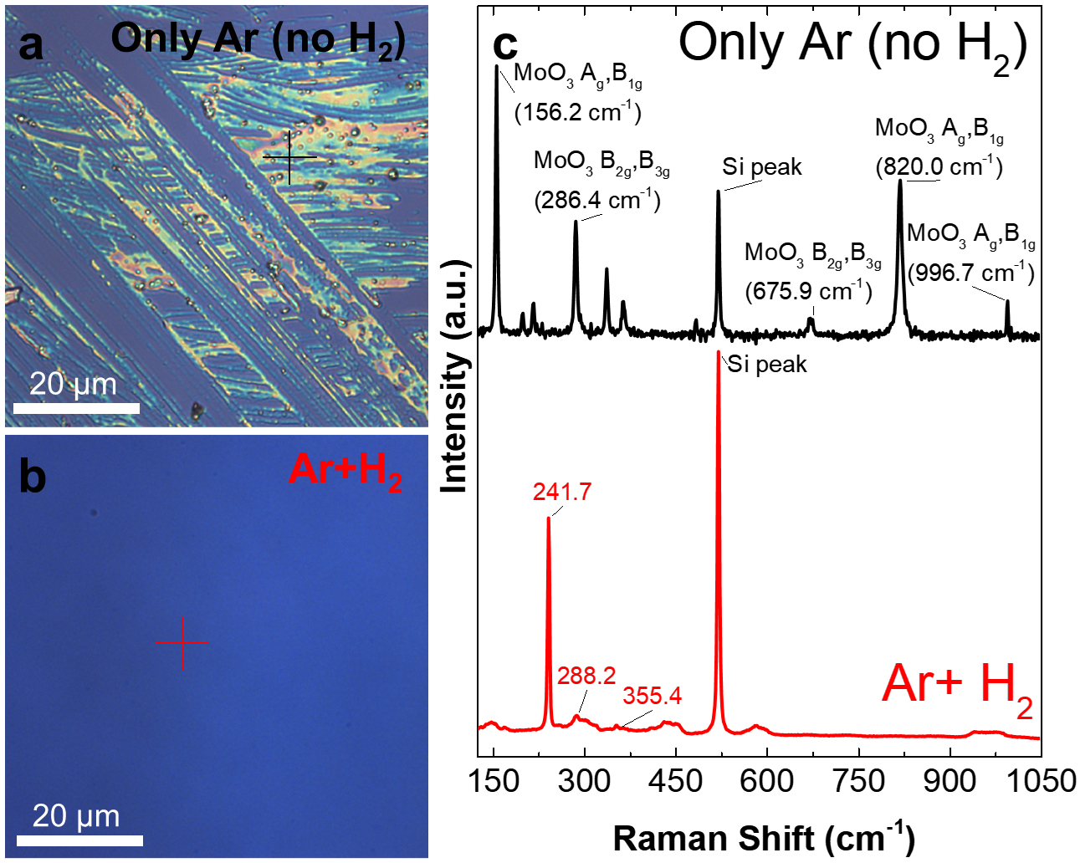
Figure S1: a) Uneven deposition of MoO₃ by a process carried out without H₂. b) 2D MoSe₂ deposition by a process carried out with 10 sccm of H₂. c) Raman spectra of the samples, showing the presence of Mo oxide with no H₂ ¹. With the introduction of H₂ no oxide peaks were detected (red plot).
In order to ascertain the role of H₂ during MoSe₂ growth, two 2PS samples were grown with different H₂ carrier gas flows: i) 0 sccm of H₂ (only 150 sccm of Ar, Figure S1a), ii) 10 sccm of H₂ (mixed with 150 sccm of Ar, Figure S1b). The other CVD parameters were kept as described in the Experimental section. The absence of H₂ appears to hinder the reduction of the MoO₃ vapor and in turn the selenization of Mo by the Se vapor.
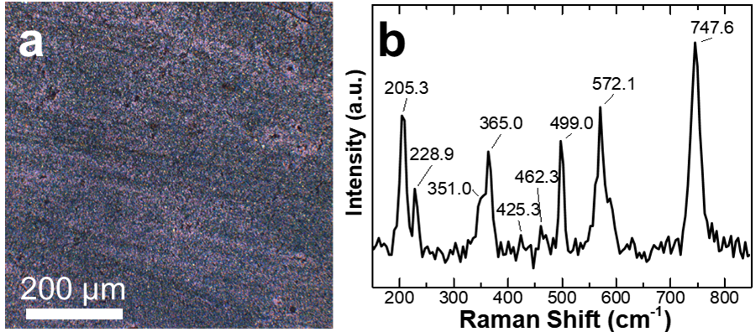
Figure S2: a) Optical image of a samples grown with the Se precursor at 320ºC. The presence of H₂ during the process allows the reduction of MoO₃ to MoO₂, but the Se powder is at a too low temperature for the selenization to occur, leading to the deposition of MoO₂. b) Raman spectra confirming showing the characteristics peaks of MoO₂ ².
In order to ascertain the role of the Se precursor temperature, a specific 2PS experiment was performed. The Se powder was kept at 320º (by placing it 45 cm upstream from the growth region). The other CVD parameters were kept as described in the Experimental section.
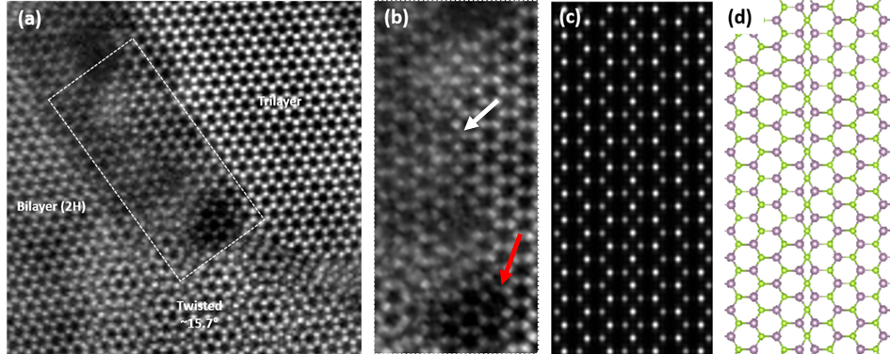
Figure S3: a) HAADF STEM image of grain boundary in monolayer and bilayer regions (2PS sample). (b) Magnified HAADF STEM image from the white dashed box area in a) showing the mirror twin boundary (MTB) with characteristic 4- and 8-member rings. c) Simulated image and d) atomic model of the mirror twin boundary (Mo atoms in purple and Se atoms in green).
Figure S3a shows a HAADF STEM image of mirror twin boundary (MTB) buried within a multilayer MoS₂ region (2PS sample). MTBs are created when the lattice is rotated in-plane by 60 degree, MTBs are joined by edge sharing 4- and 8-member rings. For the 4-member ring structure the Mo atoms retain 6-fold coordination whereas the Se atoms change from 3-fold to 4-fold coordination ³. In Figure S3b , a higher magnification view of MTB taken from the white dashed box area in Figure S3a reveals the 4-member rings (indicated with white arrow) and one 8-member ring in the bottom part (indicated with a red arrow). The experimental results correspond well with the multi-slice simulation HAADF STEM image of MTB (Figure S3c) and its atomic model (Figure S3d). The MTBs enhances the in-plane electric conductivity and quench the local photoluminescence. In bilayer films MTBs lead to the formation of 2D stacking faults namely 3R stacking.
References
(1) Windom, B. C.; Sawyer, W. G.; Hahn, D. W. A Raman Spectroscopic Study of MoS2 and MoO3: Applications to Tribological Systems. Tribol. Lett. 2011 423 2011, 42 (3), 301–310. https://doi.org/10.1007/S11249-011-9774-X.
(2) Narro-García, R.; Méndez, N.; Apátiga, L. M.; Flores-De los Ríos, J. P.; Nava-Dino, C. G.; Quintero-Torres, R. Effect of the Substrate Temperature on the Structural and Morphological Properties of MoO2 Thin Films Obtained by Pulsed Injection MOCVD. Int. J. Electrochem. Sci. 2017, 12 (5), 3907–3915. https://doi.org/10.20964/2017.05.51.
(3) Zhou, S.; Wang, S.; Shi, Z.; Sawada, H.; Kirkland, A. I.; Li, J.; Warner, J. H. Atomically Sharp Interlayer Stacking Shifts at Anti-Phase Grain Boundaries in Overlapping MoS 2 Secondary Layers. Nanoscale 2018, 10 (35), 16692–16702. https://doi.org/10.1039/C8NR04486D.

* Corresponding author: andrea.capasso@inl.int

