Phenological drivers of ungulate migration in South America: Characterizing the movement and seasonal habitat use of guanacos.
Malena Candino¹, Emiliano Donadio², Jonathan N. Pauli¹
¹Department of Forest and Wildlife Ecology, University of Wisconsin, Madison, WI 53706, U.S.A.
²Fundación Rewilding Argentina, Buenos Aires, Argentina. CP 1425.

Corresponding author: Malena Candino, candino@wisc.edu, 608-209-0291.
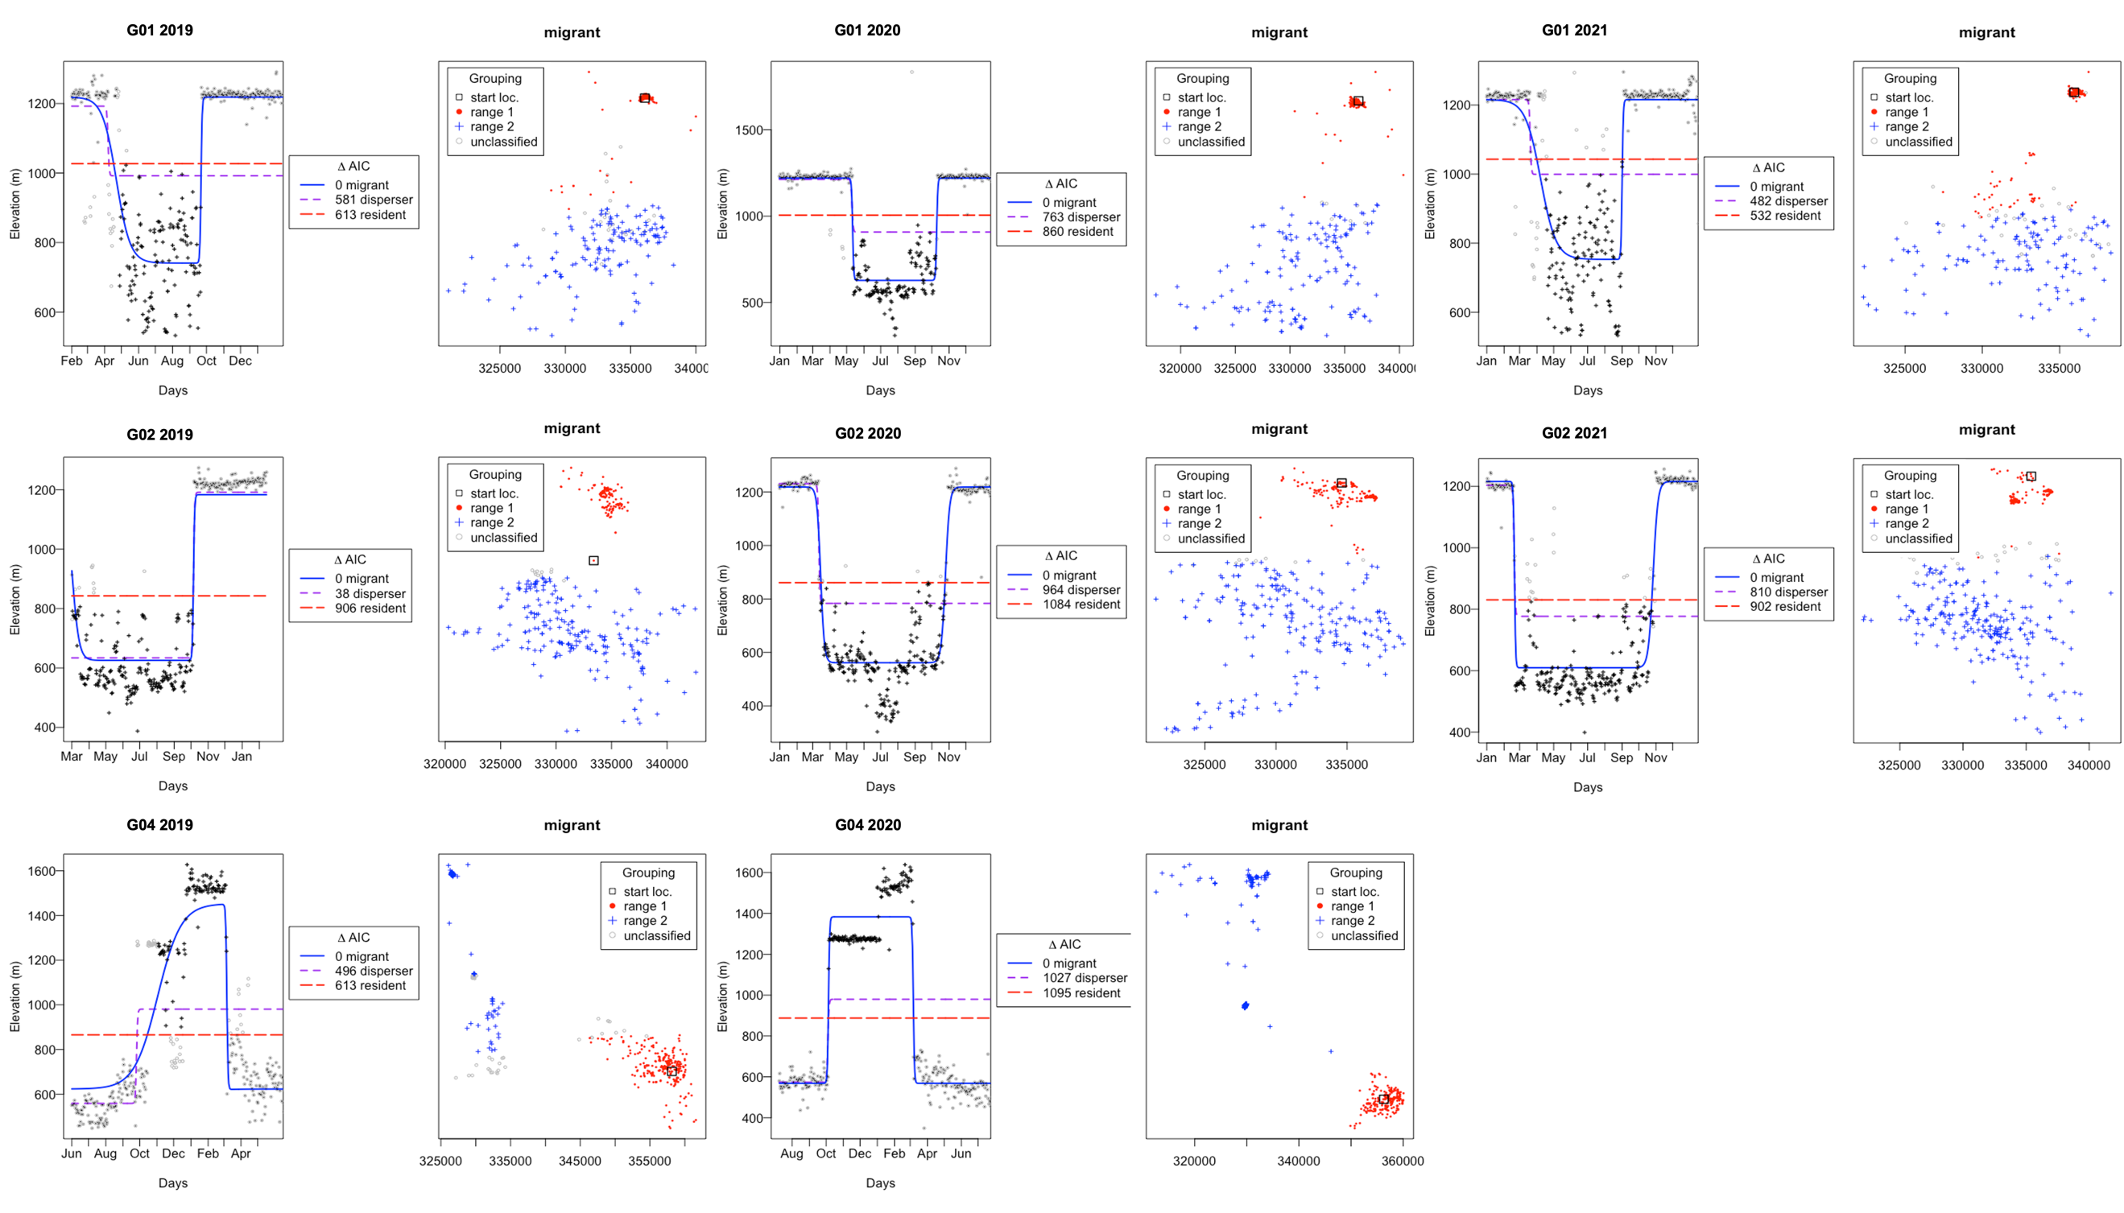
Figure 1. Net square displacement plots of each migratory cycle for 3 guanacos (G01, G02, G04) that remained migratory for the duration of the study showing all three a priori models (migrant, disperser and resident) with their corresponding AIC value, and the distribution and classification of each relocation to either the starting range (range 1), their migratory range (range 2) or unclassified locations.

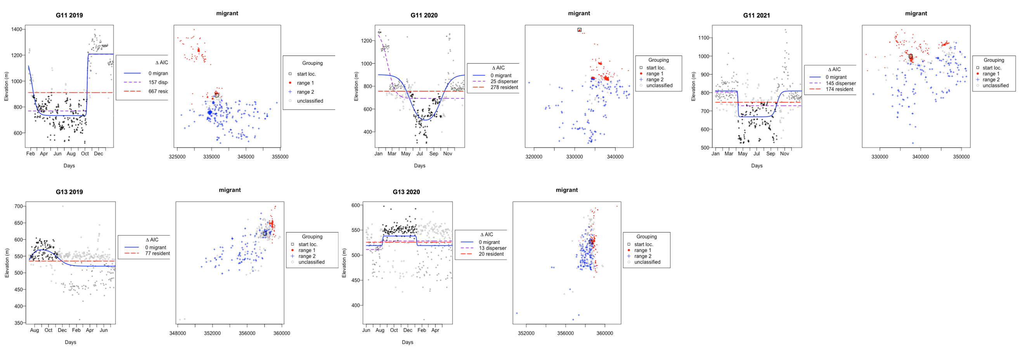
Figure 2. Net square displacement plots for 2 individual guanacos (G11, G13) that were originally classified as migratory showing all three a priori models (migrant, disperser and resident) with their corresponding AIC value, and the distribution and classification of each relocation to either the starting range (range 1), their migratory range (range 2) or unclassified locations. When incorporating the home range overlap method, G11 was considered to have switched strategies in 2021 and was finally classified as resident, and G13 was considered resident for both cycles.

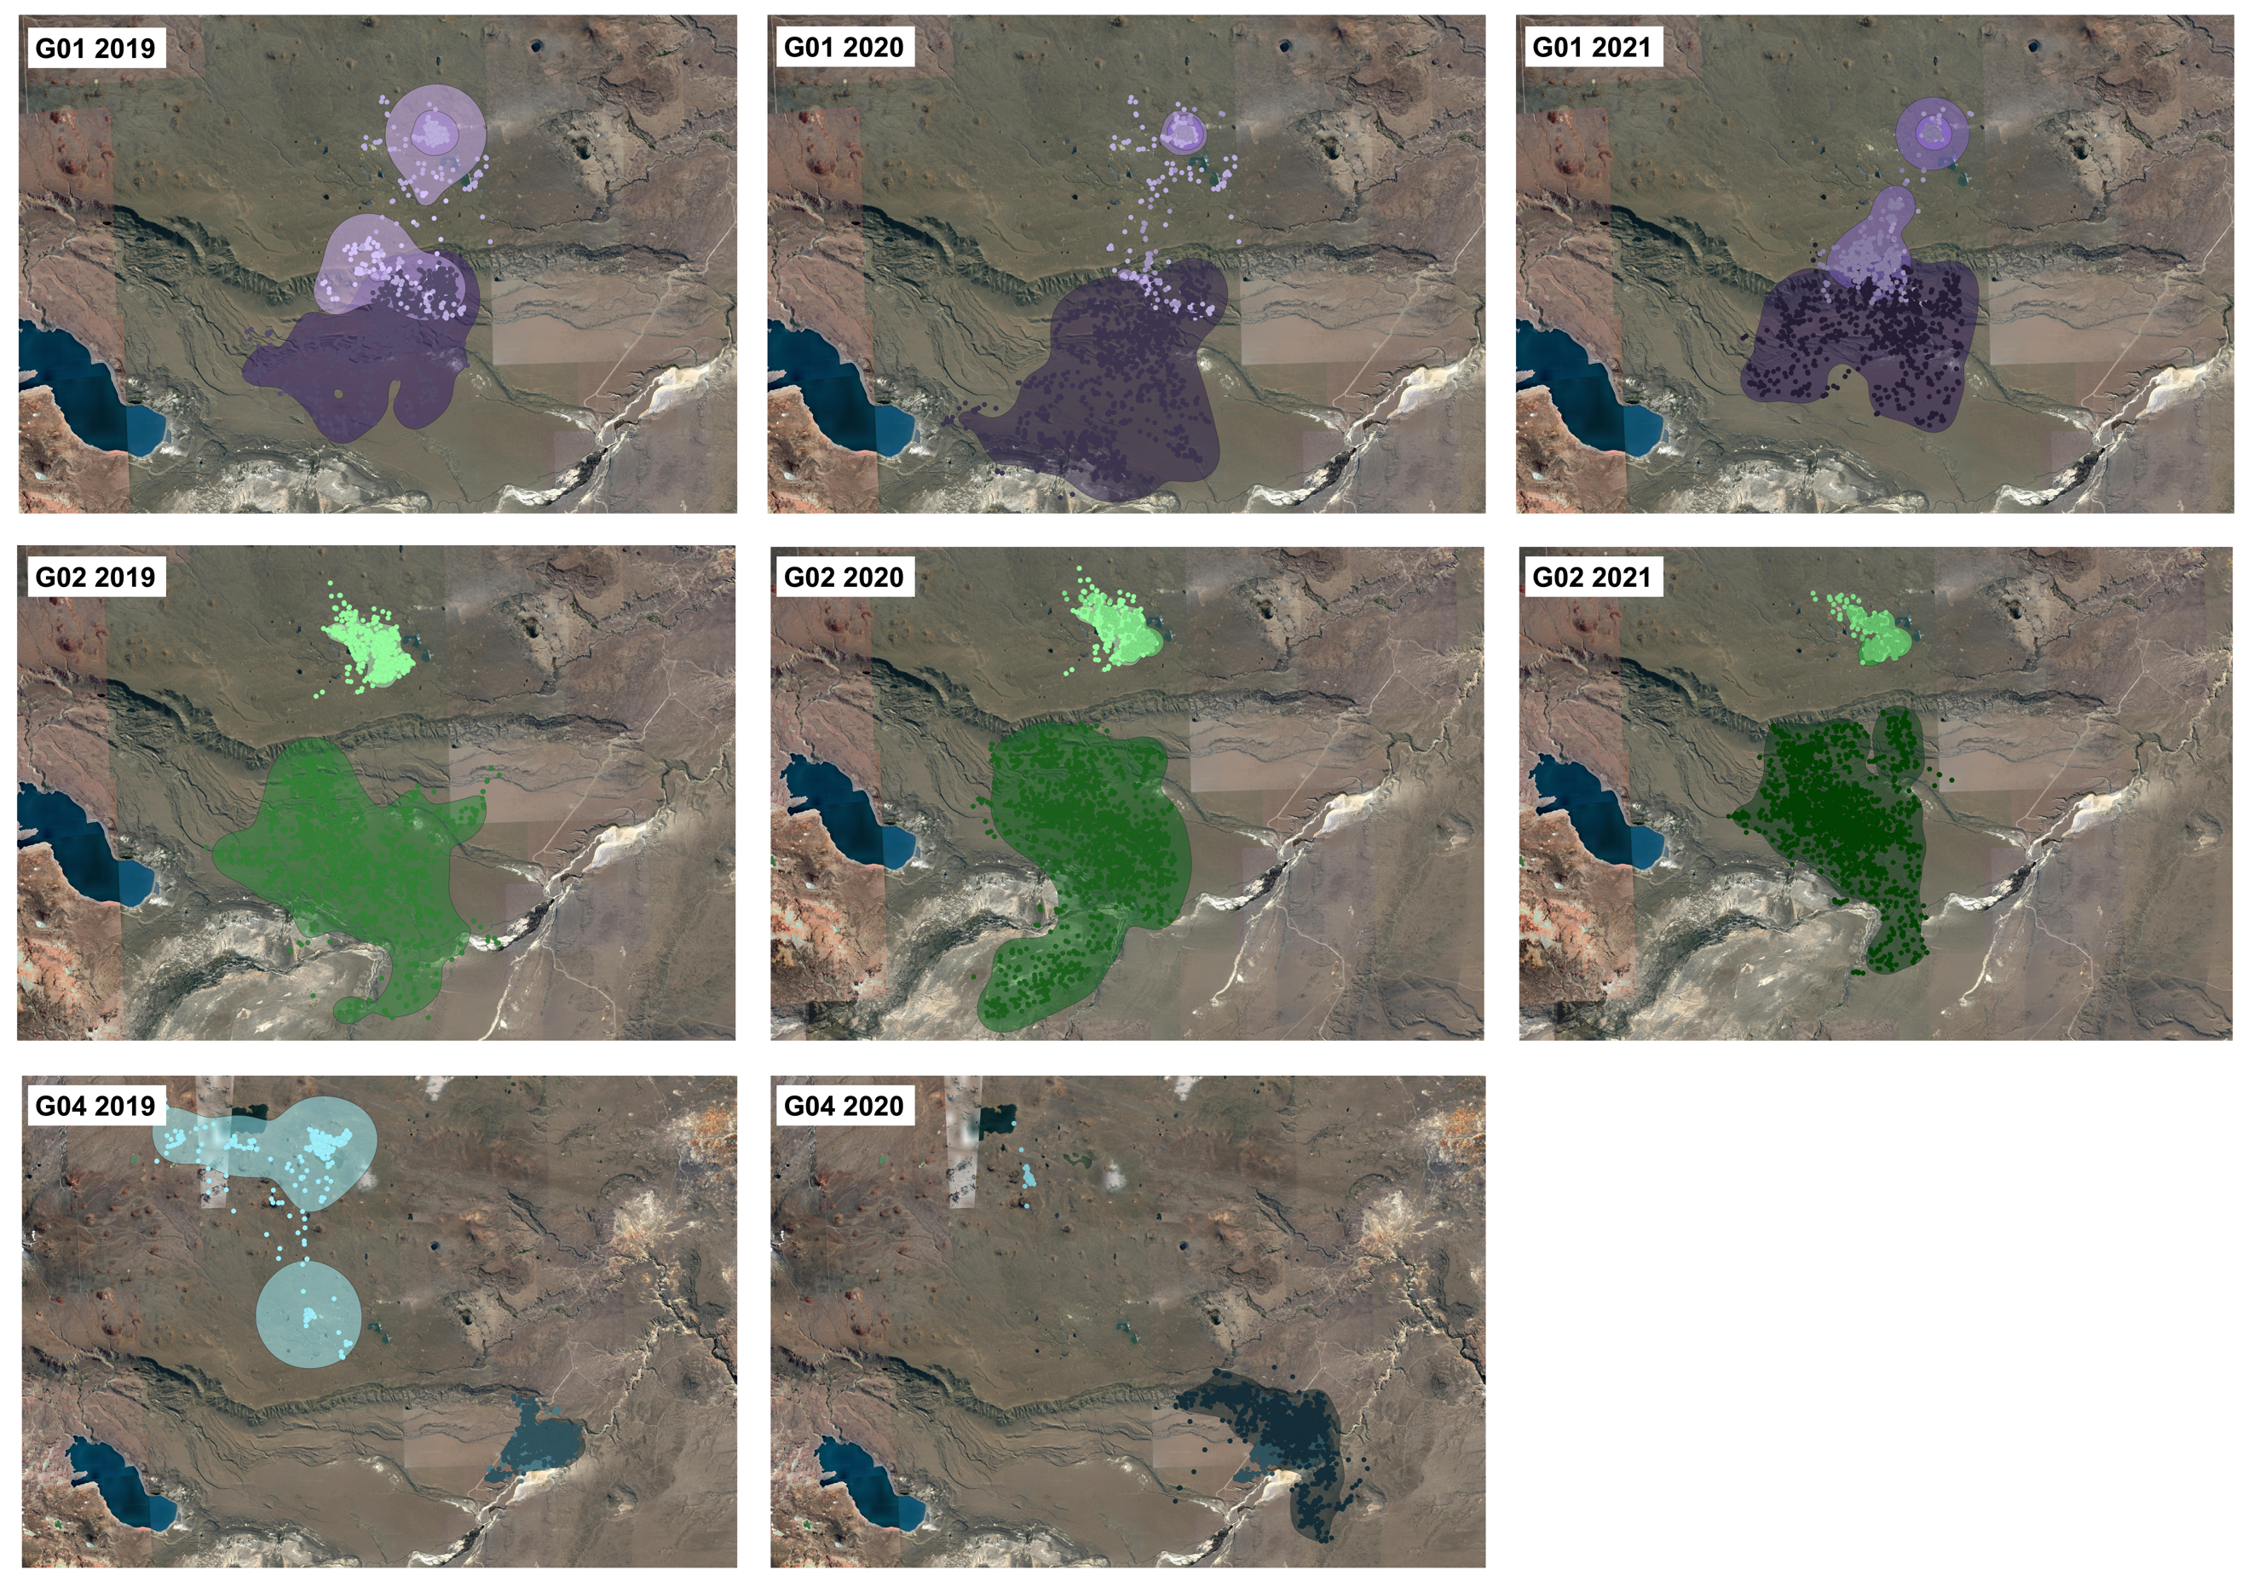
Figure 3. GPS locations and 95% Kernel Density Estimate (KDE) home ranges with color gradients for three guanacos classified as migratory by the home range overlap method (G01, G02, G04) illustrating summer (lighter) and winter (darker) ranges with different degrees of overlap and Bhattacharyya's affinity index (BA = 0 for all migratory cycles of G02 and G04; 0>BA≥0.15 for all migratory cycles of G01).
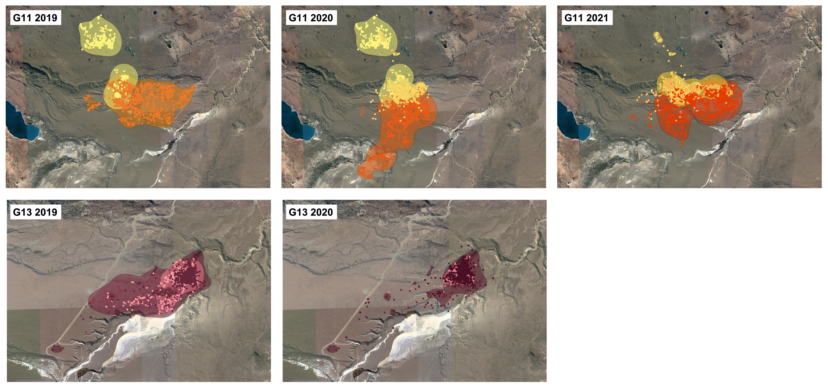
Figure 4. GPS locations and 95% Kernel Density Estimate (KDE) home ranges with color gradients for two guanacos (G11, G13) illustrating summer (lighter) and winter (darker) ranges with different degrees of overlap and Bhattacharyya's affinity index. G11 was classified as migratory by the home range overlap method for 2019 (0>BA≥0.15) but was classified as resident for 2020 and 2021 (BA ≤0.15). G13 was classified as resident for both cycles (BA ≤0.15).
Table 1. Attributes of migration for 21 adult guanacos (Lama guanicoe) equipped with GPS collars in Patagonia, Argentina 2019-2022. Identification of seasonal behaviors (migratory, residential or dispersal) according to two methods, altitudinal Net Squared Displacement (NSD) and Seasonal Range Overlap, final classification and migration parameters regarding timing, duration and distance for individuals classified as migratory obtained from the top NSD model.
ID | Starting range | NSD top model | Seasonal Overlap top model | Final classification | Summer departure date- θ | Winter departure date- θ | Duration- ρ (days) | Altitudinal Distance- δ (m) | Duration winter migration- φ (days) | Duration summer migration- φ (days)
G01 | Summer | Migratory | Migratory | Migratory | 4/23/2019 | 9/21/2019 | 125 | 479 | 13 | 1
G01 | Summer | Migratory | Migratory | Migratory | 5/12/2020 | 10/10/2020 | 148 | 592 | 1 | 1
G01 | Summer | Migratory | Migratory | Migratory | 4/11/2021 | 9/1/2021 | 117 | 459 | 13 | 1
G02 | Summer | Migratory | Migratory | Migratory | 3/3/2019 | 10/7/2019 | 200 | 629 | 6 | 1
G02 | Summer | Migratory | Migratory | Migratory | 3/16/2020 | 10/26/2020 | 212 | 655 | 3 | 3
G02 | Summer | Migratory | Migratory | Migratory | 2/20/2021 | 10/27/2021 | 240 | 606 | 1 | 3
G03 | Summer | Migratory | Migratory | Migratory | 6/11/2020 | 8/11/2020 | 1 | 395 | 17 | 16
G03 | Summer | Migratory | Resident | Resident | NA | NA | NA | NA | NA | NA
G04 | Winter | Migratory | Migratory | Migratory | 3/6/2020 | 10/6/2019 | 149 | 811 | 1 | 1
G04 | Winter | Migratory | Migratory | Migratory | 3/6/2021 | 11/3/2020 | 80 | 833 | 1 | 21
G05 | Summer | Disperser | Resident | Resident | NA | NA | NA | NA | NA | NA
G05 | Summer | Migratory | Migratory | Migratory | 6/28/2020 | 8/11/2020 | 4 | 313 | 15 | 15
G05 | Summer | Disperser | Resident | Resident | NA | NA | NA | NA | NA | NA
G06 | Winter | Migratory | Disperser | Migratory | 1/8/2020 | 11/24/2019 | 34 | 369 | 1 | 21
G07 | Summer | Migratory | Migratory | Migratory | 4/22/2019 | 9/18/2019 | 96 | 521 | 17 | 4
G07 | Summer | Migratory | Migratory | Migratory | 3/20/2020 | 10/9/2020 | 134 | 623 | 21 | 12
G07 | Summer | Migratory | Migratory | Migratory | 3/24/2021 | 9/23/2021 | 193 | 455 | 1 | 1
G09 | Summer | Resident | Migratory | Migratory | 7/3/2020 | 8/11/2020 | 1 | 295 | 11 | 4
G09 | Summer | Migratory | Resident | Resident | NA | NA | NA | NA | NA | NA
G10 | Winter | Migratory | Disperser | Migratory | 9/23/2019 | 3/4/2019 | 101 | 576 | 1 | 2
G11 | Summer | Migratory | Migratory | Migratory | 2/8/2019 | 10/16/2019 | 211 | 475 | 10 | 7
G11 | Summer | Migratory | Resident | Migratory | 2/9/2020 | 10/20/2020 | 55 | 427 | 21 | 2
G11 | Summer | Migratory | Resident | Resident | NA | NA | NA | NA | NA | NA
G12 | Winter | Migratory | Resident | Migratory | 2/25/2020 | 10/14/2019 | 89 | 510 | 21 | 1
G13 | Winter | Migratory | Resident | Resident | NA | NA | NA | NA | NA | NA
G13 | Winter | Migratory | Resident | Resident | NA | NA | NA | NA | NA | NA
G14 | Winter | Migratory | Disperser | Migratory | 3/20/2020 | 10/9/2019 | 140 | 667 | 10 | 1
G15 | Summer | Migratory | Disperser | Migratory | 3/17/2019 | 10/16/2019 | 130 | 775 | 21 | 21
G16 | Winter | Migratory | Disperser | Migratory | 2/9/2020 | 11/19/2019 | 21 | 1105 | 10 | 21
G18 | Winter | Migratory | Migratory | Migratory | 3/15/2021 | 10/10/2020 | 117 | 702 | 19 | 1
G19 | Winter | Migratory | Migratory | Migratory | 3/13/2021 | 10/25/2020 | 48 | 558 | 20 | 21
G20 | Winter | Migratory | Disperser | Migratory | 3/24/2021 | 10/20/2020 | 119 | 547 | 1 | 2
G21 | Winter | Disperser | Resident | Resident | NA | NA | NA | NA | NA | NA
G24 | Summer | Migratory | Migratory | Migratory | 5/21/2021 | 10/1/2021 | 97 | 579 | 17 | 5
G26 | Summer | Migratory | Resident | Resident | NA | NA | NA | NA | NA | NA

Table 2. Intraindividual coefficient of variation for migratory guanacos with multiple years of data (3 individuals with 3 years of data and 2 individuals with 2 years of data) compared to intraindividual variation for all collared guanacos for different migratory characteristics.
 | Intraindividual Coefficient of Variation (CV) | Interindividual coefficient of Variation (CV)
Summer departure date | 11.2 | 51.2
Winter departure date | 4.8 | 9.7
Migration distance | 8.7 | 30.7
Migration duration | 64.8 | 90.6
Time spent in migratory range | 36.4 | 61.6

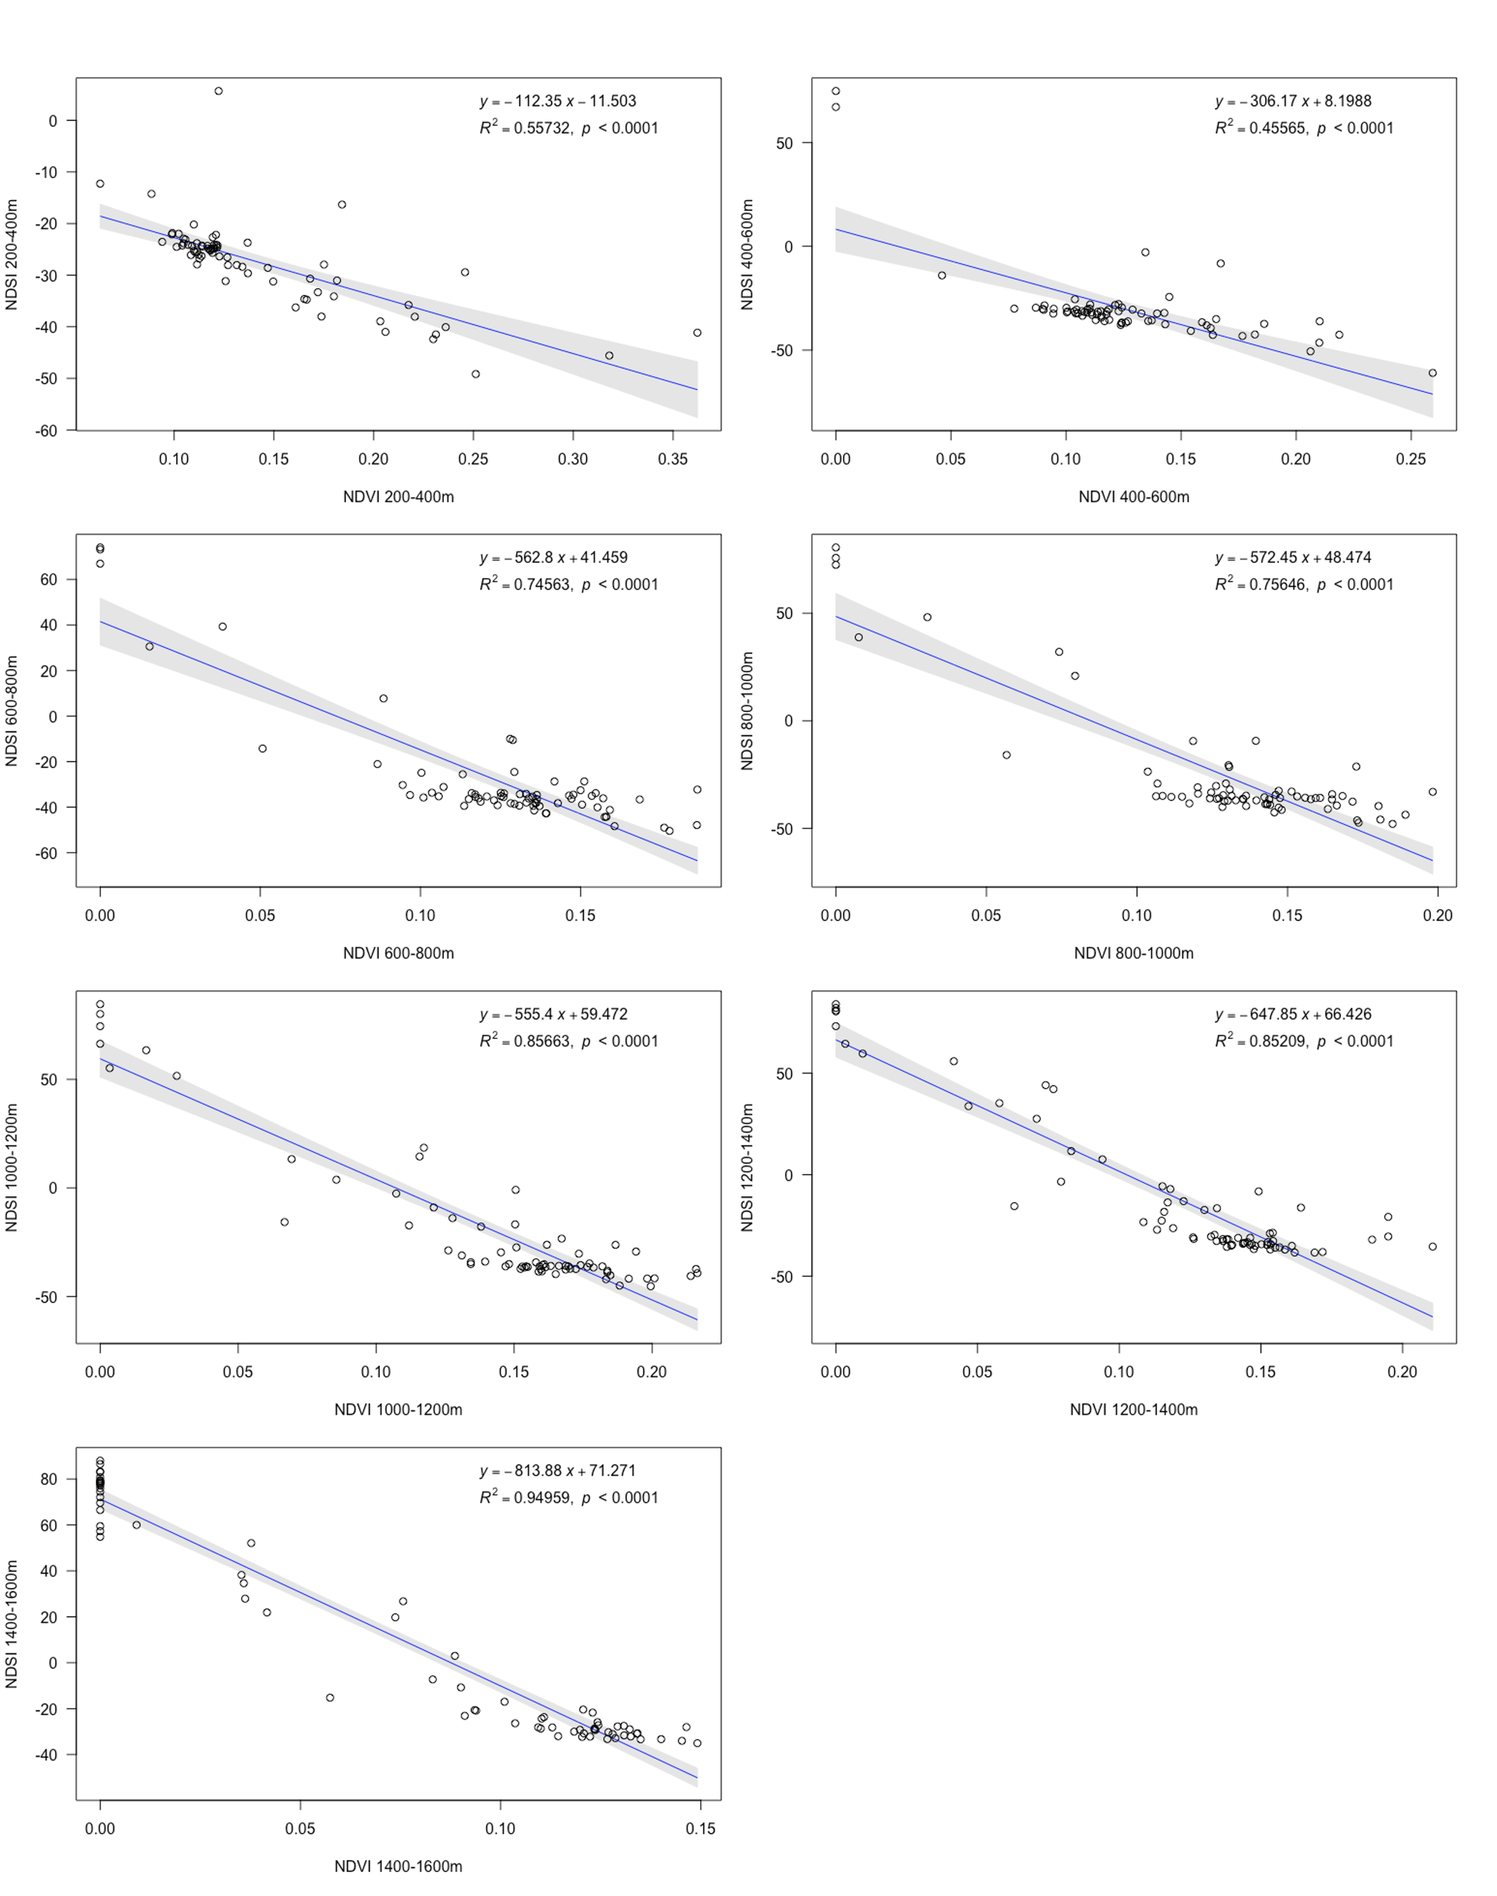
Figure 5. Plots of raw Normalized Difference Snow Index (NDSI) and Normalized Difference Vegetation Index (NDVI) summer 2019 to summer 2022, for 200 m altitudinal ranges covering the elevation gradient of the study area, in Patagonia, Argentina.

