Extended Data for
Chemistry-driven oxidant changes strongly influence climate forcing from vegetation emissions

James Weber, Scott Archer-Nicholls, N. Luke Abraham, Youngsub Matthew Shin, Paul Griffiths, Daniel P. Grosvenor, Catherine E. Scott and Alex T. Archibald

Corresponding author: James Weber
Email: j.weber@sheffield.ac.uk

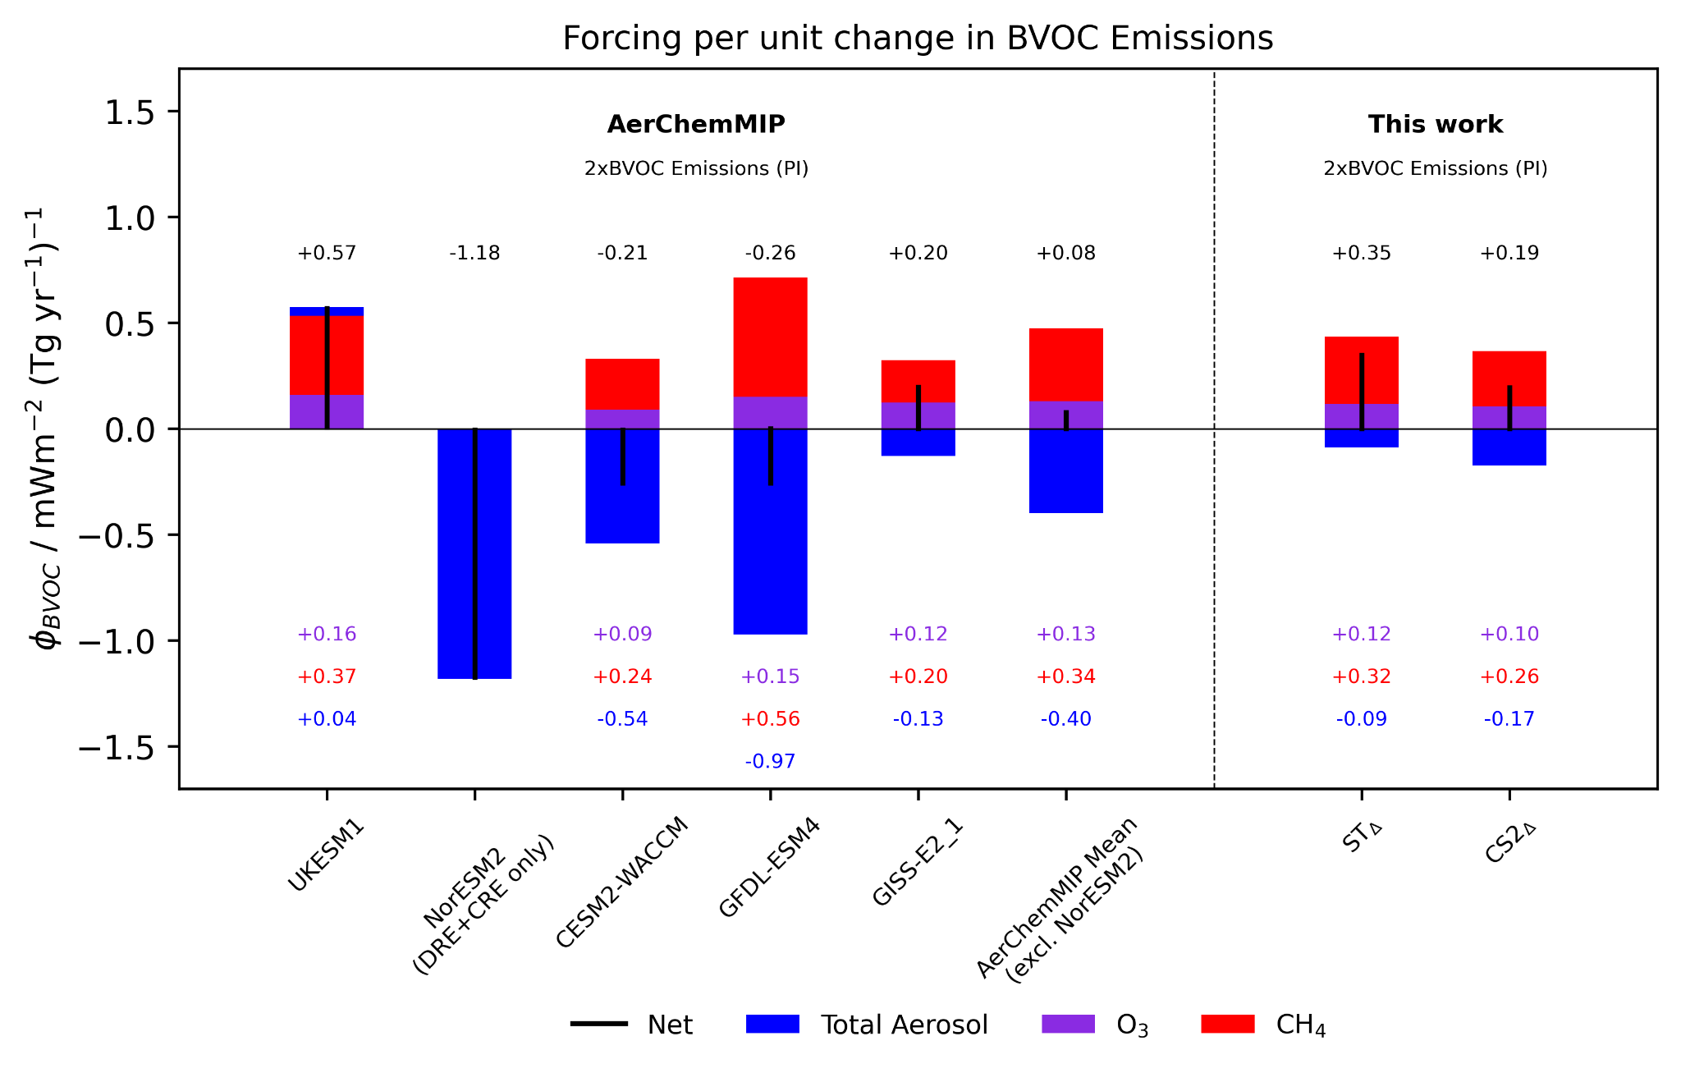
Fig. S1. Forcing per unit change in BVOC emissions from the AerChemMIP 2xBVOC study (Thornhill et al., 2021) and this work.

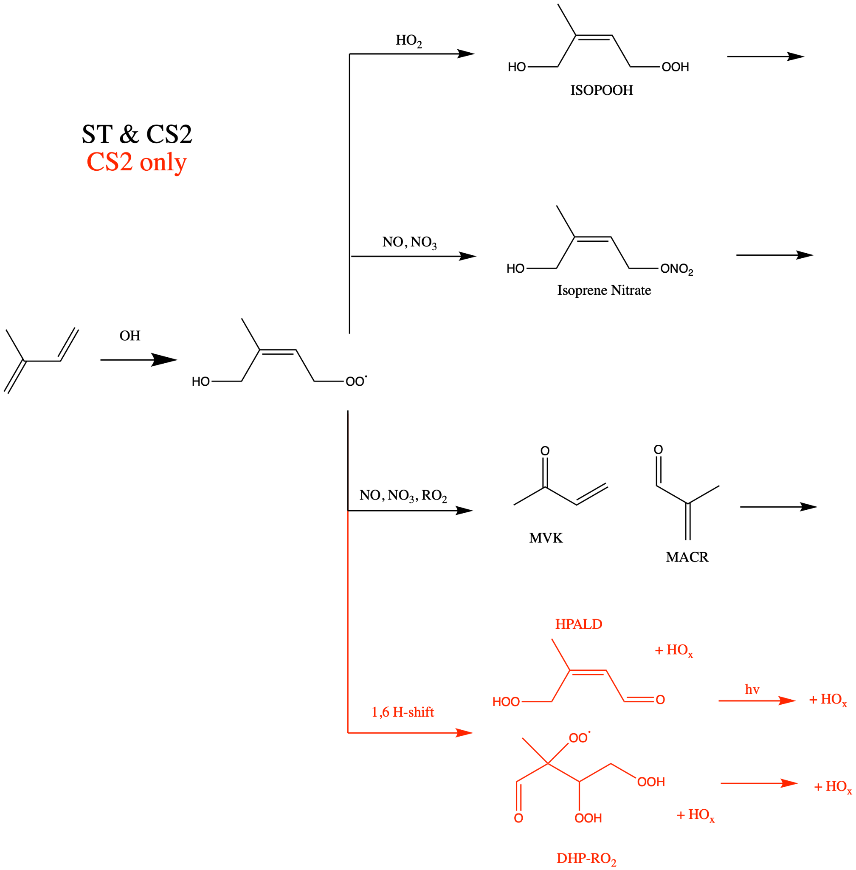
Fig. S2. Mechanistic differences for OH + isoprene between ST and CS2. Only one isomer from OH + isoprene (Z𝛿1-OH, 4-OO; Wennberg et al., 2018) is considered and the 1,5 H-shift is omitted. Reactions in both mechanisms are shown in black and reactions unique to CS2 are in red.

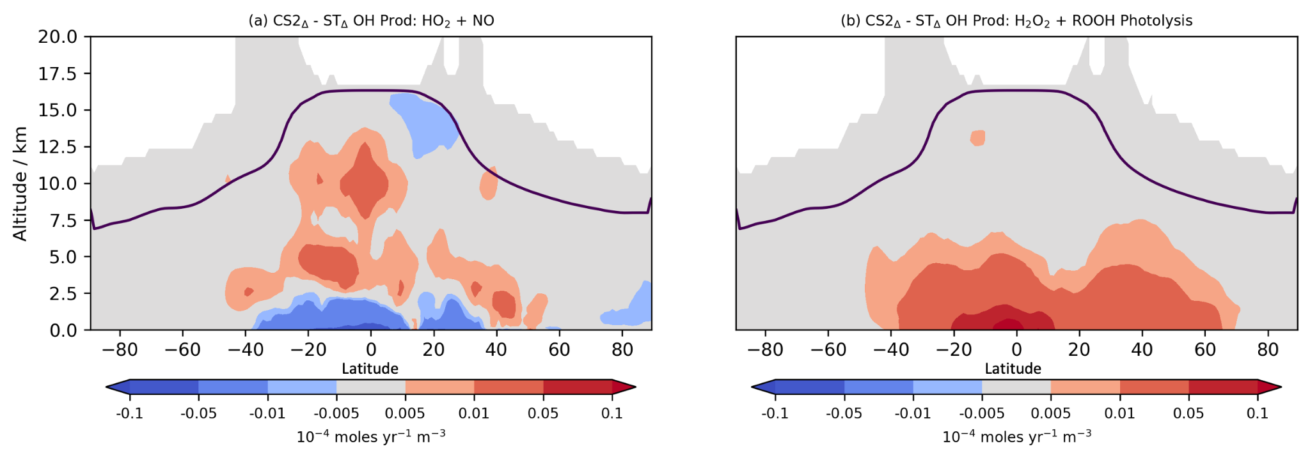
Fig. S3. Zonal mean difference between ST∆ and CS2∆ for OH production from (a) HO₂ + NO and (b) H₂O₂ and other peroxides (ROOH).

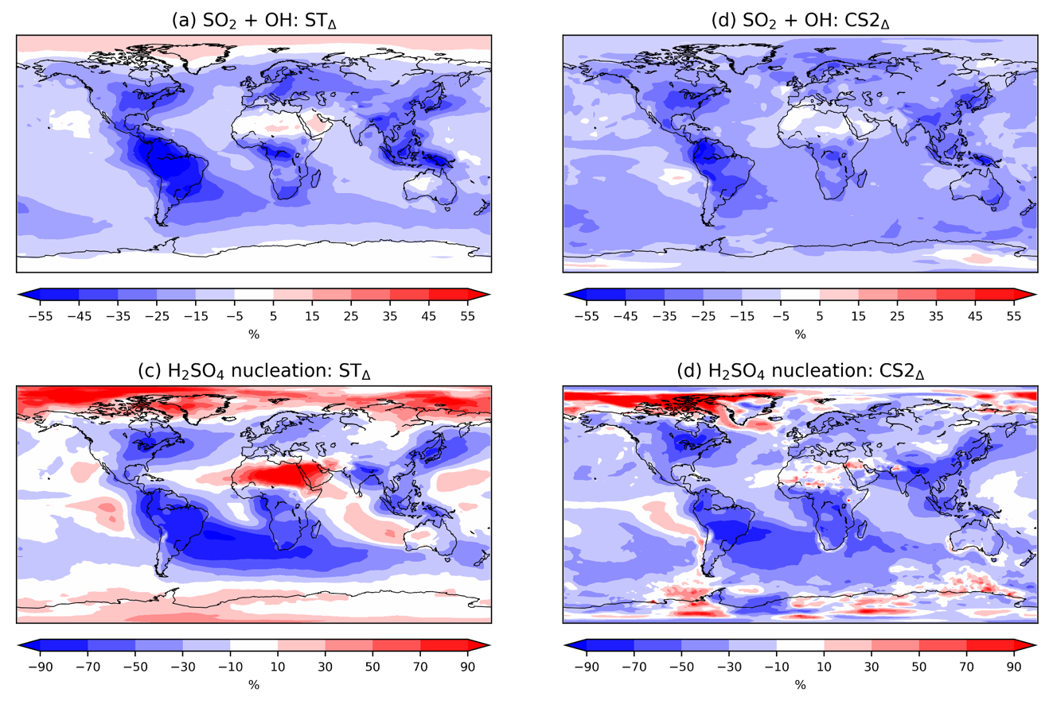
Fig. S4. Percentage change in vertically integrated flux of SO₂ + OH for (a) ST∆ and (b) CS2∆ and nucleation flux of new particle formation from H₂SO₄ for (c) ST∆ and (d) CS2∆.

References

- G. Thornhill et al. Climate-driven chemistry and aerosol feedbacks in CMIP6 Earth system models. Atmospheric Chemistry and Physics 21.2, 1105-1126 (2021).
- P.O. Wennberg et al. Gas-phase reactions of isoprene and its major oxidation products. Chemical reviews 118.7, 3337-3390 (2018).

