Supplementary Information
- The Receiver Operating Curve of Classifier with 1, 3, 6 Time windows and 5 features.
(TEWS=Time series Early Warning Score.)

- The ROC curve of 1 Time window
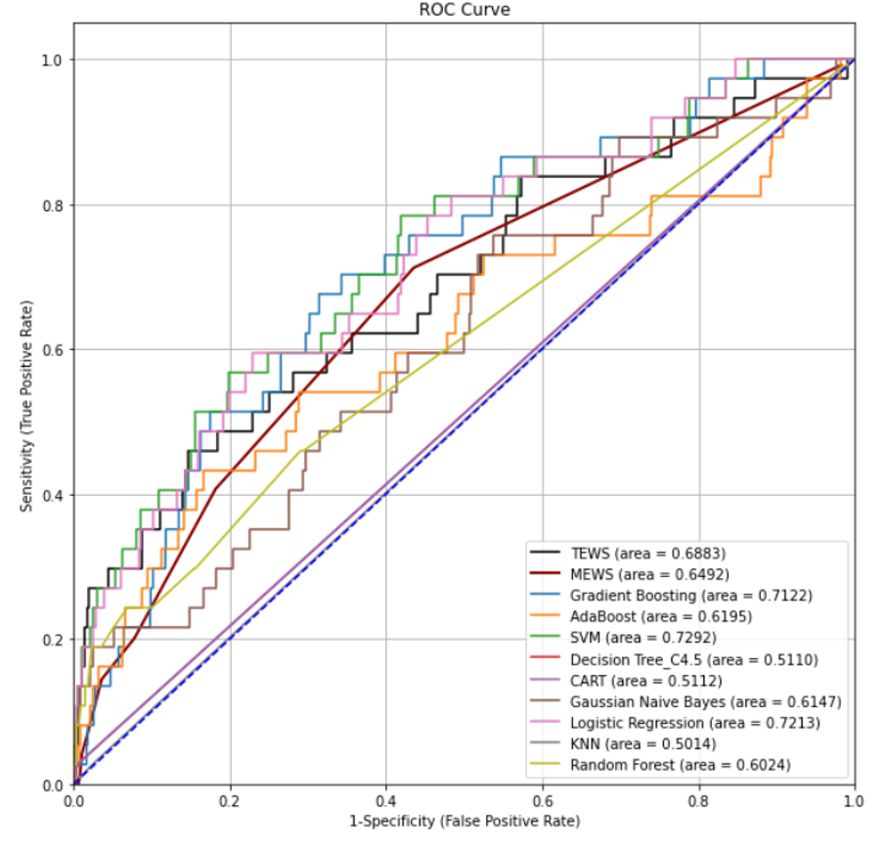

- The ROC curve of 3 Time windows
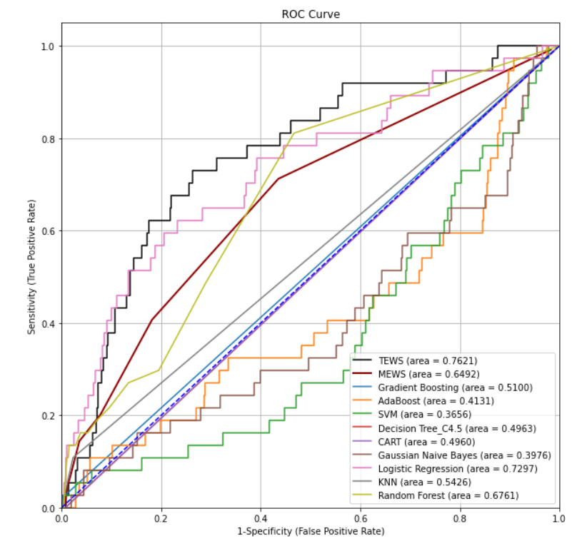

- The ROC curve of 6 Time windows with 30 features
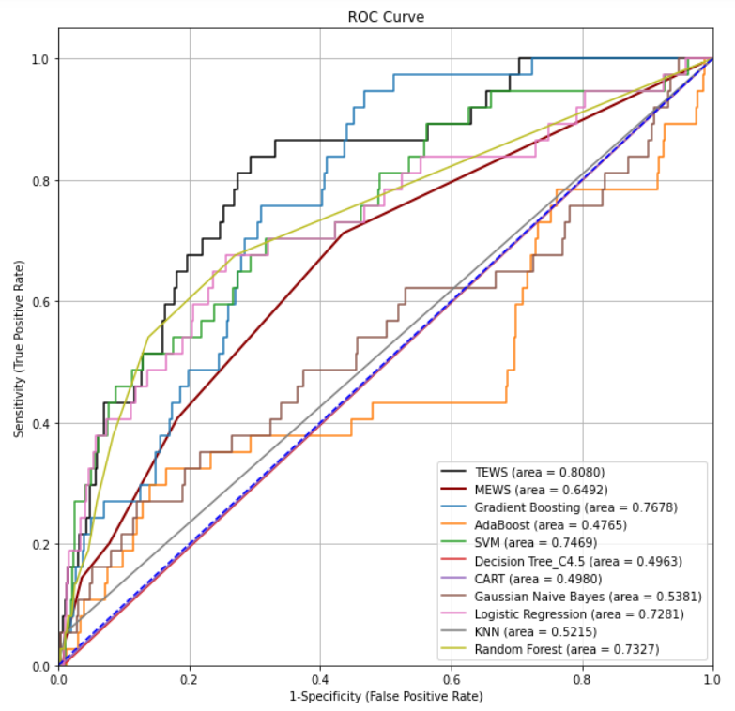

- The ROC curve of 6 Time windows with 5 selected features 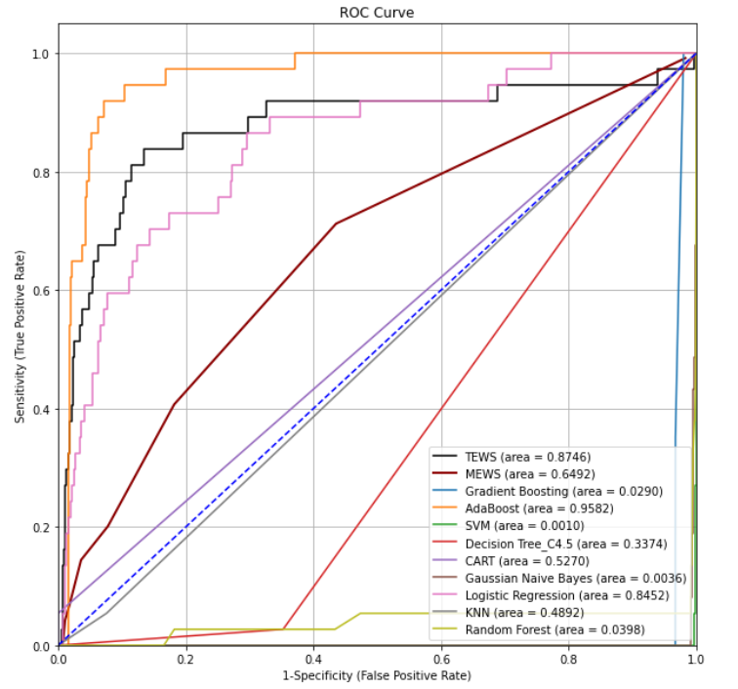

- The Precision-Recall Curve of Classifier with 1, 3, 6 Time windows and 5 features.
(TEWS=Time series Early Warning Score.)
- The PR curve of 1 Time window 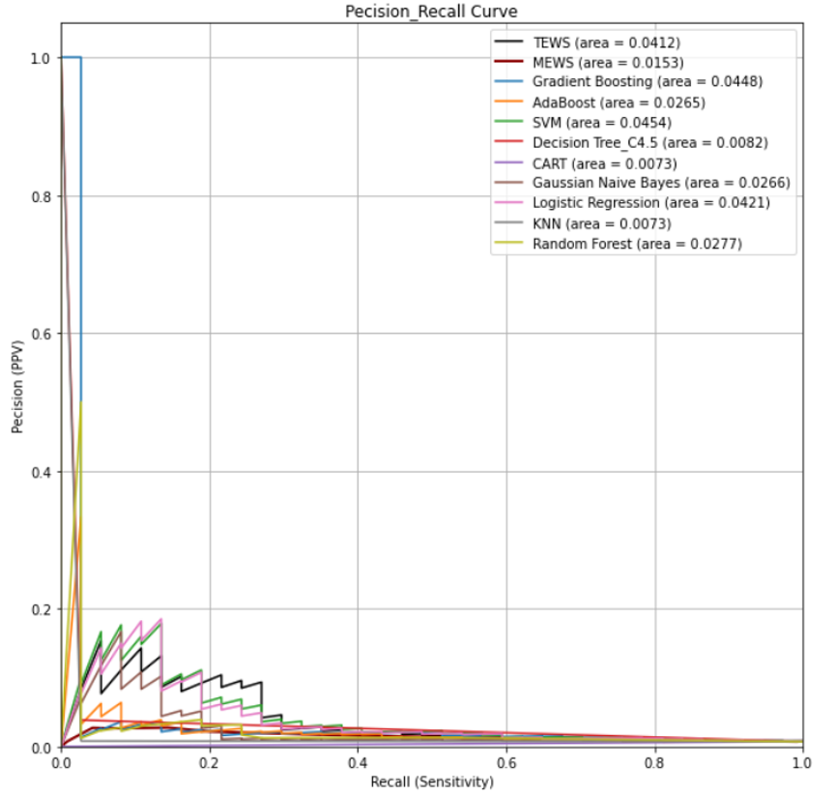

- The PR curve of 3 Time windows
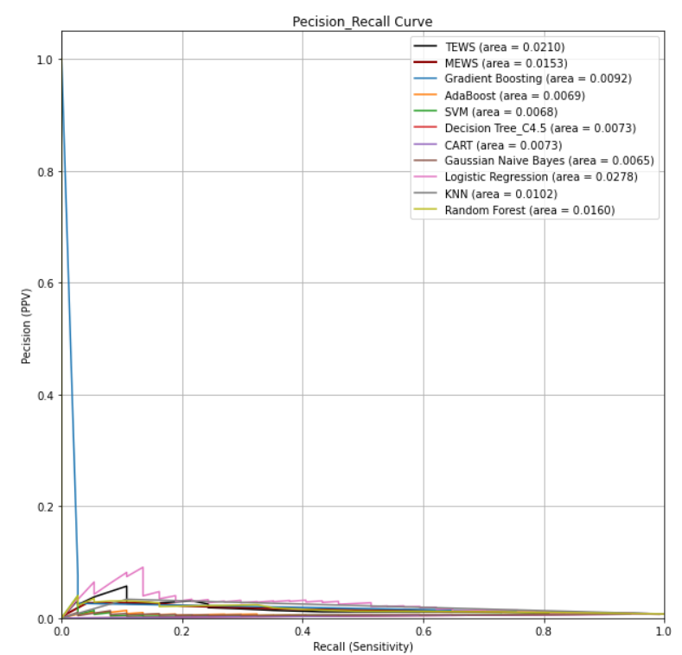

- The PR curve of 6 Time windows with 30 features 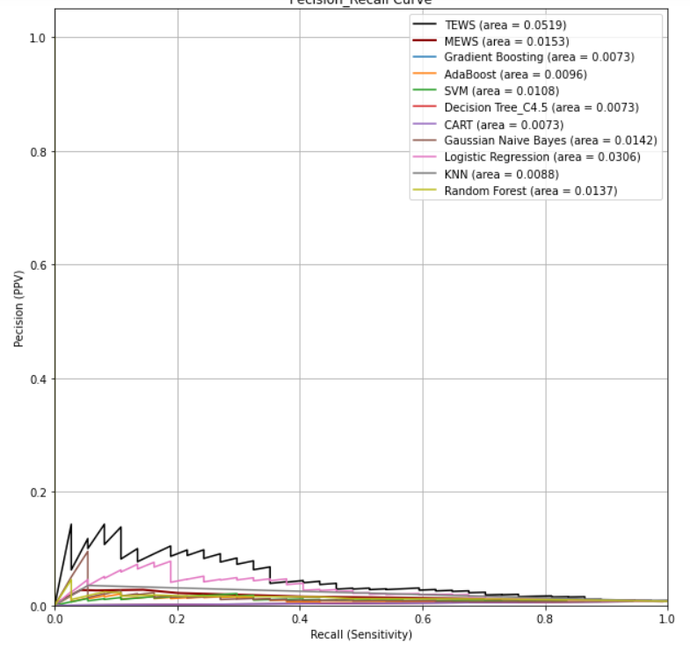

- The PR curve of 6 Time windows with 5 selected features 