Supporting information to:
Inhibitory antibacterial activity of two novel dihydroxy fatty acids and other constituents from the stem bark of Trichilia gilgiana Harms (Meliaceae)

Michael Hermann Kengne Kamdem^{a,b,c*}, Rostan Mangoua Talla^{e}, Eric Morifi^{g}, Sandra Nyanda Bodju^{e}, Blondelle Matio Kemkuignou^{d}, Charlotte Mungho Tata^{a,f}, Gertrude Laura Foudjo Melacheu^{e}, Marthe Carine Djuidje Fotsing^{a,b}, Edwin Mpho Mmutlane^{b,c}, Derek Tantoh Ndinteh^{a,b*}

ªDrug Discovery and Smart Molecules Research Laboratory, Department of Chemical Sciences, University of Johannesburg, P.O. Box 17011, Doornfontein, Johannesburg 2028, South Africa.
^{b}Centre for Natural Product Research (CNPR), Department of Chemical Sciences, University of Johannesburg, Doornfontein, Johannesburg 2028, South Africa.
^{c}Research Center for Synthesis and Catalysis; Department of Chemical Sciences, University of Johannesburg-Kingsway Campus, Auckland Park, 2008, South Africa.
^{d}Department of Microbial Drugs, Helmholtz Centre for Infection Research GmbH, Inhoffenstrasse 7, 38124 Braunschweig, Germany.
^{e}Department of Organic Chemistry, Faculty of Sciences, The University of Yaoundé I, P.O. Box 812, Yaoundé, Cameroon.
^{f}Department of Biochemistry, Faculty of Science, The University of Bamenda, P.O. Box 39 Bambili, Cameroon.
^{g}School of Chemistry, University of the Witwatersrand, Braamfontein 2000, Johannesburg, South Africa

*Corresponding authors: dndinteh@uj.ac.za (D. T. N.); michaelhermannkamdem@gmail.com (M. H. K. K.); Tel., +27837445682 (D. T. N.); +27734323247 (M. H. K. K.)

*Compound 1

Figure S1. Selected HMBC, COSY correlations and some fragments for compound 1

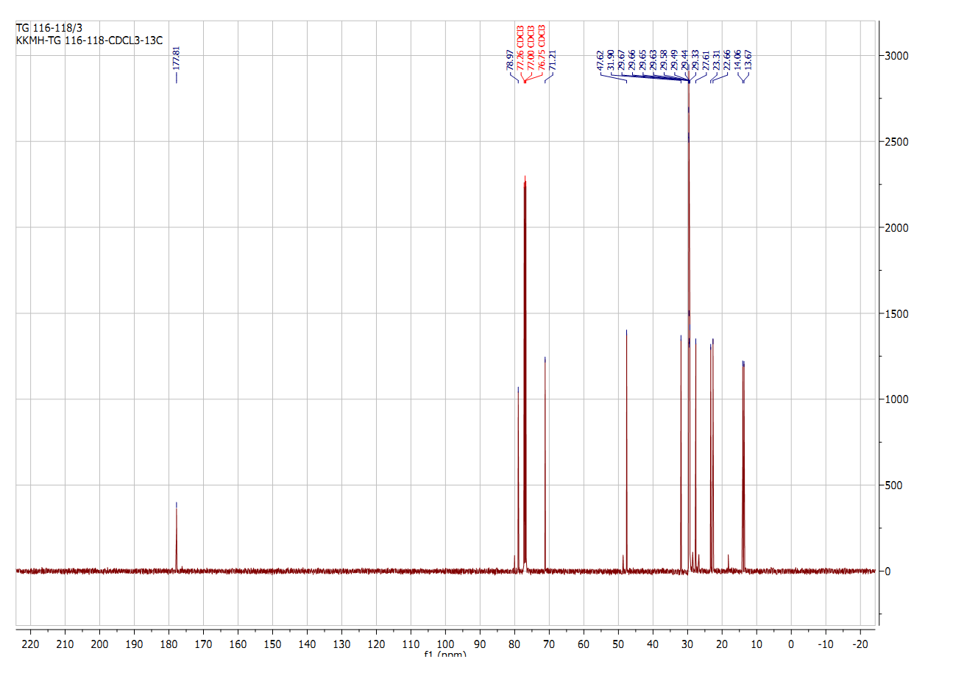
Figure S2. ¹³C NMR spectrum of compound 1 (CDCl₃, 126 MHz)
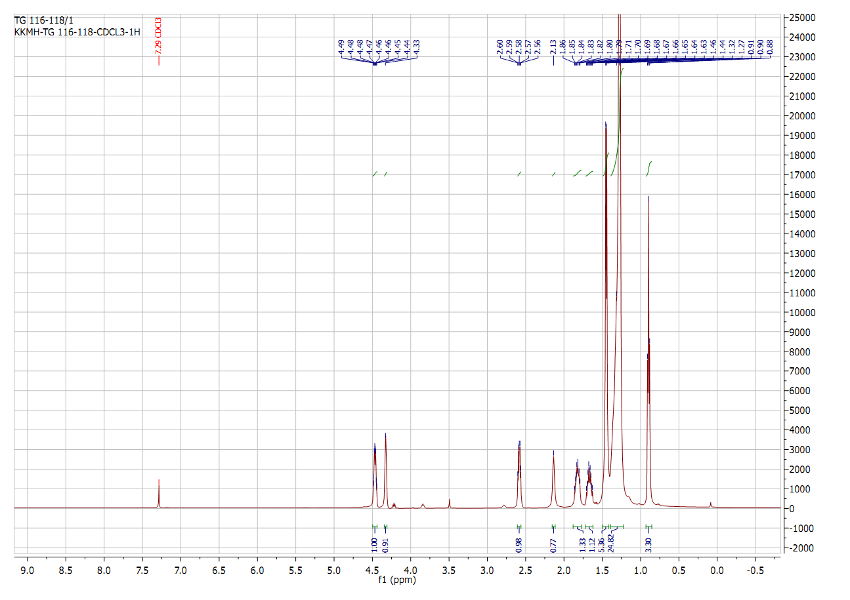
Figure S3. ¹H NMR spectrum of compound 1 (CDCl₃, 500 MHz)
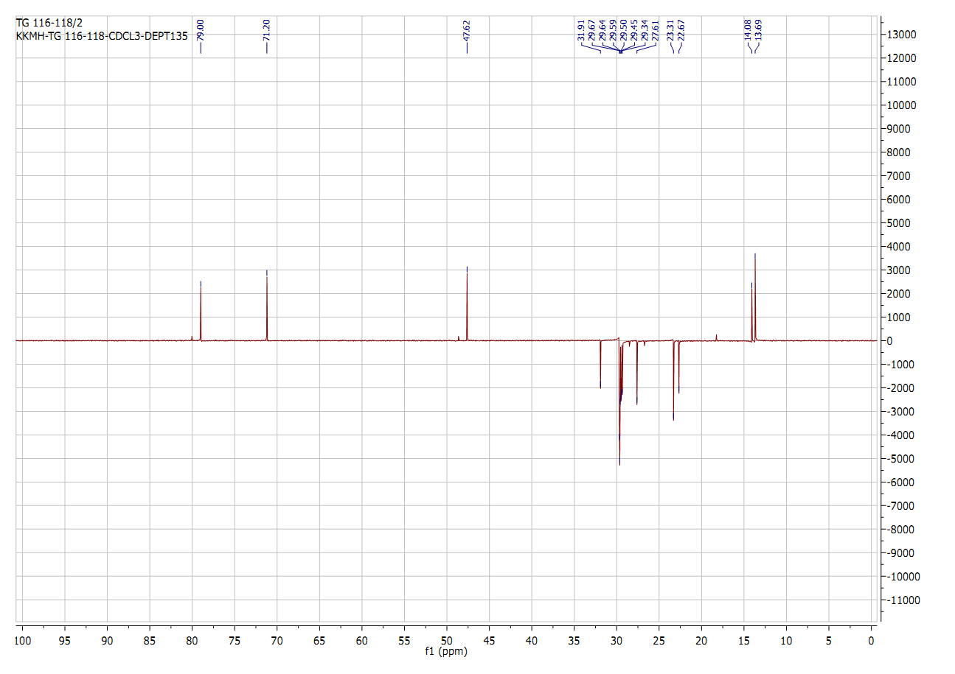
Figure S4. DEPT 135 spectrum of compound 1 (CDCl₃, 500 MHz)
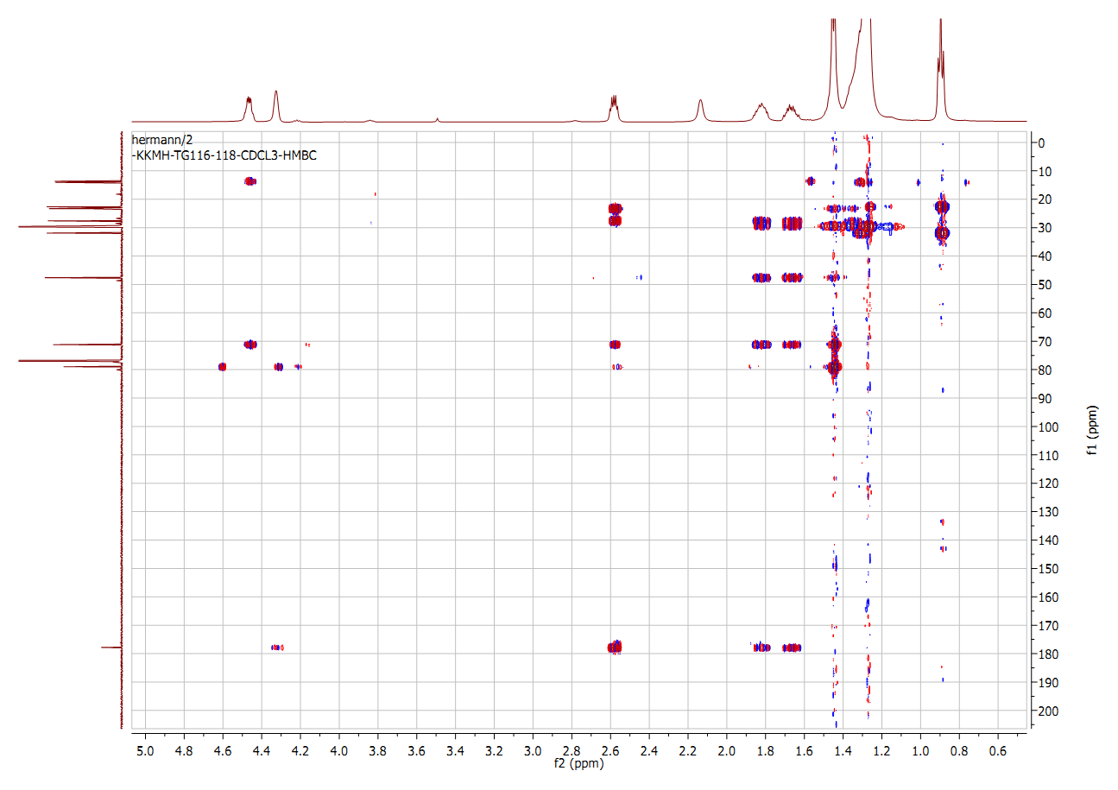
Figure S5. HMBC spectrum of compound 1 (CDCl₃, 500 MHz)
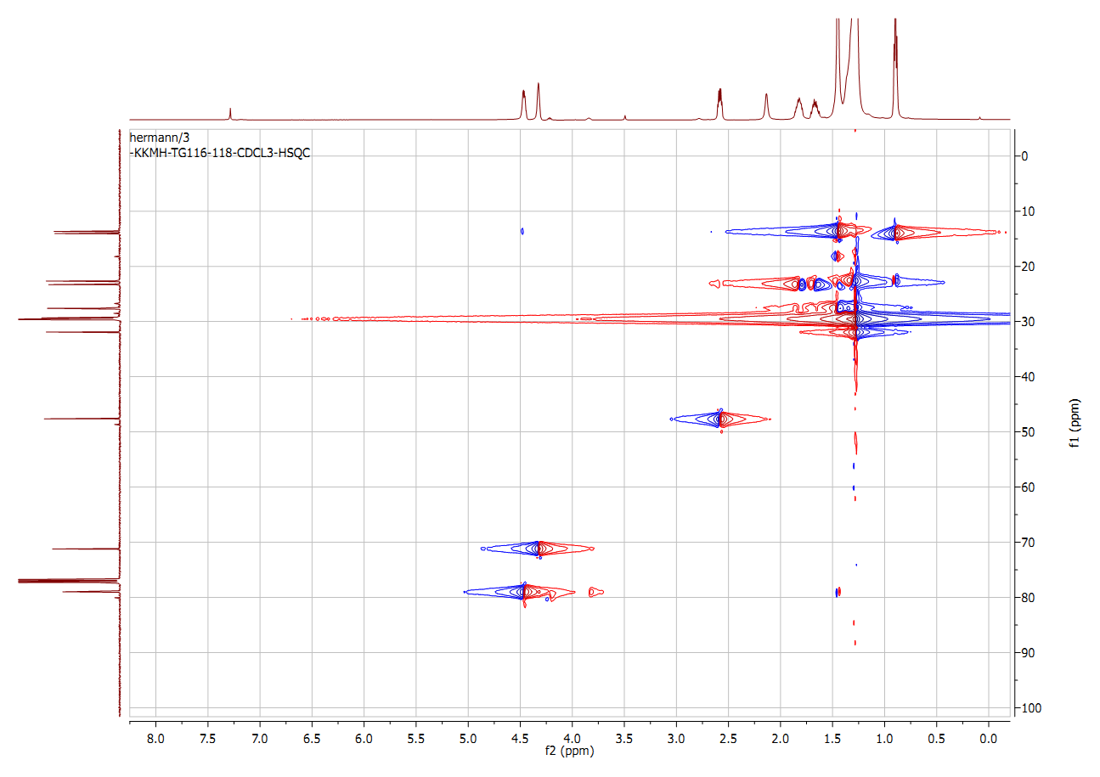
Figure S6. HSQC spectrum of compound 1 (CDCl₃, 500 MHz)
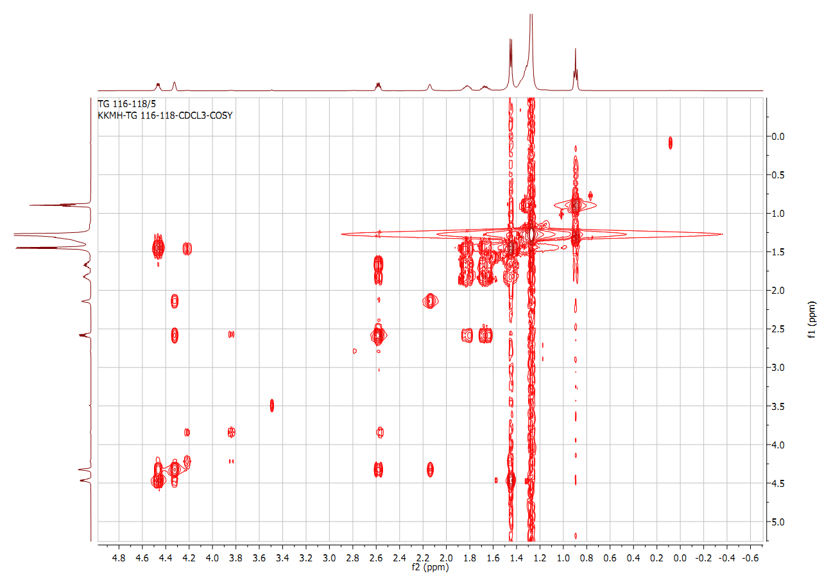
Figure S7. COSY spectrum of compound 1 (CDCl₃, 500 MHz)
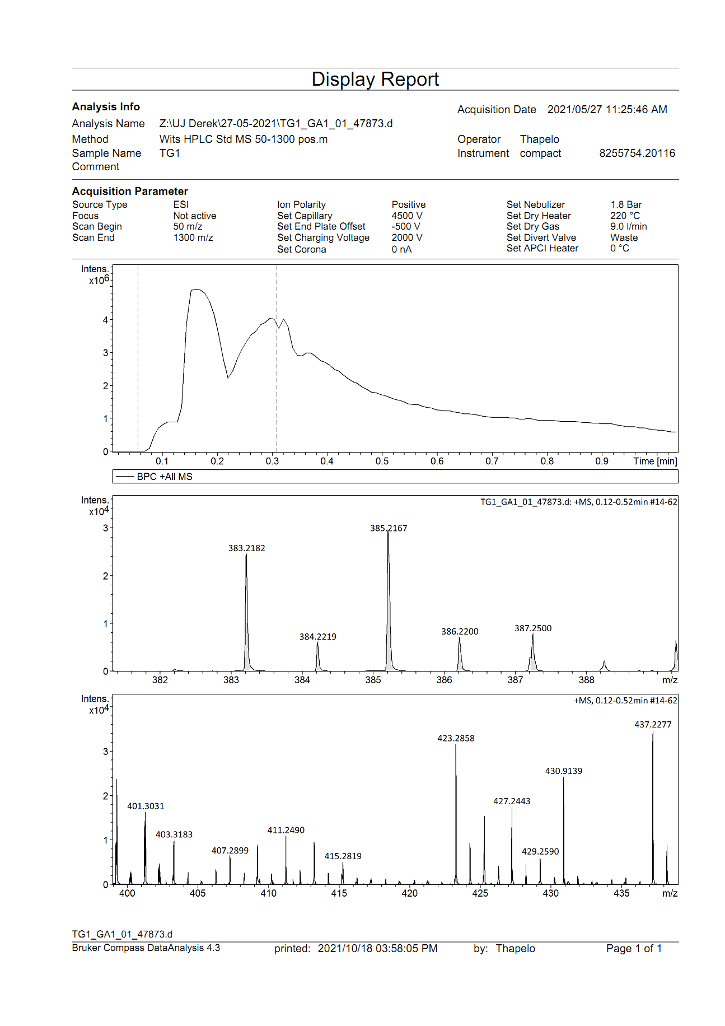

Figure S8. HRESIMS of compound 1
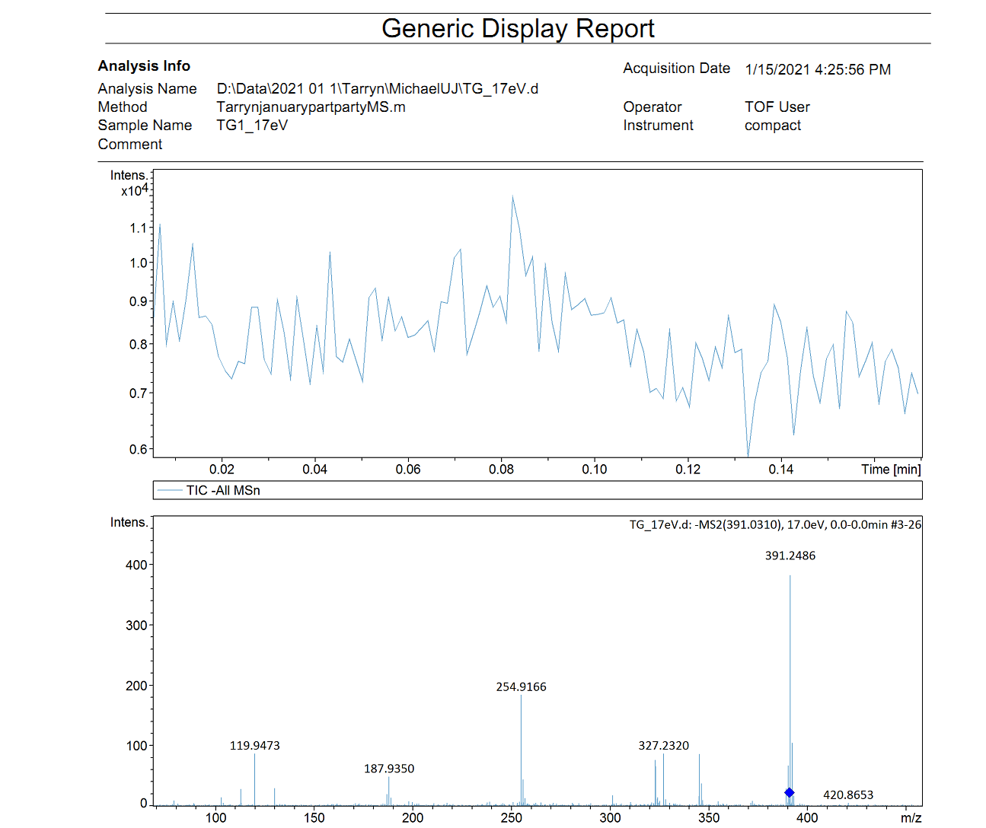
Figure S9. TOF-MS of compound 1
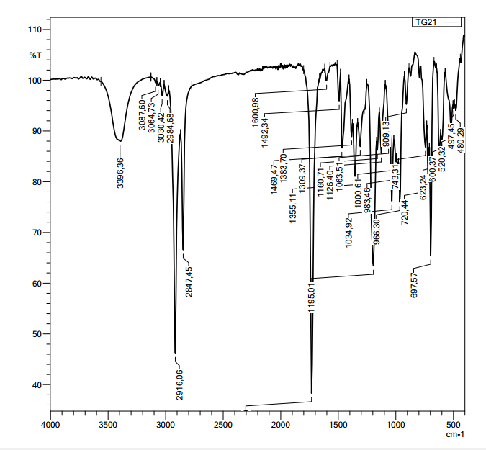
Figure S10. FT-IR spectrum of compound 1

*Compound 2
Figure S11. Selected HMBC, COSY correlations for compound 2

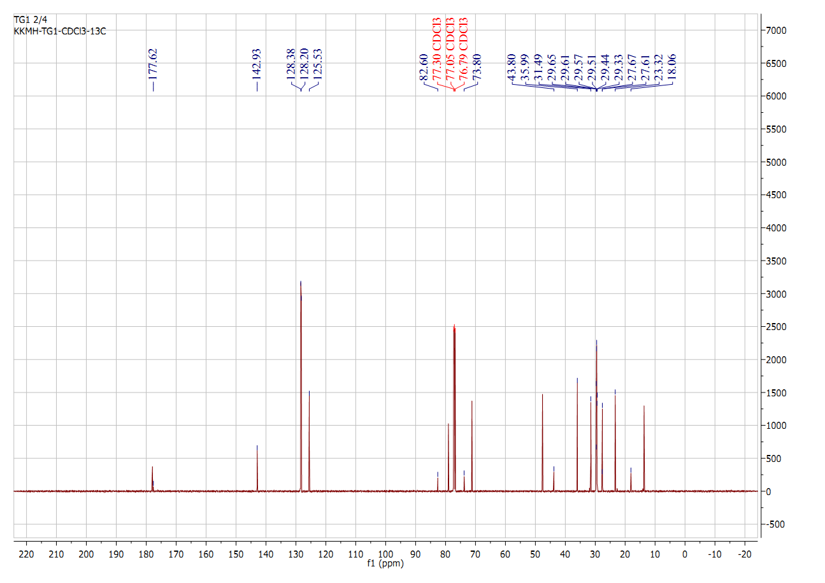
Figure S12. ¹³C NMR spectrum of compound 2 (CDCl₃, 126 MHz)

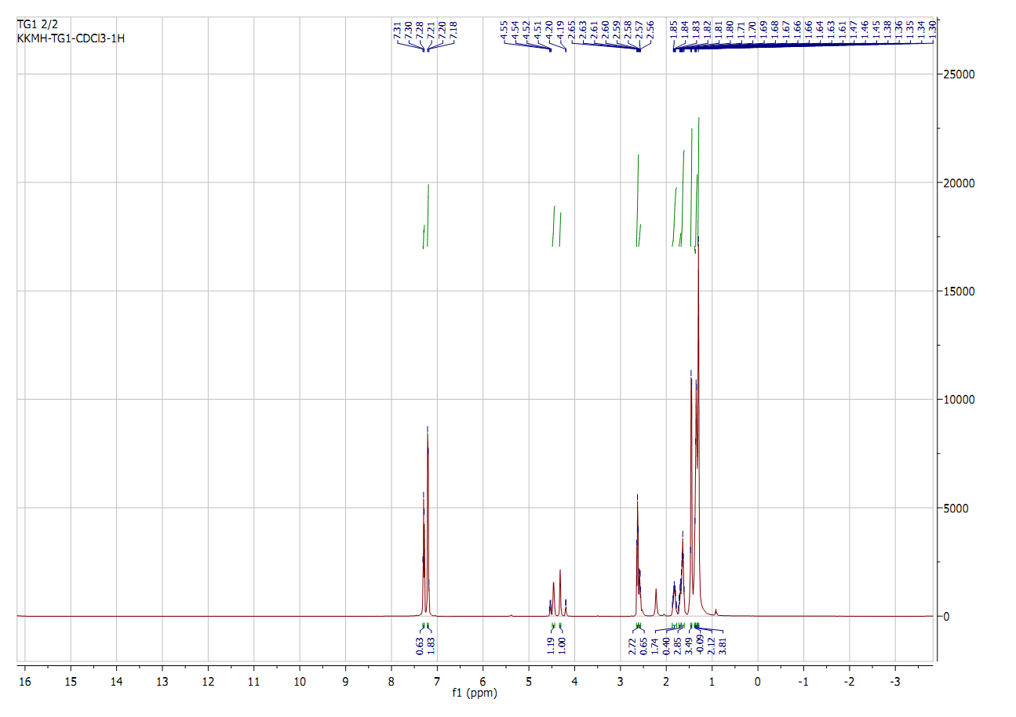
Figure S13. ¹H NMR spectrum of compound 2 (CDCl₃, 500 MHz)
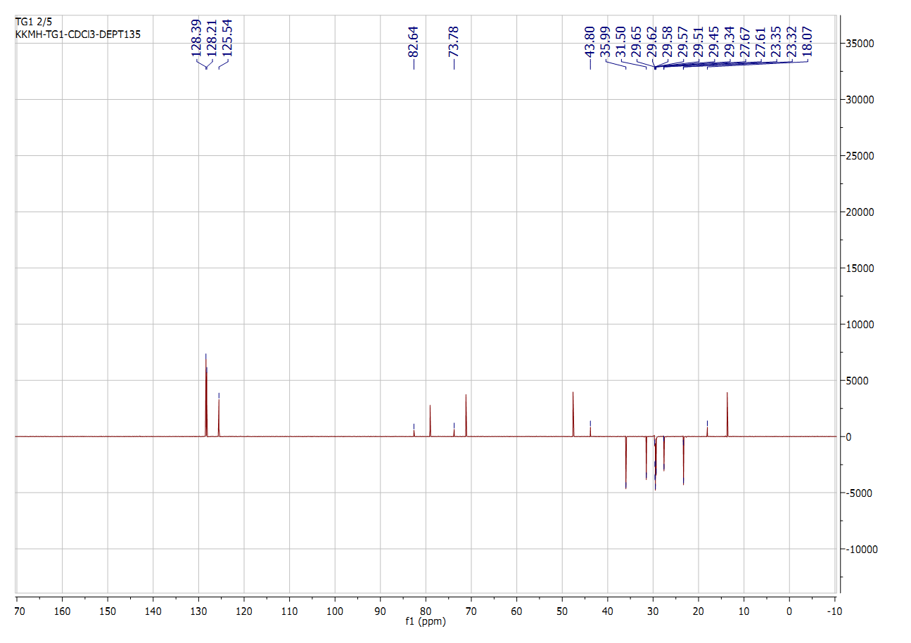
Figure S14. DEPT 135 spectrum of compound 2 (CDCl₃, 500 MHz)

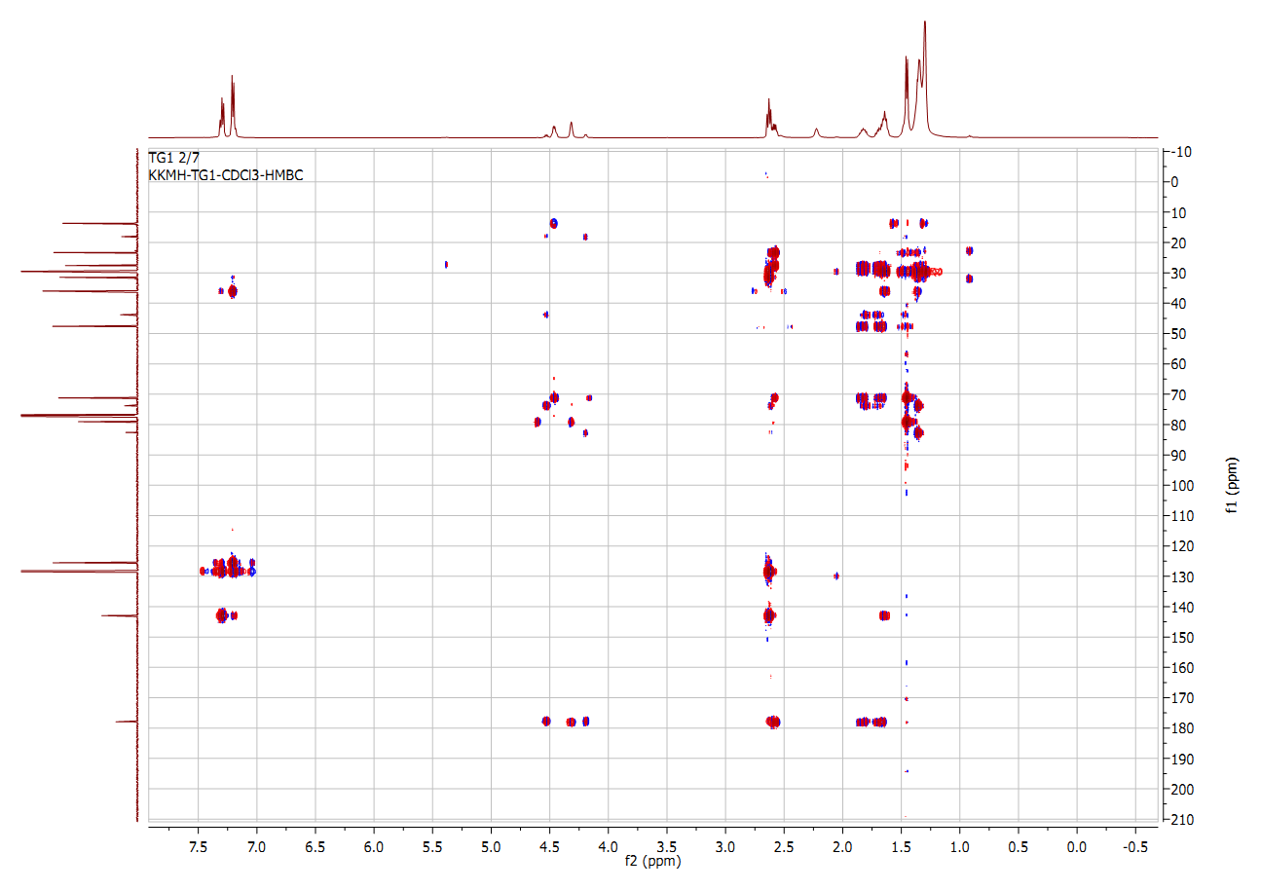
Figure S15. HMBC spectrum of compound 2 (CDCl₃, 500 MHz)

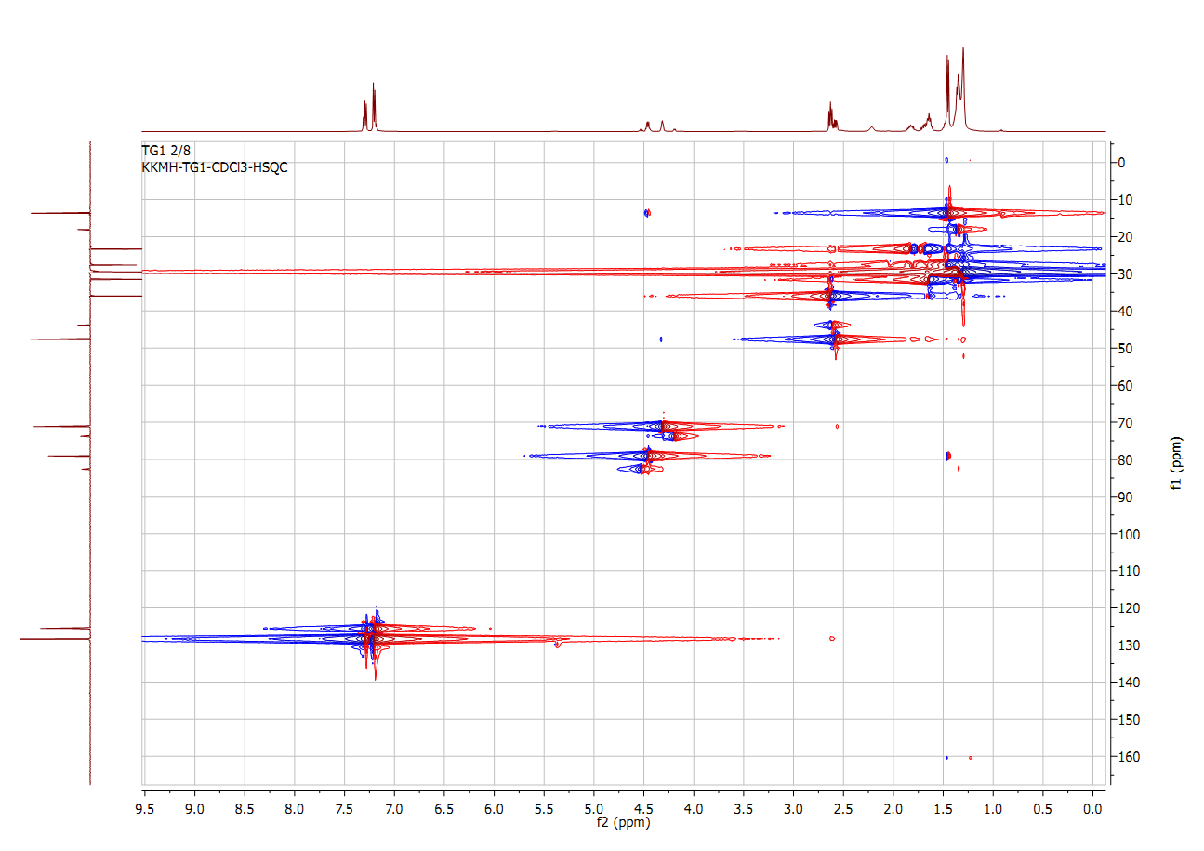
Figure S16. HSQC spectrum of compound 2 (CDCl₃, 500 MHz)

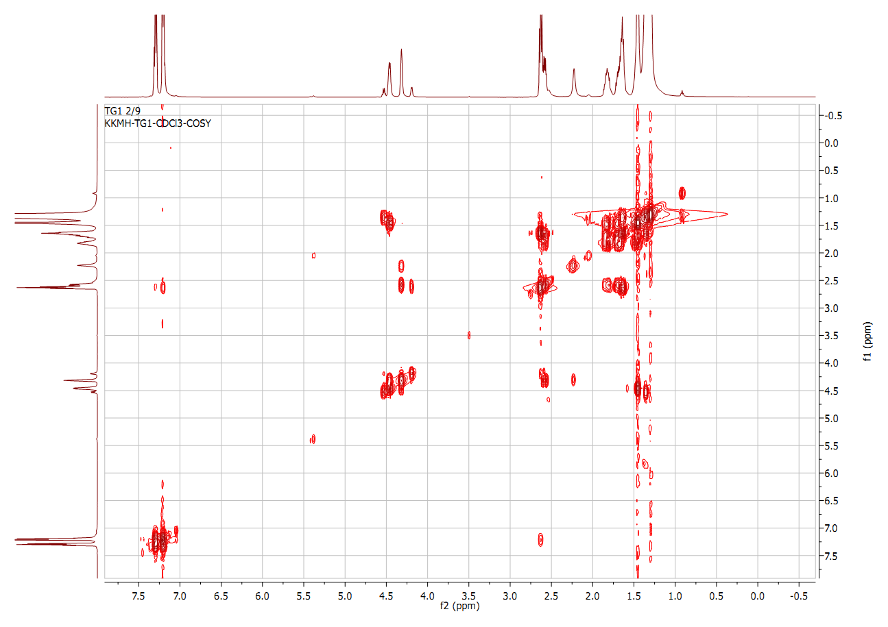
Figure S17. COSY spectrum of compound 2 (CDCl₃, 500 MHz)
Figure S18. HR-ESI-MS of compound 2

Figure S19. ¹H NMR spectrum of compound 3 (CDCl₃, 500 MHz)

Figure S20 ¹³C NMR spectrum of compound 3 (CDCl₃, 126 MHz)

Figure S21. DEPT 135 spectrum of compound 3 (CDCl₃, 500 MHz)

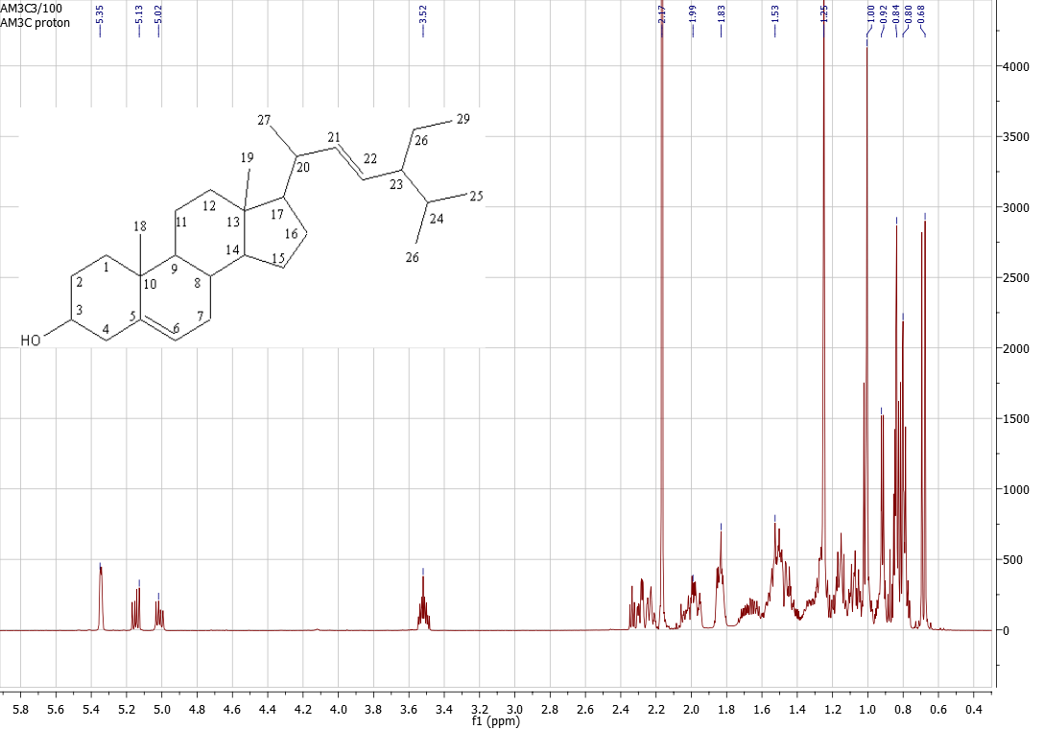
Figure S22. ¹H NMR spectrum of compound 4 in CDCl₃ (500 MHz).

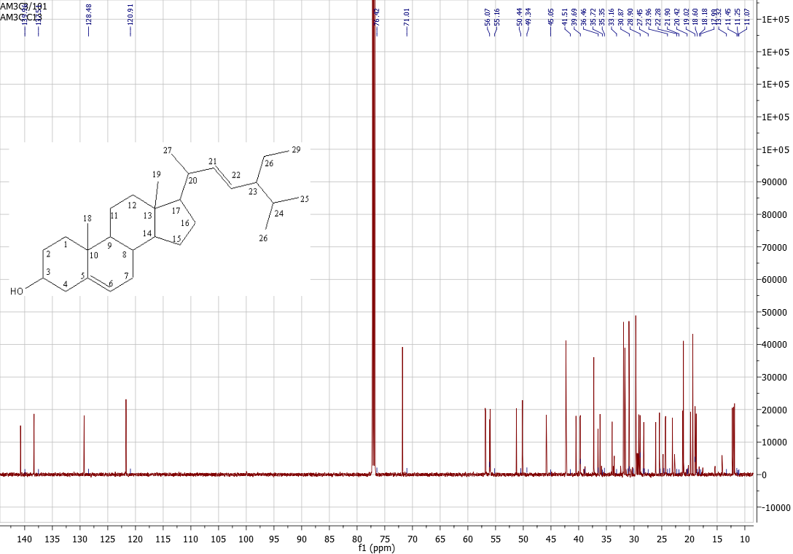
Figure S23: ¹³C NMR spectrum of compound 4 in CDCl₃ (1260 MHz)

Figure S24.¹H NMR spectrum of compound 5 in DMSO-d₆ (500 MHz).
Figure S25.¹³C NMR spectrum of compound 5 in DMSO-d₆ (126 MHz).

Figure S26. ¹H NMR spectrum of compound 6 in CDCl₃ (500 MHz).
Figure S26.¹³C NMR spectrum of compound 6 in CDCl₃ (126 MHz).

