Supporting information
Enhanced visible-light-driven photodegradation of tetracycline by salicylic acid modified-graphitic carbon nitride and toxicity assessment
Mengmeng Chen ^{a,b,c}, Mengxue Li ^{a,b,*}, Peng Li ^{d}, Stephanie Ling Jie Lee ^{a,b}, Juanjuan Tang ^{a,b}, Qian Li ^{a,b}, Sijie Lin ^{a,b,c,*}
ªCollege of Environmental Science and Engineering, Biomedical Multidisciplinary Innovation Research Institute, Shanghai East Hospital, Tongji University, 1239 Siping Road, Shanghai 200092, China
^{b}Key Laboratory of Yangtze River Water Environment, Shanghai Institute of Pollution Control and Ecological Security, Tongji University, Shanghai 200092, China
^{c}College of Environmental and Chemical Engineering, Shanghai University of Electric Power, Shanghai, 200090, China
^{d}Australian Institute for Bioengineering and Nanotechnology, The University of Queensland, Brisbane, QLD 4072, Australia

* Corresponding author:
Mengxue Li, Ph.D.
College of Environmental Science and Engineering
Tongji University, Shanghai 200092, China
E-mail: limengxue@tongji.edu.cn.

Text S1 Chemicals
The urea, melamine, dicyandiamide and salicylic acid (SA) were supplied by Shanghai Macklin Biochemical Co., Ltd (Shanghai, China). The oxytetracycline (OTC), tetracycline (TC), chlortetracycline (CTC), and doxycycline (DXC) were obtained from Sinopharm Chemical Reagent (Shanghai, China). Benzoquinone (BQ), isopropanol (IPA), and ethylenediaminetetraacetic acid disodium salt (EDTA-2Na) were purchased from Aladdin Industrial Corporation (Shanghai, China). Ultrapure water was used in all tests.
Text S2 The point of zero charge (pHpzc) of CNU-SA-2
A potentiometric titration method was used to measure pH_{pzc} of CNU-SA-2 (Li et al., 2022). Firstly, 50 mg of samples were added into 25 mL of NaCl solution (10 mM). The initial pH was adjusted using HCl (0.1 M) or NaOH (0.1 M) solution. Then, the mixtures were stirred for 12 h. The final pH values were measured to match the initial pH values. The pH_{pzc} was determined when the initial pH was equal to the final pH.

Table S1 Surface area and pore volume of synthesized photocatalysts.
Sample | Surface area ¹  (m²/g) | Pore volume ²  (cm³/g)
CNU | 90.11 | 0.56
CNU-SA-2 | 49.34 | 0.19
CNM | 26.89 | 0.19
CNM-SA-0.5 | 30.78 | 0.22
CND | 20.43 | 0.12
CND-SA-0.5 | 22.54 | 0.16
¹ The specific surface area acquired by the multipoint BET method.
² Pore volume refers to the total volume acquired at P/P₀ = 0.99.

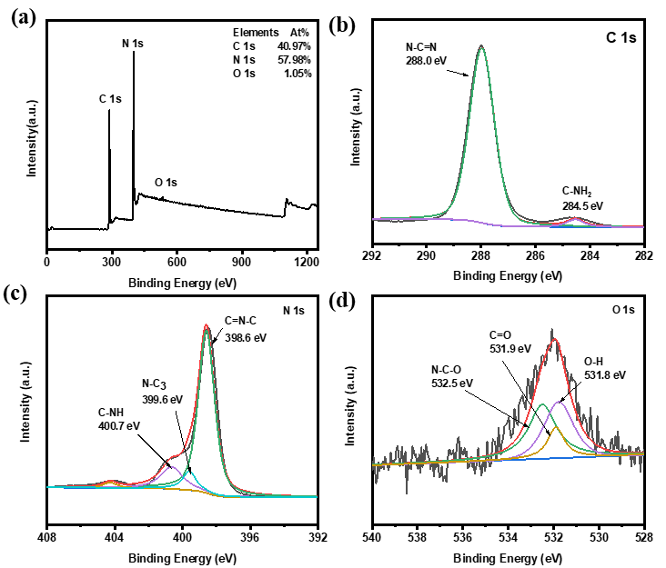
Fig. S1 XPS survey spectra (a), C 1s (b), N 1s (c), O 1s (d) of CNU-SA-2.

Fig. S2 N₂ adsorption-desorption isotherms of as-prepared samples.

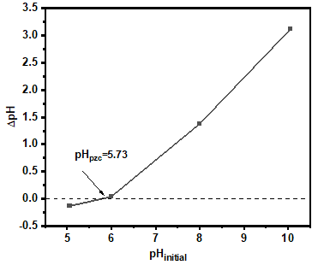
Fig. S3 The point of zero charge (pH_{pzc}) of CNU-SA-2.

References
Li M, Li P, Zhang L, Chen M, Tang J, Qin C, Ling Jie Lee S, Lin S (2022) Facile fabrication of ZnO decorated ZnFe-layered double hydroxides @ biochar nanocomposites for synergistic photodegradation of tetracycline under visible light. Chem Eng J 434:134772

