Supplementary file 2. Figures

Figure S1. Number of inclusions over time with recruitment actions

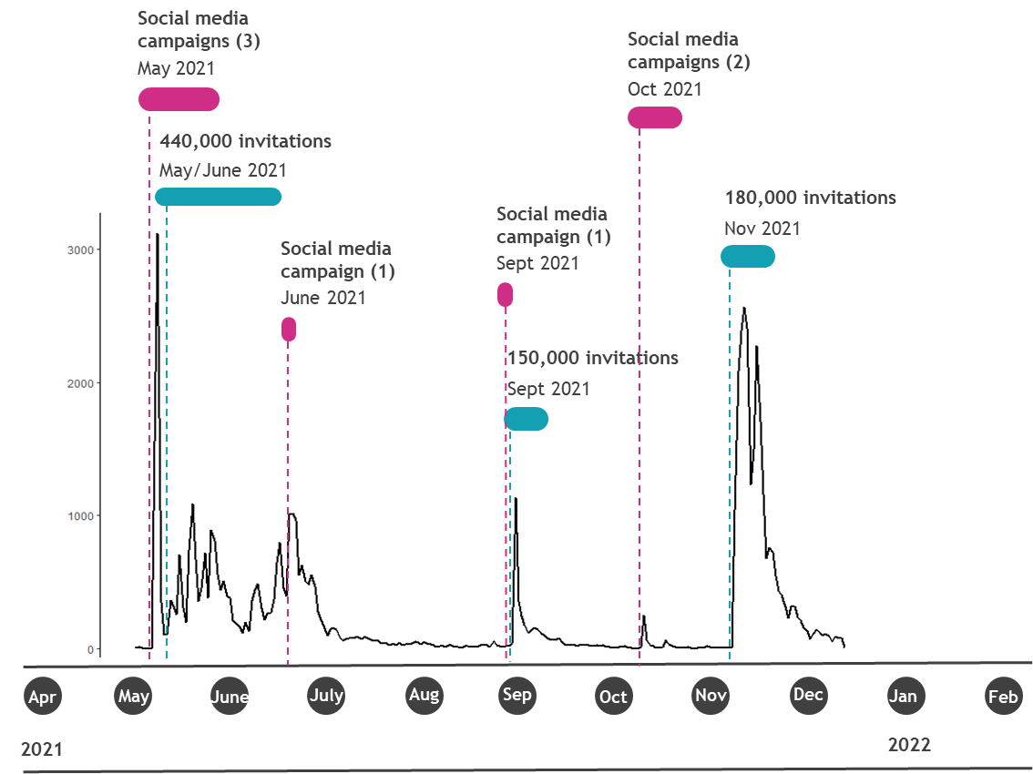

Figure S2. Timeline example participants

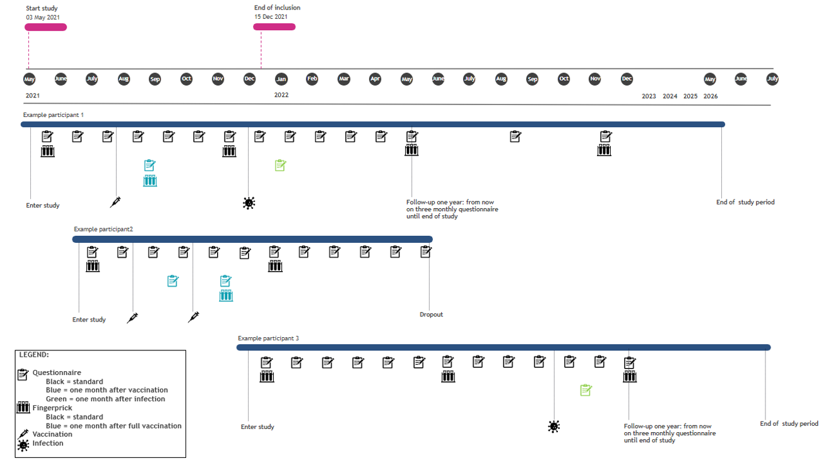

Figure S3. Vaccination status of participants over calendar time (up to October 2023)
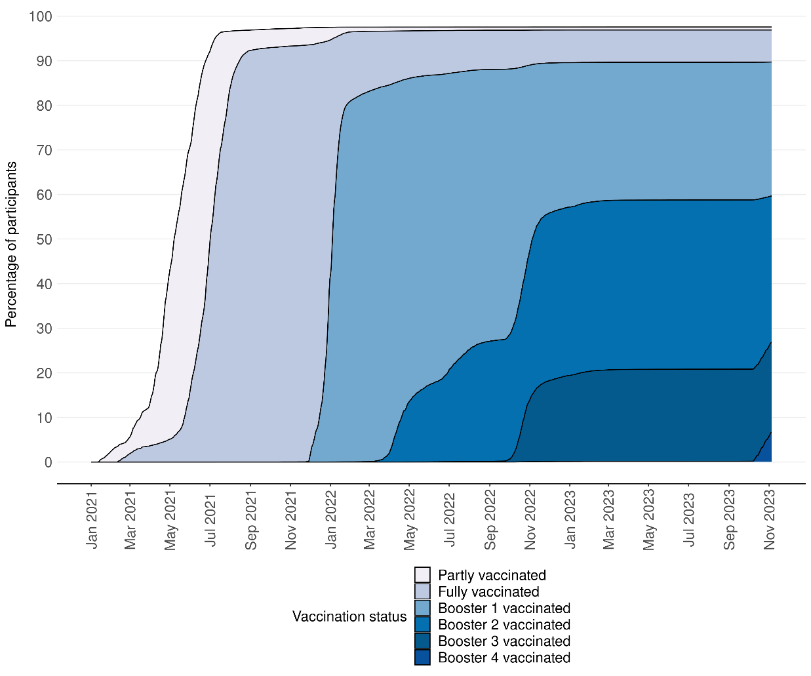

Figure S4. Reported positive SARS-CoV-2 tests per 100,000 participants over calendar time (up to November 2023)
