Supplementary material
Appendix A - Number of fires between 1973 and 2016 on the French part of the Mediterranean basin extracted from Prométhée database (www.promethee.com).
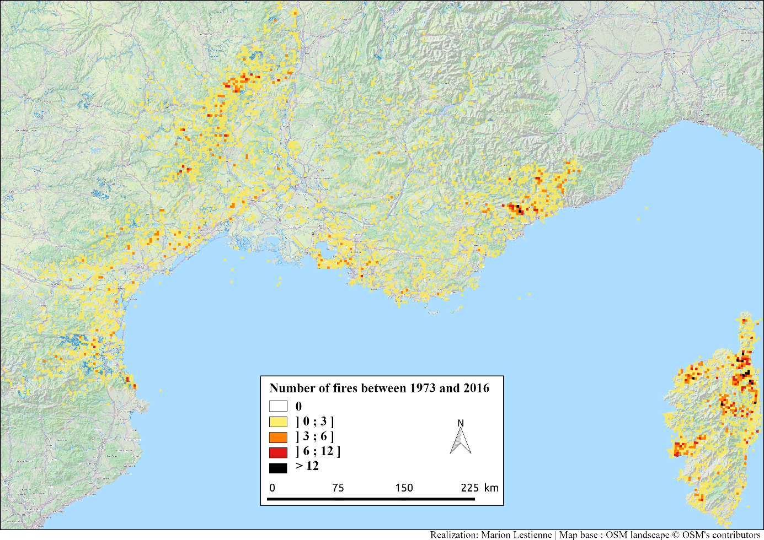

Appendix B - Mean precipitation and temperature anomalies for the next century (2020-2100) calculated for two IPCC CMIP5 scenarios (RCP45 and RCP85) from five IPCC CMIP5 climatic models: FGOALS_S20, CanESM2, MIROC_ESM_CHEM, MIROC5 (Knutti and Sedláček, 2013; Lau et al., 2013; Vera et al., 2006; Wu et al., 2013) in function of the season and the month. Months used to the mean MDC and Fire Season Length calculations are in purple.
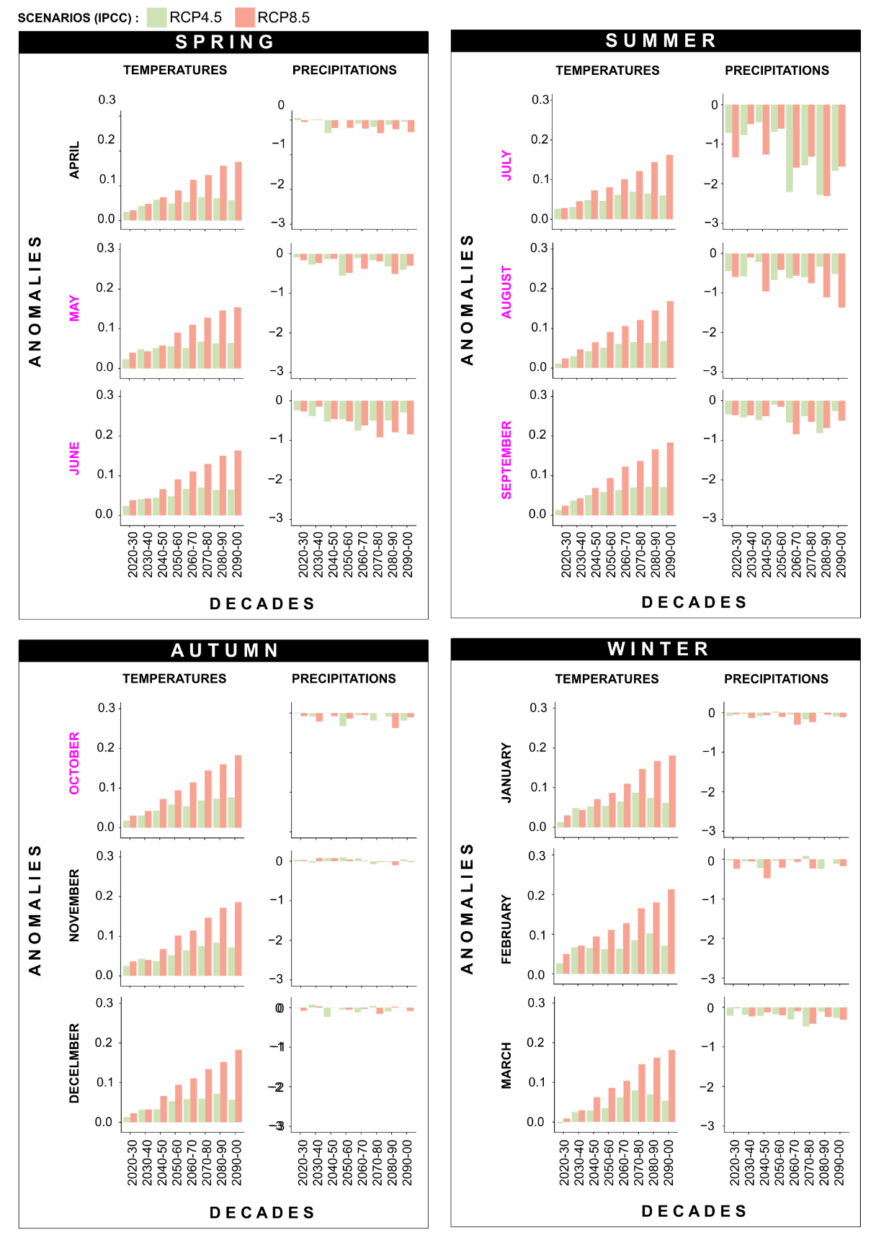
Appendix C- MDC and FSL changes during the Holocene and prediction for the future. Considered period is from May to October.
Period |  | Scenario | Mean MDC | Fire Season
Period |  | Scenario | During summer | Starting month | Ending month | Mean Fire Season length
21st century (decades) | 2090-00 | RCP4.5  RCP8.5 | 456  519 | May | November | 130  158
21st century (decades) | 2080-90 | RCP4.5  RCP8.5 | 471  518 | May | October  November | 140  164
21st century (decades) | 2070-80 | RCP4.5  RCP8.5 | 461  499 | May | October | 137  155
21st century (decades) | 2060-70 | RCP4.5  RCP8.5 | 459  490 | May | October | 134  149
21st century (decades) | 2050-60 | RCP4.5  RCP8.5 | 446  466 | May | October | 133  148
21st century (decades) | 2040-50 | RCP4.5  RCP8.5 | 450  450 | June | October | 122  128
21st century (decades) | 2030-40 | RCP4.5  RCP8.5 | 438  430 | June | October | 118  120
21st century (decades) | 2020-30 | RCP4.5  RCP8.5 | 424  429 | June | October | 105  113
Holocene (CAL. YR BP) | Present (1979 – 2016) |  | 419 | June | October | 111
Holocene (CAL. YR BP) | 1 |  | 314 | July | September | 54
Holocene (CAL. YR BP) | 2 |  | 379 | July | September | 64
Holocene (CAL. YR BP) | 3 |  | 394 | July | October | 77
Holocene (CAL. YR BP) | 4 |  | 365 | July | October | 70
Holocene (CAL. YR BP) | 5 |  | 412 | July | October | 66
Holocene (CAL. YR BP) | 6 |  | 406 | July | October | 72
Holocene (CAL. YR BP) | 7 |  | 482 | June | October | 126
Holocene (CAL. YR BP) | 8 |  | 556 | June | October | 117
Holocene (CAL. YR BP) | 9 |  | 685 | June | October | 118
Holocene (CAL. YR BP) | 10 |  | 628 | June | October | 113
Holocene (CAL. YR BP) | 11 |  | 598 | June | October | 106

