Effects of steam on polysaccharides from Polygonatum cyrtonema based on saccharide mapping analysis and pharmacological activity assays

Zherui Chen ^{a,b}, Baojie Zhu ^{a,b}, Jing Zhao ^{a,b*}, Zhixin Chen ^{a,b}, Wen Cao ^{a,b}, Junqiao Wang ^{a,b}, Shaoping Li ^{a,b*}

a State Key Laboratory of Quality Research in Chinese Medicine, Institute of Chinese Medical Sciences, University of Macau, Macao SAR, China
b Joint Laboratory of Chinese Herbal Glycoengineering and Testing Technology, University of Macau,
Macao SAR, China

*Corresponding authors:
Zhao Jing
Email: jingzhao@um.edu.mo (J Zhao); spli@um.edu.mo or lishaoping@hotmail.com (SP Li)

Supplementary Table 1 HPAEC-PAD monosaccharide analysis liquid phase conditions
Time(min) | Flow(ml/min) | A% | B% | C% | D%
-31 | 0.4 | 88 | 12 | 0 | 0
-21 | 0.4 | 88 | 12 | 0 | 0
-20 | 0.4 | 0 | 0 | 100 | 0
-11 | 0.4 | 0 | 0 | 100 | 0
-10 | 0.4 | 88 | 12 | 0 | 0
0 | 0.4 | 88 | 12 | 0 | 0
10 | 0.4 | 88 | 12 | 0 | 0
22 | 0.4 | 43 | 12 | 0 | 45
25 | 0.4 | 43 | 12 | 0 | 45
26 | 0.4 | 88 | 12 | 0 | 0
A：ddwater；B：NaOH（10 mM）；C：NaOH（200mM）；D：NaOAc（0.5 M）；

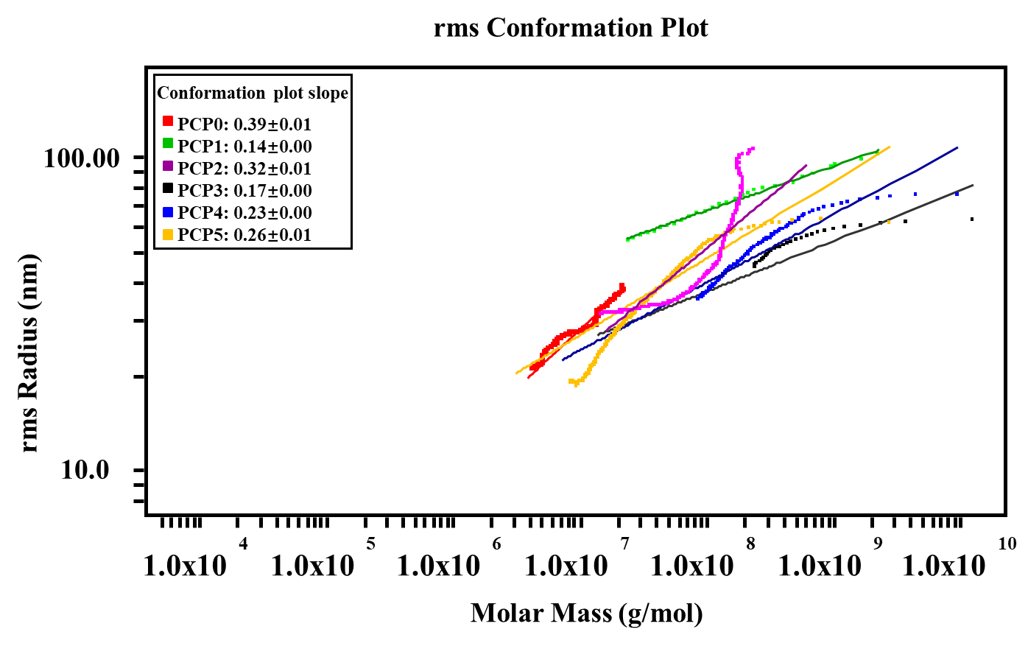
Supplementary Figure 1. The rms conformation plot and conformation plot slope of PCP0-PCP5.

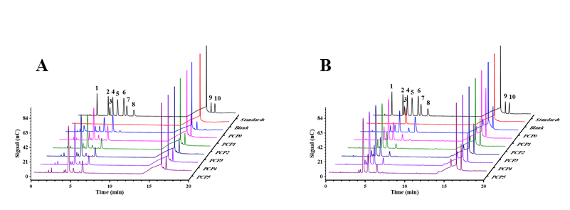
Supplementary Figure 2. Ion chromatogram of monosaccharide composition by (A) complete acid hydrolysis and (B) pectinase hydrolysis. 1–10 in descending order: Fucose, Arabinose, Rhamnose, Galactose, Glucose, Xylose, Mannose, Fructose, Galacturonic Acid, Glucuronic Acid.

Supplementary Table 2 Molar ratio of total acid hydrolyzed monosaccharide composition
Sample | Ara : Rha : Gal : Glc : Xyl : Man : Fru : GalA
PCP0 | 1.47 : 0.47 : 1.28 : 3.94 : 0.07 : 7.52 : 1.00 : 2.88
PCP1 | 106.63 : 45.31 : 330.15 : 47.43 : 11.31 : 271.15 : 1.00 : 226.25
PCP2 | 86.00 : 54.87 : 431.68 : 35.50 : 11.20 : 233.51 : 1.00 : 170.27
PCP3 | 63.60 : 79.90 : 589.41 : 35.80 : 14.16 : 212.40 : 1.00 : 206.36
PCP4 | 55.92 : 100.97 : 663.41 : 45.60 : 20.40 : 258.01 : 1.00 : 215.53
PCP5 | 33.80 : 103.16 : 610.01 : 48.67 : 20.80 : 263.17 : 1.00 : 175.79
Supplementary Table 3 Molar ratio of monosaccharide composition by pectinase hydrolysis
Sample | Ara : Rha : Gal : Glc : Xyl : Man : Fru : GalA
PCP0 | 59.40 : 7.50 : 56.33 : 57.50 : 1.00 : 59.67 : 415.16 : 262.97
PCP1 | 33.47 : 8.90 : 102.72 : 5.75 : 1.00 : 22.89 : 6.80 : 150.47
PCP2 | 26.44 : 9.83 : 137.45 : 6.35 : 1.00 : 20.99 : 2.50 : 105.09
PCP3 | 12.36 : 10.85 : 120.49 : 6.67 : 1.00 : 16.52 : 1.78 : 84.57
PCP4 | 7.64 : 10.26 : 98.72 : 5.68 : 1.00 : 17.95 : 1.61 : 63.79
PCP5 | 3.71 : 10.36 : 85.91 : 3.60 : 1.00 : 18.77 : 0.76 : 47.27
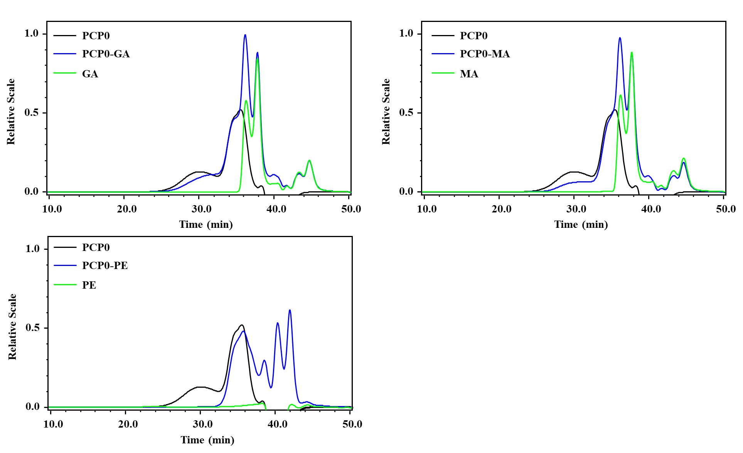
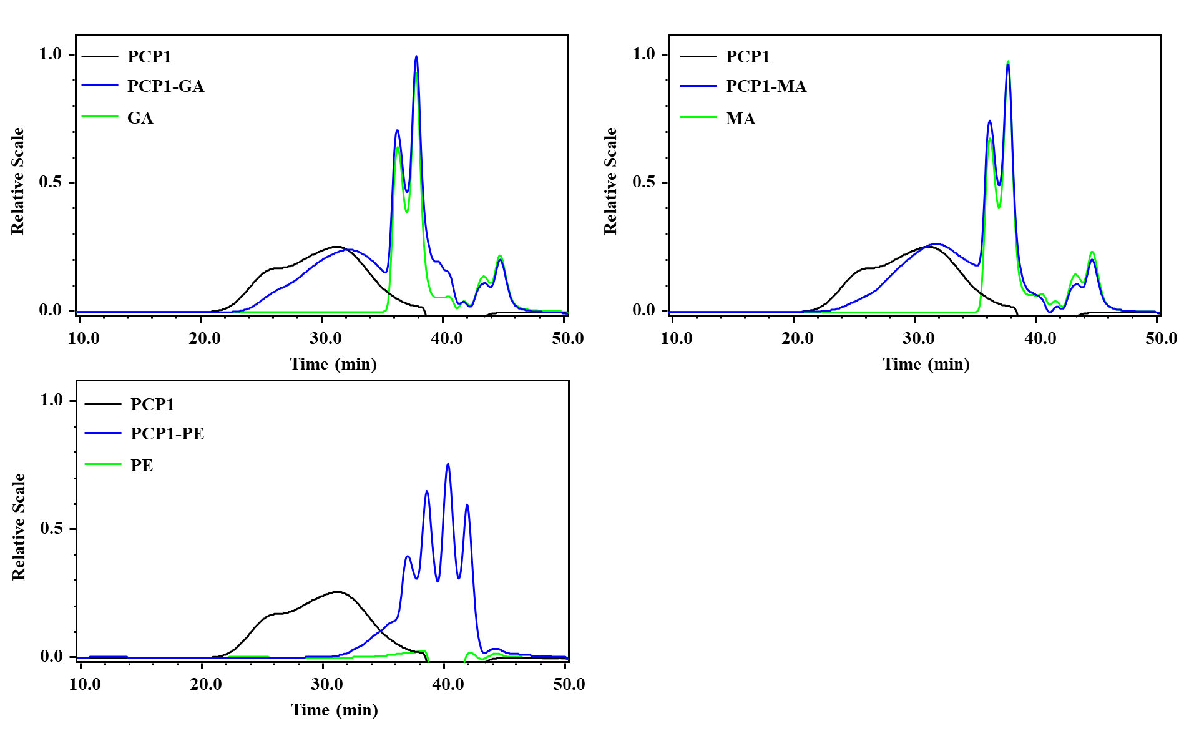
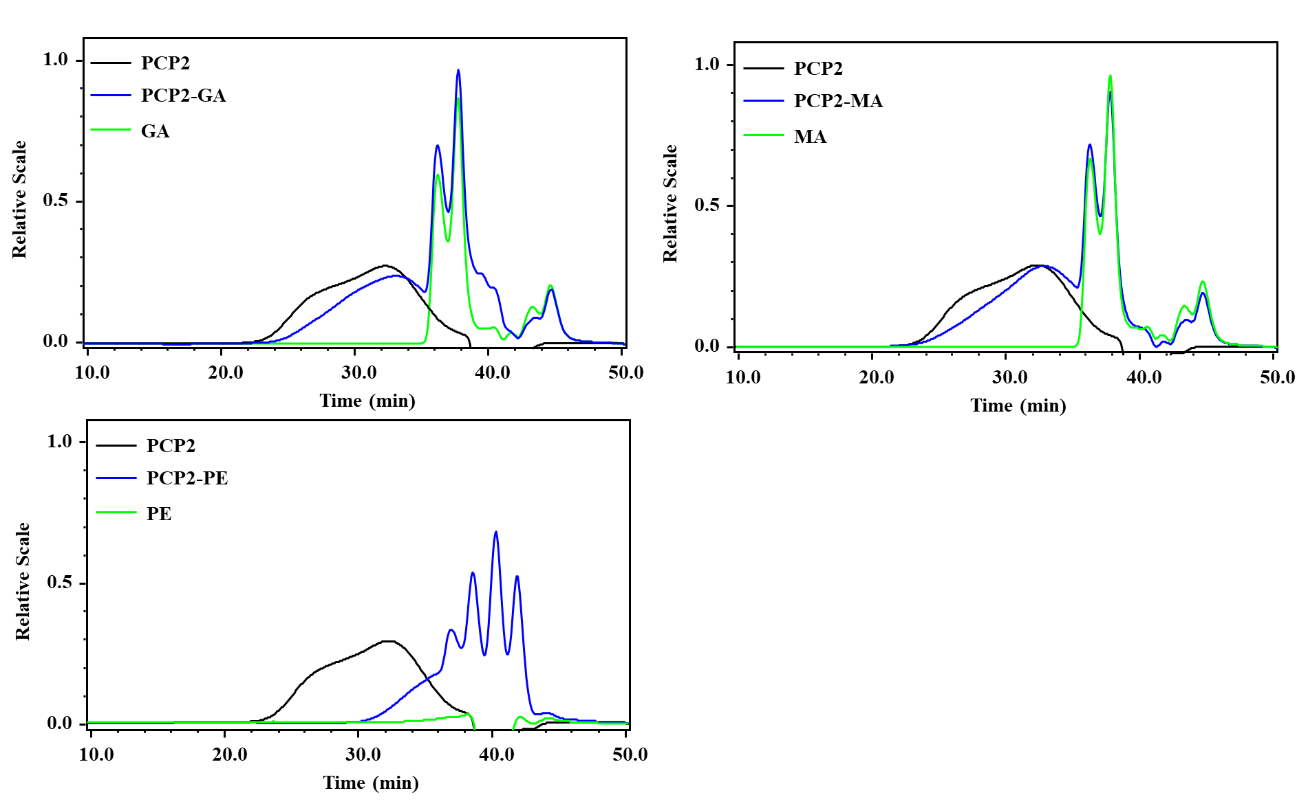
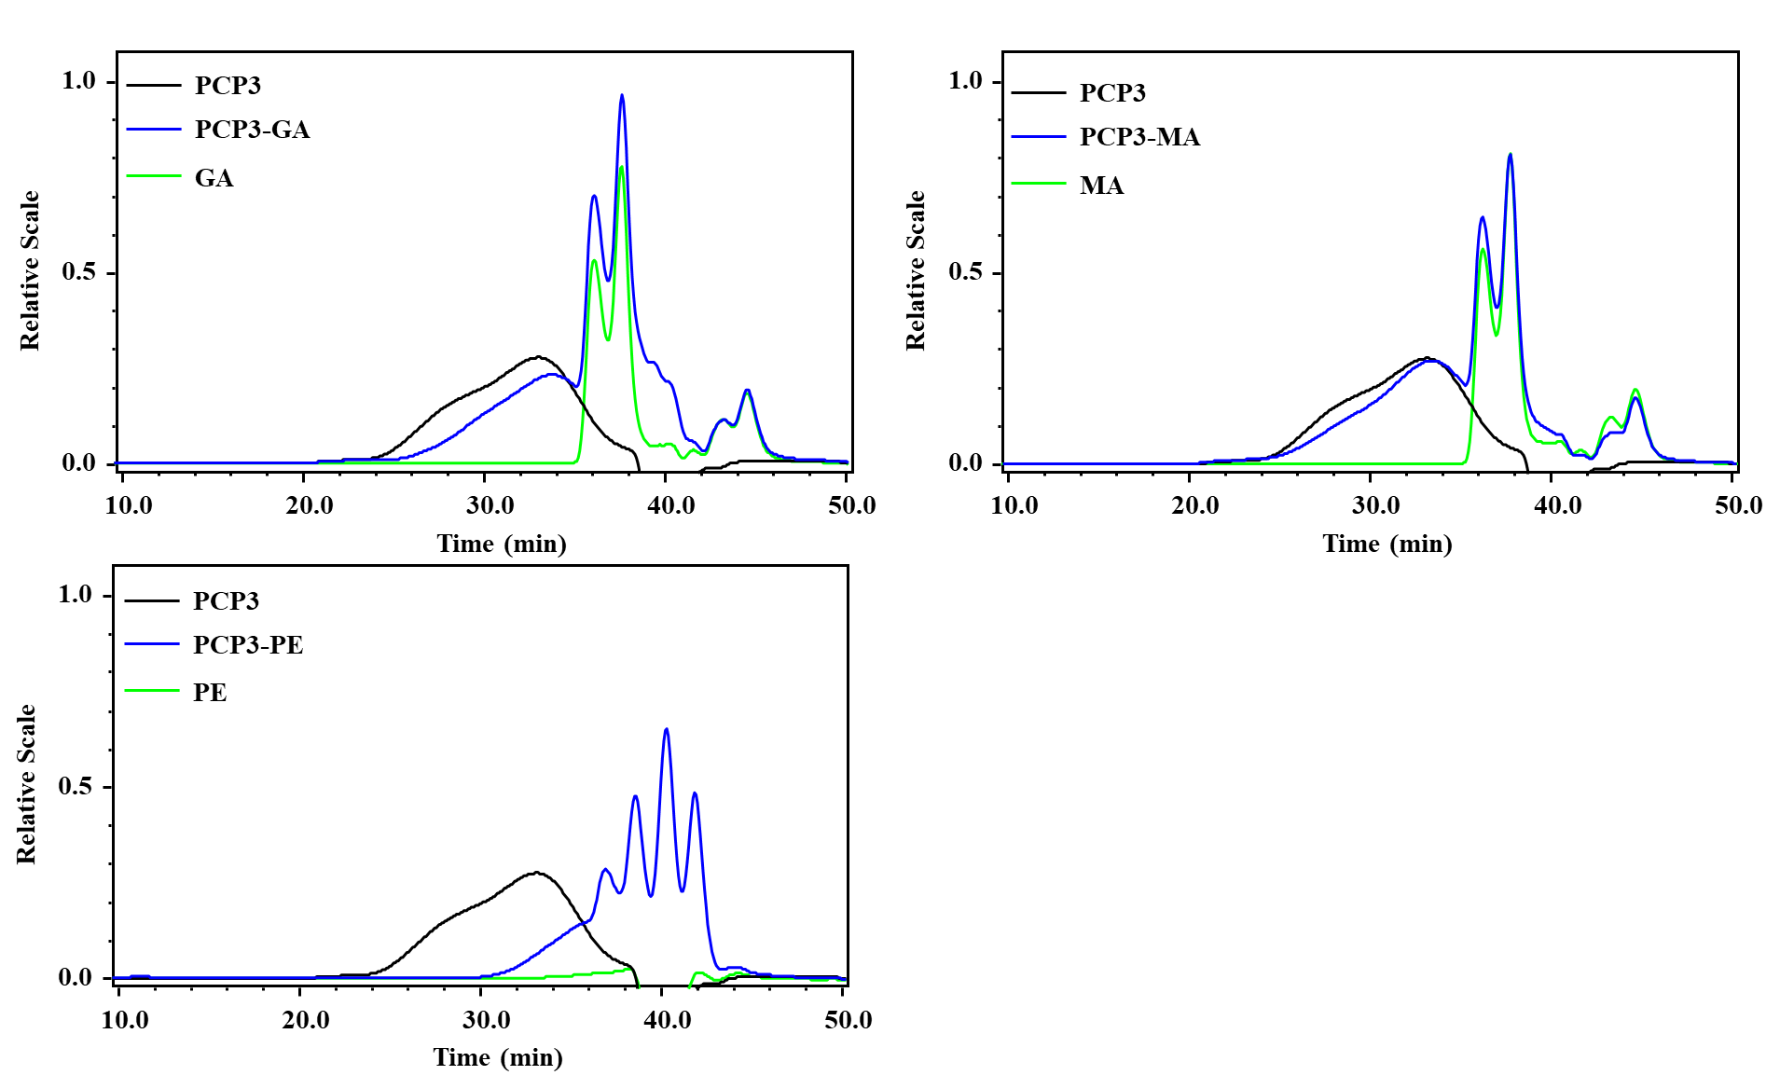
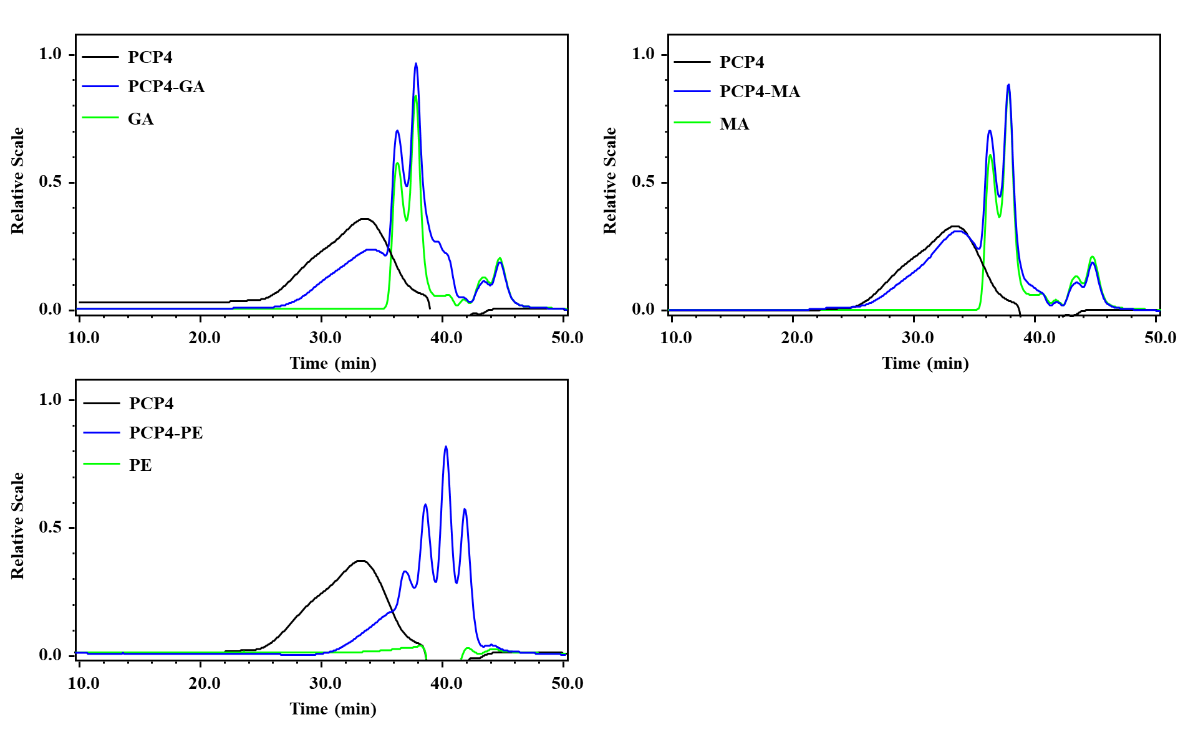
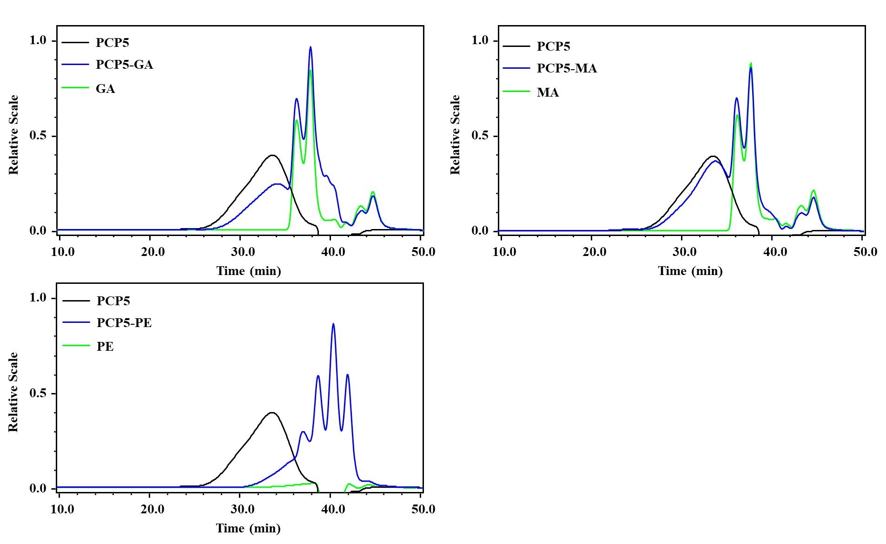
Supplementary Figure 3. The HPSEC-MALLS-RID chromatogram of PCP0-PCP5 after treat with pectinase, β-1,4-Galactanase and β-1,4-Mannanase.
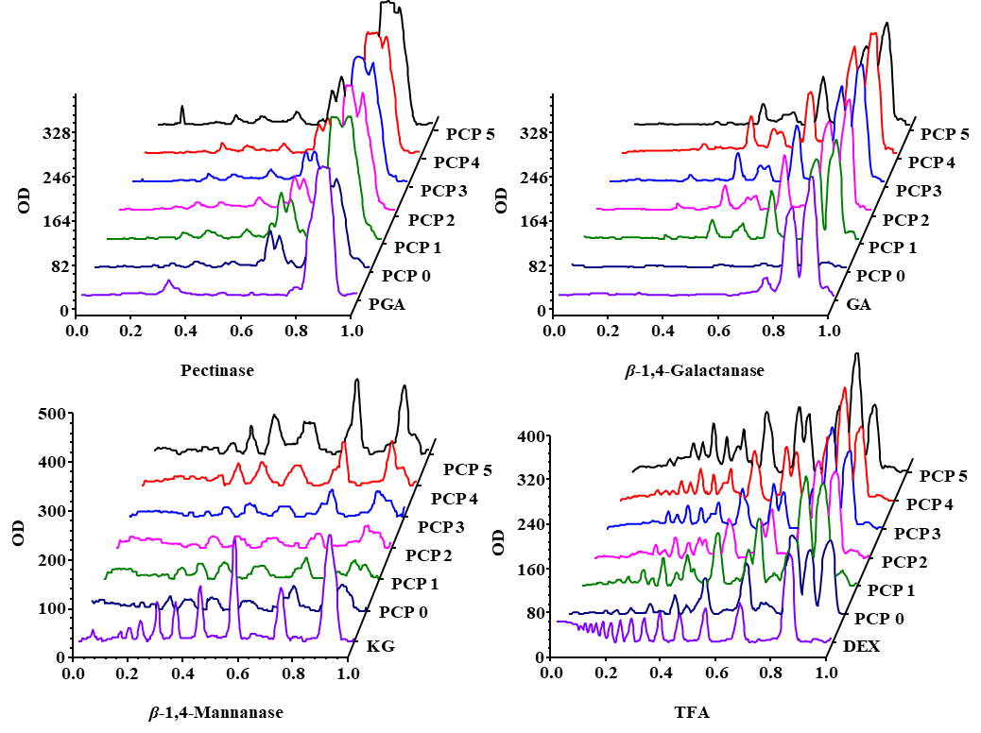
Supplementary Figure 4. The ion chromatogram of PCP0-PCP5 after treat with pectinase, β-1,4-Galactanase, β-1,4-Mannanase and TFA.

