Supporting Information
for

Effect of redox condition on the release of dissolved organic matter and nutrients at the sediment-water interface and the possible roles of microbes
Tianli Bao¹, Peifang Wang¹, *, Chao Wang¹, Bin Hu¹
1. Ministry of Education Key Laboratory of Integrated Regulation and Resource Development on Shallow Lakes, Hohai University, Nanjing, 210098, China
*, corresponding author, email: pfwang2005@hhu.edu.cn

Section S1 Real-time quantitative polymerase chain reaction
Quantitative real-time Polymerase Chain Reaction (qPCR) was used to quantify the abundance of nitrogen cycle genes in sediments. After each sediment sample was melted and homogenized thoroughly, 0.5 g of sediment was taken into a 2 mL centrifuge tube for DNA extraction and subsequent determination. The kit (Omega, USA) was selected and the DNA of the sample was extracted strictly in accordance with the operating instructions of the kit. After extracting DNA from three parallel sediment samples under the same working condition, the total amount of DNA detected by UV spectrophotometry in three parallel samples was mixed. Real-time fluorescence quantitative PCR was used to quantitatively analyze the abundance of nitrogen cycle functional genes (nifH, amoA, HZO, GDH, nirK, and nirS). in sediments.
Table. S1 Primers and RT-PCR conditions for nifH, amoA, hzo, nirK, nirS
Target | Primer |  | Conditions
nifH |  | nifH_F  nifH_R | AAAGGYGGWATCGGYAARTCCACCAC  TTGTTSGCSGCRTACATSGCCATCAT  5 min at 95°C, followed by 40 cycles of 15 s at 95°C, 30 s at 60°C
nirK |  | nirK_F  nirK_R | ATYGGCGGVAYGGCGAA  GCCTCGATCAGRTTRTGG  5 min at 95°C, followed by 40 cycles of 15 s at 95°C, 30 s at 60°C
nirS |  | nirS_F  nirS_R | GTNAAYGTNAARGARACNGG  GASTTCGGRTGSGTCTTGA  5 min at 95°C, followed by 40 cycles of 15 s at 95°C, 30 s at 60°C
amoA |  | amoA_F  amoA_R | GGGGTTTCTACTGGTGGT  CCCCTCKGSAAAGCCTTCTTC 5 min at 95°C, followed by 40 cycles of 15 s at 95°C, 30 s at 60°C
hzo |  | hzo_F  hzo_R | GTMGGHTGYATYGACTGYCAC  GRCGRTTGGTBKTYTGDCC

Section S2 High-throughput sequencing of microbes
DNA of microbial genomes was extracted from sediments and high-throughput sequencing of microbial 16S rRNA gene was performed to determine the species structure of microbial communities in sediments. The V3V4 of the 16S rRNA gene was amplified by PCR using microbial universal primers 338F and 806R. A unique 7-BP barcode was added to the primers for multiple sequencing. The PCR kit contains 5 μl buffer (5 x), 0.25 μl Fast pfuDNA polymerase (5 U/μl), 2 μl (2.5 mM) dNTPs, 1μl (10uM) forward and reverses primers, 1μl DNA template, and 14.75 μl ddH2O. The thermal cycle consisted of initial denaturation at 98℃ for 5 minutes. 25 cycles were then performed, including denaturation at 98℃ for 30 seconds, annealing at 53℃ for 30 seconds, and extension at 72℃ for 45 seconds. It was extended for 45 seconds and finally for 5 minutes at 72 ° C. PCR amplifiers were cleaned with a mixture containing 5 μL of 5× FastPfu Buffer, 2 μL of 2.5 mM dNTPs, 0.25 μL of Fast PfuDNA polymerase, and 10 ng of template DNA and 10 μL of template DNA. Amplicons were extracted from 2% agarose gels and purified using the AxyPrep DNA Gel Extraction Kit (Axygen Biosciences, USA) according to the manufacturer's instructions. After a separate quantization step, the amplicon is pooled in equal quantities and paired. The amplicon was collected in equal quantities and the Illumina MiSeq platform and MiSeq kit were used for peer 250 bp sequencing.
Table. S2 Primers used for high-throughput sequencing
Target gene | Primer | Conditions | amplification（bp） | Reference
16S rRNA V3V4(a) | 338F | ACTCCTACGGGAGGCAGCA | 480 | (Turner S et al., 1999)
16S rRNA V3V4(a) | 806R | GGACTACHVGGGTWTCTAAT’ | 480 | (Turner S et al., 1999)

Section S3 Analysis of microbial community diversity
The α diversity index of the microbial community is a comprehensive index to measure the species richness and evenness of microbial community. The richness refers to the number of species in the community, and the inhomogeneity refers to the difference in species number (the higher the inhomogeneity, the greater the community diversity)(Chen et al., 2021). In this paper, the Chao1 index, Shannon index and were selected to characterize the α diversity of samples with different hydrodynamics and dissolved oxygen groups.
(1) Chao1 Index: It was first proposed by Chao in 1984. Chao1 is often used to estimate the total number of species in ecology. Chao1 algorithm is used to calculate the number of ASVs detected only once and twice in the community to estimate the actual number of species in the community. Chao1 index can represent the richness of community, and the greater the value, the more the total number of species. Its calculation formula is as follows:
$$chao1=S_{obs}+\frac{n_{1}(n_{1}-1)}{2(n_{2}+1)}$$
Chao1 is the estimated number of ASVs, S_{obs} is the observed number of ASVs, n₁ is the number of ASVs with only one sequence, and n₂ is the number of ASVs with only two sequences.
(2) Shannon index: known as the Shannon-Wiener index, first proposed by Shannon and Wiener in 1963. When calculating the Shannon index, not only species richness but also species evenness are considered, so it is a comprehensive reflection of community structure. Its calculation formula is as follows:
$$H=-\sum{{(P}_{i})(lnP_{i})}$$
The P_{i} is the proportion of individual species of all species. If the total number of individuals in the sample is n_{i}, the individual species Numbers for $P_{i}={n_{i}}/N$. Therefore, in a sample, the more evenly distributed the individuals among the species, the greater values of Shannon index H were found. If each individual belongs to a different species, the Shannon index H is the maximum. If all individuals are of the same species, the Shannon index H is the minimum.

Section S4 Measurement of EEM and PARAFAC analysis
The EEM was measured using a Hitachi F-7000 spectrofluorometer equipped with a 150 W continuous output xenon arc lamp. Emission spectra were collected at the 1-nm interval between 250 and 550 nm, while excitation spectra were measured between 230 and 450 nm at the 5-nm interval. The bandpass width was 5 nm for both excitation and emission and the scanning speed was 2400 nm min⁻¹. The fluorescent intensities were converted to quinine sulfate units (QSE), where 1 QSE is equal to the fluorescence intensities at 350/450 nm (excitation/emission) of 1 μg L⁻¹ quinine sulfate in a 0.1 M H₂SO₄ solution (Hu et al., 2017). PARAFAC analysis of EEM datasets was conducted using MATLAB 8.3 with the drEEM toolbox (Murphy et al., 2013).
The UV-Vis absorbance was measured using a Shimadzu UV-3700DUV ultraviolet-visible spectrophotometer with a 1 cm quartz cuvette scanning from 200 nm to 800 nm at 1-nm intervals. Absorbance measurements at each wavelength were baseline corrected by subtracting the mean absorbance for the spectral range from 650 nm to 700 nm (Zhang et al., 2010).

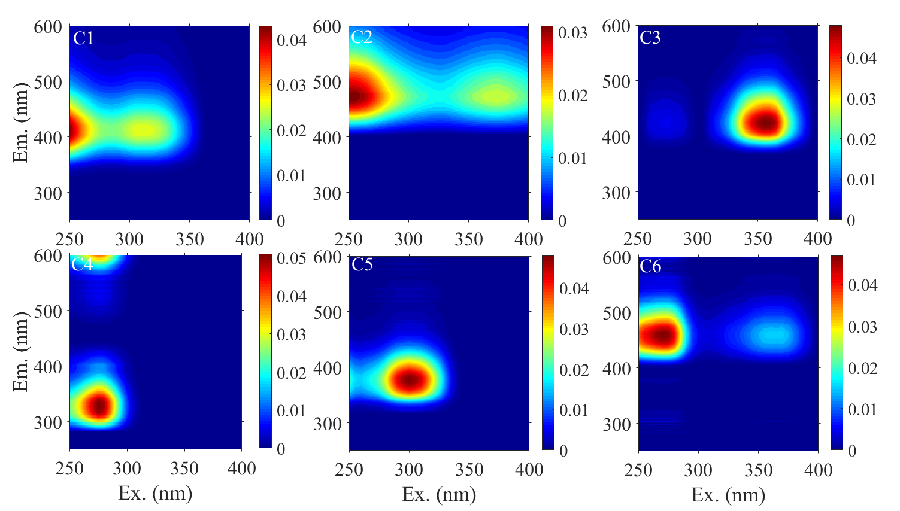
Fig. S1. Spectral characteristics of the six fluorescence components modeled by PARAFAC 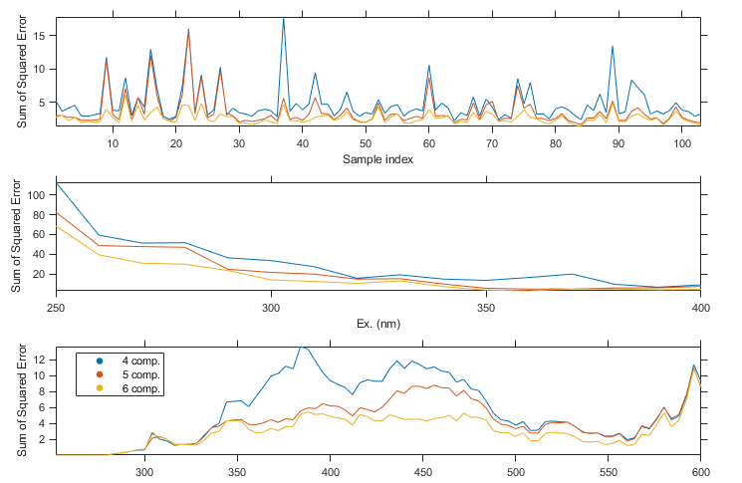
Fig. S2. The highly overlaid split-half validation of five components

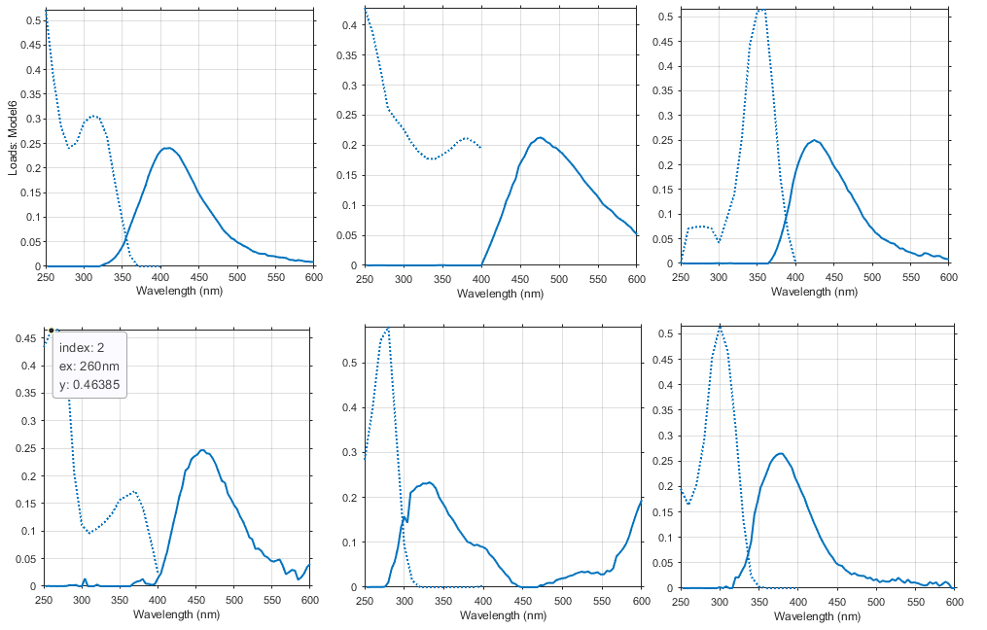
Fig. S3 The residuals analysis of excitation and emission

Section S5 Measurement of redox state in sediment
A Clark-type O2 microelectrode (OX100, Unisense, Denmark) was used to characterize the content of oxygen in sediment after 25 days of incubation. The sensor tip diameter was 100 µm, the stirring effect less than 1%, and the 90% response time less than 1 s. Microelectrodes were connected to a high-sensitivity microsensor multimeter (Unisense) and mounted on a motor-controlled micromanipulator system. The output current was measured using a picoampere meter (PA2000, Unisense) and later converted to micromolar concentrations of dissolved oxygen following the methods described by Viret et al. (2006). In each measurement, the microelectrode was moved to the sediment in a step of 100 mm. The microprobe was calibrated at the in situ temperature by determining the output current in air-saturated overlying water and the anoxic part of the sediment (Nguyen et al., 2012). Measurements were taken at room temperature (20 ℃). 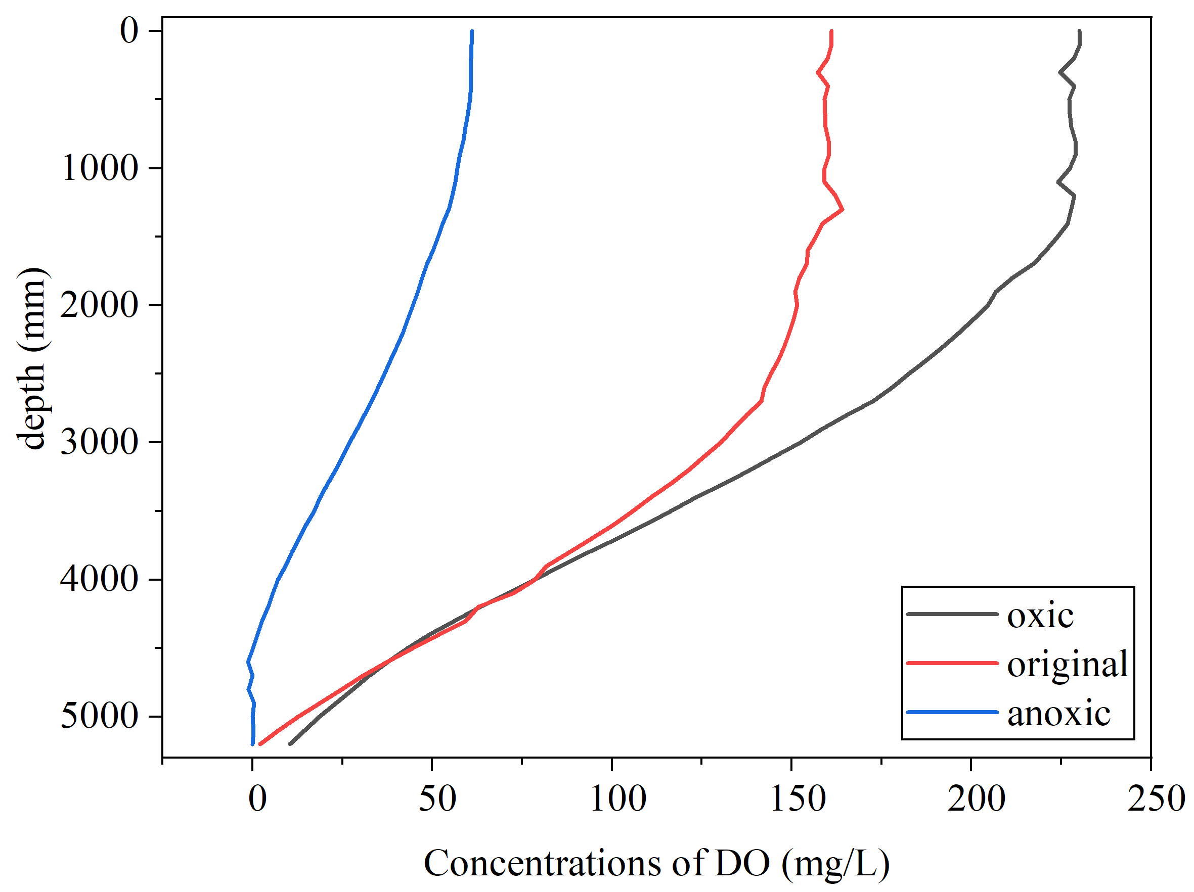
Fig. S4 Concentrations of oxygen in sediment under different oxic conditions
Reference
Chen, C., Tian, L., Sheng, Y., Wang, R., Li, J., Zhang, D., Zhang, C., 2021. Abundance, diversity, and community composition of anammox bacteria in sediments of Xiangshan Bay, China. Regional Studies in Marine Science 44.
Hu, B., Wang, P.F., Hou, J., Wang, C., Qian, J., Zhang, N.N., Yuan, Q.S., 2017. Effect of titanium dioxide (TiO₂) nanoparticles on the photo dissolution of particulate organic matter: insights from fluorescence spectroscopy and environmental implications. Environmental pollution 229, 19-28.
Nguyen, H.D., Cao, B., Mishra, B., Boyanov, M.I., Kemner, K.M., Fredrickson, J.K., Beyenal, H., 2012. Microscale geochemical gradients in Hanford 300 Area sediment biofilms and influence of uranium. Water. Res. 46 (1), 227e234.
Murphy, K.R., Stedmon, C.A., Graeber, D., Bro, R., 2013. Fluorescence spectroscopy and multi-way techniques. PARAFAC. Anal Methods-Uk 5, 6557-6566.
Turner S, Pryer K M, Miao V P W, et al. Investigating deep phylogenetic relationships among cyanobacteria and plastids by small subunit rRNA sequence analysis 1[J]. Journal of Eukaryotic Microbiology, 1999, 46(4): 327-338.
Viret, H., Pringault, O., Duran, R., 2006. Impact of zinc and nickel on oxygen consumption of benthic microbial communities assessed with microsensors. Sci.Total. Environ. 367 (1), 302e311.
Zhang, Y.L., Zhang, E.L., Yin, Y., van Dijk, M.A., Feng, L.Q., Shi, Z.Q., Liu, M.L., Qin, B.Q., 2010. Characteristics and sources of chromophoric dissolved organic matter in lakes of the Yungui Plateau, China, differing in trophic state and altitude. Limnol. Oceanogr. 55, 2645-2659.

