Supplementary material
Supplementary material A: State of the art questionnaire
Supplementary material B: Ease of communication scale
Supplementary material C: Intervention form
Supplementary material D: Communication content thematization
Supplementary material E: Difficulties of use categorization

Supplementary material A: State of the art questionnaire
The content of the « state of the art questionnaire » consists of 5 closed-ended questions covering the difficulties to communicate with intubated or tracheostomized patients, the avoidance of interactions with patients, the perception of the help that could be provided by AAC systems and the interest in learning to use these systems.

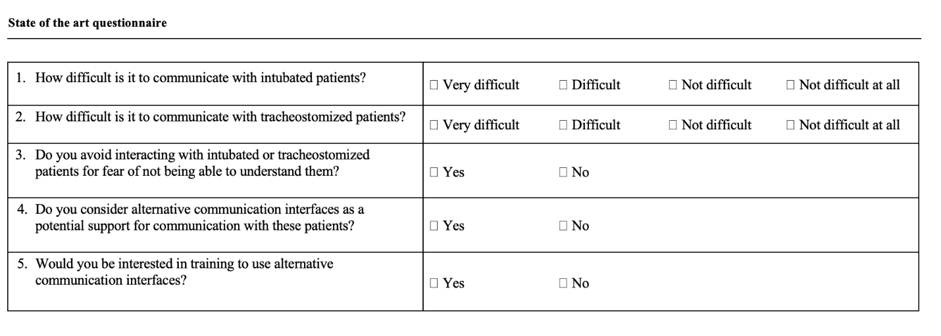

Supplementary material B: Ease of communication scale
The content of the “ease of communication scale” consists of 10 close-ended questions about the difficulty to communicate and to be understood without being able to speak, the difficulty to communicate with relatives, nurses and doctors, the difficulty to communicate physical needs, thoughts and feelings, the difficulty to ask questions about care and health status. The English version of the scale was adapted in a French version following three successive steps: a first translation from English to French, a second translation from French to English and validation by an expert.

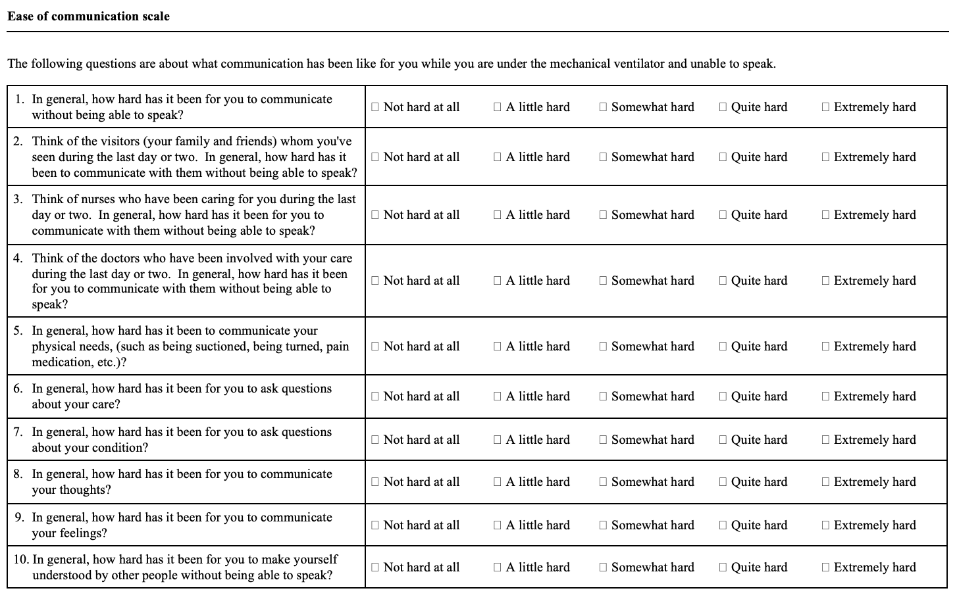

Supplementary material C: Intervention form
The content of the “intervention form” comprises 5 open- and close-ended items covering transmission success, quantity of messages transmitted, patient satisfaction, communication content and difficulties of use.

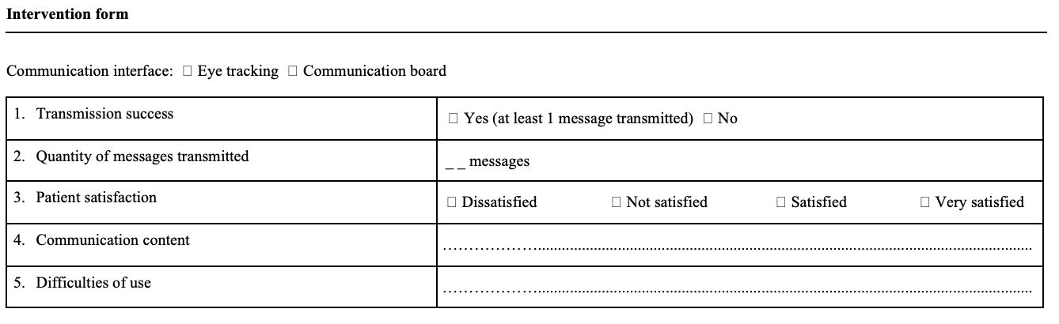

Supplementary material D: Communication content thematization
The thematic analysis of communication content by communication board and eye tracking revealed the following themes:

Themes | Board communication content | Eye tracking communication content
Breathing | Respiratory difficulty | Endotracheal aspiration, inability to speak, endotracheal tube removal, choking sensation, respiratory difficulty
Pain | Painful sensation | Painful sensation, intensity, type, location of pain
Psychological state | Fear, boredom, sadness | Worry, anger, hospitalization circumstances, smoking
Nutrition-hydratation | Feeling of thirst, feeling of hunger | Feeling of thirst, feeling of hunger, wet compresses
Hygiene | Hygiene care | Hygiene care, tube care
Thermoregulation | Sensation of warmth | Sensation of warmth, sensation of cold, misting spray
Rest | Tiredness | Tiredness
Installation | Position change, contention | Position change, incorrect installation
Environment |  | Television, hearing aids, brightness

Supplementary material D: Difficulties of use categorization
The categorical analysis of the difficulties encountered when using the communication board and eye tracking revealed the following categories:

Categories | Board use difficulties | Eye tracking use difficulties
Difficulty to understand the utilization | Total misunderstanding | Partial or total misunderstanding
Difficulty to select the items | Erroneous selection of items, long selection time, help needed for selection | Erroneous selection of items, long selection time
Difficulty to visualize items | Small items size
Insufficient items | Lack of items
Difficulty to install the device |  | Difficulty of installation, non-optimal installation
Difficulty to detect eye gaze |  | Unstable eye detection

