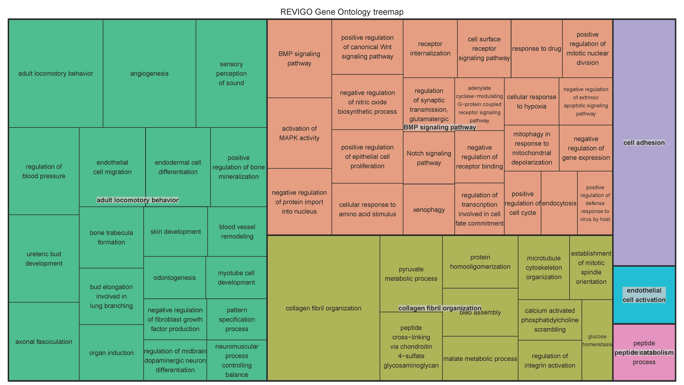

Additional Figure 1a: Tree map for Biological processes involved in upregulated hyper-methylated backfat tissue.
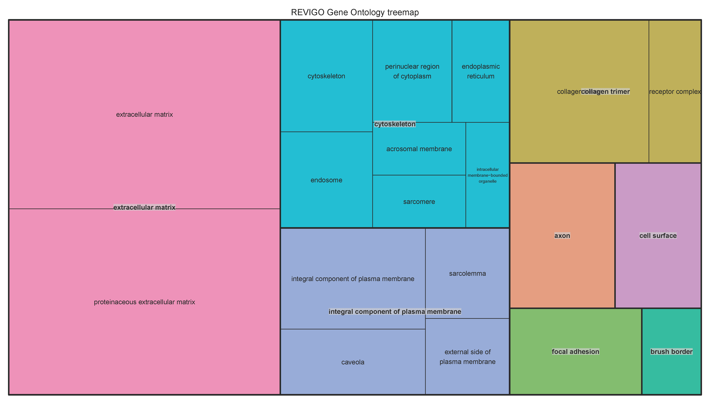

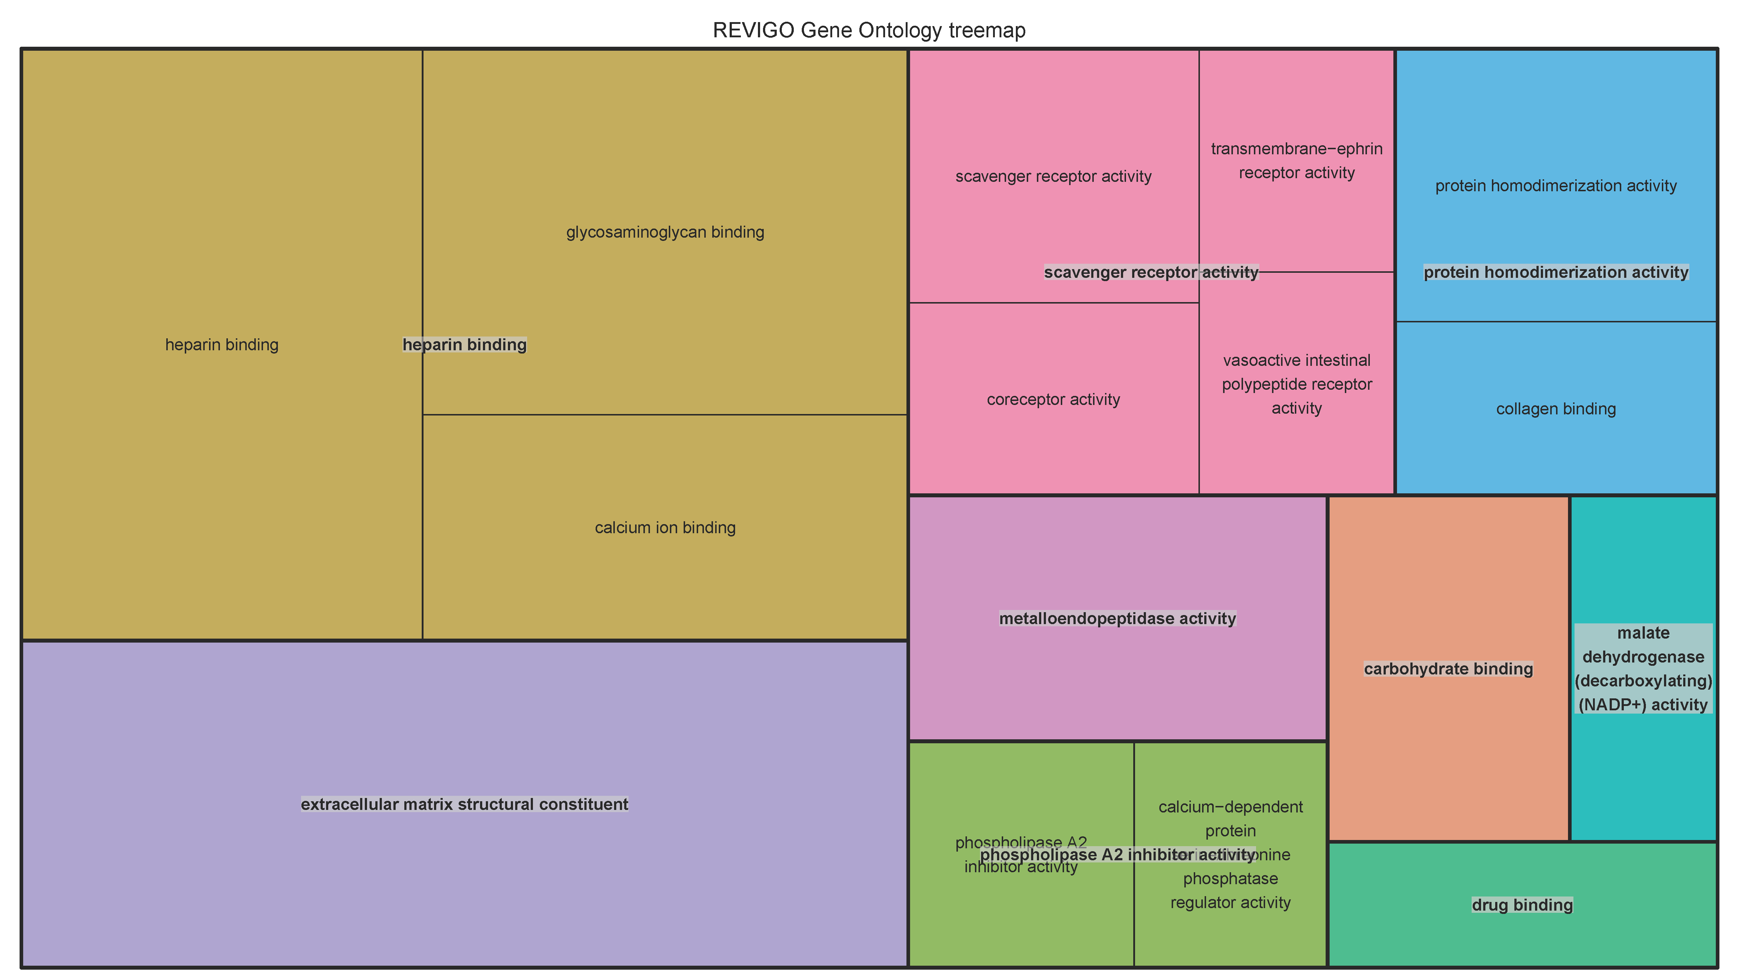Additional Figure 1b: Tree map for cellular compartment involved in upregulated hyper-methylated backfat tissue.

Additional Figure 1c: Tree map for molecular function involved in upregulated hyper-methylated backfat tissue.
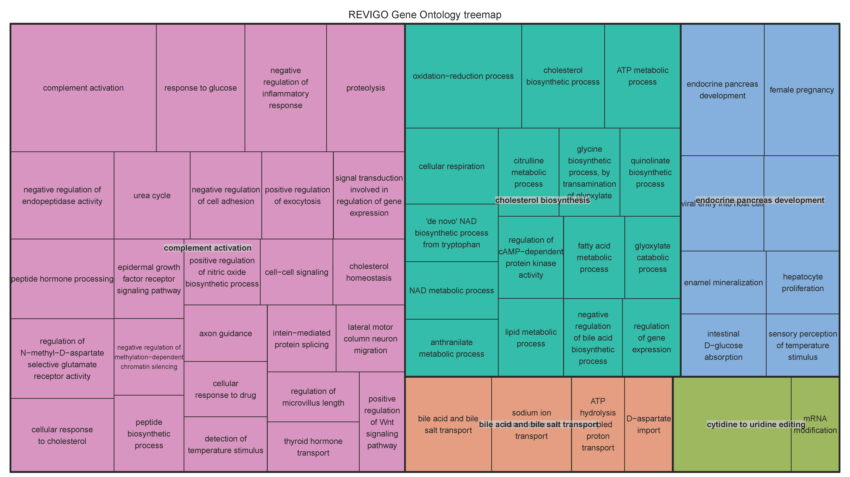

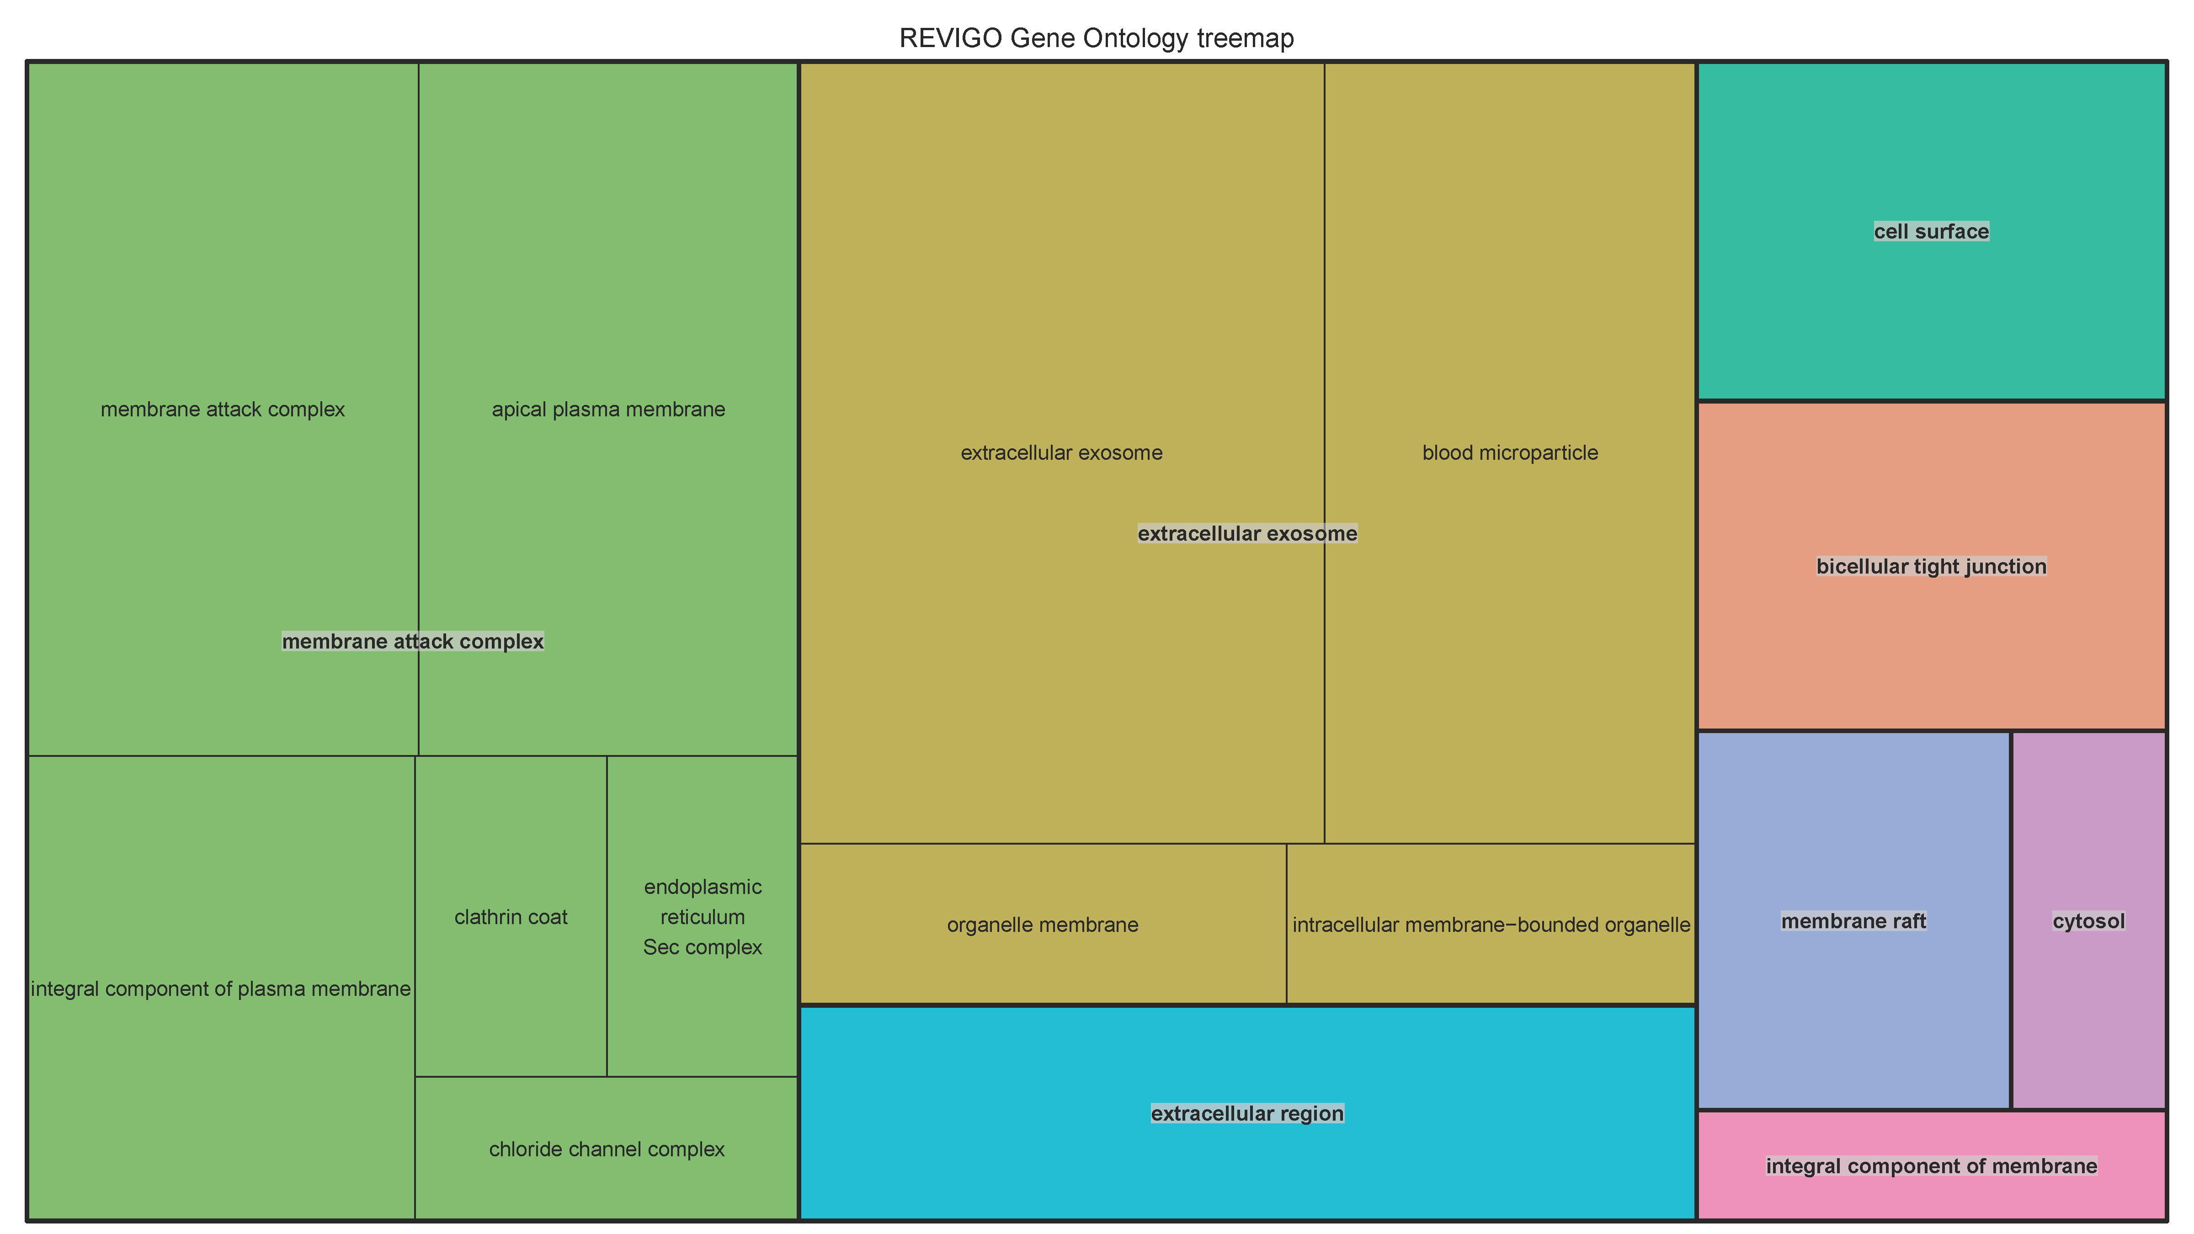Additional Figure 2a: Tree map for biological involved in downregulated hyper-methylated backfat tissue.

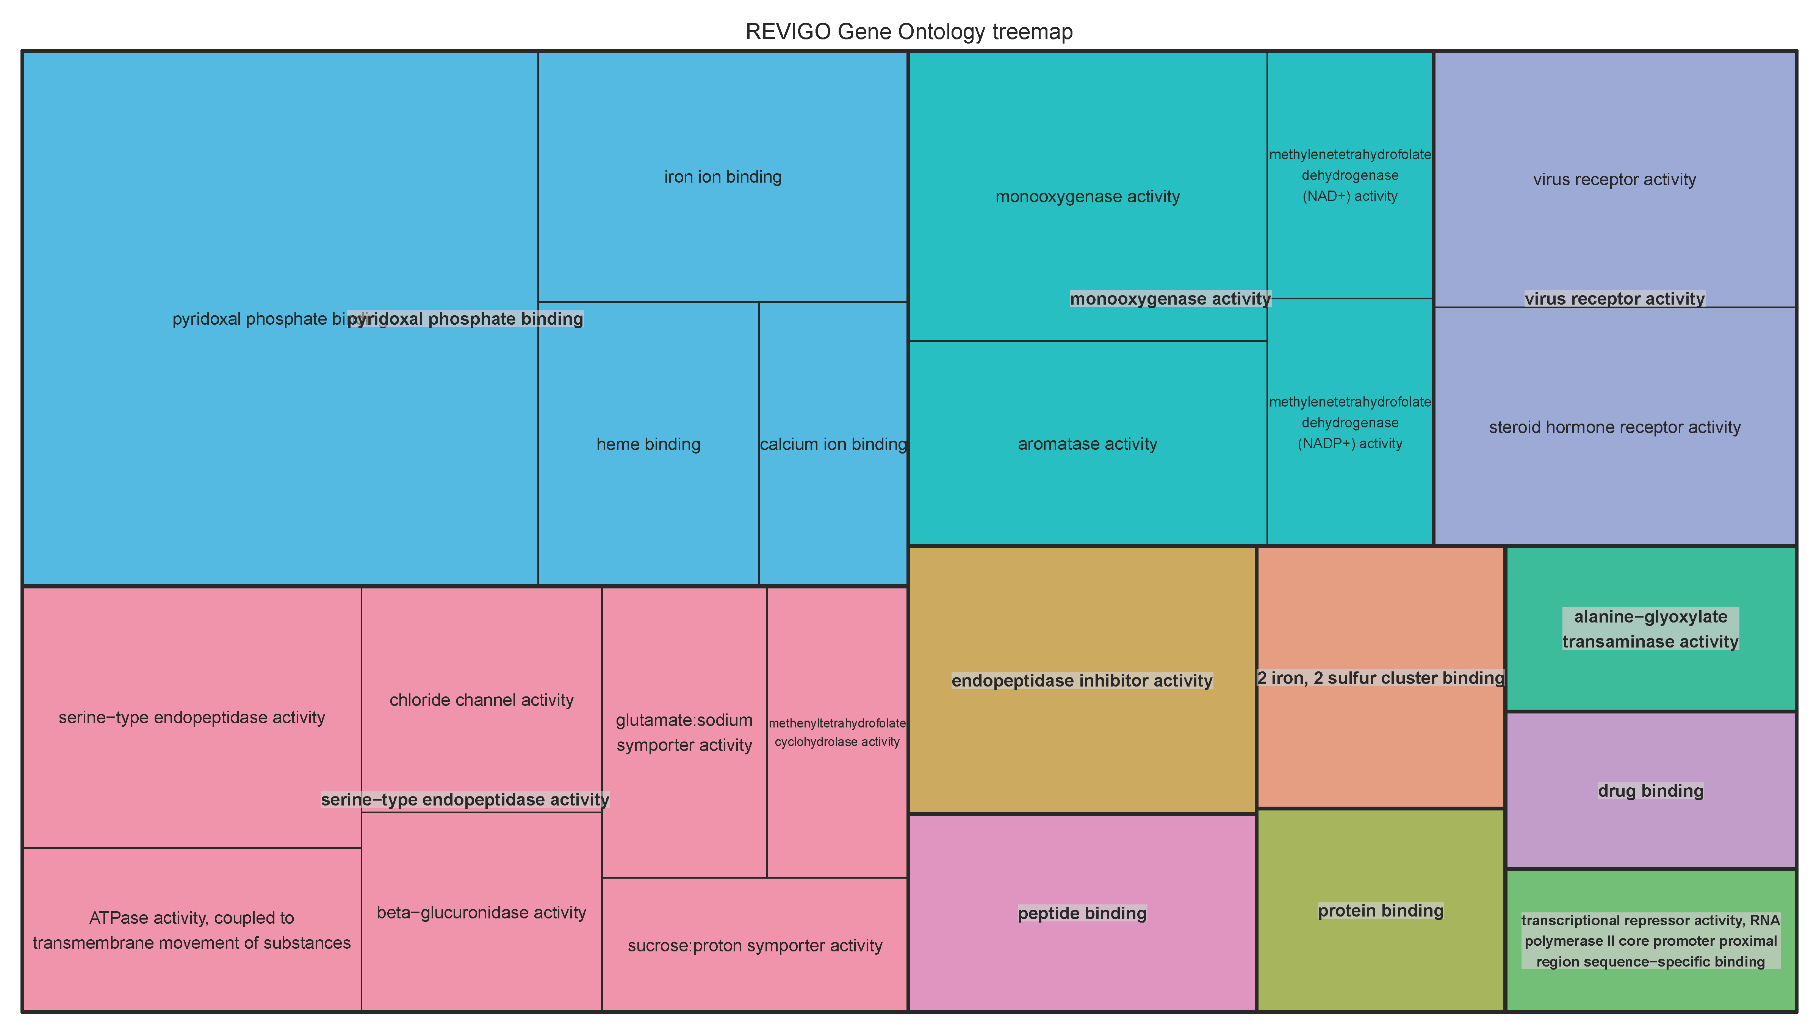Additional Figure 2b: Tree map for cellular compartment involved in downregulated hyper-methylated backfat tissue.

Additional Figure 2c: Tree map for molecular function involved in downregulated hyper-methylated backfat tissue.
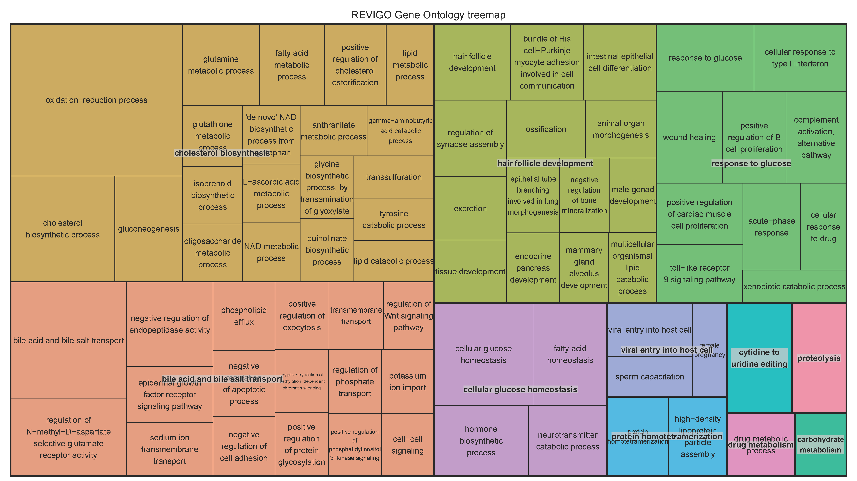

Additional Figure 3a: Tree map for Biological processes involved in upregulated hyper-methylated liver tissue.
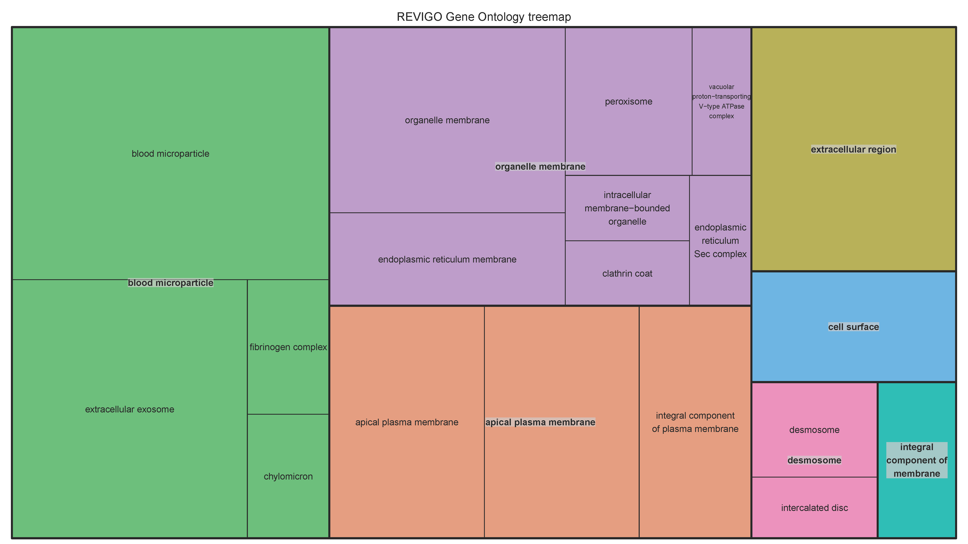

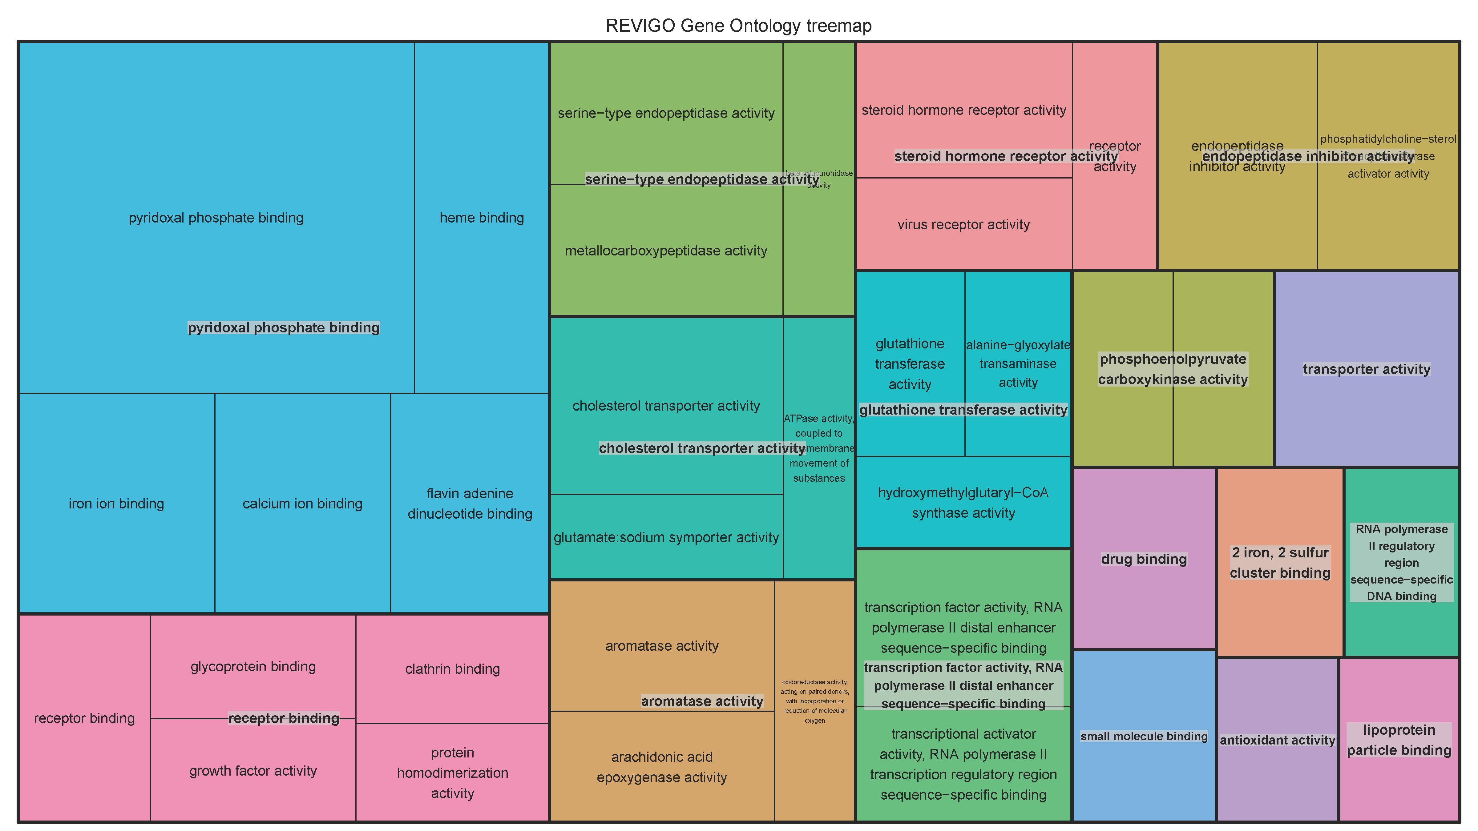Additional Figure 3b: Tree map for cellular compartment involved in upregulated hyper-methylated liver tissue.

Additional Figure 3c: Tree map for molecular function involved in upregulated hyper-methylated liver tissue.
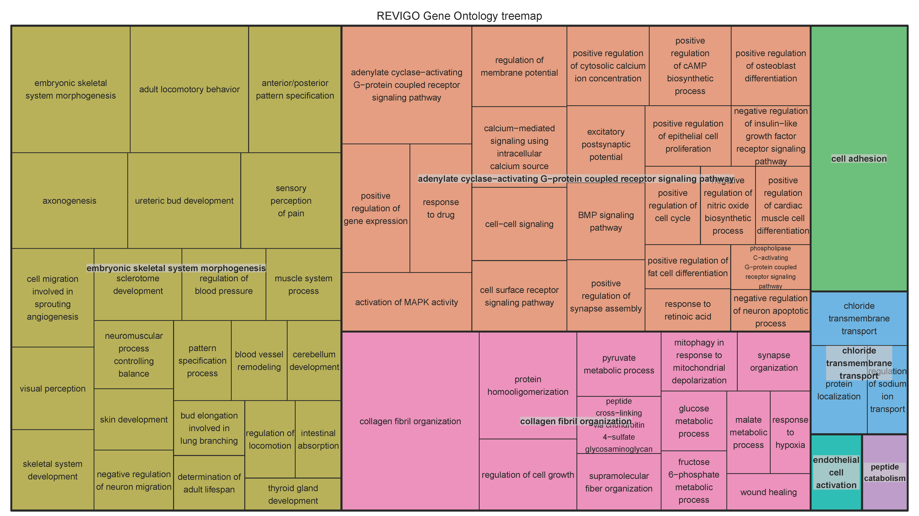

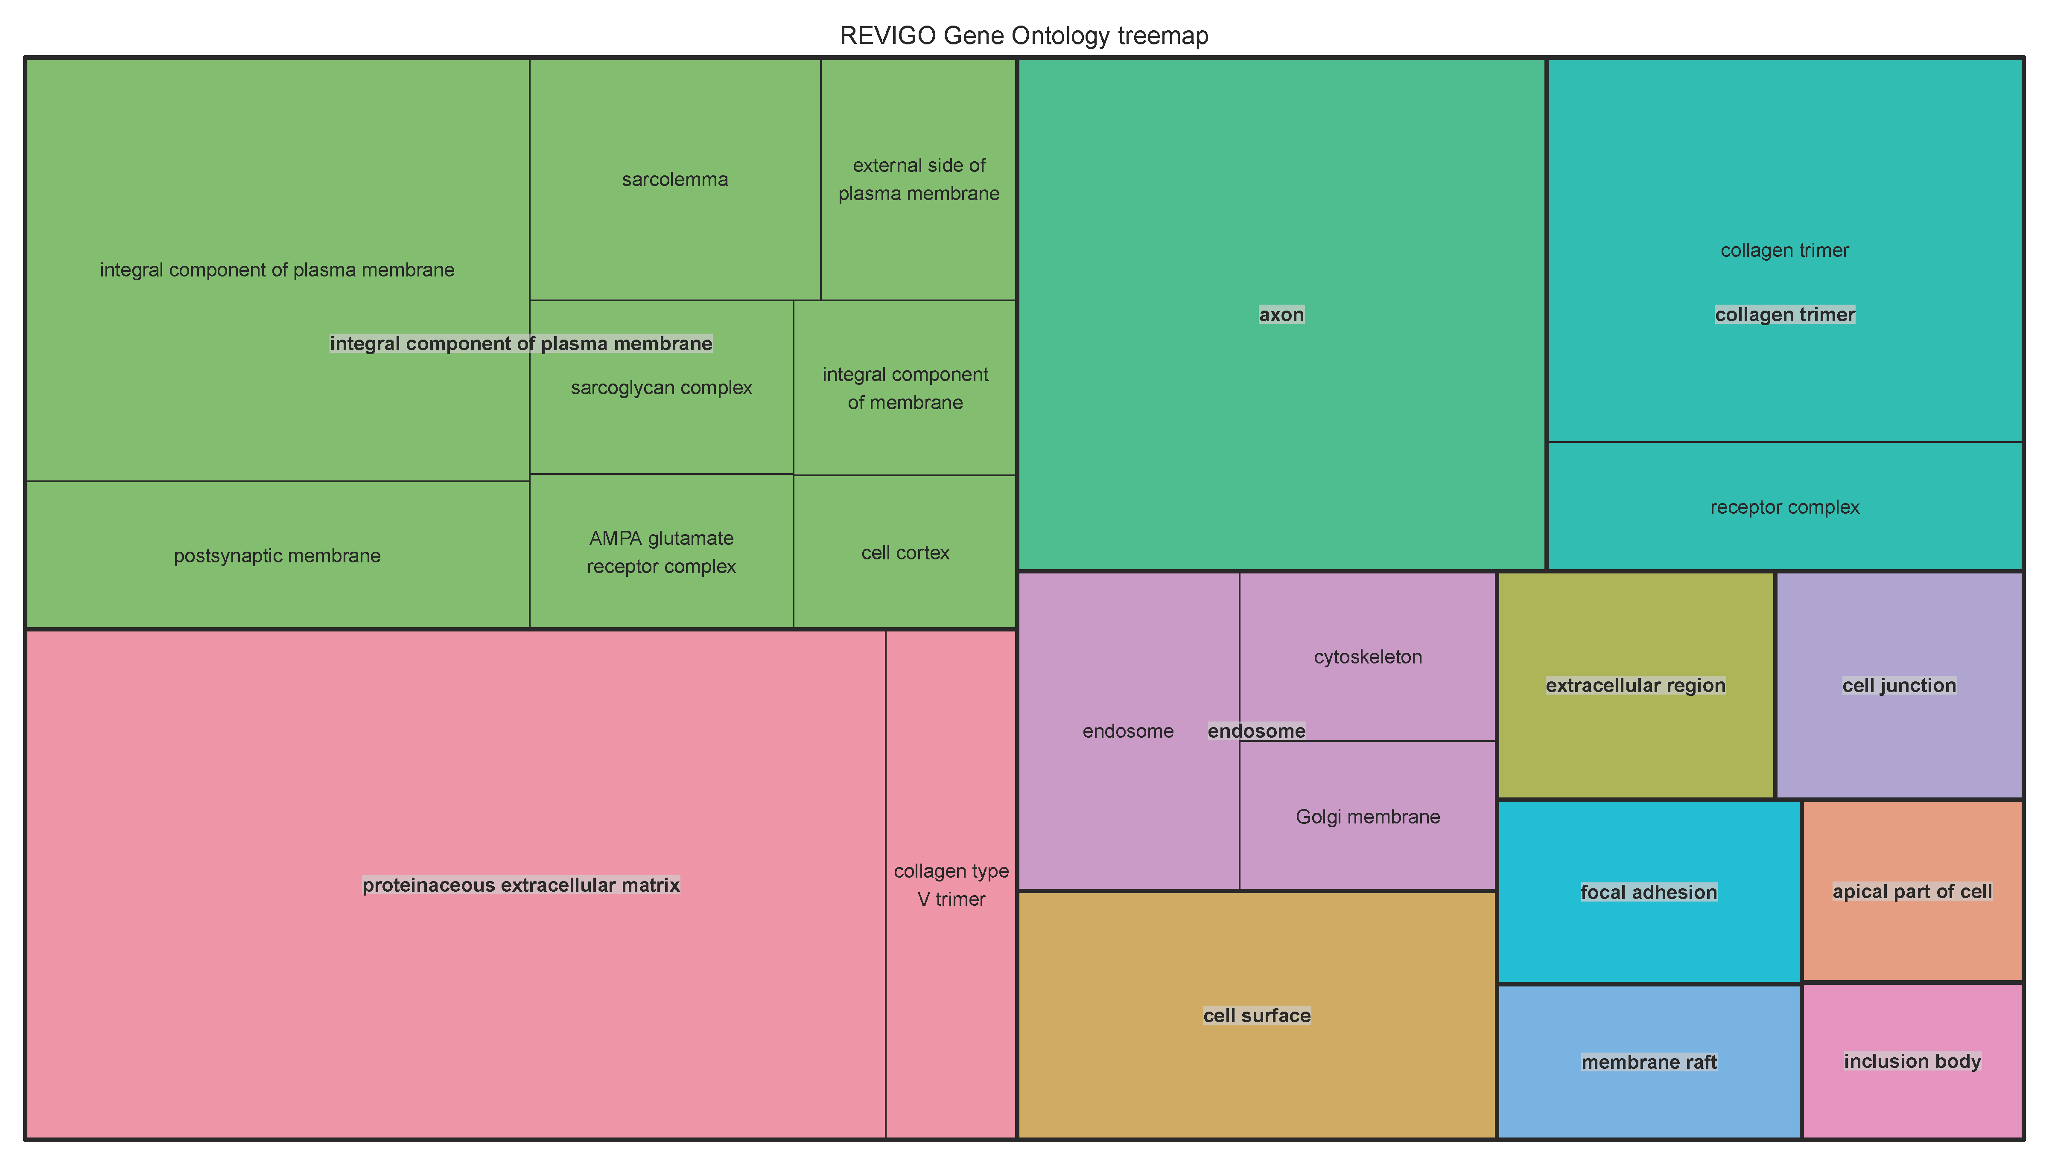Additional Figure 4a: Tree map for biological involved in downregulated hyper-methylated liver tissue.

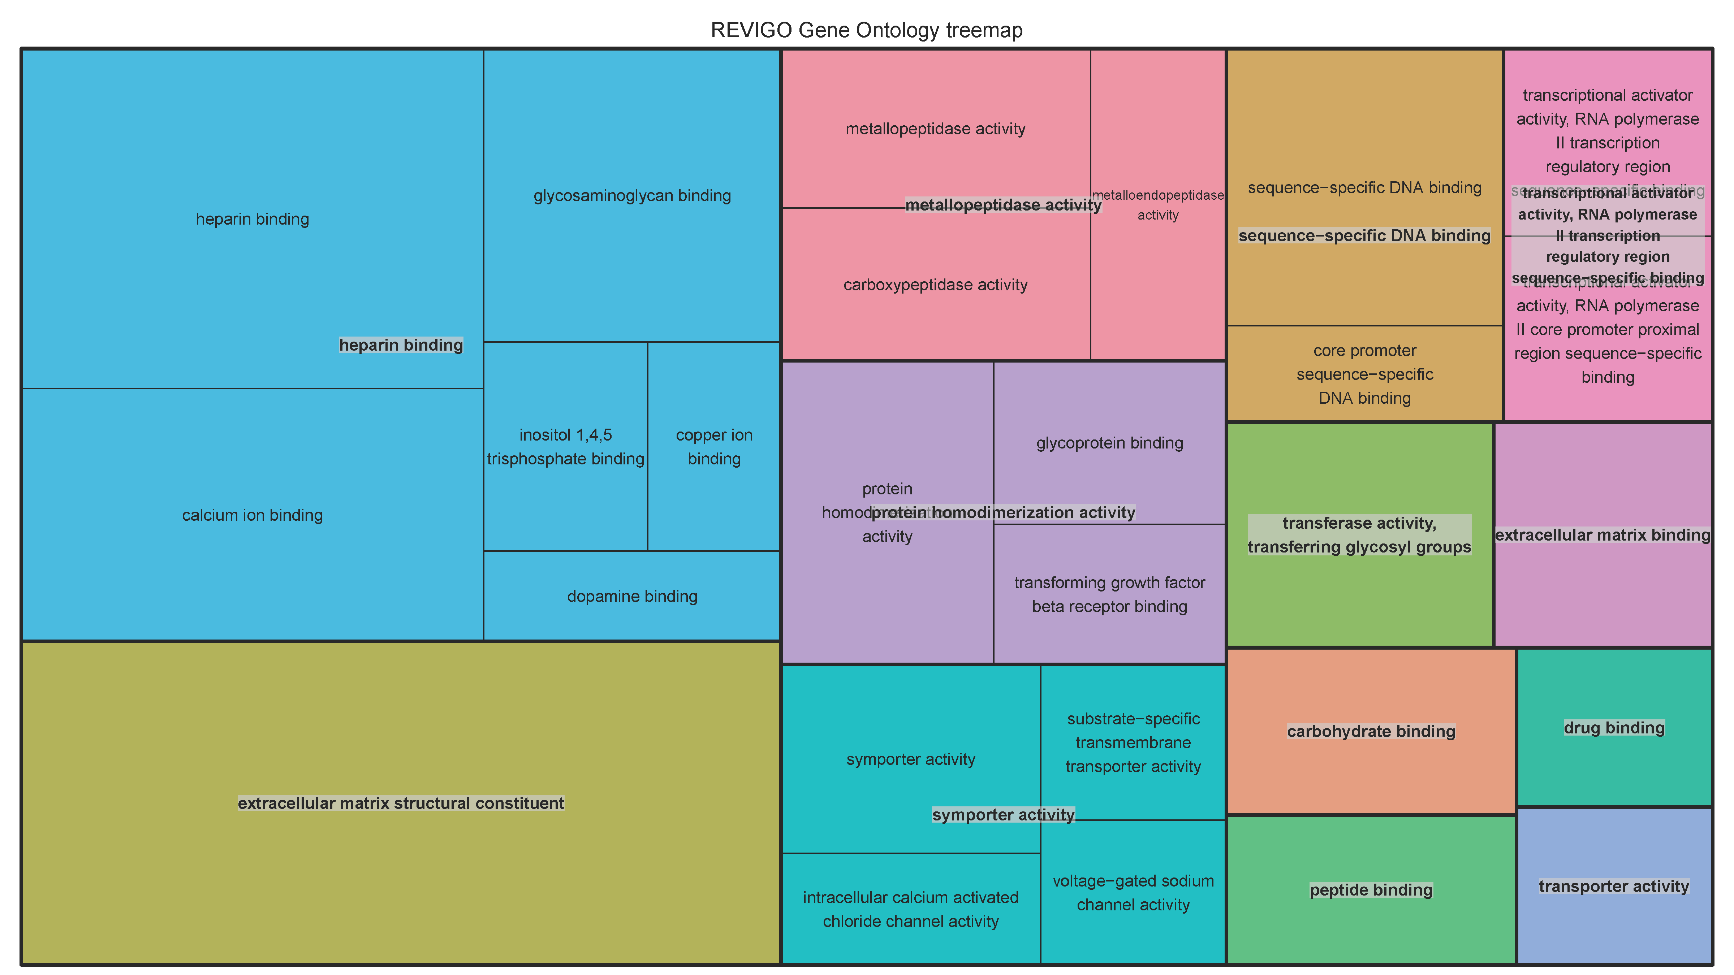Additional Figure 4b: Tree map for cellular compartment involved in downregulated hyper-methylated liver tissue.

Additional Figure 4c: Tree map for molecular function involved in downregulated hyper-methylated liver tissue.

