Online supporting information

List of supplementary information provided
Table S1: Definition of Exposures and Confounders (word supplement)
Table S2: Full results for MRS models hypothesis 1
Table S3: Full results for MRS models hypothesis 2
Table S4: Full results for MRS models hypothesis 1 – sensitivity analysis
Table S5: Full results for MRS models hypothesis 2 – sensitivity analysis
Table S6: Full results for CpG models hypothesis 1
Table S7: Full results for CpG models hypothesis 2
Table S8: Full results for CpG models hypothesis 1 – sensitivity analysis
Table S9: Full results for CpG models hypothesis 1 – sensitivity analysis
Table S10: HIMA CpGs and corresponding genes

Plot S1: Flow-chart of models
Plots S2-S9: Directed acyclic graphs for confounder selection

Table S1: Definition of Exposures and Confounders
Exposure | Definition | Timepoints | Report in literature (for confounders)
Maternal smoking | Maternal smoking during the second and/or third trimester of pregnancy; control defined as stopped smoking before the second trimester or never smoked | Determined pre-natally; assessed at birth questionnaire
Family history | Dummy whether no or at least one biological parent has ever had any allergic disease (asthma, dermatitis, allergic rhinitis) | Determined pre-natally; assessed at birth questionnaire
PRS | Polygenic risk score for any allergic disease as calculated from Ferreira et al. 2017&2019(1,2) | Determined at conception; blood or saliva samples collected at six or ten years
Confounder
Sex | Biological sex of the participants |  | King 2022(3)
Age | Exact age at blood withdrawal | At blood-withdrawal/physical examination | Shahal 2022(4), Horvarth 2013(5)
Allergy season | Dummy, whether blood withdrawal took place within the allergy season (March to August) | At blood-withdrawal/physical examination | North 2018(6)
CTPs | Cell type proportions as estimated with the EpiDish package(7); include CD8+ T-cells, CD4+ T-cells, Natural Killer (NK) cells, B-cells, Monocytes. Neutrophils, Eosinophils | At blood-withdrawal/physical examination | Houseman 2012(8), Seumois 2020(9)
BMI | Body mass index as calculated from height and weight measured at physical investigation | At blood-withdrawal/physical examination | Rzehak 2019(10), Wahl 2017(11)
SES | Socio economic status depicted here by parental education low/middle (= less or equal than 9 years of education) versus high education (=more than 9 years) | Assessed at birth questionnaire | Cerutti 2021(12)
Air pollution | NO₂ as proxy for general air pollution estimated at birth address within the ESCAPE project (described elsewhere(13)) | Assessed at birth | Park 2022(14), Aguilera 2022(15)

Plots S1: Flow-chart of models
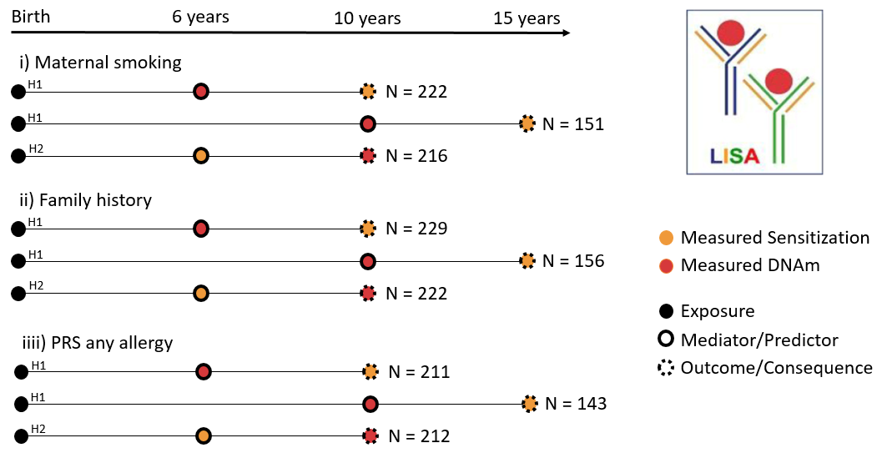
Figure S1: Model display per exposure (i-iii) and hypotheses. H1) Hypothesis 1 investigating whether prior DNAm influences sensitization, H2) Hypothesis 2 investigating whether sensitization influences posterior DNAm changes.

Plots S2-S9: Directed acyclic graphs for selection of confounders
In the present study confounders for mediation analyses were selected based on directed acyclic graphs (DAGs) created with dagitty(16).
The package annotates the DAGs as followed. Paths: Causal paths (green), biasing paths (pink). Nodes: Ancestors of exposure (yellow), ancestors of the outcome (blue), ancestors of both exposure and outcome (pink).
They are ordered according to the two tested hypotheses (H1: Exposure – DNAm – Sensitization & H2: Exposure – Sensitization – DNAm) and the three different exposures (i) Maternal smoking, ii) Family history and iii) PRS), while the first plot for each hypothesis always depicts the mediator-outcome association, which is the same for all exposure models in this effect direction.
Hypothesis (1) (Exposure – DNAm – Sensitization)
Mediator-Outcome
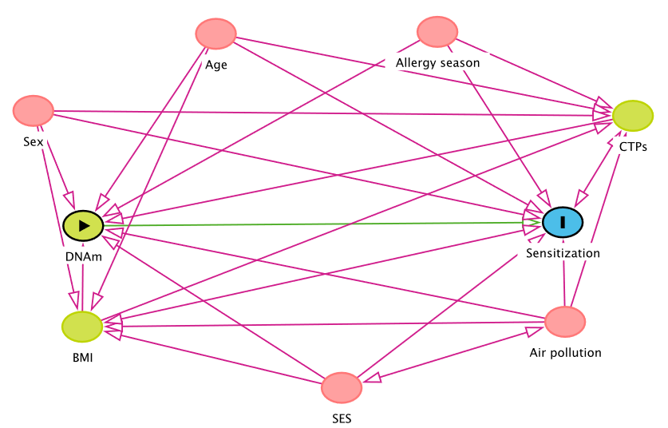
Adjust for: Age, Air pollution, Allergy season, BMI, Cell type proportions (CTPs), SES, Sex

Exposure-Mediator
- Maternal smoking
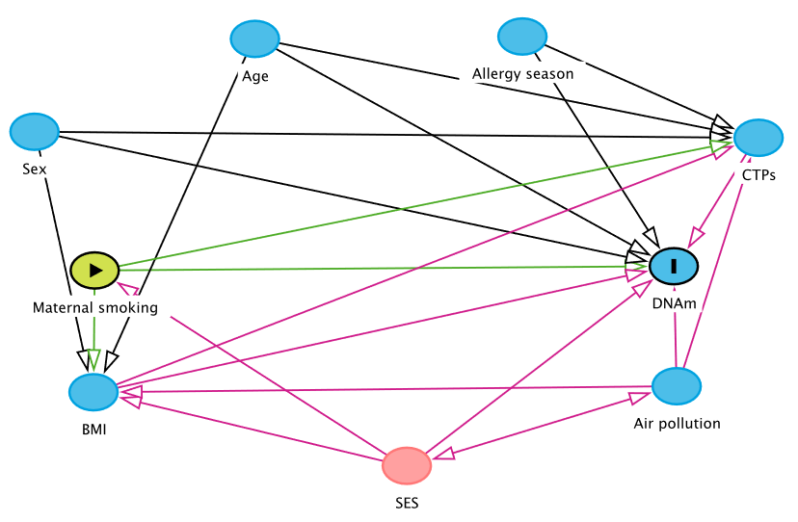
Adjust for: SES
- Family history
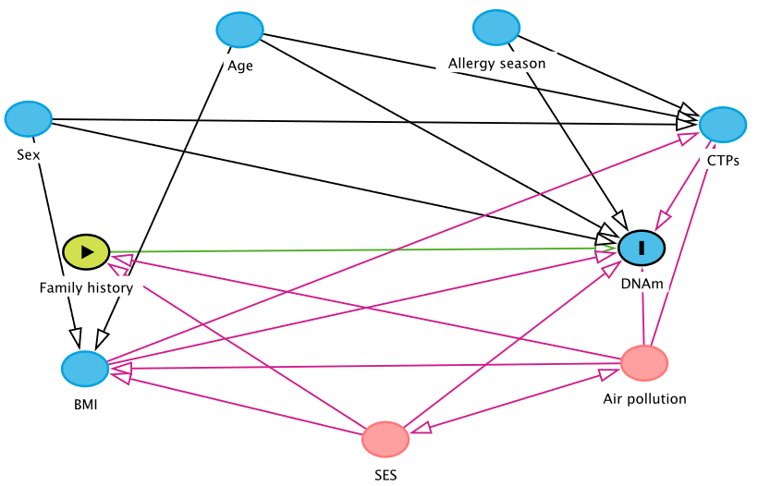
Adjust for: SES, Air pollution

- PRS
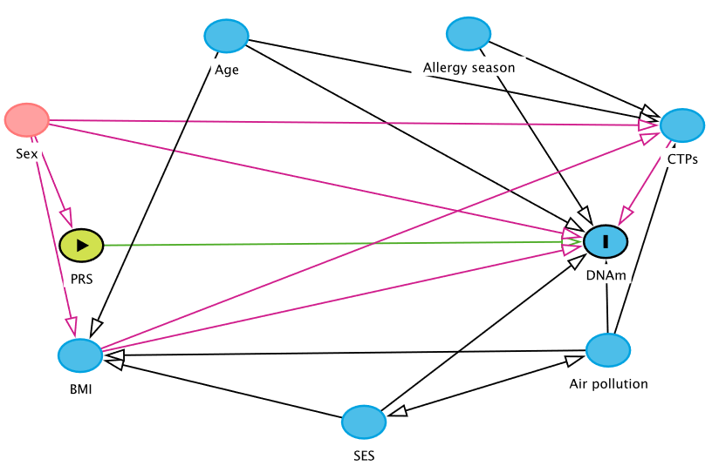
Adjust for: Sex

Hypothesis (2) (Exposure –Sensitization - DNAm)
Mediator-Outcome
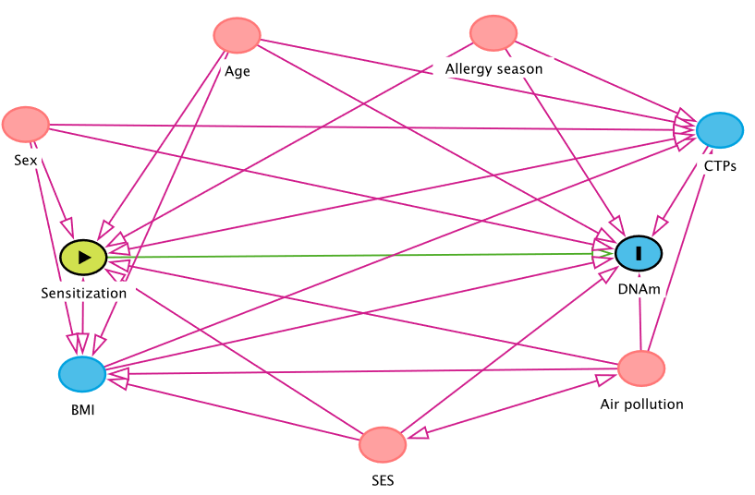
Adjust for: Age, Air pollution (NO₂), Allergy season, BMI, Cell type proportions (CTPs), SES, Sex
Exposure-Mediator
- Maternal smoking
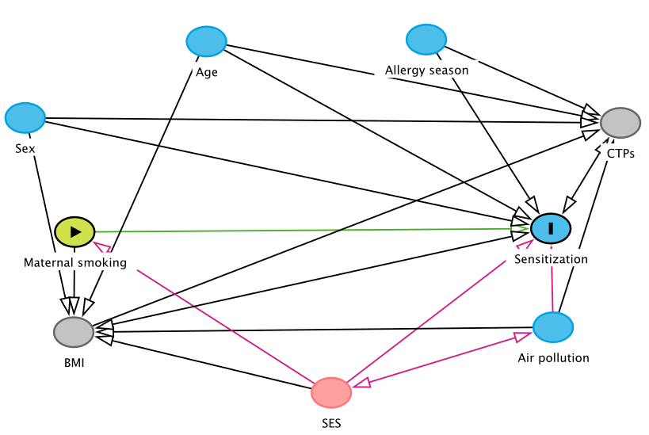
Adjust for: SES
- Family history
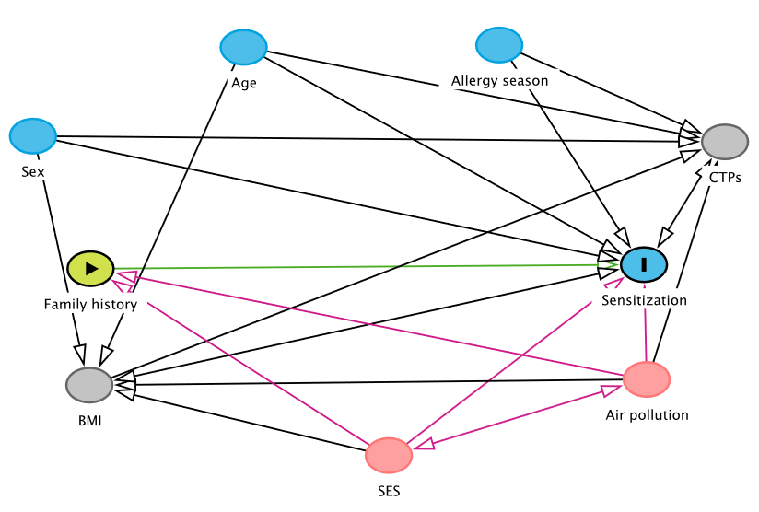
Adjust for: SES, Air pollution

- PRS
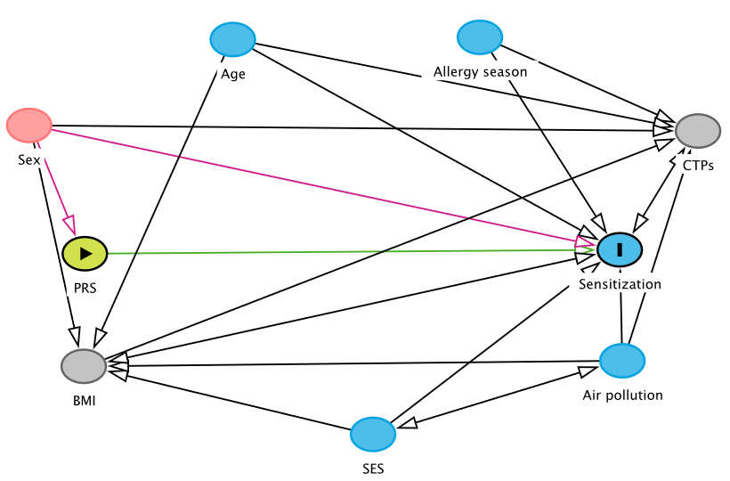
Adjust for: Sex

References
1. Ferreira MA, Vonk JM, Baurecht H, Marenholz I, Tian C, Hoffman JD, et al. Shared genetic origin of asthma, hay fever and eczema elucidates allergic disease biology. Nat Genet. 2017 Dec;49(12):1752–7.
2. Ferreira MAR, Vonk JM, Baurecht H, Marenholz I, Tian C, Hoffman JD, et al. Eleven loci with new reproducible genetic associations with allergic disease risk. J Allergy Clin Immunol. 2019 Feb 1;143(2):691–9.
3. King DE, Sparling AC, Lloyd D, Satusky MJ, Martinez M, Grenier C, et al. Sex-specific DNA methylation and associations with in utero tobacco smoke exposure at nuclear-encoded mitochondrial genes. Epigenetics. 2022 Mar 3;1–17.
4. Shahal T, Segev E, Konstantinovsky T, Marcus Y, Shefer G, Pasmanik-Chor M, et al. Deconvolution of the epigenetic age discloses distinct inter-personal variability in epigenetic aging patterns. Epigenetics Chromatin. 2022 Mar 7;15(1):9.
5. Horvath S. DNA methylation age of human tissues and cell types. Genome Biol. 2013 Dec 10;14(10):3156.
6. North ML, Jones MJ, MacIsaac JL, Morin AM, Steacy LM, Gregor A, et al. Blood and nasal epigenetics correlate with allergic rhinitis symptom development in the environmental exposure unit. Allergy. 2018 Jan;73(1):196–205.
7. Teschendorff AE, Breeze CE, Zheng SC, Beck S. A comparison of reference-based algorithms for correcting cell-type heterogeneity in Epigenome-Wide Association Studies. BMC Bioinformatics. 2017 Feb 13;18:105.
8. Houseman EA, Accomando WP, Koestler DC, Christensen BC, Marsit CJ, Nelson HH, et al. DNA methylation arrays as surrogate measures of cell mixture distribution. BMC Bioinformatics. 2012 May 8;13:86.
9. Seumois G, Ramírez-Suástegui C, Schmiedel BJ, Liang S, Peters B, Sette A, et al. Single-cell transcriptomic analysis of allergen-specific T cells in allergy and asthma. Sci Immunol. 2020 Jun 12;5(48):eaba6087.
10. Rzehak P, Covic M, Saffery R, Reischl E, Wahl S, Grote V, et al. DNA-Methylation and Body Composition in Preschool Children: Epigenome-Wide-Analysis in the European Childhood Obesity Project (CHOP)-Study. Sci Rep [Internet]. 2017 Oct 30 [cited 2019 Oct 9];7. Available from: https://www.ncbi.nlm.nih.gov/pmc/articles/PMC5662763/
11. Wahl S, Drong A, Lehne B, Loh M, Scott WR, Kunze S, et al. Epigenome-wide association study of body mass index, and the adverse outcomes of adiposity. Nature. 2017;541(7635):81–6.
12. Cerutti J, Lussier AA, Zhu Y, Liu J, Dunn EC. Associations between indicators of socioeconomic position and DNA methylation: a scoping review. Clin Epigenetics. 2021 Dec 14;13(1):221.
13. MacIntyre EA, Gehring U, Mölter A, Fuertes E, Klümper C, Krämer U, et al. Air pollution and respiratory infections during early childhood: an analysis of 10 European birth cohorts within the ESCAPE Project. Environ Health Perspect. 2014 Jan;122(1):107–13.
14. Park J, Kim WJ, Kim J, Jeong C-Y, Park H, Hong Y-C, et al. Prenatal Exposure to Traffic-Related Air Pollution and the DNA Methylation in Cord Blood Cells: MOCEH Study. Int J Environ Res Public Health. 2022 Mar 10;19(6):3292.
15. Aguilera J, Han X, Cao S, Balmes J, Lurmann F, Tyner T, et al. Increases in ambient air pollutants during pregnancy are linked to increases in methylation of IL4, IL10, and IFNγ. Clin Epigenetics. 2022 Mar 14;14(1):40.
16. Textor J, van der Zander B, Gilthorpe MS, Liskiewicz M, Ellison GT. Robust causal inference using directed acyclic graphs: the R package “dagitty.” Int J Epidemiol. 2016 Dec 1;45(6):1887–94.

