Supplementary Information

This file contains:
Fig. S1: The difference between our ancestor-offspring network method and the similarity-based methods.
Fig. S2: Illustration on the simulated evolutionary process and reconstruction of transmission network of viruses based on ancestor-offspring relationship between sequences.
Fig. S3: Kernel density of transmission chains with different chain lengths in the transmission chains using simulation data.
Fig. S4: Illustration of reconstructed transmission networks of SARS-CoV-2 with four nodes (A), five nodes (B), six nodes (C), seven nodes (D), eight nodes (E), and nine nodes (F).
Table S1: Statistics of nodes of the reconstructed transmission chains and networks with different lengths using data of the first six months.

Fig. S1.
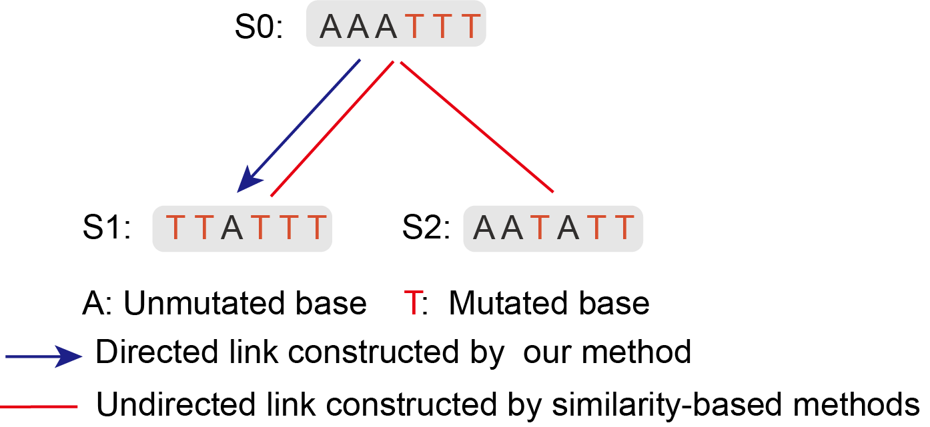
Fig. S1. The difference between our ancestor-offspring network method and the similarity-based methods. S0, S1, and S2 are three sequences with length of 6 bases. The black letter A is the original base. The red letter T in each sequence indicates mutations. According to our method, there will be a directional link between the sequences S0 and S1 (i.e., S0→S1), but there is no link relationship between S0 and S2 (i.e., S0 and S2 is not ancestor of each other). But in the haplotype network methods, S0 would be linked with both S1 and S2 respectively due to the same distance between them (i.e., the genetic distances between S0 and S1, and between S0 and S2 are the same), and there is no direction of transmission.

Fig. S2.
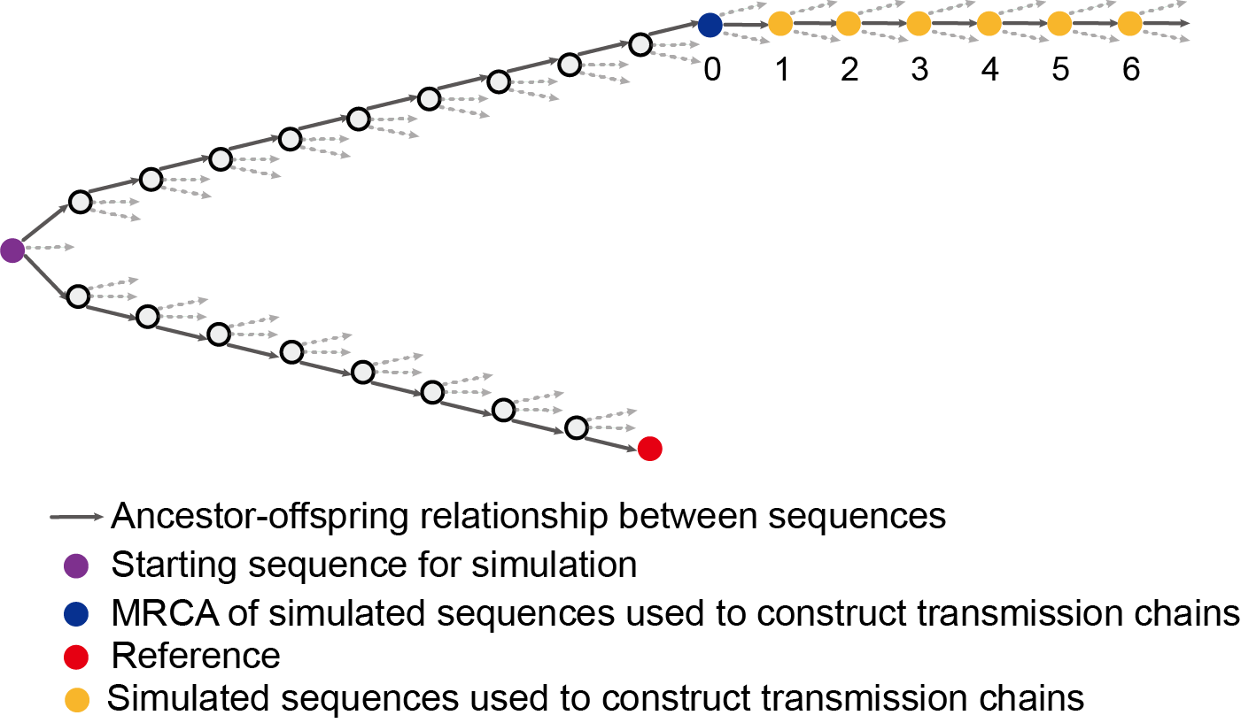
Fig. S2. Illustration on the simulated evolutionary process and reconstruction of transmission network of viruses based on ancestor-offspring relationship between sequences. Circles represent sequences, only one sequence is shown in each generation due to the limitation of space. Dashed arrows represent clades (and the offspring sequences) that are not shown due to the limitation of space. The position of reference and detected samples were determined roughly by referring to the evolution pattern of SARS-CoV-2 from coronavirus from the bat.

Fig. S3.
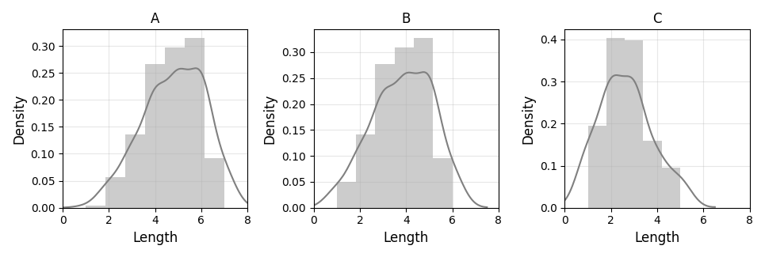
Fig. S3. Kernel density of transmission chains with different chain lengths in the transmission chains using simulation data. (A) Using 0th to 6th generation data (including ancestor). (B) Using 2nd to 6th generation data (not including ancestor). (C) Using 4th to 6th generation data (not including ancestor).

Fig. S4.
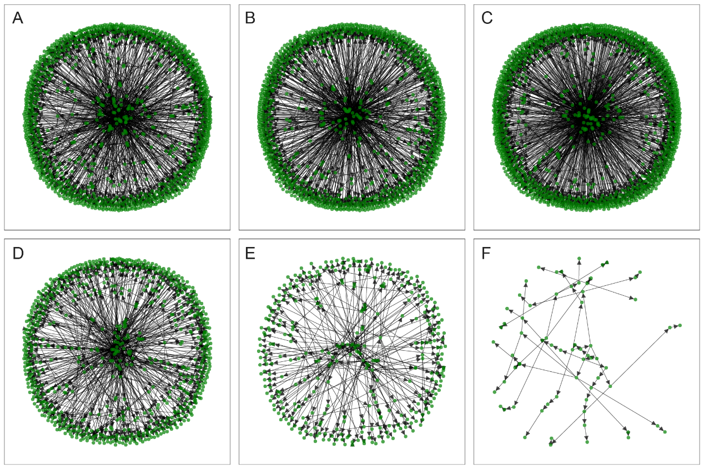
Fig. S4. Illustration of reconstructed transmission networks of SARS-CoV-2 with four nodes (A), five nodes (B), six nodes (C), seven nodes (D), eight nodes (E), and nine nodes (F). This figure is plotted using the NetworkX package in Python-3.7.

Table S1. Statistics of nodes of the reconstructed transmission chains and networks with different lengths using data of the first six months.
Chain length | No. chains | No. root nodes | No. root samples | No. root country/regions | First sampling time | Last sampling time
1 | 7087 | 7087 | 9697 | 86 | 16 | 180
2 | 5548 | 1151 | 3107 | 55 | 18 | 180
3 | 3590 | 478 | 1285 | 44 | 18 | 180
4 | 2557 | 191 | 582 | 36 | 18 | 180
5 | 3491 | 77 | 189 | 27 | 18 | 180
6 | 4782 | 38 | 112 | 20 | 18 | 158
7 | 3977 | 20 | 58 | 12 | 18 | 158
8 | 1803 | 10 | 26 | 9 | 18 | 113
9 | 680 | 6 | 18 | 7 | 18 | 113
10 | 227 | 5 | 17 | 6 | 18 | 113
11 | 64 | 3 | 8 | 3 | 37 | 113
12 | 10 | 2 | 7 | 2 | 37 | 113
13 | 2 | 1 | 6 | 1 | 37 | 47
Total | 33818 | 8426 | 13069 | 88 | 16 | 180
Table note: No. chains represent the number of chains of the corresponding length. No. root nodes represent the number of root nodes of the corresponding chains (one root node corresponds to one network). No. root samples represent the number of samples of the root nodes. No. root country/regions represent the number of sampling countries and regions of the root nodes. First sampling time represents the first sampling time (i.e., number of days since December 24, 2019 which was set as day 1) of the root nodes. Last sampling time represents the last sampling time of the samples in root nodes.

