Appendix S1
Camera deployment dates across the Neck (treatment site) and Whalebone point (control site) on lunawanna-allonah/Bruny Island, lutruwita/Tasmania, Australia during the shearwater breeding season and post-breeding season, in 2017 and 2019.

Year | Season | Site | Camera | Start | End | Total days
2017 | Breeding | The Neck | 93 | 19 Mars | 14 June | [24, 87]
2017 | Breeding | Whalebone | 20 | 17 Mars | 13 June | [28, 87]
2017 | Post-breeding | The Neck | 93 | 9 June | 21 July | 42
2017 | Post-Breeding | Whalebone | 20 | 13 June | 20 July | 37
2019 | Breeding | The Neck | 91 | 1 April | 30 April | 29
2019 | Breeding | Whalebone | 20 | 5 April | 1 May | 26
2019 | Post-breeding | The Neck | 91 | 21 June | 24 July | 33
2019 | Post-breeding | Whalebone | 20 | 25 June | 25 July | 30

Appendix S2
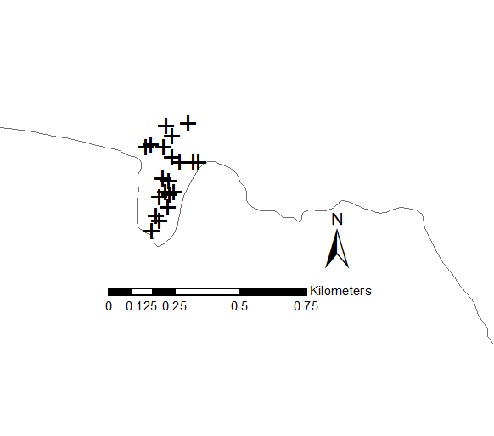
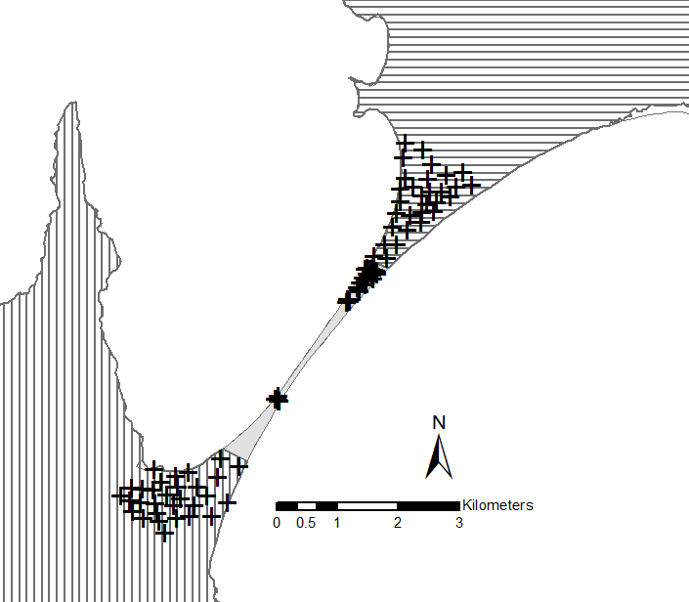
Map of The Neck (A – treatment site where cat removal occurred) and Whalebone point (B – control site) of lunawanna-allonah/Bruny Island, located off the south-east coast of lutruwita/Tasmania, Australia. The Neck is divided in three zones: North (horizontal shades), the South (vertical shades) and the seabird Neck colony (plain grey. The black crosses represent the camera deployment.
B
A

Appendix S3
Sampling design of camera trap surveys of feral cats on the shearwater colonies at The Neck (cat removals) and Whalebone Point (control site) and adjacent areas in the breeding (BS) and post-breeding seasons (PBS) in 2017 and 2019 on lunawanna-allonah/Bruny Island -lutruwita/Tasmania, Australia. The table shows the number of sampling occasions, trap-nights (sampling effort), cat detections (ID, unresolved, unmarked and total), detection per trap-night, and the number of animals identified in camera trapping.
 | BS 2017 |  |  | PBS 2017 |  |  | BS 2019 |  |  | PBS 2019
 | Neck | WBP |  | Neck | WBP |  | Neck | WBP |  | Neck | WBP
Sampling Occasions (duration in days) | 18 (90) | 18 (90) |  | 9 (43) | 9 (43) |  | 7 (31) | 7 (31) |  | 7 (35) | 7 (35)
Trap night (detector used) | 5030 (93 cam) | 835 (20 cam) |  | 3829 (91 cam) | 741 (19 cam) |  | 2723 (91 cam) | 540 (20 cam) |  | 3010 (91 cam) | 620 (20 cam)
ID Detections | 431 | 28 |  | 441 | 16 |  | 120 | 3 |  | 237 | 3
Unresolved detect | 63 | 0 |  | 38 | 1 |  | 4 | 0 |  | 0 | 0
Unmarked detect | 391 | 0 |  | 404 | 0 |  | 5 | 1 |  | 2 | 0
Total detection | 885 | 28 |  | 883 | 17 |  | 129 | 4 |  | 239 | 3
Detection/trap night | 0.18 cat/night | 0.03 cat/night |  | 0.23 cat/night | 0.02 cat/night |  | 0.05 cat/night | 0.007 cat/night |  | 0.08 cat/night | 0.005 cat/night
Animals (adults- juveniles) | 19 (13a – 6j) | 3 (3a) |  | 14 (12a – 2j) | 1 (1a) |  | 11 (11a) | 1 (1a) |  | 8 (7a - 1j) | 1 (1a)

Appendix S4
Spatial-Marked-Resight model selection results for density estimation of feral cats on lunawanna-allonah/Bruny Island - lutruwita/Tasmania, Australia. Detection function: Exponential or Halfnormal. Shoulder of the detection function (sigma): influenced by Shearwater breeding season (breed) or NULL. Model selection based on Akaike's Information Criterion (AIC), number of parameters (nPar), the difference AICc from the best fit models (see methods for models selection), model weights (AICwt), and cumulative model weights (AICcwt).
Model | Detection function | nPar | LogLik | AIC | AICc | dAICc | AICcwt
D~1 g0~1 sigma~1 pID~1 | Exponential | 4 | -8822.363 | 17652.73 | 17653.48 | 0 | 1
D~1 g0~1 sigma~1 pID~1 | Halfnormal | 4 | -9037.462 | 18082.92 | 18083.68 | 430.199 | 0
D~1 g0~1 sigma~breed pID~1 | exponential | 5 | -8772.550 | 17555.10 | 17556.25 | 0 | 1
D~1 g0~1 sigma~1 pID~1 | exponential | 4 | -8822.363 | 17652.73 | 17653.48 | 97.227 | 0

Appendix S5a and S5b

S5a. Feral cat densities across the Neck (treatment site) and Whalebone point (control site) on lunawanna-allonah/Bruny Island - lutruwita/Tasmania, Australia during the shearwater breeding season and post-breeding season, in 2017 and 2019.
 |  |  | Density
Season | Year | Site | Cat km-2 | s.e. | lwr | upr
breed | 2017 | Neck | 1.4085393 | 0.034705 | 1.3421446 | 1.478219
breed | 2017 | WBP | 0.3854347 | 0.048854 | 0.3009468 | 0.493642
post breed | 2017 | Neck | 1.9478097 | 0.121465 | 1.7239205 | 2.200776
post breed | 2017 | WBP | 0.4174065 | 0.077593 | 0.2908503 | 0.599031
breed | 2019 | Neck | 0.5626412 | 0.00497 | 0.5529837 | 0.572467
breed | 2019 | WBP | 0.4124686 | 0.06573 | 0.3024089 | 0.562584
post breed | 2019 | Neck | 0.4544736 | 0.013551 | 0.4286809 | 0.481818
post breed | 2019 | WBP | 0.3607768 | 0.076751 | 0.2388673 | 0.544905

S5b. Feral cat densities across the North, South and the colony sites of the Neck (treatment site) on lunawanna-allonah/Bruny Island - lutruwita/Tasmania, Australia during the shearwater breeding season and post-breeding season, in 2017 and 2019.
 |  |  | Density
Season | Year | Site | Cat km-2 | s.e. | lwr | upr
breed | 2017 | North | 0.93 | 0.01 | 0.91 | 0.96
breed | 2017 | Neck | 8.03 | 0.72 | 6.73 | 9.57
breed | 2017 | South | 1.52 | 0.19 | 1.20 | 1.93
post breed | 2017 | North | 0.70 | 0.04 | 0.63 | 0.79
post breed | 2017 | Neck | 15.51 | 1.07 | 13.56 | 17.74
post breed | 2017 | South | 0.61 | 0.05 | 0.53 | 0.71
breed | 2019 | North | 0.62 | 0.09 | 0.47 | 0.81
breed | 2019 | Neck | 1.48 | 0.28 | 1.02 | 2.15
breed | 2019 | South | 0.58 | 0.09 | 0.43 | 0.79
post breed | 2019 | North | 0.39 | 0.01 | 0.37 | 0.42
post breed | 2019 | Neck | 3.20 | 0.42 | 2.47 | 4.12
post breed | 2019 | South | 0.38 | 0.06 | 0.28 | 0.50

Appendix S6a, b, c and d
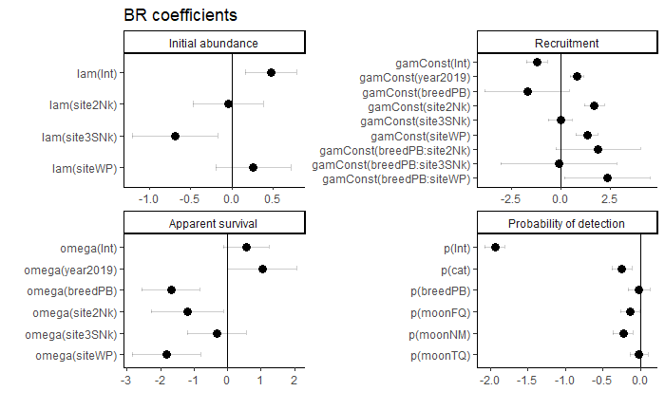
S6a. Parameter estimates for black rat on lunawanna/Alonnah Bunry Island for initial abundance, recruitment, apparent survival and detection probability parameters for the best N-mixture model selected. Site: 1NNk (North of the Neck, included in Intercept), 2Nk (The Neck), 3SNk (South of the Neck), WP (Whalebone Point), year (2017 and 2019), breed (shearwater breeding season, B: breeding, PB, post-breeding), cat (cat night detections), moon (moon phase, FM: full moon, FQ: first quarter, NM: new moon, TQ: third quarter). Where the error bar of a parameter estimate overlap zero the pvalue < 0.05.

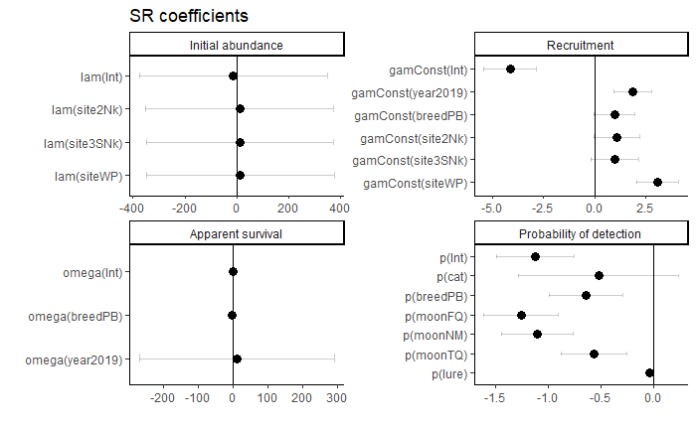

S6b. Parameter estimates for swamp rat on lunawanna/Alonnah Bunry Island for initial abundance, recruitment, apparent survival and detection probability parameters for the best N-mixture model selected. Site: 1NNk (North of the Neck, included in Intercept), 2Nk (The Neck), 3SNk (South of the Neck), WP (Whalebone Point), year (2017 and 2019), breed (shearwater breeding season, B: breeding, PB, post-breeding), lure (lure age), cat (cat night detections), moon (moon phase, FM: full moon, FQ: first quarter, NM: new moon, TQ: third quarter). Where the error bar of a parameter estimate overlap zero the pvalue < 0.05.

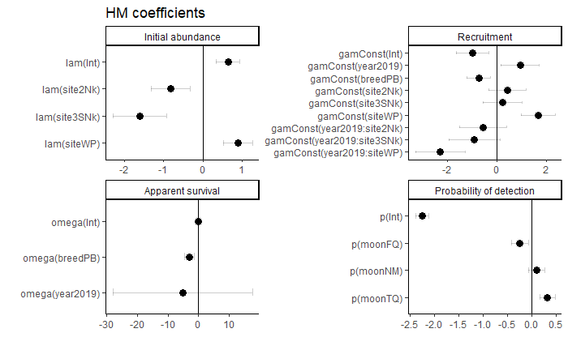
S6c. Parameter estimates for house mouse on lunawanna/Alonnah Bunry Island for initial abundance, recruitment, apparent survival and detection probability parameters for the best N-mixture model selected. Site: 1NNk (North of the Neck, included in Intercept), 2Nk (The Neck), 3SNk (South of the Neck), WP (Whalebone Point), year (2017 and 2019), breed (shearwater breeding season, B: breeding, PB, post-breeding), moon (moon phase, FM: full moon, FQ: first quarter, NM: new moon, TQ: third quarter). Where the error bar of a parameter estimate overlap zero the pvalue < 0.05.

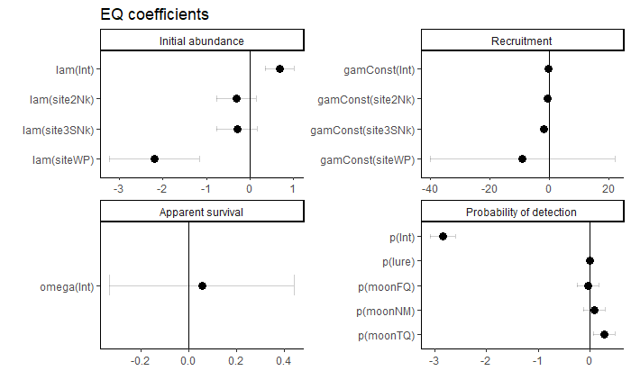

S6d. Parameter estimates for eastern quoll on lunawanna/Alonnah Bunry Island for initial abundance, recruitment, apparent survival and detection probability parameters for the best N-mixture model selected. Site: 1NNk (North of the Neck, included in Intercept), 2Nk (The Neck), 3SNk (South of the Neck), WP (Whalebone Point), lure (lure age), moon (moon phase, FM: full moon, FQ: first quarter, NM: new moon, TQ: third quarter). Where the error bar of a parameter estimate overlap zero the pvalue < 0.05.

