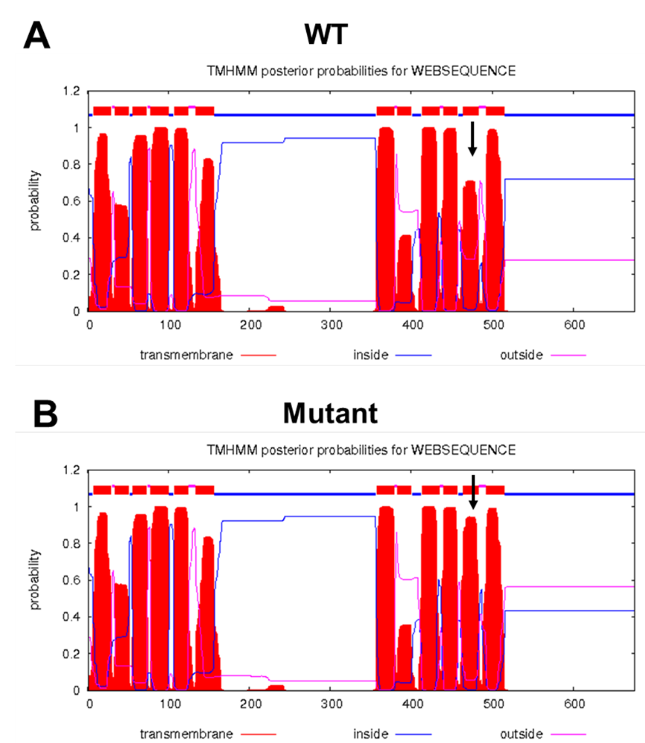

Fig. S2. The transmembrane domain prediction of the inner membrane component of RND efflux system without mutation (A) and with mutation (B) using TMHMM. The arrow points the T11 domain, where the mutation located.

