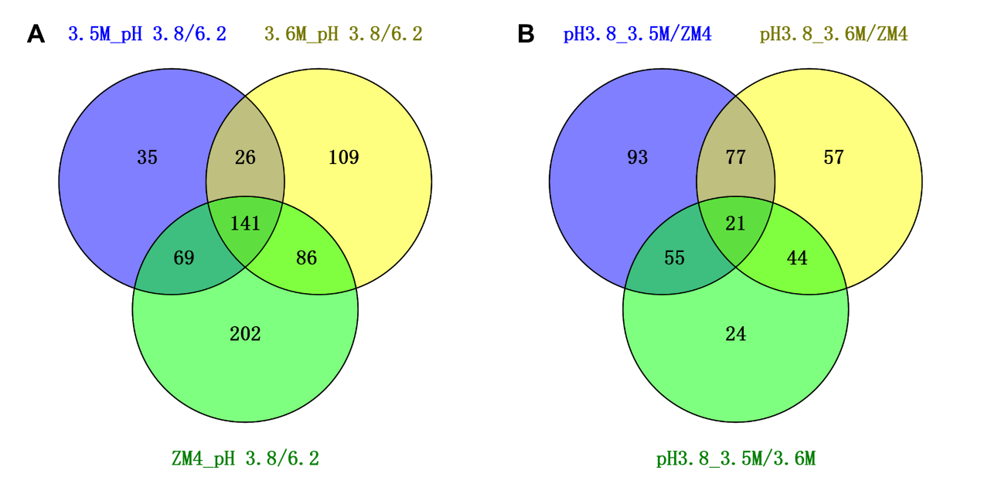
Fig. S1. The Veen diagrams of significantly differentially expressed genes of same strain under different pH conditions (A) and two different strains at acidic pH condition (B).

