Supporting Information for
Deep learning-based algorithms for long-term prediction of chlorophyll-a in catchment streams
Ather Abbasª, Minji Park^{b}, Sang-Soo Baek^{c*}, and Kyung Hwa Cho^{a*}

ª School of Urban and Environmental Engineering, Ulsan National Institute of Science and Technology, 50, UNIST-gil, Eonyang-eup, Ulju-gun, Ulsan, 44919 South Korea
^{b} Water Pollution Load Management Research Division, National Institute of Environmental Research, 42 Hwangyong-ro, Seogu, Incheon, 22689, South Korea
^{c} Department of Environmental Engineering, Yeungnam University, 280 Daehak-Ro, Gyeongsan-Si, Gyeongbuk 38541, South Korea

* Co-corresponding authors: Kyung Hwa Cho (khcho@unist.ac.kr), Sang-Soo Baek (ssbaek@yu.ac.kr)

Text S1. Architectures of Neural Networks

S1.1 Long Short-Term Memory (LSTM) networks
An LSTM is a recurrent NN which consists of cells as its building block (Hochreiter and Schmidhuber, 1997). One cell in LSTM consists of gates and memory states. The three gates, namely input, output and forget gate are used to control the flow of information in and out of the cell. The two memory states, which are called hidden state and cell state are used to store the information within a cell. The cells are processed in a loop, when the information from a time-step is given to and taken from cell. The total number of time-steps used to predict next value is called lookback time-steps. The equations describing the behavior of gates and states are given below.
$C_{c}^{<t>}=tanh\left(W_{c}[ h^{<t-1>},x^{<t>}]+ b_{c}\right),$ (1)
$Γ_{f}=σ(W_{f}[c^{<t-1>},x^{<t>}]+b_{f)},$ (2)
$Γ_{o}=σ(W_{o}[c^{<t-1>},x^{<t>}]+b_{o),}$ (3)
$Γ_{i}=σ(W_{i}[c^{<t-1>},x^{<t>}]+b_{i)},$ (4)
$c^{<t>}=Γ_{i}*C_{c}^{<t>} + Γ_{f}* c^{<t-1>},$ (5)
$h^{<t>}=Γ_{o} * tanh c^{<t>}$ (6)
where W and b are the weights and biases, respectively, which are learnable parameters; and tanh and σ are the hyperbolic tangent and sigmoid, respectively. At each step, an LSTM model receives inputs as $x^{<t>}$ and produces outputs as $c^{<t>}$ and $h^{<t>}$. The hidden state $h^{<t>}$ is then used in a fully connected network to obtain the final model predictions. This architecture was used because it is one of the most commonly deep learning architectures to process time series data (Lim and Zohren, 2021; Sezer et al., 2020).

S1.2 1-D Convolution neural network
Convolution neural networks consists of convolution and pooling layers (LeCun et al., 2015). They extract features from input data by convolving the weight matrix with the input data. The convolution operation is usually followed by a pooling layer which reduces the dimension of the output. This is usually done by either taking maximum or average of a fix number values which is called pooling size (Sze et al., 2017). A CNN has the ability to extract local or spatial features from the input data due to its convolution operation. CNNs are mostly used to for 2-dimensional and 3-dimensional data, however their 1-dimensional variants can be used for 1-dimensional data. Since the hydrological time-series data is 1-dimensional, a 1-D CNN can be used for time-series forecasting. 1-D CNN has been used in hydrological studies such as in Van et al. (2020) and Chong et al. (2020).

S1.3 CNN-LSTM
A CNN-LSTM architecture has the ability to combine the power of CNN and LSTM to extract features from a sequence. In such NN, the input data is divided into sub-sequences. First a CNN is used on these small sub-subsequences of input data to extract local features. Then the output from CNN is given to LSTM which further extracts temporal features. In this architecture, we used a 1D CNN to extracts features from sub-sequences of input data. This architecture has been found useful in time-series prediction problem due to its ability to breakdown time-dependent input into sub-sequences and extract features from them (Sainath et al., 2015). It has been used in several environmental studies such as lake water level forecasting (Barzegar et al., 2021) and urban water demand prediction (Hu et al., 2019a).

S1.4 Temporal Convolutional Networks
Temporal convolution networks (TCN) are variants of 1D CNNs with specific padding, dilation rate and stacking. TCNs have the ability to extract temporal features from a sequence using convolution operations (Lea et al., 2016). In CNNs, the weight matrix is moved and convolved on the input data to extract features. This movement step of the weight matrix can be more than one which can help the CNN to extract non-local features. This step of movement of CNN matrix on input data is called dilation rate. We can apply CNN with different dilation rates on a single input in order to extract features at different hierarchies. This hierarchical CNN structure was exploited by WaveNet (Oord et al., 2016) and led to the development of temporal convolution networks (Bai et al., 2018; Lea et al., 2016). In TCNs, layers of CNNs are stacked with different dilation rates in order to extract temporal features.

S1.5 LSTM Autoencoder Network
This kinds of NN consists of two stacked layers of LSTMs. One stack of LSTM acts as encoder which compresses the input information. The second stack of LSTMs acts as decoder and reconstructs the input from compressed data. The decoder, however, can also be used to make predictions. This architecture is also sometimes called ‘sequence to sequence’ because the output from decoder is also a sequence. We, however, used only the last value of decoder and considered it as prediction. This structure has been used for rainfall-runoff modeling (Liu et al., 2020; Xiang et al., 2020).

S1.6 Input Attention LSTM (IA-LSTM)
Qin et al. (2017) developed a dual stage attention-based structure for multi-variate time-series prediction problem. This architecture consists of an input attention mechanism and the temporal attention mechanism. The input attention mechanism is used to find relevant input data which is then fed to LSTM. The temporal attention mechanism helps the NN to select the relevant lookback time-steps. We used only the input attention part of this architecture along with LSTM. This architecture has already shown promising results in water quality prediction problems (Jang et al., 2021). IA-LSTM model calculates the importance of input variable on the model according to below equations
$e_{t}^{k}=v_{e}^{T}tanh\left(W_{e}\right)\left[h_{t-1};s_{t-1}+U_{e}x^{k}\right]$ (7)
$α_{t}^{k}=\frac{exp\left(e_{t}^{k}\right)}{\sum_{i=1}^{n}{exp\left(e_{t}^{i}\right)}}$ (8)
${\tilde{x}}^{<t>}=(a_{t}^{1}x_{t}^{1}, a_{t}^{2}x_{t}^{2}, … a_{t}^{n} x_{t}^{n})$ (9)
Given $n$ number of input features, the attention weight for the $k$-th input $a_{t}^{k}$ is calculated using the hidden and cell states of LSTM according to Eq. 7. The parameters $U_{e}$, $v_{e}^{T}$, and $W_{e}$ are calibrated during the training process. Eq. 8 is a softmax function that returns an array of attention weights that sum to one (Chollet, 2018). The attention weights for each input are then used to extract the driving inputs ${\tilde{x}}^{<t>}$ according to Eq. 9. The more relevant driving inputs are amplified by their higher weights while the less important ones are reduced to smaller corresponding weights. These inputs are then used as inputs into LSTM to extract the temporal features. Thus, instead of using the original inputs $x^{<t>}$ (Eqs. 1–4), the IA mechanism uses ${\tilde{x}}^{<t>}$ within LSTM.

Text S2 Loss calculation
The neural networks were trained using mean square error (MSE) as loss function. We compared the predictions of all models with the observed Chl-a concentration and calculated the mean square error (MSE) using the following equation:
$MSE= \frac{\sum_{i=1}^{n}{{\left(o_{i}-p_{i}\right)}^{2}}}{n}$ (10)
where $o_{i}$ and $p_{i}$ are the observed and predicted Chl-a concentrations, respectively, and $n$ indicates the number of datasets.

Text S3 Hyperparameter optimization
The performance of NN is strongly influenced by the choice of hyperparameters used to build it (Hutter et al., 2015). These parameters are specific to the architecture of NN. The hyperparameters of all the models, built in this study were optimized using Bayesian based optimization approach. Bayesian optimization is an efficient algorithm which intelligently selects new set of hyperparameters at each step, by considering the previous results (Snoek et al., 2012). This methodology has often been used to optimize hyperparameters of NNs (Adams, 2014; Shahriari et al., 2015). The optimization of hyperparameters require definition of parameter space from which the hyperparameters are sampled during optimization. The parameter space determines the possible values of hyperparameters. The parameter space of hyperparameters for each of the 6 models built in this study, and their optimized values are enlisted in Table 1. The optimization for all models was performed for 100 iterations.
We also quantified the importance of hyperparameters using the functional analysis of variance (fANOVA) (Hutter et al., 2014) and by plotting partial dependence (PD) plots (Friedman, 1991). PD plots are graphical tools to visually explain importance of each hyperparameter (Apley and Zhu, 2020). On the other hand, fANOVA quantifies the variance in the objective function explained by each hyperparameter in the form of a numerical value (Molnar, 2020). The fANOVA algorithm enabled us to analyze the variation in the model output with respect to the changed input (Klein and Hutter, 2019). The PD plot shows the marginal effect of a feature on the predicted outcome of the model (Friedman, 2001). It also shows whether the relation between the output and an input feature is linear, monotonic or more complex (Moosbauer et al., 2021).

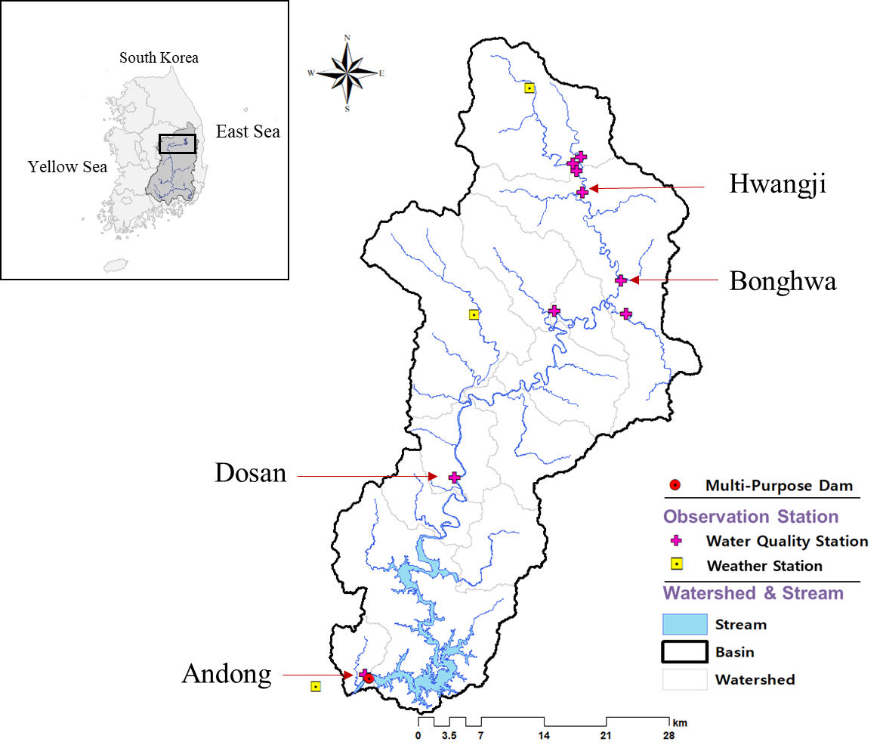
Fig. S1. Map of study sites showing monitoring stations in the upper Nakdong river. Nakdong river is located in south east of Korean peninsula. The drainage basin of Nakdong river is heighted.

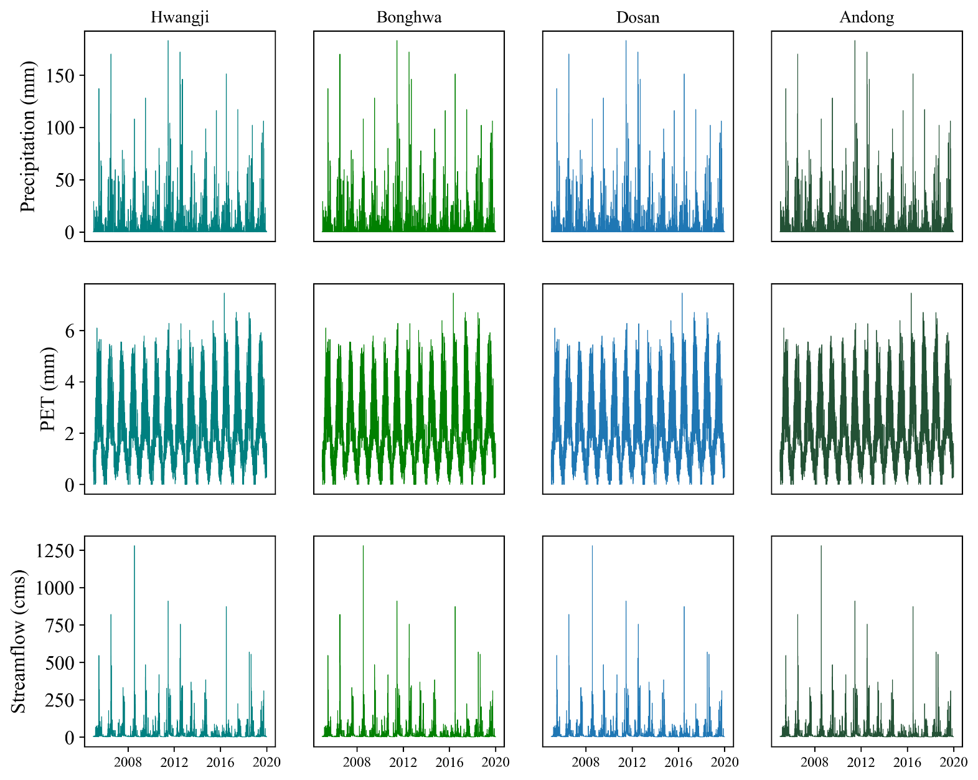
Fig. S2. Time series plots of precipitation, potential evapotranspiration and streamflow (cubic centimeters per second) at study site.

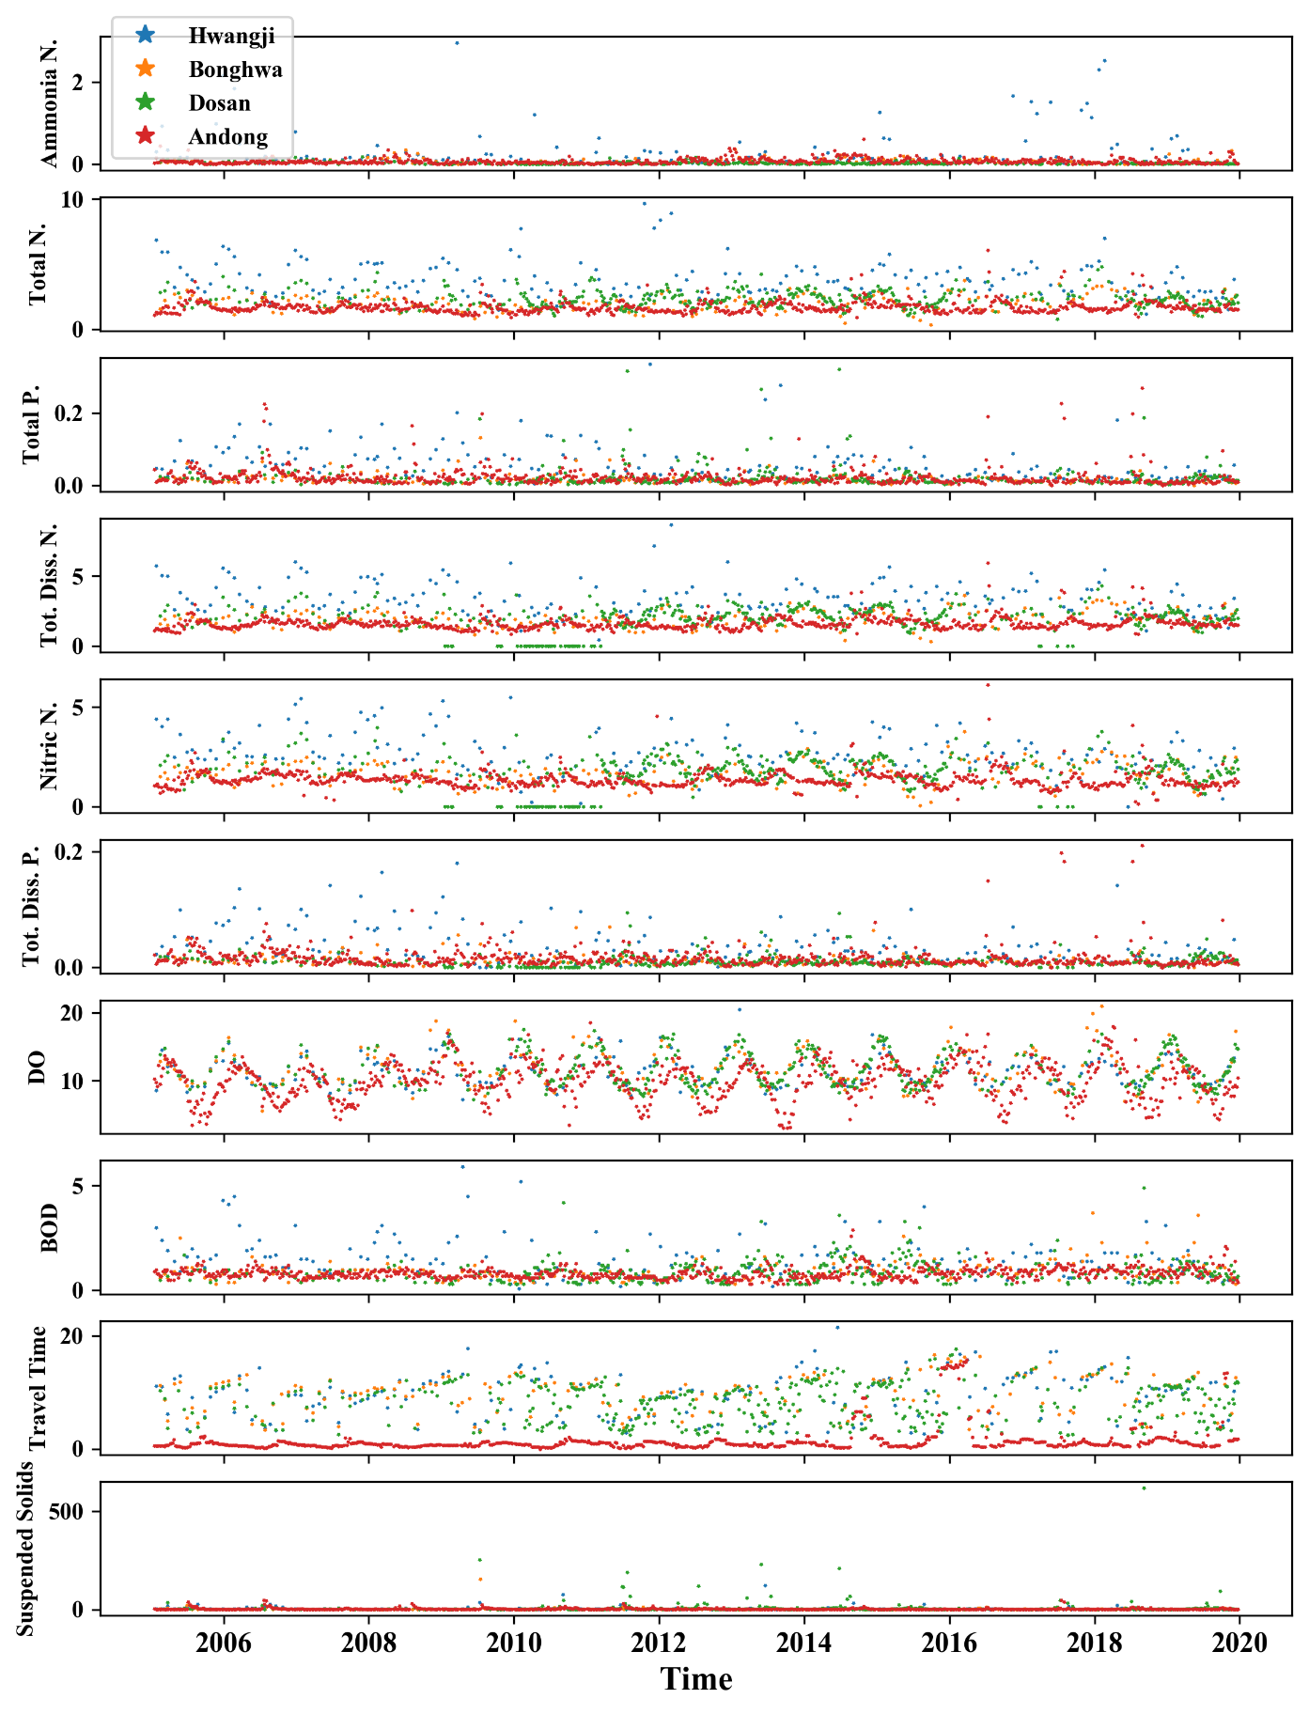
Fig. S3. Water quality parameters observed at Hwangji, Bonghwa, Dosan and Andong site of study area. These parameters were observed at irregular intervals from 2005 to 2019.
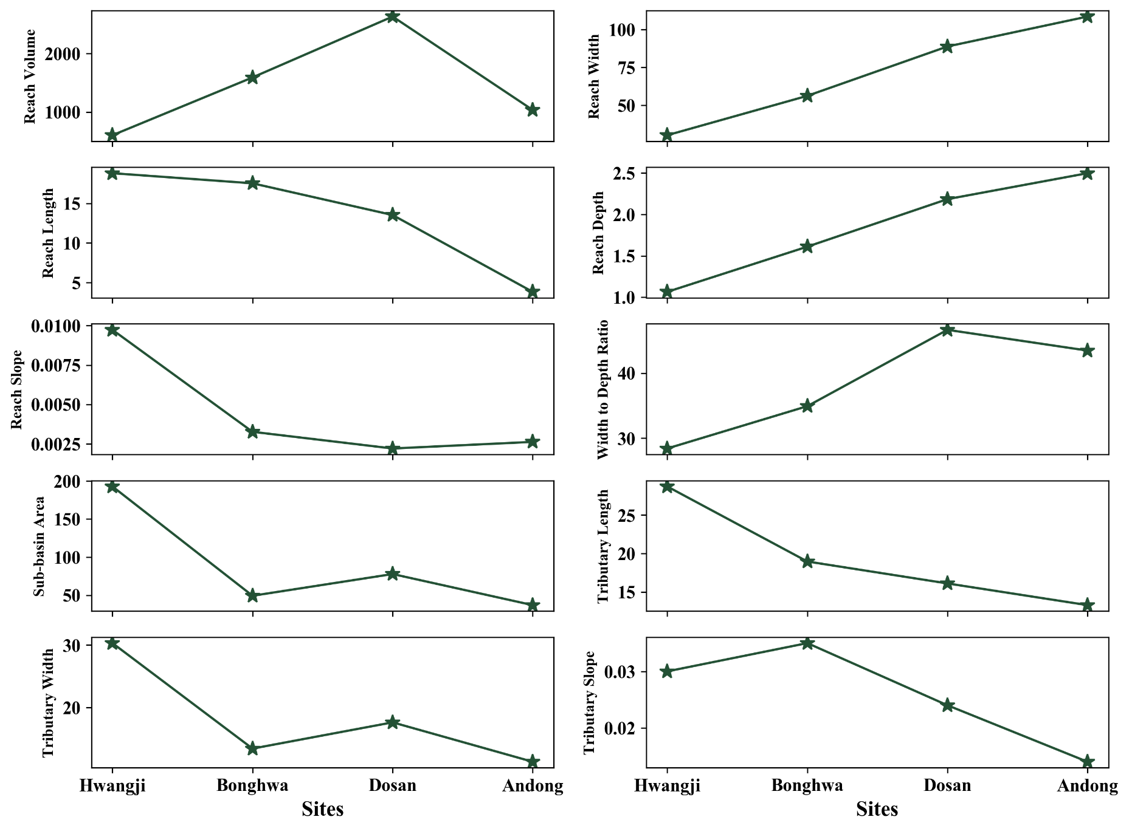

Fig. S4. Static, physical parameters of four sites. These time-invariant parameters were used to initiate the hidden state and cell state of LSTM model to condition the simulations of LSTM. Hwangji, Bonghwa and Dosan were used for training while Andong was used for model validation.

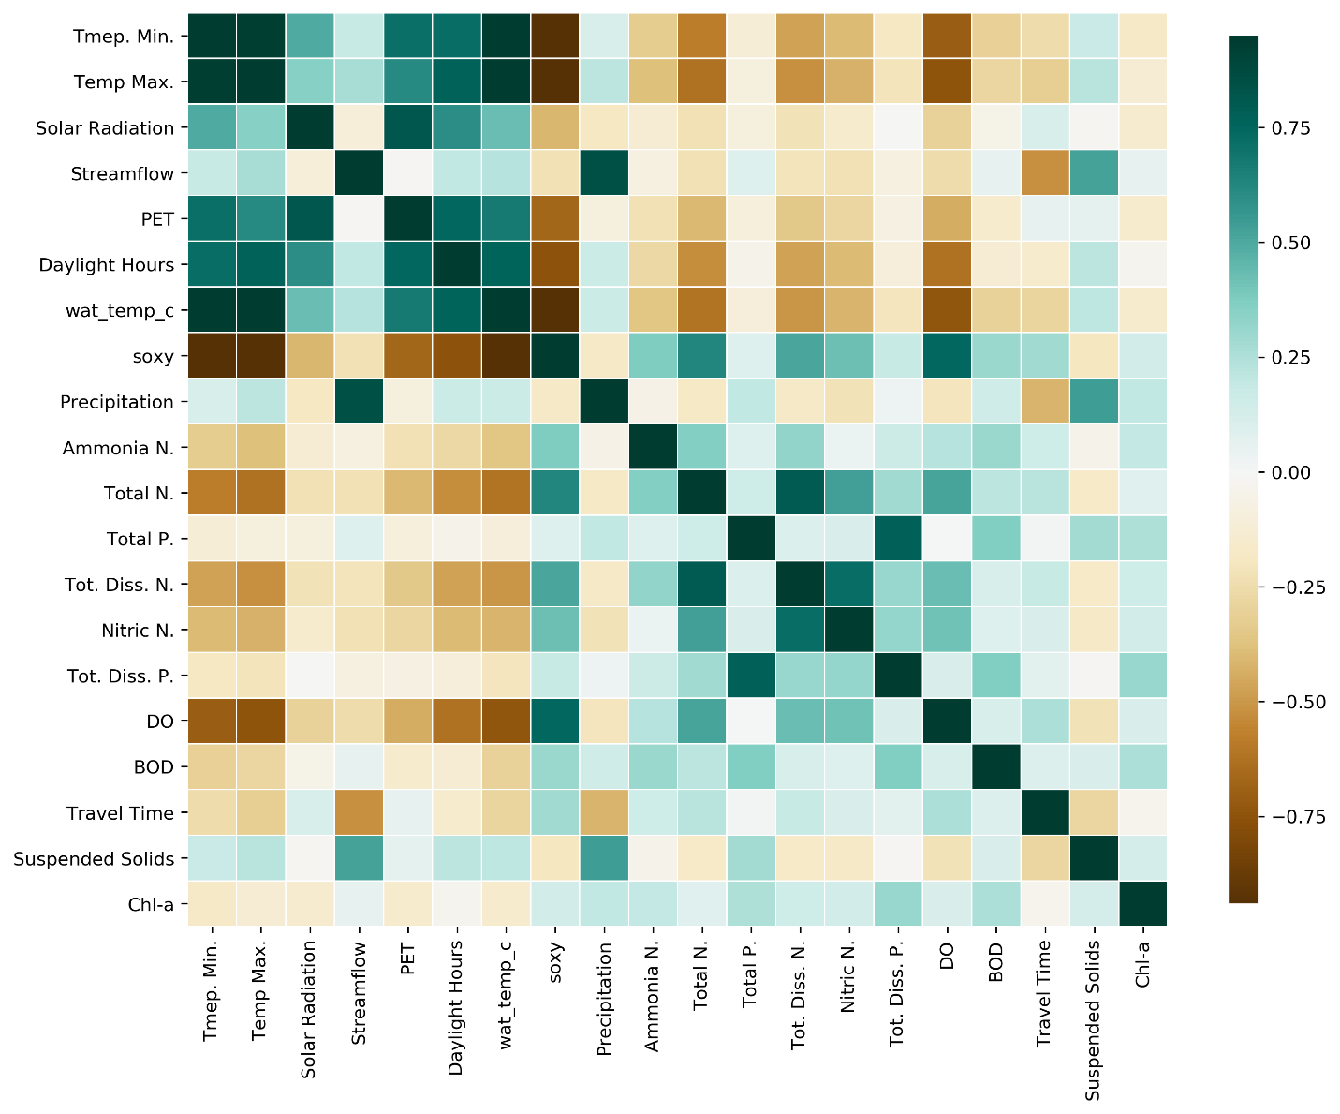
Fig. S5. Correlation coefficient of observed parameters at study site “Hwangji”.

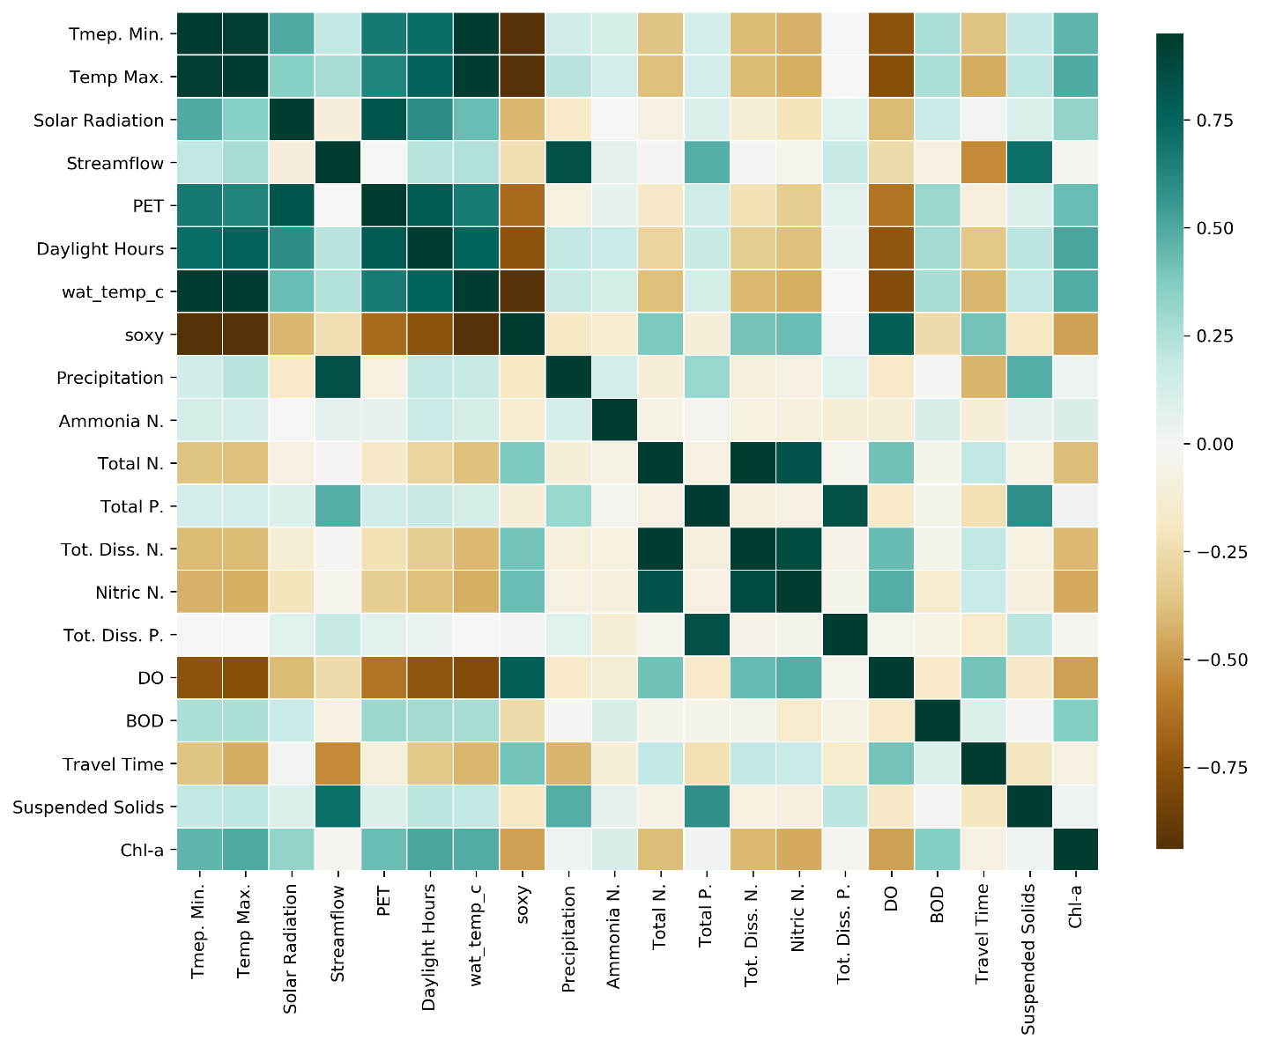
Fig. S6. Correlation coefficient of observed parameters at study site “Bonghwa”.

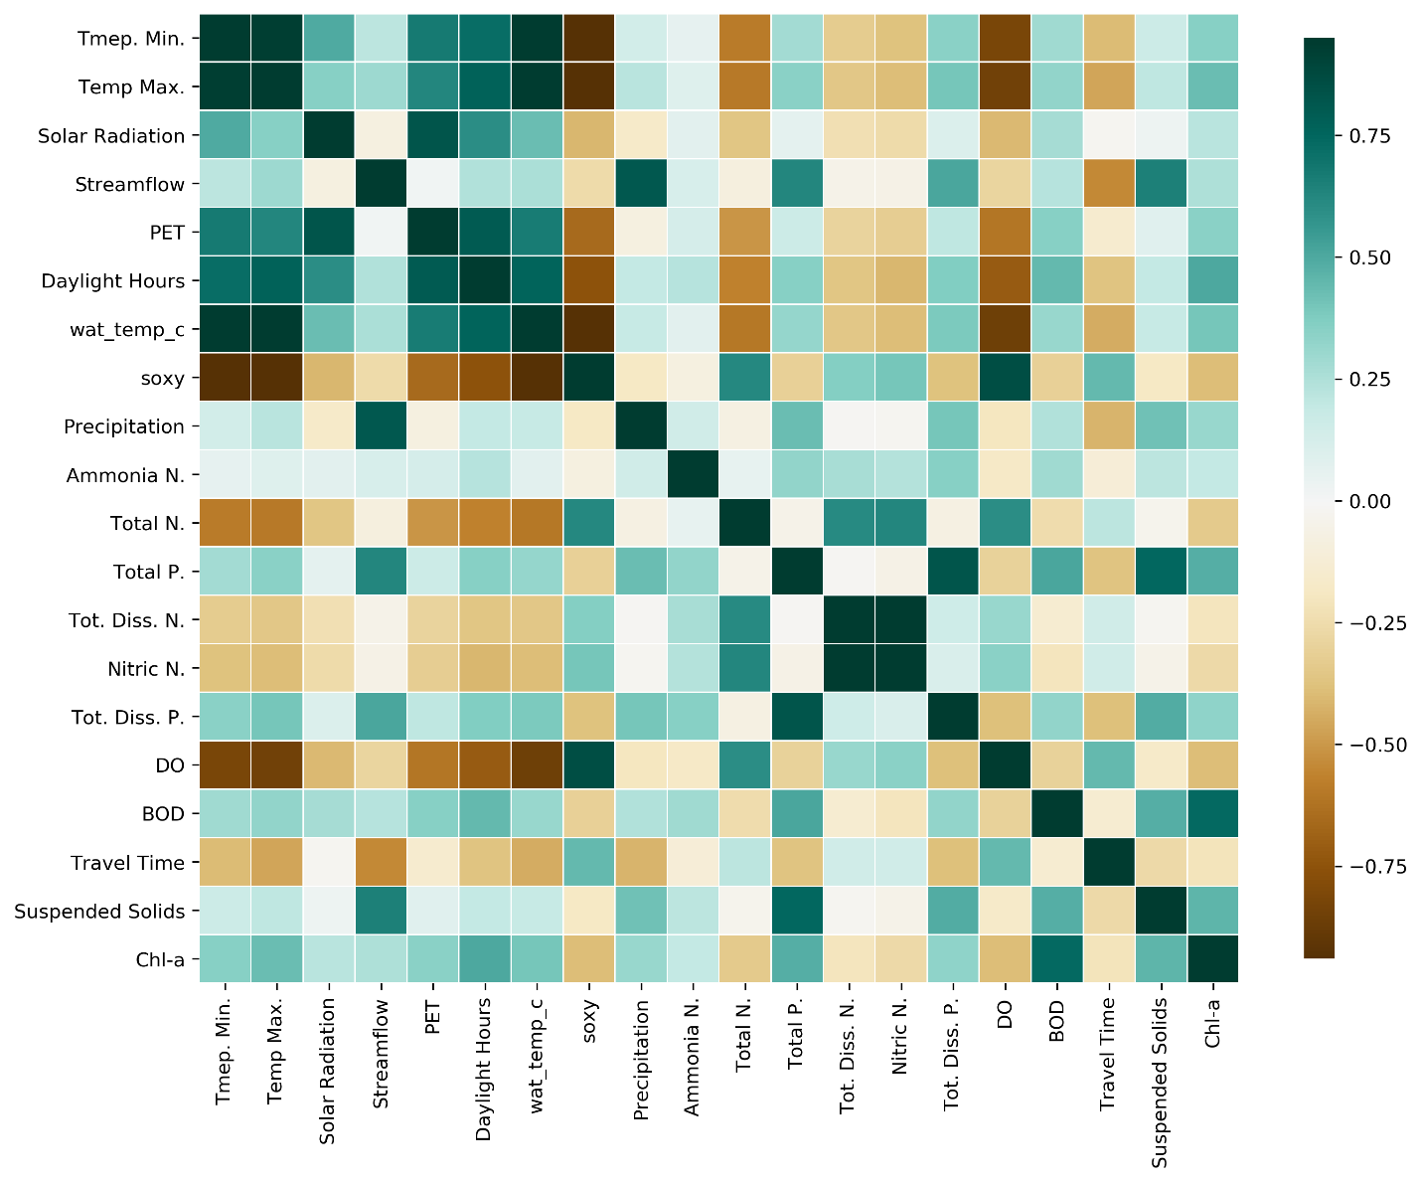
Fig. S7. Correlation coefficient of observed parameters at study site “Dosan”.

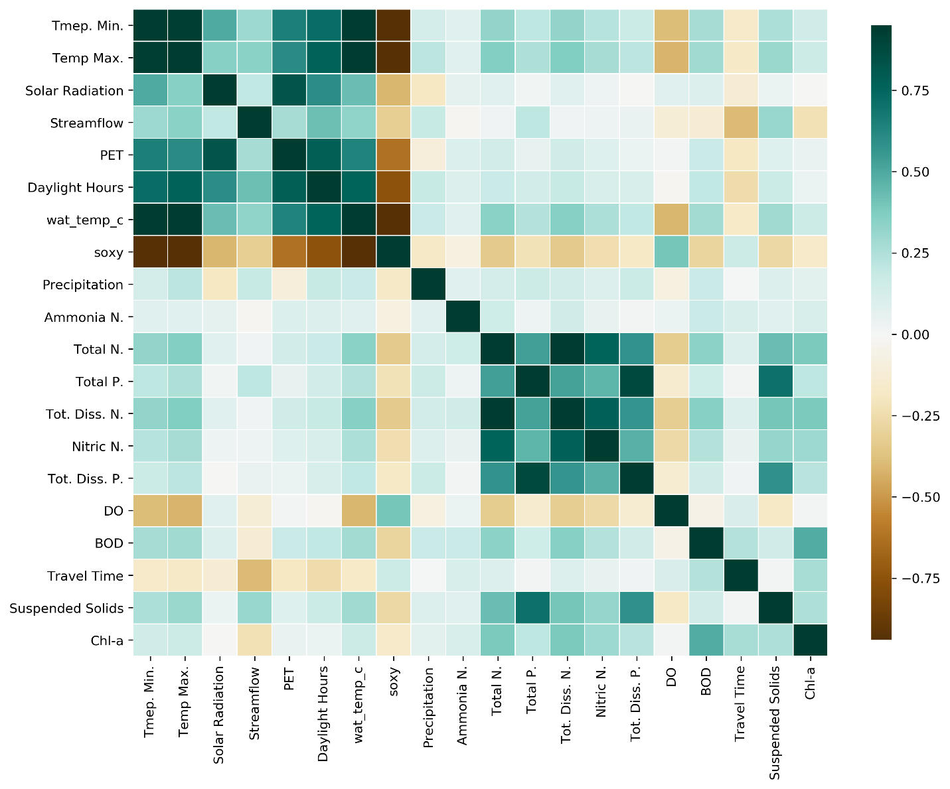
Fig. S8. Correlation coefficient of observed parameters at study site “Andong”.

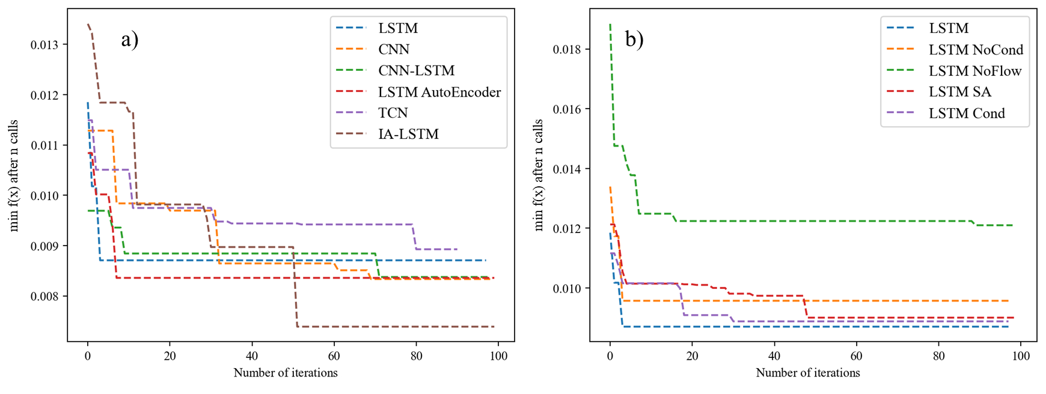

Fig. S9. Convergence plots of hyperparameter optimization. A) shows the convergence plots for the 6 basic models while b) shows convergence plots of LSTM models with different scenarios.
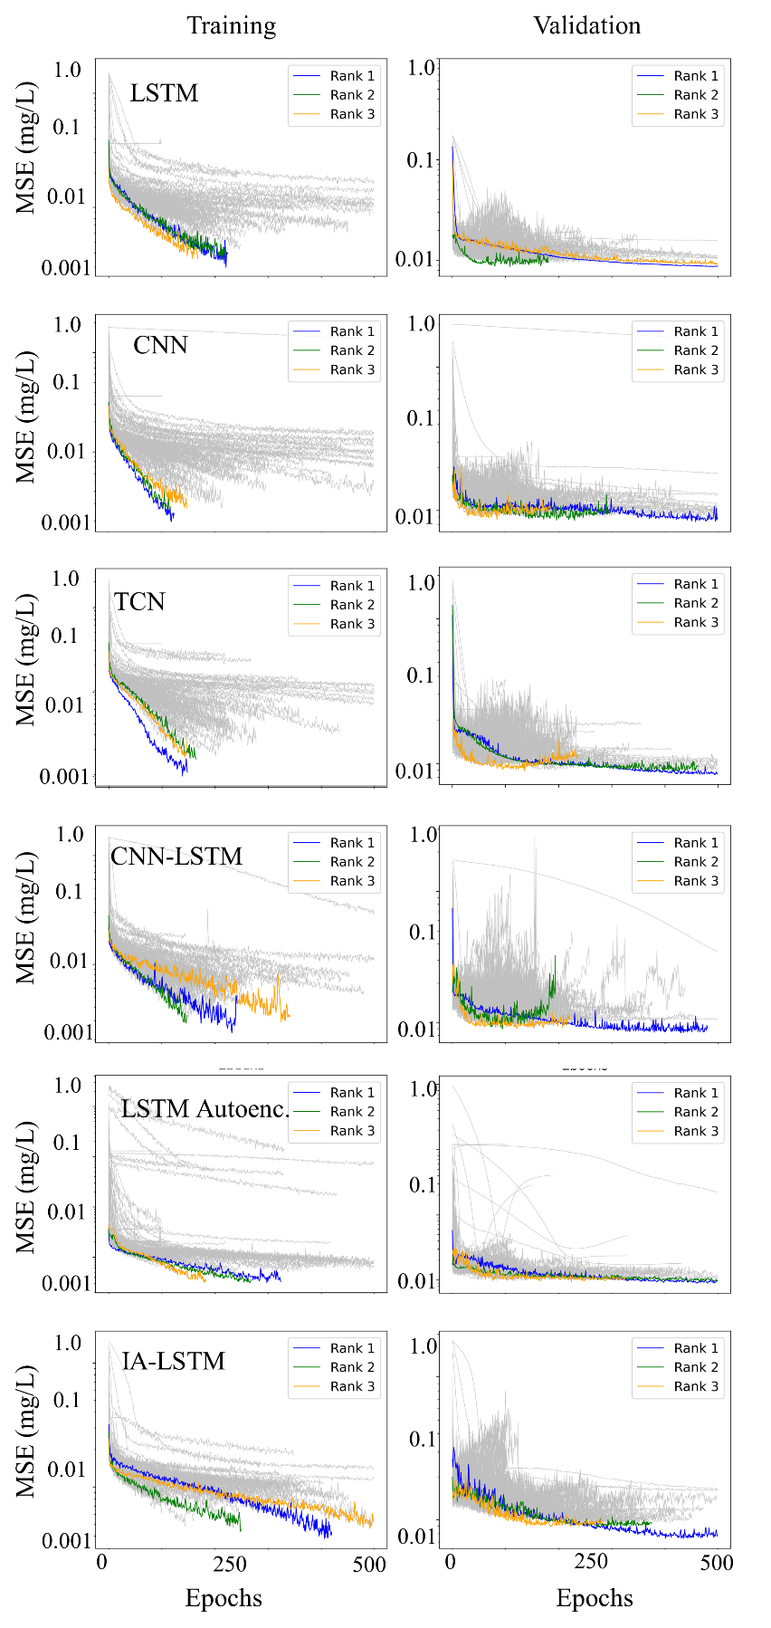
Fig. S10. Training patterns of 6 models during hyperparameter optimization during training and validation.
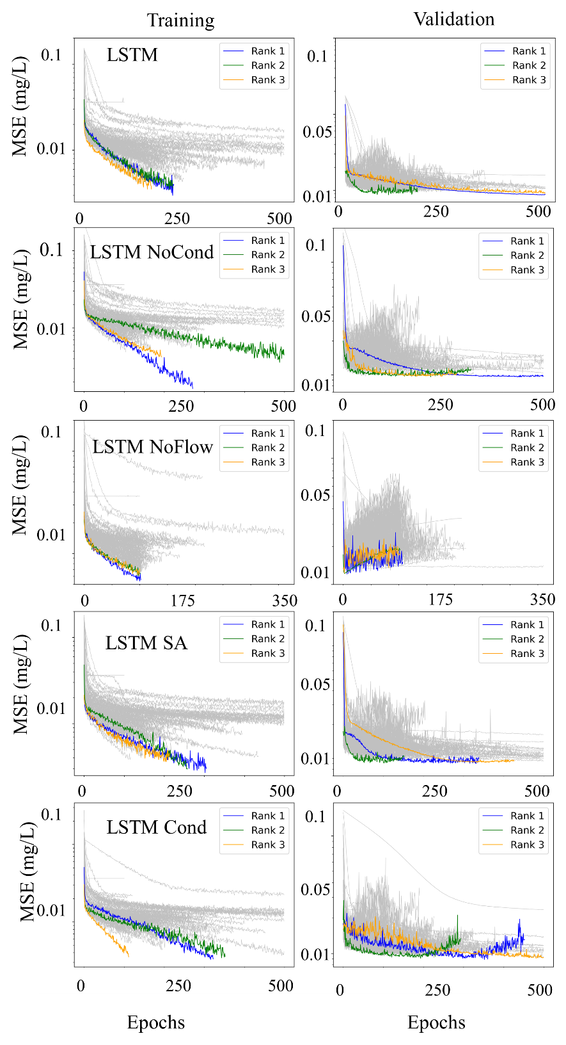

Fig. S11. Training patters of LSTM model with different scenarios. “LSTM NoCond” represents simulations without physical features, “LSTM Cond” shows simulations with physical features. “LSTM SA represents simulation with self-attention while “LSTM NoFlow” stands for simulation without streamflow.

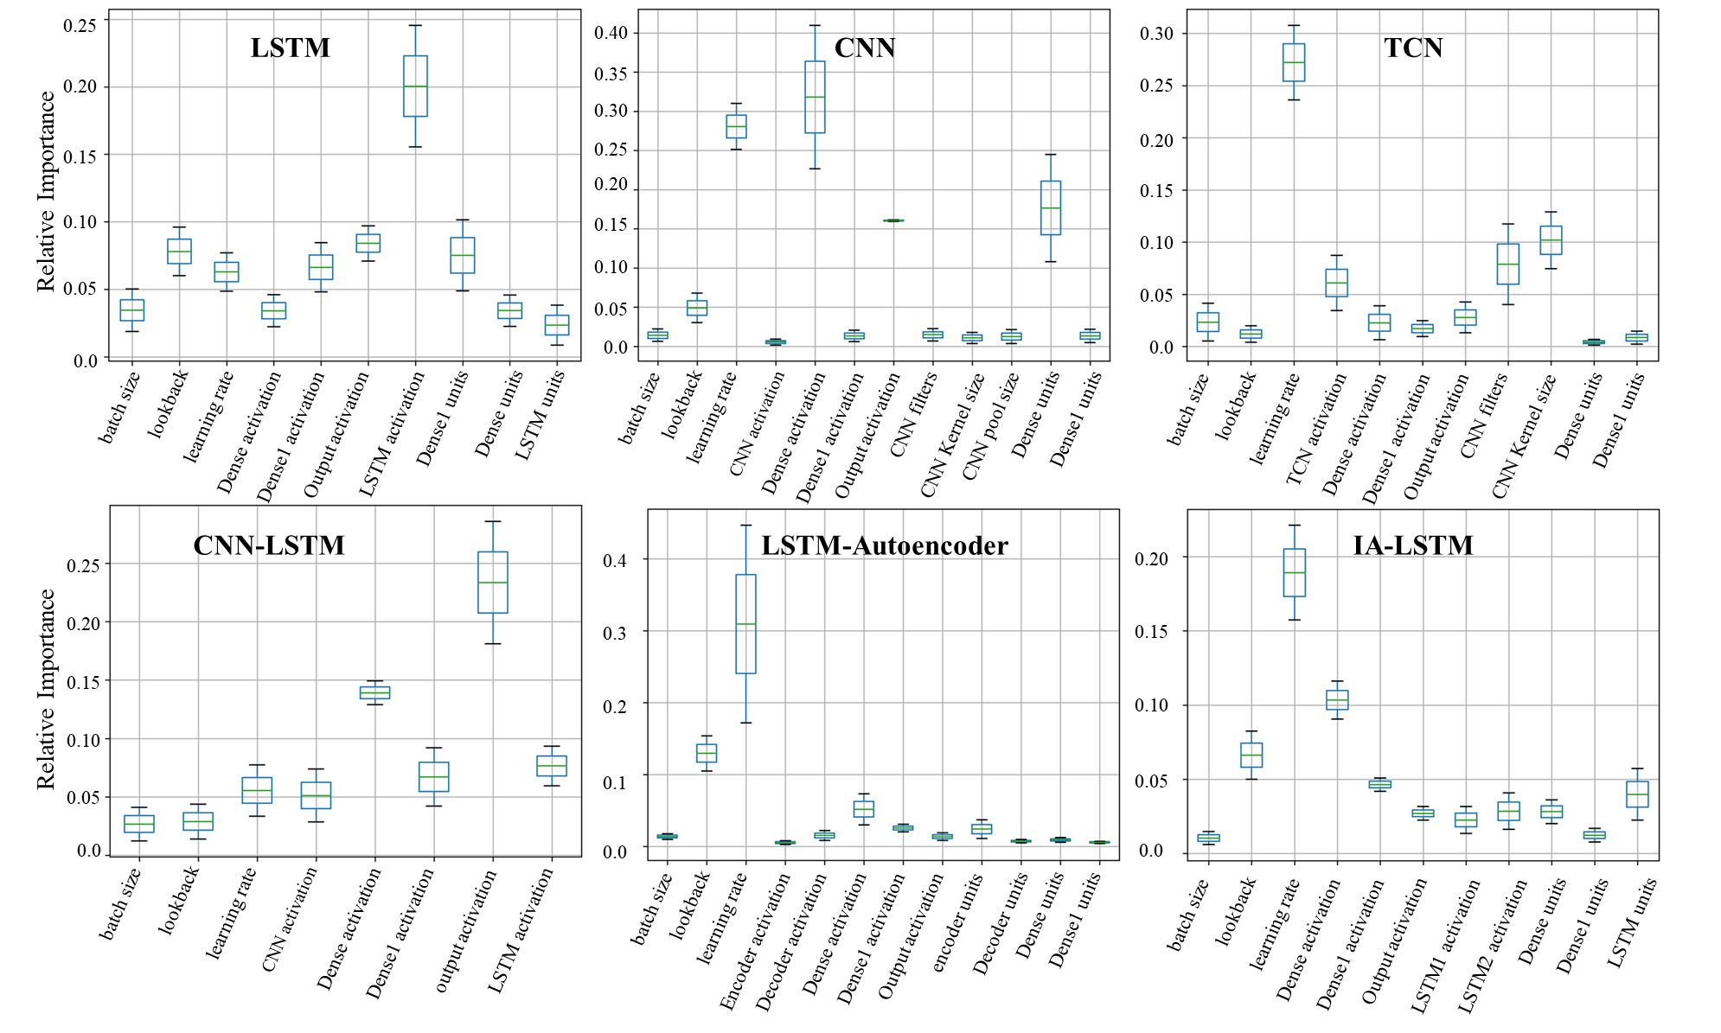

Fig. S12. Relative importance of hyperparameters quantified by fANOVA (Hutter et al 2014) method for 6 models.

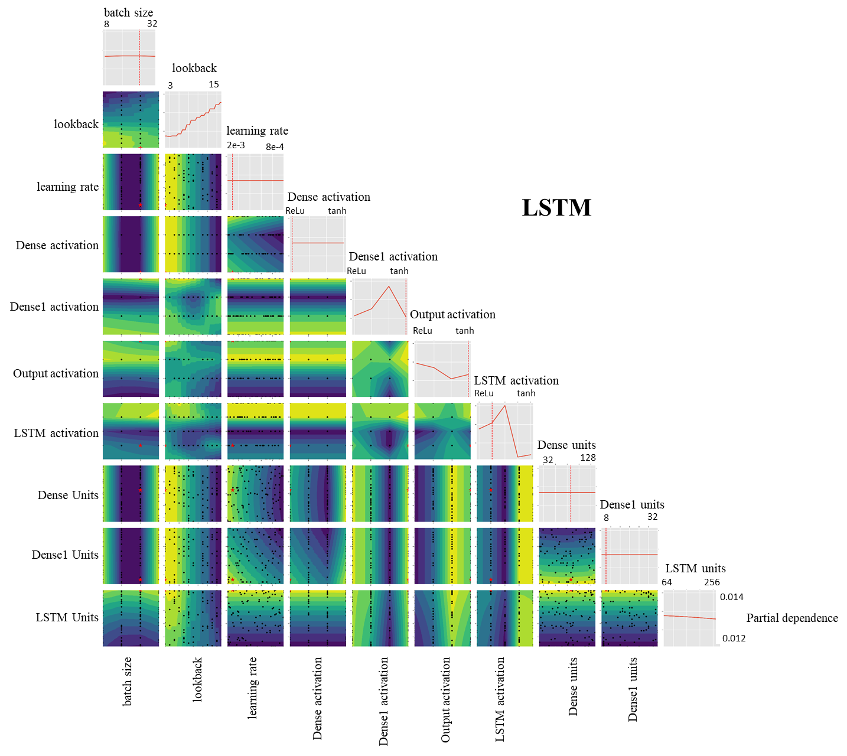
Fig. S13. Partial dependence plots of hyperparameters for LSTM model. The diagonal plots represent partial dependence plot with respect to a single hyperparameter. The measure of the slope shows sensitivity of hyperparameter.
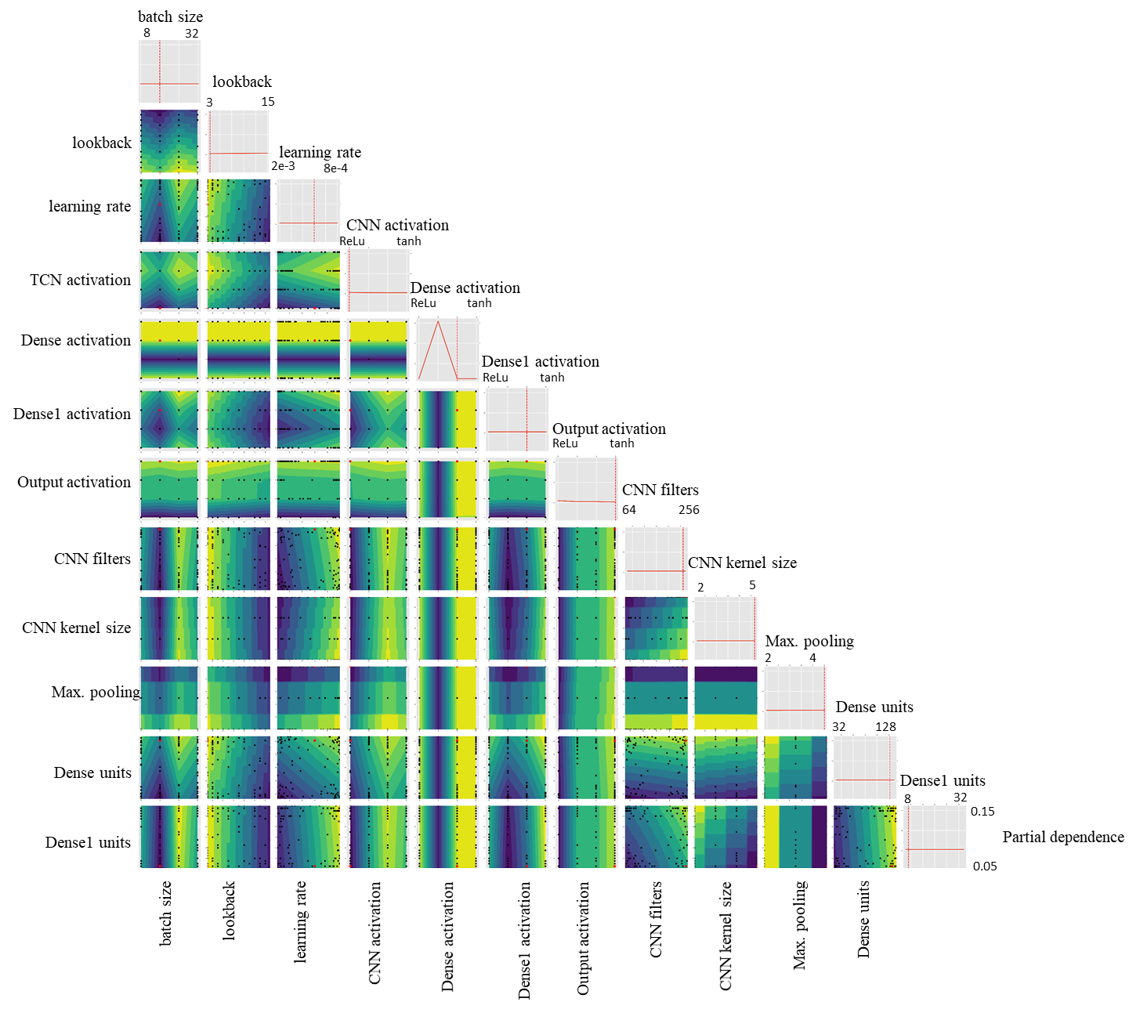
Fig. S14. Partial dependence plots of hyperparameters for CNN model. The diagonal plots represent partial dependence plot with respect to a single hyperparameter. The measure of the slope shows sensitivity of hyperparameter.
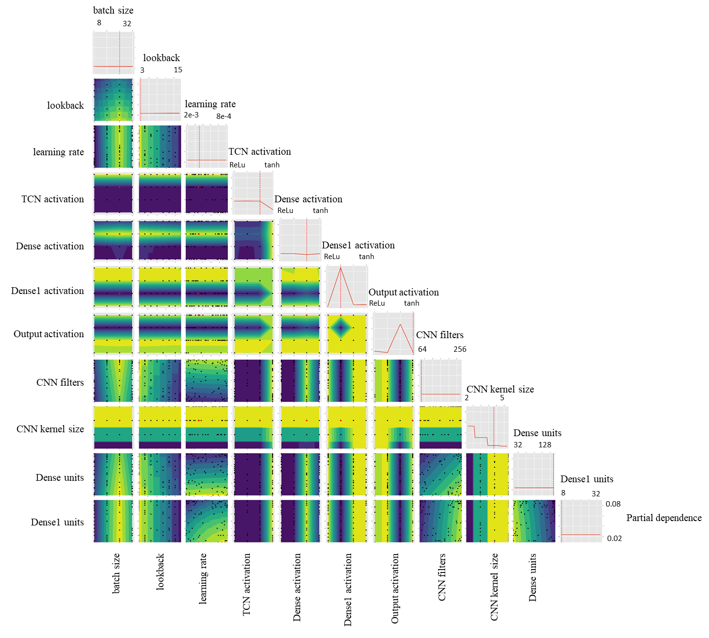
Fig. S15. Partial dependence plots of hyperparameters for TCN model. The diagonal plots represent partial dependence plot with respect to a single hyperparameter. The measure of the slope shows sensitivity of hyperparameter.

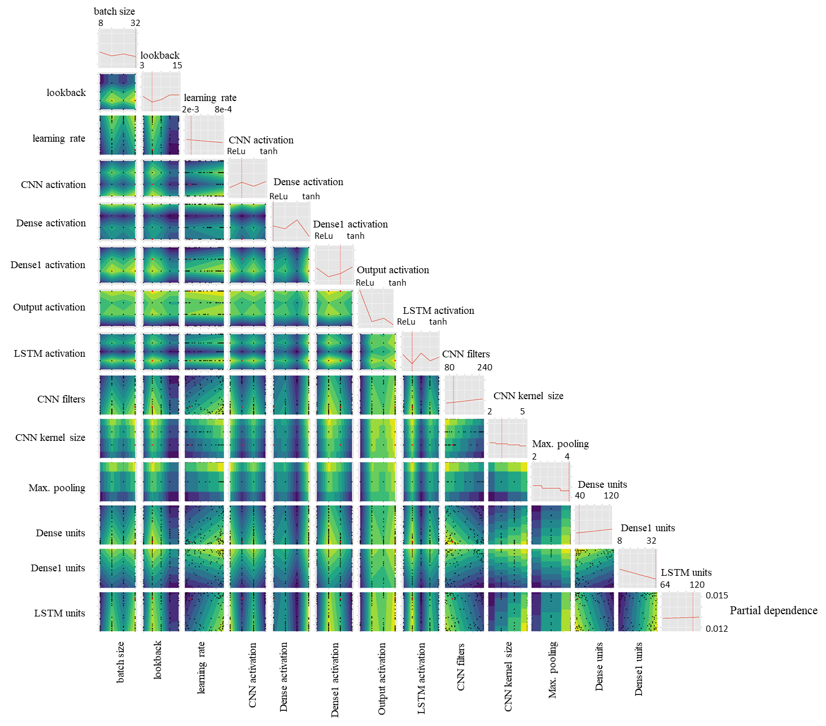

Fig. S16. Partial dependence plots of hyperparameters for CNN-LSTM model. The diagonal plots represent partial dependence plot with respect to a single hyperparameter. The measure of the slope shows sensitivity of hyperparameter

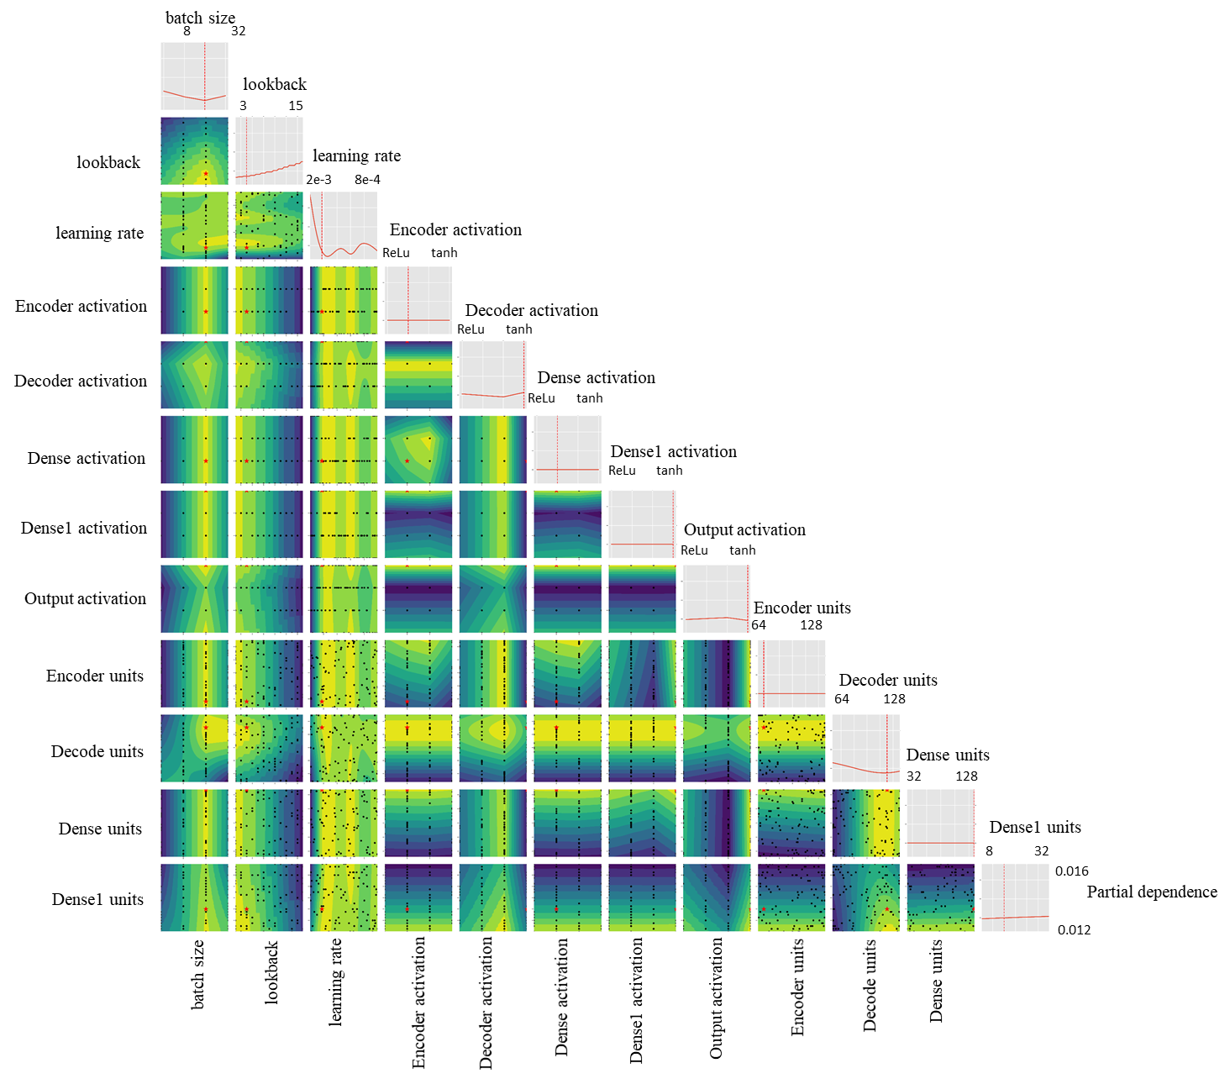
Fig. S17. Partial dependence plots of hyperparameters for LSTM Autoencoder model. The diagonal plots represent partial dependence plot with respect to a single hyperparameter. The measure of the slope shows sensitivity of hyperparameter
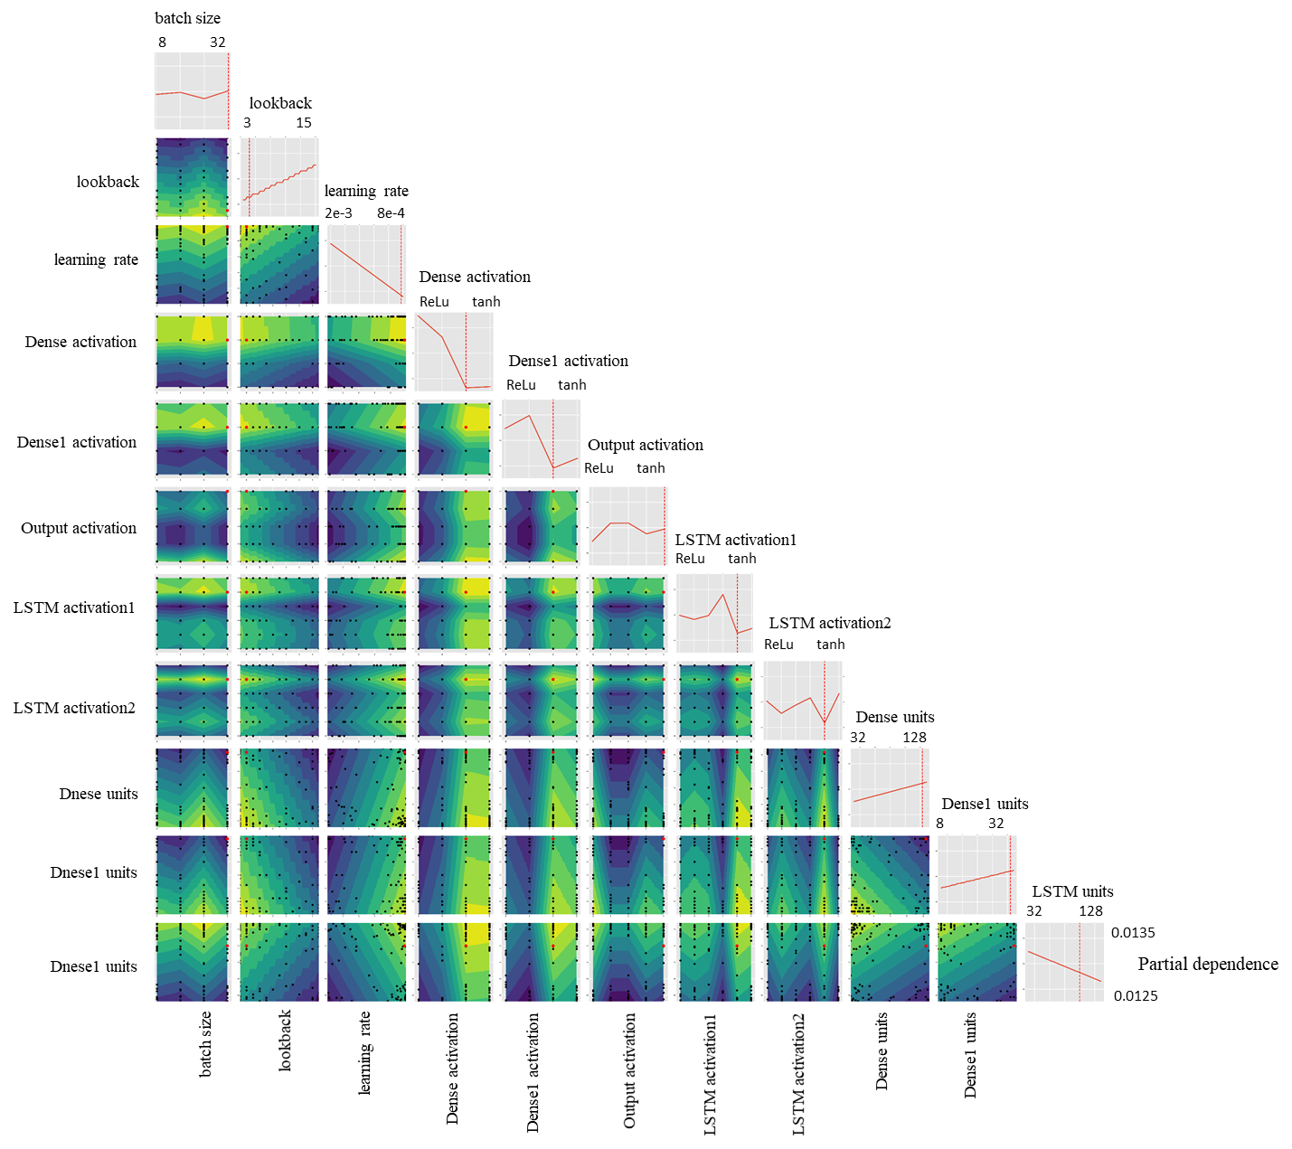

Fig. S18. Partial dependence plots of hyperparameters for IA-LSTM Autoencoder model. The diagonal plots represent partial dependence plot with respect to a single hyperparameter. The measure of the slope shows sensitivity of hyperparameter

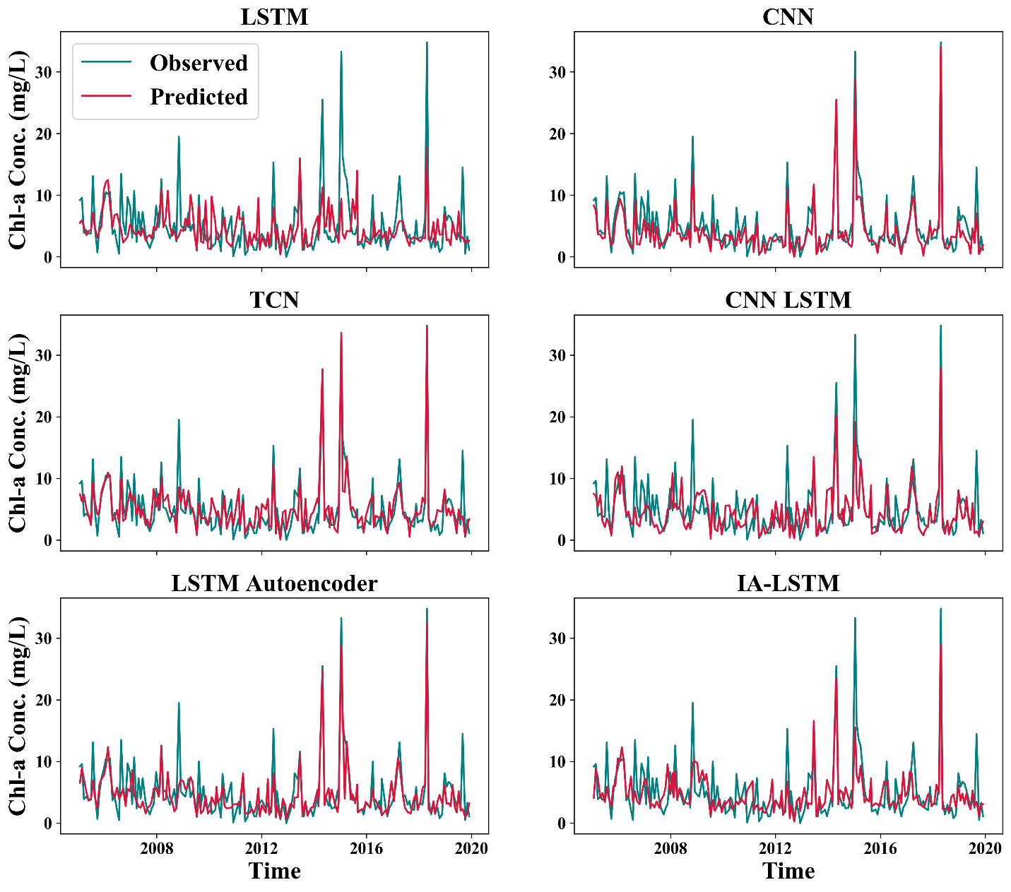
Fig. S19. Observed and simulated Chl-a concentration at Hwangji site using LSTM, CNN, TCN, CNN-LSTM, LSTM-Autoencoder and IA-LSTM model. This site was used for training purpose.
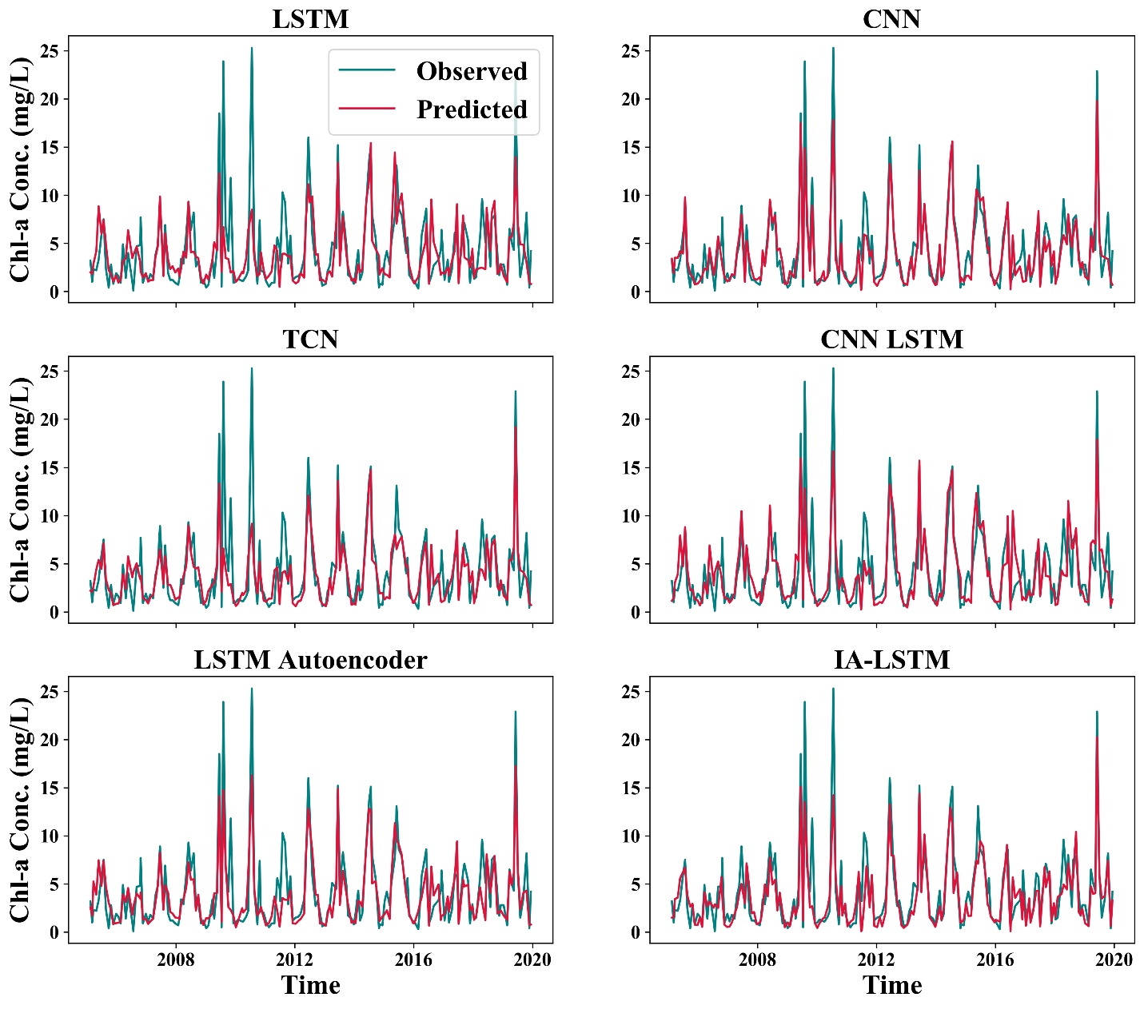
Fig. S20. Observed and simulated Chl-a concentration at Bonghwa site using LSTM, CNN, TCN, CNN-LSTM, LSTM-Autoencoder and IA-LSTM model. This site was used for training purpose.
.

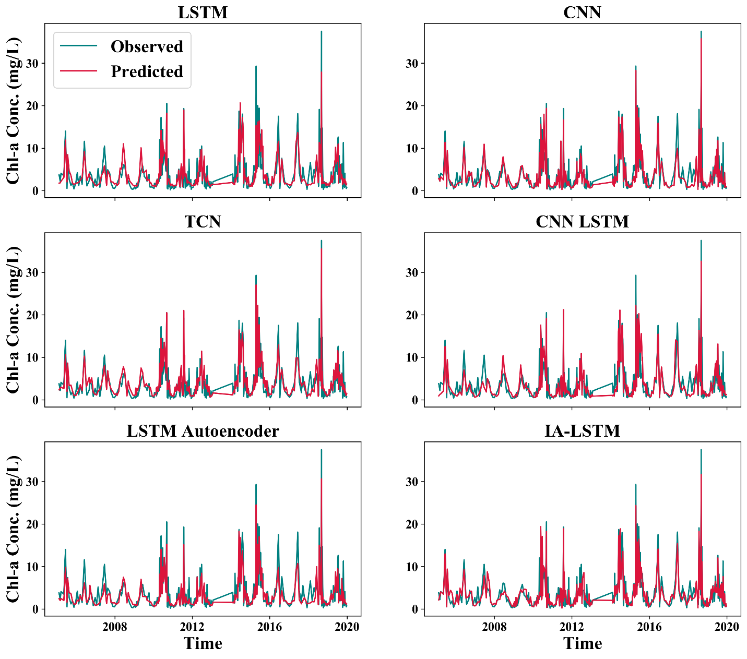

Fig. S21. Observed and simulated Chl-a concentration at Dosan site using LSTM, CNN, TCN, CNN-LSTM, LSTM-Autoencoder and IA-LSTM model. This site was used for training purpose.

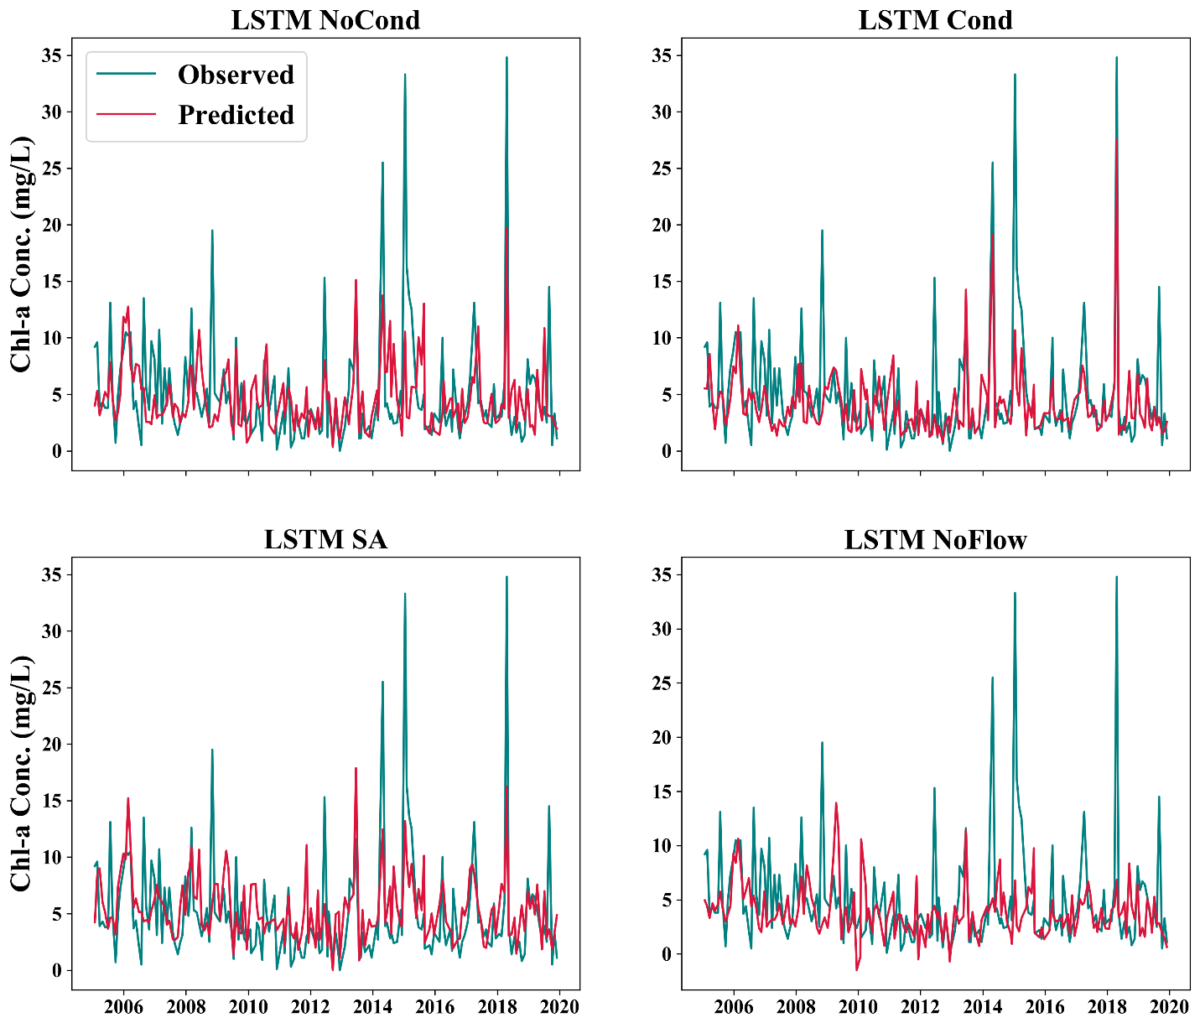

Fig. S22. Observed and simulated Chl-a concentration at Hwangji site using LSTM model with different scenarios. ‘LSTM NoCond’ is the model without static data, ‘LSTM Cond’ is the model where static data was used to initiate hidden and cell states of LSTM. ‘LSTM SA’ model has ‘self-attention’ mechanism while ‘LSTM NoFlow’ model does not use streamflow as input.

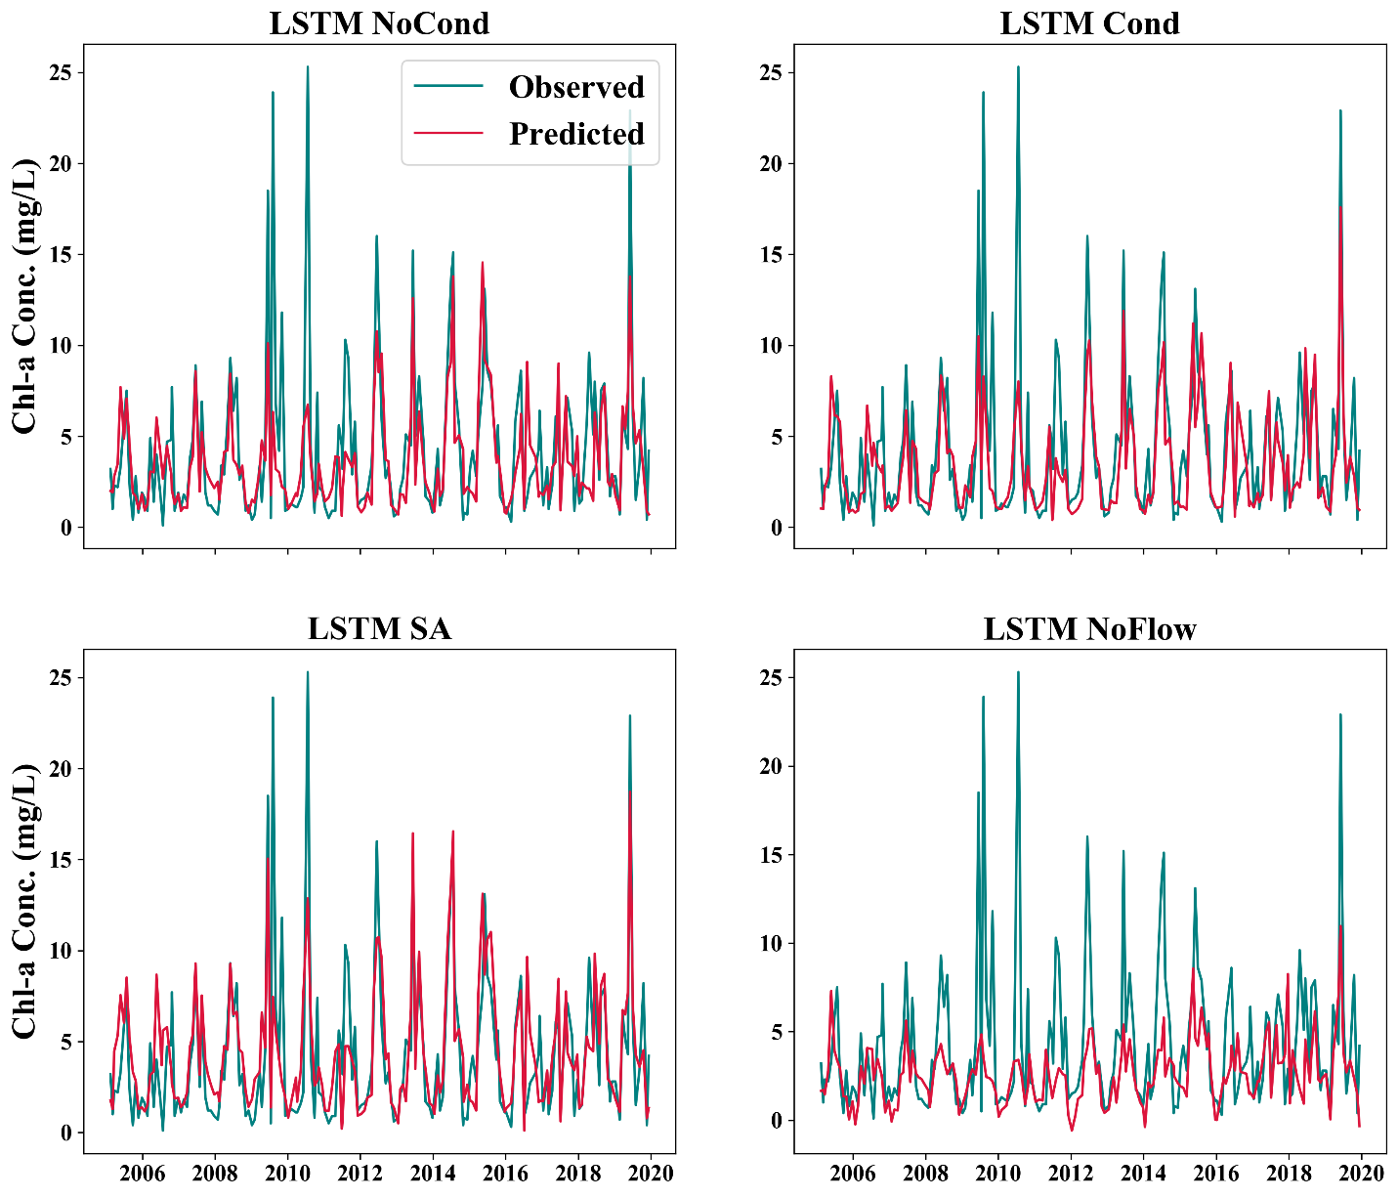
Fig. S23. Observed and simulated Chl-a concentration at Bonghwa site using LSTM model with different scenarios. ‘LSTM NoCond’ is the model without static data, ‘LSTM Cond’ is the model where static data was used to initiate hidden and cell states of LSTM. ‘LSTM SA’ model has ‘self-attention’ mechanism while ‘LSTM NoFlow’ model does not use streamflow as input.

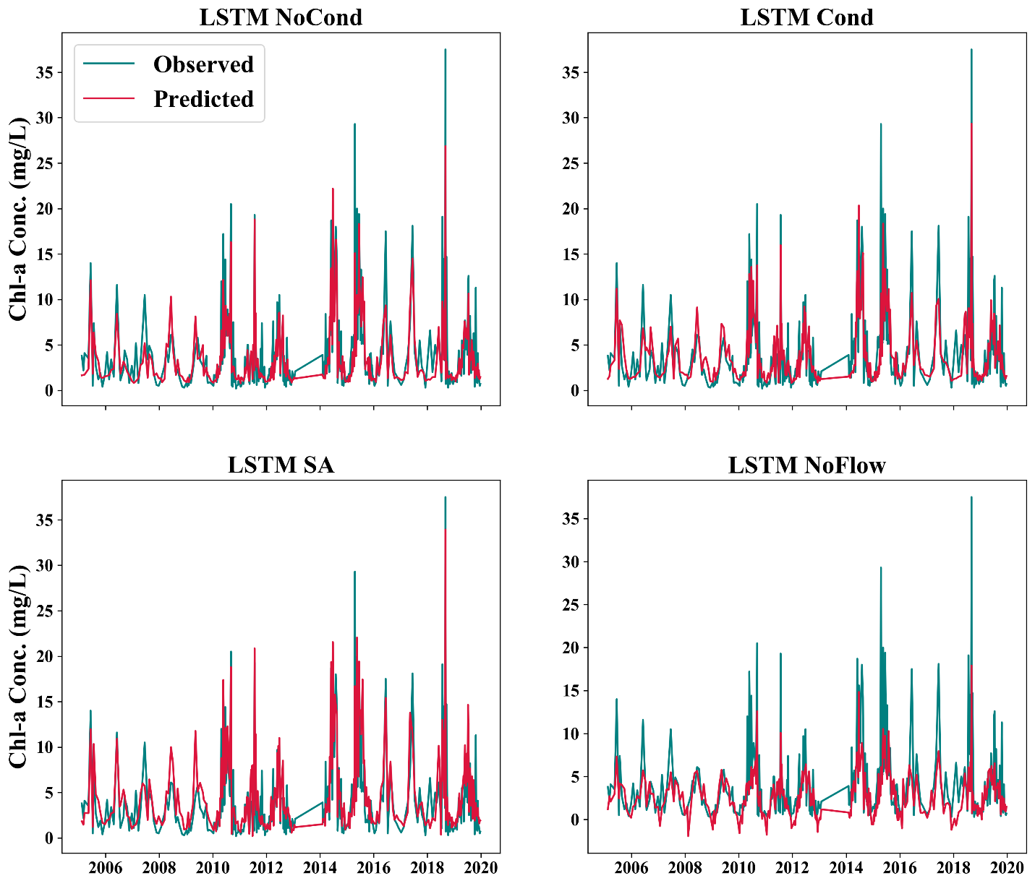

Fig. S24. Observed and simulated Chl-a concentration at Dosan site using LSTM model with different scenarios. ‘LSTM NoCond’ is the model without static data, ‘LSTM Cond’ is the model where static data was used to initiate hidden and cell states of LSTM. ‘LSTM SA’ model has ‘self-attention’ mechanism while ‘LSTM NoFlow’ model does not use streamflow as input.

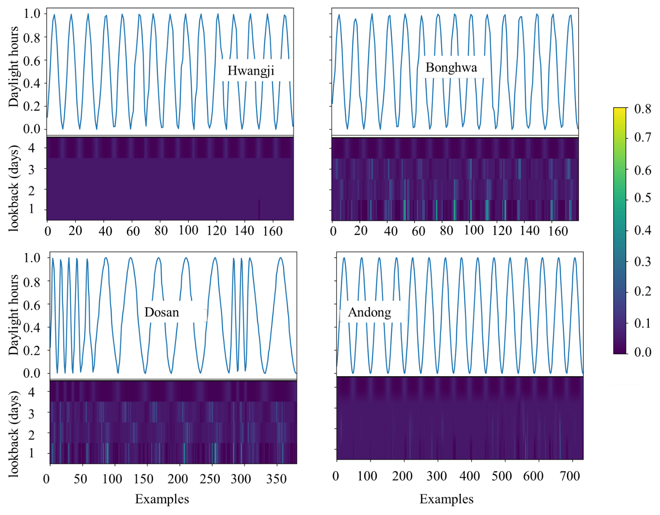

Fig S25. Attention weights of IA-LSTM model with respect to daylight hours at the four study sites. A higher weight a particular lookback step shows that the daylight hours information at that step was more informative to the model for prediction.

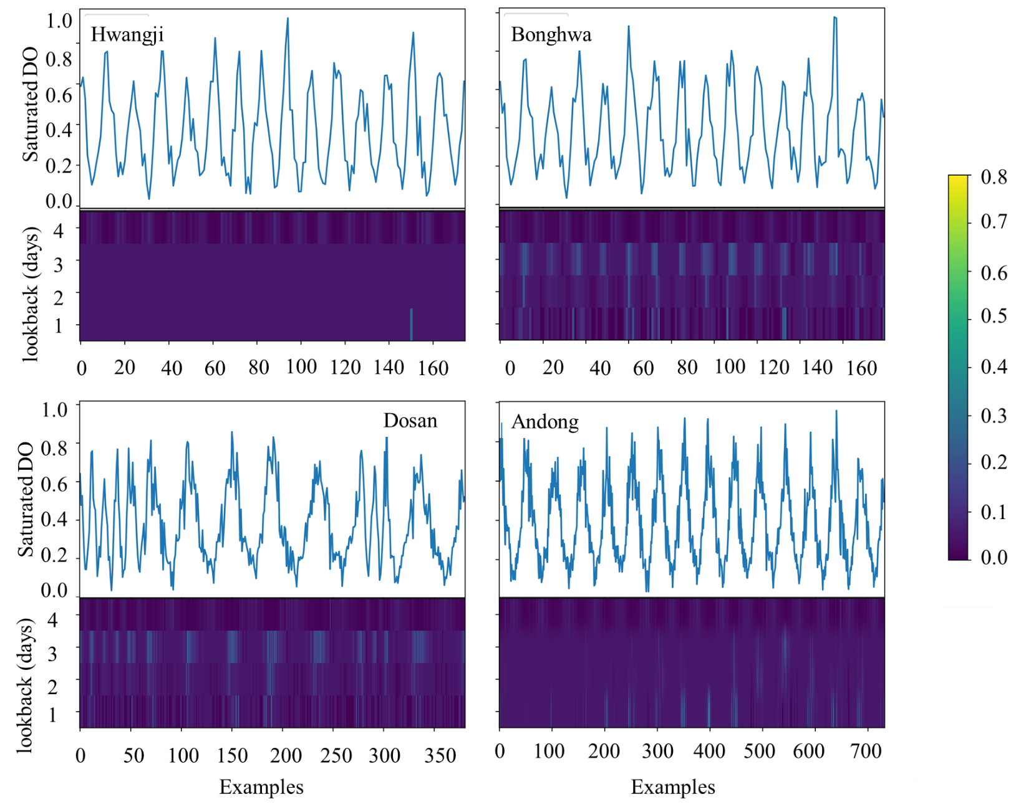

Fig S26. Attention weights of IA-LSTM model with respect to saturated concentration of dissolved oxygen at the four study sites. A higher weight a particular lookback step shows that the saturated concentration of dissolved oxygen information at that step was more informative to the model for prediction.

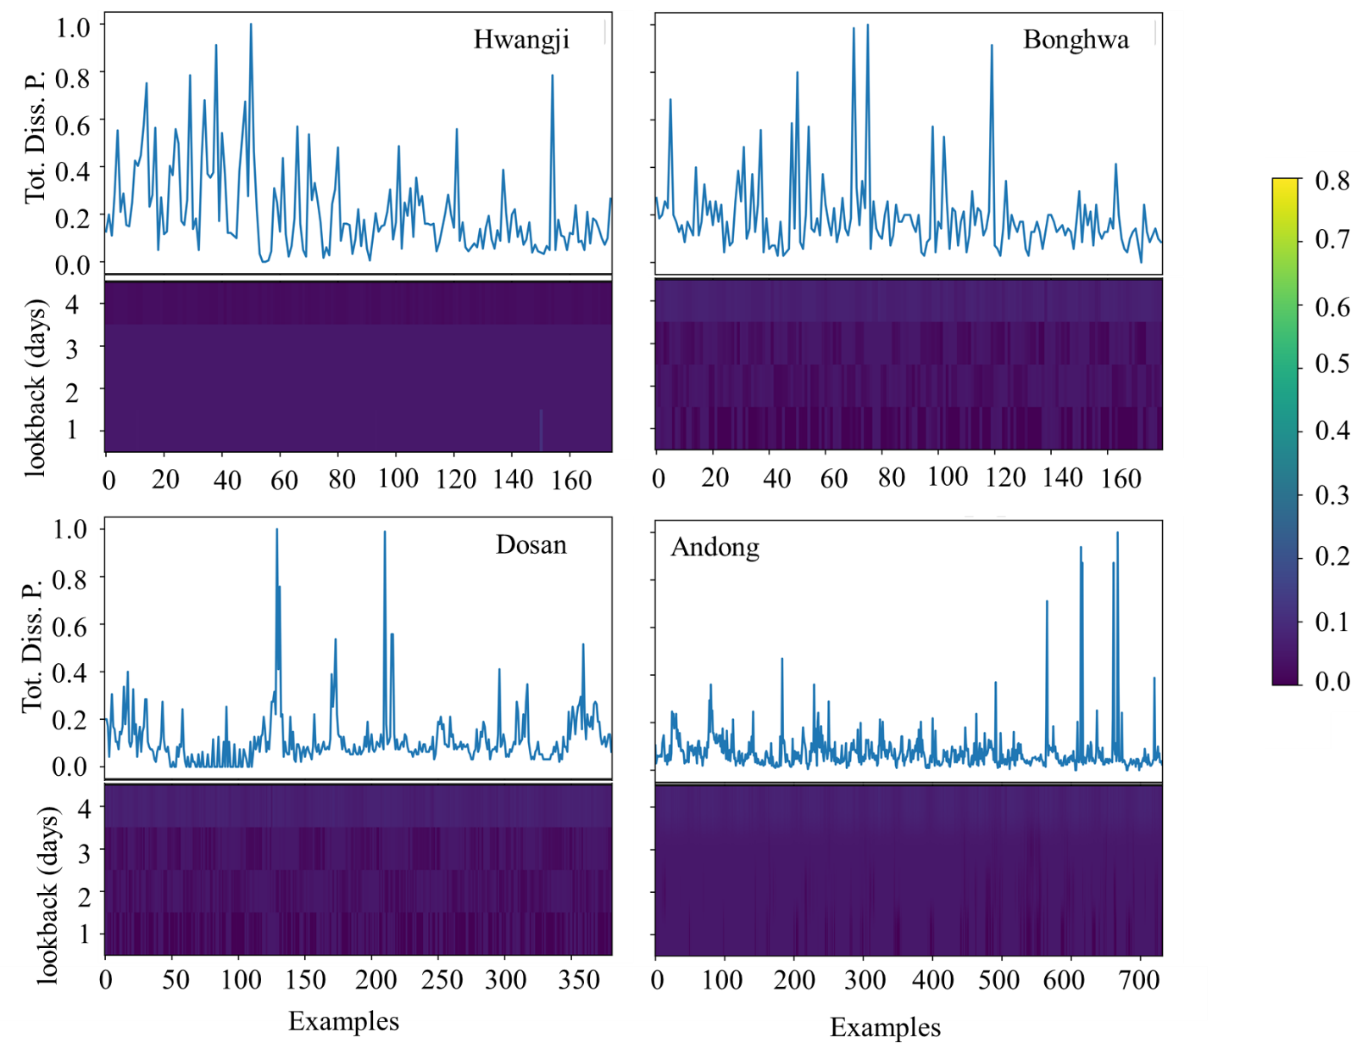

Fig S27. Attention weights of IA-LSTM model with respect to total dissolved phosphorus of dissolved oxygen at the four study sites. A higher weight a particular lookback step shows that the total dissolved phosphorus information at that step was more informative to the model for prediction.

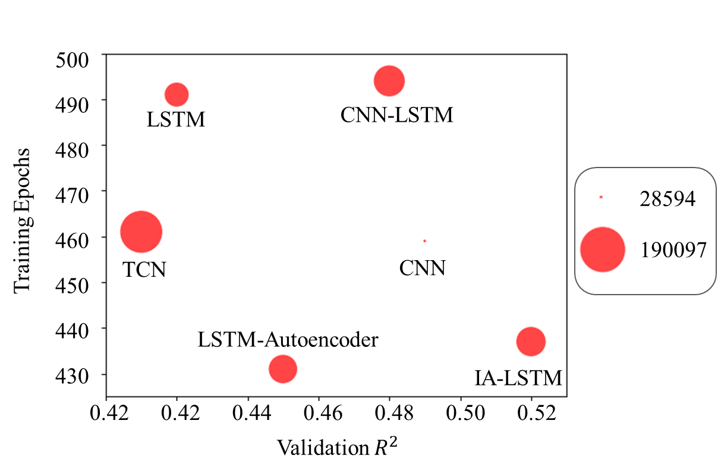
Fig S28. A comparison of model size, validation coefficient of correlation and number of training epochs of the six deep learning models. Model size is representative of number of trainable parameters. CNN is the smallest model in terms of model size with 28594 parameters while TCN is the largest model with 190097 parameters.

Table S1. Number of trainable parameters of each model built in this study and the number of training epochs used to train each model. The training was stopped when the model started overfitting.
Model Name | Number of Parameters | Training Epochs | Training Time (seconds)
LSTM | 78883 | 491 | 120
CNN | 28594 | 459 | 105
CNN-LSTM | 114362 | 494 | 160
LSTM Autoencoder | 100118 | 431 | 155
TCN | 190097 | 461 | 148
Input Attention LSTM | 105213 | 437 | 137
LSTM based model architectures
LSTM | 78883 | 491 | 120
LSTM SA | 63823 | 338 | 105
LSTM NoFlow | 78604 | 109 | 60
LSTM NoCond | 73763 | 499 | 90
LSTM Cond | 66779 | 454 | 135

Table S2. Names and statistical parameters of observed parameters at study site 1.
Parameter Name | Mean | Median | Standard Deviation | No of observations
Continuous variables
Minimum Air Temperature | 17.57 | 18.70 | 8.28 | 5478
Maximum Air Temperature | 8.72 | 9.1 | 9.02 | 5478
Solar Radiation | 14.94 | 13.5 | 6.35 | 5478
Stream Flow | 4.07 | 0.89 | 11.36 | 5478
Water Temperature | 14.86 | 15.42 | 6.37 | 5478
Saturation Concentration of DO | 10.29 | 9.99 | 1.46 | 5478
Precipitation | 11.97 | 0.0 | 3.45 | 5478
Potential Evapotranspiration | 2.26 | 1.89 | 1.57 | 5478
Daylight Hours | 12.0 | 12.01 | 1.76 | 5478
Static Variables
Stream Volume | 608.19 | - | - | 1
Stream Width | 30.3 | - | - | 1
Stream Length | 18.8 |  | - | 1
Stream Depth | 1.06 |  |  | 1
Stream Slope | 0.01 | - | - | 1
Stream width ratio | 28.4 | - |  | 1
Sub-basin area | 192.73 |  | - | 1
Tributary width | 30.3 | - | - | 1
Tributary length | 28.7 | - | - | 1
Tributary slope | 0.03 | - | - | 1
Discontinuous variables
Ammonia Nitrogen | 0.29 | 0.117 | 0.49 | 175
Suspended Solids | 5.53 | 2.60 | 11.97 | 175
Total Nitrogen | 3.87 | 3.612 | 1.38 | 175
Total Phosphorus | 0.06 | 0.046 | 0.05 | 175
Dissolved Total Nitrogen | 2.67 | 3.21 | 1.04 | 175
Dissolved Total Phosphorus | 0.04 | 0.029 | 0.03 | 175
Dissolved Oxygen | 11.46 | 11.2 | 2.22 | 175
Biological Oxygen Demand | 1.52 | 1.40 | 0.97 | 175
Travel Time | 9.44 | 10.0 | 3.92 | 175
Output Variable
Observed Chlorophyll-a | 5.06 | 3.7 | 4.93 | 175

Table S3. Names and statistical parameters of observed parameters at study site 1.
Parameter Name | Mean | Median | Standard Deviation | No of observations
Continuous variables
Minimum Air Temperature | 17.57 | 18.70 | 8.28 | 5478
Maximum Air Temperature | 8.72 | 9.10 | 9.02 | 5478
Solar Radiation | 14.97 | 13.5 | 6.35 | 5478
Stream Flow | 10.46 | 2.73 | 28.19 | 5478
Water Temperature | 14.86 | 15.42 | 6.37 | 5478
Saturation Concentration of DO | 10.29 | 9.99 | 1.46 | 5478
Precipitation | 2.97 | 0.0 | 10.39 | 5478
Potential Evapotranspiration | 2.24 | 1.91 | 1.45 | 5478
Daylight Hours | 12.0 | 12.01 | 1.76 | 5478
Static Variables
Stream Volume | 1590.9 | - | - | 1
Stream Width | 56.28 | - | - | 1
Stream Length | 17.54 |  | - | 1
Stream Depth | 1.61
Stream Slope | 0.0032 | - | - | 1
Stream width ratio | 34.93 | - |  | 1
Sub-basin area | 49.58 |  | - | 1
Tributary width | 18.96 | - | - | 1
Tributary length | 13.42 | - | - | 1
Tributary slope | 0.035 | - | - | 1
Discontinuous variables
Ammonia Nitrogen | 0.079 | 0.06 | 0.066 | 180
Suspended Solids | 3.43 | 1.6 | 11.78 | 180
Total Nitrogen | 2.05 | 2.09 | 0.61 | 180
Total Phosphorus | 0.018 | 0.014 | 0.015 | 180
Dissolved Total Nitrogen | 1.95 | 1.97 | 0.61 | 180
Nitric Nitrogen | 1.68 | 1.70 | 0.59 | 180
Dissolved Total Phosphorus | 0.013 | 0.011 | 0.59 | 180
Dissolved Oxygen | 11.87 | 11.45 | 2.85 | 180
Biological Oxygen Demand | 0.97 | 0.90 | 0.50 | 180
Travel Time | 9.70 | 10.15 | 3.23 | 180
Output Variable
Observed Chlorophyll-a | 4.29 | 2.9 | 4.25 | 180

Table S4. Names and statistical parameters of observed parameters at study site 1.
Parameter Name | Mean | Median | Standard Deviation | No of observations
Continuous variables
Minimum Air Temperature | 17.57 | 18.70 | 8.28 | 5478
Maximum Air Temperature | 8.72 | 9.10 | 9.02 | 5478
Solar Radiation | 4.94 | 13.50 | 6.35 | 5478
Stream Flow | 20.98 | 5.11 | 54.69 | 5478
Water Temperature | 14.86 | 15.42 | 6.37 | 5478
Saturation Concentration of DO | 10.29 | 9.99 | 1.46 | 5478
Precipitation | 2.97 | 0.0 | 10.39 | 5478
Potential Evapotranspiration | 2.24 | 1.91 | 1.44 | 5478
Daylight Hours | 12.0 | 12.01 | 1.76 | 5478
Static Variables
Stream Volume | 2626.22 | - | - | 1
Stream Width | 88.83 | - | - | 1
Stream Length | 13.53 |  | - | 1
Stream Depth | 2.18
Stream Slope | 0.002 | - | - | 1
Stream width ratio | 46.67 | - |  | 1
Sub-basin area | 78.03 |  | - | 1
Tributary width | 17.62 | - | - | 1
Tributary length | 16.11 | - | - | 1
Tributary slope | 0.024 | - | - | 1
Discontinuous variables
Ammonia Nitrogen | 0.033 | 0.03 | 0.030 | 430
Suspended Solids | 9.58 | 2.65 | 38.60 | 430
Total Nitrogen | 2.30 | 2.22 | 0.63 | 430
Total Phosphorus | 0.022 | 0.01 | 0.03 | 430
Dissolved Total Nitrogen | 1.95 | 2.01 | 0.85 | 430
Nitric Nitrogen | 1.72 | 1.79 | 0.79 | 430
Dissolved Total Phosphorus | 0.010 | 0.008 | 0.01 | 430
Dissolved Oxygen | 11.70 | 11.30 | 2.49 | 430
Biological Oxygen Demand | 0.90 | 0.80 | 0.54 | 430
Travel Time | 8.17 | 8.6 | 3.36 | 430
Output Variable
Observed Chlorophyll-a | 4.01 | 2.6 | 4.45 | 381

Table S5. Names and statistical parameters of observed parameters at study site 4.
Parameter Name | Mean | Median | Standard Deviation | No of observations
Continuous variables
Minimum Air Temperature | 17.57 | 18.70 | 8.28 | 5478
Maximum Air Temperature | 8.72 | 9.10 | 9.02 | 5478
Solar Radiation | 14.94 | 13.50 | 6.35 | 5478
Stream Flow | 25.81 | 22.00 | 19.75 | 5478
Water Temperature | 14.86 | 15.42 | 6.37 | 5478
Saturation Concentration of DO | 10.29 | 9.99 | 1.46 | 5478
Precipitation | 2.93 | 0.0 | 10.03 | 5478
Potential Evapotranspiration | 2.71 | 2.29 | 1.71 | 5478
Daylight Hours | 12.00 | 12.01 | 1.76 | 5478
Static Variables
Stream Volume | 1037.35 | - | - | 1
Stream Width | 108.58 | - | - | 1
Stream Length | 3.82 |  | - | 1
Stream Depth | 2.49 |  |  | 1
Stream Slope | 0.003 | - | - | 1
Stream width ratio | 43.48 | - |  | 1
Sub-basin area | 37.31 |  | - | 1
Tributary width | 11.31 | - | - | 1
Tributary length | 13.29 | - | - | 1
Tributary slope | 0.014 | - | - | 1
Discontinuous variables
Ammonia Nitrogen | 0.075 | 0.058 | 0.065 | 732
Suspended Solids | 3.39 | 2.0 | 5.02 | 732
Total Nitrogen | 1.72 | 1.62 | 0.47 | 732
Total Phosphorus | 0.023 | 0.016 | 0.02 | 732
Dissolved Total Nitrogen | 1.62 | 1.54 | 0.44 | 732
Nitric Nitrogen | 1.36 | 1.29 | 0.44 | 732
Dissolved Total Phosphorus | 0.016 | 0.012 | 0.018 | 732
Dissolved Oxygen | 9.97 | 10.10 | 2.78 | 732
Biological Oxygen Demand | 0.81 | 0.80 | 0.26 | 732
Travel Time | 1.44 | 0.79 | 2.45 | 732
Output Variable
Observed Chlorophyll-a | 4.81 | 3.0 | 6.41 | 732

Table S6. Names of hyperparameters, space of each parameter and the optimized value of hyperparameter for 6 models. The parameter space of categorical hyperparameters is the actual categories of hyperparameters while for numerical hyperparameters, the space was defined by fixing upper and lower limit.
Hyperparameter Name | Parameter space |  |  | Optimized value
Hyperparameter Name | Lower limit | Upper limit | Categories | Optimized value
LSTM
batch size | 8 | 32 | - | 24
lookback | 3 | 15 | - | 5
learning rate | 2e-3 | 8e-5 | - | 0.0001
Dense activation | - | - | ReLU, Leaky ReLU, ELU, tanh | ReLU
Dense1 activation | - | - | ReLU, Leaky ReLU, ELU, tanh | ELU
Output activation | - | - | ReLU, Leaky ReLU, ELU, tanh, None | ReLU
LSTM activation | - | - | ReLU, Leaky ReLU, ELU, tanh | ReLU
Dense units | 32 | 128 | - | 64
Dense1 units | 8 | 32 | - | 16
LSTM units | 64 | 256 | - | 128
CNN
batch size | 8 | 32 | - | 24
lookback | 3 | 15 | - | 6
learning rate | 2e-3 | 8e-5 |  | 0.006
CNN activation | - | - | ReLU, Leaky ReLU, ELU, tanh | Leaky ReLU
Dense activation |  | - | ReLU, Leaky ReLU, ELU, tanh | ReLU
Dense1 activation | - | - | ReLU, Leaky ReLU, ELU, tanh | ELU
Output activation | - | - | ReLU, Leaky ReLU, ELU, tanh, None | None
CNN filters | 64 | 256 | - | 128
CNN filter size | 2 | 5 | - | 3
Max. pooling | 2 | 4 | - | 4
Dense units | 32 | 128 | - | 64
Dense1 units | 8 | 32 | - | 32
TCN
batch size | 8 | 32 | - | 16
lookback | 3 | 15 | - | 5
learning rate | 2e-3 | 8e-5 | - | 3.8e-4
TCN activation | - | - | ReLU, Leaky ReLU, ELU, tanh | ELU
Dense activation | - | - | ReLU, Leaky ReLU, ELU, tanh | Leaky ReLU
Dense1 activation | - | - | ReLU, Leaky ReLU, ELU, tanh | ELU
Output activation | - | - | ReLU, Leaky ReLU, ELU, tanh, None | None
CNN filters | 64 | 256 | - | 128
CNN kernel size | 2 | 5 | - | 4
Dense units | 32 | 128 | - | 56
Dense1 units | 8 | 32 | - | 24
CNN-LSTM
batch size | 8 | 32 | - | 24
lookback | 3 | 15 | - | 5
learning rate | 2e-3 | 8e-5 | - | 0.0007
TCN activation | - | - | ReLU, Leaky ReLU, ELU, tanh | ELU
Dense activation | - | - | ReLU, Leaky ReLU, ELU, tanh | Leaky ReLU
Dense1 activation | - | - | ReLU, Leaky ReLU, ELU, tanh | ELU
Output activation | - | - | ReLU, Leaky ReLU, ELU, tanh, None | ReLU
LSTM activation | - | - | ReLU, Leaky ReLU, ELU, tanh | Tanh
CNN filters | 64 | 256 | - | 128
CNN kernel size | 2 | 5 | - | 3
Max. pooling | 2 | 4 | - | 3
Dense units | 32 | 128 | - | 64
Dense1 units | 8 | 32 | - | 18
LSTM units | 64 | 128 | -
LSTM Autoencoder
batch size | 8 | 32 | - | 16
lookback | 3 | 15 | - | 5
learning rate | 2e-3 | 8e-5 | - | 3.2e-4
Encoder activation | - | - | ReLU, Leaky ReLU, ELU, tanh | Tanh
Decoder activation | - | - | ReLU, Leaky ReLU, ELU, tanh | Tanh
Dense activation |  | - | ReLU, Leaky ReLU, ELU, tanh | Leaky ReLU
Dense1 activation | - | - | ReLU, Leaky ReLU, ELU, tanh | ELU
Output activation | - | - | ReLU, Leaky ReLU, ELU, tanh, None | None
Encoder units | 64 | 128 | - | 80
Decoder units | 64 | 128 | - | 70
Dense units | 32 | 128 | - | 56
Dense1 units | 8 | 32 | - | 16
IA-LSTM
batch size | 8 | 32 | - | 32
lookback | 3 | 15 | - | 4
learning rate | 2e-3 | 8e-5 | - | 0.00045
Dense activation |  | - | ReLU, Leaky ReLU, ELU, tanh | ReLU
Dense1 activation | - | - | ReLU, Leaky ReLU, ELU, tanh | Tanh
Output activation | - | - | ReLU, Leaky ReLU, ELU, tanh, None | ReLU
LSTM activation1 | - | - | ReLU, Leaky ReLU, ELU, tanh | ELU
LSTM activation2 | - | - | ReLU, Leaky ReLU, ELU, tanh | ELU
Dense units | 32 | 128 | - | 64
Dense1 units | 8 | 32 | - | 28
LSTM units | 32 | 128 | - | 50

