Polymeric microneedle-based platform enables simultaneous delivery of cancer immunomodulatory drugs and detection of biomarkers in the skin.

Pere Dosta^{1,2}*, Núria Puigmal^{1,2}*, Alexander M. Cryer^{1,2}, Alma Lorena Rodríguez^{1,2}, Ella Scott³, Ralph Weissleder^{3,4,5}, Miles A. Miller^{3,4}, Natalie Artzi^{1,2,6}

¹Institute for Medical Engineering and Science
Massachusetts Institute of Technology
Cambridge, MA 02139

²Department of Medicine
Division of Engineering in Medicine
Brigham and Women’s Hospital
Harvard Medical School
Boston, MA 02115
*E-mail: nartzi@mit.edu; nartzi@bwh.harvard.edu

³Center for Systems Biology
Massachusetts General Hospital Research Institute
Boston, MA 02114
*E-mail: miles.miller@mgh.harvard.edu

⁴Department of Radiology
Massachusetts General Hospital
Harvard Medical School
Boston, MA 02114

⁵Department of Systems Biology
Harvard Medical School

⁶Wyss Institute for Biologically Inspired Engineering
Harvard University
Boston, MA, 02115

Keywords: microneedles, immunotherapy, cancer, poly(beta-amino ester)s, theranostics

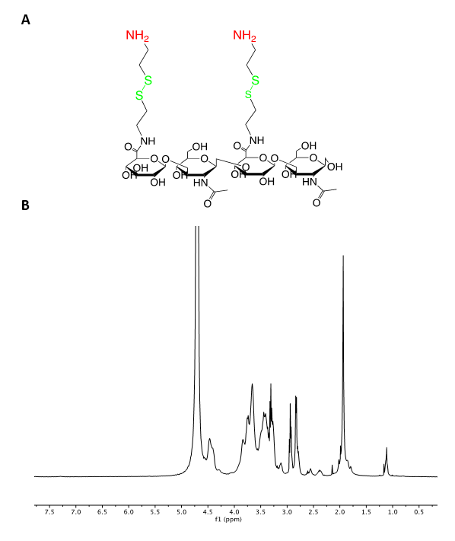
Figure S1: a, Chemical structure of HA-SS-NH₂ polymer. b, ¹H-NMR of HA-SS-NH₂ Polymer (400MHz, DMSO-d6, TMS) (ppm)

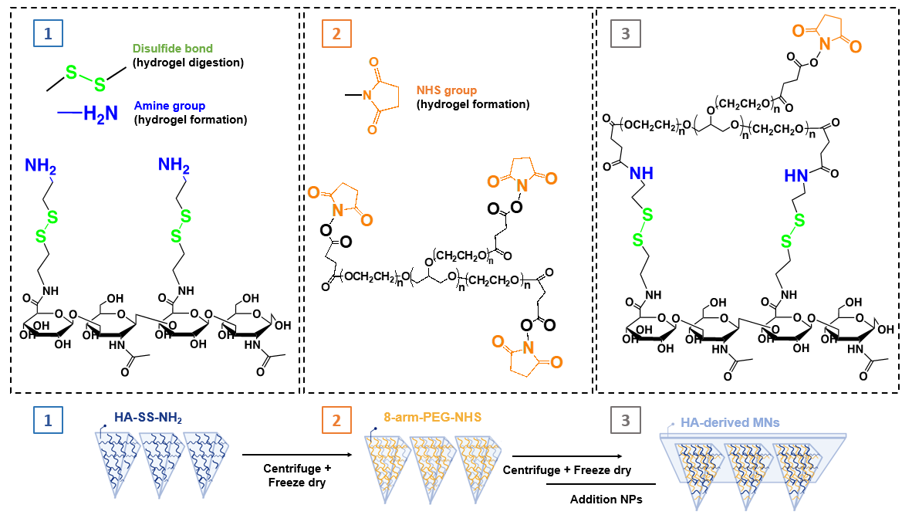
Figure S2: HA-based MN platform for simultaneous transdermal drug delivery and Interstitial fluid Sampling for cancer treatment. HA-based MN fabrication was performed by casting an aqueous amine-modified HA (HA-SS-NH2) solution into the PDMS mold by centrifugation and crosslinked using the NHS-terminated 8-arm PEG crosslinker. CpG Nanoparticles were loaded and a PLGA back layer was added (bottom scheme).

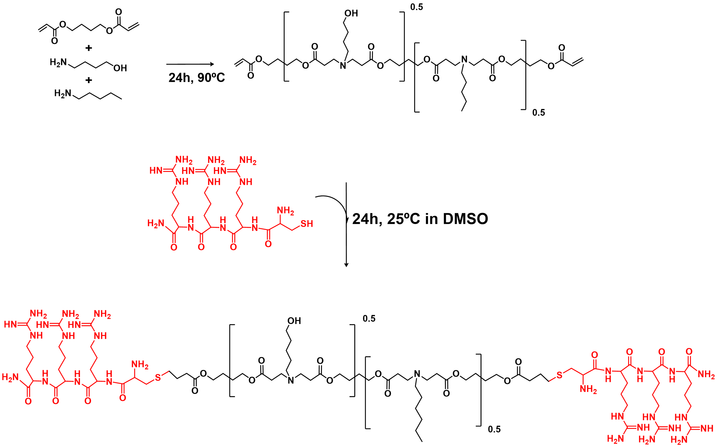
Figure S3: Synthesis of arginine modified poly (beta-amino) formulation. a, Synthesis of pBAE polymer. A mixture of 5-amino-1-pentanol, hexylamine, and 1,4-butanediol diacrylate (0.5:0.5:1.2) were used for the synthesis of pBAE C6 polymer. b, Arginine-modified pBAE are formulated mixing acrylate-terminate pBAE polymer with polyarginine peptide containing a cysteine amino acid (Cys-Arg-Arg-Arg).

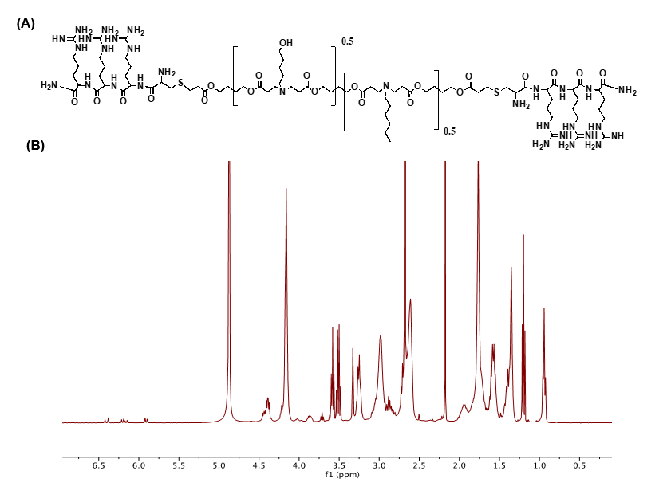
Figure S4 a, Chemical structure of C6-CR3 Polymer. b, ¹H-NMR of C6-CR3 Polymer (400MHz, Methanol-d₄, TMS) (ppm): δ = 4.41-4.33 (br, NH₂-C(=O)-CH-NH-C(=O)-CH-NH-C(=O)-CH-NH-C(=O)-CH-CH₂-, 4.16 (t, CH₂-CH₂-O), 3.58 (t, CH₂-CH₂-OH), 3.25 (br, NH₂-C(=NH)-NH-CH₂-, OH-(CH₂)₄-CH₂-N-), 3.04 (t, CH₂-CH₂-N-), 2.82 (dd, -CH₂-S-CH₂), 2.48 (br, -N-CH₂-CH₂-C(=O)-O), 1.90 (m, NH₂-C(=NH)-NH-(CH₂)₂-CH₂-CH-), 1.73 (br, -O-CH₂-CH₂-CH₂-CH₂-O), 1.69 (m, NH₂-C(=NH)-NH-CH₂-CH₂-CH₂-), 1.56 (br, -CH₂-CH2-CH₂-CH₂-OH), 1.39 (br, -N-(CH₂)₂-CH₂-(CH₂)₂-OH), 0.88 (t, CH₂-CH₂-CH₃).

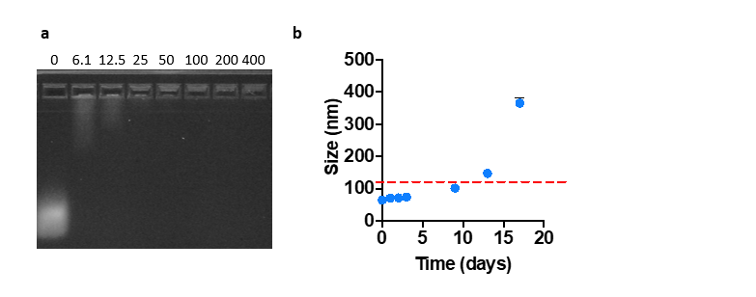
Figure S5: a, Agarose retardation assay of arginine-modified pBAE. Nanoparticles were formed using CpG and arginine-modified pBAE at different w/w ratios and loaded onto an agarose gel to assess CpG mobility by electrophoresis. b, Stability study of CpG-NPs in PBS (determined by DLS).

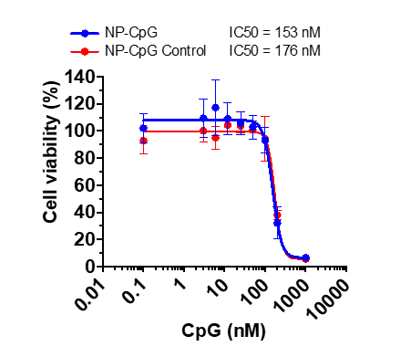
Figure S6: Cell viability profile of different concentrations of CpG-NPs and CpG-Crt-NP were analyzed 24 h post treatment. Samples were normalized to untreated cells. Data are represented as mean ± SD (n = 3).

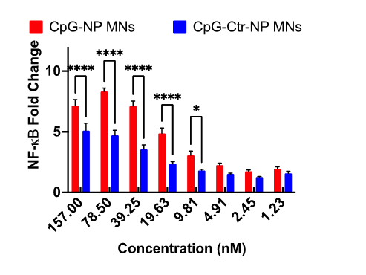
Figure S7: Dose-response of the NF-kB response produced by CpG-NP and CpG-Crt-NP released from the MNs in mouse TLR9 Reporter HEK293 cell line (n = 4 biologically independent samples).

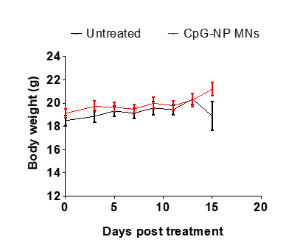
Figure S8: Mice body weight following CpG therapy. Mice with 20-40 mm³ orthotopic tumors were treated with empty microneedles or microneedles loaded with CpG-NPs five times, 3 days apart. Body weigh was measured every other day.

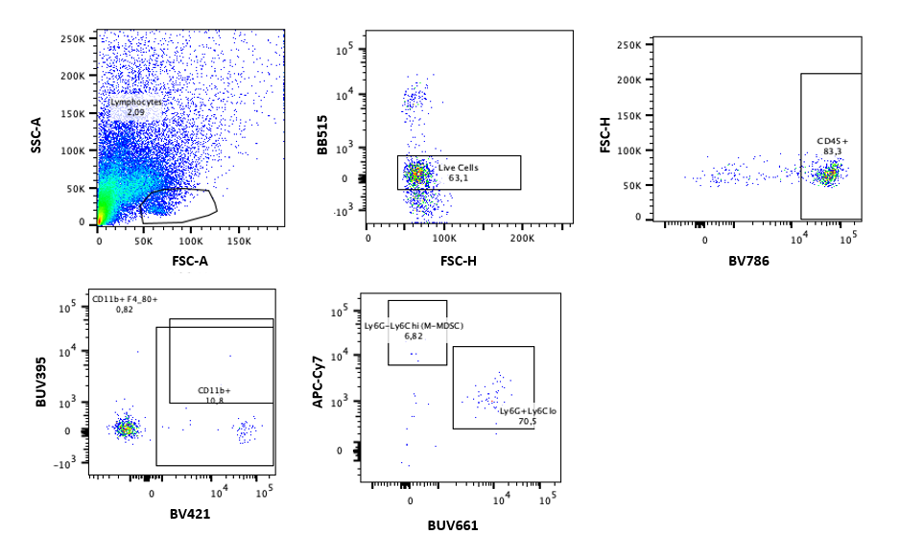
Figure S9: Macrophages gating strategy. Cells were extracted using microneedles.

