Supporting Information
Functional insights from targeted imaging BACE1: The first near-infrared fluorescent probe for Alzheimer’s disease diagnosis
Anyao Bi, ^{#[a]} Junyong Wu, ^{#[b]} Shuai Huang, ^{[a]} Yongjiang Li, ^{[b]} Fan Zheng, ^{[a]} Jipeng Ding, ^{[a]} Jie Dong^{[a]}, Daxiong Xiang*^{[b]} and Wenbin Zeng*^{[a]}
ª Xiangya School of Pharmaceutical Sciences, Central South University, Changsha, 410013, PR China
^{b} Department of Pharmacy the second Xiangya Hospital, Central South University, Changsha 410078, China.
[#] These authors contributed equally to this work.

Contents
S1 Synthesis and characterization
S1.1 Materials and methods
S1.2 Fluorescence measurement
S1.3 The imaging of cells by HBAE
S2 Cell experiments
S2.1 Cell culture
S2.2 Cell Viability Assay
S2.3 Western blot analysis
S3 Animal experiment
S3.1 Animal Model
S3.2 Real-time in Vivo imaging in 5XFAD Mice of HBAE

S1 Synthesis and characterization
S1.1 Materials and methods
All chemicals and reagents were used as received useless otherwise specified. Vitamin B1, benzaldehyde, and p-chloroaniline (99.5%) were purchased from Energy Chemical Co., Ltd (China). 4-Pyridine carboxaldehyde (98%) and pyridine were purchased from Sinopharm Chemical Reagent Co., Ltd (China). 4’,6-diamidino-2-phenylindole (DAPI) were purchased from Sigma-Aldrich. The high sugar DMEM base used was purchased from Thermo Fisher technology, phosphate buffered saline (PBS) were purchased from Invitrogen. The cell counting kit-8 (CCK-8) cytotoxicity assay kit was a commercial product of Beyotime Biotechnology (China). Milli-Q water was supplied by Milli-Q Plus System (Millipore Corporation, United States).
¹H and ¹³C NMR spectra were measured on a Bruker ARX 400 MHz NMR spectrometer using CDCl₃ and DMSO-d6 as the solvent and tetramethylsilane (TMS; δ = 0) as the internal reference. UV-vis Absorption spectra were performed on a UV-2450 scanning spectrophotometer (Shimadzu, Japan). Fluorescent spectra were recorded on a Hitachi F-2700 equipped with a 1 cm quartz cell. Fluorescent images were collected on Leica DMI4000B fluorescence microscope. The AD mice were scanned by Bruker SkyScan 1178.
Cell lines: derived Endothelial cells.3 (bEnd.3) and N2a, HEK293, U87-MG were continuously cultured in our laboratory.
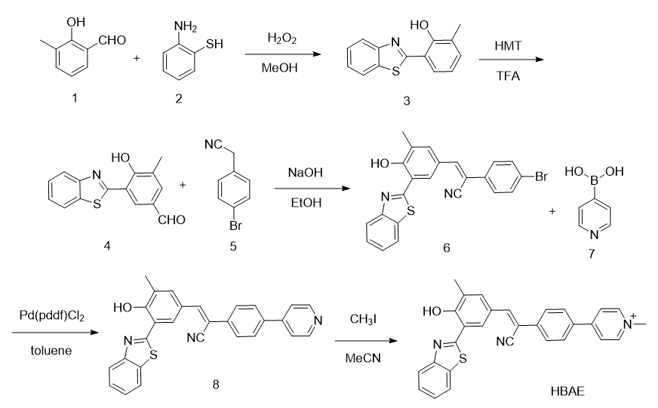
Scheme S1. Synthesis of Probe HBAE.

Synthesis of compound 3
Compound 1 (1.96 g, 10 mmol) in a 250 mL round bottom flask was added with 40 mL methanol. The mixture was added with compound 2 (1.25 g, 10 mmol) and stir at room temperature for 5 hours. Then the reaction solution gradually changes from gray liquid to light yellow liquid, which was monitored by TLC. After 6 hours, the reaction solution was poured into 200 mL of water, precipitated a large amount of light-yellow solid. Filtering the reaction under reduced pressure and obtained light yellow solid, washing with saturated sodium chloride aqueous solution for 3 times, dry at 45 ºC in an oven. Then it dissolved in dichloromethane and recrystallized with cyclohexane to obtain 2.35 g of light-yellow solid powder, with a yield of 90.0%. ¹H NMR (400 MHz, CDCl₃, δ): 12.77 (s, 1H), 7.95 (d, 1H), 7.87 (d, 1H), 7.53 (d, 1H), 7.48 (d, 1H), 7.38 (d, 1H), 7.26–7.22 (m, 1H), 6.85 (t, 1H), 2.35 (s, 3H).
Synthesis of compound 4
Compound 3 (0.241 g, 1 mmol) was dissolved in a round bottom flask and added with 3 mL of TFA and HMT (0.500 g, 3 mmol). The mixture was protected by in nitrogen, heated at reflux. After 4 hours, the reaction solution was dried and further purified by column chromatography to give a light-yellow powder (compound 4, 0.212 g, yield 67.8%). ¹H NMR (400 MHz, CDCl₃, δ): 13.42 (s, 1H), 9.78 (s, 1H), 7.90–7.81 (m,3H), 7.63 (s, 1H), 7.48–7.34 (m, 2H), 2.32 (s, 3H).
Synthesis of compound 6
Compound 4 (0.271 g, 1 mmol) and compound 5 (0.196 g, 1 mmol) were added into a round bottom flask, adding 5 ml of ethanol, then dropping 2 ml of a saturated aqueous solution of NaOH, stirring at room temperature. After 12 h, adding HCl to adjust the reaction solution into neutral, and further purified by column chromatography with PE/EA (20/1, v/v) giving 0.395 g of light yellow solid powder with a yield of 84.7%.¹H NMR(500 MHz, DMSO-d6, δ): 9.05(s, 1H), 7.70-7.71 (d, H), 7.63 (d, 2H), 7.59(d, H), 7.51-7.45 (d, 2H), 7.41-7.39 (d, 2H), 7.35 (d, 2H), 7.22 (d, H), 1.34 (s, 3H).
Synthesis of compound 8
Compound 6 (0.450 g, 1 mmol) and compound 7 (0.123 g, 1 mmol) were added into a round bottom flask, adding PdCl₂(dppf) (10 mg, 0.02 mmol) under nitrogen protection and anhydrous conditions, then reflux for 12 hours at 90 ºC. After cooling, the precipitate was filtered, and further purified by column chromatography with PE/EA (3/1, v/v) to afford 0.245 g of yellow solid powder with a yield of 55.1%.¹H NMR(500 MHz, DMSO-d6, δ): 9.05(s, 1H), 7.83-7.89(d, 2H), 7.70-7.71 (d, H), 7.63 (s, H), 7.59(d, H), 7.58-7.55 (d，2H), 7.51-7.45 (d, 2H), 7.41-7.39 (d, 2H), 7.32-7.30 (d, 2H), 7.22 (d, H), 7.18-7.14 (d, H), 1.34 (s, 3H).
Synthesis of (Z)-4-(4-(2-(3-(benzo[d]thiazol-2-yl)-4-hydroxy-5-methylphenyl)-1 -cyanovinyl)phenyl)-1-methylpyridin-1-ium (Probe HBAE)
Compound 8 (0.445 g, 1 mmol) was added to solution of acetonitrile (20 ml), pouring into a 100 ml round bottom flask. Dropping methyl iodide (0.110 g, 10 mmol) under the condition of nitrogen protection, and stirring at 90ºC. After 12 hours, solution was dried and dissolved in dichloromethane, and purified by column chromatography with DCM/MeOH (10/1, v/v), and 0.32 g of yellow solid powder was obtained with a yield of 69.6%.¹H NMR(500 MHz, DMSO-d6, δ): 9.05(s, 1H), 8.03-8.09(d, 2H), 7.70-7.71 (d, H), 7.63 (s, H), 7.59(d, H), 7.58-7.55 (d，2H), 7.51-7.45 (d, 2H), 7.41-7.39 (d, 2H), 7.32-7.30 (d, 2H), 7.22 (d, H), 7.18-7.14 (d, H), 4.03 (s, 3H), 1.34 (s, 3H). ¹³C NMR (125 MHz, DMSO-d6, δ): 168.35, 155.45, 153.58, 153.46, 151.47, 151.31, 146.17, 146.11, 144.10, 143.95, 137.96, 137.92, 134.02, 133.87, 133.18, 133.14, 129.31, 129.25, 127.67, 127.57, 127.04, 126.56, 124.46, 124.42, 123.01, 122.62, 118.50, 117.07, 47.40, 16.36. Mass spectrometry (ESI-MS, m/z): [M]+ Calcd. for [C₂₉H₂₂N₃OS]⁺460.1515; found 460.1455.
S3. Calculate the fluorescence quantum yield.
Fluorescence quantum yield (Φf) was determined by using quinine sulfate (Φf = 0.58, in 0.1 M H₂SO₄ aqueous solution) as the fluorescencestandard.¹ The quantum yield was calculated using the following equation. ΦF(X) = ΦF(S) (ASFX/AXFS) (nX/nS)² Where ΦF is the fluorescence quantum yield, A is the absorbance at the excitation wavelength, F is the area under the corrected emission curve, and n is the refractive index of the solvent used. Subscripts S and X refer to the standard and to the unknown, respectively. The quantum yield of HBAE was calculated 0.27, respectively.
S4.Absorption and Fluorescence emission spectra of HBAE
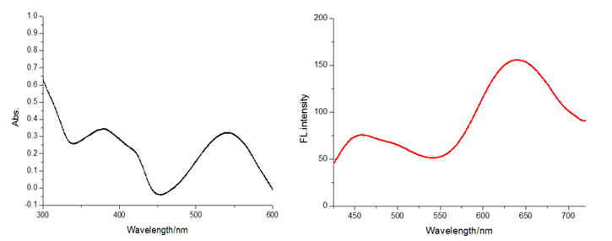
Figure S1. UV-Vis spectrum and of fluorescent spectrum of HBAE in DMSO.
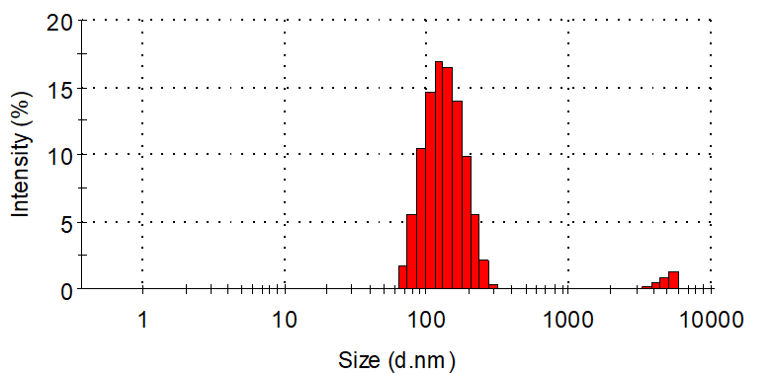
Figure S2. Particle size of HBAE by dynamic light scattering.
Average size=133.4 nm.
Figure. S3 TEM image of HBAE at pH=7.4.
S5.The imaging of cells membranes protein by HBAE
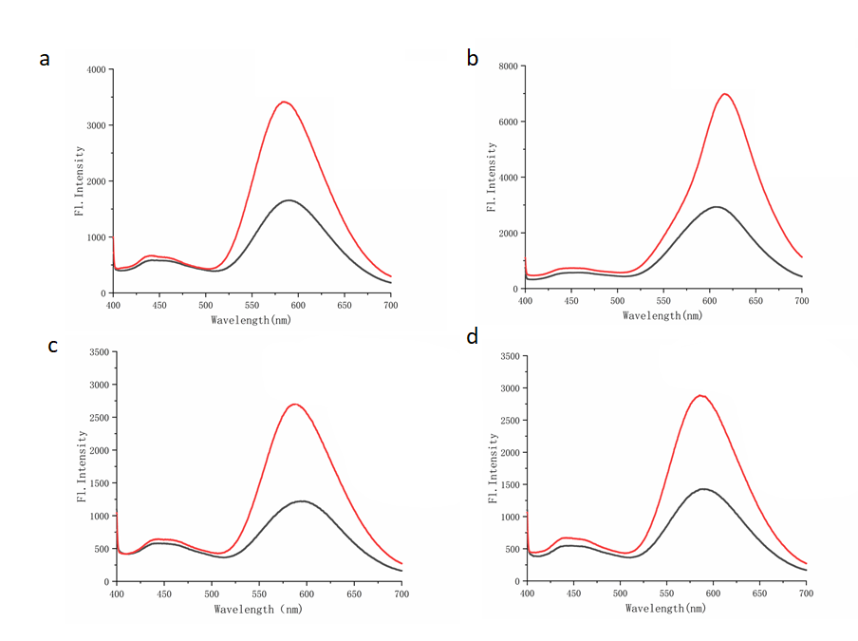
Figure S4. Fluorescence intensity of HBAE (10 μM) at 650 nm versus the different cells membranes protein. a. U87-MG cell membranes protein, b. N2a cell membranes protein, c.Bend.3 cell membranes protein, d.U251 cell membranes protein. The excitation wavelength was 560 nm.
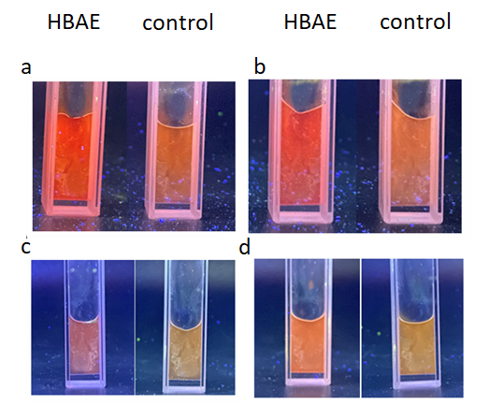
Figure S5.Fluorescence intensity of HBAE (10 μM) at 650 nm versus the different cells membranes protein. a. U87-MG cell membranes protein, b. N2a cell membranes protein, c. Bend.3 cell membranes protein, d. HEK293 cell membranes protein.
Docking scores
We used the DOCK6.8 in molecular docking², and the docking scores were:
Grid_Score: -42.900635
Grid_vdw_energy: -42.900635
Grid_es_energy: 0.000000
Internal_energy_repulsive: 22.601223
Our experiments are carried out according to the website (https://dock.compbio.ucsf.edu/DOCK_6/index.htm)
Cell Viability Assay
The cytotoxicity of HBAE was studied by CCK8 assay. Briefly, 100 μL of HeLa cell suspension was placed in a 96-well plate. The plates were preincubated in an incubator for 24 h (37 °C, 5% CO₂). A volume of 10 μL of different concentrations of HBAE was added to the plates. The plates were incubated for 24 h in an incubator. A volume of 10 μL of CCK8 solution was added to each well. The plates were incubated for 2 h in an incubator. The absorbance at 450 nm was measured with a microplate reader to reflect the cell viability of each well.
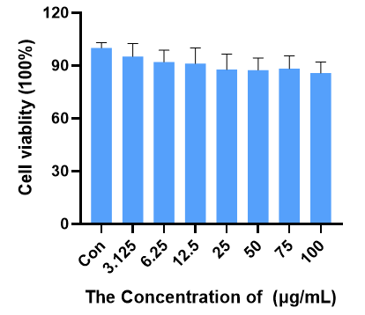
Figure. S6 CCK8 of the cell viability of HBAE. (Each sample was tested using three replicates, and the results are reported as the mean ± standard deviation).

Cell line: U87-MG，bEND.3, N2a, HEK293 cells were maintained in DMEM (Thermo Fisher Scientific, USA), supplemented with 10% FBS (fetal bovine serum, Thermo Fisher Scientific, USA) and 1% penicillin−streptomycin (Thermo Fisher Scientific, USA). Cells were incubated at 37 °C with 5% CO₂.

Western blot analysis
Western blot analysis was performed on the 4 cell lines to determine the expression of BACE1. β-actin antibody (1:1000) was used as a normalization control.
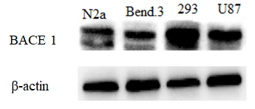
Figure. S7 Western blot images of BACE1 in 4 cell lines.

Establishment of blood-brain barrier in vitro
Transwell orifice plate was used in the experiment. 10000 bend. 3 cells were inoculated into each well in the upper chamber. Complete culture medium was added into the lower chamber, and the solution was changed every 48 hours. The resistance was measured by trans endothelial resistance meter (TEER). When the resistance value was greater than 200 Ω / cm², the in vitro blood-brain barrier was successfully established. U87-MG cells were inoculated into the lower chamber, adhered to the wall overnight, and HBAE were added into the upper chamber after 1, 2 and 4 hours respectively, The lower ventricular cells were fixed with paraformaldehyde, washed with PBS for three times, and stained with DAPI staining solution. After washing with PBS for three times, the BBB ability of the probe was observed under fluorescence microscope.
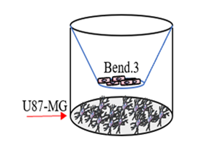
Figure. S8 Establishment of blood-brain barrier in vitro.

Animal Model
The animal experiment was approved by the Animal Ethics and welfare Committee, at the Second Xiangya Hospital, Central South University (No.2021595). All animal studies were carried out using the Institutional Animal Care and Use Committee (IACUC) approved procedures. The 22-month-old 5XFAD mice and wild-type mice were ordered from the Jackson Laboratory (34840), and maintained under standard conditions. The animals were housed in sterile cages within laminar airflow hoods in a specific pathogen-free room with a 12 h light/12 h dark schedule and fed autoclaved chow and water ad libitum.
Real-time in Vivo imaging in 5XFAD Mice of HBAE
5XFAD mice (n=4, C57BL6, 5XFAD, 22-month-old) and an age-matched wild-type mouse (n=4, C57BL6, 22-months-old) were shaved before background imaging and were intravenous injected with HBAE (2.0 mg kg-1, 1% DMSO, 99% PBS, 200 μL). Fluorescence signals from the brain were recorded at different time points after intravenous injection of HBAE. For the measurement, a filter set (λex = 560 nm, λem = 680 nm) was used, and optical images were acquired using an exposure time of 1 s. During the imaging process, the mice were kept on the imaging stage under anesthesia with 2.5% isoflurane gas in an oxygen flow (1.5 L/min).
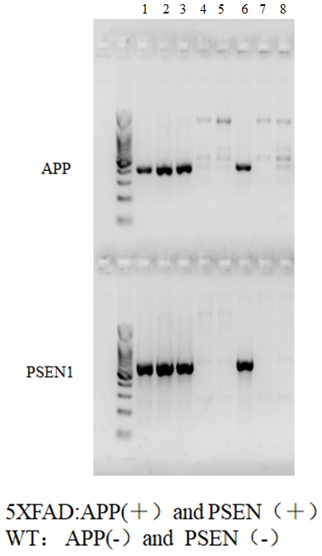
Figure. S9 Gene banding of AD and wild-type mice model. 1, 2, 3 and 6 belong to AD model mice, and 4, 5, 7 and 8 belong to wild-type mice.

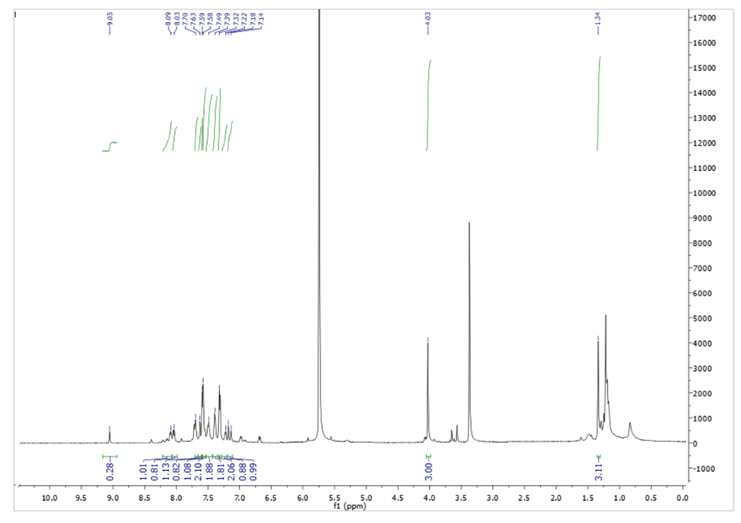
Figure. S10 ¹H NMR (500 MHz, DMSO-d6) of HBAE.
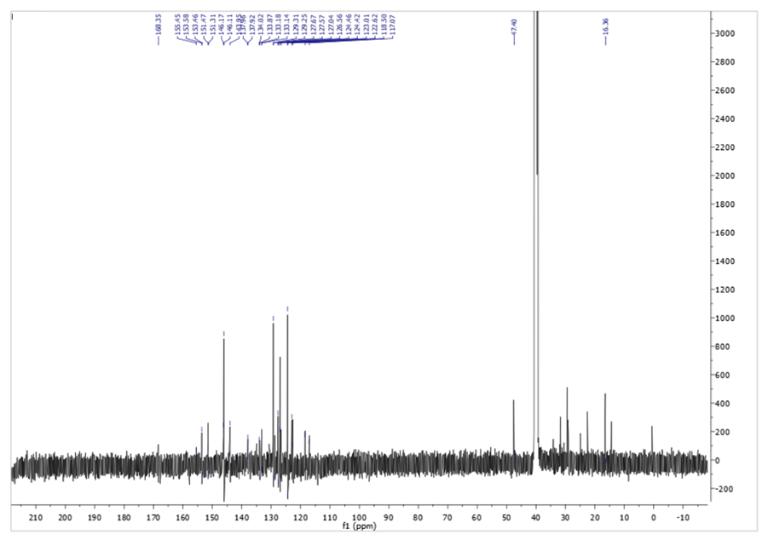
Figure. S11 ¹³C NMR (125 MHz, DMSO-d6) of HBAE.
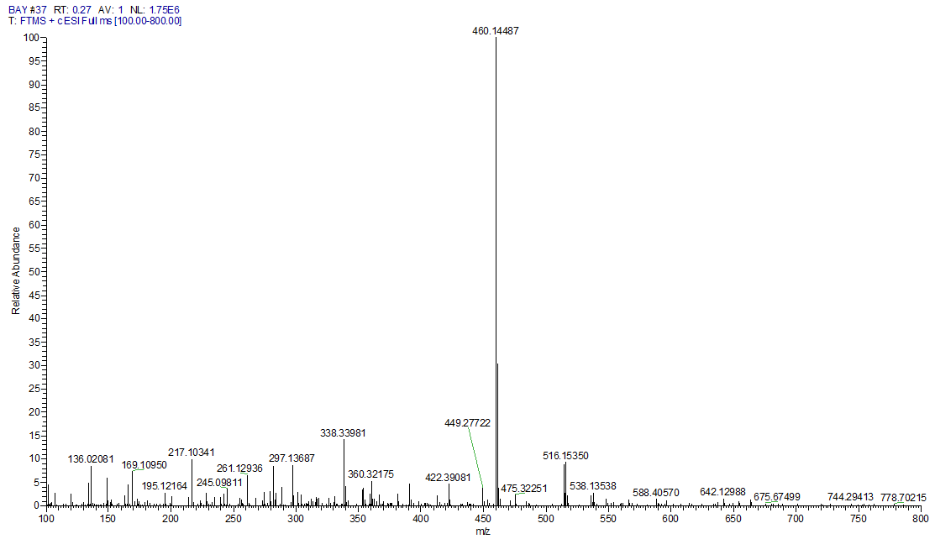
Figure. S12 MS spectra of HBAE.

Reference
1. D. Magde, G. E. Rojas and P. G. Seybold, Photochemistry and Photobiology, 1999, 70, 737-744.
2. Allen WJ, Balius TE, Mukherjee S, Brozell SR, Moustakas DT, Lang PT, Case DA, Kuntz ID, Rizzo RC. J Comput Chem. 2015, 36, 1132-56.

