Supplementary Materials for
50C fast-charge Li-ion batteries using graphite anode
Chuangchao Sun^{1,5}, Xiao Ji^{2,5}, Suting Weng^{3,5}, Ruhong Li¹, Xiaoteng Huang¹, Chunnan Zhu¹, Xuezhang Xiao¹, Tao Deng², Lixin Chen^{1,4}, Xuefeng Wang³*, Chunsheng Wang²*, Xiulin Fan¹*
- State Key Laboratory of Silicon Materials, School of Materials Science and Engineering, Zhejiang University, Hangzhou 310027, China. E-mail: xlfan@zju.edu.cn
- Department of Chemical and Biomolecular Engineering, University of Maryland, College Park, MD, USA. E-mail: cswang@umd.edu
- Beijing National Laboratory for Condensed Matter Physics, Institute of Physics, Chinese Academy of Sciences, Beijing 100190, China. E-mail: wxf@iphy.ac.cn
- Key Laboratory of Advanced Materials and Applications for Batteries of Zhejiang Province, Hangzhou 310013, China.
- These authors contributed equally: Chuangchao Sun, Xiao Ji, Suting Weng.

Supplementary Notes
Supplementary Note 1
Charge/discharge curves and overpotentials at different rates
The charge/discharge curves in Fig. 2b, Supplementary Figs. 6a, 10 and 11 are at 1C, 5C, 10C, 20C, 30C, 50C from right to left. The charge/discharge curves in Supplementary Fig. 22 are at 0.2C, 0.5C, 1C, 2C, 5C, 10C, 15C and 20C from right to left. Difference between middle value of charge voltage and the corresponding middle value of discharge voltage is the value of the whole overpotential. The overpotential of Li metal electrode is estimated from Supplementary Fig. 6 via the equation:
V = |plating overpotential – stripping overpotential|/2
The real overpotential of graphite anodes at various rates are obtained by taking the potential differences between the whole overpotential and the corresponding overpotential of Li metal electrode.

Supplementary Note 2
Analysis of the cyclic voltammetry (CV) measurement
In theory, the voltammetric response of an electrode-active material at various sweep rates can be summarized as follows^{1,2}:
i = av^{b}
in which the measured current (i) at a fixed potential obeys a power-law relationship with the potential sweep rate (v). For a redox reaction limited by semi-infinite diffusion, the peak current i follows a linear relationship with v^{0.5} (i.e., b = 0.5); for a capacitive process, it varies with v (i.e., b = 1).

Supplementary Figures
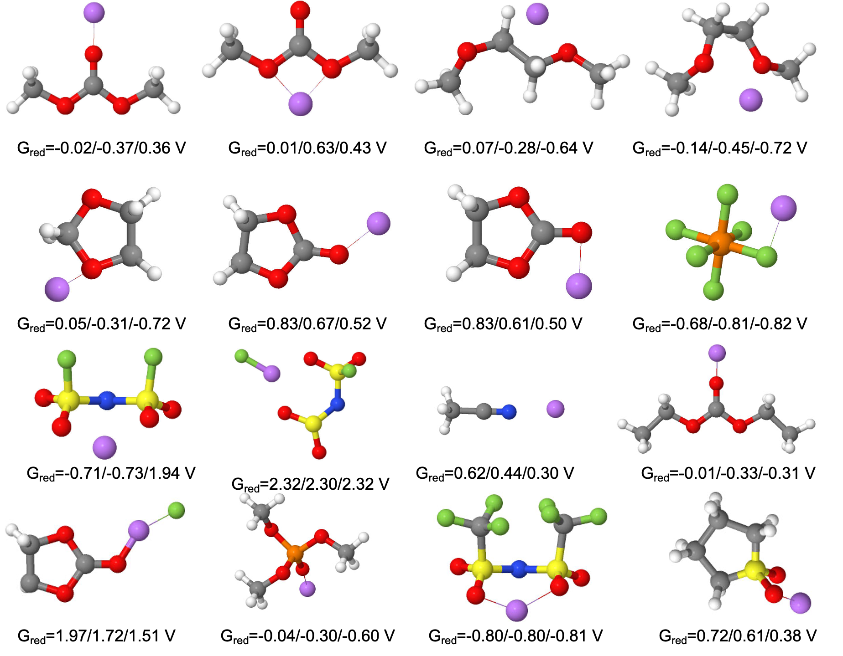
Supplementary Figure 1. Atomic structures for the reduced Li-solvent/anion combinations. The reduction potentials with different dielectric constants of epsl=4.24/7.19/20.49 are listed below respectively.

Supplementary Figure 2. (a) Impedance spectra of LTO||Li cell in 1.0 M LiPF₆ EC/DMC with a three-electrode system. Inset is the photograph of a three-electrode equipment. (b) Ionic conductivities of the LiFSI-DOL electrolytes at different concentrations. (c) Raman spectra of 1.8 M LiFSI DOL electrolyte. DOL Sol. refers to the pure DOL solvent.

Supplementary Figure 3. Radial distribution functions of (a) Li-F_{PF6}, Li-O_{EC}, and Li-O_{DMC} pairs for 1.0 M LiPF₆ EC/DMC (1:1 by vol.) and (c) Li-O_{FSI} and Li-O_{DOL} for 1.8 M LiFSI DOL. (b), (d) The corresponding distribution of the solvent number solvating with one Li⁺.

The average solvent number solvating with one Li⁺ for 1.8 M LiFSI DOL is calculated as follows:
$\text{n}\text{=}\frac{\text{0×15\%+1×47\%+2×35\%+3×3\%}}{\text{100\%}}$=1.26

Supplementary Figure 4. Impedance spectra of three different NG||Li cells with (a) 1.0 M LiPF₆ EC/DMC and (b) 1.8 M LiFSI DOL. (c) Impedance spectra of NG||Li cells using NG anodes with different particle sizes.

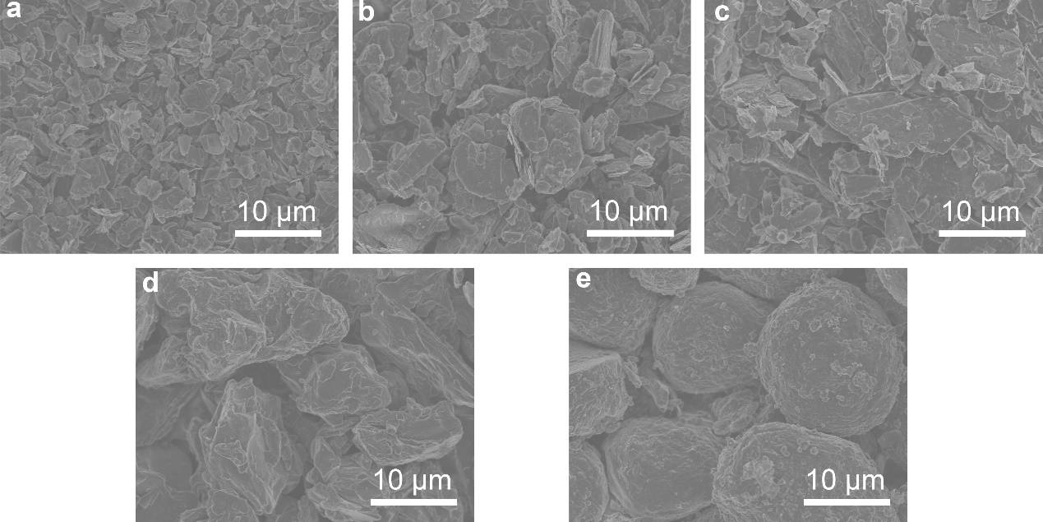
Supplementary Figure 5. SEM images of different graphite particles: (a) 2.5NG, (b) 10NG, (c) 15NG, (d) AG and (e) MCMB.

Supplementary Figure 6. (a) Charge/discharge curves of NG||Li cell with 1.0 M LiPF₆ EC/DMC. (b) Evolution of the overpotential at different current density of Li metal counter electrodes in two electrolytes. (c) Simulation of the overpotential changes for Li metal counter electrodes in Li||Li cell from 0.06 to 15 mA cm⁻² via galvanostatic Li plating/stripping tests.

Supplementary Figure 7. (a) Charge-voltage profiles of NG||Li cells via GITT measurements at 10C and (b) voltage relaxation process during the rest taken from the black ellipses. Complete GITT measurements of NG||Li cells with (c) 1.0 M LiPF₆ EC/DMC and (d) 1.8 M LiFSI DOL.

Supplementary Figure 8. CV curves at different sweep rates (0.01-1 mV s⁻¹) with (a) 1.0 M LiPF₆ EC/DMC and (c) 1.8 M LiFSI DOL. The corresponding b-value of different current peaks for the (b) 1.0 M LiPF₆ EC/DMC and (c) 1.8 M LiFSI DOL.

Supplementary Figure 9. (a) Top-viewed SEM image of the pristine Li metal counter electrode. The insets showed photographs of the Li metal counter electrode and separator before cycling. The SEM image was taken from the dotted boxes. (b) Charge/discharge curves and (c) cycling performance of NG||Li cell with 1.8 M LiFSI DOL at 20C without replacing the Li metal electrode.

Supplementary Figure 10. Charge/discharge curves of NG||Li cells with the (a)10NG and (b) 15NG anodes. (c) Rate performance of NG||Li cells assembled with different NG anodes in 1.8 M LiFSI DOL.

Supplementary Figure 11. Charge/discharge curves of NG||Li cells with (a) 0.9 M LiFSI DOL, (b) 2.4 M LiFSI DOL, (c) 2.8 M LiFSI DOL and (d) 3.2 M LiFSI DOL. (e) Rate performance of NG||Li cells with LiFSI-DOL electrolytes at different concentrations.

Supplementary Figure 12. (a) Rate performance of NG||Li cells with 1.8 M LiFSI DOL at an areal loading of 3.5 mAh cm⁻². (b) Recent researches³⁻¹² and our work on fast-charging in graphite||Li cells. The numbers in brackets represent the areal capacities of the used graphite electrodes (Loading unit: mAh cm⁻²).

Supplementary Figure 13. XPS analysis of the SEI formed on graphite anodes cycled using (a) 1.0 M LiPF₆ EC/DMC and (b) 1.8 M LiFSI DOL. The C 1s, O 1s and F 1s spectra were displayed after different sputtering times from 300 s to 1500 s with Ar⁺.

Supplementary Figure 14. The N 1s and S 2p spectra of the SEI formed on graphite anodes cycled using 1.8 M LiFSI DOL after different sputtering times with Ar⁺.

Supplementary Figure 15. Snapshots of Ab initio molecular dynamic (AIMD) calculated cells with graphite anode and (a) 1.0 M LiPF₆ EC/DMC and (b) 1.8 M LiFSI DOL electrolytes after 10 ns.

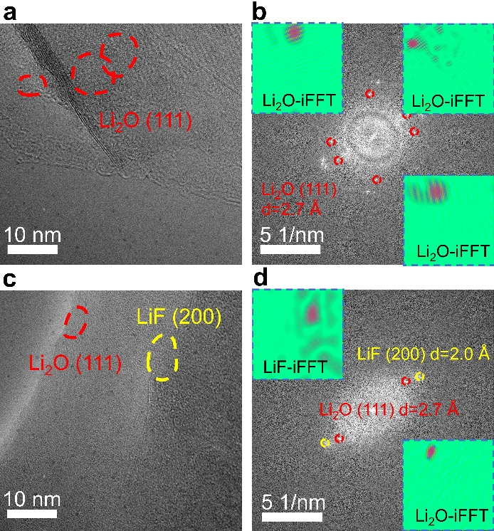
Supplementary Figure 16. Cryo-TEM images and the corresponding FFT patterns of the graphite anodes cycled in (a, b) 1.0 M LiPF₆ EC/DMC and (c, d) 1.8 M LiFSI DOL.

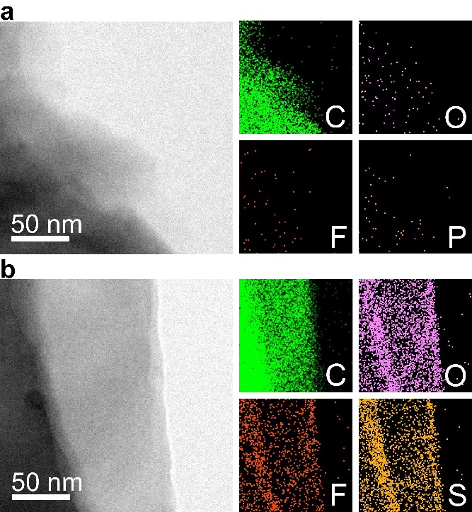
Supplementary Figure 17. Cryo-TEM images and the corresponding EDS mapping images of graphite anodes cycled in (a) 1.0 M LiPF₆ EC/DMC and (b) 1.8 M LiFSI DOL.

Supplementary Figure 18. Charge/discharge curves of NG||Li cells with (a) 1.0 M LiPF₆ EC/DMC and (b) 1.8 M LiFSI DOL. (c) Long-cycling performance of NG||Li cells with two electrolytes, respectively. The loadings of active material in all graphite anodes are 2.0 mAh cm⁻². For each cycle, the rates of charge and discharge are the same.

Supplementary Figure 19. (a) Charge/discharge curves and (b) long-cycling performance of NG||Li cells with 1.8 M LiFSI DOL at 8 C. The loadings of active material in all graphite anodes are 2.0 mAh cm⁻². For each cycle, the rates of charge and discharge are the same. The noticeable capacity decay at 8C is caused by the degradation of the Li metal rather than the graphite anode.

Supplementary Figure 20. Charge/discharge curves of NG||Li cells with (a) 1.0 M LiPF₆ EC/DMC and (b) 1.8 M LiFSI DOL. (c) Long-cycling performance of NG||Li cells with two electrolytes, respectively. The loadings of active material in all graphite anodes are 2.0 mAh cm⁻². All the cells were cycling at lithiation rate of 4C and delithiation rate of 0.3C.

Supplementary Figure 21. Ionic conductivities of 1.0 M LiPF₆ EC/DMC and 1.8 M LiFSI DOL at different temperatures.

Supplementary Figure 22. Charge/discharge curves of LFP||Li cells with (a) 1.0 M LiPF₆ EC/DMC and (b) 1.8 M LiFSI DOL at different rates. (c) Rate performance of LFP||Li cells with two electrolytes. The loadings of active material in all LFP cathodes used above are 0.4 mAh cm⁻². For each cycle, the rates of charge and discharge are the same.

Supplementary Figure 23. Charge/discharge curves of LFP||Li cells with (a) 1.0 M LiPF₆ EC/DMC and (b) 1.8 M LiFSI DOL during long cycling at 20 C. (c) Long-cycling performance at 20 C of LFP||Li cells with two electrolytes. The loadings of active material in all LFP electrodes used above are 0.4 mAh cm⁻². For each cycle, the rates of charge and discharge are the same.

Supplementary Figure 24. Charge/discharge curves of LFP||NG full cells with (a) 1.0 M LiPF₆ EC/DMC and (b) 1.8 M LiFSI DOL during long cycling at 20 C. (c) Long-cycling performance at 20 C of LFP||NG full cells with two electrolytes. The loadings of active material in all LFP cathodes used above are 0.4 mAh cm⁻². For each cycle, the rates of charge and discharge are the same.

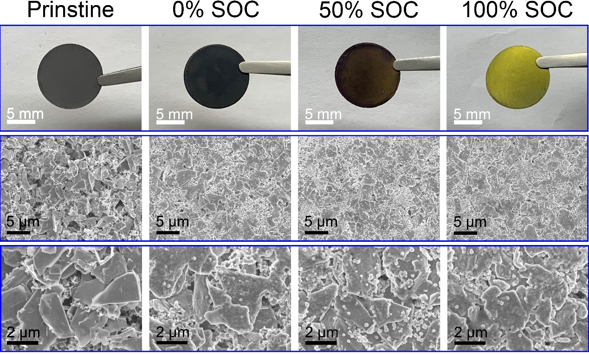
Supplementary Figure 25. Photographs and SEM images of the graphite anodes under different SOCs.

Supplementary Figure 26. Coulombic efficiency of LFP||NG pouch cells with two electrolytes during the long cycling performance.

Supplementary Figure 27. (a) Desolvation energies and ionic conductivities of different electrolytes measured at room temperature. (b) Ionic conductivities of 1.0 M LiPF₆ FEC/AN (7:3 by vol.) and 1.0 M LiPF₆ EC/DMC (1:1 by vol.) + 2% VC at different temperatures.

Supplementary Figure 28. Radial distribution functions of (a) Li-F_{PF6}, Li-O_{FEC}, and Li-N_{AN} pairs for 1.0 M LiPF₆ FEC/AN (7:3 by vol.) and (b) the corresponding distribution of the FEC solvent number solvating with one Li⁺.

Supplementary Figure 29. Charge/discharge curves of NG||Li cells with (a) 1.0 M LiPF₆ EC/DMC+ 2% VC and (b) 1.0 M LiPF₆ FEC/AN from 1C to 20C. (c) Evolution of the overpotential at different rates in NCM811||NG cells with two electrolytes.

Supplementary Figure 30. Charge/discharge curves of NCM811||NG cells with (a) 1.0 M LiPF₆ EC/DMC+ 2% VC and (b) 1.0 M LiPF₆ FEC/AN from 0.2C to 20 C. (c) Rate performance of NCM811||NG full cells with two electrolytes. The loadings of active material in all NCM811 cathodes used above are 0.3 mAh cm⁻². For each cycle, the rates of charge and discharge are the same.

Supplementary References
1. Lindstrom, H. et al. Li⁺ ion insertion in TiO₂ (anatase) .2. voltammetry on nanoporous films. J. Phys. Chem. B 101, 7717-7722 (1997).
2. Chen, J. et al. Intercalation of Bi nanoparticles into graphite results in an ultra-fast and ultra-stable anode material for sodium-ion batteries. Energy Environ. Sci. 11, 1218-1225 (2018).
3. Billaud, J., Bouville, F., Magrini, T., Villevieille, C. & Studart, A. R. Magnetically aligned graphite electrodes for high-rate performance Li-ion batteries. Nat. Energy 1, 1-6 (2016).
4. Jiang, L.-L. et al. Inhibiting solvent co-intercalation in a graphite anode by a localized high-concentration electrolyte in fast-charging batteries. Angew. Chem. Int. Ed. 60, 3402-3406 (2021).
5. Mussa, A. S. et al. Fast-charging effects on ageing for energy-optimized automotive LiNi_{1/3}Mn_{1/3}Co_{1/3}O₂/graphite prismatic lithium-ion cells. J. Power Sources 422, 175-184 (2019).
6. Shen, Y. et al. Achieving desirable initial coulombic efficiencies and full capacity utilization of Li-ion batteries by chemical prelithiation of graphite anode. Adv. Funct. Mater. 31 (2021).
7. Yamada, Y., Yaegashi, M., Abe, T. & Yamada, A. A superconcentrated ether electrolyte for fast-charging Li-ion batteries. Chem. Commun. 49, 11194-11196 (2013).
8. Yao, Y.-X. et al. Regulating interfacial chemistry in lithium-ion batteries by a weakly solvating electrolyte. Angew. Chem. Int. Ed. 60, 4090-4097 (2021).
9. Yamada, Y. et al. Unusual stability of acetonitrile-based superconcentrated electrolytes for fast-charging lithium-ion batteries. J. Am. Chem. Soc. 136, 5039-5046 (2014).
10. Zhang, C. et al. Aligned graphene array anodes with dendrite-free behavior for high-performance Li-ion batteries. Energy Storage Mater. 37, 296-305 (2021).
11. Son, D.-K., Kim, J., Raj, M. R. & Lee, G. Elucidating the structural redox behaviors of nanostructured expanded graphite anodes toward fast-charging and high-performance lithium-ion batteries. Carbon 175, 187-201 (2021).
12. Mu, Y., Han, M., Li, J., Liang, J. & Yu, J. Growing vertical graphene sheets on natural graphite for fast charging lithium-ion batteries. Carbon 173, 477-484 (2021).

