Supplimental Data
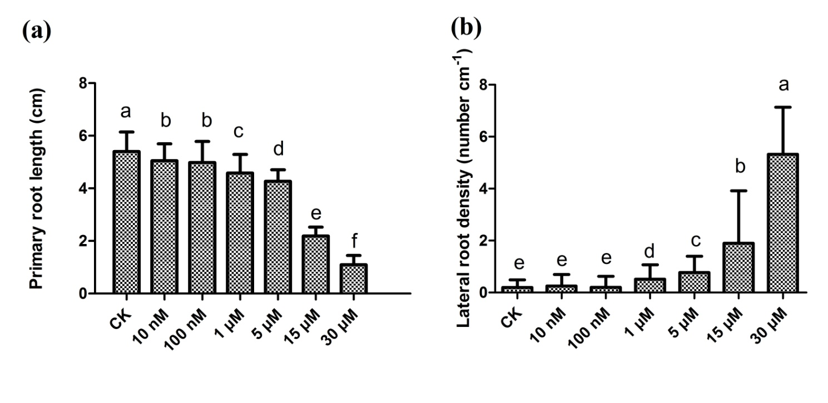
Figure S1 (a,b) Primary root length (a) and lateral root density (b) of wild-type seedlings exposed to 0 - 30 μM C10-HSL for 5 d, n=40. CK refers to solvent control. All the error bars represent +/- SD. (Different letters indicate significantly different values , P < 0.05 by Tukey’s test).

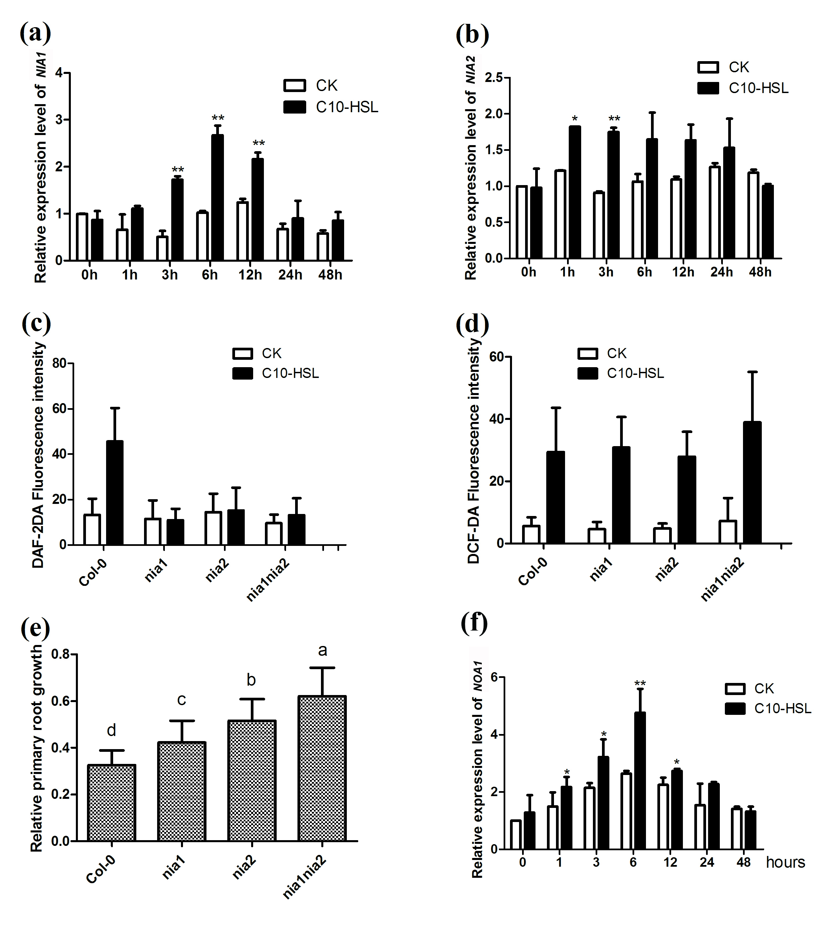
Figure S2 (a, b) Transcriptional regulation of NIA1 and NIA2 genes after exposed to 30μM C10-HSL for up to 2 days in Col-0. (c, d), Detection of NO production(c) and ROS production (d) in the roots of col-0, nia1,nia2,nia1nia2,rhd2 and noa1 seedlings exposed to 30 μM C10-HSL 1 d. (e), Relative primary root growth of Col-0, nia1,nia2,nia1nia2,rhd2 and noa1 seedlings exposed to 30μM C10-HSL for 5 d, n>=30. (f) Relative expression level of NOA1 gene after exposure to 30 μM C10-HSL for up to 2 d in wild-type seedlings. CK refers to solvent control. All the error bars represent +/- SD. (Different letters indicate significantly different values, P < 0.05 by Tukey’s test; *P < 0.05, **P < 0.001, Student’s t test).
*
**
**
**
**

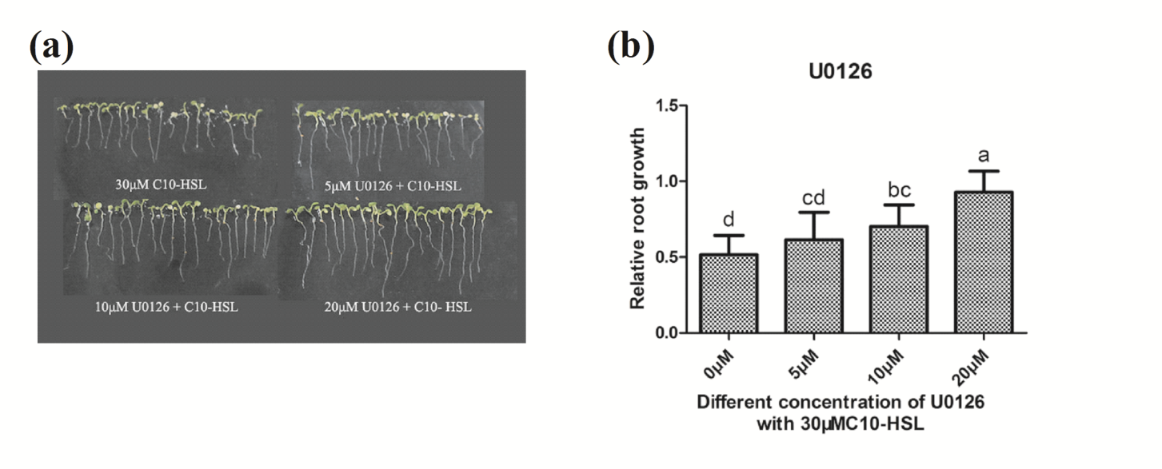
Figure S3 (a, b) Relative primary root growth of Col-0 seedlings exposed to 30 μM C10-HSL with or without 5-20 μM U0126 for 5 d, n=40, bar=1cm. CK refers to solvent control. All the error bars represent +/- SD. (Different letters indicate significantly different values , P < 0.05 by Tukey’s test)

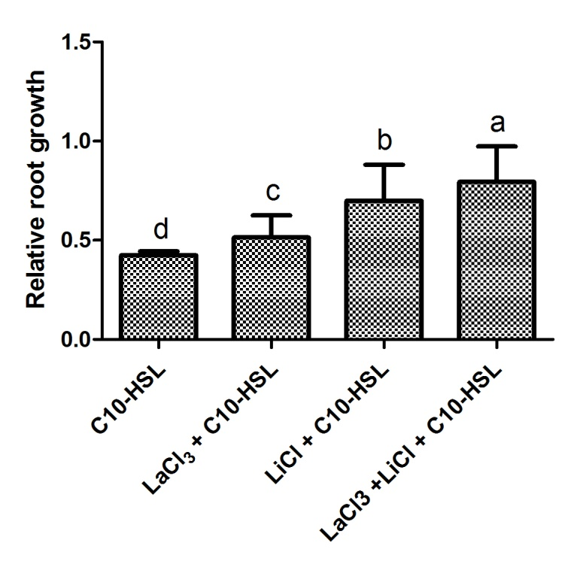
Figure S4 Relative primary root growth of Col-0 seedlings exposed to 30 μM C10-HSL with or without 100 μM LiCl plus 300 μM LaCl₃ compared for 5 d, n=40. All the error bars represent +/- SD. (Different letters indicate significantly different values , P < 0.05 by Tukey’s test)

Table1. List of the primers for qRT-PCR analysis of the genes.
Primer names | Primer sequences (5'-3')
NOA1-F | TCGGAGGAGAGAAGTTGTATGAC
NOA1-R | ATTTTGAGGAGCAAGGGCG
NIA1-RT-F | TGAAGGTGGATGGCGAACTC
NIA1-RT-R | CGTCCACGGTCACATCT
NIA2-RT-F | CCTAAGGGAGGAACTGGA
NIA2-RT-R | ACTGAATCATCGGTGGTG
ACTIN2-F | GGTAACATTGTGCTCAGTGGTGG
ACTIN2-R | AACGACCTTAATCTTCATGCTGC

