Fig. 2.
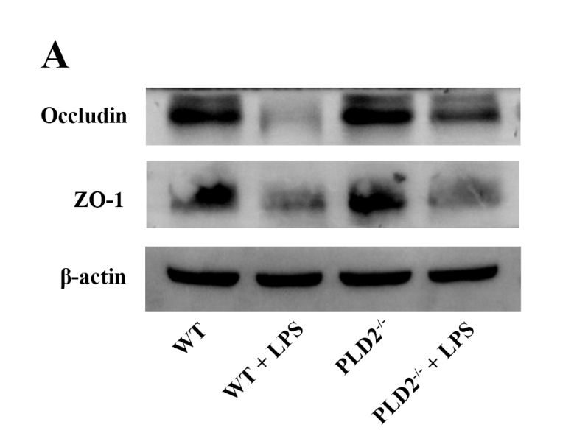
Occludin
52kDa
ZO-1
195kDa
β-actin
42kDa
Fig. 3.
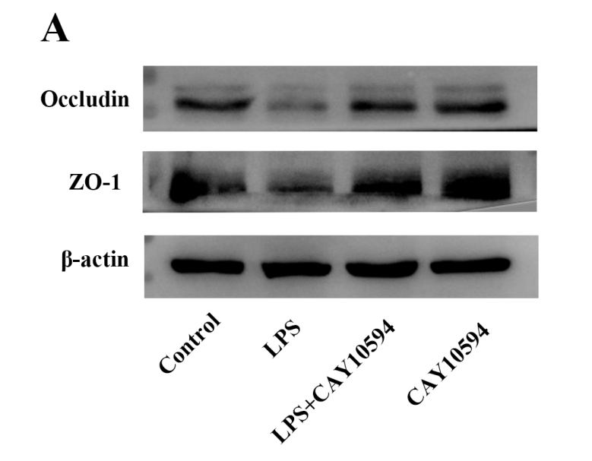
Occludin
52kDa
ZO-1
195kDa
β-actin
42kDa
Fig. 4.
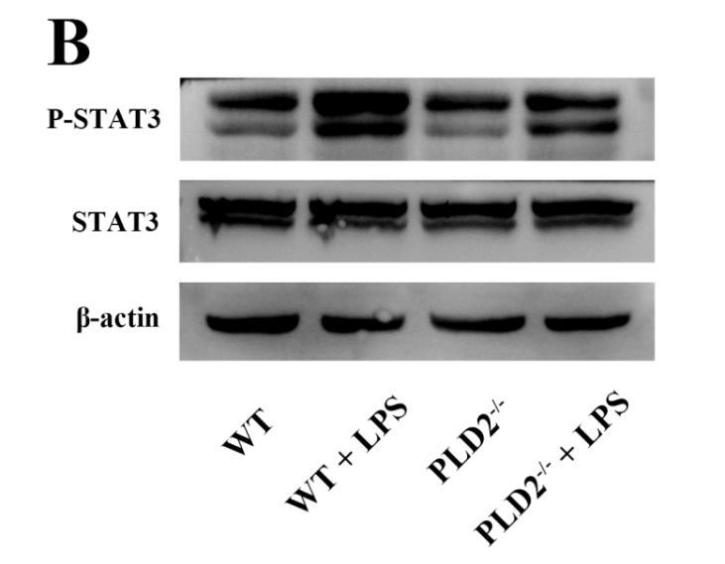
P-STAT3
98kDa
STAT3
92kDa
β-actin
42kDa
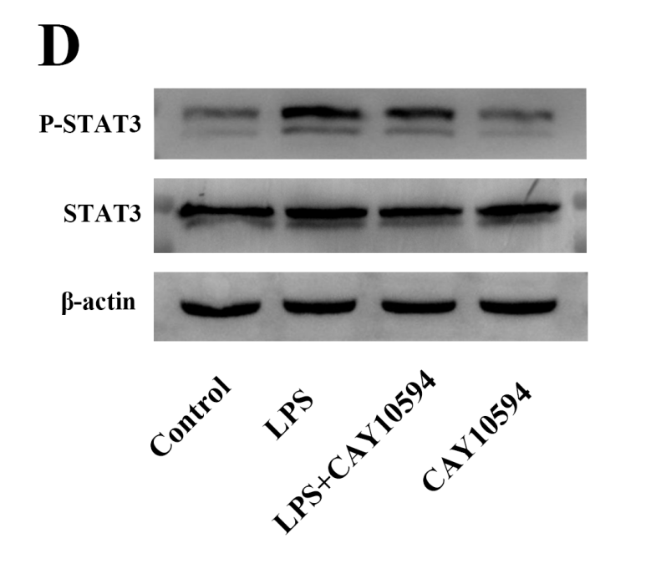
P-STAT3
98kDa
STAT3
92kDa
β-actin
42kDa
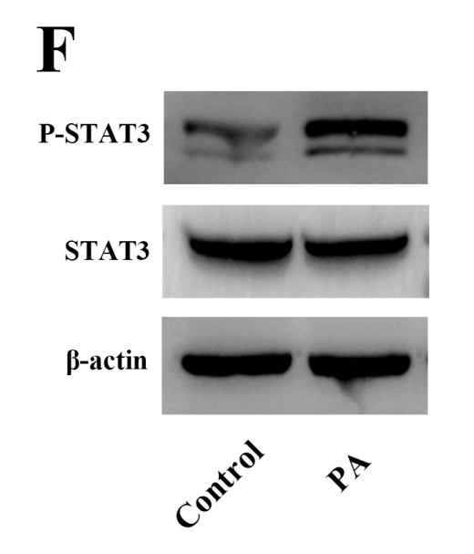
P-STAT3
98kDa
STAT3
Note: Hello, the pictures in the article were originally designed for 4 groups of experiments, which were divided into Control, PA, PA+STAT3-IN-1, and STAT3-IN-1 groups, and then divided into two groups according to the experimental design, which were divided into Control and PA groups, so the first two groups were intercepted on the basis of the original image.
92kDa
β-actin
42kDa

Fig. 5.
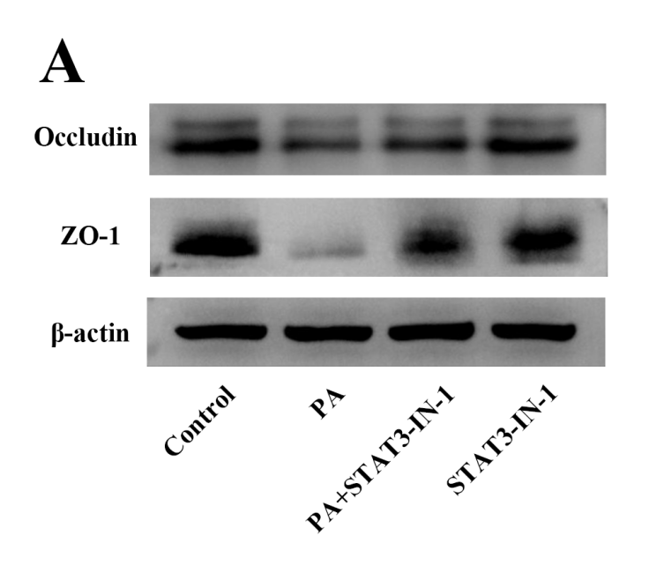
Occludin
52kDa
ZO-1
195kDa
β-actin
42kDa

